IPAC PROJECT

Integrating Pharmacists within ACCHSs to improve chronic disease management

Associate Professor Sophia Couzos on behalf of the IPAC Project Team Community Pharmacy Stakeholder Forum, Sydney, September 2018

Project Partners
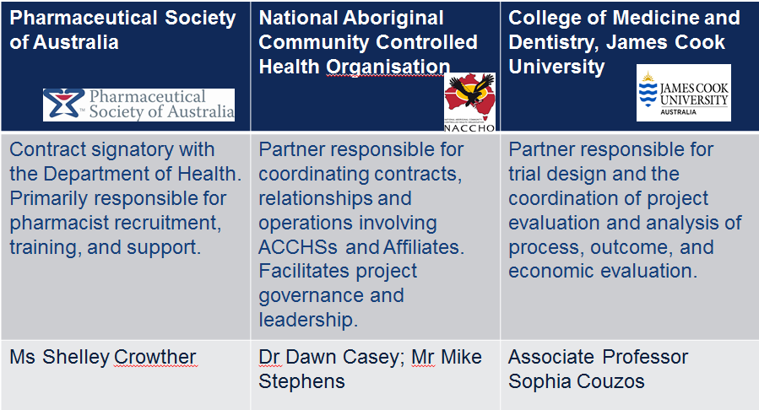

Project Managers
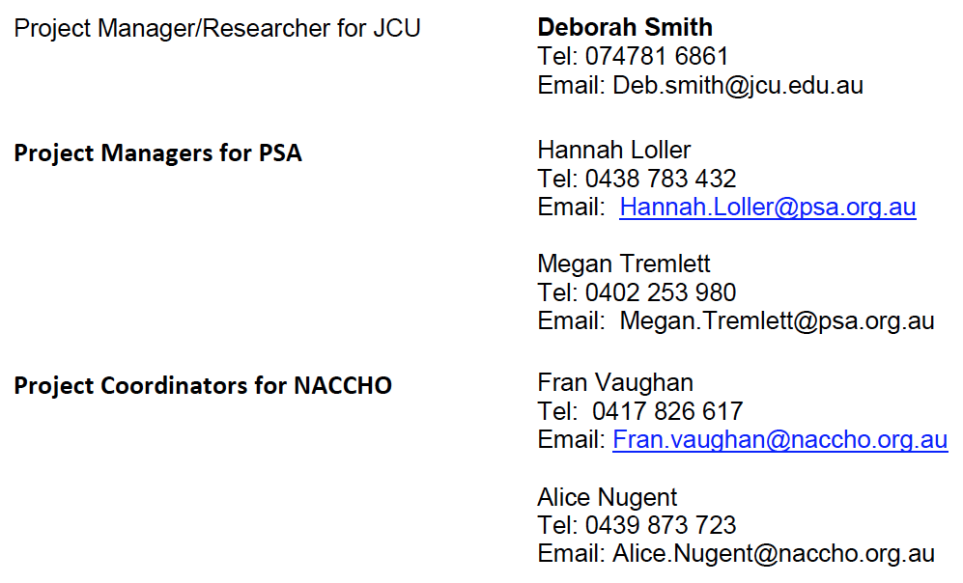

Project Operational Teams
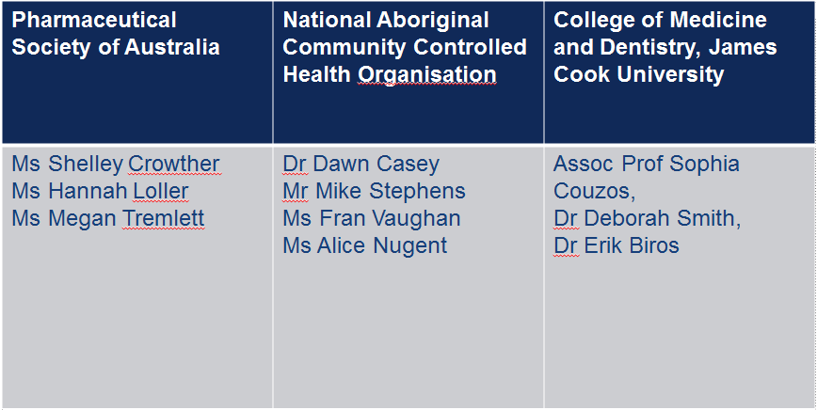

Project Steering Committee
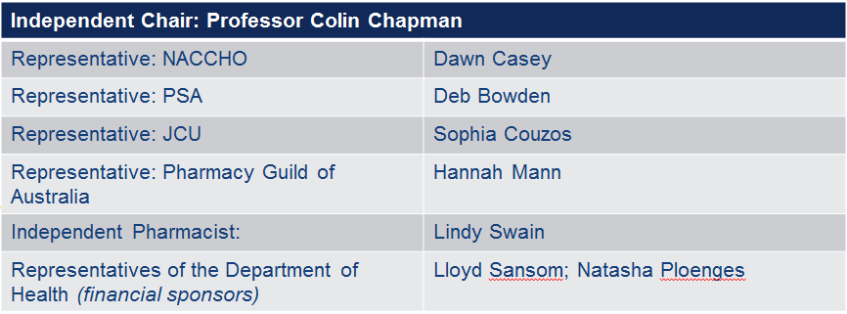

Project Evaluation Team
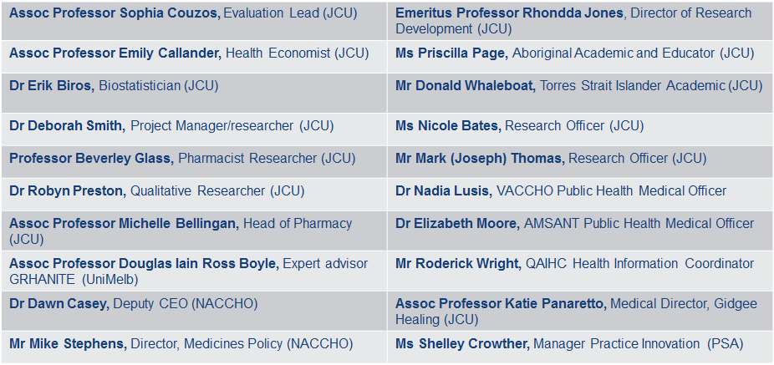

Project Reference Group
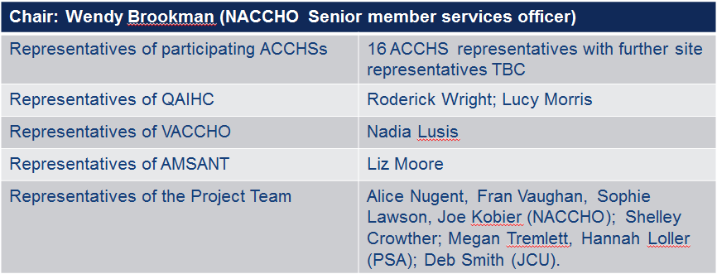

Project Sponsor
The financial sponsor of this project is the Australia Government Department of Health, under the Pharmacy Trials Program (Tranche 2) funding as part of the 6th Community Pharmacy Agreement (6CPA). The 6CPA is a five-year agreement (to June 2020) between the Commonwealth of Australia (as represented by the Department of Health) and the Pharmacy Guild of Australia.

Project Governance Structure
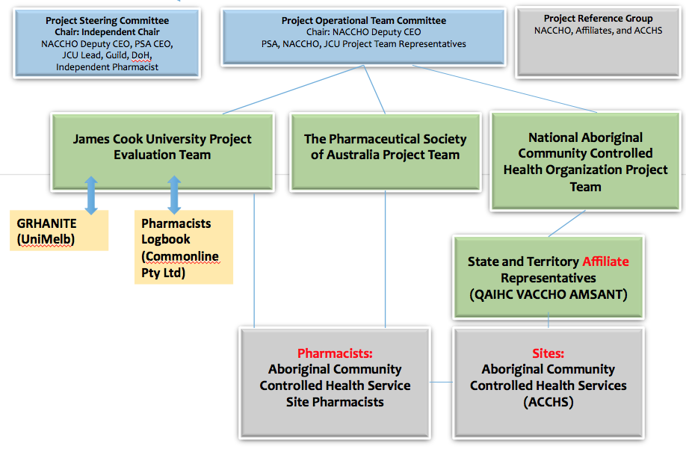
MOU- Project Partners - Signed: Nov 2017
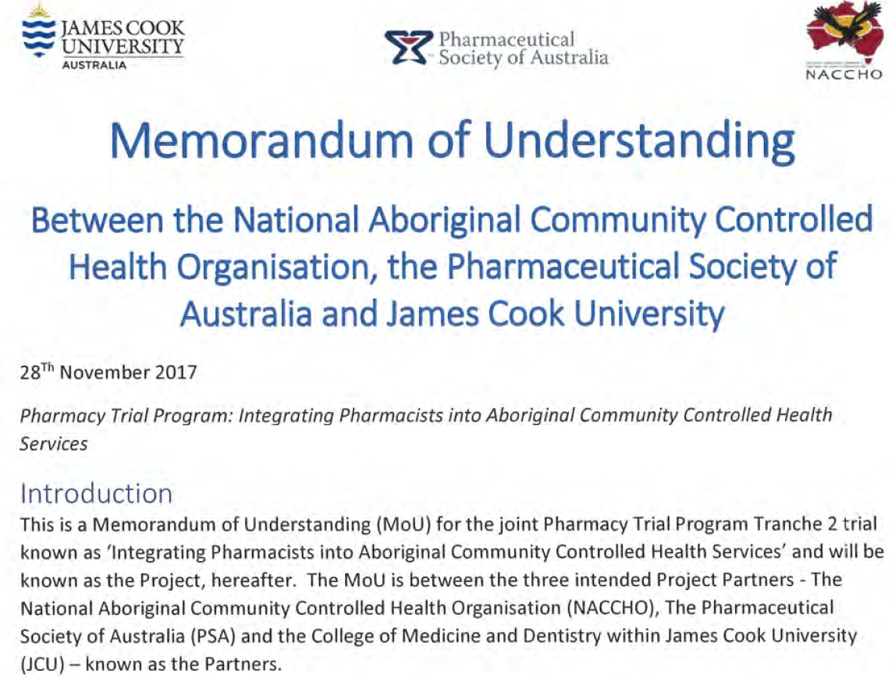

Project Objective:

To explore if quality of care outcomes for Aboriginal and/or Torres Strait Islander adult patients with chronic disease can be improved by integrating a practice pharmacist within the primary health care team of Aboriginal Community Controlled Health Services (ACCHSs), when compared with prior care.

Study Intervention:

• Registered practice pharmacist integrated within the primary health care team of an ACCHS
o15-month intervention period (aggregated to represent 0.57 FTE pharmacist per site)

oUp to 22 ACCHS sites in Queensland, Northern Territory, Victoria.

oSites geographically spread (urban, regional, remote)

Study design:

• Interventional, pragmatic, non-randomised, pre and post study with a cost-effectiveness analysis, where the pharmacist intervention will be added to standard primary health care practice within ACCHSs.
• Adhering to community-based participatory research (CBPR) principles.

CBPR principles:

• “A partnership approach to research that equitably involves, for example, community members, organizational representatives, and researchers in all aspects of the research process and in which all partners contribute expertise and share decision making and ownership.” [Israel BA, et al. Ann Rev Public Health, 1998]

• The CBPR principles for this project have been adapted from the WHO guiding principles for Indigenous CBPR. http://www.who.int/ethics/indigenous_peoples/en/index1.html

[For more information: see https://www.mja.com.au/journal/2015/202/10/talking-about-smokes-large-scale-community-based-participatory-research-project]

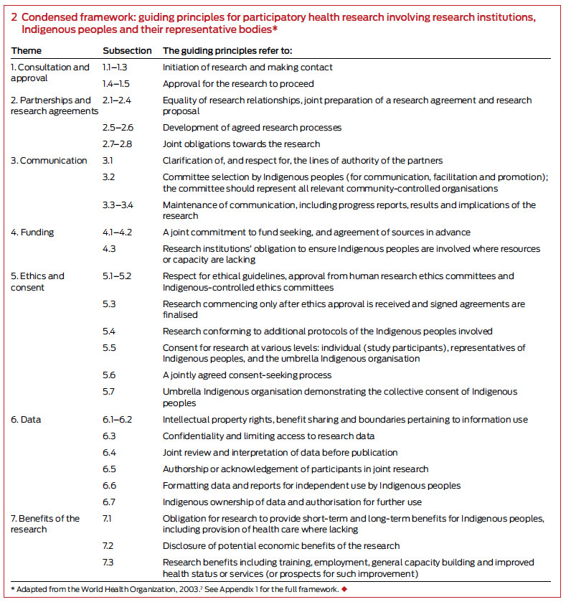

Pragmatic design
• Pragmatic trials seek to determine if interventions work under usual conditions rather than under ideal conditions. Examples shown below: 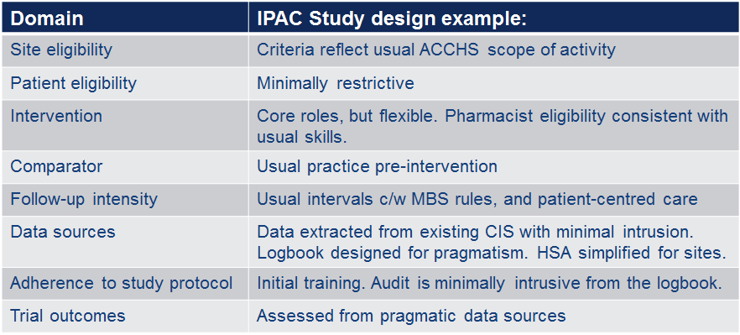

Clinical claim:

This project makes two clinical claims:
1. Patients who are managed by this model of care, involving delivery of services by a pharmacist integrated within Aboriginal Community Controlled Health Services (ACCHS), experience either equivalent or superior quality of care outcomes for Aboriginal and/or Torres Strait Islander adult patients with chronic disease compared to baseline data representing pre-intervention.

2. Appropriate funding for services provided by pharmacists within ACCHSs is likely to lead to superior health care service utilisation (towards equity) of patients with chronic disease compared to utilisation at baseline (pre-intervention).

Expected Project Outcomes:
• Improved chronic disease outcomes;
• Improved prescribing by doctors;
• Improvements in health service activity related to medicines use;
• Cost-effectiveness analysis.

6 17

Project outcome measures:
• Primary outcomes:
oimprovements in quality of care outcomes (biomedical measures such as BP, HbA1c, lipids, CV risk assessment (levels and risk) in patients with chronic disease.
• Secondary outcomes:
o improvements in other quality of care outcomes:
▪Prescribing indices (Medication Appropriateness Index, measures of overuse, and assessment of underutilization of medicines)
▪Home medication reviews (HMR) (MBS 900 claims), and other medication reviews (‘non-HMR’ and ‘follow-up to a non-HMR’)
▪Health service utilisation indices (MBS items 721, 723, etc) ▪Patient survey scores for adherence and ‘reasons for non-adherence’
▪Patient and stakeholder perceptions (ie ACCHS staff, IPAC pharmacists, community pharmacy)
ocost-effectiveness analysis.

Project Timelines
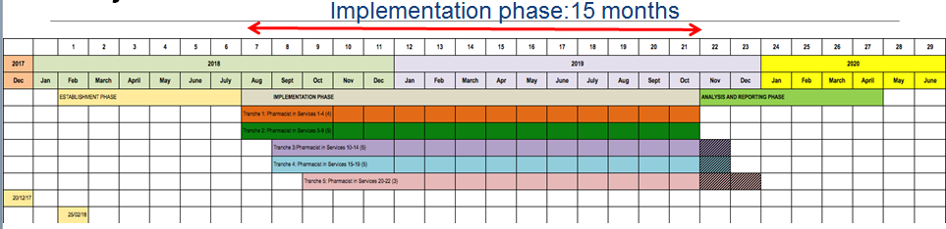
• Head Agreement signed: 20/12/17 • Partner contracts signed 25/2/18
• Implementation Phase started in August 2018
• Timelines for several sites encroaching into Analysis Phase. • Final report due: April 2020

Ethics approval

• St Vincent’s Hospital Human Research Ethics Committee (HREC), Melbourne, Victoria (for Qld and Vic sites)
oHREC/17/SVHM/280
• JCU HREC (mutual recognition of StVH HREC and approval) o HREC/H7348
• Menzies School of Health Research HREC (NT) oHREC/2018-3072
• Central Australian HREC (NT) oHREC/CA-18-3085.

ACCHS (site) inclusion criteria:
• Must be an ACCHS in Vic/Qld/NT, accredited to RACGP standards; • At least 1 FTE prescribing GP;
• No existing non-dispensing practice pharmacist (doing the same work as the project protocol);
• Communicare or Best Practice clinical information systems (CIS);
• Has participated in CQI and reporting on the national Key Performance Indicators for at least 24 months;
• GRHANITE site installation checklist approved;
• Physical on-site space for pharmacist (private consulting room), with access to the CIS;
• Nominate a ‘go to’ person to assist with informed patient consent; • Capacity for CTG scripts/S100 scheme (remote area access);
• If conducting ‘point of care’ testing - participates in the QAAMS (Quality Assurance for Aboriginal and Torres Strait Islander Medical Services) program.

Pharmacist inclusion criteria
• Tertiary qualification in pharmacy with current registration as a pharmacist with the Australian Health Practitioner Regulation Agency (AHPRA);
• More than two years post-registration experience in pharmacy (hospital, community or primary care);
• Preferably hold or be working toward accreditation for the delivery of Medication Management Reviews;
• Post-graduate clinical qualifications or demonstrated clinical experience (e.g. hospital or HMRs);
• Excellent communication skills.

Patient inclusion criteria

Aged 18 years of age and over with:
• Cardiovascular disease (coronary heart disease, stroke, hypertension, dyslipidaemia and any other CV disease),
• Type 2 diabetes mellitus, • Chronic kidney disease,
• Other chronic conditions at high risk of developing medication- related problems (e.g. polypharmacy).

Patient consent is required
All patient data is deidentified.

Recruited sites- distribution
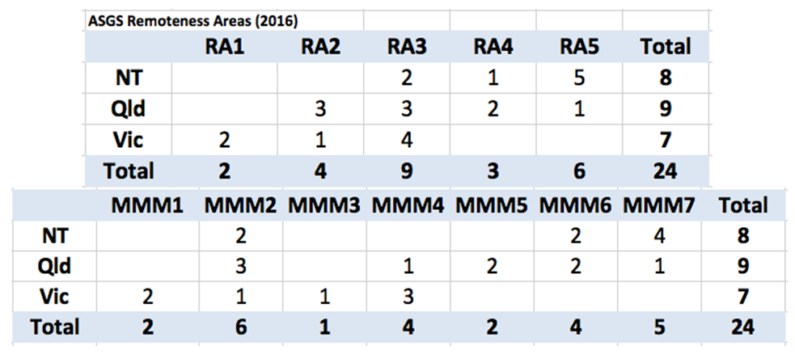

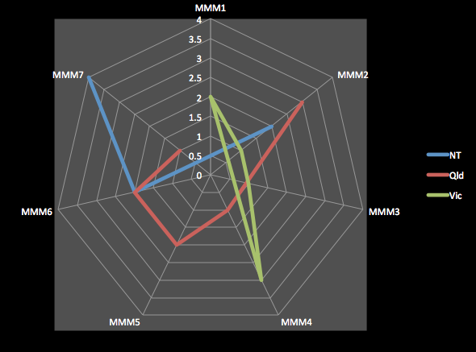

Patient recruitment targets

Based on FTE pharmacists and size of the practice:

• 0.2FTE pharmacist base allocation and a proportional allocation related to the total number of patients/site
• Total of 12.54 FTE pharmacists (all sites) for 15 months (for an average of 0.57 FTE per site)
• Target of 4 patients/day/1.0 FTE first 4-5 months (phase 1) of implementation phase, with follow-up conducted in the remaining 10 months (phase 2).
• Estimate ~5000 patients.

Pharmacists 10 core roles
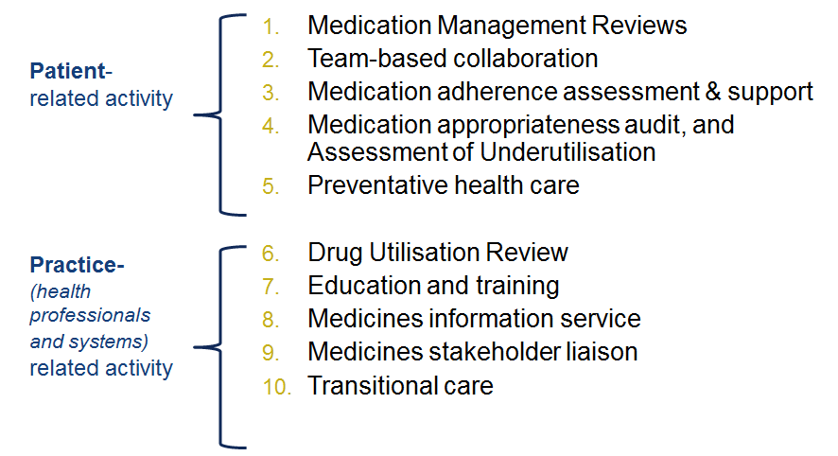
Data sources

• Health systems assessment (site assessment by interview)
• Pharmacists logbook (Commonline Pty Ltd)

• GRHANITE: clinical information systems data extraction (UniMelb)
• Qualitative (focus group, stakeholder surveys- to commence in 2019)

Health Systems Assessment
Site survey to explore site characteristics pre and post intervention.
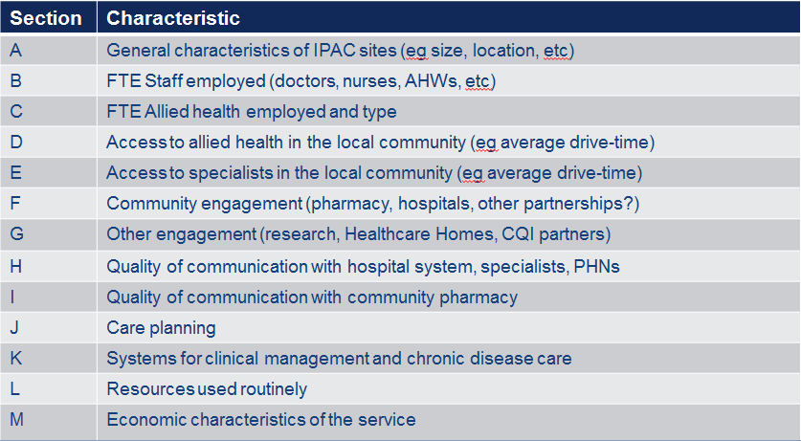

Pharmacists Logbook

• Unique domain name! www.ipac.net.au
• Custom built data entry and real time data management system developed for JCU (Copyright: Commonline Pty Ltd)
• Data source for JCU evaluation. • Pharmacists enter data.
• Assists IPAC Pharmacists to manage their activity.
• PSA can audit and track pharmacists activity.
• Simple to use.
6

GRHANITE TM
• Pharmacists have full access to clinical information systems (CIS).
• JCU subcontracted the Research Information Technology Unit, Faculty of Medicine, Dentistry & Health Sciences, Melbourne Medical School, at the University of Melbourne to use the GRHANITE data extraction tool from two CISs (Best Practice and Communicare).
• Assoc Prof Douglas Boyle (developer) is a member of the JCU evaluation team.
• Minimally intrusive, pre-programmed, automatic, weekly extraction in Microsoft SQL format.
• Data is extracted ONLY from consented participants (opt-in). • Only ethics approved data is extracted.
• Data is de-identified.

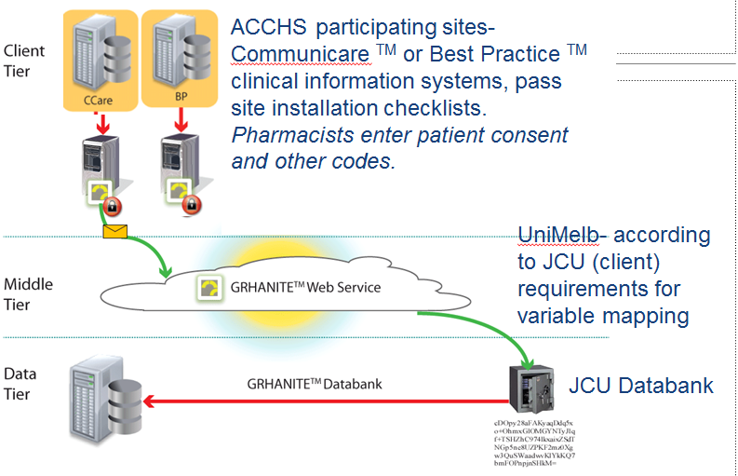
Modified from source: https://www.grhanite.com/technologies/

GRHANITE measures

• Data is extracted for the 15-month duration of the project, and 12-month pre-intervention period (for each participant).
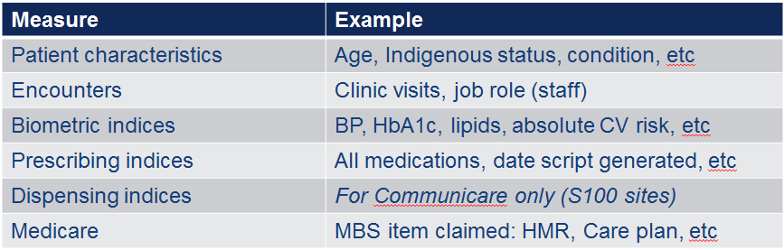

Qualitative measures

• To be conducted June- October 2019
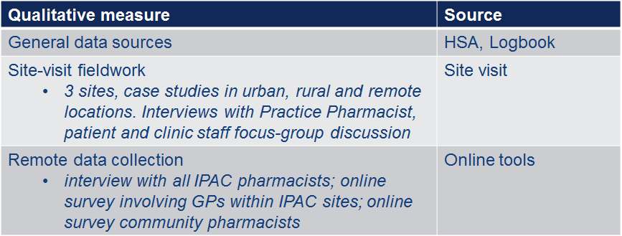

Economic measures
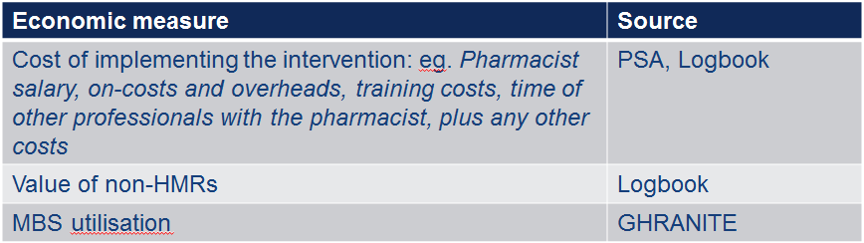

Training of pharmacists

Three parts:
- Cultural sensitivity
2. 10 Core roles
3. Data capture

Training Workshops:
- Late July/Aug 2018: 16 pharmacists trained.
- Assoc Prof Lindy Swain/Emma Walke: “Becoming a culturally aware pharmacist – Pharmacists working with Aboriginal people”
- Megan Tremlett (PSA) developed ‘10 Core roles’ materials
- Hands-on Pharmacist Logbook and CIS training (BP and CC).

Patient journey
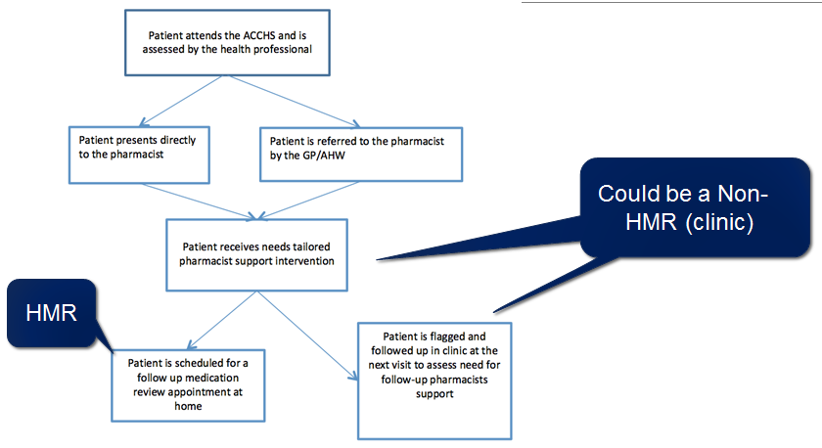

Patient consent process
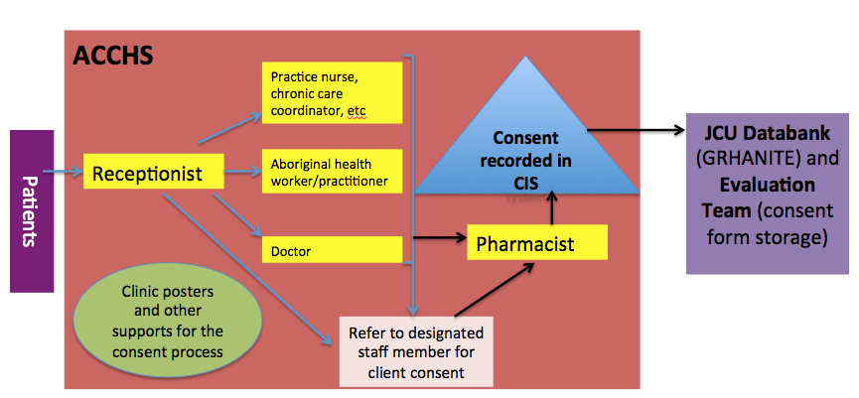

Promotional material
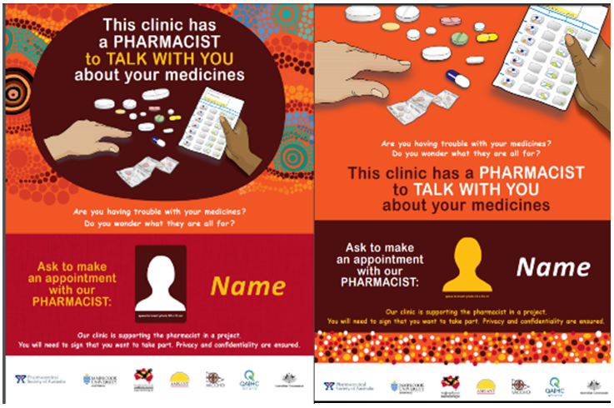

Current status

• 20 ACCHSs contracted to date (24 sites) • 19 Pharmacists trained; 4 pending.
• 3 IPAC pharmacists commenced their roles in August 2018
• GHRANITE site acceptance testing completed for BP; Communicare testing underway
• Pharmacist Logbook is fully operational • First patient recruited, 9th August 2018!

Final acknowledgement:

• To the pharmacists who have been contracted to this project:
oThe project partners acknowledge their passion, enthusiasm and commitment to delivering care to the patients of ACCHSs, to undertake training for this project, and to adhere to the project protocol!

FOR FURTHER INFORMATION ABOUT THE EVALUATION:

Dr Deb Smith (JCU Project Manager/Researcher): Deb.smith@jcu.edu.au

Dr Erik Biros (JCU Biostatistician) Eric.biros@jcu.edu.au

Assoc Prof Sophia Couzos (Evaluation Lead) Sophia.couzos@jcu.edu.au

