PROGRESS UPDATE ON THE EVALUATION OF THE NEW/EXPANDED 6CPA PHARMACY PROGRAMS
Joe Scuteri
Managing Director
HealthConsult

Evaluation of the new and expanded community pharmacy programs funded under the 6CPA

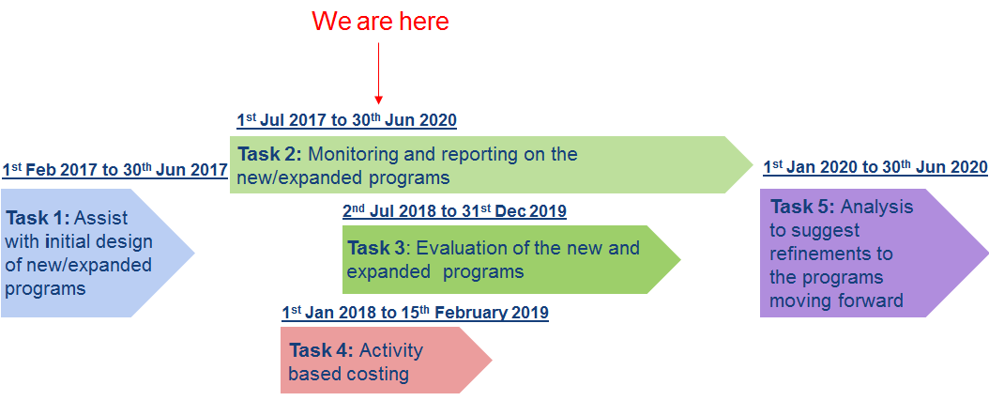

Task 1: Assist with initial design of new/expanded programs

• Developed logic model for each program
• Design Minimum Dataset (MDS) specification for each program • MedsCheck (routine data collection)
• Diabetes MedsCheck (routine data collection) • Staged Supply (routine data collection)
• Dose Administration Aids (routine data collection)
Task 1: Program logic models – an example

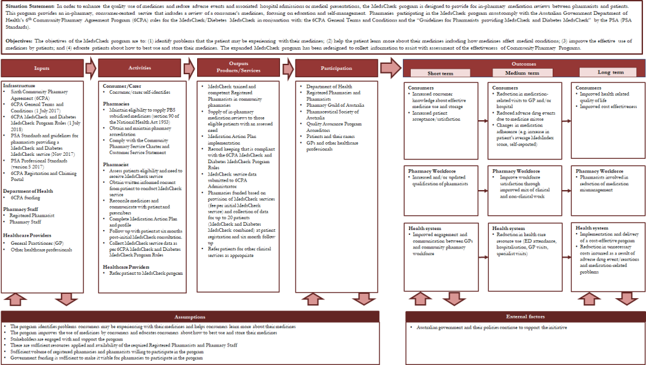

Task 2: Monitoring and reporting on the new/expanded programs

• Prepared Monitoring and Reporting Framework
• Developed quality assurance process and associated database
• Commenced receipt of claims data and MDS data from the Department (via secure web portal) on a six-monthly interval
• Analysis of each data batch received highlights minor changes that can be made in how claims data is collected or reported by the pharmacies to the Guild to improve data quality.
• Prepare five (six-monthly) Program Monitoring Reports

Task 2: Monitoring and reporting

• Period 1 report provided to Australian Government Department of Health in May 2018, covering data submitted in respect of July to December 2017
• Period 2 reporting has been recently provided to HealthConsult covering the period from November to April 2018 (time window changed to accommodate the identified lag in data receipt)
• The reports produced currently cover the following programs • MedsCheck and Diabetes MedsCheck
• Dose Administration Aids • Staged Supply
• Gradual expansion and clarification of data collection results in much improved insight into the operations of the programs through analysis

Task 2: Monitoring and reporting – some examples
Number of Staged Supply Collection Claims by Gender (Period 1 Report)
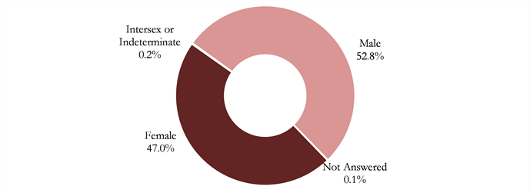
Average number of prescription medicines by age group (Diabetes MedsCheck) (Period 1 Report)
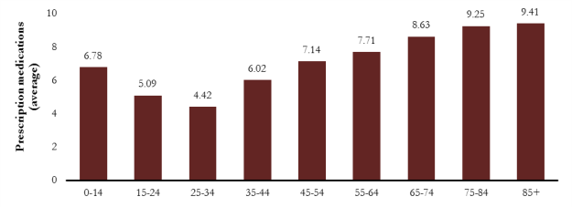

Task 3: Evaluation of the new and expanded programs

Key evaluation questions:

• Do the programs improve patient’s understanding of their medications and the importance of adhering to the prescribed medication regime?
• Do the programs improve the defined health outcomes of patients?
• Are the programs cost-effective?
• What are the barriers and enablers to providing effective patient-centred programs and how can the programs be strengthened?

Task 3: Evaluation of the new and expanded 6CPA programs

• Develop evaluation frameworks for each in-scope program • Obtain ethics and AIHW (for linked data) approval
• Recruitment of about 120 community pharmacies (not all pharmacies will be required to collect on all programs as will be too burdensome)
• About 300 patients to be recruited for MedsCheck only, with an estimated 60% follow-up rate
• About 300 patients to be recruited for Diabetes MedsCheck only, with an estimated 60% follow-up rate • About 300 patients to be recruited for Staged Supply (SS) only, with an estimated 60% follow-up rate
• About 300 patients to be recruited for Dose Administration Aids (DAA) only, with an estimated 60% follow-up rate
• About 1800 patients recruited that are participating in multiple 6CPA programs simultaneously

• Recruitment of consumers in each pharmacy will occur between 1st October and 31st December 2018 with all follow-up data collection completed by 30th June 2019

• Pharmacist to collect required service level data at two time points on each consumer (initial contact and at follow-up (6 months or cessation of the service)

• Pharmacist to provide consumers with a survey at both time points and collect the completed surveys for postage to HealthConsult for data entry.

Task 3: Evaluation of the new/ expanded programs – key questions

• Do the programs improve patients understanding of their medications and the importance of adhering to the prescribed medication regime?
• Changes to a patient’s medication profile as a result of program participation
• Patient Reported Medication Adherence, e.g.:
• Adherence to Refills and Medications Scales (ARMS)
• Changes to patient reported satisfaction, e.g.:
• Treatment Satisfaction Questionnaire for Medication (TSQM)
• Changes in patient reported side-effects/reported adverse event(s) e.g.: • Generic Assessment of Side Effects (GASE)
• Changes as witnessed by stakeholders and pharmacists • Program Monitoring Reports (Attachment A submissions)

Task 3: Evaluation of the new/ expanded programs – key questions

• Do the programs improve the defined health outcomes of patients?
• Improvements in medication adherence: • MedsIndex
• Adherence to Refills and Medications Scales (ARMS)
• Changes in health related quality of life: • Assessment of Quality of Life 4D
• Changes in patient reported side-effects/reported adverse event(s)
• Changes as witnessed by stakeholders and pharmacists
• Program Monitoring Reports (Attachment A submissions)

Task 3: Evaluation of the new/ expanded programs – key questions

• Are the programs cost-effective?
• Outcome-based measures collected as part of the evaluation phase, linked to costing study estimates identified in the 6CPA costing phase (Task 4).
• Following assessments made for participants in a single 6CPA program as well as participants in one or more 6CPA programs (to assess possible synergistic effects of multiple programs).
• Cost per unit change in primary outcome measures
• Cost per unit change (baseline to six months/cessation) in patient-reported Quality of Life • Cost per unit change (baseline to six months/cessation) in treatment satisfaction
• Cost per unit change (baseline to six months/cessation) in medication adherence
• Change in health care resource use (pre and post intervention) • Pharmacists perception of cost-effectiveness
• Stakeholder perception of cost-effectiveness

Task 3: Evaluation of the new/ expanded programs – key questions

• What are the barriers and enablers to providing an effective patient-centred programs and how the programs be strengthened?
• Patient satisfaction with the service (weighted with other factors)
• Stakeholder and pharmacist opinions
• Analysis of case study sites (pharmacies)

Task 4: Activity based costing

• Recruit 20 pharmacies to be involved in costing DAA and SS programs
• Conduct costing for SS and DAA programs between 1st February to 10th August 2018 – field work completed, results being processed.
• Recruit 20 pharmacies and 10 independent pharmacists to be involved in costing MedsCheck, Diabetes MedsCheck and HMR
• Conduct costing for MedsCheck, Diabetes MedsCheck and HMR programs between 1st August to 15th February 2019

Task 4: Activity based costing process flow diagram – an example
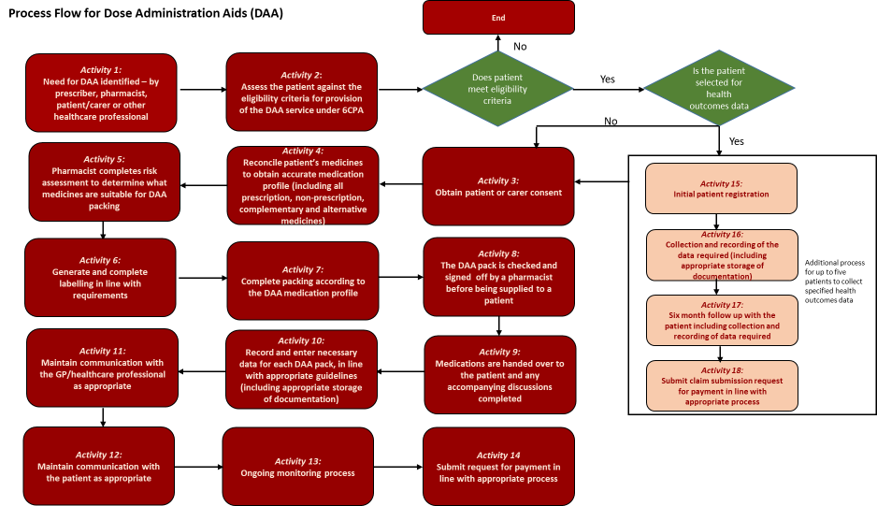

Task 5: Suggested refinements to the programs moving forward

How can stakeholders contribute/participate?

• Case study sites: Engagement from case study sites essential to ensure a representative perspective of the programs and their national implementaion, identifying their weaknesses and strengths at a ‘grass roots’ level.
• Stakeholder interviews: Engagement from stakeholders critical to ensure a diverse view of the programs as well as the identification of knock-on effects of the programs to other health services.
• Data submissions: Importance of data completeness, particularly in relation to participant follow-up.
• Pharmacist survey: Survey participants engage in understanding the questions and providing sufficient detail in their responses. The survey is a chance for providers to underscore how they feel the programs are performing.

