6CPA IMPLEMENTATION

  - COMMUNITY PHARMACY STAKEHOLDER FORUM
  - 15 November 2016

Overview of 6CPA Implementation
- 6CPA commenced on 1 July 2015
- Stakeholder groups were consulted and provided input
- $18.9 billion in remuneration for community pharmacy and to support the pharmaceutical supply chain.
- $372 million for chemotherapy compounding fees.

Three key funding elements:
  - Community pharmacy remuneration;
  - Community Service Obligation; and
  - Community pharmacy programs

Other components
  - Pharmacy Location Rules;

  - Governance arrangements;

  - Chemotherapy arrangements; and

  - Review of Pharmacy Remuneration and Regulation.

Community Pharmacy Programs
  - The total funding - $1.26 billion:
  - $613 million for continuing community pharmacy programs
  - $50 million for pharmacy trial program
  - $600 million for new and/or expanded programs

6CPA - Key Achievements
Administration, Handling and Infrastructure fee (AHI)
  - 1 July 2015 - AHI replaced the former six tier retail mark-up
  - AHI supports the ongoing viability of pharmacies
  - Timely implementation including initial interim arrangements
  - AHI - 6% increase in funding to pharmacy (2015/16).

Discounting of the PBS Patient Co-Payment
- PBS general and concessional co-payments discounted by up to $1
  - General - $37.30
  - Concessional - $5.20
- At the pharmacist’s discretion
- At the pharmacy’s own cost

Continuation of the Premium Free Dispensing Initiative (PFDI)
  - $655M allocated for PFDI
  - Encourages increased use of generic medicines
  - Fee for 2016-17 is$1.74 (indexed annually)

New Chemotherapy Compounding Arrangements
  - From 1 July 2015 – new two-tiered fee structure:
    - $60 payable where an eligible PBS EFC item is compounded at a TGA-licensed compounding site.
    - $40 paid to approved suppliers as part of the ‘preparation fee’ where an eligible PBS EFC item is compounded at any other site (i.e. non-TGA- licensed)

CSO / NDSS Administration

ITA to appoint eligible distributors of pharmaceuticals and NDSS products
- released on 27 September 2016 and closed on 3 November 2016
- submissions being assessed
- successful applicants informed before the end of this year

RFQ to appoint a CSO administrator
- issued on 24 October 2016, and closes on 28 November 2016
- successful tenderer informed before the end of this year

National Diabetes Services Scheme (NDSS)
- 1 July 2016 – new supply and delivery arrangements for NDSS products
- Improved access to NDSS through community pharmacy.

Subsidised Continuous Glucose Monitoring Technology
- Formal Advisory Group has been established.
- Process commenced for engagement of suppliers.
- Access arrangements for patients are being planned.

Review of Pharmacy Remuneration and Regulation
- Recommendations on:
  - future remuneration
  - future regulation

- Members of the Independent Panel for the Review
- Professor Stephen King (Chair),
- Ms Jo Watson, and
- Mr Bill Scott.

Review - Next Steps
- The Panel are developing draft recommendations for Interim Report.
- Seeking external expert advice via:
  - literature review
  - targeted survey to obtain financial data
  - consultation

Review Timeline

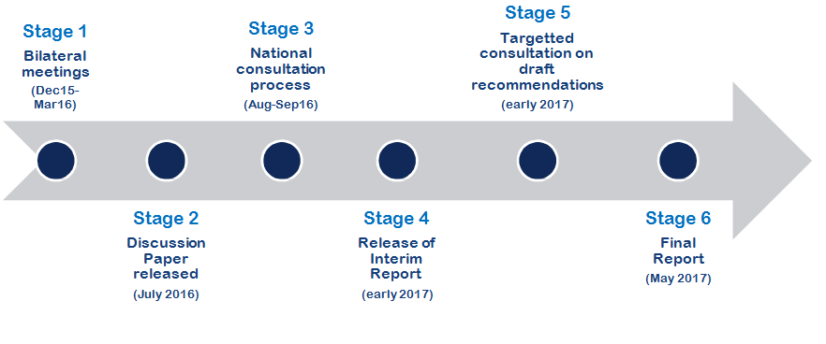

Reviews - Continuing Community Pharmacy Programs

- Reviews of all continuing community pharmacy programs and services - required under the 6CPA

- Purpose - to determine whether programs are cost-effective in delivering health outcomes

- March 2016 - Medical Services Advisory Committee (MSAC) directed the Department to undertake full reviews of each of the programs.

- Cost-effectiveness reviews of the continuing community pharmacy programs are progressing.

Pharmacy Trial Program (PTP)

- First tranche of PTP was announced by the Minister in March 2016 and includes the following trials:

  - Pharmacy-based Diabetes Screening and Referral;

  - Improved medication management for Aboriginal and Torres Strait Islanders through pharmacist advice and culturally appropriate services; and

  - Improved continuity in the management of patients’ medications when they are discharged from hospital.

- The second tranche to the PTP has commenced through an Approach to Market, which closes on 15 December 2016.

Conclusion

- A lot has been achieved over a short period but there is still much to do.

- We are focusing on cost-effectiveness, transparency and evidenced- based outcomes for consumers for all publicly funded programs.

- The Department and the Guild continue to work co-operatively in achieving the delivery of improved health outcomes for patients in partnership with all stakeholders.

