4.04 OLAPARIB

Capsule, 50 mg,

Lynparza ™, AstraZeneca Pty Ltd

Purpose of Application

  - The minor resubmission sought to address the PBAC’s reasons for deferring olaparib at the March 2016 meeting.

Requested listing

  - The PBAC suggested that the following modifications be made to the proposed PBS listing for olaparib maintenance treatment:
- To limit, amongst other criteria, any PBS subsidised access to olaparib for women who have a germline BRCA mutation (class 4 or 5 mutations only) [Paragraph 7.10, March 2016 PBAC Public Summary Document].
This was accepted in the minor resubmission.

  - In March 2016, the PBAC agreed with the ESC that the use of Response Evaluation Criteria in Solid Tumours (RECIST) to determine progression may be impractical in clinical practice. However, as a consequence, the PBAC advised that the subjective assessment of whether a patient has stable or responding disease would mean that the mean duration of olaparib treatment would likely extend beyond that predicted by Study 19, but with likely diminishing marginal effectiveness (Paragraph 7.11, March 2016 PBAC Public Summary Document).

  - The minor resubmission suggested that the PBAC consider aligning the wording of the PBS restriction for olaparib with standard clinical practice (follow-up care).

  - Additionally, the minor resubmission requested a grandfathering clause to ensure continuity and equity of access for women who currently pay for access to olaparib. The minor resubmission stated that 79 Australian women currently have received olaparib through the managed access and patient access program. Further, the minor resubmission expected that most women from this program would meet the proposed PBS restriction for olaparib. Further, the minor resubmission stated that they are willing to work with the PBS Restrictions Working Group to ensure that the wording of this clause meets the requirement for simplicity and clarity. The minor resubmission did not provide suggested wording.

  - The proposed PBS restriction for olaparib as presented in the March 2016 PBAC Public Summary Document, is presented below (with amendments by the PBAC Secretariat made in italics to reflect the March 2016 PBAC recommendation regarding the assessment of progressive disease).

Name, Restriction,  Manner of administration and form |  | Max.  Qty | №.of  Rpts | Dispensed Price for Max. Qty | Proprietary Name and Manufacturer
OLAPARIB  Capsule 50 mg, 448 |  | 1 | 2 | '''''''''''''''''''''''' | Lynparza ™ | AstraZeneca Pty Ltd
Category / Program: | GENERAL – General Schedule (Code GE)
Prescriber type: | Dental Medical Practitioners Nurse practitioners Optometrists  Midwives
Severity: | High grade serous
Condition: | Ovarian cancer, fallopian tube cancer, primary peritoneal cancer
PBS Indication: | High grade serous ovarian cancer, High grade serous fallopian tube cancer, High grade serous primary peritoneal cancer
Treatment phase: | Initial
Restriction Level / Method: | Restricted benefit  Authority Required - In Writing  Authority Required - Telephone  Authority Required – Emergency  Authority Required - Electronic  Streamlined
Clinical criteria: | The condition must be platinum sensitive  AND  Patient must have received at least two previous platinum-containing regimens  AND  Patient must have relapsed following a previous platinum-containing regimen  AND  Patient must be in partial or complete response to the immediately preceding platinum-based chemotherapy regimen  AND  The treatment must be as monotherapy  AND  The treatment must be maintenance therapy  AND  Patient must not have previously received PBS-subsidised treatment with this drug for this condition.
Population criteria: | Patient must have evidence of a germline class 4 or 5 BRCA1 or BRCA2 gene mutation.
Administrative Advice: | Platinum sensitivity is defined as disease progression greater than 6 months after completion of the penultimate platinum regimen.  A response (complete or partial) to the platinum-based chemotherapy regimen is to be assessed using either Gynaecologic Cancer InterGroup (GCIG) or Response Evaluation Criteria in Solid Tumours (RECIST) guidelines.  Evidence of a BRCA1 or BRCA2 gene mutation must be derived through germline testing.
Name, Restriction,  Manner of administration and form |  | Max.  Qty | №.of  Rpts | Dispensed Price for Max. Qty | Proprietary Name and Manufacturer
OLAPARIB  Capsule 50 mg, 448 |  | 1 | 5 | $''''''''''''''''''''''' | Lynparza ™ | AstraZeneca Pty Ltd
Category / Program: | GENERAL – General Schedule (Code GE)
Prescriber type: | Dental Medical Practitioners Nurse practitioners Optometrists  Midwives
Severity: | High grade serous
Condition: | Ovarian cancer
PBS Indication: | High grade serous ovarian cancer
Treatment phase: | Continuing
Restriction Level / Method: | Restricted benefit  Authority Required - In Writing  Authority Required - Telephone  Authority Required – Emergency  Authority Required - Electronic  Streamlined
Clinical criteria: | Patient must have previously received PBS-subsidised treatment with this drug for this condition  AND  The treatment must be as monotherapy  AND  The treatment must be maintenance therapy  AND  Patient must not have progressive disease.

Background

  - Olaparib was granted orphan drug designation by the TGA on 15 January 2015.

  - Olaparib was approved by the TGA on 23 December 2015 as monotherapy for the maintenance treatment of women with BRCAm platinum-sensitive relapsed ovarian cancer who are in response (complete or partial) after platinum-based chemotherapy. Prior treatments must have included at least two courses of platinum-based regimens.

  - Olaparib was considered by the PBAC previously in March 2016.

  - The minor resubmission sought to address the following concerns relating to the March 2016 major submission that were raised by the PBAC:
- clarification of the proposed restriction;
- adjustment of the time horizon to inform the economic model;
- updating financial estimates to reflect the changes to the proposed PBS restriction (class 4 or 5 germline BRCA mutations only); and
- the request of a risk-sharing arrangement.

  - Table 1 summarises the issues raised in the previous major submission and the changes made for the current minor resubmission.

Table 1: Key differences between the July 2016 minor resubmission and the March 2016 submission
 | March 2016 submission | July 2016 minor resubmission
Requested MBS listing | Detection of BRCA1 or BRCA2 mutations (BRCAm) in women with PSR ovarian cancer  MSAC comment: MSAC foreshadowed alignment of any MBS listing of BRCA testing to germline mutations only. | Requested germline BRCA testing only.
Requested PBS listing | BRCAm PSR ovarian cancer  PBAC comment: BRCA testing of tumour tissue is not standardised in current practice [Paragraph 7.6]  The PBAC recommended that PBS-subsidised access to olaparib would be determined through germline BRCA testing only (not tumour). Further, the classification of presence of BRCA mutation would be restricted to class 4 or 5 mutations only ª [Paragraph 7.10]. | Unchanged.  Requested germline BRCA testing only.  The minor resubmission requested that the PBAC consider aligning the wording of the PBS restriction for olaparib with standard clinical practice (follow-up care).
DPMQ | $''''''''''''''' | $'''''''''''''', a ''''''% price reduction.
Main comparator | Standard follow-up care (placebo).  PBAC comment: The PBAC agreed that this was the appropriate comparator [Paragraph 7.02]. | Unchanged.
Clinical claim | The submission stated that olaparib:  - was superior in terms of comparative effectiveness  - had a ‘consistent and well characterised’ safety profile, which was interpreted as slightly inferior but acceptable safety profile.  PBAC comment: The PBAC accepted the clinical claim of superior comparative effectiveness and inferior comparative safety [Paragraphs 6.34 & 6.35]. | Unchanged.
Claim of co-dependence | The interaction test for BRCA status and PFS was statistically significant (p=0.03).  PBAC comment: The PBAC accepted that any PBS-rebate of olaparib maintenance treatment would need to be confined to patients with BRCAm [Paragraph 7.08]. | Unchanged.
Economic model | Cost-utility analysis, 10-year time horizon  - ICER: $''''''''''''''''' per QALY gained  PBAC comment: The PBAC requested a 7.5-year time horizon with a corresponding price reduction to keep the ICER at $'''''''''''''''' per QALY gained [Paragraph 7.20]. | Cost-utility analysis, 8.75-year time horizon  - ICER: $'''''''''''''''' per QALY gained
Drug cost/patient/course | $''''''''''''''''''' | $'''''''''''''''''
Number of patients treated with olaparib | - Submission: '''''''''' in Yr 1 increasing to ''''''''' in Yr 2, then decreasing to '''''''' in Yr 5  - PSCR: '''''''''' in Yr 1 increasing to '''''''''' in Yr 2, then decreasing to '''''''''' in Yr 5 ^{b} | - ''''''''' in Yr 1 increasing to ''''''''' in Yr 2, then decreasing to '''''''' in Yr 5
Financial estimates  Net cost over first 5 years | - $''''''''' ''''''''''''''' (Submission).  - $'''''''' '''''''''''''''' (PSCR ^{b}, also included a '''% price reduction)  PBAC comment: The PBAC recommended the financial estimates be revised to reflect the restricted patient population, i.e. patients must have evidence of a germline class 4 or 5 BRCAm [Paragraph 7.19]. | - $'''''''''' ''''''''''''''''.
Risk sharing arrangement | Willing to enter RSA, none proposed.  PBAC comment: To address the uncertainty surrounding the expected duration of use of olaparib, the PBAC recommended:  - a 100% rebate beyond olaparib treatment duration cap of two years [Paragraph 7.19]. | The minor resubmission proposed an alternative RSA which was based on the:  - application of a tiered percentage rebate on any PBS expenditure above agreed thresholds.
PBAC decision | Deferred
Source: March 2016 PBAC minutes; and compiled during evaluation
AIHW = Australian Institute of Health and Welfare; BRCAm = BRCA1 or BRCA2 mutation; DPMQ = dispensed price for maximum quantity; ICER = incremental cost-effectiveness ratio; MBS = Medicare Benefits Schedule; MSAC = Medical Services Advisory Committee; PBAC = Pharmaceutical Benefits Advisory Committee; PBS = Pharmaceutical Benefits Scheme; PFS = progression free survival; PSCR = Pre-Sub-Committee Response; PSR = platinum-sensitive relapsed; QALY = quality-adjusted life year; RSA = risk-sharing arrangement; Yr = year
ª Class 5 = definitely pathogenic (probability of being pathogenic > 0.99; Class 4 = likely pathogenic (probability of being pathogenic = 0.95-0.99) [Paragraph 7.6, March 2016 Public Summary Document]
^{b} The previous Pre-Sub-Committee Response provided revised estimates of patients treated with olaparib (increased the AIHW incidence numbers by 16% to thereby include women with fallopian tube or primary peritoneal cancer (percentage from Study 19)).

The redacted table shows ICERs in the range of $45,000/QALY gained - $75,000/QALY gained.

Clinical place for the test and proposed therapy

  - The proposed listing for use in third-line or later following initial relapse (first-line or later) and then response (second-line or later) to prior platinum-based chemotherapy is unchanged from the previous submission.

  - The clinical place of BRCA testing for eligibility of olaparib maintenance treatment was unchanged in this minor resubmission.

Comparator

  - The previous major submission considered by the PBAC in March 2016 nominated standard follow-up care (placebo) as the main comparator, and this was unchanged in the minor resubmission. The PBAC accepted this as the appropriate comparator [Paragraph 7.2, March 2016 PBAC Public Summary Document].

- Consideration of the evidence

Sponsor hearing

  - There was no hearing for this item as it was a minor submission.

Consumer comments

  - The PBAC noted and welcomed the input from organisations (3) via the Consumer Comments facility on the PBS website. The comments described a range of benefits of treatment with olaparib including the ease of oral administration, fewer side effects, and improved quality of life. The comments highlighted the high value that patients place on progression-free survival with good quality of life.

Clinical trials

  - No new clinical trials were presented in the minor resubmission.

Comparative effectiveness

  - The trial results were unchanged from the March 2016 major submission. The minor resubmission did not present the data from the later (66-month median follow-up) data cut (30 September 2015), which was previously provided in the previous Pre-Sub-Committee Response (and Pre-PBAC/MSAC Response). Figure 1 presents the updated overall survival for the post hoc BRCAm ‘polyadenosine 5 diphosphoribose polymerase inhibitor (PARPi) sites-excluded’ subgroup.

Figure 1: Updated OS analyses in post hoc BRCAm ‘PARPi sites excluded’ subgroup (Study 19; median follow-up 66 months; Data cut: 30 Sep 2015)
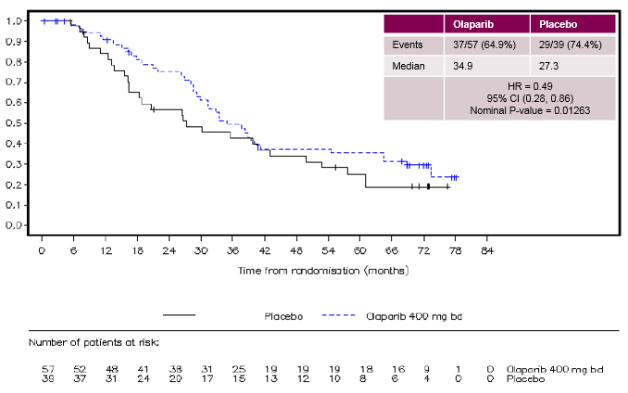
Source: Figure 2, Attachment 1 to the Pre-PBAC/MSAC Response for the March 2016 PBAC/MSAC meeting
bd = twice daily; BRCAm = BRCA1 or BRCA2 mutation; CI = confidence interval; HR = hazard ratio; OS = overall survival; PARPi = polyadenosine 5’ diphosphoribose polymerase inhibitor

Comparative harms

  - The adverse events results remain unchanged from the March 2016 major submission.

Clinical claim

  - The major submission claimed superior comparative effectiveness and a ‘consistent and well characterised safety profile’, which was interpreted as a slightly inferior but acceptable safety profile. The clinical claim remained unchanged from the previous major submission.

  - The PBAC previously considered that the claim of superior comparative effectiveness and inferior comparative safety was reasonable.

Economic analysis

  - Table 2 presents a summary of the base case economic model presented in the March 2016 submission, the amended version presented in the March 2016 Pre-PBAC/MSAC Response, recommendations made by the PBAC in the March 2016 PBAC Public Summary Document, the model presented in the current minor resubmission, and a further price reduction offered in the July 2016 Pre-PBAC Response.

Table 2: Economic model timeline
Base case approach | March-16 |  |  | July-16
 | Major submission | Pre-PBAC/MSAC Response | Recommended by PBAC | Minor  resubmission | Pre-PBAC Response
Time horizon | 10 years | 10 years | 7.5 years | 8.75 years | 7.5 years
Olaparib price (DPMQ) | $''''''''''''' | $''''''''''''''' | To result in ICER of $''''''''''''''''' | $''''''''''''''' | $'''''''''''''''
OS data for BRCAm subgroup | ‘PARPi sites-excluded’ | ‘PARPi sites-excluded’ | For minor: ‘PARPi sites-excluded’  For major: ‘PARPi sites-excluded’, using updated OS analyses from Study 19 (up to 66 m) ª | ‘PARPi sites-excluded’ | ‘PARPi sites-excluded’
OS: from TPs of Study 19; extrapolation method | Log-logistic curve throughout entire model | 1. KM up to 28.5 m 2. Extrapolated with log-logistic > 28.5 m | For minor: log-logistic curve throughout entire model not specified ^{b,c}  For major: justify an appropriate method to extrapolate beyond updated OS analyses (after 66 m) ^{b} | Log-logistic curve throughout entire model | Log-logistic curve throughout entire model
ICER ^{d} | $'''''''''''''''' | $'''''''''''''''^{e} | $'''''''''''''''' | $'''''''''''''''''' | $''''''''''''''''
Source: Compiled for the minor overview
DPMQ = dispensed price for maximum quantity; HR = hazard ratio; ICER = incremental cost effectiveness ratio; KM = Kaplan-Meier; PARPi = polyadenosine 5’ diphosphoribose polymerase inhibitor; OS = overall survival; PBAC = Pharmaceutical Benefits Advisory Committee; TP = transition probability; m = months
ª [Paragraph 7.20, March 2016 minutes]
^{b} [Paragraph 7.20, March 2016 minutes]
^{c} The PBAC noted that when the updated survival analyses (up to 66 months) was compared with the revised model (using KM OS data up to 28.5 months), the model clearly overestimated the observed incremental OS for olaparib over its comparator [Paragraph 7.13, March 2016 Minutes]
^{d} per QALY gained
^{e} Could not be verified

The redacted table shows ICERs in the range of $45,000/QALY - $75,000/QALY.

Comparison of survival within the BRCAm ‘PARPi sites-excluded’ subgroup; model versus updated survival analyses

  - The economic model in the minor resubmission used overall survival data from the post-hoc BRCAm PARPi sites-excluded’ subgroup. A comparison of model scenarios was presented using data from this subgroup for (Figure 2):
- the modelled survival analyses, using the log-logistic extrapolation throughout the ten-year time horizon of the base case model (as was used in the original major submission and the minor resubmission); and
- the updated survival analyses, using Kaplan-Meier curves up to the median follow-up of 66 months (data-cut off: September 2015) (as provided in the Attachment to the Pre-PBAC/MSAC Response).

  - As the sponsor did not provide the economic model in the Pre-PBAC/MSAC Response, data for the BRCAm PARPi-sites-excluded subgroup, using trial data up to 28 months and then log-logistic extrapolation, was not included in Figure 2.

Figure 2: Comparison of KM curves for BRCAm PARPi sites-excluded subgroup; modelled analysis (BRCAm component of model) versus updated OS analyses (median follow-up 66 months)
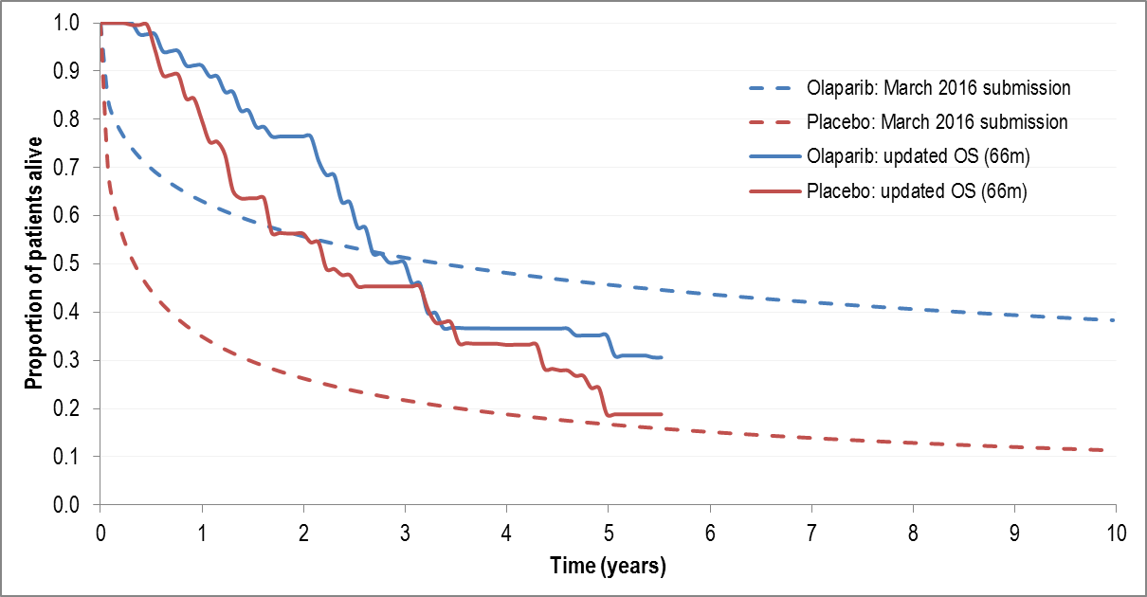
Source: Pre-PBAC/MSAC Response (from PSCR), March 2016; Excel spreadsheet; and compiled during evaluation using Plotdigitizer (updated 66-month analysis)
BRCAm = BRCA1 or BRCA2 mutation; KM = Kaplan-Meier; PARPi = polyadenosine 5’ diphosphoribose polymerase inhibitor; PSCR = Pre-Sub-Committee Response; OS = overall survival
Note: The results presented are for the BRCAm ‘PARPi sites-excluded’ subgroup only (which was used to estimate overall survival in the model).

  - Similar to the economic model presented in the previous submission, the observed results from Study 19 did not align with the updated overall survival results for the BRCAm subgroup in the minor resubmission.

  - The Pre-PBAC Response maintained that the economic model as presented in the March 2016 submission was appropriate.

Comparison of the respecified base case; minor resubmission versus PBAC recommendation (population: all BRCAm subgroups; BRCAwt)

  - The minor resubmission did not alter the economic model structure presented in the March 2016 submission; however, it did respecify the best estimate of the base case incremental cost-effectiveness ratio (ICER) by (i) using a truncated time horizon of 8.75 years (rather than 10 years); and (ii) applying a ''''''% price reduction to olaparib (dispensed price for maximum quantity (DPMQ) = $''''''''''''' per pack). This resulted in a base case ICER of $45,000/QALY gained - $75,000/QALY gained (Table 3). The respecified base case ICER was verified.

Table 3: Summary of modelled analyses as provided by resubmission
─ | DPMQ olaparib | Major submission  March 2016 | March 2016 PBAC recommendation | Minor resubmission  July 2016
Time horizon, years | ─ | 10.0 | 7.5 | 8.75
ICER (no rebate) | $''''''''''''' | $'''''''''''''''''' | $''''''''''''''''' | $'''''''''''''''
ICER (''''''% rebate) | $'''''''''''''' | $'''''''''''''''' | $''''''''''''''''' | $'''''''''''''
Source: p4 of the minor re-submission, and compiled during evaluation
DPMQ = Dispensed Price for Maximum Quantity; ICER = incremental cost-effectiveness ratio; PBAC = Pharmaceutical Benefits Advisory Committee; sub = submission; bold = presented in the minor re-submission as the base case

The redacted table shows ICERs in the range of $45,000/QALY - $75,000/QALY.

  - Based on the changes to the economic evaluation recommended by the PBAC in March 2016 for a minor resubmission (a truncated time horizon of 7.5 years and an ICER of $45,000/QALY gained - $75,000/QALY gained), a price reduction of '''''''% for olaparib (DPMQ of $''''''''''''' per pack) would be needed (see Table 4). For comparison with the trial-based economic evaluation (see below), a truncated time horizon of 5.5 years (66 months median follow-up) was also included. A price reduction of '''''''% (DPMQ of $''''''''''''' per pack) would be needed to achieve an ICER of $45,000/QALY gained - $75,000/QALY gained. The Pre-PBAC Response presented a truncated time horizon and an ICER of $45,000/QALY gained - $75,000/QALY gained to calculate a price reduction of 22.4%.

Table 4: Summary of effective prices needed to achieve an ICER of $45,000/QALY - $75,000/QALY
 | Time horizon | ICER | Olaparib price (DPMQ) | Price compared to  March 2016 submission
Major March 2016 | 10 years | $'''''''''''''''''' | $'''''''''''''' | Proposed price
Minor resubmission | 8.75 years | $''''''''''''''' | $'''''''''''' | '''''''%
Pre-PBAC Response | 7.5 years | $''''''''''''''''' | $'''''''''''''' | '''''''''''%
PBAC recommendation | 7.5 years | $'''''''''''''''' | $''''''''''' | '''''''''%
Truncated to 66 months | 5.5 years | $'''''''''''''''' | $''''''''''' | ''''''''%
Source: compiled during evaluation
DPMQ = Dispensed Price for Maximum Quantity; ICER = incremental cost-effectiveness ratio; PBAC = Pharmaceutical Benefits Advisory Committee; sub = submission; QALY = quality-adjusted life year; bold = price derived from back-calculation of revised base model with shorter time horizons

The redacted table shows ICERs in the range of $45,000/QALY - $75,000/QALY.

Trial-based economic evaluation

  - A trial-based economic evaluation was conducted for the minor overview using the updated overall survival estimates and a median follow-up of 66 months. The following assumptions and applications were required for this within trial analysis:
- a time horizon of 66 months (72 cycles of four weeks, 5.5 years);
- an effective DPMQ of $'''''''''''''''''''' (as proposed in the minor resubmission);
- for the BRCAm ‘PARPi sites-excluded’ subgroup, the Kaplan-Meier curves from the updated survival analyses from Study 19 (data cut: 30 September 2015; median duration of follow-up beyond 66 months) were digitised and applied to the within trial-based model;
- for the BRCAwt/unknown subgroup, the Kaplan-Meier curves from the original data cut (26 November 2012; median follow-up 37.3 months) were digitised and applied to the within trial-based model; last observation carried forward was required beyond the limit of the Kaplan-Meier curves. This approach was necessary as the data for the BRCAwt/unknown subgroup at the 30 September 2015 data cut (median follow-up beyond 66 months) were not provided;
- the probability of dying in the olaparib arm was the same for those with pre-progression disease and those with progressed disease (this might have resulted in bias against olaparib, but it was unlikely to have had a large impact);
- the mean duration of treatment of olaparib, 16.3 months, remained unchanged (calculated from Study 19) (this resulted in a larger bias in favour of olaparib);
- the approach to estimate utility values remained unchanged;
- background (non-cancer) mortality was excluded (similar to the modelled economic analysis provided in the minor resubmission);
- the Kaplan-Meier curves for progression free survival were unchanged; and
- the overall survival curves were not extrapolated beyond 66 months, due to the inherent uncertainty with the extrapolation methods (this resulted in a bias against olaparib).

  - The results of this trial-based economic evaluation using the updated Kaplan-Meier curves up to 66 months were compared with the results of the minor resubmission’s model using a truncated time horizon of 66 months, using the minor resubmission’s proposed price for olaparib ($''''''''''''''''''''''). Additionally, the price for olaparib was estimated for the trial-based economic evaluation that would maintain an ICER of $45,000/QALY - $75,000/QALY (see Table 5).

Table 5: Sensitivity analyses performed during evaluation, using a 66-month time horizon (within trial)
 | Δ cost | Δ QALY | ICER | DPMQ needed to achieve an ICER of $45,000/QALY - $75,000/QALY
DPMQ = $''''''''''''''''' (effective price in minor re-submission)
Trial-based evaluation using updated KM curves for 66 months | $'''''''''''''''' | 0.220 | $''''''''''''''''' | $''''''''''''
Source: compiled during evaluation
DPMQ = dispensed price for maximum quantity; KM = Kaplan-Meier; ICER = incremental cost-effectiveness ratio; QALY = quality-adjusted life year; Δ = incremental

The redacted table shows an ICER more than $200,000.

  - Using the updated overall survival of Study 19 to perform a trial-based economic evaluation resulted in a higher ICER than using the log-logistic extrapolation methodology, as used in the minor resubmission. For the trial-based economic evaluation, the DPMQ of olaparib would need to be $''''''''''''' (a ''''''% price reduction from that requested in the major submission to the March 2016 PBAC meeting) to maintain an ICER of $45,000/QALY gained - $75,000/QALY gained. The Pre-PBAC Response considered that there were significant limitations to the trial-based economic evaluation that made it unreliable for decision making.

Comparison of proposed model scenarios (population: all BRCAm subgroups; BRCAwt)

  - The current minor resubmission presented a revised cost-effectiveness analysis which compared ‘BRCA testing’, which included women with BRCAm (53.5%) treated with olaparib and women with BRCAwt/unknown (46.5%) treated with placebo, versus ‘No BRCA testing’, where all patients were treated with placebo, irrespective of BRCA status. Therefore, a comparison was made within the full population between three different approaches (Figure 3):
- March 2016 submission model: the modelled survival analyses, using the log-logistic extrapolation throughout the entire 10-year time horizon of the economic model (as was used in the original major submission and minor resubmission);
- Pre-PBAC/MSAC Response: the revised modelled survival analyses used the Kaplan-Meier curves up to 28.5 months (31 cycles). This was not the median follow-up of the first data-cut (26 November 2012; median follow-up 37.3 months). After 28.5 months, a log-logistic extrapolation was applied (this revised analysis could not be independently verified for this Minor Overview); and
- 66-month trial-based evaluation: the trial-based economic evaluation, using data up to the median follow-up of the updated survival analyses (Data cut: 30 September 2015, median follow-up beyond 66 months) and performed in the evaluation of the minor resubmission.

Figure 3: Comparison of model scenarios for full population (BRCAm, BRCAwt/unknown) – PARPi-sites-excluded subgroups
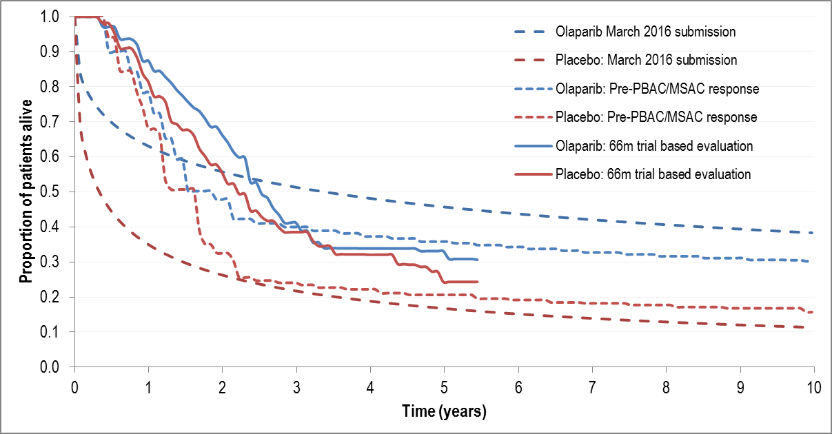
Source: Digitised from Figure 4, p4 of the Pre-PBAC/MSAC Response, March 2016; Excel spreadsheet; and compiled during evaluation using Plotdigitizer (updated 66-month analysis)
BRCAm = BRCA1 or BRCA2 mutation; BRCAw = BRCA wildtype; MSAC = Medical Services Advisory Committee; PARPi = polyadenosine 5’ diphosphoribose polymerase inhibitor; PBAC = Pharmaceutical Benefits Advisory Committee; m = months
Note: The modelled analysis included a comparison of ‘BRCA testing’, which included women with BRCAm (53.5%) treated with olaparib and women with BRCAwt/unknown (46.5%) treated with placebo, versus ‘no BRCA testing’, which included all women treated with placebo, irrespective of BRCA status.

  - The Pre-PBAC Response argued that, as a result of the digitisation approach used to create Figure 3, it incorrectly suggests that olaparib and placebo overall survival curves in the previous Pre-PBAC/MSAC Response converged around the 20-month time period.

Drug cost/patient/course: $''''''''''''''

  - The drug cost per patient was updated from the previous major submission to $'''''''''''''''''' per patient per course (reduced from $'''''''''''''''''''''). The drug cost per patient per course was based on the mean duration of treatment among BRCAm patients in Study 19 of 16.3 months ('''''''''''' scripts, with one script providing medication for 28 days), their corresponding dose intensity of '''''''''''%, and a revised effective DPMQ of $''''''''''''''''''' ('''''% price reduction).

Estimated PBS usage & financial implications

  - The minor resubmission updated the financial estimates to align with the suggested PBAC modification to the proposed PBS listing for olaparib. This further restricted access to olaparib for women with germline BRCA mutations (class 4 or 5 only). For the revised financial estimates, the resubmission used the prevalence of germline mutations observed in Study 19 (45.7%) rather than the prevalence of BRCA mutations (53.5%) (using both germline and tumour testing methods) as provided in the Pre-Sub-Committee Response. These revisions in the Pre-Sub-Committee Response addressed the inadvertent exclusion of patients with fallopian tube or primary peritoneal cancers (16% of Study 19 patients) from the financial estimates. The minor resubmission presented the financial estimates (i) including the ''''''% rebate on the DPMQ for olaparib ($'''''''''''''''); and (ii) without the DPMQ rebate ($'''''''''''''') (Table 6). This was updated in the Pre-PBAC Response to include the ''''''''''% price reduction from the previous submission.

Table 6: Updated financial estimates and estimated use
 | Year 1 |  | Year 2 | Year 3 | Year 4 | Year 5
ESTIMATED USE
Estimated extent of use BRCA test
Number of BRCA tests (90% uptake) | ''''''''''''' |  | '''''''''''''' | '''''''''' | '''''''' | ''''''''''
Estimated extent of use, olaparib
Eligible population ^{a,b} | ''''''''' |  | ''''''''' | '''''''''' | ''''''''' | '''''''''
Uptake of olaparib | '''''''% |  | ''''''% | ''''''% | '''''% | '''''''%
Number treated ^{b} | ''''''''' |  | ''''''''' | '''''''' | '''''''''' | ''''''''''
Script (1 per pack) ^{c} | '''''''''''' |  | '''''''''''' | ''''''''''''''' | ''''''''''''' | ''''''''''''
ESTIMATED COST
(1) Costs: PBS listing for patients with germline BRCA mutations, with '''''''''% rebate on the DPMQ
NET cost to PBS | $'''''''''''''''''''''''''' | $''''''''''''''''''''''''''' |  | $''''''''''''''''''''''''' | $''''''''''''''''''''''''''' | $'''''''''''''''''''''''''
NET cost to MBS | $'''''''''''''''''''''' | $''''''''''''''''''''''''' |  | $'''''''''''''''''''' | $''''''''''''''''''' | $'''''''''''''''''
NET cost to Government | $'''''''''''''''''''''' | $''''''''''''''''''''' |  | $''''''''''''''''''' | $'''''''''''''''''''''' | $''''''''''''''''''''''
(2) Costs: PBS listing for patients with germline BRCAm (class 4 or 5), with ''''% rebate on the DPMQ
NET cost to PBS | $'''''''''''''''''''''''''''' |  | $'''''''''''''''''''''''''''' | $'''''''''''''''''''''''''' | $'''''''''''''''''''''''' | $'''''''''''''''''''''''''''''
NET cost to MBS | $'''''''''''''''''''''' |  | $'''''''''''''''''''''''''' | $'''''''''''''''''''''' | $''''''''''''''''''' | $'''''''''''''''''
NET cost to Government | $''''''''''''''''''''''' |  | $''''''''''''''''''' | $'''''''''''''''''''''''' | $'''''''''''''''''''''' | $''''''''''''''''''''
(3) PBS listing for patients with germline BRCAm (class 4 or 5), and no rebate on the DPMQ
NET cost to PBS | $''''''''''''''''''''''''''' |  | $ '''''''''''''''''''''''''' | $'''''''''''''''''''''''''' | $''''''''''''''''''''''''' | $'''''''''''''''''''''''''''''
NET cost to MBS | $'''''''''''''''''''''' |  | $''''''''''''''''''''' | $''''''''''''''''' | $'''''''''''''''''''' | $''''''''''''''''''''
NET cost to Government | $''''''''''''''''''''''' |  | $''''''''''''''''''''' | $''''''''''''''''''' | $'''''''''''''''''''' | $'''''''''''''''''''''
Source: Table 1, p5 of the minor resubmission, extracted from Excel spreadsheet, and Table 2, p3 of the Pre-PBAC Response
AIHW = Australian Institute of Health and Welfare; BRCAm = BRCA1 or BRCA2 mutation; DPMQ = Dispensed Price for Maximum Quantity; MBS = Medicare Benefits Schedule; PBS = Pharmaceutical Benefits Schedule; PSCR = pre-Sub-Committee Response PSR = platinum-sensitive relapsed; Yr = year
ª BRCAm PSR ovarian, fallopian tube or primary peritoneal cancer, using germline testing
^{b} The previous Pre-Sub-Committee Response provided revised estimates of patients treated with olaparib (increased the AIHW incidence numbers by 16% to thereby include women with fallopian tube or primary peritoneal cancer (from Study 19)).
^{c} ''''''' packs/patient (one script per pack), which was based on average number of scripts/year for olaparib, assuming equal monthly proportions.

The redacted table shows that at year 5, the estimated number of patients was less than 10,000 per year and the net cost to the PBS would be $10 - $20 million per year.

  - The financial estimates from the previous major submission, were revised during the Pre-Sub-Committee Response to include patients with fallopian tube or primary peritoneal cancer. The minor resubmission estimated that if BRCA testing and olaparib were both listed, and the ''''''% price rebate on olaparib was included:
- the net cost to the PBS would be $60 - $100 million over the first five years; and
- the net cost to the Government would be $60 - $100 million over the first five years.

  - The minor resubmission estimated that without the ''''''% price rebate on olaparib:
- the net cost to the PBS would be more than $100 million over the first five years; and
- the net cost to the Government would be more than $100 milion over the first five years.

  - With a ''''''''''% price rebate on olaparib, the estimates would be:
- the net cost to the PBS would be $60 - $100 million over the first five years; and
- the net cost to the Government would be $60 - $100 million over the first five years.

  - The revised financial estimates presented in the minor resubmission did not attempt to estimate the impact of including ‘grandfathered patients.’

Financial Management – Risk Sharing Arrangements

  - To address the uncertainty surrounding the expected duration of use of olaparib the PBAC recommended “a 100% rebate beyond an olaparib treatment duration cap of two years” [Paragraph 7.19, March 2016 PBAC Public Summary Document]. In response, the minor resubmission proposed an alternative risk-sharing arrangement, which applied a tiered percentage rebate on any PBS expenditure above agreed thresholds.

  - The minor resubmission stated that the sponsor would be willing to work with the Department of Health to finalise this matter.

For more detail on PBAC’s view, see section 7 “PBAC outcome”.

PBAC Outcome

  - The PBAC did not recommended the listing of olaparib for the treatment of high grade serous ovarian, fallopian tube or primary peritoneal cancer on the basis that the magnitude of the overall survival benefit was significantly overestimated in the model presented and, as such, the incremental cost effectiveness ratio (ICER) was substantially underestimated and would be unacceptably high when corrected.

  - The PBAC considered that the updated overall survival analysis in the post hoc BRCAm ‘PARPi sites excluded’ subgroup of Study 19 did not show a survival benefit to the extent generated by the log-logistic curve throughout entire model (see Figure 2), therefore considered that the evidence provided showed that the incremental health outcomes (driven by the incremental gain in overall survival) were insufficient to justify the incremental cost of treatment. The further price reduction offered in the Pre-PBAC Response was not sufficient to overcome this significant issue.

  - The PBAC also reaffirmed its previous recommendation that a 10-year time horizon was inappropriate and prolonged the already overestimated incremental overall survival excessively beyond the observed results. A shorter time horizon would be more appropriate, and should not be justified with reference to disease type alone, but should also reflect the mechanism of action of the drug, the line of treatment proposed, the extent to which the incremental effect size is generated by modelling assumptions compared that estimated directly from the trial evidence, and thus both the internal and external validity of the model.

  - Given that olaparib is proposed for use as maintenance therapy, the PBAC also suggested that further consideration should be given to the context in which the ICER/QALY for olaparib compares against the ICER/QALY for other maintenance therapies considered by the PBAC (for example letrozole in metastatic breast cancer).

  - The PBAC considered that a major resubmission with a new economic model that accurately reflects trial data and addresses issues of internal and external validity would be required to address its concerns and further diminish uncertainties associated with the current model. The PBAC advised that a resubmission based on even more mature data would also be informative. In order for olaparib to be considered cost effective, the ICER should also be placed in the context established by other maintenance treatments considered previously by the PBAC.

  - The PBAC noted that this submission is eligible for an Independent Review.

Outcome:
Rejected

Context for Decision

The PBAC helps decide whether and, if so, how medicines should be subsidised in Australia. It considers submissions in this context. A PBAC decision not to recommend listing or not to recommend changing a listing does not represent a final PBAC view about the merits of the medicine. A company can resubmit to the PBAC or seek independent review of the PBAC decision.

Sponsor’s Comment

The sponsor had no comment.

