4.04 RITUXIMAB
Solution for subcutaneous injection containing rituximab 1400 mg in 11.7 mL,
Solution for I.V. infusion 100 mg in 10 mL,
Solution for I.V. infusion 500 mg in 50 mL,
Mabthera® SC, Mabthera®, Roche Products Pty Ltd

- Purpose of Application

  - The minor submission responded to the PBAC’s recommendation at its July 2016 meeting, to extend “the current PBS availability of rituximab, to include the treatment of all CD20 positive lymphoid cancers in combination with chemotherapy.” The PBAC recommended a consolidated listing of rituximab in CD20 positive lymphomas in combination with chemotherapy.” The minor submission proposed a consolidated rituximab restriction that includes the use of rituximab monotherapy in addition to rituximab in combination with chemotherapy, and a risk sharing agreement (RSA) for “CD20 positive lymphoma”.

- Requested listing

  - The submission requested the following consolidated restrictions for the existing listings. The submission did not propose a price for rituximab for the consolidated listing; the current approved ex-manufacturer prices (AEMP) (June 2017) have been provided in italics:

Name, Restriction,  Manner of administration and form |  | Max.  Amount | №.of  Rpts | Approved ex-man price | Proprietary Name and Manufacturer
MABTHERA  100 mg/10 mL injection, 2 x 10 mL vials  500 mg/50 mL injection, 50 mL vial  MABTHERA SC  1.4 g/11.7mL injection, 11.7 mL vial |  | 800 mg  1400 mg | 7  6 | $745.70  $1864.22  $2703.78 | Mabthera  Mabthera SC | Roche  Products Pty  Ltd
Category /  Program | GENERAL – General Schedule (Code GE): IV and SC  Section 100 (CT): SC
Prescriber type: | Dental Medical Practitioners Nurse practitioners Optometrists Midwives
Episodicity: | Previously untreated
Condition: | CD20 positive lymphoma
PBS Indication: | CD20 positive lymphoma in combination with chemotherapy
Treatment phase: | Induction
Restriction Level / Method: | Restricted benefit  Authority Required - In Writing  Authority Required - Telephone  Authority Required – Emergency  Authority Required - Electronic  Streamlined
Clinical criteria: | The treatment must be in combination with PBS-subsidised chemotherapy,  AND  The condition must be previously untreated,  AND  The treatment must be for induction treatment purposes only,  AND  Patient must not receive more than the number of cycles of treatment recommended by standard guidelines for the partner chemotherapy under this restriction.  An initial dose of rituximab must be administered with rituximab intravenous injection. Subsequent doses may be administered with either intravenous or subcutaneous rituximab with no more than 8 doses in total.
Note | A patient may only qualify for PBS-subsidised treatment under this restriction once in a lifetime.

Name, Restriction,  Manner of administration and form |  | Max.  Amount | №.of  Rpts | Approved ex-man price | Proprietary Name and Manufacturer
MABTHERA  100 mg/10 mL injection, 2 x 10 mL vials  500 mg/50 mL injection, 50 mL vial  MABTHERA SC  1.4 g/11.7mL injection, 11.7 mL vial |  | 800 mg  1400 mg | 11  11 | $745.70  $1864.22  $2703.78 | Mabthera  Mabthera SC | Roche  Products Pty  Ltd
Category /  Program | GENERAL – General Schedule (Code GE): IV and SC  Section 100 (CT): SC
Prescriber type: | Dental Medical Practitioners Nurse practitioners Optometrists Midwives
Episodicity: | Previously untreated
Condition: | CD20 positive lymphoma
PBS Indication: | CD20 positive lymphoma
Treatment phase: | Maintenance
Restriction Level / Method: | Restricted benefit  Authority Required - In Writing  Authority Required - Telephone  Authority Required – Emergency  Authority Required - Electronic  Streamlined
Clinical criteria: | The treatment must be maintenance therapy,  AND  Patient must have demonstrated a partial or complete response to induction treatment received immediately prior to this current Authority application,  AND  Patient must not receive more than 12 doses or 2 years duration of treatment, whichever comes first, under this restriction.

Name, Restriction,  Manner of administration and form |  | Max.  Amount | №.of  Rpts | Approved ex-man price | Proprietary Name and Manufacturer
MABTHERA  100 mg/10 mL injection, 2 x 10 mL vials  500 mg/50 mL injection, 50 mL vial  MABTHERA SC  1.4 g/11.7mL injection, 11.7 mL vial |  | 800 mg  1400 mg | 5  4 | $745.70  $1864.22  $2703.78 | Mabthera  Mabthera SC | Roche  Products Pty  Ltd
Category /  Program | GENERAL – General Schedule (Code GE): IV and SC  Section 100 (CT): SC
Prescriber type: | Dental Medical Practitioners Nurse practitioners Optometrists Midwives
Episodicity: | Relapsed or refractory
Condition: | CD20 positive lymphoma
PBS Indication: | CD20 positive lymphoma
Treatment phase: | Re-induction
Restriction Level / Method: | Restricted benefit  Authority Required - In Writing  Authority Required - Telephone  Authority Required – Emergency  Authority Required - Electronic  Streamlined
Clinical criteria: | The treatment must be for re-induction treatment purposes only,  AND  The condition must have relapsed or be refractory to treatment,  AND  Patient must not receive more than the number of cycles of treatment recommended by standard guidelines under this restriction.  An initial dose of rituximab must be administered with rituximab intravenous injection. Subsequent doses may be administered with either intravenous or subcutaneous rituximab with no more than 6 doses in total.

Name, Restriction,  Manner of administration and form |  | Max.  Amount | №.of  Rpts | Approved ex-man price | Proprietary Name and Manufacturer
MABTHERA  100 mg/10 mL injection, 2 x 10 mL vials  500 mg/50 mL injection, 50 mL vial  MABTHERA SC  1.4 g/11.7mL injection, 11.7 mL vial |  | 800 mg  1400 mg | 7  7 | $745.70  $1864.22  $2703.78 | Mabthera  Mabthera SC | Roche  Products Pty  Ltd
Category /  Program | GENERAL – General Schedule (Code GE): IV and SC  Section 100 (CT): SC
Prescriber type: | Dental Medical Practitioners Nurse practitioners Optometrists Midwives
Episodicity: | Relapsed or refractory
Condition: | CD20 positive lymphoma
PBS Indication: | CD20 positive lymphoma
Treatment phase: | Maintenance
Restriction Level / Method: | Restricted benefit  Authority Required - In Writing  Authority Required - Telephone  Authority Required – Emergency  Authority Required - Electronic  Streamlined
Clinical criteria: | The treatment must be maintenance therapy,  AND  Patient must have demonstrated a partial or complete response to re-induction treatment received immediately prior to this current Authority application,  AND  Patient must not receive more than 8 doses or 2 years duration of treatment, whichever comes first, under this restriction.

  - The submission argued that a consolidated listing of rituximab in CD20 positive lymphomas in combination with chemotherapy would preclude the PBS subsidised use of rituximab monotherapy. The submission requested that any amendment to the rituximab restrictions to include the treatment of all CD20 positive lymphoid cancers for use as monotherapy, or in combination with chemotherapy (dependent upon the clinical criteria). The PBAC agreed that the intent of any new listing was not to preclude use of rituximab monotherapy where it is currently indicated. Outside maintenance use in follicular lymphoma, rituximab use as monotherapy is falling. The PBAC considered this to be expected and appropriate as there is little evidence for use of monotherapy in relapsed/refractory low grade lymphoma after earlier treatment with rituximab-chemotherapy combinations, although it may be appropriate in some patients. The PBAC recommended that the current PBS listings for rituximab as monotherapy for induction treatment of relapsed indolent CD20 positive lymphoma remain unchanged.

  - The PBAC noted that although it recommended a consolidated listing of rituximab in all CD20 positive lymphoid cancers, the submission excluded chronic lymphocytic leukaemia (CLL). The PBAC noted that neither the submission nor pre-PBAC response explained the reason for this exclusion. The PBAC recommended that CLL be included in the consolidated listing of rituximab as induction therapy in combination with chemotherapy. The PBAC also recommended that based on evidence from its 2016 systematic review of rituximab use, B-cell acute lymphoblastic leukaemia (B-ALL) be included in this consolidated listing of rituximab.

  - The PBAC noted that the minor submission greatly broadened the condition and PBS indication in the requested PBS restriction to “CD20 positive lymphoma” for maintenance treatment. The PBAC has previously considered that this is not appropriate, and no data to support this change were provided. The PBAC recommended that the current PBS listings of rituximab for maintenance therapy for Stage III or IV CD20 positive follicular B-Cell non-Hodgkin’s lymphoma remain unchanged.

For more detail on PBAC’s view, see section 5 “PBAC outcome.”

- Background

  - At its July 2016 meeting, the PBAC recommended a consolidated listing of rituximab in CD20 positive lymphoid cancers in combination with chemotherapy. The PBAC advised that no adjustments be made to existing caps on rituximab use, but that a risk share arrangement should be discussed with the sponsor. Rituximab currently has a weighted price across all its PBS indications; no special pricing arrangements exist ''''''' '''''''' ''''''' ''''''''''''''''''' ''''' '''''' '''''' ''''' '''''''' ''''''''' ''''' '''''''''''''''''''''''' ''''''. The PBAC noted that rituximab has a weighted price across its current PBS indications and recommended that the ''''''''''''''''' price should include all listings for lymphoid cancers. The PBAC considered that '''''' '''''''' ''''''' '''''' '''''' '''''''' ''''''''''''''' '''' '''''' ''''''''''''''''' given the PBS availability of obinutuzumab for CLL, and therefore any risks intended to be mitigated through use of the RSA cap should instead be reflected in ''' '''''''' '''''''''''''' ''''''''''''''''''' '''''''''' for rituximab.

  - The AEMPs per mg for rituximab across different indications within CD20 positive lymphomas are presented below. The AEMPs incorporate:
- the ''''''% price reduction on 1 December 2014 for:
  - follicular B-cell non-Hodgkin’s lymphoma (FNHL) ''''''''''''''''''''' ''''''''''''''''''' '''' '''''''''''''''''''''' ''''''''' '''''''''''''''''''''''''''''' ''''''''''''''''''''''''' '''''''' '''''''''''''''''''''''''''''''''' ''''''''''' ''''''''''''''''''''''', and
  - chronic lymphocytic leukaemia (CLL) '''''''' '''' ''''''''''''''''''''''''' ''''''''' ''''''''''''''''''''''' '''''''''''''''''''''''''''''''''''' '''''''''.
This reduction was given effect through a '''''''''% reduction ''' '''''' '''''''''''' ''''''''''''''''''' ''''''''''''''''''' ''''''''''.
- the 5% statutory price reduction on 1 April 2016.

Table 1: AEMPs per mg for rituximab across different indications within CD20 positive lymphoid cancers
Proportional use* per indication | AEMP per mg | Proportional use*
FNHL ''''''''''''''''''''''''''' ''''''''''''''''''''' '''' '''''''''''''''''''''''''''' '''''''''' ''''''''''''''''''''''''''''''''''' '''''''''''''''''''''' | $'''''''''' | '''''''''''''%
FNHL '''''''''''''''''''''' '''''''''''''''''''''''' '''' ''''''''''''''''''''''''''''''' '''''''''' ''''''''''''''''''''''''''''''''''' ''''''''''''''''''''''''''''' | $'''''''''' | '''''''''''''''%
DLBCL ''''''''''''''''''''''''' ''''''''''''''''''''''' '''' ''''''''''''''''''''''''''''' '''''''''' '''''''''''''''''''''''''''''''' | $'''''''''' | '''''''''''''%
FNHL RR- ''''''''''''''''''' | $''''''''''' | '''''''''''''''%
FNHL RR- '''''''''''''''''''''''''''''' | $''''''''''' | '''''''''''''%
DLBCL RR | $'''''''''''' | ''''''''''''%
CLL ''''' ''''''''''''''''''''''''''''' ''''''''' '''''''' | $''''''''''' | ''''''''''%
CLL ''''''''''''''''' | $'''''''''' | ''''''''''%
 |  | 100.00%
''''''''''''''''''''' NHL & CLL price (AEMP/mg) | $''''''''''
*Proportional use based on the sponsor’s proposed usage emailed to the Department in December 2014. ''''''''' '''''''''''''' '''' '''''' ''''''''''''''''''' ''''' ''''''''''''' ''''''''' ''''''''''''''
AEMP = approved ex-manufacturer price; CLL = chronic lymphocytic leukaemia; DLBCL = diffuse large B-cell non-Hodgkin’s lymphoma; FC = fludarabine cyclophosphamide; FNHL = follicular B-cell non-Hodgkin’s lymphoma; RR = relapsed or refractory

  - The AEMP per mg is '''''''''''''' '''''' ''''''''' ''''''' ''''''''''''''''''''''''' as this was the first indication listed, and other indications were then listed at a ''% price reduction.

  - The currently listed PBS indications, and associated treatment phases and clinical criteria, for rituximab when used in CD20 positive lymphoid cancers are presented in the table below.

Table 2: Current PBS restrictions across CD20 positive lymphoid cancers
Circumstance codes | Circumstances and Purposes
C5998  C6039 | Relapsed or refractory low-grade B-cell non-Hodgkin's lymphoma  Re-induction treatment  The treatment must be for re-induction treatment purposes only;  AND  The condition must have relapsed or be refractory to treatment;  AND  Patient must not receive more than 4 doses of rituximab in total, including intravenous and subcutaneous injections, and no more than 3 doses of subcutaneous rituximab under this restriction.  An initial dose of rituximab must be administered with rituximab intravenous injection. Subsequent doses may be administered with either intravenous or subcutaneous rituximab with no more than 4 doses in total.
C6008  C6009  C6011  C6034 | Relapsed or refractory Stage III or IV CD20 positive follicular B-cell non-Hodgkin's lymphoma  Maintenance therapy  The treatment must be maintenance therapy;  AND  Patient must have demonstrated a partial or complete response to re-induction treatment received immediately prior to this current Authority application;  AND  Patient must not receive more than 8 cycles or 2 years duration of treatment, whichever comes first, under this restriction.
C6161 | Stage III or IV CD20 positive follicular B-cell non-Hodgkin's lymphoma  Maintenance therapy  Patient must have demonstrated a partial or complete response to induction treatment with either R-CHOP or R-CVP regimens for previously untreated follicular B-cell Non-Hodgkin's lymphoma, received immediately prior to this current Authority application;  AND  Patient must not have received bendamustine induction therapy;  AND  The treatment must be maintenance therapy;  AND  Patient must not receive more than 12 doses or 2 years duration of treatment, whichever comes first, under this restriction.
C6162 | Previously untreated symptomatic indolent CD20 positive non-Hodgkin's lymphoma in combination with chemotherapy  Induction treatment  The treatment must be in combination with PBS-subsidised chemotherapy;  AND  The condition must be previously untreated;  AND  The condition must be symptomatic;  AND  The treatment must be for induction treatment purposes only;  AND  Patient must not receive more than the number of cycles of treatment recommended by standard guidelines for the partner chemotherapy under this restriction.  An initial dose of rituximab must be administered with rituximab intravenous injection. Subsequent doses may be administered with either intravenous or subcutaneous rituximab with no more than 8 doses in total.
C6309  C6317 | Previously untreated aggressive CD20 positive non-Hodgkin's lymphoma  Induction treatment  The treatment must be in combination with PBS-subsidised chemotherapy;  AND  The condition must be previously untreated;  AND  The treatment must be for induction treatment purposes only;  AND  Patient must not receive more than the number of cycles of treatment recommended by standard guidelines for the partner chemotherapy under this restriction.  An initial dose of rituximab must be administered with rituximab intravenous injection. Subsequent doses may be administered with either intravenous or subcutaneous rituximab with no more than 8 doses in total.
C4706 | Chronic lymphocytic leukaemia (CLL)  The condition must be CD20 positive lymphocytic leukaemia (CLL);  AND  The treatment must be in combination with chemotherapy.
Source: compiled from the National Health (Listing of Pharmaceutical Benefits) Instrument 2012 (PB 71 of 2012) Compilation No.54, and the National Health (Efficient Funding of Chemotherapy) Special Arrangement 2011 (PB 79 of 2011) Compilation No.62.

For more detail on PBAC’s view, see section 5 “PBAC outcome.”

- Consideration of the evidence

Sponsor hearing

  - There was no hearing for this item as it was a minor submission.

Consumer comments

  - The PBAC noted and welcomed the letter received from the Haematology Society of Australia and New Zealand (HSANZ) and the Australasian Leukaemia & Lymphoma Group (ALLG), which requested that rituximab be made available on the PBS for all patients with CD20 positive B-cell lymphomas.

  - The HSANZ and ALLG presented evidence for rituximab use in combination with chemotherapy for mantle cell lymphoma (MCL), pre-B-cell acute lymphoblastic leukaemia (B-ALL) and relapsed diffuse large B-cell lymphoma (DLBCL). The HSANZ and ALLG also supported rituximab use in other CD20 positive lymphoproliferative disorders (hairy cell leukaemia, nodular lymphocyte predominant Hodgkin lymphoma, post‐transplant lymphoproliferative disease, immunodeficiency-related lymphoproliferative disorders, relapsed aggressive lymphoma), and stated that for patients with these conditions, access to rituximab in Australia is variable and inconsistent.

Estimated PBS usage & financial implications

  - The submission stated that the Sponsor is prepared to consider a RSA, and proposed an expenditure cap of '''''''''''''''''''''''''''' ''''''''''''''' for rituximab use in CD20 positive lymphoma, based on PBS item statistics reports from 2012 – 2016. The data used for the submission’s proposed cap and the extrapolation beyond 2016 is presented below.

Table 3: Actual and extrapolated rituximab use in CD20 positive lymphoma, based on date of prescription processing (PBS item statistics report)
Variable | Actual |  |  |  |  | Extrapolated
 | 2012 | 2013 | 2014 | 2015 | 2016 | 2017
PBS expenditure | $'''''''''''''''''''''''''''' | $''''''''''''''''''''''''''''' | $''''''''''''''''''''''''''' | $'''''''''''''''''''''''''''' | $'''''''''''''''''''''''''''''''' | $'''''''''''''''''''''''''''''''''
PBS scripts | 29,952 | 38,970 | 39,616 | 40,919 | 38,349 | 43,184
Cost per script | $''''''''''''''''''''' | $'''''''''''''''''''' | $''''''''''''''''''''' | $''''''''''''''''''' | $'''''''''''''''''''' | –
Source: Excel workbook “CD20 rituximab (MABTHERA) expenditure Cap Derivation.xlsx” of the minor submission

  - The PBS item codes included in the reports were 7258B, 7257Y, 4613T, 4614W, 10193L, 10179R, 10742J, 10719E, 10709P, 10703H, 10710Q, 10741H and 10720F. The search for item 10708N did not return any data, as this was a new PBS listing and there were no supplies made during the search period.

  - The PBAC noted that if only the data from 2013 – 2016 were used, the line of best fit showed a slightly declining use of rituximab, and would result in a smaller cap ''''' '''''''''''''''''''''''''' based on a lower forecasted prescription number of 39,324 in 2017. The comparison of the trend line, using and excluding 2012 data is shown below.

Figure 1: Usage trend of rituximab in CD20 positive lymphoma from 2012 – 2016 and 2013 – 2016.
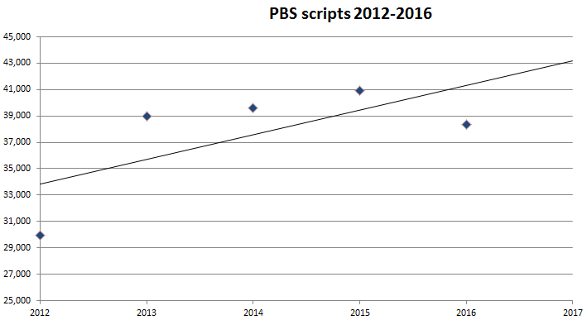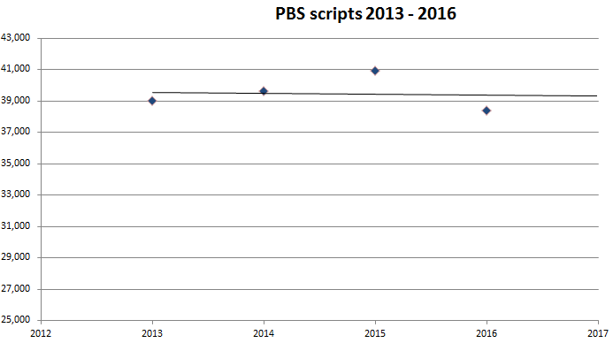
Key:,
Source: derived from the Excel workbook “CD20 rituximab (MABTHERA) expenditure Cap Derivation.xlsx” of the minor submission

  - The PBAC further noted that if data was sourced from the Department of Human Services (DHS) Supplied Prescription Database, which captures data at the time of supply, rather than at the time of Medicare processing (as with PBS item statistics reports used by the submission), the trend for rituximab use was in decline. This resulted in ''' ''''''' ''''' '''''''''''''''''''''''''' based on a forecasted prescription number of 37,221 in 2017. The DHS data for 2012 – 2016 and associated 2017 extrapolation are presented below.

Table 4: Actual and extrapolated rituximab use in CD20 positive lymphoma, based on date of prescription supply (DHS Supplied Prescription Database)
Variable | Actual |  |  |  |  | Extrapolated*
 | 2012 | 2013 | 2014 | 2015 | 2016 | 2017
PBS expenditure | $''''''''''''''''''''''''''''' | $''''''''''''''''''''''''''''''' | $'''''''''''''''''''''''''''''''' | $'''''''''''''''''''''''''''''' | $''''''''''''''''''''''''''''''' | $'''''''''''''''''''''''''''''
PBS scripts | 33,711 | 39,558 | 39,881 | 38,791 | 37,604 | 37,221
Cost per script | $'''''''''''''''''''''' | $''''''''''''''''''''' | $''''''''''''''''''''' | $''''''''''''''''''' | $'''''''''''''''''''' | –
*Extrapolated from 2013 – 2016 data
Source: DHS Supplied Prescriptions Database, sourced 24 May 2017.

Figure 2: Usage trend of rituximab in CD20 positive lymphoma from 2013 – 2016, based on date of prescription supply (DHS Supplied Prescription Database)
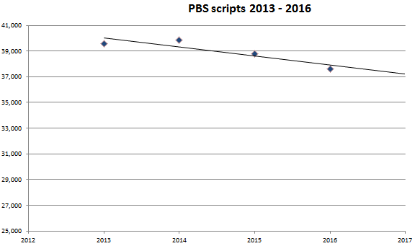
Source: DHS Supplied Prescriptions Database, sourced 24 May 2017.

  - The pre-PBAC response (p1) stated that in the Operative Provisions and Definitions prefacing each of the sponsor’s prior RSAs, the determination of Commonwealth expenditure (for the purposes of caps) are, ‘calculated by reference to the number of processed prescriptions’. The pre-PBAC response argued that the use of an alternate database which is not publicly accessible is inconsistent with precedents as well as the PBS Draft Deed of Agreement Standard Template. The pre-PBAC response further argued that capping at the existing level of use (based on the existing trend line) and using only the 2017 prescription projection to determine the proposed expenditure cap for future years is reasonable and conservative.

  - The PBAC noted that the trend for declining rituximab use would be more pronounced if data from only 2014 onwards were used. The PBAC also noted that the submission’s presentation of rituximab usage trends did not include the PBS item numbers for CLL (4615X and 7259C), and that if these were included, the overall trend for rituximab use was still in decline.

Figure 3: Usage trend of rituximab in CD20 positive lymphoid cancers including CLL from 2013 – 2016, based on date of prescription supply (DHS Supplied Prescription Database)
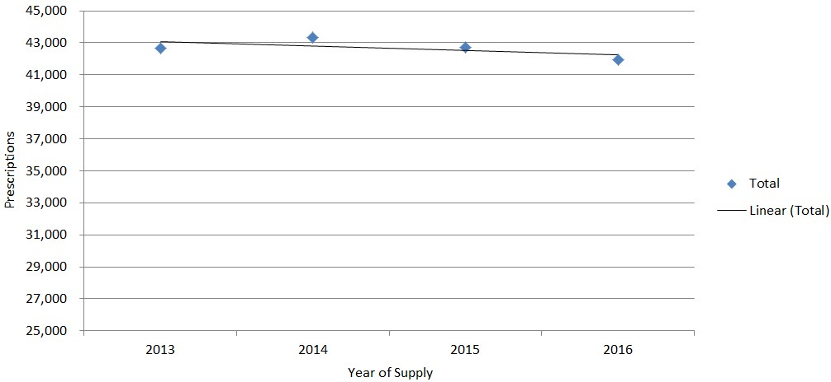
Source: DHS Supplied Prescriptions Database, sourced 10 July 2017.

  - The usage trend for rituximab by indication for CD20 positive lymphoid cancers based on current and historical PBS item and restriction codes is presented below. The indication and treatment phase for the current (June 2017) PBS item and restriction codes are provided in Attachment 1.

Figure 4: Usage trend of rituximab in CD20 positive lymphoid cancers (quarter 2 2012 – quarter 1 2017) by indication.
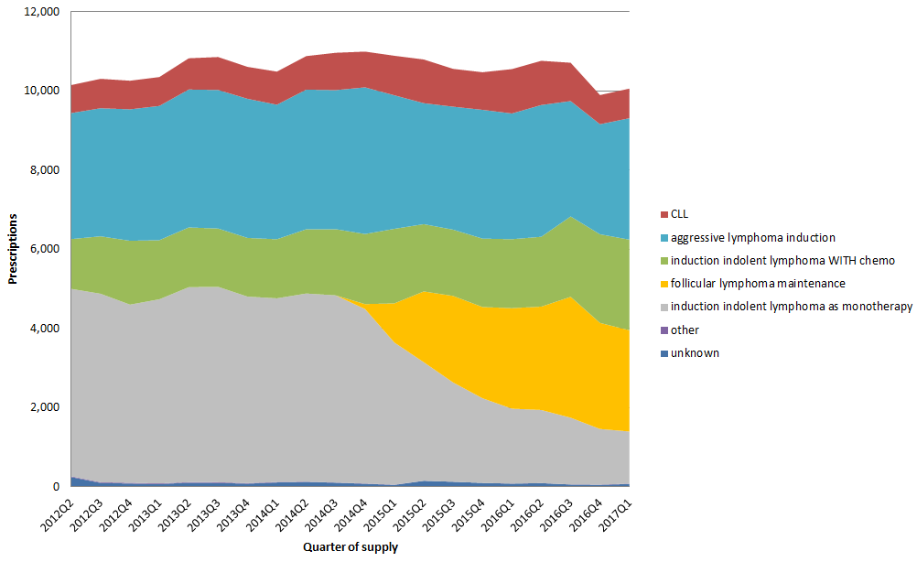
Prescriptions based on date of supply. Indication based on current and historical PBS item codes and restriction codes.
Source: DHS Supplied Prescriptions Database and Authority Prescriptions Database, sourced 3 July 2017.

  - The data in Figure 4 confirms that the overall PBS usage of rituximab for CD20 positive lymphoid cancers is in slight decline from 2014 onwards. It also shows a decline in rituximab usage as monotherapy for induction in indolent lymphomas, subsequent to the listing of the “maintenance” indications in late 2014, following the PBAC initiated review of the efficacy and cost-effectiveness of rituximab for maintenance therapy in lymphoma.

  - The PBAC noted that biosimilars of rituximab may enter the market in the near future. Under usual practice, deeds ''''''''' ''''' ''''''''''''''''''''' '''''' are only applied to drugs in the F1 formulary. Therefore, any deed ''''''''' ''''' '''''''''''''''''''''''' '''''''' for rituximab whilst it is in the F1 formulary may require ''' ''''''''''' ''''' '''''''''''' ''''''' ''''''''' when rituximab moves from the F1 to F2 formulary.

  - An alternative approach to implementing an overall expenditure cap on rituximab for CD20 positive lymphomas may be to negotiate a price reduction with the Sponsor, to reflect the increase in overall market size as a result of a broadening of the PBS restriction.

  - The pre-PBAC response (p2) proposed a '''% reduction in the price of rituximab across all indications to account for any potential increase in the market size, as an alternative to an overall expenditure cap. The pre-PBAC response claimed that a ''% price reduction equates to a PBS cost saving of $''''''''' '''''''''''' on an expenditure forecast of $''''''''''''''''''''''''' for 2017 for ''''' ''''''''''''''''' ''''''' '''''''''''''''''''''' (based on an extrapolation of PBS data from 2012-2016). The PBAC noted that no calculations were provided to support this claim. The pre-PBAC response stated that the price reduction is proposed on the condition that the streamlined CD20+ lymphoma restrictions, as proposed in the submission, are accepted by the PBAC '''''''' ''''''''' ''''''''''' ''' '''''''''''''''''''''' ''' '''''' '''''''' ''''''''''''''''''''''' '''''''' '''''''''''''''''''' ''''''''''''''''''''' '''''' '''' ''''''''''''''''''' '''''''''''''' ''''''''' '''''''''' '''' '''''''''''''''''''.

  - After reviewing the rituximab usage data and considering the sponsor’s offer of a '''% price reduction, the PBAC considered that an overall expenditure cap for rituximab may not be required. The PBAC advised that the most effective means to minimising '''''' '''' '''''''''''''''''' ''''''''''''''' ''''''''''''''''''''' is to seek a price reduction for '''''' '''''''''''''''' '''''''''''''''' '''''''''' '''' rituximab.

  - The PBAC noted that the pre-PBAC response requested that '''''' ''''''''''''''''' '''''''''''' '''''''''''''' ''''' ''''''''''''''' ''''''''''' ''' '''''''''''''''''' '''''''''''''''' ''' '''''''' ''''''''''. The PBAC considered that this was a policy matter for the Department of Health rather than a matter for the Committee’s consideration.

For more detail on PBAC’s view, see section 5 “PBAC outcome.”

- PBAC Outcome

  - The PBAC recommended an extension to the current PBS availability of rituximab as induction therapy in combination with PBS-subsidised chemotherapy for all CD20 positive lymphoid cancers. The PBAC recommended a new, single, consolidated listing for this indication.
  - The PBAC recommended no change to the current PBS listings for rituximab as monotherapy for:
- maintenance treatment of follicular B-cell non-Hodgkin’s lymphoma;
- re-induction treatment of relapsed or refractory low-grade B-cell non-Hodgkin’s lymphoma.
  - The PBAC also recommended a new listing for rituximab as maintenance therapy in combination with PBS-subsidised chemotherapy for CD20 positive acute lymphoblastic leukaemia. Treatment for this condition is prolonged and broken into induction / consolidation and maintenance phases, and therefore is more amenable to having both initial and continuing restrictions.
  - The PBAC recalled its review of the evidence for use of rituximab in combination with chemotherapy for patients not currently covered by PBS listings at its July 2016 meeting. It also recalled prior input from HSANZ, ALLG and consumers on the need to broaden the PBS listings, and noted the recent publication of evidence supporting use in CD20 positive acute lymphoblastic leukaemia.
  - The PBAC noted the sponsor’s request for a broader consolidated listing in CD20 positive lymphoma in maintenance and induction therapy. However, the PBAC considered that the listing could be broader when rituximab was used in combination with chemotherapy, covering all CD20 positive lymphoid cancers. This would simplify the current complex listings and achieve the breadth of access justified by the evidence and requested by multiple stakeholders.
  - The PBAC agreed with the sponsor that a sole restriction requiring use in combination with chemotherapy would preclude use as monotherapy. However, significant changes to the current listings for use as maintenance for follicular lymphoma or as monotherapy as re-induction for relapsed or refractory indolent lymphoma were not intended.
  - The PBAC also considered whether the current ''''''''''''''''' '''''''''' '''''''''''''''' ''''' '''''''''''''''''''' ''''''''''''' '''' ''''''''''''' '''''''''''' would be an alternative approach to reducing risk for the Commonwealth should there be an increase in usage following adoption of the broader listing. However, it recommended acceptance of the sponsor’s proposed '''% price reduction as the most administratively pragmatic solution to maintain cost-effectiveness. In doing so, PBAC recognised that it could not agree to all the sponsor’s conditions attached to the proposal.
  - The PBAC advised that rituximab is not suitable for prescribing by nurse practitioners.
  - The PBAC recommended that the Early Supply Rule should not apply.
  - The PBAC noted that this submission is not eligible for an Independent Review as it received a positive recommendation for PBS listing.

Outcome:
Recommended

- Recommended listing
  - The PBAC recommendation affects the following PBS item (and Streamlined Authority) codes:
- 4613T (6309, 6162)
- 7258B (6309, 6162)
- 10719E (6309, 6162)
- 10708N (6317, 6162)
- 4615X (4706)
- 7259C (4706)

  - Amend existing/recommended listing as follows: the below are draft restrictions to be finalised.
Name, Restriction,  Manner of administration and form |  | Max.  Amount | №.of Rpts |  | Proprietary Name and Manufacturer
MABTHERA  100 mg/10 mL injection, 2 x 10 mL vials  500 mg/50 mL injection, 50 mL vial  MABTHERA SC  1.4 g/11.7mL injection, 11.7 mL vial |  | 800 mg  1400 mg | ''''  '''' |  | Mabthera  Mabthera SC | Roche  Products Pty  Ltd
Category /  Program | GENERAL – General Schedule (Code GE): IV and SC  Section 100 (CT): SC
Prescriber type: | Dental Medical Practitioners Nurse practitioners Optometrists Midwives
Episodicity: | Previously untreated or relapsed/refractory
Condition: | CD20 positive lymphoid cancer
PBS Indication: | CD20 positive lymphoid cancer
Treatment phase: | Initial
Restriction Level / Method: | Restricted benefit  Authority Required - In Writing  Authority Required - Telephone  Authority Required – Emergency  Authority Required - Electronic  Streamlined
Clinical criteria: | The treatment must be in combination with chemotherapy;  AND  The treatment must be for induction or re-induction treatment purposes only;  AND  Patient must not receive more than the number of cycles of treatment recommended by standard guidelines for the partner chemotherapy under this restriction.
Prescriber instructions: | An initial dose of rituximab must be administered with rituximab intravenous injection. Subsequent doses may be administered with either intravenous or subcutaneous rituximab with no more than 6 doses in total for chronic lymphocyctic leukaemia, 8 doses in total for lymphoma, and 12 doses in total for acute lymphoblastic leukaemia.

Name, Restriction,  Manner of administration and form |  | Max.  Amount | №.of Rpts |  | Proprietary Name and Manufacturer
MABTHERA  100 mg/10 mL injection, 2 x 10 mL vials  500 mg/50 mL injection, 50 mL vial  MABTHERA SC  1.4 g/11.7mL injection, 11.7 mL vial |  | 800 mg  1400 mg | 5  5 |  | Mabthera  Mabthera SC | Roche  Products Pty  Ltd
Category /  Program | GENERAL – General Schedule (Code GE): IV and SC  Section 100 (CT): SC
Prescriber type: | Dental Medical Practitioners Nurse practitioners Optometrists Midwives
Episodicity: | Previously untreated or relapsed/refractory
Condition: | CD20 positive acute lymphoblastic leukaemia
PBS Indication: | CD20 positive acute lymphoblastic leukaemia
Treatment phase: | Continuing
Restriction Level / Method: | Restricted benefit  Authority Required - In Writing  Authority Required - Telephone  Authority Required – Emergency  Authority Required - Electronic  Streamlined
Clinical criteria: | The treatment must be in combination with chemotherapy;  AND  The treatment must be maintenance therapy;  AND  Patient must be in complete remission;  AND  Patient must not receive more than 6 doses in total under this restriction.
Attachment 1: Current PBS item codes included in the analysis of rituximab usage

Table 5: Current PBS item codes and streamlined authority codes as at June 2017
Program | PBS item code | Streamlined authority code | Indication (phase)
Public hospitals | 4613T | 6309 | Previously untreated aggressive CD20 positive non-Hodgkin's lymphoma (Induction treatment)
 |  | 6162 | Previously untreated symptomatic indolent CD20 positive non-Hodgkin's lymphoma in combination with chemotherapy (Induction treatment)
 |  | 6009 | Relapsed or refractory Stage III or IV CD20 positive follicular B-cell non-Hodgkin's lymphoma (Maintenance therapy)
Private hospitals | 7258B | 6309 | Previously untreated aggressive CD20 positive non-Hodgkin's lymphoma (Induction treatment)
 |  | 6162 | Previously untreated symptomatic indolent CD20 positive non-Hodgkin's lymphoma in combination with chemotherapy (Induction treatment)
 |  | 6034 | Relapsed or refractory Stage III or IV CD20 positive follicular B-cell non-Hodgkin's lymphoma (Maintenance therapy)
General | 10719E | 6309 | Previously untreated aggressive CD20 positive non-Hodgkin's lymphoma (Induction treatment)
 |  | 6162 | Previously untreated symptomatic indolent CD20 positive non-Hodgkin's lymphoma in combination with chemotherapy (Induction treatment)
S100 (CT) | 10708N | 6317 | Previously untreated aggressive CD20 positive non-Hodgkin's lymphoma (induction treatment)
 |  | 6162 | Previously untreated symptomatic indolent CD20 positive non-Hodgkin's lymphoma in combination with chemotherapy (induction treatment)
Public | 10179R | 6161 | Stage III or IV CD20 positive follicular B-cell non-Hodgkin's lymphoma (Maintenance therapy)
Private | 10193L | 6161 | Stage III or IV CD20 positive follicular B-cell non-Hodgkin's lymphoma (Maintenance therapy)
General | 10742J | 6161 | Stage III or IV CD20 positive follicular B-cell non-Hodgkin's lymphoma (Maintenance therapy)
S100 (CT) | 10710Q | 6161 | Stage III or IV CD20 positive follicular B-cell non-Hodgkin's lymphoma (Maintenance therapy)
General | 10709P | 6011 | Relapsed or refractory Stage III or IV CD20 positive follicular B-cell non-Hodgkin's lymphoma (Maintenance therapy)
S100 (CT) | 10720F | 6008 | Relapsed or refractory Stage III or IV CD20 positive follicular B-cell non-Hodgkin's lymphoma (Maintenance therapy)
Public hospitals | 4614W | 5998 | Relapsed or refractory low-grade B-cell non-Hodgkin's lymphoma (Re-induction treatment)
 |  | 6039 | Relapsed or refractory follicular B-cell non-Hodgkin's lymphoma (Re-induction treatment)
Private hospitals | 7257Y | 5998 | Relapsed or refractory low-grade B-cell non-Hodgkin's lymphoma (Re-induction treatment)
 |  | 6039 | Relapsed or refractory follicular B-cell non-Hodgkin's lymphoma (Re-induction treatment)
General | 10703H | 5998 | Relapsed or refractory low-grade B-cell non-Hodgkin's lymphoma (Re-induction treatment)
 |  | 6039 | Relapsed or refractory follicular B-cell non-Hodgkin's lymphoma (Re-induction treatment)
S100 (CT) | 10741H | 5998 | Relapsed or refractory low-grade B-cell non-Hodgkin's lymphoma (Re-induction treatment)
 |  | 6039 | Relapsed or refractory follicular B-cell non-Hodgkin's lymphoma (Re-induction treatment)
Public hospitals | 4615X | 4706 | Chronic lymphocytic leukaemia (CLL)
Private hospitals | 7259C | 4706 | Chronic lymphocytic leukaemia (CLL)

- Context for Decision

The PBAC helps decide whether and, if so, how medicines should be subsidised in Australia. It considers submissions in this context. A PBAC decision not to recommend listing or not to recommend changing a listing does not represent a final PBAC view about the merits of the medicine. A company can resubmit to the PBAC or seek independent review of the PBAC decision.

- Sponsor’s Comment
The sponsor had no comment.

