6.16 INFLIXIMAB
Powder for I.V. infusion 100 mg,
Renflexis®, Merck Sharp & Dohme (Australia) Pty Ltd
- Purpose of Application
  - Merck Sharp & Dohme (Australia) Pty Ltd (MSD) has requested a change to the initial 2 and continuing treatment restrictions for the biosimilar brand of infliximab, Renflexis®, to Authority Required (STREAMLINED).

  - The MSD application also requests a change to the prescribing software that gives preference to Renflexis® for infliximab naïve patients.

  - The Minister (delegate) has requested that the PBAC provide advice under section 101(3) of the National Health Act, 1953 (the Act) as to whether there would be any clinical or other concerns about appropriate use of medicines, if a policy decision were made to apply the biosimilar uptake measures agreed as part of the strategic agreement with Medicines Australia to infliximab biosimilar brands.
- Background
Biosimilar brands of infliximab on the PBS
  - At its July 2015 meeting, the PBAC recommended the listing of Inflectra®, the first biosimilar brand of infliximab, to which it recommended that Inflectra® should be treated as a schedule equivalent ‘a’ flag to Remicade®, the reference brand of infliximab.

  - At its November 2016 meeting, the PBAC recommended the listing of Renflexis®, a biosimilar brand of infliximab, to which it recommended that Inflectra should be treated as a schedule equivalent ‘a’ flag to Remicade®, the reference brand of infliximab. The PBAC noted that in recommending an ‘a’ flag for Renflexis® with Remicade®, it is possible that switches between Inflectra®, Renflexis® and Remicade® could occur in practice.

  - Infliximab is PBS listed for the following indications;
    - Severe active rheumatoid arthritis
    - active ankylosing spondylitis
    - severe psoriatic arthritis
    - severe chronic plaque psoriasis
    - Crohn disease
    - severe Crohn disease
    - moderate to severe Crohn disease (paediatric)
    - refractory fistulising Crohn disease
    - ulcerative colitis
    - acute severe ulcerative colitis
    - moderate to severe ulcerative colitis

Biosimilar uptake measures
  - As part of the 2017-18 budget, the Government entered into a Strategic Agreement with Medicines Australia. Part of this agreement was to introduce biosimilar uptake drivers. Two biosimilar uptake drivers identified were to:
- allow a lower level of authority for the biosimilar than the reference biological brand at commencement and/or continuation of therapy; and
- identify the biosimilar brand as the preferred choice for treatment naïve patients.

  - With respect to these uptake measures, PBAC was requested to provide case by case advice as to whether there would be any clinical or other concerns about appropriate use of medicines if a policy decision were made to apply the uptake measures mentioned above.

  - At the August 2017 Special meeting, PBAC did not anticipate having any concerns about encouraging prescribing of a biosimilar brand rather than the reference biological brand for treatment naïve patients, including through prescribing software changes, notes in the Schedule, education or by other methods.

  - PBAC also previously discussed the possibility that a lower level of authority for prescribing biosimilar medicines could result in a potential increase in use outside of the intended PBS population. PBAC generally considered that it would have minimal concerns about potential application of the ‘lower authority’ uptake driver for subsequent continuation of treatment, where the patient has met the response criteria in the first continuing restriction.
- Requested advice
  - The submission requests all Renflexis initial 2 (switch or recommencement of therapy) and continuing restrictions be changed to Authority Required (STREAMLINED), and that a ‘note’ be included in all initial 1 restrictions to indicate that the biosimilar brand is the preferred choice for treatment naïve patients.

  - The submission stated that MSD would be supportive of applying the streamlined authority from the subsequent continuing script (see figure 1) as this would address PBAC’s previous stated concerns regarding potential leakage.

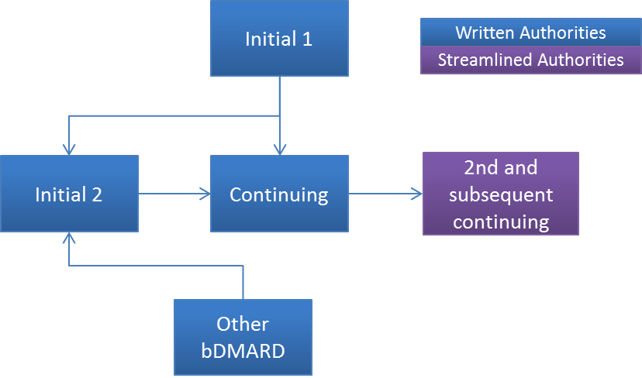
Figure 1. Approach to streamlined authorities for biosimilar brands of infliximab. Purple boxes indicate proposed Authority Required (STREAMLINED) restrictions; blue boxes indicate proposed written Authority required

  - The PBAC noted that the proposed streamlined continuing treatment restriction does not require patients to provide evidence of response in order to access ongoing treatment, although that evidence will need to be documented in the patient’s medical records.

  - The PBAC previously noted that under this option the DHS will not receive evidence of treatment failure (inadequate ongoing response to treatment) if treatment failure occurs at the second or subsequent continuing stage.

  - The submission requested the proposed changes only apply to the Renflexis® brand of infliximab. The advice provided by the PBAC regarding the biosimilar uptake drivers will be at the medicine level and not at the brand level. The decision about applying the lower authority level for one or more brands of infliximab will be made by the Minister or Departmental delegate following PBAC advice. It is expected that the uptake drivers will be applied to all biosimilar brands for a reference biological medicine following positive advice from PBAC.

Consideration of the evidence

Sponsor hearing
  - There was no hearing for this item as it was a minor submission.

Consumer comments
  - The PBAC noted that no consumer comments were received for this item.

PBAC Outcome
  - The PBAC advised that there are no clinical or other concerns about appropriate use of medicines if the policy to lower the authority requirement for only the biosimilar brands of infliximab is adopted providing the following recommendations below are followed.

  - The PBAC recommended that all initial treatment restrictions for infliximab, including those for new patients, patients changing treatment and recommencing treatment, remain as Authority Required (in writing) listings. The PBAC advised that the current restriction for acute severe ulcerative colitis remain unchanged for public hospitals as it is already an Authority Required (STREAMLINED) within the Section 100 Highly Specialised Drugs (HSD) program . This will ensure the medicine will continue to be targeted at the group where cost-effectiveness has been accepted.
  - The PBAC did not recommend lowering the category of authority for the initial 2 and continuing restrictions for infliximab as proposed by the sponsor as it considered that changing the restrictions for these treatment phases to Authority required (streamlined) was likely to result in use outside the intended PBS population to a wider population, such as patients who do not demonstrate the extent of response required for continuing treatment and use in patients with less severe disease.
  - The PBAC recommended that the continuing restrictions for infliximab be split into first continuing and subsequent continuing restrictions. The PBAC recommended that the first continuing restrictions be Authority Required (in writing) which retains the response to treatment criteria that currently exists in the continuing restrictions. The PBAC recommended that the subsequent continuing restrictions be Authority Required (STREAMLINED) restrictions. The PBAC recommended that subsequent continuing restrictions for infliximab retain the requirement for patients to be responding to treatment.
  - The PBAC confirmed its previous recommendation regarding ‘a’ flagging which is intended to support all brands of infliximab.
  - The PBAC noted the request for a change to prescribing software to give preference to Renflexis® for infliximab naïve patients. The PBAC did not have any concerns about encouraging prescribing of a biosimilar brand for treatment naïve patients.
  - The PBAC noted that there will be a number of changes required to the restriction wording for infliximab across all treatment phases (the current initial, change, recommencement and continuing restrictions and associated notes) to accommodate these changes.
Outcome
Recommended

Recommended listing
Yet to be finalised.

- Context for Decision
The PBAC helps decide whether and, if so, how medicines should be subsidised in Australia. It considers submissions in this context. A PBAC decision not to recommend listing or not to recommend changing a listing does not represent a final PBAC view about the merits of the medicine. A company can resubmit to the PBAC or seek independent review of the PBAC decision.

- Sponsor’s Comment
The sponsor had no comment.

