4.04 PEGINTERFERON ALFA-2A
180 microgram/0.5 mL injection, 4 x 0.5 mL syringes 135 microgram/0.5 mL injection, 4 x 0.5 mL syringes
Pegasys®, Roche Products Pty Ltd
- Purpose of Application
  - The minor submission requested amending the current Authority Required (STREAMLINED) and Authority Required listings for peginterferon alfa-2a to an unrestricted benefit listing.
- Requested listing
  - The submission sought a change of authority level for item codes 10278Y, 10280C, 11026H, 9515T, 9516W, 11037X, 11044G, 6439X and 6449K.

Table 1: Peginterferon alfa-2a PBS details
Item code | Schedule | Indication (abridged) | Current restriction method
10278Y | S100 HSD Community Access | Chronic hepatitis B infection | Authority Required (STREAMLINED)
10280C | S100 HSD Community Access | Chronic hepatitis B infection | Authority Required (STREAMLINED)
11026H | S100 HSD Public | Chronic hepatitis C infection | Authority Required
9515T | S100 HSD Public | Chronic hepatitis C infection | Authority Required (STREAMLINED)
9516W | S100 HSD Public | Chronic hepatitis C infection | Authority Required (STREAMLINED)
11037X | General | Chronic hepatitis C infection | Authority Required
11044G | S100 HSD Private | Chronic hepatitis C infection | Authority Required
6439X | S100 HSD Private | Chronic hepatitis C infection | Authority Required
6449K | S100 HSD Private | Chronic hepatitis C infection | Authority Required
- Background
  - Peginterferon alfa-2a is currently TGA registered and PBS listed for chronic hepatitis B and C. The utilisation of peginterferon alfa-2a for its listed indications is shown in Table 2 and Figure 1.

Table 2. The number of prevalent patients supplied peginterferon alfa-2a and the benefits paid by calendar year from 2011 to 2016
 | 2011 | 2012 | 2013 | 2014 | 2015 | 2016
Number of prevalent patients
All indications | 111 | 136 | 222 | 197 | 159 | 141
Chronic hepatitis B | 69 | 107 | 201 | 174 | 147 | 138
Chronic hepatitis C | 42 | 30 | 25 | 25 | 14 | 4
Government benefits paid
All indications | $829,844 | $889,459 | $1,643,504 | $1,391,750 | $1,234,334 | $963,217
Chronic hepatitis B | $444,009 | $643,954 | $1,404,894 | $1,247,884 | $1,105,201 | $943,834
Chronic hepatitis C | $385,835 | $245,505 | $238,610 | $143,867 | $129,133 | $19,383
Source: DUSC Secretariat. Data was extracted from the DHS prescriptions database on13 October 2017.
The data is based on the date of supply.

Figure 1. The number of prevalent patients supplied with peginterferon alfa-2a, January 2014 to June 2017
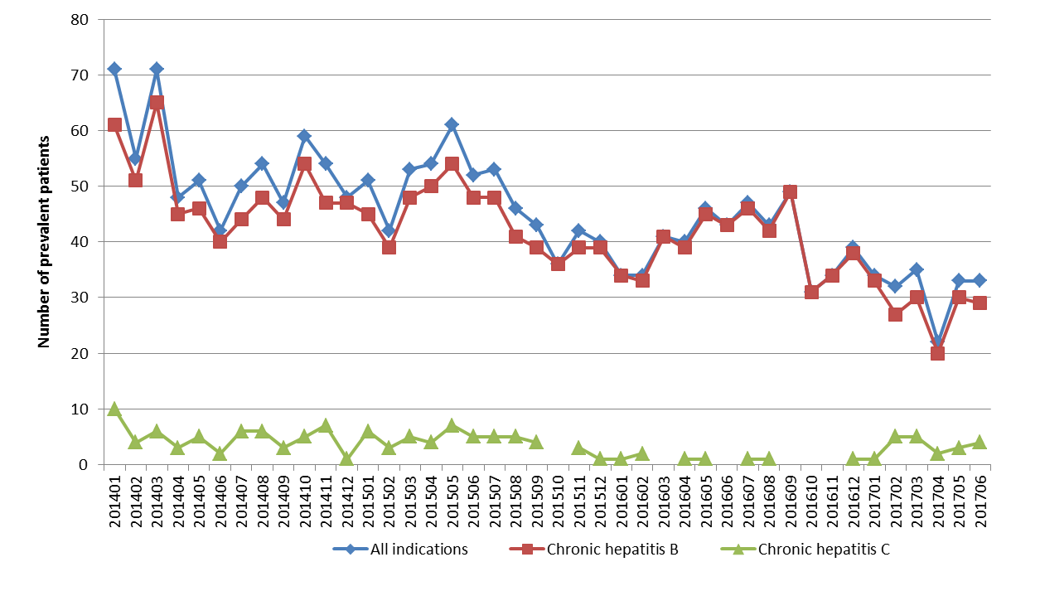
Source: DUSC Secretariat. Data was extracted from the DHS prescriptions database on13 October 2017.
The data is based on the date of supply.

  - Peginterferon alfa-2a is a modified version of non-pegylated interferon alfa-2a with once weekly dosing providing a sustained therapeutic serum concentration and improved tolerability.
  - Non-pegylated interferon alfa-2a is PBS listed for chronic hepatitis B and C as well as for specific leukaemias and lymphomas, and myeloproliferative disease. An unrestricted listing for peginterferon alfa-2a may result in use in these additional indications, in particular in myeloproliferative neoplasms (MPN) where the currently available treatments are considered inappropriate because of toxicity.
  - The submission stated that non-pegylated interferon alfa-2a (Roferon-A®) will be withdrawn from all markets by 2021 and peginterferon alfa-2a (Pegasys®) will be withdrawn by 2026. Supply is guaranteed until this time.

Consideration of the evidence

Sponsor hearing
  - There was no hearing for this item as it was a minor submission.

Consumer comments
  - The PBAC noted and welcomed the input from individuals (4) and organisations (1) via the Consumer Comments facility on the PBS website. The comments noted an unrestricted PBS listing for peginterferon alfa-2a will eliminate the current financial barrier when used for MPN. The PBAC noted Rare Cancers Australia supported the application based on the need for access to peginterferon alfa-2a as demonstrated by the MPN community.

Clinical studies
  - The minor submission provided supportive clinical evidence for the request, including details and early results of studies comparing peginterferon alfa-2a to hydroxyurea in MPN (essential thrombocythemia and polycythemia vera); and a phase III study comparing peginterferon alfa-2a to interferon alfa-2a in chronic myeloid leukaemia. Three phase II single-arm studies of peginterferon alfa-2a in MPN were also presented.

Estimated PBS usage & financial implications
  - The submission proposed a '''''% price reduction for peginterferon alfa-2a and a subsidisation cap. The proposed caps were based on projected peginterferon alfa-2a PBS expenditure in both MPN and the currently PBS-listed hepatitis B and C indications.

  - The submission used an epidemiological approach as the basis for its financial estimates. There is a lack of Australian data on the incidence and prevalence of MPN and the submission’s estimate of the eligible population are highly uncertain. The submission assumed that peginterferon alfa-2a would be used in an estimated 25% of patients who are unable to be treated with hydroxyurea.

  - The estimated prevalent MPN patient population in Year 1 of PBS listing was 3,000, based on 600 patients newly diagnosed annually (as estimated by the Leukaemia Foundation) over the previous 5 years. The financial estimates model presented in the submission omits a modelling step to derive the likely treated population out of the eligible population. Basing the treatment uptake directly on the eligible population will tend towards overestimating the projected treated population. Moreover, as the submission did not apply a mortality rate, this may further overestimate the eligible population.

  - Table 3 summarises the estimated number of MPN patients treated with peginterferon alfa-2a and the associated PBS expenditure, together with the proposed RSA expenditure caps for use in MPN and chronic hepatitis B and C patients.

Table 3: Estimated use and financial implications
 | Year 1 | Year 2 | Year 3 | Year 4 | Year 5 | Year 6
Estimated patient numbers
MPN Patients | ''''''''''''''' | '''''''''''''' | '''''''''''''' | ''''''''''''' | '''''''''''''' | '''''''''''''
Patients treated with peginterferon alfa-2a (25% uptake) | '''''''''' | '''''''' | '''''''''''''' | '''''''''''''' | ''''''''''''' | ''''''''''''
Estimated number of PBS prescriptions of peginterferon alfa-2a
135 mcg | ''''''''''''' | ''''''''''''''' | '''''''''''' | '''''''''''''' | ''''''''''''' | '''''''''''''
180 mcg | '''''''''''' | ''''''''''''' | ''''''''''''''' | '''''''''''''' | '''''''''''''' | '''''''''''''
Total | ''''''''''' | '''''''''' | '''''''''''' | '''''''''''' | '''''''''''' | ''''''''''''''
Estimated PBS expenditure of peginterferon alfa-2a
135 mcg | '''''''''''''''''''''''''' | '''''''''''''''''''''''''' | '''''''''''''''''''''''' | ''''''''''''''''''''''''''''' | '''''''''''''''''''''''' | ''''''''''''''''''''''''''''
180 mcg | '''''''''''''''''''''''''' | '''''''''''''''''''''''''' | ''''''''''''''''''''''''' | ''''''''''''''''''''''''' | ''''''''''''''''''''''''''''' | '''''''''''''''''''''''''''
Total | ''''''''''''''''''''''' | ''''''''''''''''''''' | '''''''''''''''''''''' | '''''''''''''''''''' | ''''''''''''''''''''''' | '''''''''''''''''''
Hepatitis B and C patients treated with peginterferon alfa-2a | ''''''''''''''''''''''' | '''''''''''''''''''''''' | '''''''''''''''''''''' | ''''''''''''''''''''' | '''''''''''''''''''''''' | ''''''''''''''''''''
Proposed RSA expenditure caps | ''''''''''''''''''''''' | ''''''''''''''''''''' | ''''''''''''''''''''' | '''''''''''''''''''' | '''''''''''''''''''' | '''''''''''''''''''''''
Source: Tables 1.1 and 1.2, p6 of the minor submission
The redacted table shows that at year 5, the estimated number of patients was less than 10,000 per year and the net cost to the PBS would be less than $10 million per year.

For more detail on PBAC’s view, see section 5 PBAC outcome.

PBAC Outcome
  - The PBAC recommended the change in listing for peginterferon alfa-2a from Authority Required (STREAMLINED) and Authority Required to Unrestricted, on the basis of the proposed ''''''% price reduction and subsidisation cap.
  - The PBAC noted that the change in restriction level obviated the need for a section 100 community access listing for chronic hepatitis B as patients could access the drug for this use through either of the section 100 Highly Specialised Drugs Program listings or the general schedule listing.
  - The PBAC considered the number of patients with MPN to be overestimated but that the proposed subsidisation cap limited the financial risk to the Commonwealth associated with use in conditions other than MPN and chronic hepatitis B and C.
  - The PBAC noted that this submission was not eligible for an Independent Review, as the PBAC recommended the requested listing.
Outcome:
Recommended

Recommended listing
  - Remove the current S100 community access listings and amend other existing listings as follows:

Name, restriction, manner of administration, form | Maximum quantity (packs) | Maximum quantity (units) | No. of repeats | Proprietary name and manufacturer
PEGINTERFERON ALFA-2A  135 microgram/0.5 mL injection, 4 x 0.5 mL syringes | 2 | 8 | 5 | Pegasys, Roche Products Pty Ltd
Category/Program | General Schedule
Restriction: | Unrestricted

Category/Program | Section 100 HSD Public
Restriction: | Unrestricted

Category/Program | Section 100 HSD Private
Restriction: | Unrestricted

Name, restriction, manner of administration, form | Maximum quantity (packs) | Maximum quantity (units) | No. of repeats | Proprietary name and manufacturer
PEGINTERFERON ALFA-2A  180 microgram/0.5 mL injection, 4 x 0.5 mL syringes | 2 | 8 | 5 | Pegasys, Roche Products Pty Ltd
Category/Program | General Schedule
Restriction: | Unrestricted

Category/Program | Section 100 HSD Public
Restriction: | Unrestricted

Category/Program | Section 100 HSD Private
Restriction: | Unrestricted

Context for Decision
The PBAC helps decide whether and, if so, how medicines should be subsidised in Australia. It considers submissions in this context. A PBAC decision not to recommend listing or not to recommend changing a listing does not represent a final PBAC view about the merits of the medicine. A company can resubmit to the PBAC or seek independent review of the PBAC decision.

Sponsor’s Comment
Roche commends the PBAC on their pragmatic decision and patients organisations for leading this change for Australian patients living with these rare blood cancers. The company is currently working with the Department of Health to achieve the earliest possible change to the PBS restriction.

