5.08 OLAPARIB,
Tablet 150 mg, Tablet 100 mg,
Lynparza™, AstraZeneca Pty Ltd

Purpose of Application
  - The submission requested an Authority Required (Streamlined) listing for the olaparib 150 mg tablet formulation for the maintenance treatment of women with a BRCA1 or BRCA2 gene mutation (BRCAm) and platinum-sensitive relapsed ovarian, fallopian and peritoneal cancer, who are in response (complete or partial) to their most recent platinum-based chemotherapy regimen.
  - The basis for the submission was an indirect comparison of olaparib 150 mg tablets with olaparib 50 mg capsules, using placebo as the common comparator, to inform a cost-minimisation analysis.
Table 1: Key components of the clinical issue addressed by the submission
Component | Description
Population | Patients with confirmed gBRCAm who are in response following two courses of platinum-based chemotherapy for recurrent HGSOC.
Intervention | Olaparib 300 mg (2 x 150 mg tablets) BD as maintenance until disease progression.
Comparator | Olaparib 400 mg (8 x 50 mg capsules) BD as maintenance until disease progression.
Outcomes | Bioavailability; tolerability; safety; progression free survival; time to first subsequent therapy.
Clinical claim | For the maintenance treatment of gBRCAm patients who are in response following two courses of platinum-based chemotherapy for recurrent HGSOC, olaparib tablets are:  - Therapeutically consistent with olaparib capsules;  - Non-inferior to olaparib capsules in terms of efficacy; and  - Non-inferior to olaparib capsules in terms of safety.  The submission noted that the tablet and capsule formulations are not bioequivalent and are not interchangeable. The overall clinical claim is uncertain given issues with the comparability of the clinical studies.
Source: Table 1.1.1 of the commentary.
Abbreviations: BD = twice daily; gBRCAm = germline BRCA mutated; HGSOC = high-grade serous ovarian, fallopian tube or primary peritoneal cancer; mg = milligram; PSR = platinum-sensitive relapsed.

Requested listing
  - The requested restriction is summarised below, and was consistent with the evidence presented and the listings for the olaparib capsules.
Name, restriction, manner of administration, form | Maximum quantity (packs) | Maximum quantity (units) | No. of repeats | Dispensed price for maximum quantity | Proprietary name and manufacturer
Initial treatment
Olaparib  Tablet, 150 mg | 2 | 112 | 2 | $6,959.52 published price  $'''''''''''''''''''' effective price | LYNPARZA™, AstraZeneca
Olaparib  Tablet, 100 mg | 2 | 112 | 2 | $6,959.52 published price  $''''''''''''''''''''' effective price | LYNPARZA™, AstraZeneca
Continuing treatment
Olaparib  Tablet, 150 mg | 2 | 112 | 5 | $6,959.52 published price  $'''''''''''''''''''' effective price | LYNPARZA™, AstraZeneca
Olaparib  Tablet, 100 mg | 2 | 112 | 5 | $6,959.52 published price  $''''''''''''''''''''' effective price | LYNPARZA™, AstraZeneca

Periodicity: | Platinum-sensitive relapse
Severity: | High grade serous
Condition: | Ovarian cancer, fallopian tube cancer or primary peritoneal cancer with documented germline class 4 or 5 BRCA 1 or BRCA2 gene mutation
PBS Indication: | High grade serous ovarian cancer, High grade serous fallopian tube cancer, high grade serous primary peritoneal cancer
Treatment phase: | Initial
Restriction: | Restricted benefit  Authority Required - In Writing  Authority Required - Telephone  Authority Required – Emergency  Authority Required - Electronic  Streamlined
Treatment criteria: | none
Clinical criteria: | The condition must be platinum sensitive,  AND  Patient must have received at least two previous platinum-containing regimens,  AND  Patient must have relapsed following a previous platinum-containing regimen,  AND  Patient must be in partial or complete response to the immediately preceding platinum-based chemotherapy regimen,  AND  The treatment must be the sole PBS-subsidised therapy for this condition,  AND  The treatment must be maintenance therapy,  AND  Patient must not have previously received PBS-subsidised treatment with this drug for this condition.
Population criteria: | Patient must have evidence of a germline class 4 or 5 BRCA1 or BRCA2 gene mutation
Foreword: | NA
Definitions: | Platinum sensitivity is defined as disease progression greater than 6 months after completion of the penultimate platinum regimen.  A response (complete or partial) to the platinum-based chemotherapy regimen is to be assessed using either Gynaecologic Cancer Intergroup (GCIG) or Response Evaluation Criteria in Solid Tumours (RECIST) guidelines.
Prescriber Instructions: | Evidence of a BRCA1 or BRCA2 gene mutation must be derived through germline testing.
Administrative Advice: | Special Pricing Arrangements apply.
Cautions: | Note: olaparib tablets (150 mg/100 mg) are not interchangeable with olaparib capsules (200 mg).
Abbreviations: BRCA = breast cancer susceptibility gene; NA = not applicable; PBS = pharmaceutical benefits scheme.

Periodicity: | Platinum-sensitive relapse
Severity: | High grade serous
Condition: | Ovarian cancer, fallopian tube cancer, primary peritoneal cancer
PBS Indication: | High grade serous ovarian cancer, High grade serous fallopian tube cancer, high grade serous primary peritoneal cancer
Treatment phase: | Continuing
Prescriber type | Dental Medical Practitioners Nurse practitioners  Optometrists Midwives
Restriction:  egg: Section 100 (specify program)  Authority required  Authority required (STREAMLINED)  Restricted benefit  Unrestricted | Restricted benefit  Authority Required - In Writing  Authority Required - Telephone  Authority Required – Emergency  Authority Required - Electronic  Streamlined
Treatment criteria: | none
Clinical criteria: | Patient must have previously received PBS-subsidised treatment with this drug (capsule or tablet formulation) for this condition,  AND  The treatment must be the sole PBS-subsidised therapy for this condition,  AND  The treatment must be maintenance therapy,  AND  Patient must not have progressive disease.
Population criteria: | Patient must have evidence of a germline class 4 or 5 BRCA1 or BRCA2 gene mutation
Foreword: | NA
Definitions: | NA
Prescriber Instructions: | NA
Administrative Advice: | Special Pricing Arrangements apply.
Cautions: | Note: olaparib tablets (150 mg/100 mg) are not interchangeable with olaparib capsules (200 mg).
Abbreviations: BRCA = breast cancer susceptibility gene; NA = not applicable; PBS = pharmaceutical benefits scheme.

The submission proposed that a special pricing arrangement be established for the olaparib tablets once PBS listing was recommended. The proposed effective price is included in the table above.
For more detail on PBAC’s view, see section 7 PBAC outcome.

Background

Registration status
  - The submission was made under TGA/PBAC Parallel Process. At the time of PBAC consideration, the TGA Clinical Evaluation Report and Delegate’s Overview were available. The PBAC noted the TGA Delegate was of the view that the formulations could not be considered bioequivalent and therefore should not be interchangeable .

Previous PBAC consideration
  - This is the first submission of the olaparib tablet formulation to the PBAC. The PBAC previously recommended the listing of olaparib 50 mg capsules for the same indication (olaparib Public Summary document (PSD), November 2016 PBAC meeting).
For more detail on PBAC’s view, see section 7 PBAC outcome.

Population and disease
  - Platinum-sensitive relapsed ovarian cancer is an uncommon condition which is life-threatening. The submission stated that before olaparib capsules were listed on PBS there was an unmet medical need for patients with a platinum sensitive, germline class 4 or 5 BRCA1 or BRCA2 gene mutation, and high grade serous ovarian cancer, fallopian tube, or primary peritoneal cancer, who achieved a complete or partial response (CR or PR) following their most recent platinum-based chemotherapy regimen. The goal of treatment is to prolong the duration of remission, delay disease progression, maintain quality of life and extend survival.
  - The submission proposed that olaparib tablets would replace the currently listed olaparib capsules. The rationale for the PBS listing of the tablets was: (i) higher drug loading; (ii) improved bioavailability and reduced pharmacokinetic variability compared to the capsule formulation; (iii) a reduced pill burden (2 x 150 mg tablets BD compared with 8 x 50 mg capsules BD); and (iv) simplified dosing (in contrast with the capsules, there are no dietary restrictions on when tablets should be taken, or for co-administration with food).

Comparator
  - The submission nominated olaparib capsules 50 mg as the main comparator. The ESC and the PBAC considered this comparator to be appropriate.
For more detail on PBAC’s view, see section 7 PBAC outcome.

Consideration of the evidence

Sponsor hearing
  - There was no hearing for this item.

Consumer comments
  - The PBAC noted the support of the Medical Oncology Group of Australia (MOGA) for the submission.

Clinical trials
  - The submission presented three studies as the basis of the evidence for the comparison of olaparib tablets with olaparib capsules: Study 24, a randomised controlled trial (RCT) comparing the two formulations directly; SOLO-2, an RCT of olaparib tablets compared with placebo in women with BRCA positive disease; and Study 19, an RCT of the olaparib capsules compared with placebo (not restricted to BRCA positive disease). Details of the trials presented in the submission are provided in Table 2.
  - Results from Study 24 were presented on the pharmacokinetic and relative bioavailability data following stage 1 assessment of single dosing (Cohorts 1-3) and stage 2 assessment of multiple dosing (Groups 1, 2 and 6) for the tablets and capsules. Results from Group 6 also included a comparison of clinical efficacy. The ESC noted that TGA’s assessment of the bioavailability, therapeutic equivalence and interchangeability of the two formulations, was not available at the time of ESC consideration (see paragraph 3.1).
  - Results from SOLO-2 and Study 19 were used to form an indirect comparison of olaparib tablets with the olaparib capsules, using placebo as the common comparator.
Table 2: Trials and associated reports presented in the submission
Trial ID | Protocol title/ Publication title | Publication citation
Therapeutic similarity
 | Phase I, randomised, 2 period crossover study to determine the comparative bioavailability of two different oral formulations of AZD2281 in cancer patients with advanced solid tumours. Edition 2. | 2014
Study 24 | Mateo, J., V. Moreno, A. Gupta, et al. An Adaptive Study to Determine the Optimal Dose of the Tablet Formulation of the PARP Inhibitor Olaparib. | Targeted oncology. 2016; 11, 401-415
 | Mateo, J., M. Friedlander, C. Sessa, et al. Administration of continuous/intermittent olaparib in ovarian cancer patients with a germline BRCA1/2 mutation to determine an optimal dosing schedule for the tablet formulation. | European Journal of Cancer. 2013; 49, S161
Olaparib tablet formulation
 | Randomized, Multicenter, Double Blind, Phase 3 Study of Olaparib Maintenance Monotherapy in Platinum Sensitive Relapsed BRCA Mutated Ovarian Cancer Patients who are in Complete or Partial Response Following Platinum based Chemotherapy. | 2017
SOLO-2 | Pujade-Lauraine, E., J. A. Ledermann, F. Selle, et al. Olaparib tablets as maintenance therapy in patients with platinum-sensitive, relapsed ovarian cancer and a BRCA1/2 mutation (SOLO2/ENGOT-Ov21): a double-blind, randomised, placebo-controlled, phase 3 trial. | Lancet Oncology. 2017; 18(9): 1274-1284.
Olaparib capsule formulation
 | Phase II, randomised, double blind, multicentre study to assess the efficacy of AZD2281 in the treatment of patients with platinum sensitive serous ovarian cancer following treatment with two or more platinum containing regimens. Edition 3. | 2013
Study 19 | Phase II, randomised, double blind, multicentre study to assess the efficacy of AZD2281 in the treatment of patients with platinum sensitive serous ovarian cancer following treatment with two or more platinum containing regimens. CLINICAL STUDY REPORT ADDENDUM. | September 2016
 | Ledermann, J., P. Harter, C. Gourley, et al. Olaparib maintenance therapy in platinum-sensitive relapsed ovarian cancer. | New England Journal of Medicine. 2012; 366(15): 1382-1392.
 | Ledermann, J., P. Harter, C. Gourley, et al. Olaparib maintenance therapy in patients with platinum-sensitive relapsed serous ovarian cancer: a preplanned retrospective analysis of outcomes by BRCA status in a randomised phase 2 trial. | Lancet Oncology. 2014; 15(8): 852-861. (Erratum appears in Lancet Oncology. 2015 Apr;16(4):e158)
 | Ledermann, J. A., P. Harter, C. Gourley, et al. Overall survival in patients with platinum-sensitive recurrent serous ovarian cancer receiving olaparib maintenance monotherapy: an updated analysis from a randomised, placebo-controlled, double-blind, phase 2 trial. | Lancet Oncology. 2016; 17(11): 1579-1589.
 | Ledermann, J. A., P. Harter, C. Gourley, et al. Quality of life during olaparib maintenance therapy in platinum-sensitive relapsed serous ovarian cancer. | British Journal of Cancer. 2016; 115(11): 1313-1320.
 | Matulonis, U. A., P. Harter, C. Gourley, et al. Olaparib maintenance therapy in patients with platinum-sensitive, relapsed serous ovarian cancer and a BRCA mutation: Overall survival adjusted for postprogression poly (adenosine diphosphate ribose) polymerase inhibitor therapy. | Cancer. 2016; 122(12): 1844-1852.
 | Dougherty, B. A., Lai, Z., Hodgson, D. R., et al. Biological and clinical evidence for somatic mutations in BRCA1 and BRCA2 as predictive markers for olaparib response in high-grade serous ovarian cancers in the maintenance setting. | Oncotarget, 2017; 8, 43653-43661.
 | Ledermann, J., P. Harter, C. Gourley, et al. Phase II randomized placebo-controlled study of olaparib (AZD2281) in patients with platinum-sensitive relapsed serous ovarian cancer (PSR SOC). | Journal of Clinical Oncology. 2011; 29,
 | Ledermann, J., P. Harter, C. Gourley, et al. Phase 2 randomized placebo-controlled study of olaparib (AZD2281) in patients with platinum-sensitive relapsed serous ovarian cancer (PSR SOC). | International Journal of Gynecological Cancer. 2011; 21, S13
 | Matulonis, U., M. Friedlander, B. A. Du, C. Gourley, et al. Frequency, severity and timing of common adverse events (AEs) with maintenance olaparib in patients (pts) with platinum-sensitive relapsed serous ovarian cancer (PSR SOC). | Journal of Clinical Oncology. 2015; 33
 | Matulonis, U., P. Harter, C. Gourley, et al. Olaparib maintenance therapy in patients with platinum-sensitive relapsed serous ovarian cancer and a BRCA mutation: Overall survival adjusted for post-progression PARP inhibitor therapy. | Gynecologic Oncology. 2015; 137, 8
Source: Table 2.3, pp38-40, of the submission.

  - The key features of the direct comparison randomised trial are summarised in the Table 3.
Table 3: Key features of the included evidence (Study 24)
Trial | N | Design/ duration | Risk of bias | Patient population | Outcome
Olaparib tablet vs. olaparib capsule
Study 24  (group 6) | 53 | R, OL, MC  duration of follow-up not reported | Low | Patients with gBRCAm breast or ovarian cancer | Median PFS
Source: Table 2.4, p 42, of the submission.
Abbreviations: DB = double = blind; gBRCAm = germline BRCA mutated; MC = multi-centre; OL= open label; PFS = progression-free survival; R = randomised.

  - The overall risk of bias of Study 24 was low. While this was a head-to-head comparison of olaparib tablets to capsules, it was a phase I, dose-finding study, included patients (around 30%) with breast cancer, and used dose regimens that are not applicable to Australian practice. While the tablet dose was 300 mg twice daily as per the proposed listing, it was achieved using 1 x 200 mg and 1 x 100 mg tablet; the 200 mg tablet is not available in Australia. It is unknown whether the average dose exposure achieved with this combination of tablets in Study 24 would mirror that which can be expected using potential combinations of 150 and 100 mg tablets as proposed for listing on the PBS. Thus, while this study informs the question of bioequivalence between the formulations, it provides little evidence on the question of therapeutic comparability relating to use on the PBS.
  - The key features of the randomised trials used in the indirect comparison are summarised in Table 4.
Table 4: Key features of the included evidence – indirect comparison
Trial | N | Design/ duration of follow-up | Risk of bias | Patient population | Outcome(s)
Olaparib tablet vs. placebo
SOLO-2 | 295 | R, DB, MC  22 months | Low | PSR HGSOC patients with gBRCA1 or gBRCA2 mutations who had partial or complete response following a second-course of platinum-based chemotherapy. | Median PFS, median OS (not mature), TFST
Olaparib capsule vs. placebo
Study 19 (BRCAm subgroup and gBRCAm subgroup) | n = 136;  n = 96 | R, DB, MC  37 months | Low | PSR HGSOC patients with BRCAm or gBRCAm who were in PR or CR following the immediately preceding platinum-containing chemotherapy regimen. | Median PFS, median OS, TFST
Source: Table 2.4, p 42, of the submission.
Abbreviations: DB = double blind; CR = complete response; gBRCAm = germline BRCA mutated; HGSOC = high-grade serous ovarian, fallopian tube or primary peritoneal cancer; MC = multi-centre; OL= open label; OS = overall survival; PFS = progression-free survival; PR = partial response; R = randomised; TFST = time to first subsequent treatment.

  - Overall, the risk of bias for each trial was minimal. The submission presented only sub-group analyses for Study 19 (N = 265); the BRCAm subgroup (n = 136) and gBRCAm (germline BRCA mutated) subgroup (n= 96). The PBAC has previously considered the risk of bias for Study 19 deeming it to have an unclear bias due to non-randomisation and post-identification of patients by BRCAm status. There is a potential lack of transitivity for Study 19 and SOLO-2 as discussed below.

Comparative effectiveness
  - A summary of the efficacy outcome, progression free survival (PFS), from Study 24 is presented in Table 5. The submission claimed therapeutic similarity of olaparib tablets to the capsules on the basis that there was no statistically significant difference in PFS with a hazard ratio (HR): 0.930 (CI 95% 0.4, 2.5) p = 0.886. The PBAC agreed with the ESC’s advice that while the use of Study 24 to assess therapeutic non-inferiority was appropriate, the results should be interpreted with caution as there was a high degree of uncertainty about whether the study was statistically powered to detect differences in key outcomes, in light of the small numbers of patients in this study (n=18).
Table 5: Results of median PFS for Study 24 (group 6)
 | Olaparib TAB  n/N (%) | Olaparib CAP  n/N (%) | Absolute difference | HR (95% CI)
Progression-free survival
Patients with event | 7/18 (38.9) | 9/18 (50%) | - | 0.930 (0.4, 2.5)  p, 0.886
Median PFS months (95% CI) | 217 (118, NC) | 174 (114, NC) | 43 | -
Source: Table 2.17, p66, of the submission; Study 24 CSR, Table 61.
Abbreviations: CAP= capsules; CI= confidence interval; NC= not calculated; TAB= tablets.

  - The submission presented an indirect comparison of olaparib tablets with the capsules on the basis of PFS, overall survival (OS) and time to first subsequent treatment or death (TFST).
  - Given the difference in the comparative declines in PFS for the placebo arms, the submission claimed that the comparison on the basis of PFS was not reliable. The ESC agreed with the submission’s claim, but also considered that this lack of transitivity between the trials potentially indicated that none of outcome measures could be reliably interpreted. Further, the ESC noted that SOLO-2 was restricted to patients with a known BRCA mutation, while Study 19 was not.
  - The submission presented an indirect comparison of PFS for the tablets with the capsules which showed a HR: 1.67 (95% CI 0.91, 3.05; p = 0.1103; see Table 6). The submission concluded that while this result was not statistically significant, the upper confidence interval level was above a pre-specified non-inferiority margin of 1.2 for PFS. This was based on a report which stated that for oncology studies the non-inferiority margins for PFS or OS would be around 1.2, but the report did not justify or provide a reference for the use of this value.
Figure 1: Kaplan-Meier curves for PFS for olaparib tablets 300 mg BD and placebo (SOLO-2) and for olaparib capsules 400 mg BD and placebo (Study 19 (BRCAm))

SOLO-2 | Study 19 (BRCAm)
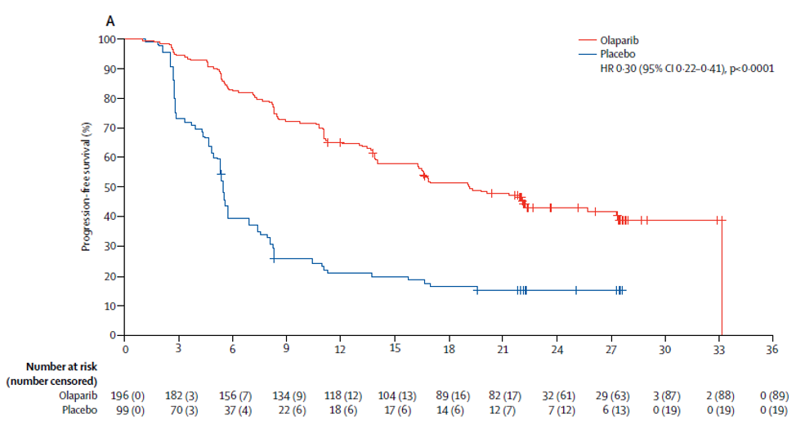 | 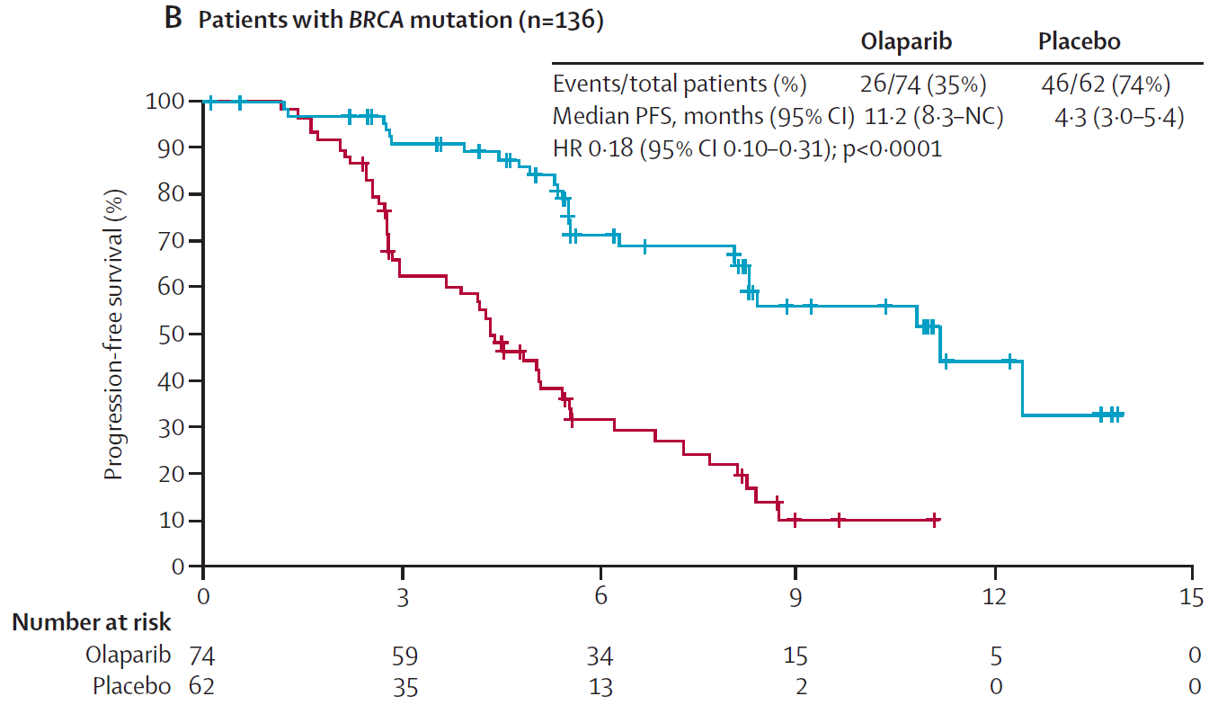
Source: Figure 2.5, p68, Figure 2.6, p69 of the submission.
Abbreviations: BD = twice daily; BRCA = breast cancer susceptibility gene; CI = confidence interval; HR = hazard ratio; PFS = progression free survival.
  - To compensate for the apparent lack of comparability for PFS, and the immaturity of OS, the submission presented an indirect comparison for the TFST outcome; the corresponding Kaplan-Meier curves for both studies are in Figure 2 below. The submission presented a base case analysis of TFST which used Bayesian indirect treatment comparative efficacy analysis to evaluate the TFST hazard ratios. A subsequent analysis applied a restricted survival mean time (RMST) analysis to account for the likely violation of the proportional hazards assumption in the TFST.
Figure 2: Kaplan-Meier plots of time to first subsequent therapy or death (TFST) for the olaparib tablets 300 mg BD and placebo (SOLO-2) and for the olaparib capsules 400 mg BD and placebo (Study 19 (BRCAm))

SOLO-2 | Study 19 (BRCAm)
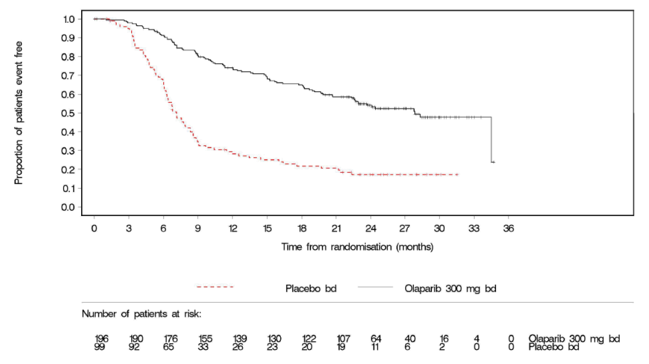 | 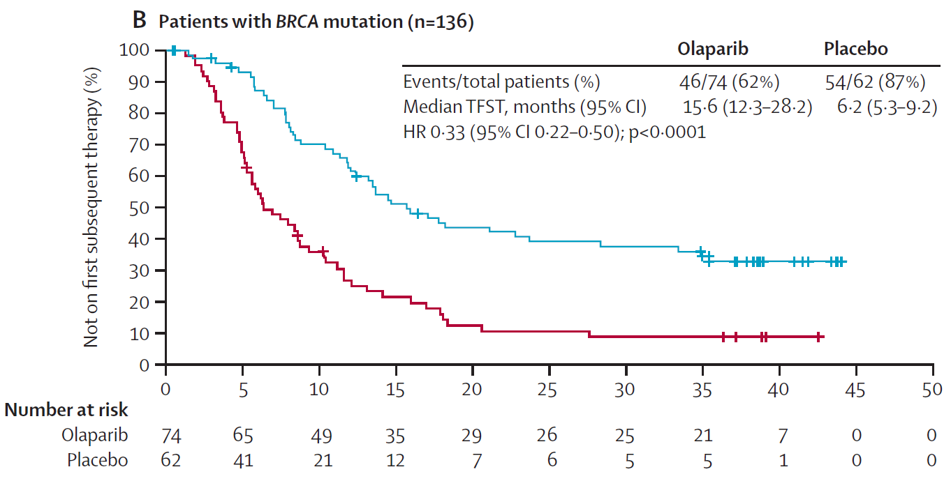
Source: SOLO-2 CSR Figure 8 (data derived from Figure 11.2.4.1); Figure 2.1, p73.
Abbreviations: BD = twice daily; BRCA = breast cancer susceptibility gene; CI = confidence interval; CSR= clinical study report; HR = hazard ratio; TFST= time to first subsequent therapy or death.

  - The result of the indirect comparison using the unadjusted Kaplan-Meier analysis of TFST was inconclusive based on the HR for BRCAm and gBRCAm populations (see Table 6), and the results for the Bayesian analysis of TFST were not statistically significant with HR: 0.87 (95% CI: 0.51, 1.50). The ESC considered that there were differences in the outcomes in the placebo arms between the studies, noting that a smaller proportion (~80%) experienced events in the placebo arm of SOLO2 compared to Study 19 (~95%).
  - The submission concluded that the indirect treatment comparison, summarised in Table 6, showed no significant difference in efficacy between the olaparib capsule and tablet formulations in maintenance therapy in gBRCAm PSR (platinum-sensitive relapsed) HGSOC (high-grade serous ovarian) patients following response to chemotherapy.
  - The ESC considered that, in light of the lack of transitivity between SOLO-2 and Study 19, it was unclear whether a conclusion could be drawn on the comparative effectiveness of olaparib capsules and tablets.
Table 6: Results of PFS, OS, TFST across the SOLO-2 and Study 19 (BRCAm subgroups)
Trial ID |  | Olaparib tablet  n/N with event (%) | Placebo  n/N with event (%) | Olaparib capsule  n / N |  | Hazard ratio  (95% CI) | P value
PFS
SOLO – 2  gBRCAm |  | 107/196  (54.6) | 80/99 (80.8) | - |  | 0.30 (0.22,0.41) | P<0.001
Study 19  BRCAm |  | - | 46/62 (74) | 26/74 (35) |  | 0.18 (0.10, 0.31) | P<0.00001
Study 19  gBRCAm |  | - | 33/43 (77) | 17/53 (32) |  | 0.17 (0.09, 0.31) | P<0.00001
Indirect comparison: SOLO-2 vs. Study 19 (BRCAm) |  |  |  |  |  | 1.67 (0.89, 3.12) | 0.1103
Indirect comparison: SOLO-2 vs. Study 19 (gBRCAm) |  |  |  |  |  | 1.77 (0.90, 3.47) | 0.1002
OS
SOLO – 2  gBRCAm |  | 45/196 (23.0) | 27/99 (27.3) | - |  | 0.80 (0.50,0.31) | 0.4267
Study 19  BRCAm |  | - | 50/62 (81) | 49/74 (66) |  | 0.62 (0.42,0.93) | 0.0214
Study 19  gBRCAm |  | - | 34/43 (79) | 35/53 (66) |  | 0.68 (0.42,1.10) | 0.11363
Indirect comparison: SOLO-2 vs. Study 19 (BRCAm) |  |  |  |  |  | 1.290 (0.68,2.44) | 0.4339
Indirect comparison: SOLO-2 vs. Study 19 (gBRCAm) |  |  |  |  |  | 1.176 (0.59,2.34) | 0.6438
TFST: Unadjusted Kaplan-Meier analysis
SOLO – 2  gBRCAm |  | 92/196 (46.9) | 79/99 (79.8) | - |  | 0.28 (0.21, 0.38) | <0.0001
Study 19  BRCAm |  | - | 59/62 (95) | 55/74 (74) |  | 0.33 (0.22, 0.49) | <0.00001
Study 19  gBRCAm |  | - | 41/43 (95) | 38/53 (72) |  | 0.32 (0.20, 0.51) | 0.00001
Indirect comparison: SOLO-2 vs. Study 19 (BRCAm) |  |  |  |  |  | 0.848 (0.515, 1.398) | 0.5191
Indirect comparison: SOLO-2 vs. Study 19 (gBRCAm) |  |  |  |  |  | 1.400 (0.523, 3.748) | 0.5030
TFST: Bayesian indirect treatment comparative efficacy
RMST (SE) truncated at 24 months | Olaparib tablet  Mean (SE) |  | Placebo  Mean (SE) |  | Olaparib capsule  Mean (SE) | HR (95% CI) | TFST RMST Difference in RMST truncated at 24 months
SOLO – 2  gBRCAm | 18.376 (0.534) |  | 10.381 (0.769) |  | - | - | -
Study 19  gBRCAm | - |  | 8.977 (1.037) |  | 16.084 (1.030) | - | -
Olaparib tablets versus Olaparib capsules |  |  |  |  |  | 0.87 (0.51, 1.50) | 0.88 (–2.5, 4.3)
Source: Table 2.18, p67, Table 2.19, p70, Table 2.20, p72, Table 2.24, p80, of the submission.
Abbreviations: CI = confidence interval; gBRCAm = germline breast cancer gene mutation; HR = hazard ratio; RMST = restricted mean survival time; PFS = progression free survival; SE = standard error; TFST = time to first subsequent therapy.
Notes: a. data cut-off 9 May 2016; b. data cut-off 19 Sep 2016
  - The ESC noted that median OS in SOLO-2 had not been reached, with data reaching 24.4% maturity, despite the treatment time surpassing the median OS in Study 19. Given the immaturity of the OS data for the olaparib tablets, the ESC considered that the differences between the two olaparib formulations remained uncertain.

Comparative harms
  - The results of the comparison of safety based on SOLO-2 and Study 19 (BRCAm subgroup) were not statistically significant (Table 7). The results of the additional comparative treatment Bayesian analysis were also not statistically significant. However, the submission stated that olaparib tablets had a numerical advantage over the capsules in treatment interruption, treatment disruption, and grade 3-4 adverse events. The ESC noted that these comparisons were subject to the same potential lack of transitivity which affected the comparison of efficacy. Moreover, the ESC noted that the submission did not present any evidence of the potential impact of a switch between the two formulations, and considered that this was very likely to take place in practice.

Table 7: Summary of the indirect comparison of key adverse events in SOLO-2 and Study 19 (BRCAm subgroups)
Outcome^{a, b} | Odds Ratio (95% CI)^{c} | p value
Any AE
TAB vs CAP (BRCAm) | 0.939 (0.165, 5.352) | 0.9437
TAB vs CAP (gBRCAm) | 1.049 (0.154, 7.172) | 0.9608
Any AE of Grade 3 or higher
TAB vs CAP (BRCAm) | 0.623 (0.187, 2.074) | 0.4409
TAB vs CAP (gBRCAm) | 0.754 (0.173, 3.282) | 0.7063
Any SAE (including death)
TAB vs CAP (BRCAm) | 0.463 (0.047, 4.583) | 0.5102
TAB vs CAP (gBRCAm) | 0.315 (0.015, 6.705) | 0.4589
Any AE leading to discontinuation of study treatment
TAB vs CAP (BRCAm) | 0.493 (0.019, 12.715) | 0.6699
TAB vs CAP (gBRCAm) | 0.593 (0.022, 15.645) | 0.7541
Source: Table 2.21, p75, of the submission.
Abbreviations: AE = adverse event; CAP= capsule; CSR= clinical study report; SAE= serious adverse event; TAB= tablet.
Notes: a. Patients with multiple events in the same category are counted only once in that category. Patients with events in more than one category are counted once in each of those categories. b. As assessed by the investigator to be causally related to study treatment. c. OR calculated using Rev 5.3, M-H random effects.

Clinical claim
  - The submission described olaparib tablets as non-inferior in terms of effectiveness and safety compared with the olaparib capsules. These claims may not be reasonable given the nature of the data presented. The ESC noted that the clinical claim presented in the submission relied primarily on an indirect comparison of the tablet and capsule formulations using data from SOLO-2 and Study 19. The ESC advised that the results from the indirect comparison presented in the submission should be interpreted with caution, as:
- the TGA’s assessment of the bioavailability, therapeutic equivalence and interchangeability of the two formulations was not available at the time of ESC consideration (see paragraph 3.1);
- Study 24 was not statistically powered to detect differences in key outcomes, in light of the small numbers of patients in this study (n=18);
- the OS data in SOLO-2 was relatively immature (24.4% maturity); and
- the differences in the event rates between the placebo arms of SOLO-2 and study 19 indicated that there was a lack of transitivity between these studies, particularly as SOLO-2 and Study 19 (i) had different patient inclusion criteria (SOLO-2 was restricted to women with a known BRCA mutation while Study 19 was not); and (ii) were conducted over different time periods.
  - The PBAC noted the following with respect to the data presented for the comparison of olaparib tablets and capsules:
- Study 19 had a broader population than the proposed PBS listing. Thus subgroup analyses, presenting data for BRCAm and gBRCAm patients, were used. While the PBAC has previously considered data from these subgroups in Study 19, this submission presented a comparison of two active treatments, and compared a full trial population (SOLO-2) to a subgroup of Study 19. The subgroup from Study 19 may not have been powered for such a comparison;
- The submission presented an extensive analysis of TFST as the most reliable basis for its efficacy claim. However, this outcome was a secondary endpoint in SOLO-2 and exploratory only in Study-19; and
- Study 24 was a phase I, dose-finding study that used dose regimens that are not applicable to Australian practice and included patients (around 30%) with breast cancer. Thus, while this study informs the question of bioequivalence between the formulations, it provides little evidence on the question of therapeutic comparability.

Economic analysis
  - The submission presented a cost-minimisation analysis for the tablets compared with the capsules. The equi-effective doses used to inform that analysis were olaparib tablets 300 mg (2 x 150 mg tablet) twice daily and olaparib capsules 400 mg (8 x 50 mg capsule) twice daily. This was based on the maximum recommended daily doses for each formulation as used in SOLO-2 and Study 19. However, the ESC noted that use of the maximum recommended daily doses did not take into account dose interruptions, delays or reductions.
  - The ESC therefore advised that the equi-effective doses for the purposes of cost-minimisation, taking into account the respective dose intensities, were:
- 568.2 mg olaparib tablets per day (based on 95% dose intensity in SOLO-2); and
- 681.6 mg olaparib capsules per day (based on 85% dose intensity in Study 19).

  - Although the Pre-Sub-Committee Response (PSCR) stated that market research indicated that similar mean doses of the capsules and tablets were used in practice, the ESC noted that no reference for this data was provided.
  - The submission proposed the same published and effective prices for olaparib tablets as the currently listed price of the capsules. The published price per olaparib tablet 150 mg is $''''''''''' and price per mg is $''''''''. Based on these prices, and the assumed equi-effective doses, the submission estimated that there would be no difference in costs between olaparib tablets and capsules.
  - During the evaluation the cost per year for olaparib tablets based on utilisation to achieve the average daily dose (568.2 mg) reported in SOLO-2, and using the proposed price as per the submission, was calculated at $''''''''''''''''''. The cost per year for olaparib capsules calculated based on the reported average daily dose (681.6 mg) in Study 19 was $''''''''''''''''''''. On this basis, the annual cost of treatment with olaparib tablets at the proposed prices is higher than with the capsules by $''''''''''''''''' (based on published price), and $'''''''''''''''' (effective price).
  - The Pre-PBAC Response acknowledged the differences in dose intensities between subgroups of Study 19, as well as between Study 19 and SOLO-2, and proposed an alternative approach to calculating the equi-effective doses. The Pre-PBAC Response proposed that an equi-effective dose of 711.0 mg should be assumed for olaparib capsules, based on a dose intensity of 88% in the gBRCA subgroup of Study 19, but argued that the differences in dose intensity are likely to be an artefact of the studies rather than an indication of a real difference in the equi-effective doses.
  - Using equi-effective doses of 568.2 mg olaparib tablets per day versus 711.0 mg olaparib capsules per day, the Pre-PBAC Response calculated the annual differential cost of treatment with olaparib tablets would be $'''''''''''''''' higher than treatment with olaparib capsules (based on effective price).
  - The PBAC noted the Pre-PBAC Response’s revised equi-effective dose, but considered that the equi-effective doses for the purposes of cost-minimisation should be maintained as reported in the clinical trial data for overall population (568.2 mg tablets in SOLO-2; 681.6 mg capsules in Study 19).

Drug cost/patient/course: $6,959.52 (published price)
  - Using the published price requested in the submission, the cost per course (dose duration of 28 days) of olaparib tablet was $6,959.52. Based on maximum recommended daily dose of 600 mg, cost per patient per year is $''''''''''''''''' (365 days x 600 mg x $''''''''). Treatment with olaparib is ongoing until disease progression.

Estimated PBS usage & financial implications
  - This submission was not considered by DUSC.
  - The submission estimated the expected utilisation and costs associated with the listing of the olaparib tablets based on a market share approach. The submission stated that this approach was previously accepted by the PBAC in November 2016 in relation to the submission for the listing of the olaparib capsules. Olaparib capsules were listed on the PBS in February 2017, and therefore data on their use (PBS service volume) are as yet immature. The current PBS service item report available presents data up until October 2017.
  - The estimates assumed each patient received a maximum of ''''' scripts at the maximum recommended daily dose of olaparib, and were presented for both the published and effective prices. A summary of the estimated use and financial implications for listing of olaparib tablets is presented in Table 8.
  - The submission stated that it intends to seek a staged removal of the capsules from the PBS and the market once the olaparib tablets are listed (i.e. the restriction for the initial treatment with olaparib capsules would be delisted along with the PBS-listing of the olaparib tablets, to ensure that all new patients were initiated on olaparib tablets alone).
  - The financial estimates were based on the assumption that olaparib tablets displace olaparib capsules, and was consequently cost neutral to the Commonwealth. The estimates were consistent with the market share approach and the intention by the sponsor to remove olaparib capsules from the market.
Table 8: Estimated use and financial implications
 | Year 1 | Year 2 | Year 3 | Year 4 | Year 5 | Year 6
Estimated extent of use
Number of scripts dispensedª | ''''''''''''' | '''''''''''' | '''''''''''''' | '''''''''''''' | '''''''''''''' | ''''''''''''
Estimated financial implications of olaparib tablet
At DPMQ (effective)
Cost to PBS/RPBS | $''''''''''''''''''''''''''''' | $''''''''''''''''''''''' | $''''''''''''''''''''''''' | $'''''''''''''''''''''''''' | $'''''''''''''''''''''''' | $'''''''''''''''''''''''''''''
Co-payments | $''''''''''''''''' | $'''''''''''''''' | $''''''''''''''' | $''''''''''''''''' | $'''''''''''''''''' | $'''''''''''''''''
Cost to PBS/RPBS less co-payments | $'''''''''''''''''''''''''' | $''''''''''''''''''''''''' | $''''''''''''''''''''''''''''' | $''''''''''''''''''''''' | $''''''''''''''''''''''''' | $''''''''''''''''''''''''''
At DPMQ (published)
Cost to PBS/RPBS | $''''''''''''''''''''''''' | $''''''''''''''''''''''''''''' | $''''''''''''''''''''''''''' | $'''''''''''''''''''''''''' | $'''''''''''''''''''''''''' | $''''''''''''''''''''''''
Co-payments | $'''''''''''''''''' | $''''''''''''''''' | $'''''''''''''''' | $''''''''''''''' | $''''''''''''''' | $'''''''''''''''
Cost to PBS/RPBS less co-payments | $''''''''''''''''''''''''''' | $'''''''''''''''''''''''''' | $'''''''''''''''''''''''' | $''''''''''''''''''''''''' | $''''''''''''''''''''''''''' | $''''''''''''''''''''''''''''
Estimated financial implications for olaparib capsule
At DPMQ (effective)
Cost to PBS/RPBS | $'''''''''''''''''''''''''' | $'''''''''''''''''''''''' | $''''''''''''''''''''''''''''' | $''''''''''''''''''''''''''' | $'''''''''''''''''''''''''''' | $''''''''''''''''''''''''
Co-payments | $''''''''''''''''' | $''''''''''''''' | $''''''''''''''''' | $'''''''''''''''' | $''''''''''''''' | $''''''''''''''''
Cost to PBS/RPBS less co-payments | $''''''''''''''''''''''''''''' | $'''''''''''''''''''''''''''' | $'''''''''''''''''''''''''' | $'''''''''''''''''''''''''' | $'''''''''''''''''''''''''''' | $'''''''''''''''''''''''''''''
At DPMQ (published)
Cost to PBS/RPBS | $'''''''''''''''''''''''''''' | $'''''''''''''''''''''''''' | $'''''''''''''''''''''''' | $''''''''''''''''''''''''''''' | $''''''''''''''''''''''' | $'''''''''''''''''''''''''
Co-payments | $''''''''''''''' | $'''''''''''''''' | $'''''''''''''''' | $''''''''''''''''' | $'''''''''''''''' | $'''''''''''''''
Cost to PBS/RPBS less co-payments | $''''''''''''''''''''''''''''' | $'''''''''''''''''''''''''''' | $'''''''''''''''''''''''''' | $''''''''''''''''''''''''' | $''''''''''''''''''''''' | $'''''''''''''''''''''''''''
Net financial implications
Net cost to PBS/RPBS | $0 | $0 | $0 | $0 | $0 | $0
Source: Table 4.7, p94, of the submission.
Abbreviations: DPMQ = dispense maximum quantity price; PBS = Pharmaceutical Benefits Scheme; RPBS = Repatriation Pharmaceutical Benefits Scheme; SPA = special pricing arrangement.
Notes: numbers in italics were corrected from the spreadsheet ‘3c. Impact – EFF’, Section 4 Lynparza utilisation-and-cost model_FINAL. ª Assuming a cap of '''''' '''''''''''''''' ''''' ''''''''''' ''''''''' ''''''' ''''''''''''''''''''''''''' per patient as estimated by the submission, and the growth rate of scripts based on the estimates for olaparib capsule PBAC submission in November 2016.

  - These estimates were based on equivalent per pack pricing, derived from an assumption that the equi-effective doses were those associated with the maximum recommended daily dose. However, the ESC noted that given the proposed price for the tablets, dosing as per the observed mean doses in the clinical studies would result in costs to Government that are higher for the tablets than for the capsules. The ESC therefore advised that a lower per pack price for the tablets than that proposed would be required to achieve cost neutrality.

Quality Use of Medicines
  - The Sponsor flagged its intention to seek a staged removal of the capsules from the PBS and the market once the tablets are made available on the PBS. Details of the proposed transition from the capsules to tablets were presented in the submission.
  - It is likely that patients who are receiving capsules currently will seek to be switched to the tablets once they become available. The submission did not discuss the potential risks (loss of benefit or occurrence of AEs) from switching, nor presented any plans to mitigate these risks.
  - The PSCR argued that switching was best left to the discretion of the prescriber as clinicians are familiar with the safety profile of olaparib, and the consistency across both formulations. The PSCR further stated that the sponsor will not encourage switching to patients who were currently on olaparib capsules, and argued that a step-wise listing process would ensure that all new patients initiate treatment with olaparib tablets only. The ESC noted the PSCR’s arguments, but remained concerned that the switching from capsule to tablet formulation is highly likely in patients currently on capsules, given the potential of a substantially reduced pill burden. The PBAC agreed with ESC’s views on the high likelihood of switching.

Financial Management – Risk Sharing Arrangements
  - The Sponsor proposed that the current Risk Sharing Arrangement in place for the olaparib capsules be extended to the olaparib tablets. The submission proposed that this arrangement would be unchanged by the listing of the tablets, implying that there would be no added financial exposure to the Commonwealth from the availability of the tablets. The submission also suggested a cap of ''''' scripts per patient. This is the same cap as is currently applied to the olaparib capsules.
  - The PSCR and Pre-PBAC Response reiterated that the PBS listing of olaparib tablets would be cost neutral to the Commonwealth, as this formulation would share the annual expenditure caps in the existing Deed of Agreement for olaparib capsules. The ESC considered that while the existing subsidisation cap would ensure that the total expenditure would not exceed the agreed limit, it did not guarantee that there would not be any additional expenditure to the Commonwealth, albeit within the agreed cap.
  - The PBAC noted the Secretariat's advice that after 9 months of reported data, olaparib capsules had reached '''''% of the Year 1 annual expenditure cap, and projection that by completion of Year 1, olaparib capsules will have reached approximately '''''% of the annual expenditure cap.
For more detail on PBAC’s view, see section 7 PBAC outcome.
- PBAC Outcome

  - The PBAC recommended the Authority Required (General Schedule) listing of a new tablet form of olaparib for the treatment of high grade serous ovarian, fallopian tube and primary peritoneal cancers, on a cost-minimisation basis to olaparib capsules. In making this recommendation, the PBAC noted that the sponsor intended to withdraw the capsule form of this medicine from the market, acknowledged that the new form represented a reduced pill burden for patients and advised that a price reduction was warranted for this listing to be cost neutral to the Commonwealth, at the equi-effective doses recommended by the Committee.
  - The PBAC accepted the nominated comparator of olaparib capsules for the proposed listing of the new tablet formulation.
  - The PBAC noted the TGA Delegate was of the view that the formulations could not be considered bioequivalent and therefore should not be interchangeable (TGA Delegates’ overview, page 1). The PBAC advised that a caution note indicating that ‘olaparib tablets (2 x 150 mg tablet twice daily) are not interchangeable and olaparib capsules (8 x 50 mg capsule twice daily)’ be incorporated into the PBS restriction for both olaparib tablets and capsules, to ensure that the two forms are not used interchangeably in practice.
  - The PBAC considered that the overall clinical claim that olaparib tablets are non-inferior to capsules was uncertain due to issues surrounding the indirect comparisons presented in the submission, including, (i) limited statistical power of Study 24 and Study 19; (ii) the relative immaturity of OS data in SOLO-2; and (iii) the lack of transitivity between Study 19 and SOLO-2. However, the PBAC also acknowledged that further comparative studies are unlikely, and the capsule formulation is likely to be phased out of the market.
  - The PBAC considered that whilst the evidence presented in the submission for olaparib tablets suggested improved efficacy versus placebo, evidence of non-inferiority to olaparib capsules was not adequately supported.
  - The PBAC also considered that the evidence presented in the submission was inadequate in supporting the claim of non-inferior comparative safety of olaparib tablets versus capsules.
  - Although the submission proposed that the published and effective prices for olaparib tablets be the same as the currently listed price of the capsules, the PBAC noted that the equi-effective doses proposed in the submission did not take into account dose interruptions, delays or reductions. The PBAC noted that while ESC took into account the dose intensities of the respective trials and advised an equi-effective dose of 568.2 mg olaparib tablets versus 681.6 mg olaparib capsules on a per day basis, the Pre-PBAC response proposed that the dose intensity-adjusted equi-effective dose for the olaparib capsules should be 711.0 mg, based on the dose intensity of 88% in the gBRCA subgroup of Study 19 alone.
  - The PBAC noted the Pre-PBAC Response’s revised equi-effective dose; however, it agreed with ESC and considered that the equi-effective doses for the purposes of cost-minimisation should be maintained as reported in the clinical trial data for overall population dosing:
- 568.2 mg olaparib tablets per day (based on 95% dose intensity in SOLO-2); and
- 681.6 mg olaparib capsules per day (based on 85% dose intensity in Study 19).

  - The PBAC noted that on the basis of the equi-effective doses stated above, the annual cost of treatment with olaparib tablets at the proposed prices was higher than with the capsules by $'''''''''''''''''' (based on published price), and $''''''''''''''''' (effective price).
  - The PBAC agreed with the submission’s proposal to extend the current Risk Share Agreement for olaparib capsules to the new tablet form, with a '''''''% rebate beyond the agreed expenditure cap. The PBAC noted that the PSCR and Pre-PBAC Response reiterated that the PBS listing of olaparib tablets would be cost neutral to the Commonwealth, as this formulation would share the annual expenditure caps in the existing Deed of Agreement for olaparib capsules. However, the PBAC considered that while the existing subsidisation cap would ensure that the total expenditure would not exceed the agreed limit, it did not guarantee that there would not be any additional expenditure to the Commonwealth, albeit within the agreed cap. The PBAC therefore advised that a price reduction should be negotiated to ensure that the listing of the olaparib tablets was cost neutral to the Commonwealth at its recommended equi-effective doses.
  - The PBAC has previously recommended that olaparib should not be treated as interchangeable on an individual patient basis with any other drugs.
  - The PBAC advised, under Section 101 (4AACD) of the National Health Act, 1953 that olaparib tablets and olaparib capsules should not be considered equivalent for the purposes of substitution
  - The PBAC has previously advised that olaparib is not suitable for prescribing by nurse practitioners.
  - The PBAC has previously recommended that the Early Supply Rule should apply for olaparib.
  - The PBAC noted that as a flow-on change, the listing of the olaparib capsules would coincide with the delisting for the initial restriction for olaparib tablets, to ensure that all new patients started on the capsule form of the medicine.
  - The PBAC noted that this submission is not eligible for an Independent Review as olaparib has been recommended for listing.
Outcome:
Recommended

Recommended listing
  - The PBAC advised that a caution note indicating that ‘olaparib tablets (2 x 150 mg tablet twice daily) are not interchangeable with olaparib capsules (8 x 50 mg capsule twice daily)’ be incorporated into the PBS restriction for both olaparib tablets and capsules.
  - The PBAC noted that as a flow-on change, the listing of the olaparib tablets would coincide with the delisting for the initial restriction for olaparib capsules, to ensure that all new patients started on the tablet form of the medicine.
  - Add new item:
Name, restriction, manner of administration, form |  | Maximum quantity (packs) |  | Maximum quantity (units) | No. of repeats | Proprietary name and manufacturer
Initial treatment
Olaparib  Tablet, 150 mg |  | 2 |  | 112 | 2 | LYNPARZA™, AstraZeneca
Olaparib  Tablet, 100 mg |  | 2 |  | 112 | 2 | LYNPARZA™, AstraZeneca
 | Category / Program |  | GENERAL – General Schedule (Code GE)
 | Periodicity: |  | Platinum-sensitive relapse
 | Severity: |  | High grade serous
 | Condition: |  | Ovarian cancer, fallopian tube cancer or primary peritoneal cancer with documented germline class 4 or 5 BRCA 1 or BRCA2 gene mutation
 | PBS Indication: |  | High grade serous ovarian cancer, High grade serous fallopian tube cancer, high grade serous primary peritoneal cancer
 | Treatment phase: |  | Initial treatment
 | Restriction: |  | Restricted benefit  Authority Required - In Writing  Authority Required - Telephone  Authority Required – Emergency  Authority Required - Electronic  Streamlined
 | Treatment criteria: |  | none
 | Clinical criteria: |  | The condition must be platinum sensitive,  AND  Patient must have received at least two previous platinum-containing regimens,  AND  Patient must have relapsed following a previous platinum-containing regimen,  AND  Patient must be in partial or complete response to the immediately preceding platinum-based chemotherapy regimen,  AND  The treatment must be the sole PBS-subsidised therapy for this condition,  AND  The treatment must be maintenance therapy,  AND  Patient must not have previously received PBS-subsidised treatment with this drug for this condition.
 | Population criteria: |  | Patient must have evidence of a germline class 4 or 5 BRCA1 or BRCA2 gene mutation
 | Foreword: |  | NA
 | Definitions: |  | Platinum sensitivity is defined as disease progression greater than 6 months after completion of the penultimate platinum regimen.  A response (complete or partial) to the platinum-based chemotherapy regimen is to be assessed using either Gynaecologic Cancer Intergroup (GCIG) or Response Evaluation Criteria in Solid Tumours (RECIST) guidelines.
 | Prescriber Instructions: |  | Evidence of a BRCA1 or BRCA2 gene mutation must be derived through germline testing.
 | Administrative Advice: |  | Special Pricing Arrangements apply.
 | Cautions: |  | Note: olaparib tablets (2 x 150 mg tablet twice daily) are not interchangeable with olaparib capsules (8 x 50 mg capsule twice daily)

Name, restriction, manner of administration, form | Maximum quantity (packs) |  | Maximum quantity (units) | No. of repeats | Proprietary name and manufacturer
Continuing treatment
Olaparib  Tablet, 150 mg | 2 |  | 112 | 5 | LYNPARZA™, AstraZeneca
Olaparib  Tablet, 100 mg | 2 |  | 112 | 5 | LYNPARZA™, AstraZeneca
Category / Program: |  | GENERAL – General Schedule (Code GE)
Periodicity: |  | Platinum-sensitive relapse
Severity: |  | High grade serous
Condition: |  | Ovarian cancer, fallopian tube cancer, primary peritoneal cancer
PBS Indication: |  | High grade serous ovarian cancer, High grade serous fallopian tube cancer, high grade serous primary peritoneal cancer
Treatment phase: |  | Continuing
Prescriber type |  | Dental Medical Practitioners Nurse practitioners  Optometrists Midwives
Restriction: |  | Restricted benefit  Authority Required - In Writing  Authority Required - Telephone  Authority Required – Emergency  Authority Required - Electronic  Streamlined
Treatment criteria: |  | none
Clinical criteria: |  | Patient must have previously received PBS-subsidised treatment with this drug (capsule or tablet formulation) for this condition,  AND  The treatment must be the sole PBS-subsidised therapy for this condition,  AND  The treatment must be maintenance therapy,  AND  Patient must not have progressive disease.
Population criteria: |  | Patient must have evidence of a germline class 4 or 5 BRCA1 or BRCA2 gene mutation
Foreword: |  | NA
Definitions: |  | NA
Prescriber Instructions: |  | NA
Administrative Advice: |  | Special Pricing Arrangements apply.
Cautions: |  | Note: olaparib tablets (2 x 150 mg tablet twice daily) are not interchangeable with olaparib capsules (8 x 50 mg capsule twice daily)

Context for Decision
The PBAC helps decide whether and, if so, how medicines should be subsidised in Australia. It considers submissions in this context. A PBAC decision not to recommend listing or not to recommend changing a listing does not represent a final PBAC view about the merits of the medicine. A company can resubmit to the PBAC or seek independent review of the PBAC decision.

Sponsor’s Comment
The sponsor had no comment.

