6.11 INFLIXIMAB
Powder for I.V. infusion 100 mg,
Inflectra®, Pfizer Australia Pty Ltd
- Purpose of Application
  - The minor submission requested to increase the maximum quantity of infliximab 100 mg vials under the Section 100 (Highly Specialised Drugs) (S100 HSD) (Public hospital) Authority Required (STREAMLINED) listing from four to five, for subsequent continuing/continuing treatment for the following indications:
- severe Crohn disease
- complex refractory fistulising Crohn disease
- moderate to severe Crohn disease
- moderate to severe ulcerative colitis
- ankylosing spondylitis
- severe psoriatic arthritis
- severe chronic plaque psoriasis
- Requested listing
  - The submission requested the following changes in maximum quantity to the existing listings of infliximab.

Table 1: Proposed changes to maximum quantities for current listings of infliximab
Item Number | Indication | Treatment phase | Current Max Quantity | Proposed Max Quantity
11400B | Severe Crohn disease | Subsequent continuing | 4 | 5
11423F | Complex refractory fistulising Crohn disease | Subsequent continuing | 4 | 5
11449N | Moderate to severe Crohn disease | Subsequent continuing | 4 | 5
11461F | Moderate to severe ulcerative colitis | Continuing ª | 4 | 5
11486M | Ankylosing spondylitis | Subsequent continuing | 4 | 5
11514B | Severe psoriatic arthritis | Subsequent continuing | 4 | 5
11605T | Severe chronic plaque psoriasis ^{b} | Subsequent continuing | 4 | 5
ª The biosimilar uptake driver for the PBS indication of Moderate to Severe Ulcerative Colitis on 1 October 2018 is implemented differently to other indications i.e. for continuing treatment.
^{b.} indication was listed from 1 January 2019

For more detail on PBAC’s view, see section 5 PBAC outcome.
- Background
  - At its July 2015 meeting, the PBAC recommended the listing of Inflectra®, the first biosimilar brand of infliximab, and recommended it should be treated as a schedule equivalent (i.e. ‘a’ flagged for the purposes of substitution at the pharmacy level) to Remicade®, the reference brand of infliximab.

  - At its November 2016 meeting, the PBAC recommended the listing of Renflexis®, a second biosimilar brand of infliximab, and recommended all three brands of infliximab should be treated as equivalent. The PBAC noted that in recommending an ‘a’ flag for Renflexis® with Remicade®, it is possible that switches between Inflectra®, Renflexis® and Remicade® could occur in practice.

  - The PBAC recommended, at November 2017 meeting, the prescriptions for the infliximab biosimilar brands Renflexis® and Inflectra® in public hospitals can be written using an Authority Required (STREAMLINED) code for subsequent continuing treatment for the PBS listed quantities and repeats, as part of its consideration of biosimilar uptake drivers. The Secretariat noted the current need for prescribers to have to seek telephone authorities for increased quantities of infliximab for a substantial number of patients.
  - The TGA approved Product Information for infliximab (Inflectra®) recommends weight-based dosing of 5 mg/kg via intravenous infusion for the indications listed in Table 1. At 5 mg/kg, a patient weighing more than 80 kg would require more than 400 mg of infliximab per infusion.
  - Infliximab has a different weight-based dosing regimen for rheumatoid arthritis (3 mg/kg), under which current maximum quantities and repeats would provide patients up to approximately 100 kg sufficient supply under current restriction.
For more detail on PBAC’s view, see section 5 PBAC outcome.
- Consideration of the evidence

Consumer comments
  - The PBAC noted and welcomed the input from individuals (3) via the Consumer Comments facility on the PBS website. The comments stated treatment with infliximab improved quality of life for patients and their families.

Estimated PBS usage & financial implications
  - The submission did not include estimates of utilisation and financial implications. The submission instead provided market research from the gastroenterology units of four Australian hospitals: St Vincent’s Hospital Sydney (NSW), Eastern Health (VIC), Fiona Stanley Hospital (WA) and the Mater Hospital Brisbane (QLD). The market research data represented utilisation of a total 426 patients across the four hospitals for the treatment of three gastroenterological indications (Crohn disease, fistulising Crohn disease and ulcerative colitis). The submission did not include market research data for ankylosing spondylitis, severe psoriatic arthritis and severe chronic plaque psoriasis.
  - The PBAC noted that the Department constructed a box-whisker plot based on the patient data provided in the submission to summarise the dose of infliximab per hospital patient (see Figure 1). The combined utilisation data across four hospitals indicated that around 75% of patients are receiving 400mg or more infliximab per infusion.
Figure 1: Infliximab dose per hospital patient for gastroenterological conditions
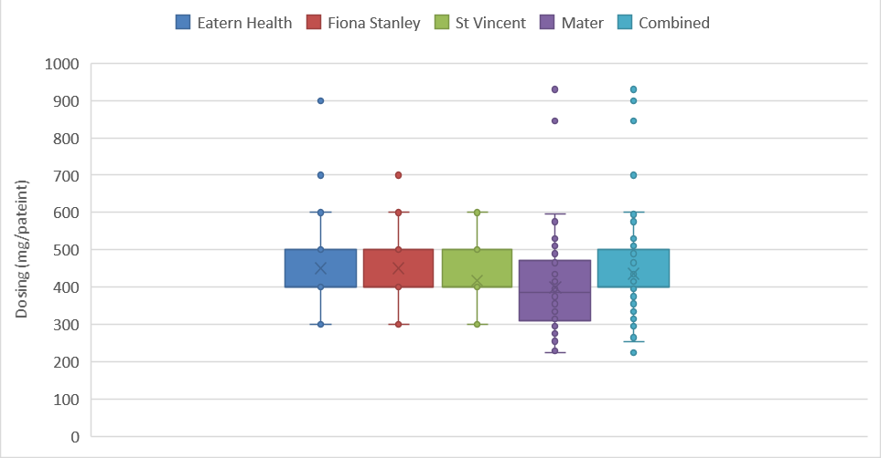Figure prepared by the Department based on data sourced from hospital market research included in the submission

  - The submission provided patient weight data for three hospitals (n=299, summarised by the Department in Figure 2). The weight distribution of the combined patient data indicated a median of 75.6 kg with a standard deviation of 20.8 kg. Around 42% of the analysed patients were over 80 kg and would have therefore required more than the maximum quantity of 4 vials (400 mg) of infliximab per infusion.

Figure 2: Weight distribution for hospital patients treated with infliximab for gastroenterological conditions
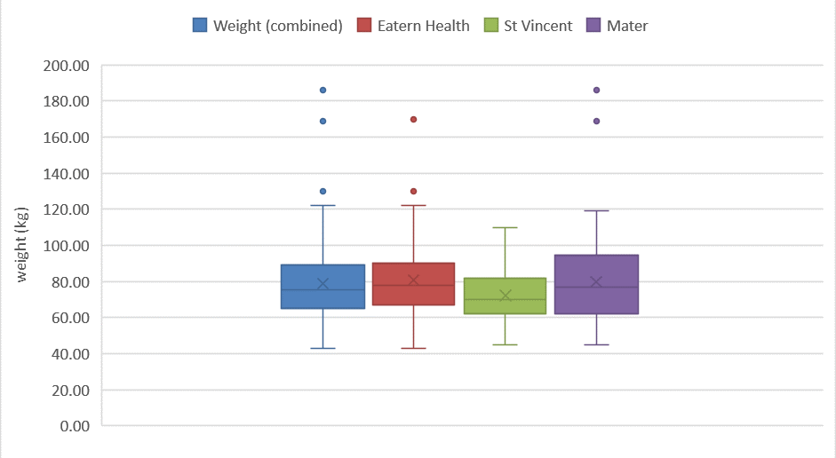Figure prepared by the Secretariat based on data sourced from hospital market research included in the submission

  - The Department conducted an analysis of PBS data to quantify the number of prescriptions in 2018 for subsequent continuing treatment where more than four vials were dispensed. As shown in Table 2, the five or more vials were dispensed for 41.7% of prescriptions across all of the listed indications for infliximab. The PBAC noted that this utilisation analysis was consistent with the sponsor’s research.

Table 2: Infliximab prescriptions in 2018 for subsequent continuing treatment
Indication | Total prescriptions | Prescriptions with  ≥5 vials dispensed | Proportion (%) of prescriptions with ≥5 vials dispensed
Ankylosing spondylitis | 80 | 52 | 65.0%
Complex refractory fistulising Crohn disease | 985 | 460 | 46.7%
Moderate to severe Crohn disease | 179 | 17 | 9.5%
Moderate to severe ulcerative colitis | 52 | 15 | 28.8%
Severe Crohn disease | 3,974 | 1,653 | 41.6%
Severe psoriatic arthritis | 4 | 2 | 50.0%
Total | 5,274 | 2,199 | 41.7%
Note: Data was extracted from the DHS Supplied Prescriptions Database on 8 March 2019 based on the date of supply. The data extraction period was 1 January to 31 December 2018.
Infliximab for severe chronic plaque psoriasis was listed on the PBS on 1 January 2019. As such its utilisation is not captured in this analysis.

  - The minor submission claimed that increasing the maximum quantity from 4 to 5 vials will not change the utilisation of the medicine, hence the cost to the Government will remain the same.
For more detail on PBAC’s view, see section 5 PBAC outcome.
- PBAC Outcome
  - The PBAC recommended an increase in the maximum quantity for the Section 100 (Highly Specialised Drugs) (Public hospital) Authority Required (STREAMLINED) listings of infliximab for subsequent continuing treatment to five vials across for all the requested indications (see the table in Section 6 below).
  - The PBAC noted that based on the weight-based dosing regimens stated in the TGA-approved Product Information (PI), the current infliximab PBS listing has maximum quantities sufficient for patients weighing up to 80 kg (5 mg/kg) for the requested indications. The recommended change in maximum quantity would provide sufficient supply for the treatment of patients weighing up to 100 kg.
  - The PBAC noted the utilisation analysis conducted by the Department indicated an average of around 42% of infliximab prescriptions across the requested indications were dispensed with five or more vials. The PBAC considered the submission’s claim that a significant portion of patients currently require more than the maximum quantity of infliximab per prescription was adequately justified.
  - The PBAC noted that if utilisation remains the same as a result of increasing the maximum quantity, there would be no financial implications for Government. The PBAC considered that the increase in maximum quantity would remove the need for those prescribers seeking to prescribe five vials (who would otherwise have used a streamlined authority code) to apply for an authority by telephone. The PBAC noted that utilisation was likely to remain the same regardless of an increase to the maximum quantity, therefore this change should not have significant financial implications for Government.
  - The PBAC noted the analysis by the Department indicated there was variation in the proportion of patients requiring 5 or more vials of infliximab across the different indications (see Table 2). The PBAC requested the Department monitor the utilisation of infliximab 12-24 months after implementation of the increases to the maximum quantities.
  - The PBAC considered that the amendment on the maximum quantity of infliximab should apply to all brands of infliximab available on the PBS with S100 HSD (Public hospital) Authority Required (STREAMLINED) listings.
  - The PBAC noted that this submission does not meet the criteria for an Independent Review as it received a positive recommendation.
Outcome:
Recommended

- Recommended listing
  - Amend maximum quantity to the following S100 HSD (Public hospital) Authority Required (STREAMLINED) listings, as follows:
Item Number | Indication | Treatment phase | Current Max Quantity | Proposed Max Quantity
11400B | Severe Crohn disease | Subsequent continuing | 4 | 5
11423F | Complex refractory fistulising Crohn disease | Subsequent continuing | 4 | 5
11449N | Moderate to severe Crohn disease | Subsequent continuing | 4 | 5
11461F | Moderate to severe ulcerative colitis | Continuing ª | 4 | 5
11486M | Ankylosing spondylitis | Subsequent continuing | 4 | 5
11514B | Severe psoriatic arthritis | Subsequent continuing | 4 | 5
11605T | Severe chronic plaque psoriasis ^{b} | Subsequent continuing | 4 | 5

- Context for Decision
The PBAC helps decide whether and, if so, how medicines should be subsidised in Australia. It considers submissions in this context. A PBAC decision not to recommend listing or not to recommend changing a listing does not represent a final PBAC view about the merits of the medicine. A company can resubmit to the PBAC or seek independent review of the PBAC decision.
- Sponsor’s Comment
The sponsor had no comment.

