3.01 PEMBROLIZUMAB,
Powder for injection 50 mg, solution concentrate for I.V. infusion 100 mg in 4 mL,
Keytruda®, Merck Sharp & Dohme (Australia) Pty Ltd
- Purpose
  - To provide advice to the Minister (delegate), under section 101(3) of the National Health Act 1953 (the Act) on the following:
  - making amendments to the circumstances in which a prescription for the supply of pembrolizumab can be written under section 85(7) of the Act by removing the non-small cell lung cancer (NCSLC) circumstances (identified as ‘C8122’, ‘C8123’ and ‘C8124’ in the National Health (Listing of Pharmaceutical Benefits) Instrument 2012) from the list of these circumstances; or
  - making appropriate amendments to the circumstances in which a prescription for the supply of pembrolizumab can be written under section 85(7) of the Act by increasing the Authority Requirements of pembrolizumab when used for NSCLC (circumstances ‘C8122’, ‘C8123’ and ‘C8124’) to a ‘written Authority required’ type of pharmaceutical benefit.
  - The Minister’s Delegate sought advice from the PBAC outlined above prior to making a decision on whether to make amendments to the circumstances in which a prescription for the supply of pembrolizumab for NSCLC can be written under section 85(7) of the Act. The Minister’s Delegate proposed making amendments for pembrolizumab monotherapy in NSCLC following the refusal of the sponsor, Merck Sharp & Dohme (Australia) Pty Ltd (MSD) to offer a ''''''''% price reduction to the current ex-manufacturer price of pembrolizumab for this indication. The Delegate asked that, in addition to any other matters that the PBAC may wish to address, the PBAC advise whether it considers that there are reasons why the Delegate should not amend the determination by one or both of the options as proposed, and if so what those reasons are.
- Background
  - At the July 2018 meeting the PBAC recommended the listing of pembrolizumab under special arrangements under Section 100 (Efficient funding of chemotherapy) as an Authority Required (STREAMLINED) item for the first-line treatment of metastatic NSCLC in patients whose tumours express PD-L1 at Tumour Proportion Score (TPS) ≥50%, on the basis of acceptable incremental cost-effectiveness within an acceptable overall net cost to the PBS each year of eligible patients defined by this listing (paragraph 6.1, item 7.17 pembrolizumab, July 2018 PBAC minutes).
  - The PBAC recommendation was based on, among other things, its acceptance that the cost-effectiveness of treatment with pembrolizumab monotherapy was acceptable at an estimated drug cost per treatment course of $'''''''''''' (drug cost $''''''''''' per infusion for an average of 16.52 infusions, with a '''''% rebate applied on administrations from '''''''''''' ''''' onwards (paragraph 6.3, item 7.17 pembrolizumab July 2018 PBAC minutes)).
  - The clinical data presented by the applicant, Merck Sharp & Dohme (Australia) Pty Ltd (MSD) for pembrolizumab was from the study KEYNOTE-024 (KN024), a phase 3, multicentre, randomised, open-label, controlled study comparing pembrolizumab monotherapy to platinum-based chemotherapy in NSCLC. KN024 enrolled patients with previously untreated EGFR wild type, ALK translocation negative metastatic NSCLC with an ECOG status 0 or 1; with a PDL1 TPS ≥ 50% NSCLC (Cancer stage at screening: IIIB 0.7%; IV 99.3%). Subjects randomised to chemotherapy in KEYNOTE-024 were permitted to crossover to pembrolizumab treatment provided they met the protocol requirements. Among the subjects randomised to chemotherapy, 54% crossed over to treatment with pembrolizumab in the Crossover Phase of the study.
  - The outcomes of KN024 relied upon by the PBAC in July 2018 are summarised in Table 1.
Table 1: Results of OS (19 months median follow-upª), ITT population, KN-024
Treatment | Events  n/N (%) | Person-months | OS rate at Month 12  (95% CI) | Median OS (months)^{b}  (95% CI) | HR^{c} (95% CI)  p-value^{d}
Pembrolizumab | 63/154 (40.9%) | 2150.8 | 70.3%  (62.3%, 76.9%) | Not reached  (14.9, not reached) | 0.63 (0.46, 0.88)  p = 0.003
Chemotherapy | 84/151 (55.6%) | 1779.8 | 54.8%  (46.4%, 62.4%) | 14.5  (9.8, 19.6)
Abbreviations: CI = confidence interval; HR = hazard ratio; ITT = intention-to-treat; OS = overall survival
ª Database cut-off date: 5 January 2017
^{b} From product-limit (Kaplan-Meier) method for censored data.
^{c} Pembrolizumab vs chemotherapy. Based on Cox regression model with treatment as a covariate stratified by geographic region (East Asia vs non-East Asia), performance status (0 vs 1) and histology (squamous vs non-squamous).
^{d} One-sided p-value based on log-rank test.
Source: Table PBAC 6; ESC Advice October 2016, Item 7.07

  - In November 2018, pembrolizumab was listed on the PBS for use in the first line treatment of metastatic NSCLC in patients with a PD-L1 TPS ≥ 50% at a dispensed price of $'''''''''' per 200 mg infusion ($''''''''''' ex-manufacturer price for 200 mg) ''''''' '''''''''''''''' ''' '''''''''''' ''''' '''''''''''''''''''''''''''' from ''''''''' ''''' onwards. The inclusion of the reduced price and removal of the rebate from the July 2018 economic model resulted in an ICER/QALY of $45,000 to $75,000.
  - Pembrolizumab is also currently listed on the PBS for unresectable Stage III or Stage IV malignant melanoma, for relapsed or refractory Hodgkin lymphoma and for urothelial cancer.
  - The Department made a price reduction request for pembrolizumab on 14 December 2018, after MSD was asked on four occasions to update the economic analysis for pembrolizumab when used as a single agent therapy in NSCLC to include the results from a second study in this indication, KEYNOTE-042 (KN042). Although the top-line results for a planned interim analysis of KN042 had been published in early June 2018, the MSD submission considered at the July 2018 PBAC meeting did not include those results, nor were these results provided to the Department in the context of the subsequent price negotiations for pembrolizumab monotherapy for NSCLC, notwithstanding that those negotiations took place when MSD had access to the final Clinical Study Report for the interim analysis of KN042.
  - KN042 was an open-label, Phase 3 study to evaluate pembrolizumab monotherapy (200 mg Q3W) versus chemotherapy in previously untreated subjects with locally advanced or metastatic squamous or non-squamous NSCLC whose tumours expressed PD-L1 TPS ≥1% with no EGFR or ALK genomic tumour aberrations. Crossover from chemotherapy to pembrolizumab was not provided within the study protocol. At the time of the February 2018 data cut-off, 30 of 637 subjects on chemotherapy continued on treatment. Of the remaining 607 subjects who discontinued treatment in the chemotherapy group, 126 (20.8%) received a checkpoint inhibitor (pembrolizumab, atezolizumab, avelumab, or nivolumab) as subsequent therapy during follow-up.
  - The overall survival results from KN042 are summarised in Table 2.
Table 2: Results of OS (13 months median follow-upª), PD1 ≥ 50% population, KN-042
Treatment | Events  n/N (%) | Person-months | OS rate at Month 12  (95% CI) | Median OS (months)^{b}  (95% CI) | HR^{c} (95% CI)  p-value^{d}
Pembrolizumab | 157/299 (52.5%) | 4436.5 | 63.5%  (57.8%, 68.7%) | 20.0  (15.4, 24.9) | 0.69 (0.56, 0.85)  p = 0.003
Chemotherapy | 199/300 (66.3%) | 3876.2 | 50.7%  (44.9%, 56.2%) | 12.2  (10.4, 14.2)
CI = confidence interval; HR = hazard ratio; ITT = intention-to-treat; OS = overall survival
ª Database Cutoff Date: 26FEB2018
^{b} From product-limit (Kaplan-Meier) method for censored data.
^{c} Based on Cox regression model with treatment as a covariate stratified by geographic region (East Asia vs. non-East Asia), ECOG PS (0 vs. 1) and histology (squamous vs. non-squamous).
d One-sided p-value based on stratified log-rank test.
Source: MSD 1 October 2018 response to Department request of 28 September 2018.
  - The MSD submission to PBAC of 4 February 2019 reports that the hazard ratio for the combined results of KN024 and KN042 is 0.67 (95% CI: 0.56, 0.90).
  - A timeline of events leading up to the Department’s price reduction request is provided in Table 3.

Table 3 Consolidated timeline - Key events relating to KN042
Date | Event | Department’s Comments | MSD’s comments (provided in 4 February 2019 submission)
3 June 2018 | Top line results for KN042 published |  | The top-line results confirm the KEYNOTE-024 trial results
27 June 2018 | MSD pre-PBAC response for pembrolizumab monotherapy for first-line treatment of NSCLC submission to July PBAC meeting | No reference made to KN042 results | The pre-PBAC response was in relation to financial estimates, so the KN042 trial was less relevant given it was confirmatory.
4 – 6 July 2018 | PBAC recommends pembrolizumab monotherapy for first-line treatment of NSCLC | Recommendation based on KN024 results
4 July 2018 | MSD provides top-line results for KN042 in November 2018 PBAC submission for pembrolizumab in combination with platinum chemotherapy and pemetrexed for NSCLC (pembrolizumab combination therapy) | MSD indicates it intends to use KN042 full results, when available, to support claim the combination therapy is superior to monotherapy. An outline of study design is provided together with published abstract but no analysis of KN042 outcomes provided at this time. | A high-level review of the KN042 trial was included in the Keytruda combination submission.  As full results were not yet available to MSD, we committed to providing these in the commentaries.
End July 2018 | Full KN042 Clinical Study Report available to MSD (Australia) | per MSD letter dated  18 December 2018 | MSD worked on including these results in the Keytruda combination commentaries.
15 August 2018 | MSD submits pricing proposal for pembrolizumab monotherapy for first-line treatment of NSCLC as recommended by PBAC at July meeting.
15 August – 27 September 2018 | Department and MSD negotiations on pembrolizumab monotherapy for first-line treatment of NSCLC price involving multiple email exchanges, telephone and face-to-face meetings
19 Sept 2018 | MSD includes new analysis utilising KN042 results in Pre-Sub-Committee response for pembrolizumab combination therapy submission | This analysis is foreshadowed in 4 July 2018 submission. It informs comparison of pembrolizumab combination therapy with pembrolizumab monotherapy only. | MSD provides KN042 results to the DoH, ESC and PBAC.
27 September 2018 | Department writes to MSD to indicate on receipt of formal price offer through Pb11a form it will recommend price offered by MSD for pembrolizumab monotherapy for first-line treatment of NSCLC for agreement by Minister/delegate.
28 September 2018 | Department requests MSD response on implications of KN042 outcomes for value proposition for pembrolizumab monotherapy for first-line treatment of NSCLC |  | MSD requests further clarity on what process is being followed but the DoH cannot provide any more detail.
1 October 2018 | MSD responds to Department’s request of 28 September | MSD response provided to ESC and PBAC | Consistent with PBAC processes, MSD awaits final advice from the PBAC.
18 October 2018 | ESC Advice requests MSD examine implications of KN042 outcomes for value proposition for pembrolizumab monotherapy. The ESC considered ”it would be informative for the economic model submitted with the July 2018 submission for pembrolizumab for NSCLC to be re-run incorporating the results from KN042” |  | No timeline or process for reviewing the model is specified.  MSD (Aus) advised that final analysis of KN042 will be available in Dec 2018.
25 October 2018 | MSD pre-PBAC response on pembrolizumab combination therapy submission | MSD “acknowledges that these analyses (incorporating KN042 results) are relevant to the KN024 value proposition but does not currently have access to a KN042 economic model to submit at this time. MSD is committed to ensuring that PBAC has all relevant up-to-date clinical data for pembrolizumab, and will work with the Department to discuss the model requirements and ensure that it is made available at the earliest possible time”. | Consistent with PBAC processes, MSD will address these concerns via a minor or major re-submission.
25 October 2018 | MSD meeting with Deputy Secretary and First Assistant Secretary Department of Health | MSD commits to doing requested KN042 work as quickly as possible. | MSD advised the Department that we are awaiting the final analysis for KN042.  Consistent with PBAC processes, MSD is also awaiting final advice from the PBAC.
31 October - 2 November 2018 | PBAC meeting at which pembrolizumab combination therapy submission considered
7 November 2018 | MSD advised pembrolizumab combination therapy submission rejected by the PBAC at November meeting
22 November 2018 | Department requests update from MSD on KN042 work
23 November 2018 | MSD response to 22 November request from Department | MSD indicates another data cut is expected for KN042 and that it is hesitant to do work ahead of this; requests clarification of what is needed, and states “We understand that you would like to progress this issue quickly, but we are balancing this with the internal global resourcing required for your request.” | MSD again requests more clarity on the review process but is not given clear guidance.
7 December 2018 | MSD advised that the Keytruda combination minutes are delayed. |  | No further information is provided as to the reasons for the delay in our minutes.
11 December 2018 | MSD receives a letter about the broad subsidy for PD-(L)1 therapies in NSCLC, indicating further information will be provided in January with submissions in March 2019. |  | MSD continues working towards a March submission deadline, in light of this new information and deadline.
11 December 2018 | Department provides MSD with explanation “the delay in finalising these (pembrolizumab with pemetrexed and chemotherapy)minutes is in large part due to the efforts we put into finalising the details of pembrolizumab urothelial listing during the same period that we would normally have been working on minutes”.
14 December 2018 | Department writes to MSD to request price reduction for pembrolizumab monotherapy for first-line treatment of NSCLC |  | A full model supporting the basis of the price cut was not provided at this time. MSD was asked to replicate the model to understand how the price cut was calculated.
24 December 2018 | Department provides MSD with PBAC minutes for pembrolizumab in combination with chemotherapy and pemetrexed from November 2018 PBAC. These minutes include PBAC’s request that the July 2018 economic model be re-run with the results of KN042.  MSD offered a post-PBAC meeting in week beginning 7 January. | MSD declines offer of post-PBAC meeting for week of 7 January and seeks meeting in following week. | No reason for the delay in the PBAC minutes was provided.  The timing of the minutes on Christmas eve causes a delay in the post-PBAC meeting until mid-January.
17 January 2019 | MSD requests copy of Department modelling of KN042 results  MSD post-PBAC meeting for pembrolizumab combination therapy |  | While this meeting was for the pembrolizumab combination therapy, the KN042 trial was discussed. This is the first opportunity MSD had to seek clarification on the key concerns.  MSD was advised that the Keytruda combination could not progress until the issue with KN042 was resolved.
18 January 2019 | Department provides MSD with copy of modelling |  | This was provided following MSD’s request at the post-PBAC meeting.
21 January | ''''''''''''' ''''''''''''''''''' ''''' '''''''''''' '''''''''''' ''''''''''''''''''' ''''''' '''''''''''''''''''''''''''''''''''' '''''''''''''''''''''''''''' ''''''' '''''''''''''''''''' ''''''''''''''''''''' '''' ''''''''''''''''
23 January | Department declines MSD request to delay consideration of KN042 matter until July 2019 PBAC meeting  MSD informed PBAC advice has been requested on delisting or changing restriction level for pembrolizumab for NSCLC at March 2019 PBAC meeting.
4 February 2019 | MSD provides submission to PBAC. | MSD aware of possibility of referral to the PBAC and timeline for submission from 14 December 2018.
  - The method used by the Department to estimate the price reduction requested for pembrolizumab for NSCLC in its 14 December 2018 letter is set out in Table 4.

Table 4: Method used to estimate price reduction requested for pembrolizumab.
Stepped analysis | ICER
- ICER presented in July 2018 minor submission | $''''''''''''''''
- Changes to the model based on subsequent negotiations  - This analysis (i) removes the rebate for patients who received treatment for longer than 48 weeks; and (ii) incorporates the reduced effective ex-man price ($'''''''''''''' per 100 mg)  Set cell I44 in ‘Model Settings’ to 0 and cell D14 in ‘Regimen inputs’ to “='''''''''''''/'''” | $'''''''''''''''
- Modelling the pembrolizumab OS curve as a function of HR (assuming a HR = 0.63, based on KN-024), rather than individually fitting the observed pembrolizumab data to parametric models and extrapolating, as presented in the submission. No other changes have been made to the model.  In the drop down box in cell I50, ‘Model settings’, select ‘Modelled based on HR’  A comparison of the individually fitted and extrapolated pembrolizumab OS curve, to that modelled using the HR applied to the SoC OS curve is presented in Figure 1.  This alternate modelling approach has a minor effect on the resulting ICER.  Figure 1: A comparison of the KN-024 individually extrapolated pembrolizumab OS curve to that modelled assuming HR = 0.63  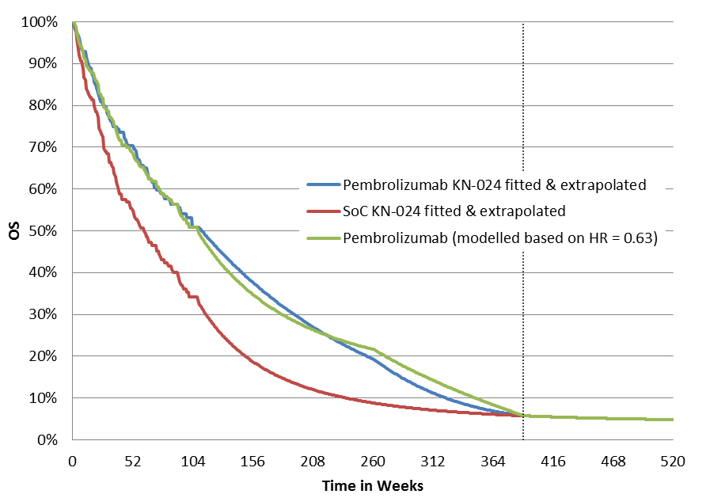  Note: Dashed line denotes model time horizon of 7.5 years (390 weeks)  HR = hazard ratio; OS = overall survival; SoC = standard of care | $''''''''''''''''
- Increasing the HR to 0.69 (based on updated OS data from KN-042, PDL1 TPS ≥50%)  Set cell W2 in ‘Modeled OS’ to 0.69  A comparison of the modelled curve to reflect the increase in the HR is presented in Figure 2.  Figure 2: A comparison of the KN-024 individually extrapolated pembrolizumab OS curve to that modelled assuming HR = 0.69  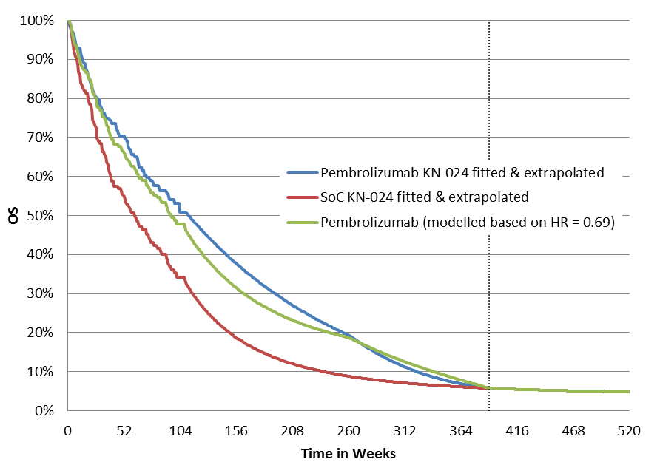  Note: Dashed line denotes model time horizon of 7.5 years (390 weeks)  HR = hazard ratio; OS = overall survival; SoC = standard of care | $'''''''''''''''''
- Price required to achieve an ICER similar to that at Step 2 $'''''''''''''''''
Set cell D14 in ‘Regimen inputs’ to “=''''''''''''''''''/'''” | $''''''''''''''''
  - On 21 January 2019 MSD formally refused the price reduction request made by the Department on 14 December 2018.
  - On 23 January 2019 the Department advised MSD of its intent to seek the advice of the PBAC on the options outlined in paragraph 1.1 for consideration by a delegate under Section 85 of the Act.
  - On 4 February 2019, MSD wrote to the PBAC with an accompanying submission, in which it requested, amongst other things, “that the PBAC reject the request to provide advice to the Minister on the de-listing or authority required for KEYTRUDA to treat Stage IV NSCLC until a major resubmission has been fully considered”. The minor submission stated that “the resubmission will provide further information on the KN042 trial, so the PBAC can fully consider its impact on the value proposition of KEYTRUDA monotherapy treatment for NSCLC.”
  - On 28 February the Department wrote to MSD in response to a number of the issues raised in MSD’s 4 February letter and accompanying submission. At the same time the Department indicated its preparedness to delay, until the PBAC’s July 2019 meeting, consideration of the question of an appropriate price for the pembrolizumab monotherapy if MSD was prepared to rebate the equivalent amount of the price reduction, should the PBAC recommend one.
  - On 28 February 2019, the Department also provided MSD with a copy of its overview for PBAC for the pembrolizumab monotherapy item (agenda item 3.01) for consideration at the March 13 – 15 meeting.
  - On 6 March 2019, MSD declined the Department’s offer on 28 February. On the same day, the Department confirmed to MSD that this matter would be considered by the PBAC at its March 13 – 15 meeting.
  - On 6 March 2019, MSD provided a pre-PBAC response in response to the Department’s overview.
- PBAC Discussion
  - The PBAC emphasised the critical importance of having all potentially relevant results at the time it considers a listing application in order to ensure evidence based decision making particularly when newly emerging data show differing benefits.
  - The PBAC requested that the Department work to implement new guidance and processes to ensure all available data is provided to PBAC in listing submissions and, where data becomes available following a PBAC recommendation for listing, there are processes to ensure those data are rapidly reviewed in the context of the value proposition on which the listing recommendation was based.
  - The PBAC considered each of the issues raised in the sponsor’s letter and submission dated 4 February 2019 and pre-PBAC response dated 6 March 2019, as well as correspondence from the Department to the sponsor dated 14 December 2018, 18 January 2019, 23 January 2019, 30 January 2019 and 28 February 2019 and correspondence from the sponsor to the Department dated 18 December 2019, 21 January 2019 and 6 March 2019.
  - The PBAC recalled it had recommended pembrolizumab monotherapy for listing for NSCLC in July 2018 on the basis of interim study results for KN024 (median follow up 19 months, data cut off 5 January 2017). The PBAC noted that based on the information provided, it is reasonable to conclude that MSD had failed to provide the PBAC with data from a planned analysis of a clinical trial which was relevant to the PBAC’s considerations in July 2018, particularly as the top-line results of this analysis had been released publicly a month before the PBAC meeting. The PBAC further noted that MSD had not provided these results to the Department in the context of the subsequent price negotiations for pembrolizumab monotherapy. The PBAC was not satisfied with MSD’s explanation that it had included the top-line results for KN042 in its separate submission to the November 2018 PBAC meeting for pembrolizumab combination therapy. The PBAC noted that this behaviour is contrary to the spirit of the submission guidelines with potential to undermine the integrity of its evidence based decision making processes. The PBAC requested that the submission guidelines should be amended to make it clear how such incidences should be managed in future.
  - The PBAC noted the Therapeutic Goods Administration (TGA) advice that MSD had submitted an application to extend the registered indications for pembrolizumab monotherapy in NSCLC in October 2018, with the submission to TGA including the 15 June 2018 final study report for the interim analysis of KN042. The PBAC noted MSD’s claim that the local company only had access to this report at the end of July 2018.
  - Regarding the impact of the KN042 trial on the value proposition for pembrolizumab monotherapy in NSCLC, the PBAC did not agree with MSD’s argument that the issue can only be addressed through a combination therapy resubmission. The PBAC considered it had sufficient information available to consider the value proposition of pembrolizumab monotherapy in light of the results of KN042.
  - The PBAC noted that the sponsor may make further submissions outlining whether pembrolizumab is cost-effective compared to alternative therapies at any time. If a submission were made after a price reduction, the sponsor could seek a price increase on the basis of the submission. In those circumstances, the PBAC did not consider that it should defer its consideration of the Minister’s request for advice until July 2019 as requested by the sponsor.
  - The PBAC agreed with the sponsor that the KN042 data supports the overall superior efficacy of pembrolizumab monotherapy as a treatment for NSCLC, but considered the evaluation of the value proposition to be separate.
  - The PBAC noted the sponsor had criticised the Department for conducting its economic analysis solely on the basis of KN042 but had not presented its own economic analysis, or disputed the method by which the Department conducted the analysis (refer Table 4 above).
  - The PBAC noted that when the KN042 hazard ratio is used in the economic model presented to the July 2018 PBAC meeting as set out in Table 4 above, the incremental cost effectiveness ratio per quality adjusted life year (ICER/QALY) at the current effective ex-manufacturer price, increases from the $45,000 to $75,000 at which the listing proceeded on 1 November 2018 (based on the KN024 data) to $45,000 to $75,000.
  - The PBAC did not accept the sponsor’s argument that the analysis should be based only on the final results of KN042 (which require further evaluation), noting that it is not unusual for PBAC to make an assessment of value based on interim results from clinical trials.
  - The PBAC also did not accept as relevant, the sponsor’s claim that an ICER/QALY of $45,000 to $75,000 should be acceptable for pembrolizumab monotherapy in NSCLC because it is lower than the ICER/QALY that the PBAC accepted for pembrolizumab for other indications or because it remains within the ranges of the sensitivity analyses considered by the PBAC when it recommended pembrolizumab monotherapy in NSCLC. The PBAC considers the cost-effectiveness of treatments on a case-by-case basis and does not apply a predefined fixed ICER threshold.
  - The PBAC recalled it had considered the applicability of the KN042 data to the Australian setting in November 2018, in forming its view that it would be appropriate to rerun the July 2018 pembrolizumab monotherapy economic model with the KN042 results. The PBAC considered that the sponsor’s argument over the extent of applicability of the KN042 dataset does not remove the need to reassess the value of this intervention given the overlap in the populations in the KN024 and KN042 trials.
  - The PBAC noted the sponsor had presented the results of a combined (meta) analysis of the KN024 and KN042 data sets in its 4 February 2019 submission and that this result supports the need for a price reduction to achieve an ICER/QALY consistent with the basis on which pembrolizumab monotherapy was listed for use in NSCLC. The ICER/QALY results generated using the July 2018 economic model with the different hazard ratios from the individual trials and the combined analysis are provided in Table 5.
Table 5: July 2018 economic model ICER results with different hazard ratios and prices
 | Ex-man price (200mg) | ICER
July 2018 PBAC  (KN024, HR 0.63) | $''''''''''' proposed  (+''''''% rebate after ''''' ''''''''') | $''''''''''''''''
Agreed price Sept 2018  (KN024, HR 0.63) | $''''''''''' agreed  ('''''' '''''''''''''''' ''''''''''' '''''' '''''''''''''''') | $'''''''''''''''''
Re-run model  KN042 HR 0.69 | $'''''''''''' | $'''''''''''''''
Re-run model  KN042 HR 0.69 | $'''''''''''''''''''' | $''''''''''''''''''
combined analysis HR 0.67 | $''''''''''''' | $'''''''''''''''
The redacted table shows ICERs in the range of $45,000/QALY to $75,000/QALY.
  - Lastly the PBAC noted the early data on initiations to pembrolizumab monotherapy (see Figure 1). The PBAC recalled that the eligible population of PDL1 ≥ 50%, EGFR and ALK negative patients comprises 19.53% of the eligible second line population for nivolumab and atezolizumab with a small uplift of 5% beyond the estimated numbers of patients each year for whom nivolumab/atezolizumab cost offsets are expected. (ratified PBAC minutes, item 7.17, July 2018). The PBAC noted that 313 and 317 patients had accessed pembrolizumab through grandfather and initial NSCLC prescriptions in the first 3 months of listing, respectively. During this same period, 278 and 168 patients initiated treatment with nivolumab or atezolizumab for NSCLC. Although recognising that it is too early to draw any firm conclusions regarding these data, the PBAC noted the potential for pembrolizumab to be used outside the PDL1≥ 50% population.
Figure 1
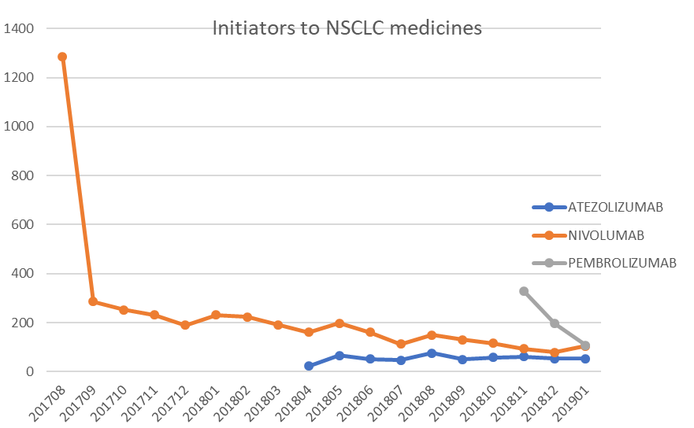
  - Overall, on consideration of all the information provided to it, the PBAC advised that it remains confident that the overall clinical claim of superior efficacy remains supported and unchanged for pembrolizumab monotherapy in the PDL1≥50% population. However, in light of the KN042 data, there is increased uncertainty regarding the cost-effectiveness of pembrolizumab monotherapy for this indication.
  - The PBAC considered the ICER/QALY of $45,000 to $75,000 to be acceptably cost-effective. However this is reliant on the correct inputs being used in the economic model, which the PBAC considered to be the hazard ratio of 0.67 from the combined analysis of KN024 and KN042, as presented in the MSD submission of 4 February 2019. Thus, the PBAC recommended the Department pursue a price reduction of around ''' percent to the effective price of pembrolizumab monotherapy for non-small cell lung cancer. The PBAC considered that such a price reduction would re-establish certainty of cost-effectiveness of pembrolizumab monotherapy in NSCLC and take account of the evidence from both KN024 and KN042.
  - The PBAC deliberated on the two options outlined by the Minister’s delegate and considered that the sponsor’s refusal to offer a new price for pembrolizumab in NSCLC based on the updated evidence disadvantages prescribers and consumers.
  - The PBAC noted that a written authority requirement places a large administrative impost on prescribers. Instead, the PBAC further advised there was no reason the Minister (delegate) should not amend the circumstances for pembrolizumab to telephone authority, if required (from the current streamlined authority), with prescribers being asked to verbally confirm that the patient meets each aspect of the restriction requirement.
  - The PBAC further advised if an alternative first line immunotherapy regimen, whether it be monotherapy or combination therapy becomes available on the PBS, it would be ready to re-consider the future place of pembrolizumab in the therapy of NSCLC. Potential options, while retaining the higher price, include limiting access to pembrolizumab subsidy to only include patients for whom no other first line immunotherapy based option for NSCLC is available on the PBS.
  - The PBAC considered that the Minister should take into account the potential for Quality Use of Medicine issues to arise from any future amendments to the listing of pembrolizumab on the PBS. It recommended that a communication and education plan, involving the Medical Oncology Group of Australia (MOGA), prescriber, hospital pharmacist and consumer groups be implemented. The PBAC considered the key messages should include the reasons for the change in PBS availability.
  - There were no other matters that the PBAC considered the Minister should take into account when considering whether to amend the circumstances for pembrolizumab monotherapy for NSCLC on the PBS.
- Context for Decision
The PBAC helps decide whether and, if so, how medicines should be subsidised in Australia. It considers submissions in this context. A PBAC decision not to recommend listing or not to recommend changing a listing does not represent a final PBAC view about the merits of the medicine. A company can resubmit to the PBAC or seek independent review of the PBAC decision.
- Sponsor’s Comment
Given the volume of new data being reported in this area, MSD welcomes the new guidance and processes around data to be provided to the PBAC in listing submissions and following a PBAC recommendation. This guidance will help to clarify the frequency with which pricing needs to be re-assessed. Since this consideration, MSD notes that further data on the 5-year overall survival data from Keynote-001 (Garon et al, 2019, released in June 2019 at ASCO), shows that the KN024 economic model under-estimated the long-term survival of treated patients. This new data requires consideration in the context of the current value proposition for pembrolizumab monotherapy.

Reck, M, Rodriguez-Abreu, D, et al. Pembrolizumab versus chemotherapy for PD-L1–positive non–small-cell lung cancer. New England Journal of Medicine 2016; 375(19):1823-33
MSD submission 4 February 2019, pp 9.

