6.08 PEMBROLIZUMAB

Solution concentrate for I.V. infusion 100 mg in 4 mL,

Keytruda®,

Merck Sharp & Dohme (Australia) Pty Ltd
- Purpose of submission
        - The application requested MBS listing of programmed death ligand 1 (PD-L1) testing and PBS listing of pembrolizumab for the targeted treatment of recurrent or metastatic (R/M) squamous cell carcinoma (SCC) of the oral cavity, pharynx and larynx (also referred to herein as head and neck SCC (HNSCC)) in patients with combined positive score (CPS) ≥1.
        - The requested basis for listing was cost-effectiveness compared with standard of care (SoC). The submission proposed that first-line (1L) platinum + 5-FU (referred to as chemotherapy herein) was the main comparator followed by second-line (2L) nivolumab in a proportion of patients (assumed to be 66.7%). This regimen is also referred to as the standard of care (SoC) and is used interchangeably herein.

Table 1: Key components of the clinical issue addressed by the submission
Component | Description
Population | Test: patients with recurrent or metastatic (R/M) squamous cell carcinoma (SCC) of the oral cavity, pharynx and larynx who have not had prior systemic therapy administered in the recurrent or metastatic setting.  Medicine: patients with R/M SCC of the oral cavity, pharynx and larynx who have not had prior systemic therapy administered in the recurrent or metastatic setting whose tumours express PD-L1 Combined Positive Score (CPS) ≥1.
Intervention | Test: PD-L1 testing using the 22C3 antibody as part of the PharmDX kit or as a laboratory developed test (LDT).  Medicine: pembrolizumab (200 mg IV) every 3 weeks in combination with platinum and 5-FU, OR pembrolizumab (200 mg IV) every 3 weeks as a single agent.
Comparator | Test: no testing.  Medicine: standard of care (SoC), defined as carboplatin (AUC 5 mg/m²) IV or cisplatin (100 mg/m²) IV and 5-FU (1000 mg/m² per day for 4 consecutive days) IV every 3 weeks for six cycles followed by 2nd-line nivolumab 480mg every 4 weeks in 66.7% of patients.
Outcomes | Overall survival, progression-free survival, overall response rate, safety and quality of life.
Clinical claim | In patients with recurrent or metastatic squamous cell cancer of the head & neck who have not had prior systemic therapy administered whose tumours express CPS ≥1:  - pembrolizumab in combination with chemotherapy (platinum + 5-FU) is superior to platinum + 5-FU in terms of efficacy and non-inferior in terms of safety; and  - pembrolizumab as monotherapy is superior to platinum + 5-FU in terms of efficacy and superior in terms of safety
Source: Table 1.1-1, p2-3 of the submission
        - The submission proposed that PD-L1 testing with CPS scoring will become a part of the diagnostic workup in patients with newly diagnosed metastatic disease. Patients whose disease has recurred and who are not suitable for local treatment are currently re-biopsied as part of standard treatment. Once PD-L1 status is confirmed, pembrolizumab may be considered as a treatment option.
        - Pembrolizumab may be used as monotherapy or together with chemotherapy and would replace SoC (1L chemotherapy ± 2L nivolumab). The use of 1L pembrolizumab would preclude patients from accessing PBS-subsidised 2L nivolumab, as the current 2L nivolumab restriction states that patients must not have received prior treatment with a programmed cell death-1 (PD-1) inhibitor for R/M SCC of the oral cavity, pharynx and larynx. Therefore 1L pembrolizumab would directly replace 2L nivolumab use. The PBAC noted there is also a group of patients who are treated with curative intent (generally with chemoradiotherapy) and where these patients relapse within 6 months they are eligible for nivolumab.
- Requested listing
        - The requested listing is presented below. Suggestions and additions proposed by the Secretariat are added in italics and suggested deletions are crossed out with strikethrough.
Name, manner of administration | PBS item code | Max. Amount | №.of Rpts | Dispensed Price for Max. Amount | Proprietary name and manufacturer
PEMBROLIZUMAB  100 mg/4 mL injection | NEW (Public)  NEW (Private) | 200 mg | 6 | Published  $8,717.46 (private)  $8,559.06 (public)  Effective (SPA) ª  $''''''''''''''''''''''' (private)  $''''''''''''''''''''''' (public) | Keytruda  Merck Sharp & Dohme (Australia) Pty Ltd

Initial treatment - Restriction Summary [new] / ToC: [new]
Category/Program: Section 100 – Efficient Funding of Chemotherapy; Public/Private Hospital
Prescriber type:
Dental Medical Practitioners Nurse practitioners Optometrists Midwives
Restriction Level / Method:
Streamlined
Administrative Advice: No increase in the maximum quantity or number of units may be authorised.
Administrative Advice: No increase in the maximum number of repeats may be authorised.
Administrative Advice: Special Pricing Arrangements apply.
Administrative Advice: Patient should be treated with the recommended dose of pembrolizumab according to the TGA-approved Product Information.
Severity: Recurrent or metastatic
Condition: Head and neck squamous cell carcinoma (HNSCC) Squamous cell carcinoma of the oral cavity, pharynx or larynx
Indication: Recurrent or metastatic squamous cell carcinoma of the oral cavity, pharynx or larynx
Treatment Phase: Initial treatment
Clinical criteria:
The condition must be recurrent or metastatic squamous cell carcinoma of the oral cavity, pharynx or larynx incurable by local therapies in the locally advanced setting
AND
Clinical criteria:
The condition should not have had prior systemic therapy administered in the recurrent or metastatic setting; or
Patient must not have had systemic therapy for this condition in the recurrent or metastatic setting prior to initiating PBS-subsidised treatment with this drug for this condition;
AND
Patient must not have experienced had a disease recurrence within 6 months of completion of systemic therapyplatinum-based chemotherapy if previously treated in the locally advanced setting
AND
Clinical criteria:
Patient must have had a WHO performance status of 0 or 1
AND
Clinical criteria:
The treatment must be administered as a single agent (monotherapy) in patients whose tumours express PD-L1 CPS ≥1; or
The treatment must be commenced in combination with platinum-based chemotherapy in patients whose tumours express PD-L1 CPS ≥1
AND
Clinical criteria:
The condition must express programmed cell death ligand 1 (PD-L1) with a combined positive score (CPS) ≥1 in the tumour sample
AND
Clinical criteria:
The treatment must not exceed a total of 7 doses under this restriction
Administrative Advice:
In the first few months after start of immunotherapy, some patients can have a transient tumour flare with subsequent disease response. When progression is suspected, this should be confirmed through a confirmatory scan, taken at least 4 weeks later.

Name, manner of administration | PBS item code | Max. Amount | №.of Rpts | Dispensed Price for Max. Amount | Proprietary name and manufacturer
PEMBROLIZUMAB  100 mg/4 mL injection | NEW (Public)  NEW (Private) | 200 mg | 6 | Published  $8,717.46 (private)  $8,559.06 (public)  Effective (SPA) ª  $''''''''''''''''''''' (private)  $'''''''''''''''''''' (public) | Keytruda  Merck Sharp & Dohme (Australia) Pty Ltd
Continuing treatment - Restriction Summary [new] / ToC: [new]
Category/Program: Section 100 – Efficient Funding of Chemotherapy; Public/Private Hospital
Prescriber type:
Dental Medical Practitioners Nurse practitioners Optometrists Midwives
Restriction Level / Method:
Streamlined
Administrative Advice: No increase in the maximum quantity or number of units may be authorised.
Administrative Advice: No increase in the maximum number of repeats may be authorised.
Administrative Advice: Special Pricing Arrangements apply.
Administrative Advice: Patient should be treated with the recommended dose of pembrolizumab according to the TGA-approved Product Information.
Severity: Recurrent or metastatic
Condition: Head and neck squamous cell carcinoma (HNSCC) Squamous cell carcinoma of the oral cavity, pharynx or larynx
Indication: Recurrent or metastatic squamous cell carcinoma of the oral cavity, pharynx or larynx
Treatment Phase: Continuing treatment
Clinical criteria:
Patient must have previously received PBS-subsidised treatment with this drug for this condition
AND
Clinical criteria:
Patient must not have developed disease progression while being treated with this drug for this condition
AND
Clinical criteria:
The treatment must not exceed a total of 35 cycles in a lifetime or up to 24 months of treatment under this restriction

Name, manner of administration | PBS item code | Max. Amount | №.of Rpts | Dispensed Price for Max. Amount | Manufacturer
PEMBROLIZUMAB  100 mg/4 mL injection | NEW (Public)  NEW (Private) | 200 mg | 6 | Published  $8,717.46 (private)  $8,559.06 (public)  Effective (SPA) ª  $''''''''''''''''''''''' (private)  $'''''''''''''''''''''' (public) | Keytruda  Merck Sharp & Dohme (Australia) Pty Ltd

Grandfather treatment - Restriction Summary [new] / ToC: [new]
Category/Program: Section 100 – Efficient Funding of Chemotherapy; Public/Private Hospital
Prescriber type:
Dental Medical Practitioners Nurse practitioners Optometrists Midwives
Restriction Level / Method:
Streamlined
Administrative Advice: No increase in the maximum quantity or number of units may be authorised.
Administrative Advice: No increase in the maximum number of repeats may be authorised.
Administrative Advice: Special Pricing Arrangements apply.
Administrative Advice: Patient should be treated with the recommended dose of pembrolizumab according to the TGA-approved Product Information.
Severity: Recurrent or metastatic
Condition: Head and neck squamous cell carcinoma (HNSCC) Squamous cell carcinoma of the oral cavity, pharynx or larynx
Indication: Recurrent or metastatic squamous cell carcinoma of the oral cavity, pharynx or larynx
Treatment Phase: Grandfather treatment
Clinical criteria:
Patient must have previously received non-PBS subsidised treatment with this drug for this condition in the recurrent/metastatic setting prior to [listing date]
AND
Clinical criteria:
Patient must not have received prior PBS-subsidised treatment with a programmed cell death-1 (PD-1) inhibitor or a programmed cell death ligand-1 (PD-L1) inhibitor for this condition
AND
Clinical criteria:
Patient must not have had systemic therapy for this condition in the recurrent or metastatic setting prior to initiating non PBS-subsidised treatment with this drug for this condition;
AND
Patient must not have experienced disease recurrence within 6 months of completion of systemic therapy if treated in the locally advanced setting prior to non-PBS subsidised treatment with this drug for this condition
AND
Clinical criteria:
The treatment must be administered as a single agent (monotherapy); or
The treatment must be commenced in combination with platinum-based chemotherapy
AND
Clinical criteria:
The condition must express programmed cell death ligand 1 (PD-L1) with a combined positive score (CPS) ≥1 in the tumour sample
AND
Clinical criteria:
Patient must not have developed disease progression while being treated with this drug for this condition
AND
Clinical criteria:
Patient must have had a WHO performance status of 0 or 1 prior to initiation of non-PBS-subsidised treatment with this drug for this condition
AND
Clinical criteria:
The patient must not have evidence of recurrence
AND
Clinical criteria:
The treatment must not exceed a total of 35 cycles of combined non-PBS subsidised and PBS-subsidised treatment under the grandfather and continuing treatment restrictions in a lifetime or up to 24 months of treatment under this restriction
Administrative Advice:
In the first few months after start of immunotherapy, some patients can have a transient tumour flare with subsequent disease response. When progression is suspected, this should be confirmed through a confirmatory scan, taken at least 4 weeks later.
Administrative Advice:
This grandfather restriction will cease to operate from 12 months after the date specified in the clinical criteria.
Administrative Advice:
A patient may only qualify for PBS-subsidised treatment under this restriction once.
Administrative Advice:
Following completion of the initial PBS subsidised course, further applications for treatment will be assessed under the continuing treatment restriction.
Source: p14-15 of the submission
        - The recommended dose of pembrolizumab is 200 mg administered as an infusion over 30 minutes every 3 weeks, up to a maximum of 35 doses (equivalent to 2 years of continuous treatment).
        - The submission proposed an effective price of $'''''''''''''''' (public) and $'''''''''''''''' (private) for 200 mg of pembrolizumab. The submission proposed two separate prices for pembrolizumab in the economic model depending on the regimen. The price applied for pembrolizumab monotherapy was $''''''''''''''''' and the price applied for pembrolizumab when used with chemotherapy was $'''''''''''''''', assuming 38.7% public hospital use. In the Pre-Sub-Committee Response (PSCR), the sponsor clarified that the different prices were based on the different incremental costs and value pembrolizumab provides in each treatment setting and suggested a final weighted price across the population could be agreed for PBS listing. The submission requested a special pricing arrangement, with the proposed public price for pembrolizumab the same as for other listed indications (AEMP $4,237 per 100 mg vial).
        - The ESCs noted that the proposed restriction for pembrolizumab in patients with tumours that express PD-L1 CPS≥1 was consistent with the approved TGA listing.
        - The requested PBS restriction indication was specific to R/M SCC of the oral cavity, pharynx and larynx, whereas the proposed TGA indication was HNSCC. The requested restriction indication for pembrolizumab aligns with the 2L nivolumab listing. It is unclear whether the requested restriction of ‘recurrent or metastatic squamous cell carcinoma of the oral cavity, pharynx or larynx’ is sufficient to exclude nasopharyngeal carcinomas as the nasopharynx is part of the pharynx. The submission noted that while Keynote-048 (KN048; the pembrolizumab trial presented in the submission) excluded patients with cancer of the nasopharynx, the requested PBS restriction may not exclude treatment in these patients. The submission argued that clinicians are unlikely to treat patients with nasopharyngeal SCC with pembrolizumab due to its distinct disease aetiology.
        - The maximum duration of treatment of 35 cycles/24 months was consistent with the maximum duration of treatment in KN048. The PBAC considered the restriction wording should reflect the fact that treatment with pembrolizumab must not exceed a total of 35 cycles in a lifetime (including use under initial, grandfather and continuing listings).
        - Patients included in the pivotal trial (KN048) did not have prior systemic therapy administered in the recurrent or metastatic setting. Prior systemic therapy, given as part of combination therapy for locally advanced disease, was allowed where the treatment was completed more than 6 months prior to signing consent. The requested clinical criteria did not align with these inclusion criteria and changes were proposed to more closely reflect the prior treatments of patients included in the trial.
        - Given that the requested listing specified that patients must express PD-L1 CPS ≥1 for either monotherapy or combination therapy, the Secretariat proposed the addition of a new, separate clinical criterion to reflect this requirement.
        - The Secretariat modified the proposed restriction for grandfather treatment so that the wording used aligns with the pembrolizumab (NSCLC) grandfather listing. Additionally, the Secretariat modified the wording of this restriction to align with requirements for initial treatment (such as prior treatments and PD-L1 CPS ≥1).
For more detail on PBAC’s view, see section 7 PBAC outcome.
- Background

Registration status
        - The submission was made under TGA/PBAC Parallel Process. At the time of evaluation the CER (stage I) was available. At the time of PBAC consideration, the delegate’s overview and approved PI were available.
        - The ESCs noted that the PSCR stated that subsequent to the CER, the TGA delegate and the sponsor agreed on the below indication:
- Pembrolizumab, as monotherapy or in combination with platinum and 5-fluorouracil (5-FU) chemotherapy, is indicated for the first-line treatment of patients with metastatic or unresectable recurrent HNSCC, and whose tumours express PD-L1 [Combined Positive Score (CPS) ≥1] as determined by a validated test.
        - Pembrolizumab is TGA approved for a number of indications including for non-small cell lung cancer (NSCLC), melanoma, Hodgkin lymphoma, urothelial cancer, primary mediastinal B-cell lymphoma and microsatellite instability-high (MSI-H) or mismatch repair deficient (dMMR) cancers.

Previous PBAC consideration
        - The PBAC has not previously considered pembrolizumab for R/M HNSCC.
For more detail on PBAC’s view, see section 7 PBAC outcome.
- Population and disease
        - The target population was patients with R/M HNSCC of the oral cavity, pharynx, and larynx which is incurable by local therapy, who have not had prior systemic therapy administered in this setting and whose tumours express PD-L1 CPS≥1. Based on estimates from the Australian Institute of Health and Welfare (AIHW) in 2019, approximately 4,455 Australian patients had SCC of the oral cavity, pharynx or larynx. A majority (73%) were male, with an average age of 65 years (based on 2014 data).
        - Patients with R/M HNSCC which is incurable by local therapy have significant mortality. The submission estimated that the 5 year survival is only 5.3%.
        - The submission proposed the use of PD-L1 biomarker, as detected by the PharmDX 22C3 test using the CPS scoring algorithm, to determine eligibility to pembrolizumab in R/M HNSCC. A CPS ≥1 was proposed as the threshold for eligibility. The CPS measures the number of PD-L1 stained cells, including tumour cells, lymphocytes, and macrophages, divided by the total number of viable tumour cells, multiplied by 100. Despite its derivation, the CPS is expressed as a value and not a percentage, and although the result can exceed 100, the maximum score is defined as CPS 100. The PBAC noted the submission estimated that 85.2% of all R/M HNSCC patients will have CPS ≥1, based on patients in the KN048 trial.
        - Pembrolizumab ± chemotherapy is expected to replace 1L chemotherapy (followed by 2L nivolumab in a proportion) in patients with R/M HNSCC of the oral cavity, pharynx and larynx who have not previously been treated.
For more detail on PBAC’s view, see section 7 PBAC outcome.
- Comparator
        - The nominated comparator for the PD-L1 testing using the 22C3 antibody was no testing. The submission proposed 1L chemotherapy as the main comparator to pembrolizumab, followed by 2L nivolumab in a proportion of patients (assumed to be 66.7%, based on PBS script data for nivolumab and submission’s financial estimates of pembrolizumab patients). The submission also referred to this as SoC. The PBAC noted that while the comparator of SoC was appropriately identified by the submission, neither the clinical evidence nor the economic evaluation presented by the submission considered the efficacy of 2L nivolumab, therefore the clinical evidence and economic information presented by the submission did not reflect the increment over current clinical practice.
        - In order to calculate the proportion of patients receiving 2L nivolumab, the sponsor used data provided by Prospection, which used the 10% PBS sample to extrapolate the total number of treated patients and related drug use. Based on this data the estimated number of patients who received 2L nivolumab for this indication was 484 patients in 2019, equivalent to 66.7% (484/726) of the incident population derived in the financial estimates. The ESCs considered that the proportion of patients likely to be treated with 2L nivolumab was uncertain as the sponsor’s calculations relied on assumptions regarding the number of patients to be treated with pembrolizumab from the complex epidemiological approach presented in the financial estimates.
For more detail on PBAC’s view, see section 7 PBAC outcome.
- Consideration of the evidence

Sponsor hearing
        - There was no hearing for this item.

Consumer comments
        - The PBAC noted and welcomed the input from individuals (2) and organisations (3) via the Consumer Comments facility on the PBS website.
        - The PBAC noted the support received from patient support organisations (Beyond Five and Rare Cancers Australia) which described benefits of treatment with pembrolizumab for HNSCC, including improved quality of life, and the option for prescribers to use an immunotherapy as first-line treatment for this difficult to treat cancer with negligible side effects.
        - The Medical Oncology Group of Australia (MOGA) also expressed its strong support for the pembrolizumab submission, categorising it as one of the therapies of “highest priority for PBS listing” on the basis of the KN048 trial. The PBAC noted that the MOGA presented a European Society for Medical Oncology Magnitude of Clinical Benefit Scale (ESMO-MCBS) for pembrolizumab monotherapy and pembrolizumab plus chemotherapy, which was limited to 4 for CPS ≥1 (out of a maximum of 5, where 5 and 4 represent the grades with substantial improvement), based on a comparison with cetuximab plus chemotherapy. The PBAC noted that the MOGA comments reflected the lack of clarity with regard to the most appropriate CPS cut-off for pembrolizumab monotherapy, listing scores for both CPS ≥1 and CPS ≥20, with the latter having a higher ESMO-MCBS score of 5.

Overview of the evidence base
        - The approach taken in the submission was to present linked evidence to support the contention that targeting of CPS ≥1 with pembrolizumab will identify patients with R/M HNSCC of the oral cavity, pharynx and larynx, who may derive the most benefit from immunotherapy.
Table 2: Summary of the linked evidence approach
 | Type of evidence supplied | Extent of evidence supplied | Overall risk of bias in clinical trials
Accuracy and performance of the test (analytical validity) | No reference standard was identified. Emancipator 2020 included a portion of patients enrolled in KN012 and KN055 (n=252) and aimed to determine whether CPS or TPS is the preferred PD-L1 scoring method in advanced HNSCC, and Cohen 2019 (n=475) did a similar study with the patients in KN040. | ☐ k=2 n=727 | Full QUADAS-2 assessment in table 2.10-2, p115-116 of the submission. Overall risk of bias was moderate, as there were issues with patient population being different from the requested population, with no information about blinding of assessment and the use of response rates for reference standard. However response rates were a poor proxy for a reference standard.
Prognostic evidence | Four systematic reviews – Tang 2020 (n=1729), Troiano 2019 (n=1060), Yang 2018 (n=3105) and Peng 2017 (n=1777) – which examined the relationship between PD-L1 and survival in HNSCC were identified by the submission. | ☐ k=3 n=5,894 | Risk of bias not assessed by submission. Significant overlap in the included systematic reviews.
Change in patient management | Not explicitly assessed, but CPS thresholds based on KN048 results. | ☐ k=0 n=0 | NA
Treatment effectiveness
Predictive effect  (treatment effect variation) | Based on KN048 subgroups by CPS. | ☐ k=1 n=477 | Risk of bias possibly high as the protocol was changed from measuring PD-L1 via TPS to CPS.
Treatment effect (enriched) | Based on indirect comparison of KN048 subgroups by CPS and ITT population in EXTREME. | ☐ k=2 n=919 | Risk of bias possibly high due to indirect comparison.
Abbreviations: k =number of studies, n = number of patients.
Source: Constructed during evaluation
        - The data available to inform the comparison are summarised in Table 3, which was primarily based on KN048. The PBAC noted that a total of 14 hypotheses, based on a combination of overall survival or progression-free survival outcomes in the ITT population or subgroups, were tested in KN048.

Table 3: Data availability to inform comparisons
Proposed test vs no test | Subgroup analysis of KN048
Proposed test vs alternative test | NA
 | Pembrolizumab | Chemotherapy alone
Biomarker test positive | KN048 | Unknown*
Biomarker test negative | KN048 | Unknown*
Source: constructed during evaluation
* The CPS status for patients enrolled in EXTREME, which was used in the indirect comparison with KN048, were unknown.
        - Details of the trials presented in the submission are provided in the Table below.
Table 4: Trials and associated reports presented in the submission
Trial ID | Protocol title/ Publication title | Publication citation
Pembrolizumab (± chemotherapy) versus cetuximab plus chemotherapy
KN048 | A Study of Pembrolizumab (MK-3475) for First Line Treatment of Recurrent or Metastatic Squamous Cell Cancer of the Head and Neck (MK-3475-048/KEYNOTE-048) | 22 July 2019
 | Pembrolizumab alone or with chemotherapy versus cetuximab with chemotherapy for recurrent or metastatic squamous cell carcinoma of the head and neck (KEYNOTE-048): a randomised, open-label, phase 3 study | Lancet. 2019;394(10212):1915-1928.
Cetuximab plus chemotherapy versus chemotherapy alone
EXTREME | Vermorken JB, Mesia R, Rivera F et al. Platinum-Based Chemotherapy plus Cetuximab in Head and Neck Cancer | New England Journal of Medicine (2008) 359:11 (1116-1127).
Source: Table 2.2-1, p37 of the submission
        - The key features of the included trials are summarised in the table below.
Table 5: Key features of the included evidence – indirect comparison
Trial | N | Design, median follow up | Patient population | Outcome(s) | Use in modelled evaluation
Pembrolizumab ± chemotherapy vs cetuximab plus chemotherapy
KN048 | 882 | R, OL, 10.7-13.0 months | Previously untreated R/M HNSCC of the oral cavity, pharynx and larynx, disease unsuitable for local therapy with curative intent and ECOG PS 0-1, all PD-L1 status | OS, PFS | Informs OS, PFS, ToT, AE resource use and utilities
Cetuximab plus chemotherapy vs chemotherapy alone
EXTREME | 442 | R, OL, 19.1 months | Previously untreated R/M HNSCC of the oral cavity, pharynx and larynx, disease unsuitable for local therapy with curative intent and ECOG PS 0-2 | OS, PFS | Informs AE, and OS, PFS by inclusion in NMA
Abbreviations: R = randomised, OL= open label, R/M = recurrent or metastatic, HNSCC = head and neck squamous cell carcinoma, ECOG = Eastern Cooperative Oncology Group, PD-L1 = programmed death ligand 1, OS = overall survival, PFS = progression-free survival, ToT = time on treatment, AE = adverse event, NMA = network meta-analysis
Source: constructed during evaluation
        - The ESCs noted the comparative efficacy data between pembrolizumab ± chemotherapy with chemotherapy alone (but not 2L nivolumab) was based on an indirect comparison of KN048 to EXTREME. The ESCs agreed with the commentary that the omission of 2L nivolumab from the efficacy evaluation was inappropriate and significantly biased the results in favour of pembrolizumab. The ESCs noted that the PSCR argued that current evidence suggests that the overall survival benefit of 1L chemotherapy followed by 2L nivolumab is similar to 1L chemotherapy. The PBAC considered that this claim was not supported by the evidence, noting it had previously considered there was a meaningful clinical benefit for 2L nivolumab in this setting (paragraph 6.1, nivolumab Public Summary Document (PSD), March 2018 PBAC meeting). The PSCR also noted that approximately half of the patients who are treated in the 1L setting are not going to get to nivolumab in the 2L setting. The PBAC agreed with the ESCs that it was not reasonable to assume that the clinical data presented reflects a comparison with current SoC, which should include 2L nivolumab for a proportion of patients, and that this omission makes the comparative effectiveness data incomplete.
        - The CPS status of patients who were treated with chemotherapy alone in EXTREME, which compared cetuximab plus chemotherapy and chemotherapy alone in patients with previously untreated R/M HNSCC of the oral cavity, larynx and pharynx, was unknown. While it is unlikely that the efficacy of chemotherapy alone will vary based on PD-L1 expression as the mechanism of action of chemotherapy is unrelated to PD-L1, the ESCs considered that not being able to compare the subgroups across the two trials was problematic. It is also possible that 2L nivolumab may be affected by PD-L1 status. Evidence from Checkmate141, an open-label randomised study of nivolumab and chemotherapy in patients with R/M HNSCC of the oral cavity, pharynx and larynx who have previously failed platinum based chemotherapy, suggests that among patients who had evaluable PD-L1 (n=260), there may be a difference between patients with PD-L1 expression ≥1% (as measured with the clone 28-8 antibody) (OS HR=0.55; 95% CI: 0.36, 0.83, n=149) compared to patients with PD-L1 <1% (OS HR=0.89; 95% CI: 0.54, 1.45, n=111).
        - The ESCs noted there were several sources of potential bias in the indirect comparison, including:
- The definition of PD-L1 expression in KN048 was changed from tumour proportion score (TPS) >50% to CPS ≥1 after the trial started recruitment. The TGA evaluators noted that the randomised stratification by TPS status in KN048 no longer holds and so the comparisons on the basis of CPS are effectively non-randomised (TGA CER p38);
- An alpha spending function to address multiplicity was used for the outcomes in KN048. The ESCs considered it was unclear how these functions would apply in the interpretation of the indirect comparison;
- Patients enrolled in KN048 appear to be healthier than patients enrolled in EXTREME based on Eastern cooperative Oncology (ECOG) performance status (PS), with KN048 enrolling only patients with ECOG 0-1 and ≥3 months life expectancy compared to EXTREME which enrolled the equivalent of ECOG PS 0-2 and no explicit requirement for life expectancy. This difference favours pembrolizumab;
- There was a higher proportion of patients with metastatic disease in KN048 ITT (67.3-71.8%) and KN048 CPS ≥1 (65.5-71.5%) compared to EXTREME (53-54%) and this may bias the results against pembrolizumab;
- EXTREME had a higher proportion of patients with laryngeal cancer (24.0-27.0%) relative to oral cavity cancer (19.0-21.0%), whereas KN048 had a higher proportion of oral cavity cancer (ITT: 27.2-30.3%, CPS ≥1: 29.2-31.8%) relative to laryngeal cancer (ITT:16.4-24.6%, CPS ≥1:15.3-22.2%). According to SEER data in the US, five year survival for regional and distant metastasis laryngeal cancer (45.4% and 33.8% respectively) was lower than regional and distant metastasis oral cavity cancer (66.8% and 40.1% respectively), indicating that the life expectancy in patients enrolled in KN048 was likely longer than patients enrolled in EXTREME;
- There were differences in the subsequent therapies used in KN048 and in EXTREME. For example, a proportion of patients in KN048 were treated with subsequent anti PD-1 or PD-L1 therapies (~6% in pembrolizumab ± chemotherapy arms and ~25% in cetuximab plus chemotherapy arm). However, the EXTREME trial was conducted in 2004-2007, prior to PD-L1 inhibitors being available, therefore none of the patients in EXTREME would have received subsequent PD-L1 inhibitors. Additionally, 18-24% of all patients treated with pembrolizumab ± chemotherapy in KN048 were treated with subsequent epidermal growth factor receptor (EGFR) inhibitors (e.g. cetuximab). However, the ESCs noted cetuximab is not currently PBS listed for R/M HNSCC of oral cavity, pharynx or larynx; therefore using unadjusted results from KN048 would overestimate the survival benefit for pembrolizumab in the Australian population;
- Because both KN048 and EXTREME were open-label studies, the ESCs considered there was likely bias with regards to reporting of adverse events. However, the risk of bias in efficacy was likely low as the primary outcome of interest, overall survival, was an objective outcome; and
- EXTREME was conducted 10 years prior to KN048, and treatments likely improved over time, thereby impacting the transitivity of the indirect comparison. In response to these concerns with the indirect comparison, the pre-PBAC response argued that the common reference arm in both trials had similar median OS and PFS rates.

Comparative effectiveness
        - The overall survival (OS) and progression-free survival (PFS) results of cetuximab + chemotherapy versus chemotherapy alone from EXTREME used in the indirect comparison are summarised in Table 6.
Table 6: Overall survival and PFS results in EXTREME ITT population
Treatment | Deaths,  n/N (%) | Median OS, months (95%CI0 | OS rate at 12 months (95% CI) | Hazard ratio (95%CI) | p-value
Cetuximab + chemotherapy | 167/222 (75.2) | 10.1 (8.6, 11.2) | NR | 0.80  (0.64, 0.99) | 0.04
Chemotherapy alone | 176/220 (80.0) | 7.4 (6.4, 8.3) | NR
 | Progressed or death, n/N (%) | Median PFS, months (95%CI0 | PFS rate at 12 months (95% CI)
Cetuximab + chemotherapy | 168/222 (75.7) | 5.6 (5.0, 6.0) | NR | 0.54  (0.43, 0.67) | <0.001
Chemotherapy | 173/220 (78.6) | 3.3 (2.9, 4.3) | NR
Text in bold indicates statistically significant results
Abbreviations: OS = overall survival, ITT = intention to treat, NR = not reported
Source: Table 2.5-2, p61 of the submission and table 6, Cetuximab PSD March 2018
        - The OS results of pembrolizumab monotherapy versus cetuximab + chemotherapy from KN048 are presented in Table 7 and the OS Kaplan Meier curves from KN048 for ITT and CPS ≥1 populations are presented in Figures 1 and 2.
Table 7: Summary of OS results for pembrolizumab monotherapy vs cetuximab + chemotherapy in KN048
Subgroup | Pembrolizumab monotherapy |  | Cetuximab + chemotherapy |  | Hazard ratio (95%CI) | P-value | Test for interaction p-value (I²)
 | Deaths, n/N (%) | Median OS  (95% CI) | Deaths, n/N (%) | Median OS (95% CI)
All CPS (ITT) | 237/301 (78.7) | 11.5 (10.3, 13.4) | 264/300 (88.0) | 10.7 (9.3, 11.7) | 0.83  (0.70, 0.99)ª | 0.01985^{b} | NA
CPS <1 | 40/44 (90.9) | 7.9 (4.7,13.6) | 35/45 (77.8) | 11.3 (9.1,15.9) | 1.72 (1.06,2.79) | 0.029 | 0.002 (89.80%)
CPS ≥1 | 197/257 (76.7) | 12.3 (10.8, 14.3) | 229/255 (89.8) | 10.3 (9.0,11.5) | 0.74 (0.61,0.90) | 0.003^{c}
CPS <20 | 142/167 (85.0) | 10.3 (8.4,12.1) | 153/175 (87.4) | 10.3 (9.1,12.2) | 1.05 (0.84,1.32) | 0.667 | 0.002 (89.86%)
CPS ≥20 | 94/133 (70.7) | 14.8 (11.5, 20.6) | 108/122 (88.5) | 10.7 (8.8,12.8) | 0.58 (0.44,0.78) | <0.001
CPS <1 | 40/44 (90.9) | 7.9 (4.7,13.6) | 35/45 (77.8) | 11.3 (9.1,15.9) | 1.72 (1.06,2.79) | 0.029 | <0.001 (86.81%)
1≤ CPS <20 | 103/124 (83.1) | 10.8 (9.0,12.6) | 121/133 (91.0) | 10.1 (8.7,12.1) | 0.92 (0.70,1.20) | 0.534
CPS ≥20 | 94/133 (70.7) | 14.8 (11.5, 20.6) | 108/122 (88.5) | 10.7 (8.8,12.8) | 0.58 (0.44,0.78) | <0.001
ª Not statistically significant due to alpha spending function in KN048
^{b} p-value boundary for statistical significance was 0.0059
^{c} p-value boundary for statistical significance was not reported in the submission
Abbreviations: OS= overall survival, ITT = intention to treat, NA = not applicable, CPS = combined positive score
Text in bold indicates statistically significant differences
Table 2.5-2, p61 and Table 2.6-1, p96 of the submission
Figure 1: OS Kaplan-Meier curve in KN048 ITT, pembrolizumab monotherapy vs cetuximab + chemotherapy
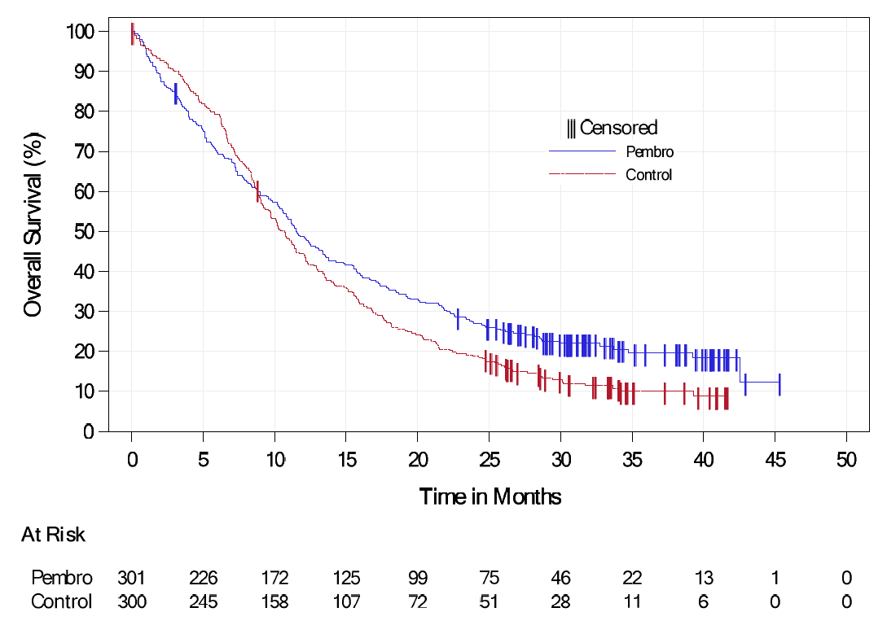
Source: Figure 11-23, p250 KN048 CSR
Figure 2: OS Kaplan-Meier curve in KN048 CPS ≥1, pembrolizumab monotherapy vs cetuximab + chemotherapy
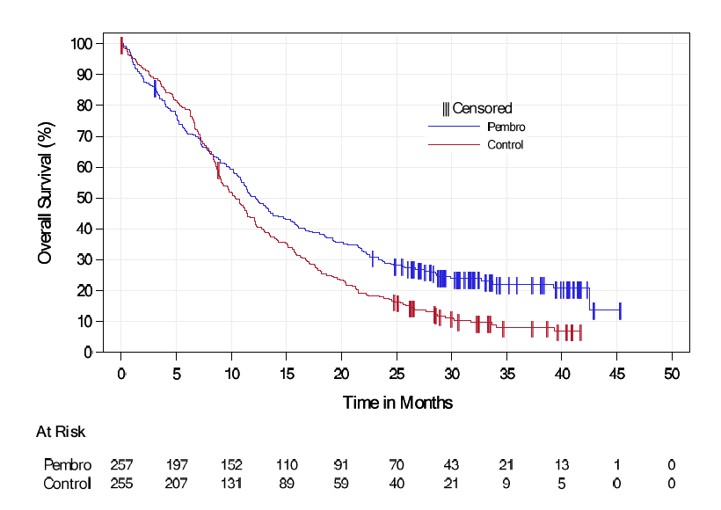
Source: Figure 2.5-1, p62 of the submission
        - The submission stated that KN048 was not powered to show a difference in OS between pembrolizumab ± chemotherapy and cetuximab + chemotherapy in patients with tumours expressing CPS <1 and CPS 1-19. In contrast, the OS analyses for CPS ≥1 and CPS ≥20 were stratified using the trial stratification factors, since these were pre-specified analyses. There were several issues with these statements:
        - The PBAC noted that KN048 was not initially stratified by CPS ≥1 or CPS ≥20, but by TPS >50%. As noted in paragraph 6.11, the comparisons on the basis of CPS are effectively non-randomised; and
        - The sample size for the 1≤CPS<20 in both comparisons appeared to be reasonable, being roughly the same as the sample size for CPS ≥20, therefore the lack of statistical power may not be an issue.
        - The PBAC noted there was no planned statistical analysis for the pembrolizumab monotherapy versus cetuximab + chemotherapy OS comparison in patients with CPS ≥1 (hypothesis H8) and it was unclear whether the outcome presented in the submission was statistically significant. The PBAC considered this outcome to be of particular relevance to the current submission given the requested population is CPS ≥1. The PBAC also noted that the hazard ratio of 0.83 (95% CI: 0.70, 0.99, p-value 0.029) for the ITT population was not statistically significant due to the alpha spending function in KN048.
        - The PBAC noted there were statistically significant HRs for the CPS ≥1 and CPS ≥20 subgroups, but not for the CPS 1-19 subgroup. As such, the PBAC considered that the benefit of pembrolizumab monotherapy was potentially being driven by the CPS ≥20 subgroup, and that both the efficacy results and most appropriate CPS cut-off for pembrolizumab monotherapy were unclear.
        - The results of the indirect comparison of OS for pembrolizumab monotherapy versus chemotherapy alone using the NMA as well as using the Bucher method are presented in Table 8.
Table 8: Indirect comparison of OS for pembrolizumab monotherapy and chemotherapy by PD-L1 status
 | Keynote 048 – Pembro mono vs cetuximab + chemo |  | EXTREME – chemo vs cetuximab + chemo |  | NMA indirect comparison (95% CI) | Bucher indirect comparison (95% CI)
PD-L1 status | N | OS HR (95% CI) | N | OS HR (95% CI) ª
All-comers | 601 | 0.83 (0.70, 0.99) ^{b} | 442 | 1.25 (1.01, 1.56) | 0.68 (0.52, 0.88) | 0.66 (0.50, 0.88)
CPS ≥1 | 512 | 0.74 (0.61, 0.90) |  |  | 0.61 (0.46, 0.8) | 0.59 (0.44, 0.79)
CPS ≥20 | 255 | 0.58 (0.44, 0.78) |  |  | 0.48 (0.34, 0.68) | 0.46 (0.32, 0.67)
1≤ CPS <20 | 257 | 0.92 (0.70, 1.20) |  |  | 0.76 (0.54, 1.06) | 0.74 (0.52, 1.04)
CPS <1 | 89 | 1.72 (1.06, 2.79) |  |  | 1.4 (0.83, 2.39) | 1.38 (0.81, 2.34)
Abbreviations: Pembro mono = pembrolizumab monotherapy, chemo = chemotherapy, OS = overall survival, HR = hazard ratio, CPS = combined positive score
ª calculated using the inverse of OS HR reported in EXTREME (HR = 0.80, 95%CI 0.64, 0.99) to reflect treatment effect of chemotherapy relative to cetuximab plus chemotherapy
^{b} incorrectly reported as 0.72 (0.60, 0.87) in table 2.6-4 of the submission
Text in bold indicate statistically significant differences
Source: Table 2.6-4, p99-100 of the submission
        - The submission (p99) stated that in the CPS ≥1 subgroup, patients treated with pembrolizumab monotherapy had a 40% reduction in risk of death (OS HR=0.61; 95% CI: 0.46, 0.80) compared to patients treated with chemotherapy, and that there was no benefit for pembrolizumab monotherapy compared to chemotherapy in the CPS <1 subgroup. The evaluation considered these claims for efficacy benefits were reasonable, though noting that the CPS <1 subgroup was underpowered so the lack of a statistically significant result may not be informative. The ESCs, noting the wide 95% CI for the CPS <1 subgroup, considered that the HR of 1.4 could indicate that these patients would be worse off in the pembrolizumab monotherapy arm.
        - The OS results of pembrolizumab + chemotherapy versus cetuximab + chemotherapy from KN048 are presented in Table 9 and the OS Kaplan Meier curves from KN048 for ITT and CPS ≥1 populations are presented in Figures 3 and 4.

Table 9: Summary of OS results for pembrolizumab + chemotherapy vs cetuximab + chemotherapy in KN048
Subgroup | Pembrolizumab + chemotherapy |  | Cetuximab + chemotherapy |  | Hazard ratio | P-value | Test for interaction p-value (I²)
 | Deaths,  n/N (%) | Median OS  (95% CI) | Deaths,  n/N (%) | Median OS (95% CI)
All CPS (ITT) | 213/281 (75.8) | 13.0 (10.9, 14.7) | 247/278 (88.8) | 10.7 (9.3, 11.7) | 0.72  (0.60, 0.87) ª | 0.00025 | NA
CPS <1 | 36/39 (92.3) | 11.3 (9.5, 14.0) | 34/43 (79.1) | 10.7 (8.5, 15.9) | 1.18  (0.73, 1.90) | 0.498 | 0.025 (80.18%)
CPS ≥1 | 177/242 (73.1) | 13.6 (10.7, 15.5) | 213/235 (90.6) | 10.4 (9.1, 11.7) | 0.65  (0.53, 0.80) | <0.001
CPS <20 | 128/154 (83.1) | 11.8 (10.4, 14.0) | 146/165 (88.5) | 10.2 (8.9, 12.1) | 0.83  (0.65, 1.05) | 0.123 | 0.109 (61.18%)
CPS ≥20 | 84/126 (66.7) | 14.7 (10.3, 19.3) | 98/110 (89.1) | 11.0 (9.2, 13.0) | 0.60  (0.45, 0.82) | <0.001
CPS <1 | 36/39 (92.3) | 11.3 (9.5, 14.0) | 34/43 (79.1) | 10.7 (8.5, 15.9) | 1.18  (0.73, 1.90) | 0.498 | 0.067 (63.08%)
1≤ CPS <20 | 93/116 (80.2) | 12.7 (9.4, 15.3) | 115/125 (92.0) | 9.9 (8.6, 11.5) | 0.71  (0.54, 0.94) | 0.017
CPS ≥20 | 84/126 (66.7) | 14.7 (10.3, 19.3) | 98/110 (89.1) | 11.0 (9.2, 13.0) | 0.60  (0.45, 0.82) | <0.001
Abbreviations: Pembro mono = pembrolizumab monotherapy, PFS = progression-free survival, HR = hazard ratio, CPS = combined positive score
ª Based on Cox regression model with Efron’s method of tie handling with treatment as a covariate stratified by ECOG, HPV status and PD-L1 status. In case the event count in any stratum is <5, stratification factors will be eliminated in the order of ECOG->HPV status->PD-L1 status until event count in every stratum is ≥5
Text in bold indicate statistically significant differences
Source: Table 2.6-6, p101 of the submission
        - The PBAC noted that, unlike for pembrolizumab monotherapy, for pembrolizumab + chemotherapy the hazard ratio of 0.72 (95% CI: 0.60, 0.87) for the ITT population was statistically significant. The PBAC considered it was unclear whether it was reasonable to assume no benefit in patients with CPS <1, given the lack of statistical power in this subgroup.
Figure 3: OS Kaplan-Meier curve in KN048 ITT, pembrolizumab + chemotherapy vs cetuximab + chemotherapy
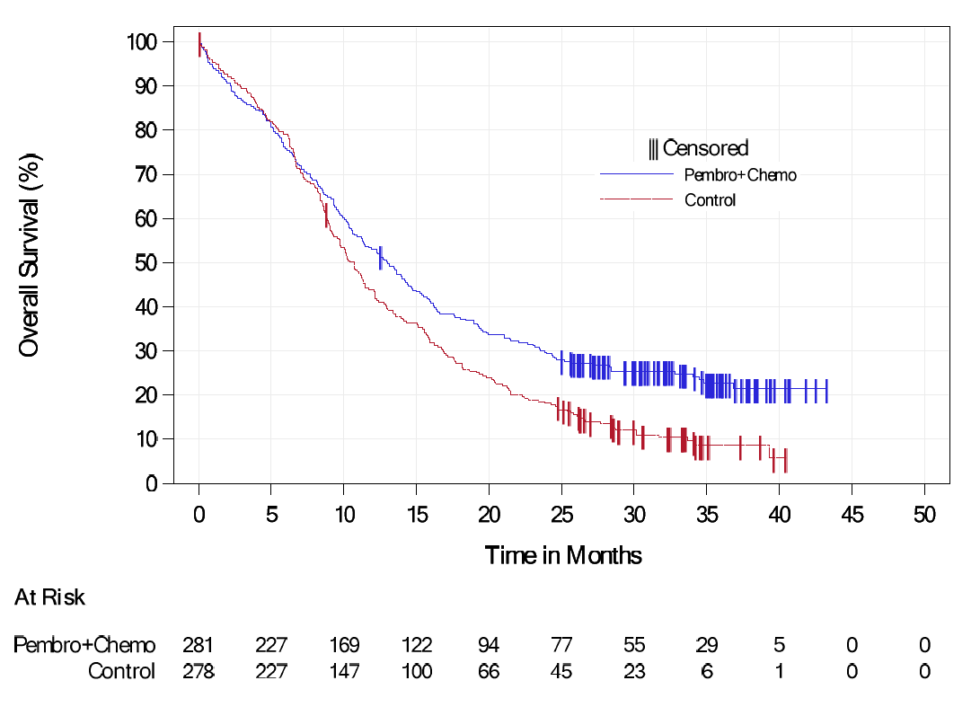
Source: Figure 11-1, p176 KN048 CSR

Figure 4: OS Kaplan-Meier curve in KN048 CPS ≥1, pembrolizumab + chemotherapy vs cetuximab + chemotherapy
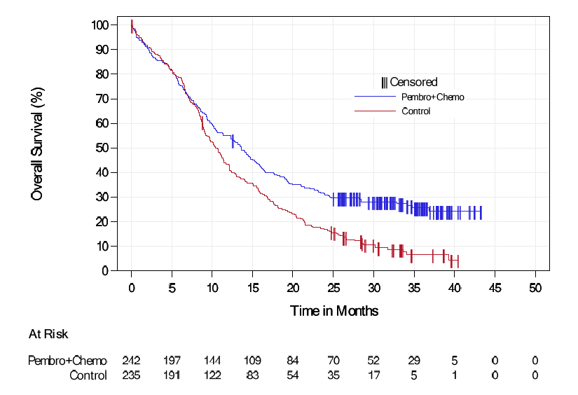
Source: Figure 2.5-7, p75 of the submission
        - The results of the indirect comparison of OS for pembrolizumab + chemotherapy versus chemotherapy alone using the NMA as well as using the Bucher method are presented in Table 10.
Table 10: Indirect comparison of OS for pembrolizumab + chemotherapy and chemotherapy by PD-L1 status
 | Keynote 048 – Pembro + chemo vs cetuximab + chemo |  | EXTREME – chemo vs cetuximab + chemo |  | NMA indirect comparison (95% CI) | Bucher indirect comparison (95% CI)
PD-L1 status | N | OS HR (95% CI) | N | OS HR (95% CI) ª
All-comers | 559 | 0.72 (0.60, 0.87) | 442 | 1.25 (1.01, 1.56) | 0.59 (0.45, 0.77) | 0.58 (0.43, 0.77)
CPS ≥1 | 455 ^{b} | 0.65 (0.53, 0.80) |  |  | 0.53 (0.4, 0.71) | 0.52 (0.39, 0.70)
CPS ≥20 | 300 ^{c} | 0.60 (0.45, 0.82) |  |  | 0.49 (0.35, 0.7) | 0.48 (0.33, 0.70)
1≤ CPS <20 | 231 | 0.71 (0.54, 0.94) |  |  | 0.58 (0.41, 0.82) | 0.57 (0.40, 0.81)
CPS <1 | 82 | 1.18 (0.73, 1.90) |  |  | 0.97 (0.58, 1.62) | 0.94 (0.56, 1.60)
Abbreviations: Pembro = pembrolizumab, chemo = chemotherapy, OS = overall survival, HR = hazard ratio, CPS = combined positive score
ª calculated using the inverse of OS HR reported in EXTREME (HR = 0.80, 95%CI 0.64, 0.99) to reflect treatment effect of chemotherapy relative to cetuximab plus chemotherapy
^{b} number of patients reported as per table 2.6-8 of the submission, but this is inconsistent with the number of patients as per table 2.6-2 of the submission (n= 242 + 235 = 477)
^{c} number of patients reported as per table 2.6-8 of the submission, but this is inconsistent with the number of patients as per table 2.6-2 of the submission (n= 126 + 110 = 236)
Text in bold indicate statistically significant differences
Source: Table 2.6-8, p102 of the submission
        - The submission concluded that the risk of death was almost halved in patients with CPS ≥1 treated with pembrolizumab plus chemotherapy compared to patients treated with chemotherapy (OS HR=0.53; 95% CI: 0.4, 0.71). There were also statistically significant benefits to pembrolizumab + chemotherapy in the CPS ≥20 and 1≥ CPS >20 subgroups, but not in the CPS <1 subgroup. The conclusions for the CPS ≥1, CPS ≥20 and 1≥ CPS >20 subgroups were reasonable, but the conclusion in the CPS <1 subgroup may suffer from lack of statistical power in KN048 and therefore the lack of statistical significance in the results of the indirect comparison may not be reliable. The ESCs considered that, although the HR for the CPS <1 subgroup of 0.94 (95% CI: 0.56, 1.60) suggested no effect, the confidence intervals were wide and these patients may be worse off if treated with pembrolizumab + chemotherapy.
        - The PFS results of pembrolizumab monotherapy versus cetuximab + chemotherapy from KN048 as well as the indirect comparison with cetuximab + chemotherapy versus chemotherapy alone is presented in Table 11. The PFS Kaplan Meier curves from KN048 for ITT and CPS ≥1 populations are presented in Figures 5 and 6.
Table 11: Indirect comparison of PFS for pembrolizumab monotherapy and chemotherapy by PD-L1 status
 | Keynote 048 – Pembro mono vs cetuximab + chemo |  | EXTREME – chemo vs cetuximab + chemo |  | Indirect comparison (95% CI)
PD-L1 status | N | PFS HR (95% CI) | N | PFS HR (95% CI) ª
All-comers | 601 | 1.29 (1.09, 1.53) | 442 | 1.85 (1.49, 2.33) | 0.69 (0.52, 0.91)
CPS ≥1 | 512 | 1.13 (0.94, 1.36) |  |  | 0.61 (0.46, 0.8)
CPS ≥20 | 255 | 0.99 (0.76, 1.29) |  |  | 0.53 (0.38, 0.74)
Abbreviations: Pembro mono = pembrolizumab monotherapy, Chemo = chemotherapy, PFS = progression-free survival, HR = hazard ratio, CPS = combined positive score
ª calculated using the inverse of PFS HR reported in EXTREME (HR=0.54, 95%CI 0.43, 0.67) to reflect treatment effect of chemotherapy relative to cetuximab plus chemotherapy
Text in bold indicate statistically significant differences
Source: Table 2.6-6, p101 of the submission

Figure 5: PFS Kaplan-Meier curve in KN048 ITT, pembrolizumab monotherapy vs cetuximab plus chemotherapy
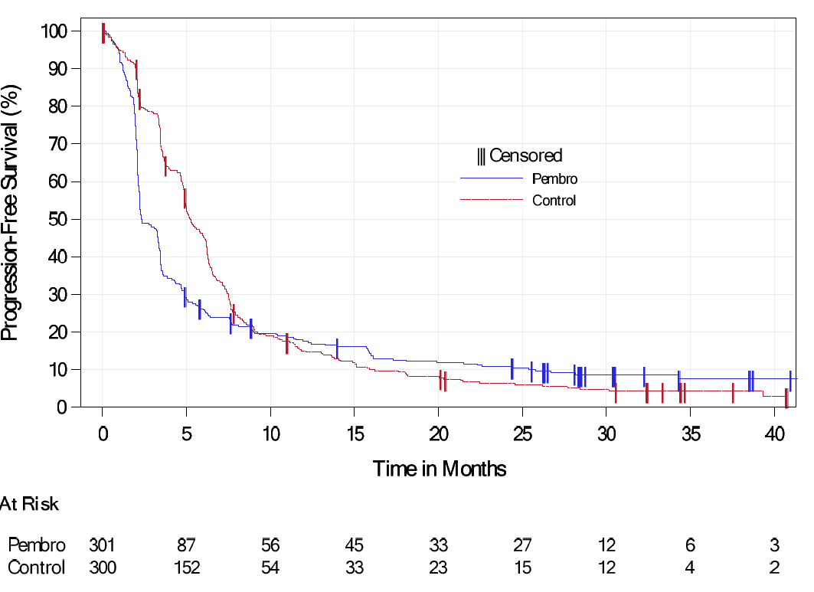
Source: Figure 11-31, p271 of KN048 CSR

Figure 6: PFS Kaplan-Meier curve in KN048 CPS ≥1, pembrolizumab monotherapy vs cetuximab plus chemotherapy
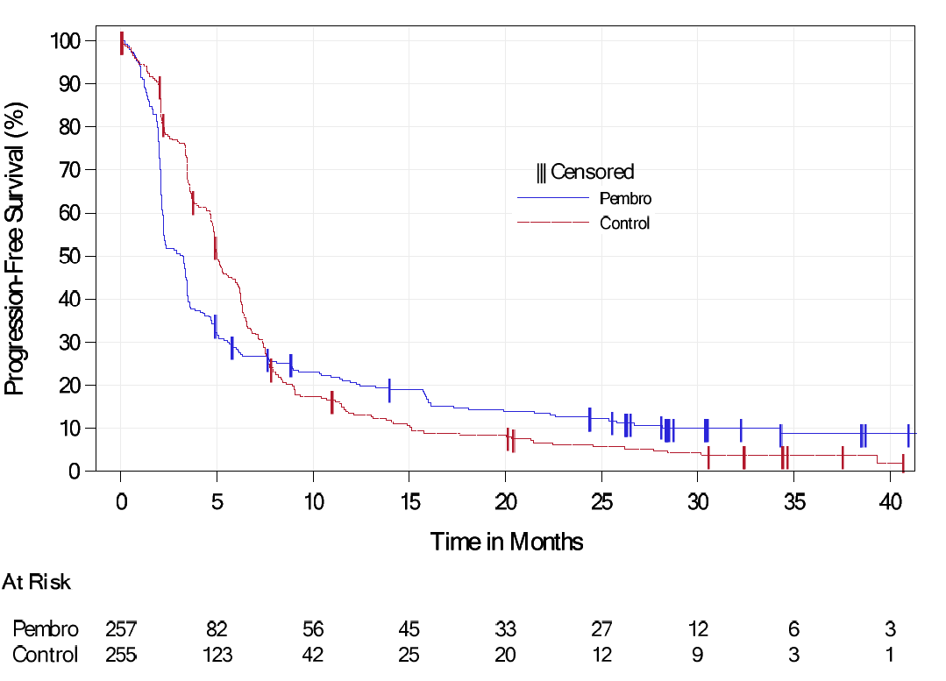
Source: Figure 2.5-3, p64 of the submission
        - The submission claimed that there was a 40% reduction in the risk of progression or death in patients with CPS ≥1 using pembrolizumab monotherapy compared to chemotherapy based on the indirect comparison. Given the violations of the Cox Proportionate Hazard assumption due to a clear crossover in the PFS in KN048, it was unlikely that the PFS HR from KN048 was informative, therefore the PFS indirect comparison results are unlikely to be reliable.
        - Noting the hazard ratio of 1.29 (95% CI: 1.09, 1.53) for the ITT population from KN048, the PBAC noted the trial did not show a PFS benefit for pembrolizumab monotherapy versus cetuximab + chemotherapy.
        - The PFS results of pembrolizumab + chemotherapy versus cetuximab + chemotherapy from KN048 as well as the indirect comparison with cetuximab + chemotherapy versus chemotherapy alone is presented in Table 12. The PFS Kaplan Meier curves from KN048 for ITT and CPS ≥1 populations are presented in Figures 7 and 8.
Table 12: Indirect comparison of PFS for pembrolizumab plus chemotherapy and chemotherapy by PD-L1 status
 | Keynote 048 – Pembro +chemo vs cetuximab + chemo |  | EXTREME – chemo vs cetuximab + chemo |  | Indirect comparison (95% CI)
PD-L1 status | N | PFS HR (95% CI) | N | PFS HR (95% CI) ª
All-comers | 559 | 0.93 (0.78, 1.11) | 442 | 1.85 (1.49, 2.33) | 0.50 (0.38, 0.66)
CPS ≥1 | 455 | 0.84 (0.69, 1.02) |  |  | 0.45 (0.34, 0.61)
CPS ≥20 | 300 | 0.76 (0.58, 1.01) ^{b} |  |  | 0.41 (0.29, 0.58)
Abbreviations: Pembro = pembrolizumab, chemo = chemotherapy, PFS = progression-free survival, HR = hazard ratio, CPS = combined positive score
ª calculated using the inverse of PFS HR reported in EXTREME (HR=0.54, 95%CI 0.43, 0.67) to reflect treatment effect of chemotherapy relative to cetuximab plus chemotherapy
^{b} incorrectly reported as 0.60 (0.45, 0.82) in table 2.6-10the submission
Text in bold indicate statistically significant differences
Source: Table 2.6-10, p103 of the submission

Figure 7: PFS Kaplan-Meier curve in KN048 ITT, pembrolizumab + chemotherapy vs cetuximab + chemotherapy
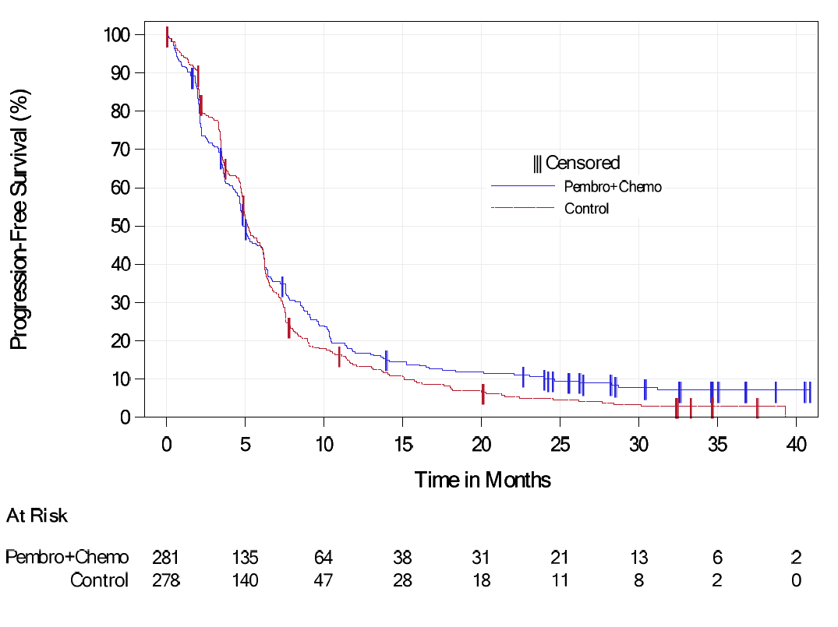
Source: Figure 11-9, p197 KN048 CSR

Figure 8: PFS Kaplan-Meier curve in KN048 CPS ≥1, pembrolizumab + chemotherapy vs cetuximab + chemotherapy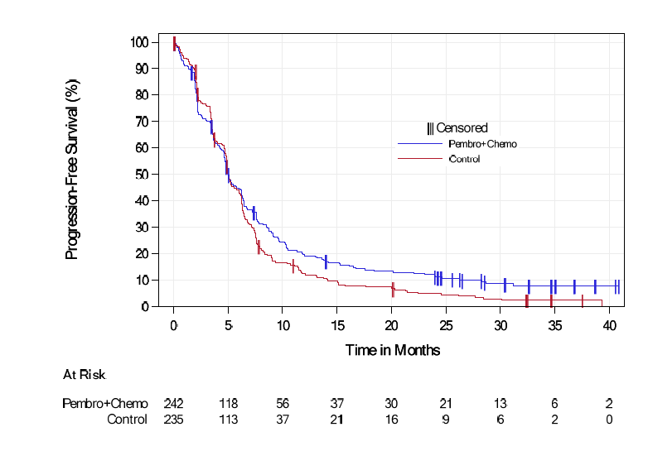
Source: Figure 2.5-9, p78 of the submission

        - The submission concluded that in patients with CPS ≥1, there was a 55% reduction in the risk of progression or death using pembrolizumab + chemotherapy compared to chemotherapy only. KN048 showed that pembrolizumab + chemotherapy was similar to cetuximab + chemotherapy in PFS outcomes, and EXTREME showed that cetuximab plus chemotherapy was superior to chemotherapy alone, with a statistically significant hazard ratio of 0.54 (95% CI: 0.43, 0.67). Unlike the pembrolizumab monotherapy vs chemotherapy comparison, there was no clear crossover in PFS in KN048, therefore the results were likely more reliable.
        - The PBAC noted the hazard ratio for the ITT population from KN048 (HR=0.93; 95% CI: 0.78, 1.11) indicated that no PFS benefit for pembrolizumab + chemotherapy versus cetuximab + chemotherapy was demonstrated in the trial.
        - The PBAC noted the objective response rate (ORR) results in the table below and considered no ORR benefit was demonstrated for either pembrolizumab monotherapy or pembrolizumab + chemotherapy in KN048 versus cetuximab + chemotherapy, with patients likely being worse off if treated with the pembrolizumab monotherapy.
Table 13: Objective response rate results in whole trial populations
Treatment | Responses n/N | Response rate, %(95%CI) | Median duration of response (95%CI) | Difference in Response rate (95%CI) | p-value
KN048 ITT population – pembrolizumab monotherapy vs cetuximab + chemotherapy
Pembrolizumab monotherapy | 51/301 | 16.9 (12.9, 21.7) | 22.6 (1.5, 43.0) | -19.0%  (-25.8, -12.1) | 1.000
Cetuximab + chemotherapy | 108/300 | 36.0 (30.6, 41.7) | 4.5 (1.2, 38.7)
KN048 ITT population – pembrolizumab + chemotherapy vs cetuximab + chemotherapy
Pembrolizumab + chemotherapy | 100/281 | 35.6 (30.0, 41.5) | 6.7 (1.6, 39.0) | -0.8  (-8.7, 7.2) | 0.5740
Cetuximab + chemotherapy | 101/278 | 36.3 (30.7, 42.3) | 4.3 (1.2, 31.5)
EXTREME ITT population – cetuximab + chemotherapy vs chemotherapy
Cetuximab + chemotherapy | 79/222 | 36 (29, 42) | 5.6 (4.7, 6.0) | OR 2.33  (1.5, 3.6) | <0.001
Chemotherapy | 43/220 | 20 (15, 25) | 4.7 (3.6, 5.9)
Abbreviations: OR = odds ratio, ITT = intention to treat, NR = not reported
Source: Table 11-17, p217, Table 11-23, p231, Table 11-45, p291 and Table 11-51, p304 of KN048 CSR, Table 6, Cetuximab PSD March 2018
        - An FP NMA was conducted by the submission to inform the base case transition probabilities for both OS and PFS. Only tier 1 trials were included in the FP NMA presented in the submission. The submission noted that this allowed for the estimation of a ‘time varying hazard ratio’ for the base case of the economic evaluation, as the data does not support the proportional hazard assumption.
        - The ESCs considered relying on the results of the FP NMA for the base case of the economic model was problematic for several reasons:
- A NMA was unjustified given that there were no additional trials which provided efficacy data beyond KN048 and EXTREME, with no other trial or study being used to inform the relative efficacy. This was evident by the Bucher PFS hazard ratios being identical to the time independent fixed effects hazard ratios derived from the NMA and the OS HR estimates being almost identical;
- The approach is highly optimistic, assuming that the benefit of pembrolizumab ± chemotherapy will increase over time with no plausible biological explanation provided. For comparison, rather than a divergence of clinical benefit from an indirect comparison as assumed in the current submission, in the 2L nivolumab for R/M HNSCC model, convergence of health outcomes from a direct head to head randomised trial was assumed after 3 years and was considered reasonable;
- The number of patients remaining at risk was less than 50 after around 12 months in KN048, noting median follow up was 11.5 months for pembrolizumab monotherapy and 13.0 months for pembrolizumab + chemotherapy; and
- The time varying hazard ratio method suffers from multiplicity issues – that is, the submission is getting multiple looks at the data to derive a significant result, without any corresponding adjustments.
        - Given the lack of plausibility of an increasing clinical benefit over time from the FP NMA, when no additional trial data beyond what was reported in KN048 and EXTREME were inputted into the model, the results were likely to be unreliable and overly optimistic. The ESCs noted that from the PBAC guidelines V5, the PBAC prefers the Bucher method for indirect comparisons, and notes that NMA may be presented as supplementary analyses. The ESCs considered it was likely unreasonable for the submission to use the results of the FP NMA as the base case in the economic model.
        - Patient reported outcomes from KN048 were reported in the submission. Outcomes included HRQoL as measured by the EORTC QLQ-30, EORTC QLQ-H&N35, and the EQ-5D questionnaires. These have not been reported as (i) these results were not used to inform the economic evaluation and (ii) there was no difference between treatment arms except for change from baseline of EQ-5D VAS at week 15 which favoured treatment with cetuximab plus chemotherapy over pembrolizumab monotherapy (difference in LS means=-4.06 (95%CI: -7.13, -0.99, p=0.01). For the economic evaluation, the submission relied on what appears to be a post hoc analysis of the EQ-5D results in KN048 by progression status. However, these results were not reported as part of the submission.

Comparative harms
        - With respect to the safety results from KN048, the PBAC noted that a lower proportion of patients in the pembrolizumab monotherapy arm reported any grade 3 to 5 drug related adverse events compared to patients in the cetuximab + chemotherapy arm (17.0% vs 69.3%, RD = -52.3%, 95% CI -58.8, -45.2). The PBAC also noted that compared to patients in the cetuximab + chemotherapy arm, a similar proportion of patients in the pembrolizumab + chemotherapy arm reported any grade 3 to 5 drug related adverse events (71.7% vs 69.3%, RD = 2.4%, 95% CI -5.1, 9.9).
        - A naive comparison of all cause grade 3-5 adverse events in KN048 and EXTREME was conducted during the evaluation and presented in Table 14. Treatment-related AEs were not reported in the publication of the EXTREME trial.

Table 14: Naïve indirect comparison of all cause grade 3-5 adverse events pembrolizumab monotherapy and pembrolizumab plus chemotherapy with chemotherapy alone
 | KN048 |  | EXTREME | Pembro mono vs chemo only |  | Pembro + chemo vs chemo only
 | Pembro mono | Pembro + chemo | Chemo only
 |  |  |  | RR (95%CI) | RD% (95%CI) | RR (95%CI) | RD% (95%CI)
All grade 3-5 AE | 164/300 (54.7) | 235/276 (85.1) | 171/215 (79.5) | 0.69  (0.61, 0.78) | -25 (-32, -17) | 1.07  (0.98, 1.16) | 6 (-1, 13)
Grade 5 AE (death in EXTREME) | 25/300 (8.3) | 32/276 (11.6) | 7/215 (3.2) | 2.56  (1.16, 5.71) | 5.1 (0.9, 9.2) | 3.56  (1.65, 7.79) | 8 (4, 13)
Drug related grade 3-5 AE | 52/300 (17.0) | 198/276 (71.7) | NR | NC | NC | NC | NC
Abbreviations: AE = adverse events, pembro = pembrolizumab, chemo = chemotherapy, RR = relative risk, RD = risk difference, NR = not reported, NC = not calculable
Figures in bold indicate statistically significant differences.
Source: Table 2.5-18, p88-89 of the submission Table 2.6-11, p103 of the submission, calculated using review manager 5.3 during evaluation.
        - For all cause grade 3-5 AE the PBAC noted that pembrolizumab + chemotherapy had a higher incidence of grade 3-5 adverse events than chemotherapy alone, which was plausible and expected, noting the PBAC has previously considered that cetuximab + chemotherapy was inferior in safety compared to chemotherapy alone (para 6.23, cetuximab PSD March 2018), and given that KN048 showed that pembrolizumab + chemotherapy was comparable to cetuximab + chemotherapy in safety, it would be expected that pembrolizumab + chemotherapy was also inferior in safety to chemotherapy alone.
        - The PSCR claimed that, based on the grade 3-4 adverse events plus deaths (i.e. grade 5 adverse events) in EXTREME (as shown in Table 14), there was no statistically significant difference between pembrolizumab + chemotherapy versus chemotherapy alone. The PBAC agreed with the ESCs that the safety results for pembrolizumab + chemotherapy were difficult to interpret due to reporting differences between KN048 and EXTREME.
        - The evaluation considered the conclusion that pembrolizumab monotherapy was superior in safety to chemotherapy was reasonable. Additionally, the PBAC noted that the safety profile of pembrolizumab monotherapy (mainly immune related) was significantly different to the profile of chemotherapy alone (more commonly associated with blood chemistry such as neutropenia and anaemia).
        - As for comparative efficacy, the safety of 2L nivolumab was not considered, therefore the comparative safety of pembrolizumab ± chemotherapy with SoC was unknown.

Benefits and harms
        - A summary of the comparative benefits and harms for pembrolizumab versus chemotherapy is presented in the table below. The PBAC considered that the extent of comparative benefits and harms were uncertain due to the limitation of the indirect comparison, as discussed above.
Table 15: Summary of comparative benefits and harms for pembrolizumab and chemotherapy
Benefits
Time-to-event outcome I: OS in CPS≥1
Trial | Median duration of follow up  (months) | Active treatment group  n/N (%) | Common arm comparator  n/N (%) |  | Absolute difference (%) |  | HR (95% CI) | Bucher indirect comparison: HR  (95% CI)
Pembrolizumab monotherapy (CPS≥1) versus chemotherapy (ITT)
KN048 (pembrolizumab monotherapy) | 11.5 ¹ | 197/257 (76.7) | 229/255 (89.8) |  | -13.1 |  | 0.74  (0.61, 0.90) | 0.59 (0.44, 0.79)
EXTREME (chemotherapy) | 19.1 | 176/220 (80.0) | 167/222 (75.2) |  | 4.8 |  | 1.25  (1.01, 1.56)
Pembrolizumab plus chemotherapy (CPS≥1) versus chemotherapy (ITT)
KN048 (pembrolizumab + chemotherapy) | 13.0 ¹ | 177/242 (73.1) | 213/235 (90.6) |  | -17.5 |  | 0.65  (0.53, 0.80) | 0.52 (0.39, 0.70)
EXTREME (chemotherapy) | 19.1 | 176/220 (80.0) | 167/222 (75.2) |  | 4.8 |  | 1.25  (1.01, 1.56)
Harms
Trial | Median duration of follow up  (pembro/ chemotherapy months) | Pembrolizumab |  | Chemotherapy |  | RR  (95% CI) |  | RD  (95% CI)
Pembrolizumab monotherapy (ITT) versus chemotherapy (ITT)
All cause grade 3+ adverse event | 11.5/19.1 | 164/300 (54.7) |  | 171/215 (79.5) |  | 0.69  (0.61, 0.78) |  | -25 (-32, -17)
Pembrolizumab plus chemotherapy (ITT) versus chemotherapy (ITT)
All cause grade 3+ adverse event | 13.0/19.1 | 235/276 (85.1) |  | 171/215 (79.5) |  | 1.07  (0.98, 1.16) |  | 6 (-1, 13)
Abbreviations: HR = hazard ratio, RD = risk difference, RR = risk ratio, CPS = combined positive score, ITT = intention to treat
¹ Median follow up in the CPS≥1 subgroup not reported in KN048, this value reflects the follow up in ITT population and is an approximation only.
Text in bold indicate statistically significant difference
Source: Table 6, Cetuximab PSD March 2018, Table 2.6-1, p96 and Table 2.6-2, p97 Table 2.5-18, p88-89 of the submission Table 2.6-11, p103 of the submission.
        - On the basis of the indirect comparison presented by the submission, the comparison of pembrolizumab monotherapy and chemotherapy resulted in:
- For patients with CPS ≥1, approximately a 41% reduction in risk of death (at roughly 11.5 months follow up for pembrolizumab and 19.1 months follow up for chemotherapy); and
- For all patients irrespective of CPS, for every 100 patients treated, 25 fewer patients will experience a grade 3+ adverse event.
        - On the basis of the indirect comparison presented by the submission, the comparison of pembrolizumab + chemotherapy and chemotherapy resulted in:
- For patients with CPS ≥1, approximately a 48% reduction in risk of death (at roughly 13.0 months follow up for pembrolizumab and 19.1 months follow up for chemotherapy); and
- For all patients irrespective of CPS, for every 100 patients treated, 6 more patients will experience a grade 3+ adverse event.

Clinical claim
        - The PBAC agreed with the ESCs that as the submission failed to recognise the effectiveness of 2L nivolumab as part of the comparator (SoC), the clinical claim made by the submission against 1L chemotherapy alone was an inaccurate and incomplete representation of the comparison between 1L pembrolizumab ± chemotherapy with the nominated comparator of SoC.
        - The submission made the following clinical claims in patients with previously untreated R/M HNSCC of the oral cavity, pharynx and larynx, with CPS ≥1:
- pembrolizumab monotherapy is superior to chemotherapy alone based on an improvement in OS (HR=0.61; 95% CI: 0.46, 0.8) and PFS (HR=0.61; 95% CI: 0.46, 0.8) from a NMA indirect comparison and superior in safety based on the incidence of grade 3-5 adverse events from a naïve indirect comparison; and
- pembrolizumab plus chemotherapy is superior to chemotherapy alone based on an improvement in OS (HR=0.53; 95% CI: 0.4, 0.71) and PFS (HR=0.45; 95% CI: 0.34, 0.61) from a NMA indirect comparison and similar in safety based on the incidence of grade 3-5 adverse events from a naïve indirect comparison.
        - The ESCs considered that the evidence suggested that pembrolizumab monotherapy may be superior to chemotherapy alone, though the indirect comparison may be biased in favour of pembrolizumab, and it is unknown whether it is superior to SoC (which includes 2L nivolumab). Additionally, the adverse event profile for pembrolizumab monotherapy (mainly immune related events) and chemotherapy alone (mainly blood chemistry events such as neutropenia and anaemia) were significantly different.
        - The ESCs considered the evidence suggested that pembrolizumab + chemotherapy may be superior to chemotherapy alone, though the indirect comparison may be biased in favour of pembrolizumab, and it is unknown whether it is superior to SoC (which includes 2L nivolumab). The ESCs considered the claim of similar safety was difficult to assess as it was based on indirect comparisons of open-labelled studies and due to reporting differences between the trials. Given that the PBAC has previously stated that cetuximab plus chemotherapy was inferior in safety to chemotherapy alone (Para 7.7, cetuximab PSD March 2018), and KN048 demonstrated that pembrolizumab plus chemotherapy had similar safety to cetuximab plus chemotherapy, the evaluation considered that pembrolizumab + chemotherapy is inferior to chemotherapy alone in terms of safety.
        - Based on the data from KN048, the PBAC considered that the claim of superior comparative effectiveness compared with chemotherapy alone was reasonable for pembrolizumab + chemotherapy in terms of OS, but superiority was not adequately supported by the data for pembrolizumab monotherapy.
        - The PBAC considered that the claim of superior safety was reasonable for pembrolizumab monotherapy, but that the claim of non-inferior safety for pembrolizumab + chemotherapy was not adequately supported by the data.

Claim of codependence
        - The expression of PD-L1, and the subsequent binding to the PD-1 receptor, allows tumour cells to escape the anti-tumour activity of the immune system. The disruption of the PD-L1-PD-1 interaction is pembrolizumab’s mechanism of action. The evidence for PD-L1 as a valid biomarker for efficacy of pembrolizumab in R/M HNSCC was first observed in Keynote-012 (KN012), a non-randomised open-label phase 1b study of pembrolizumab in R/M HNSCC, which reported a correlation between the degree of PD-L1 expression and overall response and progression-free survival. A Combined Positive Score (CPS) ≥1 was proposed as the threshold for eligibility, as subsequent analysis of data from KN012 demonstrated that the CPS scoring was more sensitive than TPS scoring and was more predictive of improved overall survival (OS) and progression-free survival (PFS) (Figure 9).
Figure 9: OS and PFS by CPS and TPS in Keynote-012 (n=190)
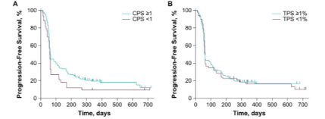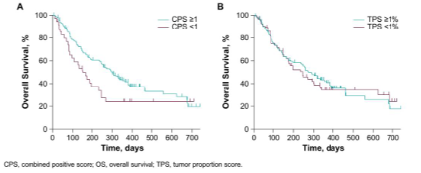
Source: Figure 2 and Figure 3, Emancipator et al 2020.
        - The results for OS in the ITT population and by CPS subgroups in KN048 are presented in Table 7 and 9 above. The ESCs noted that the TGA approved indication was in the PD L1 positive (CPS ≥1) population. Based on the subgroup analyses of KN048 in R/M HNSCC, the ESCs accepted that pembrolizumab had a larger effect in patients with a PD-L1 CPS ≥1, but the subgroup of patients with CPS <1 was too small to conclude that pembrolizumab had no effect in this subgroup. Additionally, the submission did not provide a biological explanation for why CPS rather than TPS (at any threshold) might predict a variation in pembrolizumab response. The PBAC noted that CPS was selected during the conduct of KN048 based on the results of a non-randomised Phase 1b pembrolizumab study.
        - The ESCs noted that the TGA-approved indication was in the PD-L1 positive (CPS ≥1) population. Based on the subgroup analyses of KN048 in R/M HNSCC, the ESCs accepted that pembrolizumab had a larger effect in patients with a PD-L1 CPS ≥1, but the subgroup of patients with CPS <1 was too small to conclude that pembrolizumab had no effect in this subgroup.

Economic analysis
        - The basis of the economic evaluation was a cost-effectiveness analysis. The submission presented two modelled economic evaluations comparing, separately, (i) pembrolizumab monotherapy with SoC, and (ii) pembrolizumab + chemotherapy with SoC in a population of patients with previously untreated R/M HNSCC of the oral cavity, pharynx or larynx. Both models had the same structure. Outputs from the models in all patients and in the CPS ≥1 subgroup were estimated and then used to inform a weighted ICER based on test accuracy and prevalence of CPS ≥1. The combined ICER for monotherapy (assumed to be 20%) and pembrolizumab + chemotherapy (80%) was also presented. The ESCs considered the proposed 80:20 weighting assumption was not reasonable, given that pembrolizumab + chemotherapy appeared to be more effective than pembrolizumab monotherapy in terms of OS.
        - Despite there being only two relevant trials (KN048 and EXTREME), the submission inappropriately used the results of a fractional polynomial network meta-analysis (FP NMA) in the base case of the economic analysis (see also paragraph 6.31).
        - As above, the ESCs noted that the clinical data included in the model for SoC was 1L chemotherapy alone, with the omission of 2L nivolumab and, as such, the economic model did not reflect a comparison with current SoC. The ESCs noted that two exploratory analyses around 2L nivolumab in the SoC arm were conducted during the evaluation, which demonstrated that the model and ICER were sensitive to inclusion of costs for 2L nivolumab and exclusion of benefits for nivolumab in the SoC arm:
- Removal of costs of 2L nivolumab from SoC. This is consistent with the usage in chemotherapy alone arm in EXTREME which was relied upon for the indirect comparison/NMA. However, this is not consistent with the likely usage in the PBS population; and
- Estimation of QALY gained from 2L nivolumab and adding it to the QALY estimated in the SoC arm. The QALY gain from 2L nivolumab was estimated by dividing the cost of 2L nivolumab as calculated by the model by the ICER accepted by the PBAC as cost-effective. This was based on the previous PBAC decision that stated a base case ICER of $45,000 -$75,000/QALY would be a relevant incremental cost-effectiveness target to account for the uncertainties from the clinical evidence in estimating the extent to which nivolumab would address the unmet clinical need in Australian patients and also in the economic model” (Para 6.10, p13 Nivolumab 2L R/M HNSCC PSD, March 2018). This was intended to be indicative only to illustrate the impact of omission of 2L nivolumab effectiveness, and more accurate modelling of 2L nivolumab would be required to accurately assess this.
        - The summary of the model structure and rationale is presented in Table 16.
Table 16: Summary of model structure and rationale
Component | Description | Justification/comments
Type of analysis | Cost-effectiveness / cost-utility analysis | -
Outcomes | Life years gained, quality-adjusted life years | -
Time horizon | 7.5 years in the model base case vs median 10.1-13 months follow up in KN048 and 18.2-19.1 months in EXTREME | The PSCR argued that the 4-year survival KN048 survival data presented at ESMO (September 2020) showed that, for the CPS ≥1 population, 16.7% of pembrolizumab monotherapy and 21.8% of pembrolizumab plus chemotherapy patients were still alive, and that the Kaplan-Meier curves clearly show a plateau forming. Therefore, a 5-year time horizon would inappropriately discount the benefits of pembrolizumab in approximately 15-20% of patients. The sponsor claimed that immunotherapies should not be treated the same as chemotherapies in considering the appropriate time horizon.
Methods used to generate results | Partitioned survival cohort simulation for CPS ≥1  ICER back calculated for CPS <1 subgroup | The ESCs noted that results from the ITT and CPS ≥1 subgroups were used to back calculate (and infer) the ICER in the CPS <1 subgroup, and considered this produced implausible scenarios where the effectiveness of SoC varied by pembrolizumab regimen and CPS status. The ESCs also noted that the base case model does not explore the cost-effectiveness of pembrolizumab in the CPS <1 subgroup. The ESCs considered that, as an integrated codependent submission, the costs and benefits of the PD-L1 CPS<1 population should have been included in the overall model base case and the cost effectiveness of pembrolizumab in the PD-L1 CPS<1 subgroup would be relevant where sensitivity is assumed to be <100% for PD-L1 testing.
Health states | Progression-free survival, progressed disease, death | Appropriate, although the ESCs noted the higher utilities applied than the PBAC had previously considered for cetuximab in 1L R/M HNSCC for both progression-free (0.788 vs 0.65-0.69) and progressed disease (0.716 vs 0.52), which favours pembrolizumab.
Cycle length | 1 Week | Reasonable
Discount rate | 5% per annum | Appropriate
Transition probability | Health states: Pembrolizumab based on extrapolation of KN048 results, SoC based on application of HR from FP NMA to pembrolizumab results.  Time on treatment for pembrolizumab based on data collected from KN048. Chemotherapy assumed same as pembrolizumab for six cycles only. | The ESCs considered it was not appropriate to use the FP NMA in the base case instead of the Bucher indirect comparison (as per PBAC Guidelines, and as there were no additional trials which provided efficacy data beyond KN048 and EXTREME). The indirect comparison HRs using the FP NMA were time dependent and produced implausible results, with the benefit of pembrolizumab treatment increasing over time.  The ESCs considered that the economic evaluation inappropriately does not account for the effectiveness of 2L nivolumab, despite including costs associated with 2L nivolumab.
Software package | Excel 2010 | Appropriate, but the ESCs noted concerns with respect to the code and inability to replicate parts of the analysis.
Abbreviations: CPS = combined positive score, R/M = recurrent or metastatic, HNSCC = head and neck squamous cell carcinoma, SoC = standard of care, 2L = second line, ESMO = European Society for Medical Oncology
Source: Table 3.1.1, p134-135 of the submission
        - The partitioned survival cohort models had a standard structure with progression-free survival, progressed disease and death health states.
        - The cost effectiveness in the ‘all comers’ and CPS ≥1 populations were estimated using a partitioned cohort survival simulation analysis. The cost effectiveness for patients with CPS <1 was not modelled but instead, was back-calculated based on CPS ≥1 and ITT costs and QALYs.
        - OS and PFS curves for pembrolizumab monotherapy and pembrolizumab + chemotherapy were derived from the KN048 trial (direct Kaplan Meier data used until median follow up then parametric extrapolation used until 7.5 years). OS and PFS curves for SoC were estimated by applying an inverse time variant hazard ratio derived from the FP NMA to the curve for either pembrolizumab monotherapy or pembrolizumab + chemotherapy, depending on the comparison.
        - The duration of drug treatment was estimated independently to the patient’s health state. For pembrolizumab monotherapy and pembrolizumab + chemotherapy, the observed time on treatment (ToT) Kaplan-Meier curves for the relevant treatment from KN048 were applied, with a proportion of patients discontinuing treatment each cycle. No extrapolation was required as all patients stopped treatment after two years (consistent with requested PBS listing) and the ToT data in KN048 can be considered complete. For SoC, it was assumed that the ToT data from the cetuximab + chemotherapy arm in KN048 would apply up to week 15 (for six cycles of chemotherapy). Additionally, there were treatment costs for adverse events associated with treatment, though no disutilities from adverse events were considered. A fixed proportion of patients who discontinued treatment each cycle were assumed to use subsequent anti-cancer therapy, which differed depending on the initial therapy.
        - Additionally, PD-L1 test costs were included for the pembrolizumab arms of the model.
        - The ESCs considered there were significant issues with the methods used in the economic evaluation:
- While the cost of subsequent therapies were inflated for the SoC arm (submission assumed 66.7% of patients used 2L nivolumab in the SoC arm, compared to 0% use of 2L nivolumab use in EXTREME, and assigned no efficacy to 2L nivolumab), they were deflated for pembrolizumab, as usage of 2L EGFR inhibitors (used by 18-24% of all patients treated with pembrolizumab ± chemotherapy in KN048) and 2L anti PD-1/PD-L1 therapy (used by 6% of patients treated with pembrolizumab ± chemotherapy in KN048) were removed from the economic evaluation without a corresponding adjustment for efficacy. The ESCs considered it was not appropriate to include costs but not benefit from 2L nivolumab;
- While the PSCR argued that the results generated by the FP NMA and the Bucher analyses were almost identical, the ESCs considered that use of a time-dependent HR from the FP NMA instead of a constant HR from the Bucher indirect comparison led to implausible results, with the benefit of pembrolizumab treatment increasing over time, and external validation of the SoC data suggested that the FP NMA was a poor fit. The median OS for chemotherapy alone was 7.4 months in EXTREME, but the FP NMA estimated a median OS of 10.15 months and 9.46 months for the pembrolizumab monotherapy and pembrolizumab plus chemotherapy models, respectively. Comparatively, the Bucher indirect HR estimated median OS of 7.85 and 7.62 months for the two models, respectively; and
- The ESCs considered that the method of estimation of SoC survival by applying an inverse HR from the FP NMA/indirect comparison to the pembrolizumab arm observed in KN048 led to an implausible scenario where the effectiveness of the SoC arm varied by CPS status and also by the pembrolizumab regimen it was being compared to. The variation in both life years (LY) and QALYs in the SoC arm by CPS was significant – from 1.4 LY/0.99 QALY in the pembrolizumab monotherapy vs SoC comparison in the CPS <1 subgroup to 1.01 LY/0.74 QALY in the pembrolizumab chemotherapy vs SoC comparison in the CPS ≥1 subgroup, a difference of 25%. The PSCR argued that the incremental survival estimate measured between arms was equivalent regardless of the approach.
        - The key drivers of the economic model identified during the evaluation are presented in Table 17.

Table 17: Key drivers of the model
Description | Method/Value | Impact
Efficacy of pembrolizumab | Estimated based on indirect comparison, with significant transitivity issues between KN048 and EXTREME. No confidence intervals were estimated for the FP NMA inputs therefore only multivariate sensitivity analyses (changing input to Bucher indirect comparison and changing OS HR) could be plausibly conducted on the efficacy of pembrolizumab. | High. For example, using upper 95% value for OS from the Bucher indirect comparison of pembrolizumab monotherapy vs chemotherapy (1/0.79 instead of 1/0.59 in base case), the ICER increased by 75% from the base case using time variant HR.
Omission of 2L nivolumab efficacy | Not included in submission | High, favours pembrolizumab. Exploratory analysis of including cost effectiveness of 2L nivolumab increased ICER by 28%-77% depending on assumption of cost effectiveness of 2L nivolumab. Removal of 2L nivolumab cost from SoC increased ICER by 30%.
Source of utility | Post hoc analysis of KN048 utility values by disease progression. Progression-free = 0.788, progressed disease = 0.707. | Moderate, favours pembrolizumab. Using utility values from cetuximab March 2018 submission increases ICER by 24%.
Time horizon | Base case 7.5 years, extrapolated from 11.5-13.0 month median follow up in KN048. | Moderate. Changing to 5 year time horizon as per cetuximab March 2018 submission increases ICER by 22%.
Using time on treatment data from KN048 to inform duration of treatment | Duration of treatment of pembrolizumab based on KN048 actual usage. In clinical practice, usage may extend beyond what was observed in KN048 as follow ups may not be as frequent. | Moderate. Increasing cost of pembrolizumab by 10% (as a proxy to increasing usage) increases ICER by 13%.
Assumption of perfect sensitivity and specificity | The submission claims that the 22C3 antibody test is the evidentiary standard therefore has perfect sensitivity and specificity. Using response rates as the reference standard, CPS≥1 using the 22C3 antibody had a sensitivity of 92-94% and a specificity of 19-23% as reported in Emancipator 2020 and Cohen 2019. | Moderate. Using alternative values of 94% sensitivity and 23% specificity increases ICER by 12%.
Source: compiled during the evaluation
        - The ESCs noted there were other drivers of the model which could not be fully quantified during the evaluation. These included:
- Lack of adjustment for efficacy of 2L EGFR inhibitor and anti PD-1/PD-L1 in the pembrolizumab arm as used in KN048. EGFR inhibitors are not PBS listed for R/M HNSCC, and the current restriction for 2L nivolumab would not allow for use after 1L pembrolizumab. Therefore 2L EGFR inhibitor and anti PD-1/PD-L1 use in KN048 would unlikely to be used in the Australian population, and the lack of adjustments to account for the efficacy of these subsequent therapies favours pembrolizumab;
- Applying all cause grade 3-4 adverse events from EXTREME to the SoC arm, but only very selectively applying treatment related grade 3-5 adverse events which required hospitalisation from KN048 to the pembrolizumab arms, favours pembrolizumab;
- Lack of adjustment for EXTREME having patients who were likely less healthy than KN048 based on ECOG performance status, favours pembrolizumab; and
- The use of different prices for pembrolizumab in the pembrolizumab monotherapy and pembrolizumab + chemotherapy models. The ESCs considered that the 80:20 split for pembrolizumab regimen was not reasonable, and as this interacted with the differential pricing assumed in the two settings the direction of bias was unclear.
        - The results of the two partitioned survival cohort simulations in patients with CPS ≥1 are summarised in Table 18.
Table 18: Results of the partitioned survival cohort simulation in patients with CPS ≥1 (submission base case)
Component | Pembrolizumab ± chemotherapy | SoC | Increment
Pembrolizumab monotherapy vs SoC (CPS≥1)
Cost | $''''''''''''''''' | $30,918 | $'''''''''''''''''
LY | 1.7819 | 1.0741 | 0.7079
QALY | 1.3321 | 0.7989 | 0.5332
Incremental cost per LY gained |  |  | $''''''''''''''''¹
Incremental cost per QALY gained |  |  | $''''''''''''''''''²
Pembrolizumab plus chemotherapy vs SoC ª (CPS≥1)
Cost | $''''''''''''''' | $30,803 | $'''''''''''''''
LY | 1.9297 | 1.0054 | 0.9243
QALY | 1.4251 | 0.7398 | 0.6853
Incremental cost per LY gained |  |  | $''''''''''''''''¹
Incremental cost per QALY gained |  |  | $'''''''''''''''''²
Weighted pembrolizumab monotherapy (80%) and pembrolizumab plus chemotherapy (20%) ^{b} (CPS≥1)
Cost | $''''''''''''''''' | $30,895 | $''''''''''''''''
LY | 1.81146 | 1.06036 | 0.75118
QALY | 1.3507 | 0.78708 | 0.56362
Weighted incremental cost per LY gained |  |  | $''''''''''''''''¹
Weighted incremental cost per QALY gained |  |  | $'''''''''''''''''²
ª values differ to the submission’s estimates very marginally due to correction of CPS ≥1 prevalence from 85.3% to 85.2%
^{b} values calculated as weighted 80% of pembrolizumab monotherapy cost, life year and quality adjusted life year from pembrolizumab monotherapy model and 20% of pembrolizumab plus chemotherapy model
Abbreviations: CPS = combined positive score, LY = life year, QALY = quality adjusted life year
Source: Table 3.8-6, 3.8-7 and 3.8-8, p176 and Table 3.8-9 and Table .8-10, p177 of the submission
The redacted values correspond to the following ranges:
¹$45,000 to <$55,000/QALY gained
²$55,000 to <$75,000/QALY gained
        - The results of the economic evaluation when considering all patients with R/M HNSCC (all patients are tested; patients with PD-L1 CPS ≥1 are treated with pembrolizumab and patients with CPS <1 receive SoC) are presented in Table 19.
Table 19: Results of the economic evaluation (all patients included in model, only CPS ≥1 treated)
Component | Pembrolizumab ± chemotherapy | SoC | Increment
Pembrolizumab monotherapy vs SoC (PD-L1 all comers, ITT)
Cost | $'''''''''''''''' | $30,972 | $''''''''''''''''
QALY | 1.28 | 0.83 | 0.45
Incremental cost per QALY gained |  |  | $'''''''''''''''''¹
Pembrolizumab plus chemotherapy vs SoC (PD-L1 all comers, ITT)
Cost | $''''''''''''''' | $30,679 | $''''''''''''''''
QALY | 1.35 | 0.76 | 0.58
Incremental cost per QALY gained |  |  | $'''''''''''''''¹
Weighted pembrolizumab monotherapy (80%) and pembrolizumab plus chemotherapy (20%)ª (PD-L1 all comers, ITT)
Cost | $''''''''''''''' | $30,914 | $'''''''''''''''
QALY | 1.30 | 0.82 | 0.48
Weighted incremental cost per QALY gained |  |  | $'''''''''''''''¹
ª values calculated as weighted 80% of pembrolizumab monotherapy cost, life year and quality adjusted life year from pembrolizumab monotherapy model and 20% of pembrolizumab plus chemotherapy model
Abbreviations: LY = life year, QALY = quality adjusted life year, ITT = intention to treat
Source: Section 3 Diag. Sens. Wkbk.xlsx using inputs from Section 3 workbook.xslm
The redacted values correspond to the following ranges:
¹$55,000 to <$75,000/QALY gained

        - The ESCs noted that the ICER in the CPS ≥1 and the whole population models was very similar because the submission did not consider false negative and false positive results (i.e. assumed 100% sensitivity and specificity), and the high prevalence of the CPS ≥1 population. Given that pembrolizumab is dominated by chemotherapy in CPS <1 based on the submission’s calculations, the ESCs considered that any decrease in specificity (more false positives) will significantly increase the ICER. A decrease in the sensitivity of the test (more false negatives) has a smaller impact on the ICER, but with a higher opportunity cost which was not captured by the economic evaluation due to potential benefit from pembrolizumab foregone. The ESCs considered it was unreasonable to assume no false negative or false positive results, and that the base case model is optimistic with regards to testing accuracy.
        - Additionally, the PBAC noted in the scenario where all patients are treated with pembrolizumab ± chemotherapy regardless of CPS status, the ICER increased to $55,000 to <$75,000/QALY for pembrolizumab + chemotherapy.
        - Overall, the ESCs considered the ICER presented in the submission was underestimated as:
- The efficacy of 2L nivolumab was not included as part of the model, significantly underestimating the survival of SoC. The PSCR argued that the impact of 2L nivolumab is similar to the OS benefit shown in the 1L SoC arm from the EXTREME trial, and therefore any underestimate OS benefit in the comparator arm is negligible. The PBAC agreed with the ESCs that this was not a reasonable claim;
- The lack of recognition of 2L anti-PD-L1 and anti EGFR from the pembrolizumab arms likely overestimated the survival in the pembrolizumab arms;
- The time horizon (7.5 years) was likely optimistic and may overestimate the benefit of pembrolizumab. The PBAC has previously stated that a 5-year time horizon in 1L R/M HNSCC was appropriate (Para 7.8, p30 Cetuximab PSD March 2018). As did the PSCR, the pre-PBAC response noted the 4-year data from KN048 presented at ESMO and maintained that 7.5 years is appropriate. The PBAC considered that a time horizon longer than 5 years may be reasonable, but needs to be considered in the context of uncertain magnitude of clinical benefit;
- The submission overestimated the rate of adverse events in the SoC arm, as all cause grade 3-4 adverse events from EXTREME was applied to SoC, whereas only grade 3-5 adverse events which were treatment related and led to hospitalisation were applied to the pembrolizumab arms. This led to an overestimate of the cost of management of adverse events in the SoC arm; and
- The assumption of 100% sensitivity and specificity of CPS ≥1 test was optimistic and not supported by available evidence.
        - Additionally, the ESCs considered there were uncertainties with the ICER presented due to:
- The method of estimation of SoC survival based on applying an inverse hazard ratio from the FP NMA to the pembrolizumab data, resulting in SoC survival which differed by up to 28% depending on the comparison treatment and by CPS, which was implausible;
- A different price for pembrolizumab when used as monotherapy ($''''''''''''''''''/100mg) and when used in combination with chemotherapy ($'''''''''''''''''/100mg) and uncertainty in the split for the two regimens;
- Using a time-dependent HR from the FP NMA instead of a constant HR from the Bucher indirect comparison. External validation conducted during the evaluation showed that the FP NMA method produced a poor fit to empirical data in the SoC arm. The ESCs noted that this favours pembrolizumab at a 7.5 year time horizon but favours SoC at a 5 year time horizon. The ESCs considered that use of the constant HR from the Bucher indirect comparison would be the most appropriate approach;
- Higher utilities applied than the PBAC had previously considered for cetuximab in 1L R/M HNSCC for both progression-free (0.788 vs 0.65-0.69) and progressed disease (0.716 vs 0.52). This favours pembrolizumab;
- Inclusion of disease management costs (favoured SoC as patients treated with pembrolizumab lived longer) and terminal care costs (favoured pembrolizumab as more patients in SoC arm died at the end of the model) which would only be delayed, not prevented, by treatment with pembrolizumab; and
- Patients in EXTREME may be less healthy than patients in KN048, based on ECOG status and location of primary tumour. This may potentially favour pembrolizumab in the indirect comparison and therefore in the economic model.
        - The results of key sensitivity analyses presented by the submission and conducted during the evaluation are presented in Table 20. The ESCs noted that the economic evaluation in the PD-L1 CPS≥1 population was presented as a base case, however the ESCs considered that, as an integrated codependent submission, the economic evaluation in the whole R/M HNSCC population, including testing and treatment with SoC for the PD-L1 CPS<1 population, was the appropriate base case and the sensitives around this are the most meaningful.
Table 20: Key sensitivity analyses around economic evaluation
 | Model/comparison | Incremental costs | Incremental effectiveness (QALY) | Incremental cost-effectiveness ($/QALY) | Percent change from base case
CPS≥1 patients only | Pembro mono | $'''''''''''''' | 0.53 | $''''''''''''''¹ | -
 | Pembro chemo | $''''''''''''''' | 0.69 | $'''''''''''''¹ | -
 | Weighted ª |  |  | $''''''''''''''¹ | -
Time horizon decrease to 5 years (base case 7.5 years) | Pembro mono | $''''''''''''''''' | 0.42 | $'''''''''''''''² | +21.9%
 | Pembro chemo | $'''''''''''''''' | 0.55 | $'''''''''''''''''¹ | +21.3%
 | Weighted |  |  | $'''''''''''''''² | +21.8%
Use Bucher HR (base case time variant HR) | Pembro mono | $'''''''''''''''' | 0.56 | $''''''''''''''''¹ | +1.9%
 | Pembro chemo | $''''''''''''''''' | 0.70 | $''''''''''''''''¹ | +2.4%
 | Weighted |  |  | $'''''''''''''''''¹ | +2.1%
Use upper 95% CL of Bucher HR (base case time variant HR) ^{b} | Pembro mono | $'''''''''''''''' | 0.30 | $'''''''''''''''''''³ | +75.0%
 | Pembro chemo | $'''''''''''''''' | 0.45 | $''''''''''''''''''² | +50.9%
 | Weighted |  |  | $'''''''''''''''''³ | +68.5%
Increase cost of pembrolizumab by 10% (as proxy for increasing number of doses by 10%) | Pembro mono | $''''''''''''''' | 0.53 | $'''''''''''''''''¹ | +16.7%
 | Pembro chemo | $''''''''''''''' | 0.69 | $'''''''''''''''''¹ | +7.2%
 | Weighted |  |  | $'''''''''''''''''¹ | +12.7%
Use utilities from cetuximab March 2018 submission (progression-free 0.69, progressed 0.52) | Pembro mono | $''''''''''''''''' | 0.43 | $'''''''''''''''''² | +24.0%
 | Pembro chemo | $''''''''''''''''' | 0.55 | $''''''''''''''''² | +24.8%
 | Weighted |  |  | $''''''''''''''''² | +24.1%
Assume no 2L nivolumab use in SoC (base case 66.67%) ^{c} | Pembro mono | $''''''''''''''''' | 0.53 | $''''''''''''''''² | +31.1%
 | Pembro chemo | $'''''''''''''''' | 0.69 | $''''''''''''''''''² | +24.8%
 | Weighted |  |  | $''''''''''''''''² | +29.6%
Assume $45,000/QALY gain with 2L nivolumab added to SoC ^{d} | Pembro mono | $'''''''''''''''' | 0.29 | $'''''''''''''''''''''⁴ | +84.3%
 | Pembro chemo | $'''''''''''''''' | 0.44 | $''''''''''''''''''³ | +56.5%
 | Weighted |  |  | $'''''''''''''''''''''³ | +76.6%
Assume $75,000/QALY gain with 2L nivolumab added to SoC ^{d} | Pembro mono | $''''''''''''''' | 0.39 | $''''''''''''''''''² | +37.8%
 | Pembro chemo | $'''''''''''''''' | 0.54 | $'''''''''''''''''² | +27.6%
 | Weighted |  |  | $''''''''''''''''² | +35.2%
Base case– whole R/M HNSCC population. Sensitivity and specificity of test 100% | Pembro mono | $''''''''''''' | 0.45 | $''''''''''''''¹ | -
 | Pembro chemo | $''''''''''''' | 0.58 | $'''''''''''''¹ | -
 | Weighted |  |  | $'''''''''''''¹ | -
Sensitivity of PD-L1 test used in Australia assumed to be 75% of that used in KN048 (base case 100%) ^{e} | Pembro mono | $'''''''''''''''' | 0.34 | $''''''''''''''''''¹ | +0.1%
 | Pembro chemo | $''''''''''''''''' | 0.44 | $'''''''''''''''¹ | +0.1%
 | Weighted |  |  | $''''''''''''''''¹ | +0.1%
Specificity of PD-L1 test used in Australia assumed to be 75% of that used in KN048 (base case 100%) ^{e} | Pembro mono | $'''''''''''''''' | 0.44 | $''''''''''''''''¹ | +4.2%
 | Pembro chemo | $''''''''''''''''' | 0.58 | $''''''''''''''''¹ | +3.3%
 | Weighted |  |  | $''''''''''''''''¹ | +4.0%
Use results from Emancipator 2020 (92.2% sensitivity and 18.9% specificity) | Pembro mono | $''''''''''''''''' | 0.38 | $'''''''''''''''''¹ | +15.9%
 | Pembro chemo | $''''''''''''''' | 0.54 | $''''''''''''''''¹ | +11.7%
 | Weighted |  |  | $'''''''''''''''¹ | +14.8%
Use results from Cohen 2019 (94.0% sensitivity and 23% specificity) | Pembro mono | $'''''''''''''''''' | 0.39 | $'''''''''''''''''¹ | +12.7%
 | Pembro chemo | $''''''''''''''' | 0.55 | $''''''''''''''''¹ | +9.7%
 | Weighted |  |  | $'''''''''''''''¹ | +11.9%
ª assume 20% pembrolizumab + chemotherapy and 80% pembrolizumab monotherapy
^{b} change cell G30 in Sheet ‘survival’ to Constant HR (Bucher’s Method) and change cell C34 in sheet ‘NMA_data(Bucher)’ to ‘=1/0.79’ cell C38 in sheet ‘NMA_data(Bucher)’ to ‘=1/0.70’
^{c} Change toggle in cell H12 in sheet ‘Costs3’ to ‘No’
^{d} Assumed $''''''''''''''''''''''' (in pembrolizumab monotherapy model) and $''''''''''''''''''''''' (pembrolizumab chemotherapy model) spent on 2L nivolumab, then divided by ICER (based on to estimate QALY for price paid for 2L nivolumab. This QALY gain is added to cell H59 in sheet ‘Result_tables’
^{e} Submission results could not be duplicated during evaluation
Abbreviations: CL = confidence limit, ICER = incremental cost-effectiveness ratio, OS = overall survival, Pembro = pembrolizumab, mono = monotherapy, chemo = chemotherapy, PFS = progression-free survival, QALY = quality-adjusted life-year, SOC = standard of care, R/M HNSCC = recurrent or metastatic head and neck carcinoma, 2L = second line, HR = hazard ratio
The redacted values correspond to the following ranges:
¹$55,000 to <$75,000/QALY gained
²$75,000 to <$95,000/QALY gained
³$95,000 to <$115,000/QALY gained
⁴$115,000 to <$135,000/QALY gained
        - The ESCs considered that the current model may be inadequate to support decision making due to the exclusion of benefits expected from patients who would be expected to be treated with 2L nivolumab. The ESCs did not agree with the sponsors statement that “the SoC overall survival curve used in the economic model reasonably accounts for most of the benefits of 2L nivolumab in a subgroup who progress on platinum based initial therapy within 6 months, since any incremental benefit of nivolumab in the context of the whole first-line population is reduced” (PSCR, and pre-PBAC response). The PBAC agreed with the ESCs and considered that it was inconsistent to apply costs for 2L nivolumab without attempting to model the benefit and considered that it was reasonable to expect a benefit for the proportion of patients who would receive 2L treatment with nivolumab.

Drug cost/patient/course: $''''''''''''''''' (pembrolizumab as monotherapy), $''''''''''''''''''' (pembrolizumab when used with chemotherapy)
        - The number of doses per course was 10.49 for pembrolizumab monotherapy (at $''''''''''''''''''/200mg) and 11.71 for pembrolizumab plus chemotherapy (at $'''''''''''''''''/200mg).

Estimated PBS & financial implications
        - This submission was not considered by DUSC.
        - A complex epidemiological approach was used by the submission to estimate the financial impact of listing pembrolizumab for R/M HNSCC. The submission considered a total of seven pathways for patients with previously untreated recurrent or metastatic SCC of oral cavity, pharynx or larynx (but excluding patients with HPV positive oropharyngeal carcinoma (OPC)) incurable by local therapies with CPS ≥1 and ECOG 0-1 to be treated with pembrolizumab:
- Pathway I – de novo diagnosed patients of stage IVc or metastatic squamous cell carcinoma of the oral cavity, pharynx or larynx.
- Pathway II – patients initially diagnosed with localised primary tumours, i.e. stage I or II, and have had a recurrence following surgery and/or radiotherapy. In this case, the recurrence is no longer amenable to further local therapy with curative intent.
- Pathway III and Pathway IV – patients who were initially diagnosed with loco-regional (locally advanced) primary tumours, i.e. stage III-IVB. Pathway III patients were initially treated with surgery and radiotherapy or radiotherapy alone. Pathway IV patients were treated with chemoradiation, with or without surgery.
- Pathway V – patients who have been diagnosed with HPV +ve OPC.
- Pathway VI – Prevalent patient population.
- Pathway VII – Grandfathered patients.
        - A brief summary of the various sources used to inform the financial impact of listing pembrolizumab is presented in Table 21.
Table 21: Data sources used to calculate the financial impact of pembrolizumab
Data source | Purpose
Cancer in Australia 2019, AIHW | Inform incidence and prevalence of head and neck carcinoma in Australia
Review of the Cancer Medicines in the WHO List of Essential Medicines | Inform SCC percentage
GLANCE study | Proportion of ECOG 0-1
KN048 | Prevalence of CPS≥1, dosage and usage of medications
Expert opinion (Key Scientific Leaders) | Staging of disease at diagnosis, proportion treated with surgery ± radiotherapy or chemo + radiotherapy ± surgery, usage of pembrolizumab
Kolli 2000, Hosal 2000 | Recurrence rate with surgery ± RT in patients with Stage III-IVb cancer
PBS and MBS schedule | Unit costs for drugs and administration
Source: constructed during evaluation
        - The estimated use and financial implications for listing pembrolizumab in patients with R/M HNSCC, ECOG 0-1 and CPS ≥1 is summarised in Table 22.

Table 22: Estimated use and financial implications
 | Year 1 | Year 2 | Year 3 | Year 4 | Year 5 | Year 6
Estimated extent of use of proposed test
Projected SCC of the oral cavity, pharynx, larynx cancers (exclude nasopharyngeal) | '''''''''''''''¹ | ''''''''''''''¹ | '''''''''''''¹ | '''''''''''''¹ | ''''''''''''¹ | ''''''''''''''¹
R/M SCC of the oral cavity, pharynx, larynx cancers (excludes nasopharyngeal) | ''''''''''''¹ | '''''''''''''''¹ | '''''''''''''¹ | ''''''''''''''¹ | ''''''''''''¹ | ''''''''''''''¹
Estimated extent of use of pembrolizumab (R/M SCC of oral cavity, pharynx or larynx, ECOG 0-1, CPS≥1)
Pathway I – de Novo Metastatic | ''''''''''² | ''''''''''² | '''''''''² | '''''''''² | ''''''''''² | '''''''''²
Pathway II – recurrent stage I-II | '''''''² | ''''''² | ''''''² | ''''''² | '''''² | ''''''²
Pathway III – recurrent stage III surgery | ''''''² | ''''''² | '''''² | ''''''² | '''''''² | ''''''²
Pathway IV – recurrent stage III chemo radiotherapy | ''''''''² | ''''''''''² | '''''''''² | ''''''''''² | '''''''''² | '''''''''²
Pathway V – recurrent HPV + | '''''''''² | '''''''''² | ''''''''''² | ''''''''''² | ''''''''''² | '''''''''²
Pathway VI – prevalent population (ex grandfather) | ''''''² | - | - | - | - | -
Pathway VII – grandfather | ''''''² | - | - | - | - | -
Total eligible | ''''''''¹ | ''''''''¹ | ''''''''¹ | '''''''¹ | ''''''''¹ | ''''''''¹
Total uptake pembrolizumabª | '''''''¹ | '''''''¹ | ''''''''¹ | ''''''''¹ | '''''''¹ | '''''''¹
Estimated financial implications of the PD-L1 test to the MBS
Cost to MBS ^{f} | $'''''''''''''''''³ | $'''''''''''''''''³ | $''''''''''''''''³ | $'''''''''''''''³ | $'''''''''''''''''³ | $'''''''''''''''''³
Estimated financial implications of pembrolizumab ± chemotherapy to the PBS/RPBS
Cost of pembrolizumab | $''''''''''''''''''''''''⁴ | $'''''''''''''''''''''''''''⁵ | $''''''''''''''''''''''''''⁴ | $'''''''''''''''''''''''''⁴ | $'''''''''''''''''''''''''''⁴ | $'''''''''''''''''''''''''''⁴
Cost of chemotherapy ^{c} | $'''''''''''''''''''³ | $'''''''''''''''''''³ | $''''''''''''''''''³ | $''''''''''''''''''³ | $'''''''''''''''''''''³ | $'''''''''''''''''''³
Co-payments | $''''''''''''''''³ | $''''''''''''''''''³ | $'''''''''''''''''³ | $''''''''''''''''³ | $'''''''''''''''''³ | $''''''''''''''''³
Cost to PBS/RPBS less co-payments | $'''''''''''''''''''''''''⁴ | $'''''''''''''''''''''''''''⁵ | $'''''''''''''''''''''''⁴ | $'''''''''''''''''''''''''''⁴ | $'''''''''''''''''''''''''''⁴ | $'''''''''''''''''''''''''⁴
Estimated financial implications of administration of pembrolizumab ± chemotherapy to the MBS
Cost to MBS | $'''''''''''''''''³ | $'''''''''''''''''³ | $''''''''''''''''''''³ | $''''''''''''''''''''³ | $''''''''''''''''''''³ | $''''''''''''''''''³
Estimated financial implications for SoC to the PBS/RPBS
Cost of 1L chemotherapy offset | $'''''''''''''''''''''³ | $'''''''''''''''''³ | $'''''''''''''''''''³ | $''''''''''''''''''''³ | $''''''''''''''''''''³ | $''''''''''''''''''³
Cost to 2L nivolumab offset ^{d} | $'''''''''''''''''''''''''³ | $''''''''''''''''''''''''''³ | $''''''''''''''''''''''''''³ | $'''''''''''''''''''''''³ | $''''''''''''''''''''''³ | $'''''''''''''''''''''''³
Co-payments | $''''''''''''''''''³ | $''''''''''''''''³ | $'''''''''''''''³ | $''''''''''''''''³ | $''''''''''''''''''³ | $''''''''''''''''³
Cost to PBS/RPBS less co-payments | $'''''''''''''''''''''''''⁶ | $'''''''''''''''''''''³ | $'''''''''''''''''''''''''³ | $'''''''''''''''''''''''³ | $'''''''''''''''''''''''''''⁶ | $''''''''''''''''''''''''''⁶
Estimated financial implications of administration offset of SoC to the MBS
Cost to MBS | $'''''''''''''''''''''''³ | $'''''''''''''''''''''³ | $'''''''''''''''''''''''''³ | $'''''''''''''''''''''''³ | $''''''''''''''''''''''³ | $'''''''''''''''''''''''''³
Net financial implications
Net cost to PBS/RPBS | $''''''''''''''''''''''''⁵ | $'''''''''''''''''''''''⁵ | $'''''''''''''''''''''''''''⁵ | $'''''''''''''''''''''''''''⁵ | $''''''''''''''''''''''''''⁵ | $''''''''''''''''''''''''''⁵
Net cost to MBS ^{e f} | -$'''''''''''''''''''³ | -$''''''''''''''''''''³ | -$''''''''''''''''''''³ | -$'''''''''''''''''''''³ | -$''''''''''''''''''''³ | -$''''''''''''''''''''''³
Net cost to PBS/RPBS/MBS ^{f} | $'''''''''''''''''''''''''''⁵ | $''''''''''''''''''''''''''⁶ | $'''''''''''''''''''''''''''⁵ | $'''''''''''''''''''''''''''⁵ | $'''''''''''''''''''''''''''⁵ | $''''''''''''''''''''''''''⁵
ª Assume 85% uptake in all eligible patients
^{b} Assume $59.60 (80% benefit of $74.50) per test, applied to all projected oral cavity, pharynx, larynx cancers (exclude nasopharyngeal) patients
^{c} Assume 20% of patients use pembrolizumab plus chemotherapy
^{d} Assume 66.7% of patients use 2L nivolumab
^{e} Sum of PD-L1 test and cost of administration for pembrolizumab minus cost of SoC administration
^{f} Revised to include testing costs only for patients with R/M SCC of the oral cavity, pharynx, and larynx
Source: constructed during evaluation using information from Section 4 Workbook (1L HNSCC).xlsx, with errors identified in the evaluation corrected.
The redacted values correspond to the following ranges:
¹500 to <5,000
²<500
³$0 to <$10 million
⁴$30 to <$40 million
⁵$20 to <$30 million
⁶$10 to <$20 million
        - The submission estimated the overall budget impact of listing pembrolizumab ± chemotherapy in previously untreated patients with R/M HNSCC of the oral cavity, pharynx or larynx, which is incurable by local therapy and who have CPS ≥1, in the first six years of listing was $100 to <$200 million, ranging from $20 to <$30 million (in Year 2) to $20 to <$30 million (in Year 1, which included grandfathered patients).
        - The evaluation considered the estimated cost of pembrolizumab listing was uncertain as there were several areas of uncertainty which may lead to both underestimates and overestimates:
        - The main cost offset was the cost of 2L nivolumab, which was based on an assumption that 66.7% of patients in SoC would use 2L nivolumab. Should the usage of nivolumab be lower than assumed, the cost offsets will be overestimated. Analysis of PBS script data between January 2019 and December 2019, provided by the DUSC Secretariat, indicates 379 patients initiated treatment with nivolumab for SCC of oral cavity, pharynx or larynx. The submission’s estimate that there will be 484 fewer patients using nivolumab (726 × 66.7%) may therefore be implausible; however, this may also indicate that the number of patients eligible for pembrolizumab may be overestimated (379 patients treated with 2L nivolumab ÷ 66.7% = 569 patients treated with 1L chemotherapy compared to 846 estimated eligible for pembrolizumab in Year 1). The PBAC considered that the number of 1L patients/year may be slightly lower than 569 as some of the 2L nivolumab patients will be those who have relapsed early following treatment with curative intent. The PBAC agreed with the ESCs and considered the real proportion of 2L nivolumab use remained unknown as this estimate relied on the estimated pembrolizumab population and a more reliable source for estimating the proportion of 2L nivolumab use may be required.
        - The TGA evaluator (TGA CER p38-39) noted that the proportion of patients with CPS <1 was likely to be lower in the Australian population than in the KN048 population, therefore this may have led to an overestimate of the number of patients eligible for 1L pembrolizumab. The PSCR noted the Vainer et al 2019 publication and argued that the true prevalence of CPS ≥1 in the R/M setting is only marginally lower than that used in the submission (approximately 3-5% lower). The pre-PBAC response reiterated that the prevalence of PDL-1 CPS ≥1 has been consistent across the sponsor’s trials in the R/M HNSCC setting, ranging from 79% to 85%. It also noted the Vainer et al 2019 publication that observed a prevalence of 80.1% in R/M HNSCC samples (with approximately 101/126 samples staining positive for CPS ≥1). The PBAC considered that the prevalence should be reduced to 80% (from 85.2%).
        - The number of prevalent patients who may be eligible for treatment was likely underestimated as the submission multiplied the proportion of prevalent patients who may experience recurrence or metastasis by a 5-year mortality rate (5.3%). However, the evaluation considered a 2-year mortality rate would more accurately reflect the proportion of prevalent patients who may experience recurrence or metastasis. Additionally, while the submission (p199) argued that the majority of recurrences occur within 2 years of primary diagnosis, though there is evidence that around 20% of recurrence or metastasis occurs after 2 years, therefore it may not be appropriate to restrict the estimation of pathway VI (prevalent patients) to just the first year of listing. The PSCR accepted the proposed application of a 2-year mortality rate to reflect the proportion of patients who would be eligible for treatment, but just in the first year of listing.
        - Overall, the PBAC agreed with the ESCs and considered the prevalence estimates were uncertain and likely overestimated.
        - The financial estimates were sensitive to changes in the number of doses of pembrolizumab assumed (a 20% increase in dose led to an increase of 30% in expenditure each year) and to higher uptake (100%) or if all patients were considered eligible irrespective of CPS, both of which increased the financial estimates by up to 17% per annum. The financial estimates were also sensitive to uncertainties around proportion of patients with ECOG 0-1 and CPS≥1. The impact of proportion of patients with CPS ≥1, ECOG 0-1 and uptake rate are identical, as they are all cross multiplied in the financial estimates in each of the seven pathways.

Quality use of medicines
        - The sponsor noted that there will be education materials on how to identify and manage adverse events, with educational programs and activities including face to face workshop sessions at conferences and also a medical information service hotline.

Financial management – risk sharing arrangements
        - The sponsor indicated that it was willing to enter into a risk sharing arrangement (RSA) with the Commonwealth to manage any risks to the overall costs to the PBS. The sponsor noted that there is currently an RSA in place for 2L nivolumab, and the sponsor proposed that this indication join the existing RSA whereby the current subsidisation caps are increased to reflect the additional number of patients receiving pembrolizumab and the increased cost of treatment with pembrolizumab net of the nivolumab offset, with the expanded subsidisation cap shared between nivolumab and pembrolizumab in their relevant lines of therapy.
        - The ESCs considered it may be appropriate to apply a similar approach to revision of caps as was applied in expanding caps to include 1L pembrolizumab in addition to 2L nivolumab in the NSCLC indication. The ESCs noted that the relative proportion of 1L pembrolizumab and 2L nivolumab would be an important factor in establishing the appropriate changes to caps.
For more detail on PBAC’s view, see section 7 PBAC outcome
- PBAC Outcome
        - The PBAC decided not to recommend the listing of pembrolizumab for first-line treatment of recurrent or metastatic (R/M) head and neck squamous cell carcinoma (HNSCC) in patients with PD-L1 CPS ≥1. The PBAC considered that pembrolizumab + chemotherapy (but not pembrolizumab monotherapy) was clinically superior to first-line chemotherapy alone in terms of overall survival. However, the magnitude of clinical benefit over current standard of care, which includes second-line nivolumab, was uncertain and the evidence supporting a PD-L1-based eligibility criterion was not convincing. The PBAC considered that there were a number of modelling assumptions which resulted in the incremental cost-effectiveness ratio being uncertain and substantially underestimated.
        - The PBAC noted that consumers and patient support organisations (Beyond Five and Rare Cancers Australia) were in support of the requested listing for pembrolizumab, describing the need for a first-line immunotherapy treatment option for this difficult to treat cancer. The PBAC noted the strong support of the Medical Oncology Group of Australia (MOGA) for the submission, and that the ESMO-MCBS score was higher for CPS ≥20 (5) compared to the CPS ≥1 group (4) for pembrolizumab monotherapy.
        - The PBAC accepted that SoC was the appropriate comparator, but noted that current SoC consists of 1L chemotherapy alone followed by 2L nivolumab for a proportion of patients. The PBAC noted there was no clinical evidence presented in the submission to assess the impact of 2L nivolumab on the incremental efficacy, and considered this was inappropriate.
        - The PBAC noted that the comparison provided in the submission was of 1L pembrolizumab ± platinum based chemotherapy versus platinum based chemotherapy alone (informed by an indirect comparison of KN048 and the EXTREME trial (a comparison of cetuximab plus platinum based chemotherapy versus platinum based chemotherapy alone), using cetuximab plus platinum based chemotherapy as the common reference. The PBAC noted the sources of potential bias in the indirect comparison (as described in paragraph 6.11) and agreed with the ESCs that it may be biased in favour of pembrolizumab. The PBAC also considered there was uncertainty evaluating the clinical efficacy due to KN048 having a complicated trial design with 14 primary hypotheses.
        - Pembrolizumab monotherapy: Based on the indirect comparison of the CPS ≥1 subgroup for KN048 and the ITT population for EXTREME, the submission claimed that patients treated with pembrolizumab monotherapy had approximately a 40% reduction in risk of death (OS HR=0.61; 95% CI: 0.46, 0.80) compared to patients treated with chemotherapy. The submission further claimed that there was no benefit for pembrolizumab monotherapy compared to chemotherapy in the CPS <1 subgroup. The PBAC did not accept the clinical claim that pembrolizumab monotherapy demonstrated superior clinical effectiveness compared to 1L chemotherapy alone for patients with CPS ≥1. As discussed in paragraph 6.15, the PBAC noted there was no planned statistical analysis for OS for pembrolizumab monotherapy versus cetuximab + chemotherapy in the CPS ≥1 subgroup. The PBAC noted for the ITT analysis of KN048, pembrolizumab was not statistically significantly superior to cetuximab + chemotherapy with a hazard ratio of 0.83 (95% CI: 0.70, 0.99). The PBAC further noted that in the CPS ≥1 subgroup the benefit of pembrolizumab monotherapy (HR=0.74, 95% CI: 0.61, 0.90), was potentially being driven by the results from the CPS ≥20 subgroup (HR=0.58, 95% CI: 0.44, 0.78 versus HR=0.92, 95% CI: 0.70, 1.20 in the CPS 1-19 subgroup). The PBAC also noted that there was no benefit demonstrated for PFS or ORR in the KN048 ITT population for pembrolizumab monotherapy.
        - Pembrolizumab + chemotherapy: Based on the indirect comparison of the CPS ≥1 subgroup for KN048 and the ITT population for EXTREME, the submission claimed that the risk of death was almost halved in patients treated with pembrolizumab + chemotherapy compared to patients treated with chemotherapy (OS HR=0.53; 95% CI: 0.4, 0.71). The PBAC noted that KN048 reported statistically significant hazard ratios for pembrolizumab + chemotherapy compared with chemotherapy + cetuximab in terms of OS for both the CPS ≥1 subgroup (HR=0.65, 95% CI: 0.53, 0.80) and the ITT population (HR=0.72, 95% CI: 0.60, 0.87). The PBAC considered that there is likely to be a larger effect with higher CPS score. The PBAC accepted the clinical claim that pembrolizumab + chemotherapy demonstrated superior clinical effectiveness compared to 1L chemotherapy alone in terms of OS for the CPS ≥1 subgroup, noting the limitations of the indirect comparison. The PBAC noted that there was no benefit demonstrated for PFS or ORR in the KN048 ITT population for pembrolizumab + chemotherapy. The PBAC also considered the magnitude of clinical benefit for pembrolizumab + chemotherapy over current SoC, which includes 2L nivolumab, was uncertain.
        - The PBAC noted that the safety profile of pembrolizumab monotherapy (mainly immune related) was different to the profile of chemotherapy alone, but considered that the claim of superior safety was reasonable given the known safety profile and mechanism of action of pembrolizumab.
        - The PBAC noted the submission’s claim that pembrolizumab + chemotherapy had a non-inferior safety profile to 1L chemotherapy, but considered the comparison of safety outcomes was limited by reporting differences between the trials. The PBAC recalled its previous conclusion that cetuximab + chemotherapy was inferior in safety compared to chemotherapy alone (paragraph 6.23, cetuximab PSD, March 2018). The PBAC also noted that KN048 showed that pembrolizumab + chemotherapy was similar to cetuximab + chemotherapy in safety, with a similar proportion of patients in both arms reporting any grade 3 to 5 drug related adverse events (71.7% vs 69.3% respectively, RD = 2.4%, 95% CI -6.1, 9.9). On this basis, the PBAC considered that pembrolizumab + chemotherapy was likely inferior in safety to chemotherapy alone.
        - The PBAC noted that NCCN guidelines recommend first-line pembrolizumab + chemotherapy regardless of PD-L1 status and also recommend pembrolizumab monotherapy where CPS ≥20. Noting that the TGA-approved indication is in the PD-L1 positive (CPS ≥1) population, the PBAC considered that the most appropriate CPS cut-off for a PBS listing for pembrolizumab was unclear, particularly for patients treated with pembrolizumab monotherapy. Based on the subgroup analyses of KN048, the PBAC considered that pembrolizumab had a larger effect in patients with CPS ≥1, but the sample size of patients with CPS <1 was too small to conclude that pembrolizumab + chemotherapy had no effect in this subgroup. Noting that KN048 was stratified for TPS ≥50 and did not prespecify CPS-based subgroups, the PBAC considered that advice from the Medical Services Advisory Committee (MSAC) was required regarding the PD-L1 testing component of the codependent submission.
        - The PBAC noted that the submission presented two modelled economic evaluations comparing, separately, (i) pembrolizumab monotherapy with SoC, and (ii) pembrolizumab plus chemotherapy with SoC, in a population of patients with previously untreated R/M HNSCC of the oral cavity, pharynx or larynx. The PBAC considered there was a high level of uncertainty with the economic model and interpretation of the ICER for a number of reasons, including:
- inappropriately excluding the effectiveness of 2L nivolumab in the SOC arm which resulted in a significant under-estimate of OS. The impact on the ICER was substantial due to applying a cost for 2L nivolumab in 66.7% of SOC patients whilst assuming no associated treatment benefit;
- calculating the ICER for the CPS <1 subgroup indirectly by using the results for the ITT population and the CPS ≥1 subgroup. This resulted in implausible scenarios where the effectiveness of SOC varied by pembrolizumab regimen and CPS status;
- applying the inverse hazard ratio from the FP NMA to the pembrolizumab data as observed in KN048, which resulted in increasing treatment benefit over time;
- use of a time horizon of 7.5 years in the base case, which the PBAC considered was not reasonable based on the available evidence, but may be supported with longer follow up for KN048;
- applying higher utilities than the PBAC had previously considered for 1L cetuximab for the same indication for both progression-free (0.788 vs 0.65-0.69) and progressed disease (0.716 vs 0.52);
- removing the costs associated with 2L epidermal growth factor receptor (EGFR) inhibitors and anti-PD-1/PD-L1 therapies from the pembrolizumab arms (which was used by 18-24% of all patients treated with pembrolizumab ± chemotherapy in KN048), with no adjustment of effectiveness; and
- applying all cause grade 3-4 adverse events from EXTREME to the SoC arm, but only selectively applying treatment related grade 3-5 adverse events which required hospitalisation from KN048 to the pembrolizumab arms; and
- making no adjustment for patients in EXTREME likely being less healthy than those in KN048 based on ECOG performance status.
        - The PBAC noted the submission’s base case in Table 18 (where costs and outcomes for testing and treatment for only CPS ≥1 patients were included), as well as the results in Table 19 (where all patients are tested; patients with PD-L1 CPS ≥1 are treated with pembrolizumab ± chemotherapy and patients with CPS <1 receive SoC). The PBAC noted that the ICERs in the CPS ≥1 and whole population analyses were very similar ($55,000 to <$75,000/QALY and $55,000 to <$75,000/QALY respectively for pembrolizumab + chemotherapy) because the submission inappropriately assumed 100% sensitivity and specificity of the CPS ≥1 test, and the prevalence of the CPS ≥1 population was high. The PBAC agreed with the ESCs and considered that, as an integrated codependent submission, the economic evaluation in the whole R/M HNSCC population, including testing and treatment with SoC for the PD-L1 CPS <1 population, was the appropriate base case.
        - The PBAC noted that the evaluation explored the impact on the ICER of including the cost of 2L nivolumab in the SOC arm but no associated health outcomes benefit. The PBAC noted for the scenario where the costs for nivolumab were excluded, the ICER for combination therapy increased to $75,000 to <$95,000/QALY; for the scenario where a benefit for 2L nivolumab treatment was included, the ICER increased to $95,000 to <$115,000/QALY. The PBAC agreed with the ESCs that the model presented was inadequate to support decision making due to the exclusion of health outcome benefits expected for patients in the SoC arm who would be treated with 2L nivolumab.
        - The PBAC considered that the proposed weighting of 80% of use of pembrolizumab monotherapy and 20% of use of pembrolizumab + chemotherapy was not reasonable given that the combination appeared to be more effective in terms of OS.
        - The PBAC noted the submission had estimated the overall budget impact of listing pembrolizumab ± chemotherapy in previously untreated patients with R/M HNSCC of the oral cavity, pharynx or larynx (which is incurable by local therapy and who have CPS ≥1) would be $100 to <$200 million in the first six years of listing, with costs in each of these years ranging from $20 to <$30 million (in Year 2) to $20 to <$30 million (in Year 1, with grandfathered patients included). Overall, the PBAC considered the prevalence estimates underpinning the financial forecasts were uncertain and likely overestimated. As outlined in paragraph 6.78, the PBAC advised that the prevalence of CPS ≥1 should be 80% and that a more reliable source for estimating the proportion of 2L nivolumab use may be required. The PBAC further advised that patients who have relapsed within 6 months of curative treatment (and are therefore eligible for nivolumab) should be excluded from the estimates.
        - The PBAC noted that the sponsor proposed that this indication join the existing nivolumab Risk Sharing Arrangement (RSA) with the subsidisation caps expanded to include pembrolizumab as a first line treatment. The PBAC considered that the relative proportion of 1L pembrolizumab and 2L nivolumab would be an important factor in establishing the appropriate changes to caps.
        - The PBAC considered the possible approaches for assessing the effectiveness and cost-effectiveness of pembrolizumab in HNSCC:
- Pembrolizumab + chemotherapy in the CPS ≥1 population, pending MSAC support for this approach. If MSAC did not support this approach, the PBAC noted the option of considering this combination in the ITT population, but considered this to be problematic given the TGA-approved indication of CPS ≥1.
- For pembrolizumab monotherapy, the PBAC advised that further data to demonstrate superior clinical effectiveness, and clarity regarding the appropriate CPS cut-off, would be required.
        - The PBAC advised that a resubmission would be a major resubmission and would need to address the following issues:
- Inclusion of 2L nivolumab health outcome benefits as well as costs in the SoC arm of the model,
- Additional revisions to the economic model taking into account the uncertainties described in paragraph 7.10 and the suggested approaches in paragraph 7.11 and 7.12,
- The financial estimates should be revised to reflect reduced patient numbers and a reduction in CPS ≥1 prevalence to 80% (see paragraph 6.78), along with addressing issues outlined in paragraph 6.78 and 7.14,
- An RSA with a combined cap for 1L pembrolizumab and 2L nivolumab.
        - The PBAC noted that this submission is eligible for an Independent Review.

Outcome:
Rejected

- Context for Decision
The PBAC helps decide whether and, if so, how medicines should be subsidised through the Pharmaceutical Benefits Scheme (PBS) in Australia. It considers applications regarding the listing of medicines on the PBS and provides advice about other matters relating to the operation of the PBS in this context. A PBAC decision in relation to PBS listings does not necessarily represent a final PBAC view about the merits of the medicine or the circumstances in which it should be made available through the PBS. The PBAC welcomes applications containing new information at any time.
- Sponsor’s Comment
MSD is disappointed that the PBAC has decided not to recommend pembrolizumab for recurrent or metastatic SCCHN. This is a debilitating cancer where the side effects of treatment are often visible and can result in severe facial disfigurement impacting a patient’s ability to see, swallow speak and breathe. This decision has denied patients the opportunity to have a treatment option that has demonstrated, survival benefits, durable response rates and a reduction in treatment burden.
While MSD agrees with the PBAC that pembrolizumab plus chemotherapy is clinically superior to first-line chemotherapy, we disagree that pembrolizumab monotherapy is not clinically superior to first-line chemotherapy, as the data demonstrates that pembrolizumab monotherapy is efficacious for patients with a CPS score ≥1.
MSD will work to ensure patients with recurrent or metastatic SCCHN will be able to access pembrolizumab as soon as possible on the PBS.

Cherny NI, Dafni U, Bogaerts J, et al: ESMO-Magnitude of Clinical Benefit Scale version 1.1. Annals of Oncology 28:2340-2366, 2017

