5.03 APALUTAMIDE,
Tablet 60 mg,
Eryland®,
Janssen Cilag Pty Ltd.
- Purpose of submission
  - The Category 2 submission requested Authority Required (Telephone) listing of apalutamide for the treatment of patients with metastatic hormone sensitive prostate cancer (mHSPC) who have i) low volume (LV) disease or ii) high volume (HV) disease who are unsuitable for chemotherapy.
  - Listing of apalutamide used in addition to androgen deprivation therapy (ADT) was requested on the basis of a cost-utility analysis versus ADT alone. Table 1 summarises the components of the overall clinical claim addressed by the submission.
Table 1: Key components of the clinical issue addressed by the submission
Component | Description
Population | Patients with mHSPC who have (i) low volume disease or (ii) high-volume disease who are too frail (as assessed by ECOG score ≥ 2) and/or with comorbidities or contraindications that preclude chemotherapy use.
Intervention | Apalutamide is administered orally at a dose of 240 mg daily (as 4 x 60 mg tablets) in addition to ADT.
Comparator | Main comparator: ADT which is comprised of LHRH agonists or an antagonist or surgical ADT (i.e., orchidectomy).
Outcomes | Radiographic progression free survival (rPFS), overall survival (OS), time to initiation of cytotoxic chemotherapy, adverse events (AEs), and quality of life (QoL).
Clinical claim | In patients with mHSPC who have (i) low volume disease or (ii) high-volume disease who are too frail and/or have comorbidities or contraindications that preclude chemotherapy use, apalutamide when used in addition to ADT demonstrates superior comparative effectiveness compared with ADT monotherapy (referred to placebo + ADT in the TITAN trial) as assessed by statistically and clinically significant improvements in rPFS, OS, and time to initiation of cytotoxic chemotherapy.  Apalutamide + ADT is associated with additional AEs compared with ADT monotherapy (i.e. placebo + ADT) and therefore is associated with an inferior safety profile. However, these AEs are mild to moderate in severity, manageable (predominantly managed by dose reduction or temporary dose interruption), do not require discontinuation of apalutamide, are unlikely to impact patients HRQoL and are largely consistent with treatment with ADT. As such clinicians are familiar with these AEs and thus are experienced in their management and their prevention.
Abbreviations: ADT=androgen deprivation therapy; ECOG=Eastern Cooperative Oncology Group (ECOG) Performance Status score; HRQoL=health-related quality of life; LHRH=luteinising hormone releasing hormone; mHSPC=metastatic hormone sensitive prostate cancer; OS=overall survival; rPFS=radiographical progression free survival
Source: Table 1.1, p10 of the submission.
- Background

Registration status
  - Apalutamide was registered by the TGA on 18 January 2021 for the following indication:
“For the treatment of patients with:
- Metastatic castration sensitive prostate cancer or
- Non-metastatic, castration-resistant prostate cancer”
For more detail on PBAC’s view, see Section 7 PBAC outcome.
- Requested listing

Name, restriction, manner of administration, form | Maximum quantity (packs) | Maximum quantity (units) | No. of repeats | Dispensed price for maximum quantity | Proprietary name and manufacturer
Apalutamide
Oral tablet, 60 mg | 1 | 120 | 5 | $''''''''''''''''''''''' (Published)^  $'''''''''''''''''''''' (Effective) | ERLYAND®  Janssen-Cilag Pty Ltd
^ Using July 2021 mark-ups and fees, the published DPMQ for apalutamide is $'''''''''''''''''''''

Category/Program: | GENERAL – General Schedule (Code GE)
PBS indication: | Castration sensitive metastatic carcinoma of the prostate
Treatment phase: | Initial
Restriction level: | Authority Required – Telephone, Electronic
Clinical criteria: | Patient must have low volume metastases defined as no visceral metastases and less than 4 bone lesions  OR  Patient must be contraindicated or have comorbidities that are unsuitable for docetaxel  AND  Treatment must be used in combination with androgen deprivation therapy  AND  Patients must not have received prior PBS-subsidised treatment with abiraterone or enzalutamide  AND  Patients who have progressive disease while on this drug are no longer eligible for PBS-subsidised treatment with this drug
Prescriber criteria: | Patients must have one of the following contraindications or comorbidities, or meet the ECOG performance score, to satisfy the criterion of being unsuitable for docetaxel:  Contraindications:  - Dementia,  - Hypersensitivity,  - Severe liver impairment  - Uncontrolled serious disease (such as infections, inflammatory, autoimmune disease), or  - Neutrophil count < 1500 uL.  Comorbidities:  - Renal insufficiency,  - Hepatic insufficiency,  - Peripheral neuropathy,  - Diabetes,  - HIV,  - Respiratory disease (such as COPD or severe lung disease), or  - Cardiovascular disease (such as ischaemic heart disease, cerebrovascular disease, heart failure, unstable angina, severe arrhythmia and thromboembolic events), or  ECOG performance score status of at least 2.
Administrative Advice: | Special Pricing Arrangements apply  No increase in the maximum quantity or number of units may be authorised  No increase in the maximum number of repeats may be authorised
Treatment phase | Continuing
Restriction Level | Authority Required – telephone
Clinical criteria | Patient must have previously received PBS-subsidised treatment with this drug for this condition  AND  Treatment must be used in combination with androgen deprivation therapy  AND  Patients who have progressive disease while on this drug are no longer eligible for PBS-subsidised treatment with this drug
Administrative advice | Special Pricing Arrangements apply  No increase in the maximum quantity or number of units may be authorised  No increase in the maximum number of repeats may be authorised

  - The submission proposed a special pricing arrangement (SPA) with a proposed published price of $'''''''''''''''''' and an effective price of $''''''''''''''''
  - The requested restriction of apalutamide for mHSPC is narrower than its TGA indication (which was granted irrespective of disease volume and docetaxel suitability). A key consideration with respect to the requested restriction is whether the proposed comorbidities/contraindications/ECOG status would be sufficient to exclude use of apalutamide in HV docetaxel suitable patients. Use of apalutamide in the HV population would also be clinically appropriate given results of the TITAN trial and apalutamide’s improved safety profile versus docetaxel (see further discussion below).
  - The listed contraindications/comorbidities for docetaxel unsuitability, such as dementia, diabetes, renal or hepatic insufficiency, respiratory disease or cardiovascular disease are broad and it is expected that a large number of patients with HV mHSPC will qualify given the disease predominantly affects elderly men. The median age of patients in TITAN was 69 years (compared to 74 years in the Victorian Prostate Cancer Outcomes Registry). In addition, the ESC noted that most of the contraindications/comorbidities listed were not contraindications to docetaxel, particularly if not severe (e.g. renal insufficiency, diabetes, respiratory disease) and that many were exclusion criteria to enrolment in the TITAN trial (“patients with …severe angina, myocardial infarction, congestive heart failure, arterial or venous thromboembolic events, a history of or predisposition to seizure, or recent ventricular arrhythmias were excluded” (Chi et al, TITAN study, NEJM 2019)). The ESC considered that the reasons for docetaxel unsuitability were too broad and included many contraindications/comorbidities that did not preclude treatment with docetaxel, as per the docetaxel Product Information. With regards to ECOG performance status, the ESC noted that an ECOG performance status score of 2 does not preclude treatment with docetaxel. The ESC considered that it might be more clinically appropriate if the restriction did not limit apalutamide use in HV disease. The pre-PBAC response acknowledged the difficulty in defining unsuitability for docetaxel and stated this decision is based on clinical judgement. The pre-PBAC response noted potential alternative approaches to defining this patient population may include frailty/performance assessments, and the NICE docetaxel unsuitability criteria used as the basis for the NICE apalutamide recommendation.
  - The ESC noted that the proposed clinical criteria should align with the TITAN trial and state that patients must have received no more than 6 months of ADT before commencing apalutamide.
  - The PBAC noted that in Canada, the CADTH pan-Canadian Oncology Drug Review (pCODR) Expert Review Committee conditionally recommended funding of apalutamide in combination with ADT for patients with mHSPC, and this recommendation was for all hormone sensitive patients who had not received prior ADT or were within six months of beginning ADT with good performance status (CADTH 2020).
  - Consistent with the current restrictions for abiraterone and enzalutamide for mCRPC, the requested restriction for apalutamide does not define the type of imaging i.e. conventional or new imaging modality (PSMA PET) to determine disease volume. In the TITAN trial, imaging of patients was performed using conventional bone scan and CT scans. With the availability of PSMA PET, there is potential for mHSPC patients (previously classified as having non-metastatic disease on conventional imaging) being classified as having metastatic disease and hence, becoming eligible to receive treatment earlier with apalutamide.
  - The requested restriction requires “patients must not have received prior PBS-subsidised treatment with abiraterone or enzalutamide” in an attempt to limit treatment to one novel hormonal agent (NHA) per lifetime. Given the recent PBS listing of darolutamide in m0CRPC, darolutamide should also be named in this clinical criterion. Flow on changes would be required to the abiraterone, enzalutamide and darolutamide restrictions.
  - The submission also requested non-PBS to PBS transitioning arrangements (i.e. a ‘grandfather’ listing) for an estimated 39 patients enrolled in a planned early access program (EAP).
  - The submission stated that assessment and monitoring of patients with mHSPC include routine PSA testing performed every 3 months and imaging performed between every 3 to 12 months depending on response level; these are reimbursed on the MBS. The submission stated that the continued monitoring of mHSPC patients treated with apalutamide was unlikely to change the utilisation of PSA tests given that it is routine practice; however, the submission proposed that clinicians will perform conventional imaging every 6 months. Patients were monitored more frequently in TITAN (every 16 weeks); however, given the longer expected interval between successive imaging, treatment duration with apalutamide on the PBS may be longer, including potential continued use in patients who have progressed.
For more detail on PBAC’s view, see section 7 PBAC outcome.
- Population and disease
  - mHSPC is a stage of advanced prostate cancer when the cancer has spread past the prostate but the tumour is sensitive/responds to ADT. Metastatic prostate cancer is incurable, all patients with mHSPC will eventually progress with the tumour becoming castration resistant. The goal of treatment is to delay progression to mCRPC and prolong survival. ADT (lowering the serum testosterone to castrate levels) is an integral part of the initial treatment of men with mHSPC. Recent evidence also supports the use of additional systemic therapies including docetaxel (a chemotherapeutic agent) and NHAs (abiraterone, enzalutamide and apalutamide) in combination with ADT for initial therapy of men with advanced disease. These combination therapies have now become a preferred approach for men with locally advanced HSPC, both non-metastatic and metastatic disease (ASCO 2021 and NCCN 2021).
  - Results from a growing list of published network meta-analyses (NMAs) suggest the combination therapies (i.e., apalutamide, abiraterone, enzalutamide or docetaxel plus ADT) do not differ significantly with respect to OS. All are more effective than ADT alone, and, where reported, abiraterone plus ADT was often ranked highest in terms of estimated OS benefit and abiraterone or enzalutamide plus ADT the highest in terms of delaying progression. However, no combination therapy has been clearly proven to be superior over another (Sathianathen 2020, Marchioni 2020 , Chen 2020 Wang 2021, Wenzel 2021, Mori 2021, Mutlu 2021). In addition, all NHA plus ADT combinations (particularly apalutamide or enzalutamide) were associated with significantly fewer side effects compared to docetaxel plus ADT.
  - The submission’s treatment algorithms differentiated choice of therapy for mHSPC by disease volume (as per CHARRTED and subsequently replicated in TITAN) and suitability for docetaxel. The populations identified to be eligible to receive apalutamide therapy were those with:
- LV disease – no visceral metastases and less than 4 bone metastases, or
- HV disease – visceral metastases or at least 4 bone metastases including at least one outside the vertebral column or pelvis – and who are unsuitable for chemotherapy with docetaxel.

  - Specifically, the submission only considered docetaxel plus ADT as a treatment option for patients with HV mHSPC, not in those with LV disease. As support, the submission presented a meta-analysis (Appendix 5) comparing docetaxel vs placebo in combination with ADT based on three trials (GETUG-AFU15, STAMPEDE and CHAARTED) for the total trial population and the subgroup with LV mHSPC. While the results in the whole trial population showed that treatment with docetaxel significantly extended OS and progression free survival in patients with mHSPC, there was no significant survival benefit among LV mHSPC patients. The same definition for disease volume was used in TITAN comparing apalutamide plus ADT to ADT alone. However, in contrast, TITAN found apalutamide plus ADT to be beneficial irrespective of disease volume, with statistically significant improvements in OS in the intention-to-treat (ITT) population as well as the LV and HV subgroups. Trials of other NHAs in combination with ADT in mHSPC including for enzalutamide (ENZAMET, ARCHES) and for abiraterone (LATTITUDE and STAMPEDE) similarly show benefit for OS, although the magnitude of the estimated benefits varied due to differences in trial populations, treatments administered and follow up.
  - The choice of NHAs over docetaxel in LV disease was consistent with some international guidelines (ASCO 2021 and NCCN 2021); however, other guidelines (ESMO 2020, NICE 2019 and EAU 2021) broadly consider apalutamide, abiraterone, enzalutamide and docetaxel plus ADT to be treatment options irrespective of disease volume.
  - Recently published NMAs (Wenzel 2021, Mori 2021 and Mutlu 2021) compared the relative efficacy of the combination NHA + ADT regimens in LV and HV disease. All studies concluded that abiraterone is the preferred agent with respect to OS benefit in HV disease and enzalutamide the preferred agent in LV disease. However, the estimated HRs for OS of combination regimens versus ADT included wide overlapping confidence intervals, indicating a lack of significant differences between the regimens should they be compared to each other. This is likely to hold even if incorporating the unpublished HV and LV subgroup results from the final analysis of TITAN, which reported similar HRs for OS as the interim analysis versus ADT alone (Chi et al 2019) but with tighter confidence intervals, additionally reaching statistical significance in the LV subgroup.
  - The submission’s clinical algorithms further differentiated treatment choice based on docetaxel suitability, reserving apalutamide (in the proposed algorithm) for patients in whom docetaxel treatment would not be preferred (i.e. in LV disease where the benefit of docetaxel plus ADT is less convincing and in HV disease, where docetaxel plus ADT is effective versus ADT alone but due to either poor ECOG status, comorbidities or contraindications the patient is unsuitable for docetaxel). Given the OS benefit for apalutamide plus ADT versus ADT alone was observed for patients with LV and HV mHSPC in TITAN, there appeared to be little clinical reasoning to exclude use of apalutamide in HV patients (even if they can tolerate docetaxel).
  - A PBS listing of apalutamide for mHSPC would have the effect of shifting NHA earlier in the treatment pathway and, conversely, pushing docetaxel further down the pathway. The overall impact of this shift on OS is unknown.
  - Apalutamide is an orally administered androgen receptor inhibitor that directly binds to the ligand-binding domain of the receptor, blocking the binding of endogenous androgens such as testosterone and interrupting the androgen dependent cellular cascade that leads to prostate cancer growth.
  - The recommended dose of apalutamide is 240 mg (4 x 60 mg tablets) administered orally once daily, which is the same as for patients with m0CRPC. The PI recommends dose adjustment: if a patient experiences ≥ Grade 3 toxicity or an intolerable adverse effect, hold dosing until symptoms improve to ≤ Grade 1 or original grade, then resume at the same dose or a reduced dose (180 mg or 120 mg), if warranted.
For more detail on PBAC’s view, see section 7 PBAC outcome.
- Comparator
  - The submission nominated ADT alone (also referred to as placebo plus ADT in the clinical trial) as the main comparator. ADT comprised of luteinizing hormone-releasing hormone (LHRH) agonists or an antagonist or surgical ADT (i.e. orchidectomy). The ESC considered that this was an appropriate comparator for patients with LV mHSPC.
  - The nomination of ADT alone as comparator was only reasonable if patients with HV disease accessing treatment were truly docetaxel unsuitable. A concern with the choice of comparator was that given the improved safety of apalutamide versus docetaxel and comparable OS benefit, patients who are suitable for docetaxel would be likely to prefer to receive apalutamide. The list of contraindications/comorbidities for docetaxel outlined in the requested initial restriction is broad and does not represent absolute contraindications to docetaxel. The clinical guidelines generally recommend that underlying comorbidities should be taken into consideration in the decision to use docetaxel or other NHAs but do not identify specific comorbidities that preclude docetaxel use (Virgo et al 2021, Parker et al 2020). As noted above, a large proportion of patients with HV mHSPC would likely meet the proposed contraindication/comorbidity criteria given the disease affects predominantly an elderly population.
  - In addition, the ESC noted that many patients with HV disease who would be considered unsuitable for docetaxel chemotherapy based on the proposed restriction would not have been eligible for inclusion in the TITAN trial. Therefore, the degree of benefit seen in the TITAN trial for HV patients was unlikely to reflect the benefit in this patient group in clinical practice as competing comorbidities were likely to reduce the overall survival (OS) benefit.
  - The ESC considered that docetaxel plus ADT would also be an appropriate comparator for patients with HV mHSPC given it would also be replaced in clinical practice. The pre-PBAC response argued against broadening the request to include HV docetaxel-suitable patients, reiterating the intention of the submission to seek PBS listing only for patients who are unsuitable for chemotherapy.
  - Other NHAs with evidence of benefit in mHSPC include enzalutamide and abiraterone and these may be potential future comparators for apalutamide. Abiraterone is currently TGA registered for use in newly diagnosed high risk mHSPC. Both abiraterone and enzalutamide are reimbursed on the PBS for mCRPC (once the tumour becomes irresponsive to hormone therapy), with restrictions ensuring patients receive only one NHA once in a lifetime.
For more detail on PBAC’s view, see section 7 PBAC outcome.
- Consideration of the evidence

Sponsor hearing
  - The sponsor provided a hearing for this item. The clinician discussed the narrow therapeutic index associated with docetaxel, and the potential adverse events associated with treatment. The clinician also discussed the difficulty of defining which patients are unsuitable for docetaxel, stating that age and ECOG status are not sufficient to determine this. The clinician discussed factors that are taken into consideration by the oncologist when treating these patients, highlighting frailty and comorbidities as most important. The PBAC considered that the hearing was informative as it provided a clinical perspective on the potential role for apalutamide in clinical practice.

Consumer comments
  - The PBAC noted and welcomed the input from individuals (29) and health care professionals (4), as well as organisations (9) via the Consumer Comments facility on the PBS website. The comments described a range of benefits associated with treatment with apalutamide including the potential for an improved life expectancy and improvements in quality of life. Individuals also described the high cost of apalutamide if the treatment is not PBS-listed.
  - The PBAC noted the advice received from the following prostate cancer support groups: Tamworth and District, Ocean Reef, South Eastern, Heidelberg, and Nepean/Blue Mountains and Geelong, outlining the need for additional prostate cancer treatments. Support for the submission was also received from Movember and the Prostate Cancer Foundation of Australia.
  - The Medical Oncology Group of Australia (MOGA) also expressed its strong support for the apalutamide in m0CRPC submission, categorising it as one of the therapies of “highest priority for PBS listing” on the basis of the TITAN trial. The PBAC noted that the MOGA presented a European Society for Medical Oncology Magnitude of Clinical Benefit Scale (ESMO-MCBS) for apalutamide, which was limited to 4 (out of a maximum of 5, where 5 and 4 represent the grades with substantial improvement)^{[1]}, based on a comparison with placebo.

Clinical trials
  - The submission was based on one head-to-head randomised trial (TITAN), comparing apalutamide plus ADT to placebo plus ADT (i.e. standard of care) in patients with mHSPC.
Table 2: Trials presented in the submission
Trial ID | Protocol title/ Publication title | Publication citation
TITAN  NCT02489318 | A phase 3 randomised, placebo-controlled, double-blind study of apalutamide plus androgen deprivation therapy (ADT) versus ADT in subjects with metastatic hormone sensitive prostate cancer (mHSPC). Final Report of overall survival, efficacy and safety | 12 February 2021
 | (Agarwal et al. 2019a). ‘Health-related quality of life after apalutamide treatment in patients with metastatic castration-sensitive prostate cancer (TITAN): a randomised, placebo-controlled, phase 3 study’ | Lancet Oncology, 20(11):1518-1530
 | (Chi et al. 2019). ‘Apalutamide for metastatic, castration-sensitive prostate cancer’ | New England Journal of Medicine, 381(1):13-24
Source: Table 2.3, p61 of the submission.
  - Table 3 summarises the key features of TITAN. The ITT population in TITAN consisted of two pre-specified subgroups defined by disease volume at baseline: LV disease defined as no visceral metastases and <4 bone lesions; and HV disease (the complement population).
Table 3: Key features of the included evidence
Trial | N | Design/ duration | Bias | Treatment arms | Population | Outcome(s) | Modelled evaluation
Apalutamide vs placebo (standard of care)
TITAN | 1052 | R, MC, PC, DB,  22-44 mths#, OL extension 3 years^ | Unclear | Apalutamide 4x60 mg daily plus ADT  Placebo daily plus ADT | mHSPC | 1°: rPFS, OS  2°: pain progression, SREs, initiation of chemotherapy | rPFS
Abbreviations: DB=double blind; MC=multi-centre; mHSPC=metastatic hormone sensitive prostate cancer; OL=open label; OS=overall survival; rPFS=radiographic progression-free survival; R=randomised; SRE=skeletal-related event
# Median follow-up of interim analysis was 22.7 months and final data analysis was 43.8 months. Following review of data (primary analysis of rPFS and interim analysis of OS) in November 2018, trial investigators decided to unblind the study and patients randomised to placebo could crossover to receive OL apalutamide in the OL extension phase. The final analyses were done in September 2020.
^ The OL extension phase allow patients to receive active drug (apalutamide plus ADT) for approximately 3 years. Patients previously receiving placebo in the Treatment Phase will be allowed to receive apalutamide.
Source: Section 2.3, p63 of the submission and Appendix 4 CSR_TITAN FA.
  - As per the trial protocol, based on the results of the first clinical cut-off (i.e. interim OS and final rPFS analysis met statistical significance) the independent data and safety monitoring committee decided to un-blind the study for all patients to receive active treatment in the open-label extension phase. After un-blinding, 208 (39.5%) placebo patients without evidence of disease progression switched to receive open-label apalutamide. These patients received a median of 25.8 months of placebo before switching and a median of 15.8 months of apalutamide by the final data cut-off. The final data cut-off included both the double-blind treatment phase and the open-label extension phase when placebo patients switched to active treatment.
  - At the final data cut-off, 49% of patients in the apalutamide arm and 67.9% of patients randomised to placebo had discontinued, including 18.8% (39 of 208) in placebo-apalutamide crossover arm. The most common reason for discontinuation were disease progression and adverse events.
  - There were two key differences between the trial and the Australian setting that potentially impacted on whether the results observed in TITAN would reasonably translate to practice:
- A post-hoc analysis found only 10% of patients in the HV subgroup in TITAN met the proposed PBS eligibility criteria (i.e. one of the criteria making them unsuitable for docetaxel). Hence, TITAN does not provide direct evidence for the requested PBS population of patients with HV disease who are unsuitable for chemotherapy. The submission argued that the underlying risk of disease progression and death for patients with HV disease would be similar. The submission also argued that the ITT trial results were likely applicable to a broader range of patients (including older patients and those with higher ECOG scores that make patients more likely to be unsuitable for chemotherapy), given age and ECOG status were not treatment effect modifiers. The ESC considered that there was a high degree of uncertainty surrounding the benefit of apalutamide in the HV “docetaxel unsuitable” population. The ESC noted that many patients with HV disease who would be considered unsuitable for docetaxel chemotherapy based on the proposed restriction were not eligible for the TITAN trial. Due to competing comorbidities and poor ECOG performance status score (2+), these excluded patients would be unlikely to demonstrate the same degree of survival benefit with apalutamide as the HV subgroup in the trial as many would have competing causes of mortality. The ESC considered that the arguments provided in the submission and the Pre-Sub-Committee Response (PSCR), which stated that ECOG performance scores were direct markers of suitability for docetaxel, were not reasonable. The ESC noted that differences between an ECOG performance status score of 0 and 1 were not the same as difference between 1 and 2+. In addition, as patients with higher ECOG performance status scores have poorer outcomes, the ESC considered that it was possible that these patients may not benefit from apalutamide due to the competing risks of death.
- The treatment algorithms compared in the TITAN trial may not adequately reflect the current and proposed treatment algorithms in Australia. As noted above, patients in the placebo arm who crossed over to apalutamide would not be eligible for early access to NHAs in practice until after disease progression. Similarly, approximately 24% of patients randomised to apalutamide had commenced at least one subsequent treatment (commonly docetaxel, abiraterone or enzalutamide), but patients would not be eligible for subsequent treatment with abiraterone or enzalutamide on the PBS.

Comparative effectiveness
  - Table 4 and Figure 1 presents the results of OS and rPFS in TITAN (unadjusted for placebo crossover).
Table 4: OS and rPFS in TITAN (unadjusted for treatment switching)
Outcomeª | ITT |  | LV mHSPC |  | HV mHSPC
 | APA | PBO | APA | PBO | APA | PBO
 | N=525 | N=527 | N=200 | N=192 | N=325 | N=335
OS, interim analysis
Died, n (%) | 83 (15.8) | 117 (22.2) | 14 (7.0) | 20 (10.4) | 69 (21.2) | 97 (29.0)
Median, months (95%CI) | NE (NE, NE) | NE (NE, NE) | NE (NE, NE) | NE (NE, NE) | NE (NE, NE) | NE (NE, NE)
HR (95%CI) | 0.671 (0.507, 0.890)^{b} |  | 0.67 (0.34, 1.32) |  | 0.66 (0.50, 0.92)
OS, final analysis#
Died, n (%) | 170 (32.4) | 235 (44.6) | 36 (18.0) | 60 (31.3) | 134 (41.2) | 175 (52.2)
Median, months (95%CI) | NE (NE, NE) | 52.2 (41.9, NE) | NE (NE, NE) | NE (52.2, NE) | NE (NE, NE) | NE (NE, NE)
HR (95%CI) | 0.651 (0.534, 0.793)^{b} |  | 0.525 (0.347, 0.794)^{c} |  | 0.699 (0.558, 0.875)^{c}
rPFS^
Event, n (%) | 134 (25.5) | 231 (43.8) | 25 (12.5) | 58 (30.2) | 109 (33.5) | 173 (51.6)
Median, months (95%CI) | NE (NE, NE) | 22.1(18.5,32.9) | NE (NE, NE) | 30.5 (25.8, NE) | NE (NE, NE) | 14.9 (NE, NE)
HR (95%CI) | 0.484 (0.391, 0.600)^{b} |  | 0.358 (0.224, 0.573)^{c} |  | 0.515 (0.404, 0.657)^{c}
Abbreviations: ADT=androgen deprivation therapy; APA=apalutamide; CI=confidence intervals; HR=hazard ratio; HV=high volume; LV=low volume; mHSPC=metastatic hormone-sensitive prostate cancer; NA=North America; NE=not estimable; OS=overall survival; PBO=placebo; rPFS=radiographic progression-free survival
Bold text indicates statistical significance at p<0.05 level.
^ Analysis only conducted for data cut-off on 23 November 2018
# 39.5% of placebo patients switching to apalutamide after the first interim analysis, approximately 50% with LV disease and 33% with HV disease.
a HR from stratified proportional hazards model. HR <1 favour active treatment.
b p-value from the log-rank test stratified by Gleason score at diagnosis (≤7 vs. >7), Region (NA/EU vs. Other Countries), and Prior docetaxel use (Yes vs. No).
c p-value is from the log-rank test (non-stratified)
Source: Table 2.19, p85, Table 2.20, p88 and Tables 2.33 to 2.38, pp105-113 of the submission.
Figure 1: Kaplan-Meier plots of OS and rPFS in TITAN
[A.1] OS (final analysis), ITT | [A.2] rPFS, ITT
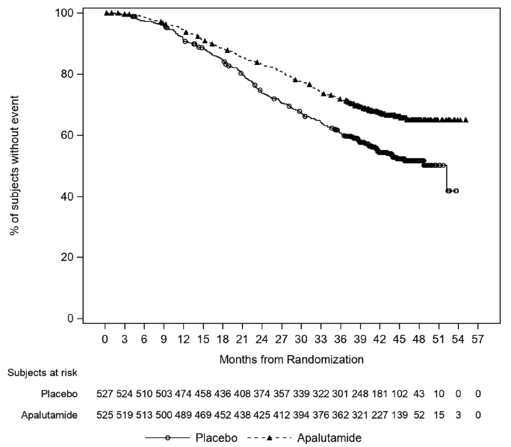 | 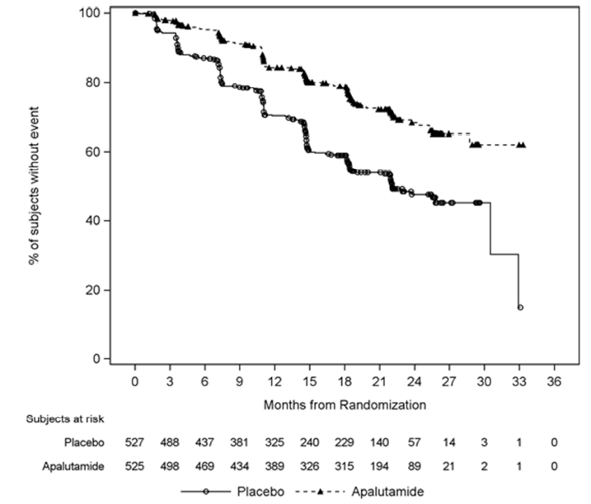
[B.1] OS (final analysis), LV | [B.2] rPFS, LV
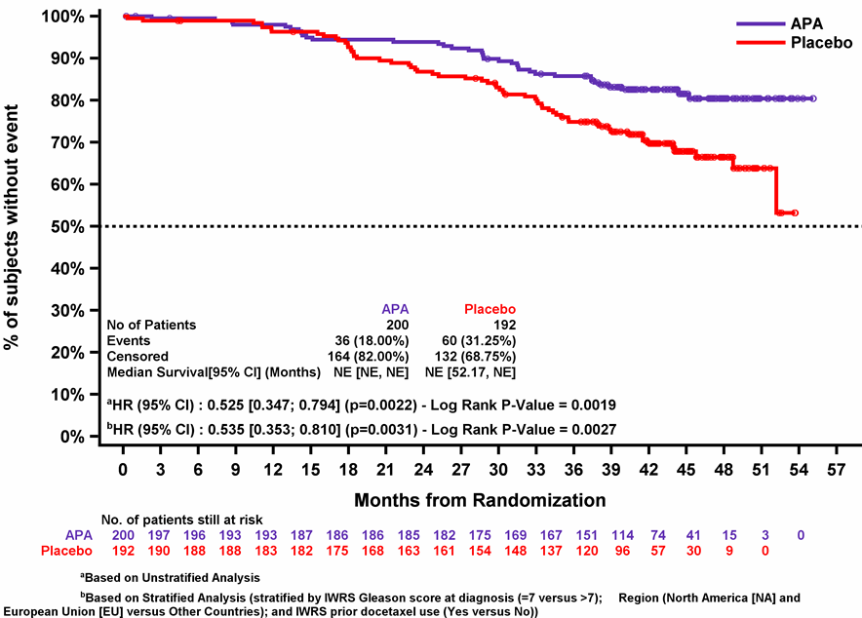 | 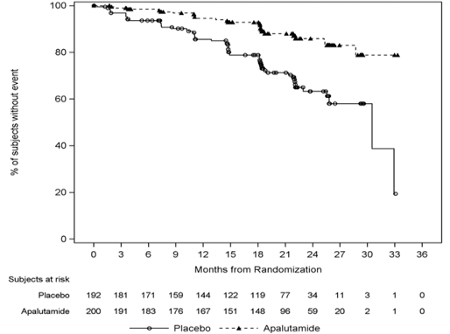
[C.1] OS (final analysis), HV | [C.2] rPFS, HV
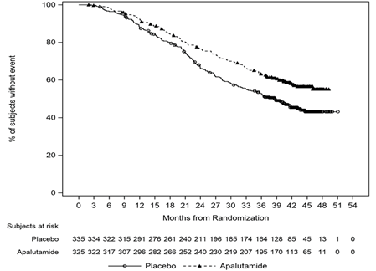 | 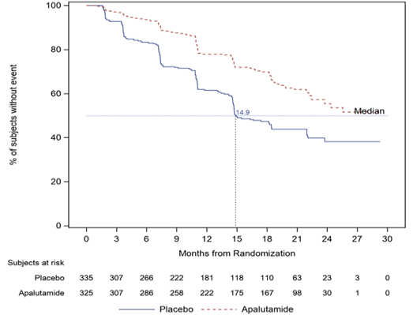
Abbreviations: HV=high volume; LV=low volume; mHSPC=metastatic hormone sensitive prostate cancer; OS=overall survival; rPFS=radiographic progression free survival
Source: Figure 2.4, p86, Figure 2.6, p88 and Figures 2.11 to 2.14, pp105-108 of the submission.
  - For the ITT population, the results showed that OS and rPFS was significantly longer for patients randomised to apalutamide compared to placebo, with a statistically significant 35% reduction in the risk of death (HR = 0.65, 95%CI: 0.53, 0.79) and a statistically significant 52% reduction in the risk of radiographic progression or death (HR = 0.48, 95%CI: 0.39, 0.60). The results also showed significantly longer OS and rPFS with apalutamide compared to placebo in patients with both LV and HV disease.
  - The estimated relative treatment effects were numerically larger in patients with LV disease compared to HV disease. Although the submission stated that there was no evidence that disease volume was a treatment effect modifier, the ESC considered that it was likely that a proportion of HV patients had received prior docetaxel, which may have reduced or negated the benefit of apalutamide. Results from a Cox proportional hazards model, which included an interaction for disease volume, found the treatment effect for OS was not significantly different for patients with LV or HV disease. (p=0.94). The submission noted no further trial data would become available; at the final follow up, the trial data did not reach median OS or rPFS in the apalutamide arm.
  - Overall, results across most secondary and exploratory outcomes either numerically or statistically favoured apalutamide compared to placebo, and the estimated treatment effects were numerically larger for patients with LV compared to HV disease. There was also no clinically meaningful difference in EQ-5D-5L utility scores between treatment arms on treatment, and there was a similar decline in utility scores between treatment arms after treatment discontinuation (i.e. disease progression). The PBAC noted that the time to cytotoxic chemotherapy was significantly longer with apalutamide than with placebo (HR = 0.39, 95%CI: 0.27, 0.56), but not time to pain progression or time to chronic opioid use (Chi et al. 2019, p7 and p9).
  - The submission presented a comparison of the results for OS with and without adjustment for treatment switching in the placebo arm. These were considered as supportive evidence, given the unadjusted results were applied in the model base case.

Comparative harms
  - Table 5 summarises the treatment emergent AEs and AEs of special interest in TITAN, as well as AEs included in the modelled economic evaluation. The submission also presented exposure-adjusted rates of AEs given median exposure to apalutamide (39 months) was twice as long as placebo (20 months) and the placebo-apalutamide crossover arm (15 months).
Table 5: Summary of the AEs in TITAN
AEs | ITT |  |  |  |  |  | LV mHSPC
 | APA  N=524 |  | PBO  N=527 |  | PBO-APA  N=208 | RD (95%CI)^{b} | APA  N=199 | PBO  N=192
Any TEAEª | 510 (97.3) |  | 510 (96.8) |  | 174 (83.7) | 1% (-2%,3%) | 197 (99.0) | 185 (96.4)
TEAE (Grade 3-4) | 259 (49.4) |  | 220 (41.7) |  | 57 (27.4) | 8% (2%, 14%) | 85 (42.7) | 63 (32.8)
TEAE to discontinuation | 62 (11.8) |  | 30 (5.7) |  | 16 (7.7) | 6% (3%, 10%) | 28 (14.1) | 13 (6.8)
TEAE to dose interruption | 119 (22.7) |  | 64 (12.1) |  | 36 (17.3) | 11% (6%, 15%) | 43 (21.6) | 28 (14.6)
SAE (Grade 3-4) | 124 (23.7) |  | 93 (17.6) |  | 27 (13.0) | 6% (1%, 11%) | 46 (23.1) | 31 (16.1)
TEAE leading to death | 20 (3.8) |  | 17 (3.2) |  | 7 (3.4) | 1% (-2%, 3%) | 7 (3.5) | 6 (3.1)
AEs of special interest
Any | 222 (42.4) |  | 99 (18.8) |  | 59 (28.4) | 24% (18%, 29%) | - | -
Skin rash | 153 (29.2) |  | 49 (9.3) |  | 45 (22) | 20% (15%, 25%) | - | -
Exposure-adjusted, /100 SY | 24.4 |  | 8.3 |  | 30.8 | - | - | -
Model (grade 3+) | 33 (6.3) |  | 5 (0.9) |  | - | - | 12 (6.0) | 4 (2.1)
Fall | 49 (9.4) |  | 37 (7.0) |  | 8 (4) | 2% (-1%, 6%) | - | -
- Exposure-adjusted, /100 SY | 4.6 |  | 6.8 |  | 5.7 | - | - | -
- Model (all grade) | 49 (9.4) |  | 37 (7.0) |  |  | - | 22 (11.1) | 19 (9.9)
Fracture | 54 (10.3) |  | 26 (4.9) |  | 5 (2) | 5% (2%, 9%) | - | -
- Exposure-adjusted, /100 SY | 6.1 |  | 4.2 |  | 2.1 | - | - | -
- Model (not SAE) | 41 (7.8) |  | 21 (4.0) |  | - | - | 18 (9.0) | 7 (3.6)
- Model (SAE) | 19 (3.6) |  | 6 (1.1) |  | - | - | 8 (4.0) | 5 (2.6)
Seizure | 3 (0.6) |  | 2 (0.4) |  | 0 | 0 (-1%, 1%) | - | -
- Exposure-adjusted, /100 SY | 0.2 |  | 0.3 |  | 0 | - | - | -
- Model (grade 3+) | 1 (0.2) |  | 0 |  | - | - | 1 (0.5) | 0
Ischaemic heart disease | 31 (6) |  | 11 (2) |  | 1 (1) | 4% (2%, 6%) | - | -
- Exposure-adjusted, /100 SY | 3.3 |  | 1.6 |  | 0.4 | - | - | -
- Model (grade 3+/SAE) | 21 (4.0) |  | 5 (0.9) |  | - | - | 9 (4.5) | 2 (1.0)
Ischaemic cerebrovascular | 13 (2) |  | 8 (2) |  | 5 (2) | 1% (-1%, 3%) | - | -
- Exposure-adjusted, /100 SY | 1.3 |  | 1.3 |  | 2.9 | - | - | -
- Model (grade 3+/SAE) | 9 (1.7) |  | 2 (0.4) |  | - | - | 3 (1.5) | 0
Other AEs in model (grade 3+/SAE)
Pneumonia | 12 (2.3) |  | 4 (0.8) |  |  |  | - | -
Urinary tract infection | 10 (1.9) |  | 3 (0.6) |  |  |  | - | -
Haematuria | 10 (1.9) | 3 (0.6) |  |  |  |  | - | -
Abbreviations: ADT=androgen deprivation therapy; AE=adverse event; CI=confidence intervals; RD=risk difference; RR=relative risk; SAE=serious adverse events; SY=subject years (of exposure); TEAE=treatment-emergent adverse event
a Excludes Grade 5 events.
b RR and RD were calculated for apalutamide + ADT vs placebo + ADT.
Treatment-emergent adverse events are those that occurred between the date of first dose of study drug and date of last dose of study drug+30 days. For each category, patients are counted only once, even if they experienced multiple events in that category.
Bold text indicates statistical significance at p<0.05 level.
Source: Tables 2.24 to 2.32, pp95-100, Table 2.39, p114 and Table 3.18, p169 of the submission.
  - Overall, the proportion of any AEs across the treatment arms were comparable and the safety outcomes reported in TITAN were consistent with the known safety profile for apalutamide. There were significantly more serious AEs (Grade 3-4), AEs leading to discontinuations and dose interruptions experienced in the apalutamide compared to placebo. Deaths due to AEs were similar between treatment arms. After adjusting for treatment exposure, the incidence of the most common TEAEs were higher in the placebo arm except for skin rash which was higher in the apalutamide arm and placebo-apalutamide crossover arm compared to placebo. The incidence of ischaemic heart disease was also higher with apalutamide, mostly in patients with underlying cardiovascular disorders risk factors.

Benefits/harms
  - Table 6 presents a summary of the comparative benefits and harms for apalutamide versus placebo for mHSPC.
Table 6: Summary of comparative benefits and harms between apalutamide and placebo, ITT population
Benefits
Event | APA | PBO | Absolute Difference | HR (95% CI)
Progression free survival
Progressed, n (%) | 134/525 (25.5) | 231/527 (43.8) | - | 0.484 (0.391, 0.600)
Median PFS, months (95% CI) | NE (NE, NE) | 22.1(18.5,32.9) | 22.1
% not progressed at 12 months (95%CI) | 84.3 (80.7, 87.3) | 70.3 (66.0, 74.1) | 14.0%
% not progressed at 24 months (95%CI) | 68.2 (62.9, 72.9) | 47.5 (42.1, 52.8) | 20.7%
Overall survival
Deaths, n/N (%) | 170 (32.4) | 235 (44.6) | - | 0.651 (0.534, 0.793)
Median OS, months (95% CI) | NE (NE, NE) | 52.2 (41.9, NE) | NE
% Alive at 12 months (95% CI) | 94.6 (92.3,96.2) | 90.8 (88.0, 93.0) | 3.8%
% Alive at 24 months (95% CI) | 83.3 (79.8, 86.3) | 73.7 (69.7, 77.3) | 9.6%
% Alive at 36 months (95% CI) | 71.9 (67.8, 75.6) | 61.0 (56.6, 65.0) | 10.9%
% Alive at 48 months (95% CI) | 65.1 (60.4, 69.3) | 51.8 (46.9, 56.4) | 13.3%
Harms
TITAN | APA  N=524 | PBO  N=527 | RR*  (95% CI) | Event rate/100 SY# |  | RD  (95% CI)
 |  |  |  | APA | PBO
AEs of special interest
Skin rash | 153 (29.2) | 49 (9.3) | 3.14 (2.33, 4.23) | 24.4 | 8.3 | 16.1% (NR, NR)
Ischaemic heart disease | 31 (5.9) | 11 (2.1) | 2.83 (1.44, 5.58) | 3.3 | 1.6 | 1.7% (NR, NR)
Abbreviations: APA=apalutamide; HR=hazard ratio; PBO=placebo; RD=risk difference; RR=risk ratio; SY=subject years
* Median follow-up of the final data analysis was 43.8 months (final data cut was in September 2020).
# adjusted for exposure, median of 39 months for apalutamide and 20 months for placebo
Source: Tables 2.24 to 2.32, pp95-100, Table 2.39, p114 and Table 3.18, p169 of the submission
  - On the basis of direct evidence from TITAN presented by the submission, for every 100 patients treated with apalutamide in comparison with placebo:
- Approximately 21 additional patients will remain progression-free after 24 months.
- Approximately 10 additional patients will remain alive after 24 months and 13 additional patients will remain alive after 48 months.
- Approximately 16 additional patients will experience skin rash, over a 12-month period.
- Approximately 2 additional patients will experience ischaemic heart disease, over a 12-month period.

Clinical claim
  - The submission described apalutamide in addition to ADT as superior in terms of effectiveness and inferior (but acceptable) in terms of safety compared with ADT alone.
  - The ESC considered that the evidence presented in the submission adequately supported this claim for patients with LV disease. The PBAC considered that the claim of superior comparative effectiveness was reasonable for patients with LV disease. However, the PBAC considered that the benefit demonstrated in TITAN overestimated the likely benefit that would be seen in the LV group in clinical practice due to differences between the trial population and likely PBS population (many aged > 75 years and poor ECOG PS in clinical practice).
  - Although there was a statistically significant improvement in rPFS and OS (as well as a number of other outcomes) favouring apalutamide in all patients irrespective of disease volume, and most AEs did not require permanent discontinuation of treatment, the ESC considered that the clinical claim in terms of efficacy could not be supported for patients with HV disease who are unsuitable for chemotherapy. The ESC noted that the TITAN trial did not provide any direct evidence for these patients, given the trial excluded patients with ECOG status ≥ 2 and a number of comorbidities.
  - For patients with HV disease, the PBAC considered that the claim of superior comparative effectiveness was not adequately supported by the data, noting that an informative comparison of apalutamide + ADT to ADT in patients unfit for docetaxel (e.g. due to ECOG PS ≥ 2 and comorbidities) was not presented in the submission. The PBAC considered that while apalutamide was likely to result in some benefit compared to placebo in patients with HV disease who are unfit for chemotherapy, the degree of benefit was likely reduced compared to that presented in the submission for the HV subgroup due to their competing comorbidities.
  - The PBAC considered that the claim of inferior comparative safety was reasonable on the basis that apalutamide + ADT is associated with additional AEs compared with ADT monotherapy.
  - The PBAC noted that the submission did not provide a comparison of apalutamide to docetaxel. The PBAC noted that a network meta-analysis (Marchioni 2020) suggests apalutamide and docetaxel have a similar effect on overall survival but apalutamide is associated with fewer adverse events (see paragraph 4.2).

Economic analysis
  - The submission presented a stepped economic evaluation (cost-utility analysis) based on the TITAN trial, using a standard partitioned survival model to estimate costs and outcomes for apalutamide versus placebo in mHSPC. Appropriately, the model used trial results unadjusted for placebo crossover.
  - Table 7 summarises the key components of the economic evaluation.
Table 7: Summary of model structure, key inputs and rationale
Component | Summary
Treatments | Apalutamide+ADT versus ADT alone
Population | A separate economic evaluation was presented for two populations:  - ‘LV model’ - patients with LV mHSPC, based on data for the LV subgroup in TITAN.  - ‘ITT/HV model’ - patients with HV mHSPC who are unsuitable for docetaxel, based on the ITT population in TITAN.  The assumption that the ITT population is a reasonable proxy for the HV subgroup on the PBS was poorly justified. See comments below.
Time horizon | - LV model: 20 years.  - ITT/HV model: 15 years.  Compared to median follow-up of 44 months in TITAN (final analysis).  The assumed time horizons were poorly justified, based on results of the parametric functions selected to extrapolate OS (i.e. less than 5% of patients alive at the nominated time horizons) rather than clinical argument. A shorter time horizon is likely more appropriate for an older population (median age of 74 years in the Victorian Prostate Cancer Registry) with metastatic prostate cancer.
Outcomes | Quality-adjusted life years, life years.
Methods used to generate results | Partitioned survival model. The model relies on KM data to inform transitions over 3 health states.
Health states | 3 health states:  - Progression free survival (mHSPC)  - Progressed disease (mCRPC)  - Death.  Reasonable; although ‘progressed disease’ in practice (mCRPC) is a heterogeneous state consisting of multiple lines of treatment and disease progressions.
Cycle length | Monthly, with half cycle correction.
Allocation to health states | Allocation to health states derived from KM data in TITAN of OS and rPFS. Time on primary treatment derived from post-hoc TTD data. Parametric extrapolation of time to event outcomes was used when < 20% of patients remain in the risk set of the KM data. The model did not adjust OS for treatment switching in the base case.  - LV model: Data for LV subgroup.  - ITT/HV model: Data for ITT population.  The overall approach was generally reasonable, and not adjusting for treatment switching was appropriate. The trial data from the final analysis is still relatively immature (i.e. less than half of the events were observed), particularly for the LV subgroup, corresponding to considerable uncertainty around the assumed comparative long-term efficacy implied by the parametric extrapolations. The ESC considered that the use of ITT data for the HV model was inappropriate.
Extrapolation method | The submission fitted parametric proportional hazards and accelerated failure time models with only one covariate for treatment group to the PFS and OS KM data. For TTD data, the submission fit separate functions to the apalutamide and PBO arms (i.e. assumed no relationship).  PFS: Use of trial-based KM curves: Up to 22-26 months*. Extrapolation: Weibull thereafter.  OS: Use of trial-based KM curves: Up to 45-48 months*. Extrapolation: Weibull thereafter.  TTD: Use of trial-based KM curves: Up to 27-33 months*. Extrapolation: Weibull (ITT/HV model), Gompertz (LV model) thereafter.  Based on evidence from the docetaxel trials (STAMPEDE, GETUG-AUF15, CHAARTED), the assumed proportional hazards assumption may not be valid over the longer-term. See comment below.
Health related quality of life | ITT/HV model: Progression-free = 0.789; Progressed = 0.676  LV model: Progression-free = 0.817; Progressed = 0.707  Health state utilities derived from post-hoc analysis of EQ-5D-5L data in TITAN.  The utilities assumed are generally reasonable, and the incremental difference between health states (0.11) was consistent with utilities assumed in other models.
Costs | The model included costs for apalutamide, background ADT, management of AEs (one-off costs), monitoring disease progression (PSA tests, specialists, imaging), subsequent treatment post progression (docetaxel, cabazitaxel, abiraterone/enzalutamide, antiandrogens, bone-sparing agents, prednisolone) and end of life costs. The model assumed patients treated with apalutamide for mHSPC did not receive abiraterone/enzalutamide for mCRPC.  The overall approach to modelling costs was generally reasonable. The cost of apalutamide for mHSPC and cost-offsets associated with no subsequent treatment with NHAs for mCRPC were the key drivers of the incremental costs of treatment. There was a modest increase in the costs for monitoring and background ADT due to the improved overall survival with apalutamide, but this was more than offset by delayed/reduced use of other therapies for mCRPC and end of life costs.
Abbreviations: ADT = androgen deprivation therapy; APA = apalutamide; EQ5D-5L = EuroQoL 5 Dimension 5-Level; HV = high volume IPD = individual patient data; KM = Kaplan-Meier; mCRPC = metastatic castration resistant prostate cancer; mHSPC = metastatic hormone sensitive prostate cancer; NHA = novel hormonal agent; PBO = placebo; PD = progressed disease; PFS = progression free survival; PSA = prostate specific antigen; rPFS = radiographic progression free survival; TTD = time to treatment discontinuation.
*20% remaining in the risk set of the KM data.
Source: constructed during the evaluation.
Population
  - The submission modelled two populations using the same model structure but different parameters: (i) ‘LV model’ for patients with LV mHSPC, based on data for the LV subgroup in TITAN; (ii) ‘ITT/HV model’ for patients with HV mHSPC unsuitable for docetaxel, based on the ITT population in TITAN. The submission argued that as the treatment effect for the ITT population and HV subgroup were consistent, that the ITT population is a reasonable proxy for the HV subgroup. The submission did not provide a clear rationale for why the ITT population would be a better proxy than the HV subgroup in TITAN for the requested HV population on the PBS. The ESC considered that this assumption was not adequately justified and likely favoured apalutamide:
- The ITT population was not representative of the requested HV population in terms of baseline characteristics, given only 63% had HV disease and only 10% of those patients met the PBS eligibility criteria.
- Volume of disease is a prognostic factor, which affects survival. In the placebo arm of TITAN, median survival was 38.7 months in the HV subgroup versus 52.2 months in the ITT population.
- The treatment effect was numerically larger in the ITT population compared to the HV subgroup (for OS, HR = 0.65 versus 0.70, respectively; for PFS, HR = 0.48 versus 0.52, respectively).
Extrapolations
  - The model estimated the proportion of patients within each of the health states (including on treatment) from rPFS, OS and TTD curves in TITAN, using the standard partitioned survival approach. Although the model used trial data until 20% of patients remained at risk, the parametric functions ultimately informed most of the model transitions, particularly in the LV model. For example, in the LV model, the trial data for rPFS captured approximately 14% and 32% of progression-related events for apalutamide and placebo respectively, and approximately 20% and 33% of deaths for apalutamide and placebo respectively. Consequently, there is greater uncertainty around the long-term extrapolations evidenced by the wide variation between the different parametric functions (see Figure 3).
  - In fitting the parametric functions to the trial data, the submission assumed that the proportional hazards assumption would hold over the modelled time horizon. This implies that moving an NHA forward in the treatment pathway (from mCRPC to mHSPC) results in a large survival benefit maintained over the entire time horizon irrespective of the parametric function chosen. The evaluators stated that this assumption may not be reasonable as moving docetaxel forward in the treatment pathway (from mCRPC to mHSPC) in the STAMPERE, GETUG-AUF15 and CHAARTED trials did not result in improved survival indefinitely. The PSCR argued that the long term survival curves for apalutamide would not follow the observed survival in the docetaxel trials because (i) docetaxel is a finite course (6 cycles) whereas apalutamide is given until disease progression; (ii) the apparent convergence was driven by LV patients, in whom docetaxel does not prolong survival; and (iii) the convergence was an artefact of small sample sizes. In addition, the PSCR stated that there was no evidence to suggest that the proportional hazards assumption would not hold based on the OS evidence from the TITAN trial. The ESC noted that the clinical consensus was that early, versus later, treatment with docetaxel or an NHA does provide a meaningful and ongoing survival benefit.
Time horizon
  - The submission assumed time horizons of 15 years in the ITT/HV model and 20 years in the LV model, corresponding to the time points with less than 5% of patients remaining alive in the preferred Weibull extrapolation of OS (see Figure 2). The submission argued that the Weibull function provided the most clinically plausible extrapolations and estimates at 5 years were externally valid compared to observed survival in the docetaxel trials (STAMPEDE, GETUG-AUF15 and CHAARTED). The same argument would also apply to other extrapolations such as the Gompertz function, which provided similar survival estimates at 5 years. Overall, it was unclear whether any of the simple parametric functions would adequately capture the expected survival of mHSPC given the many subsequent lines of treatment.
Figure 2: Parametric extrapolations of OS data in TITAN (Top: APA-treated patients; Bottom: PBO-treated patients)
[A] LV model (20 years) | [B] ITT/HV model (15 years)
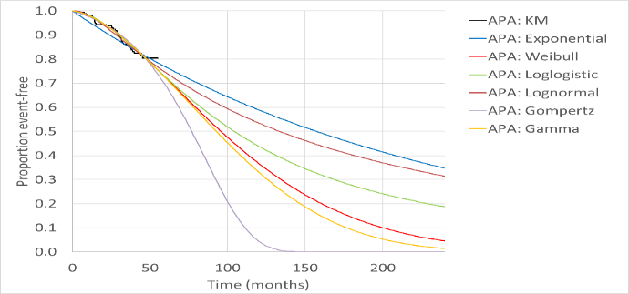 | 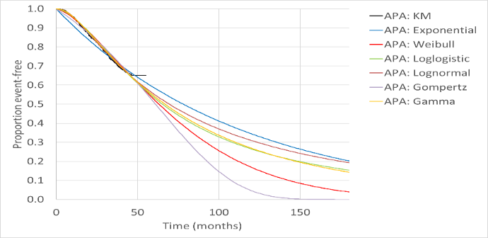
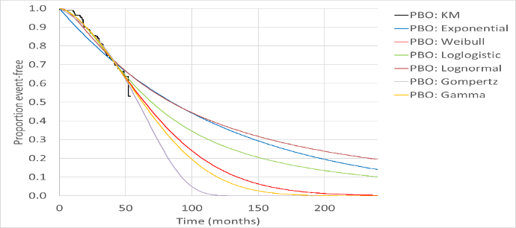 | 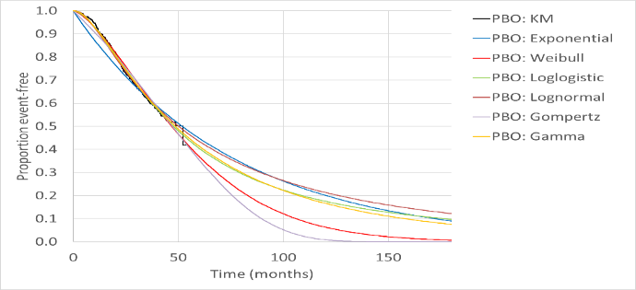
Abbreviations: APA = apalutamide; KM = Kaplan Meier; OS = overall survival; PBO = placebo.
Source: Figures 3-12c and 3-13d, p164-165 of the submission

  - Given the uncertainty around the longer-term predictions (see paragraph 6.28), a shorter time horizon may be appropriate for the modelling a population of older patients (median age in Australia reported as 74 years by the submission) with advanced cancer. The PBAC recently considered that a 10-year time horizon was appropriate for patients with m0CRPC (Table 2, apalutamide Public Summary Document (PSD), November 2020; paragraph 7.12, darolutamide, PSD, July 2020). Given the similar time to progression to mCPRC on apalutamide for mHSPC (median progression free survival of 3.2 years) and m0CRPC (median metastasis-free survival of 3.4 years), and similar expected survival thereafter, the ESC considered that shorter time horizons of 10-years for the LV model and 5 years for the ITT/HV model would be preferred as the populations were elderly men (median age = 74 years) with metastatic cancer and competing causes of mortality, particularly those in the ITT/HV model who had severe comorbidities which made them unsuitable for chemotherapy. The ESC also considered the Weibull extrapolations were highly optimistic. The ESC advised that the Gompertz model resulted in more clinically plausible outcomes.
Subsequent therapy
  - The model appropriately assumed patients treated with apalutamide for mHSPC would not receive another NHA (abiraterone or enzalutamide) for mCRPC, in line with the requested PBS restriction. For patients treated with placebo for mHSPC, the model assumed that 100% of patients would receive an average duration of 15 months of NHA treatment for mCRPC. The submission stated that the average of 15 months was derived from a PBS 10% sample analysis of 20,720 patients initiated on abiraterone or enzalutamide between January 2010 and February 2021, but provided no further detail of the analysis, e.g. whether the 15 months took into account breaks in treatment, or compliance. It was noted that 15 months (~15 packs) of NHA treatment for mCRPC was considerably longer than the 0.76 years (or 9.1 months) estimated by DUSC in June 2016 or the mean 8.9 packs of abiraterone estimated by Ghijben et al 2021 (using 2013 to 2015 data). The PSCR stated that both the 2016 DUSC review and the analysis by Ghijben 2021 substantially underestimated the current utilisation of abiraterone and enzalutamide in the mCRPC setting. The PSCR argued that using 1-2 years of utilisation data meant that most patients would still be on treatment at the data cut-offs of these analyses and stated that the average utilisation of abiraterone and enzalutamide had increased over time. The PSCR further noted that the PBAC recommendation to remove the requirement for prior docetaxel in the mCRPC setting in March 2021 would further increase their duration of therapy in mCRPC. The ESC noted that the use of the 10% PBS sample was inadequately described. The ESC also noted that in the apalutamide model for m0CRPC (November 2018 submission), a 10% PBS sample found that patients received 12.4 months of abiraterone or enzalutamide therapy in the mCRPC setting. The ESC noted the effects of altering this value and the proportion of patients receiving an NHA in the mCRPC setting in the sensitivity analyses.
  - Figure 3 presents the proportion of patients in each health state over the modelled time horizons. The model predicts a relatively large increase in average survival associated with moving NHA treatment forward in the treatment pathway of 18.1 months (undiscounted) in the ITT/HV model and 33.8 months (undiscounted) in the LV model, which may not be realistic.
Figure 3: Markov traces – all health states base case model
[A] ITT/HV model | [B] LV model
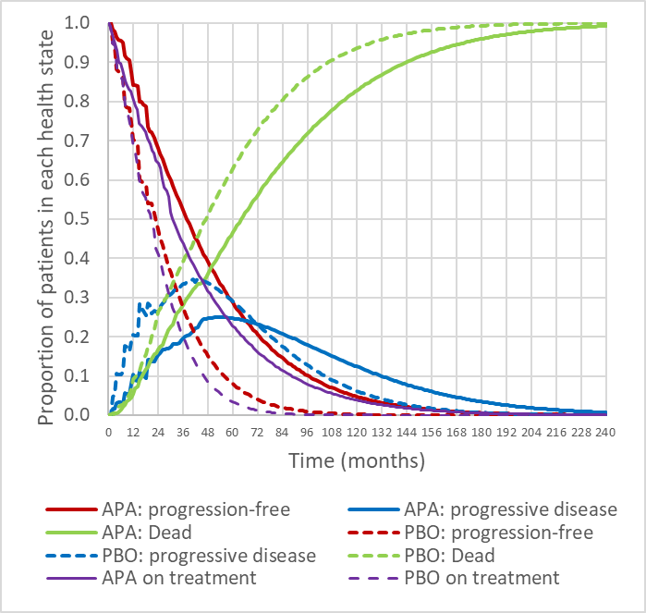 | 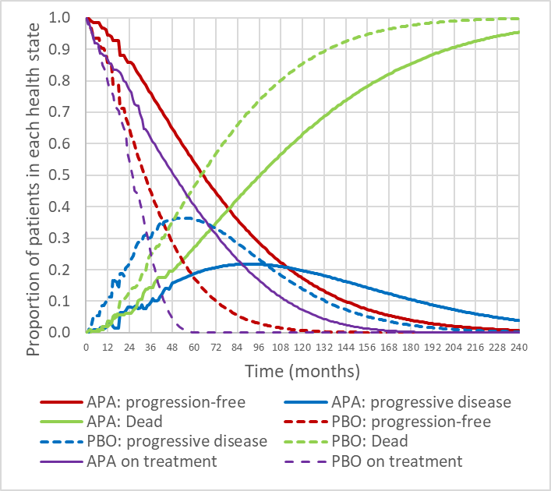
APA = apalutamide; PBO =placebo.
Source: pp181-182 of the submission; constructed during the evaluation based on the models provided.
  - The key drivers in the model included i) the duration of treatment with apalutamide (treatment cost), ii) the duration of treatment with a NHA for mCRPC in the placebo arm (the main cost offset), and iii) the estimated gain in rPFS and OS (the estimated treatment effects). Hence, the model was sensitive to inputs associated with these key parameters (such as duration of treatments and extrapolation functions), summarised in Table 8.
Table 8: Key drivers of the model
Description | Method/Value | Impact
 |  | ITT/HV model,  BC: '''''''''''''''¹/QALY | LV model,  BC: '''''''''''''''''¹/QALY
Treatment duration on APA | Patients discontinue treatment prior to or at disease progression / death, based on TTD curve. However, trial investigators frequently monitor patients for stopping criteria under trial conditions, and hence use of treatment may be longer in practice. | Moderate, favours APA. The ICER increases by 18.0% assuming treatment until disease progression. | High, favours APA. The ICER increases by 34.3% assuming treatment until disease progression.
Treatment duration on NHAs for mCRPC | Patients in the placebo arm received an average of 15 months (~15 packs) of NHAs in the mCRPC health state. This estimate was uncertain and considerably longer than other estimates of 9 months or 8.9 packs in the literature. | Moderate, favours APA. The ICER increases by 19.7% assuming an average duration on NHAs of 9 months. | Moderate, favours APA. The ICER increases by 12.2% assuming an average duration on NHAs of 9 months.
Extrapolation functions | The submission assumed the proportional hazards assumptions holds over the entire modelled time horizon irrespective of the function used. This assumption may not hold in practice for the entire time horizon. The ESC noted the wide variation in survival estimates depending on the parametric function selected (see Figure 2) and the relatively large modelled increases in OS. | Moderate, favours APA. The ICER increases by 20.1% assuming gradual convergence in OS after 5 years. | High, favours APA. The ICER increases by 33.1% assuming gradual convergence in OS after 5 years.
Abbreviations: APA = apalutamide; PBO = placebo; OS = overall survival; PFS = progression free survival.
Source: constructed during the evaluation based on Apalutamide mHSPC ITT Economic Model EXCEL file, Apalutamide Low Volume mHSPC Economic Model EXCEL file.
The redacted values correspond to the following ranges:
¹ $35,000 to < $45,000
Results
  - Table 9 presents the results of the stepped economic evaluation. Results for Step 1 include all modelled costs and outcomes over the first 44 months, whereas Step 2 includes all modelled costs and outcomes over the lifetime (15 years in the ITT/HV model and 20 years in the LV model).
Table 9: Results of the stepped economic evaluation
Step and component | ITT/HV model |  |  | LV model
 | APA | PBO | Increment | APA | PBO | Increment
Step 1: Time horizon, trial based (discounted): 44 months (ITT/HV and LV)
Costs ($) | '''''''''''''''''' | $41,688 | ''''''''''''''''''' | ''''''''''''''''''' | $35,267 | '''''''''''''''''''
Lys | 2.97 | 2.75 | 0.22 | 3.25 | 3.08 | 0.17
QALYs | 2.29 | 2.07 | 0.22 | 2.63 | 2.44 | 0.19
Incremental cost/extra QALY gained |  |  | '''''''''''''''''¹ |  |  | '''''''''''''''''''²
Step 2: Time horizon, lifetime (discounted): 15-years (ITT/HV), 20 years (LV) years
Costs ($) | '''''''''''''''''''''' | $74,919 | '''''''''''''''''' | ''''''''''''''''''''''' | $80,335 | ''''''''''''''''''
LYs | 5.06 | 3.95 | 1.10 | 6.90 | 5.08 | 1.83
QALYs | 3.81 | 2.91 | 0.90 | 5.45 | 3.90 | 1.55
Incremental cost/extra QALY gained |  |  | ''''''''''''''³ |  |  | ''''''''''''''''³
Source: Tables 3.34 and 3.35, p183 of the submission.
The redacted values correspond to the following ranges:
¹ $115,000 to < $135,000
² $155,000 to < $255,000
³ $35,000 to < $45,000
  - The results demonstrate that the majority of the incremental costs in the model occur during the first 44 months and the majority of the incremental benefits accrue after 44 months.
  - Disaggregated results showed that the incremental costs are driven largely by the cost of apalutamide ($'''''''''''''' in ITT/HV model, $''''''''''''' in LV model) and cost-offsets associated with subsequent treatment (-$'''''''''''' in ITT/HV model, -$'''''''''''' in LV model). There was a modest increase in the costs for monitoring and background ADT due to the improved overall survival, but this was more than offset by delayed/reduced use of other therapies for mCRPC and end of life costs. The results also showed that the incremental benefits are due to the survival gain spent with progression-free disease. The model predicts moving NHA treatment forward leads to 19.7 months (undiscounted) additional survival with progression-free disease and 18.1 months (undiscounted) overall in the ITT/HV model, and 37.3 months (undiscounted) additional survival with progression-free disease and 33.8 months (undiscounted) overall in the LV model.
  - Table 10 presents key univariate and multivariate sensitivity analyses.
Table 10: Sensitivity analyses
Analyses | ITT/HV model |  |  | LV model
 | Incremental |  | ICER | Incremental |  | ICER
 | Cost ($) | QALY |  | Cost ($) | QALY
Base case | ''''''''''''''' | 0.90 | ''''''''''''''''¹ | '''''''''''''' | 1.55 | '''''''''''''''''¹
Discount rate (BC: 5%))
0% | '''''''''''''''''' | 1.21 | ''''''''''''''''''''¹ | ''''''''''''''''' | 2.33 | '''''''''''''''''''''⁵
3.5% | ''''''''''''''''''''' | 0.98 | '''''''''''''''''''''¹ | '''''''''''''''''' | 1.74 | ''''''''''''''''''''⁵
Time horizon (BC: 15yr in ITT/HV, 20yr in LV)
5 years | ''''''''''''''''''' | 0.37 | '''''''''''''''''''² | '''''''''''''''''''''' | 0.37 | '''''''''''''''''''³
10 years | '''''''''''''''''''' | 0.77 | '''''''''''''''''''¹ | ''''''''''''''''''''' | 1.05 | ''''''''''''''''''¹
Treatment switching for OS (BC: none)
IPCW (HR=0.530 ITT/HV, 0.395 LV) | '''''''''''''''''''' | 1.18 | ''''''''''''''''''¹ | '''''''''''''''''' | 2.04 | '''''''''''''''''⁵
RPSFTM1* (HR=0.611 ITT/HV, 0.436 LV) | '''''''''''''''''' | 0.97 | ''''''''''''''''''''¹ | '''''''''''''''''''' | 1.87 | ''''''''''''''''''⁵
RPSFTM2^ (HR=0.604 ITT/HV, 0.478 LV) | '''''''''''''''''''' | 0.99 | '''''''''''''''''''¹ | ''''''''''''''''''''' | 1.72 | '''''''''''''''''''''¹
NHA post apalutamide (BC: none)
TITAN (80.7% ITT/HV, 70.3% LV) | '''''''''''''''''' | 0.90 | '''''''''''''''''''''² | ''''''''''''''''''' | 1.55 | '''''''''''''''''''¹
Assumption, 100% | ''''''''''''''''''''' | 0.90 | '''''''''''''''''''''³ | ''''''''''''''''''' | 1.55 | ''''''''''''''''''¹
Time on chemo (BC: 10.7% DOC, 5.1% CAB)
50% increase post APA | ''''''''''''''''''' | 0.90 | '''''''''''''''''''''¹ | ''''''''''''''''''' | 1.55 | ''''''''''''''''''¹
100% increase post APA | '''''''''''''''''' | 0.90 | '''''''''''''''''''¹ | ''''''''''''''''' | 1.55 | ''''''''''''''''''¹
Extrapolation for PFS (BC: Weibull)
Gompertz | ''''''''''''''''''' | 0.85 | '''''''''''''''''''''¹ | ''''''''''''''''''''' | 1.41 | '''''''''''''''''''⁵
Δ PBO PFS = Δ APA PFS after 23 monthsª | ''''''''''''''''''''' | 0.83 | ''''''''''''''''''² | '''''''''''''''''' | 1.40 | '''''''''''''''''''²
Extrapolation for OS (BC: Weibull)
Gompertz extrapolation  Convergence: | '''''''''''''''''''' | 0.72 | ''''''''''''''''''² | '''''''''''''''''''' | 0.94 | ''''''''''''''''''''²
Δ PBO OS = Δ APA OS after 44 months^{b} | ''''''''''''''''''' | 0.60 | '''''''''''''''''³ | ''''''''''''''''''''' | 0.86 | ''''''''''''''''''³
Δ PBO OS = Δ APA OS after 5 years^{c} | ''''''''''''''''''''' | 0.72 | ''''''''''''''''''''² | ''''''''''''''''''' | 1.04 | '''''''''''''''''''''³
Extrapolation for TTD for APA (BC: Weibull)
TTD=PFS | ''''''''''''''''''''' | 0.90 | '''''''''''''''''''''² | '''''''''''''''''' | 1.55 | '''''''''''''''''''³
Mean time on NHAs, mCRPC (BC:15 months)
9 months | ''''''''''''''''''''' | 0.90 | ''''''''''''''''''² | '''''''''''''''''''' | 1.55 | ''''''''''''''''''¹
12 months | '''''''''''''''''''' | 0.90 | '''''''''''''''''''''¹ | '''''''''''''''''' | 1.55 | ''''''''''''''''''''¹
% patients on NHAs for mCRPC (BC: 100%)
75%^{d} | '''''''''''''''''' | 0.90 | ''''''''''''''''''''² | ''''''''''''''''' | 1.55 | '''''''''''''''''''''¹
45%^{d} | ''''''''''''''''''''' | 0.90 | '''''''''''''''''² | '''''''''''''''''''' | 1.55 | ''''''''''''''''''''¹
Multi-variate analyses
Δ PBO PFS = Δ APA PFS after 23 monthsª +  Δ PBO OS = Δ APA OS after 44 months^{b} | '''''''''''''''''' | 0.54 | '''''''''''''''''''''³ | ''''''''''''''''' | 0.71 | ''''''''''''''''''⁴
Δ PBO PFS = Δ APA PFS after 23 monthsª +  Δ PBO OS = Δ APA OS after 5 years^{c} | '''''''''''''''''' | 0.65 | '''''''''''''''''³ | ''''''''''''''''''' | 0.89 | ''''''''''''''''''³
Δ PBO OS = Δ APA OS after 44 months^{b} +  Mean time on NHAs, mCRPC = 9 months | ''''''''''''''''''' | 0.60 | '''''''''''''''''''''³ | '''''''''''''''''' | 0.86 | ''''''''''''''''''''³
Δ PBO OS = Δ APA OS after 44 months^{b} +  Mean time on NHAs, mCRPC = 9 months +  APA TTD = APA PFS | '''''''''''''''''' | 0.60 | ''''''''''''''''''⁴ | '''''''''''''''''''' | 0.86 | ''''''''''''''''''⁴
Time horizon = 10 years +  Extrapolation for OS = Gompertz | ''''''''''''''''' | 0.70 | '''''''''''''''''² | '''''''''''''''''' | 0.93 | ''''''''''''''''''''²
Time horizon = 10 years +  Extrapolation for OS = Gompertz +  mean time on NHAs, mCRPC = 9 months | ''''''''''''''''''' | 0.70 | '''''''''''''''''''³ | '''''''''''''''''' | 0.93 | ''''''''''''''''''''³
Time horizon = 10 years +  Extrapolation for OS = Gompertz +  mean time on NHAs, mCRPC = 9 months  % patients on NHAs, mCRPC = 45% | ''''''''''''''''''''' | 0.70 | ''''''''''''''''''''³ | '''''''''''''''''''' | 0.93 | ''''''''''''''''''³
ESC proposed revised base case models
Time horizon = 5 years +  Extrapolation for OS = Gompertz +  ΔPBO OS = ΔAPA OS after 44 months | '''''''''''''''''''' | 0.34 | ''''''''''''''''''³ | - | - | -
Time horizon = 10 years +  Extrapolation for OS = Gompertz +  ΔPBO OS = ΔAPA OS after 5 years | - | - | - | '''''''''''''''''' | 0.73 | '''''''''''''''''''''³
Abbreviations: APA = apalutamide; BC = base case; CAB = cabazitaxel; DOC = docetaxel; HR = hazard ratio; IPCW = inverse probability of censoring weights; NHA = novel hormonal agent; OS = overall survival; PFS = progression free survival; RPSFTM = Rank Preserving Structure Failure Time Models; TTD = time to treatment discontinuation.
ª PFS for PBO arm was extrapolated using the function fitted to the APA arm after 23 months (end of follow-up for PFS trial data), applying monthly per cycle transition probabilities for APA PFS to PBO PFS after this timepoint.
^{b} OS for PBO arm was extrapolated using the function fitted to the APA arm after 44 months (end of follow-up for OS trial data), applying monthly per cycle transition probabilities for APA OS to PBO OS after this timepoint.
^{c} OS for PBO arm was extrapolated using the function fitted to the APA arm after 5 years, applying monthly per cycle transition probabilities for APA OS to PBO OS after this timepoint.
^{d} The exact proportion of patients who received subsequent NHAs is unclear. At the final analysis, of the 527 patients randomised to placebo, 208 (39.5%) had crossed over to apalutamide before disease progression, 99 (18.8%) received subsequent abiraterone after study treatment discontinuation and 57 (10.8%) received subsequent enzalutamide after study treatment discontinuation.
Source: Table 3.44, p188 of the submission; Apalutamide mHSPC ITT Economic Model EXCEL file; Apalutamide Low Volume mHSPC Economic Model EXCEL file.
The redacted values correspond to the following ranges:
¹ $35,000 to < $45,000
² $45,000 to < $55,000
³ $55,000 to < $75,000
⁴ $75,000 to < $95,000
⁵ $25,000 to < $35,000

  - Noting the immaturity of the data which informed the modelled extrapolations and most of the model transitions sensitivity analyses were conducted during the evaluation assuming gradual convergence between the apalutamide and placebo survivor functions. In these sensitivities, the parametric function for the apalutamide arm was used to inform transitions in the placebo arm after the end of follow up (44 months) and after 5 years and resulted in ICERs of $55,000 to < $75,000/QALY and $45,000 to < $55,000/QALY for the LV model and $55,000 to < $75,000/QALY and $45,000 to < $55,000/QALY for the ITT/HV model respectively. Figure 4 illustrates the impact of these different scenarios on the OS curves compared to those assumed in the base case. The ESC considered that the treatment and placebo arms of the models should begin to converge after 44 months for the ITT/HV model and 5 years for the LV model.

Figure 4: Base and alternative extrapolations of OS for the placebo arm of the model
[A] ITT/HV model | [B] LV model
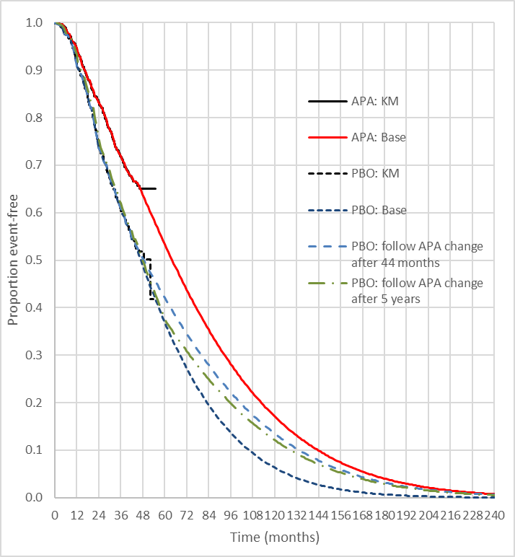 | 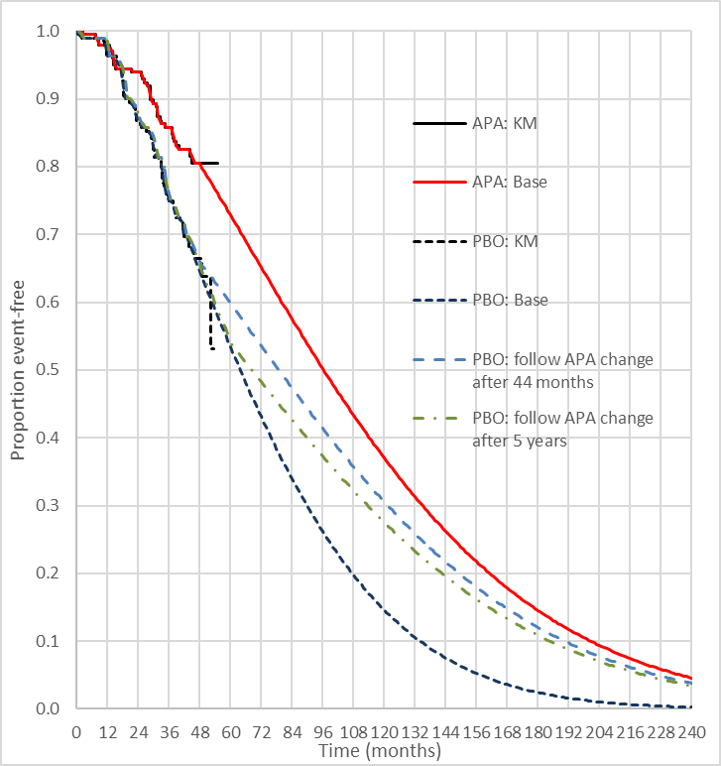
Source: Constructed during the evaluation
  - Overall, the ESC considered that a number of the model inputs/parameters were highly uncertain and proposed revised base case models which:
- ITT/HV model – 5 year time horizon, Gompertz extrapolation of OS, and convergence applied from 44 months. These changes resulted in an ICER of $55,000 to < $75,000/QALY, compared to $35,000 to < $45,000/QALY in the submission;
- LV model – 10 year time horizon, Gompertz extrapolation of OS, and convergence applied from 5 years. These changes resulted in an ICER of $55,000 to < $75,000/QALY, compared to $35,000 to < $45,000/QALY in the submission.
  - The pre-PBAC response defended the presented economic models, reiterating that the submission model did not adjust for treatment switching, which biases against apalutamide. The pre-PBAC response argued against the alterations to extrapolation function and convergence of curves. However, recognising the concern that the long-term survival of apalutamide was uncertain, the pre-PBAC response provided new models with reduced time horizons (from 15 to 10 years for the ITT/HV model and from 20 to 15 years for the LV model). This resulted in a revised ICER in LV patients of $35,000 to < $45,000/QALY and in HV patients of $35,000 to < $45,000/QALY (using the ITT model). The PBAC noted the time horizons proposed in the pre-PBAC response were not justified and did not reflect the time horizons proposed by the ESC (see paragraph 6.40). In addition, the PBAC noted that other advice (Gompertz extrapolation and convergence of curves) from the ESC had not been incorporated into the models.
  - The pre-PBAC response also presented an analysis for the HV population using selected parameters (rPFS, TTD and OS) from the HV group within the existing ITT/HV model. The model used the Weibull function for extrapolation, consistent with the original ITT/HV model. Over a 15-year time horizon the ICER was $35,000 to < $45,000/QALY, which was slightly lower than the base case ITT/HV model ($35,000 to < $45,000/QALY); over a 10-year time horizon the ICER was $35,000 to < $45,000/QALY. Although not evaluated in detail, the revised model appeared to apply new data for selected variables only, and therefore, it may not be appropriate.

Drug cost/patient/course: $'''''''''''''''' (ITT/HV model); $'''''''''''''''''' (LV model)
Table 11: Drug cost per patient for apalutamide
 | Trial dose and duration | ITT/HV model | LV model | Financial estimates
Mean dose | 240 mg/dayª | 240 mg/dayª | 240 mg/dayª | 240 mg/day
Mean duration per course | 39.3 months | 41.0 months | 55.6 months | Dose, dose intensity, cost per script and duration assumptions consistent with the models for ITT/HV and LV subgroups.
Cost/patient/month | - | $||ª | $||ª
Cost/patient/course ($) | ITT: '''''''''''''''''''' | ''''''''''''''''' | '''''''''''''''''
Source: Apalutamide mHSPC ITT Economic model EXCEL file; Apalutamide Low Volume mHSPC Economic Model.
ª APA dose intensity of 95.8% in the ITT/HV model; 95.9% in the LV model, based on TITAN IPD.

  - The estimated (undiscounted) average cost per patient per course of apalutamide is approximately $''''''''''''' in the ITT/HV model and approximately $'''''''''''' in the LV model, at the requested effective price (DPMQ of $'''''''''''''''' per script). The submission assumed patients received 1.01 scripts per month, at a dose intensity of 95.8% (ITT/HV model) or 95.9% (LV model), for an average duration of 41.0 months (ITT/HV model) or 55.6 months (LV model). The model assumes the average (undiscounted) cost per patient per course of NHA (enzalutamide and abiraterone) for mCRPC avoided due to PBS-listing of apalutamide for mHSPC is $'''''''''''''' in both the ITT/HV and LV models, where patients would have received approximately 15 months of treatment at an average cost per month of $''''''''''''''''''.

Estimated PBS usage & financial implications
  - This submission was not considered by DUSC. The submission estimated the financial implications of the proposed listing using an epidemiological approach, including both incident and prevalent patients. The incident population (i.e. newly diagnosed patients) was estimated using the PBS 10% sample combined with data from the Victorian Prostate Cancer Outcomes Registry. The prevalent population (i.e. incident patients in previous years), was then estimated from the incident population using the median time to disease progression reported in the CHAARTED trial.
  - For treated patients, the model estimated the time on treatment (expressed as patient-years) using TTD data in TITAN. Untreated patients remained eligible for treatment in subsequent years provided the cancer does not progress to mCRPC. The model also assumed that patients treated with apalutamide for mHSPC would not be eligible for enzalutamide or abiraterone for mCRPC. To capture this impact, the submission estimated the time patients treated with apalutamide would have otherwise spent with mCRPC (assuming no treatment) using data from the placebo arm of TITAN.
  - Table 12 summarises the key inputs in the financial estimates.
Table 12: Data sources and parameter values applied in the utilisation and financial estimates
Data | Value | Source | Comment
Eligible population
Incident mHSPC patients treated with docetaxel | 2016: 610  2017: 770  2018: 890  2019: 930  2020: 940 | PBS 10% sample (re-scaled). Sample includes patients treated with docetaxel within 12 months of first ADT. Assumes the 12 month duration captures patients who would still be hormone sensitive. | Likely overestimates the incident population. To quantify use of docetaxel for mHSPC, Azad et al 2021 assumed that docetaxel started within 6 months of ADT would be for mHSPC as opposed to mCRPC. .
Proportion of all incident mHSPC patients treated with docetaxel | 2016: 25.2%  2017: 24.3%  2018: 32.7%  2019: 27.4%  2020: 27.4% | Azad et al 2021. Proportion of ‘any docetaxel’ within 6 months of diagnosis with mHSPC in the PCOR-Vic registry in 2016, 2017, 2018. Average assumed for 2019 and 2020. Used to estimate total incident population from those treated with docetaxel. | Inappropriate and likely overestimates the incident population in latter periods. Azad et al 2021 found the proportional use of docetaxel increased over time independent of patient characteristics, potentially due to prescribers adjusting to changes to updated clinical guidelines / evidence. Given the shift in practice, using the average estimate for 2019 and 2020 was not appropriate, and may overestimate the total incident population from the proportion treated with docetaxel. . The ESC considered that it would have been more appropriate to apply the 2018 rate to 2019 and 2020.
Growth of total incident mHSPC patients over forecast period | Patients in Y_{i} = 2482.1*(Y_{i}^0.1969) | Regression model fit to historical estimates. | The predictions are likely overestimates because the historical patients are likely overestimates (see above). The model predicts 3,641 in Yr1 (2022) to 4,049 in Yr6 (2027).
% incident patients with LV and HV disease | LV: 47.7%  HV: 52.3% | ENZAMET trial sample. | Uncertain. The proportion with HV disease is likely to be higher. The ESC noted that the ENZAMET trial did not initially allow prior docetaxel treatment, resulting in less HV patients enrolled in the initial phase of the trial. Trials included in a network meta-analysis by Wenzel 2021 included approximately 50% to 80% of patients with HV disease.
% ineligible for chemotherapy │mHSPC | 17.1%  (8.5% + 8.6%), where all ineligible patients have HV disease | Ineligibility due to ECOG ≥2: 8.5%, based on 16.2% of mHSPC with ECOG ≥2 (meta-analysis of 6 trials) and 52.3% with HV disease (see above).  Other ineligibility due to comorbidities │ ECOG <2: 8.6%, based on 10.3% with HV disease and comorbidities (TITAN) and 83.8% with ECOG <2 (see above). | Uncertain. This is generally consistent with the finding in Azad et al 2021 that 67.3% of all mHSPC patients did not get docetaxel in 2018 (i.e. 1-0.327): assuming no use in LV disease (accounting for 47.7% of patients), this implies 19.6% of mHSPC patients did not use chemotherapy for other reasons (presumably ineligibility). However, expressed differently, the submission’s estimate implies approximately 33% of the HV patients would be ineligible for chemotherapy (i.e. 17.1%/52.3%), which the ESC considered to be high. The PBAC considered a more plausible estimate was that 25% of the HV patients would be ineligible for chemotherapy (i.e. 13%/52.3%), according to listed contraindications in the TGA product information for docetaxel.
% untreated patients in Yr_{i} remaining eligible in Yr_{i+1}  (used to derive prevalent patients) | 49.12% | 11.7 months median time to progression (mCRPC) in ADT-only arm of the CHAARTED trial. 49.12% = 0.5^(1/(11.7/12)). | Uncertain. The method assumes an exponential extrapolation of time to progression that is unrelated to patient characteristics such as HV and LV disease. Applied to incident patients to estimate the prevalent population in Yr1 of the model (based on the incident historical patients in prior 5 years) as well as the prevalent population remaining eligible for treatment in Yr2-Yr6 of the model (untreated patients remaining eligible).
Treatment utilisation
Uptake of APA │ LV disease | Yr1:40%  Y2: 45%  Y3: 50%  Y4: 55%  Y5-6: 60% | Assumption. | Uncertain. The same uptake rate is applied to incident and prevalent patients, which may not be reasonable as incident patients may be more likely to get treated. Overall, 58.6% of incident LV patients in Yr1 get treated with APA over the first six years of the model (given 49.12% of untreated patients in a given year remain eligible in the subsequent year).
Uptake of APA │ HV disease | Yr1:50%  Y2: 70%  Y3: 80%  Y4: 85%  Y5-6: 90% | Assumption. | Uncertain. The same uptake rate is applied to incident and prevalent patients, which may not be reasonable as incident patients may be more likely to get treated. Overall, 70.4% of incident HV patients in Yr1 get treated with APA over the first six years of the model (given 49.12% of untreated patients in a given year remain eligible in the subsequent year).
% initiations remaining on treatment, by volume of disease | Yr LV HV  1 92.4% 88.1  2 82.3 65.4  3 69.1 44.8  4 56.1 27.8  5 45.4 16.6  6 35.7 9.6 | TITAN trial. Weibull extrapolation of time-to-discontinuation data. The estimates reflect the average annual half-cycle corrected proportions remaining on treatment. | Consistent with the modelled economic evaluation.
APA scripts per year │ full compliance | 12.18 | Based on recommended dose, tablets/script, 365.25 days/year. | -
Compliance to APA | 95.88% | TITAN, dose intensity. | Consistent with the modelled economic evaluation. Assumes patient compliance is constant throughout the duration of treatment.
Average proportion of APA treated patients in mCRPC health state over time, assuming treatment with ADT-only for mHSPC | Yr1: 11.1%  Yr2: 25.6%  Yr3: 30.7%  Yr4: 34.2%  Yr5: 31.5%  Yr6: 26.1% | Area under the curve for the probability of being in the mCRPC health state, based on the placebo arm in TITAN (ITT). | Consistent with the modelled economic evaluation. The submission applies the estimates to the number of patients who initiate APR each year in the financial estimates model, to calculate the patient-years spent with mCRPC assuming patients had received ADT-only treatment for mHSPC. This reflects the change in time spent with mCRPC when patients would otherwise be eligible for treatment with ENZ or ABI on the PBS.
Average proportion of time in mCRPC health state spent on ENZ or ABI | 55.24% | Assumes 15 months of NHA treatment for mCRPC, corresponding to 55.2% of time spent with mCRPC in placebo arm of the modelled economic evaluation. | Consistent with the modelled economic evaluation, but the average of 15 months treatment with NHAs for mCRPC appears high.
ENZ or ABI scripts per year │ full compliance | ABI: 12.18  ENZ: 13.04 | Based on recommended dose, tablets/script, 365.25 days/year. | -
Market share of ENZ and ABI for mCRPC | ENZ: 66.3%  ABI: 33.7% | Based on proportional use of ABI (2698B, 11206T) and ENZ (10174L) on PBS/RPBS (May 2020 to April 2021). | -
Costs
DPMQ, APA | $'''''''''''''''''''''' | Requested effective price. | -
DPMQ, ENZ | $'''''''''''''''''''' | Effective price for PBS item 10174L. | -
DPMQ, ABI | $''''''''''''''''''' | Effective price for PBS items 2698B and 11206T. | -
% ENZ : ABI for mCRPC | ENZ: 66.3%  ABI: 33.7% | Based on proportional use of ABI (2698B, 11206T) and ENZ (10174L) on PBS/RPBS (May 2020 to April 2021). | -
% PBS : RPBS (APA, ENZ, ABI) | PBS: 96.0%  RPBS: 4.0% |  | -
Co-payment  (APA, ENZ, ABI) | PBS: $11.45  RPBS: $4.72 |  | -
Abbreviations: ABI=abiraterone; APA=apalutamide; ADT=androgen deprivation therapy; ENZ=enzalutamide; HV=high volume; LV=low volume; mCRPC=metastatic castration resistant prostate cancer; mHSPC=metastatic hormone sensitive prostate cancer
Source: Section 4.1 to 4.2, pp191-201 of the submission and Utilisation cost model - apalutamide mHSPC final.xlsx.
  - Table 13 summarises the estimated net financial implications to the PBS/RPBS for the proposed listing of APA over the first six years (assumed as 2022 to 2027). The table shows net costs separately for LV and HV disease, derived during the evaluation.
Table 13: Data sources and parameter values applied in the utilisation and financial estimates
 | Year 1 | Year 2 | Year 3 | Year 4 | Year 5 | Year 6
Estimated number of patients with mHSPC
Incident patients | ''''''''''''¹ | ''''''''''''¹ | ''''''''''¹ | '''''''''''¹ | ''''''''''¹ | '''''''''''¹
LV disease | ''''''''''''¹ | ''''''''''''¹ | '''''''''''''¹ | ''''''''''''¹ | '''''''''''''''¹ | '''''''''''''¹
HV disease | '''''''''''''¹ | ''''''''''''''¹ | '''''''''''''¹ | '''''''''''''¹ | ''''''''''''''¹ | '''''''''''''¹
Prevalent patients in Yr1 | ''''''''''''¹ | - | - | - | - | -
LV disease | ''''''''''''''¹ | - | - | - | - | -
HV disease | ''''''''''''¹ | - | - | - | - | -
Estimated number of patients eligible for the requested restriction
Total patients eligible (unique) | ''''''''''¹ | ''''''''''¹ | '''''''''''¹ | '''''''''''¹ | '''''''''''¹ | ''''''''''''¹
LV disease | '''''''''''''''¹ | ''''''''''''''¹ | '''''''''''''¹ | ''''''''''''¹ | ''''''''''''''¹ | ''''''''''''''¹
HV disease | '''''''''''''' ¹ | '''''''''¹ | ''''''''''¹ | ''''''''¹ | '''''''''¹ | ''''''''¹
Total patients eligible (in yr)^ | '''''''''''' ¹ | ''''''''''''¹ | ''''''''''¹ | ''''''''''¹ | '''''''''''¹ | '''''''''''¹
Estimated number of patients likely to take APA
Total patient initiations | '''''''''''' ¹ | '''''''''''¹ | ''''''''''¹ | '''''''''''¹ | ''''''''''¹ | '''''''''''¹
LV disease | ''''''''''''' ¹ | ''''''''''''' ¹ | ''''''''''''' ¹ | ''''''''''''' ¹ | '''''''''''''' ¹ | ''''''''''''' ¹
HV disease | '''''''''' ¹ | '''''''''' ¹ | '''''''' ¹ | '''''''''' ¹ | ''''''''' ¹ | '''''''' ¹
Estimated use of APA
Patient-years on APA | '''''''''''¹ | ''''''''''¹ | ''''''''''¹ | '''''''''''² | ''''''''''² | ''''''''''²
LV disease | ''''''''''''¹ | ''''''''''''''¹ | '''''''''''''¹ | ''''''''''''¹ | ''''''''''''''¹ | '''''''''''''²
HV disease | ''''''''''¹ | '''''''''¹ | ''''''''''''¹ | '''''''''''''¹ | ''''''''''''''¹ | '''''''''''''¹
APA scripts | '''''''''''''''⁴ | ''''''''''''''⁵ | '''''''''''''⁷ | ''''''''''''⁸ | ''''''''''''''⁹ | '''''''''''''¹⁰
LV disease | '''''''''''''''''³ | ''''''''''''''''⁴ | '''''''''''''''''⁵ | '''''''''''''''⁶ | ''''''''''''''''''⁷ | '''''''''''''''''⁸
HV disease | ''''''''''''² | ''''''''''''''''''³ | '''''''''''''''³ | ''''''''''''''''³ | '''''''''''''''³ | ''''''''''''''''''³
APA PBS/RPBS cost | '''''''''''''''''''''''¹¹ | '''''''''''''''''''''''''¹⁵ | '''''''''''''''''''''''''¹⁶ | ''''''''''''''''''''''''''¹⁸ | ''''''''''''''''''''''''¹⁹ | '''''''''''''''''''''''''¹⁹
APA net PBS/RPBS cost# | ''''''''''''''''''''''''''¹¹ | ''''''''''''''''''''''''¹⁵ | '''''''''''''''''''''''¹⁶ | '''''''''''''''''''''''''¹⁸ | ''''''''''''''''''''''''¹⁹ | '''''''''''''''''''''''''¹⁹
LV disease | '''''''''''''''''''''''''''¹² | '''''''''''''''''''''''''''''''¹⁴ | ''''''''''''''''''''''''''''''¹⁵ | ''''''''''''''''''''''''''''¹⁷ | ''''''''''''''''''''''''''''''''¹⁶ | '''''''''''''''''''''''''''''''¹⁸
HV disease | '''''''''''''''''''''''''¹³ | '''''''''''''''''''''''''''''''¹² | ''''''''''''''''''''''''''''¹¹ | '''''''''''''''''''''''''''¹¹ | '''''''''''''''''''''''''''''''¹¹ | '''''''''''''''''''''''''''''¹¹
Estimated change in use of ENZ / ABI for mCRPC
Patients-years eligible ENZ/ABI | -'''''''²⁰ | -'''''''¹ | -''''''''''''¹ | -'''''''''''¹ | -'''''''''''¹ | -''''''''''¹
LV disease | -''''''''''²⁰ | -''''''''²⁰ | -'''''''''¹ | -''''''''''''''¹ | -''''''''''''''¹ | -'''''''''''''¹
HV disease | -''''''²⁰ | -''''''''''²⁰ | -''''''''''²⁰ | -'''''''''¹ | -''''''''''¹ | -''''''''''''''¹
ENZ/ABI scripts | -''''''''''''¹ | -'''''''''''''¹ | -'''''''''''² | -''''''''''''''''³ | -'''''''''''''''³ | -''''''''''''''⁴
LV disease | -''''''''''''''¹ | -'''''''''''''¹ | -'''''''''''² | -'''''''''''² | -''''''''''''''³ | -''''''''''''''³
HV disease | -'''''''''²⁰ | -''''''''''''¹ | -'''''''''''¹ | -'''''''''''''¹ | -''''''''''''² | -'''''''''''²
ENZ/ABI PBS/RPBS cost | -'''''''''''''''''''''''''¹³ | -''''''''''''''''''''''''''''¹³ | -'''''''''''''''''''''''''''''¹² | -''''''''''''''''''''''''''''''¹² | -''''''''''''''''''''''''''''¹¹ | -'''''''''''''''''''''''''''''''¹¹
ENZ/ABI net PBS/RPBS cost# | -'''''''''''''''''''''''''''¹³ | -'''''''''''''''''''''''''''¹³ | -'''''''''''''''''''''''''''''''¹² | -''''''''''''''''''''''''''''¹² | -'''''''''''''''''''''''''''¹¹ | -''''''''''''''''''''''''''''''¹¹
LV disease | -'''''''''''''''''''''''''''¹³ | -'''''''''''''''''''''''''¹³ | -''''''''''''''''''''''''''''¹³ | -'''''''''''''''''''''''''''''¹² | -'''''''''''''''''''''''''''''¹² | -'''''''''''''''''''''''''''¹¹
HV disease | -''''''''''''''''''''''''¹³ | -'''''''''''''''''''''''''¹³ | -'''''''''''''''''''''''''¹³ | -'''''''''''''''''''''''''''''¹³ | -'''''''''''''''''''''''''''¹³ | -''''''''''''''''''''''''' ¹³
Net financial implications to government
Total PBS/RPBS cost | ''''''''''''''''''''''''''¹¹ | ''''''''''''''''''''''''²¹ | '''''''''''''''''''''''''¹⁵ | ''''''''''''''''''''''''''¹⁷ | '''''''''''''''''''''''¹⁶ | '''''''''''''''''''''''¹⁸
Total net PBS/RPBS cost# | '''''''''''''''''''''''''¹¹ | '''''''''''''''''''''''²¹ | '''''''''''''''''''''''''¹⁵ | ''''''''''''''''''''''''''¹⁷ | '''''''''''''''''''''''''¹⁶ | '''''''''''''''''''''''¹⁸
LV disease | ''''''''''''''''''''''''''''''''¹² | '''''''''''''''''''''''''''¹⁴ | ''''''''''''''''''''''''''''''''²¹ | ''''''''''''''''''''''''''''''''¹⁵ | ''''''''''''''''''''''''''''¹⁷ | '''''''''''''''''''''''''''¹⁷
HV disease | '''''''''''''''''''''''''''¹³ | ''''''''''''''''''''''''''''''''¹² | '''''''''''''''''''''''''''''''¹² | ''''''''''''''''''''''''''''¹² | ''''''''''''''''''''''''''''''¹² | '''''''''''''''''''''''''''¹²
Net financial implications to government (revised in pre-PBAC response)*
Total net PBS/RPBS cost | '''''''''''''''''''''''''¹¹ | '''''''''''''''''''''''¹⁴ | ''''''''''''''''''''''''''²¹ | ''''''''''''''''''''''''¹⁵ | ''''''''''''''''''''''''¹⁷ | '''''''''''''''''''''''¹⁷
Abbreviations: ABI=abiraterone; APA=apalutamide; ADT=androgen deprivation therapy; ENZ=enzalutamide; HV=high volume; LV=low volume; mHSPC=metastatic hormone sensitive prostate cancer
Source: Tables 4.2 to 4.14, pp197-206 of the submission and Utilisation cost model - apalutamide mHSPC final.xlsx
^ Including incident and prevalent patients without disease progression who remain untreated in previous years.
# Net costs presented in the table reflect estimates without rounding of RPBS patient numbers. The submission rounded the number of patients treated on the RPBS, which impacts on the proportion of PBS:RPBS patients and corresponding co-payment amounts.
* Sourced from Utilisation cost model - apalutamide mHSPC Pre-PBAC sensitivity analysis.xlsx, ‘5. Impact - net', cells C43:H43.
The redacted values correspond to the following ranges:
¹ 500 to < 5,000
² 5,000 to < 10,000
³ 10,000 to < 20,000
⁴ 20,000 to < 30,000
⁵ 30,000 to < 40,000
⁶ 40,000 to < 50,000
⁷ 50,000 to < 60,000
⁸ 60,000 to < 70,000
⁹ 70,000 to < 80,000
¹⁰ 80,000 to < 90,000
¹¹ $20 million to < $30 million
¹² $10 million to < $20 million
¹³ $0 to < $10 million
¹⁴ $30 million to < $40 million
¹⁵ $50 million to < $60 million
¹⁶ $70 million to < $80 million
¹⁷ $60 million to < $70 million
¹⁸ $80 million to < $90 million
¹⁹ $100 million to < $200 million
²⁰ < 500
²¹ $40 million to < $50 million
  - The estimated total cost to the PBS/RPBS of listing apalutamide was $80 million to < $90 million in Year 6, and a total of $300 million to < $400 million in the first 6 years of listing in the submission’s estimates. The estimated net cost to government was likely an overestimate (see paragraphs 6.49 and 6.50). The pre-PBAC response provided revised estimates, which reduced the uptake of docetaxel in the 2019-2020, resulting in a cost of $60 million to < $70 million in Year 6, and a total of $200 million to < $300 million in the first 6 years of listing. Although the estimates do not consider additional costs for ADT or monitoring associated with life extension, the impact on total costs was likely to be modest based on results from the modelled economic evaluation.
  - The submission’s approach to estimating the number of incident patients with mHSPC likely resulted in an overestimation of the target population. The submission estimated the mHSPC from the 10% PBS sample, assuming all patients treated with docetaxel within 12 months of ADT have mHSPC. This assumption was incorrectly justified as being ‘consistent with the Azad et al 2021 analysis to define mHSPC patients in the PCOR-Vic analysis’. However, the PCOR-Vic registry is a population-based (opt out) prospectively collected Australian prostate cancer registry. The Azad et al 2021 analysis included all men definitely diagnosed with mHSPC and assumed treatment with docetaxel within six months of diagnosis was for mHSPC rather than mCRPC.
  - Based on alternative data sources identified during the evaluation, the incident population with mHSPC may be one third of the population estimated by the submission. For example, the AIHW reported 19,508 incident cases of prostate cancer in 2019 and 4.2% of incident cases in 2011 had metastatic disease (stage at diagnosis not reported for 2019). The relatively low proportion with metastatic disease at diagnosis is generally consistent with the 7.7% reported by Azad et al 2021 (‘clinically’ metastatic disease) and the 4-5% of cases at diagnosis observed in the US. These parameters, when combined with the 13.7% of patients enrolled in TITAN that were diagnosed with non-metastatic disease (m0) who subsequently progressed to mHSPC, equates to approximately 950 incident patients with mHSPC in 2019 (compared to 3,392 incident patients estimated by the submission). The PSCR stated that the data applied in this approach was outdated and underestimated, noting that the most recent (2018) data from the PCOR-ANZ and PCOR-Vic registries reported 7% to 7.7% of patients respectively have mHSPC at diagnosis (compared to 4.2% suggested above). In addition, the PSCR stated that commissioned market research found that approximately 50% of mHSPC patients progressed from m0HSPC in practice (compared to 13.7% of patients in TITAN). The ESC noted that applying the updated alternate parameters would result in an estimated incident population in 2019 of 3,000 patients, as compared to 3,400 in the submission. The ESC noted that there wasn’t any discussion about the difference in the types of patients accessing treatment in practice versus those included in TITAN.

Quality Use of Medicines
  - The submission provided a description of the activities to support quality use of medicines. The submission listed factors to ensure the quality use of APA and the groups of people who would play a role in the appropriate use of APA in practice (patients, prescribers and dispensers). The submission stated that each of these groups will be provided with appropriate education, resources and support from the sponsor to promote appropriate prescribing and use of APA. Examples of the types of educational materials that may be generated locally were provided in the November 2018 submission for APA in m0CRPC.

Financial Management – Risk Sharing Arrangements
  - To address the uncertainties in the financial estimates the sponsor proposed a risk-sharing arrangement (RSA) with annual subsidisation cap set at the level of the total base case utilisation estimates, and a ''''''% rebate for the Commonwealth payment above the annual subsidisation cap. The ESC considered that a RSA based on expenditure caps would be required to minimise the high risk of leakage into the HV population who were suitable for docetaxel therapy.
For more detail on PBAC’s view, see section 7 PBAC outcome.

- PBAC Outcome
  - The PBAC did not recommend apalutamide for the treatment of metastatic hormone sensitive prostate cancer (mHSPC) in patients who have low volume (LV) disease, or high volume (HV) disease and who are unsuitable for chemotherapy. The PBAC noted that although apalutamide provides a moderate clinical benefit compared to androgen deprivation therapy (ADT) alone for patients with mHSPC, it considered that there were issues with the listed contraindications and comorbidities for docetaxel unsuitability in the proposed restriction for the HV population and hence, the comparator proposed. The PBAC considered that the incremental cost effectiveness ratios (ICERs) presented in the submission were highly uncertain and likely underestimated. In addition, the PBAC considered that the financial impact estimates were high and likely overestimated.
  - The PBAC noted the comments from consumers, prostate cancer support groups and the Medical Oncology Group of Australia, all of which supported the listing of apalutamide on the PBS for the treatment of mHSPC.
  - The PBAC considered that an ongoing need for more effective therapies for prostate cancer remained. The PBAC noted that novel hormonal agents (NHAs) are already PBS-funded for metastatic and non-metastatic castrate-resistant prostate cancer (mCRPC and m0CRPC respectively). The PBAC considered that the potential PBS listing of apalutamide in the mHSPC setting would have the effect of shifting NHA treatment to earlier in the treatment pathway, increasing treatment durations compared with NHA current use.
  - In addition, the PBAC considered that the proposed clinical algorithm for patients with HV disease inappropriately excluded apalutamide as a treatment option in patients that would currently be considered fit for chemotherapy. The PBAC noted that the results of the TITAN trial supported use in these patients. The PBAC further noted the results of the meta-analyses (see paragraph 4.2) which found that compared with docetaxel, NHAs (apalutamide, abiraterone, enzalutamide) are similarly effective with regards to overall survival (OS) and less toxic. The PBAC therefore considered that apalutamide use in the HV population would result in similar OS outcomes and improved tolerability compared to docetaxel; however, it would be more costly.
  - The PBAC noted that the requested restriction limited treatment to patients with LV disease, defined as no visceral metastases and less than four bone lesions, or those with contraindications or comorbidities that make the patient unsuitable for docetaxel. The PBAC considered that the requested listing was inadequate to exclude use in patients with HV mHSPC who were suitable for docetaxel as the listed contraindications and comorbidities for docetaxel unsuitability were very broad (see paragraph 3.3) and did not represent absolute contraindications to docetaxel. In addition, the PBAC noted that a large proportion of patients with HV disease would meet the proposed unsuitability criteria given the disease affects predominantly elderly men. Based on prior PBS experience with enzalutamide and abiraterone in mCRPC, the PBAC considered that use of apalutamide in this population was likely, particularly as the submission did not provide a strong clinical rationale for excluding these patients from accessing apalutamide. As outlined in paragraph 7.4, the PBAC noted that apalutamide is effective in treating HV disease and may be preferred by patients due to better safety compared to docetaxel. The PBAC considered that a broad restriction allowing use in all fit mHSPC patients was appropriate given the clinical evidence had demonstrated efficacy in both the LV and HV populations. The PBAC noted that CADTH had recommended use in the total mHSPC population in 2020 (see paragraph 3.5).
  - The PBAC noted that the submission had nominated ADT alone as the main comparator. The PBAC considered this was only reasonable if patients with HV disease accessing treatment were truly docetaxel unsuitable. As noted above, the PBAC considered that the requested restriction did not reflect this. Therefore, the PBAC considered that docetaxel plus ADT would be an appropriate comparator for patients with HV mHSPC, given it would also be replaced in clinical practice.
  - The PBAC noted that the submission was based on one head-to-head randomised controlled trial (TITAN) comparing apalutamide + ADT to placebo + ADT (N = 1,052). The submission presented results for the intention to treat (ITT) population, as well as for LV and HV subgroups. The PBAC noted that the HV subgroup presented in the submission was not representative of the HV population defined by the proposed restriction, with a post hoc analysis finding that only 10% of patients in the HV subgroup were unsuitable for docetaxel due to contraindications or comorbidities. The PBAC noted that this was due to the TITAN trial excluding many patients with HV disease who would be considered unsuitable for docetaxel.
  - The PBAC noted that the TITAN trial demonstrated a statistically significant improvement in OS (HR = 0.651; 95% CI: 0.534, 0.793) after a median follow up of 43.8 months, and that statistically significant benefits were also demonstrated in both the LV (HR = 0.525; 95% CI: 0.347, 0.794) and HV (HR = 0.699; 95% CI: 0.558, 0.875) subgroups. The PBAC noted that the TITAN trial also demonstrated statistically significant improvement in radiographic progression-free survival (rPFS) in the ITT population (HR = 0.484; 95% CI: 0.391, 0.600) and the LV (HR = 0.358; 95% CI: 0.224, 0.573) and HV (HR = 0.515; 95% CI: 0.404, 0.657) subgroups.
  - The PBAC considered there remained a high degree of uncertainty around the long-term survival benefits as the trial data was relatively immature (i.e. less than half of the events were observed). The PBAC also considered that, due to competing comorbidities, the actual PBS population would be unlikely to demonstrate the same degree of survival benefit with apalutamide in clinical practice as compared to that demonstrated in the TITAN trial. The PBAC considered that the LV population would likely be older and frailer than the trial population and the HV population would contain more patients who were considered unfit for chemotherapy.
  - The PBAC noted there were significantly more serious adverse events (AEs; Grade 3-4), AEs leading to discontinuations and dose interruptions experienced in the apalutamide arm compared to placebo. After adjusting for treatment exposure, the incidence of skin rash, fractures and ischaemic heart disease were higher in the apalutamide arm compared to placebo (see paragraph 6.16). The PBAC also noted that there was no clinically meaningful improvement in quality of life, not time to pain progression or chronic opioid use for apalutamide patients compared to placebo patients.
  - The PBAC considered that the submission’s claim of superior comparative effectiveness for apalutamide + ADT over ADT monotherapy was reasonable for patients with LV disease, but not for patients with HV disease. The trial did not provide direct evidence for the requested PBS population of patients with HV disease who are unsuitable for chemotherapy. The PBAC considered that while apalutamide was likely to result in some benefit compared to placebo in patients with HV disease who are unfit for chemotherapy, the degree of benefit was likely reduced compared to that presented in the submission due to their competing comorbidities. The PBAC considered that the submission’s claim of inferior comparative safety was reasonable on the basis that apalutamide + ADT is associated with additional AEs compared with ADT monotherapy.
  - The PBAC noted that the submission presented a stepped economic evaluation (cost-utility analysis) based on the TITAN trial, using a standard partitioned survival model to estimate costs and outcomes for apalutamide versus placebo in mHSPC. The PBAC noted that the submission modelled two populations using the same model structure but different input parameters: (i) the ‘LV model’, based on the LV subgroup in TITAN; and (ii) the ‘ITT/HV model’, based on the ITT population in TITAN and used as a proxy for the HV subgroup.
  - The PBAC considered the use of the ITT population data as a proxy for the HV subgroup was inappropriate as the ITT population was not representative of the requested HV population in terms of baseline characteristics given only 63% had HV disease and only 10% of those patients met the PBS eligibility criteria. In addition, volume of disease is a prognostic factor and the PBAC noted that median survival in the placebo arm of the HV subgroup was 38.7 months, compared to 52.2 months in the ITT population. Finally, the treatment effect in the ITT population was numerically larger than in the HV subgroup.
  - The PBAC noted additional concerns relating to the model structure and inputs, including:
  - The time horizons proposed by the submission were not adequately justified (LV model =20 years; ITT/HV model = 15 years) and were long compared to the median follow-up of 44 months in TITAN (final analysis) and given the uncertainty around the longer-term predictions (see paragraph 6.28). The PBAC noted that the time horizons were truncated in the pre-PBAC response to 15 years for the LV model and 10 years for the ITT/HV population. The estimated survival benefits of 18.1 months (undiscounted) in the ITT/HV model and 33.8 months (undiscounted) in the LV model may not be realistic, particularly given the immaturity of the data which informed the modelled extrapolations; and
  - The submission applied Weibull extrapolations to the OS Kaplan Meier data which resulted in 5% of patients remaining alive at the end of the time horizons. The PBAC considered that the Weibull extrapolations were highly optimistic and noted that the Gompertz models resulted in more clinically plausible outcomes.
  - In terms of the LV model, the PBAC considered that the ICER of $35,000 to < $45,000 per QALY presented in the submission was uncertain and likely underestimated as the PBS population was likely to be less fit than the subgroup population. The PBAC considered that a revised base case should incorporate the changes suggested by the ESC and include a 10 year time horizon, Gompertz extrapolation of OS and convergence of the treatment and placebo arms from 5 years. The PBAC considered that a reasonable ICER for the LV population would be in the range of $40,000 to $45,000 per QALY.
  - In terms of the ITT/HV model, the PBAC considered that the ICER of $35,000 to < $45,000 per QALY presented in the submission was uncertain and underestimated as the trial population was not representative of the proposed HV disease PBS population. The PBAC considered that if a broader restriction was accepted which allowed use in all HV patients, then there would be two patient groups. The PBAC considered a more plausible estimate was that 25% of the HV population would be unfit for chemotherapy (13%/52.1%), according to listed contraindications in the TGA product information for docetaxel. For this group, the PBAC considered that a revised base case should incorporate the changes suggested by ESC, including a 5 year time horizon, Gompertz extrapolation of OS and convergence of the treatment and placebo arms from 44 months in addition to incorporating the HV population subgroup data. The PBAC considered that a reasonable ICER for this population would be in the range of $40,000 to $45,000 per QALY. For the remaining 75% of the HV population, the PBAC considered that an economic analysis using docetaxel as the comparator would be appropriate.
  - The PBAC considered the financial impact ($200 million to < $300 million over five years, based on pre-PBAC response estimates) to be high and likely overestimated (Table 13). The PBAC considered there was a high risk of use in the HV population who were suitable for docetaxel chemotherapy which had not been adequately addressed by the submission. The PBAC considered the proposed '''''% rebate above the proposed expenditure caps did not mitigate this risk.
  - The PBAC considered a resubmission for apalutamide in mHSPC should:
- revise the restriction to include all fit mHSPC patients (see paragraph 7.5);
- include docetaxel plus ADT as a relevant comparator for chemotherapy suitable HV patients (see paragraph 7.6);
- revise the economic models as outlined in paragraphs 7.15 and 7.16; and
- present revised financial estimates consistent with revised restriction.
  - The resubmission may be lodged at any future standard due date for PBAC submissions using the standard re-entry pathway.
  - The PBAC noted that this submission is eligible for an Independent Review.
Outcome:
Not recommended

- Context for Decision
The PBAC helps decide whether and, if so, how medicines should be subsidised through the Pharmaceutical Benefits Scheme (PBS) in Australia. It considers applications regarding the listing of medicines on the PBS and provides advice about other matters relating to the operation of the PBS in this context. A PBAC decision in relation to PBS listings does not necessarily represent a final PBAC view about the merits of the medicine or the circumstances in which it should be made available through the PBS. The PBAC welcomes applications containing new information at any time.
- Sponsor’s Comment
The sponsor had no comment.

Note metastatic hormone sensitive prostate cancer (mHSPC) is also referred to in the literature as metastatic castration sensitive prostate cancer (mCSPC). The terminology mHSPC is used in this document.
https://cadth.ca/apalutamide-erleada-metastatic-castration-sensitive-prostate-cancer-details
Sathianathen NJ, Koschel S, Thangasamy IA, Teh J, Alghazo O, Butcher G, Howard H, Kapoor J, Lawrentschuk N, Siva S, Azad A, Tran B, Bolton D, Murphy DG. Indirect Comparisons of Efficacy between Combination Approaches in Metastatic Hormone-sensitive Prostate Cancer: A Systematic Review and Network Meta-analysis. Eur Urol. 2020 Mar;77(3):365-372.
Marchioni M, Di Nicola M, Primiceri G, et al. New Antiandrogen Compounds Compared to Docetaxel for Metastatic Hormone Sensitive Prostate Cancer: Results from a Network Meta-Analysis. J Urol. 2020 Apr;203(4):751-759.
Chen J, Ni Y, Sun G et al (2020) Comparison of Current Systemic Combination Therapies for Metastatic Hormone-Sensitive Prostate Cancer and Selection of Candidates for Optimal Treatment: A Systematic Review and Bayesian Network Meta-Analysis. Front. Oncol. 10:519388.
Wang L, Paller CJ, Hong H et al. Comparison of Systemic Treatments for Metastatic Castration-Sensitive Prostate Cancer: A Systematic Review and Network Meta-analysis. JAMA Oncol. 2021 Mar 1;7(3):412-420.
Wenzel M, Nocera L, Collà Ruvolo C, Würnschimmel C, Tian Z, Shariat SF, Saad F, Tilki D, Graefen M, Kluth LA, Briganti A, Mandel P, Montorsi F, Chun FKH, Karakiewicz PI. Overall survival and adverse events after treatment with darolutamide vs. apalutamide vs. enzalutamide for high-risk non-metastatic castration-resistant prostate cancer: a systematic review and network meta-analysis. Prostate Cancer Prostatic Dis. 2021 May 30.
Keiichiro Mori, Hadi Mostafaei, Reza Sari Motlagh et al, Systemic therapies for metastatic hormone-sensitive prostate cancer: network meta-analysis, BJUI international, 25 June 2021, DOI https://doi.org/10.1111/bju.15507
Mutlu H and Bozcuk H, The optimal upfront therapy in metastatic hormone-sensitive prostate cancer: A network meta-analysis. Journal of Cancer Research and Therapeutics (online ahead of print, accessed 5 August 2021). DOI: 10.4103/jcrt.JCRT_23_20
Katherine S. Virgo, R. Bryan Rumble, Ronald de Wit et al. Initial Management of Noncastrate Advanced, Recurrent, or Metastatic Prostate Cancer: ASCO Guideline Update, Journal of Clinical Oncology 2021 39:11, 1274-1305
Cherny NI, Dafni U, Bogaerts J, et al: ESMO-Magnitude of Clinical Benefit Scale version 1.1. Annals of Oncology 28:2340-2366, 2017
Data from the ENZAMET trial indicated that receiving docetaxel prior to enzalutamide in the mHSPC setting resulted in a shorter overall survival compared to patients who did not receive prior docetaxel. Available from: https://www.nejm.org/doi/pdf/10.1056/NEJMoa1903835?articleTools=true
Chi KN, Agarwal N, Bjartell A, Chung BH, et al. TITAN Investigators. Apalutamide for Metastatic, Castration-Sensitive Prostate Cancer. N Engl J Med. 2019 Jul 4;381(1):13-24.
Marchioni M, Di Nicola M, Primiceri G, et al. New Antiandrogen Compounds Compared to Docetaxel for Metastatic Hormone Sensitive Prostate Cancer: Results from a Network Meta-Analysis. J Urol. 2020 Apr;203(4):751-759.
Median progression free survival on apalutamide of 38 months in the ITT population.
Median meta-static free survival on apalutamide of 40.5 months in the ITT population (Table 11, apalutamide PSD, November 2020 PBAC meeting). Same median time reported for darolutamide (Table 6, darolutamide PSD, November 2020 PBAC meeting).
Metastatic prostate cancer: predicted versus actual analysis, DUSC June 2016; Table 19.
Ghijben et al. 2021. Healthcare funding decisions and real-world benefits: reducing bias by matching untreated patients. PharmacoEconomics 39, 741-756. Electronic Supplementary Material, Table A.10.
Wenzel M, Nocera L, Collà Ruvolo C, Würnschimmel C, Tian Z, Shariat SF, Saad F, Tilki D, Graefen M, Kluth LA, Briganti A, Mandel P, Montorsi F, Chun FKH, Karakiewicz PI. Overall survival and adverse events after treatment with darolutamide vs. apalutamide vs. enzalutamide for high-risk non-metastatic castration-resistant prostate cancer: a systematic review and network meta-analysis. Prostate Cancer Prostatic Dis. 2021 May 30.
AIHW, Cancer in Australia 2019, Table 3.1. https://www.aihw.gov.au/getmedia/8c9fcf52-0055-41a0-96d9-f81b0feb98cf/aihw-can-123.pdf.aspx?inline=true
Finianos et al 2018. Characterization of Differences Between Prostate Cancer Patients Presenting With De Novo Versus Primary Progressive Metastatic Disease. Clinical genitourinary cancer. 16(1):85-89.
Bernard et al 2020. Impact of age at diagnosis of de novo metastatic prostate cancer on survival. Cancer 126(5):986-993.

