7.01 ABEMACICLIB,
Tablet 50 mg, Tablet 100 mg, Tablet 150 mg
Verzenio®,
Eli Lilly Australia Pty Ltd.
- Purpose of submission
  - The Standard Re-entry resubmission requested a General Schedule Authority Required (telephone/online) listing for abemaciclib, in combination with standard adjuvant endocrine therapy (ET), for the treatment of hormone receptor positive (HR+), human epidermal growth factor receptor 2 negative (HER2-), lymph node positive, invasive, resected early breast cancer (EBC) at high risk of disease recurrence.
  - Listing was requested on the basis of a cost-effectiveness analysis versus ET alone.
Table 1: Key components of the clinical issue addressed by the submission (as stated in the submission)
Component | Description
Population | Adult patients with HR+, HER2- lymph node positive, invasive, resected, early-stage breast cancer and high risk of recurrence
Intervention | Abemaciclib (ABE), 150mg twice daily (recommended dose) in combination with standard adjuvant endocrine therapy (ET)
Comparator | Adjuvant endocrine therapy alone, presenting Standard of Care (SoC)
Outcomes | Primary endpoint: IDFS  Secondary endpoints: DRFS, OS  Health-related Quality of Life (HRQoL)
Clinical claim | In the target population described above:  ABE + ET provides superior effectiveness to ET alone and ABE + ET provides manageable safety to ET alone
Source: Table 1-1, p34 of the resubmission.
ABE = Abemaciclib, DRFS = Distant Relapse Free Survival, ET = Endocrine therapy, HER2- = human epidermal growth factor 2 negative HR+ = hormone receptor positive; HRQoL = Health Related Quality of Life, EBC = early breast cancer, IDFS = invasive disease-free survival; OS = overall survival; SoC = Standard of Care
Blue shading indicates data previously seen by the PBAC. OS has been added as a relevant outcome in the key components.
- Background

Registration status
  - Abemaciclib in combination with ET was registered with the Therapeutic Goods Administration (TGA) on the 9 June 2022 for the adjuvant treatment of patients with HR+, HER2-, node positive EBC at high risk of recurrence.
  - Abemaciclib also has TGA registration for the treatment of HR+, HER2- locally advanced or metastatic breast cancer in combination with an aromatase inhibitor (AI) or fulvestrant as initial endocrine-based therapy or following prior ET.

Previous PBAC consideration
  - Abemaciclib was considered but not recommended by the PBAC in March 2022 for the use in combination with ET, for the adjuvant treatment of patients with HR+, HER2-, node positive, invasive, resected, EBC at high risk of recurrence. The main PBAC concerns and how they were addressed in the resubmission are summarised in Table 2.
Table 2: Summary of key matters of concern
Component | Matter of concern (March 2022) | How the resubmission addresses it
Clinical place in therapy | The PBAC previously considered that abemaciclib treatment in early breast cancer may lead to partial replacement of treatment with CDK4/6 inhibitors in combination with fulvestrant in later stages of disease, potentially leading to a reduction in future treatment options (Para 7.5, Abemaciclib PSD, March 2022). | Not addressed.
Clinical effectiveness | The OS data were immature and no benefit in OS was observed in the previous submission (Para 7.8, Abemaciclib PSD, March 2022). | The resubmission presents a longer follow up with additional OS data. However, the OS data remain immature, and no OS benefit was observed.
 | The PBAC previously considered that the observed IDFS benefit appeared modest. The absolute difference in IDFS rates was 2.7% at 2 years (92.7% vs 90.0%), and 5.4% at 3 years (88.8% vs 83.4%). However, it also considered the difference may be clinically meaningful in the adjuvant setting where the goal is cure (Para 7.8, Abemaciclib PSD, March 2022). | With additional 15-months follow-up in the trial (median: 42 months vs. 27 months), the absolute difference in IDFS rates at 4 years were 6.4% in the ITT population (85.8% vs 79.4%) and 6.8% (85.5% vs 78.6%) in Cohort 1.
Economic evaluation | The PBAC agreed with the corrections made by the previous evaluation (Para 7.10, Abemaciclib PSD, March 2022). | The resubmission has adopted the corrections made by the previous evaluation.
 | The PBAC previously considered the assumption of treatment effect duration of abemaciclib (waning from Year 8-38) was highly optimistic and not well justified. The PBAC advised a more conservative estimate should be implemented (Para 7.11, Abemaciclib PSD, March 2022). | The resubmission has reduced the treatment effect waning period (Year 7-28.9), however this remains longer than previous ESC advice (Year 2-7). No evidence was presented to support a treatment effect of abemaciclib beyond the observed period of monarchE (48 months).
 | The PBAC previously considered reducing the time horizon from 40 to 20 years would be more reasonable given the average age of diagnosis (Para 7.11, Abemaciclib PSD, March 2022). | The resubmission has reduced the time horizon to 30 years, based on the argument that the average age cited by the PBAC (61.4 years) was older than the population expected to be treated with abemaciclib. However, data presented in the resubmission suggest that the age of patients treated may be closer to 59 years, and so this does not adequately support the nominated time horizon.
 | The PBAC previously considered that due to the low number of observed events, the extrapolation (a jointly-fitted Weibull parametric model) was highly uncertain (Para 7.11, Abemaciclib PSD, March 2022). | The resubmission uses a log-logistic model to extrapolate IDFS which was more consistent with external data, though due to the small number of events the data was based on, long-term projections remain highly uncertain.
 | The PBAC previously considered that the ICER was sensitive to calibration of outcomes in endocrine-sensitive metastatic breast cancer (Para 7.10, Abemaciclib PSD, March 2022). | The resubmission used uncalibrated outcomes in the base case analysis which was reasonable.
 | The PBAC previously considered that the ICER was sensitive to the proportion of recurrences that are non-metastatic (Para 7.10, Abemaciclib PSD, March 2022). | The resubmission maintained differences across model arms for the proportion of recurrence events that were metastatic. These are unlikely to be statistically significant and so modelling a difference is not likely to be reasonable, favouring abemaciclib.
 | The PBAC previously considered that transitivity issues were likely to exist between the monarchE trial and the metastatic MONARCH-2 and MONARCH-3 trials and thus the one-off costs and QALYs applied on transition to metastatic disease introduced further uncertainty (Para 7.12, Abemaciclib PSD, March 2022). | The resubmission acknowledged the transitivity issues but maintained that the MONACH-2 and MONARCH-3 trials are the most robust estimates of outcomes in metastatic disease.
 | The PBAC previously considered the costs and outcomes of the CDK4/6i treatments applied after metastatic recurrence did not reflect previously accepted ICERs and that the assumption that CDK4/6i treatment in this setting would not be cost-effective was not appropriate and favoured the abemaciclib arm in the economic model (Para 7.12, Abemaciclib PSD, March 2022). | The ICERs for the mix of therapies modelled in the metastatic setting have reduced though remain higher than previously accepted, $15,000-$45,000.
 | The PBAC previously considered that some CDK4/6i use would be likely post adjuvant abemaciclib treatment (Para 7.12, Abemaciclib PSD, March 2022). | No CDK4/6i use was assumed in the resubmission base case. A sensitivity analysis was presented, though this assumed the same treatment effect of CDK4/6i in patients irrespective of exposure to abemaciclib in the adjuvant setting.
 | The PBAC previously considered the model was not a reliable basis for decision making and noted that estimates of life years gained per metastatic recurrence or recurrence avoided were implausibly high (Para 7.13, Abemaciclib PSD, March 2022). | The resubmission’s base case predicts lower life years gained per metastatic recurrence or recurrence avoided, however these remain higher than what was previously accepted in similar adjuvant breast cancer submissions to the PBAC.
Financial estimates | The PBAC previously considered the financial estimates presented in the submission were overestimated and a resubmission should present revised financial estimates consistent with the DUSC advice for:  - reduction to the assumed uptake and compliance rates, and duration of therapy | The resubmission stated that these inputs had been reviewed, and mostly retained as they continue to represent robust data. However, the resubmission did not provide sufficient clinical evidence to support these assumptions (other than expert opinion).
 | - review the costs used for metastatic recurrence and AEs (Para 7.14-7.15, Abemaciclib PSD, March 2022). | -The costs for metastatic recurrence was not addressed. Costs related to AEs (other than the cost associated with antidiarrhoeals (e.g. loperamide), remain outstanding.
Source: Abemaciclib Public Summary Document, March 2022
AEs = adverse events; CDK = cyclin-dependent kinase; CDK4/6i = CDK4/6 inhibitor; DUSC = Drug Utilisation Sub-Committee; ICER, incremental cost-effectiveness ratio; IDFS = invasive disease-free survival; OS = overall survival; PBAC = Pharmaceutical Benefits Advisory Committee; PSD = public summary document
For more detail on PBAC’s view, see section 7 PBAC outcome.
- Requested listing
MEDICINAL PRODUCT  medicinal product pack | Dispensed Price for Max. Qty | Max. qty packs | Max. qty units | №.of  Rpts | Available brands
Abemaciclib
Abemaciclib, 150mg tablet, 56 | $4,249.13 published price  $|||| effective price | 56 | 1 | 5 | Verzenio
Abemaciclib, 100mg tablet, 56 | $4,249.13 published price  $|||| effective price | 56 | 1 | 5 | Verzenio
Abemaciclib, 50mg tablet, 56 | $4,249.13 published price  $|||| effective price | 56 | 1 | 5 | Verzenio
Category / Program: General Schedule
Prescriber type: Medical Practitioners
Restriction type: Authority Required (telephone/online PBS Authorities system)
Administrative Advice: Applications for authorisation under this restriction may be made in real time using the Online PBS Authorities system (see www.servicesaustralia.gov.au/HPOS) or by telephone by contacting Services Australia on 1800 888 333.
Episodicity: Adjuvant treatment of
Severity: Early stage
Condition: Breast cancer
Indication: Adjuvant treatment of early-stage breast cancer
Treatment Phase: Adjuvant
Clinical criteria:
The treatment must be adjuvant to surgical resection
AND
Clinical criteria:
The condition must be each of: (i) negative for human epidermal growth factor receptor 2 (HER2) overexpression, (ii) hormone receptor positive, (iii) early-stage disease (i.e. the most recent medical imaging indicates an absence of disease metastasis)
AND
The condition must be considered to be of high risk of recurrence at treatment initiation with this drug, with high risk being any of: (a) cancer cells in at least 4 positive axillary lymph nodes, (b) cancer cells in 1 to 3 positive axillary lymph nodes plus at least one of: (i) tumour size of ≥5 cm, (ii) tumour histological grading = 3
AND
The treatment must not be a PBS-subsidised benefit beyond whichever comes first: (i) week 104 of treatment in accordance with the Product Information, (ii) disease recurrence/progression
Treatment criteria:
Patient must be undergoing concurrent treatment with endocrine therapy
Prescribing Instructions: Retain all pathology imaging and investigative test results in the patient’s medical records. Do not submit copies of these as part of the authority application.
Administrative Advice: No increase in the maximum quantity or number of units may be authorised.
Administrative Advice: No increase in the maximum number of repeats may be authorised.
Administrative Advice: Special Pricing Arrangements apply.
Blue shading indicates data previously seen by the PBAC.
  - As in the original submission, the resubmission proposed a special pricing arrangement. The requested effective price in the resubmission was 4.6% lower than the previous submission ($| | vs. $| | per 56 tablets [DPMQ] for 10 mg, 100 mg, 150 mg strengths).
  - The effective price proposed in the resubmission for EBC was higher than the effective price for abemaciclib for locally advanced or metastatic breast cancer in combination with an aromatase inhibitor or fulvestrant (effective price of $| | per 56 tablets [DPMQ] for 10 mg, 100 mg, 150 mg strengths).
  - The PBAC has previously considered the proposed target population appropriate if it is restricted to high-risk patients to maintain a risk benefit balance (paragraph 7.6, Abemaciclib Public Summary Document [PSD], March 2022). The proposed population has not changed from the previous submission.
  - The key clinical trial for abemaciclib in EBC is the monarchE trial. Patients were eligible to participate if they were at high risk of recurrence based on having 4 or more positive lymph nodes or having 1 to 3 positive lymph nodes in addition to a tumour ≥ 5 cm or a histological grade = 3) (Cohort 1), or if they had 1 to 3 positive lymph nodes and a cell proliferation rate (Ki-67 index) ≥ 20% but did not qualify for abemaciclib according to tumour size or histological grade (Cohort 2) (see Table 4 below). The PBAC considered at the March 2022 meeting that a Ki-67 threshold did not require inclusion in the restriction, either (1) as a required eligibility criterion, or (2) to expand eligibility to patients with 1 to 3 positive lymph nodes who do not qualify for abemaciclib according to tumour size or histological grade (paragraph 3.5, Abemaciclib PSD, March 2022 PBAC meeting).
  - The restriction has been changed for clarity, but has not changed the target population:
  - The previous restriction stated “evidence of invasive early-stage breast cancer and ≥ 1 positive axillary lymph node(s) following completion of surgery, as demonstrated by a pathology report” was required prior to commencing treatment. This has been removed as lymph node involvement is covered in the definition of high risk.
  - The previous submission had a tumour histological grade ≥ 3 as a marker of high risk of recurrence. The resubmission has this listed as grade = 3. As grade 3 is the highest grade for this tumour type, this does not change the target population.
  - Ninety-eight percent of patients in the monarchE trial received prior chemotherapy (98.3% in the abemaciclib + ET arm vs 97.6% in the ET arm). A criterion regarding prior chemotherapy use was not included in the proposed restriction.
  - The use of abemaciclib in EBC could limit the later use of cyclin-dependent kinase (CDK)4/6 inhibitors, potentially leading to a reduction in future treatment options (paragraph 7.5, Abemaciclib PSD, March 2022). Abemaciclib is currently listed for metastatic cancer, but there are no safety or efficacy data for repeated use of CDK4/6 inhibitors. The metastatic cancer listing currently states that patients must not have previously received a CDK4/6 inhibitor.
For more detail on PBAC’s view, see section 7 PBAC outcome.
- Population and disease
  - The population proposed to be eligible for abemaciclib are those with HR+, HER2-, lymph node positive, invasive, EBC, at high risk of recurrence. This has not changed from the previous submission. ‘Early’ breast cancer is defined, in the resubmission, as stages 1-3 breast cancer (early or locally advanced), which has not spread beyond the breast tissue or nearby lymph nodes. The resubmission uses the term ‘early breast cancer’ to encompass non-metastatic breast cancers (stages I-III), which aligns with the inclusion criteria from the key trial (monarchE). However, this conflicts with the Cancer Australia definition where stage I to IIB (early) is classified as early breast cancer while stages IIB (advanced) to IIIC are regarded as advanced breast cancer.
  - In Australia, breast cancer is the most common type of cancer in women and the second most common cause of cancer-related death in women. The majority of breast cancer cases are diagnosed at an early stage (95%)¹ and HR+, HER2- breast cancer remains the most common subtype, accounting for 70% of cases.
  - Approximately 30% of patients with early breast cancer experience recurrence at some time point. The submission proposed listing of abemaciclib in those classified as being at high risk of recurrence based on having 4 or more positive lymph nodes, or having 1 to 3 positive lymph nodes in addition to a tumour > 5 cm or a histological grade = 3.
  - Abemaciclib is a cyclin D-dependent kinases (CDK) 4 and 6 inhibitor. It blocks cancer cell proliferation by inhibiting CDK4/6 phosphorylation of the growth suppressor retinoblastoma protein (Rb).
For more detail on PBAC’s view, see section 7 PBAC outcome.
- Comparator
  - The submission nominated ET alone as the main comparator. ET may include either an AI (e.g. letrozole, anastrozole or exemestane), or an established selective estrogen receptor modulator (SERM) (e.g. tamoxifen [TAM]). The PBAC has previously considered single agent ET alone as the appropriate comparator (paragraph 7.7, Abemaciclib PSD, March 2022).
For more detail on PBAC’s view, see section 7 PBAC outcome.
- Consideration of the evidence
Sponsor hearing
  - There was no hearing for this item.
Consumer comments
  - The PBAC noted and welcomed the input from individuals (2), health care professionals (2) and organisations (5) via the Consumer Comments facility on the PBS website.
  - Comments from health care professionals noted the likelihood of disease recurrence among patients with high risk early stage breast cancer despite currently available treatment options and highlighted that disease recurrence for these patient is often incurable and life-limiting. The health care professionals noted that abemaciclib was associated with improved disease free survival that would likely translate into clinically meaningful OS benefits. The health care professionals outlined common side effects associated with abemaciclib treatment, including diarrhoea, abdominal pain, alopecia, fatigue, and neutropenia, however stated that these could be managed with appropriate monitoring and treatment.
  - One individual who had used abemaciclib provided insight into their experience with early breast cancer and treatment with abemaciclib. This individual noted that they experienced diarrhoea and low energy levels, however considered these manageable with dosing adjustments. The individual also noted the quality of life benefits gained by reducing the burden associated with the fear of cancer recurrence. One individual stated they would like access to abemaciclib and considered it would likely lead to an improvement in their survival.
  - The PBAC noted the advice received from 5 organisations (Medical Oncology Group of Australia [MOGA], MOGA Breast Cancer Expert Advisory Group, Pink Hope, Breast Cancer Network Australia [BCNA], Prince of Wales Nelune Cancer Centre) supporting the PBS listing of abemaciclib for the treatment of HR+, HER2- lymph node positive, invasive resected early breast cancer. The PBAC noted advice from the organisations stating that the private cost of abemaciclib is currently a barrier to accessing treatment for this patient population and that a PBS listing would ensure equity of access. The organisations outlined the clinical benefits associated with abemaciclib treatment and emphasised the psycho-social benefits associated with reducing the fear of recurrence.
  - The Medical Oncology Group of Australia (MOGA) also expressed its strong support for the use of abemaciclib in early breast cancer at high risk of recurrence, categorising it as one of the therapies of “highest priority for PBS listing” on the basis of the monarchE trial. The PBAC noted that the MOGA presented a European Society for Medical Oncology Magnitude of Clinical Benefit Scale (ESMO-MCBS) for abemaciclib the highest grade ‘A’, categorising it as a treatment with substantial benefit in the curative setting.
  - The MOGA Breast Cancer Expert Advisory Group noted that CDK 4/6 inhibitor therapy is associated with improved progression free survival (PFS) and OS in the metastatic breast cancer setting. The Advisory Group emphasised the clinical need for reducing the risk of recurrence for patients diagnosed with early breast cancer and expressed support for access to CDK 4/6 inhibitor therapy for these patients with the aim to reduce the risk of recurrence and improve the likelihood of survival. The Advisory Group noted that the OS data for abemaciclib remains immature and given the trial size of monarchE and the treatments provided in metastatic disease, it may not be possible for long-term data to show benefit in OS. However, it considered that disease free survival was a clinically relevant endpoint for the purposes of regulatory approval.

Clinical trials
  - The submission was based on one head-to-head trial comparing abemaciclib + ET to ET alone (n=5,637), the monarchE trial. This has not changed from the previous submission, the duration of follow up is now a median of 42 months compared to a median follow up of 27 months in the previous submission.
  - Details of the trial presented in the submission are provided in Table 3. The key trial has not changed but an updated search identified 13 additional published papers using the same search strategy from the previous submission.
Table 3: Trials and associated reports presented in the resubmission
Trial ID | Protocol title/ Publication title | Publication citation
monarchE /  I3Y-MC-JPBL  (NCT03155997)  (JPRN0JapicCTI-173668)  EUCTR2016-004362-26-DE)  CTRI/2017/10/010017) | Clinical Study Report  A Randomized, Open-Label, Phase 3 Study of Abemaciclib combined with standard adjuvant endocrine therapy versus standard adjuvant endocrine therapy alone in patients with high risk, node positive, early stage, hormone receptor positive, human epidermal receptor 2 negative, breast cancer. | CSR approval date: 30-Nov-2020;  CSR approval date: 28-Jun-2021
 | Protocol I3Y-MC-JPCF. Amendment (e) | Approval date: 18-Sept-2020
 | Statistical Analysis Plan I3Y-MC-JPC, version 5. | Approval date: 05-Jun-2020
 | Statistical Analysis Plan I3Y-MC-JPC, PRO version 2 | Approval date: 06-May-2020
 | Statistical Analysis Plan I3Y-MC-JPC, Addendum for OS Analyses | Approval date: 15-Dec-2020
 | Cohort 1 additional tables. Additional analyses of Cohort 1. | Approval date: April 2021
 | Statistical tables – confidential Statistical tables and figures for key outcomes for ITT and Cohort 1 (CSR not yet available) | Approval date: July 2022
 | Publications  Rastogi, P., Toi, M. et al. MonarchE: a randomized, open-label, phase 3 study of ABE combined with standard adjuvant endocrine therapy versus standard adjuvant endocrine therapy alone in patients with high risk, node positive, early stage, HR+, HER2-breast cancer. | Cancer Research 2018; 78 (4).
 | Johnston, S., Harbeck, N. et al. 2MO ABE in high-risk early breast cancer. | Annals of Oncology 2020; 31:S1242‐S1243.
 | Johnston, S. R. D., Harbeck, N. et al. ABE Combined with Endocrine Therapy for the Adjuvant Treatment of HR+, HER2-, Node-Positive, High-Risk, Early Breast Cancer (monarchE). | Journal of clinical oncology 2020
 | Johnston, S. R. D., Harbeck, N. et al. ABE in high-risk early breast cancer. | Annals of Oncology 2020; 31:S1143‐S1144
 | Jiang, Z., Nakayama, T. et al. LBA 1 Baseline characteristics of patients from Asia enrolled in monarchE, evaluating ABE in high-risk early breast cancer. | Annals of oncology 2020; 31:S1241.
 | Harbeck N., Rastogi P., et al. Adjuvant abemaciclib combined with endocrine therapy for high-risk early breast cancer: updated efficacy and Ki-67 analysis from the monarchE study | 2021 (in press)
 | Harbeck N., Rastogi P., et al. Adjuvant abemaciclib combined with endocrine therapy for high-risk early breast cancer: updated efficacy and Ki-67 analysis from the monarchE study | 2021 (in press – supplementary data)
 | Harbeck N., Rastogi P., et al. Letter to the Editor for "Adjuvant Abemaciclib Combined With Endocrine Therapy for High-Risk Early Breast Cancer: Updated Efficacy and Ki-67 Analysis From the monarchE Study" | 2021 (in press)
 | M. Martin, R. Hegg, S. B. Kim, M. Schenker, D. Grecea, J. A. Garcia-Saenz, et al. Abemaciclib combined with adjuvant endocrine therapy in patients with high-risk early breast cancer who received neoadjuvant chemotherapy (NAC). | Journal of clinical oncology 2021 Vol. 39 Issue 15 SUPPL
 | S. Zhimin, Q. Zhang, C. G. Song, Q. Ouyang, Z. Liu, Q. Liu, et al. Efficacy and safety analysis of Chinese patients in monarchE: abemaciclib combined with adjuvant endocrine therapy for high risk HR+, HER2-early breast cancer. | Journal of clinical oncology 2021 Vol. 39 Issue 15 SUPPL.
 | Y. S. Yap, S. B. Kim, J. W. Y. Chiu, E. Lim, R. Broom, Z. Liu, et al. 48P Abemaciclib combined with adjuvant endocrine therapy in patients from Asia with high-risk early breast cancer: monarchE. | Annals of oncology 2021 Vol. 32 Pages S41‐S42.
 | S. Tolaney, I. Blancas, Y. Im, P. Rastogi, J. Brown, A. Shahir, et al. Patients’ quality of life and side effect perceptions in monarchE, a study of abemaciclib plus endocrine therapy in adjuvant treatment of HR+, HER2-, node-positive, high-risk, early breast cancer. | Breast (Edinburgh, Scotland) 2021 Vol. 56 Pages S20‐S21.
 | M. Toi, F. Boyle, Y. H. Im, M. Reinisch, D. Molthrop, Z. Jiang, et al. 59MO Adjuvant abemaciclib combined with endocrine therapy (ET): efficacy results in monarchE cohort 1. | Annals of oncology 2022 Vol. 33 Page S149.
 | S. Paluch-Shimon, P. Neven, J. Huober, I. Cicin, Z. Jiang, M. P. Goetz, et al. 63P Efficacy and safety results by menopausal status in monarchE: adjuvant abemaciclib combined with endocrine therapy in patients with HR+, HER2- high-risk early breast cancer. | Annals of oncology 2022 Vol. 33 Page S151.
 | S. Paluch-Shimon, H. Lueck, J. Beith, E. Tokunaga, J. R. Contreras, R. O. de Sant'Ana, et al. Adjuvant endocrine therapy combined with abemaciclib in monarchE patients with high-risk early breast cancer: disease characteristics and endocrine therapy choice by menopausal status. | Annals of oncology 2021 Vol. 32 Pages S427‐S428.
 | J. O'Shaughnessy, S. Johnston, N. Harbeck, M. Toi, Y. Im, M. Reinisch, et al. Primary outcome analysis of invasive disease-free survival for monarchE: abemaciclib plus adjuvant endocrine therapy for high-risk early breast cancer. | Tumori 2021 Vol. 107 Issue 2 SUPPL Pages 11‐12.
 | J. A. O'Shaughnessy, S. Johnston, N. Harbeck, M. Toi, Y. H. Im, M. Reinisch, et al. Primary outcome analysis of invasive disease-free survival for monarchE: abemaciclib combined with adjuvant endocrine therapy for high risk early breast cancer. | Cancer Research 2021 Vol. 81 Issue 4 SUPPL
 | M. Martin, R. Hegg, S. B. Kim, M. Schenker, D. Grecea, J. A. Garcia-Saenz, et al. Treatment With Adjuvant Abemaciclib Plus Endocrine Therapy in Patients With High-risk Early Breast Cancer Who Received Neoadjuvant Chemotherapy: a Prespecified Analysis of the monarchE Randomized Clinical Trial. | JAMA oncology 2022.
 | N. Harbeck, P. Rastogi, M. Martin, S. M. Tolaney, Z. M. Shao, P. A. Fasching, et al. Adjuvant abemaciclib combined with endocrine therapy for high-risk early breast cancer: updated efficacy and Ki-67 analysis from the monarchE study. | Annals of oncology 2021 Vol. 32 Issue 12 Pages 1571‐1581.
 | N. Harbeck, S. Johnston, P. Fasching, M. Martin, M. Toi, P. Rastogi, et al. High Ki-67 as a biomarker for identifying patients with high risk early breast cancer treated in monarchE. | Cancer Research 2021 Vol. 81 Issue 4 SUPPL.
 | P. Fasching, N. Harbeck, S. Johnston, M. Martin, M. Toi, P. Rastogi, et al. High Ki-67 as a biomarker for identifying patients with high-risk early breast cancer treated in monarchE. | Oncology research and treatment 2021 Vol. 44 Issue SUPPL 2 Page 244.
Source: Table 2-5, pp60-61 of the resubmission.
Blue shading indicates data previously seen by the PBAC.
  - The key features of the monarchE direct randomised trial are summarised in Table 4. The trial had an overall low risk of bias, although there was no attempt made to blind participants to treatment allocation. This has not changed from the previous submission.
Table 4: Key features of the included evidence
Trial | N | Design/ duration | Risk of bias | Patient population | Outcomes | Use in modelled evaluation
Abemaciclib in combination with endocrine therapy versus endocrine therapy
monarchE | ITT: 5637 | R, OL  42 mths | Low | HR+, HER2- resected EBC, ALN+ with high risk of recurrence  ITT: both cohort 1 and cohort 2 | IDFS, DRFS, OS, HR-QoL and safety | Not used
 | Cohort 1:5120 |  |  | Cohort 1: high risk of recurrence: ≥ 4 ALNs; or 1-3 ALNs and tumour ≥ 5cm or grade 3 disease | IDFS, DRFS, OS | IDFSª,DRFSª, and OS without distant recurrence used^{ab}
 | Cohort 2: 517 |  |  | Cohort 2: 1-3 ALNs and high Ki-67 index (≥ 20%), not meeting eligibility for cohort 1 due to tumour < 5cm and grade < 3 disease | IDFS, DRFS, OS | Not used
Source: Figure 2-3, p64, table 2-6, p64, table 2-7, p65 and table 2-22, p83 of the resubmission.
ALN = axillary lymph node; DRFS = distant relapse free survival; EBC = early breast cancer; HER2- = human epidermal growth factor receptor 2 negative; HR+ = hormone receptor positive; HR-QoL = health-related quality of life; IDFS = invasive disease-free survival; mths, months; OL = open label; OS = overall survival; R = randomised.
ª The economic model used the trial data on IDFS, DRFS, and OS without distant recurrence at an earlier data cutoff (median follow-up: 27 months), instead of the most recent data cutoff (median follow-up: 42 month).
^{b} OS without distant recurrence was not a pre-specified outcome.
Blue shading indicates data previously seen by the PBAC.

Comparative effectiveness
  - In the previous submission, abemaciclib + ET resulted in a 30% reduction in hazard of invasive disease-free survival (IDFS) compared to ET alone in the intention-to-treat (ITT) population at a median follow up of 27 months. The absolute difference in IDFS rates was 2.7% at 2 years (92.7% vs 90.0%), and 5.4% at 3 years (88.8% vs 83.4%). The overall survival (OS) data were immature, and no difference was observed between the two arms.
  - The resubmission presented updated data with a median follow up of 42 months (Table 5).
  - At the additional follow-up 2 data cut-off (AFU2 DCO) (July 2022) abemaciclib + ET resulted in a 34% reduction in hazard of IDFS compared to ET alone in the ITT population (hazard ratio [HR] = 0.66 (95% confidence interval [CI]: 0.58, 0.76) with a 35% reduction in hazard of IDFS in the proposed PBS population (Cohort 1) (HR = 0.65 (95% CI: 0.57, 0.75). The absolute difference in IDFS rates at 4 years were 6.4% in the ITT population (85.8% vs 79.4%) (see Table 8) and 6.8% (85.5% vs 78.6%) in Cohort 1.
  - Cohort 1 included patients at high risk of recurrence (defined as ≥ 4 axillary lymph nodes (ALNs); or 1-3 ALNs and tumor ≥ 5 cm or grade 3 disease) which reflects the proposed target population and accounts for 91% of the ITT population in monarchE. The IDFS results in Cohort 1 did not differ greatly to those in the ITT population (see paragraph 6.13). The ESC noted the IDFS result for Cohort 1 (HR = 0.65) reflected the potential benefit in the requested population, which encompassed 91% of the ITT trial population.
  - The evaluation noted that the OS data remained immature, and a statistically significant difference was not observed between the two arms for either the ITT population or Cohort 1 (Table 5).
  - No updated quality of life data were presented. The impact of treatment on patients’ health status was assessed using the EuroQol 5D 5-level version (EQ-5D-5L) after 24 months of treatment. Data from the previous submission showed that changes from baseline in both the abemaciclib in combination with ET arm and the ET alone arm were smaller than the specified minimal clinically important difference (MCID) of 0.5 of the baseline standard deviation (i.e. 0.085).
Table 5: Key outcomes from the monarchE trial at the AFU2 DCO (July 2022)
 | Arm A  ABE + ET  n with event/N (%) | Arm B  ET  n with event/N (%) | HR (95% CI)
Invasive disease events
ITT population | 336/2808 (12.0%) | 499/2829 (17.6%) | 0.66 (0.58, 0.76)
Cohort 1 | 317/2555 (12.4%) | 474/2565 (18.5%) | 0.65 (0.57, 0.75)
Cohort 2 | 19/253 (7.5%) | 25/264 (9.5%) | Not available
Distant relapse events
ITT population | 281/2808 (10.0%) | 421/2829 (14.9%) | 0.66 (0.57, 0.77)
Cohort 1 | 267/2555 (10.5%) | 402/2565 (15.7%) | 0.65 (0.56, 0.76)
Cohort 2 | 14/253 (5.5%) | 19/264 (7.2%) | Not available
Death
ITT population | 157/2808 (5.6%) | 173/2829 (6.1%) | 0.93 (0.75, 1.15)
Cohort 1 | 147/2555 (5.8%) | 168/2565 (6.6%) | 0.89 (0.71, 1.11)
Cohort 2 | 10/253 (4.0%) | 5/264 (1.9%) | Not available
Source: Attachment A2.16_monarchE_AFU2 (July 2022) Statistical tables – confidential, pp 4, 6, 8, 20, 22, and 24.
ABE = abemaciclib; AFU2 = additional follow-up 2; CI = confidence interval; DCO = data cut-off; DRFS = distant relapse-free survival; ET = endocrine therapy; HR = hazard ratio; ITT = intention-to-treat; n = number of participants reporting data; N = total participants in group; OS = overall survival. Bold indicates statistically significant results.
Figure 1: K-M plot of IDFS, ITT population, AFU2 (July 2022)
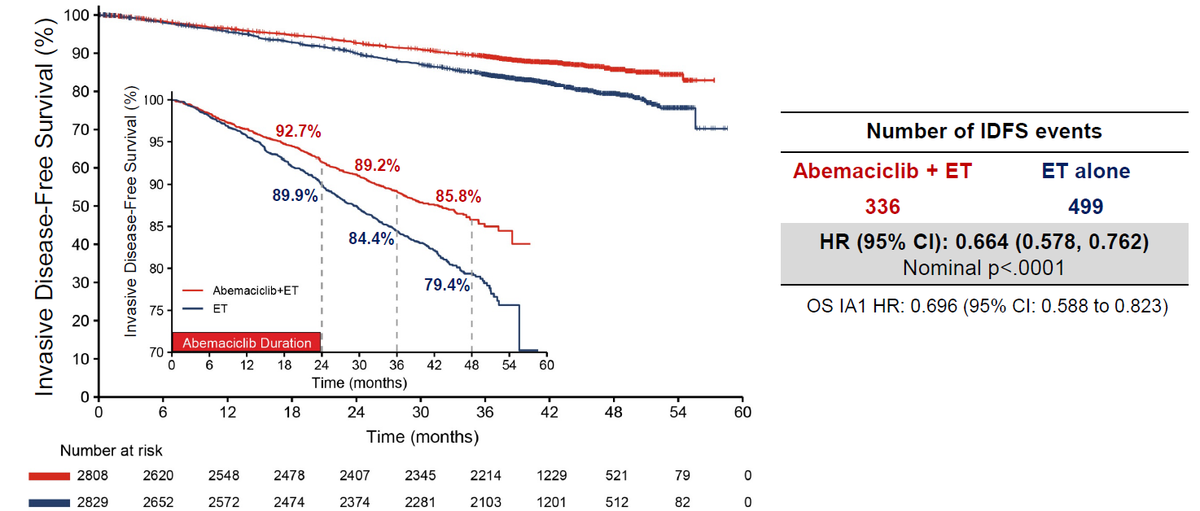
Source: Figure 2-8, p98 of the resubmission.
# = number of; CI = confidence interval; ET = endocrine therapy; HR = hazard ratio; IDFS = invasive disease-free survival; ITT = intent-to-treat; K-M = Kaplan-Meier; OS = overall survival; OS IA1 = OS Interim Analysis 1 = Additional Follow up 1 (AFU1; April 2021)
Figure 2: K-M plot of IDFS, Cohort 1, AFU2 (July 2022)
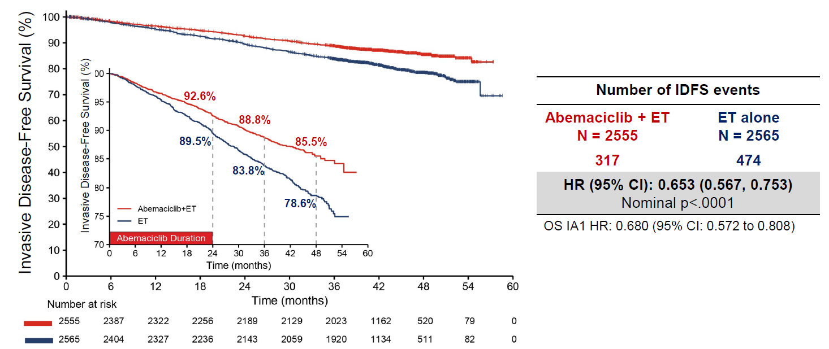
Source: Figure 2-25, p156 of the resubmission.
# = number of; CI = confidence interval; ET = endocrine therapy; HR = hazard ratio; IDFS = invasive disease-free survival; K-M = Kaplan-Meier; OS = overall survival; OS IA1 = OS Interim Analysis 1 = Additional Follow up 1 (AFU1; April 2021.

Figure 3: K-M plot of DRFS, ITT population, AFU2 (July 2022)
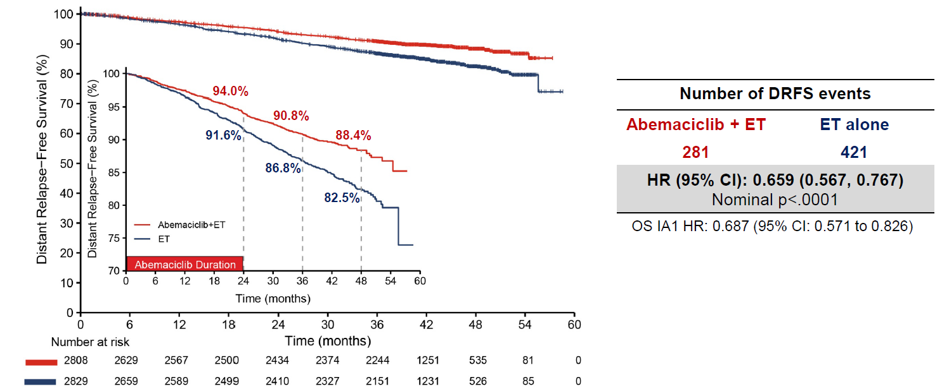
Source: Figure 2-15, p109 of the resubmission.
# = number of; CI = confidence interval; DRFS = distant relapse-free survival; ET = endocrine therapy; HR = hazard ratio; ITT = intent-to-treat; K-M = Kaplan-Meier; OS = overall survival; OS IA1 = OS Interim Analysis 1 = Additional Follow up 1 (AFU1; April 2021.

Figure 4: K-M plot of DRFS, Cohort 1, AFU2 (July 2022)
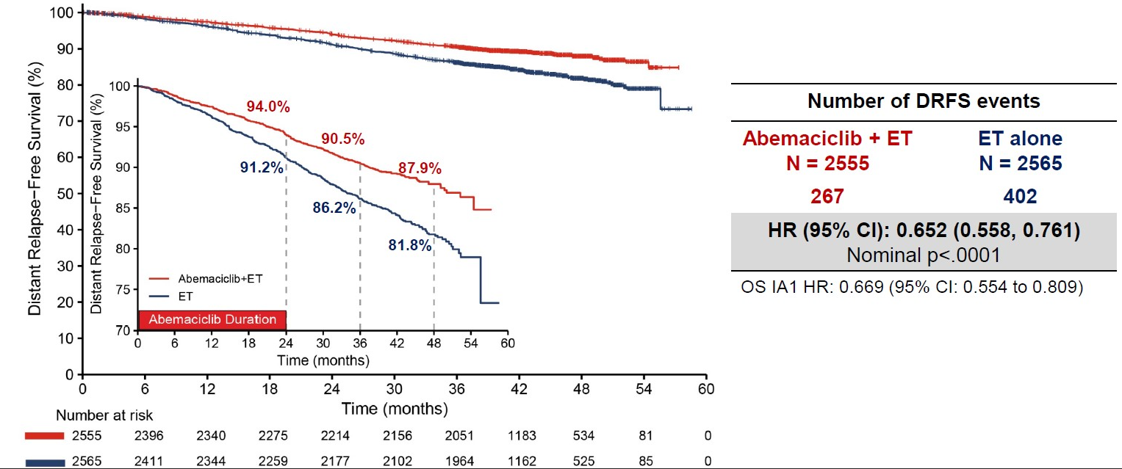
Source: Figure 2-27, p158 of the resubmission.
# = number of; CI = confidence interval; DRFS = distant relapse-free survival; ET = endocrine therapy; HR = hazard ratio; K-M = Kaplan-Meier; OS = overall survival; OS IA1 = OS Interim Analysis 1 = Additional Follow up 1 (AFU1; April 2021.

Figure 5: K-M plot of overall survival, ITT population, AFU2 (July 2022)
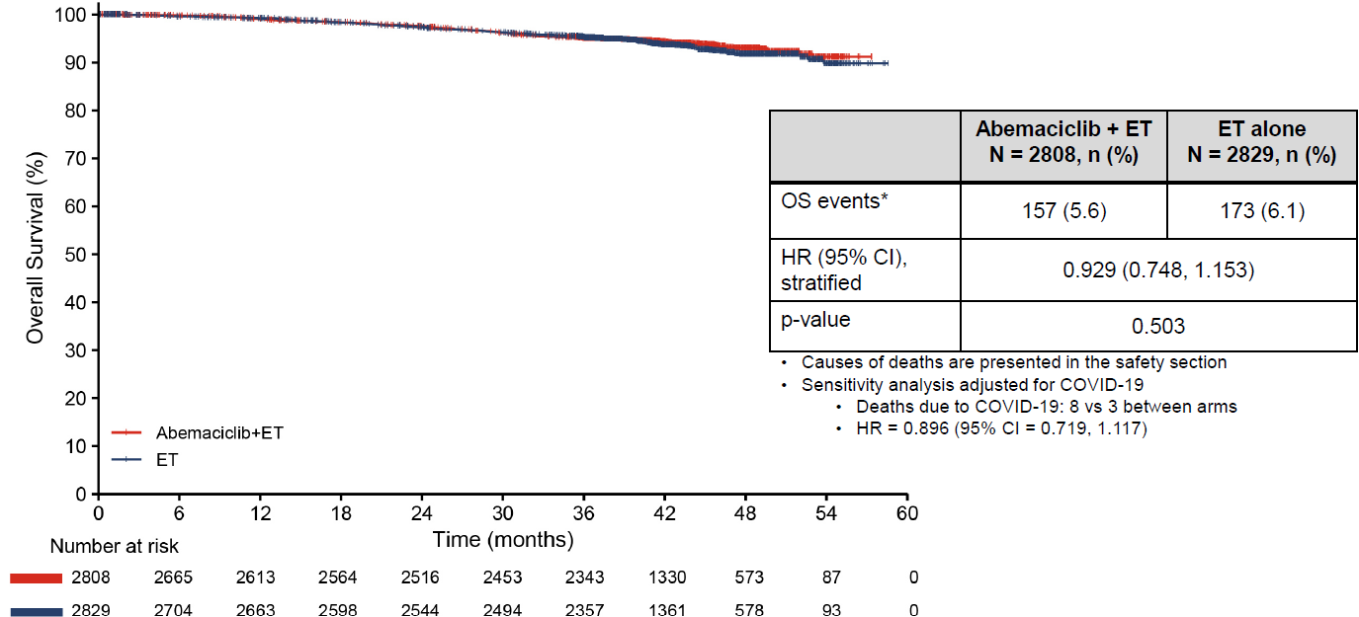
Source: Figure 2-20, p 115 of the resubmission.
# = number of; CI = confidence interval; ET = endocrine therapy; HR = hazard ratio; K-M = Kaplan-Meier; n = number of participants with event; N = total participants in group; OS = overall survival.

Figure 6: K-M plot of overall survival, Cohort 1, AFU2 (July 2022)
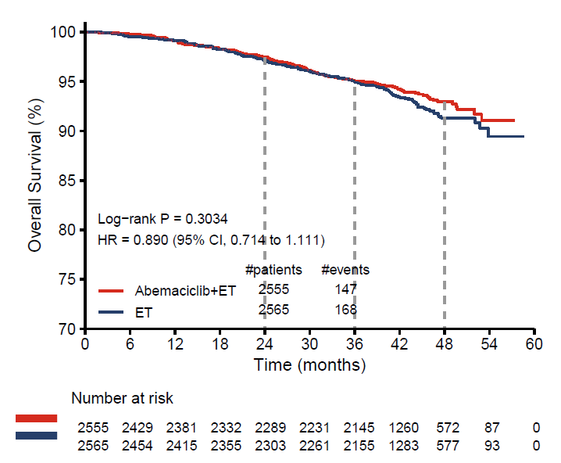
Source: Figure 2-29, p161 of the resubmission.
# = number of; CI = confidence interval; ET = endocrine therapy; HR = hazard ratio; K-M = Kaplan-Meier; n = number of participants reporting data; N = total participants in group; OS = overall survival.
  - A post hoc piecewise analysis of IDFS and DRFS at AFU2 (July 2022) based on the ITT population was provided in the Pre-Sub-Committee Response (PSCR) (Table 6).
Table 6: Piecewise analysis for invasive disease-free survival and distant relapse-free survival, AFU2 (July 2022), ITT population
 | IDFS |  |  | DRFS
 | Number of events |  | Piecewise HRª  (95% CI^{b}) | Number of events |  | Piecewise HRª  (95% CI^{b})
 | ABE + ET | ET alone |  | ABE + ET | ET alone
Year 0-1 | 93 | 116 | 0.782 (0.583, 1.018) | 69 | 93 | 0.725 (0.519, 0.983)
Year 1-2 | 100 | 154 | 0.674 (0.521, 0.858) | 88 | 133 | 0.691 (0.521, 0.887)
Year 2-3 | 90 | 143 | 0.618 (0.477, 0.788) | 82 | 124 | 0.651 (0.497, 0.851)
Year 3+ | 53 | 86 | 0.602 (0.428, 0.803) | 42 | 71 | 0.581 (0.391, 0.818)
Source: PSCR
CI = confidence interval; ET = endocrine therapy; HR = hazard ratio; IDFS = invasive disease-free survival; ITT = intent-to-treat; OS = overall survival.
ª Piecewise HR was estimated using Bayesian piecewise exponential model for the yearly hazard rate within each treatment arm.
^{b} 95% credible intervals were calculated by equal tails in the posterior samples of Bayesian exponential models.

Comparative harms
  - Table 7 presents a summary of adverse events (AEs) based on the monarchE trial. The AEs have not changed greatly from the previous submission with Grade ≥ 3 treatment emergent adverse events (TEAEs) still being 33% higher in the patient group who received abemaciclib + ET, compared to ET alone.
Table 7: Summary of key adverse events in the trials in the monarchE trial at AFU2, safety population
Trial ID | Arm A  ABE + ET  n with event/N (%) | Arm B  ET  n with event/N (%) | RD % (95%CI) | RR (95% CI)
Patients with ≥ 1 TEAE | 2746/2791 (98.4) | 2488/2800 (88.9) | 9.5 (8.28, 10.79) | 1.11 (1.09, 1.12)
Patients with ≥ 1 CTCAE Grade ≥ 3 TEAE | 1393/2791 (49.9) | 472/2800 (16.9) | 33.1 (30.74, 35.37) | 2.96 (2.71, 3.24)
Patients with ≥ 1 TE-SAE | 433/2791 (15.5) | 256/2800 (9.1) | 6.4 (4.66, 8.09) | 1.70 (1.47, 1.96)
Patients who discontinued all study treatment due to AE | 180/2791 (6.4) | 30/2800 (1.1) | 5.4 (4.39, 6.37) | 6.02 (4.10, 8.82)
Patients who died due to AE on study therapy or ≤ 30 days of discontinuation from study treatment | 15/2791 (0.5) | 11/2800 (0.4) | 0.1 (-0.21, 0.50) | 1.37 (0.63, 2.97)
Patients who discontinued abemaciclib due to AEª | 515 (18.5) | NA | NA | NA
Grade ≥ 3 diarrhoeaª | 219/2791 (7.8) | 6/2800 (0.2) | 7.63 (6.62, 8.64) | 36.62 (16.30, 82.26)
Grade ≥ 3 neutropeniaª | 546/2791 (19.6) | 23/2800 (0.8) | 18.74 (17.23, 20.24) | 23.82 (15.74, 36.03)
Grade ≥ 3 leukopeniaª | 317/2791 (11.4) | 11/2800 (0.4) | 10.96 (9.77, 12.16) | 28.91 (15.89, 52.62)
Grade ≥ 3 lymphopeniaª | 151/2791 (5.4) | 13/2800 (0.5) | 4.95 (4.07, 5.82) | 11.65 (6.63, 20.48)
Source: Table 2-51, p133 and table 2-53, p135 of the resubmission.
ABE = abemaciclib; AE = adverse event; CTCAE = common terminology criteria for adverse events; CI = confidence interval; ET = endocrine therapy; n = number of participants reporting data; N = total participants in group; RD = risk difference; RR = relative risk; TEAE = treatment emergent adverse events; TE-SAE = treatment emergent serious adverse events.
Notes: Bold indicates statistically significant results.
Blue shading indicates data previously seen by the PBAC.
ª No update data was provided at AFU2

Benefits/harms
  - A summary of the comparative benefits and harms for abemaciclib in combination with ET versus ET alone is presented in Table 8.
Table 8: Summary of comparative benefits and harms for ABE + ET vs ET (intention-to-treat population, median duration of follow-up 42 months)
Event | ABE + ET | ET | Absolute Difference | HR (95% CI)
Invasive disease-free survival (IDFS)
Invasive disease or death, n (%) | 336/2808 (12.0%) | 499/2829 (17.6%) | NA | 0.66 (0.58, 0.76)
Median IDFS, months (95% CI) | NR | NR | NE | –
% alive without invasive disease at 36 months (95% CI) | 89.2%  (87.9%, 90.3%) | 84.4%  (83.0%, 85.8%) | 4.8%  (2.9%, 6.6%) | –
% alive without invasive disease at 48 months (95% CI) | 85.8%  (84.2%, 87.3%) | 79.4%  (77.5%, 81.1%) | 6.4%  (4.1%, 8.8%) | –
Distant relapse-free survival (DRFS)
Distant relapse or death, n (%) | 281/2808 (10.0%) | 421/2829 (14.9%) | NA | 0.66 (0.57, 0.77)
Median DRFS, months (95% CI) | NR | NR | NE | –
% alive without distant relapse at 36 months (95% CI) | 90.8%  (89.7%, 91.9%) | 86.8%  (85.4%, 88.0%) | 4.1%  (2.4%, 5.8%) | –
% alive without distant relapse at 48 months (95% CI) | 88.4%  (86.9%, 89.7%) | 82.5%  (80.7%, 84.1%) | 5.9%  (3.7%, 8.1%) | –
Overall survival (OS)
Deaths, n/N (%) | 157/2808 (5.6%) | 173/2829 (6.1%) | NA | 0.93 (0.75, 1.15)
Median OS, months (95% CI) | NR | NR | NE | –
% alive at 36 months (95% CI) | 95.1%  (94.2%, 95.9%) | 95.3%  (94.4%, 96.0%) | -0.2%  (-1.3%, 1.0) | –
% alive at 48 months (95% CI) | 93.1%  (91.8%, 94.2%) | 91.7%  (90.7%, 93.0%) | 1.4%  (-0.4%, 3.1%) | –
Harms
 | ABE + ET  n/N | ET  n/N | RR  (95% CI) | Event rate/100 patients |  | RD  (95% CI)
 |  |  |  | ABE + ET | ET
Grade ≥ 3 TEAE | 1393/2791 | 472/2800 | 2.96 (2.71, 3.24) | 49.9 | 16.9 | 33.1 (30.74, 35.37)
TE-SAE | 433/2791 | 256/2800 | 1.70 (1.47, 1.96) | 15.5 | 9.1 | 6.4 (4.66, 8.09)
Discontinuation due to AE | 180/2791 | 30/2800 | 6.02 (4.10, 8.82) | 6.4 | 1.1 | 5.4 (4.39, 6.37)
Grade ≥ 3 diarrhoeaª | 219/2791 | 6/2800 | 36.62 (16.30, 82.26) | 7.8 | 0.2 | 7.63 (6.62, 8.64)
Grade ≥ 3 neutropeniaª | 546/2791 | 23/2800 | 23.82 (15.74, 36.03) | 19.6 | 0.8 | 18.74 (17.23, 20.24)
Source: Attachment A2.16_monarchE_AFU2 (July 2022) Statistical tables – confidential, pp4-9. Table 2-51, p133 and table 2-53, p135 of the resubmission.
ABE = abemaciclib; AE = adverse event; CI = confidence interval; DRFS = distant relapse-free survival; ET = endocrine therapy; HR = hazard ratio; IDFS = invasive disease-free survival; n = number of participants reporting data; N = total participants in group; NA = not applicable; NE = not estimable; NR = not reported; OS = overall survival; RD = risk difference; RR = risk ratio; TEAE = treatment emergent adverse event; TE-SAE = treatment emergent serious adverse event.
Notes: Bold indicated statistically significant results.
Blue shading indicates data previously seen by the PBAC.
ª No updated data was provided at AFU2.
  - Based on direct evidence presented by the submission, for every 100 patients with HR+, HER2-, EBC with a high risk of recurrence, treated with abemaciclib + ET instead of ET alone for a median follow-up duration of 42 months:
- Approximately 6 fewer patients would experience invasive disease or death at 48 months.
- No difference in OS.
- Approximately 33 additional patients would experience a grade ≥ 3 TEAE.
- Approximately 6 additional patients would experience a treatment-emergent serious adverse event.
- Approximately 5 additional patients would discontinue all study treatment due to adverse events.
- Approximately 8 additional patients would experience grade ≥ 3 diarrhoea (this is over a median of 27 months follow-up as data are not available for the later data cut with a median of 42 months follow-up).
- Approximately 19 additional cases of neutropenia (this is over a median of 27 months follow-up as data are not available for the later data cut with a median of 42 months follow-up).

Clinical claim
  - The submission described abemaciclib in combination with ET as superior in terms of effectiveness compared with ET alone and with a manageable safety profile.
  - The therapeutic conclusion presented in the submission was supported by a statistically significant difference in the hazard of invasive disease recurrence or death between patients receiving abemaciclib in combination with ET versus those receiving ET alone. However, the evaluation considered it remains unclear if the difference observed would translate into clinically meaningful OS benefit. When the previous submission was considered, the PBAC determined that the claim of superior comparative effectiveness was uncertain but supportable (paragraph 6.22, Abemaciclib PSD, March 2022). The evaluation noted that updated results presented in the resubmission are largely consistent with those presented in the previous submission at an earlier DCO for both ITT and cohort 1. The ESC considered that the updated clinical data does not alter the prior determination that superior comparative effectiveness of abemaciclib was uncertain but supportable.
  - The ESC noted that in the early breast cancer setting, with curative intent of treatments, it may take a significant period of time for abemaciclib to show a definitive survival benefit. The PSCR stated that the final OS analysis is planned at | | events, or 10 years, with the next interim analysis planned at | | events (currently | | events at AFU2 in July 2022). The ESC noted that the OS HR was numerically favourable for abemaciclib + ET over ET alone for both the ITT (HR = 0.93) and the Cohort 1 (HR = 0.89) populations (Table 5).
  - The PBAC noted that the OS data remained immature and there would be several years until final reporting and that in the meantime it considered there was an unclear relationship between IDFS/DRFS and OS.
  - The PBAC also noted that the updated annualised HRs (Table 6), although based on small numbers of events and hence the confidence intervals for the HRs were wide, indicated that the the magnitude of relative treatment effect appears to be maintained to approximately 4 years and considered that the difference in IDFS and DRFS observed for abemaciclib + ET versus ET alone at the updated data cut-off was likely to represent a clinically meaningful benefit. For the current submission, the PBAC considered that the claim of superior comparative effectiveness of abemaciclib was supportable.
  - The evaluation noted that abemaciclib in combination with ET appeared to be associated with inferior safety compared to ET alone with higher rates of grade ≥ 3 TEAEs, TE-SAEs, and AEs leading to discontinuation in patients taking abemaciclib. Based on the data cut-off from the previous submission, the PBAC considered that that while abemaciclib was associated with inferior safety, there were no new safety signals and the safety profile of abemaciclib is manageable with monitoring and dose modifications (paragraph 6.23, Abemaciclib PSD, March 2022). For the current submission, the PBAC agreed with the ESC and the evaluation that the updated safety results do not change this conclusion.

Economic analysis
  - The resubmission presented a modelled economic evaluation that remained based on the monarchE randomised controlled trial with the addition of health states in the model that drew on separate economic evaluations based on the MONARCH-2 and MONARCH-3 trials (and associated network meta-analyses). The structure of the model and approach to model metastatic disease – with two metastatic recurrent substates where one-off costs and QALYs were applied on transition – was unchanged. The evaluation considered that this may not be reasonable, as this approach was previously considered to add unwarranted complexity and the one-off costs and QALYs applied on transition to the metastatic recurrence sub-states was not justified due to transitivity issues (paragraph 6.32, Abemaciclib PSD, March 2022).
  - The resubmission did not present a stepped economic evaluation. The evaluation considered that a stepped analysis would be informative, as the analysis remains highly dependent on modelled assumptions including extrapolation of IDFS and generation of outcomes in metastatic recurrence.
  - Key changes from the previous submission include:
- Restricting the population modelled to reflect Cohort 1 of monarchE (rather than the ITT used previously);
- A 10-year reduction in time horizon (from 40 to 30 years);
- A reduction in the treatment effect waning period (from Year 8-38 to Year 7-28.9);
- The parametric model selection of IDFS extrapolation (from Weibull to log-logistic);
- The removal of the calibration of outcomes in the endocrine-sensitive metastatic breast cancer (ES-MBC) setting.
As described in Table 2, a number of these changes were in response to concerns raised during the previous PBAC consideration.
  - The key components of the economic evaluation comparing abemaciclib + ET with ET alone are presented in Table 9.
Table 9: Summary of model structure, key inputs and rationale
Component | Summary
Treatments | Abemaciclib + ET vs ET
Time horizon | 30 years in the model base case versus 27 months median follow-up in the monarchE trial. The PBAC previously considered that a 20-year time horizon is more reasonable in this model (paragraph 7.11, Abemaciclib PSD, March 2022)
Outcomes | Quality-adjusted life-years (QALYs). This is reasonable and unchanged from the previous submission.
Methods used to generate results | Cohort expected value analysis (Markov model). This is reasonable and unchanged from the previous submission.
Health states | Five health states: Invasive disease-free survival; Non-metastatic recurrence (including three sub-states: second primary neoplasmª, locoregional recurrence and contralateral recurrence); Remission; Metastatic recurrence (including two sub-states: endocrine-resistant and endocrine-sensitive)ª; and Deadª. This is unchanged which is likely not reasonable. The ESC previously advised the two sub-health states in the metastatic setting added unwarranted complexity (paragraph 6.31, Abemaciclib PSD, March 2022).
Cycle length | 28 days. This is reasonable and unchanged from the previous submission.
Transition probabilities | IDFS, recurrence type, OS without metastatic recurrence and TTD were sourced from Cohort 1, monarchE. The probability of recurrence in remission was based on Hamilton (2015).  As metastatic recurrence was modelled as an absorbing health state, one-off costs and QALYs were applied on transition, based on LYs (by progression status) generated in analyses of abemaciclib in the metastatic setting for each first-line metastatic treatment option included. These were weighted by the distribution of use with and without abemaciclib in the adjuvant setting. The majority of these were unchanged from the previous submission.
Extrapolation method | Observed KM data were used in the model with extrapolation of Cohort 1, monarchE KM IDFS, OS without distant recurrence and TTD for ET (with or without adjuvant abemaciclib) data. IDFS data was not updated to a more recent data cut in the resubmission. Therefore, data used in the model remains based on a small number of events and may not provide a reliable basis for extrapolation. Parametric model selection was based on an assessment of proportional hazards, goodness of fit statistics, clinical plausibility and previous PBAC consideration.  - IDFS: a jointly fitted log-logistic distribution was used from month 32.  The ESC previously had noted that the crossing of the log-hazard plot suggests that joint modelling is not appropriate beyond the observed period for the IDFS (Table 7, Abemaciclib PSD, March 2022 PBAC Meeting). This crossing still occurs in the resubmission’s log-hazard plot. The resubmission had not presented any evidence to support a treatment effect beyond the observed period.  - OS without metastatic recurrence: a jointly fitted exponential distribution was used from month 34.7.  - IDFS and OS without metastatic recurrence were adjusted for a waning of the abemaciclib treatment effect (over Year 7−28.9).  - ET TTD: independently fitted models were used after all of the observed KM TTD. Hazards spline models with two knots were used for both arms.  - All extrapolations were adjusted for background mortality
Health related quality of life | Derived from monarchE Cohort 1 (IDFS and remission: 0.785), MONARCH-2 (ER-MBC PFS and ES-MBC PFS2: 0.748), MONARCH-3 (ER-MBC PFS1: 0.724) and published literature (Lidgren 2007ª and Lloyd 2006^{b}). These were mostly reasonable, however the ESC previously noted that not all utility data were transformed to Australian preference weights (Table 7, Abemaciclib PSD, March 2022 PBAC Meeting).
Source: Constructed during the evaluation from the ‘A6.1_Abemaciclib Section 3 workbook 2022.xlsm’ workbook included in the resubmission.
ER-MBC = endocrine-resistant metastatic breast cancer; ES-MBC = endocrine-sensitive metastatic breast cancer; ET = endocrine therapy; IDFS = invasive disease-free survival; KM = Kaplan-Meier; LY = life years; OS = overall survival; PFS = progression-free survival; QALY = quality-adjusted life year; TTD = time to treatment discontinuation.
ª Lidgren M, Wilking N, Jonsson B, Rehnberg C. Health related quality of life in different states of breast cancer. Qual Life Res. 2007 Aug;16(6):1073-81.
^{b} Lloyd A, Nafees B, Narewska J, Dewilde S, Watkins J. Health state utilities for metastatic breast cancer. Br J Cancer. 2006 Sep 18;95(6):683-90.
Blue shading indicates components remaining unchanged since the previous submission.
  - The resubmission nominated a time horizon of 30 years (reduced from 40 years in the March 2022 submission), citing an analysis of Scottish Registry data (conducted by the sponsor) found the median age of diagnosis for this patient cohort to be 59 years. The evaluation considered that this is not substantially different from the age of diagnosis previously accepted by the PBAC, 61.4 years (paragraph 6.26, Abemaciclib PSD, March 2022) and as such, is not sufficient justification for an extension of the time horizon by a further 10 years from PBAC’s prior recommendation of a 20 year time horizon (paragraph 7.11, Abemaciclib PSD, March 2022). The PSCR reiterated that a 30 year time horizon represents the lifetime of this patient cohort, and furthermore is a conservative approach. While the ESC acknowledged that a 20 year time horizon was reasonable (as previously noted by the PBAC), it considered that a 30 year time horizon may be acceptable if treatment waning occurred from Year 4 to Year 7 and age at model entry was specified as 61.4 years. The ESC also considered that a 30 year time horizon may be acceptable in the context of aiming for a cure in EBC. The pre-PBAC response maintained that the starting age of the monarchE cohort (52.2 years) is the appropriate starting age for the modelled cohort and argued that it aligns with the age of patients enrolled in the patient familiarisation program (PFP) for abemaciclib in Australia (mean = | | years).
  - As per the previous submission, the OS benefit of abemaciclib was modelled indirectly through IDFS, where an improvement in IDFS was assumed to reduce the number of recurrences, in particular metastatic recurrences, and therefore death due to metastatic recurrence. In addition to improved IDFS with abemaciclib, the resubmission has maintained a lower proportion of recurrences that were metastatic (70.9% with abemaciclib + ET versus 74.0% with ET alone) based on monarchE data from Cohort 1 on the first occurrence of tumour recurrence. As noted previously (paragraph 6.27, Abemaciclib PSD, March 2022), the evaluation considered that this approach was not likely to be reasonable as these differences are not statistically significant. Assuming a lower proportion of invasive disease events that are metastatic favoured abemaciclib. Furthermore, the ESC maintained its previous view that the separation of the metastatic health states into endocrine-sensitive (ES) and endocrine-resistant (ER) substates resulted in unnecessary complexity to the model, and also considered that the negative impact of metastatic breast cancer may have been overestimated by employing a utility value of 0.476 for ES and ER post-progression survival.
  - A summary of the key drivers of the model is shown below.
Table 10: Key drivers of the model
Description | Method/Value | Impact  Base case ICER: $|| ¹
Duration of treatment effect | The treatment effect based on the jointly-fitted parametric model extrapolations was assumed to continue beyond the trial period (median follow-up of 42 months) until Year 7. A waning of the treatment effect was implemented until the extrapolated comparator IDFS hazard rate equalled background mortality (at Year 28.9). This approach is not well justified. The resubmission has not presented evidence to support an ongoing benefit of abemaciclib beyond the observed period. | High, favours abemaciclib. Assuming that the treatment effect wanes over the period from the end of the observed data (Year 4) to Year 7 increases the ICER to $|||||| ². Assuming no effect beyond the observed period increases the ICER to $|||||| ³.
Time horizon | 30 years in the base case. The PBAC had previously considered that a 20-year time horizon was more appropriate in this model, given the median age at diagnosis (paragraph 7.11, Abemaciclib PSD, March 2022). | High, favours abemaciclib. Reducing the time horizon to 20 years increases the ICER to $|||||| ².
Age of modelled patients | 52.2 years. Average age of patients was based on Cohort 1 of the monarchE trial. This is considerably higher that what the PBAC have previously noted as the mean age of diagnosis for early breast cancer (61.4 years) (paragraph 7.11 Abemaciclib PSD, March 2022). The resubmission claimed that age is not a treatment effect modifier. | High, favours abemaciclib. Increasing the average age of patients in the model to 61.4 years (only affecting background mortality and age-related utility) increases the ICER to $|||||| ¹.
Extrapolation of IDFS | Jointly-fitted log-logistic extrapolation from month 32. The monarchE IDFS data were immature (approximately 10% events at the AFU1 data cut (April 2021 data cut)) and may not provide a reliable basis for extrapolation. However, of the models that fit external data, the nominated curve appeared to be the most conservative curve (among independent and dependent functions). | High, may favour ET alone. Using dependent Weibull curves (best fitting curve by AIC/BIC) decreased the ICER to $|||||| ⁴.
Proportion of recurrences that are non-metastatic | A constant proportion was assumed, though varied by model arm (ABE + ET: 29%; ET: 26%). The resubmission has not supported that the differences are statistically significant, and so the evaluation considered that approach may not be reasonable. | Moderate, favours abemaciclib. When the pooled proportion was used (28%) across both model arms, the ICER increased to $|||||| ¹.
CDKI use in metastatic setting following adjuvant abemaciclib | The resubmission base case assumes no metastatic CDKI use following adjuvant abemaciclib and that the majority of metastatic CDKI use is following adjuvant ET alone. The resubmission has tested some metastatic CDKI following abemaciclib through a scenario analysis. As noted previously, this scenario analysis may overestimate the effect of metastatic CDKI as it assumed outcomes with metastatic CDK inhibitors were independent of the treatment received in the adjuvant setting (paragraph 6.42, Abemaciclib PSD, March 2022). | Moderate, favours abemaciclib. When some metastatic CDKI use following adjuvant abemaciclib is modelled so that no additional benefit is received^{b} and no adjustments made to the ET arm, the ICER increased to $|||||| ¹.
Proportion of NMRs that are second primary neoplasms | The resubmission has assumed that the proportion of NMR events resulting in second primary neoplasms is the same across modelled arms. This may not be reasonable as while treatment with abemaciclib is not likely to alter the incidence of secondary primaries, if abemaciclib delays or prevents breast cancer recurrence, more patients in this arm may be at risk of a second primary neoplasm as they remain in IDFS. | Moderate, favours abemaciclib. When a difference was assumed in the incidence of secondary primary neoplasm across modelled arms (30% in ABE + ET and 25% in ET)ª, the ICER increased to $|||||| ¹.
Source: Constructed during the evaluation.
AIC = Akaike’s Information Criterion; BIC = Bayesian Information Criterion; CDK4/6 = cyclin-dependent kinases 4 and 6; ER-MBC = endocrine-resistant metastatic breast cancer; ES-MBC = endocrine-sensitive metastatic breast cancer; ET = endocrine therapy; HER2 = human epidermal growth factor receptor-2; ICER = incremental cost-effectiveness ratio; IDFS = invasive disease-free survival; LY = life years; NMR = non-metastatic recurrence; NSAI = non-steroidal aromatase inhibitor; OS = overall survival; PFS = progression-free survival; PPS = post-progression survival.
ª This reflects half of the observed difference in the ITT population.
^{b} CDKI pay-off altered in the intervention arm of the metastatic setting such that the life years gained and time on treatment was the same as FUL (alone) for ET-MBC and NSAI (alone) for ES-MBC. CDKI use in intervention arm modelled as 15% in ET-MBC and 10% in ES-MBC, remaining patients proportional distributed to other treatment paths.
The redacted values correspond to the following ranges:
¹ $35,000 to < $45,000
² $55,000 to < $75,000
³ $115,000 to < $135,000
⁴ $15,000 to < $25,000
  - Updated IDFS data from monarchE were not used in the resubmission’s economic analysis. This may not be reasonable given the high degree of uncertainty in the extrapolations previously noted (paragraph 6.29, Abemaciclib March 2022). The updated data presented in the resubmission (July 2022 data cut) were, however, used to validate extrapolations. The updated data suggests that the extrapolations are slightly conservative during the observed period in the intervention arm, see Figure 7.
Figure 7: Comparison of AFU2 data cut and modelled IDFS curves
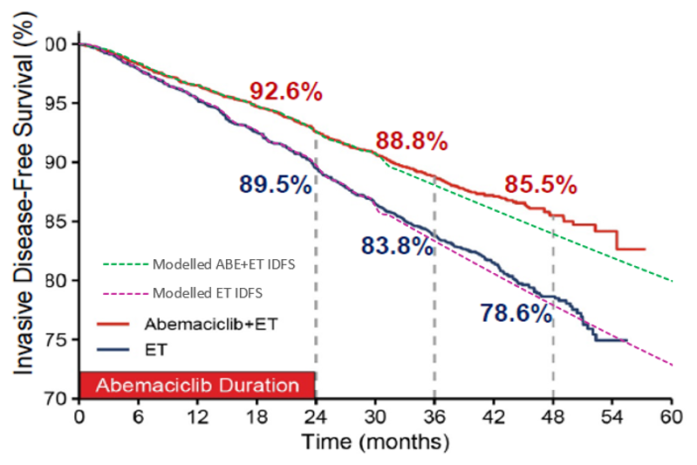
Source: pp. 217-219 of the resubmission and the ‘A6.1_Abemaciclib Section 3 workbook 2022.xlsm’ workbook included in the resubmission.
ET = endocrine therapy; IDFS = invasive disease-free survival.
  - While data from the same data cut were used in the resubmission, these were changed to reflect Cohort 1 of the pivotal trial. KM data from this subgroup were used until 32 months. After this time, IDFS was extrapolated using dependant parametric models. The IDFS data modelled therefore remain based on a small number of events (8.5% in the intervention arm and 12.4% in the comparator) and may not provide a reliable basis for extrapolation. A log-logistic parametric model was chosen for IDFS extrapolation (compared to a Weibull model used previously). Noting the limitations of the underlying data, the log-logistic model is a reasonable choice, as projected estimates in the ET arm were consistent with external studies for both IDFS at 5 years (Smith 2017), and metastatic recurrence at 5−20 years (Pan 2017).
Figure 8: Dependant IDFS curve extrapolation
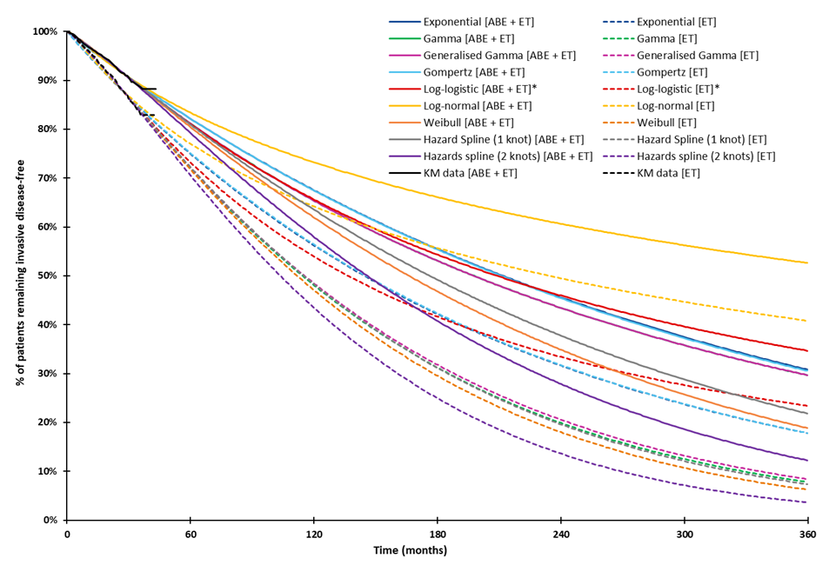 Source: Constructed during the evaluation from the ‘A6.1_Abemaciclib Section 3 workbook 2022.xlsm’ workbook included in the resubmission.
ABE = abemaciclib; ET = endocrine therapy; IDFS = invasive disease-free survival; KM = Kaplan-Meier.
* Denotes parametric model chosen in the base case analysis.
  - As dependent parametric functions were used, the parametric extrapolations included an ongoing treatment effect of abemaciclib + ET over ET alone. This treatment effect was modelled to last for 7 years, after which the effect of abemaciclib waned until the extrapolated comparator arm IDFS hazard rate equalled background mortality (Year 28.9) (reduced from a maintenance of effect until year 8, with waning until year 38 assumed previously). This is substantially longer than advised by the ESC, from year 2 (i.e. the end of adjuvant abemaciclib treatment) to year 7 (paragraph 6.30, Abemaciclib PSD, March 2022). The evaluation considered that updated data from monarchE may provide reasonable justification to extend the treatment effect, as observed from the trial data, to 48 months (Year 4), as any waning in the effect of treatment from the time of treatment cessation until the end of the observed period would have been captured. While data from the most recent data cut were not used in the resubmission’s analysis, this may be reasonable, based on a comparison of the extrapolations with landmark analyses from the updated data at 48 months (Figure 7). However, beyond this period, the treatment effect of abemaciclib is associated with substantial uncertainty. The ESC noted that the resubmission did not provide evidence specific to the use of abemaciclib, and therefore assumptions regarding the duration of treatment effect remain highly uncertain. The ICER was observed to be sensitive to changes in these assumptions, where a waning in effect from Year 4 to Year 7 increased the ICER to $55,000 to < $75,000 . The effect of assumptions around treatment effect waning on the modelled IDFS curve is presented in Figure 9.
Figure 9: The effect of the treatment waning period on the ABE + ET IDFS curve
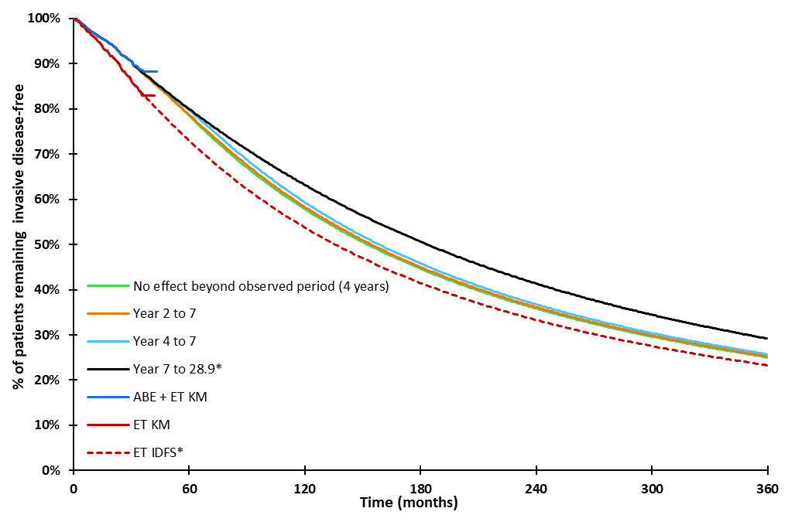
Source: Constructed during the evaluation from the ‘A6.1_Abemaciclib Section 3 workbook 2022.xlsm’ workbook included in the resubmission.
ABE = abemaciclib; ET = endocrine therapy; IDFS = invasive disease-free survival; KM = Kaplan-Meier.
Note: Curves were constructed using the resubmission’s base case parameters (dependant log-logistic curves).
*Denotes the resubmission’s base case.
  - The ESC agreed with the evaluation that based on updated data provided in the resubmission (AFU2), an abemaciclib treatment effect maintenance period until the end of Year 4 (48 months) may be reasonable. However, the ESC noted that using 4 years of data to predict the next 25 years of treatment effect is highly uncertain (submission base case: full treatment effect until year 7 with treatment waning from Year 7 to Year 28.9). The ESC considered that treatment waning from Year 4 to Year 7 would be a more reasonable assumption. The pre-PBAC response argued that the piecewise hazard ratios for IDFS and DRFS (Table 6) suggest that the magnitude of the effect size of abemaciclib increases over time and do not support a rapid reduction in treatment effect at Year 4. The pre-PBAC response also noted that treatment waning maintained to Year 7 had previously been accepted in the early breast cancer setting for TDM-1, despite annualised hazard rates suggesting a reducing treatment benefit prior to a 7 year threshold (KATHERINE ITT population, NICE [2020]).
  - Unchanged from the previous submission, the resubmission has applied fixed payoffs that represent the expected costs and QALYs in metastatic disease on transition into the health state due to limited follow-up in monarchE. These were based on estimates of life years gained from analyses that explored the cost-effectiveness of abemaciclib in the metastatic setting based on the MONARCH-2 and MONARCH-3 trials (and associated network meta-analyses). There are likely to be differences between monarchE and the metastatic studies in terms of patient characteristics and the types of therapy provided. The effect of these transitivity issues on the results of the analysis remains unclear. The ESC advised that the application of the one-off costs and QALYs on transition to the metastatic recurrence substates was not justified due to these transitivity issues (paragraph 6.32, Abemaciclib PSD, March 2022). Furthermore, inputs derived from MONARCH-2 and MONARCH-3 trials were not updated to reflect more recent data cuts.
  - The resubmission maintained that costs and outcomes in the metastatic setting would vary by the treatment received in the adjuvant setting, as it was assumed that patients in the abemaciclib + ET arm would not receive a CDK4/6 inhibitor after metastatic recurrence. While the PBAC previously considered that some CDK4/6 inhibitor use would be likely post adjuvant abemaciclib treatment (paragraph 7.12, Abemaciclib PSD, March 2022), it may be reasonable to assume differences in use across model arms. The modelled ICERs for the mix of treatments received in the metastatic setting were calculated during the evaluation (Table 11). As post-progression outcomes in those with endocrine-sensitive recurrences were no longer calibrated to achieve a set relationship between the gain in OS relative to PFS, the ICER for the mix of treatments in endocrine-sensitive recurrences was substantially lower than the previous submission ($155,000 to < $255,000; Table 9, Abemaciclib PSD, March 2022 PBAC Meeting). However, the ICERs for the mix of treatments in either setting remain higher than what the PBAC had previously considered cost-effective ($15,000−$45,000, paragraph 6.10 Palbociclib PSD, March 2018). The ESC noted that the cost-effectiveness of abemaciclib in the adjuvant setting remains influenced by the exposure of the ET arm to (as modelled) lower-value downstream treatment decisions.
Table 11: Incremental cost effectiveness of modelled metastatic treatment, with and without adjuvant abemaciclib
 | ET | ABE + ET | Increment
Endocrine-resistant metastatic recurrence
Depicts first-line metastatic treatment of predominantly CDK4/6 inhibitor + fulvestrant after adjuvant ET compared to a mix single-agent therapies (exemestane, capecitabine and fulvestrant) after adjuvant ABE + ET.
Costs | $72,534 | $| | $|
QALYs | 2.466 | 2.001 | 0.465
ICER per additional QALY gained |  |  | $| ¹
Endocrine-sensitive metastatic recurrence
Depicts first-line metastatic treatment of predominantly CDK4/6 inhibitor + NSAI after adjuvant ET compared to predominantly NSAI alone after adjuvant ABE + ET.
Costs | $86,808 | $| | $|
QALYs | 3.782 | 3.097 | 0.685
ICER per additional QALY gained |  |  | $| ¹
Source: Constructed during the evaluation from the ‘A6.1_Abemaciclib Section 3 workbook 2022.xlsm’ workbook included in the resubmission.
ABE = abemaciclib; CDK4/6 = cyclin-dependent kinases 4 and 6; ET= endocrine therapy; NSAI = non-steroidal aromatase inhibitor; PFS = progression-free survival; QALY = quality-adjusted life year.
The redacted values correspond to the following ranges:
¹ $55,000 to < $75,000
  - The results of the economic analysis are presented in the table below.
Table 12: Results of the economic evaluation
 | Previous Submission |  |  | Resubmission
 | ABE + ET (revised) | ET (revised) | Increment (revised) | ABE + ET | ET | Increment
Costs | $|| | $51,152 | $|| | $|| | $37,732 | $|||
QALYs | 9.044 | 8.446 | 0.598 | 9.317 | 8.881 | 0.436
Incremental cost per additional QALY gained |  |  | $|||| ¹ |  |  | $|||| ²
Source: Table 3-66, p275 of the resubmission, the ‘A6.1_Abemaciclib Section 3 workbook 2022.xlsm’ workbook and Table 10, Abemaciclib PSD, March 2022 PBAC Meeting
ABE = abemaciclib; ET = endocrine therapy; QALY = quality-adjusted life year.
Note: Analyses were revised during the previous evaluation to correct the per cycle probability of recurrence in the Remission health state, to apply the probability of death in IDFS to the proportion in IDFS rather than ID events, and to apply only one hospitalisation cost per cycle in abemaciclib monitoring. The metastatic health state fixed pay-offs (costs and QALYs) were also revised to apply a discount rate of 5% × (28/365.25) per cycle, the ES-MBC PPS QALYs and costs were revised based on PPS LYs, rather than PFS1 LYs, and to correct for calculation errors in the ER-MBC PPS and ES-MBC PFS2 weighted treatment costs per cycle.
The redacted values correspond to the following ranges:
¹ $15,000 to < $25,000
² $35,000 to < $45,000
  - A stepped analysis was conducted during the evaluation to identify the effect on the ICER of changes between the previous submission and the resubmission. Results are presented in Table 13. Changes made in response to issues raised during the previous PBAC consideration (Step 1−6) resulted in cumulative increases in the ICER. The ICER substantially increased with the change in the parametric model used for IDFS extrapolation. The resubmission has made a number of additional changes to reduce the ICER. Those that substantially reduce the ICER include the reduction in the price of abemaciclib, changing the population modelled to Cohort 1 of monarchE and changing the proportion of non-metastatic recurrence (NMR) events that are second primary neoplasms.
Table 13: Stepped analysis of the resubmission's economic model
Step |  | Incremental cost ($) | Incremental QALYs | ICER
0 | ICER presented in the previous submission | ||| | 0.687 | |||| ¹
 | Cumulative changes applied in the resubmission
1 | Resubmission adopting changes in the previous evaluation’s revised base caseª | ||| | 0.589 | |||| ²
2 | + Time horizon, 30 years (40 years previously) | ||| | 0.531 | |||| ²
3 | + Treatment waning, 7 years to 28.9 years (8-38 years previously) | ||| | 0.522 | |||| ²
4 | + Uncalibrated outcomes in ES-MBC | ||| | 0.388 | |||| ³
5 | + Updated costs of FUL and ECG | ||| | 0.388 | |||| ³
6 | + IDFS extrapolation model, log-logistic (Weibull previously) | ||| | 0.316 | |||| ⁴
7 | + Proposed adjuvant abemaciclib cost | ||| | 0.316 | |||| ⁴
8 | + Population modelled, Cohort 1 | ||| | 0.358 | |||| ¹
9 | + The proportion of NMR events that are secondary primary neoplasms^{b} | ||| | 0.435 | |||| ¹
10 | + Minor model changes^{c} | ||| | 0.436 | |||| ¹
Source: Constructed during the evaluation from the ‘A6.1_Abemaciclib Section 3 workbook 2022.xlsm’ workbook.
ABE = abemaciclib; AE = adverse events; CDKi = Cyclin-Dependent Kinase Inhibitors; ECHO = echocardiogram; ES-MBC = endocrine-sensitive metastatic breast cancer; ET= endocrine therapy; FUL = fulvestrant; ID = invasive disease; IDFS = invasive disease-free survival; LY = life year; MBC = metastatic breast cancer; MBS = Medicare Benefits Schedule; MUGA = Multigated Acquisition Scan; PBS = Pharmaceutical Benefits Scheme; PFS = progression-free survival; PPS = post-progression survival; QALY = quality-adjusted life year; TTD = time to treatment discontinuation; 1L = first line.
ª Calculation errors, discounting approach and estimation of deaths in IDFS. The ICER differs to the revised ICER presented in the previous evaluation due to differences in the approaches used to apply changes. The resubmission’s approaches were generally reasonable however, a calculation error still remains in the ES-MBC PFS2 health state.
^{b} All distributions of patients entering NMR substates (second primary neoplasm, locoregional and contralateral) have changed however as locoregional and contralateral substates do not differ in costs and outcomes, changes in the proportion of patients entering these substates had no effect on the ICER. Proportion of NMR events that were secondary primary were 28% for both arms, previously 32% for ABE + ET and 23% for ET.
^{c} Minor changes include: updated hospitalisation rates in ABE + ET treatment and ET treatment, types of resource use with ET treatment, incidence of adjuvant AEs, life tables, ECHO and MUGA resource use, inclusion of one-off FUL costs in MBC, updating PBS and MBS item costs, updating the distribution of CDKi use in 1L metastatic breast cancer setting, changing ET comparator arm TTD extrapolation to Hazard Spline 2 knots.
The redacted values correspond to the following ranges:
¹ $35,000 to < $45,000
² $15,000 to < $25,000
³ $25,000 to < $35,000
⁴ $45,000 to < $55,000
  - The evaluation noted that changing the proportion of NMR events that were secondary primary neoplasms to assume no difference across model arms (base case: 27% in both arms) substantially reduced the ICER. This was changed from 32% in the intervention arm and 23% in the comparator arm in the previous submission. The resubmission did not justify the change which resulted in a lower incidence of secondary primary neoplasms following adjuvant abemaciclib, which may not be reasonable due to the claimed prolongation in IDFS (Figure 10). More secondary primary neoplasm recurrences could be expected, relative to the comparator arm, by the end of the time horizon. The ESC noted that if abemaciclib delays or prevents breast cancer recurrence, more patients in this arm may be at risk of a secondary primary neoplasm, as they remain in IDFS. As modelled, abemaciclib is assumed to be associated with the same proportion of secondary primary neoplasms, which is not consistent with a greater number of patients at risk.
  - The ESC noted that AEs for abemaciclib were heavily managed within the monarchE trial, resulting in treatment interruptions (61.7%) and dose reductions (43.6%). The real-world impact of monitoring or AEs on QALYs and costs may not be fully captured. The pre-PBAC response argued that the cost and consequences associated with adverse events were applied to the economic model based on monarchE trial data and considered the management of adverse events within the clinical trial setting more likely to represent an overestimate compared to the real-world clinical practice.
  - Traces for the model results are presented in Figure 10. As with the previous submission, time spent in IDFS is the key driver of the clinical benefits modelled.
Figure 10: Model traces over the time horizon
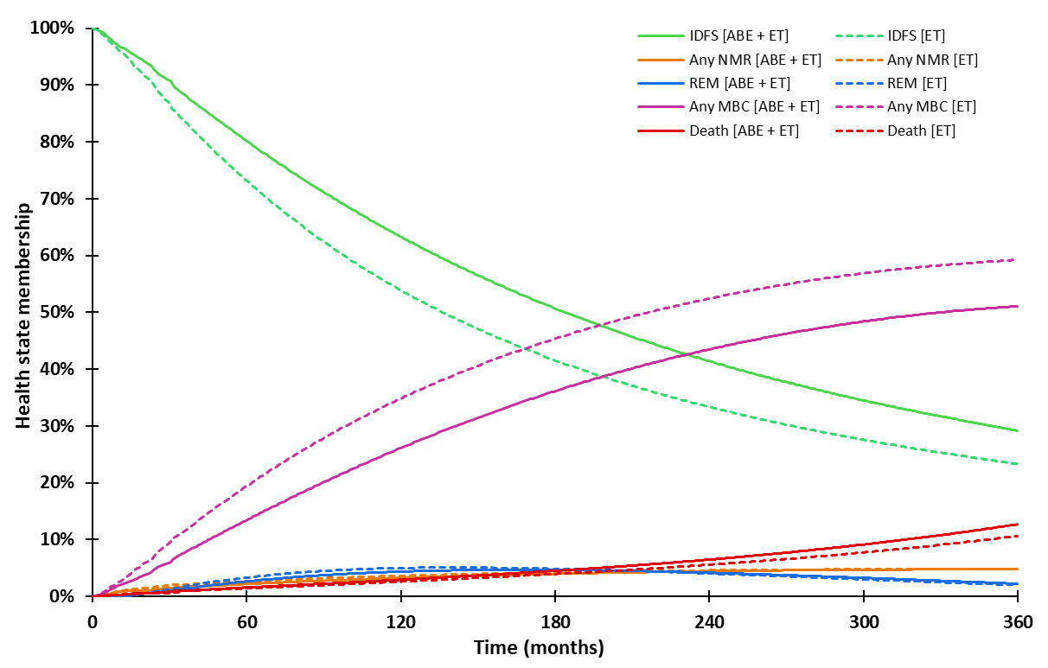 Source: Constructed during the evaluation from the resubmission’s base case parameters the ‘A6.1_Abemaciclib Section 3 workbook 2022.xlsm’ workbook included in the resubmission.
ABE = abemaciclib; ET = endocrine therapy; ID = invasive disease; IDFS = invasive disease-free survival; NMR = non-metastatic recurrence; MBC = metastatic breast cancer.
Note: Death indicates deaths without invasive disease.
  - Disaggregate costs and QALYs are presented in Table 14. The LYs and QALYs gained were predominantly accrued in the IDFS health state, with a reduction in QALYs related to non-metastatic and metastatic recurrences. This is consistent with the claim that abemaciclib improves IDFS and leads to a reduction in metastatic recurrences, and is similar to the previous submission. The LYs and QALYs gained with abemaciclib treatment are likely to be an overestimate due to the approach used to wane the treatment effect of abemaciclib beyond the observed period and the time horizon chosen. The accumulation of life years gained over the model time horizon is depicted in Figure 11. Most of the life years gained with abemaciclib treatment were accrued in the extrapolated period, particularly beyond 15 years. The incremental cost was driven by the cost of adjuvant abemaciclib treatment, with cost-offsets due to a reduction in the treatment of metastatic recurrence. As the modelled reduction in metastatic recurrences may be an overestimate (due to assumptions in the modelling of IDFS and differences in the proportions of events that are metastatic), so too may be the modelled cost-offsets related to metastatic recurrence.
Table 14: Disaggregate costs and QALYs
 | ABE + ET | ET | Increment | %
Drug-related costs (pre-metastatic recurrence)
Adjuvant drug acquisition
ABE | $||| |  | $|| | 214%
ET | $||| | $496 | $|| | 1%
Adjuvant treatment-specific monitoring costs | $||| | $1,033 | $|| | 7%
Total drug-related costs in NMR | $||| | $50 | −$|||| | −0%
Disease management costs (pre-metastatic recurrence)
Invasive disease-free survival | $||| | $941 | $|| | 0%
NMR | $||| | $1,492 | −$|||| | −1%
Remission | $||| | $22 | −$|||| | −0%
Metastatic recurrence (endocrine-resistant)
PFS | $||| | $8,987 | −$|||| | −49%
PPS | $||| | $5,219 | −$|||| | −9%
Metastatic recurrence (endocrine-sensitive)
PFS1 | $||| | $11,424 | −$|||| | −61%
PFS2 | $||| | $1,929 | −$|||| | −1%
PPS | $||| | $4,182 | $|| | −1%
Terminal care | $||| | $1,890 | −$|||| | −2%
Adverse events | $||| | $68 | $|| | 1%
Total costs | $|| | $37,732 | $|||| | 100%
QALYS
Invasive disease-free survival | 8.016 | 7.148 | 0.868 | 199%
Non-Metastatic Recurrence | 0.058 | 0.063 | −0.004 | −1%
Remission | 0.387 | 0.421 | −0.034 | −8%
Metastatic recurrence (ER-MBC)
PFS | 0.119 | 0.282 | −0.163 | −37%
PPS | 0.155 | 0.202 | −0.047 | −11%
Metastatic recurrence (ES-MBC)
PFS1 | 0.223 | 0.386 | −0.163 | −37%
PFS2 | 0.189 | 0.200 | −0.011 | −3%
PPS | 0.170 | 0.179 | −0.009 | −2%
Adverse events | −0.001 | −0.000 | −0.000 | −0%
Total QALYs | 9.317 | 8.881 | 0.436 | 100%
Source: Table 3−65, p273 of the resubmission and the ‘A6.1_Abemaciclib Section 3 workbook 2022.xlsm’ workbook.
ABE = abemaciclib; ER-MBC = endocrine-resistant metastatic breast cancer; ES-MBC = endocrine-sensitive metastatic breast cancer; ET= endocrine therapy; ID = invasive disease; IDFS = invasive disease-free survival; LY = life year; MBC = metastatic breast cancer; NMR = non-metastatic recurrence; PFS = progression-free survival; PPS = post-progression survival; QALY = quality-adjusted life year.
Figure 11: Life years gained over the time horizon (undiscounted)
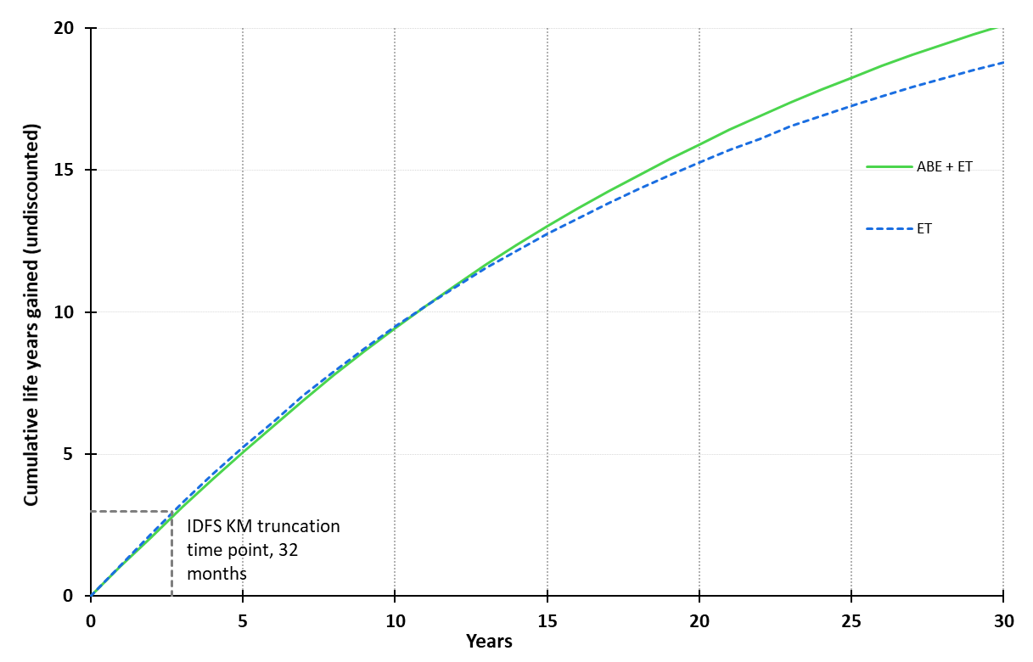
Source: Constructed during the evaluation from the ‘A6.1_Abemaciclib Section 3 workbook 2022.xlsm’ workbook included with the resubmission.
ABE = abemaciclib; ET= endocrine therapy; IDFS = invasive disease-free survival; KM = Kaplan-Meier; LY = life year.

  - The number of recurrence events and resulting number of recurrences avoided with abemaciclib treatment are presented in Table 15. Similar to the previous submission, the resubmission’s ICER relies on avoiding metastatic recurrence in 8.2% of patients over the 30-year time horizon (previously 8.1% recurrences were avoided over 40 years). Over the 30-year time horizon, patients treated with abemaciclib received an additional 1.332 life years which equates to 15.9 (133.2/8.4) life years gained per recurrence avoided (previously 38.0) or 16.2 (133.2/8.2) life years gained per metastatic recurrence avoided (previously 25.8). The PBAC have previously accepted the TDM-1 analysis which modelled 12.9 and 18.9 life years gained per recurrence and metastatic recurrence avoided (paragraph 6.12, Trastuzumab emtansine PSD, November 2019).
Table 15: Recurrence events (undiscounted)
Recurrence event | ABE + ET | ET | Incremental outcome (per 100 patients)
LYG (resubmission base case) | 20.127 | 18.795 | 1.332 (133.2 per 100 patients)
Cohort 1, monarchE, April 2021 data cut
Non-metastatic recurrence | 2.4% | 3.2% | −0.8
Metastatic recurrence | 5.7% | 9.1% | −3.4
Any recurrence | 7.9% | 12.0% | −4.1
Model time horizon (30 years)
Non-metastatic recurrence | 17.2% | 17.4% | −0.2
Metastatic recurrence | 51.1% | 59.3% | −8.2
From IDFS | 41.9% | 50.0% | −8.1
From Remission | 9.2% | 9.7% | −0.5
Any recurrence ª | 68.3% | 76.7% | −8.4
Source: Constructed from the ‘A6.1_Abemaciclib Section 3 workbook 2022.xlsm’ workbook included with the resubmission.
ABE = abemaciclib; ET = endocrine therapy; IDFS = invasive disease-free survival; LYG = lie years gained.
ª Any recurrence is not the sum of non-metastatic and metastatic recurrences, as patients who experience a non-metastatic recurrence could later develop a metastatic recurrence.
  - The results of key sensitivity analyses are summarised in Table 16. As noted in the previous evaluation, the resubmission’s economic model is most sensitive to changed estimates that affect the proportion of patients that transition to the metastatic recurrence health states, including duration of the treatment effect and proportion of IDFS events that are NMR (where the same estimate has been applied across both model arms). The resubmission has not adequately justified the base case values associated with these parameters and thus there is substantial uncertainty surrounding these parameters. Further, the model is sensitive to the proportion of NMR events that are second primary neoplasms. Sensitivity analyses conducted during the evaluation may better reflect the greater number of patients at risk following adjuvant abemaciclib.
  - The resubmission did not present any multivariate analyses; these were conducted during the evaluation, varying in a stepped manner on the basis of plausible alternative estimates. The ICER was highly sensitive to cumulative changes in the model (see Table 16). The first step includes the correction of errors identified during the evaluation and updating costs to improve the model’s accuracy. The second step corrects for poorly fit hazard spline (1 or 2 knot) models applied to the ET time to treatment discontinuation (TTD) data.
  - A respecified base case was proposed by the ESC, which employed treatment waning from Year 4 to Year 7 (changed from Year 7 to Year 28.9 in the submission base case), and patients entering the model at 61.4 years (changed from 52.2 years in the submission base case). This increased the ICER from $35,000 to < $45,000/QALY gained (submission base case) to $115,000 to < $135,000/QALY gained, and $95,000 to < $115,000/QALY gained with updated costs and correction to errors identified during the evaluation (step 1 and step 2 of the sensitivity analyses presented in Table 16).
Table 16: Results of the key sensitivity analyses
 | Inc.  cost ($) | Inc.  QALYs | ICER | %
Base case | || | 0.436 | || ¹
Time horizon (base case: 30 years)
- 20 years #5 | | | 0.277 | || ² | 66%
- 25 years | | | 0.372 | || ¹ | 19%
Age at model entry (base case: 52.2 years), 61.4 years #8 | | | 0.390 | || ¹ | 21%
Modelled population (base case: Cohort 1), ITT | | | 0.391 | || ¹ | 13%
Discount rate (base case: 5% per annum)
- 0% | | | 1.069 | || ³ | -83%
- 3.5% | | | 0.565 | || ⁴ | -33%
IDFS extrapolation (base case: log-logistic in both arms)
- Dependant Exponential (in both arms) | | | 0.525 | || ⁵ | -24%
- Independent Exponential (in both arms) | | | 0.525 | || ⁵ | -24%
- Independent Log-logistic (in both arms) | | | 0.629 | || ⁴ | -33%
Treatment waning (base case: from Year 7 to Year 28.9)
- No waning | | | 0.467 | || ⁵ | -9%
- Year 4 to Year 7 #6 | | | 0.228 | || ² | 107%
- No effect beyond the observed data (month 48) | | | 0.140 | || ⁶ | 244%
Proportion of NMR (base case: ABE+ET: 28%, ET: 26%)
- 28% (pooled trial data) in ABE + ET and ET #4 | | | 0.402 | || ¹ | 11%
Proportion of NMRs that are second primary neoplasms (base case: 27% in both arms)
- 32% in ABE + ET and 23% in ET (ITT trial data) | | | 0.358 | || ¹ | 17%
- 30% in ABE + ET and 25% in ET #7 (half the difference observed in the ITT) | | | 0.397 | || ¹ | 8%
ET TTD extrapolation in both arms, (base case: Independent models - Hazards spline model with two knots), Independent models - ET intervention: log-normal, ET comparator: gamma #2 | | | 0.436 | || ⁵ | -2%
Inclusion of ovarian suppression costs associated with patients receiving ET (0.22 per cycle, $270.32) #1 | | | 0.436 | || ¹ | 2%
Hospitalisation rate (base case: 0.003 per cycle in ABE + ET, 0.004 per cycle in ET)
0.002 per cycle in ABE + ET, 0.004 per cycle in ET (correction of error) #1 | | | 0.436 | || ¹ | -1%
Exclusion of one-off fulvestrant costs applied in the MBC setting #1 | | | 0.436 | || ¹ | -0%
NHCDC component of oncology visit (base case: $463), $81 (Tier 2 2042 Medical Oncology (Consultation) direct ward medical component #3 | | | 0.436 | || ¹ | 6%
Inclusion of electrocardiogram scans in ET-MBC #1 | | | 0.436 | || ¹ | -0%
Correction of ES-MBC PF2 in ET arm treatment costs (base case: $2,312), $2,253 #1 | | | 0.436 | || ¹ | 0%
MBC endocrine resistance
- All ES-MBC | | | 0.328 | || ¹ | 11%
- All ER-MBC | | | 0.430 | || ¹ | 13%
Metastatic CDKI use in the ABE + ET arm (base case 0%), 15% in ET-MBC, 10% ES-MBC, CDKI pay-off altered ^{a,b} | | | 0.433 | || ¹ | 8%
Multivariate analyses conducted during the evaluation
#1 | | | 0.436 | || ¹ | 1%
#1, #2 | | | 0.436 | || ⁵ | -3%
#1, #2, #3 | | | 0.436 | || ¹ | 3%
#1, #2, #3, #4 | | | 0.402 | || ¹ | 14%
#1, #2, #3, #4, #5 | | | 0.253 | || ² | 90%
#1, #2, #3, #4, #5, #6 | | | 0.135 | || ⁷ | 282%
#1, #2, #3, #4, #5, #6, #7 | | | 0.101 | || ⁸ | 404%
#1, #2, #3, #4, #5, #6, #7, #8 | | | 0.10 | || ⁸ | 420%
Multivariate analysis, as proposed by ESC:  - Treatment waning: Year 4 to Year 7 #6, AND  - Age at model entry: 61.4 years #8 | | | 0.156 | || ⁶ | 224%
Revised base case, as proposed by ESC with corrections to errors and updated costs:  - Treatment waning: Year 4 to Year 7 #6,  - Age at model entry: 61.4 years #8  - Correction of errors identified during the evaluation and updating costs to improve the model’s accuracy #1  - ET TTD extrapolation in both arms, (base case: Independent models - Hazards spline model with two knots), Independent models - ET intervention: log-normal, ET comparator: gamma #2 | | | 0.156 | || ⁹ | 216%
Source: Constructed during the evaluation from the ‘A6.1_Abemaciclib Section 3 workbook 2022.xlsm’ workbook included with the resubmission.
ABE = abemaciclib; CAP = capecitabine; CDKI = cyclin-dependent kinases 4 and 6 inhibitors; ECG = electrocardiogram; ER-MBC = endocrine-resistant metastatic breast cancer; ES-MBC = endocrine-sensitive metastatic breast cancer; ET = endocrine therapy; EXE = exemestane; EXE + EVE = exemestane and everolimus; FUL = fulvestrant; ICER = incremental cost-effectiveness; IDFS = invasive disease-free survival; LY = life years; MBC = metastatic breast cancer; NMR = non-metastatic recurrence; NSAI = non-steroidal aromatase inhibitor; OS = overall survival; PFS = progression-free survival; PPS = post-progression survival; QALY = quality-adjusted life year; TMX = tamoxifen; TTD = time to treatment discontinuation.
ª The remaining patients proportionally distributed to other treatment options in the ET arm according to base case proportions.
^{b} CDKI pay-off was altered in the intervention arm of the metastatic setting such that the life years gained and time on treatment was the same as FUL (alone) for ET-MBC and NSAI (alone) for ES-MBC.
The redacted values correspond to the following ranges:
¹ $35,000 to < $45,000
² $55,000 to < $75,000
³ $5,000 to < $15,000
⁴ $15,000 to < $25,000
⁵ $25,000 to < $35,000
⁶ $115,000 to < $135,000
⁷ $135,000 to < $155,000
⁸ $155,000 to < $255,000
⁹ $95,000 to < $115,000
  - The pre-PBAC response provided an updated economic model with corrections to errors related to the formula selecting TTD extrapolations for ET and age-adjusted utility calculations. The results of the economic model provided in the pre-PBAC response are shown in Table 17.
Table 17: Results of the economic evaluation based on the economic model provided in the pre-PBAC response
 | Pre-PBAC response
 | ABE + ET | ET | Increment
Costs | $| | $42,482 | $|
QALYs | 9.317 | 8.881 | 0.436
Incremental cost per additional QALY gained |  |  | $| ¹
ABE = abemaciclib; ET = endocrine therapy; QALY = quality-adjusted life year.
Note: As the revised economic model was provided subsequent to the time of evaluation, the revisions to the model provided in the pre-PBAC response could not be validated.
The redacted values correspond to the following ranges:
¹ $25,000 to < $35,000
  - The PBAC noted that with the updated economic model provided by the sponsor in the pre-PBAC response the revised base case, as proposed by ESC, resulted in an ICER of $75,000 to < $95,000.

Abemaciclib cost/patient/course
  - The per patient cost of abemaciclib + ET and ET alone used in the monarchE trial, the economic model, and the financial analysis, are presented in Table 18. The ESC noted the cost/patient/course was substantially higher in the financial estimates compared with the economic model due to the assumed longer treatment duration. The ESC considered the treatment duration assumed for the financial estimates to be overestimated (see paragraph 6.59).
Table 18: Drug cost per patient for ABE + ET and ET alone
 | ABE + ET  monarchE | ABE + ET  Model | ABE + ET  Financial estimates | ET  monarchE | ET  Model | ET  Financial estimates
Mean duration  (28-day cycles) | ABE: 20.68ª  ET: 22.75^{b} | ABE: 21.1  ET: 28.55^{c} | ABE: 26.08  ET: NE | ET: 23.30^{d} | 22.62^{c} | NE
Cost/patient/28-day cycle ($) | ABE: $||||  ET: $22.46 | ABE: $|||  ET: $22 | ABE: $||||  ET: NE | ET: $22.46 | $22 | NE
Cost/patient/course($) | ABE: $||||  ET: $511 | ABE: $|||  ET: $641 | ABE: $||||  ET: NE | ET: $523 | $508 | NE
Source: Constructed during the evaluation, based on Tables on pp37-40 of “A2.16 monarchE_AFU2 (July 2022) Statistical tables – CONFIDENTIAL”, “A6.1_Abemaciclib Section 3 Workbook 2022” Excel workbook, and “A7.1_Cost and utilisation model abemaciclib EBC 2022” Excel workbook
ABE = abemaciclib; ET = endocrine therapy; NE = not estimated
ª Mean duration of treatment was 82.70 weeks at the July 2022 data cut.
^{b} Mean duration of treatment was 91.01 weeks at the July 2022 data cut.
^{c} The ET TTD extrapolations in both arms appeared to be erroneous, however as the incremental difference is small this does not substantially affect the ICER.
^{d} Mean duration of treatment was 93.18 weeks at the July 2022 data cut.

Estimated PBS usage & financial implications
  - This resubmission was not considered by DUSC.
  - As in the previous submission, an epidemiological approach was taken to estimate the financial impact of the proposed listing of abemaciclib.
  - In the resubmission, the assumptions and inputs used in the previous submission have been mostly retained. The key inputs in the financial analysis are summarised in the Table 19 below.
Table 19: Key inputs for financial estimates
Data | Value applied, and Source |  | Comment
Eligible population
Incidence of breast cancer | 21,159 in Year 1 of listing, increasing to 24,955 in Year 6  (BreastScreen Australia monitoring report, AIHW 2020, assuming a linear projection applying an annual growth rate of 3.36%.) |  | Appropriate data source
Proportion of EBC (including inflammatory breast cancer) | 100%  (Abemaciclib PSD, March 2022 PBAC meeting) |  | The inclusion of inflammatory breast cancer (i.e. 2% sourced from National Breast Cancer Centre 2007) in the financial estimates is in line with the proposed PBS listing.
% incident breast cancer cases of Stage 1-3 | 95.3%  NCCI data on distribution of cancer stage (2018) |  | Appropriate data source
% HR+/HER2- | 70%  Everolimus PSD, March 2013 PBAC meeting  Nelson et.al. 2022 |  | Reasonable estimate
% node-positive EBC | 24.6% | US SEER Registries Research Data  Nelson et.al. 2022 | The estimates appeared reasonable and were supported by the recently published study (Nelson et.al. 2022).
% meeting high risk criteria | 48.8%
Uptake rate abemaciclib | |||||| % in Year 1, increasing to |||||| % in Years 3-6  (Previous PBAC advice on the uptake of trastuzumab emtansine (PSD, November 2019 PBAC meeting) |  | These inputs remained unchanged from the original submission. This is not in line with the DUSC advice that a reduction to the assumed uptake and compliance rates, and duration of therapy should be considered. The resubmission did not provide sufficient evidence to support these assumptions (other than expert opinion).
Treatment duration | 2 years  (Median treatment duration in monarchE clinical trial 23.8 months)
Compliance | 100%  (Compliance rate in AFU1 data-cut in monarchE is 98.9%)
Utilisation across abemaciclib dose forms (150mg vs. 100mg vs. 50mg) | 50.1%:37.9%:12.0%  PBS script data for abemaciclib relating to locally advanced or metastatic HR+/HER2- breast cancer |  | The resubmission updated the distribution of various abemaciclib doses (the period information not specified). The change in dose distribution of abemaciclib would not affect the results given the proposed flat pricing.
Abemaciclib (150mg, 100mg, or 50mg, 56 tablets) | $||||||  (flat pricing)  Requested effective DPMQ |  | Appropriate
Patient co-payment | PBS/ RPBS split: 99.6%:0.4% | Medicare data on trastuzumab for early HER2+ breast cancer in 2021 | These sources for PBS/RPBS split and patient co-payment calculation was reasonable. It is noted that patient co-payments have changed since 1 January 2023ª. This, however, has a minimal impact on the financial estimates.
PBS: $30.65
RPBS: $6.74

Source: Information provided in Section 4.1, pp284-288 of the resubmission
AFU = additional follow up analysis; AIHW = Australian Institute of Health and Welfare; DUSC = Drug Utilisation Sub-committee; DPMQ = dispensed price for maximum quantity; EBC = early breast cancer; HER2+ = human epidermal growth factor receptor 2 positive; HER2- = human epidermal growth factor receptor 2 negative; HR+ = hormone receptor positive; NCCI = National Cancer Control Indicators, PBAC = Pharmaceutical Benefits Advisory Committee; PBS = Pharmaceutical Benefits Scheme; PSD = public summary document; RPBS = Repatriation Pharmaceutical Benefits Scheme; SEER = Surveillance, Epidemiology and End Results
Blue shading indicates data previously seen by the PBAC.
ª Reduction in general patient co-payment from $42.50 to $30.00 and increase in concessional patient co-payment from $6.80 to $7.30.
  - The resubmission’s estimate for use and financial impacts of listing abemaciclib are summarised in Table 20.
Table 20: Estimated use and financial implications
 | Year 1 | Year 2 | Year 3 | Year 4 | Year 5 | Year 6
Estimated extent of use
Number of patients treatedª | ||| ¹ | || ¹ | || ¹ | ||| ¹ | ||| ¹ | || ¹
Number of scripts dispensed^{b} | ||| ² | || ⁵ | || ⁸ | ||| ⁸ | || ⁸|||| | || ⁸
Estimated financial implications of abemaciclib
Cost to PBS/RPBS less  co-payments ($) | ||| ³ | || ⁶ | || ⁷ | ||| ⁹ | ||| ⁹ | || ⁹
Estimated financial implications for other medicines
Cost to PBS/RPBS less co-payments ($) | ||| ⁴ | || ⁴ | || ⁴ | ||| ⁴ | ||| ⁴ | || ⁴
Net financial implications
Net cost to PBS/RPBS ($) | ||| ³ | || ⁶ | || ⁷ | ||| ⁹ | ||| ⁹ | || ⁹
Net cost to MBS ($) | ||| ⁴ | || ⁴ | || ⁴ | ||| ⁴ | ||| ⁴ | || ⁴
Net cost to PBS/RPBS/MBS ($) | ||| ³ | || ⁶ | || ⁷ | ||| ⁹ | ||| ⁹ | || ⁹
Previous submission (considered at the March 2022 PBAC meeting)
Net cost to PBS/RPBS ($) | ||| ³ | || ⁷ | || ⁷ | ||| ⁹ | ||| ⁹ | || ⁹
Source: Tables 4-3, p289, Table 4-4, p291, and Table 4-6, p291, of the submission
Blue shading indicates data previously seen by the PBAC.
ª From Year 2, the number of treated patients includes patients who initiate abemaciclib therapy in the previous year and continue on their second year of treatment
^{b} Assuming 13.04 (=365.25/28) scripts per patient per year as estimated by the submission.
The redacted values correspond to the following ranges:
¹ 500 to < 5,000
² 10,000 to < 20,000
³ $20 million to < $30 million
⁴ $0 to < $10 million
⁵ 30,000 to < 40,000
⁶ $50 million to < $60 million
⁷ $60 million to < $70 million
⁸ 40,000 to < 50,000
⁹ $70 million to < $80 million
  - The total cost to the PBS/RPBS of listing abemaciclib was estimated to be $70 million to < $80 million in Year 6, and a total of $300 million to < $400 million in the first 6 years of listing. This estimate is approximately $10 million to < $20 million lower than the estimate presented in the previous submission (which was $300 million to < $400 million for the first 6 years of listing).
  - When the previous submission was considered, the DUSC considered that the uptake of abemaciclib, the abemaciclib treatment duration and the compliance rate were overestimated. In addition, the DUSC noted that the financial analysis did not account for the costs for management of AEs, which resulted in an underestimate of the net costs to the PBS/RPBS and to the MBS due to an increased number of AEs with abemaciclib + ET compared to ET alone (paragraph 6.57, Abemaciclib PSD, March 2022). The DUSC advised that changes to the inputs and structure of the model used to derive the utilisation and financial estimates should be considered; however, the financial analysis in the resubmission did not change the inputs. The proposed changes from DUSC included:
- A reduction to the (i) uptake and (ii) compliance rates. The PSCR stated that the high uptake of abemaciclib was justified by the high uptake observed in the PFP operating since September 2022, and that a 100% compliance rate was justified by the high compliance for the AFU2 data-cut in monarchE).
- A reduction to the duration of therapy. The PSCR stated that abemaciclib treatment is administered in combination with endocrine therapy with curative intent for two years, and the duration of therapy of 24 months is supported by the AFU2 data cut where the median duration of therapy was 24 months.
- A review of the costs used for (i) metastatic recurrence and (ii) AEs.
  - The ESC considered uncertainty remained regarding the estimated use in a clinical setting. The ESC considered that:
- Sufficient evidence was not provided to justify the proposed high uptake rates;
- The proposed 100% compliance rate was unrealistic;
- The median duration of therapy of 24 months indicates that 50% of patients completed the 24 month course and that the appropriate measure is the mean. Further, use in a heavily controlled trial may not reflect real-world usage; and
- There are likely to be cost savings associated with delayed or prevented metastatic recurrence and increased costs associated with managing AEs.
The pre-PBAC response maintained that the uptake rates assumed for abemaciclib in the resubmission were appropriate and reiterated that the rates reflect the unmet clinical need seen in this patient population and aligns with clinical opinion and the uptake seen in the PFP. The pre-PBAC response also maintained the duration of therapy and compliance rate assumed in the resubmission and reiterated that these assumptions were supported by the treatment duration and drug exposure reported in the monarchE clinical trial and reflected the likely utilisation of a potentially curative treatment in a high risk population.
  - The sensitivity analyses performed during evaluation are presented in Table 21, which include the revisions for the incident patients in 2023 – 2028, uptake rates as advised by DUSC, and the mean duration of treatment (82.7 weeks), which accounted for the compliance. The cumulative effect of these changes is a 45% decrease in the financial impact to the PBS/RPBS in the first six years of listing.
Table 21: Uncertainty analyses: net financial impacts to the PBS/RPBS (performed during the evaluation)
Assumption | Year 1 | Year 2 | Year 3 | Year 4 | Year 5 | Year 6 | % change over 6 yrs
Base case | | ¹ | | ² | | ³ | | ⁶ | | ⁶ | | ⁶
SA.1: Number of incident patients in Years 2023-2028 (base case: Years 2022-2027)
21,869 in 2023, increasing up to 25,793 in 2028 (annual growth rate of 3.36%) | | ¹ | | ³ | | ³ | | ⁶ | | ⁶ | | ⁶ | 3.4%
SA.2: Uptake of abemaciclib (base case: ||| ||| % in Year 1, ||| ||| % in Year 2 and ||| ||| % in Years 3-6)
|||||| % in Year 1, increasing by |||||| % per year up to |||||| % in Year 6 (as suggested by the DUSC) | | ¹ | | ⁴ | | ⁴ | | ⁴ | | ² | | ² | -27.8%
SA.3: Treatment duration of abemaciclib (base case: 24 months)
82.7 weeks (mean DoT in monarchE) | | ¹ | | ⁴ | | ² | | ² | | ² | | ³ | -18.6%
SA.4: Compliance rate (base case: 100%)
90% (arbitrary assumption) | | ¹ | | ² | | ³ | | ³ | | ³ | | ³ | -10.0%
Multivariate analyses
(#1, #2) | | ¹ | | ⁴ | | ⁴ | | ² | | ² | | ² | -25.4%
(#1, #2, #3) | | ¹ | | ⁵ | | ⁵ | | ⁴ | | ⁴ | | ⁴ | -39.2%
(#1, #2, #3, #4) | | ¹ | | ⁵ | | ⁵ | | ⁵ | | ⁵ | | ⁴ | -45.2%
Source: Compiled during evaluation using “A7.1_Cost and utilisation model abemaciclib EBC 2022” Excel workbook.
DoT = duration of treatment; DUSC = Drug Utilisation Sub-Committee; SA = sensitivity analysis
The redacted values correspond to the following ranges:
¹ $20 million to < $30 million
² $50 million to < $60 million
³ $60 million to < $70 million
⁴ $40 million to < $50 million
⁵ $30 million to < $40 million
⁶ $70 million to < $80 million
  - The PBAC previously noted that there was significant risk in use outside the proposed restriction to patients with lower risk of recurrence than seen in the monarchE trial (paragraph 7.14, Abemaciclib PSD, March 2022). This issue has not been addressed in the resubmission. However, the PSCR stated that the risk of use outside the target population is ameliorated by an appropriate definition of high risk of recurrence in the proposed restriction. While the ESC considered this was likely to be reasonable, the PBAC maintained there remained a risk of use outside the proposed restriction, especially among a younger patient population that exhibit some but not all of the proposed clinical criteria that define a high risk of recurrence. Therefore, the PBAC considered that a risk sharing arrangement (RSA) would be required to manage the risk of utilisation outside the proposed restriction.

Quality Use of Medicines
  - The activities outlined in the resubmission to promote safe and effective use of abemaciclib in clinical practice included online medical education modules, scientific meetings, health education symposia, and conferences. These remained unchanged from the previous submission and are reasonable.
  - The resubmission noted that the PBAC previously considered that there was unlikely to be new QUM issues given abemaciclib is an existing therapy with a known safety profile and agreed with the submission that the adverse events associated with adjuvant abemaciclib could be monitored and managed with dose modifications (paragraph 7.9, Abemaciclib PSD, March 2022).
  - The resubmission stated that the sponsor will continue to support a patient program that supplies loperamide free of charge to patients on PBS subsidised treatment for the management of the most common AE, diarrhoea, associated with abemaciclib treatment.

Financial Management – risk sharing arrangements
  - The PBAC considered there is a risk of use outside the proposed restriction, especially among a younger patient population that exhibit some but not all of the proposed clinical criteria that define a high risk of recurrence. Therefore, the PBAC considered that a risk sharing arrangement would be required to manage the risk of utilisation outside the proposed restriction.
For more detail on PBAC’s view, see section 7 PBAC outcome.
- PBAC Outcome
  - The PBAC recommended the General Schedule Authority Required listing of abemaciclib, in combination with standard adjuvant endocrine therapy (ET), for the treatment of hormone receptor positive (HR+), human epidermal growth factor receptor 2 negative (HER2-), lymph node positive, invasive, resected early breast cancer (EBC) at high risk of disease recurrence. The PBAC considered the evidence presented in the resubmission demonstrated a meaningful difference in invasive disease-free survival (IDFS) and distant relapse free survival (DRFS) over the comparator (ET alone), but noted that a benefit in terms of overall survival had not been demonstrated in the clinical trial and therefore remained uncertain. The PBAC considered that the incremental cost-effectiveness ratio (ICER) was likely underestimated and that a price reduction would be required for abemaciclib to be considered cost-effective. The PBAC considered that the financial estimates were overestimated due to optimistic assumptions regarding uptake, compliance and treatment duration. The PBAC also considered that a risk sharing arrangement would be required due to risk of utilisation in patients at lower risk of disease recurrence than defined by the proposed restriction.
  - The PBAC noted the consumer comments outlining the disease free survival benefits associated with abemaciclib and emphasising the psycho-social benefits associated with reducing the fear of recurrence. The PBAC noted comments describing the side effects of abemaciclib, particularly diarrhoea, but considered these manageable with dosing adjustments. The PBAC noted comments stating that the private cost of abemaciclib is currently a financial burden to patients and that a PBS listing would ensure equity of access.
  - The PBAC noted that there had been small incremental benefits recently observed for patients with high risk early breast cancer from therapies such as dose dense chemotherapy, extended hormonal therapy and ovarian function suppression. However, the PBAC considered there remains a moderate clinical need for further reducing the risk of recurrence for patients diagnosed with early breast cancer.
  - The PBAC considered the restriction proposed by the Secretariat was acceptable and noted that a specific grandfather clause was not required if the restriction is phrased as suggested by the Secretariat.
  - The PBAC recommended flow on changes to all cyclin-dependent kinase (CDK)4/6 inhibitors currently PBS listed in the advanced/metastatic treatment setting to exclude sequential use (i.e. use in early breast cancer and then use in advanced/metastatic breast cancer) as there are currently no safety or efficacy data for repeated use of CDK4/6 inhibitors.
  - The PBAC noted the nominated comparator, ET alone, was the same as for the March 2022 submission and considered it remained appropriate.
  - The PBAC noted additional follow-up data were available for the head-to-head trial comparing abemaciclib + ET to ET alone (n=5,637), the monarchE trial, which increased the median duration of follow up from 27 months for data included in the previous submission to 42 months. The PBAC noted the addition of abemaciclib resulted in a statistically significant reduction in IDFS (HR 0.66, 95% CI 0.58, 0.76; 6.4% difference at 48 months) and DRFS (HR 0.66, 95% CI 0.57, 0.77; 5.9% difference at 48 months), and that the the magnitude of relative treatment effect appears to be maintained to approximately 4 years. The PBAC considered that the difference in IDFS and DRFS was likely to represent a clinically meaningful benefit. Overall, the PBAC considered that the claim of superior comparative effectiveness of abemaciclib + ET over ET alone was supported. However, the PBAC considered that due to immature OS data there remained an unclear relationship between IDFS/DRFS and OS.
  - The PBAC recalled it had previously considered that a claim of inferior yet manageable safety was reasonable (paragraph 7.9, Abemaciclib PBAC PSD, March 2022). The PBAC considered that the updated safety results do not change this conclusion. The PBAC also considered that while the risk of adverse events was likely to be greater outside the controlled clinical trial environment, the adverse events associated with abemaciclib could be monitored and managed with dose modifications.
  - The PBAC noted the economic model assumed that treatment with abemaciclib would reduce the risk of recurrence and that this would result in an increase in OS. The PBAC considered it unclear if treatment with abemaciclib results in recurrence being avoided in a proportion of patients and hence a permanent cure as claimed, or if abemaciclib delays micro-metastases progressing to macro-metastases and hence delays when recurrence occurs. The PBAC further noted a relationship between DFS and OS had not been consistently demonstrated with other treatments for HR+ EBC. Overall, the PBAC considered the modelled OS gain to be highly uncertain.
  - The PBAC noted the revised economic model provided with the pre-PBAC response corrected the errors noted during the evaluation (paragraph 6.48) as well as errors relating to the TTD extrapolations for the ET arm and the age adjusted utility estimates, and the resulting base case ICER was $25,000 to < $35,000/QALY. The PBAC noted the ICER was particularly sensitive to assumptions for continuing treatment waning, cohort age, and time horizon.
  - The PBAC noted in the pre-PBAC base case analysis that the treatment effect was modelled to last for 7 years, after which the effect of abemaciclib waned until year 28.9. The PBAC acknowledged the piecewise hazard ratios for IDFS and DRFS (Table 6) suggested that the magnitude of relative treatment effect appears to be maintained to approximately 4 years, however, agreed with ESC that using 4 years of data to predict the next 25 years of treatment effect is highly uncertain. The PBAC noted that the base case scenario modelled an increase in OS of 1.332 years (undiscounted) and considered this optimistic, especially in the context of a gain in OS not being demonstrated in the clinical trial. The PBAC also noted that the PALLAS trial did not demonstrate an improvement in DFS with adjuvant palbociclib (another CDK4/6 inhibitor which is considered comparable to abemaciclib in the treatment of metastatic breast cancer), and although the applicability of this trial to the proposed listing was unclear given it enrolled a lower risk patient population, it suggested uncertainty with respect to the magnitude of the treatment benefit of CDK4/6 inhibitors in the adjuvant setting. Overall, the PBAC agreed with ESC and considered waning of the treatment effect from Year 4 to Year 7 would be a more reasonable assumption.
  - The PBAC noted the starting age for the cohort in the pre-PBAC base case analysis was 52.2 years based on the starting age of patients in the monarchE trial. The pre-PBAC response stated that the mean age of patients enrolled in the Australian patient familiarisation program was also similar (| | years) and considered that the older age reported for Australian EBC patients (61.4 years, Chan et al 2021) was due to the inclusion of all patients regardless of sub-type or risk profile. The PBAC noted the mean age reported by Chan et al 2021 was based on approximately 100,000 patients diagnosed with EBC from January 2002 to December 2016 and that it included patients with triple negative breast cancer who are approximately 10 years younger at diagnosis. The PBAC also noted no evidence or biological rationale was provided to support that high risk patients are on average younger. In addition, the PBAC noted the sponsor’s analysis of Scottish Registry data reported a median age of diagnosis of 59 years. Overall, the PBAC considered the starting age for the modelled cohort should be approximately 60 years.
  - The PBAC noted the time horizon for the pre-PBAC base case analysis was 30 years and recalled it had previously advised that a 20-year time horizon would be more reasonable (paragraph 7.11, Abemaciclib PSD, March 2022). However, in the context of more conservative treatment waning (paragraph 7.11) and an older age at model entry (paragraph 7.12), and given the aim of treatment is cure, the PBAC agreed with the ESC that a 30-year time horizon would be reasonable. The PBAC noted that with waning implemented over 4 to 7 years and a starting age of 61.4 years, the ICER for the pre-PBAC model increased from $25,000 to < $35,000 to $75,000 to < $95,000/ QALY. The PBAC considered that an ICER of up to $30,000/QALY gained would account for the uncertainty regarding the modelled OS (paragraph 7.9). The PBAC noted that the cost-effectiveness of abemaciclib relied on a gain in OS and advised that if listed, the sponsor should provide the PBAC with the final overall survival results (or any further interim analyses) from the monarchE trial when available (planned at | | events, or 10 years).
  - The PBAC considered the financial estimates presented in the resubmission remained overestimated. The PBAC recalled the issues raised by DUSC in relation to the March 2022 submission and reiterated that the assumed uptake and compliance rates, and duration of therapy remained overestimated.
- The PBAC considered that the assumed maximum uptake of | % was too high, and although this was consistent with the assumption for the November 2019 TDM1 financial estimates, uptake would be expected to be higher for TDM1 as all patients had received prior chemotherapy. The PBAC recalled that DUSC had suggested a maximum uptake rate of | |% would be more appropriate however, noting the stated rapid uptake of abemaciclib in the Australian patient familiarisation program, the PBAC considered that a maximum uptake rate of | |% would be reasonable.
- The PBAC considered that the assumed treatment duration of 24 months was too long. The PBAC considered abemaciclib use in clinical practice is likely to be less than the mean treatment duration reported in the monarchE trial (82.7 weeks, 20.7 months) due to the toxicity associated with abemaciclib and the likely older cohort treated through the PBS. The PBAC considered that a mean treatment duration of 18 months was a more reasonable estimate.
- The PBAC considered that the assumed compliance of 100% was too high. The PBAC noted that compliance with hormonal therapy alone is approximately 84% at Year 1 and therefore considered 100% compliance with abemaciclib given its increased toxicity was not plausible. The PBAC considered that the assumed compliance with abemaciclib should be less than reported for hormonal therapy.
  - The PBAC noted there was risk of use outside the proposed restriction to patients with lower risk of recurrence than seen in the monarchE trial, especially among a younger patient population that exhibit some but not all of the proposed clinical criteria that define high risk of recurrence. Therefore, the PBAC considered that a risk sharing arrangement (RSA) with financial caps based on revised estimates as outlined in paragraph 7.14 would be required to manage the risk of utilisation in patients with a lower risk of recurrence where use would be less cost-effective. The PBAC considered a rebate of 80% for use exceeding the financial caps would be appropriate noting that the cost effectiveness of such use would be unknown.
  - The PBAC found that the criteria prescribed by the National Health (Pharmaceuticals and Vaccines – Cost Recovery) Regulations 2022 for Pricing Pathway A were not met. Specifically the PBAC found that in the circumstances of its recommendation for abemaciclib:
  - The treatment is expected to provide a moderate improvement in efficacy over the comparator (ET alone) on the basis of the clinical evidence considered at the March 2023 meeting;
  - The treatment is not expected to address a high and urgent unmet clinical need;
  - It was not necessary to make a finding in relation to whether it would be in the public interest for the subsequent pricing application to be progressed under Pricing Pathway A because one or more of the preceding tests had failed.
  - The PBAC noted that this submission is not eligible for an Independent Review as it received a positive recommendation.
Outcome:
Recommended
- Recommended listing
8.1 Add indication as follows:

Category / Program: GENERAL – General Schedule (Code GE)
MEDICINAL PRODUCT  medicinal product pack |  | PBS item code | Max. qty packs | Max. qty units | Rpts | Available brands
ABEMACICLIB
abemaciclib 150 mg tablet, 56 |  | NEW  _{MP} | 1 | 56 | 5 | Verzenio
abemaciclib 100 mg tablet, 56 |  | NEW  _{MP} | 1 | 56 | 5 | Verzenio
abemaciclib 50 mg tablet, 56 |  | NEW  _{MP} | 1 | 56 | 5 | Verzenio
Safety Net Rule Penalty Applies? Yes
MP = Medical Practitioners
Restriction Summary [New 1]/ Treatment of Concept: [New 1.1]: Authority Required

 | Indication: Early breast cancer
 | Clinical criteria:
 | The treatment must be adjuvant to surgical resection
 | AND
 | Clinical criteria:
 | The condition must be human epidermal growth factor receptor 2 (HER2) negative
 | AND
 | Clinical criteria:
 | The condition must be hormone receptor positive
 | AND
 | Clinical criteria:
 | The condition must be at high risk of recurrence at treatment initiation with this drug, with high risk being any of: (a) cancer cells in at least 4 positive axillary lymph nodes, (b) cancer cells in 1 to 3 positive axillary lymph nodes plus at least one of: (i) tumour size of at least 5 cm in size, (ii) grade 3 tumour histology
 | AND
 | Clinical criteria:
 | The treatment must not be a PBS-subsidised benefit beyond whichever comes first: (i) a total of 2.00 years of active treatment (this includes any non-PBS subsidised supply if applicable), (ii) disease recurrence/progression
 | Treatment criteria:
 | Patient must be undergoing concurrent treatment with endocrine therapy
Prescribing Instructions:
Retain all pathology imaging and investigative test results in the patient’s medical records.
 | Administrative advice: No increase in the maximum quantity or number of units may be authorised.
 | Administrative advice: No increase in the maximum number of repeats may be authorised.
 | Administrative advice: Special Pricing Arrangements apply.
Administrative advice:
Applications for authorisation under this restriction may be made in real time using the Online PBS Authorities system (see www.servicesaustralia.gov.au/HPOS) or by telephone by contacting Services Australia on 1800 888 333.

Flow on changes to limit subsidy of CDK4/6i therapy to once per lifetime, irrespective if prescribed for early disease or late stage disease:

8.2 Amend the following abemaciclib listings as follows:
Category / Program: GENERAL – General Schedule (Code GE)
MEDICINAL PRODUCT  medicinal product pack |  | PBS item code | Max. qty packs | Max. qty units | Rpts | Available brands
ABEMACICLIB
abemaciclib 150 mg tablet, 56 |  | 11868P  _{MP} | 1 | 56 | 5 | Verzenio
abemaciclib 100 mg tablet, 56 |  | 11871T  _{MP} | 1 | 56 | 5 | Verzenio
abemaciclib 50 mg tablet, 56 |  | 11876C  _{MP} | 1 | 56 | 5 | Verzenio
Administrative Advice:
Applications for authorisation under this restriction may be made in real time using the Online PBS Authorities system (see www.servicesaustralia.gov.au/HPOS) or by telephone by contacting Services Australia on 1800 888 333.
Administrative Advice:
Cyclin-dependent kinase 4 and 6 (CDK4/6) inhibitors for the purposes of this restriction are abemaciclib, palbociclib and ribociclib.
 | Administrative Advice: No increase in the maximum quantity or number of units may be authorised.
 | Administrative Advice: No increase in the maximum number of repeats may be authorised.
 | Administrative Advice: Special Pricing Arrangements apply.
 | Administrative Advice: Non-steroidal aromatase inhibitors for the purposes of this restriction are anastrozole and letrozole.
Edit Restriction Summary / ToC: Authority Required

 | Indication: Locally advanced or metastatic breast cancer
 | Treatment Phase: Initial treatment
 | Clinical criteria:
 | Patient must be untreated with cyclin-dependent kinase 4/6 (CDK4/6) inhibitor therapy; or
 | Patient must have developed an intolerance to another CDK4/6 inhibitor therapy (other than this drug) of a severity necessitating permanent treatment withdrawal
 | AND
 | Clinical criteria:
 | The condition must be hormone receptor positive
 | AND
 | Clinical criteria:
 | The condition must be human epidermal growth factor receptor 2 (HER2) negative
 | AND
 | Clinical criteria:
 | The condition must be inoperable
 | AND
 | Clinical criteria:
 | Patient must have a World Health Organisation (WHO) Eastern Cooperative Oncology Group (ECOG) performance status score of 2 or less
 | AND
 | Clinical criteria:
 | The treatment must be in combination, where the patient has never been treated with endocrine therapy for advanced/metastatic disease, with one of (i) a non-steroidal aromatase inhibitor, (ii) fulvestrant; or
 | The treatment must be in combination, where the patient has recurrence/progressive disease despite being treated with endocrine therapy for advanced/metastatic disease, with fulvestrant only
 | AND
 | Clinical criteria:
 | The treatment must not be in combination with another cyclin-dependent kinase 4/6 (CDK4/6) inhibitor therapy
 | Population criteria:
 | Patient must not be premenopausal
Prescribing instructions:
Definition:
Untreated with cyclin-dependent kinase 4/6 (CDK4/6) inhibitor therapy means that the patient has never been treated with such therapy irrespective of the disease staging (i.e. if CDK4/6 inhibitor therapy has been prescribed for early disease, subsidy under this PBS-indication of advanced/metastatic disease is no longer available).
Edit Restriction Summary / ToC: Authority Required

 | Indication: Locally advanced or metastatic breast cancer
 | Treatment Phase: Continuing treatment
 | Clinical criteria:
 | Patient must have previously received PBS-subsidised treatment with this drug for this condition
 | AND
 | Clinical criteria:
 | Patient must not have developed disease progression while being treated with this drug for this condition
 | AND
 | Clinical criteria:
 | The treatment must be in combination with one of: (i) non-steroidal aromatase inhibitor, (ii) fulvestrant
 | AND
 | Clinical criteria:
 | The treatment must not be in combination with another cyclin-dependent kinase 4/6 (CDK4/6) inhibitor therapy
 | Population criteria:
 | Patient must not be premenopausal
Prescribing instructions:
Definition:
Previous PBS-subsidised treatment with this drug for this condition means that treatment has been initiated under the PBS indication for locally advanced/metastatic disease through the initial treatment phase. Subsidy commenced under the early disease indication must not continue through this treatment phase.

8.3 Amend the following palbociclib listings as follows:
Category / Program: GENERAL – General Schedule (Code GE)
MEDICINAL PRODUCT  medicinal product pack |  | PBS item code | Max. qty packs | Max. qty units | Rpts | Available brands
PALBOCICLIB
palbociclib 125 mg tablet, 21 |  | 12822W  _{MP} | 1 | 21 | 5 | Ibrance
palbociclib 100 mg tablet, 21 |  | 12819Q  _{MP} | 1 | 21 | 5 | Ibrance
palbociclib 75 mg tablet, 21 |  | 12818P  _{MP} | 1 | 21 | 5 | Ibrance
 | Administrative Advice: No increase in the maximum quantity or number of units may be authorised.
 | Administrative Advice: No increase in the maximum number of repeats may be authorised.
Administrative Advice:
Applications for authorisation under this restriction may be made in real time using the Online PBS Authorities system (see www.servicesaustralia.gov.au/HPOS) or by telephone by contacting Services Australia on 1800 888 333.
 | Administrative Advice: Special Pricing Arrangements apply.
Administrative Advice:
Cyclin-dependent kinase 4 and 6 (CDK4/6) inhibitors for the purposes of this restriction are abemaciclib, palbociclib and ribociclib.
 | Administrative Advice: Non-steroidal aromatase inhibitors for the purposes of this restriction are anastrozole and letrozole.
Edit Restriction Summary / ToC: Authority Required

 | Indication: Locally advanced or metastatic breast cancer
 | Treatment Phase: Initial treatment
 | Clinical criteria:
 | Patient must be untreated with cyclin-dependent kinase 4/6 (CDK4/6) inhibitor therapy; or
 | Patient must have developed an intolerance to another CDK4/6 inhibitor therapy (other than this drug) of a severity necessitating permanent treatment withdrawal
 | AND
 | Clinical criteria:
 | The condition must be hormone receptor positive
 | AND
 | Clinical criteria:
 | The condition must be human epidermal growth factor receptor 2 (HER2) negative
 | AND
 | Clinical criteria:
 | The condition must be inoperable
 | AND
 | Clinical criteria:
 | Patient must have a World Health Organisation (WHO) Eastern Cooperative Oncology Group (ECOG) performance status score of 2 or less
 | AND
 | Clinical criteria:
 | The treatment must be in combination, where the patient has never been treated with endocrine therapy for advanced/metastatic disease, with a non-steroidal aromatase inhibitor; or
 | The treatment must be in combination, where the patient has recurrence/progressive disease despite being treated with endocrine therapy for advanced/metastatic disease, with fulvestrant only
 | AND
 | Clinical criteria:
 | The treatment must not be in combination with another cyclin-dependent kinase 4/6 (CDK4/6) inhibitor therapy
 | Population criteria:
 | Patient must not be premenopausal
Prescribing instructions:
Definition:
Untreated with cyclin-dependent kinase 4/6 (CDK4/6) inhibitor therapy means that the patient has never been treated with such therapy irrespective of the disease staging (i.e. if CDK4/6 inhibitor therapy has been prescribed for early disease, subsidy under this PBS-indication of advanced/metastatic disease is no longer available).
Edit Restriction Summary / ToC: Authority Required

 | Indication: Locally advanced or metastatic breast cancer
 | Treatment Phase: Continuing treatment
 | Clinical criteria:
 | Patient must have previously received PBS-subsidised treatment with this drug for this condition
 | AND
 | Clinical criteria:
 | Patient must not have developed disease progression while being treated with this drug for this condition
 | AND
 | Clinical criteria:
 | The treatment must be in combination with one of: (i) non-steroidal aromatase inhibitor, (ii) fulvestrant
 | AND
 | Clinical criteria:
 | The treatment must not be in combination with another cyclin-dependent kinase 4/6 (CDK4/6) inhibitor therapy
 | Population criteria:
 | Patient must not be premenopausal
Prescribing Instructions:
A patient who has progressive disease when treated with this drug is no longer eligible for PBS-subsidised treatment with this drug. (reason: duplication of concept 23678)
Edit Restriction Summary / ToC: Authority Required

 | Indication: Locally advanced or metastatic breast cancer
 | Treatment Phase: Transitioning from non-PBS to PBS-subsidised supply - Grandfather arrangements
 | Clinical criteria:
 | Patient must have received non-PBS-subsidised treatment with this drug for this PBS indication prior to 1 August 2022
 | AND
 | Clinical criteria:
 | Patient must not have developed disease progression while being treated with this drug for this condition
 | AND
 | Clinical criteria:
 | Patient must have been untreated with cyclin-dependent kinase 4/6 (CDK4/6) inhibitor therapy at the time non-PBS supply was initiated; or
 | Patient must have developed an intolerance to another CDK4/6 inhibitor therapy (other than this drug) of a severity necessitating permanent treatment withdrawal
 | AND
 | Clinical criteria:
 | The condition must be hormone receptor positive
 | AND
 | Clinical criteria:
 | The condition must be human epidermal growth factor receptor 2 (HER2) negative
 | AND
 | Clinical criteria:
 | The condition must be inoperable
 | AND
 | Clinical criteria:
 | Patient must have had a World Health Organisation (WHO) Eastern Cooperative Oncology Group (ECOG) performance status score no higher than 2 at the time non-PBS supply was initiated
 | AND
 | Clinical criteria:
 | The treatment must be in combination with fulvestrant only, where at the time non-PBS supply was initiated, the patient had recurrent/progressive disease despite being treated with endocrine therapy for advanced/metastatic disease
 | AND
 | Clinical criteria:
 | The treatment must not be in combination with another cyclin-dependent kinase 4/6 (CDK4/6) inhibitor therapy
 | Population criteria:
 | Patient must not be premenopausal
Prescribing instructions:
Definition:
Untreated with cyclin-dependent kinase 4/6 (CDK4/6) inhibitor therapy means that the patient has never been treated with such therapy irrespective of the disease staging (i.e. if CDK4/6 inhibitor therapy has been prescribed for early disease, subsidy under this PBS-indication of advanced/metastatic disease is no longer available).
Administrative Advice:
Patients may qualify for PBS-subsidised treatment under this restriction once only. For continuing PBS-subsidised treatment, a 'Grandfathered' patient must qualify under the 'Continuing treatment' criteria.
Administrative Advice:
This grandfather restriction will cease to operate from 12 months after the date specified in the clinical criteria.

8.4 Amend the following ribociclib listings as follows:

Category / Program: GENERAL – General Schedule (Code GE)
MEDICINAL PRODUCT  medicinal product pack |  | PBS item code | Max. qty packs | Max. qty units | Rpts | Available brands
RIBOCICLIB
ribociclib 200 mg tablet, 63 |  | 11386G  _{MP} | 1 | 63 | 5 | Kisqali
 | Administrative Advice: No increase in the maximum quantity or number of units may be authorised.
 | Administrative Advice: No increase in the maximum number of repeats may be authorised.
Administrative Advice:
Applications for authorisation under this restriction may be made in real time using the Online PBS Authorities system (see www.servicesaustralia.gov.au/HPOS) or by telephone by contacting Services Australia on 1800 888 333.
 | Administrative Advice: Special Pricing Arrangements apply.
Administrative Advice:
Cyclin-dependent kinase 4 and 6 (CDK4/6) inhibitors for the purposes of this restriction are abemaciclib, palbociclib and ribociclib.
 | Administrative Advice: Non-steroidal aromatase inhibitors for the purposes of this restriction are anastrozole and letrozole.
Edit Restriction Summary / ToC: Authority Required

 | Indication: Locally advanced or metastatic breast cancer
 | Treatment Phase: Initial treatment
 | Clinical criteria:
 | Patient must be untreated with cyclin-dependent kinase 4/6 (CDK4/6) inhibitor therapy; or
 | Patient must have developed an intolerance to another CDK4/6 inhibitor therapy (other than this drug) of a severity necessitating permanent treatment withdrawal
 | AND
 | Clinical criteria:
 | The condition must be hormone receptor positive
 | AND
 | Clinical criteria:
 | The condition must be human epidermal growth factor receptor 2 (HER2) negative
 | AND
 | Clinical criteria:
 | The condition must be inoperable
 | AND
 | Clinical criteria:
 | Patient must have a World Health Organisation (WHO) Eastern Cooperative Oncology Group (ECOG) performance status score of 2 or less
 | AND
 | Clinical criteria:
 | The treatment must be in combination, where the patient has never been treated with endocrine therapy for advanced/metastatic disease, with one of (i) a non-steroidal aromatase inhibitor, (ii) fulvestrant; or
 | The treatment must be in combination, where the patient has recurrence/progressive disease despite being treated with endocrine therapy for advanced/metastatic disease, with fulvestrant only
 | AND
 | Clinical criteria:
 | The treatment must not be in combination with another cyclin-dependent kinase 4/6 (CDK4/6) inhibitor therapy
 | Population criteria:
 | Patient must not be premenopausal
Prescribing instructions:
Definition:
Untreated with cyclin-dependent kinase 4/6 (CDK4/6) inhibitor therapy means that the patient has never been treated with such therapy irrespective of the disease staging (i.e. if CDK4/6 inhibitor therapy has been prescribed for early disease, subsidy under this PBS-indication of advanced/metastatic disease is no longer available).
 | Caution: QT interval monitoring is required for patients treated with this drug.
Restriction Summary / ToC: Authority Required ********************UNCHANGED*************************

 | Indication: Locally advanced or metastatic breast cancer
 | Treatment Phase: Continuing treatment
 | Clinical criteria:
 | Patient must have previously received PBS-subsidised treatment with this drug for this condition
 | AND
 | Clinical criteria:
 | Patient must not have developed disease progression while being treated with this drug for this condition
 | AND
 | Clinical criteria:
 | The treatment must be in combination with one of: (i) non-steroidal aromatase inhibitor, (ii) fulvestrant
 | AND
 | Clinical criteria:
 | The treatment must not be in combination with another cyclin-dependent kinase 4/6 (CDK4/6) inhibitor therapy
 | Population criteria:
 | Patient must not be premenopausal
 | Caution: QT interval monitoring is required for patients treated with this drug.

Category / Program: GENERAL – General Schedule (Code GE)
MEDICINAL PRODUCT  medicinal product pack |  | PBS item code | Max. qty packs | Max. qty units | Rpts | Available brands
RIBOCICLIB
ribociclib 200 mg tablet, 42 |  | 11397W  _{MP} | 1 | 42 | 5 | Kisqali
 | Administrative Advice: No increase in the maximum quantity or number of units may be authorised.
 | Administrative Advice: No increase in the maximum number of repeats may be authorised.
Administrative Advice:
Applications for authorisation under this restriction may be made in real time using the Online PBS Authorities system (see www.servicesaustralia.gov.au/HPOS) or by telephone by contacting Services Australia on 1800 888 333.
 | Administrative Advice: Special Pricing Arrangements apply.
Administrative Advice:
Cyclin-dependent kinase 4 and 6 (CDK4/6) inhibitors for the purposes of this restriction are abemaciclib, palbociclib and ribociclib.
 | Administrative Advice: Non-steroidal aromatase inhibitors for the purposes of this restriction are anastrozole and letrozole.
Edit Restriction Summary / ToC: Authority Required

 | Indication: Locally advanced or metastatic breast cancer
 | Treatment Phase: Initial treatment
 | Clinical criteria:
 | Patient must be untreated with cyclin-dependent kinase 4/6 (CDK4/6) inhibitor therapy; or
 | Patient must have developed an intolerance to another CDK4/6 inhibitor therapy (other than this drug) of a severity necessitating permanent treatment withdrawal
 | AND
 | Clinical criteria:
 | The condition must be hormone receptor positive
 | AND
 | Clinical criteria:
 | The condition must be human epidermal growth factor receptor 2 (HER2) negative
 | AND
 | Clinical criteria:
 | The condition must be inoperable
 | AND
 | Clinical criteria:
 | Patient must have a World Health Organisation (WHO) Eastern Cooperative Oncology Group (ECOG) performance status score of 2 or less
 | AND
 | Clinical criteria:
 | The treatment must be in combination, where the patient has never been treated with endocrine therapy for advanced/metastatic disease, with one of (i) a non-steroidal aromatase inhibitor, (ii) fulvestrant; or
 | The treatment must be in combination, where the patient has recurrence/progressive disease despite being treated with endocrine therapy for advanced/metastatic disease, with fulvestrant only
 | AND
 | Clinical criteria:
 | The treatment must not be in combination with another cyclin-dependent kinase 4/6 (CDK4/6) inhibitor therapy
 | AND
 | Clinical criteria:
 | Patient must require dosage reduction requiring a pack of 42 tablets
 | Population criteria:
 | Patient must not be premenopausal
Prescribing instructions:
Definition:
Untreated with cyclin-dependent kinase 4/6 (CDK4/6) inhibitor therapy means that the patient has never been treated with such therapy irrespective of the disease staging (i.e. if CDK4/6 inhibitor therapy has been prescribed for early disease, subsidy under this PBS-indication of advanced/metastatic disease is no longer available).
 | Caution: QT interval monitoring is required for patients treated with this drug.
Restriction Summary / ToC: Authority Required ********************UNCHANGED*************************

 | Indication: Locally advanced or metastatic breast cancer
 | Treatment Phase: Continuing treatment
 | Clinical criteria:
 | Patient must have previously received PBS-subsidised treatment with this drug for this condition
 | AND
 | Clinical criteria:
 | Patient must not have developed disease progression while being treated with this drug for this condition
 | AND
 | Clinical criteria:
 | The treatment must be in combination with one of: (i) non-steroidal aromatase inhibitor, (ii) fulvestrant
 | AND
 | Clinical criteria:
 | The treatment must not be in combination with another cyclin-dependent kinase 4/6 (CDK4/6) inhibitor therapy
 | AND
 | Clinical criteria:
 | Patient must require dosage reduction requiring a pack of 42 tablets
 | Population criteria:
 | Patient must not be premenopausal
 | Caution: QT interval monitoring is required for patients treated with this drug.

Category / Program: GENERAL – General Schedule (Code GE)
MEDICINAL PRODUCT  medicinal product pack |  | PBS item code | Max. qty packs | Max. qty units | Rpts | Available brands
RIBOCICLIB
ribociclib 200 mg tablet, 21 |  | 11385F  _{MP} | 1 | 21 | 5 | Kisqali
 | Administrative Advice: No increase in the maximum quantity or number of units may be authorised.
 | Administrative Advice: No increase in the maximum number of repeats may be authorised.
Administrative Advice:
Applications for authorisation under this restriction may be made in real time using the Online PBS Authorities system (see www.servicesaustralia.gov.au/HPOS) or by telephone by contacting Services Australia on 1800 888 333.
 | Administrative Advice: Special Pricing Arrangements apply.
Administrative Advice:
Cyclin-dependent kinase 4 and 6 (CDK4/6) inhibitors for the purposes of this restriction are abemaciclib, palbociclib and ribociclib.
 | Administrative Advice: Non-steroidal aromatase inhibitors for the purposes of this restriction are anastrozole and letrozole.
Edit Restriction Summary / ToC: Authority Required

 | Indication: Locally advanced or metastatic breast cancer
 | Treatment Phase: Initial treatment
 | Clinical criteria:
 | Patient must be untreated with cyclin-dependent kinase 4/6 (CDK4/6) inhibitor therapy; or
 | Patient must have developed an intolerance to another CDK4/6 inhibitor therapy (other than this drug) of a severity necessitating permanent treatment withdrawal
 | AND
 | Clinical criteria:
 | The condition must be hormone receptor positive
 | AND
 | Clinical criteria:
 | The condition must be human epidermal growth factor receptor 2 (HER2) negative
 | AND
 | Clinical criteria:
 | The condition must be inoperable
 | AND
 | Clinical criteria:
 | Patient must have a World Health Organisation (WHO) Eastern Cooperative Oncology Group (ECOG) performance status score of 2 or less
 | AND
 | Clinical criteria:
 | The treatment must be in combination, where the patient has never been treated with endocrine therapy for advanced/metastatic disease, with one of (i) a non-steroidal aromatase inhibitor, (ii) fulvestrant; or
 | The treatment must be in combination, where the patient has recurrence/progressive disease despite being treated with endocrine therapy for advanced/metastatic disease, with fulvestrant only
 | AND
 | Clinical criteria:
 | The treatment must not be in combination with another cyclin-dependent kinase 4/6 (CDK4/6) inhibitor therapy
 | AND
 | Clinical criteria:
 | Patient must require dosage reduction requiring a pack of 21 tablets
 | Population criteria:
 | Patient must not be premenopausal
Prescribing instructions:
Definition:
Untreated with cyclin-dependent kinase 4/6 (CDK4/6) inhibitor therapy means that the patient has never been treated with such therapy irrespective of the disease staging (i.e. if CDK4/6 inhibitor therapy has been prescribed for early disease, subsidy under this PBS-indication of advanced/metastatic disease is no longer available).
 | Caution: QT interval monitoring is required for patients treated with this drug.
Restriction Summary / ToC: Authority Required ********************UNCHANGED*************************

 | Indication: Locally advanced or metastatic breast cancer
 | Treatment Phase: Continuing treatment
 | Clinical criteria:
 | Patient must have previously received PBS-subsidised treatment with this drug for this condition
 | AND
 | Clinical criteria:
 | Patient must not have developed disease progression while being treated with this drug for this condition
 | AND
 | Clinical criteria:
 | The treatment must be in combination with one of: (i) non-steroidal aromatase inhibitor, (ii) fulvestrant
 | AND
 | Clinical criteria:
 | Patient must require dosage reduction requiring a pack of 21 tablets
 | AND
 | Clinical criteria:
 | The treatment must not be in combination with another cyclin-dependent kinase 4/6 (CDK4/6) inhibitor therapy
 | Population criteria:
 | Patient must not be premenopausal
 | Caution: QT interval monitoring is required for patients treated with this drug.
These restrictions may be subject to further review. Should there be any changes made to the restriction the sponsor will be informed.

Committee-In-Confidence information
||||||||||||||||||||||||||||||||||||||||||||||||||||||||||||||||||||||||| ||||||||||||||||||||||||||||||||||||||||||||||||||||||||||||||||||||||||| |||||||||||||||||||||||||||||||||||||||||||||||| ||||||||||||||||||||||||||||||||||||||||||||||||
||||||||||||||||||||||||||||||||||||||||||||||||||||||||||||||||||||||||| ||||||||||||||||||||||||||||||||||||||||||||||||||||||||||||||||||||||||| ||||||||||||||||||||||||||||||||||||||||||||||||||||||||||||||||||||||||| ||||||||||||||||||||||||||||||||||||||||||||||||||||||||||||||||||||||||| ||||||||||||||||||||||||||||||| |||||||||||||||||||||||||||||||
||||||||||||||||||||||||||||||||||||||||||||||||||||| |||||||||||||||||||||||||||||||||||||||||||||||||||||

|||||||||||||||||||||||||||||||||||||||||||||||||||||||||||||||||||||||||||||||||||||||||||||||||||||||||||||||||||||||||||||||||||||||||||||||| | |||||||||||||||||||||||||||||||||||||||||||||||||||||||||||||||||||||||||||||||||||||||||||||||||||||||||||||||||||||||||||||||||||||||||||||||| |||||||||||||||||||||||||||||||||||||||||||||||||||||||||||||||||||||||||||||||||||||||||||||||||||||||||||||||||||||||||||||||||||||||||||| ||||||||||||||||||||||||||||||||||||||||||||||||||||||||||||||||||||||||||||||||||||||||||||||||||||||||||||||

End Committee-In-Confidence information
- Context for Decision
The PBAC helps decide whether and, if so, how medicines should be subsidised through the Pharmaceutical Benefits Scheme (PBS) in Australia. It considers applications regarding the listing of medicines on the PBS and provides advice about other matters relating to the operation of the PBS in this context. A PBAC decision in relation to PBS listings does not necessarily represent a final PBAC view about the merits of the medicine or the circumstances in which it should be made available through the PBS. The PBAC welcomes applications containing new information at any time.
- Sponsor’s Comment
The sponsor had no comment.

https://www.canceraustralia.gov.au/cancer-types/breast-cancer/symptoms-and-diagnosis/stages-breast-cancer
AIHW. Cancer in Australia. 2019 [cited 2021 2 December]; Available from: https://www.aihw.gov.au/getmedia/8c9fcf52-0055-41a0-96d9-f81b0feb98cf/aihw-can-123.pdf.aspx?inline=true.
American Cancer Society. Breast Cancer Facts & Figures 2019-2000. 2019 [cited 15 February 2021; Available from: https://www.cancer.org/cancer/breast-cancer/understanding-a-breast-cancer-diagnosis/breast-cancer-survival-rates.html.
Gerber, B., M. Freund, and T. Reimer, Recurrent breast cancer: treatment strategies for maintaining and prolonging good quality of life. Dtsch Arztebl Int, 2010. 107(6): p. 85-91. O'Shaughnessy, J., Extending survival with chemotherapy in metastatic breast cancer. Oncologist, 2005. 10 Suppl 3: p. 20-9.
Cherny NI, Dafni U, Bogaerts J, et al: ESMO-Magnitude of Clinical Benefit Scale version 1.1. Annals of Oncology 28:2340-2366, 2017.
Chan, A., N. O'Neil, C. Lomma, H. Chih, and P. Willsher. 2021. "BreastSurgANZ members recommendations for adjuvant systemic treatment and patient compliance in Australian breast cancer patients." ANZ J Surg 91 (11):2418-2424.
Zhao H, Lei X, Niu J, Zhang N, Duan Z, Chavez-MacGregor M, Giordano SH. Prescription Patterns, Initiation, and 5-Year Adherence to Adjuvant Hormonal Therapy Among Commercially Insured Patients With Breast Cancer. JCO Oncol Pract. 2021 Jun;17(6):e794-e808.

