An addendum to this public summary document has been included at the end of the document.

6.14 NIRAPARIB,

Capsule 100 mg,

Zejula®,

GlaxoSmithKline Australia Pty Ltd.
- Purpose of submission
        - A Category 1 integrated codependent submission requesting MBS listing of homologous recombination deficiency (HRD) testing and General Schedule Authority PBS listing of niraparib for maintenance therapy in patients with newly diagnosed advanced epithelial ovarian, fallopian tube or primary peritoneal cancer that is both HRD positive and breast cancer gene (BRCA) wild type (wt). This population is referred to as HRD positive BRCAwt.
        - Listing was requested on the basis of a cost-effectiveness analysis versus standard medical management (SMM).
Table 1: Key components of the clinical issue addressed by the submission
Population (NDA HGEOC) |  | Intervention | Comparator
Test | At diagnosis | Parallel: HRD testing to provide BRCA1/2 result and GIS (base case) | Tumour BRCA1 and BRCA2 testing
 |  | Sequential: HRD testing to provide GIS for BRCAwt cohort only | Sequential: No Test
 | Receive PBC | Parallel or sequential HRD testing | Parallel: Tumour BRCA1/2 testing;  Sequential: No Test
Primary Tx (HRD+ BRCAwt) | PBC | Niraparib maintenance | SMM
 | PBC + Beva | Not applicable | Near market comparator: Olaparib + Beva maintenance  Qualitative comparator: Beva maintenance ª
Clinical claim |  | For patients with NDA (FIGO Stage III-IV) HGEOC who are in response (CR/PR) to PBC and HRD positive BRCAwt, the following therapeutic conclusions were made in the submission:  • Efficacy: Niraparib is superior in terms of effectiveness for PFS in comparison to SMM.  • Safety: Niraparib is inferior to SMM with respect to safety.  Given the concordance between the clinical utility standard (Myriad myChoice) and the locally commercialised HRD test (Illumina TruSight Oncology 500 HRD), the above claims will apply to the Australian setting.  There was insufficient clinical evidence to indicate there is an added clinical benefit for olaparib + beva over monotherapy (niraparib) in the HRD+ BRCAwt cohort.
Source: Tables 3 and 11, p25 and 38 of the submission
Beva = bevacizumab; BRCAwt = breast cancer gene wild type; CR = complete response; GIS = genomic instability score; HGEOC = high grade epithelial ovarian cancer; HRD = homologous recombination deficiency; NDA = newly diagnosed advanced; PBC = platinum-based chemotherapy; PR = partial response; SMM = standard medical management; Tx = treatment
ª The submission (p25) stated that given the PBAC’s prior views (March 2022) regarding the limited informative value of bevacizumab as a comparator (limited utilisation, unable to form the basis of an assessment of cost-effectiveness), the co-dependent submission did not consider bevacizumab in the clinical or economic evaluation.
        - A cost minimisation analysis (CMA) for niraparib versus olaparib for the treatment of HRD positive BRCAwt newly diagnosed advanced high grade epithelial ovarian cancer (HGEOC) was also presented in the submission, based on the conclusions of the clinical evaluation of niraparib versus olaparib + bevacizumab. The submission stated that the CMA would be applicable for the scenario where olaparib + bevacizumab becomes PBS listed at the time of consideration of niraparib.
        - The Pre-Sub-Committee Response (PSCR) acknowledged that issues persist regarding the HRD testing proposals currently under evaluation (SOPHiA, Illumina), and stated there was a significant risk that consensus on the role and parameters for HRD testing may not be reached by the March 2023 PBAC and MSAC meetings. In light of this, the PSCR offered a second proposal for consideration, which it called the ITT (no test) proposal, which was consistent with the population requested for niraparib in the July 2021 and March 2022 submissions (allcomers). The sponsor proposed to address the PBAC’s concerns about clinical uncertainty with a lower price offer (see paragraph 6.87) and a financial cap. The PBAC considered that the benefit of niraparib treatment in the HRD negative subgroup remained highly uncertain and that treatment of these patients may not be clinically appropriate. The PBAC considered it was appropriate to require HRD testing to determine PBS eligibility for niraparib, and therefore did not support the ITT (no test) proposal.
For more detail on PBAC’s view, see section 7 PBAC outcome.
- Background

Registration status
        - Niraparib was initially approved by the TGA on 28 June 2019 and is currently registered for the following indications:
        - For the maintenance treatment of adult patients with advanced high-grade ovarian, fallopian tube or primary peritoneal cancer who are in response (complete or partial) following completion of first-line platinum-based chemotherapy.
        - As monotherapy for the maintenance treatment of adult patients with platinum-sensitive relapsed high grade serous epithelial ovarian, fallopian tube, or primary peritoneal cancer who are in response (complete or partial) to platinum-based chemotherapy.

Previous PBAC consideration
        - The requested listing of niraparib for the treatment of HRD positive BRCAwt high grade epithelial ovarian cancer (HGEOC) has not been previously considered by the PBAC.
        - Niraparib was recommended by the PBAC at the March 2022 meeting for the treatment of high-grade epithelial ovarian, fallopian tube, or primary peritoneal cancer in patients with BRCA1/2 pathogenic gene variants, who are in response (complete or partial) to first line (1L) platinum-based chemotherapy (PBC), following an initial consideration in July 2021. Both of these submissions also requested PBS listing of niraparib for patients without evidence of BRCA1/2 pathogenic gene variants, but on both occasions, listing was not recommended for this population. Prior to that, a submission requesting use of niraparib in the second-line (2L) HGEOC setting (platinum sensitive relapsed) was considered at the March 2021 meeting and was not recommended. In July 2022, the PBAC did not recommend olaparib for use in combination with bevacizumab for maintenance therapy in patients with newly diagnosed HRD positive BRCAwt advanced epithelial ovarian, fallopian tube or primary peritoneal cancer (paragraph 7.1, olaparib Public Summary Document [PSD], July 2022 PBAC meeting). At its meeting in November 2022 the PBAC deferred its decision on whether to recommend olaparib in the HRD positive BRCAwt HGEOC population but was of a mind to recommend, pending MSAC consideration of HRD testing. MSAC did not support public funding of testing ovarian tumour tissue for genomic instability to determine HRD status to define eligibility for treatment of ovarian cancer with olaparib and bevacizumab (p1, Application No. 1658 MSAC PSD, MSAC meeting July 2022). Currently there is not an HRD test on the MBS to allow determination of eligibility to a PARP inhibitor for the treatment of HGEOC or for any other indication.
For more detail on PBAC’s view, see section 7 PBAC outcome.
- Requested listing
        - The requested PBS listing was an extension of the current niraparib listing. Suggestions and additions proposed by the Secretariat are added in italics and suggested deletions are crossed out with strikethrough. The submission did not propose any changes to the current niraparib restriction for continuing treatment.
Name, restriction, manner of administration, form | Maximum quantity (packs) | Maximum quantity (units) | No. of repeats | Dispensed price for maximum quantity | Proprietary name and manufacturer
Niraparib 100mg (as tosilate monohydrate), capsules | 1 | 84 | 2 (initial) | $9,873.54 (published;  $|||| (effective) | Zejula®, GlaxoSmithKline Australia Pty Ltd
 |  |  | 5 (continuing)
Niraparib 100mg (as tosilate monohydrate), capsules | 1 | 56 | 2 (initial) | $6,636.12 (published;  $|||| (effective) | Zejula®, GlaxoSmithKline Australia Pty Ltd
Indication: High grade stage III/IV epithelial ovarian, fallopian tube or primary peritoneal cancer
Treatment phase (84 pack):
Initial treatment – first line treatment of a patient requiring a daily dose of 3 capsules
Treatment phase (56 pack):
Initial treatment – first line treatment of a patient requiring a daily dose of 2 capsules
Clinical criteria:
The condition must be associated with a class 4 or 5 BRCA1 or BRCA2 gene mutation pathogenic gene variant; or
The condition must be associated with a functional defect in homologous recombination repair (i.e. homologous recombination deficiency) where there is an absence of BRCA1/2 pathogenic gene variant
AND
Clinical criteria:
Patient must be in partial or complete response to the immediately preceding platinum-based chemotherapy regimen prior to commencing treatment with this drug for this condition
AND
Clinical criteria:
The treatment must be the sole PBS-subsidised therapy for this condition
AND
Clinical criteria:
Patient must not have previously received PBS-subsidised treatment with this drug for this condition
Treatment criteria:
Patient must be undergoing treatment with this drug class for the first time; or
Patient must be undergoing treatment with this drug class on a subsequent occasion, but only because there was an intolerance/contraindication to another drug in the same class that required permanent treatment withdrawal
Prescribing Instructions:
A response (complete or partial) to the platinum-based chemotherapy regimen is to be assessed using either Gynaecologic Cancer InterGroup (GCIG) or Response Evaluation Criteria in Solid Tumours (RECIST) guidelines.
Prescribing Instructions:
Evidence of a BRCA1 or BRCA2 gene mutation pathogenic gene variant must be derived through germline or somatic mutation testing.
Prescribing Instructions:
Where applicable, evidence of homologous recombination deficiency must be derived through a tumour test validated against the clinical utility standard, which defines homologous recombination deficiency as a BRCA1 or BRCA2 pathogenic gene variant or a genomic instability score of at least 42, based on the assessment of loss of heterozygosity, telomeric allelic imbalance and large-scale state transitions.
Administrative Advice:
Applications for authorisation under this restriction may be made in real time using the Online PBS Authorities system (see www.servicesaustralia.gov.au/HPOS) or by telephone by contacting Services Australia on 1800 888 333.
Administrative Advice:
This drug belongs to the poly (ADP-ribose) polymerase (PARP) inhibitor drug class. The restriction refers to the following PARP inhibitors: olaparib, niraparib
Administrative Advice: Special Pricing Arrangements apply.
Treatment phase (84 pack):
Continuing treatment - first line treatment of a patient requiring a daily dose of 3 capsules
Treatment phase (56 pack):
Continuing treatment - first line treatment of a patient requiring a daily dose of 2 capsules
Clinical criteria:
Patient must have received previous PBS-subsidised treatment with this drug as first line maintenance therapy for this condition
AND
Clinical criteria:
The treatment must be the sole PBS-subsidised therapy for this condition
AND
Clinical criteria:
Patient must not have developed disease progression while receiving treatment with this drug for this condition
AND
Clinical criteria:
The treatment must not exceed a total of 36 months of combined non-PBS-subsidised/PBS-subsidised treatment for patients who are in complete response
Administrative Advice:
Applications for authorisation under this restriction may be made in real time using the Online PBS Authorities system (see www.servicesaustralia.gov.au/HPOS) or by telephone by contacting Services Australia on 1800 888 333.
Administrative Advice: Special Pricing Arrangements apply.

        - The effective price for niraparib listed above was calculated as a weighted price based on the estimated usage in BRCAm (55.9%) and HRD positive BRCAwt patients (44.1%). The proposed effective price (AEMP) for HRD positive BRCAwt patients was $| | for a pack of 56 capsules and $| | for a pack of 84 capsules. This compared to the current effective price of $| | for 56 capsules and $| | for BRCAm patients. The PSCR and pre-PBAC response proposed a reduced AEMP of $| | per 56 capsules for the HRD positive BRCAwt cohort (see paragraph 6.85).
        - The ESC noted that the restriction requested by the submission is reliant on the availability of an appropriate HRD assay to enable identification of the proposed population of HRD positive BRCAwt patients. For a scenario where HRD testing is not available, the PSCR and pre-PBAC response proposed a reduced AEMP for the BRCAwt population of $| | (see paragraph 6.87). This compared with an AEMP of $| | in the March 2022 PSCR for the same population.
        - The main clinical trial supporting this submission (PRIMA) excluded all patients with Stage III tumours who had no residual disease (R0) post primary debulking surgery (PDS), but these patients are eligible for treatment under the proposed listing. While it may not be clinically reasonable to exclude these patients from niraparib maintenance therapy, the incremental effectiveness (and cost effectiveness) of niraparib monotherapy compared to SMM in these patients was unknown. The ESC considered this was a minor applicability issue as this referred to a small subset of patients.
        - The submission also suggested that niraparib maintenance therapy will only be used in patients who received 1L PBC, but not bevacizumab, and this was the assumption applied in both the economic evaluation and financial estimates. However, the proposed restriction did not specifically exclude patients who have received 1L bevacizumab. The ESC considered that patients with confirmed HRD positive BRCAwt are unlikely to be treated with bevacizumab.
        - The PBAC noted that the proposed restriction for niraparib would allow up to 3 years of treatment for patients with a complete response, in line with the circumstances of use in the PRIMA trial.
        - The Secretariat recommended that the relevant criterion be modified to “The condition must not be associated with a class 4 /5 BRCA1 /BRCA2 pathogenic gene variant”.
        - The PBAC noted that the proposed HRD test includes a gene signature of genomic instability (GI), which generates scores on a scale rather than providing a dichotomous detection (or not) of a pathogenic variation. In order to dichotomise a gene signature score to a positive result or a negative result, a threshold also needs to be defined. However, based on advice from three HRD experts, there is no uniformly accepted ‘gold standard’ HRD test or threshold to determine HRD or threshold to determine which patients benefit from PARP inhibitors. The PBAC considered that further advice from MSAC was required, but considered that it may be appropriate for the proposed restriction to require evidence (in the absence of BRCAm) that the condition is homologous recombination deficient, without stating a specific threshold of genomic instability corresponding to HRD positivity. The PBAC considered this approach may be reasonable as measures of GI are continuous, making it difficult to determine a robust cut off for HRD positivity. The PBAC noted that this differed from its previous advice when considering olaparib for the same population in July 2022. At that time, the PBAC had considered that stating the threshold would allow a clear definition of HRD positive status, and requested MSAC advice regarding the threshold that should be used to define HRD positivity for determining PARPi eligibility with reference to the clinical utility standard (paragraph 3.11, olaparib PSD, July 2022 PBAC meeting). The PBAC noted that the MSAC re-application in relation to PBS eligibility for olaparib will also be considered at the March 2023 MSAC meeting (Application 1658.1) and considered that restriction criteria relating to HRD testing should be aligned for olaparib and niraparib if both are PBS listed.
        - The PBAC considered that the criterion “The treatment must be the sole PBS-subsidised therapy for this condition” should be removed, consistent its previous advice that it would be appropriate for the PBS listings for first line PARPi in the BRCAm population to allow combination use with bevacizumab, and that similar flexibility regarding concomitant use of bevacizumab with PARPi should apply if it recommends PBS listing for the HRD+ BRCAm subgroup in the future (paragraph 7.3, olaparib PSD, July 2022 PBAC meeting).
        - No request was made for a separate grandfather restriction.
For more detail on PBAC’s view, see section 7 PBAC outcome.
- Population and disease
        - The majority (84%) of ovarian cancers are classified as epithelial cancers. Epithelial tumours are grouped by histology into five main sub-types with high grade serous ovarian cancer (HGSOC) by far the most common, constituting nearly 82% of advanced cases (Linderman 2018, Alsop 2012). HGSOC has a high prevalence of HRD with approximately 50% of epithelial ovarian carcinomas estimated to exhibit defective DNA repair by HRD (Konstantinopoulos 2015). Germline BRCA1 and BRCA2 pathogenic variants are the most well-known HRD aetiology, others include somatic BRCA1 or BRCA2 pathogenic variants and germline and somatic pathogenic variants in other genes related to HRD (Bonadio 2018).
        - The target population is the subgroup of patients with newly diagnosed advanced (NDA) HGEOC whose tumours are HRD positive BRCAwt and who responded (CR or PR) to 1L PBC. The proposed HRD test, which determines both BRCA and HRD status, allows identification of these patients.
        - HRD is a phenotype that is characterised by the inability of a cell to effectively repair DNA double-strand breaks using the homologous recombination repair (HRR) pathway. Alterations in the genes encoding components of the HRR pathway (including BRCA) have been deemed “causes” of HRD (e.g. genetic events and epigenetic events). This can result in an impaired HRR, which can be assessed by examining the genome for evidence of genomic instability (GI) (e.g. chromosomal instability and other genomic signatures). Variants in genes involved in this pathway can sensitise tumours to PARP inhibitors and platinum-based chemotherapy, which target the destruction of cancer cells by working in concert with HRD through synthetic lethality. A key current challenge is that there is no standardized method to define, measure, and report HR status using diagnostics in the clinical setting (Stewart 2022).
        - International guidelines reviewed, including American Society of Clinical Oncology (ASCO, Tew 2020), European Society of Medical Oncology (ESMO, Columbo 2021), European expert consensus (Vergote 2022), National Comprehensive Cancer Network (NCCN, Armstrong 2022), the National Institute for Health and Care Excellence (NICE, NICE TA693) and the Pan-Canadian consensus statement (Tinker 2022) as well as the UpToDate guidelines, all broadly recommend that patients with HRD tumours should be treated with PARP inhibitors as maintenance therapy after response to 1L chemotherapy. Both ASCO and ESMO considered that the strength of the evidence was strong, though the ESMO Magnitude of Clinical Benefit score was only 3 out of 5, which does not indicate substantial benefit. UpToDate guidelines considered that the recommendation was a weak recommendation and alternative approaches may be better for some patients under some circumstances. All guidelines recommend that BRCA testing should be carried out and that PARP inhibitors should be used as maintenance therapy in BRCAm patients.
        - The submission stated that primary debulking surgery (PDS) involving extensive upper abdominal surgical resection followed by chemotherapy is the standard approach for the initial treatment of advanced HGEOC, however the submission also noted that there has been a gradual shift to the use of neoadjuvant chemotherapy and subsequent interval debulking surgery (NACT+IDS) with the proportion of patients receiving NACT+IDS increasing from 3.2% to 61.5% over the 2000-2013 period. Systemic chemotherapy with a platinum agent in conjunction with a taxane is recommended post PDS, with the combination of carboplatin/paclitaxel being the dominant regimen used in clinical practice. The eviQ guidelines recommend the addition of bevacizumab to 1L PBC for patients that are sub-optimally debulked. Patients with BRCAm are also eligible for niraparib or olaparib treatment subsidised by the PBS.
        - Niraparib is a selective PARP inhibitor. When niraparib is bound to the active site of DNA-associated PARP it prevents the dissociation of PARP and traps it on the DNA, thus blocking repair and leading to tumour cell death.
        - The submission proposed that testing of tumours to identify HRD (BRCA and GI) status should occur once per primary tumour diagnosis for women with NDA high-grade epithelial ovarian, fallopian tube or primary peritoneal cancer.
        - Similar to the July 2022 olaparib submission, this codependent submission also proposed the option of four different testing scenarios. HRD testing to determine BRCA1/2 variant and GI status in parallel at diagnosis was proposed as the base case rather than sequential testing. MSAC has previously considered that a single combined test is preferred as it would be more efficient use of the sample for the pathology laboratory workflow, would more likely use the fresh tissue which gives the best genetic test results and would report both results faster than sequential testing. MSAC considered the logistics of sequential testing would be complex (p5, application 1658, PSD, July 2022 MSAC meeting).
For more detail on PBAC’s view, see section 7 PBAC outcome.
- Comparator
        - The submission nominated SMM involving active surveillance as the main comparator. The submission did not consider bevacizumab to be an appropriate comparator, noting that the PBAC considered that few HGEOC patients are currently treated with bevacizumab as maintenance therapy (paragraph 7.10, niraparib PSD, March 2022 PBAC meeting). However, it remains possible that bevacizumab may be used in a proportion of patients or as part of SMM. There is some evidence that bevacizumab maintenance therapy is associated with better progression free survival (PFS) compared to placebo in the HRD positive BRCAwt population based on an unanchored side-by-side comparison on PAOLA-1 with PRIMA, and exclusion of bevacizumab as a comparator may lead to an overestimate of the incremental benefit of niraparib in the Australian population.
        - During its consideration of niraparib for the treatment of newly diagnosed HGEOC in patients who are in response to PBC, the PBAC accepted that the appropriate comparator for niraparib monotherapy in BRCAwt patients was either bevacizumab or no active treatment (SMM) (para 5.1, niraparib PSD, July 2021 PBAC meeting).
        - The ESC considered that patients with confirmed HRD positive BRCAwt are unlikely to be treated with bevacizumab.
        - The nominated comparator for niraparib differed to the July 2022 olaparib submission for patients with HRD positive BRCAwt HGEOC, for which the PBAC found that the submission appropriately nominated bevacizumab as the main comparator for the proposed drug regimen, with routine surveillance ‘watch and wait’ (i.e. placebo) nominated as a supplementary comparator (in approximately 10% of the population) (paragraph 7.5, olaparib PSD, July 2022 PBAC meeting). However, for the July 2022 olaparib submission, patients who would not be suitable for bevacizumab would also not have been suitable for olaparib plus bevacizumab.
        - Olaparib was appropriately nominated as a near market comparator for treatment of NDA HGEOC following response to 1L PBC in HRD positive BRCAwt patients.
        - Currently tumour BRCA testing is MBS funded under MBS item 73301 upon diagnosis of advanced ovarian cancer. This test was nominated by the submission as the main comparator to the proposed test as the submission proposed that the HRD test will replace the existing tumour BRCA test, given that the HRD test will provide both BRCA and GI status. This was an appropriate comparator and was consistent with the comparator nominated in the July 2022 olaparib codependent submission.
For more detail on PBAC’s view, see section 7 PBAC outcome.
- Consideration of the evidence

Sponsor hearing
        - There was no hearing for this item.

Consumer comments
        - The PBAC noted and welcomed input from 2 consumers via the Consumer Comments facility on the PBS website which supported the proposed listing of niraparib. The individuals discussed the low quality of life experienced by those living with ovarian cancer, and the benefits of niraparib for patients with HRD+ tumours, and highlighted these benefits extended beyond patients with BRCA+ tumours. The individuals also commented that providing a medicine in tablet form was an advantage. An individual treated with niraparib considered the side effects were mostly manageable. Comments were also made regarding the cost burden of niraparib for those who have self-funded the treatment.
        - The PBAC noted and welcomed input from three patient support organisations (Pink Hope, Ovarian Cancer Australia and Rare Cancers Australia) in support of the niraparib submission. The comments noted that ovarian cancer is the sixth most common cause of death from cancer in females, and the deadliest gynaecological cancer. The comments described the limited treatment options for women with non-BRCA ovarian cancer, and the impact of ovarian cancer in terms of physical and mental health. The comments also noted a high financial burden associated with accessing HRD testing from overseas and high costs of PARPi treatment without PBS subsidy.
        - The Medical Oncology Group of Australia (MOGA) expressed its strong support for the niraparib submission, categorising it as one of the therapies of “high priority for PBS listing” on the basis of the PRIMA trial. The PBAC noted that MOGA presented a European Society for Medical Oncology Magnitude of Clinical Benefit Scale (ESMO-MCBS) for niraparib, of 3 (out of a maximum of 5, where 5 and 4 represent the grades with substantial improvement), based on a comparison with placebo. The PBAC noted that MOGA reported a positive benefit for niraparib in terms of PFS, while the OS benefit was classified unknown because the result was not significant at interim analysis, consistent with evidence presented in the PBAC submission.

Overview of the evidence base
        - The submission presented a linked evidence approach to support the contention that patients with HGEOC whose tumours are HRD positive BRCAwt who respond to PBC will derive benefit from maintenance treatment with niraparib.
        - The clinical evaluation of niraparib was based on two phase III randomised trials (PRIMA, PRIME), comparing niraparib versus standard medical management (SMM) in women with newly diagnosed advanced (NDA) HGEOC who are in response (complete (CR) or partial (PR)) to PBC. A direct evidence approach could not be used as the methods used to test HRD status in PRIMA (Myriad myChoice CDx assay) and PRIME (BGI assay) were different to the test proposed for use in Australia (Illumina TruSight Oncology 500 HRD). Instead, the evidence presented included:
        - Studies investigating the concordance of any Myriad myChoice HRD test with any other test to determine HRD status with the most relevant study identified comparing the Myriad myChoice PLUS assay with the Illumina TruSight Oncology 500 HRD RUO, (Weichert 2021a and 2022); and
        - Clinical trial data demonstrating the concordance of different iterations of the Myriad myChoice assay, as the version of the Myriad myChoice test used in the studies identified in the submission did not appear to be consistent and was not always known.
Table 2: Summary of the linked evidence approach
 | Type of evidence supplied | Extent of evidence supplied
Accuracy and performance of the test (cross-sectional accuracy) | PRIMA (n=733) used Myriad myChoice CDx assay with a threshold of ≥42 to determine HRD positivity. PRIME (n=408) used the BGI assay.  Nine studies were identified to address the concordance of any Myriad myChoice HRD test (i.e. either Myriad myChoice PLUS, Myriad myChoice CDx, Myriad myChoice PLUS RUO or Myriad myChoice) with any other test to determine HRD status. Of these, the study reported by Weichert (2021a and 2022) compared use of Myriad myChoice PLUS with the Illumina RUO TruSight Oncology 500.  As the identified studies used various versions of the Myriad myChoice test, the submission provided ‘bridging data’, in order to demonstrate that that the different iterations of the myChoice test are highly concordant.  No concordance information between the BGI assay and any of the Myriad myChoice assays were included. | RCT niraparib vs SMM for the 1L maintenance treatment of HGEOC  ☐ k=2 n=1,141  Concordance of studies using Myriad myChoice versus any other HRD test  ☐ k=9 n=1,246ª  Myriad myChoice concordance data  ☐ k=6 n=1,442
Prognostic evidence (longitudinal accuracy) | The prognostic evidence supplied was the PFS outcome data for the placebo arm of five PARP inhibitor maintenance RCTs (1L treatment: PRIMA, PAOLA-1 and VELIA; 2L treatment: NOVA and ARIEL3) and one study investigating PBC flat dosing versus intra patient dose escalation (SCOTROC4). Four RCTs used the Myriad myChoice assay and one study used the Foundation Medicine assay to identify patients with HRD tumours. The assay used was not reported in one study. The PARP inhibitor arm of these studies was not reported in the submission. PRIME was not included as part of the evidence to support longitudinal accuracy. | ☐ k=6 n=1,510
Change in patient management | Not explicitly assessed.  Patients designated as HRD positive BRCAwt using the proposed test would be eligible for niraparib treatment. | ☐ k=0 n=0
Predictive effect (treatment effect variation) | Based on PRIMA using primary endpoint PFS (investigator assessed).  Analysis of PRIMA subgroups conducted (based on HRD and BRCA status, including HRD positive BRCAwt). PRIME was not included as part of the evidence to support predictive effect. | ☐ k=1 n=733
Source: Constructed during evaluation
1L = first line; 2L = second line; BRCA = breast cancer gene; HGEOC = high grade epithelial ovarian cancer; HRD = homologous recombination deficiency; k=number of studies, n=number of patients; RCT = randomised controlled trial; RUO = research use only; wt = wild type
ª Data not available for all studies.
        - The data available to inform the comparisons of PARP inhibitor efficacy in biomarker positive and negative patients are summarised in Table 3.
Table 3: Data availability to inform comparisons
Proposed test vs no test | HRD positive BRCAwt subgroup versus ITT analysis of PRIMA
Proposed test vs alternative test | Weichert (2021a and 2022) compared use Myriad myChoice PLUS with the Illumina RUO TruSight Oncology 500 HRD
 | Proposed drug | Comparator drug
Biomarker test positive | PRIMA | PRIMA
Biomarker test negative | PRIMA | PRIMA
Source: Constructed during evaluation
HRD = homologous recombination deficiency; ITT = intention to treat; RUO = research use only;
        - HRD positive status was defined in the submission as having either tumour BRCA1/2 mutation(s) (BRCAm) or positive genomic instability score (GIS) status (≥42 using the Illumina TruSight Oncology 500 HRD assay). This was based on the applicant’s definition and is consistent with PRIMA where the same GIS threshold was used (with the Myriad myChoice CDx). The same threshold was proposed for the July 2022 olaparib submission. MSAC had previously expressed concerns with setting dichotomous thresholds for HRD of ‘positive’ or ‘negative’, stating that as there is no distinct point at which an individual can be classified as either positive or negative; similarly, there is no distinct point at which the codependent treatment will or will not be effective (or will be more or less effective) (p4, application 1658, PSD, July 2022 MSAC meeting).
        - Weichert (2021a and 2022) reported details of a single study that compared the Myriad myChoice HRD PLUS test with the research use only (RUO) version of the Illumina TruSight Oncology 500 HRD test. The submission stated that this was the only study identified that compared the clinical utility standard HRD test with an HRD test that it anticipated would soon be available in Australia.
        - There was limited information available regarding the Weichert (2021a and 2022) study, with only information from two abstracts available. The study was likely associated with a high degree of bias, with no details available to describe the ovarian cancer sample selection or their source. It was also unclear if the index test results were interpreted without knowledge of the results of the reference standard, and different numbers of samples were tested with the Illumina and Myriad assays.

Clinical trials on the safety/effectiveness of niraparib
        - The submission was primarily based on one head-to-head trial comparing niraparib to placebo (with placebo being a proxy for SMM), PRIMA (n=733). A second head-to-head trial, PRIME (n=384) was identified, but was only included as supplementary evidence as it used a different HRD test, the BGI assay, and enrolled mainly Chinese patients, limiting its applicability to the Australian population. The ESC considered the exclusion of PRIME from the primary evidence was reasonable.
        - The submission also presented an unanchored side-by-side comparison of niraparib (from PRIMA) with olaparib + bevacizumab (from PAOLA-1), and a population adjusted indirect comparison (PAIC) of HRD positive patients from PRIMA and PAOLA-1 (Hettle 2021) to inform the relative efficacy against olaparib.
        - PRIMA is a placebo-controlled, double blind, randomised, international multicentre phase III trial which compared niraparib to placebo in patients with newly diagnosed high-grade ovarian cancer who are in partial or complete response after 6 to 9 cycles of PBC. PRIMA used the Myriad myChoice CDx assay to determine HRD status. Study completion is expected in 2024 when OS data is anticipated to become mature. The PBAC has previously considered some results from PRIMA in the March 2022 niraparib submission. The submission, however, included some additional data from an unplanned data cut-off (DCO) dated November 2021 as well as the requested HRD positive BRCAwt subgroup.
        - Details of the trials and key publications presented in the submission are provided in the table below.
Table 4: Trials and key associated reports presented in the submission*
Trial ID | Protocol title/ Publication title | Publication citation
PRIMA | Clinical study report: Niraparib PR-30-5017-C A phase 3, randomised, double-blind, placebo-controlled, multicentre study of niraparib maintenance treatment in patients with advanced ovarian cancer following response of front-line platinum-based chemotherapy | 24 September 2016
 | González-Martín A, Pothuri B, Vergote I, DePont Christensen R, Graybill W, Mirza MR et al. Niraparib in patients with newly diagnosed advanced ovarian cancer. | New England Journal of Medicine 2019;381(25):2391-2402
 | Gonzalez-Martin A, Pothuri B, Vergote I, et al. PRIMA/ENGOT-OV26/GOG-3012 Study: Updated Long-term PFS and Safety | European Society for Medical Oncology Congress; 9–13 September 2022; Paris, France.
Source: Table 46 (pp109-110) of the submission
        - The key features of the direct randomised trials are summarised in the table below.
Table 5: Key features of the included evidence
Trial | N | Design/ duration | Patient population | Outcome(s) | Use in modelled evaluation
Niraparib vs placebo
PRIMA | 733 | MC – International, DB, R, PC, Ph III superiority  HRD assay = Myriad myChoice CDx | - ≥18 years; newly diagnosed, histologically confirmed, HGSOC:  - FIGO Stage III: inoperable disease; visible residual disease after primary debulking surgery; treated with neoadjuvant chemotherapy and interval debulking  - FIGO Stage IV disease  - Received 6 to 9 cycles of platinum-based therapy, with CR or PR after ≥3 cycles of therapy  - Patients were stratified by the use of neoadjuvant chemotherapy (yes or no), best response to platinum therapy (CR or PR), and homologous recombination deficiency test status (positive or negative/not determined) | Primary: PFS per BICR  Other: OS, safety, HRQoL | PFS  DoT
Source: Table 47 (p111) of the submission
BICR = blinded independent centralised review; CR = complete response; DB = double blind; DoT = duration of treatment; FIGO = International Federation of Gynecology and Obstetrics; HRQoL = health-related quality of life; INV = investigator; MC = multicentre; OC = ovarian cancer; PC = placebo controlled; PFS = progression-free survival; Ph III = phase III, PR = partial response; R = randomised; TFST, time to first subsequent anti-cancer therapy.
        - Overall, the ITT results from PRIMA were considered to have a low risk of bias. However, patients were not stratified by BRCA status, therefore the HRD positive BRCAwt and complementary HRD negative BRCAwt subgroups were partially non-randomised between treatment arms which could lead to higher risk of selection bias. The statistical analysis plan for PRIMA also did not include the HRD positive BRCAwt subgroup, therefore the results from this subgroup should be considered exploratory and were associated with risk of higher detection bias. Further, as the November 2021 DCO was unplanned, all analyses, including all subgroup analyses are therefore associated with additional risk of detection bias.

Comparative effectiveness
        - The requested population of HRD positive BRCAwt HGEOC patients was a subpopulation of PRIMA. The PBAC has previously considered data from PRIMA in the ITT population at the primary data cut-off (DCO) of May 2019 (median follow-up ~15 months), while PFS data presented in the current submission from the interim November 2021 DCO (median follow up ~3.5 years) has not previously been considered by the PBAC.
        - The number of patients in the HRD positive BRCAwt subgroup was small (n=150) compared to the ITT population (N=733) and may not be sufficiently powered to detect differences between treatments.
        - A summary of the investigator assessed (INV) PFS and PFS per blinded independent central review (BICR) from the May 2019 DCO in PRIMA and INV PFS at the November 2021 DCO, conditional on biomarker status is provided in Table 6. A more detailed breakdown of PFS at landmark timepoints in the requested HRD positive BRCAwt subgroup at the November 2021 DCO is presented in Table 7.
Table 6: PFS subgroup results in PRIMA
 | May 2019 (primary DCO) |  |  |  | November 2021 DCO
 | Per BICR |  | INV PFS |  | INV PFS
 | NIRA | PBO | NIRA | PBO | NIRA | PBO
ITT
Events, n/N(%) | 232/487  (47.6) | 155/246 (64.0) | 255/487  (52.4) | 166/246 (67.5) | 332/487 (68.2) | 199/246 (80.9)
Median months (95%CI) | 13.8  (11.5, 14.9) | 8.2  (7.3, 8.5) | 13.8  (11.3, 14.2) | 8.2  (7.6, 9.8) | 13.8  (11.9, 16.3) | 8.2  (7.6, 9.8)
PFS HR (95%CI) | 0.62 (0.502, 0.755), p<0.0001 |  | 0.63 (0.514, 0.763),  p <0.0001 |  | 0.66 (0.556, 0.792), p<0.0001
HRD positive BRCAwt
Events, n/N(%) | 32/95 (33.7) | 33/55 (60.0) | 39/95 (41.1)* | 35/55 (63.6)* | 54/95 (56.8) | 43/55 (78.2)
Median months (95%CI) | 19.6  (13.6, NE) | 8.2  (6.7, 16.8) | 16.6  (11.9, NE)* | 10.4  (7.0, 12.9)* | 19.4 (12.5, 33.5) | 10.4 (7.0,13.7)
PFS HR | 0.50 (0.305, 0.831), p=0.0064 |  | 0.60 (0.374, 0.954), p=0.0291* |  | 0.66 (0.437, 0.999)
BRCAm
Events, n/N(%) | 49/152 (32.2) | 40/71 (56.3) | 53/152 (34.9)* | 45/71 (63.4)* | 83/152 (54.6) | 55/71 (77.5)
Median months (95%CI) | 22.1  (19.3, NE) | 10.9  (8.0, 19.4) | 24.2  (18.7, NE)* | 11.5  (8.4, 16.7)* | 31.5  (19.3, 51.8) | 11.5  (8.4, 16.6)
PFS HR | 0.40 (0.265, 0.618); p<0.0001 |  | 0.40 (0.266, 0.596): p<0.0001* |  | 0.45 (0.322, 0.641)
HRD negative
Events, n/N(%) | 111/169 (65.7) | 56/80 (70.0) | 118/169 (69.8)* | 61/80 (76.3)* | NR | NR
Median months (95%CI) | 8.1  (5.7, 9.4) | 5.4  (4.0, 7.3) | 8.3  (7.2, 10.5)* | 5.4  (4.5, 7.0)* | 8.4 (NR) | 5.4 (NR)
PFS HR | 0.68 (0.492,0.944); p=0.0203 |  | 0.63 (0.457, 0.866); p=0.004* |  | 0.65 (0.49, 0.87)
HRnd
Events, n/N(%) | 40/71 (56.3) | 26/40 (65.0) | 45/71 (63.4)* | 25/40 (62.5)* | NR | NR
Median months (95%CI) | 11.0  (7.4, 13.9) | 8.3  (5.7, 12.5) | 11.0  (7.8, 13.9)* | 8.3  (5.7, 19.4)* | NR | NR
PFS HR | 0.85 (0.509,1.432); p=0.5577 |  | 0.95 (0.571,1.589); p=0.8624* |  | NR
BRCAwt
Events, n/N(%) | 170/310 (54.8) | 108/163 (66.3) | NR | NR | NR | NR
Median months (95%CI) | 10.9 (8.3, 11.8) | 7.4 (5.6, 8.2) | NR | NR | NR | NR
PFS HR | 0.69 (0.54, 0.88); p=0.0029 |  | NR |  | NR
Source: Table 75 and Table 76 p155 of the submission, paragraph 6.18 niraparib PSD, March 2022 PBAC meeting)
Blue shaded cells indicate data previously considered by PBAC
Bolded values indicate statistically significant difference (upper 95%CI does not exceed one)
BICR = blinded independent central review; BRCAm = BRCA mutation; CI = confidence interval; BRCAm = BRCA mutation; HR = hazard ratio; HRD = homologous deficiency repair; INV = investigator; nd = not determined; NE = not evaluable; NIRA = niraparib; NR = not reported; PBO = placebo; wt= wild type
Note that the results denoted by (*) are derived from post-hoc analyses conducted by the applicant specifically for the purposes of informing the PBAC consideration. Interpretation of the results and their application should therefore be limited to seeking to understand the basis for the PBAC outcome and should not be used for any other purpose
Table 7: Investigator assessed PFS HRD positive BRCAwt subgroup results in PRIMA (November 2021 DCO)*
 |  | NIRA  (n=95) | PBO  (n=55)
Events, n (%) |  | 54 (56.8) | 43 (78.2)
Survival distribution (95 % CI) | 6 months | 0.83 (0.73,0.90) | 0.73 (0.59,0.83)
 | 12 months | 0.62 (0.51,0.72) | 0.44 (0.30,0.56)
 | 18 months | 0.52 (0.41,0.63) | 0.34 (0.22,0.47)
 | 24 months | 0.42 (0.31,0.53) | 0.31 (0.19,0.43)
 | 36 months | 0.38 (0.27,0.49) | 0.27 (0.16,0.39)
 | 48 months | 0.31 (0.21,0.42) | 0.15 (0.04,0.31)
Median, months (95% CI) |  | 19.4 (12.5, 33.5) | 10.4 (7.0, 13.7)
HR (95% CI), p value |  | 0.66 (0.437, 0.999), p=0.0477
Source: Table 64 (p135) of the submission
BRCAm = BRCA mutation; CI = confidence interval; BRCAm = BRCA mutation; HR = hazard ratio; INV = investigator; NE = not evaluable; NIRA = niraparib; NR = not reported; PBO = placebo
*Note that the results presented in this table are derived from post-hoc analyses conducted by the applicant specifically for the purposes of informing the PBAC consideration. Interpretation of the results and their application should therefore be limited to seeking to understand the basis for the PBAC outcome and should not be used for any other purpose.
        - Kaplan Meier (KM) plots of PFS per BICR by subgroup populations at the May 2019 DCO are provided in the figure below. The KM curves from the May 2019 DCO for the HRD positive BRCAwt and HRD negative subgroups were used in the economic model.
Figure 1: PFS (per BICR) subgroup KM curves (May 2019 DCO)
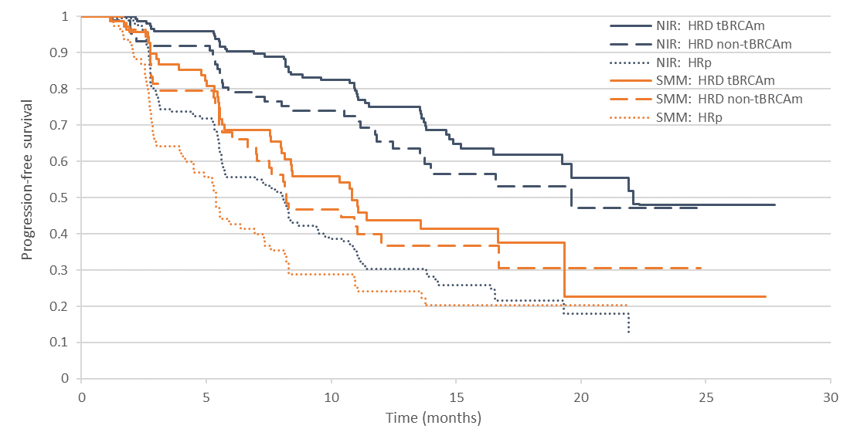 Source: Figure 36 (p156) of the submission
BICR = blinded independent central review; BRCAm = BRCA mutation; CI = confidence interval; BRCAm = BRCA mutation; DCO = data cut-off; HR = hazard ratio; INV = investigator; NIRA = niraparib; NR = not reported; PBO = placebo
Note: The submission used the terms HRD non-BRCAm to represent the HRD positive BRCAwt population and HRp to represent the HRD negative population.
Note that KM curves depicted for HRD non-tBRCAm and HRp subgroups are derived from a post-hoc analysis conducted by the applicant specifically for the purposes of informing the PBAC consideration. Interpretation of the results and their application should therefore be limited to seeking to understand the basis for the PBAC outcome and should not be used for any other purpose.
        - KM plots of INV PFS for the HRD positive BRCAwt subgroup at the November 2021 DCO population are provided in Figure 2. The INV PFS KM plot from November 2021 did not appear to be substantively different to the May 2019 DCO KM plot.
Figure 2: INV PFS KM curve for HRD positive BRCAwt (November 2021 DCO)
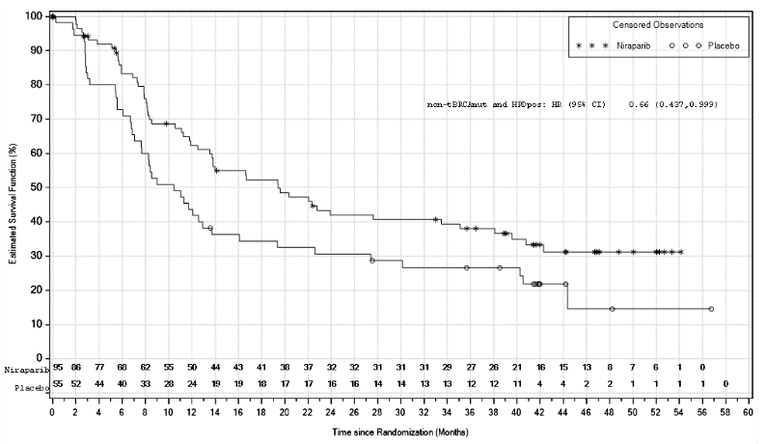
Source: F-14-2-1-9m-pfsinv.rtf
BRCAmut = BRCA mutation; BRCAwt = BRCA wild type; CI = confidence interval; DCO = data cut-off; HR = hazard ratio; INV = investigator
Note: The submission used the terms HRD non-BRCAmut to represent the HRD positive BRCAwt population and HRDpos to represent the HRD positive population.
        - While the INV PFS HR in the HRD positive BRCAwt subgroup was statistically significant at the November 2021 DCO (HR = 0.66, 95% CI 0.437, 0.999), the upper 95% CI was very close to 1.0, indicating a level of uncertainty with the magnitude of the result. Compared to the other populations, the November 2021 DCO INV PFS median benefit in the HRD positive BRCAwt subgroup was:
        - Higher than in the ITT for INV PFS at the same DCO (median benefit of 5.6 months favouring niraparib) with the same hazard ratio point estimate (HR 0.66, 95% CI 0.56-0.79);
        - Lower than the November 2021 DCO INV PFS median benefit in the BRCAm subgroup of 20.0 months favouring niraparib patients, and had a less favourable hazard ratio than the BRCAm subgroup (0.45, 95% CI 0.32-0.64); and
        - Higher than the HRD-negative subgroup median benefit of 3.0 months favouring niraparib patients, but numerically higher than the hazard ratio (0.65, 95% CI 0.49-0.87).
        - No tests of interaction were provided for any subgroup results to assess whether HRD positive BRCAwt was a treatment effect modifier.
        - At the May 2019 DCO, the INV PFS HR of niraparib compared placebo in the HRD negative subgroup (0.63, 95% CI 0.47, 0.866) was numerically comparable to the HRD positive BRCAwt subgroup (0.60, 95%CI 0.374, 0.954) though the difference in median PFS per BICR (2.7 months) was substantially lower than in the HRD positive BRCAwt subgroup (11.4 months). The PBAC previously considered that the clinical importance of a median PFS benefit in the HRD negative subgroup was uncertain, particularly given the increase in toxicity of niraparib and uncertain OS (paragraph 6.38, niraparib PSD, March 2022 PBAC meeting). As such, it was unclear if it was reasonable to have assumed a clinical benefit in the HRD negative subgroup in the economic evaluation.
        - A summary of the trial results for OS, for the HRD positive BRCAwt subgroup in PRIMA is provided in the table below. The submission did not provide any other subgroup OS results or any OS results for the November 2021 DCO. The submission stated that final OS results are expected in 2024 for PRIMA when approximately 440 deaths have occurred in the ITT population (60% data maturity), and that at the November 2021 DCO, OS maturity was 41% for the ITT population (data not provided).
Table 8: OS HRD positive BRCAwt subgroup results in PRIMA (May 2019 DCO)
 |  | NIRA (n=95) | PBO (n=55)
Events, n (%) |  | 6 (6.3) | 6 (10.9)
Survival distribution function (95 % CI) | 6 months | 1.00 (1.00,1.00) | 1.00 (1.00,1.00)
 | 12 months | 0.95 (0.88,0.98) | 0.90 (0.78,0.96)
 | 18 months | 0.95 (0.88,0.98) | 0.90 (0.78,0.96)
 | 24 months | NR | NR
 | 30 months | NR | NR
Median, months (95% CI) |  | 30.3 (NE, NE) | NE (22.7, NE)
HR (95% CI) |  | 0.52 (0.157, 1.746)
CI = confidence interval; HR = hazard ratio; ITT = intent to treat; NE = not evaluable; NIRA = niraparib; NR = not reached; PBO = placebo
Source: Table 66 (p140) of the submission
Note that the OS results for the HRD positive BRCAwt subgroup from the May 2019 DCO of PRIMA are derived from post-hoc analyses conducted by the applicant specifically for the purposes of informing the PBAC consideration. Interpretation of the results and their application should therefore be limited to seeking to understand the basis for the PBAC outcome and should not be used for any other purpose
        - KM plots of OS for the HRD positive BRCAwt and the HRD negative patient subpopulations are provided in the figures below.
Figure 3: OS HRD positive BRCAwt subgroup KM curves (May 2019 DCO)
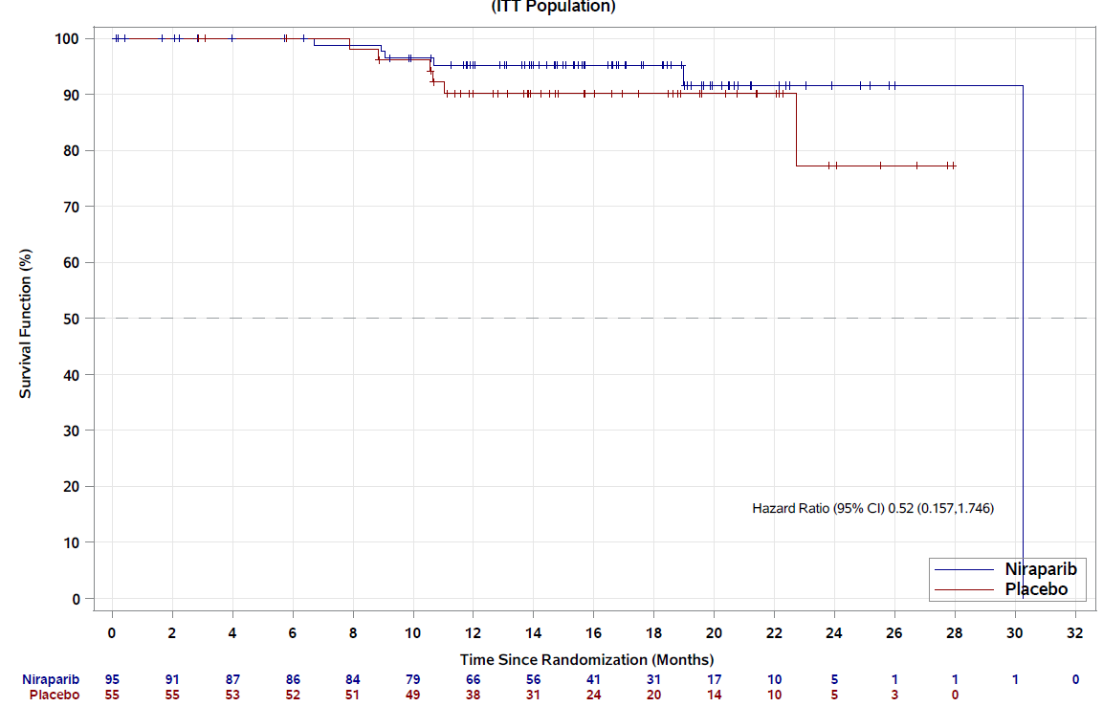
Source: Figure 28 (p141) of the submission
BRCAwt = BRCA wild type; CI = confidence interval; DCO = data cut-off; HRD = homologous recombination deficient; KM = Kaplan Meier
Note that Figure 3 depicts results that are derived from a post-hoc analysis conducted by the applicant specifically for the purposes of informing the PBAC consideration. Interpretation of the results and their application should therefore be limited to seeking to understand the basis for the PBAC outcome and should not be used for any other purpose
Figure 4: OS HRD negative subgroup KM curves (May 2019 DCO)
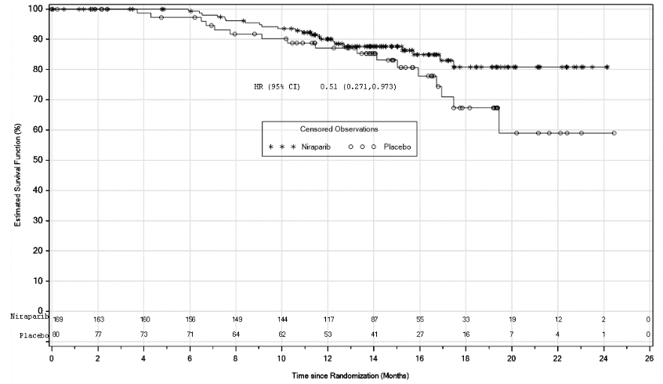
Source Figure 54, p 199 of the submission
CI = confidence interval; DCO = data cut-off; HR = hazard ratio
Note that Figure 4 depicts results that are derived from a post-hoc analysis conducted by the applicant specifically for the purposes of informing the PBAC consideration. Interpretation of the results and their application should therefore be limited to seeking to understand the basis for the PBAC outcome and should not be used for any other purpose
        - The OS data from the PRIMA trial was immature. The OS HR (0.52, 95%CI 0.16-1.75) in the HRD positive BRCAwt subgroup was not statistically significantly different between treatments and had a wide 95% confidence interval, indicating a high level of uncertainty. The HR in the HRD positive BRCAwt subgroup was numerically better than for the ITT population (0.70, 95%CI 0.44-1.11).
        - For the HRD negative subgroup, an OS HR = 0.51 (95% CI: 0.271, 0.973, p=0.0376) over a median follow-up of 14.8 months in the niraparib arm and 15.2 months in the placebo arm months was reported at the May 2019 DCO. At primary analysis, only 13.0% of niraparib patients and 21.3% of placebo patients had experienced an event. This information was used to inform the outcome of false positive patients treated in the economic model.
        - While health-related quality of life data was collected in PRIMA, no results by HRD or BRCA status subgroups was presented in the submission.
Niraparib vs olaparib
        - For the comparison against the near market comparator olaparib, the submission presented an unanchored side-by-side comparison of niraparib (from PRIMA) with olaparib + bevacizumab (from PAOLA-1), and a population adjusted indirect comparison (PAIC) of HRD positive patients from PRIMA and PAOLA-1 (Hettle 2021).
        - As PRIMA excluded Stage III R0 post PDS patients, similar results excluding stage III R0 post PDS patients from PAOLA-1 from Harter 2021 were used in the unanchored side-by-side comparison. The submission claimed that in the HRD positive BRCAwt subgroup, the median INV PFS was similar for niraparib (19.4 months) and olaparib + bevacizumab (20.3 months) when patients with stage III R0 PDS were excluded (Table 9).
        - Unanchored side by side comparisons between single arms of the PRIMA and PAOLA-1 trials should be considered as highly uncertain due to lack of adjustment for confounding factors and multiple sources of heterogeneity between trials. The PFS HR between the two trials could not be used in a comparison as the control arm in both trials (placebo in PRIMA and bevacizumab in PAOLA-1) differed. OS HR was not statistically significantly different between the PARP inhibitor arm and the control arm in either PRIMA or PAOLA-1 (Table 10).
Table 9: Results from individual trials for PFS per INV
PFS per INV |  | PRIMA |  |  |  |  | PAOLA-1
 |  | (DCO: 17/5/19)  Median FU = 13.8 months |  |  | (DCO: 17/11/21)  Median FU = 3.5 years |  | (DCO: 22/3/19)  Median FU = 22.9 months |  | (Excl PDS Stage III R0)  Median FU = 22.9 months
 |  | NIRA |  | PBO | NIRA | PBO | OLA/BEVA | PBO/BEVA | OLA/BEVA | PBO/BEVA
ITT | Events/N | 255/487 |  | 166/246 | 332/487 | 199/246 | 280/537 | 194/269 | 239/399 | 154/196
 | Median, months | 13.8  (11.3, 14.2) |  | 8.2  (7.6, 9.8) | 13.8  (11.9, 16.3) | 8.2  (7.6, 9.8( | 22.1  (21.8, 24.1) | 16.6  (15.4, 18.6) | 20.3 (NR) | 14.7 (NR)
 | HR (95% CI) | 0.63 (0.514, 0.763) |  |  | 0.66 (0.556, 0.792) |  | 0.59 (0.49, 0.72) |  | 0.60 (0.49, 0.74)
HRD positive | Events/N | 92/247 | 80/126 |  | 137/247 | 98/126 | 87/255 | 92/132 | 77/177 | 67/89
 | Median, months | 21.9  (16.5, NE) | 11.2  (8.4, 13.1) |  | 24.5  (18.7, 36.1) | 11.2  (8.4, 13.7) | 37.2 (NR) | 17.7 (NR) | 36.0 (NR) | 16.0 (NR)
 | HR (95% CI) | 0.46 (0.342, 0626) |  |  | 0.52 (0.401, 0.677) |  | 0.33 (0.25, 0.45) |  | 0.39 (0.28, 0.54)
BRCAm | Events/N | 53/152* | 45/71* |  | 83/152 | 55/71 | 41/157 | 49/80 | 378/109 | 36/55
 | Median, months | 24.2  (18.7, NE)* | 11.5  (8.4, 16.7)* |  | 31.5  (19.3, 51.8) | 11.5  (8.4, 16.6) | 37.2 (NR) | 21.7 (NR) | 36.0 (NR) | 19.4 (NR)
 | HR (95% CI) | 0.40 (0.266, 0.596)* |  |  | 0.45 (0.322, 0.641) |  | 0.31 (0.20, 0.47) |  | 0.37 (0.23, 0.59)
HRD positive BRCAwt | Events/N | 39/95* | 35/55* |  | 54/95 | 43/55 | NR | NR | 37/64 | 30/37
 | Median, months | 16.6  (11.9, NE)* | 10.4  (7.0, 12.9)* |  | 19.4  (12.5, 33.5) | 10.4  (7.0,13.7) | 28.1 (NR) | 16.6 (NR) | 20.3 (NR) | 15.4 (NR)
 | HR (95% CI) | 0.60 (0.374, 0.954)* |  |  | 0.66 (0.437, 0.999) |  | 0.43 (0.28, 0.66) |  | 0.51 (0.31, 0.83)
HRD-negative | Events/N | 118/169* | 61/80* |  | NR |  | 145/192 | 65/85 | 117/144 | 53/62
 | Median, months | 8.3  (7.2, 10.5)* | 5.4  (4.5, 7.0)* |  | 8.4  (NR) | 5.4  (NR) | 16.6 (NR) | 16.2 (NR) | 15.6 (NR) | 13.8 (NR)
 | HR (95% CI) | 0.63 (0.457, 0.866)* |  |  | 0.65 (0.49, 0.87) |  | 1.00 (0.75, 1.35) |  | 0.93 (0.68, 1.30)
HRnd | Events/N | 45/71* | 25/40* |  | NR |  | 48/90 | 36/52 | 45/78 | 34/45
 | Median, months | 11.0  (7.8,13.9)* | 8.3  (5.7,19.4)* |  |  |  | NR (NR) | NR (NR) | 19.8 (NR) | 14.3 (NR)
 | HR (95% CI) | 0.95 (0.571, 1.589)* |  |  |  |  | 0.71 (0.46, 1.10) |  | 0.63 (0.41, 1.00)
Source: Table 231 (p359) of the submission
Grey shading indicates requested population
BEVA = bevacizumab; BICR = blinded independent centralised review; BRCAm = BRCA gene mutation; CI = confidence interval; DCO = data cut-off; HR = hazard ratio; HRD = homologous recombination deficient; HRp = homologous recombination proficient; HRnd = homologous recombination not determined; NE = not evaluable; NIRA = niraparib; NR = not reported; OLA = olaparib; PBO = placebo
Note: Results denoted by (*) are derived from post-hoc analyses conducted by the applicant specifically for the purposes of informing the PBAC consideration. Interpretation of the results and their application should therefore be limited to seeking to understand the basis for the PBAC outcome and should not be used for any other purpose.
Table 10: OS Results from PRIMA and PAOLA-1
OS |  | Interim OS analysis |  | Final OS analysis
 |  | PRIMA (DCO: 17/5/19) |  | PAOLA-1 (DCO: 22/3/22)
 |  | NIRA | PBO | OLA/BEVA | PBO/BEVA
ITT | Events/N | 48/487 | 31/246 | 288/537 | 158/269
 | Median, months | 30.3 (30.3, NE) | NE (25.0, NE) | 56.5 | 51.6
 | HR (95% CI) | 0.70 (0.442,1.106) |  | 0.92 (0.76, 1.12)
HRD positive | Events/N | 16/247 | 10/126 | 93/255 | 69/132
 | Median, months | 30 (30.3, NE) | NE (25.0, NE) | 75.2* | 57.3
 | HR (95% CI) | 0.61 (0.265, 1.388) |  | 0.62 (0.45, 0.83)
BRCAm | Events/N | 10/152** | 4/71** | 48/157 | 37/80
 | Median, months | NR | NR | 75.2* | 66.9
 | HR (95% CI) | 0.75 (0.222, 2.537) ** |  | 0.60 (0.39, 0.93)
HRD positive BRCAwt | Events/N | 6/95** | 6/55** | 44/97 | 32/55
 | Median, months | NR | NR | NR | 52.0
 | HR (95% CI) | 0.52 (0.157, 1.746) ** |  | 0.71 (0.45, 1.13)
HRD negative | Events/N | 22/169** | 17/80** | 140/192 | 58/85
 | Median, months | NE (NE, NE) | NE (19.4, NE) | 36.8 | 40.4
 | HR (95% CI) | 0.51 (0.271,0.973) |  | 1.19 (0.88, 1.63)
Source: Table 233, p371 of the submission
*Unstable median (<50% maturity)
Abbreviations: BEVA = bevacizumab; CI = confidence interval; DCO = data cut-off; HRD = homologous repair deficiency; HR = hazard ratio; ITT = intent to treat; NE = not evaluable; NIRA = niraparib; NR = not reported; OS = overall survival; PBO = placebo.
Note: results denoted by (**) are derived from a post-hoc analysis conducted by the applicant specifically for the purposes of informing the PBAC consideration. Interpretation of the results and their application should therefore be limited to seeking to understand the basis for the PBAC outcome and should not be used for any other purpose
        - Hettle 2021 performed a PAIC in the ITT and in the HRD positive populations using aggregate data from the May 2019 PRIMA data cut-off, and patient-level data from a subset of patients at the March 2019 PAOLA-1 data cut-off who met the surgery and FIGO staging eligibility criteria of PRIMA (i.e. excluded patients with stage III R0 PDS to create a modified PAOLA-1 set). Prognostic and effect modifiers including the PRIMA stratification factors (response to therapy and prior use of neoadjuvant chemotherapy), FIGO stage, BRCA status, age, ECOG performance status and CA-125 ≥ upper limit normal were matched in the PAIC. No analysis was conducted for the HRD positive BRCAwt population. The results from Hettle 2021 are presented in Figure 5.
Figure 5: PFS KM curves from the PAIC in Hettle 2021 the HRD positive population
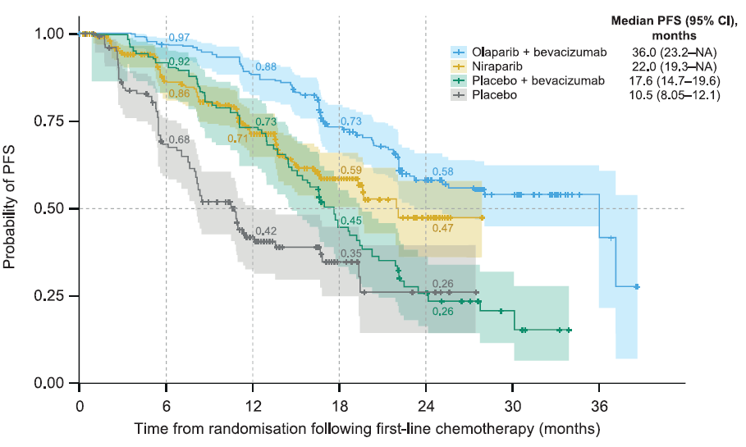
Source: Figure 4, Hettle 2021
        - In the HRD positive population, Hettle 2021 reported a statistically significant difference in PFS HR favouring treatment with olaparib + bevacizumab compared to niraparib (PFS HR = 0.57, 95% CI 0.41, 0.79), with a median difference of 14.0 months. The large difference in median PFS and statistically significant HR would suggest that the submission’s claim that olaparib + bevacizumab had no added clinical benefit compared to niraparib in the HRD positive BRCAwt population was potentially not supported based on the available evidence.
        - The submission claimed that Hettle 2021 was unlikely to have adequately controlled for all sources of heterogeneity between trials, particularly for characteristics that cannot be controlled for, such as 1L treatment and that the decision to treat patients with bevacizumab takes into account patient level factors beyond those adjusted for in the PAIC. The ESCs noted that outcomes for the control arms across the two trials (placebo and placebo + bevacizumab) were quite different, and the ESCs considered bevacizumab would not be expected to provide the level of benefit shown in these patients (based on outcomes from the ICON trial). The ESCs considered this suggests that the two study populations remained significantly different and sources of heterogeneity had not been adequately controlled for in this comparison.
        - Overall, the PAIC by Hettle 2021 had significant limitations in terms of possibly not having adjusted for all unobserved variables, was associated with a high level of uncertainty and represents a lower level of evidence compared to the randomised controlled trials of PRIMA and PAOLA-1. Nonetheless, it does represent the highest level evidence currently available comparing niraparib with olaparib + bevacizumab in the HRD positive population (which includes the requested HRD positive BRCAwt subpopulation).
        - The ESCs considered that the PAIC by Hettle 2021 should be interpreted with caution, given the limitations described above.

Comparative harms
        - The PBAC has previously considered that niraparib was inferior to placebo in terms of safety in PRIMA due to more grade ≥3 treatment emergent adverse events (TEAEs), serious adverse events (SAEs) and TEAEs leading to treatment discontinuation in the niraparib arm, based on the ITT population (paragraph 6.37, niraparib PSD, July 2021 PBAC meeting).
        - The table below presents an overview of the TEAEs reported in PRIMA for the safety population and the HRD positive BRCAwt subgroup. The relative risks for HRD positive BRCAwt patients who received niraparib compared to those who received placebo experiencing any TEAE, experiencing a Grade ≥3 TEAE and experiencing a SAE were similar to those in the overall safety population of PRIMA, with patients in the niraparib significantly more likely to experience a TEAE, a Grade ≥3 TEAE or a SAE compared to patients who received placebo. Previously, the PBAC found that it was reasonable to assume that the safety results for the overall population were applicable to the subgroup of interest (HRD positive BRCAwt) (paragraph 6.31, olaparib PSD, July 2022 PBAC meeting).
Table 11: PRIMA trial TEAEs
 | Niraparib  N (%) | Placebo  N (%) | Risk difference  (95% CI)*^{c} | Relative risk  (95% CI)*^{c}
Overall population (SAF), May 2019 DCO
N | 484 | 244 | - | -
Mean treatment duration months (SD) | 10.3 (6.6) | 9.5 (5.9) | - | -
Any TEAE | 478 (98.8) | 224 (91.8) | 7.0 (3.4, 10.5) | 1.08 (1.04, 1.12)
Grade ≥ 3 TEAE | 341 (70.5) | 46 (18.9) | 51.6 (45.2, 58.0) | 3.74 (2.86, 4.88)
SAE | 156 (32.2) | 32 (13.1) | 19.1 (13.2, 25.1) | 2.46 (1.74, 3.48)
Any TEAE leading drug interruption | 385 (79.5) | 44 (18.0) | 61.5 (55.5, 67.5) | 4.41 (3.36, 5.79)
Any TEAE leading drug dose reduction | 343 (70.9) | 20 (8.2) | 62.7 (57.4, 68.0) | 8.65 (5.66, 13.21)
Any TEAE leading drug withdrawal | 58 (12.0) | 6 (2.5) | 9.5 (6.0, 13.0) | 4.87 (2.13, 11.13)
Any TEAE leading to death** | 2 (0.4) | 1 (0.4) | 0.003 (-0.98, 0.99) | 1.01 (0.09, 11.07)
Overall population (SAF) November 2021 DCO
N | 484 | 244 | - | -
Mean treatment duration months (SD) | NR | NR | - | -
Any TEAE ª | 479 (99.0) | 229 (93.9) | 5.1 (2.5, 8.9) | 1.05 (1.02, 1.09)
Grade ≥ 3 TEAE ª | 353 (72.9) | 56 (23.0) | 50.0 (43.1, 56.2) | 3.18 (2.53, 4.05)
Any TEAE leading drug interruption | 389 (80.4) | 51 (20.9) | 59.5 (52.9, 65.3) | 3.85 (3.00, 4.93)
Any TEAE leading drug dose reduction | 347 (71.7) | 23 (9.4) | 62.3 (56.4, 67.3) | 7.61 (5.13, 11.27)
Any TEAE leading drug withdrawal | 69 (14.3) | 7 (2.9) | 11.4 (7.5, 15.2) | 4.97 (2.32, 10.65)
Any TEAE leading to death** ª | 5 (1.0) | 2 (0.8) | 0.2 (-2.0, 1.7) | 1.26 (0.25, 6.45)
HRD positive BRCAwt population, May 2019 DCO
N | 93^{b} | 55 ^{b} | - | -
Mean treatment duration months (SD) | 10.5 (6.8) ^{b} | 10.2 (6.3) ^{b} | - | -
Any TEAE | 93 (100.0) ^{b} | 47 (85.5) ^{b} | 14.5 (7.5, 26.2) | 1.17 (1.05, 1.31)
Grade ≥ 3 TEAE | 64 (68.8) ^{b} | 12 (21.8) ^{b} | 47.0 (31.2, 59.9) | 3.15 (1.88, 5.23)
SAE | 31 (33.3) ^{b} | 8 (14.5) ^{b} | 18.8 (4.3, 3.2) | 2.29 (1.14, 4.72)
Any TEAE leading to death** | 0 ^{b} | 0 ^{b} | NA | NA
BRCA = breast cancer gene; DCO = data cut-off; HRD = homologous recombination deficiency; NR = not reported; SAE= serious adverse events; SAF = safety population; SD= standard deviation; TEAE = treatment emergent adverse event; wt = wild type
*Calculated during the evaluation
**One subject in the fixed starting dose cohort died from a serious AE related to intestinal perforation. Two other subjects in the PRIMA trial (one in the niraparib arm and one in the placebo arm) experienced TEAEs that led to death (pleural effusion and intentional overdose respectively), none of which were assessed as study treatment related.
Note: Blue shading indicates data previously seen by the PBAC.
Source: Table 70 of the submission (p147-8); Table 57 (p125) of the submission and Table 2.5.2 of the July 2021 niraparib PBAC commentary
ª N’s not reported, calculated during the evaluation based on reported proportions
^{b} Note: Results are derived from a post-hoc analysis conducted by the applicant specifically for the purposes of informing the PBAC consideration. Interpretation of the results and their application should therefore be limited to seeking to understand the basis for the PBAC outcome and should not be used for any other purpose
^{c} Note: Results are derived from post-hoc analyses conducted by the evaluation specifically for the purposes of informing the PBAC consideration. Interpretation of the results and their application should therefore be limited to seeking to understand the basis for the PBAC outcome and should not be used for any other purpose
        - The figure below presents individual TEAEs reported in ≥20% of patients in the overall safety population and in the ISD population of PRIMA. In the overall population, thrombocytopenia (67.1%), anaemia (65.1%) and nausea (58.3%) were the most commonly reported TEAEs in niraparib patients, and abdominal pain (32.4%), fatigue (31.1%) and nausea (29.9%) were the most commonly reported TEAEs in placebo patients.
Figure 6: TEAEs reported in ≥ 20% of patients (November 2021 DCO)
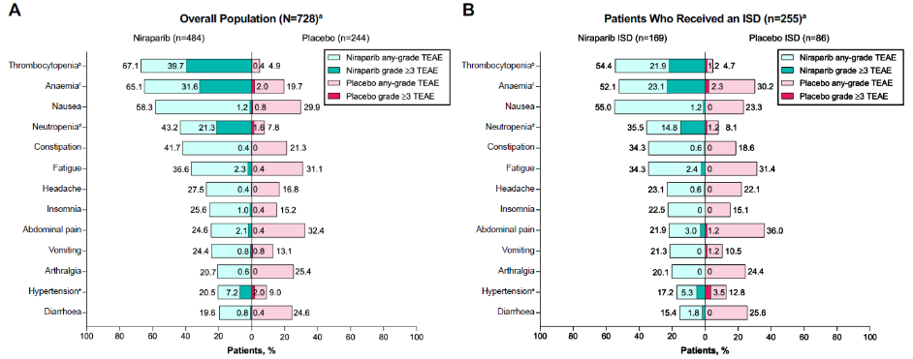
Source: Figure 34 (p150) of the submission
DCO = data cut-off; SAF = safety population; ISD = individualised-starting dose; TEAE = treatment emergent adverse event
        - Given the relatively small number of patients in the HRD positive BRCAwt subgroup, the safety data reported may not be exhaustive. In the July 2021 niraparib PBAC submission, ESC noted there remained a clinical concern about the rates of myelodysplastic syndromes (MDS) and/or acute myeloid leukaemia (AMS) for patients treated with PARP inhibitors, with further follow-up data likely to provide a more accurate estimate of risk (paragraph 6.26, niraparib PSD, July 2021 PBAC meeting). The submission stated at the November 2021 DCO, the incidence of MDS/AML in both arms was similar (niraparib: 6/484 = 1.2%; placebo: 3/244 = 1.2%). The submission stated that the sponsor was conducting adverse event follow-up questionnaires and plans to conduct a meta-analysis of MDS/AMS and other second primary malignancies in patients with ovarian cancer who received niraparib. DUSC has previously commented that clinicians treating gynaecological malignancies are now relatively familiar with olaparib and its QUM issues (paragraph 6.101, olaparib PSD, July 2022 PBAC meeting) and this may extend to niraparib.
Niraparib vs olaparib
        - A summary of TEAEs in the safety populations of PRIMA (individualised starting dose) and PAOLA-1 trials is shown in Table 12. As noted above, unanchored side by side comparisons between single arms of the PRIMA and PAOLA-1 trials should be considered as highly uncertain due to lack of adjustment for confounding factors and multiple sources of heterogeneity between trials. However, a visual inspection indicates the safety data between the niraparib and olaparib plus bevacizumab arms are generally comparable, with a slightly higher proportion of olaparib plus bevacizumab patients experiencing any TEAE (by approximately 2%), a grade ≥3 TEAE (by approximately 4%), a SAE (by approximately 5%) and a TEAE leading to treatment discontinuation (by approximately 7%).
Table 12: Overall summary of TEAEs in PRIMA and PAOLA-1
n (%) | PRIMA (SAF) DCO: 17/05/2019 |  | PRIMA (SAF) DCO: 17/11/2021 |  | PAOLA-1 (SAF) DCO: 22/3/2019
 | ISD cohort |  | ISD cohort |  | ITT
 | NIRA  (N=169) | PBO  (N=86) | NIRA  (N=169) | PBO  (N=86) | OLA/BEVA  (N=535) | PBO/BEVA  (N=267)
Any TEAE | 165 (97.6) | 76 (88.4) | 166 (98.2) | 79 (91.9) | 531 (99.3) | 256 (95.9)
Gr ≥3 TEAE | 102 (60.4) | 16 (18.6) | 106 (62.7) | 20 (23.3) | 303 (56.8) | 136 (50.9)
SAE | 45 (26.6) | 14 (16.3) | NR | NR | 167 (31.2) | 83 (31.1)
TEAEs leading to tx discontinuation | 23 (13.6) | 2 (2.3) | 26 (15.4) | 2 (2.3) | 109 (20.4) | 15 (5.6)
TEAEs leading to death | 0 | 1 (1.2) | 2 (1.2) | 1 (1.2) | 1 (<1) | 4 (1.5)
Source: Table 238 (p380) of the submission
DCO = data cut-off; NIRA = niraparib; NR = not reported; OLA = olaparib; PBO = placebo; SAF = safety population; TEAE = treatment emergent adverse event; tx = treatment.
        - Hettle 2021 also included a safety assessment in their PAIC. Hettle 2021 reported that a higher proportion of patients treated with niraparib experienced grade ≥3 haematological adverse events compared to patients treated with olaparib + bevacizumab (neutropenia: 15% vs 6%, thrombocytopenia: 21% vs 2%). However, a higher proportion of patients treated with olaparib + bevacizumab experienced grade ≥3 hypertension (19% vs 5%), which was a known adverse event with bevacizumab. The increase in grade 3-4 haematological adverse events with niraparib was consistent with a meta-analysis of PARP inhibitors as monotherapy in platinum-sensitive recurrent ovarian cancer (Xu 2021) in which niraparib (RR = 1.6 with 95% Credible Interval: 1.1–2.4) was associated with a higher risk of grade 3 or 4 adverse events as compared with olaparib.

Benefits/Harms
        - A summary of the comparative benefits and harms for niraparib versus placebo is presented in the table below.
Table 13: Summary of comparative benefits and harms for the HRD positive BRCAwt subgroup in PRIMA
Event | Niraparib  n/N | Placebo  n/N | Absolute Differenceª | HR (95% CI)
Progression free survival for HRD+BRCAwt subgroup, (ITT median follow-up 3.5 years), November 2021 DCO
Progressed, n/N (%) | 54/95 (56.8%) | 43/55 (78.2) |  | 0.66  (0.437, 0.999)
Median PFS months (95% CI) | 19.4 (12.5, 33.5) | 10.4 (7.0, 13.7) | 9.0 months (NR)
Progression free at 6 months, % | 83% | 73% | 10%
Progression free at 12 months, % | 62% | 44% | 18%
Progression free at 24 months, % | 52% | 34% | 18%
Progression free at 36 months, % | 42% | 31% | 11%
Progression free at 48 months, % | 38% | 27% | 11%
Harms (Safety analysis set) ^{b}
 | Niraparib  n/N | Placebo  n/N | RR  (95% CI) ª | Event rate/100 patientsª |  | RDª
 |  |  |  | Niraparib | Placebo
Any casually related AE
Thrombocytopenia | 57/165 | 3/86 | 9.90 (3.19, 307) | 34.5 | 3.5 | 31.1
Vomiting | 28/165 | 8/86 | 1.57 (0.75, 3.31) | 17.0 | 9.3 | 7.7
Nausea | 90/165 | 18/86 | 2.61 (1.69, 4.02) | 54.5 | 20.9 | 33.6
BRCAwt = breast cancer gene wild type; DCO = data cut off; HR = hazard ratio; HRD = homologous recombination deficiency; ITT = intention to treat; NE = not evaluable; NR =not reported
Source: Tables 64, 66, 71 (p135, 140, 148) of the submission
ª Note: Results are derived from post-hoc analyses conducted by the evaluation specifically for the purposes of informing the PBAC consideration. Interpretation of the results and their application should therefore be limited to seeking to understand the basis for the PBAC outcome and should not be used for any other purpose.
^{b} Safety results are from the May 2019 DCO and for the ISD cohort
        - On the basis of direct evidence presented by the submission, for every 100 patients treated with niraparib in comparison with placebo:
- Approximately 11 additional patients will remain progression-free after approximately 4 years.
- Approximately 31 additional patients would experience thrombocytopenia.
- Approximately 8 additional patients would experience vomiting.
- Approximately 34 additional patients would experience nausea.

Clinical claim
Niraparib vs SMM
        - The submission described niraparib as superior in terms of effectiveness for PFS compared to SMM in the HRD positive BRCAwt population. While the PFS results in PRIMA demonstrated that niraparib was statistically significantly superior to placebo for the HRD positive BRCAwt population and the claim of superior clinical effectiveness may be plausible, the magnitude of PFS benefit and clinical significance may be considered uncertain as:
- OS data from PRIMA was immature. At the primary DCO there was no statistically significant difference in OS between treatments;
- PRIMA may not have been sufficiently powered to detect differences in the HRD positive BRCAwt subgroup;
- PRIMA was not stratified by BRCA status, and the HRD positive BRCAwt subgroup results in PRIMA were not considered in the formal statistical testing plan and therefore were associated with a higher risk of detection and selection bias; and
- The HR of niraparib vs placebo for PFS benefit per INV at the longest available follow-up had a 95% confidence interval upper limit of 0.999, where a value 1 represents no difference in risk of PFS.
        - The ESCs considered that PRIMA demonstrated a PFS benefit for niraparib compared with SMM, however the magnitude of benefit for the proposed PBS population remained uncertain due to reliance on exploratory subgroup analyses, and because OS data from PRIMA remained immature.
        - The submission described niraparib as inferior in terms of safety compared to SMM in the HRD positive BRCAwt population. The ESCs agreed with the commentary that this claim was adequately supported and was consistent with the PBAC’s previous assessment of the safety for niraparib compared to placebo in the ITT population.
        - The PBAC considered the claim of superior effectiveness was supported by the improvement in PFS for niraparib compared to SMM demonstrated in PRIMA (Table 6). At the primary data cut off (median follow-up 13.8 months, investigator assessed), the hazard ratio of niraparib vs placebo in the HRD positive BRCAwt subgroup was 0.60 (95% CI 0.374, 0.954). A significant difference was maintained in the latest data cut (median follow-up 3.5 years), the hazard ratio of niraparib vs placebo was 0.66 (95% CI 0.437, 0.999) in the HRD positive BRCAwt subgroup.
        - The PBAC noted that OS data for the HRD positive BRCAwt subgroup was immature (Table 8). The OS HR (0.52, 95% CI 0.16-1.75) was not statistically significant and had a wide 95% confidence interval, indicating a high level of uncertainty. The KM plot showed a separation of curves in favour of niraparib approximately 11 months after treatment initiation, although this was uncertain due to high censoring (Figure 3).
        - The PBAC considered the claim of inferior safety of niraparib in comparison with placebo was supported by the data presented. The incidence of TEAEs, ≥ Grade 3 TEAEs, and SAEs, were significantly higher in HRD positive BRCAwt patients who received niraparib than those treated with placebo (Table 11).
Niraparib vs olaparib
        - Against the near market comparator, olaparib, the submission claimed that there was insufficient clinical evidence to indicate there is an added clinical benefit for the combination (i.e. olaparib + bevacizumab) over monotherapy (i.e. niraparib) in the non-BRCAm HRD cohort. The submission noted the uncertainty as to whether a durable PFS advantage exists over time and the increased toxicity burden associated with the combination regimen. However, the PAIC from Hettle 2021 suggests that this claim may not be supported as in this analysis olaparib + bevacizumab was superior in PFS to niraparib. The ESCs considered that the PAIC by Hettle 2021 was associated with a high level of uncertainty due to the limitations described (see paragraph 6.36) and that non-inferiority between olaparib + bevacizumab vs niraparib was uncertain based on the evidence available. The ESCs also recalled that PBAC previously accepted non-inferior comparative safety for niraparib and olaparib (paragraph 7.9, niraparib PSD, March 2022 PBAC meeting).
        - The PBAC considered that on balance, a conclusion of non-inferior efficacy and safety for niraparib compared with olaparib was sufficiently supported by the evidence presented, despite the limitations discussed in paragraphs 6.32 to 6.37 and 6.42. The PBAC noted this conclusion was consistent with its previous consideration in March 2022, in which a claim of non-inferior efficacy and safety was accepted for niraparib compared with olaparib in the BRCAm population (Paragraphs 7.8 and 7.9, niraparib PSD, March 2022). The PBAC considered there were no reliable data to suggest a different therapeutic conclusion in the BRCAm HRDwt population compared with the BRCAm population.

Claim of codependence
        - The submission did not explicitly state that there was a biological rationale for targeting HRD positive BRCAwt HGEOC. While the codependency between HRD status and PARP inhibitors has not previously been accepted by MSAC and PBAC, they have both accepted that variation in the size of the treatment effect of PARP inhibitors is predicted by BRCA1/2 status as one HRD biomarker (paragraph 6.45, olaparib PSD, July 2022 PBAC meeting).
        - However, as discussed in paragraph 6.24, PFS results from PRIMA provided less support for a claim of codependence, as niraparib appears to provide a statistically significant PFS benefit over placebo irrespective of the patient’s HRD status, though the clinical significance of the median PFS benefit in the HRD negative population was unclear. The ESCs noted that this was inconsistent with studies in other PARP inhibitors which makes it difficult to determine whether or not the claim of codependence is reasonable.

Economic analysis
        - The submission presented a modelled economic evaluation, based on subgroup results from PRIMA. The submission stated that as there was an absence of mature OS data for PRIMA, data from an olaparib trial in the BRCAm population were used (SOLO-1) in the estimation of OS for the niraparib arm, while PRIMA OS data were used for the SMM arm.
        - The basis of the economic evaluation was a cost utility analysis (CUA). The model used a partitioned survival analysis with patients distributed between four mutually exclusive health states; progression-free (‘cured’), progression-free (‘not-cured’), progressed disease and death, over a base case time horizon of 20 years.
        - The table below summarises the key components of the economic evaluation.
Table 14: Summary of model structure, key inputs and rationale
Component | Description | Justification/comments
Type(s) of analysis | Cost-utility analysis | Appropriate.
Outcomes | Quality adjusted life-years (and life years) | Appropriate.
Time horizon | 20 years | The PBAC considered that the time horizon of 20 years was reasonable for the HRD+ population (paragraph 7.12, olaparib PSD, July 2022 PBAC meeting). However median follow up in PRIMA was only around 15 months.
Method(s) used to generate results | Partitioned survival analysis | Appropriate. As used in previous niraparib submissions.
Health states | Progression-free (‘cured’ and ‘not cured’), progressed disease and dead.  Cured patients were attributed zero progression and general population mortality. | Reasonable. As used in previous niraparib submissions.
Transition probabilities | The model included a diagnostic component to account for the impact of HRD testing to determine niraparib eligibility in clinical practice. The PPV and NPV of HRD testing based on clinical practice testing (Illumina TruSight Oncology 500 RUO) versus the clinical utility standard (Myriad myChoice PLUS) from Weichert 2021a/2022, were used to allocate patient outcomes based on HRD/BRCA status.  Within each HRD/BRCA based population, transition probabilities between health states were implicitly captured via PFS and OS curves, in line with the partitioned survival model structure. PFS and OS curves were estimated based on a combination of Kaplan-Meier data from PRIMA, fitted parametric survival functions, hazard ratios and curve convergence. | The inclusion of a diagnostic component to account for the impact of HRD testing was appropriate.
Extrapolation method | Independent parametric extrapolation was conducted for PFS and TTD. OS was modelled via a HR based on the ratio of PFS to OS ‘benefit’ from SOLO-1, and curve convergence relative to SMM OS was applied from 80 months until 20 years using an ‘adjusted curve convergence’. | The submission used a single measure of PFS and OS from SOLO-1 to calculate a constant ratio of the proportion of PFS benefit translating to OS benefit’ for the treatment arm and used this to estimate OS HR for the HRD positive BRCAwt and HRD negative cohorts. This methodology introduced a high degree of uncertainty.
Cure fraction | A cure fraction was estimated to equal 5% for both treatment arms. | This cure fraction used was in contrast to the cure fraction used for olaparib plus bevacizumab (38.57%, used with a comparator cure fraction of 6.63%), (Table 12, olaparib PSD, July 2022 PBAC meeting).
Health related quality of life | Values are derived from the PRIMA ITT cohort using an Australian EQ-5D mapping algorithm (Norman 2013), PF = 0.777 and PD = 0.689.  Additionally, a disutility of 0.008 was applied to niraparib patients in the model base case. This QALY loss was derived from disutility and incidence data presented in the NICE Single Technology Assessment Report for Niraparib in advanced HGEOC (BMJ-TAG 2020). | Reasonable. The PBAC previously considered not applying a disutility associated with niraparib treatment compared with no active treatment to be inappropriate given a conclusion of inferior safety, and favours niraparib (paragraph 6.53, niraparib PSD, July 2021 PBAC meeting).
Software | Microsoft Excel | Reasonable.
Source: Constructed during the evaluation using Tables 80 and 81, pp166-167 of the submission.
BRCA = breast cancer gene; BRCAm = breast cancer gene mutation; BRCAwt = breast cancer gene wild type; HGEOC = high-grade epithelial ovarian cancer; HR = hazard ratio; HRD = homologous recombination deficient; HRnd = homologous recombination not determined; ITT = intention to treat; NPV = negative predictive value; OS = overall survival; PFS = progression-free survival; PPV = positive predictive value; SMM = standard medical management.
Blue shaded cells indicate inputs that have previously been considered by PBAC
        - No data from the unplanned November 2021 DCO was used in the economic model. While this may have been reasonable due to the ad hoc nature of the November 2021 DCO, the May 2019 DCO used to inform the model only had a follow-up of around 15 months, which was extrapolated to 20-years in the base case of the model.
        - The economic model compared the proposed scenario where all patients undergo HRD testing versus the comparator/current scenario where patients receive BRCA testing only, using a stepped economic evaluation. The model base case scenario of HRD testing to determine BRCA1/2 variant and GIS in parallel at diagnosis is shown in the figure below. The submission also proposed a ‘without diagnostic testing’ scenario. However, this was actually a ‘free and perfect testing’ scenario which assumed that all patients were correctly classified and treated with no testing costs and was therefore implausible.
Figure 7: Tumour testing at diagnosis and outcomes in proposed clinical practice (Population #1: parallel – base case)
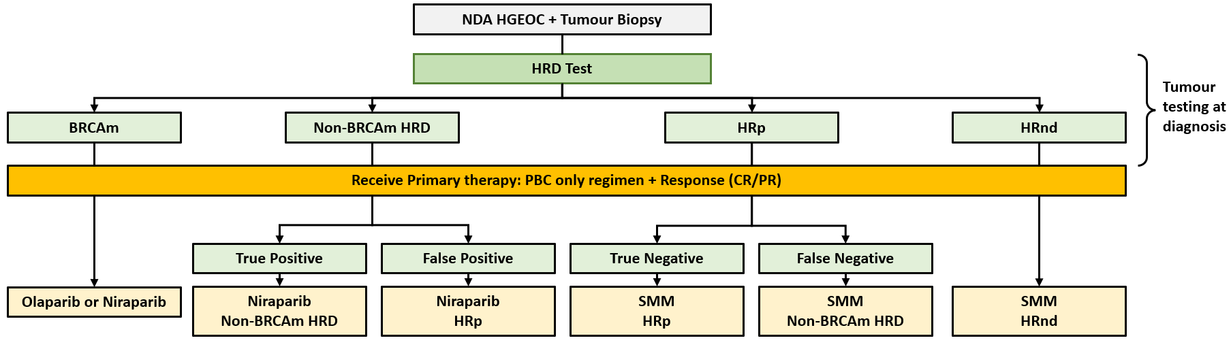
Source: Figure 41, p177 of the submission
BRCAm = breast cancer gene mutation; CP = complete response; HGEOC = high-grade epithelial ovarian cancer; HRnd = homologous recombination not determined; HRD = homologous recombination deficient; HRp = homologous recombination proficient; ND = not determined; NDA = newly diagnosed advanced; PBC = platinum-based chemotherapy; PR = partial response; SMM = standard medical management.
* The diagnostic accuracy of HRD testing was assessed based on concordance between Illumina TSO 500 assay and Myriad myChoice.
        - While treatment allocation was based on the tests used in clinical practice, the clinical outcomes experienced by patients are a function of diagnostic accuracy. Patients treated with niraparib with a true positive result were allocated outcomes from the HRD positive BRCAwt cohort in PRIMA, while patients with a false positive result were allocated outcomes from the HRD negative cohort. Patients with a true negative result were treated with SMM and allocated outcomes from the HRD negative cohort, and patients with a false negative result were treated with SMM were allocated outcomes from the HRD positive BRCAwt cohort. While false results were considered for HRD they were not considered separately for GIS and BRCA results. All categorisation of BRCAm or BRCAwt were inappropriately assumed to be true positives. False BRCA test results should have been considered for BRCAm patients as this could result in a different treatment allocation.
        - The submission stated that BRCAm and homologous recombination not determined (HRnd) patients were not included in the model as HRD testing is not expected to impact the use of PARP inhibitors in these patients. As it was proposed HRD testing will replace the currently available BRCA test, BRCAm patients would face a higher cost of testing for no additional benefit, with a potentially less accurate test. The PSCR stated that the base case applied parallel testing at OC diagnosis, in which all patients receive HRD testing in the niraparib arm of the model and therefore the model captures the costs of HRD testing across all patients, including BRCAm patients, via the inflation of diagnostic testing costs from $3,000 per test to $17,252 per treated patient included in the modelled cohort in the submission base case. As such, the effective price of niraparib in the HRD+ BRCAwt cohort has factored in the cost of testing the entire eligible population. The ESCs noted the inclusion of overall HRD testing costs, but considered that a revised model would be required to estimate the cost-effectiveness for the entire population impacted by the proposed medicine and proposed test, which would include BRCAm patients. HRnd patients would also incur additional costs for testing with no benefit, and some would need to have a subsequent germline BRCA test, which was not accounted for in the economic model nor in the financial estimates.
        - The clinical outcomes modelled in the economic evaluation (based on concordance from Weichert 2021a and 2022) are presented in Figure 8. The figure shows that 94.43% (21.3%/22.6%) of all patients treated with niraparib were considered to be true HRD positive BRCAwt and 5.57% (1. 3%/22.6%) were false positives and were actually HRD negative patients.
Figure 8: Clinical outcomes (blue shaded boxes) modelled in the economic evaluation – parallel testing
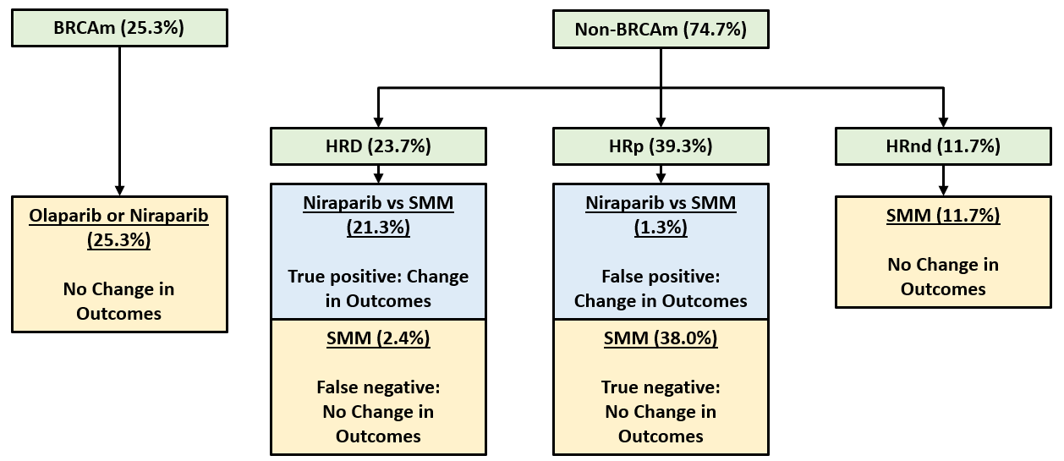
Source: Figure 49, p194 of the submission
BRCAm = BRCA mutation; HRD = homologous recombination deficient; HRnd = homologous recombination not determined; HRp = homologous recombination proficient; SMM = standard medical management
        - The ratio of the single estimate of PFS HR to the single estimate of OS HR from SOLO-1 was applied to PRIMA PFS data to derive the OS HR applied to the niraparib arm (as outlined in Table 15).
Table 15: PFS to OS benefit in SOLO-1
 | PFS HR (95%CI) | OS HR (95%CI) | Proportion of PFS benefit translating to OS benefit ª | Estimated OS HR HRD positive BRCAwt for niraparib ^{b} | Estimated OS HR HRD negative for niraparib ^{b}
BRCAm unadjusted ^{b} | 0.28 (0.20, 0.39) | 0.55 (0.40, 0.76) | 62.5% | 0.69 | 0.80
Source: Tables 105 and 106, p217 of the submission
ª Calculated as the OS rate reduction (1- OS HR) divided by the PFS rate reduction (1 – PFS HR).
^{b} Estimated by: 1 – proportion of PFS benefit translating to OS benefit (62.5%) multiplied by PFS benefit reported in PRIMA of 50% in HRD positive BRCAwt (PFS HR = 0.5, 95% CI 0.305,0.831) and 32% in HRD negative patients (PFS HR = 0.68, 95% CI 0.492, 0.944)
        - The submission claimed that the derivation of niraparib survival based on a HR relative to SMM was aligned with the approach previously accepted for olaparib in BRCAm NDA HGEOC, referencing paragraph 7.17, olaparib PSD, July 2020. In that submission an OS HR of 0.95 was applied for olaparib relative to SMM based on interim OS results from that submission’s pivotal trial SOLO-1 (DCO: 17/5/2018). However, in the olaparib submission the data used were from the pivotal trial rather than from an external trial in a different biomarker population, and the OS HR was not estimated using a calculated proportion of PFS benefit translating to OS benefit. Consequently, the methodology in the current submission was not similar to olaparib in July 2020. Moreover, the magnitude of benefit assumed in this submission (OS HR = 0.69) was substantially more optimistic than that assumed in the July 2020 olaparib submission (OS HR = 0.95).
        - There were significant issues with the submission’s approach to estimating the OS HR in the economic model:
- The submission did not provide an explanation of clinical plausibility for the approach of using the ratio of the PFS and OS HR as an effective surrogate for OS HR;
- The estimated OS HR was applied on the extrapolated SMM OS data from PRIMA, and it was unclear why the same approach should not be also taken for the niraparib arm. Any uncertainty from the use of immature data from PRIMA would have already been carried over from the use of extrapolated SMM OS data, so it was unclear that there was any benefit to the submission’s approach for estimating OS HR;
- The SOLO-1 study enrolled only BRCAm patients and the treatment considered (olaparib) was different. As such, there was no a priori reason to assume these ratios would be applicable to niraparib for the treatment in HRD positive BRCAwt and HRD negative patients;
- The use of single estimates did not account for any uncertainty associated with any of the estimates.
- The PBAC has previously questioned whether the PFS improvement in the HRD negative population in PRIMA was clinically relevant. If the PFS improvement was not clinically relevant it was unlikely to be reasonable to be modelling an OS benefit based on an assumption of PFS benefit in HRD negative patients; and
Overall, the methodology used to derive OS estimates for niraparib in HRD positive BRCAwt and HRD negative NDA HGEOC was unsubstantiated and lacking in external validity. Consequently, the results were associated with a high degree of uncertainty. The ESCs considered this was a non-standard methodological approach and considered this method was likely unreliable since it assumes that the ratio of single estimates of PFS and OS from a different trial of a different drug in a different biomarker population would apply to niraparib.
        - The ESC noted that the PSCR did not provide any further justification for the approach to modelling OS for niraparib, but argued that the survival benefit modelled was likely to be conservative compared with that accepted for the olaparib + bevacizumab submission in HRD positive BRCAwt HGEOC at the November 2022 PBAC meeting.
        - Inappropriately, no consideration of treatment with bevacizumab (before initiation of niraparib or as subsequent therapy, or as part of SMM) was included. This likely led to an overestimate of the incremental benefit of niraparib. The cost effectiveness of niraparib in patients with Stage III R0 post PDS and ECOG status ≥2 (who are eligible for treatment under the proposed restriction but were excluded from PRIMA) was also unknown.
        - In the model, patient outcomes (PFS, OS and TTD) were extrapolated separately for ‘cured’ and ‘not cured’ patients, with the base case assuming 5% of patients were ‘cured’ prior to initiating 1L maintenance treatment. In modelling outcomes for ‘cured’ patients, it was reasonably assumed patient mortality risks were equivalent to those of the general population, matched for age and sex and that they are not at risk of disease progression or treatment discontinuation for other reasons.
        - Outcomes (PFS, OS and TTD) for ‘not cured’ patients were informed by KM estimates from the HRD positive BRCAwt and HRD negative cohorts of PRIMA up to the median follow up (HRD positive BRCAwt 13.6 months for PFS and 15.7 months for OS, HRD negative 13.9 months for PFS and 14.8 months for OS), then informed by parametric extrapolations over the rest of the modelled time horizon. The LogNormal function was applied for the extrapolation of PFS in the model base case.
Figure 9: Niraparib PFS Kaplan-Meier estimates and fitted independent parametric models (HRD positive BRCAwt cohort)
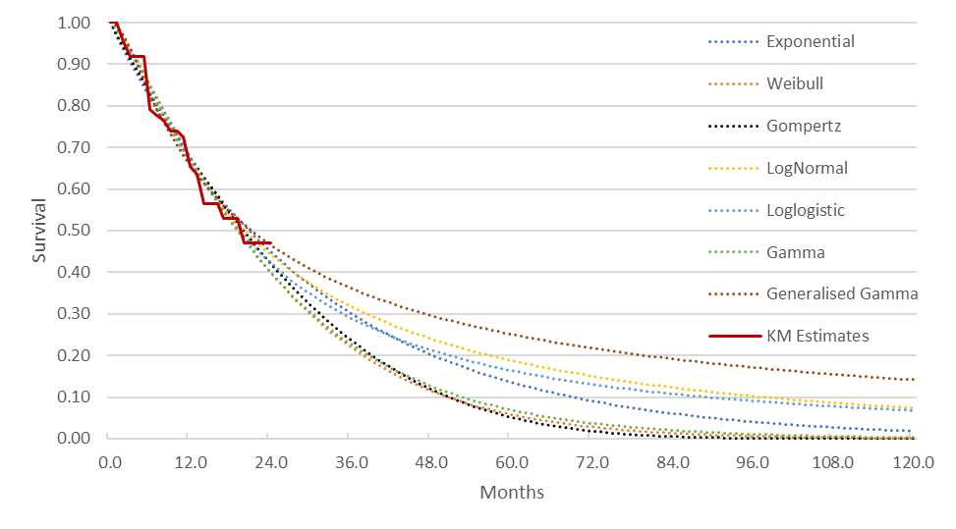
Source: Figure 59, p204 of the submission
BRCAwt = breast cancer gene wild type; HRD = homologous recombination deficient.
Figure 10: SMM PFS Kaplan-Meier estimates and fitted independent parametric models (HRD positive BRCAwt cohort)
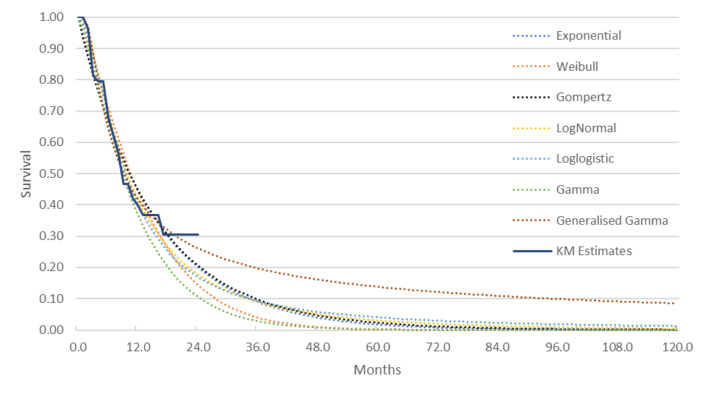
Source: Figure 60, p204 of the submission
BRCAwt = breast cancer gene wild type; HRD = homologous recombination deficient; SMM = standard medical management.
        - As shown in the figures below, the extrapolations of the different functions varied substantially over time for OS and therefore the choice of function was likely to have a sizeable impact on the results. The immaturity of OS data in PRIMA was a large contributor to the high variation and subsequent uncertainty in the OS estimates in the model. Further, because the submission subsequently applies a HR to the SMM OS curve to derive the niraparib OS, changes to the SMM OS curve also led to changes in the niraparib OS curve and the correlation between SMM OS and ICER was complex.
Figure 11: OS Kaplan-Meier estimates and fitted independent parametric models, SMM (HRD positive BRCAwt)
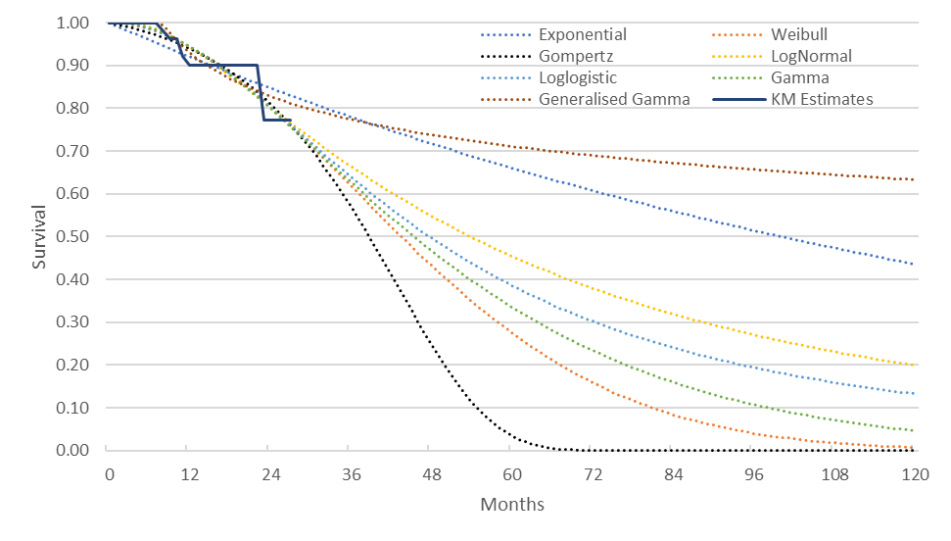
Source: Figure 71, p212 of the submission
BRCAwt = breast cancer gene wild type; HRD = homologous recombination deficient; SMM = standard medical management.

Figure 12: OS Kaplan-Meier estimates and fitted independent parametric models, SMM (HRD negative)
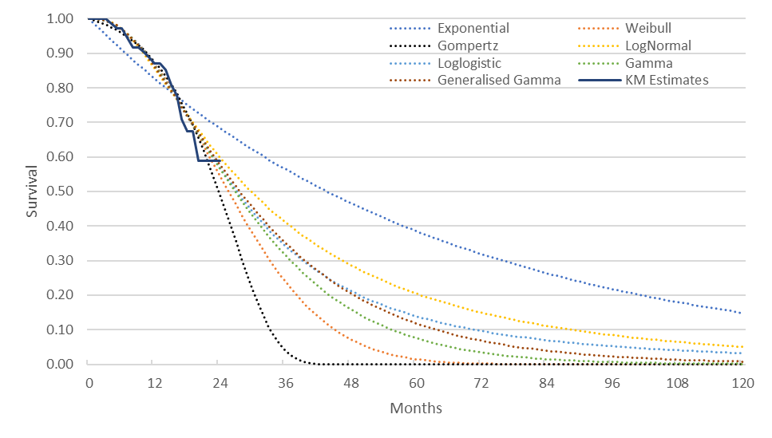
Source: Figure 73, p213 of the submission
HRD = homologous recombination deficient; SMM = standard medical management
        - Curve convergence was incorporated to ensure niraparib OS was equal to SMM OS at the modelled 20-year time point, with convergence beginning at 80 months in the base case. The modelled curves applied in the economic model are shown in the figure below.
Figure 13: Modelled curves applied in economic model
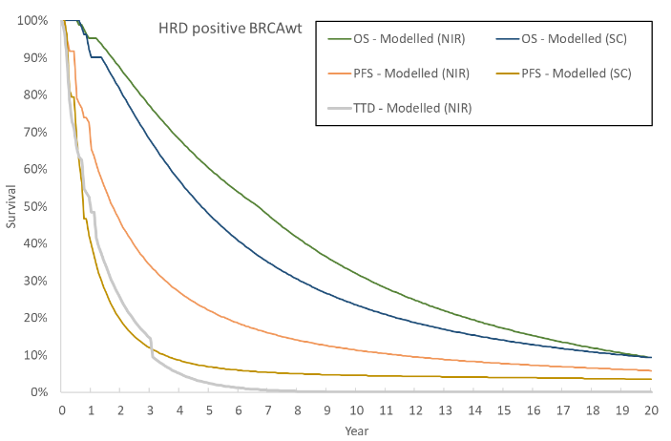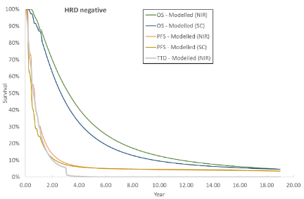
Source: Zejula (niraparib) 1L HRD_nonBRCAm CUA.xls, ‘Survival Traces -nonBRCA HRD’ spreadsheet and ‘Survival Traces -HRp’ spreadsheet.
BRCAwt = breast cancer gene wild type; NIR = niraparib; HRD = homologous recombination deficient; OS = overall survival; PFS = progression free survival; SC = standard care/standard medical management; TTD = time to discontinuation
        - The 5 level EuroQol 5-dimension Questionnaire (EQ-5D-5L) data from PRIMA was translated to utility values (progression-free = 0.777; progressed disease = 0.689) via the mapping algorithm presented in Norman 2013, as in the previous niraparib submissions (March 2022 and July 2021). The PBAC previously considered that this may not be reasonable since the data were not specific to the non-BRCAm cohort (Table 12, niraparib PSD, March 2022 PBAC meeting). Similarly, the utilities used in the current submission may not be appropriate because the data were not specific to the HRD positive BRCAwt cohort.
        - A treatment related QALY loss of 0.008 was applied as a once off in the first cycle to niraparib patients, as used in the PSCR for the March 2022 niraparib economic model. The ESC previously considered that this may have been a reasonable approach, however it was unclear whether there may be treatment-related disutility outside the immediate AE period (paragraph 6.53, niraparib PSD, March 2022 PBAC meeting).
        - The submission claimed that due to its short-term follow-up, PRIMA data was expected to underestimate the total number of patients receiving subsequent therapy (with or without associated maintenance therapy) and the average number of subsequent therapies. Consequently, the model assumed all patients experiencing disease progression for NDA HGEOC received a single line of subsequent anti-cancer treatment and applied subsequent treatment costs to all patients transitioning from the PF health state. The submission acknowledged that this may overestimate the proportion of patients going on to subsequent therapy, as a minority of patients will transition directly from PF to death and noted that this approach was conservative.
        - The model applied a safety cost of $440.68 for niraparib patients only, to account for AEs due to thrombocytopenia and anaemia based on the results of the PRIMA ISD cohort. This was consistent with the claim of inferior safety.
        - A summary of the key drivers of the model is provided in the table below. As expected from the use of short follow-up data to inform a 20-year model, many of the drivers relate to the extrapolation functions applied.
Table 16: Key drivers of the model
Description | Method/Value | Impact  Base case: $|¹/QALY gained
Extrapolation function applied to OS for the SMM arm | Base case Lognormal.  Submission claimed that similar goodness of fit statistics were observed across the models not excluded using visual inspection (Weibull, LogLogistic, LogNormal, Gamma) but that validation against PAOLA-1 indicated the LogNormal was most appropriate. | High, favours niraparib. Using the Weibull function lead to a +34.68% change in ICER and using the Gompertz function lead to a +131.87% change in ICER.
OS HR in HRD positive BRCAwt niraparib patients | Base case = 0.69 with convergence started at 80 months  HR derived from SOLO-1 PFS and OS data. | High, favours niraparib.  Changing the HR to 0.8 (convergences starts at 70 months) and 0.95 (start convergence at 70 months) resulted in changes in the ICER of +42.85% and +152.69%, respectively.
Duration of applying the HR for the OS extrapolation, niraparib arm. | Base case: convergence from 80 months to 240 months  OS HRs applied until estimated median OS (based on niraparib survival derived from the applied HRs). | Moderate, uncertain which treatment is favoured.  If convergence is applied from 36 months to 240 months the ICER changed by +25.51%.  If no convergence is applied, ICER changes by -26.93%
Time horizon | Base case: 20 years | Moderate, favours niraparib.  Decreasing the time horizon to 15 and 10 years lead to changes in the ICER of +14.86% and +42.43%, respectively.
Extrapolation function used for the TTD curve for niraparib arm. | Base case: Exponential  Found to have the best goodness of fit based on BIC, although Loglogistic was best based on AIC. | Moderate, favours niraparib.  Changing to Lognormal and Loglogistic lead to changes in the ICER of +32.19% and +31.21%, respectively.
Source: Constructed during evaluation using Zejula (niraparib) 1L HRD_nonBRCAm CUA.xls.
AIC = Akaike information criterion; BIC = Bayesian information criterion; ICER = incremental cost effectiveness; QALY – quality adjusted life year; OS = overall survival; PFS = progression free survival; TTD = time to discontinuation
The redacted values correspond to the following ranges:
¹ $55,000 to < $75,000
        - The cost of the BRCA test used in the submission was $1,200 (MBS item 73301). While the current fee for MBS item 73301 is $1,200, MSAC previously advised that the fee for MBS items to test for pathogenic variants in only the BRCA1 and BRCA2 genes should be reduced from $1,200 to $1,000 (p1, Application No. 1618 MSAC PSD, MSAC meeting November 2021) as reflected in the new MBS item 73304 for prostate cancer.
        - The corrected base case ICER was $55,000 to < $75,000/QALY (with application of half-cycle correction and testing and drug costs corrected during the evaluation), which was an increase of 4.95% compared to the base case ICER presented in the submission ($55,000 to < $75,000/QALY). The corrected base case ICERs for the trial-based analysis and the modelled analysis are presented below.
Table 17: Presentation of the stepped derivation of the base case economic evaluation from clinical study data
Component | Niraparib (proposed scenario) | SMM  (current scenario) | Increment
Trial-based ICER (24 months), with diagnostic testing
Discounted cost | $| | $5,751 | $|
Progression-free years gained | 1.8656 | 1.0131 | 0.3282
QALYs | 1.3934 | 1.3362 | 0.0572
Incremental cost per progression-free year gained |  |  | $|¹
Incremental cost per QALY gained |  |  | $|²
Modelled cost per QALY versus SMM (20 years), with diagnostic testing
Discounted costs | $| | $44,154 | $|
Discounted LYG | 6.2065 | 5.3203 | 0.8863
Discounted QALYs | 4.5369 | 3.8075 | 0.7294
Incremental cost per LY gained |  |  | $|³
Incremental cost per QALY gained |  |  | $|³
Source: Table 146, p267 of the submission and Zejula (niraparib) 1L HRD_nonBRCAm CUA.xls.
ICER = incremental cost effectiveness ratio; ISD = PFLY = progression-free life year; QALY = quality adjusted life year; SMM = standard medical management.
The redacted values correspond to the following ranges:
¹ $135,000 to < $155,000
² $755,000 to < $855,000
³ $55,000 to < $75,000
        - Results of the key univariate sensitivity analyses are summarised in Table 18.
Table 18: Univariate sensitivity analyses conducted by submission and during evaluation
Model variable | Incr. cost | Incr. QALYs | IC per QALY | % difference
Base case (respecified: BRCAm test = $1,000; chemotherapy costs updated, no half cycle correction) | $|||| | 0.7294 | $|||| ¹ | -
Base case presented in submission | $|| | 0.7294 | $|||| ¹ | -4.95%
Time horizon: 20 years
10 years | $|| | 0.5127 | $|||| ² | +42.43%
15 years | $|| | 0.6361 | $|||| ³ | +14.86%
25 years | $|| | 0.7870 | $|||| ¹ | -7.88%
Discount rate: 5%
0% | $|| | 1.0086 | $|||| ⁴ | -21.96%
3.5% | $|| | 0.7993 | $|||| ¹ | -6.91%
Prevalence of HRD positive: 49%
40%, 25.3% BRCAm | $|| | 0.7384 | $|||| ¹ | -6.59%
60%, 25.3% BRCAm | $|| | 0.7470 | $|||| ¹ | -12.65%
Utility values: PRIMA ITT cohort (Australian dataset)
Olaparib July 2020 PSD (PF 0.803; PD 0.557) | $|| | 0.8178 | $|||| ¹ | -10.81%
Olaparib July 2022 PSD (PF 0.765; PD 0.544) | $|| | 0.7922 | $|||| ¹ | -7.93%
PRIMA, ITT cohort (UK dataset) | $|| | 0.7343 | $|||| ¹ | -0.67%
Exposure/compliance: PRIMA ISD cohort
PRIMA ITT cohort | $|| | 0.7294 | $|||| ¹ | +5.88%
Niraparib dosage: PRIMA ISD, mean
PRIMA ISD, median | $|| | 0.7294 | $|||| ¹ | +2.88%
Proportion of cured patients: 5%
0% | $|| | 0.7359 | $|||| ¹ | -2.26%
2.5% | $|| | 0.7340 | $|||| ¹ | -1.29%
10% | $|| | 0.7176 | $|||| ¹ | +2.89%
Cost of proposed HRD test: Base case $3,000
$2,500 | $|| | 0.7294 | $|||| ¹ | -5.80%
$2,000 | $|| | 0.7294 | $|||| ¹ | -11.59%
OS extrapolation (SMM only): base case Lognormal
Weibull | $|| | 0.5453 | $|||| ³ | +34.68%
OS HR in HRD positive BRCAwt (niraparib)
Base case HR = 0.69, start convergence at 80 months
0.6, start convergence at 90 months | $|| | 0.9472 | $|||| ⁴ | -23.56%
0.8, start convergence at 70 months | $|| | 0.5143 | $|||| ² | +42.85%
0.95, start convergence at 70 months | $|| | 0.2929 | $|||| ⁵ | +152.69%
TTD extrapolation (niraparib): Exponential
Loglogistic | $|| | 0.7294 | $|||| ³ | +31.21%
Gamma | $|| | 0.7294 | $|||| ¹ | +0.60%
Source: Table 154, p275 of the submission and Zejula (niraparib) 1L HRD_nonBRCAm CUA.xls.
AE = adverse events; BRCAm = breast cancer gene mutation; HR = hazard ratio; HRD = homologous recombination deficient; ISD = individualised starting dose; IC = incremental cost; ITT = intention-to-treat; NPV = negative predictive value; PD = progressive disease; PF = progression free; PPV = positive predictive value; QALY = quality adjusted life year; SMM = standard medical management; TTD = time to treatment discontinuation; tx = treatment
The redacted values correspond to the following ranges:
¹ $55,000 to < $75,000
² $95,000 to < $115,000
³ $75,000 to < $95,000
⁴ $45,000 to < $55,000
⁵ $155,000 to < $255,000
        - The model was most sensitive to changes in time horizon, the parametric extrapolation applied to OS for the SMM arm, the HR and duration of applying the HR for the OS extrapolation for the niraparib arm and the extrapolation used for the TTD curve for niraparib arm.
        - The sensitivity of the model to the HR and duration of applying the HR for the OS extrapolation for the niraparib arm was of particular concern. As discussed in paragraph 6.66, there was considerable uncertainty in the method used to derive the OS HR applied to the niraparib arm. As such, the ESC considered that the incremental outcomes and resulting ICER from the economic model should be considered highly uncertain.
        - During the evaluation, several multivariate sensitivity analyses around the key drivers of the model were conducted. For the scenario assuming Weibull extrapolation for OS, OS HR for niraparib = 0.8, convergence from 36 months, Log logistic for niraparib TTD extrapolation the ICER increased to $155,000 to < $255,000. These multivariate analyses further highlight the uncertainty with the economic model presented by the submission.
        - The PSCR provided a revised base case (presented in Table 19), which accepted the revisions in the commentary base case and made additional changes based on the early re-entry criteria for olaparib (paragraph 7.16, olaparib PSD, July 2022 PBAC meeting). The amendments in the PSCR revised model for the co-dependency scenario included the following changes:
- Use of utilities from olaparib + bevacizumab early re-entry resubmission from PAOLA-1
- Removal of niraparib related QALY loss due to adverse events
- Reduced cost of proposed HRD test to $2,500 (from $3,000) and BRCA test to $1,000 (from $1,200)
- Aligned proportion of HRD positive BRCAwt with olaparib + bevacizumab early re-entry resubmission to 24.7% (from 23.7%)
        - Applying the inputs from paragraph 6.84 to the niraparib model reduced the ICER from $55,000 to < $75,000/QALY to $55,000 to < $75,000/QALY. The PSCR noted that previously the PBAC recommended an ICER of less than $50,000/QALY would be considered appropriately cost-effective in this setting (paragraph 7.16, olaparib PSD, July 2022 PBAC meeting). The PSCR claimed that the same clinical uncertainties are applicable to niraparib, and proposed a reduction in the niraparib effective price from $| | to $| | per 56 capsules for the HRD positive BRCAwt cohort to reflect an ICER of $50,000/QALY. The PSCR requested a weighted effective price of $| |/56 capsules for the PBS listing (which assumed the effective prices applicable to the BRCAm ($| |) and HRD positive BRCAwt populations ($| |), and proportions of BRCAm/HRD positive BRCAwt cohorts (55.2%/44.8%). The pre-PBAC response requested a reduced weighted effective price of $| |/56 capsules compared with the PSCR ($| |). The pre-PBAC response assumed the same effective prices as the PSCR for BRCAm ($| |) and HRD positive BRCAwt cohorts ($| |), but slightly different proportions of BRCAm/HRD positive BRCAwt cohorts (48.0%/52.0%%) resulting from updates to the financial impact estimates provided in the pre-PBAC response (see paragraph 6.101).
        - The ESCs noted that the use of olaparib + bevacizumab utilities favoured niraparib and considered the utilities from PRIMA in the HRD positive BRCAwt cohort were most appropriate. The omission of disutility for AE from the respecified base case was also unjustified as niraparib had an inferior safety profile compared to placebo, and the utilities from PAOLA-1 would not have captured the same adverse events as those reported in PRIMA. The ESC noted that all other issues relating to the economic evaluation (including but not limited to: derivation of OS HR, time horizon, assumption of benefit in HRD negative patients) remained unresolved.
        - The PSCR also provided a new CUA base case corresponding to the ITT (no test) proposal for the BRCAwt cohort (presented in Table 19) for a scenario where HRD testing is not available. The PSCR proposed a reduced effective price ($| |/ 56 capsules) for the BRCAwt cohort based on a <$50,000/QALY ICER threshold (compared with the previous proposed price of $| | from the March 2022 PSCR). This resulted in a revised proposed niraparib weighted AEMP of $| |/ 56 capsules. As this model was for the ITT population, the patient characteristics such as age, clinical inputs used for PFS, OS and time on treatment, and consequently the parametric functions used throughout the model were different to the base case model used for the co-dependency scenario, in addition to other key parameters (time horizon of 15 years, OS extrapolation with Independent log-logistic function, disutilities for AEs). The ITT population scenario did not incorporate any of the changes applied in the PSCR for the codependent scenario (see paragraph 6.84) and was more aligned with the assumptions from the original submission.
Table 19: Revised sensitivity analyses - PSCR
Assumptions varied | Incremental costs | Incremental QALYs | ICER  ($/QALY)
Base case (respecified: BRCAm test = $1,000; chemotherapy costs updated, no half cycle correction) | $|| | 0.7294 | $| ¹
Revised base case in PSCR (HRD+ BRCAwt cohort, source: PSCR Table 3)
Revised as described in paragraphs 6.84 and 6.85, AEMP: $|||||| | $||| | 0.7945 | $| ²
ITT (no test) proposal: New CUA presented in PSCR (BRCAwt cohort, source: PSCR Table 8)
Revised as described in paragraph 6.87, AEMP: $|||||| | $||| | 0.3274 | $| ²
Source: Constructed during the evaluation using Zejula (niraparib) 1L HRD_nonBRCAm CUA.xls; PSCR Table 3 and Table 8
BRCAm = breast cancer gene mutation; HR = hazard ratio; ICER = incremental cost effectiveness ratio; OS = overall survival; PFS = progression free survival; QALY = quality adjusted life year; SMM = standard medical management; TTD = time to treatment discontinuation
The redacted values correspond to the following ranges:
¹ $55,000 to < $75,000
² $45,000 to < $55,000
        - As discussed in paragraph 6.24, it may not have been appropriate to have modelled any PFS or OS difference in the HRD negative subgroup. Compared to the proposed scenario, the ‘no testing scenario’ was more cost effective, however if there is no clinical benefit in HRD negative (HR proficient) patients, then the ICER is slightly underestimated. The ESC noted that if the ‘no testing scenario’ is combined with an assumption of no clinical benefit in the HRD negative patients (such that niraparib is available to all patients, which increases drug costs but provides no additional benefit) the ICER increases to over one hundred thousand dollars per QALY ($95,000 to < $115,000/QALY, see table below).
Table 20: Sensitivity analyses around HRD negative and codependency assumptions
Assumptions varied | Incremental costs | Incremental QALYs | ICER  ($/QALY) | % change from base case
Base case (respecified: BRCAm test = $1,000; chemotherapy costs updated, no half cycle correction) | $|||| | 0.7294 | $|||| ¹ | -
No difference in OS or PFS between the treatment arms for HRD negative patients ª | $|| | 0.7087 | $|||| ¹ | +2.66%
‘No testing’ scenario (HRD test cost = $0 and % treated with niraparib = 100%) ^{b} | $|| | 0.5088 | $|||| ¹ | -15.02%
No difference in OS or PFS between the treatment arms for HRD negative patients and ‘no testing’ scenario | $|| | 0.2774 | $|||| ² | +48.69%
Source: Constructed during the evaluation using Zejula (niraparib) 1L HRD_nonBRCAm CUA.xls.
ª ratio of HRD positive BRCAwt (94.43%) to HRD negative (5.57%) unchanged from base case
^{b} ratio of HRD positive BRCAwt (37.59%) to HRD negative (62.41%) reflects prevalence
The redacted values correspond to the following ranges:
¹ $55,000 to < $75,000
² $95,000 to < $115,000
        - The ESCs agreed with the evaluation that there were significant issues with the submission’s approach to estimating the OS HR in the economic model (see paragraph 6.66), which are likely to make it unreliable for decision-making. The ESCs considered that a revised model should include extrapolation of OS trial data, applying conservative assumptions rather than ad hoc use of PFS:OS ratio from another drug/trial. In addition, the ESCs advised that it may be informative for the comparator in the model to be revised to include the near-market comparator olaparib + bevacizumab, noting that this would capture any differences in outcomes for patients treated with olaparib + bevacizumab compared with niraparib. However, the ESCs acknowledged that this may also be associated with considerable uncertainty given the limitations of the available data. The ESC considered that revisions to the model to allow for estimation of cost effectiveness in BRCAm patients may also be informative.
Cost minimisation analysis of niraparib vs olaparib
        - In addition to the CUA, a cost minimisation approach (CMA) for niraparib versus the near-market comparator olaparib was presented for the scenario where a positive PBAC recommendation for olaparib was received. The CMA used the published ex-manufacturer price for olaparib. The details are shown in the table below.
Table 21: Cost-minimisation per course of treatment
Row | Parameter | Input | Source / calculation
 | Olaparib
A | AEMP per script | $6,469.50 | PBS list price
B | Packs per script | 2 | By definition
C | Tablets per pack | 56
D | Tablets per day | 4
E | Compliance | 96.0% | Table 39, PAOLA-1 EPAR
F | Cost per day | $221.81 | A / (B*C/D) * E
G | Treatment duration, months | 15.66 | Estimated from PAOLA-1 ª
H | Cost per course of treatment | $105,726.69 | F * (G/12*365.25)
 | Additional costs / cost offsets
I | Net monitoring costs: niraparib versus olaparib | $399.52 | Submission Table 253
 | Niraparib
J | Cost per course of treatment^{c} | $105,327.17 | H-I
K | Mean dose, mg/day^{b} | 162.1 | PRIMA ISD (CSR Table 14.3.5.13b)
L | Treatment duration, months | 16.87 | TTD from PRIMA to 13.6 months, then extrapolated to 72 months, 5% complete responders discontinue at 3 years
M | Mean dose per course of treatment, mg | 83,235.21 | K * (L/12*365.25)
N | Cost per mg^{c} | $1.27 | J / M
O | Total mg per 84-capsule pack | 8400 | By definition
P | Total mg per 56-capsule pack | 5600
Q | Cost-minimising niraparib AEMP per 84-capsule script^{c} | $10,629.50 | N * O
R | Cost-minimising niraparib AEMP per 56-capsule script^{c} | $7,086.33 | N * P
Source: Table 254, p396 of the submission
AEMP = approved ex-manufacturer price; ISD = individualised starting dose; TTD = time to treatment discontinuation.
ª Estimated from PAOLA-1, area under the curve of olaparib exposure over time data, PAOLA-1 CSR Figure 14.3.1.1.
^{b} Note: mean dose of treatment was provided for the purposes of informing the PBAC consideration. Interpretation of the results and their application should therefore be limited to seeking to understand the basis for the PBAC outcome and should not be used for any other purpose.
^{c} Rows J, N, Q and R do not reflect the requested prices. For more details, please see Section 3
        - The CMA replicated the approach used in the submission for niraparib for 1L BRCAm HGEOC (March 2022 PBAC meeting), in which the equi-effective doses for niraparib and olaparib were determined over a 6-year period, taking into account the different stopping rules for complete responders (i.e. 3 years for niraparib and 2 years for olaparib), relative dose intensity per the ISD for niraparib and the flat pricing adjusted for compliance for to olaparib.
        - The submission estimated that HRD positive BRCAwt patients, in the first six years of treatment, will receive 16.87 months of niraparib treatment (based on area under curve of PRIMA TTD, HRD positive BRCAwt subgroup) compared to 15.66 months of olaparib treatment (based on area under curve of PAOLA-1 TTD, ITT population, adjusted to reflect HRD positive BRCAwt subgroup) with a 96.0% compliance to olaparib. A mean dose of 162.1 mg per day of niraparib was used in the CMA based on the figure for the PRIMA ISD cohort. Comparatively, in the March 2022 submission for the 1L BRCAm population, the equi-effective doses were estimated as niraparib 162.1 mg/day for 25 months and a fixed daily cost of any olaparib daily dose (600 mg/day, 500 mg/day or 400 mg/day) for 20.9 months at 97% compliance (paragraph 7.13, niraparib PSD, March 2022 PBAC meeting).
        - The submission noted that patients on niraparib require increased monitoring of complete blood counts (CBC) and blood pressure (BP monitoring) over the first year of treatment. Niraparib patients require CBCs weekly in the first month of treatment, followed by monthly for the next 11 months and periodically thereafter, whereas olaparib patients require CBCs monthly for the first 12 months of treatment and periodically thereafter. Niraparib patients also require blood pressure (BP) monitoring monthly for the first 12 months of treatment. The CMA included MBS item fees to reflect these monitoring costs which totalled $399.52 additional cost per course of niraparib compared to olaparib (MBS item 65070 for CBC and MBS item 23 for a GP consult for BP monitoring).
        - The PBAC noted that the CMA used in the submission for niraparib for 1L BRCAm HGEOC (March 2022 PBAC meeting) included the costs of managing and monitoring AEs which the PBAC considered was appropriate (para 7.12 niraparib PSD, March 2022 PBAC meeting). The PBAC noted that no safety costs were included in the CMA in this submission on the basis that an increased toxicity burden was associated with olaparib + bevacizumab when compared to niraparib.

Drug cost/patient/course
Table 22: Drug cost per patient for niraparib – HRD positive BRCAwt (requested effective DPMQ)*
 | Niraparib
 | Trial dose and duration | Model | Financial estimates
Mean dose | PRIMA ITT cohort dosing ª  174.7 mg/day  PRIMA ISD cohort dosing ^{b}  162.1 mg mg/day | PRIMA ISD cohort dosing ^{b}  162.1 mg/day | PRIMA ISD cohort dosing ^{b}  162.1 mg/day
Mean duration | 12.81 months ^{c} | 16.74 months ^{d} | 16.47 months ^{e}
Cost/patient/course | $| ^{f} | $| ^{g} | $| ^{h}
Source: Compiled during evaluation based on Table 55 (p122) of the submission, Zejula (niraparib) 1L HRD_nonBRCAm CUA.xls, ‘costs’ and ‘CUA results’ spreadsheet and “Zejula (niraparib) 1L BIM Oct 22”.xlsx worksheet sheets 2d, 3c, and 5”
BRCAm = BRCA gene mutation; DPMQ = dispensed price for maximum quantity; ISD = individualised starting dose, ITT = intention-to-treat; NDA HGEOC = newly diagnosed advanced high grade epithelial ovarian, fallopian tube or primary peritoneal cancer
* Requested effective AEMP for niraparib (HRD positive BRCAwt): 84 caps = $||||, 56 caps= $||||
ª Initial dose intensity for ITT cohort was 204 mg/day, decreasing to 160-170 mg/day from Cycle 4 onwards. Note that the mean dose of treatment stated was provided for the purposes of informing the PBAC consideration. Interpretation of the results and their application should therefore be limited to seeking to understand the basis for the PBAC outcome and should not be used for any other purpose
^{b} Initial dose intensity for ISD cohort was 184 mg/day, decreasing to 150-158 mg/day from Cycle 4 onwards. Note that the mean dose of treatment stated was provided for the purposes of informing the PBAC consideration. Interpretation of the results and their application should therefore be limited to seeking to understand the basis for the PBAC outcome and should not be used for any other purpose
^{c} Undiscounted duration from step 1 of model (1.0672 years)
^{d} Undiscounted duration from step 6 of model without half-cycle correction (1.3948 years).
^{e} Weighted duration assuming 94.4% HRD positive BRCAwt (17.08 months) and 5.6% HRD negative (10.97 months) estimated from model assuming no half cycle correction (but with discounting)
f Undiscounted incremental niraparib cost in step 1 of model and without half-cycle correction
^{g} Undiscounted incremental niraparib cost in step 6 of model without half-cycle correction
^{h} Calculated using weighted DPMQ of niraparib assuming 55.9% BRCAm and 44.1% HRD positive BRCAwt; 84 caps = $||||, 56 caps= $||||. If calculated using HRD positive BRCAwt pricing only (see * above) cost/patient/course in financial estimates becomes $||||.
        - The estimation of drug cost per patient was complex, as the dosage of niraparib was highly variable within PRIMA and extrapolations of TTD were required to estimate the total length of treatment, therefore the cost per course per patient was associated with substantial uncertainty. The large difference between the modelled cost per course per patient and the financial estimates was due to the economic model using only the proposed effective price for HRD positive BRCAwt patients whereas the financial estimates used the weighted price for both BRCAm and HRD positive BRCAwt.

Estimated PBS and financial implications
        - This submission was considered by DUSC. DUSC has also previously considered the near market comparator, olaparib for the treatment of HRD positive BRCAwt HGEOC (July 2022 PBAC meeting).
        - The submission used an epidemiological approach to estimate the number of patients who would be eligible for the proposed HRD test, likely uptake of the test and the estimated number of patients with HRD positive BRCAwt tumours. Only patients who then subsequently receive treatment with and have a response to 1L PBC were considered eligible for niraparib maintenance treatment.
        - An overview of the sources used to inform the financial impact of the proposed expanded PBS listing of niraparib, incorporating both the listing of niraparib for patients with HRD positive BRCAwt HGEOC on the PBS/RPBS and its associated codependent HRD testing, is presented in the table below.
Table 23: Data sources and parameter values applied in the utilisation and financial estimates
Data | Value | Source | Comment
Eligible population
Ovarian cancer incidence projections in Australia | Yr 1: 1,731  Yr 2: 1,758  Yr 3: 1,786  Yr 4: 1,813  Yr 5: 1,841  Yr 6: 1,868 | AIHW 2022 | Values similar to those used for olaparib (Yr 1 1,733 to Yr 6 1,900; paragraph 6.90, olaparib PSD, July 2022 PBAC meeting)
% with high grade disease | 93.6% | Analysis of patients in the AOCS (Alsop 2012) | Value previously considered to be reasonable (paragraph 6.79, niraparib PSD, March 2022 PBAC meeting).
% with advanced (FIGO III/IV) disease in high-grade ovarian cancer | 81.8%
% treated with PBC | 91.5%
% treated with PBC only | 95% | Assumption based on PBAC advice (paragraph 7.10, niraparib, PSD, March 2022 PBAC meeting) | Figure consistent with the economic model.
% 1L PBC responders | 88.6% | Morgan 2020 | Reasonable (paragraph 6.79, niraparib PSD, March 2022 PBAC meeting).
% with viable tissue sample available | Yr 1: 67.5%  Yr 2: 70.0%  Yr 3: 72.5%  Yr 4: 75.0%  Yr 5: 77.5%  Yr 6: 80.0% | The proportion of patients who received a tumour BRCA test (MBS item: 73301) over the 2021-2022 financial year was used as a proxy for Year 1 and assumed to increase to 80% over time. | There is uncertainty regarding the proportion of patients with a viable tissue sample and may be underestimated. Olaparib in BRCAm (paragraph 6.47, olaparib, PSD, PBAC July 2020) assumed 95% of patients will be tested.  DUSC considered that this proportion was underestimated and was likely to increase to a peak of 90%, as there is increased recognition of importance of adequate tissue. The pre-PBAC response considered 90% to be optimistic, however applied this rate from Year 5 to Year 6.
% HRD positive BRCAwt | 23.7% | PRIMA CSR | Reasonable and consistent with model. Similar to the figure used olaparib (25%; Table 22, olaparib PSD, July 2022 PBAC meeting).
% BRCAm | 25.3% | Based on paragraph 6.46, olaparib PSD, July 2020 PBAC meeting. | Reasonable
Proportion discontinuing olaparib as 1L therapy due to AEs | 11.5%, | Moore 2018 (SOLO-1 trial) | Value previously considered to be reasonable (paragraph 6.79, niraparib PSD, March 2022 PBAC meeting).
Niraparib
Niraparib uptake rate (HRD positive BRCAwt patients) | Yr 1: 50%  Yr 2: 60%  Yr 3: 65%  Yr 4: 70%  Yr 5: 72.5%  Yr 6: 75% | Uptake rate sponsor assumption. | Maximum uptake rate based on sponsor advisory board advice that ~20% of HRD positive BRCAwt patients will not be suitable for niraparib treatment due to age/frailty or patient preference not to risk an AE. However a proportion of these patients would also not have had 1L PBC and already excluded from the calculation. Uptake rate was possibly underestimated and was lower than previous submission (50% in year 1 increasing to 75% in year 3 onwards). DUSC considered the uptake rate (from eligible population) was likely underestimated.  Uptake rates were increased in the pre-PBAC response to 75% in year 1, and 80% in years 2 to 6.
Niraparib uptake rate (BRCAm patients) | Yr 1: 25.5%  Yr 2+: 36% | As used in the finalised BIM for the PBS listing of niraparib in September 2022. | DUSC considered this reasonable as olaparib is likely to have a larger market share for BRCAm patients.
Niraparib uptake rate (BRCAm patients switching from olaparib due to AEs) | 20% | As used for the PBS listing of niraparib in September 2022. | Reasonable.
DoT: BRCAm patients | 760.9 days (25 months) | Based paragraph 7.13, niraparib PSD, March 2022 PBAC meeting | Reasonable.
DoT: HRD positive BRCAwt patients | 486.2 days (15.98 months) | Weighted average of HRD positive BRCAwt true positive and HRD negative DoT from CUA | May be underestimated as half cycle correction inappropriately applied. The PSCR presented updated estimates with the half cycle correction removed (16.47 months).
Niraparib packs per patient in first year | 84 pack: 0.99  56 pack: 8.79 | PRIMA exposure by dose and cycle volumes and compliance rates for the ISD cohort | DUSC considered this simplified approach should be maintained.
Niraparib packs per patient in first year | 84 pack: 0.30ª  56 pack: 9.37ª
Cost of niraparib, (DPMQ), effective | 84 tablets: $|||  56 tablets: $||| | Weighted effective prices proposed across the BRCAm and HRD positive BRCAwt cohorts | The PSCR and pre-PBAC response both amended the proposed DPMQ in the estimates provided.
Olaparib uptake rate (BRCAm patients) | Yr 1: 59.5%  Yr 2+: 54.0% | Submission (p279): assumption. | The uptake rate applied for Year 1 (i.e. 2023; 59.5%) corresponded with Year 2 (i.e. 2023; 59.5%) of the niraparib March 2022 submission.
Patients discontinuing olaparib due to adverse events | 11.5% | Moore 2018, based on SOLO-1 | Value previously considered to be reasonable (paragraph 6.79, niraparib PSD, March 2022 PBAC meeting).
Average copayment | $25.05 PBS  $6.60 RPBS | Current PBS item codes for olaparib (1215W, 1216C, 12169L and 12170M) used to determine split. | The estimates in Table 24 reflect the new co-payment amounts ($30, $7.30 concessional).
Cost of tumour BRCA1/2 mutation testing | $1,200 | MBS item 73301 | The MSAC has advised that this cost should be $1,000. Updated in commentary.  The PSCR agreed and presented estimates with the updated price.
Cost of HRD testing | $3,000 | Requested MBS fee | The submission calculated a mathematical 85% benefit, which did not account for the resultant out of pocket cost exceeding the MBS Greatest Permissible Gap (GPG). The PSCR accepted this change and presented estimates that accounted for the GPG.
Complete blood count | $16.95 | MBS item 65070 | 85% rebate appropriately applied
Source: Table 157, p279 of the submission.
AE = adverse event; AOCS = Australian Ovarian Cancer Study, AIHW = Australian Institute of Health and Welfare; BRCAm = breast cancer gene mutation; BRCAwt = breast cancer gene wild type; CUA = cost utility analysis; DoT = duration of treatment; DPMA = dispensed price maximum quantity; GPG = greatest permissible gap; HRD = homologous recombination deficiency; HGEOC = high grade epithelial ovarian cancer; ISD = individual starting dose; MBS = Medicare Benefits Schedule; PBC = platinum based chemotherapy; PSD = public summary document; Yr = year
Blue shaded values indicate values previously considered by the PBAC
ª Note that the dose intensity and compliance data from PRIMA used to derive the number of niraparib packs were provided for the purposes of informing the PBAC consideration. Interpretation of the results and their application should therefore be limited to seeking to understand the basis for the PBAC outcome and should not be used for any other purpose.
        - The submission claimed that financial impact assessment of the proposed expanded listing of niraparib on the PBS/RPBS required consideration of not only the impact of niraparib listing in the HRD positive BRCAwt population but also the impact of the change in effective price for niraparib in the BRCAm population. Consequently, the epidemiological approach included three incident populations: (1) HRD positive BRCAwt patients; (2) BRCAm patients eligible for niraparib; and (3) patients discontinuing olaparib due to AEs. The derivation of the estimated patients initiating niraparib in each of these populations is shown in the table below.
        - The estimated use and financial implications for listing niraparib on the PBS for the treatment of patients with HRD positive BRCAwt HGEOC are summarised in the table below.
Table 24: Estimated use and financial implications after correction by DUSC
 | 2023 | 2024 | 2025 | 2026 | 2027 | 2028
Estimated financial implications of niraparib to PBS/RPBS
HRD positive BRCAwt cohort
Incidence ovarian cancer | 1,731 | 1,758 | 1,786 | 1,813 | 1,841 | 1,868
NDA HGEOC HRD positive BRCAwt eligible for niraparib | || ¹ | |||| ¹ | || ¹ | || ¹ | || ¹ | || ¹
NDA HGEOC HRD positive BRCAwt initiating niraparib | || ¹ | |||| ¹ | || ¹ | || ¹ | || ¹ | || ¹
Total 84-pack scripts dispensed | || ¹ | |||| ¹ | || ¹ | || ¹ | || ¹ | || ¹
Total 56-pack scripts dispensed | || ² | |||| ² | || ² | || ² | || ² | || ²
Net cost to PBS/RPBS | $|||| ³ | $|||| ³ | $|||| ³ | $|||| ³ | $|||| ³ | $|||| ³
BRCAm cohort
Incidence ovarian cancer | 1,731 | 1,758 | 1,786 | 1,813 | 1,841 | 1,868
NDA HGEOC (BRCAm) eligible for niraparib ^{d} | || ¹ | |||| ¹ | || ¹ | || ¹ | || ¹ | || ¹
NDA HGEOC (BRCAm) initiating niraparib ^{d} | || ¹ | |||| ¹ | || ¹ | || ¹ | || ¹ | || ¹
BRCAm patients initiating niraparib post olaparib | || ¹ | |||| ¹ | || ¹ | || ¹ | || ¹ | || ¹
TOTAL: HRD positive BRCAwt + BRCAm
Net cost to PBS/RPBS of niraparib (weighted price) | $|| ³ | $|| ⁴ | $|| ⁴ | $|| ⁴ | $|| ⁴ | $|| ⁴
Niraparib (BRCAm) listing at current price, cost saving
Net cost PBS / RPBS (current price) | -$|||| ⁵ | -$|||| ⁵ | -$|| ⁵ | -$|| ⁵ | -$|| ⁵ | -$|| ⁵
Net cost PBS / RPBS | $|||| ³ | $|||| ³ | $|||| ³ | $|||| ³ | $|||| ³ | $|||| ³
Estimated financial implications of HRD and BRCA tests to the MBS
Total MBS services (HRD test) | || ¹ | |||| ¹ | || ¹ | || ¹ | || ¹ | || ¹
Number of tBRCA testing services to be replaced | || ¹ | |||| ¹ | || ¹ | || ¹ | || ¹ | || ¹
tBRCA test offset (GPG) ª | -$|||| ⁵ | -$|||| ⁵ | -$|||| ⁵ | -$|||| ⁵ | -$|||| ⁵ | -$|||| ⁵
HRD test cost to MBS (GPG) ª | $|||| ³ | $|||| ³ | $|||| ³ | $|||| ³ | $|||| ³ | $|||| ³
Net testing cost to MBS (GPG) ª | $|||| ³ | $|||| ³ | $|||| ³ | $|||| ³ | $|||| ³ | $|||| ³
Financial impact of complete blood count
Cost to MBS (85% rebate) | $|||| ³ | $|||| ³ | $|||| ³ | $|||| ³ | $|||| ³ | $|||| ³
Total net cost to MBS | $|||| ³ | $|||| ³ | $|||| ³ | $|||| ³ | $|||| ³ | $|||| ³
Net financial implications
Net cost to PBS/RPBS | $|||| ³ | $|||| ³ | $|||| ³ | $|||| ³ | $|||| ³ | $|||| ³
Net cost to MBS using GPG ª | $|||| ³ | $|||| ³ | $|||| ³ | $|||| ³ | $|||| ³ | $|||| ³
Net cost health budget (GPG for tBRCA and HRD test) | $|||| ³ | $|||||| ³ | $|||| ³ | $|||| ³ | $|||| ³ | $|||| ³
Updated estimates provided in pre-PBAC response
Net cost to PBS/RPBS | $|||| ³ | $|||| ³ | $|||| ³ | $|||| ³ | $|||| ³ | $|||| ³
Net cost of HRD testing for MBS | $|||| ³ | $|||| ³ | $|||| ³ | $|||| ³ | $|||| ³ | $|||| ³
Net cost of changes to other MBS items | $|||| ³ | $|||| ³ | $|||| ³ | $|||| ³ | $|||| ³ | $|||| ³
Overall net cost to government health budgets | $|||| ³ | $|||||| ³ | $|||| ³ | $|||| ³ | $|||| ³ | $|||| ³
Source: Table 2, DUSC Advice, Niraparib March 2023. Includes updates from the PSCR and following DUSC (updating co-payments and changing the reference of ‘5. Impact – net’!D66:H66 from '3c. Impact - proposed (eff)'!I303:N303 to ='3c. Impact - proposed (eff)'!I301:N301).
ª 85% benefit reflects the 1 November 2022 Greatest Permissible Gap (GPG) of $93.20. All out-of-hospital Medicare services that have an MBS fee of $621.50 or more will attract a benefit that is greater than 85% of the MBS fee – being the schedule fee less the GPG amount. The GPG amount is indexed annually on 1 November in line with the Consumer Price Index (CPI) (June quarter). Rebate per HRD test set to $2,906.80 and rebate per BRCA test set to $906.80.
tBRCA = tumour BReast CAncer gene expression
The redacted values correspond to the following ranges:
¹ < 500
² 500 to < 5,000
³ $0 to < $10 million
⁴ $10 million to < $20 million
⁵ net cost saving
        - The pre-PBAC response provided revised estimates in response to feedback from DUSC as shown in Table 24. The assumed proportions of patients with a viable tissue sample were increased, and the assumed uptake rate for niraparib was increased (see Table 23).
        - The total cost to the PBS/RPBS of listing niraparib was estimated to be $0 to < $10 million in year 1 and $0 to < $10 million in Year 6, and a total of $30 million to < $40 million in the first 6 years of listing based on the estimates and price proposed in the pre-PBAC response.
        - Retesting was not included in the financial analysis. Throughout the submission it was assumed that if a patient has an inconclusive HRD test result, they are not able to have another HRD test under the proposed restriction, but were eligible for a germline BRCA test to potentially access treatment with niraparib or olaparib. The omission of germline BRCA test in patients in whom HRD testing was inconclusive would have led to an underestimate of the net MBS cost.
        - The proposed price was based on a weighted price of niraparib for the treatment of BRCAm (current) and HRD positive BRCAwt (proposed additional listing) patients. This method relies on a ratio of total packs used for BRCAm/HRD positive BRCAwt, based on the estimated proportion of drug utilisation in the respective cohorts. The submission assumed the proportions to be 55.9% and 44.1% for BRCAm and HRD positive BRCAwt, respectively. This calculation was based on the post-PBAC budget impact model (BRCAm) and Section 4 of the current submission (HRD positive BRCAwt), both of which are estimations and may therefore not prove to be accurate. For example, the proportion of niraparib utilisation by the different patient cohorts will vary depending on whether olaparib is PBS listed for patients with HRD positive HGEOC, and the number of HRD positive BRCAwt patients treated with niraparib was estimated to be higher than BRCAm patients. Should the ratio of BRCAm and HRD positive BRCAwt be different than what was estimated, then the weighted price and subsequently the financial estimates become unreliable. Cost savings from BRCAm patients in the financial estimates arose from the weighted price being lower than the current effective price for niraparib in BRCAm, although this may be balanced by the weighted price being higher than the requested price in the HRD positive BRCAwt population. The proposed weighting between BRCAm and HRD positive BRCAwt packs was updated in the PSCR (55.2% and 44.8%, respectively) and pre-PBAC response (48.0% and 52.0%, respectively). The PSCR and pre-PBAC response both amended the proposed weighted DPMQ (see paragraph 6.85).

Quality use of medicines
        - Additional pharmacovigilance activities beyond adverse reaction reporting and signal detection, the sponsor stated that they were conducting adverse event follow-up questionnaires and planning to conduct a meta-analysis of Acute Myeloid Leukaemia/Myelodysplastic Syndrome and other Second Primary Malignancies in patients with ovarian cancer who received niraparib.
        - The sponsor is also developing the following activities to support the appropriate prescribing of niraparib for NDA HGEOC: Niraparib patient access program, symposia, advisory boards and HCP and patient brochures.
        - The PBAC noted the DUSC advice that clinicians are likely to seek out HRD testing for BRCAwt patients to determine the best treatment pathway before prescribing a PARPi, e.g. where the patient is able to self-fund the HRD test. If niraparib is PBS listed for BRCAwt patients without HRD testing being MBS listed, it may create an equity of access issue.

Financial management – risk sharing arrangements
        - The submission stated that the sponsor recognises that a risk-sharing arrangement (RSA), informed by the budget impact analyses, will be required for the expanded PBS listing of niraparib. The submission elaborated that if the PBAC were to consider maintaining the administration of a joint cap with olaparib, the Sponsor proposed the expansion of the existing RSA arrangement (niraparib 1L BRCAm and olaparib 1L and 2L BRCAm) with the estimated expenditure from the HRD positive BRCAwt cohort for niraparib 1L (Table 24).
For more detail on PBAC’s view, see section 7 PBAC outcome.

- PBAC Outcome
        - The PBAC deferred making a recommendation regarding niraparib for maintenance therapy in patients with newly diagnosed homologous recombination deficiency (HRD) positive BRCA wild type (BRCAwt) advanced epithelial ovarian, fallopian tube or primary peritoneal cancer. The PBAC noted that the integrated codependent submission sought MBS funding of HRD testing to determine eligibility for niraparib under the proposed PBS listing. The PBAC considered niraparib was superior to standard medical management (SMM) in terms of progression free survival in the proposed population of patients with HRD positive BRCAwt tumours, though overall survival data were immature. Consistent with its previous advice, the PBAC considered that the benefit of niraparib treatment in the HRD-negative subgroup was uncertain and on this basis it was appropriate to require HRD testing to determine PBS eligibility for niraparib. The PBAC considered that the economic model presented was not reliable for decision-making. However, the PBAC considered that niraparib is likely to be non-inferior to olaparib in the HRD positive BRCAwt setting, as previously accepted in the BRCAm setting and therefore could be recommended on the basis of cost-minimisation versus olaparib in the event that olaparib is listed on the PBS for patients with HRD positive BRCAwt ovarian cancer.
        - The PBAC noted that the proposed clinical place for PARP inhibitors in patients without BRCAm was reliant on access to a publicly funded HRD test. The PBAC recalled that in November 2022 it had been of a mind to recommend olaparib for the same population and had deferred making a recommendation pending MSAC advice concerning the HRD test component.
        - Noting MSAC’s previous advice that measures of GI are continuous, making it difficult to determine a robust cut off for HRD positivity, the PBAC considered it may be appropriate to simplify the proposed restriction to require evidence (in the absence of BRCAm) that the condition is associated with HRD, without stating a specific threshold of GI corresponding to HRD positivity. The PBAC also considered that, consistent with its previous advice, it would be appropriate for the restriction to allow flexibility regarding concomitant use of bevacizumab (paragraph 7.3, olaparib PSD, July 2022 PBAC meeting).
        - The PBAC noted the input from individuals, and organisations and acknowledged that the Medical Oncology Group of Australia (MOGA) had expressed its strong support for the niraparib submission. The PBAC noted that consumer comments reflected a clinical need for effective treatments for patients without a confirmed BRCA1/2 pathogenic variant, and that fear of recurrence is a significant concern for patients. The PBAC noted that HRD testing was recommended to guide prescribing of PARPi in other countries as reflected by clinical guidelines in Europe, the United Kingdom and the United States.
        - The PBAC considered that the nomination of SMM as the main comparator, and olaparib as a near market comparator was appropriate. The PBAC considered that the comparison with olaparib was relevant, while noting that it had not yet been recommended for PBS listing. The PBAC recalled that it had been of a mind to recommend olaparib in the proposed population at the November 2022 PBAC meeting, pending MSAC consideration of HRD testing. The PBAC considered that olaparib would become the most relevant comparator, in the event it is PBS listed in HRD positive BRCAwt ovarian cancer.
        - The PBAC noted that the primary clinical evidence supporting the clinical claim was from PRIMA, a phase 3, randomised, double-blind, placebo-controlled, multicentre study of niraparib maintenance treatment compared to placebo in patients with advanced ovarian cancer following response to front-line platinum-based chemotherapy. The PBAC recalled it had previously considered data from PRIMA at the primary data cut-off (DCO) of May 2019 (median follow-up ~15 months). Additional PFS data were presented in the current submission from an interim November 2021 DCO (median follow up ~3.5 years) which had not previously been considered by the PBAC. The PBAC noted that a second head to-head trial, PRIME (n=384) was included as supplementary evidence because it was less applicable to the proposed PBS population in terms of the population and the HRD test used. The PBAC considered this was reasonable.
        - The PBAC noted that at the May 2019 DCO of PRIMA, there was a statistically significant improvement in PFS associated with niraparib versus SMM in BRCAwt patients (HR for PFS: 0.69 [0.54, 0.88]). The PBAC noted the PFS benefit was greater for patients with BRCAwt HRD positive tumours (HR= 0.50, 95% CI: 0.31, 0.83) compared to patients in the HRD negative subgroup (HR= 0.68, 95% CI: 0.49, 0.94) and the difference in median PFS (BICR) was substantially greater in the HRD positive BRCAwt subgroup compared to the HRD negative subgroup (11.4 vs 2.7 months, respectively). The PBAC noted that in the November 2021 DCO the PFS (per investigator assessed) benefit remained similar in the HRD positive BRCAwt subgroup (HR for PFS: 0.66, 95% CI: 0.437, 0.999; compared with 0.60, 95% CI: 0.374 0.954, in the May 2019 DCO). The PBAC noted that the submission did not provide any OS results for the November 2021 DCO and the OS data remain immature. The PBAC considered the claim of superior effectiveness for patients with BRCAwt HRD positive tumours was supported by the improvement in PFS for niraparib compared to SMM demonstrated in PRIMA.
        - The PBAC noted that a statistically significant benefit had been reported for niraparib in the HRD negative subgroup (see paragraph 7.7) however considered that treatment of these patients may not be clinically appropriate because the PFS benefit was small, uncertain and may not translate to overall survival benefit. The PBAC considered it was appropriate to require HRD testing to determine PBS eligibility for niraparib, because this would identify patients more likely to benefit from treatment, and noted this was consistent with the proposed PBS listing of olaparib considered in July 2022 and November 2022.
        - The PBAC considered the claim of inferior safety of niraparib in comparison with placebo was supported by the data presented. The incidence of TEAEs, Grade ≥ 3 TEAEs, and SAEs, were significantly higher in HRD positive BRCAwt patients who received niraparib than those treated with placebo (Table 11). The PBAC recalled it had previously considered that niraparib was inferior to placebo in terms of safety in PRIMA based on the ITT population (paragraph 6.37, niraparib PSD, July 2021 PBAC meeting).
        - The PBAC noted that limited evidence was available to assess the comparative clinical efficacy and safety of niraparib and olaparib in the BRCAwt HRD+ population, particularly as olaparib was used in combination with bevacizumab in the pivotal trial. The submission presented an unanchored side-by-side comparison of niraparib (from PRIMA) with olaparib + bevacizumab (from PAOLA-1), to inform the relative efficacy compared with olaparib. This comparison suggested the median PFS was similar for niraparib (19.4 months) and olaparib + bevacizumab (20.3 months) in the HRD positive BRCAwt subgroup, when patients with stage III R0 PDS were excluded from PAOLA-1 (to improve comparability with the PRIMA population). The PBAC noted that the HRD positive BRCAwt subgroups were relatively small in both PRIMA (n=150, compared to 733 in ITT population) and PAOLA-1 (n=152, compared to 806 in ITT population, reduced to n=101 once patients with PDS Stage III R0 were excluded).
        - The submission also presented a population adjusted indirect comparison (PAIC) of HRD positive patients from PRIMA and PAOLA-1 (Hettle 2021). In the PAIC there was a statistically significant difference in PFS HR favouring treatment with olaparib + bevacizumab versus niraparib (PFS HR 0.57, 95% CI: 0.41, 0.79). However, the PBAC considered that this analysis had significant limitations as it presented results for the overall HRD positive population (including BRCAm) and outcomes for the control arms were substantially different, suggesting it was unlikely to have adjusted for all prognostic and effect modifiers.
        - The PBAC considered that on balance, a conclusion of non-inferior efficacy for niraparib compared with olaparib was sufficiently supported by the evidence presented, despite the limitations of the comparisons. The PBAC noted this conclusion was consistent with its previous consideration in March 2022, in which a claim of non-inferior efficacy and safety was accepted for niraparib compared with olaparib in the BRCAm population (paragraphs 7.8 and 7.9, niraparib PSD, March 2022 PBAC meeting). The PBAC considered there were no reliable data to suggest a different therapeutic conclusion in the BRCAm HRDwt population.
        - The PBAC noted that the PAIC also included comparison of safety outcomes between olaparib and niraparib, however the comparison was limited due to the use of bevacizumab in the olaparib trial. The PBAC noted that there was an increase in grade 3-4 haematological adverse events with niraparib compared to olaparib, consistent with the comparison between the PRIMA and SOLO-1 trials (in the ITT population). Overall, the PBAC considered that on balance, a conclusion of non-inferior safety for niraparib compared with olaparib was sufficiently supported by the evidence presented. The PBAC noted this conclusion was consistent with its previous consideration in March 2022, that “TEAEs for niraparib appeared to be generally manageable with dose interruptions and likely to be sufficiently similar for niraparib and olaparib” in the BRCAm population (para 7.9, niraparib PSD, March 2022). The PBAC considered there were no reliable data to suggest a different therapeutic conclusion in the BRCAm population compared with the HRD positive BRCAwt population.
        - The submission presented a modelled economic evaluation (cost utility analysis (CUA)), based on subgroup results from PRIMA. The submission stated that as there was an absence of mature OS data for PRIMA, data from the olaparib trial (SOLO-1) in the BRCAm population were used in the estimation of OS for the niraparib arm, while PRIMA OS data were used for the SMM arm. In addition to the CUA, a cost minimisation approach (CMA) for niraparib versus the near-market comparator olaparib was presented for the scenario where a positive PBAC recommendation for olaparib was received.
        - The PBAC considered that the CUA was not reliable for decision-making. In particular, the method of estimating OS in the niraparib arm based on results from the olaparib SOLO-1 trial (BRCAm population) introduced a high degree of uncertainty (paragraph 6.66). The PBAC considered this method was likely to be unreliable since it assumes that the ratio of a single measure of PFS and OS from a different trial of a different drug in a different biomarker population would apply to niraparib. In the base case, the model estimated 1.27 life years gained (LYG, undiscounted) even though PRIMA had not demonstrated a significant improvement in OS in HRD positive BRCAwt patients (Table 8).
        - The PBAC noted that the base case ICER was $55,000 to < $75,000/QALY (after correction during the evaluation). The PSCR provided a revised base case, which accepted the revisions raised in the commentary and made additional changes based on the early re-entry criteria for olaparib, which reduced the ICER from $55,000 to < $75,000/QALY to $55,000 to < $75,000/QALY. The PSCR proposed a reduction in the niraparib effective AEMP from $| | to $| | per 56 capsules for the HRD positive BRCAwt cohort which reduced the ICER to $45,000 to < $55,000/QALY (paragraph 6.85). The PBAC noted that several issues relating to the economic evaluation remained unresolved for the PSCR base case, such as derivation of OS HR (see paragraph 7.15), source of utility values, omission of disutility for AE, time horizon, assumption of benefit in HRD negative patients (paragraph 6.86). The PBAC also noted that the median follow up for the olaparib trial was considerably longer at the time of PBAC consideration than for PRIMA (38 months in PAOLA-1 compared with 13-15 months in PRIMA), making the modelled outcomes for niraparib more uncertain.
        - While noting the limitations of the evidence available to support the non-inferiority claim (paragraph 7.12), the PBAC considered that a cost minimisation approach (CMA) could be supported for niraparib versus olaparib for HRD positive BRCAwt disease in the event that olaparib is listed on the PBS for patients with HRD positive BRCAwt ovarian cancer. The submission estimated the equi-effective doses as niraparib 162.1 mg/day for 16.87 months and a fixed daily cost of any olaparib daily dose (600 mg/day, 500 mg/day or 400 mg/day) for 15.66 months at 96% compliance. The PBAC noted that the equi-effective doses differed from those accepted for the BRCAm population and resulted in a higher relative price for niraparib due to the increase in the treatment duration with niraparib being smaller (16.87 vs 15.66 months for HRD positive BRCAwt; 25.0 vs 20.9 months for BRCAm). The PBAC considered that given the inputs for time on treatment for HRD positive BRCAwt were comparatively immature compared with that for the BRCAm population, it may be appropriate in the CMA to apply the same relative treatment duration as accepted for BRCAm (i.e. 18.7 [25.0/20.9 x 15.66] vs 15.66 months). The PBAC recalled it had previously recommended the CMA for niraparib compared with olaparib (BRCAm) should include cost offsets for hospitalisations due to thrombocytopenia and anaemia and monitoring of CBC and BP (para 7.12 niraparib PSD, March 2022 PBAC meeting). The PBAC considered that the application of offsets for monitoring of CBC and BP in the submission’s CMA ($399.52) were appropriate. The PBAC noted that no safety costs were included in the CMA in this submission on the basis that an increased toxicity burden was associated with olaparib + bevacizumab when compared to niraparib. The PBAC noted that the CMA relied on the claim of non-inferiority of niraparib compared with olaparib, and considered that utilisation of bevacizumab is likely to be limited. As such, the PBAC considered that it would be appropriate for the CMA to apply cost offsets for hospitalisations due to thrombocytopenia and anaemia, consistent with the CMA in the BRCAm population.
        - Regarding the financial estimates, the submission used an epidemiological approach to estimate the number of patients who would be eligible for the proposed HRD test, likely uptake of the test and the estimated number of patients with HRD positive BRCAwt tumours. Only patients who then subsequently receive treatment with and have a response to 1L PBC were considered eligible for niraparib maintenance treatment. The PBAC considered that if niraparib were to be listed on a cost minimisation basis, the listing should be cost-neutral overall, with a small reduction in the cost to the PBS/RPBS due to inclusion of AE and monitoring costs in the CMA.
        - The PBAC considered that a cost minimisation approach (CMA) could be supported for niraparib versus olaparib for HRD positive BRCAwt disease in the event that olaparib is listed on the PBS for patients with HRD positive BRCAwt ovarian cancer. The PBAC considered that the following additional information would be required to support the consideration of niraparib in that scenario:
- Advice from the MSAC concerning its consideration of Application 1726 regarding “Testing of tumour tissue to determine a positive homologous recombination deficiency status in women newly diagnosed with advanced (FIGO stage III-IV) high grade epithelial ovarian, fallopian tube or primary peritoneal cancer, for access to PBS niraparib”.
- Sponsor to provide updated restriction, consistent with MSAC advice concerning the HRD test.
- Sponsor to provide a recalculated CMA according to the methodology described in paragraph 7.17.
- Sponsor to provide recalculated financial implications using the revised niraparib price and any other changes to parameters arising from the revised CMA as discussed in paragraph 7.18.
        - If the option outlined in paragraph 7.19 is not acceptable to the sponsor, a standard re-entry pathway is available, noting this would necessitate a different economic model.
Outcome:
Deferred
- Context for Decision
The PBAC helps decide whether and, if so, how medicines should be subsidised through the Pharmaceutical Benefits Scheme (PBS) in Australia. It considers applications regarding the listing of medicines on the PBS and provides advice about other matters relating to the operation of the PBS in this context. A PBAC decision in relation to PBS listings does not necessarily represent a final PBAC view about the merits of the medicine or the circumstances in which it should be made available through the PBS. The PBAC welcomes applications containing new information at any time.
- Sponsor’s Comment
The sponsor had no comment.

Addendum to the March 2023 PBAC Public Summary Document:

4.07 NIRAPARIB,
Capsule 100 mg,
Zejula®,
GlaxoSmithKline Australia Pty Ltd.
- Background
        - In March 2023, the PBAC deferred its decision on whether to recommend niraparib for maintenance therapy in patients with newly diagnosed homologous recombination deficiency (HRD) positive BRCA wild type (BRCAwt) advanced epithelial ovarian, fallopian tube or primary peritoneal cancer. However, the PBAC considered that niraparib is likely to be non-inferior to olaparib in the HRD positive BRCAwt setting, as previously accepted in the BRCAm setting and therefore could be recommended on the basis of cost-minimisation versus olaparib in the event that olaparib is listed on the PBS for patients with HRD positive BRCAwt ovarian cancer (see paragraph 7.1).
        - In March 2023, the Medical Services Advisory Committee (MSAC) supported the creation of a new Medicare Benefits Schedule (MBS) item to test tumour tissue for genomic instability (GI) to determine homologous recombination deficiency (HRD) status (including BRCA1/2 status) to define eligibility for treatment with a poly-ADP ribose polymerase (PARP) inhibitor for patients with advanced (FIGO stage III-IV), high grade serous or other non-mucinous high grade ovarian, fallopian tube or primary peritoneal carcinoma (see Table 25). It was noted that the sponsor had notified the Department that NATA accreditation had been granted for HRD testing by at least one pathology provider (| | for the TSO500 HRD test).
Table 25: MSAC’s supported item descriptor (applies to MSAC Application 1726)
Category 6 – Pathology Services Group P7 - Genetics
MBS item XXXXX
A test of tumour tissue from a patient with advanced (FIGO III–IV), high-grade serous or other high-grade ovarian, fallopian tube or primary peritoneal carcinoma, requested by a specialist or consultant physician, to determine eligibility with respect to homologous recombination deficiency (HRD) status, including BRCA1/2 status, for access to PARP inhibitor therapy under the Pharmaceutical Benefits Scheme (PBS).
Evidence of homologous recombination deficiency must be derived through a test that has been validated against the Myriad MyChoice® HRD assay.
Applicable once per primary tumour diagnosis. Not applicable to a service to which 73295 or 73301 applies.
Fee: $3,000.00 Benefit: 75% = $2,250.00 85% = $2,906.80
Practice note: Validation against the Myriad MyChoice® HRD assay should use a score of 42 or greater as the threshold for HRD (genomic instability) positivity.
85% benefit reflects the 1 November 2022 Greatest Permissible Gap (GPG) of $93.20. All out-of-hospital Medicare services that have an MBS fee of $621.50 or more will attract a benefit that is greater than 85% of the MBS fee – being the schedule fee less the GPG amount. The GPG amount is indexed annually on 1 November in line with the Consumer Price Index (CPI) (June quarter).
        - The sponsor provided additional information for PBAC consideration after receipt of the MSAC Public Summary Document for Application No. 1726. A summary of the additional information and issues addressed is provided in Table 26.
Table 26: Issues to be addressed
Matter of Concern |  | Additional information from sponsor
1 | Sponsor to provide a recalculated CMA according to the methodology described in paragraph 7.17, March 2023 PSD. | Consistent with PBAC advice, the sponsor proposed the following parameters for the CMA:  - Equi-effective doses were estimated as niraparib 162.1 mg/day for 15.66 months and a fixed daily cost of any olaparib daily dose (600 mg/day, 500 mg/day or 400 mg/day) for 18.7 months at 96% compliance.  - Cost offsets for hospitalisations due to adverse events, thrombocytopenia and anaemia ($209.55) and monitoring of CBC and BP ($399.52).  The CMA applying the published price for olaparib results in a niraparib price of $6,378.14 (56 capsules) and $9,567.21 (84 capsules) for niraparib (Table 27), however the sponsor noted that the niraparib price would be recalculated after the confidential olaparib price is available.
2 | Sponsor to provide recalculated financial implications using the revised niraparib price and any other changes to parameters arising from the revised CMA as discussed in paragraph 7.18, March 2023 PSD. | The sponsor provided revised estimates as requested (Table 28). Consistent with PBAC advice, the estimates resulted in modest cost savings to PBS/RPBS due to the inclusion of AE and monitoring costs in the CMA (Table 27, based on published Olaparib price).  The estimates also include the addition of an incident population representing patients treated with 1L olaparib and who switch to 1L niraparib due to intolerance (corresponding to 1 or 2 patients per year).
3 | Sponsor to provide updated restriction, consistent with MSAC advice concerning the HRD test. | Provided by the sponsor.
        - The results of the revised economic evaluation are provided in Table 27.
Table 27: Cost minimisation analysis – Niraparib vs Olaparib – Published Prices
Row | Parameter | Input | Source
 | Olaparib
A | AEMP (150mg, 100mg), 56 tablets | $3,234.75 | PBS Pricing, corresponds to 14 days treatment
B | Compliance | 96% | Item 6.14, Paragraph 7.17, March 2023 minutes
C | Cost/day | $221.72 | =A*2*C/28
D | Treatment duration, months | 15.66 | Item 6.14, Paragraph 7.17, March 2023 minutes
E | Cost/course of Tx | $105,693.78 | C*(D/12*365.25)
 | Additional costs/cost offsets
F | Net safety costs: niraparib versus olaparib | $209.55 | Item 7.07, Table 17, March 2023 minutes
G | Net monitoring costs: niraparib versus olaparib | $399.52 | Item 6.14, Paragraph 7.17, March 2023 minutes
H | Total net costs: niraparib versus olaparib | $609.06 | F+G
 | Niraparib
I | Niraparib drug cost/course of Tx^{b} | $105,084.72 | E-H
J | Mean dose intensity, mg/dayª | 162.1 | PRIMA ISD (CSR Table 14.3.5.13b)
K | Treatment duration, months | 18.7 | Item 6.14, Paragraph 7.17, March 2023 minutes
L | Volume per course of treatment, mg | 92,264.3 | J*(K/12*365.25)
M | Cost per mg^{b} | $1.14 | I/L
N | Volume per 84 capsule pack (100 mg caps) | 8,400 | 84*100 (corresponds to 28 days treatment for patients requiring a daily dose of 3 capsules)
O | Cost minimising niraparib AEMP per 84 capsule pack^{b} | $9,657.21 | M*N
P | Volume per 56 capsule pack (100 mg caps) | 5,600 | 56*100 (corresponds to 28 days treatment for patients requiring a daily dose of 2 capsules)
Q | Cost minimising niraparib AEMP per 56 capsule pack^{b} | $6,378.14 | P*Q
Source: Table 1 Sponsor submission, April 2023.
ª Note: mean dose of treatment was provided for the purposes of informing the PBAC consideration. Interpretation of the results and their application should therefore be limited to seeking to understand the basis for the PBAC outcome and should not be used for any other purpose.
^{b} Rows I, M, O and Q do not reflect the requested prices.
        - The estimated financial implications for the listing of niraparib in the HRD+ BRCAwt cohort are provided in Table 28.
Table 28: Estimated financial implications for the listing of niraparib in the HRD+ BRCAwt cohort based on published olaparib price
 | Year 1 | Year 2 | Year 3 | Year 4 | Year 5 | Year 6
New listing: niraparibª ($) | | ¹ | | ¹ | | ¹ | | ¹ | | ¹ | | ¹
Changed listing: olaparib^{b}. ($) | | ² | | ² | | ² | | ² | | ² | | ²
Net cost to PBS/RPBS ($) | | ² | | ² | | ² | | ² | | ² | | ²
Source: Table 2 Sponsor submission, April 2023.
a. Cost-minimised prices for niraparib based on published price of olaparib. AEMP = $6,378.14 (56 caps); $9,567.21 (84 caps)
b. Published prices for olaparib. AEMP = $3,234.75 (56 tabs)
The redacted values correspond to the following ranges:
¹ $0 to < $10 million
² net cost saving

- PBAC Outcome
        - The PBAC recommended niraparib for maintenance therapy in patients with newly diagnosed homologous recombination deficiency (HRD) positive BRCA wild type advanced epithelial ovarian, fallopian tube or primary peritoneal cancer. The PBAC noted that it had deferred its decision on whether to recommend the proposed listing at the March 2023 PBAC meeting, pending MSAC consideration of HRD testing. Consistent with its March 2023 advice, the PBAC considered that niraparib is likely to be non-inferior to olaparib in the HRD positive BRCA wildtype setting, as previously accepted in the BRCAm setting and therefore could be recommended on the basis of cost-minimisation versus olaparib in the event that olaparib is listed on the PBS for patients with HRD-positive BRCAwt ovarian cancer. The PBAC considered that the outstanding issues were satisfactorily resolved by the revised restriction, revised CMA and recalculated financial estimates provided by the sponsor. The PBAC noted that the MSAC had recommended HRD testing for determination of eligibility for PARPi for this indication at the March 2023 MSAC meeting.
        - Consistent with its previous advice, the PBAC considered that based on the PRIMA study, niraparib was superior to standard medical management (SMM) in terms of progression free survival in the proposed population of patients with HRD positive BRCAwt tumours, though overall survival data were immature. The PBAC recalled that the CUA provided previously for niraparib was not reliable for decision-making (see paragraph 7.15).
        - The PBAC noted the MSAC advice that confirmed support for the proposed MBS item that would enable determination of HRD status for access to PARPi therapy under the PBS. The PBAC noted that MSAC’s supported item descriptor (see Table 25), includes a practice note stating that “Validation against the Myriad MyChoice® HRD assay should use a score of 42 or greater as the threshold for HRD (genomic instability) positivity”.
        - The PBAC noted that the revised CMA provided by the sponsor was consistent with its March 2023 advice and included cost offsets for hospitalisations due to thrombocytopenia and anaemia and monitoring of CBC and BP (Table 27). The equi-effective doses were estimated as niraparib 162.1 mg/day for 15.66 months and a fixed daily cost of any olaparib daily dose (600 mg/day, 500 mg/day or 400 mg/day) for 18.7 months at 96% compliance (see paragraph 7.17). The PBAC considered the approach to the CMA was reasonable, noting this rested on its previous conclusion that niraparib is likely to be non-inferior to olaparib in the HRD+ BRCAwt setting. As the recommended listing for niraparib was on the basis of cost minimisation versus olaparib, listing arrangements for olaparib for patients with HRD positive BRCAwt ovarian cancer would need to be available to progress the listing for niraparib.
        - The PBAC noted the revised financial estimates based on the published olaparib price (Table 28). The PBAC noted that the financial impact from listing niraparib in the HRD positive BRCAwt population was expected to be cost-neutral overall, with a small reduction in the cost to the PBS/RPBS due to inclusion of AE and monitoring costs in the CMA.
        - The PBAC noted that risk sharing arrangements are currently in place for olaparib and niraparib in the BRCAm population. The PBAC considered it would be appropriate for niraparib to join the same arrangements that would apply for olaparib in the event that olaparib is listed on the PBS for patients with HRD-positive BRCAwt ovarian cancer.
        - With regard to the proposed restriction, the PBAC provided the following advice:
- The PBAC noted that testing of tumour tissue to determine HRD status (i.e. both BRCA status and genomic instability status) would be enabled by the MBS item that was supported by the MSAC at its March 2023 meeting.
- The PBAC’s preference was for a combined first line listing for the maintenance population, including the population currently eligible for niraparib under the existing first line item codes for BRCAm patients and the new population of HRD positive BRCAwt patients. The PBAC considered a combined restriction would be preferred because this would be simpler for prescribers, especially if there was a time lag between reporting of HRD and BRCA status by test providers. The PBAC considered that separate restrictions would be acceptable if defined in a way that is easily understood by prescribers, however the restrictions for niraparib must be aligned with olaparib, consistent with the cost-minimisation recommendation.
- A weighted price will be required to implement the combined restriction, given that the recommended price for HRD positive BRCAwt patients is different to that for BRCAm patients which reflects the clinical efficacy observed in the different patient subgroups.
- Ongoing PBS supply of niraparib would be appropriate for patients commencing treatment before the effective date of the PBS listing, for patients fulfilling the eligibility criteria before commencing niraparib. A separate grandfather restriction is not required for these patients, as the restriction would be worded so as to not inadvertently exclude such situations. The sponsor did not request a grandfather restriction and estimated zero grandfathered patients in Year 1 of listing.
- The PBAC recommendation is on the basis of cost-minimisation to olaparib therefore the restrictions for niraparib should be consistent with those for olaparib, with the exception that the treatment must not exceed a total of 36 months of combined non-PBS-subsidised and PBS-subsidised treatment for patients who are in complete response for niraparib, consistent with the TGA approved product information, as previously accepted by the PBAC when niraparib was listed for the BRCAm population.
        - The PBAC noted that its recommendation was on a cost-minimisation basis and advised that, because niraparib is not expected to provide a substantial and clinically relevant improvement in efficacy, or reduction of toxicity, over olaparib, or not expected to address a high and urgent unmet clinical need given the presence of an alternative therapy, the criteria prescribed by the National Health (Pharmaceuticals and Vaccines – Cost Recovery) Regulations 2022 for Pricing Pathway A were not met.
        - The PBAC noted that this submission is not eligible for an Independent Review as it was a positive recommendation.
Outcome:
Recommended
- Recommended listing
        - The recommended listing is shown below, reflecting the combined first-line maintenance population, including the population currently eligible for niraparib under the existing item codes for BRCAm patients and the newly recommended population of HRD positive BRCAwt patients.
        - Amend the existing PBS listings relating to first-line use in ovarian cancer to include the new HRD+ BRCAwt population whilst retaining the existing BRCAm population. Amend items: 13092C, 13079J, 13089X, 13112D (current item codes for niraparib as first-line ovarian cancer treatment for BRCAm population).
MEDICINAL PRODUCT  medicinal product pack |  | PBS item code | Max. qty packs | Max. qty units | №.of Rpts | Available brands
NIRAPARIB
Niraparib 100 mg capsule, 84 |  | 13092C: (initial)  13079J: (continuing) | 1 | 84 (full dose) | 2 (initial)  5 (continuing) | Zejula
Niraparib 100 mg capsule, 56 |  | 13089X: (initial)  13112D: (continuing) | 1 | 56 (reduced dose) | 2 (initial)  5 continuing) | Zejula
Category / Program: GENERAL – General Schedule (Code GE)
Prescriber type: Medical Practitioners
Restriction type: Authority Required - Telephone / Electronic
Administrative Advice |  | This drug belongs to the poly ADP ribose polymerase (PARP) inhibitor drug class. The restriction refers to the following PARP inhibitors: olaparib, niraparib  Applications for authorisation under this restriction may be made in real time using the Online PBS Authorities system (see www.servicesaustralia.gov.au/HPOS) or by telephone by contacting Services Australia on 1800 888 333.  Special Pricing Arrangements apply.
PBS Indication |  | High grade stage III/IV epithelial ovarian, fallopian tube or primary peritoneal cancer
Treatment phase (edit): Initial treatment – first-line maintenance therapy
- 84 pack: Initial treatment - first-line maintenance therapy of a patient requiring a daily dose of 3 capsules
- 56 pack: Initial treatment - first-line maintenance therapy of a patient requiring a daily dose of up to 2 capsules
Clinical criteria |  | Patient must be in partial or complete response to the first-line platinum-based chemotherapy regimen prior to commencing treatment with this drug for this condition,  AND  The condition must be associated with homologous recombination deficiency (HRD)-positive status, defined by at least one of: (i) BRCA1 or BRCA2 positive status, (ii) Evidence of genomic instability above threshold for HRD-positivity demonstrated on a validated test  AND  Patient must not have previously received PBS-subsidised treatment with this drug for this condition.
Treatment criteria: |  | Patient must be undergoing treatment with this drug class for the first time; OR  Patient must be undergoing treatment with this drug class on a subsequent occasion, but only because there was an intolerance/contraindication to another drug in the same class that required permanent treatment withdrawal
Prescribing Instructions |  | A response (complete or partial) to the platinum-based chemotherapy regimen is to be assessed using either Gynaecologic Cancer InterGroup (GCIG) or Response Evaluation Criteria in Solid Tumours (RECIST) guidelines.  Evidence of HRD-positive status must be derived through a test validated against the Myriad MyChoice HRD assay, which defines HRD positivity as a genomic instability score (GIS) of 42 or greater.  BRCA1 or BRCA2 positive status is defined as presence in the BRCA1 and/or BRCA2 genes of (i) a pathogenic or likely pathogenic germline gene variant (class 4 or 5) and/or (ii) a somatic gene variant of strong or potential clinical significance (tier I-II).
Treatment phase (edit): Continuing treatment – first-line maintenance therapy
- 84 pack: Continuing treatment - first-line maintenance therapy of a patient requiring a daily dose of 3 capsules
- 56 pack: Continuing treatment - first-line maintenance therapy of a patient requiring a daily dose of up to 2 capsules
Clinical criteria |  | Patient must have received previous PBS-subsidised treatment with this drug as first-line maintenance therapy for this condition  AND  Patient must not have developed disease progression while receiving treatment with this drug for this condition  AND  Treatment with niraparib must not exceed a total of 36 months of combined non-PBS subsidised and PBS-subsidised treatment for patients who are in complete response.
This restriction may be subject to further review. Should there be any changes made to the restriction the sponsor will be informed.
- Context for Decision
The PBAC helps decide whether and, if so, how medicines should be subsidised through the Pharmaceutical Benefits Scheme (PBS) in Australia. It considers applications regarding the listing of medicines on the PBS and provides advice about other matters relating to the operation of the PBS in this context. A PBAC decision in relation to PBS listings does not necessarily represent a final PBAC view about the merits of the medicine or the circumstances in which it should be made available through the PBS. The PBAC welcomes applications containing new information at any time.
- Sponsor’s Comment
GSK welcomes the recommendation of niraparib for the homologous recombination deficiency (HRD) positive BRCA wild type population. GSK is disappointed with the PBAC's recommendation for the listing of niraparib being subject to the PBS listing of olaparib in combination with bevacizumab. This will result in a delay for patients seeking PBS-subsidised access to niraparib, which is the only TGA registered PARP inhibitor monotherapy for this population. Niraparib has been TGA registered for this patient population since 22 November 2021.

Cherny NI, Dafni U, Bogaerts J, et al: ESMO-Magnitude of Clinical Benefit Scale version 1.1. Annals of Oncology 28:2340-2366, 2017
Note that the INV PFS HR results for the HRD negative subgroup and HRD positive BRCAwt subgroup May 2019 DCO are derived from a post-hoc analysis conducted by the applicant specifically for the purposes of informing the PBAC consideration. Interpretation of the results and their application should therefore be limited to seeking to understand the basis for the PBAC outcome and should not be used for any other purpose.
Note that the OS results for the HRD positive BRCAwt subgroup from the May 2019 DCO are derived from a post-hoc analysis conducted by the applicant specifically for the purposes of informing the PBAC consideration. Interpretation of the results and their application should therefore be limited to seeking to understand the basis for the PBAC outcome and should not be used for any other purpose
Note that the median follow-up and event rates for OS results for the HRD negative subgroup from the May 2019 DCO are derived from a post-hoc analysis conducted by the applicant specifically for the purposes of informing the PBAC consideration. Interpretation of the results and their application should therefore be limited to seeking to understand the basis for the PBAC outcome and should not be used for any other purpose
Harter P, Mouret-Reynier MA, Pignata S, Cropet C, Gonzalez-Martin A, Bogner G, et al. Efficacy of maintenance olaparib plus bevacizumab according to clinical risk in patients with newly diagnosed, advanced ovarian cancer in the phase III PAOLA-1/ENGOT-ov25 trial. Gynecologic Oncology 2022;164:254-264
Xu Y, Ding L, Tian Y, Bi M, Han N and Wang L (2021) Comparative Efficacy and Safety of PARP Inhibitors as Maintenance Therapy in Platinum Sensitive Recurrent Ovarian Cancer: A Network Meta-Analysis. Front. Oncol. 10:573801. doi: 10.3389/fonc.2020.573801
Note that the INV PFS HR results for HRD positive BRCAwt subgroup are derived from a post-hoc analysis conducted by the applicant specifically for the purposes of informing the PBAC consideration. Interpretation of the results and their application should therefore be limited to seeking to understand the basis for the PBAC outcome and should not be used for any other purpose.
Note that the OS results for HRD positive BRCAwt subgroup are derived from a post-hoc analysis conducted by the applicant specifically for the purposes of informing the PBAC consideration. Interpretation of the results and their application should therefore be limited to seeking to understand the basis for the PBAC outcome and should not be used for any other purpose.
: Note that the mean dose of treatment was provided for the purposes of informing the PBAC consideration. Interpretation of the results and their application should therefore be limited to seeking to understand the basis for the PBAC outcome and should not be used for any other purpose
Miller RE, Leary A, Scott CL, Serra V, Lord CJ, Bowtell D, Chang DK, Garsed DW, Jonkers J, Ledermann JA, Nik-Zainal S, Ray-Coquard I, Shah SP, Matias-Guiu X, Swisher EM, Yates LR. ESMO recommendations on predictive biomarker testing for homologous recombination deficiency and PARP inhibitor benefit in ovarian cancer. Ann Oncol. 2020 Dec;31(12):1606-1622. doi: 10.1016/j.annonc.2020.08.2102. Epub 2020 Sep 28. PMID: 33004253.
NICE Technology appraisal guidance [TA693], Published: 28 April 2021. Olaparib plus bevacizumab for maintenance treatment of advanced ovarian, fallopian tube or primary peritoneal cancer. https://www.nice.org.uk/guidance/ta693
National Comprehensive Cancer Network (NCCN). NCCN clinical practice guidelines – ovarian cancer including fallopian tube cancer and primary peritoneal cancer Version 1. 2021.

