6.08 CALCIPOTRIOL WITH BETAMETHASONE,  
Foam containing calcipotriol 50 micrograms with betamethasone 500 micrograms (as dipropionate) per g, 60 g,  
Enstilar®,  
Leo Pharma Pty Ltd

1. Purpose of Submission
   1. The Category 3 submission requested increasing the maximum quantity (MQ) under the General Schedule Authority Required (STREAMLINED) Pharmaceutical Benefits Scheme (PBS) listing for calcipotriol 0.005% with betamethasone (as dipropionate) 0.05% foam, 60 g (Enstilar®) from 1 to 2 packs.
2. Background
   1. Calcipotriol with betamethasone foam (CBF) is listed on the PBS as a restricted benefit for the treatment of chronic stable plaque type psoriasis vulgaris with a MQ of 1.
   2. The submission stated that a single 60 g can of CBF is sufficient to provide 1 month of treatment for a body surface area (BSA) of up to 5%.
   3. The submission stated that while the current listing of CBF allows prescribers to request a larger quantity/dose through the PBS authority’s system if required, an analysis of PBS 10% data showed that up to 20% of patients with prescriptions for 1 can per supply were needing more than 1 can in a period of 20 days or less. The submission claimed that this data was indicative that the prescribed quantity was insufficient for 1 months’ supply. Furthermore, the submission indicated that prescribers have expressed opposition to requesting a PBS authority for a larger MQ due to the associated administrative burden.
   4. The submission further stated that patients who require multiple supplies of CBF in a month face additional financial burden in the form of multiple co-payments, and that there are financial implications to the Government due to the added pharmacy fees (dispensing fee and administration, handling and infrastructure (AHI) fee).
   5. CBF was subject to a Risk Sharing Arrangement (RSA) upon listing, however the arrangements were terminated from 1 April 2022, as Commonwealth expenditure had consistently been below the subsidisation caps.

Registration status

* 1. CBF was registered in the Australian Register of Therapeutic Goods on 11 October 2016 for the topical treatment of psoriasis vulgaris in adults.
  2. The Product Information recommends a treatment period of 4 weeks where the total BSA treated should not exceed 30%.

Previous PBAC consideration

* 1. At its November 2016 meeting, where the PBAC recommended the Restricted Benefit listing of CBF, the PBAC noted the number of cans of foam spray used by patients and the amount administered during the treatment of each flare up was uncertain, and specifically the proportion of patients who required less than 120 g (2 cans) versus more than 120 g (3 cans) was uncertain (paragraph 7.6, calcipotriol with betamethasone, November 2016 Public Summary Document (PSD)).
  2. At the same meeting, the PBAC requested a 24-month Drug Utilisation Sub Committee (DUSC) utilisation review on the usage of CBF, including a comparison of the predicted and actual number of packs per service (paragraph 7.9, calcipotriol with betamethasone, November 2016 PSD).
  3. ||| ||| ||| ||| ||| ||| ||| ||| ||| ||| ||| ||| ||| ||| ||| ||| ||| ||| ||| ||| ||| ||| ||| ||| ||| ||| ||| ||| ||| ||| | | | | | | | | | | | | | | | | | | | | | | | | | | | | | | | | | | | | | | | | | | | | | | | | | | | | | | | | | | | | | | | | | | | | | | | | | | | | | | | | | | | | | | | | | | | | | | | | | | | | | | | | | | | |
  4. Calcipotriol with betamethasone gel (CBG, Daivobet®) was considered by the PBAC at its March 2018 meeting to allow access to increased quantities based on the proportion of BSA affected by psoriasis. The PBAC did not recommend amending the listings of CBG to facilitate access to increased quantities based on the proportion of BSA affected by psoriasis. The PBAC considered that there was limited clinical need for the amendment as the utilisation data provided by the DUSC Secretariat indicated the majority of patients were covered by existing arrangements. The PBAC further noted that, where there is a clinical need, access to increased quantities of CBG is available via an Authority PBS prescription for patients who require more than 60 g per prescription. The PBAC considered that BSA measurement may not always be undertaken accurately and hence broader access to larger quantities of CBG may potentially increase the risk of toxicity associated with calcipotriol (paragraphs 5.1-5.4, calcipotriol with betamethasone dipropionate, March 2018 PSD).
  5. A request for an increase in the MQ of CBF has not been considered previously by the PBAC.
  6. At its January 2023 meeting, the PBAC Executive considered correspondence from a dermatologist making a similar request to this submission and raising concerns regarding the lack of awareness of prescribers’ ability to request increased maximum quantities above what is listed on the PBS website through authority prescription.
  7. The PBAC Executive recalled the PBAC’s consideration of CBG at its March 2018 meeting and reiterated its concerns about the increased potential of calcipotriol associated toxicity due to access to increased quantities and further expressed that the safety issues with utilisation remain a concern. The PBAC Executive considered that these concerns, as well as an estimate of the financial impact of the requested changes would need to be addressed through consideration of a formal submission.

1. Requested listing
   1. The submission requested a new Authority Required (STREAMLINED) listing with restriction criteria limiting use to patients with an affected BSA of at least 5% and less than 30%. The submission proposed no changes to the existing listing (item number 11091R).
   2. Suggested additions are in italics and deletions are in strikethrough.

|  |  |  |  |  |  |  |
| --- | --- | --- | --- | --- | --- | --- |
| **MEDICINAL PRODUCT**  **medicinal product pack** | **PBS item code** | **Max. qty packs** | **Max. qty units** | **№.of**  **Rpts** | **Available brands** | |
| *CALCIPOTRIOL + BETAMETHASONE DIPROPIONATE* | *NEW* | *2* | *2* | *1* | *Enstilar* | |
| *calcipotriol 0.005% + betamethasone (as dipropionate) 0.05% foam, 60 g* |
|  | | | | | | |
| ***Restriction Summary / ToC:*** | | | | | | |
| **Category / Program:** GENERAL – General Schedule (Code GE) | | | | | |
| **Prescriber type:** Medical Practitioners Nurse practitioners | | | | | |
| **Restriction type:** Authority Required (STREAMLINED) | | | | | |
| **Indication:** Chronic stable plaque type psoriasis vulgaris | | | | | |
|  | | | | | |
| **Clinical criteria:** | | | | | |
| The condition must be inadequately controlled by potent topical corticosteroid monotherapy | | | | | |
| **AND** | | | | | |
| **Clinical criteria:** | | | | | |
| The condition must be affecting an area greater than 5% and less than 30% of the patient’s body surface area ~~(BSA)~~ | | | | | |
| **AND** | | | | | |
| **Clinical criteria:** | | | | | |
| The treatment must require a dosing frequency~~that would render~~ *where* a single *foam* can *is* insufficient to provide a full month’s treatment | | | | | |
|  | | | | | |
| **~~Prescribing Instructions:~~**  ~~Prescribers may use the patient’s palm surface area (PSA) as a proxy for the affected percentage of body surface area (BSA). An affected area of 10 or more PSAs relate to a percentage of BSA of 5% or greater~~. | | | | | |
| **Administrative Advice:**  Continuing Therapy Only:  For prescribing by nurse practitioners as continuing therapy only, where the treatment of, and prescribing of medicine for, a patient has been initiated by a medical practitioner. Further information can be found in the Explanatory Notes for Nurse Practitioners. | | | | | |
| ***Administrative Advice:***  *Prescribers may request an increase to the maximum quantity of this listing (for affected areas of up to 30% of the patient’s body surface area).* | | | | | |

* 1. The submission stated that the proposed listing would not result in unwarranted prescriptions, as it would be restricted to patients based on the percentage of their affected BSA.
  2. Prescribers are currently able to seek an increased quantity or increased number of repeats via the Health Professional Online Service (HPOS) system or via telephone authority.
  3. The current listings of CBF allow for the approval of a MQ of up to 6 foam cans, and up to 5 repeats through the HPOS.
  4. Following feedback from clinicians, the submission stated that an Authority Required (STREAMLINED) listing was requested over an Authority Required (Telephone/Online) because the latter would be no different from the current listing which requires a phone call for the prescription of increased quantities and would therefore remain an administrative burden to prescribers.
  5. The submission proposed prescribing instructions about the use of palm surface area (PSA) as a measure of BSA for the purposes of this restriction. Mainstream clinical practice uses the Dubois and Dubois[1] formula or the Mosteller[2] formula to calculate BSA. More information on the PSA method is in the Quality Use of medicines section below.

1. Consideration of the evidence

Sponsor hearing

* 1. There was no hearing for this item.

Consumer comments

* 1. The PBAC noted and welcomed the input from health care professionals (9), a medical organisation (1) and a consumer group/organisations (1) via the Consumer Comments facility on the PBS website. The comments from the health care professionals highlighted CBF’s effectiveness in treating psoriasis vulgaris for up to 30% of BSA and emphasised that sufficient treatment quantity is crucial to achieving therapeutic results. The comments further outlined that CBF is well tolerated systemically and that increasing the maximum quantity would improve patient quality of life.
  2. The PBAC noted input received from the Australasian College of Dermatologists which supports the CBF submission and also highlighted CBF as an effective and well tolerated therapy for chronic stable plaque type psoriasis vulgaris.
  3. The PBAC also noted input received from Psoriasis Australia in support of the submission. The input emphasised the significance of CBF in managing moderate psoriasis, particularly for patients who are ineligible for biologics. It advocated for the increase in maximum quantity of CBF as most patients who exhaust their supply before their next refill often face either a treatment gap or insufficient application leading to inadequate management of their condition.
  4. The PBAC noted that all the consumer comments were supportive of the submission’s request and were centred around patients having sufficient supply for the adequate management of their condition.

Clinical trials

* 1. The submission presented no new clinical evidence.

Basis for the request

* 1. Following analysis of the PBS 10% data sample, the submission claimed that the prescribed quantities of CBF are insufficient for a portion of patients.
  2. The submission stated there was a consistent pattern of early dispensing of CBF, where between 2017 and 2022, 24.20% of PBS prescriptions were dispensed at 24 days or less from the previous supply and 13.52% were dispensed within 14 days or less from the previous supply.
  3. The submission interpreted these data to indicate that:
* a consumption rate of at least double is required to last 30 days for a portion of patients.
* pharmacists were unaware that the listed MQ was not sufficient for a 30-day treatment regime at the time of dispensing, or pharmacists were aware of the MQ issue and had spaced out the supply of CBF or had dispensed multiple cans on the same day to minimise patient inconvenience.
* prescribers do not utilise the Authority system to prescribe increased quantities in practice and this has resulted in an additional cost for patients.

**Table 1: Time between PBS supplies for CBF (January 2017 to October 2022)**

|  |  |  |  |
| --- | --- | --- | --- |
| **Number of days between**  **PBS supplies** | **Number of PBS**  **supplies** | **Percentage of total PBS**  **supplies** | **Cumulative percentage of**  **total PBS supplies** |
| ‘0 | 11630 | 3.87% | 3.87% |
| ‘1-4 | 3460 | 1.15% | 5.02% |
| ‘5-9 | 11300 | 3.76% | 8.78% |
| ‘10-14 | 14250 | 4.74% | 13.52% |
| ‘15-19 | 13590 | 4.52% | 18.04% |
| ‘20-24 | 18520 | 6.16% | 24.20% |
| ‘25-29 | 18290 | 6.08% | 30.28% |
| ‘30-34 | 14200 | 4.72% | 35.00% |
| ‘35-39 | 12580 | 4.18% | 39.18% |
| ‘40-44 | 12620 | 4.20% | 43.38% |
| ‘45-49 | 10920 | 3.63% | 47.01% |
| ‘50-54 | 8940 | 2.97% | 49.98% |
| ‘55-59 | 9090 | 3.02% | 53.00% |
| ‘60-64 | 9390 | 3.12% | 56.12% |
| ‘65-69 | 6890 | 2.29% | 58.41% |
| ‘70-74 | 7140 | 2.37% | 60.78% |
| ‘75-79 | 5910 | 1.97% | 62.75% |
| ‘80-84 | 6450 | 2.14% | 64.89% |
| ‘85-89 | 5250 | 1.75% | 66.64% |
| ‘90-94 | 5140 | 1.71% | 68.35% |
| ‘95-99 | 4520 | 1.50% | 69.85% |
| ‘100-104 | 4310 | 1.43% | 71.28% |
| ‘105-109 | 4050 | 1.35% | 72.63% |
| ‘110-114 | 4000 | 1.33% | 73.96% |
| ‘115-119 | 3550 | 1.18% | 75.14% |
| ‘120-124 | 3550 | 1.18% | 76.32% |
| ‘125-129 | 3050 | 1.01% | 77.33% |
| ‘130-134 | 2900 | 0.96% | 78.29% |
| ‘135-139 | 2880 | 0.96% | 79.25% |
| ‘140-144 | 2450 | 0.81% | 80.06% |
| ‘145-149 | 2350 | 0.78% | 80.84% |
| ‘150-154 | 2600 | 0.86% | 81.70% |
| ‘155-159 | 2040 | 0.68% | 82.38% |
| ‘160-164 | 2020 | 0.67% | 83.05% |
| ‘165-169 | 2450 | 0.81% | 83.86% |
| ‘170-174 | 1950 | 0.65% | 84.51% |
| ‘175-179 | 1860 | 0.62% | 85.13% |

Source: Table 1 provided in the submission main body.

Abbreviations: PBS – Pharmaceutical Benefit Scheme

* 1. The data provided by the submission in Table 1 showed that 69.69% of patients were dispensed a second supply 30+ days after the primary dispensing, with 24.83% of patients receiving a second supply 120+ days after primary dispensing. That is, the claimed under prescribing of CBF is occurring in less than 30% of patients.
  2. The Department performed two analyses of PBS data during the evaluation of this submission to determine the distribution of quantity (i.e. cans) per prescription and the distribution of time between prescription (i.e. time to resupply).
  3. Figure 1 shows the distribution of days between the supply of CBF. The data reports that 7.3%, 16.1% and 25.1% of prescriptions were resupplied on the same day, 14 days or less from the previous supply, and 24 days or less from the previous supply respectively.

**Figure 1: Distribution of days between supply**

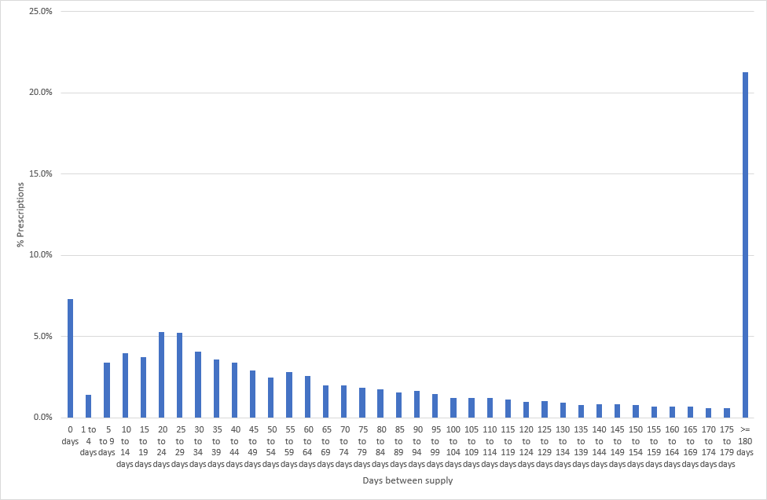

Source: DUSC Secretariat analysis

* 1. While the data in Figure 1 was comparable to that reported in the submission, further analysis of the data by quantity per prescription revealed that the distributions of days between supply varied between a repeat of 1 can per prescription to more than 2 cans per prescription (Figure 2).

Figure 2: Distribution of days between supply by quantity (i.e. cans) per prescription

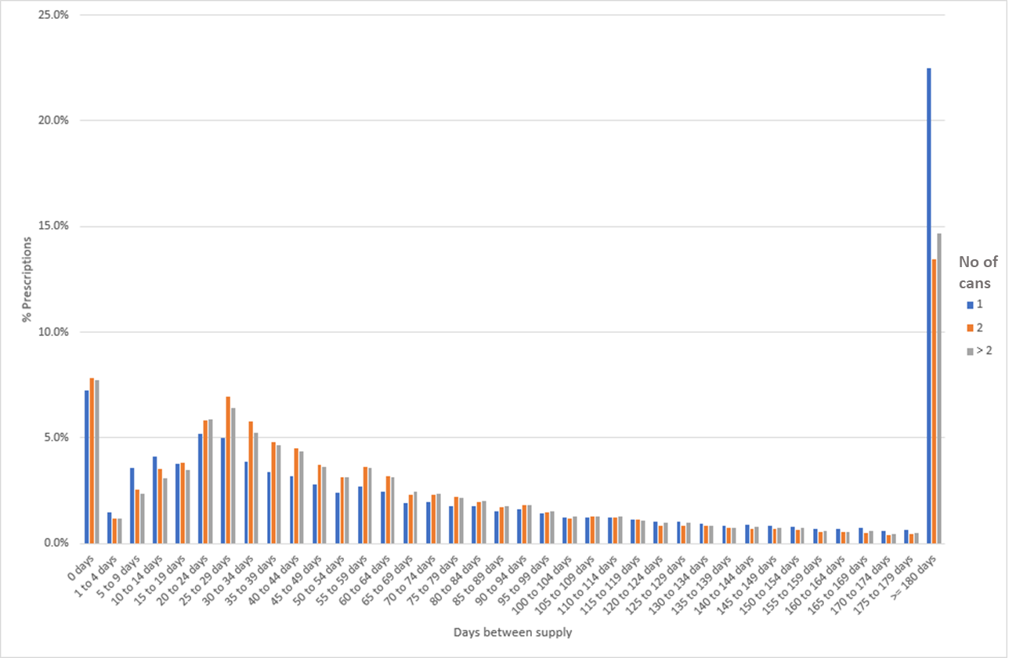

Source: DUSC Secretariat analysis

* 1. It was shown that prescriptions supplying 1 can were more likely to be re‑supplied between day 1 and 14 compared to prescriptions supplying greater than 1 can. While the submission referred to cumulative percentages of prescriptions, the DUSC Secretariat analyses in Figures 1 and 2 demonstrated that a median analysis of time between PBS supplies for CBF was not a reliable measure to determine days between supplies. On balance, the results of Figure 2 may support the contention that patients with prescriptions supplying 1 can may have been prescribed a quantity insufficient for 30 days of treatment.
  2. CBF was among the dermatological products in the “[Medicine List for Increased Dispensing Quantities](https://www.pbs.gov.au/industry/listing/elements/pbac-meetings/pbac-outcomes/2022-12/Increased-Dispensing-Quantities-List-of-Medicines.pdf)” recommended by the PBAC for the 60 day dispensing of PBS medicines policy at its December 2022 Intracycle meeting. The intent of the policy was to supply 2 months of treatment at once. The target population of this submission under the policy alone would still have an insufficient quantity of cans over a period of 60 days.
  3. Figure 3 shows that for over 98% of prescriptions with 0 or 1 repeat, the quantity supplied is 1 can. That is, prescribers who have not obtained an Authority to increase the maximum number of repeats had in 98% of cases only prescribed 1 can per prescription. Over 80% of prescribers that obtained an Authority to increase the maximum number of repeats also increased the MQ. This suggested that most patients who are prescribed 1 can per prescription are only using it for a short period or with closer monitoring (i.e. more frequent visits with their doctor) and may also suggest the reluctance of prescribers to seek Authority for greater quantities or repeats.

Figure 3: Distribution of quantity supplied per prescription by number of repeats ordered

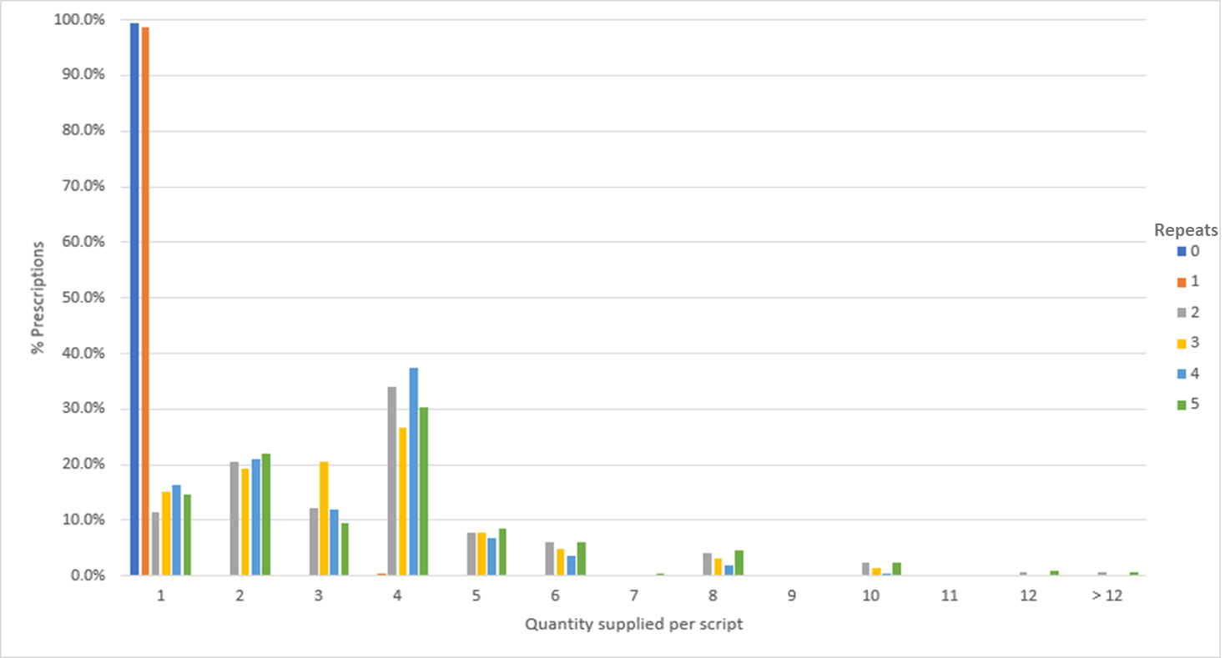

Source: DUSC Secretariat analysis

Estimated PBS usage and financial implications

* 1. The submission has used an ex-manufacturer price of $134.38 in its estimates which is double that of the approved ex-manufacturer price of a single can.
  2. The submission claimed that based on the dispensing frequency between 2017 to 2022, about 30% of patients paid additional costs in co-payments per month following the separate dispensing of 2 cans.
  3. The pharmacy remuneration including the dispensing fee and AHI fee amounts to a total of $24.28 should 2 cans be dispensed separately. The submission stated that with its proposed listing, there would be reduced financial implication to the patient through co-payments and reduced financial implication to the PBS (Table 2). This statement is inconsistent with the financial estimates shown below.
  4. The submission noted that there would be no change to wholesaler remuneration.
  5. Table 2 outlines the estimated financial implication of the proposed listing to patients and to the Government.

**Table 2: Comparison of financial impact for all stakeholders – status quo vs Streamlined listing with MQ 2**

|  |  |  |  |
| --- | --- | --- | --- |
|  | **Status quo – MQ 1 can, supplied twice per month on separate prescriptions/ dispensing** | **Proposed listing – MQ 2 cans, supplied once per month on a single Streamlined prescription** | **Difference from status quo to proposed listing** |
| Cost to patient – Concessional patient | $14.60 | $7.30 | $7.30 |
| Cost to patient – General patient | $60.00 | $30.00 | $30.00 |
| Wholesaler remuneration | $10.11 | $10.11 | $0.00 |
| Pharmacy remuneration | $24.28 | $14.36 | $9.92b |
| Cost to the PBS (net of Concessional co-payment) | $154.17a | $151.55 | $2.62 |
| Cost to the PBS (net of General co-payment) | $108.77 | $128.85 | -$20.08 |

Source: Table 2 provided in the submission main body.

Abbreviations: MQ – maximum quantity, PBS – Pharmaceutical Benefit Scheme

a $152.17 was quoted in main body of submission (last paragraph of page 6) and this is different from number in table.

b This value was -$9.92 in the submission and has been corrected to $9.92.

* 1. The submission included the estimated extent of use, proposed cost to the PBS/RPBS and the net financial implications to the PBS/RPBS over a 6-year period in its financial workbook.
  2. The cost model provided by the sponsor as a pre-PBAC response showed an estimated financial cost to the government of $0 to < $10 million over a period of 6 years with $0 to < $10 million in Year 1 and $0 to < $10 million in Year 6 (Table 3).

Table 3: Financial implication and utilisation of proposed listing

|  | **2023** | **2024** | **2025** | **2026** | **2027** | **2028** |
| --- | --- | --- | --- | --- | --- | --- |
| **Estimated extent of use (based on 13.52% of existing patients)** | | | | | | |
| Number of scripts dispensed | |　 1 | |　 1 | |　 1 | |　 1 | |　 1 | | 2 |
| **Estimated financial implications of [**the proposed medicine**]** | | | | | | |
| New PBS listing | |　 3 | |　 3 | |　 3 | |　 3 | |　 3 | | 3 |
| Changed PBS listing | |　 4 | |　 4 | |　 4 | |　 4 | |　 4 | | 4 |
| Net cost to PBS | |　 3 | |　 3 | |　 3 | |　 3 | |　 3 | | 3 |
| New RPBS listing | |　 3 | |　 3 | |　 3 | |　 3 | |　 3 | | 3 |
| Changed RPBS listing | |　 4 | |　 4 | |　 4 | |　 4 | |　 4 | | 4 |
| Net cost to RPBS | |　 4 | |　 4 | |　 4 | |　 4 | |　 4 | | 4 |
| **Net financial implications** | | | | | | |
| Net cost to PBS/RPBS | |　 3 | |　 3 | |　 3 | |　 3 | |　 3 | | 3 |

Source: manually filled in from financial estimates workbook provided by sponsor as Pre‑PBAC response.

Abbreviations: MBS = Medical Benefits Scheme; PBS = Pharmaceutical Benefits Scheme; RPBS = Repatriation Pharmaceutical Benefits Scheme.

*The redacted values correspond to the following ranges:*

*1 5,000 to < 10,000*

*2 10,000 to < 20,000*

*3 $0 to < $10 million*

*4 net cost saving*

* 1. As a Category 3 submission, the financial estimates have not been independently evaluated.

Quality Use of Medicines

* 1. The submission provided a dosing chart that it claimed was designed by the sponsor in collaboration with leading dermatologists in Australia. The submission claimed that the chart illustrates how to determine when an increased prescription is required by using the patient’s PSA. The submission stated that a BSA greater than 5% equates to 10 times the patient’s PSA. The submission had included a reference to this method of calculating BSA in its proposed restriction criteria for the requested listing. PSA (also known as hand surface area) is a method of measuring total BSA on the basis that 1 PSA equals 0.5% of total BSA. This method is mainly used in the emergency room for estimation of burned skin area in burn therapy and skin grafting and is not a standard way of calculating total BSA[3],[4],[5].

Figure 4: Calcipotriol with betamethasone dosing chart

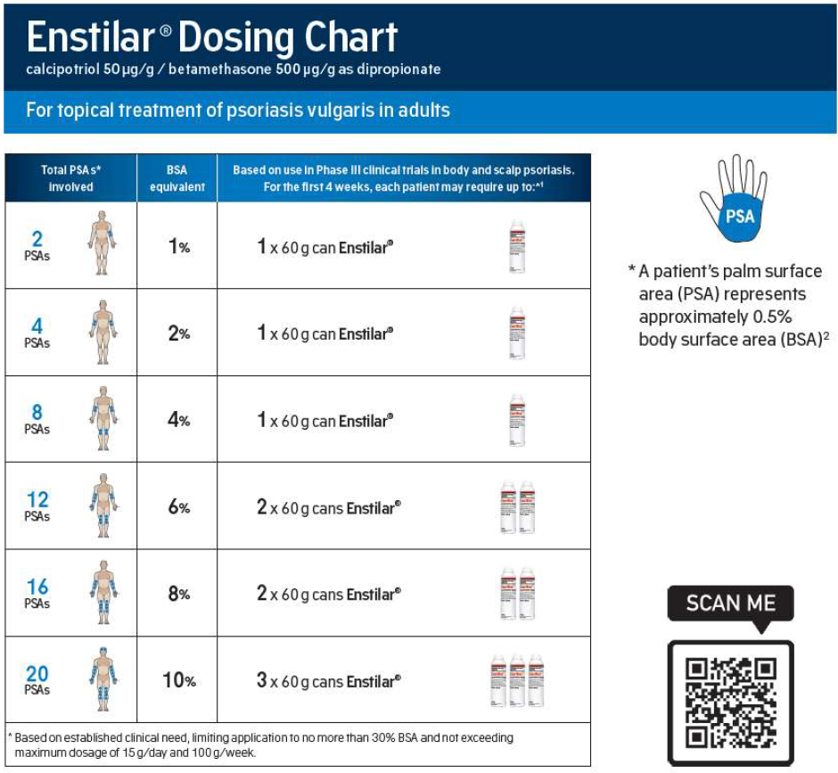Source: Figure 1 provided in the submission main body.

* 1. The submission suggested an educational campaign to promote awareness among prescribers on the use of the Authority system for the prescription of increased quantities if the proposed listing was not to be recommended. However, the submission expressed concerns around the effectiveness of such campaigns over a prolonged period of time.

1. PBAC Outcome
   1. The PBAC did not recommend amending the maximum quantity of the General Schedule Authority Required (STREAMLINED) PBS listing of CBF from 1 to 2 packs.
   2. The PBAC considered the PBS data does not support that there is a large proportion of patients requiring higher maximum quantities and that increased quantities can be sought by prescribers under the existing arrangements.
   3. The PBAC advised that increasing prescriber awareness of their ability to order increased quantities for patients who need them could be adequately achieved by the addition of an administrative note to the existing listing as a reminder of this existing option.
   4. The PBAC advised that this note should apply to calcipotriol 0.005% + betamethasone (as dipropionate) 0.05% ointment and other similar corticosteroid preparations on the PBS used for the treatment of chronic stable plaque type psoriasis vulgaris.
   5. The PBAC recalled its previous consideration at its March 2018 meeting and noted that no further evidence was provided regarding the risk of toxicity associated with increased access to larger quantities of calcipotriol.
   6. The PBAC requested that the DUSC reviews the utilisation of CBF when 24 months of data are available following the implementation of the administrative note.
   7. No resubmission pathway was nominated.

**Outcome:**

Not recommended

1. Recommended listing
   1. Add administrative note to calcipotriol with betamethasone existing listing as follows:

|  |  |  |  |  |  |  |
| --- | --- | --- | --- | --- | --- | --- |
| **MEDICINAL PRODUCT**  **medicinal product pack** | | **PBS item code** | **Max. qty packs** | **Max. qty units** | **№.of**  **Rpts** | **Available brands** |
| CALCIPOTRIOL + BETAMETHASONE DIPROPIONATE | | 11091R | 1 | 1 | 1 | Enstilar |
| calcipotriol 0.005% + betamethasone (as dipropionate) 0.05% foam, 60 g | |
|  | | | | | | |
| **Restriction Summary / ToC:** | | | | | | |
| **Concept ID** | **Category / Program:** GENERAL – General Schedule (Code GE) | | | | | |
| **Prescriber type:** Medical Practitioners Nurse practitioners | | | | | |
| **Restriction type:**  Restricted Benefit | | | | | |
|  | **Indication:** Chronic stable plaque type psoriasis vulgaris | | | | | |
|  | | | | | | |
|  | **Clinical criteria:** | | | | | |
|  | The condition must be inadequately controlled by potent topical corticosteroid monotherapy | | | | | |
|  | **AND** | | | | | |
|  | **Administrative Advice:**  Continuing Therapy Only:  For prescribing by nurse practitioners as continuing therapy only, where the treatment of, and prescribing of medicine for, a patient has been initiated by a medical practitioner. Further information can be found in the Explanatory Notes for Nurse Practitioners. | | | | | |
|  | **Administrative Advice:**  Authority applications for increased quantities/repeats (where relevant) may be made in real time using the Online PBS Authorities system (see www.servicesaustralia.gov.au/HPOS) or by telephone to Services Australia on 1800 700 270 (hours of operation 8 a.m. to 5 p.m. Monday to Friday). | | | | | |

Flow on changes:

* 1. Add administrative note to calcipotriol 0.005% + betamethasone (as dipropionate) 0.05% ointment, 30 g (9494Q).

***This restriction may be subject to further review. Should there be any changes made to the restriction the sponsor will be informed.***

1. Context for Decision

The PBAC helps decide whether and, if so, how medicines should be subsidised through the Pharmaceutical Benefits Scheme (PBS) in Australia. It considers applications regarding the listing of medicines on the PBS and provides advice about other matters relating to the operation of the PBS in this context. A PBAC decision in relation to PBS listings does not necessarily represent a final PBAC view about the merits of the medicine or the circumstances in which it should be made available through the PBS. The PBAC welcomes applications containing new information at any time.

1. Sponsor’s Comment

The sponsor had no comment.

1. Du Bois D, Du Bois EF. Clinical calorimetry tenth paper a formula to estimate the approximate surface area if height and weight be known Arch Intern Med (Chic). 1916;XVII(6_2):863-871. doi:10.1001/archinte.1916.00080130010002
2. Mosteller RD. Simplified calculation of body-surface area. N Engl J Med. 1987 Oct 22;317(17):1098. doi: 10.1056/NEJM198710223171717. PMID: 3657876.
3. Choi H, Park MS, Lee HM. Hand surface area as a percentage of body surface area in Asian children: a pilot study. Burns. 2011 Sep;37(6):1062-6. doi: 10.1016/j.burns.2011.03.010. Epub 2011 Apr 13. PMID: 21489696.
4. Schaefer TJ, Szymanski KD. Burn Evaluation and Management. [Updated 2022 Aug 23]. In: StatPearls [Internet]. Treasure Island (FL): StatPearls Publishing; 2023 Jan-. Available from: <https://www.ncbi.nlm.nih.gov/books/NBK430741/>
5. Enoch S, Roshan A, Shah M. Emergency and early management of burns and scalds. BMJ 2009;338:b1037 doi:10.1136/bmj.b1037