Gender ratio analysis for Ankylosing Spondylitis: addendum to the February 2016 analysis

Drug utilisation sub-committee (DUSC)

June 2016

Abstract

Purpose
To assess the ratio of male to female patients initiating on and prevalent to biological disease modifying anti-rheumatic drugs (bDMARDs) since the listing of these drugs on the PBS for the treatment of ankylosing spondylitis (AS).

Date of listing on the Pharmaceutical Benefits Scheme (PBS) for AS
- Infliximab: 1 August 2004
- Etanercept: 1 April 2005
- Adalimumab: 1 March 2007
- Golimumab: 1 August 2010
- Certolizumab pegol: 1 September 2014

Data Source / methodology
The Department of Human Services (DHS) Authority Approvals database was used for the analyses in this addendum.

Key Findings
- The male:female ratio for patients treated with PBS subsidised bDMARDs for AS is declining over time. In 2005, the ratio was approximately 3.5:1 for initiating and prevalent patients. The ratios for initiating and prevalent patients decreased to 1.2:1 and 2:1, respectively, by 2015.
- The declining gender ratio may in part be accounted for by increased or earlier diagnosis, and increased rates of treatment with bDMARDs for women with AS. Another factor may be use outside of the PBS restriction in arthropathies such as non-radiographic axial spondyloarthritis that are more common in women. This concern is most apparent in Western Australia where the number of females commencing on bDMARDs is far higher than in other states and female cases outweigh males.

Background
The DUSC considered a report on the use of bDMARDs for AS at its February 2016 meeting. At this meeting the DUSC considered ‘that the ratio of male:female bDMARD initiating and prevalent patients is inconsistent with known epidemiological data and has requested further analysis of the PBS data and published literature.’ Specifically the DUSC requested that ‘the Secretariat produce a time series of the male:female ratio for prevalent and initiating patients to see if the ratio has changed over time.’
For more details see the “Background” section of the Public Release Document of the bDMARDs for AS analysis considered at the February 2016 DUSC meeting.

Methods
PBS and RPBS prescription approvals for the bDMARD medicines were extracted from the Department of Human Services (DHS) PBS Authority Approval database for the period August 2004 (month of listing of the first bDMARD, infliximab) to December 2015 inclusive, based on the date that the prescription was approved.
The number of prevalent patients was determined by counting the number of person specific numbers (non-identifying) in the authority approval data for the specified time period. Authority approvals data was used rather than prescription supply data as the latter is incomplete with respect to patient level supply history for infliximab prior to July 2013. The analysis period for patient counts was ‘per calendar year’ because it was assumed that patients would receive at least one approval a year as no more than 24 weeks of treatment is approved at a time for AS.
Treatment rate (percentage of population) of patients initiating on and prevalent to bDMARDs (e.g. Figure 5) was calculated as the number of initiating or prevalent patients divided by the ABS population. When the treatment rate was calculated by gender (e.g. Figure 6) or by state or by both, the gender and state specified ABS populations was used as the denominator. All age groups where included.
The analyses by state were based on the Medicare enrolment postcode of the patient at the time of the authority approval.

Results

Analysis of drug utilisation
Figure 1 provides the number of initiating and prevalent patients receiving bDMARD treatment for ankylosing spondylitis per calendar year since listing on 1 August 2004. This is an update of Figure 2 in bDMARDs for AS analysis considered at February 2016 DUSC meeting to include 2015 data.
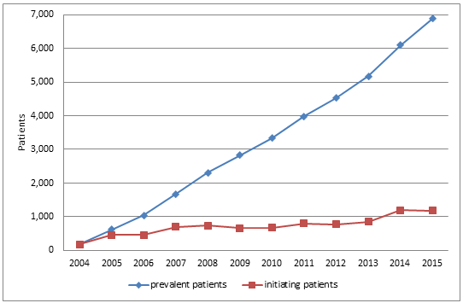
Figure 1: Patients initiating on and prevalent to bDMARD therapy by year of approval
Source: DHS Authority Approvals database, approvals from August 2004 (date of first bDMARD listing), extracted 5 April 2016.
The number of prevalent patients continues to increase. The step up in the number of initiating patients in 2014 seems to have plateaued in 2015.
Figure 2 shows the gender ratio (male:female) of initiating and prevalent patients.
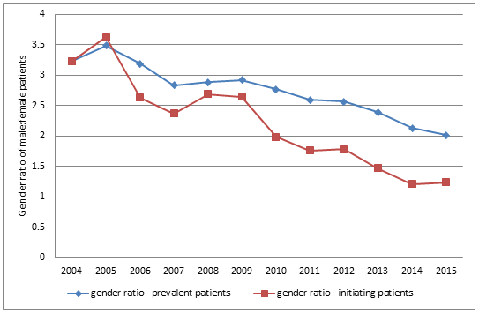
Figure 2: Gender ratio (male:female) for patients initiating on and prevalent to bDMARD therapy by year of approval
Source: DHS Authority Approvals database, approvals from August 2004 (date of first bDMARD listing), extracted 5 April 2016.
The gender ratio was 3.62 for initiating and 3.49 for prevalent patients in 2005 (the first full calendar year after the listing of bDMARDs for AS). The gender ratio for initiating and prevalent patients had decreased to 1.24 and 2.01 respectively by 2015.
The starting treatment prevalent patient male:female gender ratio (i.e. 3.49 in 2005) was close to that indicated in the available epidemiological data. That is, a male:female prevalence ratio of about 3:1,,,.
Figures 3 (initiating patients) and 4 (prevalent patients) show the number of patients by gender used to calculate the gender ratio.

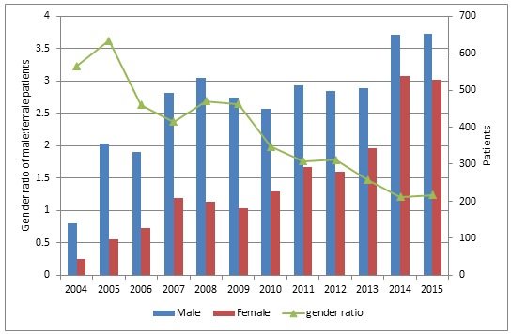
Figure 3: Gender ratio (male:female) and patient count by gender for patients initiating bDMARD therapy by year of approval
Between 2008 and 2013 the number of male initiating patients was fairly steady averaging 480 per year. Over the same time the number of female initiating patients grew from 198 in 2008 to 344 in 2013. This resulted in the gender ratio dropping from 2.69 to 1.47. In 2014 there was a large increase in both male and female initiators. As the percentage increase was greater for females, the gender ratio fell further to 1.21 in 2014. In 2015 the gender ratio was 1.24.

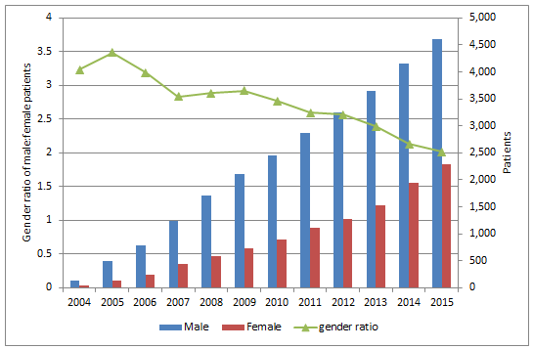
Figure 4: Gender ratio (male:female) and patient count by gender for patients prevalent to bDMARD therapy by year of approval
Figure 4 shows that the rate of growth in the number of prevalent patients in recent years is higher for females than males. The main driver of this is the increasing number of female initiators.
The onset of AS generally occurs between the ages of 15 and 45. Table 1 shows the median and mean patient age at initiation to bDMARD therapy.
Table 1: Median and mean patient age at initiation to bDMARD therapy
 | Median |  | Mean |  | Patients (N)
Year | Females | Males | Females | Males | Females | Males
2004 | 45 | 42 | 45 | 42 | 43 | 139
2005 | 43 | 41 | 44 | 42 | 98 | 355
2006 | 42 | 41 | 42 | 41 | 127 | 334
2007 | 43 | 42 | 43 | 43 | 208 | 493
2008 | 44 | 43 | 44 | 44 | 198 | 533
2009 | 41 | 42 | 43 | 44 | 181 | 479
2010 | 44 | 41 | 45 | 42 | 227 | 450
2011 | 44 | 41 | 45 | 42 | 292 | 514
2012 | 43 | 41 | 44 | 43 | 280 | 499
2013 | 45 | 41 | 45 | 43 | 344 | 506
2014 | 47 | 42 | 47 | 43 | 538 | 650
2015 | 44 | 42 | 45 | 43 | 527 | 653
There may be many years between symptom onset, diagnosis and treatment. Age at initiation of bDMARDs has remained reasonably consistent over time for males and females.
For comparison with the incidence and prevalence rates reported in the literature, patient counts in Figures 2, 3 and 4 have been converted to a bDMARD for AS treatment rate, expressed as a percentage of the ABS population in Figures 5 and 6.
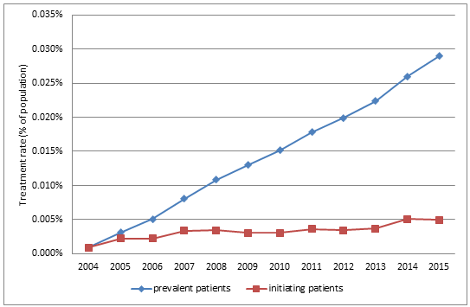
Figure 5: Treatment rate of patients initiating on and prevalent to bDMARD therapy by year of approval
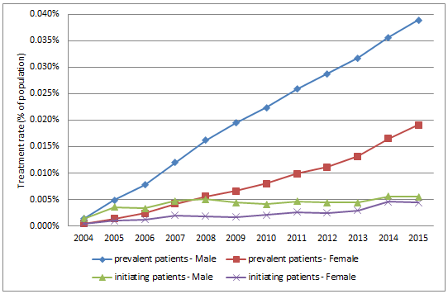
Figure 6: Treatment rate of patients initiating on and prevalent to bDMARD therapy by gender and year of approval
Figure 6 shows that the treatment initiation rate for males has remained relatively constant since 2007 and the rate for females has risen over this period to be almost the same as for males.

By state analysis
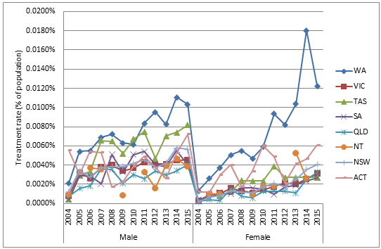
Figure 7: Treatment rate for patients initiating on bDMARD therapy by gender, patient state and year of approval
Figure 7 shows that there are marked differences in treatment rates across some jurisdictions. Initiation rates are highest in Western Australia for both males and females. Notably WA is the only state where the rate of bDMARD initiations for females is currently above the rate for males. This has been the case since 2013. Compared with other jurisdictions, the ACT also had a higher rate of prescribing in women. Tasmania had relatively high treatment rates for males.
Treatment initiation rates for males have been lowest in QLD. Treatment initiation rates for females were lowest in QLD up until 2013. However in 2014 and 2015, the rates in QLD rose strongly.
In most jurisdictions the treatment initiation rate for males has remained relatively constant since 2007 and the rate for females has risen over this period, creating a falling gender ratio over this period (see Figure 9). One reason for the national treatment initiation rate for females almost rising to the same level as the rate for males in 2014 and 2015 (see Figure 6) was the large increase in the WA rate for females.

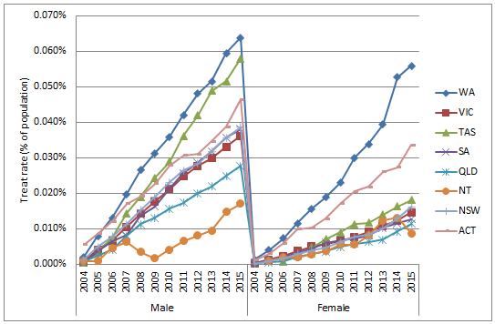
Figure 8: Treatment rate for patients prevalent to bDMARD therapy by gender, patient state and year of approval
Figure 8 shows a similar result to Figure 7 with WA and TAS having high treatment rates for males and WA and ACT having high rate for females compared to the other jurisdictions.
Treatment prevalence rates for males and females are lowest in QLD and NT.

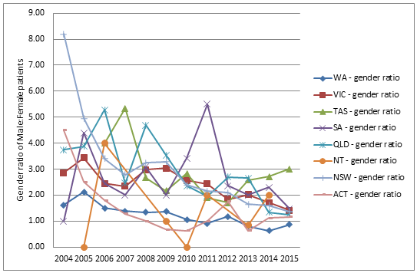
Figure 9: Gender ratio (male:female patients) for patients initiating on bDMARD therapy by patient state and year of approval.
Figure 9 shows that the gender ratio for initiating patients has been on a downward trend in all jurisdictions (with the possible exceptions of TAS, ACT and NT).

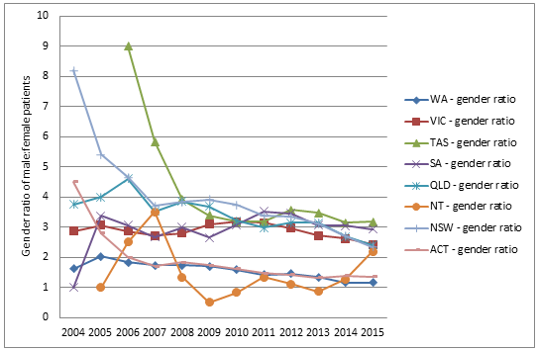
Figure 10: Gender ratio (male:female patients) for patients prevalent to bDMARD therapy by patient state and year of approval.
Figure 10 shows a downward trend in the gender ratio for prevalent patients in all jurisdictions except NT. WA and ACT have considerably lower gender ratios (ie. 1.17 and 1.36 respectively, in 2015) than the other large jurisdictions (ie. NSW, VIC and QLD were 2.35, 2.42 and 2.20 respectively, in 2015). The overall prevalent patient gender ratio in 2015 was 2.01 (see Figure 4).

Discussion and Secretariat comments
The key finding in this addendum is that the male:female ratio for patients treated with PBS subsidised bDMARDs for ankylosing spondylitis is declining over time. In 2005, the first full year that a bDMARD was available through the PBS for ankylosing spondylitis, the male:female ratio was approximately 3.5:1 for initiating and prevalent patients. The ratios for initiating and prevalent patients decreased to 1.2:1 and 2:1 respectively, by 2015.
A literature review was undertaken to assess trends in the epidemiology of AS. Published data on the incidence and prevalence of AS, including stratification by gender, are limited and variable. Further, longitudinal epidemiological data to assess changes in incidence and prevalence over time are scarce, and only one Australian study was identified. Factors contributing to variability in reported values may include differences in patient characteristics such as age, ethnicity and prevalence of HLA-B27; differences in criteria used to diagnose AS and to differentiate it from other spondylopathies; and differences in study design, size and quality.
In 2004, when the first bDMARD was listed on the PBS for AS, available epidemiological data generally indicated a male:female prevalence ratio of about 3:1^{1,2,3,4} and an incidence of 4:1. Prevalence data published since this time include a study of patients attending an outpatient clinic in Melbourne between June 2004 to December 2005 with newly diagnosed AS, according to the New York Criteria where the gender ratio was 2.6:1 and the German Spondyloarthritis Inception Cohort (GESPIC) where 64% of 236 patients with AS were male (1.78:1). More recent studies continue to show a prevalent patient male:female gender ratio of approximately 2-3:1, but with some variability. A study in outpatient clinics and rheumatology practices in Germany in 2010 found that 43 of 56 patients with AS were male, giving a ratio of about 3:1. Similarly, AS patients attending an outpatient clinic in Toronto between January 2003 and December 2012 were predominantly male (3.2:1). A study in a single rheumatology clinic in India found a higher ratio with men comprising 84.5% of AS patients from October 2000 to July 2014 (5.8:1), whereas at an outpatient clinic in Berlin between July 2004 and April 2007, 58% of referred patient with AS were male (1.4:1). In a larger study, the Swiss Clinical Quality Management Cohort conducted from January 2005 to May 2011, 74.1% of patients diagnosed with radiographic axial spondyloarthritis were male (2.86:1). A subsequent report from this same research group included patients recruited to June 2014 that shows a decrease in the gender ratio to 2.21:1. Prevalence estimates from the Swedish National Patient Registry found a comparatively lower male to female ratio of 1.7 in 2009. However, a limitation of this study is that it relies on clinical diagnoses by individual clinicians rather than using established criteria. A validation study indicated a positive-predictive value of 80% for fulfilling the modified New York Criteria.
Several systematic reviews of the published literature have reported gender ratios. A report on the global prevalence of AS identified male:female ratios ranging from 1.2 to 7.0:1 with a mean of 3.4:1. Another systematic review on the global prevalence of spondyloarthritis reported the prevalence of AS to be 0.31% in males and 0.12% in females (male:female ratio=2.58:1). One review presented incidence data from eight studies with values ranging from 0.44 in Iceland to 7.3/100,000 in US and Northern Norway. The male:female ratio ranged from 1.9:1 to 4.7:1.
A longitudinal epidemiological study undertaken with Canadian provincial health administrative data between 1995 and 2010, concluded that while men have a higher prevalence of AS than women, the male:female prevalence ratio decreased from 1.7 in 1995 to 1.21 by 2010, and that the incidence among women has increased since 2003. While this finding appears consistent with the findings from this addendum regarding declining male:female of patients treated with bDMARDs, a major limitation of this study is that diagnosis of AS was based on a diagnostic algorithm including billing codes, not the modified New York Criteria. The prevalence estimate does not distinguish AS characterised by radiographic changes in the sacroiliac joints from other inflammatory spondylopathies including non-radiographic axial spondyloarthritis (nr-AxSpA). Other studies have shown that the prevalence of nr-AxSpA is higher in women than men^{7,8,9} therefore the increased incidence rates in the Canadian administrative data cannot be attributed to increase in radiographic disease.
The declining gender ratio apparent in the PBS data may in part be accounted for by increased or earlier diagnosis, and increased rates of treatment with bDMARDs for women with AS. However, given that females constitute a majority of patients with non-radiographic axial spondyloarthritis^{7,8,9} it is possible that despite PBS criteria and authority approval requirements there is some use in nr-axSpA contributing to increasing use in females. This concern is most apparent in Western Australia because utilisation across both genders is high compared with reported prevalence and incidence rates, the absolute number of female patients initiating treatment is higher than in any other jurisdiction despite being a less populous state, and more females are initiating treatment than males. The latter is inconsistent with every available published epidemiological study that shows that radiographic changes are more common in males. Furthermore, the number of females initiating bDMARDs in WA is higher than the incidence of AS. The WA incident treatment rate for females in 2015 was 0.0122% which is higher than published studies on the incidence of AS which range from 0.44 to 7.3 per 100,000 population (ie. 0.00044% to 0.0073%).¹⁸ In comparing diagnosed prevalence from the literature, with treated prevalence from the PBS data, it should be noted that not all patients with AS meet the criteria for PBS subsidy and/or are suitable for treatment with a biologic agent.

DUSC consideration
DUSC noted that:
- Figure 2 showed the decrease in the male:female ratio was primarily due to the increase in the number of women being treated whilst the number of men treated was relatively stable.
- Figure 7 showed that the treatment rate in QLD has been low. DUSC commented that there are a relatively low number of rheumatologists in QLD (not reported in the analysis) and this may explain the low treatment rate.

The DUSC considered that:

- The changing male:female ratio is broadly consistent with the literature. However the changing gender ratios in the literature are generally the result of changing definitions and inclusion of non-radiographic axial spondyloarthritis. DUSC considered that these patients should not be represented in the epidemiological data for comparison with the PBS treatment rates as the authority application requires evidence of Stage II sacroiliitis/radiographic changes on X-ray.
- Increased and/or earlier diagnosis in women may have contributed to some extent in the reduction of the male:female treatment ratio.
- Higher use in WA is difficult to explain and could be related to a small number of prescribers.
- Differences in reporting of sacroiliac joint involvement on X-ray may occur. This has been demonstrated in randomised controlled trials of nr-SpA where re-reading of X-rays has altered results. This may have contributed to the differences in treatment rates between jurisdictions.

DUSC Actions
The DUSC requested that the:
- Australian Rheumatology Association (ARA) be asked to comment about these findings.
- Report be provided to the PBAC once comment has been received from the ARA.

Context for analysis
The DUSC is a Sub Committee of the Pharmaceutical Benefits Advisory Committee (PBAC). The DUSC assesses estimates on projected usage and financial cost of medicines.
The DUSC also analyses data on actual use of medicines, including the utilisation of PBS listed medicines, and provides advice to the PBAC on these matters. This may include outlining how the current utilisation of PBS medicines compares with the use as recommended by the PBAC.
The DUSC operates in accordance with the quality use of medicines objective of the National Medicines Policy and considers that the DUSC utilisation analyses will assist consumers and health professionals to better understand the costs, benefits and risks of medicines.
The utilisation analysis report was provided to the pharmaceutical sponsors of each drug and comments on the report were provided to DUSC prior to its consideration of the analysis.

Sponsors’ comments
AbbVie Pty Ltd: The sponsor has no comment.
Janssen-Cilag Pty Ltd: The sponsor has no comment.
Pfizer Pty Ltd: The sponsor has no comment.
UCB Australia Pty Ltd: The sponsor has no comment.

Disclaimer
The information provided in this report does not constitute medical advice and is not intended to take the place of professional medical advice or care. It is not intended to define what constitutes reasonable, appropriate or best care for any individual for any given health issue. The information should not be used as a substitute for the judgement and skill of a medical practitioner.
The Department of Health (DoH) has made all reasonable efforts to ensure that information provided in this report is accurate. The information provided in this report was up-to-date when it was considered by the Drug Utilisation Sub-committee of the Pharmaceutical Benefits Advisory Committee. The context for that information may have changed since publication.
To the extent provided by law, DoH makes no warranties or representations as to accuracy or completeness of information contained in this report.
To the fullest extent permitted by law, neither the DoH nor any DoH employee is liable for any liability, loss, claim, damage, expense, injury or personal injury (including death), whether direct or indirect (including consequential loss and loss of profits) and however incurred (including in tort), caused or contributed to by any person’s use or misuse of the information available from this report or contained on any third party website referred to in this report.

References

3101.0 - Australian Demographic Statistics, Sep 2015, http://www.abs.gov.au/AUSSTATS/abs@.nsf/DetailsPage/3101.0Sep%202015?OpenDocument
3101.0 - Australian Demographic Statistics, Sep 2015, http://www.abs.gov.au/AUSSTATS/abs@.nsf/DetailsPage/3101.0Sep%202015?OpenDocument
The authority application must be made in writing and must include: (a) a completed authority prescription form; and (b) a completed Ankylosing Spondylitis PBS Authority Application - Supporting Information Form which must include the following: (i) a copy of the radiological report confirming Grade II bilateral sacroiliitis or Grade III unilateral sacroiliitis
Arnett FC (1989) Spondyloarthropathies, in Textbook of Internal Medicine (Eds: Kelley WB, De Vita VT Jr, DuPont HL). Philadelphia, Pa: JB Lippincott; pp 986–990.
Bakland G, Nossent H, Gran J (2005) Incidence and prevalence of Ankylosing Spondylitis in Northern Norway. Arthritis and Rheumatism, 53(6); 850-855.
Braun J, Bollow M, Remlinger G, et al (1998) Prevalence of spondylarthropathies in HLA-B27 positive and negative blood donors. Arthritis Rheum, 1998; 41(1):58-67
Gran J, Husby G, Hordvik M (1985) Prevalence of ankylosing spondylitis in males and females in a young middle-aged population of Tromso, northern Norway, Annals of the Rheumatic Diseases, 1985, 44, 359-367
Carbone LD, Cooper C, Michet CJ, et al (1992) Ankylosing spondylitis in Rochester, Minnesota, 1935-1989: Is the epidemiology changing? Arthritis and Rheumatism. 1992; 35(12):1476–82.
Reed M, Dharmage S, Boers A, et al (2008) Ankylosing spondylitis: an Australian experience. Internal Medicine Journal, 38:321-327.
Rudwaleit M, Haibel H, Baraliakos X, et al (2009) The early disease stage in axial spondylarthritis: results from the German Spondyloarthritis Inception Cohort. Arthritis Rheum 2009;60:717–27.
Kiltz, U., Baraliakos, X., Karakostas, P. et al (2012) Do patients with non-radiographic axial spondylarthritis differ from patients with ankylosing spondylitis?. Arthritis Care Res, 64: 1415–1422. doi: 10.1002/acr.21688
Wallis D, Haroon N, Ayearst R, et al (2013) Ankylosing Spondylitis and nonradiographic axial spondyloarthritis: part of a common spectrum or distinct disease? J Rheumatol. 2013;40:2038–4. doi: 10.3899/jrheum.130588.
Malaviya AN, Kalyani A, Rawat R, et al (2015) Comparison of patients with ankylosing spondylitis (AS) and non-radiographic axial spondyloarthritis (nr-axSpA) from a single rheumatology clinic in New Delhi. Int J Rheum Dis. 2015. doi:10.​1111/​1756-185X.​12579
Poddubnyy D, Brandt H, Janis V, et al (2012) The frequency of non-radiographic axial spndyloarthritis in relation to symptom duration in patients referred because of chronic back pain: results from the Berlin early spondyloarthritis clinic. Ann Rheum Dis, 2012; 71:1998-2001.
Ciurea A, Scherer A, Exer P et al (2013) Tumor necrosis factor-α inhibition in radiographic and non-radiographic axial spondyloarthritis: results from a large observational cohort. Arthritis Rheum. 2013;65:3096–106
Ciurea A, Scherer A, Weber U et al (2014) Age at symptom onset in ankylosing spondylitis: is there a gender difference? Ann Rheum Dis annrheumdis-2014-205613Published Online First: 7 August 2014
Exarchou S, Lindström U, Askling J, et al (2015) The prevalence of clinically diagnosed ankylosing spondylitis and its clinical manifestations: a nationwide register study. Arthritis research and therapy, 17:118-126
Lindström U, Exarchou S, Sigurdardottir V, et al (2015) Validity of ankylosing spondylitis and undifferentiated spondyloarthritis diagnoses in the Swedish National Patient Register.Scand J Rheumatol. 2015;23:1-8.
Dean LE, Jones GT, MacDonald AG, et al (2014) Global prevalence of ankylosing spondylitis. Rheumatology (Oxford). 2014 Apr;53(4):650-7.
Stolwijk C, van Onna M, Boonen A, et al (2015) The global prevalence of spondyloarthritis: a systematic review and meta-regression analysis, 2015, Arthritis Care & Research.
Stolwijk C, Boonen A, Tubergen A, et al (2012) Epidemiology of Spondyloarthritis. Rheumatic diseases clinics of North America 38.3 (2012): 441–476. PMC. Web. 5 May 2016.
Haroon N, Paterson J, Li P, et al (2014) Increasing proportion of female patients with ankylosing spondylitis: a population-based study of trends in the incidence and prevalence of AS. BMJ Open;

