Everolimus: 24 month review of treatment for metastatic (Stage IV) breast cancer

Drug utilisation sub-committee (DUSC)
February 2017

Abstract

Purpose
The PBAC requested a 24 month predicted versus actual review of the utilisation of everolimus for metastatic breast cancer. Everolimus was first listed for this indication on 1 June 2014.
Everolimus is PBS subsidised for stage (IV) metastatic breast cancer after resistance to anastrozole or letrozole.

Data Source / methodology
The analyses use data from the Department of Human Services (DHS) prescriptions database and the DHS Authority approvals database from August 2003 to September 2016.

Key Findings
- There were 1,813 patients identified as having been treated with everolimus for metastatic breast cancer over its first two years of listing. This was less than predicted.
- The duration of therapy with everolimus plus exemestane was shorter than predicted. There was a median of four prescriptions per year compared with an estimated seven prescriptions per year.
- The proportional use of the higher (10 mg) strength of everolimus was greater than predicted.

Purpose of analysis
The PBAC requested a 24 month predicted versus actual review of the utilisation of everolimus for metastatic (Stage IV) breast cancer.
Everolimus was first listed for this indication on 1 June 2014 and is subsidised for treatment after resistance to anastrozole or letrozole.

Background

Clinical situation
Advanced, or metastatic, breast cancer is cancer that has spread from the breast to another part of the body, or cancer which has occurred in another location within the same or the other breast. Treatment decisions for metastatic breast cancer depend on genes and proteins in breast cells which influence how a breast cancer may response to a specific treatment.
The human epidermal growth factor receptor 2 gene (commonly referred to as HER2) has an important role in the development of breast cancer. Breast cancers with high levels of HER2 are more likely to spread and less likely to respond to treatment. Breast cells with abnormally high levels of the HER2 gene are called HER2-positive, those with lower levels are called HER2-negative. Most patients with metastatic breast cancer have HER2-negative breast cancer.

Hormone receptors within breast cells are also involved in the development of breast cancer. Cancers with detectable hormone receptors, called hormone receptor-positive, use the hormones oestrogen and progesterone to grow and spread. Oestrogen binds and activates the oestrogen receptor which promotes the growth of cancerous breast cells and activates genes responsible for inhibition of cell death and promotion of cell division. The oestrogen-dependent processes involved in the development and progression of breast cancer can be interrupted in several ways. For postmenopausal women, the amount of oestrogen can be reduced using aromatase inhibitor drugs. While ovaries stop producing oestrogen post menopause, other body tissues can produce oestrogen by an action of the aromatase enzyme to convert androgen, a weak male hormone, into oestrogen. Aromatase inhibitors act to block the aromatase enzyme to reduce the production of oestrogen.
For first-line therapy of postmenopausal women with hormone receptor–positive metastatic breast cancer, treatment guidelines recommend the use of endocrine therapy with aromatase inhibitors, including letrozole, anastrozole and exemestane (ASCO Guidelines 2016; Tomas and Barrios 2015). Chemotherapy may also be appropriate as initial therapy for patients with immediate life-threatening disease or in patients with low levels of oestrogen receptor where endocrine therapy may be less effective (ASCO Guidelines 2016). Patients on hormonal therapy with aromatase inhibitors may relapse if they develop distant metastasis, making endocrine therapy less effective (de novo resistance), or if resistance develops to the endocrine therapy (acquired resistance), (Beaver and Park, 2012). Exemestane and everolimus may be offered as targeted therapy to postmenopausal women with hormone receptor–positive metastatic breast cancer who experience disease progression during prior treatment with nonsteroidal aromatase inhibitors with or without one line of prior chemotherapy.

Pharmacology
Everolimus is an oestrogen inhibitor through its action on the mammalian target of rapamycin (mTOR) which has a key role in the proliferation, growth and survival of cancer cells. By activating the mTOR pathway, everolimus contributes to endocrine resistance in breast cancer by inhibiting the downstream signalling events of the mTOR pathway.

Therapeutic Goods Administration (TGA) approved indications
Everolimus is approved for the treatment of postmenopausal women with hormone receptor-positive, HER2 negative advanced breast cancer in combination with exemestane after failure of treatment with letrozole or anastrozole.
Everolimus is also registered for several other indications including for the treatment of:
- prophylaxis of organ rejection in adult patients at mild to moderate immunological risk receiving an allogeneic renal or cardiac transplant and in adult patients receiving an allogeneic hepatic transplant
- progressive, unresectable or metastatic, well or moderately differentiated, neuroendocrine tumours (NETs) of pancreatic origin
- advanced renal cell carcinoma after failure of treatment with sorafenib or sunitinib
- subependymal giant cell astrocytoma (SEGA) associated with tuberous sclerosis complex (TSC), who require therapeutic intervention but are not candidates for curative surgical resection
- tuberous sclerosis complex (TSC) who have renal angiomyolipoma not requiring immediate surgery.

Dosage and administration
Everolimus for metastatic breast cancer is taken in combination with exemestane. The recommended dosages and administration of each product are summarised in Table 1.
Table 1: Dosage and administration of everolimus and exemestane
Brand name and sponsor | PBS listed Products | Recommended dose and frequency of administration
Afinitor®, Novartis Pharmaceuticals Australia Pty Limited | Everolimus 5 mg and 10 mg tablets | 10 mg to be taken once daily.
Multiple brands and sponsors | Exemestane 25 mg tablet | One 25 mg tablet taken once daily.
Source: Production Information.
Further information on dose adjustments and monitoring requirements for everolimus and exemestane is provided in Appendix 1.

PBS listing details (as at 1 November 2016)
Table 2: PBS listing of everolimus for metastatic (Stage IV) breast cancer
Item | Name, form & strength, pack size | Max. quant. | Rpts | DPMQ | Brand name and manufacturer
2819J | Everolimus, Tablet 5 mg, 30 tablets | 30 | 5 | $2712.88 | Afinitor®, Novartis Pharmaceuticals Australia Pty Limited
2985D | Everolimus, Tablet 10 mg, 30 tablets | 30 | 5 | $5277.88 | Afinitor®, Novartis Pharmaceuticals Australia Pty Limited
Source: the PBS website. Special pricing arrangements apply for these listings.

Restriction – Authority Required
Metastatic (Stage IV) breast cancer

Clinical criteria:
The condition must be hormone receptor positive,
AND
The condition must be human epidermal growth factor receptor 2 (HER2) negative,
AND
The condition must have acquired endocrine resistance as demonstrated by initial response and then recurrence or progression of disease after treatment with letrozole or anastrozole,
AND
The treatment must be in combination with exemestane.

Population criteria:
Patient must not be pre-menopausal.

Note
Patients who have progressive disease with everolimus are no longer eligible for PBS-subsidised everolimus.

For details of the current PBS listing refer to the PBS website.

Changes to listing
The first listing of everolimus on 1 June 2014 included the population criteria that a patient must be female and post-menopausal.
Following a PBAC recommendation in November 2014, the listing was changed from 1 March 2015 to remove the criterion that a patient must be female to allow access for males with breast cancer. The criterion that a patient must be post-menopausal was also amended to “…patient must not be pre-menopausal…”.
Current PBS listing details are available from the PBS website.

Relevant aspects of consideration by the Pharmaceutical Benefits Advisory Committee (PBAC)
The first submission for everolimus for metastatic breast cancer was rejected at the March 2013 PBAC meeting. The sponsor requested an Authority required listing for treatment, in combination with an aromatase inhibitor, of post-menopausal women with hormone-receptor positive, HER2 negative advanced breast cancer after failure of treatment with letrozole or anastrozole. The PBAC did not consider that everolimus would be used in combination with any aromastase inhibitor. Based on the clinical evidence presented in the submission, PBAC considered that exemestane was the appropriate comparator. The overall survival data from the trial was immature leading to uncertainty with the modelled survival benefits and utility gain.
The July 2013 minor re-submission requested the same listing as the March 2013 submission but specifying everolimus in combination with exemestane. The PBAC considered that the use of everolimus beyond disease progression should be precluded in the restriction. The PBAC further considered that the restriction should preclude the use of everolimus in aromatase inhibitor naïve, oestrogen receptor positive breast cancer patients. The PBAC noted the role of everolimus in restoring the sensitivity of estrogen receptor positive cancers to endocrine therapy. As such, a combination of everolimus and exemestane was considered to be only clinically appropriate in patients with a prior response to a non-steroidal aromatase inhibitor, such as letrozole or anastrozole. The submission was deferred to allow the Department of Health to negotiate a price with the sponsor recognising the value of everolimus but also considering the lack of overall survival data. The submission was recommended out-of-session following an acceptable price offer from the sponsor.
At its November 2014 meeting the PBAC considered correspondence from the Medical Oncology Group of Australia (MOGA) which sought to have the drugs anastrozole, everolimus, exemestane, goserelin and letrozole made available to males with breast cancer on equity grounds. The PBAC noted that there were only a small number of men with breast cancer. The PBAC recommended amending the restrictions for everolimus and exemestane, as well as anastrozole, letrozole and goserelin to allow access for male patients with breast cancer. The population criteria for everolimus and exemestane was amended to remove the requirement that the patient must be female and post-menopausal which was replaced with “…patient must not be pre-menopausal…”.
For further details refer to the March 2013 Public Summary Document, July 2013 Public Summary Document and November 2014 Public Summary Document.

Approach taken to estimate utilisation
The modelling steps used to derive the utilisation and cost of everolimus to the PBS and RPBS are presented in Appendix 2.
An epidemiological approach was used to estimate the number of incident patients who would be eligible for treatment with everolimus with exemestane. The estimates for the incident eligible population were not used in the financial forecasting but indicate the pool of potential treated patients.
The number of treated patients was forecasted based on patients participating in the sponsor’s compassionate use program which was established in December 2012. Under this program, everolimus was supplied to patients whose eligibility aligned with the BOLERO-2 study inclusion criteria and TGA approved indication (Minor Submission November 2013 p8). At the time of listing, XX patients were participating in the program per month. This was extrapolated to an annual estimate of XXX patients at baseline, (Appendix 2, model step B.2). It was assumed that only female patients would be treated.
The projected number of prescriptions was derived separately for the 10 mg and 5 mg strengths of everolimus. Derived proportions for each strength were obtained to result in the weighted average dose observed in the BOLERO-2 trial of XXXXX mg (i.e. XXXXXX of patients would require the 10 mg strength with the remainder taking the 5 mg strength to give XXXXXXXXXXXXXXXXXXXXXXXXX, (Appendix 2, model step C.1)). The 10mg: 5mg split was applied to the forecast of treated patients. The average annual number of prescriptions per patient was estimated to be seven based on the progression-free survival time of 6.9 months for everolimus with exemestane observed in the BOLERO-2 trial. The average of seven scripts was then applied to the 10 mg and 5 mg treated patient groups to forecast the number of prescriptions for each strength (Appendix 2, model steps C.6 and C.9).
The total projected costs were calculated by multiplying the forecasted number of prescriptions for the 10 mg and 5 mg strengths by the dispensed price for maximum quantity for each strength (Appendix 2, model step D.3). The cost of exemestane was not included as it was assumed that the listing of everolimus would not change the usage of existing endocrine therapy in the market. The estimated net cost to Government factored in the differing patient co-payments under the PBS and RPBS. Existing listings for anastrozole (Item 8179L), letrozole (Item 8245Y) and exemestane (Item 8506Q) were used as a proxy to estimate the patient contributions. Prescriptions for these items were analysed over the period January 2012 to December 2013 to obtain proportions of use by PBS and RPBS clients and by concessional status and safety net status (Appendix 2, model step D.4).
The financial estimates included the costs to the Commonwealth to manage the potential side effect of grade 3-4 hyperglycaemia associated with everolimus plus exemestane therapy. It was assumed that this would occur in 5% of patients based on observations from the BOLERO-2 trial. It was assumed that affected patients would be treated with insulin glargine (Item 9039R). The estimate for the additional cost to treat adverse events was relatively small, around $30,000 per year.

Methods
Data sources
The analyses use data from the Department of Human Services (DHS) Authority approvals database and the DHS prescriptions database. Authorities data was extracted from 1 June 2014 (i.e. the date of first listing) to September 2016. Prescriptions data for anastrozole, letrozole and exemestane was extracted from August 2003 (the first listing date of included aromatase inhibitor therapy) to September 2016.

Extraction of data for the use of everolimus to treat breast cancer
Everolimus’ listings for metastatic (Stage IV) breast cancer and tuberous sclerosis complex share the same PBS item codes (2819J and 2985D). These are general schedule listings with no identifier in the claims data to directly identify use for a specific indication. To separate use for breast cancer only, patients receiving an Authority for this indication were matched to claims records for PBS items 2819J and 2985D. Prescriptions were matched to an approval if the de-identified patient identification number (PIN) and item codes matched for both the approval and supplied prescription. The date of authority approval had to be before the supply date for it to be assigned as the corresponding approval. An approval was matched to a supply in 99.3% of cases.
Patient level analyses
The matched dataset described above was used to derive patient counts for the first two listing years (June 2014 to May 2015 and June 2015 to May 2016) and by listing month.
The number of prevalent patients was determined by counting the number of people supplied at least one PBS or RPBS prescription using person specific numbers (non-identifying) in the data for the specified time periods.
Patient initiation to everolimus was defined as the date of supply of the first PBS or RPBS prescription.
The impact of changing the restriction from 1 March 2015 to allow use in males was examined through an analysis of gender. The age at initiation was also analysed.
Grandfathered patients were not able to be directly identified within the Authorities or prescriptions data. As such, analyses of time on therapy and sequences of therapy received, described below, were undertaken in a cohort of patients initiating in 2015 (i.e. at least six months after the first listing date) to mitigate the impact of grandfathered patients on these analyses.

Derivation of drug sequences
A cohort of patients first initiating on either 5 mg or 10 mg everolimus in 2015 was selected. The patient identifiers for this initiating cohort were matched to any prior supply of anastrozole, letrozole or exemestane. The look back period was to August 2003, the first listing date of an aromatase inhibitor drug, anastrozole. To examine the potential use of everolimus as monotherapy, future supply was followed up to 30 September 2016.
The median days between re-supply of everolimus was 29 days. However, around 5% of patients received a re-supply of everolimus between 55 to 65 days. It was assumed that everolimus was co-administered with exemestane if the single drugs were supplied within 60 days of each other. A sensitivity analyses was undertaken to identify co-administration within the median re-supply period for everolimus (29 days), this did not have any substantive effects on the proportion of patients identified as having co-administered therapy or the drug sequence results.
The analysis included everolimus used in combination with either of exemestane’s listings (i.e. the specific listing of exemestane used in combination with everolimus for metastatic breast cancer (Item 10103R) or the broader listing for hormone receptor positive breast cancer (item 8506Q)).

Results

Analysis of drug utilisation

Patient level analyses
The mean age at initiation was 64 years during the initial two years of listing.
A small number of additional male patients accessed everolimus after its restriction was changed from 1 March 2015 to allow use in males (Table 3).

Table 3: Patient demographics
 | Year 1  (June 2014 – May 2015) | Year 2  (June 2015 – May 2016)
Age at initiation (years) -  mean (min, max) | 64 (29,91) | 64 (31,92)
Gender - Female (%): Male (%) | F 99.8%: M 0.2% | F 99.0%: M 1.0%

After the initial transitioning of patients from the sponsor’s compassionate use program, the number of new patients being treated with everolimus had stabilised within its first two years of listing (Figure 1). As at September 2016, the overall number of treated patients was continuing to slowly decline, reflecting the reduction in the number of initiating patients over time compared with the number of initiating patients in 2014 (Figure 1, Figure 2).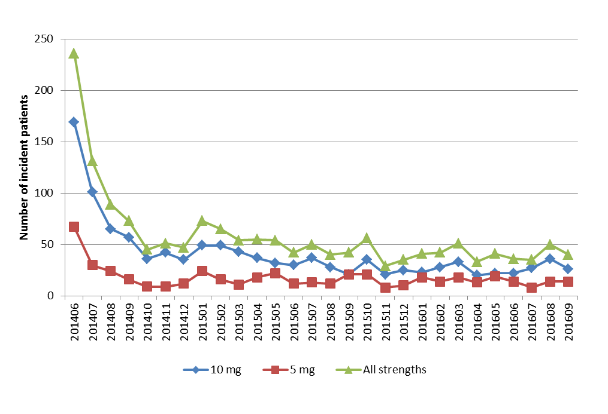Figure 1: Number of incident patients by listing month and drug strength at initiation.
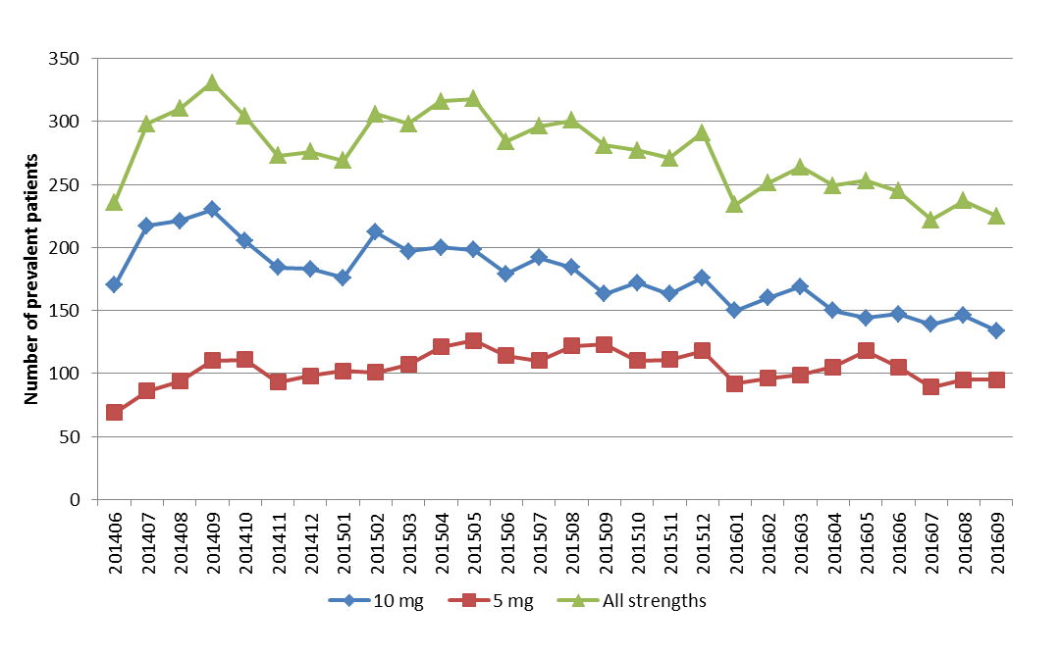Figure 2: Number of prevalent patients by listing month and drug strength.
People over 70 years of age were more commonly initiated on the 5 mg strength of everolimus compared to younger age cohorts (Figure 3).

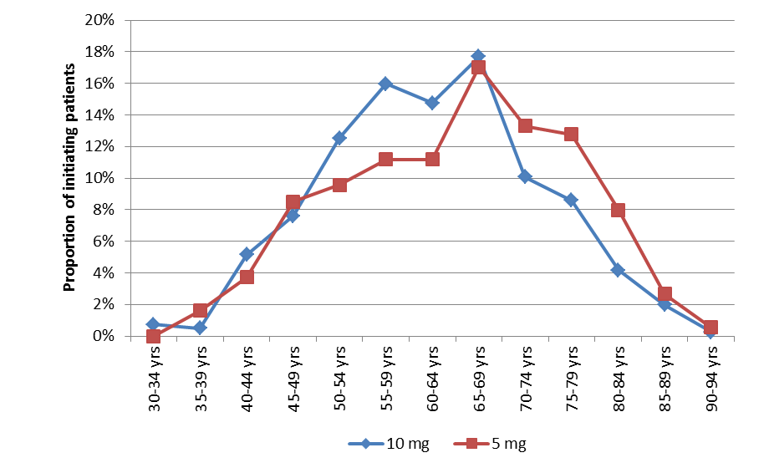
Figure 3: Comparison of the initiating dose by age, 2015.
Use of everolimus in combination with exemestane, and prior use of aromatase inhibitor therapy, was examined in 595 patients who initiated on everolimus in 2015. It was assumed that everolimus could be used in combination with either of exemestane’s listings, including Item 10103R specifically for use in metastatic breast cancer and Item 8506Q for nurse practitioner prescribing for breast cancer. Co-administration of everolimus and exemestane was identified if either of these drugs was supplied within 60 days of each other (refer to the ‘Methods’ section for further details).
The majority (94%) of patients were found to be using everolimus consistent with the restriction criteria with evidence of the prior use of letrozole or anastrozole (Table 4). Use as combination therapy without prior letrozole or anastrozole was negligible (Table 4). Only a small number of cases were identified of everolimus potentially being used as monotherapy (Table 4).
Table 4: Use of everolimus and aromatase inhibitor therapy
 | n | Proportion (%)
Number of initiators on everolimus in 2015 | 595
Use as per restriction (i.e. prior letrozole or anastrozole) | 560 | 94.1%
Combination therapy only, no prior letrozole or anastrozole | 10 | 1.7%
Everolimus monotherapy after letrozole or anastrozole | 24 | 4.0%
Everolimus monotherapy | 1 | 0.2%
Note: For everolimus in combination with either of exemestane’s listings (Item 10103R or Item 8506Q).

Analysis of actual versus predicted utilisation
A comparison of the predicted utilisation of everolimus 5 mg and 10 mg versus actual use is shown in Table 5.
Table 5: Comparison of the actual versus predicted utilisation of everolimus for the treatment of metastatic (Stage IV) breast cancer
Parameter | Comparison | Year 1  (June 2014 –  May 2015) | Year 2  (June 2015 –  May 2016)
Treated patients | Predicted | XXXXX | XXXXX
 | Actual | 973 | 840
 | % of Predicted | XXX | XXX
10 mg scripts | Predicted | XXXXX | XXXXX
 | Actual | 2,732 | 2,268
 | % of Predicted | XXX | XXX
5 mg scripts | Predicted | XXXXX | XXXXX
 | Actual | 1,414 | 1,505
 | % of Predicted | XXX | XXX
Proportional use of 10 mg | Predicted | XXXXX | XXXXX
 | Actual | 65.89% | 60.11%
 | Difference (%) | XXXXXX | XXXXXX
Average daily dose (mg) | Predicted | XXXXX | XXXXX
 | Actual | 8.776 | 8.355
 | % of Predicted | XXXX | XXXX
Overall expenditure for the | Predicted | XXXXXXXX | XXXXXXXX
10 mg strength¹ | Actual | $15,335,885 | $12,553,559
 | % of Predicted | XXX | XXX
Overall expenditure for the | Predicted | XXXXXXXX | XXXXXXXX
5 mg strength¹ | Actual | $4,189,489 | $4,412,123
 | % of Predicted | XXX | XXX
Note: The predicted figures were sourced from the financial estimates model agreed with the sponsor.
¹ Expenditure figures are based on the published prices. A Special Pricing Arrangement applies for everolimus and the actual cost to the Commonwealth is less than presented here.

The actual number of prescriptions for each strength was less than predicted due to an overestimation of the average number of scripts per patient. Based on a median progression-free survival of 6.9 months for everolimus with exemestane therapy from the BOLERO-2 trial (Baselga et al., 2012), it was predicted that patients would receive 7 months of treatment on average. The actual annual number of prescriptions was examined in patients who first initiated on everolimus in a six month period between February to July 2015 (which allowed a follow up period of 12 months to the most recent month of supply at the time of the analysis). The number of prescriptions of everolimus supplied to the initiating cohort was counted over 12 months from their date of initiation. For both the 5 mg and 10 mg strengths, there was a median of four scripts per annum, considerably less than predicted.

Discussion
The projected utilisation of everolimus for metastatic breast cancer was based on the number of participants in the Sponsor’s compassionate use program (Appendix 2). As predicted, a relatively large number of patients transitioned from the compassionate use program to access subsidised everolimus during the initial months of listing (Table 5, Figure 1). The estimated number of treated patients for Year 1 of listing was similar to the actual (within XXX Table 5). However, the predicted number of treated patients in Year 2 was substantially overestimated (Table 5). Since August 2015 there was a gradual decline in the number of treated patients (Figure 2) as the number of incident patients had stabilised to lower levels over the second year of listing compared to the initial months of listing (Figure 1).
Based on the progression-free survival time of 6.9 months from the BOLERO-2 trial (Tomas and Barrios, 2015) it was assumed that patients would receive an average of 7 prescriptions per year, which appeared to be an overestimate. An analysis of initiators on everolimus in 2015 found that the median annual number of scripts was 4 for the supply of any strength (i.e. either 5 mg or 10 mg). The proportional use of the 10 mg strength, and consequently the average daily dose, were higher than anticipated (Table 5). The predicted number of prescriptions by drug strength may have been over- or under- estimated by applying the assumptions for the proportional use by drug strength to the forecasted number of patients and then applying the assumption of 7 prescriptions per patient per year. The usual approach in estimating the number of prescriptions by drug strength is to apply the assumptions of proportional use to the estimated number of overall prescriptions.
To qualify for everolimus, patients must meet the criterion of having received prior treatment with either anastrozole or letrozole. Based on patients identified as having initiated on everolimus with exemestane in 2015, the majority (94%) complied with this requirement (Table 4). There were only a small number of cases where everolimus was potentially being used as monotherapy or in combination with exemestane without prior anastrozole or letrozole (Table 4). The use of everolimus as monotherapy is not recommended in current guidelines (e.g. ASCO 2016), however the efficacy of such use in second-line is being investigated in the BOLERO-6 trial (Anderson and Cuellar, 2016).
The recommended starting dose of everolimus for advanced breast cancer is 10 mg regardless of age or renal function (Appendix 1). The BOLERO-2 trial (Hortobagyi, 2015) found that no dosage adjustment of initial dosing was required in otherwise healthy elderly patients. However, people aged over 70 years were more commonly initiated on the 5 mg strength compared to younger age cohorts (Figure 3). This may have been due to reasons other than age, such as a need to reduce the dose to prevent drug interactions with CYP3A4/PgP inhibitors (e.g. antidepressants, antibiotics, antifungals and calcium channel blockers).
Expanding the restriction to allow use in males from 1 March 2015 had a minimal impact on the overall utilisation of everolimus. Over the first two years of listing, around 1% of patients accessing everolimus were male (Table 3).

DUSC consideration
The recommended starting dose of everolimus for advanced breast cancer is 10 mg regardless of age or renal function. However, DUSC noted people aged over 70 years were more commonly initiated on the 5 mg strength compared to younger age cohorts. DUSC further noted that in the overall prevalent population there was a greater use of the 5 mg strength compared with the 10 mg strength over time (Figure 2 of the review). DUSC considered that the 10 mg strength was too toxic for some patients.
The projected number of prescriptions was derived separately for the 10 mg and 5 mg strengths of everolimus. Derived proportions for each strength were obtained to result in the weighted average dose observed in the BOLERO-2 trial of XXXXX mg (i.e. XXXXX of patients would require the 10 mg strength with the remainder taking the 5 mg strength to give XXXXXXXXXXXXXXXXXXXXXXXXX). DUSC noted that the average daily dose of XXXXX mg was calculated in the March 2013 submission as follows:
Average daily dose = recommended dose (10 mg) x dose intensity (XXXXX) x dose duration of everolimus treatment [mean everolimus duration (XXXXX weeks) / mean exemestane duration (XXXXX weeks)] = XXXXX mg.
The number of treated patients was forecasted based on patients participating in the sponsor’s compassionate use program which was established in December 2012. The average annual number of prescriptions per patient was estimated to be seven based on the progression-free survival time of 6.9 months for everolimus with exemestane observed in the BOLERO-2 trial. For both the 5 mg and 10 mg strengths, there was a median of four scripts per annum, considerably less than predicted. DUSC commented that the duration of use in the sponsor’s compassionate program was unknown and considered that this would have been informative about expected use. DUSC considered that the time on therapy was overestimated by not factoring in treatment breaks into the financial estimates.
The predicted number of prescriptions by drug strength may have been over- or under- estimated by applying the assumptions for the proportional use by drug strength to the forecasted number of patients and then applying the assumption of 7 prescriptions per patient per year. DUSC agreed that it was more conventional to apply the assumptions for proportional use to the estimated number of prescriptions compared with the submission’s approach.
The majority (94%) of patients were found to be using everolimus consistent with the restriction criteria with evidence of the prior use of letrozole or anastrozole. DUSC commented that letrozole and anastrozole were considered to be good treatment options and as such would be expected to be used prior to everolimus.
DUSC noted that Table 5 demonstrated that the expenditure on everolimus for breast cancer based on its published prices had been less than predicted over the first two years of its listing.

DUSC actions
The report was provided to the PBAC.

Context for analysis
The DUSC is a Sub Committee of the Pharmaceutical Benefits Advisory Committee (PBAC). The DUSC assesses estimates on projected usage and financial cost of medicines.
The DUSC also analyses data on actual use of medicines, including the utilisation of PBS listed medicines, and provides advice to the PBAC on these matters. This may include outlining how the current utilisation of PBS medicines compares with the use as recommended by the PBAC.
The DUSC operates in accordance with the quality use of medicines objective of the National Medicines Policy and considers that the DUSC utilisation analyses will assist consumers and health professionals to better understand the costs, benefits and risks of medicines.
The utilisation analysis report was provided to the pharmaceutical sponsors of each drug and comments on the report were provided to DUSC prior to its consideration of the analysis.

Sponsors’ comments
Novartis Pharmaceuticals Australia Pty Limited:
The sponsor has no comment.

Disclaimer
The information provided in this report does not constitute medical advice and is not intended to take the place of professional medical advice or care. It is not intended to define what constitutes reasonable, appropriate or best care for any individual for any given health issue. The information should not be used as a substitute for the judgement and skill of a medical practitioner.
The Department of Health (DoH) has made all reasonable efforts to ensure that information provided in this report is accurate. The information provided in this report was up-to-date when it was considered by the Drug Utilisation Sub-committee of the Pharmaceutical Benefits Advisory Committee. The context for that information may have changed since publication.
To the extent provided by law, DoH makes no warranties or representations as to accuracy or completeness of information contained in this report.
To the fullest extent permitted by law, neither the DoH nor any DoH employee is liable for any liability, loss, claim, damage, expense, injury or personal injury (including death), whether direct or indirect (including consequential loss and loss of profits) and however incurred (including in tort), caused or contributed to by any person’s use or misuse of the information available from this report or contained on any third party website referred to in this report.

References
Anderson, J. and Cuellar, S. (2016) Updates in the Use of the mTOR Inhibitor Everolimus in Advanced Breast Cancer. J Cancer Clin Trials 1: 112.

(ASCO Guidelines 2016). Rugo, H.S., R. Rumble., R.B., Macrae, E., Barton, D.L. et al. (2016) Endocrine Therapy for Hormone Receptor–Positive Metastatic Breast Cancer: American Society of Clinical Oncology Guideline. J Clin Oncol 34:3069-3103.
Baselga, J., Campone, M., Piccart, M., Burris, H.A. et al. (2012) Everolimus in Postmenopausal Hormone-Receptor–Positive Advanced Breast Cancer. N Engl J Med 366:520-9.

Fabian, C.J. (2007) The what, why and how of aromatase inhibitors: hormonal agents for treatment and prevention of breast cancer. Int J Clin Pract. 61(12): 2051–2063.
Hortobagyi, G.N. (2015) Everolimus Plus Exemestane for the Treatment of Advanced Breast Cancer: A Review of Subanalyses from BOLERO-2. Neoplasia (2015) 17, 279–288.
Tomas, R. and Barrios, C.H. (2015) Optimal management of hormone receptor positive metastatic breast cancer in 2016. Ther Adv Med Oncol. 7(6): 304–320.

Appendix 1: Dose adjustment and monitoring requirements for everolimus and exemestane
The current Product Information (PI) and Consumer Medicine Information (CMI) are available from the TGA (Product Information) and the TGA (Consumer Medicines Information).
Everolimus
In the event of intolerable or severe adverse reactions to everolimus, the suggested dose reduction is 50% lower than the daily dose previously administered.
Dose reductions are required for everolimus for hepatic impairment, refer to the Product Information for further information.
No dosage adjustment is required for patients aged 65 years and over or for renal impairment.
The following table summarises the recommended monitoring for everolimus.
Associated outcome with everolimus | Recommended monitoring in Product Information
Elevations in proteinuria and serum creatinine | Renal function prior and periodically during treatment.
Hyperglycaemia | Serum glucose prior and periodically during treatment.
Dyslipidemia | Blood cholesterol and triglycerides prior and periodically during treatment.
Decreased haemoglobin, lymphocytes, neutrophils and platelets | Complete blood count prior and periodically during treatment.

Exemestane
No dose adjustments are required for exemestane for patients with hepatic or renal insufficiency.
The following table summarises the recommended monitoring for exemestane.
Associated outcome or precaution with exemestane | Recommended monitoring in Product Information
Should not be administered to women with premenopausal endocrine status. | Confirmation of postmenopausal status may be required through laboratory testing of luteinising, follicle stimulating hormone and oestradiol levels.
Potent oestrogen lowering agent with possible reduction in bone mineral density. | Bone densitometry at the commencement of treatment and at regular intervals thereafter.

Appendix 2: Derivation of the forecasted utilisation of everolimus in combination with exemestane
XXXXXXXX | XXXXXXXXXX | XXXXXX | XXXXXX | XXXXXXX | XXXXXXX | XXXXXXX | XXXXXXX
XXXXXXXXX
xxxxx | ^{XXXXXXXXXXXXXXXXX}  ^{XXXXXXXXXXXXX} |  | xxxxx | xxxxx | xxxxx | xxxxx | xxxxx
xxxxx | ^{XXXXXXXXXXXXXXXXXXX}  ^{XXXXXXXXXX} | xxxxx | xxxxx | xxxxx | xxxxx | xxxxx | xxxxx
xxxxx | ^{XXXXXXXXXXXXXXXXXXXX}  ^{XXXXXXXXXXXXXXXX}  ^{XXXXXXXXXXXXXXX}  ^{XXXXXX} | xxxxx | xxxxx | xxxxx | xxxxx | xxxxx | xxxxx
xxxxx | XXXXXXXXXXXXXX  XXXXXXXXX  XXXXXXX |  | xxxxx | xxxxx | xxxxx | xxxxx | xxxxx
xxxxx | ^{XXXXXXXXXXXXXXXXXXXX}  ^{XXXXXXXXXXXXXXXXX}  ^{XXXXXXXXXXXXXXX} | xxxxx | xxxxx | xxxxx | xxxxx | xxxxx | xxxxx
xxxxx | XXXXXXXXXXX  XXXXXXXXXXXXXX | xxxxx
xxxxx | XXXXXXXXXXXX  XXXXXXXX |  | xxxxx | xxxxx | xxxxx | xxxxx | xxxxx
XXXXXXXXX
xxxxx | XXXXXX  XXXXXXXXXXXXXX  XXXXXXXXXXX  XXXXXX | xxxxx
xxxxx | XXXXXXXXXXX  XXXXXXXXXXX | xxxxx
xxxxx | XXXXXXXXXXXXXX |  | xxxxx | xxxxx | xxxxx | xxxxx | xxxxx
xxxxx | XXXXXXXXXXXXX  XXXXXX |  | xxxxx | xxxxx | xxxxx | xxxxx | xxxxx
XXXXXXXXX
xxxxx | XXXXXXXXXXXXXXXXXXXXXXXXXXXX | xxxxx
xxxxx | XXXXXXXXXXXXXXXXXXXXXXXXXXXX | xxxxx
xxxxx | XXXXXXXXXXXXXXXXXXXXXXXXXXXX | xxxxx
xxxxx | XXXXXXXXXXXXXXXXXXXXXXXXXXXX |  | xxxxx
xxxxx | XXXXXXXX  XXXXXXXXXXXXXX  XX |  | xxxxx | xxxxx | xxxxx | xxxxx | xxxxx
xxxxx | XXXXXXXXXXXXXX  XXXXXXX |  | xxxxx | xxxxx | xxxxx | xxxxx | xxxxx
xxxxx | ^{XXXXXXXXXXXXXXXXXXXX}  ^{XXXXXXXXXXXXXXXXX} |  | xxxxx
xxxxx | XXXXXXXX  XXXXXXXXXXXXXX |  | xxxxx | xxxxx | xxxxx | xxxxx | xxxxx
xxxxx | XXXXXXXXXXXXXXXXXXXX |  | xxxxx | xxxxx | xxxxx | xxxxx | xxxxx
XXXXXXXXX
xxxxx | XXXXXXXXXXXX  XXXXXXXXXXXXXXXXXXXXXXXXXX  XXXXXXXXXXX | xxxxx
xxxxx | XXXXXXXXXXXX  XXXXXXXXXXXXXXXXXXXXXXXXXX  XXXXXXXXXXX | xxxxx
xxxxx | XXXXXXXXXXXXXXXXXXXXXXX |  | xxxxx | xxxxx | xxxxx | xxxxx | xxxxx
xxxxx | XXXXXXXXXXXXXX |  | xxxxx | xxxxx | xxxxx | xxxxx | xxxxx
xxxxx | XXXXXXXXXXXXXX  XXXXX |  | xxxxx | xxxxx | xxxxx | xxxxx | xxxxx
Note: The treatment costs for everolimus presented in this table are based on its published price. A special pricing arrangement is in place for everolimus, as such the figures presented here do not reflect the actual cost to Government.

^{1,2} AIHW. Cancer incidence and projections Australia, 2011 to 2020. Canberra: AIHW 2012.
³ Lord SJ et al. MJA 2012; 196:688–692.
^{4,5} Parise CA, Bauer KR, Brown MM, Caggiano V. The Breast Journal 2009; 15:593–602.
⁶ Novartis Compassionate Use Program (CUP).
⁷ Proportion is based on BOLERO-2 trial average daily dose of xxxxx.
⁸ Seven prescriptions were assumed for each patient based on the median PFS for everolimus plus exemestane of 6.9 months from the BOLERO-2 trial.
⁹ As at February 2014.
¹⁰ Estimates for the average PBS and RPBS copayments were $16.59 and $4.97, respectively. The split in PBS:RPBS use was assumed to be 97.66% and 2.34%. These estimates were based on prescriptions for anastrozole, letrozole and exemestane from January 2012 to December 2013.

