Imatinib: 24 month review of adjuvant treatment for gastrointestinal stromal tumours (GIST)

Drug utilisation sub-committee (DUSC)

February 2017

Abstract

Purpose
DUSC considered a review of adjuvant therapy with imatinib for gastrointestinal stromal tumours (GIST) at its October 2013 meeting. The adjuvant listing for imatinib was extended to allow an increase in its total treatment duration from 12 months to 36 months from
1 December 2013. DUSC requested a further utilisation analysis of imatinib 24 months after its listing extension.

Data Source / methodology
Prescriptions for patient level and predicted versus actual analyses were extracted from the Department of Human Services (DHS) prescription database for prescriptions supplied from the February 2004 to September 2016.

Key Findings
- In the first two years from the extension to the listing on the PBS on 1 December 2013, 449 patients were supplied imatinib for the adjuvant treatment of GIST.
- The number of prescriptions was lower than predicted.
- Persistence on imatinib at Year 2 was lower than estimated.
- The total net expenditure was higher than expected, likely due to the higher than predicted average daily dose.

Purpose of analysis
DUSC considered a review of adjuvant therapy with imatinib for gastrointestinal stromal tumours (GIST) at its October 2013 meeting. The adjuvant listing for imatinib was extended to allow an increase in its total treatment duration from 12 months to 36 months from
1 December 2013. DUSC requested a further utilisation analysis of imatinib 24 months after its listing extension.

Background

Pharmacology
Imatinib is a small molecule protein-tyrosine kinase inhibitor that potently inhibits the activity of the Bcr-Abl tyrosine kinase (TK), as well as several receptor TKs: KIT, the receptor for stem cell factor (SCF) coded for by the c-Kit proto-oncogene; the discoidin domain receptors (DDR1 and DDR2); the colony stimulating factor receptor (CSF-1R); and the platelet-derived growth factor receptors alpha and beta (PDGFR-alpha and PDGFR-beta). Imatinib can also inhibit cellular events mediated by activation of these receptor kinases.
For further details see the current Product Information (PI).

Therapeutic Goods Administration (TGA) approved indications
Imatinib is indicated for adjuvant treatment of adult patients at high risk of recurrence following complete gross resection of KIT (CD117)-positive primary GIST.
Imatinib is also indicated for treatment of patients with KIT (CD117)-positive unresectable and/or metastatic malignant GIST.
In addition, imatinib is indicated for chronic myeloid leukaemia, myelodysplastic/myeloproliferative diseases, and a range of other rare diseases.
For full details see the current Product Information (PI) and Consumer Medicine Information (CMI).

Dosage and administration
The recommended dose of imatinib for the adjuvant treatment of adult patients following resection of GIST is 400 mg/day. In clinical trials, both 1-year and 3-year durations of treatment were studied. The optimal duration of treatment with imatinib is not known.

Clinical situation
Gastrointestinal stromal tumours (GIST), which occur in the muscular layer of the digestive tract, comprise approximately 1% of all gastrointestinal tumours. Due to the rare nature of the condition, GIST is not routinely reported in publications of cancer incidence and prevalence by the Australian Institute of Health and Welfare (AIHW); however, the estimated prevalence reported in the literature is around 15 per million (Vilain and Ackland, 2008). Most GIST are caused by activation of the KIT proto-oncogene, which encodes a tyrosine-kinase receptor (Demetri et al., 2012). GIST can be readily identified by testing for a specific marker, the expression of KIT (also called CD117), with immunohistochemical staining.
Surgery is the sole treatment for primary localised GIST and after surgery most patients are observed (‘watchful waiting’). However, surgery alone is not curative for the majority of patients and over 50% of patients will have disease recurrence within two years. Patients at high risk of recurrence and who have resectable GIST may be offered 3-year imatinib adjuvant therapy. Patients remain on imatinib therapy unless they experience a recurrence, at which time the cancer is considered metastatic and the patient has the option to receive imatinib at a higher dose (600 mg), and failing this, sunitinib as metastatic therapy.

PBS listing details (as at December 2016)
Details of the PBS listings are presented in Table 1.

Table 1: PBS listing of imatinib for adjuvant GIST
Item | Name, form & strength, pack size | Maximum  quantity | Rpts | DPMQ | Brand name and manufacturer
5443L | Imatinib 100 mg tablet, 30 | 60 tablets | 5 | $1576.95 | Glivec, Alphapharmª
5444M | Imatinib 400 mg tablet, 30 | 30 tablets | 5 | $3047.02 | Glivec, Alphapharmª
Source: PBS website (Accessed 1 December 2016). Thirty additional PBS codes are used for other restrictions of imatinib, including metastatic or unresectable malignant GIST.
DPMQ: Dispensed price for maximum quantity
ª The manufacturer changed from Novartis to Alphapharm on 1 October 2016

Restriction – Authority Required (Written)
The PBS restriction for adjuvant treatment with imatinib includes the following criteria:
- The treatment must be adjuvant to complete surgical resection of primary gastrointestinal stromal tumour (GIST); AND
- Patient must be at high risk of recurrence following complete surgical resection of primary GIST; AND
- The condition must be histologically confirmed by the detection of CD117 on immunohistochemical staining; AND
- The treatment must not exceed a dose of 400 mg per day for a period of 36 months in total (initial plus continuing therapy).
High risk of recurrence is defined as:
- Primary GIST greater than 5 cm with a mitotic count of greater than 5/50 high power fields (HPF); or
- Primary GIST greater than 10 cm with any mitotic rate; or
- Primary GIST with a mitotic count of greater than 10/50 HPF.
For details of the current PBS listing refer to the PBS website.

Date of listing on PBS
Imatinib was first listed on the PBS on 1 February 2004, for treatment of metastatic or unresectable malignant GIST. The maximum dose per day for this listing was changed from 400 mg to 600 mg on 1 August 2004.
On 1 September 2011, imatinib was listed on the PBS for adjuvant treatment of a patient at high risk of recurrence following complete resection of primary GIST. Treatment duration was limited to 12 months.

Changes to listing
The listing for adjuvant treatment of a patient at high risk of recurrence following complete resection of primary GIST was extended on 1 December 2013 to allow a total of 36 months of treatment (initial plus continuing therapy).
Current PBS listing details are available from the PBS website.

Relevant aspects of consideration by the Pharmaceutical Benefits Advisory Committee (PBAC)
In March 2011, the PBAC recommended the listing of imatinib as an Authority Required benefit for the adjuvant treatment of GIST following complete resection of the primary tumour on the basis of an acceptable cost-effectiveness ratio compared with placebo. The PBAC agreed that there was a high clinical need for the use of imatinib in the adjuvant treatment of GIST.
At the March 2012 meeting, the PBAC rejected a submission to increase the maximum duration of treatment from 1 year to 3 years on the basis of uncertainty regarding the magnitude of the survival benefit and unacceptably high cost-effectiveness ratio.
The PBAC subsequently recommended the extension to treatment duration up to 3 years at the November 2012 meeting, contingent on price negotiations to achieve an incremental cost-effectiveness ratio consistent with the previous recommendation for 1-year adjuvant treatment.
For further details refer to the Public Summary Document from the November 2012 PBAC meeting.

Approach taken to estimate utilisation
The submission used an epidemiological approach to estimate the number of patients with resectable GIST, who undergo surgery, and who are at high risk of recurrence. The approach was similar to that used for the March 2011 submission for 12 months of adjuvant treatment.
The steps used to derive the utilisation and cost of imatinib to the PBS is presented in
Table 2.

Table 2: Derivation of forecast utilisation and cost of imatinib for 36 month adjuvant treatment of resectable GIST
 | Baseline | Year 1 | Year 2 | Year 3 | Year 4 | Year 5
Derivation of eligible population
Number of people diagnosed with GIST¹ |  | 272 | 276 | 280 | 284 | 288
Proportion and number of patients with resectable GIST² | 80% | 218 | 221 | 224 | 227 | 231
Proportion and number of patients with successful surgery³ | 85% | 185 | 188 | 190 | 193 | 196
Proportion and number of high risk patients eligible for imatinib⁴ | 52% | 98 | 99 | 100 | 102 | 103
Treated population
Uptake rate |  | ''''''''' | ''''''''' | ''''''''' | '''''''' | '''''''''
Incident patients |  | '''''' | ''''' | ''''' | '''''' | '''''
Proportion and number of prescriptions - 400 mg | '''''''' | '''''''' | ''''''' | '''''''' | ''''''' | ''''''''''
Proportion and number of prescriptions - 100 mg | '''''' | '''''' | ''''' | ''''' | ''''''' | ''''''''
Patients continuing in Year 1 | '''''''''''' | ''''' | ''''' | '''''' | ''''' | ''''''''
Patients continuing in Year 2 | '''''''''''' | ' | ''''' | '''''' | ''''' | ''''''
Patients continuing in Year 3 | '''''''''''' | ' | '' | ''''' | ''''' | ''''''
Total patients continuing years 1, 2 and 3 years |  | ''''' | ''''' | '''''''' | ''''''' | ''''''''
R/PBS expenditure
Imatinib 400mg |  | '''''''''''''''''''' | ''''''''''''''''''''' | '''''''''''''''''''' | ''''''''''''''''''' | '''''''''''''''''''''
Imatinib 100 mg |  | ''''''''''''''''''' | '''''''''''''''''' | ''''''''''''''''' | ''''''''''''''''''' | ''''''''''''''''
Net cost |  | '''''''''''''''''''''' | '''''''''''''''''''''' | ''''''''''''''''''''' | ''''''''''''''''''' | '''''''''''''''''''''''
Note:
¹ Based on data supplied by the Health Registers and Cancer Monitoring Unit, AIHW there were 251 patients estimated with malignant GIST within Australia in 2005. Annual growth in the Australian population (based on ABS Series B) was applied to project the number of patients diagnosed with GIST from the 2005 estimate.
² Schnadig ID, Blanke CD. Gastrointestinal Stromal Tumors: Imatinib and Beyond. Current Treatment Options in Oncology 2006; 7:427-37.
³ DeMatteo RP et al. Two Hundred Gastrointestinal Stromal Tumors Recurrance Patterns and Prognostic Factors for survival. Annals of Surgery 2000; 231(1): 51-8.
⁴ Goh BKP, Chow PKH, Yap WM, Kesavan SM, Song IC, Paul PG, et al. Which is the optimal risk stratification system for surgically treated localized primary GIST? Comparison of three contemporary prognostic criteria in 171 tumors and a proposal for a modified armed forces institute of pathology risk criteria. Annals of Surgical Oncology 2008; 15(8): 2153-63.

The submission assumed that ''''''''' of patients will receive 400mg per day, and '''''' will receive 100mg per day. The submission assumed continuation rates of '''''''''''' '''''''''''' and ''''''''''' in Years 1, 2 and 3 respectively. The average daily dose of 360.89 mg was determined based on clinical trial SSGXVIII. It was assumed that the average number of prescriptions per patient per year for 100 mg and 400 mg imatinib would be 21.65 and 10.83 respectively.

Previous reviews by the DUSC
A predicted versus actual analysis of imatinib as adjuvant treatment of GIST was considered by DUSC in October 2013. The data suggested that more patients had accessed imatinib for adjuvant treatment of GIST than was estimated by the submission, possibly due to the population being underestimated, or a higher uptake in the eligible group. Despite there being more patients, there were fewer prescriptions than expected.
The submission proposed that the use of imatinib as adjuvant therapy was expected to delay the time to metastatic disease recurrence and therefore there was expected to be less use of downstream treatment with imatinib and sunitinib in the metastatic treatment setting. At the time of the previous review, it was too soon to assess whether there will be any delay in the use of imatinib and sunitinib for metastatic/unresectable disease as a result of adjuvant treatment.

Methods
Prescriptions data was extracted from the Department of Human Services (DHS) PBS prescription claim database for prescriptions supplied from February 2004 (data of first listing of imatinib for GIST) to September 2016, inclusive. The analyses in this report were based on date of supply prescription data. As such, there may be small differences compared with publicly available DHS date of processing data.
The number of prevalent patients was determined by counting the number of people supplied at least one PBS prescription using person specific numbers (non-identifying) in the data for the specified time periods. Patient initiation was defined as the date of supply of the first PBS or RPBS prescription. The adjuvant and non-adjuvant to surgical resection listings were examined in these analyses.
Continuation on imatinib was examined in a six month cohort of patients’ adjuvant to surgical resection who first initiated on imatinib between 1 December 2013 (the date of the extension of the listing) to 31 May 2014. There were 41 initiators in this period. The time on imatinib therapy was analysed from the date of patient initiation to the end date for the analysis (30 September 2016). The median time of re-supply of imatinib was 31 days. Patients were assumed to have had a break in therapy if the time between successive supplies was more than three times the median days between supply (i.e. 93 days). Persistence to imatinib treatment was examined through constructing a Kaplan-Meier plot of the duration of therapy. Patients were censored from the Kaplan-Meier analysis if they were identified as potential continuers. Patients were assumed to be continuing on therapy if their last supply was within two times the median days to re-supply (i.e. 62 days) of the end analysis date (30 September 2016).
The average daily dose of imatinib for adjuvant therapy was calculated as the total amount of drug dispensed (in milligrams) for a given script divided by the number of days to re-supply. This analysis accounted for any co-administration of the 100 mg and 400 mg strengths.
All analyses were undertaken using SAS Enterprise Guide version 7.1.

Results

Analysis of drug utilisation
The number of patients treated with imatinib as adjuvant therapy increased after the extension to its listing from December 2013 to allow up to 36 months of treatment (Figure 1). Since 2015 Quarter 2 the number of treated adjuvant patients had plateaued to around 200 patients per quarter (Figure 1). The number of patients initiating on adjuvant therapy remained at similar levels before and after the extension to imatinib’s listing (Figure 1).
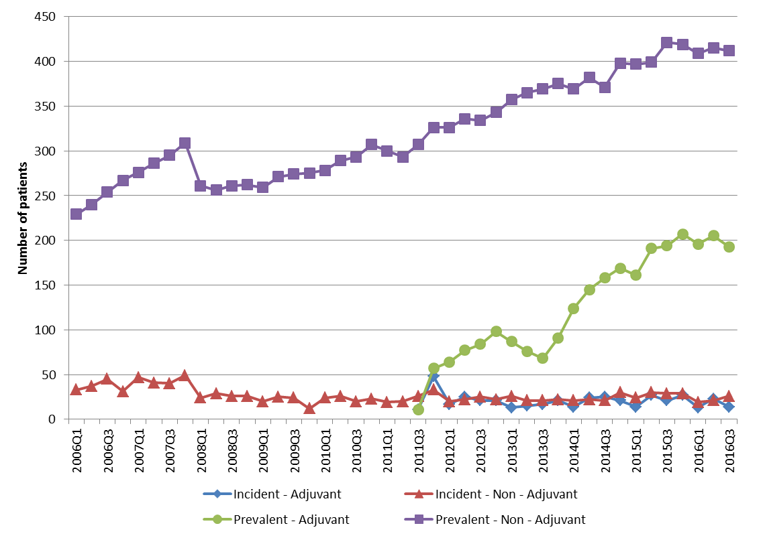

Figure 1. Number of incident and prevalent patients supplied imatinib as adjuvant and non-adjuvant treatment by quarter.
A plateau in the number of patients treated with imatinib as non-adjuvant therapy was also seen from 2015 Quarter 3 (Figure 1).
Time on imatinib was examined in 41 patients initiating on imatinib between 1 December 2013 and 31 May 2014 who were adjuvant to surgical resection. The data was too premature to identify patients who exceeded the treatment limit of 36 months. Figure 2 shows that for both patients on their first episode of imatinib treatment and those who were identified as having a break in imatinib therapy, a relatively high proportion had remained on imatinib by the end of the analysis period (to 30 September 2016).
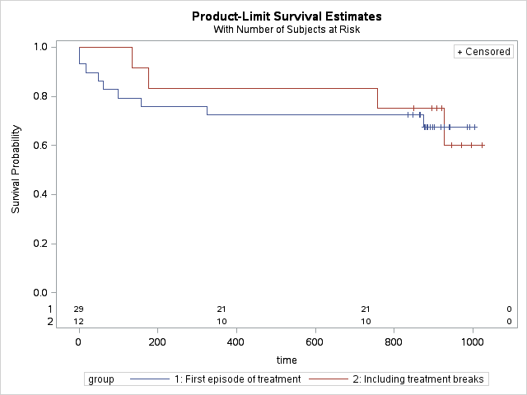

Figure 2. Kaplan-Meier plot of time on imatinib treatment for patients initiating on imatinib between 1 December 2013 and 31 May 2014.
The follow up period was to 30 September 2016. Survival time for patients on their first episode of treatment and those identified as having a treatment break are shown.

Analysis of actual versus predicted utilisation
A comparison of the estimated versus actual use of imatinib for the adjuvant treatment of GIST, for the first two years since its listing was extended from December 2013, is shown in Table 3.

Table 3: Analysis of actual versus predicted utilisation
Parameter | Comparison | Year 1  (Dec 2013 to Nov 2014) | Year 2  (Dec 2014 to Nov 2015)
Overall expenditure – all strengths
Incident patients | Predicted | ''''' | ''''''
 | Actual | 87 | 101
 | Difference (Actual - Predicted), n | '''' | '''
 | Difference (Predicted vs. Actual), % | '''''''' | '''''''
Treated patients | Predicted | ''''''' | ''''''''
 | Actual | 199 | 250
 | Difference (Actual - Predicted), n | ''''''' | ''''
 | Difference (Predicted vs. Actual), % | ''''''''' | '''''''
Net expenditure | Predicted | '''''''''''''''''''''' | '''''''''''''''''''''
 | Actual | $5,568,770 | $7,317,540
 | Difference (Actual - Predicted), n | ''''''''''''''''''' | '''''''''''''''''''
 | Difference (Predicted vs. Actual), % | ''''''''' | ''''''''''
100 mg strength
Incident patients | Predicted | ''' | '''
 | Actual | 1 | 6
 | Difference n (Actual - Predicted) | '''' | '''
 | Difference % (Predicted vs. Actual) | ''''''''' | ''''''''''''
Prevalent patients | Predicted | ''''' | '''''
 | Actual | 19 | 34
 | Difference (Actual - Predicted), n | '' | ''''''
 | Difference (Predicted vs. Actual), % | '''''''''' | ''''''''''''''
Prescriptions | Predicted | '''''''' | '''''''
 | Actual | 88 | 190
 | Difference (Actual - Predicted), n | '''''' | ''''''
 | Difference (Predicted vs. Actual), % | '''''''''' | ''''''''
Net expenditure | Predicted | ''''''''''''''''' | ''''''''''''''''
 | Actual | $260,620 | $546,710
 | Difference (Actual - Predicted), n | ''''''''''''''''' | '''''''''''''''''
 | Difference (Predicted vs. Actual), % | ''''''' | '''''''''''
400 mg strength
Incident patients | Predicted | ''''' | '''''
 | Actual | 86 | 95
 | Difference (Actual - Predicted), n | '''' | '''
 | Difference (Predicted vs. Actual), % | '''''''' | '''''''''
Prevalent patients | Predicted | ''''''' | '''''''
 | Actual | 193 | 233
 | Difference (Actual - Predicted), n | '''''' | ''''''
 | Difference (Predicted vs. Actual), % | ''''''''' | '''''''
Prescriptions | Predicted | '''''''''' | ''''''''''
 | Actual | 1395 | 1781
 | Difference n (Actual - Predicted) | '''''''''' | '''''''''
 | Difference % (Predicted vs. Actual) | ''''''''' | ''''''''
Net expenditure | Predicted | '''''''''''''''''''''' | '''''''''''''''''''''
 | Actual | $5,308,149 | $6,770,830
 | Difference (Actual - Predicted), n | ''''''''''''''''' | ''''''''''''''''''''''
 | Difference (Predicted vs. Actual), % | '''''''' | ''''''''''
Note: Includes PBS and RPBS clients. The predicted figures were sourced from the financial estimates model agreed with the sponsor. Part-year corrections were applied to the predicted figures to align these estimates to the listing years. e.g. In deriving the December 2013 to November 2014 estimates, the factors applied were 1/12 to 2013 and 11/12.
There were fewer prescriptions dispensed across both the 100 mg and 400 mg strengths than predicted, but there was a higher than expected net expenditure.

Discussion
The overall number of patients accessing imatinib for the adjuvant treatment of GIST after the extension to its listing was similar to that estimated by the submission (Table 3). However there were fewer prescriptions than predicted (Table 3) which may have been due to discontinuation from side effects or treatment failures. In the key clinical trial presented in the submission (SSGXVIII), 13.6% of patients treated with 36 months of adjuvant imatinib discontinued due to adverse events. Further, Figure 2 shows that the persistence to treatment in Year 2 was marginally lower than predicted (''''''''''') when treatment breaks were included. This suggests that tolerability to imatinib may be lower in practice.
The analysis of actual versus predicted utilisation of imatinib presented in Table 3 shows that while the number of prescriptions is lower than expected, the total net expenditure was higher than forecast. This may relate to the use of a higher average dose of imatinib than anticipated. The submission assumed that the average daily dose of imatinib for adjuvant therapy would be 360.9 mg based on the SSGXVIII trial. The median (387.1 mg) and mean (518.0 mg) average daily doses were higher than assumed in the submission.
The submission considered that adjuvant therapy with imatinib would delay the time to metastatic disease recurrence resulting in less use of downstream treatment with imatinib and sunitinib. At the time of reporting the data was too premature to examine if there was a reduction in use of imatinib or sunitinib in the metastatic treatment setting due to the extension to the listing of imatinib.

DUSC consideration
DUSC noted that the total number of patients treated and the number of new patients treated in Year 1 and Year 2 of listing were similar to predicted. In relation to there being fewer prescriptions than predicted, DUSC noted that while tolerability might be slightly lower in practice than in the pivotal trial, a high proportion of patients remain on treatment.
DUSC commented that the expenditure difference is large as a proportion of total expenditure in this setting (''''''''' above the estimates in Year 2). DUSC noted that the dose per day for imatinib when used to treat metastatic or unresectable GIST is 600 mg per day, compared with 400 mg per day in the adjuvant setting. DUSC considered that the mean and median average daily doses for the adjuvant setting in practice imply that some patients may be receiving the 600 mg per day dose. DUSC considered that this might have cost-effectiveness implications. However, as patients can progress from the adjuvant to metastatic setting, it is possible that some of these prescriptions might inadvertently continue to be entered under the authority code for the adjuvant setting. DUSC considered that further analysis of the average dose per day would not be able to confirm whether the use is clinically appropriate, as the available data cannot be used to determine whether the patient has progressed to metastatic disease.

DUSC actions
DUSC requested that the report be provided to the PBAC.

Context for analysis
The DUSC is a Sub Committee of the Pharmaceutical Benefits Advisory Committee (PBAC). The DUSC assesses estimates on projected usage and financial cost of medicines.
The DUSC also analyses data on actual use of medicines, including the utilisation of PBS listed medicines, and provides advice to the PBAC on these matters. This may include outlining how the current utilisation of PBS medicines compares with the use as recommended by the PBAC.
The DUSC operates in accordance with the quality use of medicines objective of the National Medicines Policy and considers that the DUSC utilisation analyses will assist consumers and health professionals to better understand the costs, benefits and risks of medicines.
The utilisation analysis report was provided to the pharmaceutical sponsors of each drug and comments on the report were provided to DUSC prior to its consideration of the analysis.

Sponsor comments
Alphapharm Pty Ltd: The sponsor has no comment.

Disclaimer
The information provided in this report does not constitute medical advice and is not intended to take the place of professional medical advice or care. It is not intended to define what constitutes reasonable, appropriate or best care for any individual for any given health issue. The information should not be used as a substitute for the judgement and skill of a medical practitioner.
The Department of Health (DoH) has made all reasonable efforts to ensure that information provided in this report is accurate. The information provided in this report was up-to-date when it was considered by the Drug Utilisation Sub-committee of the Pharmaceutical Benefits Advisory Committee. The context for that information may have changed since publication.
To the extent provided by law, DoH makes no warranties or representations as to accuracy or completeness of information contained in this report.
To the fullest extent permitted by law, neither the DoH nor any DoH employee is liable for any liability, loss, claim, damage, expense, injury or personal injury (including death), whether direct or indirect (including consequential loss and loss of profits) and however incurred (including in tort), caused or contributed to by any person’s use or misuse of the information available from this report or contained on any third party website referred to in this report.

References
Demetri GD et al. Efficacy and safety of regorafenib for advanced gastrointestinal stromal tumours after failure of imatinib and sunitinib (GRID): an international, multicentre, randomised, placebo-controlled, phase 3 trial. The Lancet 2012; 381: 295-302.
Vilain RE, Ackland SP. Gastrointestinal stromal tumors – A model for understanding solid tumor biology and development of targeted therapies, or just another low-hanging fruit? Asia-Pacific Journal of Clinical Oncology, 2008; 4: 185–187.

PBS statistics. Australian Government Department of Human Services Medicare. Canberra. Available from <http://www.medicareaustralia.gov.au/provider/pbs/stats.jsp>.

