Botulinum toxin for spasticity and dystonia: utilisation analysis

Drug utilisation sub-committee (DUSC)

May 2018

Abstract

Purpose
To review the utilisation of botulinum toxin type A supplied through the Pharmaceutical Benefits Scheme (PBS) for the treatment of spasticity in patients with cerebral palsy or following a stroke, and for spasmodic torticollis, blepharospasm and hemifacial spasm.

Current PBS indications of botulinum toxin type A for spasticity and dystonia (abridged)
Three preparations of botulinum toxin type A are listed on the PBS: Botox®, Dysport®and Xeomin®. The three preparations are not interchangeable. The units used to express the potency of botulinum toxin preparations are not equivalent.

Botox is PBS subsidised for:
- Blepharospasm or hemifacial spasm for patients aged 12 years or older.
- Spasmodic torticollis as monotherapy or as adjunctive therapy to current standard care
- Dynamic equinus foot deformity due to spasticity in ambulant patients with cerebral palsy who are aged 2 to 17 years or who commenced treatment with botulinum toxin as a paediatric patient (i.e. 2 to 17 years).
- Moderate to severe spasticity of the upper limb in patients with cerebral palsy who are aged 2 to 17 years or who commenced treatment with botulinum toxin as a paediatric patient.
- Moderate to severe spasticity of the upper limb following a stroke in adult patients meeting certain criteria. PBS subsidy is for a maximum of 4 treatment periods (total of Botox, Dysport and Xeomin) per upper limb per lifetime.

Dysport is PBS subsidised for the same indications as Botox except:
- it is not subsidised for moderate to severe spasticity of the upper limb in patients with cerebral palsy.
- the blepharospasm and hemifacial spasm listing is limited to patients aged 18 years or older, consistent with its TGA registered indication.

Xeomin is PBS subsidised for:
- Blepharospasm in patients aged 18 years or older.
- Spasmodic torticollis as monotherapy or as adjunctive therapy to current standard care in patients aged 18 years or older.
- Moderate to severe spasticity of the upper limb following a stroke in adult patients meeting certain criteria. PBS subsidy is for a maximum of 4 treatment periods (total of Botox, Dysport and Xeomin) per upper limb per lifetime.
The PBS restrictions specify that prescribing of botulinum toxin is limited to certain specialties (see Table 4 for details).

Data Sources
Pharmaceutical Benefits Scheme (PBS) prescription data for prescriptions supplied from 1 September 2015 to 31 December 2017, and Medicare Benefits Schedule (MBS) services data for injection of botulinum toxin from 1 December 1991 to 31 December 2017 were used to assess utilisation of botulinum toxin for spasticity and dystonia.

Key Findings
- In 2017, 13,116 patients were treated with PBS subsidised botulinum toxin type A for spasticity or dystonia. The number of patients receiving treatment has been increasing steadily with an approximate doubling of the number of patients receiving treatment over the past decade.
- The majority of use is for spasmodic torticollis, blepharospasm and hemifacial spasm. Use for each of these indications has been growing, with a higher rate of growth evident for spasmodic torticollis in 2016 and 2017.
- The number of patients with cerebral palsy receiving botulinum toxin for upper limb spasticity and/or foot deformity due to spasticity increased until 2015 and has now stabilised.
- In 2017, 742 patients were treated with PBS subsidised botulinum toxin for upper limb spasticity following a stroke and 1,002 prescriptions were dispensed for this indication. Utilisation of botulinum toxin post-stroke seems low in the context of all patients who have experienced a stroke and may have resultant spasticity.

Purpose of analysis
To review the utilisation of botulinum toxin type A supplied through the Pharmaceutical Benefits Scheme (PBS) for the treatment of spasticity in patients with cerebral palsy or following a stroke, and for spasmodic torticollis, blepharospasm and hemifacial spasm.

Background

Botulinum neurotoxin is a naturally occurring toxin produced by the bacterium Clostridium botulinum. Botulinum neurotoxin type A blocks peripheral acetylcholine release at presynaptic cholinergic nerve terminals resulting in muscle paralysis or weakness. Purified forms of the toxin injected into affected areas can be used to treat a range of conditions including dystonia and spasticity.

Three preparations of botulinum toxin type A are available in Australia. Botox® is a purified neurotoxin complex, Dysport® is a haemagglutinin complex and Xeomin® is purified toxin separated from complexing proteins. The TGA approved and PBS subsidised indications vary across the different preparations as summarised in Table 1. For focal spasticity some preparations have broadly worded TGA approved indications whereas others are specific about the part of the body affected and/or the underlying neurological condition resulting in spasticity.
Dosage and administration
The recommended dose depends on which preparation of botulinum toxin A is used, its dilution, the size of the muscle or gland being injected, and the method used to localise the injection site. Dosage and administration varies across indications and brands of botulinum toxin (Table 2). The units used to express the potency of the toxin across the three products are not equivalent. Botox has marketing approval for 50, 100 and 200 unit vials, Dysport as 125, 300 and 500 unit vials, and Xeomin as 50 and 100 unit vials. PBS listed vials are Botox 100 units, Dysport 300 and 500 units and Xeomin 100 units.

Table 1: TGA indications and PBS listings (abridged)ª
 | Botulinum purified neurotoxin complex^{b} (Botox) | Clostridium botulinum type A toxin-haemagglutinin complex^{c} (Dysport) | IncobotulinumtoxinA (Xeomin)
Blepharospasm | X^{d} | Xe | X
Hemifacial spasm | X^{d} | Xe
Cervical dystonia (spasmodic torticollis) | X | Xe | X
Focal spasticity | Xe
Focal spasticity upper limbs | X^{g} | Xe | X
Spasticity of the upper limb following stroke | X^{f,g} | X^{h} | X^{h}
Spasticity of the upper limb due to cerebral palsy | X^{f,g} | X^{h}
Focal spasticity lower limbs | X^{g} | X^{g}
Dynamic equinus foot deformity due to cerebral palsy spasticity | X^{g} | X^{i}
Chronic migraine prophylaxis | Xe
Urinary incontinence due to overactive bladder | Xe
Urinary incontinence due to neurogenic detrusor overactivity | X
Hyperhidrosis of the axillae | X
Strabismus | X
Spasmodic dysphonia | X
Glabellar frown lines (cosmetic) | X | Xe | X
Crow’s feet (cosmetic) | X |  | X
Forehead lines (cosmetic) | X |  | X
Crosses (X) indicate TGA registration. Shaded are PBS subsidised under certain criteria.
ª As at April 2018; ^{b} Also known as onabotulinumtoxinA; ^{c} Also known as abobotulinumtoxinA;
^{d} 12 years and over; ^{e} In adults; ^{f} TGA approved indication is for focal spasticity of the lower limbs;
^{g} 2 years and over; ^{h} Covered by the focal spasticity of the upper limb indication;
^{i} Covered by the focal spasticity of the lower limb indication
For full details of the TGA approved indications refer to the Product Information (PI) ,, available from the TGA website.
The full PBS restrictions are provided in Appendix A and are also available in the PBS Schedule.

Table 2: Dose summary from TGA Product Information^{2,3,4}
 | Stage | Botulinum toxin type A (Botox) | Clostridium botulinum type A toxin-haemagglutinin complex (Dysport) | IncobotulinumtoxinA (Xeomin)
Blepharospasm | Initial | 1.25 U to 2.5 U in 3 sites (i.e. 3.75 to 7.5U) | 40 to 80 U per eye | 1.25 U to 2.5 U in each site  (max of 25U per eye and max 100U per session)
 | Continuing | May be increased up to two-fold if the response from the initial treatment is considered insufficient. (i.e. up to 7.5 to 15U) | May be increased to a maximum of 120 U per eye | N/A
 | Cumulative | < 200U in two months | N/A
Hemifacial spasm |  | Similar to unilateral  blepharospasm. However Injections into more facial muscles may be necessary. | As for blepharospasm | N/A
Cervical dystonia/ spasmodic torticollis |  | Dose of Botox can range from 25-200 U at 1-8 sites. | Initial:250-500U per session  Continuing:250-1000U per session | Normally, dose should not exceed 200U per session (≤50U per site), but up to 300U may be given
Dynamic equinus foot deformity due to cerebral palsy spasticity |  | 2-4 U/kg or 200U (whichever is less) divided in 2 sites | Children: Up to 1000U or 30U/kg (whichever is less) per session  Adults: Up to 1500U per session | N/A
Spasticity of the upper limb due to cerebral palsy |  | 0.5-2.0 U/kg/muscle (children) or 15-200U in up to 4 sites (adults) | Up to 1000U per session | Up to 500U per session (<= 250U on shoulder muscles)
 | Cumulative for cerebral palsy | < 8.0 U/kg body weight or 300U in 3 months
Spasticity of the upper limb following stroke | Based on Focal Spasticity in Adults in PI | Depends on muscles involved. Up to 200U total in up to 4 sites. | Up to 1000U per session | Up to 500U per session (≤250U on shoulder muscles)
Repeat doses are usually required as the effect of the toxin wears off after 3-4 months.¹⁻⁴ The dosing frequencies recommended in the Product Information are summarised in Table 3.

Table 3: Dosing frequency summary from TGA Product Information^{2,3,4}
 | Botulinum toxin type A (Botox) | Clostridium botulinum type A toxin-haemagglutinin complex (Dysport) | IncobotulinumtoxinA (Xeomin)
Blepharospasm | ≥3 months | ≥12 weeks | 6 to 20 weeks  (median 12 weeks)
Hemifacial spasm | ≥3 months | ≥12 weeks | N/A
Cervical dystonia/ spasmodic torticollis | ≥2 months | 16 weeks  (< 12 weeks not recommended) | 6 to 20 weeks  (median 12 weeks)
Dynamic equinus foot deformity due to cerebral palsy spasticity | ≥3 months | ≥12 weeks  Children: 16-28 weeks range  Adults: 12-16 weeks range | N/A
Spasticity of the upper limb following stroke | 12 to 16 weeks (i.e. Focal Spasticity in Adults) | ≥12 weeks  (12 to 20 weeks range) | 12 weeks
Spasticity of the upper limb due to cerebral palsy | ≥3 months | ≥12 weeks  (12 to 20 weeks range) | N/A
The Product Information also provides the maximum dose per treatment or in a defined period. Refer to the Product Information (PI) for full details available from the TGA website.

Relevant aspects of consideration by the PBAC

Botox was first listed on the PBS under Section 100 (Botulinum Toxin Program) in October 1994 for the treatment of blepharospasm associated with dystonia, including benign blepharospasm and VIIth nerve disorders (hemifacial spasm) in patients 12 years and older. At the December 1999 meeting, the PBAC recommended extension of the Section 100 listing of Botox to include the treatment of dynamic equinus foot deformity due to spasticity in juvenile cerebral palsy patients two years of age and older, on the basis of acceptable cost-effectiveness (PBS listed in November 2000).
An application seeking PBS listing of Dysport for “treatment of spasmodic torticollis, either as monotherapy or as adjunctive therapy to current standard care” was recommended at the December 2000 PBAC meeting on the basis that the incremental effectiveness, toxicity and costs with Dysport® in spasmodic torticollis are similar to that with Botox® in blepharospasm, hemifacial spasm and equinus foot of juvenile cerebral palsy. This was PBS listed in May 2001.

At the March 2001 meeting, the PBAC recommended extending the listing of Botox to include treatment of spasmodic torticollis, either as monotherapy or as adjunctive therapy to current standard care on a cost-minimisation basis compared with clostridium botulinum type A toxin (Dysport). This extension was PBS listed in August 2001.
An application to extend the Section 100 listing of Dysport to include ‘treatment of dynamic equinus foot deformity due to spasticity in ambulant paediatric cerebral palsy patients, two years of age or older’, was recommended at the December 2001 PBAC meeting on a cost-minimisation basis compared with botulinum toxin, with 3 Ipsen units of Dysport being considered equivalent to one unit of Botox. This extension was PBS listed in May 2002.
Applications to add the indication “treatment of spasticity of the arm in adults following a stroke” for Dysport were rejected at the September 2001 and September 2002 PBAC meetings; because of uncertainty over the extent of clinically relevant benefits and the resulting uncertain cost-effectiveness.

At the November 2005 PBAC meeting, the Committee rejected an application to extend listing to include the treatment of focal spasticity in adults for Botox because of uncertainty with interpreting the extent of clinically relevant benefits arising from the spasticity outcomes analysed by the trials, uncertainty associated with the modelled physiotherapy cost off-sets, and the resulting unacceptable and uncertain cost-effectiveness. The PBAC considered that if listing were to be recommended, a narrower restriction may help to identify those patients likely to derive the most benefit from a reduction in spasticity, for example by being able to undergo physiotherapy to achieve a longer-term response, by identifying patients manifesting more severe spasticity at baseline, and by identifying particular types of potentially reversible focal spasticity associated with the most functional impairment. Further, that a limitation on the number of treatment doses was appropriate as no justification had been provided for longer periods of therapy.

In July 2006, the PBAC considered a resubmission for Botox for the treatment of focal spasticity of upper and lower limbs in adult patients who meet certain criteria. The PBAC again rejected the listing because of high and uncertain cost-effectiveness. The PBAC noted the re-submission clearly defined the target patient population, and again considered that it would be appropriate to limit the number of treatment doses per patient.
At the November 2007 meeting, the PBAC recommended an extension to the Section 100 botulinum toxin program for Dysport to include the treatment of moderate to severe spasticity of the upper limb in adults following a stroke, as second line therapy when standard management has failed or as an adjunct to physical therapy, on a the basis of an acceptable cost-effectiveness ratio compared with standard management (placebo). The restriction was to specify that the maximum number of treatments authorised be 4 per upper limb and per lifetime. This extension was PBS listed in April 2008.
At the November 2007 meeting, the PBAC recommended extending the Section 100 – Botulinum Toxin Program listing of the 500 unit vial of Dysport to include treatment of blepharospasm or hemifacial spasm in adults on a cost-minimisation basis with botulinum toxin type A (Botox®). This extension was PBS listed in April 2012.

At the July 2008 meeting, the PBAC recommended an extension to the Section 100 listing for Botox A to include the treatment of moderate to severe spasticity of the upper limb in adults following a stroke, as second line therapy when standard management has failed or as an adjunct to physical therapy, on a cost-minimisation basis compared with clostridium botulinum (Dysport).This extension was PBS listed in April 2009. The PBAC considered the restriction should be the same as for the currently listed clostridium botulinum for post-stroke upper limb spasticity, and that the maximum total number of botulinum treatments authorised be limited to 4 per upper limb, per lifetime. The PBAC considered that the cost effectiveness would be unacceptable if the number of treatments increased to 4 per each formulation.

At the same meeting the PBAC rejected a submission requesting extension of the current section 100 listing of Botox to include the treatment of moderate to severe spasticity of the lower limb in ambulatory adults following a stroke as a second line therapy when standard management has failed or as an adjunct to physical therapy because of uncertain clinical benefit and the resulting high and uncertain cost-effectiveness. The PBAC has not received any further applications from Sponsors of botulinum toxin seeking PBS subsidy for lower limb spasticity.

At the November 2008 meeting, the PBAC recommended extending the availability of Botox through the Section 100 Botox program to include the treatment of moderate to severe spasticity of the upper limb(s) in cerebral palsy patients aged 2 years and over on the basis of acceptable cost effectiveness in the context of a condition in which large utility gains are probable in responders to treatment, and where non-responders are unlikely to continue treatment. This extension was PBS listed in April 2009.
At the July 2014 meeting, the PBAC recommended the listing of incobotulinumtoxin A (Xeomin) to treat spasmodic torticollis, blepharospasm or hemifacial spasm or moderate to severe spasticity of the upper limb following stroke, on a cost-minimisation basis compared with Botox®. The PBAC accepted the equieffective doses presented in the submission as follows: cervical dystonia: 140.4U of Xeomin over approximately 110 days and Botox 140.4U over approximately 110 days; blepharospasm: 40.7U of Xeomin over approximately 110 days and Botox 40.7U over approximately 110 days; and post-stroke spasticity of the upper limb: 229U of Xeomin over approximately 87 days and 229U Botox over approximately 87 days.
The PBAC noted the estimated PBS usage and financial implications presented in the submission assumed no financial impact to PBS and MBS because of cost offset by a corresponding decrease in the number of items processed for Botox and Dysport. The PBAC considered this was reasonable.
These were PBS listed in April 2015.
For further details refer to the Public Summary Document by product or meeting.

Previous DUSC reviews
DUSC has not previously reviewed the utilisation of botulinum toxin type A for spasticity and dystonia. Predicted versus actual utilisation analyses of Botox for prophylaxis of headache in patients with chronic migraine was considered at the June 2017 meeting and for severe primary axillary hyperhidrosis at the October 2013 meeting.

PBS listing details (as at March 2018)
The PBS restrictions for botulinum toxin type A are summarised in Table 1 and the full restriction wording is provided in Appendix A. Botulinum toxin is listed in the Section 100 Botulinum toxin program as an Authority required (streamlined) medicine.
The PBS restrictions specify that prescribing of botulinum toxin is limited to certain specialties. These are summarised in Table 4.
Table 4: Treatment specialists specified in restriction by indication
 | Blepharospasm or hemifacial spasm | Spasmodic torticollis | Dynamic equinus foot deformity | Moderate to severe spasticity of the upper limb due to cerebral palsy | Moderate to severe spasticity of the upper limb following a stroke)
neurologist | X | X | X | X | X
ophthalmologist | X
otolaryngology head and neck surgeon | X
plastic surgeon | X | X |  | X | X
rehabilitation specialist |  | X | X | X | X
paediatrician |  |  | X | X
orthopaedic surgeon |  |  | X | X | X
geriatrician |  |  |  |  | X

The PBS items codes, maximum quantities and repeats are provided in Table 5.

Table 5: Spasticity and dystonia PBS listings of botulinum toxin type A (at 1 March 2018)
Name, form & strength, pack size | Max qty packs | Rpts | DPMQ | Item | Indication | Brand name and manufacturer
botulinum toxin type A 100 units injection, 1 vial | 4 | 0 | $1626.07 | 10997T  (6103F*) | Blepharospasm or hemifacial spasm | Botox, Allergan Australia Pty Ltd
 |  |  |  | 11023T  (6103F*) | Spasmodic torticollis
 |  |  |  | 10998W  (6103F*) | Dynamic equinus foot deformity (cerebral palsy)
 |  |  |  | 10999X  (6103F*) | Moderate to severe spasticity of the upper limb (due to cerebral palsy or stroke)
Clostridium botulinum type A toxin-haemagglutinin complex, 300 units injection, 1 vial | 4 | 0 | $1420.91 | 10928B  (1152P*) | Moderate to severe spasticity of the upper limb following a stroke | Dysport, Ipsen Pty Ltd
Clostridium botulinum type A toxin-haemagglutinin complex, 500 units injection, 1 vial | 2 | 0 | $1272.29 | 10988H  (6293F*)
Clostridium botulinum type A toxin-haemagglutinin complex, 300 units injection, 1 vial | 4 | 0 | $1420.91 | 10987G  (1152P*) | Blepharospasm or hemifacial spasm
Clostridium botulinum type A toxin-haemagglutinin complex, 500 units injection, 1 vial | 2 | 0 | $1272.29 | 11022D  (6293F*)
Clostridium botulinum type A toxin-haemagglutinin complex, 300 units injection, 1 vial | 4 | 0 | $1420.91 | 11007H  (1152P*) | Spasmodic torticollis
Clostridium botulinum type A toxin-haemagglutinin complex, 500 units injection, 1 vial | 2 | 0 | $1272.29 | 11015R  (6293F*)
Clostridium botulinum type A toxin-haemagglutinin complex, 300 units injection, 1 vial | 4 | 0 | $1420.91 | 10981Y  (1152P*) | Dynamic equinus foot deformity (cerebral palsy)
Clostridium botulinum type A toxin-haemagglutinin complex, 500 units injection, 1 vial | 2 | 0 | $1272.29 | 11006G  (6293F*)
incobotulinumtoxinA, 100 mouse LD50 units injection, 1 x 100 mouse LD50 units vial | 4 | 0 | $1547.15 | 10983C  (10253P*) | Moderate to severe spasticity of the upper limb following a stroke | Xeomin, Merz Australia Pty Ltd
 | 4 | 0 | $1547.15 | 10994P  (10253P*) | Blepharospasm
 | 4 | 0 | $1547.15 | 11005F  (10253P*) | Spasmodic torticollis
Source: pbs.gov.au
* PBS item codes prior to 1 January 2017, when indications needed to be distinguished by using the Streamlined Authority code

Changes to listing and supply arrangements
In recent years there have been two reforms to the way PBS subsidised botulinum toxin is supplied. The intent of the PBS restriction, including patient and prescriber eligibility criteria, has remained unchanged.
Prior to 1 September 2015 botulinum toxin was available via the National Health (Botulinum Toxin Program) Special Arrangement 2011. This program provided alternative arrangements for distribution of botulinum toxin. Prescribers were required to be individually authorised to prescribe botulinum toxin under the PBS following application to the Department of Human Services (DHS). Prescribers then telephoned DHS to arrange direct supply of the drug to the prescriber by the pharmaceutical company.
From 1 September 2015 the way PBS-subsidised botulinum toxin was supplied changed to better align with other PBS arrangements, using PBS prescriptions and hospital pharmacy coordination points. The revised arrangements were supported through the National Health (Botulinum Toxin Program) Special Arrangement 2015. This change meant that eligible PBS botulinum toxin prescriptions are now claimed like other PBS prescriptions and prescription level data is made available to the Department of Health for analysis. This change required adaption of the Program from manual ordering by clinics through DHS to a system of Streamlined Authority prescriptions.
The implementation of the Authority required (STREAMLINED) restriction meant that prescribers were no longer required to telephone DHS for authorisation and ordering supply. Prescribers must write a prescription for each patient ensuring the prescriptions they write comply with PBS requirements for subsidised botulinum toxin, including patient and prescriber eligibility criteria. As direct patient handing of botulinum toxin is not permitted, hospital pharmacies co-ordinate the supply to physicians.
Changes to the National Health (Botulinum Toxin Program) Special Arrangement 2015 (effective 1 March 2017) allow prescribers to write two prescriptions for botulinum toxin on the same day, where a patient requires treatment for two different indications. Due to the limitation of the DHS PBS Online system, changes in the PBS item codes were required.
Further information and frequently asked questions regarding the 1 September 2015 and 1 January 2017 – 1 March 2017 changes are available from the PBS website.
There are MBS items for the injection of botulinum toxin for the all of the PBS subsidised indications as summarised in Table 6.

Table 6: MBS items for the injection of botulinum toxin for spasticity and dystonia
MBS item | Description of injection service (abridged)
18350 | Botox for hemifacial spasm in a patient ≥12 years of age, including all such injections on any one day.
18351 | Dysport for hemifacial spasm in a patient ≥ 18 years of age, including all such injections on any one day
18353 | Botox or Dysport or Xeomin for cervical dystonia (spasmodic torticollis), including all such injections on any one day
18354 | Botox or Dysport for dynamic equinus foot deformity (including equinovarus and equinovalgus) due to spasticity in an ambulant cerebral palsy patient, if (a) patient ≥ 2 years of age; and (b) the treatment is for all or any of the muscles subserving one functional activity and supplied by one motor nerve, with a maximum of 4 sets of injections for the patient on any one day (with a maximum of 2 sets of injections for each lower limb), including all injections per set
18360* | Botox for moderate to severe focal spasticity, if (a) patient ≥18 years of age; and (b) the spasticity is associated with a previously diagnosed neurological disorder; and (c) treatment is provided as (i) second line therapy when standard treatment for the conditions has failed; or (ii) an adjunct to physical therapy; and (d) the treatment is for all or any of the muscles subserving one functional activity and supplied by one motor nerve, with a maximum of 4 sets of injections for the patient on any one day (with a maximum of 2 sets of injections for each limb), including all injections per set; and (e) the treatment is not provided on the same occasion as a service mentioned in item 18365.
18361 | Botox for moderate to severe upper limb spasticity due to cerebral palsy if: (a) patient ≥ 2 years of age, and (b) for a patient who is at least 18 years of age - before the patient turned 18, the patient had commenced treatment for the spasticity with botulinum toxin supplied under the pharmaceutical benefits scheme; and (c) the treatment is for all or any of the muscles subserving one functional activity and supplied by one motor nerve, with a maximum of 4 sets of injections for the patient on any one day (with a maximum of 2 sets of injections for each upper limb), including all injections per set.
18365 | Botox or Dysport or Xeomin for moderate to severe spasticity of the upper limb following a stroke, if: (a) patient ≥18 years of age; and (b) treatment is provided as (i) second line therapy when standard treatment for the condition has failed; or (ii) an adjunct to physical therapy; and (c) the patient does not have established severe contracture in the limb that is to be treated; and (d) the treatment is for all or any of the muscles subserving one functional activity and supplied by one motor nerve, with a maximum of 4 sets of injections for the patient on any one day (with a maximum of 2 sets of injections for each upper limb), including all injections per set; and (e) for a patient who has received treatment on 2 previous separate occasions - the patient has responded to the treatment .
18369 | Dysport or Xeomin for unilateral blepharospasm in a patient who is at least 18 years of age, including all such injections on any one day.
18370 | Botox for unilateral blepharospasm in a patient ≥12 years of age, including all such injections on any one day
18372 | Botox for bilateral blepharospasm, in a patient ≥12 years of age; including all such injections on any one day
18374 | Dysport or Xeomin for bilateral blepharospasm in a patient ≥18 years of age, including all such injections on any one day
Source: MBS Online Medicare Benefits Schedule. Accessed 18 April 2018.
*This MBS item for focal spasticity is broad and is included in this review as there is potential for it to be used for injection of PBS subsidised botulinum toxin A.

There are MBS items for strabismus (18366) and spasmodic dysphonia (18368), but no corresponding PBS subsidy for these indications. There are also MBS items for severe primary axillary hyperhidrosis (18362), urinary incontinence (18375,18379) and chronic migraine (18377) which have corresponding PBS items but are out of scope of this review.
In addition, electrical stimulation, electromyography, ultrasound or a combination of these are generally used for localisation of the muscle and neuromuscular receptors.¹
Further information on the MBS botulinum toxin injection items is available from the MBS online website.

Methods
PBS prescription data
PBS prescription data for botulinum toxin from 1 September 2015 to 31 December 2017 were extracted from the DHS prescription database based on the date of dispensing. The date of dispensing may differ from the date of administration because prescribers may order botulinum toxin medicines from hospital pharmacies in advance of providing a valid PBS prescription/s to cover the supply. PBS Regulations require prescribers to make prescriptions available within seven days of a verbal or written order. The date of processing of the PBS prescription may also differ from the date of dispensing. Consequently there may be differences in data reported by date of dispensing or processing (such as that available publicly available from DHS Medicare website).
PBS prescription data were used to determine the number of prescriptions supplied, the time to resupply of prescriptions, incident and prevalent patient counts. Prescription indications were determined using Streamlined Authority codes for the period 1 September 2015 to 31 December 2016 when the PBS item codes were not indication specific (see Table 5). New PBS item codes were introduced on 1 January 2017. These were indication specific so indications were allocated on the basis of PBS item codes alone. An exception was in order to distinguish between cerebral palsy and stroke for spasticity of the upper limb it was necessary to have regard to the Streamlined Authority codes for item 10999X (i.e. 5178 and 5261 for cerebral palsy and 5220 for stroke).
The prevalent patients per 1000 population (age standardised, ABS direct method) in 2017 by patient state (see Figure 10) was calculated using population data sourced from the ABS publication, 3101.0, Australian Demographic Statistics, Jun 2017, Table 8, Estimated resident population, by age and sex at 30 June 2017.

MBS services data
MBS services data for injection of botulinum toxin (MBS Group T11) were extracted from the DHS MBS services database for date of services from 1 December 1991 to the end of December 2017 (date of processing up until the end of March 2018).
The MBS data were used because they have a longer time series of patient level data than PBS data. This enabled the analysis of trends in prevalent and initiating patients and the calculation of length of treatment.
The duration of MBS treatment analysis used the Kaplan Meier (aka Product-Limit) method to determine the length of treatment for patients receiving botulinum toxin injections by indication. The length of treatment chosen for this analysis included breaks in treatment. This was the time from a patient’s first service until their last service, plus an allowance for the coverage of the last service. This allowance was the indication specific median time to next service, calculated across all the data. A patient was deemed to be continuing treatment (classified as censored in the Product-Limit method) at the end of the data period (i.e. the end of December 2017) if their last service was within 3 times the median time to next service of this end date. The continuing patient’s length of treatment was based on the treatment coverage end date being the end of the data period or the service date of their last service plus a median time to next service, whichever was later.

Results

Number of services and prescriptions
Figure 1 shows the utilisation of MBS services for injection of botulinum toxin for spasticity and dystonia.

Figure 1: MBS services for injection of botulinum toxin for spasticity and dystonia
Source: DHS MBS services database (accessed 18 April 2018)

The first MBS item available for the administration of botulinum toxin was for blepharospasm (item 42827) from December 1991. In May 2003, new items were introduced and several amendments were made to existing items to cover the treatment of specific conditions with botulinum toxin.
The new indications added were;
- hemifacial spasm in adults (item 18350)
- cervical dystonia (spasmodic torticollis, item 18352)
- dynamic equinus (item 18354) , equinovarus (item 18356) and equinovalgus (item 18358) foot deformity in cerebral palsy patients. Note that all these items have been mapped to “Dynamic equinus foot deformity” in Figure 1. The current descriptor of item 18354 has been changed to include equinovarus and equinovalgus (see Table 6) and the items 18356 & 18358 have ceased.
Also in May 2003, item 42827 was renumbered to 18370, but the descriptor remained the same. The drop in the services for the blepharospasm indication in 2003, suggests that prior to May 2003 there may have been some use of the blepharospasm item 42827 for other indications.
Since May 2003, the number of services for blepharospasm, hemifacial spasm and spasmodic torticollis has grown steadily. Spasmodic torticollis has grown the fastest and is now the most common. The growth rate for spasmodic torticollis has increased more rapidly since 2016 coinciding with the PBS approval process for prescribing of botulinum toxin changing from telephone approval to Authority Required (Streamlined). Services for moderate to severe spasticity of the upper limb due to stroke or cerebral palsy represent a small proportion of all MBS services. The number of services for upper limb spasticity and dynamic equinus foot deformity due to spasticity has remained steady in recent years.
Figure 2 shows the PBS utilisation of botulinum toxin for spasticity and dystonia since the processing of this medicine became prescription based on 1 September 2015. Note that the first quarter (2015Q3) is not included in Figure 2 as it only contains one month of data (i.e. September 2015).
Figure 2: Prescriptions of botulinum toxin for spasticity and dystonia by indication
Sources: DHS prescription database (accessed 21 February 2018).
Figure 2 shows that the utilisation for the blepharospasm or hemifacial spasm and spasmodic torticollis indications has been increasing steadily since the first complete quarter, 2015 Q4. As there is no prior PBS data, it is not possible from this data alone to determine if the growth rates for these indications have increased since September 2015 when prescribing of botulinum toxin changed from telephone approval to Authority Required (Streamlined). However, comparison with the MBS services data in Figure 1 indicates that there has been substantial growth in the utilisation of botulinum toxin for spasmodic torticollis.
Utilisation for the other three indications (i.e. dynamic equinus foot deformity and moderate to severe spasticity of the upper limb due to cerebral palsy or stroke) has remained relatively constant over the same period.
Comparing the number of MBS services (Figure 1) with the number of PBS prescriptions (Figure 2) it can be seen that the number of MBS services is not the same as the number of PBS prescriptions for some indications.

Table 7: Ratio of MBS services to PBS prescriptions by indication
 | Year
Indication | 2016 | 2017
Blepharospasm or hemifacial spasm | 1.09 | 1.09
Spasmodic torticollis | 0.97 | 1.00
Dynamic equinus foot deformity | 1.51 | 1.50
Moderate to severe spasticity - upper limb, cerebral palsy | 1.39 | 1.34
Moderate to severe spasticity - upper limb, stroke | 0.97 | 0.85
Total | 1.10 | 1.10
Source: DHS MBS services database (accessed 18 April 2018) and DHS prescription database (accessed 21 February 2018)
Table 7 shows that the number of MBS services matches the number of PBS prescriptions reasonably well for the dystonia indications. However, for cerebral palsy patients (including upper limb spasticity and dynamic equinus foot deformity) there is on average more than one MBS service per PBS prescription. This may possibly be explained by two limbs or feet being injected using two MBS services (this could be on the same or separate occasions) and the quantity supplied on a single prescription being sufficient for both limbs. The distribution of MBS services per PBS prescription could be investigated further by linking the MBS and PBS data, but this was considered out of scope for the current review.
Figure 2 includes all three preparations of botulinum toxin - Botox, Dysport and Xeomin. Figure 3 shows utilisation by brand, form and strength. Botox is the dominant brand utilised for spasticity and dystonia indications.
Figure 3: Prescriptions of botulinum toxin for spasticity and dystonia by brand, form and strength
Source: DHS prescription database (accessed 21 February 2018).
Number of patients treated – MBS data
Figure 4 shows the overall number of patients commencing botulinum toxin for the first time (incident patients) and the total number of patients receiving treatment (prevalent patients) based on MBS injection services. Figures 5 and 6 present the number of prevalent and initiating patients receiving injections by indication. The MBS data (from Dec 1991) gives a much longer time series than the PBS data (from September 2015) to assess trends in the number of patients treated with botulinum toxin. It is also simpler methodologically, as the MBS data is complete, there is no need for a lookback period to determine if a patient is initiating treatment (i.e. the first MBS service for a patient is an initiation).
Figure 4: Patients initiating and prevalent to MBS services for injection of botulinum toxin for all spasticity and dystonia indications
Source: DHS MBS services database (accessed 18 April 2018)
The step up in the number of patients receiving botulinum toxin injections in 2003 was due to the addition of MBS items for hemifacial spasm, cervical dystonia and spasticity described for Figure 1. The slight increase in new patients in 2009 is likely due to the PBS listing of botulinum toxin for upper limb spasticity. This is evident in Figures 5 and 6 where patient counts are presented by indication. Between 2009 and 2015 the growth in the number of new patients commencing botulinum injections was reasonably steady with an average of about 2% per annum. In 2016 and 2017 the annual growth in new patients treated has been approximately 9%, with this increase driven by the dystonia indications, particularly spasmodic torticollis.

The prevalent treated population, both overall and for each indication, continue to grow likely due to the chronic nature of the underlying conditions and the requirement for repeated administration of botulinum toxin as the effects generally wear off after 3-4 months. A length of treatment analysis is presented later in this report.
Figure 5: Prevalent patients receiving MBS services for injection of botulinum toxin for spasticity and dystonia by indication
Source: DHS MBS services database (accessed 18 April 2018)
Figure 6: Patients initiating MBS services for injection of botulinum toxin for spasticity and dystonia by indication
Source: DHS MBS services database (accessed 18 April 2018)
The high number of initiations to hemifacial spasm and spasmodic torticollis in 2003 indicates there was a prevalent pool of patients having these injections prior to the listing of this service on the MBS.
Number of patients treated – PBS data
The number of patients commencing and receiving treatment with PBS subsidised botulinum toxin type A is presented in Table 8. The number of new patients commencing treatment is presented for 2017 only. A time to resupply analysis showed that the median time to resupply was about 3 months for the dystonia indications and 6 to 7 months for spasticity (Appendix B). As patient level prescription data was not available prior to September 2015 there is an inadequate ‘look back’ period to distinguish new from continuing patients in 2016. The prevalent patient counts in Table 8 represent any patient with at least one prescription supplied for the indication in either 2016 or 2017. Patients receiving treatment for more than one indication will be represented multiple times in Table 8. Approximately 5% of prevalent patients treated in 2017 received treatment under more than one indication, with the majority of cases being dynamic equinus foot deformity and spasticity of the upper limb in patients with cerebral palsy (data not shown).

Table 8: Incident and prevalent PBS patient counts by indication
Patient count type | Indication | 2016 | 2017
Initiating patients by indication - no script since 1 September 2015 | Blepharospasm or hemifacial spasm |  | 1,367
 | Spasmodic torticollis |  | 1,283
 | Dynamic equinus foot deformity |  | 746
 | Moderate to severe spasticity - upper limb, cerebral palsy |  | 455
 | Moderate to severe spasticity - upper limb, stroke |  | 501
 | Moderate to severe spasticity - upper limb, unknown |  | 33
Total unique initiating patients | Any PBS subsidised dystonia or spasticity indication |  | 3,759
Prevalent patients by indication | Blepharospasm or hemifacial spasm | 5,363 | 5,681
 | Spasmodic torticollis | 3,665 | 4,185
 | Dynamic equinus foot deformity | 2,022 | 2,059
 | Moderate to severe spasticity - upper limb, cerebral palsy | 1,065 | 1,082
 | Moderate to severe spasticity - upper limb, stroke | 629 | 742
 | Moderate to severe spasticity - upper limb, unknown |  | 33
Total unique prevalent patients | Any PBS subsidised dystonia or spasticity indication | 12,152 | 13,116

Note: the unique patient totals are not the sum of the indication specific patient counts as a patient can be counted in more than one indication.

The vast majority of patients are initiated on treatment with the Botox brand as shown in Table 9. There is some use of Dysport and Xeomin for spasmodic torticollis and moderate to severe spasticity of the upper limb due to stroke, and very little use for blepharospasm and hemifacial spasm. Xeomin is not PBS listed for equinus foot deformity, and neither Xeomin nor Dysport are listed for upper limb spasticity in cerebral palsy patients.

The available PBS data is insufficient to assess the extent of switching (if any) between the various botulinum toxin A preparations.
Table 9: Percent of PBS patient initiations by indication and brand
Indication | Botox | Dysport | Xeomin
Blepharospasm or hemifacial spasm | 94.6% | 3.9% | 1.5%
Spasmodic torticollis | 75.4% | 16.1% | 8.5%
Dynamic equinus foot deformity | 96.1% | 3.9% | -
Moderate to severe spasticity - upper limb, cerebral palsy | 100% | - | -
Moderate to severe spasticity - upper limb, stroke | 73.5% | 20.4% | 6.2%

Length of MBS treatment

The MBS injection services data were used to estimate length of treatment with botulinum toxin, as there was not a long enough history of patient level PBS data to do this analysis. The analysis includes all MBS services data for the injection of botulinum toxin (i.e. date of service from December 1991 to the end of 2017).

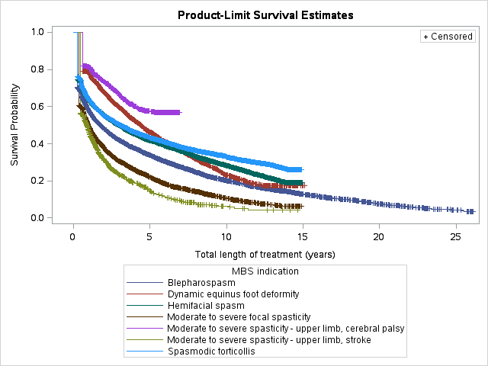Figure 7: Length of MBS treatment with botulinum toxin (including breaks)

Table 10: Estimated median length of treatment based on MBS services
Indication | Length of treatment  (including breaks)  (years) | Patients
Blepharospasm | 1.8 | 8,815
Hemifacial spasm | 3.0 | 10,493
Spasmodic torticollis | 3.1 | 8,761
Dynamic equinus foot deformity | 4.4 | 4,394
Moderate to severe focal spasticity* | 1.0 | 7,187
Moderate to severe spasticity - upper limb, cerebral palsy | N/A | 1,421
Moderate to severe spasticity - upper limb, stroke | 0.9 | 1,973

N/A = median value not yet reached

* No matching PBS listing
A notable feature of Figure 7 is the large proportion of discontinuations after the first MBS service. Approximately 20% of patients receiving treatment for spasticity of the upper limb or dynamic equinus foot deformity due to cerebral palsy, and 40% of the spasticity of the upper limb post stroke, discontinue after one service.
Figures 7 and Table 10 show that upper limb spasticity in patients with cerebral palsy has the longest length of treatment (median appears to be > 5 years). Spasticity of the upper limb post stroke has the shortest median length of treatment for the injections that have a corresponding PBS listing. This finding is unsurprising given the PBS restriction limits use to four treatments. The number of treatments per patient following stroke is investigated further below.

Testing the four treatment limit for stroke patients using MBS data

The restriction for stroke patients states that “The treatment must not exceed 4 treatment periods (total Botox, Dysport, and Xeomin) per upper limb per lifetime.” Figure 8 shows the number of injection services per patient for this indication.

Figure 8: MBS services per patient for “Moderate to severe spasticity - upper limb, stroke”

Note: for patients with at least 2 years follow-up since initiation of treatment for this indication (i.e. initiators from 1 November 2005 (date of listing) to the end of 2015 and with follow-up to the end of 2017)

More than half of patients have only one or two injections. The number of services per patient fell substantially after 4 services and fell again after 8 services. This is consistent with the restriction. Many stroke patients will have a unilateral injury and so only be eligible for 4 treatments. A few will have bilateral injury and so be eligible for 8 treatments. It is possible that the injections for greater than eight treatments were not provided using PBS subsidised botulinum toxin. The availability of patient level PBS prescription data from September 2013 will mean that compliance with the 4 limit injection per limb per lifetime can be monitored in any future reviews.

Patient demographics

Figure 9: Number of prevalent patients in 2017, by indication, age and gender*
* age and gender are those recorded on a patient’s first script in 2017 for the specific indication. A patient may be represented in more than one indication in the period.
Note: Where the number of patients was between 1 and 5 (inclusive), the data point has been set to 5 to protect confidentiality.

Figure 9 shows that treatment of the cerebral palsy spasticity indications occurred mainly in young patients (most commonly in the 5-9 years age group). Treatment of blepharospasm, hemifacial spasm and spasmodic torticollis is most common in the 50-75 age range. The treatment of spasticity of the upper limb following stroke is mainly in older patients however there are small numbers of patients in all age brackets from 20 to 100 years.

Spasticity is more common in males than females consistent with cerebral palsy and stroke affecting more men than women., The situation is reversed for dystonia with more women experiencing, and being treated for, these conditions.

The PBS restrictions for dynamic equinus foot deformity and upper limb spasticity in patients with cerebral palsy require that patients must initiate treatment between the ages of 2 and 17. Table 11 shows the number of patients initiating botulinum toxin type A treatment for these indications in 2017. Initiation was defined as no prior prescription since 1 September 2015 (i.e. at least 16 months).

The vast majority of patients commence treatment before 18 years of age. There are a small number of patients that appear to initiate treatment after having turned 18, however these patients may have had botulinum toxin prior to the available lookback period in the PBS data or may have had non-PBS botulinum toxin.
Table 11: Cerebral palsy patient initiations by indication in 2017
 | Age at initiation
 | 0 to 17 years | 18+ years | Total
Dynamic equinus foot deformity | 684 | 61 | 745
Moderate to severe spasticity - upper limb | 360 | 95 | 455

Note: A patient can initiate more than one indication

Figure 10: Prevalent patients per 1000 population (age standardised, ABS direct method) in 2017, by indication and patient state*
* patient state is that recorded on a patient’s first script in 2017 for the specific indication. A patient can be represented in more than one indication in the period.
Note: population data sourced from ABS, 3101.0, Australian Demographic Statistics, Jun 2017, Table 8, Estimated resident population, by age and sex at 30 June 2017.

Figure 10 shows that there is some variation in treatment rate by patient state, however the degree of variation is not as pronounced as noted in a previous DUSC review for the treatment of chronic migraine. The treatment rate(s) of;
- dystonia indications were low in the NT compared to other states;
- spasmodic torticollis was also relatively low in WA;
- dynamic equinus foot deformity was relatively high in WA;
- moderate to severe spasticity - upper limb, cerebral palsy was relatively high in Tasmania; and
- moderate to severe spasticity - upper limb, stroke was relatively high in SA
The age standardisation process has removed any variation due to the different age distribution in each state.

Prescriptions by prescriber specialty
The prescriber specialty is derived by the Department of Health using a combination of the prescriber’s registered qualifications and their MBS services claiming in the previous quarter.
Figure 11: Prescriptions supplied in 2017 by indication and prescriber specialty
Note: Where the number of prescriptions was between 1 and 5 (inclusive), the data point has been set to 5 to protect confidentiality.
Figure 11 shows that most prescriptions for the dystonia indications were written by neurologists. The blepharospasm or hemifacial spasm indication also has a large portion of prescriptions written by ophthalmologists. Prescriptions for dynamic equinus foot deformity and moderate to severe spasticity of the upper limb in cerebral palsy were most commonly written by paediatric medicine and rehabilitation medicine specialists respectively. Prescriptions for spasticity of the upper limb following stroke were most commonly written by rehabilitation specialists.
The specialties shown in Figure 11 are broadly consistent with the restriction specialties shown in Table 4. The specialties in Figure 11 that are not mentioned in the restrictions are GPs and Internal Medicine specialists; however this may reflect the assignment of specialty in the data rather than indicate prescribing outside of the PBS criteria.

Number of prescribers by prescriber specialty
Table 12: Number of prescribers of botulinum toxin for spasticity and dystonia indications by specialty
Prescriber specialty | 2016 | 2017
Ophthalmology | 176 | 190
GP | 146 | 188
Neurology | 151 | 168
Rehabilitation Medicine | 92 | 100
Other | 49 | 87
Paediatric Medicine | 35 | 36
Orthopaedic Surgery | 10 | 9
Plastic and Reconstructive Surgery | <=5 | 12
ENT | <=5 | <=5
Internal Medicine | <=5 | <=5
Grand Total | 673 | 799

Note: Prescribers only counted once in each year. Specialty is the derived major specialty at the time of processing of the first botulinum toxin prescription in the year.

Expenditure

Table 13: Government expenditure by indication
 | Year
Indication | 2016 | 2017 | % change
Blepharospasm or hemifacial spasm | $5,993,307 | $6,339,510 | 5.8%
Spasmodic torticollis | $8,353,377 | $9,423,760 | 12.8%
Dynamic equinus foot deformity | $2,894,941 | $2,813,500 | -2.8%
Moderate to severe spasticity - upper limb | $2,228,042 | $2,444,888 | 9.7%
Undefined | $355,995
Total | $19,825,662 | $21,021,658 | 6.0%

In contrast to Figure 2 where prescription utilisation is greatest for the blepharospasm or hemifacial spasm indication, government expenditure is greatest for the spasmodic torticollis indication. This is due to the average government expenditure per prescription for the blepharospasm or hemifacial spasm indication being less than half that for spasmodic torticollis because fewer vials per treatment are required for these indications (see Figure 12).

Figure 12: Average government expenditure per prescription by indication
The difference in expenditure per prescription is mainly due to variation in the number of packs per prescription (see Figure 13).
Figure 13: Average packs per prescription by indication

Distribution of packs per prescription

Figure 14: % Distribution of packs per prescription by indication, all brands
Note: includes all prescriptions from September 2015 to the end of December 2017. A small proportion of scripts (0.12%) had greater than 4 packs per prescription and these are not shown in the figure.

For blepharospasm or hemifacial spasm the vast majority of prescriptions are for only one vial, consistent with the small size and number of muscles in this area and lower doses as outlined in Table 2.

For the other indications where the size and number of affected muscles may vary, the number of vials per prescription also varies. For spasmodic torticollis the majority of prescriptions are for one or two vials. The number of vials for cerebral palsy will also depend on the proportion of use that is in children.

The vial per prescription data gives reassurance that since botulinum toxin became a streamlined authority listing that prescribers are making an active decision about the number of vials required for treatment for the patient, rather than defaulting to the maximum quantity (4 for Botox and Xeomin; 4 or 2 for Dysport – see Table 5 for details). However, as prescription data are not available prior to September 2015 it is not possible to confirm that the quantity per treatment/prescription has not changed over time.

Wastage

The minimum quantity that can be prescribed on the PBS is a 100 unit vial for Botox, a 300 unit vial for Dysport and a 100 unit vial for Xeomin (the units for each brand are not equivalent). According to the Product Information, for blepharospasm the initial dose for Botox is 1.25 to 2.5 units in 3 sites, so this is only up to 7.5 units (if only one eye is treated) from a 100 unit vial. The Dysport dose is 40 to 80 units per eye. The Xeomin dose is the same as for Botox. The dosage for hemifacial spasm is similar to blepharospasm (see Table 2). Given that the blepharospasm and hemifacial spasm combined indication is the most common PBS indication, it is likely that significant wastage is occurring because of the vial sizes PBS listed for these indications.

Botox has other TGA approved vial sizes (i.e. 50 units), Dysport has a 125 unit vial (as well as the 300 & 500 unit vials that are PBS listed) and Xeomin has a 50 unit vial (as well as the 100 unit PBS listed vial). The PBS listing of these may well provide a saving, if currently there is significant wastage.

Other matters

Request for broader PBS restrictions
The Rehabilitation Medicine Society of Australia and New Zealand (RMSANZ) has recently adopted a new Position Statement on the Therapeutic Use of Botulinum Toxin in Rehabilitation Medicine for spasticity and dystonia. The statement presents consensus expert opinion on the utilisation of botulinum toxin as an intervention for reducing the impact of spasticity, and highlights differences between registered/funded indications and clinical practice. A perspective piece has also been published in the Medical Journal of Australia on use of botulinum toxin for spasticity.

DUSC consideration
DUSC noted that:
- It was interesting and informative to see the long term perspective that was gained by using the MBS services data (i.e. back to 1991).
- The growth rate (i.e. approximate doubling of the number of patients receiving treatment over the past decade) seemed reasonable noting there have been a number of extensions to PBS listings over time and an increase in the number of prescribers of botulinum toxin. The distribution of prescriber type by indication was as expected. Neurologists are the most common prescribers for spasmodic torticollis, blepharospasm and hemi-facial spasm. Ophthalmologists were also common prescribers of botulinum toxin for blepharospasm and hemifacial spasm.
- The number of patients treated with botulinum toxin for stroke is small compared to the number of people who have a stroke. DUSC noted that botulinum toxin is used as an adjunct to physiotherapy. The decision to initiate treatment with botulinum toxin would be made on the basis of whether an individual was anticipated to receive benefit in terms of functional gain.
- The length of treatment analysis shown in Figure 7 of the report revealed that a large proportion of patients (approximately 20% to 45% depending on indication) only had one prescription. This suggests that many patients who initiate botulinum toxin do not get a functional improvement and so stop treatment. Length of treatment is longest in dynamic equinus foot deformity.
- The rate of growth was higher for spasmodic torticollis in 2016 and 2017. DUSC considered a factor contributing to this may be greater awareness possibly through initiatives such as the Dystonia Network of Australia Inc., a patient group that formed in late 2013.

DUSC actions
The report, Sponsor responses and DUSC minutes were referred to the PBAC.

Context for analysis
The DUSC is a Sub Committee of the Pharmaceutical Benefits Advisory Committee (PBAC). The DUSC assesses estimates on projected usage and financial cost of medicines.
The DUSC also analyses data on actual use of medicines, including the utilisation of PBS listed medicines, and provides advice to the PBAC on these matters. This may include outlining how the current utilisation of PBS medicines compares with the use as recommended by the PBAC.
The DUSC operates in accordance with the quality use of medicines objective of the National Medicines Policy and considers that the DUSC utilisation analyses will assist consumers and health professionals to better understand the costs, benefits and risks of medicines.
The utilisation analysis report was provided to the pharmaceutical sponsors of each drug and comments on the report were provided to DUSC prior to its consideration of the analysis.

Sponsors’ comments
Allergan Australia Pty Limited (Botox®): The sponsor has no comment.
Ipsen Pty Ltd (Dysport®): The sponsor has no comment.
Merz Australia Pty Ltd (Xeomin®): The sponsor has no comment.

Disclaimer
The information provided in this report does not constitute medical advice and is not intended to take the place of professional medical advice or care. It is not intended to define what constitutes reasonable, appropriate or best care for any individual for any given health issue. The information should not be used as a substitute for the judgement and skill of a medical practitioner.
The Department of Health (DoH) has made all reasonable efforts to ensure that information provided in this report is accurate. The information provided in this report was up-to-date when it was considered by the Drug Utilisation Sub-committee of the Pharmaceutical Benefits Advisory Committee. The context for that information may have changed since publication.
To the extent provided by law, DoH makes no warranties or representations as to accuracy or completeness of information contained in this report.
To the fullest extent permitted by law, neither the DoH nor any DoH employee is liable for any liability, loss, claim, damage, expense, injury or personal injury (including death), whether direct or indirect (including consequential loss and loss of profits) and however incurred (including in tort), caused or contributed to by any person’s use or misuse of the information available from this report or contained on any third party website referred to in this report.

Appendix A: Spasticity and dystonia PBS listings for botulinum toxin (as at 1 March 2018)
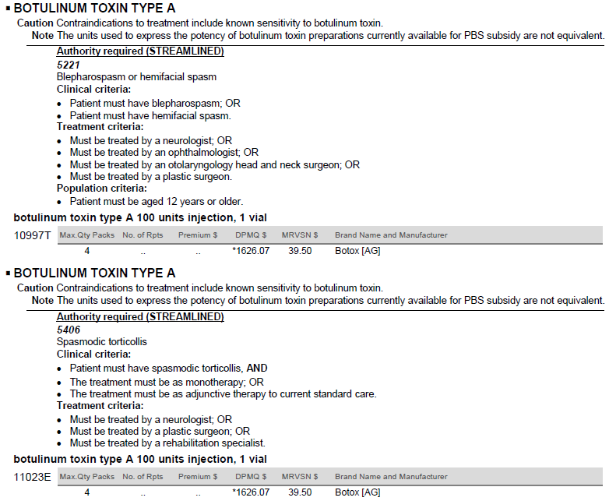
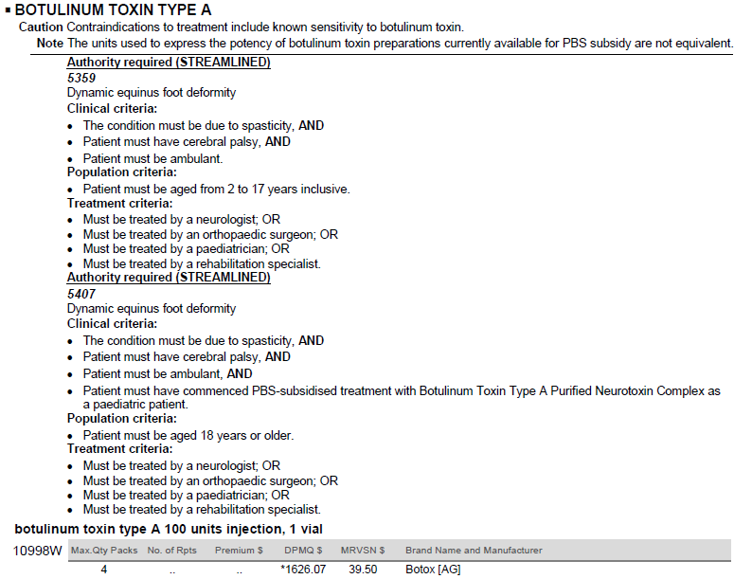

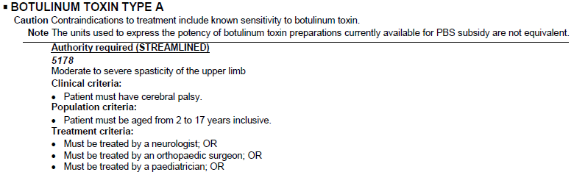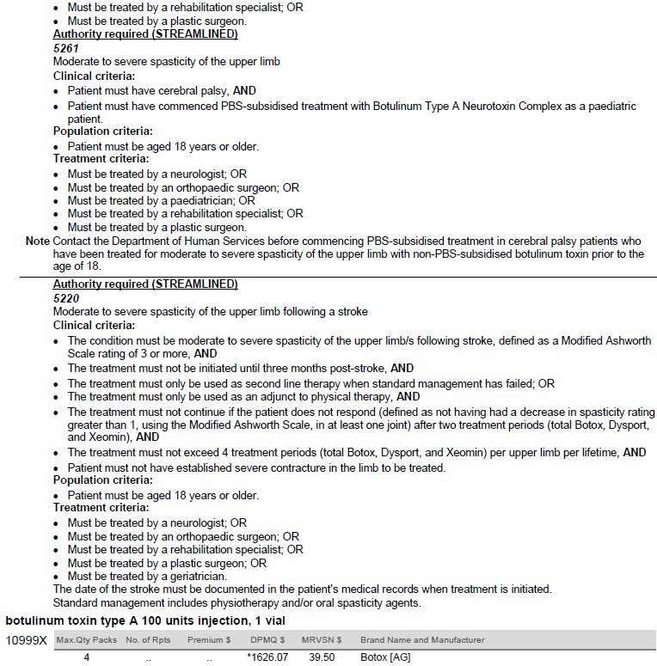

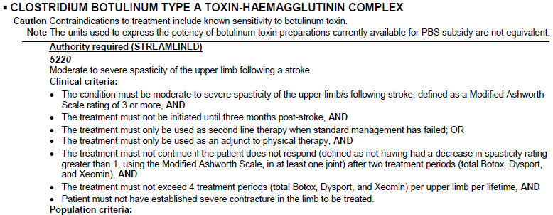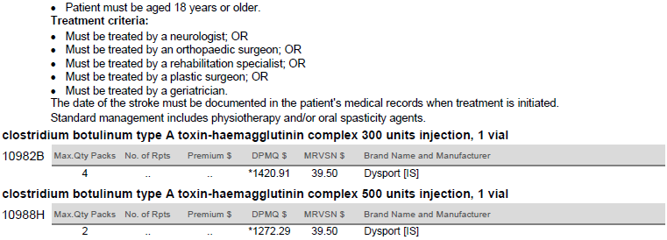
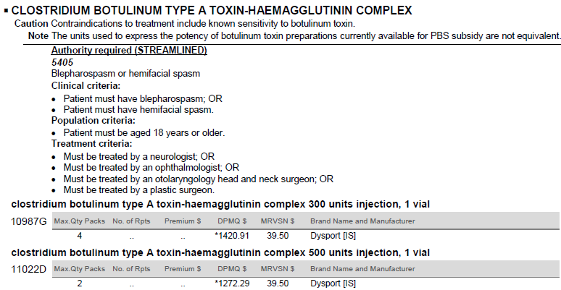

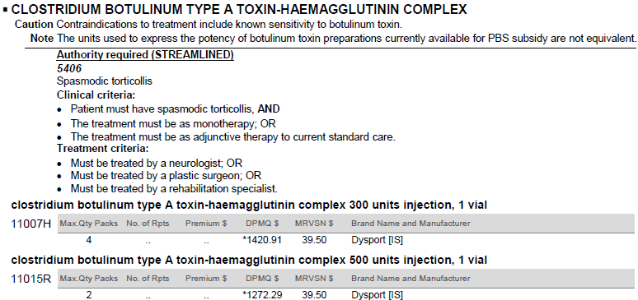
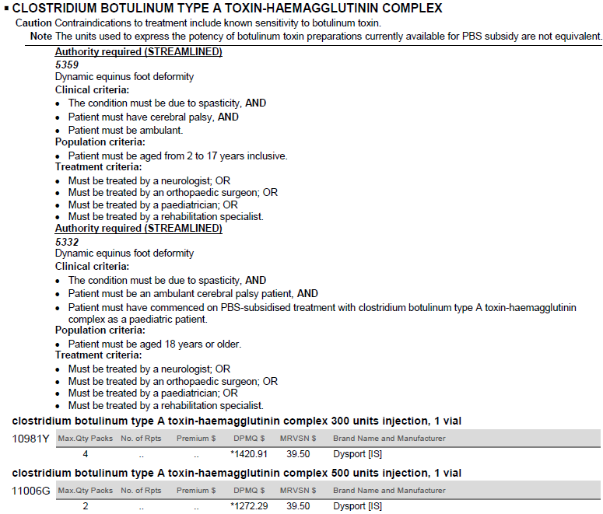

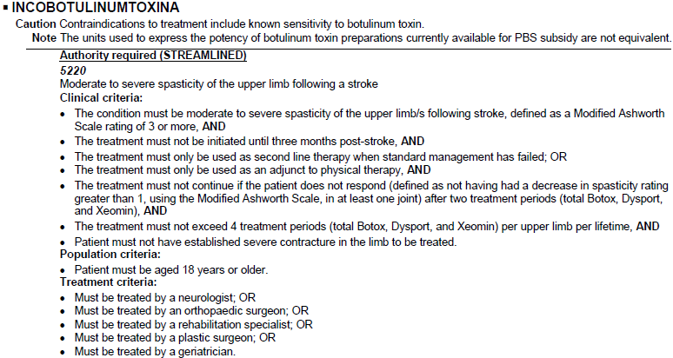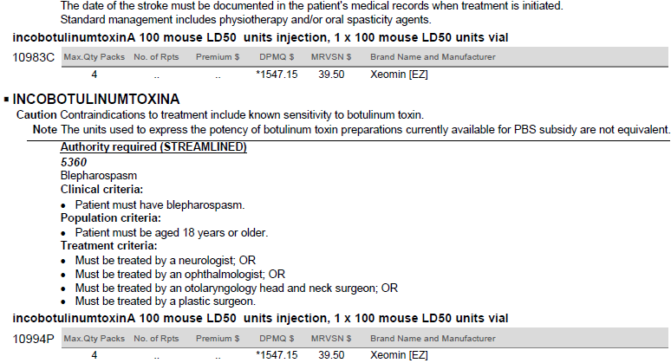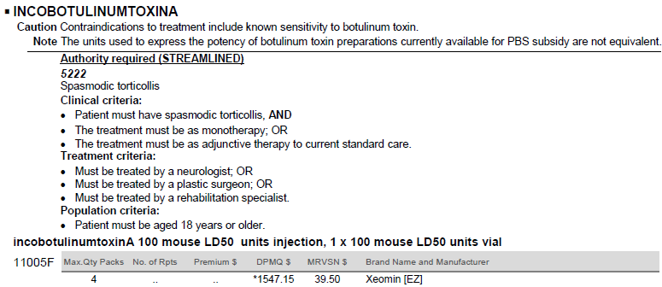
Appendix B: Time to resupply analysis for spasticity and dystonia PBS supplies for botulinum toxin by brand
To estimate the number of PBS initiations to treatment it was necessary to have an appropriate “lookback” period to determine if a patient has previously had the medicine. A time-to-prescription-resupply analysis was undertaken to determine the appropriate “lookback” period for determining initiations.
Table B: Statistics on time to resupply of botulinum toxin prescriptions by indication and brand
 |  | Brand
Days to resupply | Indication | Botox | Dysport | Xeomin
Median | Blepharospasm or hemifacial spasm | 97 | 99 | 99
 | Spasmodic torticollis | 95 | 97 | 87.5
 | Dynamic equinus foot deformity | 197 | * | **
 | Moderate to severe spasticity - upper limb, cerebral palsy | 201 | ** | **
 | Moderate to severe spasticity - upper limb, stroke | 182 | 170 | *
95th percentile | Blepharospasm or hemifacial spasm | 264 | 276 | 196
 | Spasmodic torticollis | 200 | 220 | 170
 | Dynamic equinus foot deformity | 497 | * | **
 | Moderate to severe spasticity - upper limb, cerebral palsy | 518 | ** | **
 | Moderate to severe spasticity - upper limb, stroke | 510 | 428 | *
99th percentile | Blepharospasm or hemifacial spasm | 450 | 461 | 256
 | Spasmodic torticollis | 360 | 341 | 368.5
 | Dynamic equinus foot deformity | 659 | * | **
 | Moderate to severe spasticity - upper limb, cerebral palsy | 693 | ** | **
 | Moderate to severe spasticity - upper limb, stroke | 631 | 574 | *
Number of prescriptions used in calculation of above statistics (n) | Blepharospasm or hemifacial spasm | 17,846 | 510 | 176
 | Spasmodic torticollis | 9,902 | 3,319 | 500
 | Dynamic equinus foot deformity | 1,613 | 67 | 0
 | Moderate to severe spasticity - upper limb, cerebral palsy | 719 | 0 | 0
 | Moderate to severe spasticity - upper limb, stroke | 399 | 176 | 15
* n < 100 prescriptions so statistic not calculated.
** No prescriptions for this indication
Note: The method allows any brand of botulinum toxin to resupply by any other. See methods section for details (explain why n is low).
Overall the median time to resupply for all brands was approximately 3 months for the dystonia indications. For the spasticity indications the median time to resupply was 6 to 7 months for Botox prescriptions and slightly less than 6 months for Dysport prescriptions for moderate to severe spasticity - upper limb, stroke.
It was desirable to count patients from the start of 2017. As the patient level prescription data starts on 1 September 2015, then a look back period of at least 16 months (487 days) was available. This was long enough for more than 99% of prescriptions for the dystonia indications to be resupplied (see Table B). For the spasticity indications this lookback period was long enough for approximately 95% of prescriptions to be resupplied. Thus the initiation count will be slightly overestimated for these indications because some apparent initiations will actually be re-initiations with a break of more than 16 months.
Given the infrequency of supply, it would not be reasonable to count prevalent patients by quarter as many patients on treatment will not receive a prescription in every quarter. A six month analysis period will give a reasonable estimate of patients on treatment for spasm indications, but not for the spasticity indications which have a median time to re-supply of more than six months. Thus to make a valid comparison of patients numbers across all 4 indications required that the analysis period be 12 months to be reasonably confident of detecting each patient on treatment in the period. There are only two complete 12 month periods (i.e. 2016 and 2017) for each indication.

Scheinberg A. Clinical use of botulinum toxin. Australian Prescriber 32(2) April 2009.
Botox Australian Approved Product Information. Allergan Australia Pty Ltd. Date of most recent amendment: 8 February 2018. Available from <https://www.ebs.tga.gov.au/>. Accessed April 2018
Dysport Australian Approved Product Information. Ipsen Pty Ltd. Date of most recent amendment: 13 March 2018. Available from <https://www.ebs.tga.gov.au/>. Accessed April 2018
Xeomin Australian Approved Product Information. Merz Australia Pty Ltd. Date of most recent amendment: 15 March 2018. Available from <https://www.ebs.tga.gov.au/>. Accessed April 2018
T11 – Botulinum Toxin injections, http://www9.health.gov.au/mbs/search.cfm?cat1=32&cat2=267&cat3=&adv=
http://www.pbs.gov.au/general/changes-to-certain-s100-programs/botulinum-toxin-program-frequently-asked-questions.pdf
http://www.mbsonline.gov.au/internet/mbsonline/publishing.nsf/Content/B55546F33798EF39CA257CD00081F202/$File/2003-05-MBS.pdf
https://www.cpregister.com/pubs/pdf/ACPR-Report_Web_2016.pdf
https://www.aihw.gov.au/getmedia/c420f6f1-0464-4f43-b55a-62f995a0f8f3/ah16-3-6-stroke.pdf.aspx
Valls-Sole J, and Defazio G. Blepharospasm: Update on Epidemiology, Clinical Aspects, and Pathophysiology Front Neurol. 2016; 7: 45.
http://www.pbs.gov.au/info/industry/listing/participants/public-release-docs/2017-06/botulinum-toxin-chronic-migraine-june-2017-meeting
Botulinum toxin for spasticity: a case for change to the Pharmaceutical Benefits Scheme, Anupam Datta Gupta and David H Wilson, Med J Aust || doi: 10.5694/mja17.00841, Published online: 29 January 2018

