Medicines for the treatment of melanoma

Drug utilisation sub-committee (DUSC)

May 2018

Abstract

Purpose
To review the utilisation of molecularly targeted drugs and immunotherapies listed on the PBS for the treatment of unresectable stage III or metastatic (stage IV) melanoma.

Date of listings and key listing amendments on the Pharmaceutical Benefits Scheme (PBS)
Drug name | Listing date | Details
Ipilimumab | 1 August 2013 | First listing for ipilimumab as monotherapy.
Dabrafenib | 1 December 2013 | First listing for dabrafenib in patients who are BRAF V600 mutation positive. For use in previously untreated patients and those developing intolerance to another BRAF inhibitor.
Trametinib | 1 August 2015 | First listing for trametinib for use in combination with dabrafenib for patients who are BRAF V600 mutation positive.
Pembrolizumab | 1 September 2015 | First listing for pembrolizumab for use as a sole PBS-subsidised therapy.
Dabrafenib and trametinib | 1 April 2016 | The restriction levels of dabrafenib and trametinib were changed from Authority Required (telephone) to STREAMLINED Authority.
Nivolumab | 1 May 2016 | First listing of nivolumab for use as a sole PBS-subsidised therapy.
Ipilimumab | 1 December 2016 | The clinical criteria were amended from “The treatment must be as monotherapy” to read “The treatment must be the sole PBS-subsidised therapy for this condition”.
Vemurafenib | 1 April 2017 | First listing of vemurafenib in patients who are BRAF V600 mutation positive. For use as monotherapy or in combination with cobimetinib.
Cobimetinib | 1 April 2017 | First listing of cobimetinib for use in combination with vemurafenib.
Pembrolizumab | 1 July 2017 | Listing of an additional strength, 100 mg concentrated injection, under the same conditions as the 50 mg listing.

Data Source
Data to assess the utilisation of medicines listed on the Pharmaceutical Benefits Scheme (PBS) was obtained from the Department of Human Services (DHS) PBS prescription claims database. Data on the utilisation of Medicare Benefits Schedule (MBS) services for mutation testing of the BRAF gene were extracted from the DHS Medicare Item Statistics Report.

Key Findings
- There was substantial growth in the overall utilisation of medicines to treat Stage III unresectable and Stage IV metastatic melanoma since the listing of pembrolizumab from 1 September 2015. In 2017, a total of 3,792 patients received a supply of a PBS subsidised medicine.
- For patients initiating therapy between 1 January and 30 June in 2016, the time on PBS therapy with pembrolizumab and BRAF targeted medicines was similar to the progression-free survival times observed in clinical trials. The duration of treatment with ipilimumab, for both induction and re-induction, was less than anticipated.
- Pembrolizumab was the most commonly dispensed medicine in patients first initiating on PBS therapy in 2016 or 2017. A relatively small proportion (less than 10 percent) of patients was supplied further episodes of therapy with a different drug regimen. Ipilimumab was the most commonly supplied drug regimen to patients who were refractory to their first episode of therapy.

Purpose of analysis
To review the utilisation of molecularly targeted drugs and immunotherapies listed on the PBS for the treatment of unresectable stage III or metastatic (stage IV) melanoma.

Background

Clinical situation
The American Joint Committee on Cancer classification system is generally used in Australia to classify the stage of melanoma. Earliest stage melanomas are referred to as Stage 0 and then range from Stages I to IV. The higher the stage, the more the cancer has spread. Patients with advanced or metastatic malignant melanoma (including unresectable Stage III or Stage IV disease) are eligible for targeted and immunological therapies available through the PBS. Such patients have pathological evidence of metastases (i.e. cancer cells break away from where they were first formed to develop as new cancers in other parts of the body).
Advanced melanoma is an aggressive cancer with a median survival of around six to nine months. In 2015, there were 1,520 deaths attributed to melanoma of the skin (AIHW, 2017b). The age-standardised mortality rate for melanoma of skin in Australia was 5.5 per 100,000 population (AIHW, 2017b). Mortality from melanoma was higher in males (8 per 100,000) compared to females (3.5 per 100,000), (AIHW, 2017b).
Guidelines for treatment selection are evolving with the availability of newer therapies that target cancer mutations or improve the immune response against melanoma cells (Atkins and Larkin, 2016; Garbe et al., 2016; Cancer Council of Australia, 2018). A revised draft of clinical practice guidelines for the diagnosis and management of melanoma was released by the Cancer Council Australia for public consultation at the time of this report. Melanoma is usually diagnosed at an early stage where surgical excision of the cancer is curative in the majority of cases (Cancer Council Australia, 2018; Sosman et al., 2018). In patients at a high risk of developing metastatic disease, adjuvant therapy after surgery using targeted drugs or immunotherapy may be beneficial in reducing the risk of cancer returning (Cancer Council Australia 2018; Sosman et al., 2018). Targeted drugs and immunotherapy are mostly used to treat metastatic melanoma. Treatment is selected based on the mutation status of the tumour or the presence of biomarkers.
The most common mutation identified for metastatic melanoma is BRAF V600, occurring in between 40 to 60 percent of cases (Hannan et al., 2017). In its consideration of a
co-dependent submission for dabrafenib in August 2013, the Medical Services Advisory Committee (MSAC) recommended that the best estimate for the prevalence of BRAF V600 mutations at the time of the submission was 44.5 percent based on Australian data reported by Menzies et al. (2012). A more recent retrospective Australian study reported a prevalence of 38 percent for BRAF V600 (Lyle et al., 2016). It is recommended that BRAF-mutated tumours are treated with a combination of a BRAF inhibitor and a mitogen-activated extracellular signal regulated kinase (MEK) inhibitor (Garbe et al., 2016). The addition of a MEK inhibitor is recommended because the mitogen-activated protein kinase (MAPK) pathway can be reactivated during therapy with BRAF inhibitors which can lead to an acquired resistance to BRAF inhibitors (Chen et al., 2017; Cheng et al., 2018). For patients without a BRAF V600 mutation, the use of targeted therapy with BRAF inhibitors is not indicated (Cheng et al., 2018; Sosman et al., 2018). Combination therapies with a BRAF and MEK inhibitor available through the PBS for patients who are positive for a BRAF V600 mutation include dabrafenib plus trametinib and vemurafinib plus cobimetinib.
The response to therapy with BRAF inhibitors is influenced by the presence of the V600E or V600K variant of a BRAF mutation, with the V600E variant shown to be more sensitive to treatment with BRAF inhibitors (Long et al., 2014; Hannan et al., 2017). The majority of BRAF mutations (80 to 90 percent of cases) involve the V600E variant and the V600K variant is present in around 10 percent of cases (Rubinstein et al., 2010; Hannan et al., 2017).
Immunotherapy is used to stimulate a person’s own immune system to detect and destroy melanoma cells. An immune response is activated by proteins on immune cells, referred to as “checkpoints” (Achkar and Tarhini, 2017). Melanoma cells can prevent an attack by the immune system by influencing the checkpoints on immune cells. Drugs are used to target the checkpoints to restore the response of the immune system against melanoma cells. Immunotherapies listed on the PBS include ipilimumab, nivolumab and pembrolizumab. Pembrolizumab and nivolumab target the PD-1 protein which prevents T cells from attacking other cells. Blocking the PD-1 protein enhances the immune response against melanoma by facilitating the action of T cells. Ipilimumab blocks another checkpoint on T cells, the cytotoxic T lymphocyte-associated antigen 4 (CTLA-4) protein.

Therapeutic Goods Administration (TGA) approved indications
The registered indications for the medicines are summarised in Table 1. Compared to the registered indications, the PBS restrictions for all listings (except ipilimumab) include an additional continuing criteria that the patient must have stable or responding disease. Other differences between the registered indication and PBS restriction criteria are noted for each listing in Table 1.

Table 1: Summary of registered indications as at March 2018
Drug name | ARTG start date | Registered indication(s)
Cobimetinib | 5 April 2016 | For use in combination with vemurafenib for the treatment of patients with unresectable or metastatic melanoma with BRAF V600 mutation.
Dabrafenib | 27 August 2013 | For use as monotherapy or in combination with trametinib for the treatment of patients with BRAFV600 mutation positive unresectable Stage III or metastatic (Stage IV) melanoma.  The PBS restriction has an additional clinical criterion that a patient must have a WHO performance status of 2 or less.
Ipilimumab | 4 July 2011 | For use as monotherapy for the treatment of patients with unresectable or metastatic melanoma.  The registered indication is broader than the PBS restriction in that patients can only have a maximum of 4 doses for induction treatment and 4 doses for re-induction therapy.
Nivolumab | 11 January 2016 | Nivolumab is indicated for the treatment of unresectable (Stage III) or metastatic (Stage IV) melanoma as:  - monotherapy; or  - in combination with ipilimumab for patients with M1c disease or elevated lactic dehydrogenase (LDH).  Compared to the TGA indication, additional requirements for the PBS restrictions include:  - nivolumab cannot be used in combination with PBS subsidised ipilimumab; and  - for patients who are BRAF V600 mutation positive, nivolumab must be used after prior therapy with a BRAF inhibitor unless not tolerated or contraindicated.  Nivolumab is also indicated for:  - locally advanced or metastatic squamous or non-squamous non-small cell lung cancer (NSCLC);  - advanced clear cell renal cell carcinoma;  - relapsed or refractory classical Hodgkin lymphoma (cHL);  - recurrent or metastatic squamous cell cancer of the head and neck; and  - locally advanced unresectable or metastatic urothelial carcinoma
Pembrolizumab | 8 March 2016 | For use as monotherapy for the treatment of unresectable or metastatic melanoma in adults.  Under the PBS restriction, a further criteria to the TGA indication is that patients who are BRAF V600 mutation positive must have prior therapy with a BRAF inhibitor unless not tolerated or contraindicated.  Pembrolizumab is also registered for the following indications:  - first-line treatment of patients with metastatic non-small cell lung carcinoma;  - recurrent or metastatic head and neck;  - relapsed or refractory classical Hodgkin Lymphoma; and  - locally advanced or metastatic urothelial carcinoma
Trametinib | 14 February 2014 | In combination with dabrafenib for the treatment of patients with BRAFV600 mutation positive unresectable Stage III or metastatic (Stage IV) melanoma.  As a monotherapy for the treatment of patients with BRAFV600 mutation positive unresectable Stage III or metastatic (Stage IV) melanoma and in whom either there is intolerance to BRAF inhibitors or BRAF inhibitors cannot be used.
Vemurafenib | 10 May 2012 | For the treatment of unresectable stage IIIC or stage IV metastatic melanoma positive for a BRAF V600 mutation.
Source: Australian Register of Therapeutic Goods, accessed in March 2018.

Dosage and administration
The recommended doses and methods of administration for the medicines included in the review are summarised in Table 2.

Table 2: Dosage and administration summary
Drug name, brand name and sponsor | Dose and frequency of administration
Cobimetinib (Cotellic), Roche Products Pty Ltd | The standard dosage when used as monotherapy or in combination with vemurafenib is 60 mg (three 20 mg tablets) once daily for 21 days, followed by a 7 day break, in a 28 day cycle.
Dabrafenib (Tafinlar), Novartis Pharmaceuticals Australia Pty Limited | The recommended dose when used as monotherapy or in combination with trametinib is 150 mg (two 75 mg capsules) twice daily. This corresponds to a total daily dose of 300 mg.
Ipilimumab (Yervoy), Bristol-Myers Squibb Australia Pty Ltd | The recommended dose of ipilimumab is 3mg/kg administered intravenously over 90 minutes every 3 weeks for a total of 4 doses.  Re-induction with 4 doses may be considered for patients who develop progressive disease after a prior complete response or partial response or after stable disease lasting longer than 3 months from the first tumour assessment. The recommended re-induction regimen is 3 mg/kg administered intravenously over a 90-minute period every 3 weeks for a total of 4 doses as tolerated.  Management of immune-related adverse reactions may require withholding of a dose. Dose reduction is not recommended. If a dose is withheld, ipilimumab is generally resumed at a dose of 3mg/kg every 3 weeks until administration of all 4 planned doses or 16 weeks from the first administration, whichever occurs earlier.
Nivolumab (Opdivo), Bristol-Myers Squibb Australia Pty Ltd | The recommended dose of nivolumab as a monotherapy is 3 mg/kg administered intravenously over 60 minutes every 2 weeks.
Pembrolizumab (Keytruda), Merck Sharp & Dohme (Australia) Pty Ltd | Pembrolizumab is administered as an intravenous infusion every 3 weeks.  The recommended dose for melanoma is either 2 mg/kg or a fixed dose of 200 mg.
Trametinib (Mekinist), Novartis Pharmaceuticals Australia Pty Limited | The standard dose of trametinib, used as monotherapy or in combination with dabrafenib, is 2 mg given orally once daily.
Vemurafenib (Zelboraf), Roche Products Pty Ltd | The recommended total daily dose of vemurafenib is 1920 mg. This comprises of 960 mg (four 240 mg tablets) given twice daily.
Source: Product Information for the PBS listings as at March 2018.
The current Product Information (PI) and Consumer Medicine Information (CMI) are available from the TGA (Product Information) and the TGA (Consumer Medicines Information).

PBS listing details
Table 3 presents the history of PBS listings, and amendments to the listings, in chronological order from the first listing of ipilimumab in August 2013 to March 2018.

Table 3. History of PBS listings and listing amendments
Drug name | Listing date | Details
Ipilimumab | 1 August 2013 | First listing for ipilimumab as monotherapy.
Dabrafenib | 1 December 2013 | First listing for dabrafenib in patients who are BRAF V600 mutation positive. For use in previously untreated patients and those developing intolerance to another BRAF inhibitor.
Trametinib | 1 August 2015 | First listing for trametinib for use in combination with dabrafenib for patients who are BRAF V600 mutation positive.
Pembrolizumab | 1 September 2015 | First listing for pembrolizumab for use as a sole PBS-subsidised therapy.
Dabrafenib and trametinib | 1 April 2016 | The restriction levels of dabrafenib and trametinib were changed from Authority Required (telephone) to STREAMLINED Authority.
Nivolumab | 1 May 2016 | First listing of nivolumab for use as a sole PBS-subsidised therapy.
Ipilimumab | 1 December 2016 | The clinical criteria were amended from “The treatment must be as monotherapy” to read “The treatment must be the sole PBS-subsidised therapy for this condition”.
Vemurafenib | 1 April 2017 | First listing of vemurafenib in patients who are BRAF V600 mutation positive. For use as monotherapy or in combination with cobimetinib.
Cobimetinib | 1 April 2017 | First listing of cobimetinib for use in combination with vemurafenib.
Pembrolizumab | 1 July 2017 | Listing of an additional strength, 100 mg concentrated injection, under the same conditions as the 50 mg listing.

Current PBS listing details are available from the PBS website.

Restrictions (as at March 2018)
Table 4 provides a summary of the restriction levels and the relevant restriction codes for each phase of treatment.

Table 4: Summary of restriction levels and restriction codes by treatment phase
Drug (ATC5) | Restriction level | Treatment  phase | Restriction code | PBS item code
Cobimetinib  (L01XE38) | Authority Required (STREAMLINED), General Schedule | Initial  treatment | 6839 | 11074W (20 mg)
 |  | Continuing treatment | 6803 | 11075X (20 mg)
Dabrafenib  (L01XE23) | Authority Required (STREAMLINED), General Schedule | Initial  treatment | 6044 | 2963Y (50 mg),  2846T (75 mg)
 |  | Continuing treatment | 6013 | 2954L (50 mg),  10003L (75 mg)
Ipilimumab  (L01XC11) | Authority Required (STREAMLINED), Chemotherapy Items | Induction Treatment | 6562 | 2638W (Private Hospital), 2641B (Public Hospital)
 |  | Re-Induction Treatment | 6585 | 2638W (Private Hospital), 2641B (Public Hospital)
Nivolumab  (L01XC) | Authority Required (STREAMLINED), Chemotherapy Items | Initial  Treatment 1 | 6095 (BRAF positive) | 10775D (Private Hospital)  10764M (Public Hospital)
 |  | Initial  Treatment 2 | 6070(BRAF negative) | 10775D (Private Hospital)  10764M (Public Hospital)
 |  | Continuing treatment | 6111 | 10745M (Public Hospital)  10748Q (Private Hospital)
Pembrolizumab (L01XC18) | Authority Required (STREAMLINED), Chemotherapy Items | Initial  Treatment | 6806 (BRAF positive), 6817 (BRAF negative) | 10475H (Private Hospital), 10493G (Public Hospital)
 |  | Continuing Treatment | 6801 | 10424P (Private Hospital), 10436G (Public Hospital)
Trametinib  (L01XE25) | Authority Required (STREAMLINED), General Schedule | Initial  Treatment | 6778 | 10403M (0.5 mg),  10382K (2 mg)
 |  | Continuing Treatment | 6752 | 10385N (0.5 mg),  10405P (2 mg)
Vemurafenib  (L01XE15) | Authority Required (STREAMLINED), General Schedule | Initial  Treatment | 6044 | 11076Y (240 mg)
 |  | Continuing Treatment | 6013 | 11081F (240 mg)
Source: Schedule of Pharmaceutical Benefits, March 2018.
Table 5 provides an abridged summary of the initial and continuing treatment criteria for each drug. For full details of the current PBS listings refer to the PBS website.

Table 5: Abridged summary of the initial and continuing criteria by drug
Drug | Initial criteria | Continuing criteria
Cobimetinib | - Administered with vemurafenib concomitantly.  - Must not have progressive disease when treated with a BRAF inhibitor. | - Given with vemurafenib concomitantly.  - Stable or responding disease.
Dabrafenib | - Positive for a BRAF V600 mutation.  - Must not have been treated previously with PBS subsidised therapy OR  - patient must have developed intolerance to another BRAF inhibitor of a severity necessitating permanent treatment withdrawal.  - WHO performance status of 2 or less. | - Stable or responding disease.
Ipilimumab | - Must be sole PBS-subsidised therapy.  - No prior treatment with ipilimumab.  - Up to 4 doses may be supplied at a maximum dose of 3 mg per kg every 3 weeks. | - Progressive disease after achieving an initial objective response to the most recent course of ipilimumab treatment (induction or re-induction).  - Up to a total of 4 doses may be supplied at a maximum dose of 3 mg per kg every 3 weeks.
Nivolumab | - BRAF V600 mutation (either positive or negative.  - If positive for a BRAF V600 mutation, must have progressed following treatment with a BRAF inhibitor (with or without a MEK inhibitor) unless contraindicated or not tolerated.  - No prior treatment with ipilimumab or a PD-1 (programmed cell death-1) inhibitor.  - Must be sole PBS-subsidised therapy for this condition.  - Up to a total of 9 doses may be supplied at a maximum dose of 3 mg per kg every 2 weeks. | - Sole PBS-subsidised therapy for this condition.  - Stable or responding disease.  - Must not exceed a maximum dose of 3 mg per kg every 2 weeks.
Pembrolizumab | - BRAF V600 mutation (either positive or negative).  - Must be sole PBS-subsidised therapy.  - No prior treatment with ipilimumab or a PD-1 (programmed cell death-1) inhibitor for this condition.  - If positive for a BRAF V600 mutation, must have progressed following treatment with a BRAF inhibitor (with or without a MEK inhibitor) unless contraindicated or not tolerated.  - Up to a total of 6 doses may be supplied at a maximum dose of 2 mg per kg every 3 weeks. | - Sole PBS-subsidised therapy for this condition.  - Stable or responding disease.  - Must not exceed a maximum dose of 2 mg per kg every 3 weeks.
Trametinib | - Administered with dabrafenib concomitantly.  - Must not have had progressive disease when treated with a BRAF inhibitor. | - Administered with dabrafenib concomitantly.  - Stable or responding disease.
Vemurafenib | - Positive for a BRAF V600 mutation.  - No prior PBS subsidised therapy OR  patient must have developed intolerance to another BRAF inhibitor of a severity necessitating permanent treatment withdrawal.  - WHO performance status of 2 or less. | - Stable or responding disease.
Source: Schedule of Pharmaceutical Benefits, March 2018.
Details of the PBS listings, including the list prices, maximum quantities and number of repeats, presentation, dose forms, brand name and manufacturer, are provided in Appendix 1.

Relevant aspects of consideration by the Pharmaceutical Benefits Advisory Committee (PBAC)
Molecularly targeted drugs

PBAC and MSAC considerations for co-dependent listings
Vemurafenib was the first co-dependent seeking a PBS listing. The July 2012 submission was considered by the PBAC and the Medical Services Advisory Committee (MSAC) respectively under the pilot co-dependent technology assessment process. The PBAC recommended that the definition of the biomarker should be any V600 mutation, rather than V600E only or limited to V600E and V600K. This definition was made on the basis that a large proportion of mutations were V600E and that there was underpowered evidence that the other V600 mutations predict a similar treatment.
As part of the March 2013 PBAC submission for dabrafenib, the sponsor submitted a minor submission to the April 2013 MSAC meeting for the associated BRAF V600 mutation testing. The MSAC considered the submission further at its August 2013 meeting. The MSAC concluded that there were likely to be low levels of false positive and false negative results based on the available concordance and analytical validity data for the BRAF test. MSAC noted that there was a possibility that some patients may require another biopsy if the quality of the first sample is poor or if there is an inadequate amount of tumour tissue to perform the test. However, the MSAC considered that there was only a small risk of a patient having an extra medical procedure. The MSAC considered that the best estimate for the prevalence of BRAF V600 mutations was 44.5 percent based on Australian data reported by Menzies et al., 2012). The MSAC recommended the listing of item 73336 to test for BRAF V600 mutation status in order to fulfil PBS criteria to access dabrafenib and vemurafenib.

Dabrafenib
Dabrafenib was recommended by PBAC in July 2013 for the treatment of patients with BRAF V600 mutation positive advanced (unresectable stage III) or metastatic (stage IV) melanoma.
The accepted main comparator was dacarbazine (DTIC) and dabrafenib was recommended on a cost-effectiveness basis to DTIC. The PBAC considered that vemurafenib and dabrafenib were therapeutically interchangeable and that if a resubmission was lodged for vemurafenib, a cost-minimisation approach to dabrafenib would be appropriate.
The PBAC noted that it was difficult to estimate the population size due to a lack of data on the prevalence of the BRAF mutation sub-types in the Australian population. The PBAC also noted that there may be some cost offsets for the use of ipilimumab with the availability of a BRAF inhibitor as first-line treatment.
For further details refer to the Public Summary Documents for the March 2012 and July 2013 PBAC meetings.

Trametinib
In November 2014, the PBAC recommended trametinib for use in combination with dabrafenib to treat BRAF V600 mutation positive unresectable stage III or metastatic (stage IV) malignant melanoma. The PBAC noted that the duration of effect of BRAF inhibitors is short-lived, and this was extended to some extent when BRAF inhibitors are used in combination with MEK inhibitors.
The PBAC noted that the revised financial estimates model forecasted an increased cost to the PBS compared to the March 2014 submission. The PBAC noted that this was driven by large increases in duration of exposure to dabrafenib. The assumed treatment duration was based on a trial that the PBAC did not consider was reliable. As such, the estimates were not considered to be accurate. The PBAC recommended a risk sharing arrangement to address the uncertainty in the financial estimates.
The PBAC considered that the claim of superior comparative effectiveness of trametinib plus dabrafenib combination treatment to dabrafenib monotherapy was reasonable. However there were incomplete trial results presented in the November 2014 submission from the randomised phase III COMBI-D and COMBI-V trials. The size of the treatment effect and duration of treatment benefit was uncertain. As such, a MES was proposed for the listing. If the size of benefit of trametinib modelled from BRF113220 was not realised in the final COMBI-D and COMBI-V results, the sponsor would be required to rebate the Commonwealth. Refer to the November 2014 Public Summary Document for further details of the conditions for the MES.
In July 2016 a submission was lodged to fulfil the requirements of the MES. PBAC recommended that the listing for trametinib should continue with a reduction in the price. There were no changes to the restriction.
For further details refer to the Public Summary Documents for the March 2014, November 2014 and July 2016 meetings.

Dabrafenib and trametinib
In November 2015, the PBAC recommended that the restriction levels of dabrafenib and trametinib be changed from Authority Required (telephone) to STREAMLINED Authority. There were no changes to the content of the restriction wording.
For further details refer to the Public Summary Document for the November 2015 meeting.

Vemurafenib
Vemurafenib was recommended for use in combination with cobimetinib in March 2016.
In April 2017, the PBAC recommended the listing of vemurafenib monotherapy for the treatment of patients with BRAF V600 mutation positive unresectable Stage III or Stage IV malignant melanoma. The listing was recommended on a cost-minimisation basis with dabrafenib.

Cobimetinib with vemurafenib
PBAC recommended in March 2016 the listing of vemurafenib in combination with cobimetinib for BRAF V600 mutation positive unresectable or metastatic melanoma. The recommended listing was on a cost-minimisation basis against dabrafenib plus trametinib.
It was recommended that cobimetinib plus vemurafenib share the current risk sharing arrangement with the sponsor of dabrafenib plus trametinib. There was no expected additional cost to Government above the financial caps in the existing risk sharing arrangement.
For further details refer to the Public Summary Document for the March 2016 meeting.
Immunotherapy drugs

Ipilimumab
PBAC recommended the listing of ipilimumab in November 2012 as monotherapy for the treatment of unresectable Stage III or Stage IV malignant melanoma. The listing was on the basis of cost-effectiveness over best supportive care (dacarbazine (DTIC) and fotemustine). The proposed restriction was for use after failure or intolerance to prior therapy for metastatic disease. The PBAC considered that it was not clinically appropriate to require patients to first use then fail toxic first-line chemotherapy. The PBAC requested that the PBS restriction should allow the use of ipilimumab in first-line.
The PBAC requested amendments to the financial estimates model to reflect a treatment algorithm incorporating the use of ipilimumab in first-line. The PBAC considered that the estimates for the number of patients diagnosed with unresectable Stage IIIC/IV melanoma each year and the number of patients eligible for ipilimumab were likely to be substantially higher than estimated by the sponsor. The PBAC noted that there were significant financial risks both from increased patient numbers by opening up the restriction for use in first-line and the potential for the use of 10 mg/kg doses, compared with 3 mg/kg doses, in a second-line setting. In its prior consideration of the March 2012 submission, the PBAC noted there were uncertainties with the dose of ipilimumab as the first-line trials used a higher dose of ipilimumab (10 mg/kg) whereas in the second-line setting the dose was 3 mg/kg. The PBAC considered that higher doses might be used in clinical practice based on doses used in the first-line study.
To manage the financial risk, the PBAC recommended that a risk sharing arrangement be established. This included a pay for performance arrangement to account for whether the extent of the survival benefit used in the calculation of cost-effectiveness of ipilimumab was realised in Australian clinical practice. Under such an arrangement, the PBAC commented that the sponsor would be expected to rebate the cost of the difference in performance between the observed versus predicted benefits of ipilimumab.
Prior submissions for ipilimumab for the treatment of melanoma were considered by the PBAC in July 2011 and March 2012. These submissions were not recommended due to an uncertain extent of clinical benefit, uncertain clinical place in therapy and a high and uncertain cost effectiveness.
In July 2016, the PBAC recommended that the clinical criteria for ipilimumab be changed from “The treatment must be as monotherapy” to read “The treatment must be the sole PBS-subsidised therapy for this condition”. The amendment would allow patients to access non-PBS therapy concomitantly with PBS-subsidised ipilimumab.
For further details refer to the Public Summary Documents for the July 2011, March 2012, November 2012, and July 2016 PBAC meetings.

Nivolumab
The PBAC (November 2015) recommended nivolumab as monotherapy to treat unresectable stage III or stage IV malignant melanoma on a cost-minimisation basis with pembrolizumab. The recommended criteria included that pembrolizumab must be used as a sole PBS subsidised therapy. It was recommended that the price of nivolumab resulted in the same cost per patient as pembrolizumab less the additional infusion costs from nivolumab from it higher frequency of infusions.
The estimates for utilisation were not updated from the original July 2015 submission. The PBAC agreed with the ESC’s view that the patient numbers were overestimated and should be based on a market share.
The July 2015 submission for nivolumab was not recommended due to several issues with the economic model and an inappropriate choice of comparator.
For further details refer to the Public Summary Documents for the July 2015 and November 2015 meetings.

Pembrolizumab
In March 2015, pembrolizumab was recommended by PBAC as monotherapy to treat unresectable stage III or metastatic (stage IV) malignant melanoma. The recommended criteria included that pembrolizumab must be used as a sole PBS subsidised therapy. An initial risk share arrangement was recommended to achieve the same cost per patient to the PBS for pembrolizumab as ipilimumab.
The recommended PBS listing was limited to patients with no prior use of ipilimumab. The PBAC noted that there was a high clinical need for pembrolizumab in patients who are refractory to ipilimumab. The PBAC accepted an undertaking by the sponsor to subsidise ongoing access to pembrolizumab for patients who are refractory to ipilimumab.
The PBAC supported the use of pembrolizumab following progression with dabrafenib therapy, including in combination with trametinib, for patients with a BRAF mutation because trial evidence indicated improved progression-free survival from such use.
The listing was recommended via a Managed Entry Scheme (MES) on the basis of a high clinical need. Early trial data suggested that pembrolizumab appeared more effective than ipilimumab but there was uncertainty about the size of the incremental treatment effect and duration of the benefit. As such, the PBAC considered that a MES was necessary.
The main parameters recommended for the MES relevant to the financial estimates included:
- The initial price of pembrolizumab would be determined on the basis of the current cost per patient for ipilimumab at its effective price.
- Expenditure caps would be based on the average cost of ipilimumab per patient and revised utilisation estimates based on the current PBS use of ipilimumab.
- A review of new evidence should be provided after maximal follow-up of the KN-006 trial.

The PBAC considered that the caps for the risk-share arrangement should reflect the duration of pembrolizumab therapy as determined by the duration of progression-free survival observed in the trial. The PBAC was concerned that progression-defining events may not be assessed as rigorously or as frequently in routine clinical practice compared to the KN-006 trial. The PBAC also noted that pembrolizumab may be continued in the setting of disease progression, irrespective of the wording of the PBS restriction.
The PBAC considered that epidemiological approach used in the submission had overestimated the number of patients who would be treated with pembrolizumab. It was noted that the uptake of ipilimumab had stabilised at around 800 patients per year. The PBAC considered that the submission’s estimate of 12 percent of patients starting ipilimumab after pembrolizumab, based on the KN-001 trial, was an underestimate as pembrolizumab would likely displace ipilimumab rather than replace it.
In March 2016, PBAC considered a submission which was lodged to fulfil the requirements of the MES for pembrolizumab. This submission brought to a close the MES component of the Deed of Agreement. The PBAC considered that the updated KN-006 trial results were similar to those provided in the March 2015 submission.
The PBAC rejected the sponsor’s request to increase the patient numbers contributing to the risk share arrangements. The basis for increasing the duration of treatment for more than one year was uncertain. PBAC also considered that the treatment uptake rates were biased upwards. It was noted that the patient numbers in the existing risk share arrangement had already been increased to account for more patients likely to be treated with pembrolizumab than ipilimumab.
The November 2016 submission for pembrolizumab sought a reconsideration of the Deed of Agreement in terms of the cost-effectiveness of pembrolizumab and the associated risk sharing arrangement caps.
The PBAC did not recommend any changes to the circumstances of pembrolizumab’s listing. The PBAC considered that the submission did not demonstrate a greater effectiveness or safety of pembrolizumab compared with nivolumab. Therefore a change in the cost per patient of pembrolizumab was not justified. The PBAC considered that there remained some uncertainty about the appropriate annual numbers of eligible patients for PD-L1 inhibitors in melanoma. The PBAC considered that smaller increases in the annual risk sharing arrangement caps may be reasonable.
A separate submission was considered in November 2016 seeking to list a 100 mg strength of pembrolizumab with the same indications and dosing regimen as the current PBS listing of the 50 mg strength. The PBAC considered that there would be no financial impact from listing the 100 mg concentrated injection as it had the same price per mg as the currently listed form of pembrolizumab and the cost per patient was capped under the Deed of Agreement.

For further details refer to the Public Summary Documents for the March 2015, March 2016, and November 2016 meetings.
In March 2018, the PBAC recommended an amendment to the existing PBS restrictions for pembrolizumab for the treatment of unresectable Stage III or Stage IV malignant melanoma. The amendment would allow a weight-based dosing regimen of 2 mg/kg or a fixed dose of 200 mg every three weeks. The PBAC recommended that the maximum amount per prescription be adjusted to 200 mg.
For further details refer to the PBAC Outcome Statement for the March 2018 meeting.

Nivolumab
A submission was submitted for the July 2018 PBAC meeting for nivolumab for the adjuvant treatment for resectable melanoma. At the time of reporting, the submission had not been considered by PBAC.

Nivolumab and ipilimumab
A submission was submitted for the July 2018 PBAC meeting for combination therapy with nivolumab and ipilimumab for the treatment of unresectable (Stage III) or metastatic disease (Stage IV) melanoma. At the time of reporting, the submission had not been considered by PBAC.

Previous reviews by the DUSC
A predicted versus actual analysis of ipilimumab and dabrafenib was reviewed by DUSC in October 2015. It was noted that only a low proportion of patients receiving induction treatment with ipilimumab continue to re-induction therapy. An increase in the use of ipilimumab in early 2014 was noted. This may have indicated the prior use of dabrafenib to elicit a rapid tumour shrinkage before commencing on ipilimumab which is a slower acting immunotherapy. DUSC considered that analyses of switching and cycling between medicines should be included in future utilisation estimates.
In its consideration of the DUSC review in November 2015, the PBAC noted that the utilisation of dabrafenib was growing and the use of ipilimumab had stabilised. The PBAC considered that ipilimumab and dabrafenib were being used within their listed indications and their utilisation during the initial years of listing was as expected. The PBAC noted that the market for ipilimumab and dabrafenib would be impacted by the entry of pembrolizumab.
For further details, refer to the Public Release Document for the October 2015 DUSC meeting and the PBAC outcome statement for the November 2015 meeting.

Methods
All analyses of PBS data were undertaken using SAS Enterprise Guide version 7.12.
PBS prescription data were extracted from the DHS prescription claims database from
1 August 2013 (the date of the first listing of the immunological and targeted therapies for melanoma) to December 2017 based on the date of dispensing (supply) for the following medicines: cobimetinib, dabrafenib, ipilimumab, nivolumab, pembrolizumab, trametinib and vemurafenib.

The number of prevalent patients was determined by counting the number of people supplied at least one PBS prescription using person specific numbers (non-identifying) in the data for the specified time periods. Patient initiation was defined as the date of supply of the first PBS or RPBS prescription.

Identifying drug regimens for the BRAF inhibitors
Under the PBS restrictions, cobimetinib must be coadministered with vemurafenib and trametinib must be coadministered with dabrafenib. Vemurafenib and dabrafenib may also be used as monotherapy.
The median number of days to re-supply for the BRAF inhibitors was 28 days and this was assumed to be the standard number of coverage days for a prescription for a BRAF drug either as monotherapy or in combination with a MEK inhibitor. The method used to identify the co-administration of BRAF and MEK inhibitor drugs is described in Appendix 2.
A sensitivity analysis was undertaken to test the detection of drug regimens depending on the assumption for the number of coverage days for a prescription. Varying the standard coverage days to twice or three times the median days to re-supply (i.e. 56 days and 84 days, respectively), had no impact to counts of the number of patients on each drug regimen.

Investigation of the co-administration of the immunotherapies
The PBS restrictions do not allow for the co-administration of immunotherapies. An investigation was undertaken to identify if there was any potential co-administration of the following drug combinations: ipilimumab with nivolumab; ipilimumab with pembrolizumab; and pembrolizumab with nivolumab. The method is described in Appendix 2.

Length of treatment analyses
The time on therapy was examined using a Kaplan-Meier analysis in a cohort of patients who first initiated on PBS therapy between January to June, 2016 (n=919). This six month cohort was selected to capture the listings of nivolumab and trametinib in 2016 and to allow at least an 18 month follow-up period from the last initiators in the cohort in June 2016. A patient cohort from 2015 was not examined given the high number of initiators in this year (Figure 1) resulting in a substantial change in the market (Figure 4).
The median time between supplies across all medicines was 21 days because of the dominance of pembrolizumab in the market. It was assumed that a patient had a treatment break if the total time from the date of their last supply exceeded three times the median time between supplies (i.e. 63 days). A patient was assumed to be continuing treatment if the time from their last supply was less than 63 days from the data cut-off date (31 December 2017) and they were censored from the treatment duration analyses.
A sensitivity analysis was undertaken by changing the treatment break assumption to 84 days (i.e. assuming that the median time between supplies was 28 days and multiplying the median time by three). Applying the assumption of 84 days marginally reduced the mean time of BRAF targeted therapy as the first drug regimen from 279 days (Table 7) to 267 days but had negligible impact on the other time on treatment results when compared to basing the assumption on 63 days.

Induction and re-induction therapy with ipilimumab
The number of doses and quantity dispensed for induction and re-induction treatment with ipilimumab was investigated in patients who first initiated on this drug between July and December, 2016. There was a greater number of patients who were supplied ipilimumab during this time period to inform the analysis when compared to the first half of 2016 and late 2015. The inclusion of patients to December 2016 allowed a minimum of 12 months follow-up to the analysis end date (31 December 2017).
Streamlined Authority codes were used to determine if the supply of ipilimumab was for induction or re-induction. There were few instances of missing Authority codes in the DHS prescription claims data. The relevant codes were:
- Induction: 4265; 4251; 4254; 4235; and 6562.
- Re-induction: 4256; 4252; 4261; 4236; and 6585.

Drug sequence analysis
The sequence of drug regimens supplied was examined in two patient cohorts who first initiated on PBS therapy between January to June in 2016 or between January to June in 2017. For each initiating cohort, the supplies for each patient were analysed from the date of their first initiation to 31 December 2017.
The analysis of 2017 initiators does not capture the complete supply for the whole cohort as patients initiating towards the end of June 2017 who only have up to six months of follow up. However this analysis was undertaken to show the preliminary impact of the listings of vemurafenib and cobimetinib from April 2017.
Prior to the sequence analysis, supplies for the BRAF inhibitors, either as monotherapy of in combination with MEK inhibitors, were first classified into drug regimens as described above.

BRAF mutation testing analysis
MBS item 73336 is available to provide subsidised testing to determine the BRAF V600 status to access dabrafenib or vemurafenib. The number of MBS services for Item 73336 was extracted from the Department of Human Services MBS Item Report. The data extraction was based on the date the service was processed by Medicare Australia.

Results

Analysis of drug utilisation

Incident and prevalent patients
Table 6 presents the overall number of incident and prevalent patients by year and the number of patients by mode of action and by drug.
In 2014, there was a similar proportion (around 50 percent) of patients first initiating on a BRAF inhibitor compared to immunotherapy with ipilimumab. In 2017, the majority of patients were initiated on immunotherapy. Around half of patients (52 percent) were initiated on a PD-1 inhibitor, around one-third (34 percent) were initiated on a BRAF inhibitor and the remainder (13 percent) commenced on ipilimumab.

Table 6: Number of incident and prevalent patients
 | 2013ª | 2014 | 2015 | 2016^{h} | 2017^{i}
Incident patients
Total number of incident patients | 480 | 1,467 | 1,522 | 1,798 | 2,001
Number of incident patients by drug regimen:
Dabrafenib + trametinib |  |  | 250^{d} | 554 | 570
Dabrafenib | 81^{b} | 712 | 331 | 17 | 12
Ipilimumab | 399 | 755 | 333 | 86 | 278
Nivolumab |  |  |  | 93e | 209
Pembrolizumab |  |  | 608^{c} | 1,043 | 899
Vemurafenib+cobimetinib |  |  |  |  | 20^{f}
Vemurafenib |  |  |  |  | 11^{g}
Prevalent patients
Total number of prevalent patients | 480 | 1,642 | 2,149 | 3,031 | 3,792
Source: DHS prescription claims database, based on the date of supply. Data extracted on 21 March 2018.
Note:
ª Part year figures from August 2013 (first listing of ipilimumab) to December.
^{b} Part year figure. Dabrafenib first listed in December 2013.
^{c} Part year figure from September 2015 (first listing of pembrolizumab).
^{d} Part year figure from August 2015 when trametinib was first listed.
^{e} Part year figure from May 2016 when nivolumab was first listed.
^{f} Part year figure from April 2017 when cobimetinib was first listed.
^{g} Part year figure from April 2017 when vemurafenib was first listed.
^{h} In 2016, there were 5 patients with a supply record for trametinib which were not identified as being coadministered with dabrafenib.
^{i} In 2017, there were two patients with a supply record for cobimetinib which were not identified as being coadministered with vemurafenib.

There was a decline in the number of patients first initiating on ipilimumab after pembrolizumab became available in 2015 (Figure 1). The utilisation of ipilimumab remained at low levels until December 2016. Over 2017, there was an increase in the number of patients initiating on ipilimumab of around 23 patients per month on average (Figure 1).
A large number of grandfathered patients were expected to access pembrolizumab when it was first listed. As anticipated, there was a substantial increase in the number of incident PBS patients after pembrolizumab became available in September 2015 (Figure 1). The listing of the alternative PD-1 inhibitor, nivolumab, in May 2016 had a relatively small impact on the overall number of incident patients (Figure 1). First initiation to BRAF targeted therapy had remained stable since April 2014 at around 50 patients per month. The listing of the MEK inhibitors in August 2015 (trametinib) and April 2017 (cobimetinib) had minor overall impacts on the number of patients initiating on BRAF targeted therapy (Figure 1).

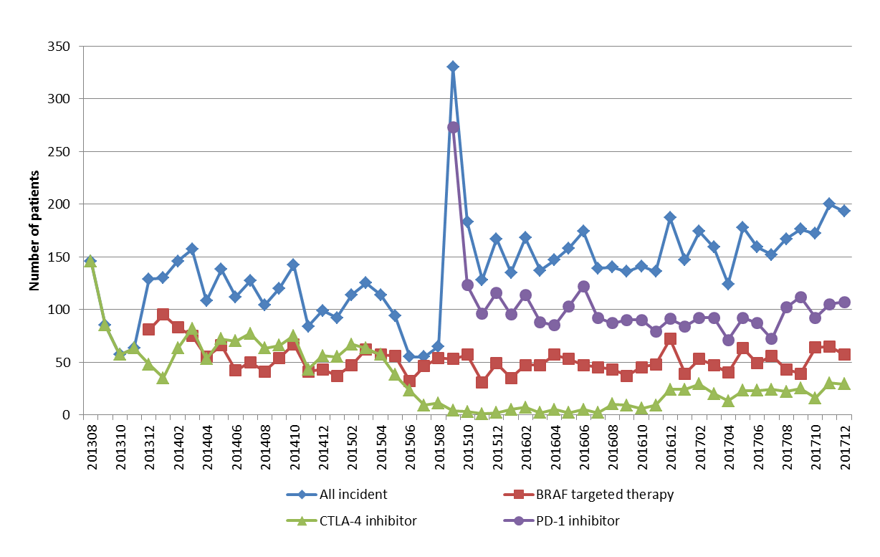
Figure 1. Overall number of incident patients by month and the number of patients by drug mode of action
Source: DHS prescription claims database, based on the date of supply. Data extracted on 9 March 2018.
Note: BRAF targeted therapy – dabrafenib, dabrafenib+trametinib, vemurafenib, vemurafenib+cobimetinib; CLTA-4 inhibitor – iplilimumab; PD-1 inhibitor – pembrolizumab, nivolumab.

The overall number of prevalent (treated) patients has increased substantially since the listing of PD-1 inhibitors from 2015 (Figure 2). This was mainly from a high number of incident patients initiating on pembrolizumab when it first listed (Figure 1). There was a small net growth in the number of patients treated with a BRAF inhibitor or ipilimumab over 2017 (Figure 2).
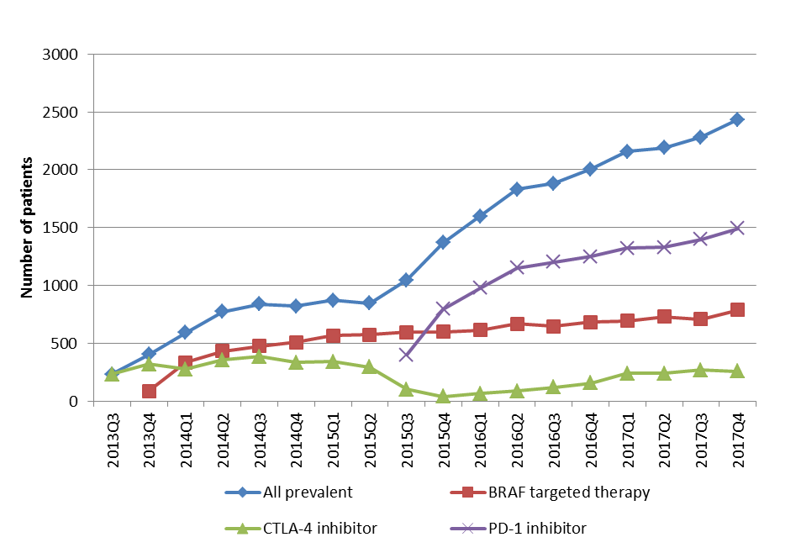
Figure 2. Overall number of prevalent patients by quarter and the number of patients by drug mode of action
Source: DHS prescription claims database, based on the date of supply. Data extracted on 9 March 2018.
Note: BRAF targeted therapy – dabrafenib, dabrafenib+trametinib, vemurafenib, vemurafenib+cobimetinib; CLTA-4 inhibitor – iplilimumab; PD-1 inhibitor – pembrolizumab, nivolumab.

Patient demographics
In 2017, the PBS population mainly consisted of persons aged 60 years or more (mean 68 years and median 69 years for incident patients), (Figure 3b). In 2014, the mean age of the PBS incident population was 63 years (median 64 years). When compared to 2014 (Figure 3a), the growth in utilisation occurred mostly in older persons.

- 2014
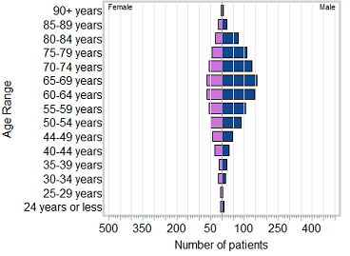
- 2017

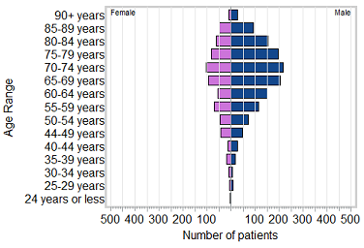
Figure 3. Pyramid chart for patients first initiating to PBS therapy for melanoma by age and gender in 2014 vs. 2017
Source: DHS prescription claims database, based on the date of supply. Data extracted on 23 May 2018.

Overall utilisation
In 2017, the majority of patients (62 percent) were treated with PD-1 inhibitors (Table 6, Figure 4, Figure 5). For these patients, 86 percent were supplied pembrolizumab with a relatively small proportion (14 percent) of patients supplied with nivolumab (Table 6, Figure 4).
Around one-fifth (19 percent) of patients were supplied ipilimumab in 2017. Since the availability of PD-1 inhibitors, there was a slight decline in the overall proportion of patients supplied BRAF targeted drugs from 76 percent in 2015 to 67 percent in 2017 (Table 6). The uptake of vemurafenib and cobimetinib was low as these drugs were recent listings (April 2017) at the time of the analysis.
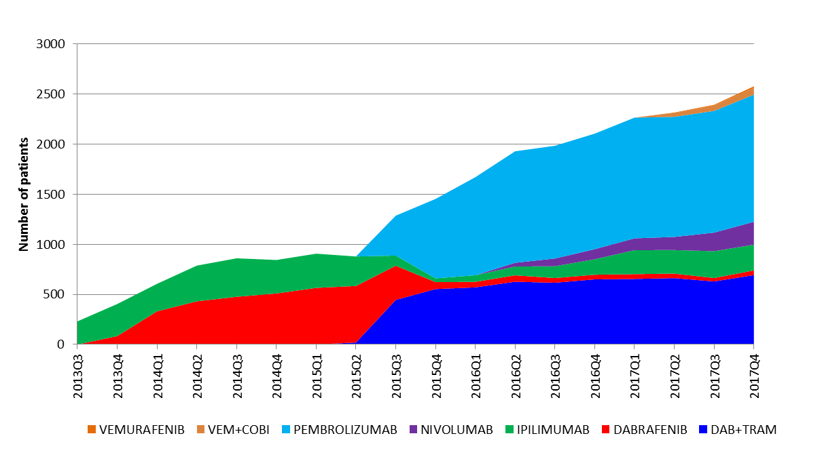

Figure 4. Number of prevalent patients by quarter and by drug
Source: DHS prescription claims database, based on the date of supply. Data extracted on 20 March 2018.
Note: DAB+TRAM, dabrafenib+trametinib; VEM+COBI, vemurafenib+cobimetinib.

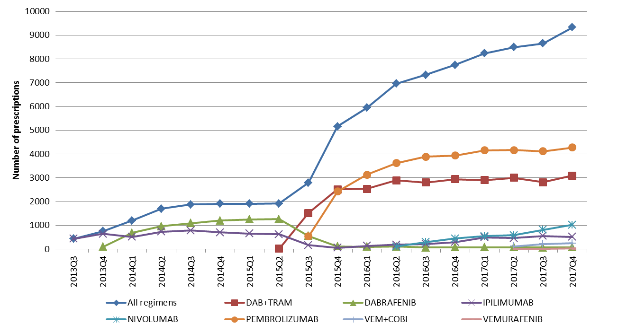

Figure 5. Number of prescriptions by quarter and by drug
Source: DHS prescription claims database, based on the date of supply. Data extracted on 9 March 2018.
Note: DAB+TRAM, dabrafenib+trametinib; VEM+COBI, vemurafenib+cobimetinib.

Time on therapy
Time on the melanoma medicines was examined in a six month cohort of patients who first initiated on PBS therapy between January to June 2016 (n=919).
For all drug regimens supplied, the median time on therapy, excluding breaks in treatment, was 249 days (around 8 months), (Table 7, Figure 6).
As the first drug regimen supplied to a patient, the time on treatment with pembrolizumab was similar to BRAF targeted therapy (Table 7, Figure 7). A small number of patients were initiated on ipilimumab and nivolumab and the time on therapy with these agents should be viewed with caution (Table 7, Figure 7).
There were only a small number of patients who received more than two different drug regimens (Table 7). Very few patients were supplied BRAF medicines as their second drug regimen (Table 7).

Table 7: Duration of treatment by the number of drug regimens supplied for initiators between January to June 2016
 | N | Censored | Mean (days) | Median (days) | Lower 95% CI (days) | Upper 95% CI (days)
All drug regimens received | (n=919)
Including breaks | 898 | 249 | 338 | 337 | 266 | Not reached
Excluding breaks | 21 | 7 | 312 | 249 | 224 | 278
Time on first drug regimen | (n=919)¹
BRAF targeted therapy³ | 286 | 62 | 279 | 202 | 151 | 240
Ipilimumab | 26 | 0 | 37 | 38 | 19 | 60
Nivolumab | 21 | 7 | 239 | 251 | 56 | Not reached
Pembrolizumab | 586 | 151 | 276 | 206 | 170 | 232
Time on second drug regimen | (n=210) ¹
BRAF targeted therapy³ | x | NR | NR | NR | NR | NR
Ipilimumab | 107 | 20 | 61 | 46 | 38 | 59
Nivolumab | 14 | x | 137 | 74 | x | 373
Pembrolizumab | 86 | 16 | 142 | 63 | 43 | 84
Time on third drug regimen | (n=37) ¹
BRAF targeted therapy³ | 13 | 8 | 64 | 98 | Not estimated | Not estimated
Ipilimumab | 16 | x | 63 | 33 | 17 | 67
Nivolumab² | x | x | NR | NR | NR | NR
Pembrolizumab² | x | x | NR | NR | NR | NR
Source: DHS prescription claims database, based on the date of supply. Data extracted on 20 March 2018.
Note:
¹ Treatment breaks included.
² Not analysed as few patients were supplied PD-1 inhibitors after two different prior drug regimens.
³ Either supplied as monotherapy or used in combination with a MEK inhibitor.

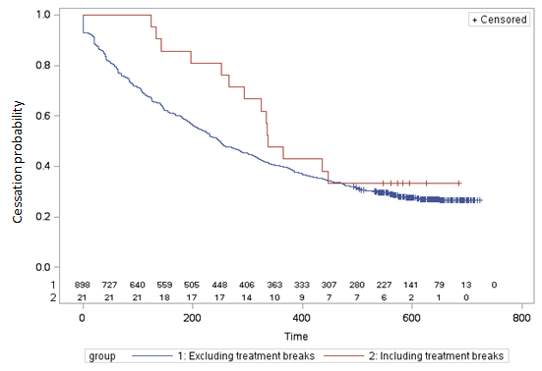
Figure 6. Kaplan-Meier estimate for time to treatment discontinuation for any supply of melanoma medicine for initiators between January to June 2016

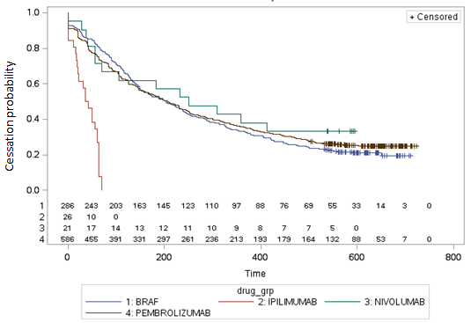
Figure 7. Kaplan-Meier estimate for time to treatment discontinuation of the first melanoma medicine supplied to a patient for initiators between January to June 2016
Note: BRAF targeted therapy – dabrafenib, dabrafenib+trametinib, vemurafenib, vemurafenib+cobimetinib; CLTA-4 inhibitor – iplilimumab; PD-1 inhibitor – pembrolizumab, nivolumab.

There were 210 patients in the 2016 initiating cohort who were supplied a second drug regimen. The time on their second drug regimen was compared between the prior drug regimen that was supplied (Table 8). There were only a small number of cases (n=10) where patients first initiated on dabrafenib monotherapy, nivolumab or vemurafenib with cobimetinib who were supplied another drug regimen. As such, these cases were excluded from the analysis (Table 8).

Table 8: Duration of treatment on a second drug regimen by the prior drug regimen supplied, including treatment breaks, for initiators between January to June 2016
 | N | Mean (days) | Median (days) | Lower 95% CI (days) | Upper 95% CI (days)
Dabrafenib+trametinib to ipilimumab | 37 | 55 | 43 | 22 | 56
Dabrafenib+trametinib to nivolumab | 14 | 137 | 74 | 3 | 373
Dabrafenib+trametinib to pembrolizumab | 80 | 105 | 63 | 43 | 84
Pembrolizumab to ipilimumab | 66 | 68 | 55 | 32 | 64
Source: DHS prescription claims database, based on the date of supply. Data extracted on 20 March 2018.
Most patients progressing to a second drug regimen were supplied dabrafenib with trametinib as their first drug regimen (Table 8). The time on pembrolizumab and nivolumab as a second drug regimen was relatively similar (Table 8). For patients first initiating on pembrolizumab who switched to ipilimumab (n=66), their mean time on ipilimumab was around 2.4 months (Table 8).

Induction and re-induction treatment with ipilimumab
The number of doses of ipilimumab supplied as induction or re-induction therapy was examined in patients initiating on ipilimumab between July to December 2016 (n=176), (Table 9). A July to December 2016 was selected because there was a greater number of patients who were supplied ipilimumab during this time period to inform the analysis when compared to the first half of 2016 and late 2015. The inclusion of patients to December 2016 allowed a minimum of 12 months follow-up to the analysis end date (31 December 2017).
A maximum of four doses is allowed under the PBS restriction for both a course of induction and re-induction therapy. As reported in the October 2015 DUSC review, very few patients were supplied re-induction therapy (Table 9).
Table 9: Number of doses for induction and re-induction therapy with ipilimumab
 | Number of patients | Mean (doses) | Median (doses)
Induction | 176 | 2.2 | 2
Re-induction | 7 | 2.1 | 2
Source: DHS prescription claims database, based on the date of supply. Data extracted on 20 March 2018.

The dose of ipilimumab for induction and re-induction therapy is 3 mg per kg. The PBS quantities dispensed for induction and re-induction for the six-month initiating cohort are summarised in Table 10. Based on the mean quantities dispensed, the average body mass for the PBS population was around 80 kg.

Table 10: PBS quantities for induction and re-induction therapy with ipilimumab
 | N | Mean (mg) | Median (mg) | Min (mg) | Max (mg)
Induction | 176 | 243 | 237 | 135 | 383
Re-induction | 7 | 234 | 219 | 141 | 300
Source: DHS prescription claims database, based on the date of supply. Data extracted on 20 March 2018.

Drug regimen sequences
For both the 2016 and 2017 initiating cohorts, most patients were first initiated on pembrolizumab (Tables 11 and 12). The second most common therapy for both cohorts was dabrafenib with trametinib (Tables 11 and 12).
Compared to 2016, a greater number of patients commenced therapy with ipilimumab in 2017 (Tables 11 and 12).
A relatively small number of initiators were supplied a different drug regimen. Patients refractory to pembrolizumab were mainly supplied ipilimumab as their next drug regimen (Tables 11 and 12).
January to June 2016 cohort
Table 11: Drug regimen sequences for initiators in 2016 between January to June
Drug regimen sequence | n | Proportion
PEMBROLIZUMAB | 517 | 56.3%
DAB+TRAM | 111 | 12.1%
PEMBROLIZUMAB -> IPILIMUMAB | 64 | 7.0%
DAB+TRAM -> PEMBROLIZUMAB | 57 | 6.2%
IPILIMUMAB | 26 | 2.8%
DAB+TRAM -> IPILIMUMAB | 23 | 2.5%
NIVOLUMAB | 18 | 2.0%
DAB+TRAM -> PEMBROLIZUMAB -> IPILIMUMAB | 11 | 1.2%
Other - total | 92 | 10.0%
Total number of initiators | 919
Source: DHS prescription claims database, based on the date of supply. Data extracted on 20 March 2018.
Note: DAB+TRAM, dabrafenib with trametinib.

January to June 2017 cohort
Table 12: Drug regimen sequences for initiators in 2017 between January to June
Drug regimen sequence | n | Proportion
PEMBROLIZUMAB | 399 | 42.4%
DAB+TRAM | 131 | 13.9%
IPILIMUMAB | 126 | 13.4%
NIVOLUMAB | 66 | 7.0%
PEMBROLIZUMAB -> IPILIMUMAB | 46 | 4.9%
DAB+TRAM -> PEMBROLIZUMAB | 45 | 4.8%
DAB+TRAM -> IPILIMUMAB | 27 | 2.9%
DAB+TRAM -> VEM+COBI | 15 | 1.6%
Other - total | 86 | 9.1%
Total number of initiators | 941
Source: DHS prescription claims database, based on the date of supply. Data extracted on 20 March 2018.
Note: DAB+TRAM, dabrafenib with trametinib; VEM+COBI, vemurafenib with cobimetinib
¹ At the time of the analysis, vemurafenib and cobimetinib were only recent PBS listings for 1 April 2017.

BRAF mutation testing
An MBS item (Item 73336) is available to enable patients to have a subsidised BRAF test in order to fulfil the eligibility requirements for PBS listed dabrafenib and vemurafenib. The annual number of MBS services in 2016 versus 2017 was 1,945 and 2,172, respectively (Figure 8). The year-on-year growth in services between 2016 and 2017 was around 11 percent.
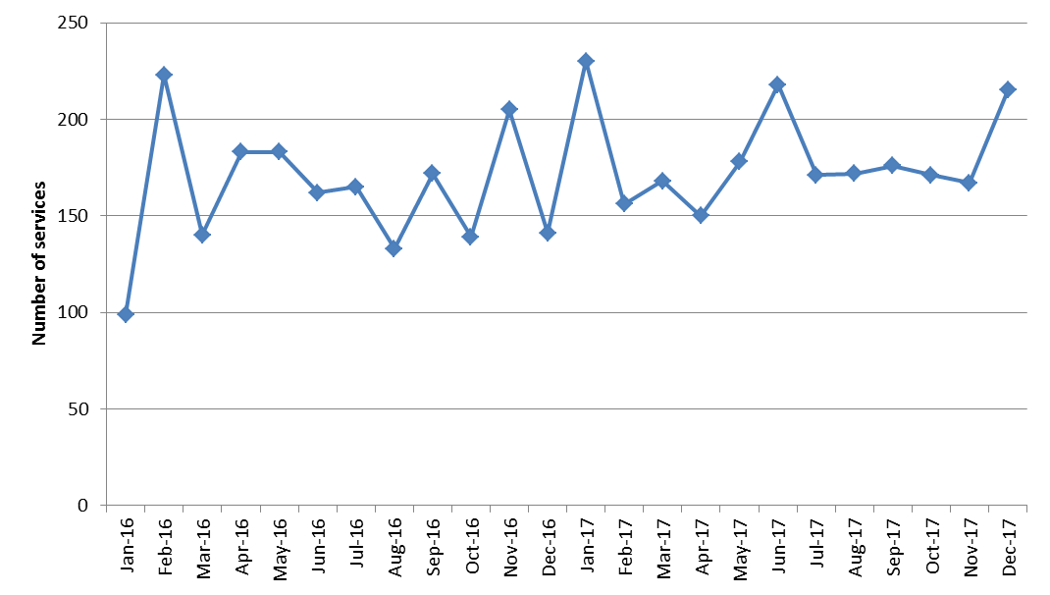

Figure 8. The number of MBS services for BRAF testing (Item 73336), 2016 and 2017
Source: Department of Human Services Medicine Item Reports. Accessed on 17 April 2018 at: http://medicarestatistics.humanservices.gov.au/statistics/mbs_item.jsp
Figures are based on the date of processing.

In its consideration of BRAF testing in August 2013, MSAC concluded that the rate of re-testing would be low. The number of MBS services appeared to be consistent with the number of patients first initiating on PBS therapy. In 2017 there were 2,001 incident patients (Table 6) compared to 2,172 MBS services for that year.
The number of tests may be higher than the number of initiations to PBS therapy for several reasons, including:
- there is a lag between when a patient is tested and their initiation on PBS therapy; and
- not all patients undergoing a test and being diagnosed as having a BRAF mutation will be prescribed a PBS subsidised medicine.

Discussion
Melanoma of the skin is the fourth most commonly diagnosed cancer in Australia (AIHW, 2017a). The disease is more common in males compared to females, as seen in the PBS population where in 2017, 68 percent were males (Figure 3b). In 2014, there were 13,134 new cases of melanoma of the skin at a rate of 62 per 100,000 population in males versus 41 per 100,000 in females, standardised by age (AIHW, 2017b).
Patients treated with PBS medicines for unresectable stage III or metastatic (stage IV) melanoma were mostly aged 60 years or more (Figure 3b). In 2017, the mean age of the PBS population was 66 years compared with 62 years in 2014 (Figure 3a).

Treatment uptake
There was substantial growth in the treated population following the listing of pembrolizumab in 2015 (Table 6, Figure 4). The uptake of the BRAF targeted therapies and ipilimumab remained at similar levels over 2017 (Figure 4).
The use of ipilimumab increased during 2014 (Figure 4). The DUSC review of ipilimumab and dabrafenib in October 2015 noted that during this period, there were few patients who initiated ipilimumab after PBS subsidised dabrafenib. DUSC considered that the rise in use of ipilimumab at this time could indicate patients moving to second-line ipilimumab on the PBS after receiving targeted therapies outside the PBS, such as through access programs or clinical trials.
After the listing of pembrolizumab in 2015, the utilisation of ipilimumab declined until Quarter 2 in 2016 where an increase in the use of ipilimumab occurred (Figure 4). This may relate to the PBAC recommendation in July 2016 to change the clinical criteria for ipilimumab to read “The treatment must be the sole PBS-subsidised therapy for this condition”. In making this recommendation, the PBAC noted that the utilisation of PBS subsidised ipilimumab may change as under the revised criteria, patients could access non-PBS subsidised therapy to be used concomitantly with ipilimumab.
XXXXXXXXXXXXXXXXXXXXXXXXXXXXXXXXXXXXXXXXXXXXXXXXXXXXXXXXXXXXXXXXXX
XXXXXXXXXXXXXXXXXXXXXXXXXXXXXXXXXXXXXXXXXXXXXXXXXXXXXXXXXXXXXXXXX
XXXXXXXXXXXXXXXXXXXXXXXXXXXXXXXXXXXXXXXXXXXXXXXXXXXXXXXXXXXXXX
On 1 April 2016, the restriction levels of dabrafenib and trametinib were changed from Authority Required (telephone) to STREAMLINED Authority. The utilisation of combination therapy with dabrafenib and trametinib grew by 16 percent between Quarter 1 and Quarter 2 in 2016 after the amendment to the restriction criteria (Figure 4). Since the fourth quarter of 2016, growth in the utilisation of dabrafenib with trametinib has been modest (around 3 percent growth per quarter).

Use of drug regimens
It is recommended in clinical guidelines that patients with BRAF-mutated tumours should be treated with a BRAF inhibitor and MEK inhibitor (Garbe et al., 2016; Sosman et al., 2018). The prevalence of BRAF V600 mutations for metastatic melanoma is reported to be around 40 percent in Australia (Menzies et al., 2012; Lyle et al., 2016). In 2017, 36 percent of PBS patients were supplied a BRAF targeted medicine (Table 6) which is similar to the estimated prevalence of BRAF mutations in Australia.
Around one-fifth of patients first initiating on PBS therapy in 2016 or 2017 was subsequently supplied another PBS subsidised drug regimen (Tables 11 and 12). A low overall number of patients refractory to first-line therapy was also reported in the October 2015 DUSC review of ipilimumab and dabrafenib. As noted for the October 2015 review, this may be due to participation in access programs or clinical trials, patients not requiring or being unsuitable for further PBS therapy or death.
Drug regimen analyses were conducted in two six-month patient cohorts who first initiated on PBS therapy in 2016 and 2017. This was intended to compare the prescribing practices before and after the listing of nivolumab in 2016, the listings of vemurafenib and cobimetinib in April 2017, and the change to ipilimumab’s listing in December 2016 which may have resulted in its concomitant use with non-PBS nivolumab. For the 2016 initiating cohort, around 30 percent received a BRAF inhibitor as their first therapy and the remaining patients were mainly initiated on pembrolizumab (Table 11). In 2017, there was a shift towards ipilimumab and nivolumab having a higher market share (Table 12).
Of the 210 patients in the 2016 cohort who became refractory to their first treatment, 48 percent received a supply of ipilimumab as their second therapy (Table 11). Most patients supplied ipilimumab as their second drug regimen had a prior supply of pembrolizumab (Table 11).

As vemurafenib and cobimetinib were listed towards the end of the analysis period, there was minimal detection of their use in the 2016 initiating cohort.

Consistent with the PBS restriction criteria, there were no instances identified of a potential co-administration of PBS subsidised immunotherapies (i.e. ipilimumab, nivolumab and pembrolizumab) in either the 2016 or 2017 initiating cohorts.

Time on therapy
The progression-free survival (PFS) times reported in clinical trials for dabrafenib, ipilimumab, pembrolizumab and vemurafenib are shown in Table 16.

Table 16. Progression-free survival times for dabrafenib, ipilimumab, pembrolizumab and vemurafenib
Drug | Progression-Free Survival time (months) | Trial
Dabrafenib | Median PFS 6.9ª | BREAK-3
Ipilimumab | Median PFS 2.8^{b} | CT-020
Pembrolizumab | Median PFS 8.2^{c} | KN-001
Vemurafenib | Median PFS 5.3^{d} | BRIM 3
Note: PFS, progression free survival; OS, overall survival.
ª Public Summary Document, dabrafenib, March 2013. Section 8.
^{b} Hodi et al. (2010).
^{c} Public Summary Document, pembrolizumab, March 2015, para 6.13.
^{d}Public Summary Document, vemurafenib, July 2012, Section 8.

Time on PBS therapy was examined in a six month cohort of patients first initiating on treatment between January and June in 2016. This initiating cohort was selected to allow a sufficient follow-up time of at least 18 months to the analysis end date of 31 December 2017. At the time of the analysis, there was insufficient data to fully examine the treatment times for nivolumab, which first listed in May 2016, and vemurafenib and cobimetinib which listed in April 2017. As discussed above, a relatively low proportion of patients were supplied more than one different drug regimen. As such, the duration for the first drug regimen is discussed here.

The time on the first episode of PBS therapy with pembrolizumab and BRAF targeted medicines was similar to the PFS times observed in clinical trials. The median time on PBS subsidised pembrolizumab was 7 months compared with a PFS of 8.2 months reported in the KN-001 trial (Table 7, Table 16). PBS patients had a median time on BRAF targeted therapy of 7 months which was similar to the PFS reported for dabrafenib in the BREAK-3 trial (6.9 months) and vemurafenib in the BRIM 3 trial (5.3 months), (Table 7, Table 16).

The time on ipilimumab as a first episode of PBS therapy (median 1.4 months) was less than the PFS of 2.8 months reported in the CT-020 trial (Table 7, Table 16). For patients initiating on ipilimumab between July to December 2016, the mean number of doses of ipilimumab supplied as induction or re-induction therapy was less than the maximum number of four doses allowed under the PBS restrictions (Table 9). The previous DUSC review of ipilimumab in October 2015 noted that there was a shorter duration of ipilimumab therapy than predicted. Contributing factors were considered to be adverse events associated with ipilimumab, including steroid-refractory ipilimumab-induced colitis, and the availability of newer therapies.

DUSC consideration
DUSC noted that the utilisation of the melanoma medicines was growing with no indication of a slowing in growth in the market over the short-term. DUSC noted that the listing of pembrolizumab had resulted in substantial growth in the overall market beyond expectations.
DUSC noted that the most common mutation identified for metastatic melanoma is BRAF V600. In its consideration of a co-dependent submission for dabrafenib in August 2013, the Medical Services Advisory Committee (MSAC) recommended that the best estimate for the prevalence of BRAF V600 mutations at the time of the submission was 44.5 percent. DUSC noted that for the total prevalent population in 2017, 38 percent were supplied PBS-listed BRAF targeted therapy which was less than the estimated prevalence of BRAF mutations in the Australian population (approximately 45 percent). DUSC considered that the lower than expected uptake of BRAF targeted therapy relative to the estimated prevalence of BRAF mutation may have occurred for two main reasons:
- clinical trials are common for metastatic melanoma. DUSC considered that some patients who would otherwise have been supplied a BRAF targeted therapy may have received alternative therapy through participation in clinical research; or
- some BRAF mutation positive patients may be first initiating on a PD-1 inhibitor rather than initiating on BRAF targeted therapy prior to PD-1 inhibitor therapy. The PBS restrictions (authority required streamlined) for nivolumab and pembrolizumab allow first line use in BRAF V600 mutation positive patients only if a BRAF inhibitor (with or without a MEK inhibitor) is contraindicated or not tolerated. DUSC considered there was clinician support to have a choice between the use of BRAF/MEK or PD-1 inhibitor therapy as front-line treatment for the BRAF positive population. DUSC noted that the time on PD-1 inhibitors in second-line after BRAF therapy was shorter than expected. DUSC commented that it was possible that BRAF positive patients may have a longer time on PD-1 therapy if it was allowed for use in first-line. However, DUSC considered there was limited data at this time to establish if PD-1 inhibitors were as effective as BRAF targeted therapy first-line to treat BRAF positive patients. DUSC considered that extending the use of PD-1 inhibitor therapy to first-line for this patient group would not increase the total number of patients treated first-line. However an increase in PBS expenditure could be expected from patients remaining on PD-1 treatment for longer if available for first line use in BRAF positive patients compared to when it is used following BRAF therapy. Clinicians may want to be able to individualise treatment for BRAF positive patients. For patients with fast spreading tumour, BRAF with MEK inhibitor therapy may be preferred while for other patients, PD-1 therapy may be better for long-term survival.
DUSC noted that melanoma mostly affected people over 70 years of age and that the age of the PBS population was increasing. In 2017, the median age was 68 years compared with 63 years in 2014. DUSC noted that for the key clinical trials considered by the PBAC at the time of the submissions for the BRAF targeted therapies, PD-1 inhibitors and ipilimumab, the trial populations were younger than the current PBS population. Due to the treatment of older and frail patients, the efficacy of the drug regimens and the choice of therapy in practice may differ to that observed in clinical trials previously considered by the PBAC, discussed further below.
DUSC considered the time on PBS therapy, which was examined in a six month cohort of patients first initiating treatment between January and June 2016 with follow-up to December 2017. DUSC compared these findings to the progression-free survival (PFS) times observed in clinical trials presented in Table 16 of the report. DUSC agreed with including further data in Table 7 of the report for the PBAC and for the Public Release Document on the number of patients remaining on therapy at the end date of the analysis (i.e. 31 December 2017) to aid in the interpretation of the maturity of the time on treatment results. While some patients in the January to June 2016 initiating cohort remained on therapy on the analysis end date, the median time on treatment had been reached within the follow-up period. The time on the first episode of PBS therapy with pembrolizumab and BRAF targeted medicines was similar to the PFS times observed in clinical trials. The time on ipilimumab as a first episode of PBS therapy (median 1.4 months) was less than the PFS of 2.8 months reported in the CT-020 trial (Table 7, Table 16). DUSC noted that the duration of second-line therapy with either ipilimumab or a PD-1 inhibitor after prior BRAF targeted therapy was substantially less than expected. DUSC considered that the efficacy of second-line therapy appeared to be very limited. DUSC commented that the lower than expected median time on therapy in practice may reflect that PBS clients are less fit than the trial populations which tend to include younger patients. DUSC commented that it would be informative to know whether later trials involve patients who are more representative of the PBS population. DUSC considered that fact of death data was required in order to fully interpret the time on PBS therapy data.
DUSC noted Tables 11 and 12, and related text on pages 32 and 33 of the report, in relation to drug regimen analyses were amended to correct errors. DUSC requested that the revised tables and accompanying text are included in the Public Release Document for the report and for the PBAC.
DUSC noted that the entry of pembrolizumab substantially changed the patterns of utilisation of melanoma medicines. The most common sequence of treatment was monotherapy with PD-1 inhibitors. DUSC considered pembrolizumab had a higher market share than nivolumab as it was listed first. DUSC also considered that the choice of PD-1 therapy was influenced by their frequency of administration. DUSC noted pembrolizumab was given every three weeks versus nivolumab which was administered every two weeks. DUSC noted that the utilisation of dabrafenib plus the MEK inhibitor, trametinib, had remained stable since the listing of trametinib. DUSC noted that the uptake of vemurafenib plus cobimetinib had been low since the constituent drugs were first listed from April 2017. DUSC considered that the utilisation of vemurafenib plus cobimetinib was likely to stay low because it is more complex to administer this drug regimen compared to dabrafenib plus trametinib.
DUSC noted that from 1 July 2016 the PBS restriction for ipilimumab was amended which allows its use with non-subsidised nivolumab. DUSC considered that the growth in the utilisation of ipilimumab since Quarter 2 2016 was a result of its restriction change. DUSC considered it was likely that ipilimumab was now being increasingly used in combination with non-PBS nivolumab.
The breakdown of utilisation by age and gender was presented for the prevalent population for 2014 versus 2017. DUSC requested that this information is also presented for the incident population in the Public Release Document for the report. DUSC noted that the age at first treatment was increasing which may have influenced the use of less toxic therapies over time, such as the shift from ipilimumab to PD-1 inhibitors. DUSC discussed whether the use of immunotherapy in older and frail patients was appropriate as survival in such patients when treated with immunotherapy was not well known. DUSC noted that the PBS listings for pembrolizumab and nivolumab do not include performance status in the clinical criteria. The PBAC may wish to consider whether the inclusion of Eastern Cooperative Oncology Group (ECOG) criteria in the PBS restrictions for pembrolizumab and nivolumab would be beneficial towards the quality use of these medicines.
A complete course of ipilimumab is four doses. DUSC noted that for both induction and re-induction, patients were receiving a mean of around two doses. DUSC further noted that re-induction with ipilimumab was uncommon. DUSC considered that the earlier than expected discontinuation of ipilimumab was likely due to toxicity rather than from disease progression. DUSC considered that the use of fewer doses of ipilimumab in practice may have implications for its cost-effectiveness as the clinical benefits realised from the use of fewer doses is uncertain.
An MBS item (Item 73336) is available to enable patients to have a subsidised BRAF test in order to fulfil the eligibility requirements for PBS listed dabrafenib and vemurafenib. DUSC did not identify any concerns with the utilisation of the BRAF mutation test. DUSC noted that for 2017, the number of tests was similar to the number of patients initiating on BRAF targeted therapy (2,172 tests versus 2,001 incident patients). DUSC commented that the number of tests was slightly higher than the number of patients due to the following likely factors: some re-testing may occur with a better biopsy sample; patients not progressing to treatment due to mortality or patient choice not to be treated with BRAF therapy. DUSC also noted there is a lag between when a test is done and the supply of treatment.

DUSC actions
- DUSC requested that the report be provided to the PBAC.
- DUSC requested the PBAC consider whether it may be appropriate to revise the PBS restrictions to allow the use of PD-1 inhibitors first-line for BRAF positive patients.
- DUSC requested the following additions to the report for provision to the PBAC and for the Public Release Document:
- to include the number of patients remaining on treatment in Table 7;
- amended versions of Tables 11 and 12 and amend accompanying text; and
- to include pyramid charts and the mean and median patient age for the incident population for 2014 and 2017.

Context for analysis
The DUSC is a Sub Committee of the Pharmaceutical Benefits Advisory Committee (PBAC). The DUSC assesses estimates on projected usage and financial cost of medicines.
The DUSC also analyses data on actual use of medicines, including the utilisation of PBS listed medicines, and provides advice to the PBAC on these matters. This may include outlining how the current utilisation of PBS medicines compares with the use as recommended by the PBAC.
The DUSC operates in accordance with the quality use of medicines objective of the National Medicines Policy and considers that the DUSC utilisation analyses will assist consumers and health professionals to better understand the costs, benefits and risks of medicines.
The utilisation analysis report was provided to the pharmaceutical sponsors of each drug and comments on the report were provided to DUSC prior to its consideration of the analysis.

Sponsor’s comments
Bristol-Myers Squibb Australia Pty Ltd:
The sponsor had no comment.

Merck Sharp & Dohme (Australia) Pty Ltd:
MSD notes that the actual patient numbers in the DUSC report closely aligned with the patient numbers in MSD’s pembrolizumab melanoma submissions.

Novartis Pharmaceuticals Australia Pty Limited:
The sponsor had no comment.

Roche Products Pty Ltd:
The sponsor had no comment.

Disclaimer
The information provided in this report does not constitute medical advice and is not intended to take the place of professional medical advice or care. It is not intended to define what constitutes reasonable, appropriate or best care for any individual for any given health issue. The information should not be used as a substitute for the judgement and skill of a medical practitioner.
The Department of Health (DoH) has made all reasonable efforts to ensure that information provided in this report is accurate. The information provided in this report was up-to-date when it was considered by the Drug Utilisation Sub-committee of the Pharmaceutical Benefits Advisory Committee. The context for that information may have changed since publication.
To the extent provided by law, DoH makes no warranties or representations as to accuracy or completeness of information contained in this report.
To the fullest extent permitted by law, neither the DoH nor any DoH employee is liable for any liability, loss, claim, damage, expense, injury or personal injury (including death), whether direct or indirect (including consequential loss and loss of profits) and however incurred (including in tort), caused or contributed to by any person’s use or misuse of the information available from this report or contained on any third party website referred to in this report.

References
Achkar, T. and Tarhini, A.A. The use of immunotherapy in the treatment of melanoma. Journal of Hematology & Oncology 2017; 10:88.
(AIHW 2017a). Australian Institute of Health and Welfare 2017. Cancer in Australia 2017. Cancer series no.101.Cat. no. CAN 100. Canberra: AIHW.
(AIHW 2017b). Australian Institute of Health and Welfare (AIHW) 2017 Australian Cancer Incidence and Mortality (ACIM) books: melanoma of the skin Canberra: AIHW. <http://www.aihw.gov.au/acim-books>.
Atkins, M.B. and Larkin, J. Immunotherapy Combined or Sequenced With Targeted Therapy in the Treatment of Solid Tumors: Current Perspectives. JNCI J Natl Cancer Inst 2016; 108(6): djv414.
(Cancer Council Australia and Australian Cancer Network guidelines 2008). Australian Cancer Network Melanoma Guidelines Revision Working Party. Clinical Practice Guidelines for the Management of Melanoma in Australia and New Zealand. Cancer Council Australia and Australian Cancer Network, Sydney and New Zealand Guidelines Group, Wellington (2008).
Cancer Council Australia 2018 Clinical Practice Guidelines for the Diagnosis and Management of Melanoma. Draft guidelines accessed on 18 April 2018 at: https://wiki.cancer.org.au/australia/Guidelines:Melanoma
Chen, P., Chen, F. and Zhou, B. Therapeutic efficacy and safety of combined BRAF and MEK inhibition in patients with malignant melanoma: a meta-analysis OncoTargets and Therapy 2017; 10: 5391–5403.

Cheng, L., Lopez-Beltran, Massari, F. et al. Molecular testing for BRAF mutations to inform melanoma treatment decisions: a move toward precision medicine. Modern Pathology (2018) 31, 24–38.

Fisher, R. and Larkin, J. Vemurafenib: a new treatment for BRAF-V600 mutated advanced melanoma. Cancer Management and Research 2012; 4: 243–252.
Garbe, C., Peris, K., Hauschild, A. et al. Diagnosis and treatment of melanoma. European consensus-based interdisciplinary guideline - Update 2016. European Journal of Cancer 2016; 63: 201-217.
Hannan, E.J., O’Leary, D.P., MacNally, S.P. et al. The significance of BRAF V600E mutation status discordance between primary cutaneous melanoma and brain metastases - The implications for BRAF inhibitor therapy. Medicine 2017; 96:48.
Hodi, S.F., O’Day, S.J., McDermott, D.F. et al. Improved survival with ipilimumab in patients with metastatic melanoma. N Engl J Med 2010; 363(8): 711-723.
Long, G.V., Stroyakovskiy, D., Gogas, H. et al. Combined BRAF and MEK Inhibition versus BRAF Inhibition Alone in Melanoma. N Engl J Med 2014; 371:1877-88.
Menzies, A.M., Haydu, L.E., Visintin, L. et al. Distinguishing Clinicopathologic Features of Patients with V600E and V600K BRAF-Mutant Metastatic Melanoma. Clin Cancer Res 2012; 18:3242-3249.

Rubinstein, J.C., Sznol, M., Pavlick, A.C. et al. Incidence of the V600K mutation among melanoma patients with BRAF mutations, and potential therapeutic response to the specific BRAF inhibitor PLX4032. Journal of Translational Medicine 2010; 8:67.
Sosman, J.A. (2018) Molecularly targeted therapy for metastatic melanoma. UpToDate, January 2018. Accessed on 20 February 2018 at: https://www.uptodate.com

Appendices
- PBS listing details as at March 2018.
- Illustration of methods used to identify co-administered drugs.

Appendix 1: Listing details as at March 2018
Item code | Max units or amount | Number of repeats | Dispensed price | Drug name, form and strength | Brand name, manufacturer
11074W | Max units: 63 | 3 | DPMQ $8,187.55 | Cobimetinib, Tablet 20 mg | Cotellic, Roche Products Pty Ltd
11075X | Max units: 63 | 5 | DPMQ $8,187.55 | Cobimetinib, Tablet 20 mg | Cotellic, Roche Products Pty Ltd
02846T | Max units: 120 | 3 | DPMQ $8,761.69 | Dabrafenib, Capsule 75 mg (as mesilate) | Tafinlar, Novartis Pharmaceuticals Australia Pty Limited
02954L | Max units: 120 | 5 | DPMQ $5,890.97 | Dabrafenib, Capsule 50 mg (as mesilate) | Tafinlar, Novartis Pharmaceuticals Australia Pty Limited
02963Y | Max units: 120 | 3 | DPMQ $5,890.97 | Dabrafenib, Capsule 50 mg (as mesilate) | Tafinlar, Novartis Pharmaceuticals Australia Pty Limited
10003L | Max units: 120 | 5 | DPMQ $8,761.69 | Dabrafenib, Capsule 75 mg (as mesilate) | Tafinlar, Novartis Pharmaceuticals Australia Pty Limited
02638W | Max amt: 360 mg | 3 | DPMA $48,161.91 | Ipilimumab, Injection concentrate for I.V. infusion 200 mg in 40 mL | Yervoy, Bristol-Myers Squibb Australia Pty Ltd
02638W | Max amt: 360 mg | 3 | DPMA $48,161.91 | Ipilimumab, Injection concentrate for I.V. infusion 50 mg in 10 mL | Yervoy, Bristol-Myers Squibb Australia Pty Ltd
02641B | Max amt: 360 mg | 3 | DPMA $47,459.99 | Ipilimumab, Injection concentrate for I.V. infusion 50 mg in 10 mL | Yervoy, Bristol-Myers Squibb Australia Pty Ltd
02641B | Max amt: 360 mg | 3 | DPMA $47,459.99 | Ipilimumab, Injection concentrate for I.V. infusion 200 mg in 40 mL | Yervoy, Bristol-Myers Squibb Australia Pty Ltd
10745M | Max amt: 360 mg | 11 | DPMA  $7560.13 | Nivolumab, Injection concentrate for I.V. infusion 40 mg in 4 mL | Opdivo, Bristol-Myers Squibb Australia Pty Ltd
10745M | Max amt: 360 mg | 11 | DPMA  $7560.13 | Nivolumab, Injection concentrate for I.V. infusion 100 mg in 10 mL | Opdivo, Bristol-Myers Squibb Australia Pty Ltd
10748Q | Max amt: 360 mg | 11 | DPMA  $7703.43 | Nivolumab, Injection concentrate for I.V. infusion 100 mg in 10 mL | Opdivo, Bristol-Myers Squibb Australia Pty Ltd
10748Q | Max amt: 360 mg | 11 | DPMA  $7703.43 | Nivolumab, Injection concentrate for I.V. infusion 40 mg in 4 mL | Opdivo, Bristol-Myers Squibb Australia Pty Ltd
10764M | Max amt: 360 mg | 8 | DPMA  $7560.13 | Nivolumab, Injection concentrate for I.V. infusion 40 mg in 4 mL | Opdivo, Bristol-Myers Squibb Australia Pty Ltd
10764M | Max amt: 360 mg | 8 | DPMA  $7560.13 | Nivolumab, Injection concentrate for I.V. infusion 100 mg in 10 mL | Opdivo, Bristol-Myers Squibb Australia Pty Ltd
10775D | Max amt: 360 mg | 8 | DPMA  $7703.43 | Nivolumab, Injection concentrate for I.V. infusion 100 mg in 10 mL | Opdivo, Bristol-Myers Squibb Australia Pty Ltd
10775D | Max amt: 360 mg | 8 | DPMA  $7703.43 | Nivolumab, Injection concentrate for I.V. infusion 40 mg in 4 mL | Opdivo, Bristol-Myers Squibb Australia Pty Ltd
10424P | Max amt: 240 mg | 7 | DPMA $11,428.57 | Pembrolizumab, Powder for injection 50 mg | Keytruda, Merck Sharp & Dohme (Australia) Pty Ltd
10424P | Max amt: 240 mg | 7 | DPMA $11,428.57 | Pembrolizumab, Solution concentrate for I.V. infusion 100 mg in 4 mL | Keytruda, Merck Sharp & Dohme (Australia) Pty Ltd
10436G | Max amt: 240 mg | 7 | DPMA $11,233.83 | Pembrolizumab, Solution concentrate for I.V. infusion 100 mg in 4 mL | Keytruda, Merck Sharp & Dohme (Australia) Pty Ltd
10436G | Max amt: 240 mg | 7 | DPMA $11,233.83 | Pembrolizumab, Powder for injection 50 mg | Keytruda, Merck Sharp & Dohme (Australia) Pty Ltd
10475H | Max amt: 240 mg | 5 | DPMA $11,428.57 | Pembrolizumab, Powder for injection 50 mg | Keytruda, Merck Sharp & Dohme (Australia) Pty Ltd
10475H | Max amt: 240 mg | 5 | DPMA $11,428.57 | Pembrolizumab, Solution concentrate for I.V. infusion 100 mg in 4 mL | Keytruda, Merck Sharp & Dohme (Australia) Pty Ltd
10493G | Max amt: 240 mg | 5 | DPMA $11,233.83 | Pembrolizumab, Solution concentrate for I.V. infusion 100 mg in 4 mL | Keytruda, Merck Sharp & Dohme (Australia) Pty Ltd
10493G | Max amt: 240 mg | 5 | DPMA $11,233.83 | Pembrolizumab, Powder for injection 50 mg | Keytruda, Merck Sharp & Dohme (Australia) Pty Ltd
10382K | Max units: 30 | 3 | DPMQ $8,761.69 | Trametinib, Tablet 2 mg | Mekinist, Novartis Pharmaceuticals Australia Pty Limited
10385N | Max units: 90 | 5 | DPMQ $6,608.62 | Trametinib, Tablet 500 micrograms | Mekinist, Novartis Pharmaceuticals Australia Pty Limited
10403M | Max units: 90 | 3 | DPMQ $6,608.62 | Trametinib, Tablet 500 micrograms | Mekinist, Novartis Pharmaceuticals Australia Pty Limited
10405P | Max units: 90 | 5 | DPMQ $8,761.69 | Trametinib, Tablet 2 mg | Mekinist, Novartis Pharmaceuticals Australia Pty Limited
11076Y | Max units: 224 | 3 | DPMQ: $8,187.59 | Vemurafenib, Tablet 240 mg | Zelboraf, Roche Products Pty Ltd
11081F | Max units: 224 | 5 | DPMQ: $8,187.59 | Vemurafenib, Tablet 240 mg | Zelboraf, Roche Products Pty Ltd
Source: Schedule of Pharmaceutical Benefits, March 2018.

Appendix 2: Illustration of methods used to identify co-administration

- Co-administered of BRAF and MEK inhibitor drugs

The number of coverage days for a prescription for a BRAF inhibitor was assumed to be 28 days, which was the median time between supplies for the BRAF inhibitors. The BRAF inhibitors were assumed to be co-administered with a MEK inhibitor if there was an overlap in the coverage days from the date each BRAF drug was dispensed. The overlap period included a lookback period of 28 days and look forward period of 28 days. The method is illustrated in the following example.

A patient’s first claim for a BRAF inhibitor is for dabrafenib. The patient receives a subsequent claim for trametinib which occurs within 28 days from the date that the first claim for dabrafenib was dispensed. As the prescription coverage days for dabrafenib and trametinib overlap, these drugs are assumed to be co-administered. The patient has a second claim for dabrafenib. A look back period of 28 days is applied which detects an overlap between the first claim for trametinib and the second claim for dabrafenib. A look forward period identifies a second claim for trametinib which falls within the standard coverage days for the second prescription for dabrafenib. This is classified as an ongoing co-administration of dabrafenib and trametinib for the patient.

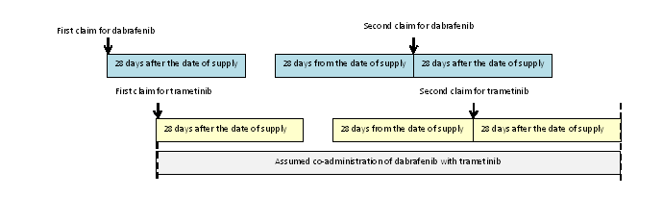

- Investigation of co-administration of immunotherapy

The median time between supplies was 21 days for ipilimumab and pembrolizumab and 14 days for nivolumab. This was consistent with the recommended time between administrations in the product information for each drug. It was assumed that a typical prescription for an immunotherapy covers a period of 21 days of treatment from the time a prescription is dispensed. For each claim for an immunotherapy, a lookback and look forward period of 21 days was done from the date of dispensing. If another immunotherapy was dispensed within the lookback or look forward periods, it was identified as a potential co-administered drug. Immunotherapies were only considered to be co-administered if there was more than one instance where each drug was dispensed within the coverage days of the other drug. That is, if there was an established pattern of co-prescribing.

In the following example, a patient initiates on ipilimumab as their first PBS subsidised immunotherapy. The patient gets a supply of nivolumab within 21 days of their first claim for ipilimumab. This could represent a switch in therapy rather than a co-supply, so the first claim for nivolumab is not counted as potential co-administration. The patient gets further supplies of ipilimumab and nivolumab within the expected coverage days for a prescription for each drug. This is assumed to represent co-administration of the immunotherapies starting from the date of the supply for the second claim for nivolumab.

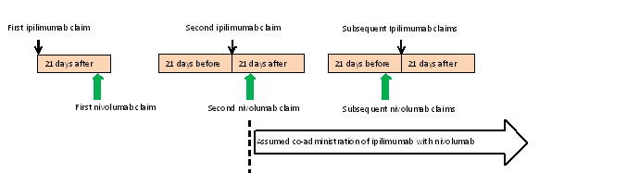

Cancer Council of Australia. Accessed on 16 April 2018 at: https://wiki.cancer.org.au
Public Summary Document, ipilimumab, November 2012 PBAC meeting
Public Summary Document for the August 2013 MSAC meeting.
Public Summary Document for the July 2012 PBAC meeting.
Public Summary Document for the August 2013 MSAC meeting.
Public Summary Document, pembrolizumab, March 2015, p29
Public Summary Document for the August 2013 MSAC meeting.
Public Release Document, October 2015 DUSC review, p16.
Public Summary Document for the July 2016 meeting
Public Release Document. Ipilimumab and dabrafenib: Predicted vs. actual analysis. October 2015.

