Lenalidomide for newly diagnosed multiple myeloma: 24 month predicted vs actual analysis

Drug utilisation sub-committee (DUSC)

October 2019

Abstract

Purpose
To compare the predicted and actual utilisation of lenalidomide for newly diagnosed multiple myeloma (NDMM) patients who are ineligible for autologous stem cell transplantation.

Date of listing on the Pharmaceutical Benefits Scheme (PBS)
Lenalidomide for the treatment of NDMM in transplant ineligible patients was PBS listed on 1 February 2017.

Data Source

Data to assess utilisation was obtained from the PBS supplied prescriptions database.

Key Findings
- The listing of lenalidomide in the NDMM setting had not grown the overall NDMM market. Lenalidomide had mainly substituted for thalidomide with bortezomib use largely unchanged in the NDMM setting. Between Year 1 and Year 2 of listing, the number of lenalidomide patients in NDMM increased by 62.4%. In contrast, the number of thalidomide patients in NDMM decreased by 77.6% between the period 1 February 2017 and 30 June 2019 inclusive.
- There was a higher number of actual than predicted patients using lenalidomide for NDMM. The higher patient numbers did not translate to higher expenditure due to lower than predicted number of prescriptions per patient.
- The lower than expected number of overall prescriptions for lenalidomide was mainly due to an overestimate of the number of prescriptions per patient. Other possible reasons for the relatively low number of prescriptions per patient included:
  - patients who were unable to tolerate lenalidomide toxicity despite dose adjustments or those with partial response who subsequently move to another anti-myeloma therapy (AMT); and
  - potential use of lenalidomide in transplant eligible patients as induction therapy prior to stem cell transplant. The usual duration of induction therapy was between three to six cycles.
- The median time on PBS subsidised lenalidomide therapy (322 days) was less than the progression-free survival time reported from the MM-020 trial of 25.5 months. The median time on lenalidomide therapy was more than double the median time on thalidomide therapy (322 vs 153 days).
- A total of 39.2% of patients were using a lenalidomide capsule strength lower than 25 mg. Additionally, a total of 21.8% of patients undertook a dose reduction based on the sequence analysis of the capsule strength that was supplied.
- The average lenalidomide dose of 94.5 mg/week was slightly higher than the average dose from the MM-020 trial of 90.5 mg/week. However, the financial estimates were based on an assumption that patients would be treated with ''''' mg per day for '''''''' cycles without dose reductions or dose interruptions which likely led to the overestimate of the financial estimates.

Purpose of analysis
To compare the predicted and actual utilisation of lenalidomide for newly diagnosed multiple myeloma (NDMM) since it was PBS listed for this indication in February 2017.

Background

Clinical situation
Multiple myeloma is a type of cancer that develops from plasma cells within bone marrow. The disease is characterised by the abnormal growth of plasma cells, called myeloma cells, which spread throughout the bone marrow. By taking up space within the bone marrow, the myeloma cells do not allow enough production of normal blood cells. The proliferation of myeloma cells can also result in extensive skeletal destruction with softened sections of bone (osteolytic lesions), areas of lower bone density (osteopenia), and disease-related (pathologic) fractures.

Myeloma cells also produce an abnormal antibody called paraprotein, monoclonal protein or M protein, which is a monoclonal immunoglobulin. Paraprotein acts to weaken the immune system by reducing the production of normal antibodies.

Clinical presentations of the disease include a deficiency in red blood cells (anaemia), bone pain, elevated creatinine levels, fatigue and generalised weakness, elevated calcium levels in the blood (hypercalcaemia) and weight loss. Multiple myeloma is diagnosed from a number of different tests including:
- full or complete blood count – to measure the number of red cells, white cells and platelets in circulation and note their size and shape;
- urinalysis – to measure the amount of protein in the urine;
- bone scans such as X-ray, CT or MRI – to check if there any areas of bone that have been weakened or eroded by the myeloma cells; and
- bone marrow biopsy – to determine the number and type of cells present and the amount of haemopoiesis (blood forming) activity taking place in the bone marrow. The diagnosis of myeloma is confirmed by the presence of an excessive number of plasma cells in the bone marrow.
In 2015, the age-standardised incidence rate of multiple myeloma was 6.9 cases per 100,000 persons per year, or approximately 1,500 new cases per year. It is more common in males than in females (8.4 every 100,000 versus 5.6 every 100,000). The median age at diagnosis is 65-70 years; only 10 percent of males and 2 percent of females are younger than 50 and 40 years, respectively.
Although multiple myeloma remains an incurable disease, survival for patients with multiple myeloma has improved, with median survival generally reported within the range of 5 to 7 years.^{1,2} This is mainly due to the introduction of first generation, high dose therapy (HDT) and autologous stem cell transplant (ASCT) in the late 1990s, followed by first and second generation immunomodulatory drugs (IMiDs: thalidomide, lenalidomide and pomalidomide and the first generation proteasome inhibitor bortezomib which was first in class. Since 2015, a number of novel agents have been approved by Food Drug Administration for the treatment of multiple myeloma. These include the second generation PIs including carfilzomib and ixazomib, the monoclonal antibodies daratumumab and elotuzumab, and the histone deacetylase inhibitor (HDACi) panabinostat. Therapeutic options for multiple myeloma will continue to expand with further novel agents under investigation including other PIs (oprozomib and mirazomib) and HDACi (e.g. ricolinostat). There are also newer classes of therapeutics being developed including small molecules (e.g. Bcl-2 or MCL1 inhibitors) novel immune approaches including Bispecific T-cell Engagers (BiTEs), chimeric antigen T cell receptors (CAR-T) and immune check point inhibitors.⁵
In Australia, high dose melphalan and autologous stem cell transplant remains the standard upfront treatment for patients aged ≤65 years, and patients between 65-70 years with good performance status and organ reserve.⁵ Treatment for newly diagnosed multiple myeloma usually consists of a regimen with a PI or IMid backbone. The treatment algorithm is differentiated based on transplant eligibility status (refer to Appendix A diagram). Recommended first line therapy for transplant-eligible patients is 3-6 cycles of induction treatment prior to ASCT. Currently, induction treatment options that are PBS listed include bortezomib (in combination with chemotherapy) or thalidomide (in combination with dexamethasone with or without cyclophosphamide). For transplant-ineligible patients, treatment options include lenalidomide (in combination with dexamethasone), bortezomib (in combination with dexamethasone/prednisone with or without melphalan/cyclophosphamide), or thalidomide (in combination with dexamethasone/prednisone with or without melphalan/cyclophosphamide).^{5,}
Clinical guidelines recommend combination therapy with IMiDs and PIs which can obviate the need for including additional chemotherapy agents in drug regimens.⁵ Such combinations are not currently subsidised under the PBS for the treatment of multiple myeloma.

Pharmacology
Lenalidomide inhibits proliferation of certain haematopoietic tumour cells (including multiple myeloma plasma tumour cells and those with deletions of chromosome 5), enhances T cell- and Natural Killer (NK) cell-mediated immunity and increases the number of NK T cells, inhibits production of pro-inflammatory cytokines (e.g. tumour necrosis factor (TNF)-α and interleukin (IL)-6) by monocytes, inhibits angiogenesis by blocking the migration and adhesion of endothelial cells and the formation of microvessels, and augments foetal haemoglobin production by CD34+ haematopoietic stem cells.¹

Therapeutic Goods Administration (TGA) approved indications
Lenalidomide (Revlimid®) is approved by the TGA for:
- Newly diagnosed multiple myeloma in patients who are ineligible for autologous stem cell transplantation.
- In patients who have received one prior therapy and have progressed multiple myeloma disease. Lenalidomide is administered in combination with dexamethasone.
- Patients with relapsed or refractory mantle cell lymphoma.
- Transfusion dependent anaemia due to low or intermediate-1 risk myelodysplastic syndrome associated with deletion 5q cytogenetic abnormality.
Lenalidomide is a category X (high risk) poison. All patients, prescribers and dispensing pharmacists are required to be registered on the i-access® program provided by Celgene Pty Ltd.

Dosage and administration
Lenalidomide in combination with dexamethasone is used in the first line treatment of multiple myeloma. The recommended starting dose of lenalidomide is 25 mg orally once daily on Days 1-21 of repeated 28-day cycles. The recommended dose of dexamethasone is 40 mg orally once daily on Days 1-4, 9-12, and 17-20 of each 28-day cycle for the first 4 cycles of therapy and then 40 mg once daily on Days 1-4 every 28 days. Treatment should be continued until disease progression or unacceptable toxicity. Dosing is continued or modified based upon clinical and laboratory findings. Lenalidomide treatment must not be started if the Absolute Neutrophil Count < 1.0 x 109/L, and/or platelet counts < 75 x 109/L or, dependent on bone marrow infiltration by plasma cells, platelet counts < 30 x 109/L.
The current Product Information (PI) and Consumer Medicine Information (CMI) are available from the TGA (Product Information) and the TGA (Consumer Medicines Information).

PBS listing details (as at 1 August 2019)

Table 1: PBS listings of Lenalidomide for the treatment of NDMM
Item | Name, form & strength, pack size | Maximum quantity | Repeats | DPMQ | Brand name and manufacturer
11029L, 11036W | Lenalidomide Capsule 5 mg | 21 | 0 | $5122.76 | Revlimid®, Celgene Pty Limited
11063G, 11064H | Lenalidomide Capsule 10 mg | 21 | 0 | $5361.16 | Revlimid®, Celgene Pty Limited
11042E, 11062F | Lenalidomide Capsule 15 mg | 21 | 0 | $6252.53 | Revlimid®, Celgene Pty Limited
11041D, 11055W | Lenalidomide Capsule 25 mg | 21 | 0 | $6587.49 | Revlimid®, Celgene Pty Limited
Source: the PBS website. Note: Special Pricing Arrangements apply.
Restriction
Authority required – written
- Initial treatment of a patient who has been newly diagnosed with multiple myeloma, and is ineligible for a primary stem cell transplant, and will be treated in combination with dexamethasone, and is not receiving PBS-subsidised bortezomib, thalidomide, or its analogues, for this condition.
- Confirmation of eligibility for treatment is supported through current diagnostic reports of at least one of the following must be provided: (a) the level of serum monoclonal protein; or (b) Bence-Jones proteinuria - the results of 24-hour urinary light chain M protein excretion; or (c) the serum level of free kappa and lambda light chains; or (d) bone marrow aspirate or trephine; or (e) if present, the size and location of lytic bone lesions (not including compression fractures); or (f) if present, the size and location of all soft tissue plasmacytomas by clinical or radiographic examination i.e. MRI or CT-scan; or (g) if present, the level of hypercalcaemia, corrected for albumin concentration.
For details of the current PBS listing refer to the PBS website.

Date of listing on PBS

Lenalidomide for the treatment of NDMM in transplant ineligible patients was PBS listed on 1 February 2017. A summary of lenalidomide’s other PBS listed indications is presented in Table 2.

Table 2: Changes to listing
Start Date | PBS listing
1 November 2009 | Initial and continuing treatment, as monotherapy or in combination with dexamethasone, of a patient with a histological diagnosis of multiple myeloma who has progressive disease after at least 1 prior therapy and who has undergone or is ineligible for a primary stem cell transplant.
1 October 2013 | Initial and continuing treatment of myelodysplastic syndrome. The treatment must be limited to a maximum duration of 16 weeks. Patient must be classified as Low risk or Intermediate-1 according to the International Prognostic Scoring System (IPSS), and patient must have a deletion 5q cytogenetic abnormality with or without additional cytogenetic abnormalities, and patient must be red blood cell transfusion dependent.
1 February 2017 | Initial and continuing treatment, in combination with dexamethasone, of a patient with a histological diagnosis of multiple myeloma. Patient must be ineligible for a primary stem cell transplantation, and the condition must be newly diagnosed.
Current PBS listing details are available from the PBS website.

Relevant aspects of consideration by the Pharmaceutical Benefits Advisory Committee (PBAC)
Lenalidomide for the treatment of NDMM in transplant ineligible patients was first considered at the November 2015 PBAC meeting. The submission nominated thalidomide within the regimen of melphalan plus prednisone and thalidomide (MPT) as the primary comparator. Bortezomib was nominated as a secondary comparator.
At the Consumer Hearing, the Leukaemia Foundation commented that the availability of oral agents such as lenalidomide as an upfront treatment option was attractive as it allows dosing convenience compared to bortezomib, and does not have the dose-limiting factor of neurotoxicity as in the case of thalidomide. The PBAC noted that the availability of lenalidomide in first line would likely replace bortezomib and thalidomide.
The PBAC noted that the financial estimates were most sensitive to increasing the duration of treatment for lenalidomide. The PBAC considered the submission’s assumption of a mean duration of therapy of ''''''''' cycles for lenalidomide substantially underestimated costs.
The PBAC deferred making a recommendation for the submission as it considered that the presented base case ICER likely favoured lenalidomide and was highly uncertain due to the inclusion of many favourable assumptions in the economic model. Following the new price offer, the PBAC recommended the listing of lenalidomide for treatment of NDMM on the basis of acceptable cost effectiveness over MPT. The PBAC noted recent correspondence from clinical stakeholders regarding re-use of lenalidomide upon disease progression, and further noted that under the current restriction for progressive disease, patients who cease treatment with lenalidomide after initial successful disease control and then experience disease progression are not eligible to resume treatment with lenalidomide. The PBAC considered that, based on the sponsor’s proposal, lenalidomide would remain cost effective in that setting and advised that the PBS restriction should permit re-treatment with lenalidomide following disease progression, in patients who had discontinued earlier when the disease was controlled.
The PBAC also recommended that a financial cap be implemented to mitigate the significant financial risk created by uncertainties surrounding lenalidomide use outside the restriction (e.g. use in patients who are eligible for stem cell transplant prior to stem cell transplant) with a '''''''''''' ''''' '''''' ''''''''''' '''' ''''''''''''''''''''''' beyond the cap.
For further details refer to the Public Summary Documents for the November 2015 and March 2016 PBAC meetings.

Approach taken to estimate utilisation
An epidemiological approach was used to estimate the number of patients with NDMM who are ineligible for a stem cell transplant. The forecast of incident MM patients was based on a linear trend in growth of 50 additional patients per year resulting in an estimated NDMM population of 1,780 in Year 1. A market share approach was used to estimate the proportion of patients likely to be displaced from MPT or bortezomib. The submission assumed that there would be '''''''''% displacement of bortezomib. The PBAC considered this was an underestimate, and noted that at the Consumer Hearing there was a strong preference for oral therapies, so it would be expected that the lenalidomide-based therapy substitution for bortezomib-based therapy was likely to be much higher than estimated.
Displacement of bortezomib-based therapy by lenalidomide was subsequently increased to between '''''% in Year 1 up to ''''''% in Year 6, and displacement of thalidomide was adjusted to '''''% in Year 1 up to '''''% in Year 6. The duration of treatment was also subsequently adjusted to ''''''''' cycles, which is based on an average number of scripts per patient of ''''''''''' scripts in Year 1 and ''''''''''' scripts in Year 2.

Table 3: Number of patients likely to be treated with lenalidomide
 | Year 1 (Feb 2017 to Jan 2018) | Year 2 (Feb 2018 – Jan 2019) | Year 3 (Feb 2019 – Jan 2020) | Year 4 (Feb 2020 – Jan 2021) | Year 5 (Feb 2021 – Jan 2022)
Estimated and projected prevalence of MM in Australia | '''''''''' | ''''''''''' | ''''''''''' | '''''''''''' | '''''''''''
Proportion of patients ineligible for stem cell transplant | ''''''''' | '''''''' | '''''''' | '''''''' | '''''''''
Estimated number of patients eligible for Rd | ''''''''''' | ''''''''''' | '''''''''' | '''''''''''' | '''''''''''
Proportion of Rd eligible patients receiving VMP | '''''''' | ''''''''' | '''''''' | '''''''' | '''''''''
Estimated number of Rd eligible patients receiving VMP | '''''''' | ''''''' | ''''''' | '''''''''' | ''''''''''
Proportion of Rd eligible patients receiving MPT | '''''''' | '''''''' | ''''''''' | ''''''''' | ''''''''
Estimated number of Rd eligible patients receiving MPT | ''''''' | ''''''' | '''''''' | ''''''' | '''''''
Estimated uptake of Rd, displacing VMP | ''''''''' | ''''''''' | ''''''''' | ''''''''' | '''''''''
Estimated number of Rd patients displaced from VMP | '''''''' | ''''''' | ''''''' | ''''''' | '''''''
Estimated uptake of Rd, displacing MPT | '''''''' | ''''''''' | '''''''' | '''''''' | ''''''''
Estimated number of Rd patients displaced from MPT | ''''''' | '''''''' | ''''''' | ''''''' | '''''''
Total estimated patients on PBS Rd | '''''''' | '''''''' | ''''''' | ''''''' | ''''''''
Source: Final estimates agreed with Department of Health, sheet E2.

Table 4: Estimated use and financial implications
 | Year 1 (Feb 2017 to Jan 2018) | Year 2 (Feb 2018 – Jan 2019) | Year 3 (Feb 2019 – Jan 2020) | Year 4 (Feb 2020 – Jan 2021) | Year 5 (Feb 2021 – Jan 2022)
Estimated extent of use
Number treated | ''''''' | ''''''' | ''''''' | ''''''' | ''''''''
Scripts | ''''''''''' | '''''''''''' | '''''''''''' | '''''''''''''' | ''''''''''''''
Estimated net cost to PBS/RPBS/MBS
Net cost to PBS/RPBS | '''''''''''''''''''''' | ''''''''''''''''''''' | ''''''''''''''''''''''''' | ''''''''''''''''''''' | '''''''''''''''''''''''''
Net cost to Government | ''''''''''''''''''''''' | ''''''''''''''''''' | ''''''''''''''''''''''' | '''''''''''''''''''''' | '''''''''''''''''''''
Source: Final estimates agreed with Department of Health, sheets E2 and E5.

Previous reviews by the DUSC
The September 2017 DUSC analysis of medicines to treat multiple myeloma noted the following key findings:
- Overall, 9,445 people received 204,947 dispensings for the medicines listed for multiple myeloma in the period 1 July 2013 to 31 December 2016. The number of people receiving treatment rose from 9.4 per 100,000 in July 2013 to 11.8 per 100,000 in December 2016.
- 1,826 people initiated therapy with the medicines listed for multiple myeloma in 2016, with most initiating bortezomib. Their median age was 70 years. This was consistent with AIHW (2013) estimates of incidence of approximately 1,600 persons per year.
- 61% of people treated for multiple myeloma received one therapy only in the period 2014-2016, with two-thirds of these receiving therapy with bortezomib only, a quarter receiving thalidomide only, and the remaining receiving therapy with lenalidomide only. Where people did require a second therapy, the most common pathways were from bortezomib to thalidomide, and thalidomide to lenalidomide.
- For patients eligible for stem cell transplant who initiated therapy in 2014, the median duration of the first episode on bortezomib was 3 months; it was 3.5 months for other bortezomib; it was 5 months for thalidomide and 9.5 months for lenalidomide.
- Analysis on cumulative duration of all episodes on any medicine showed a median duration of 282 days (95% CI 269-293). Analysis on cumulative duration of all breaks (gaps) in medicine coverage showed a median duration of 29 days (95% CI 21-39). The majority of the people survived the two year follow-up; overall 11% died within the follow-up period.
- There was very little co-prescribing. Only 1% of all 9,445 people with a multiple myeloma medicine between 1 July 2013 and 31 December 2016 had concurrent use of two medicines listed for multiple myeloma for a whole month at some point of time.
- Utilisation was mostly consistent with guideline recommendations and PBS restrictions. The use found outside the recommendations was for pomalidomide which was first or second line therapy in 1% of people, and for lenalidomide as first line therapy. The analysis showed that lenalidomide accounted for 6% of first line medicine use when assessed across the 2014 to 2016 cohort, and up to 12% when assessed in the 2014 cohort alone.
For details of the DUSC consideration of the ‘Analysis of medicines to treat multiple myeloma’ refer to the Public Release Document from the September 2017 DUSC meeting.

Methods
PBS prescription data for lenalidomide from 1 February 2017 (the date of first listing of lenalidomide for treatment of NDMM) to 30 June 2019 were extracted from the PBS supplied prescriptions database, managed by Services Australia, based on the date of supply. The date of processing of PBS prescriptions may differ from the date of supply. Consequently there may be differences in data publicly available from the Medicare Statistics website, which is based on date of processing.
PBS prescription data were used to determine the number of prescriptions supplied and the PBS expenditure. These data were also used to count the number of patients, both incident (new to treatment) and prevalent (number treated in each time period, i.e. year or quarter).
The Kaplan Meier method was used to determine the length of treatment for patients on lenalidomide for NDMM. A break in treatment was defined as a gap of more than 3 times the median time between supplies. A patient was deemed to be continuing treatment (classified as censored in the Kaplan Meier analysis) at the end of the data period (i.e. the end of June 2019) if their last prescription was within 3 times the median time to resupply of this end date. Otherwise the patient was deemed to have ceased treatment with the treatment coverage end date being the supply date of their last prescription plus a median time to resupply. If a patient’s supply was after a gap of more than 3 times the median time to resupply, then the patient was deemed to have been re-treated.
In the “Estimated Dose” section the estimated dose was calculated at the patient level and was equal to the total mass of lenalidomide (in mg) supplied to a patient summed across all their prescriptions, divided by their total length of treatment (including breaks). Firstly, total mass amount per supply was determined. This was calculated by multiplying the mass amount per pack by the PBS listed pack quantity. A cumulative total mass amount per patient was then calculated. The total length of treatment was defined by the total time between the first initiation supply date and the latest supply date.
A sequence analysis was used to determine the pattern of dose adjustments of lenalidomide in the NDMM setting. This analysis captured the sequence of different capsule strengths of lenalidomide that was supplied at the patient level at each dispensing. To establish a consistent pattern of supply on different capsule strengths, movements from one capsule strength to another were recorded by order of sequence of supply. Recurring use of the same capsule strengths in between movements to a different capsule strength were recorded as a single supply. For example, if a patient received a 25 mg capsule supply for the first three months and then a 15 mg capsule supply on the fourth month until the sixth month, the analysis shows ‘25-> 15’ instead of ‘25->25->25->15->15->15’.
If a patient received no dose adjustments from the time of initiation, then the analysis only shows the capsule strength which the patient first initiated on. The different dose sequences were then aggregated to show the frequency patterns of dose adjustments. As thalidomide does not have specific item codes to distinguish thalidomide first line use from subsequent lines of use, sequence analysis was also employed to determine the number of patients treated with thalidomide in the newly diagnosed setting. A patient was considered to have used thalidomide in the first line setting if thalidomide was the medicine first initiated by the patient (i.e. no previous AMT supplied during the data period).
All data analyses were undertaken using SAS Enterprise Guide 7.13.

Results

Analysis of drug utilisation

Overall utilisation
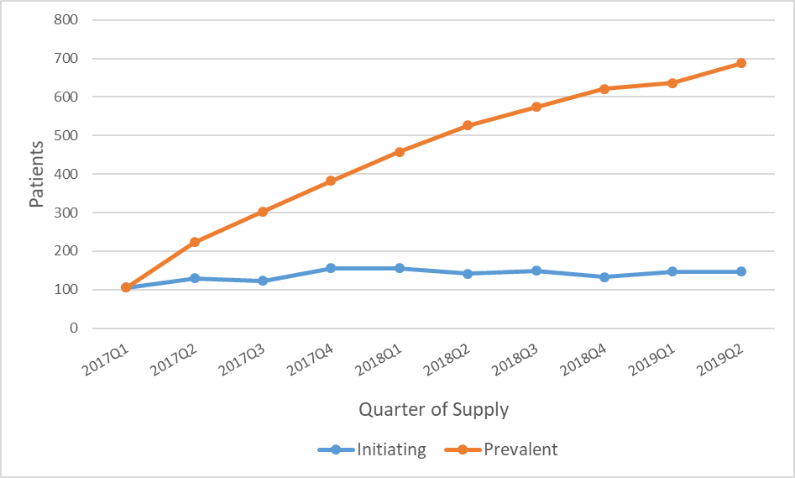
Figure 1: Number of patients initiating and prevalent to lenalidomide for NDMM
Data period: 1 February 2017 to 30 June 2019 inclusive based on date of supply.

The number of prevalent patients steadily increased since PBS listing on 1 February 2017. The number of initiating patients increased from 105 patients in the first quarter of 2017 to 156 patients in the fourth quarter of 2017, and stabilised to around 150 patients per quarter since then.
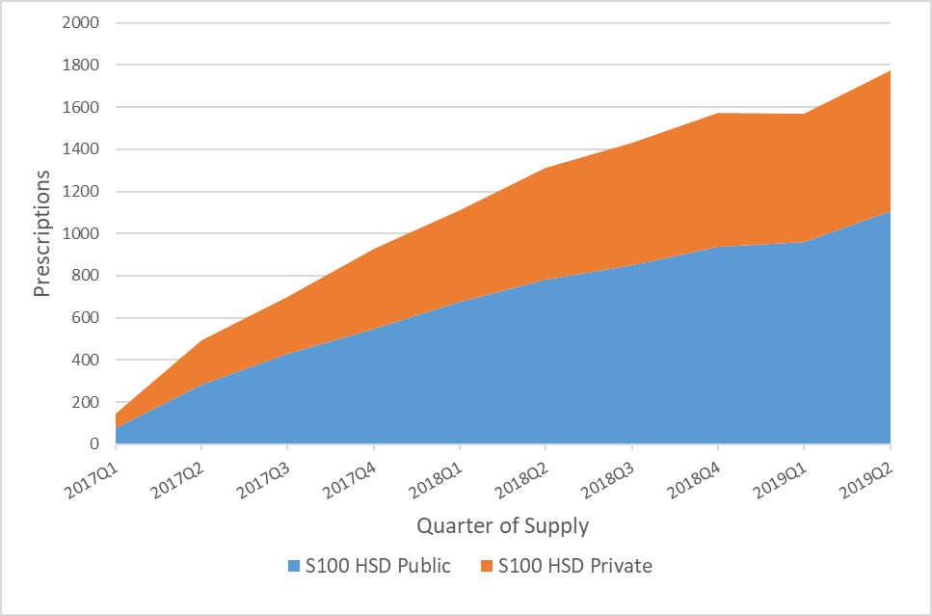
Figure 2: PBS/RPBS Prescriptions of lenalidomide for treatment of NDMM
Data period: 1 February 2017 to 30 June 2019 inclusive based on date of supply.

A greater proportion of lenalidomide prescriptions is dispensed in the S100 public hospital setting, with a split of 60% public and 40% private hospital dispensing. For comparison, the submission estimated that ''''''% of prescriptions would be dispensed in the private hospital setting and '''% in the public hospital setting.

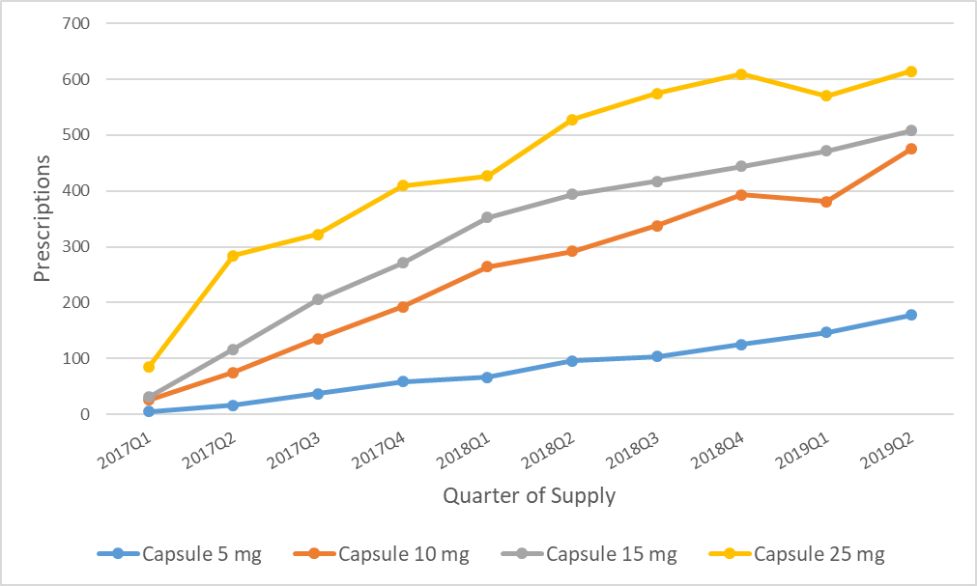
Figure 3: PBS/RPBS Prescriptions of lenalidomide for treatment of NDMM by strength
Data period: 1 February 2017 to 30 June 2019 inclusive based on date of supply.

The most common strength of lenalidomide supplied was the 25 mg capsule. This was followed by 15 mg, 10 mg and 5 mg capsule respectively. In 2017, the 25 mg capsule was dispensed in almost half of all prescriptions supplied for that year (49%). However, the 25 mg capsule as a proportion of total lenalidomide supplies decreased to 39% in 2018, and to 35% in the two quarters of 2019. This was likely due to patients who experienced treatment-related adverse effects with the high dose, thus requiring a dose reduction. Further analysis on dose can be found under ‘Estimated Dose’ section.

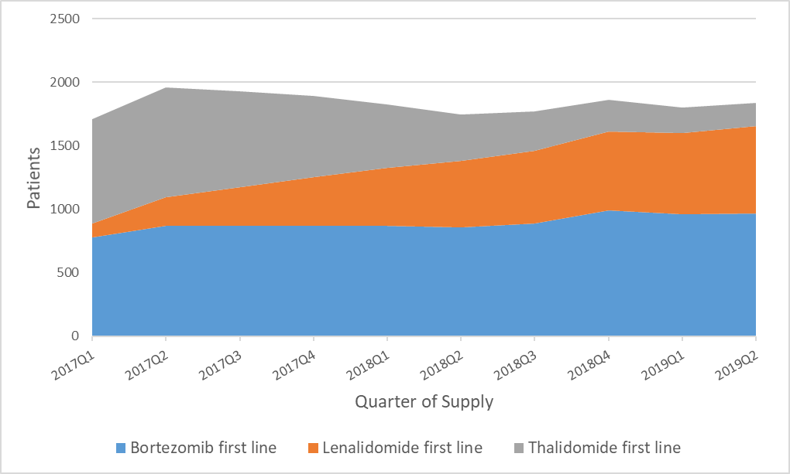
Figure 4: Number of treated patients by medicine in NDMM setting
Data period: 1 February 2017 to 30 June 2019 inclusive based on date of supply.

The above graph shows the NDMM market share by number of prevalent patients for each medicine. Consistent with the utilisation of prescriptions shown in Figure 3, the number of lenalidomide patients had grown steadily since PBS listing. As anticipated, the number of thalidomide patients had decreased since the lenalidomide NDMM listing, from 825 patients in the first quarter of 2017 to 185 patients in the second quarter of 2019. The number of bortezomib patients have remained largely consistent throughout the analysis period, averaging around 900 prevalent patients per quarter.

Table 5 below shows that around 72% of patients were initiated and maintained with one lenalidomide capsule strength, with no changes in the lenalidomide strength supplied over time. Of these patients, who did not have any changes to their lenalidomide strength supplied, the highest number of patients were found to be using the 25 mg capsule (32.6%) followed by the 15 mg capsule (19.6%) and 10 mg capsule (13.9%). Notably, there were changes in capsule strength observed for around 25% of patients. The most common adjustment was for reduction: 25 mg to 15 mg capsule (7.8%), 15 mg to 10 mg capsule (4.03%) and 25 mg to 10 mg capsule (3.2%). Only around 3% of patients required an increase in capsule strength: 10 mg to 15 mg capsule (2.2%) and 15 mg to 25 mg capsule (1.1%).

Table 5: Patient level sequence of lenalidomide capsule strengths supplied from 1 February 2017 until 30 June 2019
Sequence of lenalidomide capsule strength supplied (in mg) | Count | Percent
25 | 372 | 32.6
15 | 223 | 19.6
10 | 159 | 13.9
25-> 15 | 89 | 7.8
5 | 65 | 5.7
15-> 10 | 46 | 4.0
25-> 10 | 37 | 3.2
25-> 15-> 10 | 34 | 3.0
10-> 15 | 25 | 2.2
10-> 5 | 16 | 1.4
15-> 25 | 12 | 1.1
15-> 5 | 10 | 0.9
25-> 10-> 15 | 9 | 0.8
25-> 15-> 10-> 5 | 7 | 0.6
15-> 10-> 5 | ≤5 | N.R
25-> 15-> 5 | ≤5 | N.R
Data period: 1 February 2017 to 30 June 2019 inclusive based on date of supply. Note: Where the patient or prescription count is between 1 and 5 (inclusive), a figure data point is set to 5 to protect patient confidentiality.

Analysis of expenditure
The expenditure of lenalidomide doubled from $16,361,512 in Year 1 to $34,306,318 in Year 2 of listing (based on the published prices). Year 3 was tracking to maintain the same level of expenditure as in Year 2. The actual expenditure of bortezomib in the transplant-ineligible newly diagnosed setting decreased by 14% in 2017, and then by a further 3.5% in 2018. Thalidomide expenditure in the newly diagnosed setting also decreased by 2% and 37% in 2017 and 2018 respectively.
Estimated dose
The estimated dose at the patient level was calculated with the total mass of lenalidomide (in mg) supplied to a patient summed across all their prescriptions, divided by their total length of treatment (including breaks). As there were 21 treatment days out of the 28-day cycle, the total length of treatment was adjusted to account for this. The estimated dose for Year 1 initiators was 13.5 mg per day, equivalent to 94.5 mg per week. The estimated dose for Year 2 initiators was slightly higher at 13.8 mg per day, equivalent to 96.6 mg per week. The submission assumed treatment at the same dose intensity in Trial MM-020 of 90.4mg/week until disease progression or death.
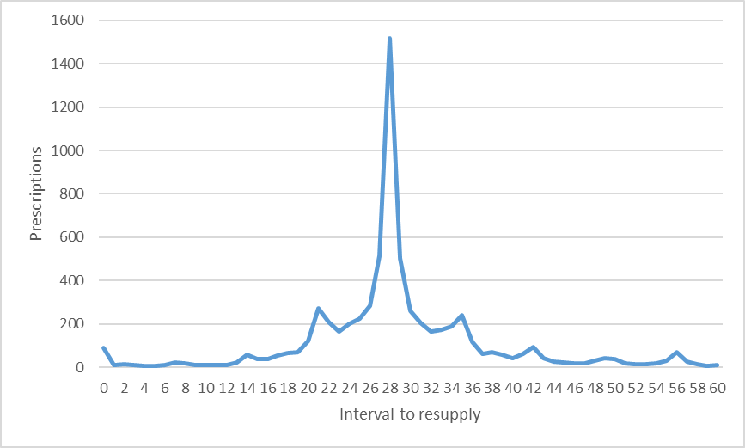
Figure 5: Number of interval days to prescription re-supply for lenalidomide in NDMM
Data period: 1 February 2017 to 28 February 2019 inclusive based on date of supply. Note: Where the patient or prescription count is between 1 and 5 (inclusive), a figure data point is set to 5 to protect patient confidentiality.

The most common (mode) time for resupply was 28 days. This resupply interval was consistent with the lenalidomide dosage regimen of 1 tablet every day for 21 days repeated as 28-day treatment cycles. 21 days was the next most common interval to resupply. These patients were likely having their prescriptions re-supplied after their lenalidomide supply runs out. A slightly lower peak at 35 days can also be observed in the graph. These patients were likely having their prescriptions re-supplied after the 28-day treatment cycle. The 7-day delay could be due to the processing lag for the dispensing of lenalidomide as a S100 HSD medicine at the hospital.
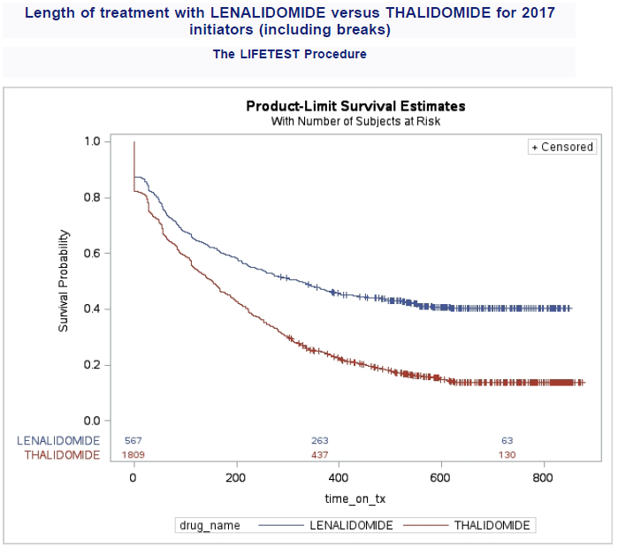
Figure 6: Length of treatment (days) with lenalidomide versus thalidomide for NDMM
Note: Lenalidomide patients (n=567), thalidomide patients (n=1809). Data period: 1 February 2017 to 30 June 2019 inclusive based on date of supply.

Total length of treatment (including breaks) was the time that patients received supplies of either lenalidomide or thalidomide and counts the additional time that patients were not receiving supply of lenalidomide or thalidomide between episodes of treatment. The analysis allows patients to stop treatment (i.e. no more supplies of medicine) or be censored (i.e. deemed to be continuing treatment at the end of the data period). See Method section above for further details. The total observation period of the analysis was 30 months. Of the 567 patients who initiated on lenalidomide in 2017, 333 patients (59%) discontinued treatment, and 234 patients (41%) were censored due to continuing treatment. Comparatively, of the 1,809 patients who initiated on thalidomide in 2017, 1539 patients (85%) discontinued treatment, and 270 (15%) were censored due to continuing treatment. The length of time on lenalidomide treatment was a median of 322 days (10.6 months) and mean of 337 days. Time on thalidomide treatment for thalidomide was a median of 153 days (5 months) and mean of 223 days. The submission assumed that patients would on average have '''''''' cycles of treatment (i.e. '''''''' months), noting that this does not include breaks in treatment.

Analysis of actual versus predicted utilisation
Table 6: Predicted versus actual for patients, prescriptions and expenditure
 |  | Year 1 (1 February 2017 – 31 January 2018) | Year 2 (1 February 2018 – 31 January 2019)
Patients | Predicted (P) | '''''''' | ''''''''
 | Actual (A) | 567 | 921
 | Difference (A-P) | ''''' | '''''''
 | % Difference (A-P)/P | ''''''''' | '''''''''''
Prescriptions | Predicted (P) | '''''''''' | ''''''''''''
 | Actual (A) | 2,622 | 5,610
 | Difference (A-P) | '''''''''''' | -8,625
 | % Difference (A-P)/P | '''''''''''' | ''''''''''''
Prescriptions per patient | Predicted (P) | ''''''''''' | ''''''''''
 | Actual (A) | 4.62 | 6.09
 | Difference (A-P) | '''''''''' | ''''''''''
 | % Difference (A-P)/P | '''''''''''''' | '''''''''''''
R/PBS Expenditure | Predicted (P) | '''''''''''''''''''''' | '''''''''''''''''''''
 | Actual (A) | $16,361,512 | $34,306,318
 | Difference (A-P) | ''''''''''''''''''''' | ''''''''''''''''''''''''
 | % Difference (A-P)/P | '''''''''''' | ''''''''''''''

Between Year 1 and Year 2 of listing, the actual number of lenalidomide patients in NDMM has increased by 62.4%. The actual number of patients exceeded predicted levels in Year 1 and Year 2 by ''''''% and ''''''''% respectively. However, the actual number of prescriptions is lower than predicted in Year 1 and Year 2 by ''''''''% and ''''''''% respectively. The number of prescriptions per patient is also lower in Year 1 and Year 2 by ''''''''% and '''''''''% respectively. As a result of the lower than anticipated prescription numbers, the higher than predicted patient numbers did not translate to higher expenditure. Expenditure was lower than predicted by ''''''''% and '''''''''% in Year 1 and Year 2 respectively.
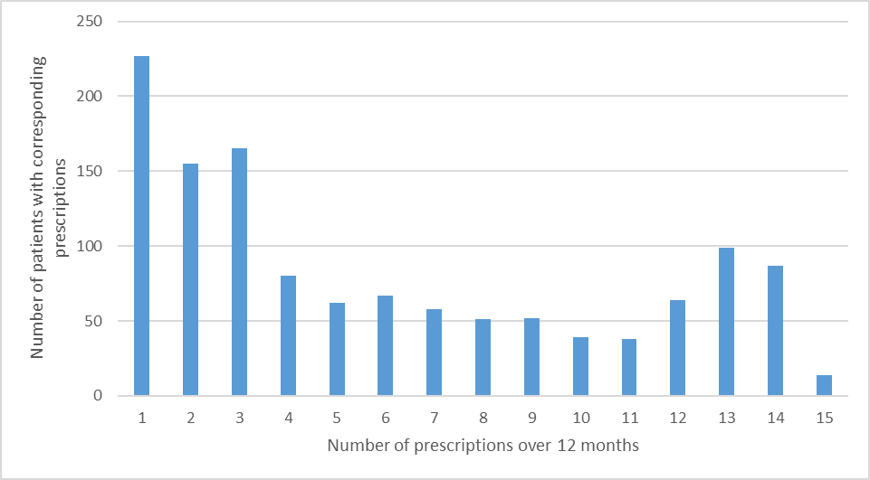
Figure 7: Distribution of number of prescriptions per patient over 12 months follow-up from the date of first initiation
Data period: 1 February 2017 to 30 June 2019 inclusive based on date of supply.

Figure 7 shows the distribution of prescriptions for patients who have initiated lenalidomide in the first line with 12 months of follow-up. Most patients were supplied up to three prescriptions.

Table 7: Drug sequences for lenalidomide initiators follow up to 30 June 2019
Drug sequence | Count | Percent
Lenalidomide first line | 882 | 77.3
Lenalidomide first line -> Lenalidomide subsequent line | 74 | 6.5
Lenalidomide first line -> Bortezomib subsequent line | 61 | 5.3
Lenalidomide first line -> Bortezomib first line | 34 | 3.0
Lenalidomide first line -> Thalidomide subsequent line | 16 | 1.4
Lenalidomide first line -> Carfilzomib | 12 | 1.1
Lenalidomide first line -> Bortezomib subsequent line -> Pomalidomide | 7 | 0.6
Lenalidomide first line -> Bortezomib subsequent line -> Carfilzomib | ≤5 | N.R
Lenalidomide first line -> Thalidomide subsequent line -> Bortezomib subsequent line | ≤5 | N.R
Data period: 1 February 2017 to 30 June 2019 inclusive based on date of supply. Note: Where the patient or prescription count is between 1 and 5 (inclusive), a figure data point is set to 5 to protect patient confidentiality.

The submission claimed that a high continuation rate on lenalidomide was expected. Table 7 shows that a majority of patients who initiated with lenalidomide in 2017 did not switch or move to a subsequent line of therapy (77%), which is consistent with Figure 7 showing that patients tend to remain on lenalidomide over the longer-term. The most common sequence of therapy for lenalidomide initiators is moving from lenalidomide first line to lenalidomide subsequent line (6.5%). Patients must have progressive disease after at least one prior therapy and must have undergone or be ineligible for a primary stem cell transplant for patients to be eligible for lenalidomide treatment in the subsequent line (relapsed/refractory setting). In its recommendation, the PBAC advised that the lenalidomide restriction should permit re-treatment with lenalidomide following disease progression, in patients who had discontinued earlier when the disease was controlled. It was plausible that these patients were deemed to be lenalidomide responders prior to treatment discontinuation, and then re-treated with lenalidomide in the relapsed/refractory setting, instead of the first line setting item codes. The next most common sequence is the movement from lenalidomide first line to bortezomib subsequent line (5.3%). These patients are likely to have had progressive disease after a number of cycles of lenalidomide treatment, who subsequently responded to a trial of another AMT medicine with a different mechanism of action to lenalidomide, such as bortezomib (a proteasome inhibitor).

Discussion
Lenalidomide is listed for the treatment of multiple myeloma and myelodysplastic syndrome. Lenalidomide, in combination with dexamethasone, is listed for the treatment of NDMM in transplant ineligible patients. At the time of reporting, it was not reimbursed under the PBS for the initial induction in patients in transplant eligible patients with multiple myeloma. Initiating patients must also not be receiving concomitant PBS-subsidised bortezomib, thalidomide or its analogues. Patients must not have demonstrated progressive disease to qualify for continuing treatment.
Lenalidomide was also listed, as monotherapy or in combination with dexamethasone, for the treatment of relapsed/refractory multiple myeloma (RRMM). To qualify for treatment in the RRMM setting, patients must demonstrate progressive disease after at least one prior AMT, have undergone or be ineligible for a stem cell transplant, and must not be receiving concomitant PBS-subsidised AMT.
The listing of lenalidomide had not grown the overall NDMM market and had mainly replaced thalidomide. The utilisation of lenalidomide in NDMM was less than anticipated during its first two years of listing.
Figure 4 shows the NDMM market based on number of prevalent patients per AMT in the first line setting. Based on this, thalidomide patients had decreased by 77.6% between the first quarter of 2017 and second quarter of 2019, whilst bortezomib patients had increased by 23.9% over the same period. This demonstrated that lenalidomide uptake had largely resulted from the displacement of thalidomide patients in the first line setting. Figure 5 shows the expenditure of the different AMT used in first line setting, based on the published prices for the listings. Between Year 1 and Year 2 of listing, lenalidomide expenditure in the first line setting had more than doubled from $16.4 million to $34.3 million. In contrast, bortezomib and thalidomide expenditure had decreased between 2015 and Year 2 of listing, by 33% and 39% respectively.
Table 6 shows that there was a higher number of actual patients than predicted using lenalidomide for NDMM. However, the higher patient numbers did not translate to higher expenditure due to lower than predicted number of prescriptions per patient. The submission estimated that the number of scripts per patients would be ''''''''''' and ''''''''' in Years 1 and 2, respectively. The submission likely overestimated the predicted script numbers when it assumed '''''''% patient compliance in Year 1 and did not apply an adjustment to the predicted script numbers to account for patients who would be initiating and discontinuing throughout the year. The actual average script number per patient in Year 1 and Year 2 was 4.62 and 6.09, respectively. The distribution of scripts dispensed per patient within 12 months of first initiation (Figure 8) shows that 43.4% of patients were supplied between one to three prescriptions. A lower number of scripts in first line may have partly resulted from some patients not responding to lenalidomide who were subsequently switched to a later line of AMT. However, only a relative small number of patients (n=214) switched from first line lenalidomide to subsequent line therapy (Table 7).
The reasons for the relatively low number of prescriptions per patient on average was unclear. Table 7 shows only a modest number of patients appeared to transition to a subsequent line of therapy. This finding may indicate some potential use in transplant eligible patients where lenalidomide could have been supplied as induction therapy prior to transplant hence the low prescription numbers in the first line setting. The lower than expected number of overall prescriptions for lenalidomide was mainly due to an overestimate of the number of prescriptions per patient (Table 6).
The 2017 DUSC review of multiple myeloma found that lenalidomide accounted for 6% of first line medicine use when assessed across the 2014 to 2016 cohort, and up to 12% when assessed in the 2014 cohort alone. As lenalidomide for NDMM was not listed until 1 February 2017, 6-12% of use between 2014 and 2016 in the first line setting may represent a possible leakage outside the PBS restrictions. Such use could include for transplant eligible patients as induction therapy prior to stem cell transplant and then as maintenance therapy post stem cell transplant. At the July 2019 meeting, the PBAC recommended lenalidomide for the maintenance treatment of patients with NDMM following a stem cell transplant. Once implemented, this listing will likely reduce any lenalidomide leakage in the post-transplant setting, and offer an additional treatment option to patients who cannot use bortezomib or who cannot access lenalidomide until after their condition has progressed.⁹
For patients first initiating on lenalidomide in 2017, the median time on therapy was 322 days (mean 337 days), (Figure 6). The time on PBS subsidised therapy was less than the progression-free survival (PFS) time reported from the MM-020 trial (25.5 months).⁸
The submission assumed recommended dose of lenalidomide of ''''' mg a day for 21 days in a 28-day cycle, without any dose reductions or dose interruptions. Figure 3 and Table 5 confirms that the 25 mg capsule is the most commonly used strength for lenalidomide for NDMM (32.6%). However, Table 5 also shows that a significant proportion of patients (39.2%) are continuing treatment using one of the lower capsule strengths of lenalidomide (i.e. 15 mg, 10 mg or 5 mg). Additionally, dose adjustments were observed for 25% of lenalidomide patients. Of these, 21.8% were for dose reductions. It is worth noting that the lenalidomide capsule strengths are not flat-priced with each other which means the PBS dispensed price of the 25 mg capsule pack is higher than the lower strength dispense prices.
In the ‘Estimated Dose’ section, the average lenalidomide dose was calculated to be 94.5 mg/week. This was only slightly higher to the estimated average dose derived from Trial MM-020 of 90.4 mg/week. The financial estimates, however, were based on the assumption that patients would be treated with ''''' mg per day for ''''''''' cycles. This approach overestimated the financial impact of the listing. As discussed above, there was a lower than predicted number of scripts per patient ('''''%-'''''% lower than predicted), there was also a significant proportion of patients using a lower strength of lenalidomide capsule other than the 25 mg (39.2%), and dose reductions were relatively common in patients using lenalidomide in the first line setting (21.8%).
The PBAC considered that lenalidomide would remain cost effective in the re-treatment setting and advised that the PBS restriction should permit re-treatment with lenalidomide following disease progression, in patients who had discontinued earlier when the disease was controlled. Between 1 February 2017 and 30 June 2019, there were 168 patients who discontinued and then were subsequently re-treated with lenalidomide. Appendix B lists the drug sequences observed for patients using AMT medicines between 1 February 2017 and 30 June 2019. As per the 2017 DUSC review, bortezomib remains the most common initiated AMT therapy in the first line setting (23.5%), followed by thalidomide (8.1%) and then lenalidomide (7%). Bortezomib to thalidomide remained as the most common sequence of therapy (7.4%), followed by thalidomide to lenalidomide (4.4%). Notably, the numerous different treatment sequences highlights the challenges faced by clinicians when deciding on the ideal treatment to achieve optimal patient outcomes. One of the highest priorities identified at the Multiple Myeloma stakeholder meeting was increasing flexibility for prescribers in available treatments and combinations in the first line setting as this is where the greatest benefit in survival appears to be achieved. Access to a combination of a PI and an IMiD up front, with the possibility of triple therapy combination as new treatments was identified as an area of need .⁹
The November 2015 submission presented survival results for lenalidomide from the MM-020 trial which estimated median overall survival (OS) of 58.9 months after a median duration of follow-up of 45.5 months, representing an estimated improvement of 10.4 months in OS compared with thalidomide.⁸ The PBAC agreed with the ESC that the statistically significant results in OS supported the submission’s claim of superior comparative effectiveness and a different safety profile compared to thalidomide.⁸ Consistent to the MM-020 trial, the length of treatment analysis in Figure 6 demonstrates the higher continuation rates of lenalidomide when compared to thalidomide (median length of treatment of lenalidomide and thalidomide is 322 days and 153 days respectively). Lenalidomide demonstrated a better progression-free survival compared to thalidomide (in combination with melphalan plus prednisone). This correlated with the length of treatment analysis in Figure 6 as the PBS restrictions require the patient to not have demonstrated progressive disease to be eligible for continuing treatment with lenalidomide.

DUSC consideration
Lenalidomide is PBS listed for the treatment of newly diagnosed multiple myeloma in transplant ineligible patients. DUSC noted that some patients can move between transplant states following initial treatment. DUSC also noted that current guidelines recommend lenalidomide as induction therapy prior to transplant, but this indication is not subsidised under the PBS.
The PBAC considered in November 2015 that lenalidomide would likely replace some of bortezomib’s market in the NDMM setting. DUSC noted that lenalidomide uptake had largely resulted from the displacement of thalidomide patients in the NDMM setting. DUSC noted comments obtained from consumer consultation that parenteral treatment may be preferred over oral therapy, particularly in high risk patients where there are data to suggest that bortezomib is more effective in this subgroup. Other advantages include ease of administration, better tolerance and the additional support of day oncology unit attendance to help educate and monitor the patient. DUSC considered that these are possible factors in bortezomib retaining a consistent level of market share over time.
The most common strength of lenalidomide supplied is the 25 mg capsule. This is followed by 15 mg, 10 mg and 5 mg capsule, respectively. In 2017, the 25 mg capsule was dispensed in almost half of all prescriptions supplied for that year (49%). However, the 25 mg capsule as a proportion of total lenalidomide supplies has decreased to 39% in 2018, and to 35% in the two quarters of 2019. DUSC noted the trend towards the use of lower doses which is expected as there is more treatment of elderly, frail and co-morbid patients. DUSC noted feedback from Myeloma Australia that clinicians are becoming more comfortable in reducing lenalidomide doses in the treatment of the elderly and co-morbid populations, as there is evidence in the relapsed setting that a 15 mg dose is equivalent to a 20 mg dose in terms of efficacy.
The distribution of scripts dispensed per patient within 12 months of first initiation shows that 43.4% of patients were supplied between one to three prescriptions. DUSC noted that the average number of prescriptions per patient was less than presented from the pivotal clinical trial from the lenalidomide submission. DUSC discussed that in its consideration of PBS medicine use, patients generally tend to have more dispensings during clinical trials than in practice due to the additional clinical support. The lower than expected number of overall prescriptions for lenalidomide was mainly due to an overestimate of the number of prescriptions per patient. DUSC considered that the assumption of an average time on therapy of '''''''' months was considered optimistic in hindsight given the toxicities associated with lenalidomide. DUSC questioned if the low script numbers may reflect potential use of lenalidomide for transplant induction. However, it was noted that feedback from Myeloma Australia suggests that this is unlikely as lenalidomide is less effective as induction therapy, and data from the Myeloma Registry did not indicate an increased trend of use of lenalidomide in the pre-transplant setting. Other possible reasons include use in borderline patients, or patients who have dropped out due to co-morbidities or unmanageable toxicity (i.e. neuropathy), or patients switching between different anti-myeloma agents. DUSC considered it would be informative to undertake an analysis of prescriptions per patient by age distribution and compare this to similar age subgroups from the clinical trial to determine if greater age in practice may be a contributing factor for a lower time on therapy.
DUSC noted the Pre-Sub Committee Response (PSCR) comments that the difference in the predicted versus actual figures will decrease over time as the prevalent population increases and reaches steady state. DUSC considered that script numbers are unlikely to '''''''''''' in the next few years to reach the predicted levels. DUSC noted the PSCR’s comment that the public and private hospital dispensing splits were consistent with the findings of the report.

DUSC actions
DUSC requested that the report be provided to the PBAC.

Context for analysis
The DUSC is a Sub Committee of the Pharmaceutical Benefits Advisory Committee (PBAC). The DUSC assesses estimates on projected usage and financial cost of medicines.
The DUSC also analyses data on actual use of medicines, including the utilisation of PBS listed medicines, and provides advice to the PBAC on these matters. This may include outlining how the current utilisation of PBS medicines compares with the use as recommended by the PBAC.
The DUSC operates in accordance with the quality use of medicines objective of the National Medicines Policy and considers that the DUSC utilisation analyses will assist consumers and health professionals to better understand the costs, benefits and risks of medicines.
The utilisation analysis report was provided to the pharmaceutical sponsors of each drug and comments on the report were provided to DUSC prior to its consideration of the analysis.

Sponsors’ comments
Celgene Pty Ltd: The sponsor has no comment.

Disclaimer
The information provided in this report does not constitute medical advice and is not intended to take the place of professional medical advice or care. It is not intended to define what constitutes reasonable, appropriate or best care for any individual for any given health issue. The information should not be used as a substitute for the judgement and skill of a medical practitioner.
The Department of Health (DoH) has made all reasonable efforts to ensure that information provided in this report is accurate. The information provided in this report was up-to-date when it was considered by the Drug Utilisation Sub-committee of the Pharmaceutical Benefits Advisory Committee. The context for that information may have changed since publication.
To the extent provided by law, DoH makes no warranties or representations as to accuracy or completeness of information contained in this report.
To the fullest extent permitted by law, neither the DoH nor any DoH employee is liable for any liability, loss, claim, damage, expense, injury or personal injury (including death), whether direct or indirect (including consequential loss and loss of profits) and however incurred (including in tort), caused or contributed to by any person’s use or misuse of the information available from this report or contained on any third party website referred to in this report.

References
¹ Kyle RA, Gertz MA, Witzig TE, Lust JA, Lacy MQ, Dispenzieri A et al. Review of 1027 patients with newly diagnosed multiple myeloma. Mayo Clin Proc. 2003 Jan;78(1):21-33.
² Leukaemia Foundation: Myeloma diagnosis. Last updated 19 June 2019. Available from: https://www.leukaemia.org.au/disease-information/myeloma/how-is-it-diagnosed/
³ Australian Institute of Health and Welfare (AIHW) 2018 Cancer Data in Australia; Australian Cancer Incidence and Mortality (ACIM) books: multiple myeloma Canberra: AIHW. Available from: https://www.aihw.gov.au/reports/cancer/cancer-data-in-australia/
⁴ Bladé J, Kyle RA. Multiple myeloma in young patients: clinical presentation and treatment approach. Leuk Lymphoma. 1998;30(5-6):493.
⁵ Myeloma Australia: Clinical Practice Guideline Multiple Myeloma. Clinical Practice Guideline V.4 – March 2017. Available from: http://myeloma.org.au/wp-content/uploads/2017/10/MSAG-Clinical-Practice-Guideline-Myeloma-V4-March-2017.pdf
⁶ PBS website: https://pbs.gov.au
⁷ Lenalidomide (Revlimid) Product Information. Available from: https://www.ebs.tga.gov.au/
⁸ Lenalidomide, Public Summary Document, November 2015.
⁹ Multiple Myeloma Stakeholder Meeting Outcome Statement (May 2018). http://www.pbs.gov.au/industry/listing/elements/pbac-meetings/pbac-stakeholder-meetings/Multiple-myeloma-May-2018.pdf
¹⁰ Eslick R. Multiple myeloma: from diagnosis to treatment. Australian Family Physician. Volume 42, No.10. October 2013 Pages 684-688. Available from: https://www.racgp.org.au/afp/2013/october/multiple-myeloma/

Appendices

Appendix A: Treatment flow chart for newly diagnosed multiple myeloma

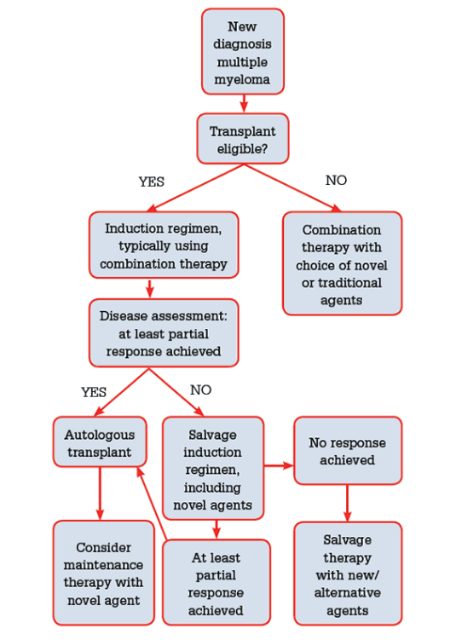

Appendix B: Top 25 most common drug sequences of patients using anti-myeloma medicines for the period 1 February 2017 until 30 June 2019 inclusive.
Drug sequence | Count | Percent
Bortezomib first line | 2373 | 23.5
Lenalidomide subsequent line | 1105 | 10.9
Thalidomide first line | 820 | 8.1
Bortezomib first line -> Thalidomide subsequent line | 742 | 7.4
Lenalidomide first line | 710 | 7
Thalidomide first line -> Lenalidomide subsequent line | 448 | 4.4
Bortezomib subsequent line | 361 | 3.6
Bortezomib first line -> Lenalidomide subsequent line | 305 | 3
Bortezomib first line -> Thalidomide subsequent line -> Lenalidomide subsequent line | 272 | 2.7
Pomalidomide | 177 | 1.8
Lenalidomide subsequent line -> Bortezomib subsequent line | 165 | 1.6
Bortezomib subsequent line -> Lenalidomide subsequent line | 126 | 1.2
Lenalidomide subsequent line -> Pomalidomide | 117 | 1.2
Bortezomib subsequent line -> Pomalidomide | 104 | 1
Bortezomib first line -> Bortezomib subsequent line | 101 | 1
Lenalidomide subsequent line -> Carfilzomib | 86 | 0.9
Lenalidomide subsequent line -> Lenalidomide first line | 84 | 0.8
Bortezomib subsequent line -> Thalidomide subsequent line | 80 | 0.8
Lenalidomide subsequent line -> Bortezomib subsequent line -> Pomalidomide | 77 | 0.8
Thalidomide first line -> Lenalidomide subsequent line -> Bortezomib subsequent line | 70 | 0.7
Carfilzomib | 61 | 0.6
Thalidomide first line -> Bortezomib subsequent line | 60 | 0.6
Lenalidomide first line -> Lenalidomide subsequent line | 57 | 0.6
Bortezomib first line -> Carfilzomib | 53 | 0.5
Bortezomib subsequent line -> Carfilzomib | 52 | 0.5
Data period: 1 February 2017 to 30 June 2019 inclusive based on date of supply.

Kyle RA, Gertz MA, Witzig TE, Lust JA, Lacy MQ, Dispenzieri A et al. Review of 1027 patients with newly diagnosed multiple myeloma. Mayo Clin Proc. 2003 Jan;78(1):21-33.
Leukaemia Foundation: Myeloma diagnosis. Last updated 19 June 2019. Available from: https://www.leukaemia.org.au/disease-information/myeloma/how-is-it-diagnosed/
Australian Institute of Health and Welfare (AIHW) 2018 Cancer Data in Australia; Australian Cancer Incidence and Mortality (ACIM) books: multiple myeloma Canberra: AIHW. Available from: https://www.aihw.gov.au/reports/cancer/cancer-data-in-australia/
Bladé J, Kyle RA. Multiple myeloma in young patients: clinical presentation and treatment approach. Leuk Lymphoma. 1998;30(5-6):493.
Myeloma Australia: Clinical Practice Guideline Multiple Myeloma. Clinical Practice Guideline V.4 – March 2017. Available from: http://myeloma.org.au/wp-content/uploads/2017/10/MSAG-Clinical-Practice-Guideline-Myeloma-V4-March-2017.pdf
PBS website: https://pbs.gov.au
Lenalidomide (Revlimid) Product Information. Available from: https://www.ebs.tga.gov.au/
Public Summary Document, lenalidomide, November 2015.
Multiple Myeloma Stakeholder Meeting Outcome Statement (May 2018). http://www.pbs.gov.au/industry/listing/elements/pbac-meetings/pbac-stakeholder-meetings/Multiple-myeloma-May-2018.pdf
Eslick R. Multiple myeloma: from diagnosis to treatment. Australian Family Physician. Volume 42, No.10. October 2013 Page 687. Available from: https://www.racgp.org.au/afp/2013/october/multiple-myeloma/

