Avelumab for Merkel cell carcinoma: 24 month predicted versus actual analysis

Drug utilisation sub-committee (DUSC)

February 2022

Abstract

Purpose

Analysis of the predicted versus actual utilisation of avelumab 24 months following its addition to the Pharmaceutical Benefits Scheme (PBS) for the treatment of metastatic Merkel cell carcinoma (MCC) on 1 May 2019.

Data Source / methodology
PBS dispensing data for avelumab was extracted from the PBS data maintained by the Department of Health, processed by Services Australia. This data was used to establish the number of prevalent and incident patients utilising avelumab for Merkel cell carcinoma and time on therapy.

Key Findings
- In the first three years of listing there were 182, 235 and 244 prevalent patients per year since May 2019 to the data cut-off to 30 November 2021.
- Since listing, avelumab has had a steady increase in utilisation with up to 20 newly initiating patients per month and a prevalent patient population that does not appear to have plateaued.
- The number of prevalent patients per year was underestimated in years 2 and 3 while the number of prescriptions per year was overestimated.
- The number of Initial Authority STREAMLINED prescriptions was less than estimated in the first two years of listing while the number of Continuing prescriptions was considerably less than estimated in all three years of listing. However this may be due to only the availability of part year data in years 1 and 3.
- The number of males undergoing treatment with avelumab was over three times greater than females in 2020.
- The median age of patients initiating in 2020 was 79 years old in females and 77 years old in males.
- In the first month following listing, 38 patients who initiated on avelumab appeared to use previous therapies for MCC and there continues to be a small number of patients initiating per month with a previous history of other therapies. The median age in this group of patients was 72 years.
- The PBAC in July 2018 considered time on treatment to be an area of uncertainty. The submission estimated | | of patients would continue treatment into the second year. The Kaplan-Meier analysis in this report indicates that the median time on treatment for patients was 304 days with breaks in supply or 248 days without breaks.

Purpose of analysis
Analysis of the predicted versus actual utilisation of avelumab 24 months following its addition to the Pharmaceutical Benefits Scheme (PBS) for the treatment of metastatic Merkel cell carcinoma on 1 May 2019.

Background

Clinical situation
Merkel cell carcinoma (MCC) is a cutaneous carcinoma that usually appears after sun-exposure and commonly occurs in elderly Caucasian males or the immunocompromised. The Australian Institute of Health and Welfare (AIHW) estimates that MCC accounts for 36% of all rare non-melanoma skin cancers in Australia which equates to a projected 1.5 cases per 100, 000 population in 2021.
Chemotherapy was the preferred treatment in metastatic MCC prior to immunotherapies being available in May 2019. Avelumab is the first and only immunotherapy in Australia currently listed on the PBS for the treatment of metastatic MCC and has become the treatment of choice with chemotherapy being moved to the palliative setting.¹

Pharmacology
Avelumab is an antibody that binds to the programmed death ligand 1 (PD-L1) which inhibits the ligand from binding to the programmed death 1 (PD-1) and B7-1 receptors. Inhibition of this pathway removes the suppressive effects of PD-L1 on cytotoxic CD8+ T-cells and restores anti-tumour T-cell responses.

Therapeutic Goods Administration (TGA) approved indications
Avelumab is indicated for the treatment of³:
- Metastatic Merkel cell carcinoma
- First-line maintenance treatment of advanced or metastatic urothelial carcinoma. following no disease progression after first-line platinum-based therapy.
- In combination with axitinib for first-line advanced renal cell carcinoma.

Dosage and administration
The recommended dose of avelumab for MCC is 10mg/kg body weight or 800mg administered intravenously every two weeks until disease progression or unacceptable toxicity.
The current Product Information (PI) and Consumer Medicine Information (CMI) are available from the TGA (Product Information) and the TGA (Consumer Medicines Information).

PBS listing details (as at 1 December 2021)
Table 1 shows the current PBS listing for avelumab for metastatic MCC.

Table 1: PBS listing of avelumab for metastatic MCC
Item | Name, form & strength, pack size | Max. quant. | Rpts | DPMQ | Brand name and manufacturer
11671G | Avelumab  Injection concentrate for intravenous infusion, 200mg in 10mL vials | 1200mg | 11 | $8230.44 | Bavencio®  Merck Healthcare Pty Ltd
11679Q |  |  | 8 | $8385.47
11685B |  |  | 11 | $8385.47
11695M |  |  | 8 | $8230.44
Source: the PBS website. Special Pricing Arrangement applies.

Restriction
Stage IV (metastatic) Merkel Cell Carcinoma
Treatment Phase: Initial treatment
Clinical criteria:
The treatment must be the sole PBS-subsidised therapy for this condition,
AND
The treatment must not exceed a total of 9 doses at a maximum dose of 10 mg per kg every 2 weeks under this restriction.
Stage IV (metastatic) Merkel Cell Carcinoma
Treatment Phase: Continuing treatment
Clinical criteria:
The treatment must be the sole PBS-subsidised therapy for this condition,
AND
Patient must have previously received PBS-subsidised treatment with this drug for this condition,
AND
Patient must not have developed disease progression while being treated with this drug for this condition,
AND
The treatment must not exceed a maximum dose of 10 mg per kg every 2 weeks under this restriction.
The patient's body weight must be documented in the patient's medical records at the time treatment is initiated.
For details of the current PBS listing refer to the PBS website.

Changes to listing
The original ‘Continuing treatment’ listings contained an added requirement that treatment could not exceed 12 doses. This requirement was removed in the current restriction which was listed on 1 January 2020.

Relevant aspects of consideration by the Pharmaceutical Benefits Advisory Committee (PBAC)
Avelumab for metastatic MCC was considered by DUSC and PBAC for the July 2018 meeting. The submission used a cost-utility analysis compared to the Australian standard of care chemotherapy regimens at the time which consisted of cyclophosphamide + doxorubicin + vincristine, or cisplatin + etoposide, or carboplatin + etoposide. The submission proposed the use of avelumab in the second-line treatment of metastatic MCC with an epidemiological approach to estimate utilisation. Incidence and prevalence data were obtained from the 2016 AIHW Skin Cancer Report which informed the population based studies used to estimate the number of metastatic MCC patients in Australia. Estimated treatment uptake rates were based on information from the 2017 Nivolumab Public Summary Document for renal cell carcinoma.
The PBAC noted that there was a high unmet need for new treatments in this condition and that a line agnostic listing may be appropriate despite the early data presented in the submission. The PBAC noted comments that described avelumab as more effective and tolerable than chemotherapy especially given the average age of patients at 70 years old. The PBAC noted that there was significant uncertainty in the duration of treatment in a line agnostic setting and acknowledged DUSC’s advice that the potential for greater efficacy in the first-line setting would cause the average time on treatment to be greater than estimated in this setting. Overall DUSC considered the estimates to be reasonable.
For further details refer to the Public Summary Document from the July 2018 PBAC meeting.

Approach taken to estimate utilisation
The submission used an epidemiological approach to estimate utilisation of avelumab for metastatic MCC. The approach used AIHW incidence of non-melanoma skin cancers and noted the 2016 AIHW Skin Cancer Report which stated that 36% of these cases in 2012 were related to MCC. The proportion of these patients who would have metastatic disease was calculated based on patients who were diagnosed with MCC and subsequently died (Youlden 2014 and Girschick 2011). DUSC noted that these studies were based in Queensland and Western Australia and likely introduced a positive bias due to higher rates of sun exposure in these locations. DUSC commented that this approach may be an overestimation as it implies these patients died from MCC rather than from other causes. The submission assumed treatment uptake rates of | | to || over the forward estimates based on the uptake rates for nivolumab in second-line renal cell carcinoma. However, DUSC noted that this was likely an underestimate as there was a larger clinical need in MCC. It was assumed that approximately 20% incident patients will continue into year 2 and 2% will continue into year three.

Previous reviews by the DUSC
This is the first utilisation review of avelumab for MCC.

Methods
Data from 1 May 2019 to 31 October 2021 were extracted from the PBS data maintained by Department of Health, processed by Services Australia on or before 1 December 2021 for the PBS item codes listed in Table 1 which corresponds to the treatment of MCC.
PBS prescription data were used to determine the number of prescriptions supplied and the PBS expenditure. These data were also used to count the number of patients, both incident (new to treatment) and prevalent (number treated in each time period, i.e. year or quarter).
PBS prescription data also contains age and gender information. This information was used to perform a breakdown of prevalent patients by age and gender from 1 January 2020 until 31 December 2020.
The Kaplan-Meier method was used to determine the length of treatment for patients on avelumab. A break in treatment was defined as a gap of more than three times the median time between supplies. A patient was deemed to be continuing treatment (classified as censored in the Kaplan-Meier analysis) at the end of the data period (i.e. the end of June 2021) if their last prescription was within three times the median time to resupply of this end date. Otherwise the patient was deemed to have ceased treatment with the treatment coverage end date being the supply date of their last prescription plus a median time to resupply. If a patient’s supply was after a gap of more than three times the median time to resupply, then the patient was deemed to have been re-treated.
The estimates model used to present the estimated cost to the PBS/RPBS was a model that was agreed upon by both the Department of Health and the Sponsor. Refer to the ‘Approach to estimate utilisation’ section for further details on the development of the financial estimates.

Results

Analysis of drug utilisation

Overall utilisation
Avelumab was listed for MCC on 1 May 2019 with 182 prevalent patients supplied in the first year followed by an increase in years 2 and 3 with 235 and 243 prevalent patients respectively (Table 2). The number of incident patients in the first year of listing was 182 which decreased in years 2 and 3 with 113 and 112 patients respectively. Dispensings in the first year of listing were lower with 1,856 prescriptions compared with years 2 and 3 which were similar at 3,081 and 2,917 respectively.

Table 2: Summary of overall utilisation of avelumab for MCC since listing on the PBS on 1 May 2019
Year | Prevalent Patients | Incident Patients | Dispensings
2019ª | 182 | 182 | 1,856
2020 | 235 | 113 | 3,081
2021^{b} | 243 | 112 | 2,917
ªPart-year data beginning in 1 May 2019 to 31 December 2019
^{b}Part-year data for the period 1 January 2021 to 31 October 2021
Since listing, monthly utilisation of avelumab started at 88 prevalent patients and had increased steadily to 166 prevalent patients as at October 2021 and showed no signs of plateauing (Figure 1). Incidence had remained steady with 10-20 new patients per month. Notable timepoints are April 2020, October 2020, and June 2021 which approximately mark the points of the first, second and third wave of the COVID-19 pandemic in Australia and show an increasing number of prevalent patients in Figure 1.
Figure 2 shows the monthly number of prescriptions by application type for avelumab for MCC. The number of Initial and Continuing prescriptions have remained fairly consistent with approximately 250 Initial scripts per month and 90 Continuing scripts per month. The number of prescriptions per month do not appear to have risen with the number of prevalent patients during the first two waves of the COVID-19 pandemic however the third wave seemed to have had an impact with a rise in Initial prescriptions to over 300 and over 100 Continuing prescriptions.

Figure 1: Number of incident and prevalent patients supplied avelumab since listing on the PBS on 01 May 2019 to 31 October 2021

Figure 2: Avelumab prescriptions by application type since listing on the PBS in 01 May 2019 to 31 October 2021

Patient level analysis
The breakdown of avelumab first initiators in 2020 by age and gender can be seen in Figure 3 which indicates that the interquartile range of patients, whether female or male, are beginning avelumab for MCC between 70 to 85 years old with the median age in females 79 and 77 in males. The number of males undergoing treatment with avelumab was over three times greater than females with 87 incident patients compared to 26 females in 2020.
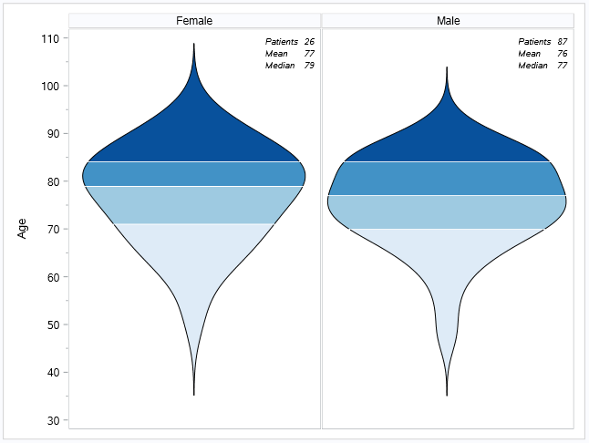

Figure 3: Violin plot of the age of first initiators on avelumab for MCC in 2020.

Note: Each section of the graph represents quartiles.
Avelumab was initially proposed for first- or second- line use for MCC however the PBAC considered a line-agnostic listing would be most appropriate considering the clinical need for new therapies in MCC. Figure 4 shows the number of incident patients who may have been using standard first-line therapies for MCC prior to moving to avelumab after it was listed. In May 2019, 38 incident patients moved to avelumab from previous use of other drugs. However, this number declines to 1 to 2 new patients per month and the median age of suspected first-line treatment is 72 years old. This illustrates that the majority of patients appear to be using avelumab as first-line for MCC.

Figure 4: History in initiating patients using avelumab of prior PBS supplied therapies possibly used as first line for MCC.

Note: List of prior therapies includes cisplatin, carboplatin, etoposide, doxorubicin, and vincristine (based on the proposed comparators in the submission).

Time on treatment
The median time to resupply was 14 days resulting in a 42 day interval. The patient was deemed to have ceased treatment with the treatment coverage end date being the supply date of their last prescription plus a median time to resupply. The Kaplan-Meier analysis includes patients with identified treatment breaks. Figure 5 shows this analysis where 42% of patients were censored and the median time on treatment for the remaining 235 patients was 304 days (260-378 days 95% CI).
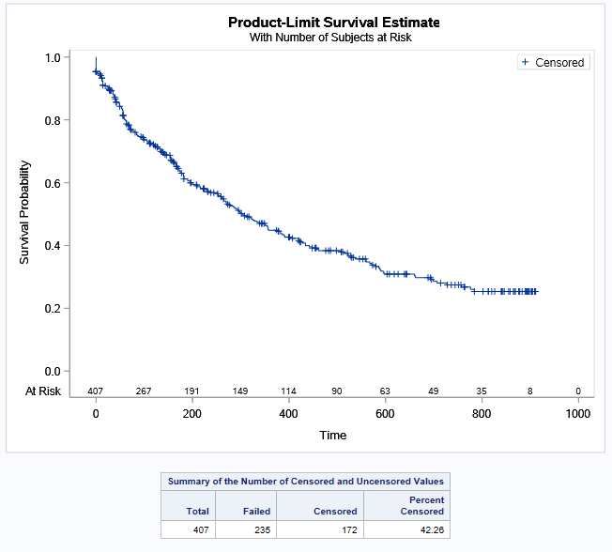

Figure 5: Kaplan-Meier analysis of the time on treatment of patients supplied avelumab including treatment breaks

If a patient’s supply was after a gap of more than three times the median time to resupply, then the patient was deemed to have been re-treated. Figure 7 represents this analysis for each patient’s first episode of treatment. The median time on treatment in Figure 6 is 258 days (203 - 294 days 95% CI) for 407 patients where 40% of patients were censored.

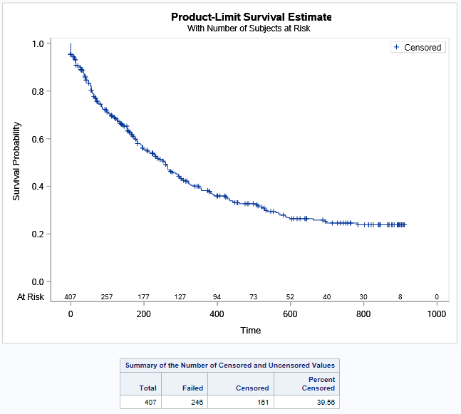

Figure 6: Kaplan-Meier analysis of the time on treatment of the first episode of therapy in those supplied avelumab (excludes treatment breaks)

Analysis of actual versus predicted utilisation
Table 3 presents a comparison of the predicted versus actual utilisation and expenditure of avelumab for MCC since listing in May 2019. In the first year of listing the number of initiating patients was 182 which is 2% less than what was predicted. The number of patients in Year 2 and Year 3 are greater than predicted at +28% and +26% respectively while noting that Year 3 is part-year data. The number of prescriptions dispensed in all years of listing are less than what was predicted and the cost to the PBS/RPBS mirror the amount of prescriptions that were dispensed and were less than predicted.

Table 3: Actual versus predicted utilisation and cost to the PBS/RPBS
Avelumab listing years |  | Year 1 | Year 2 | Year 3
 |  | January 2019- December 2019ª | January 2020 - December 2021 | January 2021-December 2021^{b}
Patients | Predicted | || | || | ||
 | Actual | 182 | 235 | 243
 | Difference | || | |||| | ||||
Prescriptions | Predicted | |||| | |||| | ||||
 | Actual | 1,856 | 3,081 | 2,917
 | Difference | |||| | |||| | ||||
Net Cost PBS/RPBS | Predicted | |||||||||||||| | |||||||||||||| | ||||||||||||||
 | Actual | $10,255,691 | $17,419,303 | $16,553,772
 | Difference | |||| | |||| | ||||
ªPart-year data beginning in 1 May 2019 to 31 December 2019
^{b}Part-year data for the period 1 January 2021 to 31 July 2021
Note: Predicted figures represent full-year values and have not been adjusted for any part-years.
Table 4 presents the utilisation by the types of Authority STREAMLINED prescriptions that were dispensed for avelumab for MCC. In the first two years of listing Initial prescriptions were -18% and -30% less than predicted before rising in Year 3 to 18% greater than predicted. Continuing prescriptions were consistently lower than predicted with -82% in the first year, -18% in the second year and -23% in the third year.

Table 4: Actual versus predicted STREAMLINED script data for PBS/RPBS
Avelumab listing years |  | Year 1 | Year 2 | Year 3
 |  | January 2019- December 2019ª | January 2020 - December 2021 | January 2021-December 2021^{b}
Initial | Predicted | || | || | ||
 | Actual | 1289 | 1089 | 1928
 | Difference | |||| | |||| | ||
Continuing | Predicted | || | || | ||
 | Actual | 543 | 1928 | 1960
 | Difference | |||| | |||| | ||||
ªPart-year data beginning in 1 May 2019 to 31 December 2019
^{b}Part-year data for the period 1 January 2021 to 31 July 2021
Note: Predicted figures represent full-year values and have not been adjusted for any part-years.
Prescription count in Table 3 represents all prescriptions including STREAMLINED and non-STREAMLINED while Table 4 only contains STREAMLINED prescriptions so may not necessarily represent total script volume.

Discussion and DUSC Consideration
DUSC noted that the predicted utilisation of avelumab for MCC in terms of prevalent patients was underestimated however the number of prescriptions and cost to the PBS was overestimated.
At the July 2018 meeting, the PBAC and DUSC considered the financial estimates provided in the submission to be reasonable. The PBAC noted that one area of significant uncertainty was in the duration of treatment in a line agnostic setting and acknowledged DUSC’s advice that the potential for greater efficacy in the first-line setting would cause the average time on treatment to be greater than estimated in this setting. DUSC noted that the Kaplan-Meier analysis of time on treatment done in this report indicated that the median time on treatment for patients was 304 days or 43.4 weeks with breaks in supply or 248 days or 35.4 weeks without breaks in supply. However, a large number of patients were censored around these timepoints suggesting the median time could be greater. This indicates that the time on treatment in the submission was likely underestimated. DUSC considered that the median time on treatment from the Kaplan-Meier analysis would underestimate treatment duration. DUSC noted this would be due to the large number of ‘short lived’ patients beginning treatment in the first year of listing followed by a long tail of partial or well responding patients who remain eligible for supply as there is currently no stopping criteria in the restriction.
DUSC noted the data presented in this analysis indicates that the majority of patients are over 70 years old with median ages at 79 and 76 for females and males respectively and appear to be accessing avelumab as first-line treatment for MCC. A small percentage of newly initiating patients per month show a history of previous likely therapies for MCC and these patients were typically younger than the median age of all avelumab initiating patients.
DUSC noted the number of prescriptions for avelumab per year was less than predicted despite underestimated prevalent patients. DUSC noted that Initial prescriptions were |||||| |||||||||||| less than predicted before rising in Year 3 to || greater than predicted while continuing prescriptions were consistently lower than predicted with |||| in the first year, |||||| in the second year and |||||| in the third year. The significant overestimation in the first year is likely due to avelumab being listed in May however those patients initiating in year 1 should be reflected in years 2 and 3 but this does not appear to be occurring and may require more mature data. DUSC also considered that clinicians likely reduced doses due to COVID which would be reflected in the lower prescription numbers seen in years two and three.

DUSC Actions
The report was provided to the PBAC for consideration.

Context for analysis
The DUSC is a Sub Committee of the Pharmaceutical Benefits Advisory Committee (PBAC). The DUSC assesses estimates on projected usage and financial cost of medicines.
The DUSC also analyses data on actual use of medicines, including the utilisation of PBS listed medicines, and provides advice to the PBAC on these matters. This may include outlining how the current utilisation of PBS medicines compares with the use as recommended by the PBAC.
The DUSC operates in accordance with the quality use of medicines objective of the National Medicines Policy and considers that the DUSC utilisation analyses will assist consumers and health professionals to better understand the costs, benefits and risks of medicines.
The utilisation analysis report was provided to the pharmaceutical sponsors of each drug and comments on the report were provided to DUSC prior to its consideration of the analysis.

Sponsors’ comments
Merck would like to thank DUSC for reviewing the utilisation of Avelumab for Merkel cell carcinoma in 24 months on predicted versus actual use.

Disclaimer
The information provided in this report does not constitute medical advice and is not intended to take the place of professional medical advice or care. It is not intended to define what constitutes reasonable, appropriate or best care for any individual for any given health issue. The information should not be used as a substitute for the judgement and skill of a medical practitioner.
The Department of Health (DoH) has made all reasonable efforts to ensure that information provided in this report is accurate. The information provided in this report was up-to-date when it was considered by the Drug Utilisation Sub-committee of the Pharmaceutical Benefits Advisory Committee. The context for that information may have changed since publication.
To the extent provided by law, DoH makes no warranties or representations as to accuracy or completeness of information contained in this report.
To the fullest extent permitted by law, neither the DoH nor any DoH employee is liable for any liability, loss, claim, damage, expense, injury or personal injury (including death), whether direct or indirect (including consequential loss and loss of profits) and however incurred (including in tort), caused or contributed to by any person’s use or misuse of the information available from this report or contained on any third party website referred to in this report.

References
- Kok, DL, Wang, A, Xu, W, et al. The changing paradigm of managing Merkel cell carcinoma in Australia: an expert commentary. Asia-Pac J Clin Oncol. 2020; 16: 312– 319. https://doi.org/10.1111/ajco.13407
- Australian Institute of Health and Welfare. Cancer data in Australia [Internet]. Canberra: Australian Institute of Health and Welfare, 2021 [cited 2021 Dec. 3]. Available from: https://www.aihw.gov.au/reports/cancer/cancer-data-in-australia
- BAVENCIO® (AVELUMAB). Australian Approved Product Information. Merck Healthcare Pty Ltd. Approved 3 January 2018, updated 24 February 2021. Available from https://www.tga.gov.au/product-information-0
- D'Angelo SP, Bhatia S, Brohl AS, et al. Avelumab in patients with previously treated metastatic Merkel cell carcinoma: long-term data and biomarker analyses from the single-arm phase 2 JAVELIN Merkel 200 trial. J Immunother Cancer. 2020;8(1):e000674. doi:10.1136/jitc-2020-000674
- D'Angelo SP, Lebbé C, Mortier L, et al. First-line avelumab in a cohort of 116 patients with metastatic Merkel cell carcinoma (JAVELIN Merkel 200): primary and biomarker analyses of a phase II study. J Immunother Cancer. 2021;9(7):e002646. doi:10.1136/jitc-2021-002646

Kok, DL, Wang, A, Xu, W, et al. The changing paradigm of managing Merkel cell carcinoma in Australia: an expert commentary. Asia-Pac J Clin Oncol. 2020; 16: 312– 319. https://doi.org/10.1111/ajco.13407
Australian Institute of Health and Welfare. Cancer data in Australia [Internet]. Canberra: Australian Institute of Health and Welfare, 2021 [cited 2021 Dec. 3]. Available from: https://www.aihw.gov.au/reports/cancer/cancer-data-in-australia
BAVENCIO® (AVELUMAB). Australian Approved Product Information. Merck Healthcare Pty Ltd. Approved 3 January 2018, updated 24 February 2021. Available from https://www.tga.gov.au/product-information-0

