Atezolizumab for extensive-stage small cell lung cancer: analysis of predicted versus actual utilisation

Drug utilisation sub-committee (DUSC)

September 2022

Abstract

Purpose

To compare the predicted and actual utilisation of atezolizumab for extensive-stage small cell lung cancer (ES-SCLC) since its listing on the Pharmaceutical Benefits Scheme (PBS).

Date of listing on the Pharmaceutical Benefits Scheme (PBS)
Atezolizumab was first listed for ES-SCLC on the PBS on 1 March 2020. On 1 July 2020 the listing was extended to include an additional flat dosing regimen of 1680 mg every four weeks (Q4W) using a new 840 mg in 14mL formulation.

Data Source / methodology
Data extracted from the PBS database maintained by Department of Health and Aged Care, processed by Services Australia were used for the analyses.

Key Findings
- The number of patients using atezolizumab has been more than predicted, but the number of scripts and benefits paid is lower than anticipated.
- In the first year of listing there were 961 prevalent patients supplied atezolizumab and in the second year of listing there were 1,209.
- The estimated number of grandfathered patients (n=|) was uncertain as the patient access program had not commenced at the time of the submission. The actual count of grandfathered patients in Year 1 was 113. The underestimation may also have contributed to more patients being supplied treatment in Year 2.
- The mean time on treatment with breaks in supply was 170 days. This was less than the sponsor’s estimate of a treatment duration of | days based on the IMpower133 trial. The mean time on treatment without breaks was 188 days, which is close to the sponsor’s estimate of | days.
- The PBAC noted in the March 2020 submission that there was uncertainty around the estimated 100% uptake of the 1680 mg four weekly (Q4W) dosing regimen for continuing treatment. However, it was considered likely that most patients would be prescribed this new dosing regimen once it became available. This review demonstrates that most patients were still being prescribed the three weekly regimen (Q3W).

Purpose of analysis
To compare the predicted and actual utilisation of atezolizumab for ES-SCLC since its listing on the PBS.

Background

Clinical situation
There are two main types of lung cancer: non-small cell lung cancer (NSCLC) and small cell lung cancer (SCLC).
NSCLC contributes to around 80-85% of all lung cancers. The main subtypes of NSCLC include adenocarcinoma, squamous cell carcinoma and large cell carcinoma. These lung cancers differ in the type of lung cells affected however are grouped together because their prognosis and response to treatment is comparable.
SCLC is less common than NSCLC, representing around 12% of new lung cancer cases, however is known to be more aggressive in nature. It generally forms in the lung cells that would secrete mucus like substances. The cancer cells are usually found in the periphery of the lung and can grow quickly and rapidly spread to other parts of the body. Patients with SCLC are generally classified as having limited-stage (LS) or extensive-stage (ES) SCLC. The disease is ES if the cancer is metastatic or if it has spread beyond an area that can be treated with a single beam of external radiation.
Smoking is a significant high risk factor for people developing lung cancer.

Pharmacology
Atezolizumab is a human formulated immunoglobulin G1 (IgG1) monoclonal antibody that directly binds to programmed death-ligand 1 (PD-L1) protein to block interactions with the PD-1 and B7.1 receptors, releasing PD-L1/PD-1 pathway-mediated inhibition of the immune response, including reactivating the anti-tumour immune response. Atezolizumab has been shown in mouse tumour models to block PD-L1 activity resulting in decreased tumour growth.

Therapeutic Goods Administration (TGA) approved indications
Atezolizumab is TGA approved for:
- Early-stage NSCLC
- Metastatic NSCLC
- SCLC
- Urothelial carcinoma
- Triple-negative breast cancer
- Hepatocellular carcinoma
Further information about atezolizumab’s registered indications is available from the Australian Register of Therapeutic Goods.
Dosage and administration

Table 1: Dosage and administration of Atezolizumab for ES-SCLC
Brand name and sponsor | Product | Dose and frequency of administration
Tecentriq, Roche Products Pty Ltd | atezolizumab 1.2 g/20 mL injection, 20 mL vial  atezolizumab 840 mg/14 mL injection, 14 mL vial | During the induction phase, the recommended dose of atezolizumab is 1200 mg, followed by carboplatin, and then etoposide administered by IV infusion on day 1. Etoposide is administered by IV infusion on days 2 and 3. This regimen is administered every 3 weeks for 4 cycles.  The induction phase is followed by a maintenance phase without chemotherapy in which the recommended dosage of atezolizumab is either;  - 840 mg every 2 weeks,  - 1200 mg every 3 weeks or  - 1680 mg every 4 weeks.
Source: Product Information
The current Product Information (PI) and Consumer Medicine Information (CMI) are available from the TGA (Product Information) and the TGA (Consumer Medicines Information).

PBS listing details (as at 1 July 2022)

Table 2: PBS listing of atezolizumab for ES-SCLC
Item | Name, form & strength, pack size | Max. amt. | Rpts | DPMA | Brand name and manufacturer
11929W | atezolizumab 1.2 g/20 mL injection, 20 mL vial | 1200 mg | 4 | $7189.56 | Tecentriq®  Roche Products Pty Ltd
11928T | atezolizumab 1.2 g/20 mL injection, 20 mL vial | 1200 mg | 4 | $7330.62
12078Q | atezolizumab 840 mg/14 mL injection, 14 mL vial | 1680 mg | 3 | $10030.55
12076N | atezolizumab 840 mg/14 mL injection, 14 mL vial | 1680 mg | 3 | $10211.38
Source: the PBS website. Note: Special Pricing Arrangements apply.

Restriction
Treatment Phase: Initial treatment
Clinical criteria:
- The condition must be previously untreated,
AND
- Patient must have a WHO performance status of 0 or 1,
AND
- The treatment must be in combination with etoposide and a platinum-based antineoplastic drug.

Treatment Phase: Continuing treatment - 3 weekly treatment regimen
Clinical criteria:
- The treatment must be as monotherapy,
AND
- Patient must have previously received PBS-subsidised treatment with this drug for this condition,
AND
- Patient must not have developed disease progression while being treated with this drug for this condition.
Treatment Phase: Continuing treatment - 4 weekly treatment regimen
Clinical criteria:
- The treatment must be as monotherapy,
AND
- Patient must have previously received PBS-subsidised treatment with this drug for this condition,
AND
Patient must not have developed disease progression while being treated with this drug for this condition.
For details of the current PBS listing and related notes, refer to the PBS website.

Date of listing on PBS
Atezolizumab was first listed for previously untreated ES-SCLC on 1 March 2020.

Changes to listing
On 1 July 2020 the listing was extended to include an additional flat dosing regimen of 1680 mg every four weeks (Q4W) using a new 840mg in 14mL formulation.
Atezolizumab has been listed on the PBS for other indications since 1 June 2018, including locally advanced or metastatic non-small cell lung cancer and hepatocellular carcinoma.

Relevant aspects of consideration by the Pharmaceutical Benefits Advisory Committee (PBAC)
PBAC July 2019
The first submission was considered at the July 2019 meeting where the PBAC did not recommend the PBS listing of atezolizumab for previously untreated ES-SCLC. The PBAC considered there was uncertainty in the magnitude and durability of the benefit in overall survival (OS) and the impact on patient quality of life was unclear. The PBAC also considered the incremental cost effectiveness ratio (ICER) in this setting was uncertain and unacceptably high at the proposed price.
In July 2019, the PBAC considered the changes to the financial estimates that were proposed by DUSC, and accepted by the pre-PBAC response, were reasonable including reducing the proportion of patients who progress from limited stage (LS)-SCLC to ES-SCLC and who have an Eastern Cooperative Oncology Group (ECOG) performance status of 0-1 to 80%; and reducing the estimated uptake rate in incident and prevalent patients to 95% (due to contraindications). The total number of treated patients and scripts were unchanged from those estimated in the previous pre-PBAC response. The financial estimates were only updated for the lower effective price (and updates to dispensing fees).
For further details refer to the Public Summary Document from the July 2019 PBAC meeting.
PBAC November 2019
In November 2019, the PBAC recommended the listing of atezolizumab be made available for previously untreated patients with ES-SCLC and an ECOG score 0–1. The PBAC recommended the listing if used in combination with platinum-based chemotherapy plus etoposide and reflected changes to the financial estimates suggested by DUSC.
For further details refer to the Public Summary Document from the November 2019 PBAC meeting.
PBAC March 2020
In March 2020, the PBAC recommended extending its November 2019 recommendation for the 840 mg in 14 mL injection of atezolizumab and the addition of the 1680 mg every four weeks (Q4W) flat dosing regimen to include the treatment of previously untreated patients with 1L ES-SCLC where atezolizumab monotherapy is used for continuing treatment following the sponsor’s November 2019 minor submission request.
The PBAC noted no new clinical evidence was provided to compare the two flat dosing regimens in terms of efficacy and safety. However, PBAC previously considered that the 1680 mg Q4W dosing regimen was likely comparable to the 1200 mg every three weeks (Q3W) dosing regimen based on the same evidence in its November 2019 consideration of the addition of the 1680 mg Q4W dosing regimen for NSCLC indications. In this regard, the PBAC considered that the effectiveness and safety of the 1680 mg Q4W dosing regimen was likely comparable to that of the 1200 mg Q3W dosing regimen for 1L ES-SCLC.
The PBAC noted that the sponsor had previously agreed to pricing for the 1680 mg Q4W dosing regimen in 1L and 2L NSCLC based on cost-minimisation at the ex-manufacturer level compared to the 1200 mg Q3W dosing regimen and considered it would be appropriate to apply consistent methodology for the first line (1L) ES-SCLC indication. Further, the PBAC considered that the cost of treatment with the 1680 mg Q4W dosing regimen should not exceed that of the 1200 mg Q3W dosing regimen.
The PBAC noted the uncertainty around the estimated 100% uptake of the 1680 mg Q4W dosing regimen for continuing treatment. However, it was likely that most patients would be prescribed this new dosing regimen once it became available. The PBAC considered that overall, the addition of the 1680 mg Q4W dosing regimen for 1L ES-SCLC would likely be cost neutral for the Government.
The PBAC considered that 3 repeats for continuing treatment, which would provide 16 weeks of therapy under a Q4W dosing regimen, would be appropriate and that improved convenience from less frequent dosing would be beneficial for patients, particularly those in rural or remote areas.
The PBAC considered that additional grandfathering provisions for the 1680 mg Q4W dosing regimen would not be required as any 1L ES-SCLC grandfathered patients could be prescribed the 1680 mg Q4W dosing regimen under the continuing treatment restriction following PBS subsidised treatment under the existing grandfather restriction for 1L ES-SCLC.
For further details refer to the Public Summary Document from the March 2020 PBAC meeting.

Approach taken to estimate utilisation
An epidemiological approach was used to estimate the financial impact of listing based on the following key assumptions accepted by the PBAC:
- The number of incident patients was forecast using a linear extrapolation from historical incidence of lung cancer in Australia from 2012-2018 extracted from 2017 Australian Cancer Incidence and Mortality (ACIM) book (2012-2014) and Australian Institute of Health and Welfare (AIHW)’s Cancer in Australia 2017 report (2017-2018).
- 11.75% incidence of lung cancers were assumed to be SCLC (AIHW 2011).
- 71% of SCLC patients were assumed to have extensive-stage disease based on an average of registry data sourced from the Victorian Cancer Registry (Mitchell 2013), Liverpool and Macarthur Cancer Therapy Centre (Kang 2012), Queen Elizabeth Hospital Cancer Registry in South Australia (Bishnoi 2011), and the Sydney South West Area Health Service (Duggan 2010).
- 80% of patients progress from LS-SCLC to ES-SCLC who have an ECOG of 0-1 as advised by DUSC for the July 2019 submission.
- 67% of patients with ES-SCLC would be eligible for atezolizumab who are ECOG 0-1.
- An estimated treatment uptake of 95% in incident and prevalent patients.
- | grandfathered patients were estimated to initiate atezolizumab in Year 1.
- The average treatment duration was estimated to be || months, equivalent to || doses, based on the IMpower133 trial.
- All patients were assumed to have 4 initiating doses.
- || continuing doses was assumed for all patients, based on average doses from economic model.

In March 2020 the PBAC recommended the addition of atezolizumab 840 mg injection for the 1680 mg Q4W flat dosing regimen in 1L ES-SCLC. This listing change was expected to be cost neutral and the financial estimates were not further updated from the November 2019 submission.

The utilisation estimates for atezolizumab are summarised in Table 3. For the purposes of the predicted vs. actual analysis the estimates based on a treatment duration of || months are used to compare to actual use.

Table 3: Total utilisation and cost to PBS of listing atezolizumab (as presented in the November 2019 submission)
 | Year 1 | Year 2 | Year 3 | Year 4 | Year 5 | Year 6
Estimated extent of use
Number of treated patients | | | | | | | | | | | |
Number of scripts | | | | | | | | | | | |
Estimated financial implications of atezolizumab
Net cost to PBS/RPBS (published price) | |||||||||||| | |||||||||||| | |||||||||||| | |||||||||||| | |||||||||| | ||||||||||
Source: November 2019 resubmission.

Previous reviews by the DUSC
DUSC had previously reviewed the use of nivolumab in June 2020 and alectinib in October 2020 for the treatment of NSCLC.

Methods
Data extracted from the PBS claims database maintained by the Department of Health and Aged Care and processed by Services Australia were used for the analyses. Prescription data were extracted from the PBS listing of atezolizumab in March 2020 up to and including 01 March 2022. Data was extracted on 25 July 2022.
This data was used to determine the number of incident and prevalent patients, and number of prescriptions supplied. Patient counts were based on de-identified unique patient identification numbers (PINs) from the prescription data. Initiating and prevalent patients were counted by quarter of supply and by listing year for the predicted versus actual analysis. An incident patient was defined based on their first date of supply of atezolizumab (new to treatment). The number of incident patients contained ‘grandfathered’ patients (i.e. patients who obtained atezolizumab through other means prior to listing on the PBS and then commenced PBS-subsidised treatment). Patients were identified as being prevalent if they had received at least one dispensing of atezolizumab. Prevalent patients are the count of unique patient identifiers (IDs) on prescriptions for the analysis period (i.e. quarterly).
As this analysis uses date of supply prescription data, there may be small differences compared with publicly available Services Australia Medicare date of processing data. The publicly available Services Australia Medicare data only includes subsidised R/PBS prescriptions with prescriptions under the patient co-payment not included. The Services Australia Medicare data used in this report includes under co-payment prescriptions from
1 April 2012.
Number of doses
The number of doses patients supplied was calculated for patients who initiated treatment with atezolizumab between 1 March 2020 and 1 March 2022, i.e. in the first two years of PBS listing.
Length of treatment
The length of treatment was estimated using the Kaplan-Meier method for the 2,170 patients included in the Services Australia data who initiated atezolizumab. Two ways of measuring length of treatment were undertaken to account for patients stopping atezolizumab for periods of time (called a ‘break’ in therapy). One analysis excluded the time of any breaks in treatment (i.e. reports the total time a patient is receiving regular supplies of atezolizumab) and the other did not. A patient was deemed to have a break in treatment if the time between two of their supplied prescriptions was more than three times the median time to resupply (i.e. 3 x 21 days), which is an estimated break in treatment of at least one median time to resupply (i.e. 21 days). A censoring definition was applied in the length of treatment analysis, to account for the end of the data observation period where patients who might be continuing supply appear to stop treatment (because there is no further data for supplies).

Results

Analysis of drug utilisation

Overall utilisation

Figure 1: Number of prevalent and incident patients prescribed atezolizumab for ES-SCLC by quarter of supply
Figure 1 shows the number of prevalent and initiating patients prescribed atezolizumab for ES-SCLC over a two-year period. In Q1 2020 there were 146 initiating patients, in Q1 2021 there were 545 prevalent patients and 185 initiating patients. The highest number of prevalent patients prescribed atezolizumab was 645 in Q4 2021. New patients prescribed atezolizumab have been declining since 2021Q2 which has resulted in a plateau of prevalent patients between 2021Q4 and 2022Q1.

Figure 2: Number of scripts dispensed per quarter for grandfathered and non-grandfathered patients
Figure 2 shows the number of scripts dispensed per quarter for grandfathered and non-grandfathered patients. The sponsor estimated that there would be | grandfathered patients in the first year of listing. The number of actual grandfathered patients in Year 1 was 113. The highest number of scripts for non-grandfathered was 1,783 in Q4 2021 in comparison to 119 grandfathered scripts for the same time period.

Figure 3: Age and gender of patients at initiation of atezolizumab between 1 March 2020 to 1 March 2022
Figure 3 shows the age and gender of patients at initiation of atezolizumab for ES-SCLC between 1 March 2020 to 1 March 2022. More males than females have initiated treatment in the majority of the age categories. In females, the number of patients aged 60 to 64 and 65 to 69 years old are similar. The highest male age group was 70 to 74 year old containing 281 patients, which was also the highest number of patients initiating atezolizumab. The highest female age group was 65-69 containing 196 patients.

Dosing regimen

Figure 4: Number of prevalent patients between 2020Q1 and 2022Q1 using either the 3 weekly or 4 weekly treatment regimen of atezolizumab
Figure 4 shows the number of prevalent patients supplied either a 3 weekly treatment or 4 weekly treatment of between 2020 to 2022. There were more patients supplied the 3 weekly cycle treatment overall than patients on the 4 weekly cycle treatment. In Q4 2021 there was 318 prevalent patients using the 3 weekly cycle treatment compared to Q4 2021 where there were 62 patients using the 4 weekly cycle treatment.

Time on treatment
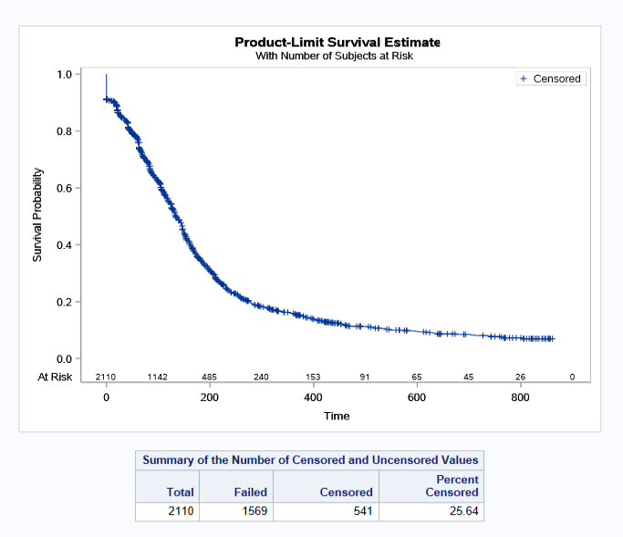

Figure 5: Length of treatment for patients treated with atezolizumab for ES-SCLC with breaks

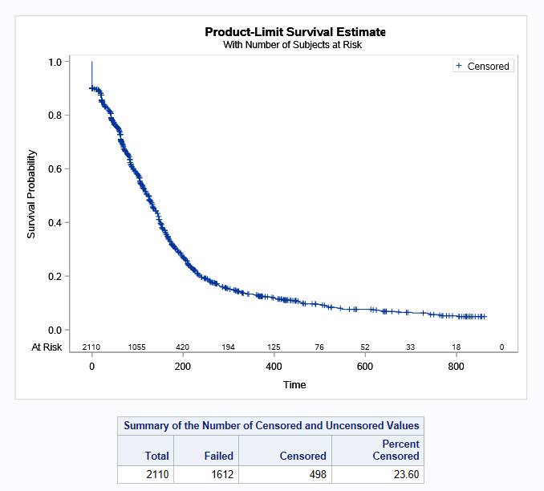

Figure 6: Length of treatment for patients treated with atezolizumab for ES-SCLC without breaks
Figures 5 and 6 show the length of treatment for patients treated with atezolizumab with breaks and without any breaks between treatment.
There were 23.6% of patients censored without breaks and 1612 patients stopped treatment. The median time on treatment was 134 days (130-144 days 95% CI), and the mean time on treatment was 188 days.
There were 25.64% censored with breaks and 1,569 patients stopped treatment. The median time on treatment was 123 days (115-130 days 95% CI), and the mean time on treatment was 170 days.

Analysis of actual versus predicted utilisation

Table 4: Analysis of actual versus predicted utilisation
 |  | Year 1 | Year 2
Prevalent patients | Predicted | | | |
 | Actual | 961 | 1,209
 | Difference | | | |
Prescriptions | Predicted | | | |
 | Actual | 5,271 | 7,128
 | Difference | | | |
Benefit cost to the PBS | Predicted | |||||||||||||| | ||||||||||||||
 | Actual | $38,786,938 | $53,216,270
 | Difference | | | |

Note: The benefit amounts are based on the published list prices. Special pricing arrangements apply to the listing of atezolizumab.
The submission predicted prevalent patients would be treated from Year 1 and would continue treatment in subsequent years. The number of patients who initiated in Year 1 was 961 which was | less than predicted. In year two the number of predicted patients was | % lower than the actual figure of 1,209 patients being treated with atezolizumab.

Discussion
The PBAC’s recommendation for atezolizumab in November 2019 was based on the achievement of cost effectiveness through RSA rebates and that actual utilisation for this indication should be monitored to ensure that cost-effectiveness is reached (see Public Summary Document).
The actual number of patients has been more than predicted, but the number of scripts and benefits paid is lower than anticipated. It was noted from the July 2019 advice that DUSC considered the submission’s approach to estimating the number of patients with ES-SCLC was reasonable. More patients being supplied atezolizumab than estimated could relate to more patients progressing from LS to ES than predicted, or a greater proportion of ES-SCLC patients who have an ECOG 0-1 than 67% that was assumed for the estimates.
The estimated number of grandfathered patients (n= | ) was uncertain as the patient access program had not commenced at the time of the submission and the number of participants was unknown. The actual count of grandfathered patients in Year 1 was 113 in comparison to the estimated amount of | . The underestimation may also have contributed to more patients being supplied treatment in Year 2.
The mean time on treatment with breaks was 170 days. This is less than the sponsor’s estimate of a treatment duration of || days based on the IMpower133 trial. The mean time on treatment without breaks was 188 days, which is close to the sponsor’s estimate of || days.
The PBAC noted in the March 2020 submission that there was uncertainty around the estimated 100% uptake of the 1680 mg Q4W dosing regimen for continuing treatment. However, it was considered likely that most patients would be prescribed this new dosing regimen once it became available. This review indicates that most patients were still being prescribed the 1200 mg Q3W regimen.

DUSC consideration
DUSC noted the findings from the review and considered that only a small percentage of patients would continue on to the Q4W regimen following induction on the Q3W regimen due to the nature of the disease and the likelihood of disease progression.

DUSC actions
DUSC requested that the report be provided to the PBAC for consideration.

Context for analysis
The DUSC is a Sub Committee of the Pharmaceutical Benefits Advisory Committee (PBAC). The DUSC assesses estimates on projected usage and financial cost of medicines.
The DUSC also analyses data on actual use of medicines, including the utilisation of PBS listed medicines, and provides advice to the PBAC on these matters. This may include outlining how the current utilisation of PBS medicines compares with the use as recommended by the PBAC.
The DUSC operates in accordance with the quality use of medicines objective of the National Medicines Policy and considers that the DUSC utilisation analyses will assist consumers and health professionals to better understand the costs, benefits and risks of medicines.
The utilisation analysis report was provided to the pharmaceutical sponsors of each drug and comments on the report were provided to DUSC prior to its consideration of the analysis.

Sponsor comment
Roche Products Pty Ltd: The sponsor has no comment.

Disclaimer
The information provided in this report does not constitute medical advice and is not intended to take the place of professional medical advice or care. It is not intended to define what constitutes reasonable, appropriate or best care for any individual for any given health issue. The information should not be used as a substitute for the judgement and skill of a medical practitioner.
The Department of Health and Aged Care has made all reasonable efforts to ensure that information provided in this report is accurate. The information provided in this report was up-to-date when it was considered by the Drug Utilisation Sub-committee of the Pharmaceutical Benefits Advisory Committee. The context for that information may have changed since publication.
To the extent provided by law, the Department of Health and Aged Care makes no warranties or representations as to accuracy or completeness of information contained in this report.
To the fullest extent permitted by law, neither the Department of Health and Aged Care nor any Department of Health and Aged Care employee is liable for any liability, loss, claim, damage, expense, injury or personal injury (including death), whether direct or indirect (including consequential loss and loss of profits) and however incurred (including in tort), caused or contributed to by any person’s use or misuse of the information available from this report or contained on any third party website referred to in this report.

References
- The American Cancer Society. What is Lung Cancer [Internet]. America: The American Cancer Society; Unknown [updated 2019 Oct 19; cited 2022 July 27]. Available from: What Is Lung Cancer? | Types of Lung Cancer
- Tecentriq (Atezolizumab) Australian Approved Product Information. Sydney: Roche Products Pty Limited. Approved 4 June 2020.
- PBS statistics. Services Australia. Available from <http://www.medicareaustralia.gov.au/provider/pbs/stats.jsp>.
- Horn L, Mansfield AS, Szczęsna A, Havel L, Krzakowski M, Hochmair MJ, Huemer F, Losonczy G, Johnson ML, Nishio M, Reck M. First-line atezolizumab plus chemotherapy in extensive-stage small-cell lung cancer. New England Journal of Medicine. 2018 Dec 6;379(23):2220-9. Available https://www.nejm.org/doi/full/10.1056/NEJMoa1809064

What Is Lung Cancer? | Types of Lung Cancer
Australian Institute of Health and Welfare & Cancer Australia 2011. Lung cancer in Australia: an overview. Cancer series no. 64. Cat. no. CAN 58. Canberra: AIHW. 2011.
Attachment: Product Information Atezolizumab (tga.gov.au)
PBS statistics. Australian Government Department of Human Services Medicare. Canberra. Available from <http://www.medicareaustralia.gov.au/provider/pbs/stats.jsp>.

