Analysis of evolocumab for hypercholesterolaemia

Drug utilisation sub-committee (DUSC)

February 2023

Abstract

Purpose
To review the utilisation of evolocumab for all of its listed Pharmaceutical Benefits Scheme (PBS) indications: homozygous familial hypercholesterolaemia, heterozygous familial hypercholesterolaemia and non-familial hypercholesterolaemia.

Date of listing on the PBS
Evolocumab was first listed on the PBS on 1 December 2016.

Data Source / methodology
Data extracted from the PBS and Authorities databases maintained by the Department of Health and Aged Care, processed by Services Australia were used for the analyses.

Key Findings
- In 2021, 6,119 patients were treated with evolocumab and supplied 48,483 prescriptions.
- There was a greater proportion of patients treated with evolocumab for non-familial hypercholesterolaemia compared to familial hypercholesterolaemia.
- Utilisation of evolocumab for non-familial hypercholesterolaemia was lower than estimated.
- In 2021, 80.7% of patients were consistently supplied evolocumab for the same indication based on the PBS item code compared to 70.5% of patients being consistently supplied for the same indication based on the authority or streamlined code.

Purpose of analysis
To review the utilisation of evolocumab for all of its listed PBS indications: homozygous familial hypercholesterolaemia, heterozygous familial hypercholesterolaemia and non-familial hypercholesterolaemia.

Background

Clinical situation
Hypercholesterolaemia is a condition characterised by elevated serum cholesterol levels. The causes of hypercholesterolaemia can include both genetic and environmental factors (e.g. diet and lifestyle).
Hypercholesterolaemia is associated with the development of atherosclerosis and an increased incidence of myocardial infarction, stable or unstable angina, coronary revascularisation procedures, stroke, transient ischaemic attack, carotid endarterectomy and intermittent claudication of peripheral arteries. These cardiovascular events can have major impact on survival, quality of life and future risk of further cardiovascular events.

Familial hypercholesterolaemia (FH) is a dominantly inherited disorder present from birth that markedly elevates plasma low-density lipoprotein (LDL) cholesterol (LDL-C) and causes premature coronary heart disease. There are two types of FH:
- homozygous familial hypercholesterolaemia (HoFH), and
- heterozygous familial hypercholesterolaemia (HeFH).

Non-familial hypercholesterolaemia (Non-FH) refers to elevated cholesterol levels in the absence of any specific genetic disorder.

Pharmacology
Evolocumab is a human monoclonal antibody that binds to proprotein convertase subtilisin/kexin type 9 (PCSK9) and inhibits circulating PCSK9 from binding to the LDL receptor on the liver cell surface, thus preventing PCSK9‐mediated LDL receptor degradation. Increasing liver LDL receptor levels results in associated reductions in serum LDL-C.

Therapeutic Goods Administration (TGA) approved indications
Evolocumab is indicated as an adjunct to diet and exercise in:
- Prevention of Cardiovascular Events: Evolocumab is indicated to reduce the risk of cardiovascular events (myocardial infarction, stroke and coronary revascularisation) in adults with established cardiovascular disease in combination with an optimally dosed statin and/or other lipid-lowering therapies.
- Primary Hypercholesterolaemia: Evolocumab is indicated in adults with primary hypercholesterolaemia (including heterozygous familial hypercholesterolaemia and non-familial hypercholesterolaemia) to reduce LDL-C:
- in combination with a statin or statin with other lipid lowering therapies, or
- alone or in combination with other lipid-lowering therapies in patients who are statin-intolerant.
- Homozygous Familial Hypercholesterolaemia: Evolocumab is indicated in adults and adolescents aged 12 years and over with homozygous familial hypercholesterolaemia in combination with other lipid lowering therapies.

Dosage and administration
Evolocumab is administered subcutaneously.

Table 1: Dosage and administration of evolocumab
Indication | Recommended Dosage and Frequency | Method of Administration
Primary Hypercholesterolaemia and Prevention of Cardiovascular Events | 140 mg every 2 weeks | One single-use pre-filled pen
 | 420 mg once monthly | One single-use automated mini-doser (AMD) with 3.5 mL pre-filled cartridge or Three single-use pre-filled pens administered consecutively within 30 minutes
Homozygous Familial Hypercholesterolaemia | Initial dose is 420 mg once monthly. The dose can be increased to 420 mg every 2 weeks if a clinical meaningful response is not achieved in 12 weeks. Patients on apheresis may initiate treatment with 420 mg every 2 weeks to correspond with apheresis schedule. | One single-use automated mini-doser (AMD) with 3.5 mL pre-filled cartridge or Three single-use pre-filled pens administered consecutively within 30 minutes

The current Product Information (PI) and Consumer Medicine Information (CMI) are available from the TGA (Product Information) and the TGA (Consumer Medicines Information).

PBS listing details (as at December 2022)

Table 2: PBS listing of evolocumab for familial homozygous hypercholesterolaemia
Item code | Name, form & strength, pack size | Max. quant. | Rpts | DPMQ | Brand name and manufacturer
10958R | evolocumab 140 mg/mL injection, 1 mL pen device | 3 | 5 | $503.33 | Reptha®  Amgen Australia Pty Limited
11193D | evolocumab 420 mg/3.5 mL injection, 3.5 mL cartridge | 1 | 5 | $365.36 | Reptha®  Amgen Australia Pty Limited
11977J | evolocumab 140 mg/mL injection, 1 mL pen device | 3 | 5 | $503.33 | Reptha®  Amgen Australia Pty Limited
11972D | evolocumab 420 mg/3.5 mL injection, 3.5 mL cartridge | 1 | 5 | $365.36 | Reptha®  Amgen Australia Pty Limited
Source: the PBS website.
Note:
- No increase in the maximum number of repeats may be authorised.
- Special Pricing Arrangements apply.
- Applications for authorisation under this restriction may be made in real time using the Online PBS Authorities system (see www.servicesaustralia.gov.au/HPOS) or by telephone by contacting Services Australia on 1800 888 333.

Table 3: PBS listing of evolocumab for familial heterozygous and non-familial hypercholesterolaemia
Item code | Name, form & strength, pack size | Max. quant. | Rpts | DPMQ | Brand name and manufacturer
11484K | evolocumab 140 mg/mL injection, 1 mL pen device | 2 | 5 | $337.94 | Reptha®  Amgen Australia Pty Limited
11485L | evolocumab 420 mg/3.5 mL injection, 3.5 mL cartridge | 1 | 5 | $365.36 | Reptha®  Amgen Australia Pty Limited
11985T | evolocumab 140 mg/mL injection, 1 mL pen device | 2 | 5 | $337.94 | Reptha®  Amgen Australia Pty Limited
11986W | evolocumab 420 mg/3.5 mL injection, 3.5 mL cartridge | 1 | 5 | $365.36 | Reptha®  Amgen Australia Pty Limited
Source: the PBS website.
Note:
- No increase in the maximum quantity or number of units may be authorised.
- No increase in the maximum number of repeats may be authorised.
- Special Pricing Arrangements apply.
- Applications for authorisation under this restriction may be made in real time using the Online PBS Authorities system (see www.servicesaustralia.gov.au/HPOS) or by telephone by contacting Services Australia on 1800 888 333.

Restriction (abridged)
In the initial treatment phase, all indications (familial homozygous and heterozygous hypercholesterolaemia and non-familial hypercholesterolaemia) are Authority Required listings and require:
- Clinical criteria:
- The treatment must be in conjunction with dietary therapy and exercise, AND
- Patient must have been treated with the maximum recommended dose of atorvastatin, AND
- Patient must have been treated with the maximum recommended dose of atorvastatin (80 mg daily) or rosuvastatin (40 mg daily) according to the TGA-approved Product Information or the maximum tolerated dose of atorvastatin or rosuvastatin for at least 12 consecutive weeks in conjunction with dietary therapy and exercise; OR
- Patient must have developed clinically important product-related adverse events necessitating withdrawal of statin treatment to trials of each of atorvastatin and rosuvastatin; OR
- Patient must be contraindicated to treatment with a HMG CoA reductase inhibitor (statin) as defined in the TGA-approved Product Information.
- Treatment criteria: Must be treated by a specialist physician OR by a physician who has consulted a specialist physician.
In the continuing treatment phase, all indications (familial homozygous and heterozygous hypercholesterolaemia and non-familial hypercholesterolaemia) are Authority Required (STREAMLINED) listings and require:
- Clinical criteria:
- Patient must have previously received PBS-subsidised treatment with this drug for this condition, AND
- The treatment must be in conjunction with dietary therapy and exercise.
Details of the evolocumab restrictions can be found in Appendix A.
For details of the current PBS listing refer to the PBS website.

Date of listing on PBS
Evolocumab was first PBS listed on 1 December 2016.

Changes to listing

Table 4: Changes to the PBS listing of evolocumab
Date | Change to listing
1 December 2016 | Listed for the treatment of HoFH, as recommended at the March 2016 PBAC Meeting.
1 November 2017 | A new dose and form: evolocumab 420 mg/3.5 mL injection, 3.5 mL cartridge was PBS listed.  This was recommended at the July 2017 PBAC Meeting.
1 February 2018 | Removal of listing for grandfathered HoFH patients.
1 November 2018 | Extended listing to include the treatment of HeFH under new PBS item codes.  This was recommended at the March 2018 PBAC Meeting.
1 May 2020 | Extended listing to include the treatment of non-FH under the same PBS item codes as HeFH.  Listings for continuing treatment changed from Authority Required to Authority Required (Streamlined).  These changes were recommended at the November 2019 PBAC Meeting.
1 August 2021 | New grandfather listings to allow the patient population that would have qualified for PBS-subsidy had the LDL-C level criterion been 2.6 mmol/L instead of 3.3 mmol/L.  The Authority approval method HeFH grandfather listing was changed from ‘In writing’ to ‘Telephone/emergency/electronic’, aligning with the HoFH listing.  These changes were recommended at the November 2019 PBAC Meeting.
1 November 2021 | HoFH and HeFH listings  The LDL-C eligibility threshold was revised from 3.3mmol/L to 2.6 mmol/L.  Clarification that the qualifying LDL-C level must be following 3 months treatment with ezetimibe and a statin.  The ‘maximum recommended dose of atorvastatin or rosuvastatin’ was revised to ‘maximum recommended or tolerated dose of atorvastatin or rosuvastatin’  Authority approval method for the initial restriction was changed from ‘In writing’ to ‘Telephone/Emergency/Electronic’  These changes were recommended at the November 2019 PBAC Meeting.
1 December 2022 | LDL-C eligibility threshold was revised from 2.6 mmol/L to 1.8 mmol/L.  Allow initial prescribing by any medical practitioner in consultation with a specialist physician.  New grandfather phase listings to allow the patient population that would have qualified for PBS-subsidy had the LDL-C level criterion been 1.8 mmol/L.  These changes were recommended at the July 2022 PBAC Meeting.
Current PBS listing details are available from the PBS website.

Relevant aspects of consideration by the Pharmaceutical Benefits Advisory Committee (PBAC)
The PBAC has considered 11 submissions for evolocumab since 2015. A summary of all the evolocumab submissions can be found in Appendix B.

Previous reviews by the DUSC
October 2019
Evolocumab for HoFH was considered by DUSC at its October 2019 meeting. The number of patients treated with evolocumab in the first two years of listing was higher than expected. DUSC noted to qualify for treatment under HoFH item codes, the condition must have been confirmed by genetic testing or by a Dutch Lipid Clinic Network Score (DLCNS) of at least 7. DUSC considered that as the DLCNS was used by the majority of prescribers to confirm the condition, the actual number of treated patients most likely included both HoFH and HeFH patients.
For details of the DUSC consideration of evolocumab for HoFH refer to the Public Release Document from the October 2019 DUSC meeting.
June 2021
DUSC reviewed the use of evolocumab for the treatment of HeFH. The submission was based on FH; both homozygous or heterozygous. In 2020, 2,693 patients were supplied at least one prescription for FH and, of these, 923 patients were supplied their first PBS subsidised evolocumab prescription for this indication. Evolocumab is most frequently supplied as a dose of 280 mg or 420 mg in quantities of two or three 140 mg/mL pen devices. In 2020, 88% (17,181) of evolocumab prescriptions and 95% (43,675) of the total quantity supplied for FH were for the 140 mg/mL pen device.
For details of the DUSC consideration of evolocumab for HeFH refer to the Public Release Document from the June 2021 DUSC meeting.

Methods
PBS prescription data for evolocumab was extracted from the PBS data maintained by the Department of Health and Aged Care, processed by Services Australia. Data were extracted for dates of supply up to and including 30 September 2022. These prescription data were used to analyse utilisation, the age and gender of patients, time to resupply and prescriber type.
Authorities data were extracted from the Authorities database, and matched to the prescription data to determine the type of hypercholesterolaemia the prescription was intended to treat. Where a streamlined code for hypercholesterolaemia was recorded, this was used in preference to the Authority code.
Consistency of utilisation by indication was investigated, including indication by item code and restriction code for 2021, and the sequence of indication for each patient. Sequence of indication ignored prescriptions with an unknown indication, and assigned the patient ‘Unknown’ if none of the prescriptions supplied to that patient included an indication. In some analyses a patient’s main indication was used. Main indication was determined by the indication recorded on a majority of the patient’s prescriptions. If two indications were recorded the same number of times, the patient’s main indication was determined by the indication recorded on their initial prescription.
An indication sequence analysis was conducted to examine consistency of indication according item code and restriction code in 2021. In both of these analyses, the first indication was recorded and if patients were subsequently supplied other indications throughout the year, these were noted to form the patient’s indication sequence.
Treatment duration was analysed using the Kaplan-Meier method. A patient was censored if they were supplied a prescription within three times the median time to resupply prior to 30 September 2022 (i.e. 3×31 days).
The indication by which patients initiated evolocumab treatment were analysed. This included the prescriber type as well as the patient’s level of remoteness. The remoteness area is based on the patient postcode at the time of prescription processing by Services Australia and uses the ABS Remoteness Structure 2018 (cat no. 1270.0.55.005)
Assumptions used to derive the financial estimates of the non-FH listing were analysed. A 10% PBS sample was used to analyse the number of patients treated with ezetimibe ± statins to determine the proportion of patients who initiated and continued treatment for longer than three months.
As this analysis uses date of supply prescription data, there may be small differences compared with publicly available Medicare date of processing data.

Results

Analysis of drug utilisation

Overall utilisation

Table 5: Utilisation of evolocumab by calendar year
 | 2016 | 2017 | 2018 | 2019 | 2020 | 2021 | 2022
Prevalent patients | 5 | 556 | 1,146 | 1,778 | 3,691 | 6,119 | 7,639
Prescriptions | 11 | 2,407 | 7,329 | 12,634 | 24,607 | 48,483 | 49,677
Note: As evolocumab was first PBS listed on 1 December 2016, the utilisation figures for 2016 only include the month of December. Utilisation figures for 2022 only include the months January to September 2022, inclusive.

Consistency of indication

Figure 1: Evolocumab prescriptions supplied by indication determined by item code

Figure 1 shows the number of evolocumab prescriptions supplied has increased over time, particularly from 1 May 2020 onwards with the extension of the PBS listing to include treatment for non-FH and listings for continuing treatment were changed from Authority Required to Authority Required (Streamlined). As the item codes for non-FH are the same as HeFH, the individual utilisation by these indications cannot be distinguished.

Table 6: Indication sequence by item code in 2021
Indication sequence | Patients | Percent
Non-FH/HeFH | 3,454 | 56.4%
HoFH | 1,488 | 24.3%
Non-FH/HeFH>HoFH | 601 | 9.8%
HoFH>Non-FH/HeFH | 265 | 4.3%
Non-FH/HeFH>HoFH>Non-FH/HeFH | 110 | 1.8%
HoFH>Non-FH/HeFH>HoFH | 97 | 1.6%
Other sequences | 104 | 1.7%

In Table 6, approximately 80.7% of evolocumab patients were consistently supplied a PBS listing for the same indication according to item code in 2021.

Figure 2: Evolocumab prescriptions supplied by indication determined by streamlined code

As aforementioned, from 1 May 2020 onwards, the PBS listings for continuing treatment were changed from Authority Required to Authority Required (Streamlined). Figure 2 shows a large number of these prescriptions do not have a recorded streamlined code, however some of these may have been approved as Authority Required prescriptions, for example to approve an increased quantity.

Figure 3: Evolocumab prescriptions supplied by indication determined by authority or streamlined code

Figure 3 shows that when authority codes and streamlined codes were used to determine the indication, the number of prescriptions with an unknown indication was much smaller.

Table 7: Indication sequences by authority or streamlined code in 2021
Indication sequence | Patients | Percent
Non-FH | 1,975 | 32.3%
HoFH | 1,490 | 24.4%
HeFH | 849 | 13.9%
Non-FH>HoFH | 298 | 4.9%
Non-FH>HeFH | 266 | 4.3%
HeFH>Non-FH | 247 | 4.0%
HeFH>HoFH | 194 | 3.2%
HoFH>HeFH | 136 | 2.2%
HoFH>Non-FH | 95 | 1.6%
Non-FH>HeFH>Non-FH | 80 | 1.3%
Other sequences | 489 | 8%

In Table 7, approximately 70.5% of evolocumab patients were consistently supplied a PBS listing for same indication based on the authority or streamlined code in 2021.

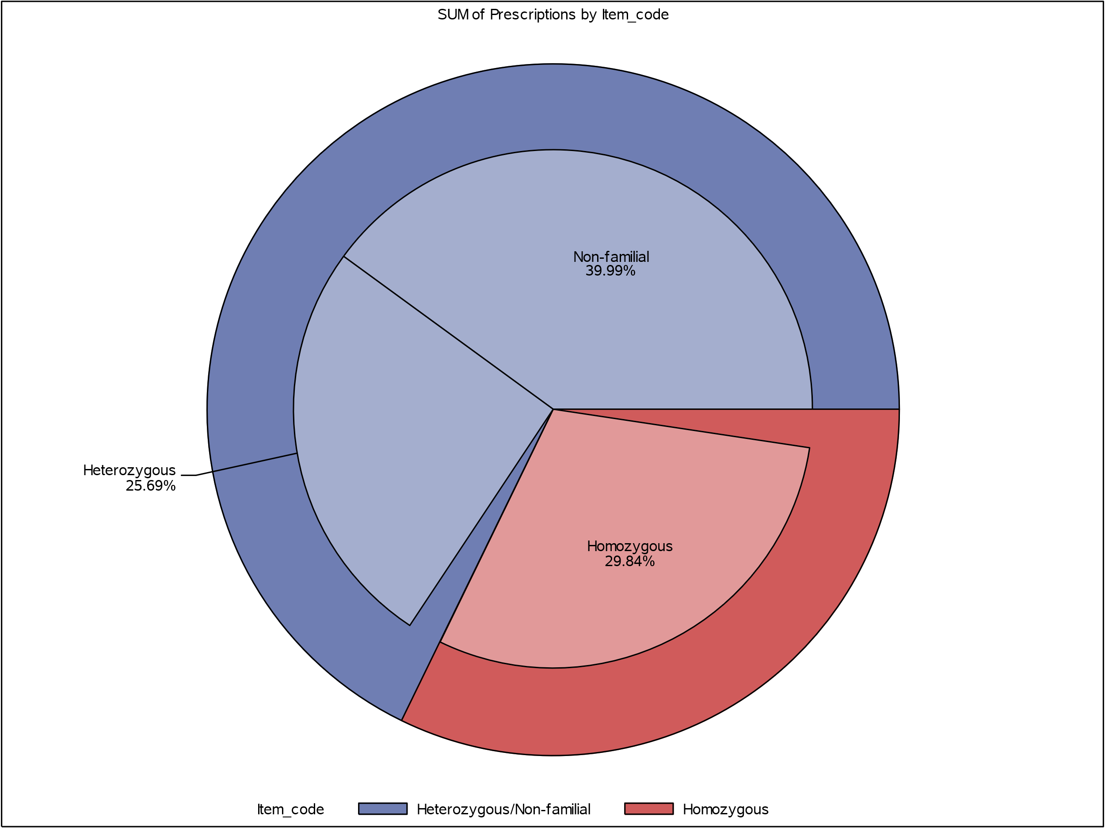

Figure 4: Proportion of prescriptions by indication based on item code and restriction code in 2021

Figure 4 shows the indication of the item code in the outer circle, and the indication of the restriction code in the inner circle. The number of unknowns or mismatched codes, i.e. a restriction code for HoFH against an item code for HeFH, are represented by the incomplete segments of the inner circles, however the numbers of these were too small to be shown.

Utilisation by prevalent patients

Figure 5: Prevalent evolocumab patients by indication
Note: Indication determined by authority or streamlined code
As shown in Figure 5, there was a large increase in the number of prevalent evolocumab patients when the listing was extended to include treatment for non-FH in May 2020.

Utilisation by initiating patients

Figure 6: Initiating evolocumab patients by indication
Note: Indication determined by authority or streamlined code
As shown in Figure 6, there was a large increase in the number of patients initiating treatment with evolocumab in 2020Q2. The majority of patients who initiated treatment with evolocumab were treated for non-FH.

Age and gender distribution

Figure 7: Age and gender distribution of patients initiating evolocumab

Figure 7 shows a greater proportion of males initiated treatment with evolocumab compared to females. The median age of initiation for males and females was 63 and 66 years, respectively. The mean age of initiation for males and females was 62 and 64 years, respectively.

Figure 8: Age distribution of patients initiating evolocumab by indication

Figure 8 shows a greater level of positive skewness in age in patients who initiated treatment with evolocumab for non-FH compared to HeFH and HoFH.

Table 8: Median age (years) at initiation by main indication
Main indication | Female | Male | Overall
HeFH | 64 | 59 | 61
HoFH | 62 | 58 | 60
Non-FH | 70 | 66 | 68
Unknown | 65 | 69 | 67

Utilisation by prescriber type

Figure 9: Proportion of patients initiating evolocumab by prescriber type in 2021

In Figure 9, across all indications, the majority (72.7%) of initial treatment with evolocumab in 2021 was prescribed by cardiologists. Approximately 76.2% of non-FH patients were treated by cardiologists compared to 67% of HoFH and 66% of HeFH patients treated by cardiologists.

Treatment duration
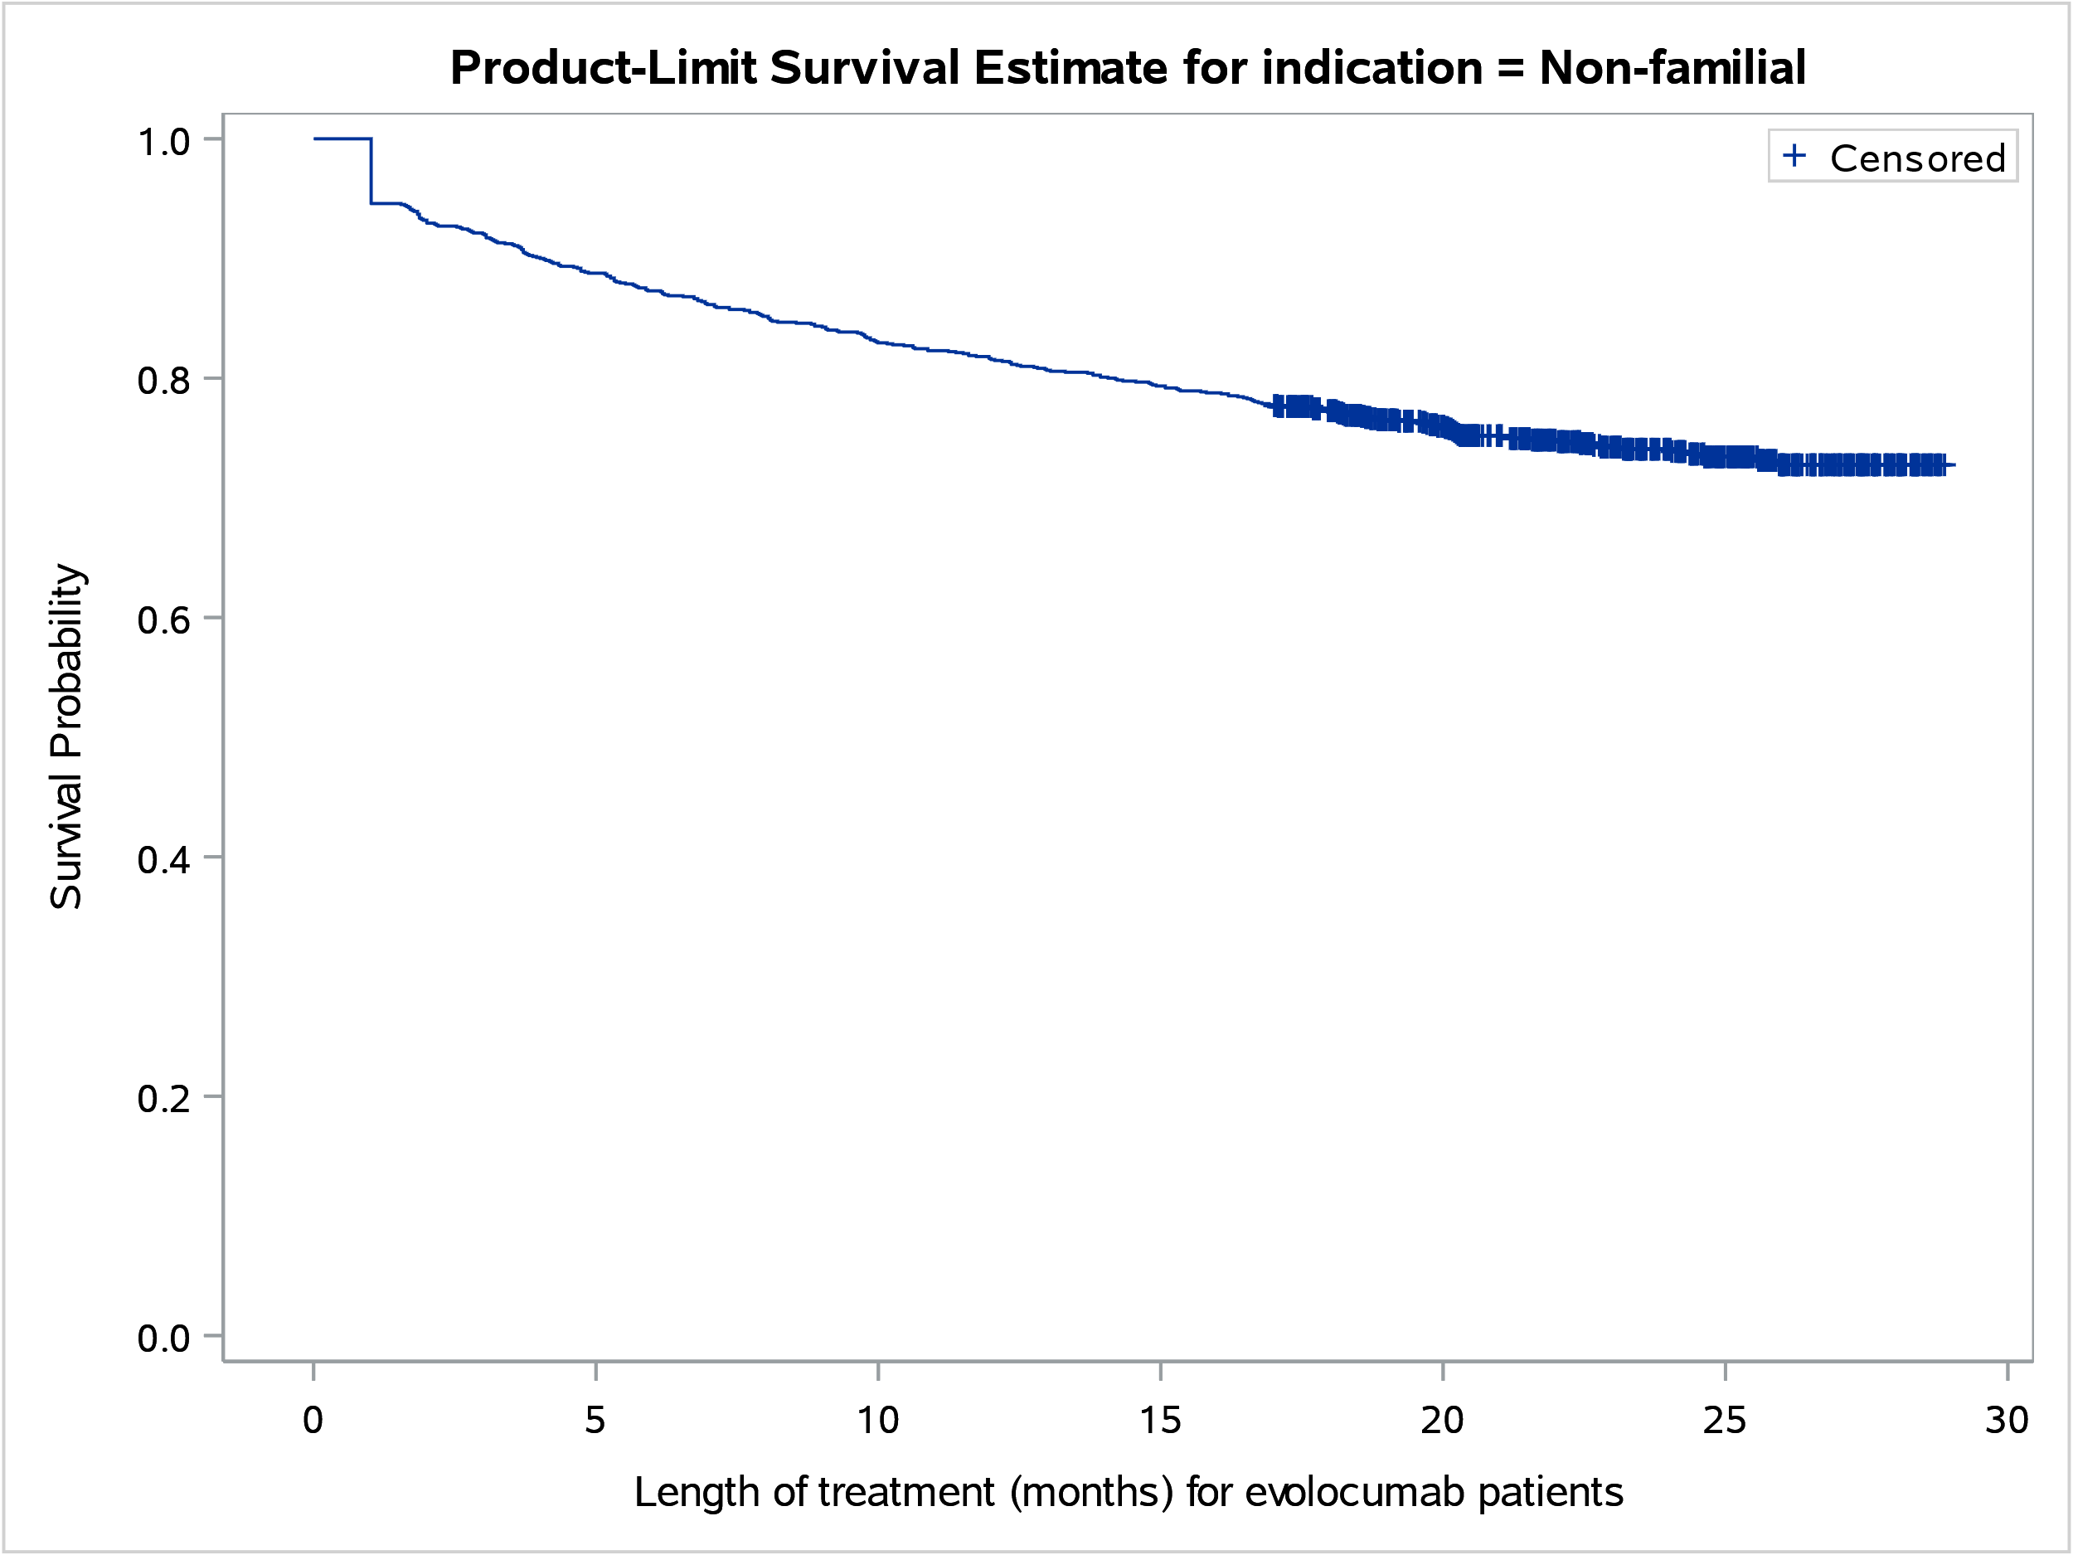

Figure 10: Treatment duration for patients who initiated evolocumab treatment for non-FH between 1 May 2020 to 30 April 2021 and followed up to 30 September 2022

The data were too immature to fully analyse the time on evolocumab, with a median time on therapy not being reached within 29 months from first listing. Of the 1,220 patients who initiated evolocumab treatment between 1 May 2020 and 30 April 2021, 74.6% of patients were censored at analysis end date.

Utilisation by remoteness area

Figure 11: Proportion of patients initiating evolocumab by prescriber type and by remoteness area in 2021

In Figure 11, across major cities, inner regional and outer regional areas of Australia, the majority of patients initiating evolocumab were treated by cardiologists in 2021.
Similar to the remoteness areas shown in Figure 11, the majority of patients in remote and very remote areas of Australia were treated by cardiologists.

Actual versus predicted utilisation of evolocumab for non-FH

Approach taken to estimate utilisation
The November 2019 minor resubmission used a mixed market share/epidemiological approach to estimate the eligible patient population and estimated that:
- The revised number patients treated with ezetimibe +/- statin in 2018 to be xxxx. A 10% PBS sample analysis (ezetimibe, ezetimibe with simvastatin, rosuvastatin with ezetimibe and ezetimibe with atorvastatin) undertaken by the DUSC Secretariat found a lower estimate of xxxx patients treated in 2018 compared to the submission’s estimate.
- The revised annual growth rate for symptomatic atherosclerotic cardiovascular disease (ASCVD) would be xxxx. The DUSC Secretariat calculated an annual growth rate for prevalent patients for all listings of ezetimibe +/- statin to be xxxx in 2018.
- There would be xxxx of patients with symptomatic ACSVD.
- There would be xxxx of patients with additional risk factors.
- The revised proportion of symptomatic ASCVD (non-FH) patients remaining on ezetimibe +/- statins for more than three months would be xxxx. The DUSC Secretariat examined the time on therapy for patients first initiating on the following drugs in 2017-18 with follow-up to 30 June 2019 using a 10% sample. xxxx of initiators were found to have three or more months of therapy.
- There would be xxxx of patients with LDL-C >2.6mmol/L.
- Treatment uptake would be xxxx in Year 1, increasing to xxxx in Year 6.

Analysis of actual versus predicted utilisation

Table 9: Evolocumab for non-FH actual versus predicted utilisation
Evolocumab for non-FH listing years |  | Year 1 | Year 2 | Year 3
 |  | May 2020 – April 2021 | May 2021 – April 2022 | May 2022 – April 2023 (part year to September 2022)
Patients | Predicted | xxxx xx | xxxx xx | xxxx xx
 | Actual | 1,917 | 3,841 | 3,627
 | Difference | xxxx xx | xxxx xx | xxxx xx
Prescriptions | Predicted | xxxx xx | xxxx xx | xxxx xx
 | Actual | 9,761 | 23,922 | 13,587
 | Difference | xxxx xx | xxxx xx | xxxx xx
Note: Year 3 predicted and actual numbers are five months of data (May 2022 to September 2022 inclusive).
As shown in Table 9, actual patient and prescription figures of evolocumab for non-FH were lower than estimated. The number of patients in the first and second year of evolocumab’s listing for non-FH were lower by xx% and xx%, respectively.
The number of prescriptions in the first and second year of evolocumab listing were lower by xx% and xx %, respectively.

Table 10: Utilisation of ezetimibe +/- statins by calendar year
 | 2018 | 2019 | 2020 | 2021
Number of prevalent patients | 362,810 | 379,930 | 407,110 | 438,450
Annual growth rate | 5% | 5% | 7% | 8%
Note: Utilisation of ezetimibe, ezetimibe with simvastatin, ezetimibe with rosuvastatin and ezetimibe with atorvastatin were derived through a 10% PBS sample.

Table 11: Proportion of patients first initiating on ezetimibe with simvastatin, ezetimibe with rosuvastatin and ezetimibe with atorvastatin to have three or more months of therapy
Period | Proportion
2017-18, follow up to 30 June 2019 | 80%
2018-19, follow up to 30 June 2020 | 80%
2019-20, follow up to 30 June 2021 | 84%
2020-21, follow up to 30 June 2022 | 83%

As shown in Table 10 and 11, the annual growth rate in the number of patients treated with ezetimibe ± statins and the proportion of patients initiating on ezetimibe ± statins who have three or months of therapy are increasing over time.

Discussion
In the October 2019 evolocumab DUSC review, utilisation was greater than estimated for HoFH, whereas in the June 2021 evolocumab DUSC review, utilisation was lower than estimated for HeFH.
As shown in Table 9, utilisation of evolocumab for non-FH was lower than estimated, with a greater decrease in the number of prescriptions supplied compared to the number of patients treated. Despite this, analysis of utilisation of ezetimibe +/- statins had increased over time.
A large growth in evolocumab was observed from 2020Q2 onwards, likely due to the extension of listing to include non-FH, and the change in restriction level for the continuing listings from Authority Required to Authority Required (Streamlined). Despite the PBS item codes for the non-FH listing being the same as those of HoFH, the majority of evolocumab utilisation could be distinguished through authority and streamline codes (Figure 4). There was a greater proportion of patients consistently supplied evolocumab for the same indication according to item code (80.8%) compared to authority or streamlined code (70.5%) in 2021.
As shown in Figures 9 and 11, in 2021 the majority (72.7%) of patients who initiated treatment with evolocumab were treated by cardiologists. This was also observed across indications (Figure 9) and remoteness areas (Figure 11). These findings correspond with the treatment criteria outlined in the evolocumab restriction which states initiating evolocumab treatment requires treatment by a specialist physician.
At its July 2022 meeting, the PBAC recommended extending the existing PBS listings for evolocumab for hypercholesterolaemia to include patients who have a LDL-C level between 1.8 and 2.6 mmol/L despite optimised treatment with statins and ezetimibe, and to allow initial prescribing by any medical practitioner in consultation with a specialist physician. These changes were implemented in December 2022. As the data analysis period ended in September 2022, the impact of these changes was not included as part of the review.

DUSC consideration
DUSC noted evolocumab utilisation for non-FH was lower than estimated. DUSC considered the impact of the COVID-19 pandemic and barriers to patient access on utilisation.

DUSC noted the restriction changes since PBS listing of evolocumab and noted the restriction changes that occurred in December 2022 were not included as part of the review. DUSC noted the LDL-C criterion in the PBS listing was revised from 3.3 mmol/L to 2.6 mmol/L in November 2021 and revised to 1.8 mmol/L in December 2022. DUSC noted that as the LDL-C criterion had been revised several times since PBS listing, there was potential for clinicians to be unaware of the lowered LDL-C threshold. DUSC noted initial prescribing was extended to any medical practitioner in consultation with a specialist physician in December 2022. The Pre-Sub-Committee Response (PSCR) raised that, “GPs, in consultation with a specialist, would be able to initiate evolocumab and the lower than estimated utilisation may be indicative of challenges with patient access. GP initiation was only introduced in December 2022.”

DUSC noted that although the PBS item codes for the non-FH listing were the same as those for HoFH, the majority of evolocumab utilisation could be distinguished through Authority and Streamlined codes. DUSC noted a greater proportion of patients were consistently supplied evolocumab for the same indication according to item code (80.8%) compared to authority or streamlined code (70.5%) in 2021. DUSC considered inconsistency in indication was likely due to human error associated with prescribing software. DUSC noted the complexities in navigating the presentation of restriction and the corresponding item codes in the prescribing software.

DUSC actions
DUSC requested that the report be provided to the PBAC for consideration.

Context for analysis
The DUSC is a Sub Committee of the PBAC. The DUSC assesses estimates on projected usage and financial cost of medicines.
The DUSC also analyses data on actual use of medicines, including the utilisation of PBS listed medicines, and provides advice to the PBAC on these matters. This may include outlining how the current utilisation of PBS medicines compares with the use as recommended by the PBAC.
The DUSC operates in accordance with the quality use of medicines objective of the National Medicines Policy and considers that the DUSC utilisation analyses will assist consumers and health professionals to better understand the costs, benefits and risks of medicines.
The utilisation analysis report was provided to the pharmaceutical sponsors of each drug and comments on the report were provided to DUSC prior to its consideration of the analysis.

Sponsors’ comments
Amgen Australia Limited: The sponsor has no comment.

Disclaimer
The information provided in this report does not constitute medical advice and is not intended to take the place of professional medical advice or care. It is not intended to define what constitutes reasonable, appropriate or best care for any individual for any given health issue. The information should not be used as a substitute for the judgement and skill of a medical practitioner.
The Department of Health and Aged Care has made all reasonable efforts to ensure that information provided in this report is accurate. The information provided in this report was up-to-date when it was considered by the Drug Utilisation Sub-committee of the Pharmaceutical Benefits Advisory Committee. The context for that information may have changed since publication.
To the extent provided by law, the Department of Health and Aged Care makes no warranties or representations as to accuracy or completeness of information contained in this report.
To the fullest extent permitted by law, neither the Department of Health and Aged Care nor any Department of Health and Aged Care employee is liable for any liability, loss, claim, damage, expense, injury or personal injury (including death), whether direct or indirect (including consequential loss and loss of profits) and however incurred (including in tort), caused or contributed to by any person’s use or misuse of the information available from this report or contained on any third party website referred to in this report.

Appendices

Appendix A: Evolocumab PBS restrictions as at December 2022
In the initial treatment phase, all indications (familial homozygous and heterozygous hypercholesterolaemia and non-familial hypercholesterolaemia) are Authority Required listings and require:
- Clinical criteria:
- The treatment must be in conjunction with dietary therapy and exercise, AND
- Patient must have been treated with the maximum recommended dose of atorvastatin, AND
- Patient must have been treated with the maximum recommended dose of atorvastatin (80 mg daily) or rosuvastatin (40 mg daily) according to the TGA-approved Product Information or the maximum tolerated dose of atorvastatin or rosuvastatin for at least 12 consecutive weeks in conjunction with dietary therapy and exercise; OR
- Patient must have developed clinically important product-related adverse events necessitating withdrawal of statin treatment to trials of each of atorvastatin and rosuvastatin; OR
- Patient must be contraindicated to treatment with a HMG CoA reductase inhibitor (statin) as defined in the TGA-approved Product Information.
- Treatment criteria: Must be treated by a specialist physician OR by a physician who has consulted a specialist physician.

Table A.1: Differences in clinical criteria between HoFH, HeFH and Non-FH
Indication | Clinical criteria
HoFH | - The condition must have been confirmed by genetic testing; OR  - The condition must have been confirmed by a Dutch Lipid Clinic Network Score of at least 7, AND  - Patient must have an LDL cholesterol level in excess of 2.6 millimoles per litre,
HeFH | - The condition must have been confirmed by genetic testing; OR  - The condition must have been confirmed by a Dutch Lipid Clinic Network Score of at least 6, AND  - Patient must have an LDL cholesterol level in excess of 1.8 millimoles per litre in the presence of symptomatic atherosclerotic cardiovascular disease; OR  - Patient must have an LDL cholesterol level in excess of 5 millimoles per litre, AND  - Patient must have been treated with ezetimibe for at least 12 consecutive weeks in conjunction with a statin (if tolerated), dietary therapy and exercise, AND  - Patient must not be receiving concomitant PBS-subsidised treatment with another drug that belongs to the same pharmacological class as this drug, for this PBS indication.
Non-FH | - Patient must not be receiving concomitant PBS-subsidised treatment with another drug that belongs to the same pharmacological class as this drug, AND  - Patient must have symptomatic atherosclerotic cardiovascular disease, AND  - Patient must have an LDL cholesterol level in excess of 1.8 millimoles per litre, AND  - Patient must have atherosclerotic disease in two or more vascular territories (coronary, cerebrovascular or peripheral vascular territories); OR  - Patient must have severe multi-vessel coronary heart disease defined as at least 50% stenosis in at least two large vessels; OR  - Patient must have had at least two major cardiovascular events (i.e. myocardial infarction, unstable angina, stroke or unplanned revascularisation) in the previous 5 years; OR  - Patient must have diabetes mellitus with microalbuminuria; OR  - Patient must have diabetes mellitus and be aged 60 years or more; OR  - Patient must be an Aboriginal or Torres Strait Islander with diabetes mellitus; OR  - Patient must have a Thrombolysis in Myocardial Infarction (TIMI) risk score for secondary prevention of 4 or higher, AND  - Patient must have been treated with ezetimibe for at least 12 consecutive weeks in conjunction with a statin (if tolerated), dietary therapy and exercise.
In the continuing treatment phase, all indications (familial homozygous and heterozygous hypercholesterolaemia and non-familial hypercholesterolaemia) are Authority Required (STREAMLINED) listings.
For familial homozygous hypercholesterolaemia, the clinical criteria requires:
- Patient must have previously received PBS-subsidised treatment with this drug for this condition, AND
- The treatment must be in conjunction with dietary therapy and exercise.
For familial heterozygous and non-familial hypercholesterolaemia, the clinical criteria requires:
- Patient must have previously received PBS-subsidised treatment with this drug for this condition, OR
- Patient must have previously received PBS-subsidised treatment with this drug for this condition,
AND
- The treatment must be in conjunction with dietary therapy and exercise.
- Patient must not be receiving concomitant PBS-subsidised treatment with another drug that belongs to the same pharmacological class as this drug, for this PBS indication.
For definitions of symptomatic atherosclerotic cardiovascular disease, clinically important product-related adverse events and for details of the current PBS listing refer to the PBS website.

Appendix B: Summary of PBAC considerations for evolocumab
PBAC Meeting | Indication Considered | Outcome
March 2015 | Hypercholesterolaemia | The submission sought to open a dialogue regarding the potential future listing of evolocumab on the PBS for the treatment of hypercholesterolaemia.  The submission was considered by DUSC. DUSC considered the main issues were:  - The market share approach, based on ezetimibe utilisation, underestimated the population eligible for evolocumab.  - Changing clinical practice, including increased assessment of cardiovascular risk or more widespread treatment to target cholesterol levels, could result in many more patients being treated with evolocumab. Given the high prevalence of dyslipidaemia and the proposed price of evolocumab, small changes in practice could have a large budget impact.  - Significant potential for use beyond the restriction by patients who are not achieving target cholesterol levels, but who would not qualify for evolocumab treatment under the proposed restriction.  The PBAC rejected the request to list evolocumab for the treatment of hypercholesterolaemia on the basis of unestablished clinical place in therapy and the uncertainty surrounding its use in clinical practice.  For further details refer to the Public Summary Document from the March 2015 PBAC meeting.
March 2016 | FH | The resubmission requested a Section 85 Authority Required PBS listing for evolocumab for the treatment of familial hypercholesterolaemia (FH). This resubmission was not considered by DUSC.  The PBAC recommended the Section 85 Authority Required listing of evolocumab for homozygous familial hypercholesterolaemia (HoFH). In making this recommendation, the PBAC considered that the HoFH population represent a small, definable, patient group, in whom there is a high level of clinical need.  The PBAC considered that the submission’s estimates of usage in the HoFH population were more reliable than the estimates for the heterozygous FH (HeFH) population, as there are likely to be less undiagnosed HoFH patients. The PBAC recommended a risk‐sharing arrangement (RSA) that should include a cap based on the number of patients treated.  For further details refer to the Public Summary Document from the March 2016 PBAC meeting.
July 2017 | HoFH (listing of Injection 420 mg in 3.5 mL single dose autoinjector) | The PBAC recommended the listing of the new strength of evolocumab for the treatment of HoFH. The PBAC accepted that this additional form of evolocumab would provide patients with an alternative dosing schedule to the currently listed form at no additional cost to the Government.  For further details refer to the Public Summary Document from the July 2017 PBAC meeting.
November 2017 | FH (extension of the listing to include the treatment of HeFH)/ hypercholesterolaemia with symptomatic atherosclerotic cardiovascular disease (ASCVD) who do not have underlying FH | The resubmission requested an extension of the current Section 85 (Authority Required) listing for evolocumab to include the treatment of HeFH (patients with atherosclerotic disease or very high LDL-c levels). This resubmission was considered by DUSC. The resubmission used epidemiological (FH with ASCVD, FH with very high LDL-c) and market share (non-FH with ASCVD) approaches to estimate the utilisation/financial implications associated with the PBS listing of evolocumab.  The PBAC deferred making a recommendation to extend the PBS listing of evolocumab for patients with FH in order to address the residual uncertainty with the economic model following revisions provided in the pre-PBAC response. The PBAC did not recommend the listing of evolocumab for patients with non-FH with atherosclerotic disease on the basis of a high incremental cost effectiveness ratio and high and uncertain patient population numbers.  For further details refer to the Public Summary Document from the November 2017 PBAC meeting.
March 2018 | FH | The minor resubmission sought an Authority Required listing for treatment of patients with FH and either symptomatic atherosclerotic cardiovascular disease (ASCVD) or FH with very high LDL-c.  The PBAC recommended extending the PBS listing for evolocumab for patients with FH to include patients with HeFH, under certain conditions. The PBAC accepted that both the HeFH and HoFH populations are high risk, and that the use of evolocumab could be extended to include the HeFH population as it would be an effective and safe therapy following failed treatment with statins and ezetimibe. The PBAC considered that the revised economic model, reduced price and other arrangements proposed in the resubmission addressed the outstanding issues raised by the PBAC from the November 2017 submission.  For further details refer to the Public Summary Document from the March 2018 PBAC meeting.
July 2018 | Non-FH with atherosclerotic disease. | The PBAC did not recommend the listing of evolocumab for patients with non-FH with atherosclerotic disease on the basis of an inadequately defined patient population, an uncertain incremental cost-effectiveness ratio (ICER) and high and uncertain patient population numbers. The PBAC considered that this population required more refined eligibility criteria in the proposed PBS listing given the very high financial estimates.  For further details refer to the Public Summary Document from the July 2018 PBAC meeting.
July 2019 | Hypercholesterolaemia | The PBAC deferred making a recommendation on the listing of evolocumab for the treatment of non-FH in patients with ASCVD and additional high-risk factors.  The PBAC also deferred making a recommendation on the resubmission’s request to extend the existing familial hypercholesterolaemia listing in the ASCVD population to include patients with low-density lipoprotein (LDL)  levels between 2.6 mmol/L and 3.3 mmol/L.  For further details refer to the Public Summary Document from the July 2019 PBAC meeting.
November 2019 | Non-FH with atherosclerotic disease and an extension for FH to include patients with symptomatic ASCVD or HoFH who have an LDL level between 2.6 and 3.3 mmol/L despite optimised treatment with statins and ezetimibe. | The minor resubmission sought an Authority Required listing for evolocumab for the treatment of non-FH in patients with atherosclerotic cardiovascular disease (ASCVD) and additional high-risk factors. The minor resubmission also sought an extension of the current Authority Required listing of evolocumab for the treatment of FH to include patients with symptomatic ASCVD or homozygous FH who have an LDL level between 2.6 and 3.3 mmol/L despite optimised treatment with statins and ezetimibe.  The PBAC recommended the Authority Required listing of evolocumab, but on the basis that it be available only in the circumstances where use is restricted to the treatment of:  - non-FH in patients with atherosclerotic cardiovascular disease (ASCVD), who have an LDL level greater than 2.6 mmol/L and additional high-risk factors; and  - FH in patients with symptomatic ASCVD or homozygous FH (HoFH), who have an LDL level between 2.6 and 3.3 mmol/L.  For further details refer to the Public Summary Document from the November 2019 PBAC meeting.
November 2020 | All listings | The minor submission requested an amendment to the Authority Required listings of evolocumab for all indications to allow general practitioners (GPs) to initiate treatment, but only after having consulted a specialist.  The PBAC did not recommend an amendment to the Authority Required listings of evolocumab for all indications to allow GPs to initiate treatment after having consulted a specialist. The PBAC advised that “Must be treated by a specialist physician” for initiation of treatment should remain for all indications, consistent with its previous advice.  For further details refer to the Public Summary Document from the November 2020 PBAC meeting.
March 2021 | All listings | The submission provided notification that the existing evolocumab 420 mg/3.5 mL injection (cartridge presentation) is to be phased out and replaced with a modified automated mini-doser (AMD) that will shorten the injection time from 9 minutes to 5 minutes, herein referred to as the 9-minute AMD device and 5-minute AMD device respectively. No changes to the listed drug were otherwise proposed.  The PBAC held no objections to the planned discontinuation of the existing evolocumab 420 mg/3.5 mL injection (cartridge presentation) and its replacement with an updated product whereby the modified automated mini-doser (AMD) will shorten the injection time from 9 minutes to 5 minutes.  The PBAC noted there have been no changes to the drug or cartridge container with the design change, and that the legal instruments enacting the current PBS listings of evolocumab 420 mg/3.5 mL injection do not require any amendments. The PBAC therefore recommended no changes to the existing evolocumab listings.  For further details refer to the Public Summary Document from the March 2021 PBAC meeting.
July 2022 | All listings | The PBAC recommended extending the existing PBS listings for evolocumab for hypercholesterolaemia, to include patients who have a low density lipoprotein cholesterol (LDL-C) level between 1.8 and 2.6 mmol/L despite optimised treatment with statins and ezetimibe, and to allow initial prescribing by any medical practitioner in consultation with a specialist physician. The PBAC was satisfied that evolocumab provides, for some patients, a significant improvement in efficacy over optimised background treatment, in the extended population. The PBAC advised that the expanded LDL-C criteria were consistent with current international clinical guidelines and the expanded prescriber criteria would reduce current equity and access issues associated with initiation only by specialists.  For further details refer to the Public Summary Document from the July 2022 PBAC meeting.

Familial Hypercholesterolaemia Australasia Network. Accessed on 20 October 2022, Available from: https://www.athero.org.au/fh/
Repatha(evolocumab). Australian Approved Product Information. Sydney: Amgen Australia Pty Ltd. Approved 9 December 2015, updated 16 March 2022. Available from <https://www.tga.gov.au/product-information-pi.>
PBS statistics. Australian Government Services Australia Medicare. Canberra. Available from <http://www.medicareaustralia.gov.au/provider/pbs/stats.jsp>.

