Use of antipsychotics in children and adolescents

A Report prepared by the Drug Utilisation Subcommittee (DUSC) of the Pharmaceutical Benefits Advisory Committee (PBAC)

This report was compiled for the DUSC by the DUSC Secretariat from two examinations of utilisation of antipsychotics in Australia considered by DUSC in February 2013 and June 2013.
The initial utilisation studies were provided to the pharmaceutical sponsors of each drug and comments on the studies were provided to DUSC. These comments, where applicable, have been included in this final report. The final report was also provided to clinical specialists in the management of psychiatric problems in children and adults. These comments have also been incorporated.
The Report was compiled by O Morrison, C Raymond and M Firipis with assistance of members of DUSC. Final approval by M Robinson.

Abstract
Use of atypical antipsychotics in children is increasing in Australia as in many other countries with increasing awareness of harms. The Australian Government subsidises antipsychotics on the Pharmaceutical Benefits Scheme for a limited number of conditions. This study aimed to examine the patterns of utilisation of subsidised antipsychotics in children and adolescents.
De-identified, patients level pharmacy claim data from 1 December 2010 to 31 December 2012 was extracted from the records of subsidised claims provided to the Australian Government by dispensing pharmacies. As the number of records was very large a 10% sample of the dataset was used for some analyses. Data elements extracted for each de-identified record were age at date of supply, gender, medicine form and strength. Prescriber type was determined from the de-identified prescriber approval number. Initiation to treatment was the first drug supply after a minimum of 12 months previously. Co-administration was assumed where the days of coverage of both drugs were evident based on dates of supply.
The percentage of children using an antipsychotic in 2012 ranged from 0.01% for children aged 4 years or less to 0.44% for adolescents 15–19 years of age. There were slightly more males than females. The most commonly prescribed drug in children aged 14 years or younger was risperidone. In older children quetiapine was most commonly dispensed and is an increasing proportion of the market. For risperidone the 1 mg tablet, then 0.5 mg tablet were the most commonly supplied peaking at 3.5/1000 10–14 years. In older children, 15–19 years, olanzapine 5 mg (1.5/1000 age group) and 10 mg (1/1000 age group) and quetiapine 25 mg (3.5/1000 age group) and 100 mg (2/1000 age group) were supplied. Quetiapine 25 mg was the most commonly prescribed drug in adolescents 15–19. Quetiapine was also equally as likely to be prescribed with an antidepressant as without, which is different to olanzapine which was more frequently supplied without an antidepressant. In the 15-19 years age group, the most common initiation pattern was quetiapine alone or added to an antidepressant. A small number of people commenced an antidepressant and antipsychotic at the same time. Only antidepressants were considered in this analysis of co-administration.
A number of results in this analysis are concerning given the potential harms associated with use of antipsychotics, even at low doses. Use of risperidone in very young patients is worrying but of low prevalence. However it is not clear initiation to risperidone remains constant even in adolescents in the 15–19 year age group. There are low levels of use of olanzapine and quetiapine in children as young as 14 years but most use is in the 15–19 year age group. Quetiapine use is increasing but appears to have a different pattern of use, which may reflect increased rates of diagnosis and pharmacological intervention but may also show increased diversion amongst adolescents. Of major concern is the high use of low dose quetiapine, presumably for ‘off-label’ use as an anxiolytic and sedative.

Introduction
Use of atypical antipsychotics is increasing in many countries, including Australia.^{1–4} Of particular concern is the increasing use in younger patients.^{2–4} Children and adolescents can gain a significant amount of weight after taking antipsychotics for a short period of time.³ Other adverse effects also include diabetes, metabolic syndrome, increased total cholesterol, incident hypertension, extrapyramidal symptoms and changes in hepatic transaminases and prolactin.^{2,3} Because of the long term harms associated with the use of antipsychotics in children and adolescents,^{2–4} it is important that these medicines are used within a quality use of medicines framework.
In Australia, antipsychotics are primarily used in children and adolescents for the treatment of schizophrenia, bipolar disorder (BPD) and for behavioural disturbances associated with autism. The antipsychotics most commonly used in these age groups are risperidone, quetiapine and olanzapine.
Risperidone is approved by the Therapeutic Goods Administration (TGA) for the treatment of behavioural disorders associated with autism at a starting dose of 0.25 mg or 0.5 mg per day based on weight. It is also approved for the treatment of schizophrenia at a dose of 1 mg twice daily on day one and 2 mg twice daily on day two. The recommended dose range is 4–6 mg per day, given once or twice daily. In the treatment of bipolar mania the recommended dose is 2 mg once per day, increasing up to 6 mg per day.⁵
Quetiapine is approved by the TGA for use in the treatment of acute mania in children and adolescents aged 10 years or more and for schizophrenia in adolescents aged 13 years or more. In adults it is also approved for use in the treatment of depression associated with BPD, maintenance treatment for BPD, and in the extended release form, for generalised anxiety disorder and treatment resistant major depression. The recommended dose for children and adolescents 17 years of age or less is 50 mg per day on day one, with dose titration up to a 400 mg per day on day five and a recommended dose range thereafter of 400–600 mg per day.^{6–7} Higher doses are recommended for young adults.^{6–7}
Olanzapine is approved by the TGA for the treatment of schizophrenia and related disorders at a recommended dose of 5–10 mg per day. For the treatment of acute mania associated with BPD the recommended dose is 10–15 mg once a day as monotherapy and 10 mg per day (range 5–20 mg per day) for maintenance treatment.⁸
The Pharmaceutical Benefits Advisory Committee (PBAC) advises the Minister on issues related to reimbursement of pharmaceuticals in Australia on the Government subsidised Pharmaceutical Benefits Scheme (PBS). The committee has considered the majority of newer or atypical antipsychotics for the treatment of schizophrenia and BPD. Risperidone has additionally been considered and recommended as cost-effective as a treatment for behavioural disturbances in people with dementia and for severe behavioural disturbances in persons diagnosed with autism who have commenced treatment with risperidone before 18 years of age. A summary of the subsidised restrictions for antipsychotics listed on the PBS is provided in Table 1.
Table 1: Summary of subsidised restrictions for PBS-listed antipsychotics
Generic name | Not restricted | Schizo-phrenia | Maintenance treatment of bipolar I disorder | Acute mania associated with bipolar I disorder | Behavioural disturbances dementia and autism | Comments
Conventional
Chlorpromazine | X |  |  |  |  | May be used to treat acute and chronic psychoses, short-term management of anxiety, agitation or disturbed behaviour in non-psychotic disorders and intractable hiccup
Fluphenazine | X |  |  |  |  | Chronic psychoses
Flupenthixol | X |  |  |  |  | Chronic psychoses
Haloperidol | X |  |  |  |  | May be used to treat acute and chronic psychoses, acute mania, Tourette's syndrome and other choreas, adjunct in treatment of alcoholic hallucinosis and intractable nausea and vomiting associated with cancer chemotherapy or radiotherapy
Pericyazine | X |  |  |  |  | Acute and chronic psychoses
Trifluoperazine | X |  |  |  |  | May be used to treat acute and chronic psychoses or short-term management of anxiety, agitation or disturbed behaviour in non-psychotic disorders
Zuclopenthixol | X |  |  |  |  | May be used for initial treatment of acute psychoses, chronic psychoses or acute mania
Atypical
Amisulpride |  | X |  |  |  | Only listed for schizophrenia
Aripiprazole |  | X |  |  |  | Only listed for schizophrenia
Asenapine |  | x | X | X |  | Treatment of acute mania associated with bipolar I disorder is monotherapy for up to 6 months
Clozapine |  | X |  |  |  | Schizophrenia in patients who are non-responsive to, or intolerant of, other antipsychotics (s100)
Olanzapine |  | X | X |  |  | Injections are only listed for schizophrenia
Paliperidone |  | X |  |  |  | Only listed for schizophrenia
Quetiapine |  | X | X | X |  | Treatment of acute mania associated with bipolar I disorder is monotherapy for up to 6 months
Risperidone |  | X |  | X | X | Treatment of acute mania associated with bipolar I disorder is adjunctive therapy to mood stabilisers for up to 6 months
Ziprasidone |  | X |  | X |  | Treatment of acute mania or mixed episodes associated with bipolar I disorder is monotherapy for up to 6 months
Source: www.pbs.gov.au, accessed January 2013
Note: The shaded boxes represent that the drug is approved by the TGA for that indication

The present study aimed to examine the patterns of utilisation of PBS-listed antipsychotics in Australia using pharmacy prescription transaction data from the PBS/RPBS prescription information provided to the Commonwealth Government during the period 1 December 2010 to 31 December 2012. The study was designed as a staged analysis that included assessment by age, gender, formulation and strength supplied (stage 1) and assessment of co-administration of multiple psychotropic medicines (stage 2). This report focuses on the data obtained from children and adolescents aged between 0–19 years of age.

Methods
Prescription (script) data was extracted from the Medicare Department of Human Services (DHS) Pharmacy transaction database. Medicare DHS is the Government agency that collects information on all PBS and Repatriation PBS (RPBS) scripts dispensed in Australia. The Pharmacy transaction database is an administrative dataset. The data used in this analysis is based on the date of supply of the prescription.

The number of prescriptions for antipsychotics and antidepressants in Australia over the period of study for these analyses results in a very large dataset. To aid in the computation of data, the dataset from the claim data was reduced to a 10% random patient sample. This sampling method has been accepted in similar pharmacoepidemiology studies and is considered by the Drug Utilisation Sub-Committee (DUSC) of the PBAC to be reasonably representative of the full data in large prevalent patient populations. Analyses that examined small numbers of patients over time (for example initiating patients) used the complete database.

The extracted prescription data included:
- Patient’s date of birth used to derive age at either date of first script supply for the initiation analysis, or at 31 October 2012 for the prevalence analysis
- Patient’s gender
- Prescriber approval number used to derive specialty.

Two cohorts were investigated:
- Patients currently treated with an antipsychotic (cross-section patient analysis)
- Patients commencing treatment (initiation analysis).

A general analysis of scripts and expenditure was also undertaken. In this analysis de-identified pharmacy claim data for PBS and RPBS subsidised scripts were extracted from the DUSC database for the period January 2004 to May 2012. The DUSC database combines data for PBS scripts submitted to DHS for payment of PBS/RPBS subsidy by the Government, with an estimate of under general copayment and private scripts based on dispensing data from a sample of pharmacies. The extracted data included the number of scripts, patient beneficiary category and Government expenditure based on the price of medicines published in the PBS schedule and the data of supply of each script.

To determine the number of patients in Australia initiating treatment with an antipsychotic, all de-identified patients’ PBS/RPBS pharmacy claims for antipsychotics (N05A) and antidepressants (N06A) were extracted from 1 December 2010 to 31 December 2012. An initiating patient was assumed to be a patient who had no prior PBS/RPBS-subsidised supply of any antipsychotic in a minimum period of 12 months prior to the first script being supplied. The entry criterion for this analysis was any de-identified patient record with a first supply of any antipsychotic between 1 December 2011 and 1 December 2012.

In order to examine the drug regimens for patients taking an antipsychotic, a random 10% sample of all de-identified patients receiving a prescription for an antipsychotic between 1 December 2010 and 31 December 2012 were extracted. The index date for ‘on antipsychotic therapy’ of 31 October 2012 was selected. The analysis cohort was any patient who was currently being supplied with an antipsychotic medicine. A ‘standard coverage days’ method based on date of supply of prescriptions⁷ was used to estimate prior, sequential or co-administered psychotropic medicines (using ATC classification N05A and N06A).

Prescriber type was determined from the speciality of the authorised prescriber in the initiating patients’ dataset first prescription supplied between 1 December 2011 and 31 March 2012. Initiators were followed up for exactly 9 months and the approved prescriber type of each of the initiator’s first three original scripts supplied in this 9-month period was determined.

Abbreviations
AD | ANTIDEPRESSANTS
AP | ANTIPSYCHOTICS
AMIS | AMISULPRIDE
ARIP | ARIPIPRAZOLE
CHLO | CHLORPROMAZINE
HALO | HALOPERIDOL
OLAN | OLANZAPINE
PALI | PALIPERIDONE
PERI | PERICYAZINE
QUET | QUETIAPINE
RISP | RISPERIDONE
ZIPR | ZIPRASIDONE

Results

Overall use of antipsychotics in Australia
The use of atypical antipsychotics in Australia is growing (Figure 1). The number of scripts supplied across all age groups from 0 to 100 plus years grew by 70% over the 5-year period between May 2007 and May 2012.
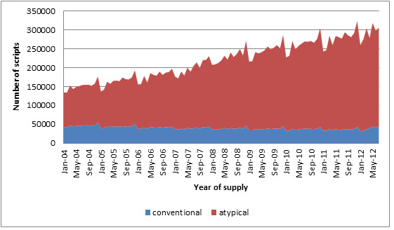
Figure 1: PBS and RPBS script volume between 2004 and 2011 by type of antipsychotic medicine (including subsidised and non-subsidised prescriptions)
Source: DUSC Database, accessed 9 August 2012

Government expenditure for atypical antipsychotics across all age groups from 0 to 100 plus years is shown in Figure 2.

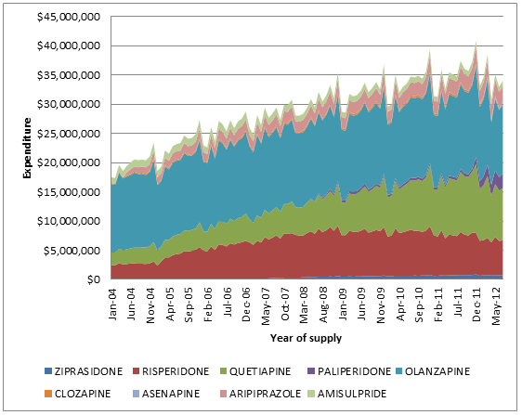
Figure 2: Government expenditure for atypical antipsychotics
Government expenditure excludes any patient or other third party contribution. Note that the price of risperidone decreased on 1 April 2011, and the prices of olanzapine, quetiapine and clozapine decreased on 1 April 2012.
Source: DUSC Database, accessed January 2013

Government expenditure for all subsidised scripts appears to have decreased in 2012. This is likely to be due to price reductions for some brands, as the number of scripts increased in 2012 (Figure 1). The downward trend relates to a short time period at the beginning of 2012, and as expenditure tends to decrease in January and February and increase through the year, it is too early to determine whether the overall trend will continue downwards.

Utilisation of antipsychotics in children and adolescents

It was estimated that 12,680 children and adolescents aged 0–19 years were taking an antipsychotic as of 31 October 2012. The following table shows the breakdown by age group.

Table 2: The estimated number of children and adolescents taking any antipsychotic on 31 October 2012
Age group (years)  (at 31 October 2012) | Estimated patients  (i.e. 10% sample patients x 10) | Total population
0–4 | 110 | 1,448,670
5–9 | 2,000 | 1,396,712
10–14 | 3,980 | 1,404,641
15–19 | 6,590 | 1,487,518
20–24 | 9,580 | 1,594,994
Note: The total population in each age range is provided for perspective.

An age-standardised analysis of age at the time of first atypical antipsychotic script supply shows that the take up of the first script varies according to age and there are differences in gender uptake (Figure 3): in the 0–19 year age group, atypical antipsychotics were supplied more often to males than to females.

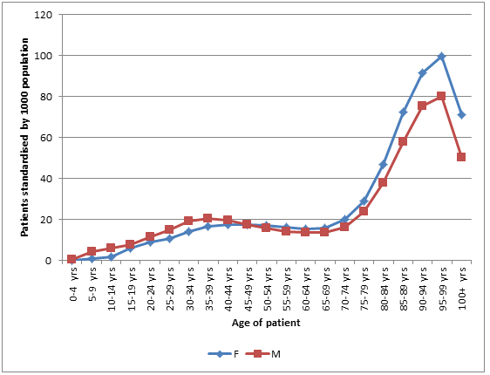
Figure 3: Age and gender of all patients at first PBS/RPBS supply for any atypical antipsychotic in 2011 (standardised by 1000 population and by age and gender)
Note: The age and gender of patients receiving non subsidised (under-copayment) scripts were not collected by Medicare Australia at this time and so are not included in this analysis.
Source: Medicare DHS Supplied Prescription Database, accessed November 2012

Changing pattern of use over time
In the 0–19 year age group, the three most commonly used antipsychotics were risperidone, quetiapine and olanzapine. Two periods of time are compared to examine change in utilisation for the most popular medicines using the population standardised numbers of patients in 2008 and 2011 (Figure 4). Between 2008 and 2011 there was a large increase in the use of quetiapine, with the number of patients in the 0–19 year age group who were supplied the drug more than doubling (an increase of 138%). Risperidone use also increased in all age groups across this age category (+46%). The number of patients supplied olanzapine remained fairly stable (+8%). The 20–24 year age group is supplied for reference.
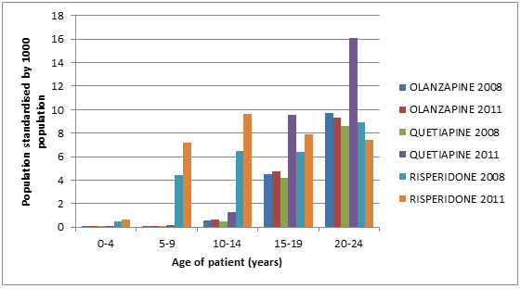
Figure 4: Population standardised number of patients supplied a subsidised PBS/RPBS atypical antipsychotic in 2008 and 2011 for the three most frequently prescribed drugs
Source: Medicare DHS Supplied Prescription Database, accessed November 2012

Most commonly used forms of risperidone, olanzapine and quetiapine
Of the dose forms of risperidone supplied, the most common was the 1 mg/mL oral solution in children aged 4 years or less, and the 1 mg tablet for all other age groups (Figure 5). The 20–24 year age group is supplied for reference.

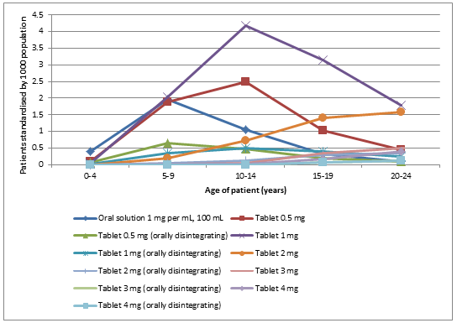
Figure 5: Number of patients supplied oral risperidone by form and strength in 2011 (age-standardised)
Source: Medicare DHS Supplied Prescription Database, accessed January 2013

For olanzapine, the most common doses supplied were the 5 mg and the 10 mg strengths, with the tablet formulation being supplied more often than the wafer (Figure 6).
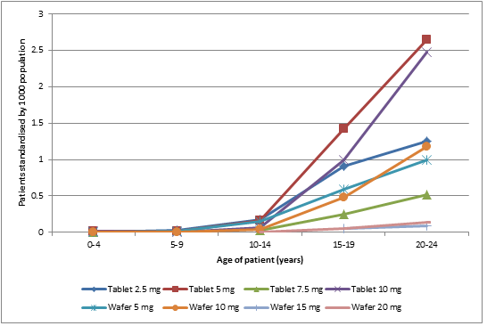
Figure 6: Number of patients supplied oral olanzapine by form and strength in 2011 (age-standardised)
Source: Medicare DHS Supplied Prescription Database, accessed January 2013
Quetiapine was most frequently supplied as a 25 mg tablet. The 100 mg strength was also commonly used (Figure 7). The 20–24 year age group is supplied for reference.

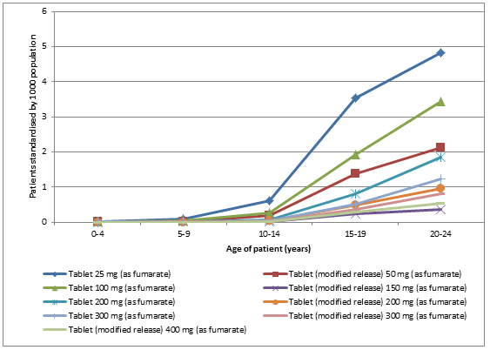
Figure 7: Number of patients supplied oral quetiapine by form and strength in 2011 (age-standardised)
Source: Medicare DHS Supplied Prescription Database, accessed January 2013

Co-administration of antipsychotics and antidepressants
The co-administration analysis showed that patients in the 0–19 year age groups are most commonly taking single agent risperidone. Pericyazine is also often used as a single agent in patients aged less than 15 years. A combination of quetiapine, aripiprazole or pericyazine with an antidepressant is relatively common in patients supplied an antipsychotic (Figure 8). The analysis methodology accounted for switching between therapies.¹⁰

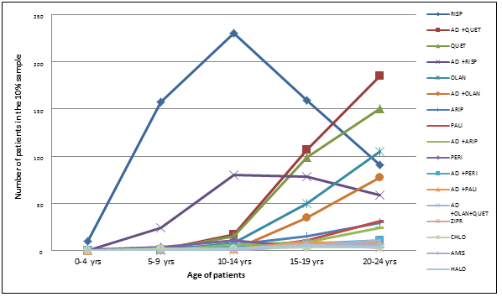
Figure 8: Estimated co-administered regimens for children and adolescents for all patients from 10% sample, for patients supplied an AD or AP medicine from December 2010 to December 2012 inclusive
Note: Only the most frequent 17 regimens are shown. The AD only regimen is excluded.
Source: Medicare DHS Supplied Prescription Database, accessed January 2013

Patterns of utilisation (regimens) of psychoactive drugs at the point of initiation of an antipsychotic
The number of children and adolescents initiating on an antipsychotic for each age bracket are shown in Table 3.

Table 3: Number of children and adolescents initiating to an antipsychotic during August 2012 by age range
 | Initiating drug
Age group (years)  (at initiation) | Quetiapine | Risperidone | Olanzapine | Haloperidol | Other antipsychotics | Total initiators | Total population
0–4 | 0 | 26 | 0 | 0 | 5 | 31 | 1,448,670
5–9 | 3 | 132 | 1 | 1 | 5 | 142 | 1,396,712
10–14 | 34 | 119 | 13 | 2 | 24 | 192 | 1,404,641
15–19 | 254 | 100 | 125 | 7 | 72 | 558 | 1,487,518
20–24 | 357 | 88 | 179 | 11 | 109 | 744 | 1,594,994
Note: The total population in each age range is provided for perspective.
Drug regimens supplied prior to and at initiation of the antipsychotic for this sample from Table 3 of children and adolescents are presented in Figure 9.

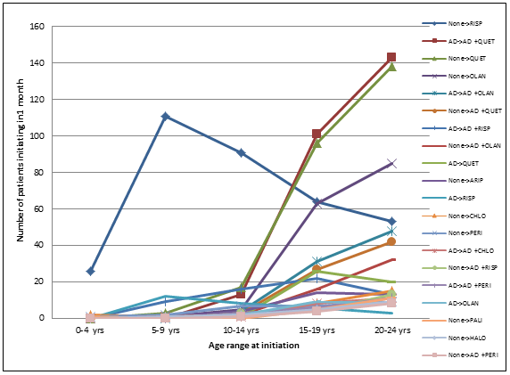
Figure 9: Regimen transitions for patients initiating an antipsychotic in August 2012
Note: In patients aged 0–24 years, only the top 20 transitions are shown, lower frequency transitions are not shown, the legend shows the regimen in the week before initiation and the regimen at initiation.
Source: Medicare DHS Supplied Prescription Database, accessed January 2013

Transitions between treatments vary with age. The pattern of use of antipsychotics in 0–19 year olds shows very few initiations in children aged less than 5 years (31 children in total). Risperidone was the most usual first antipsychotic supplied to children and adolescents aged less than 15 years. It was most often initiated as a single agent (None->RISP) (Figure 9). Quetiapine was the most frequently initiated antipsychotic in adolescents aged 15 years and older. Of all patients aged 0–19 years who initiated on quetiapine, approximately 40% added it to an antidepressant (AD->AD+QUET), 39% were not on an antidepressant just prior (None->QUET), 11% initiated both at the same time (None->AD+QUET) and 7.5% switched from an antidepressant (AD->QUET) (Figure 9).

Olanzapine was initiated as a sole therapy more often than quetiapine. Of the patients who initiated treatment on olanzapine, 26.1% added it to an antidepressant (AD->AD+OLAN), 48.4% were not on an antidepressant just prior (None->OLAN), 15.7% initiated both at the same time (None->AD+OLAN) and 6.0% switched from an antidepressant (AD->OLAN) (Figure 9).

Prescriber analysis
The pattern of uptake in the community may be influenced by the initiating physician. Medicare Australia data for first presentation of prescription (original script) was examined by de-identified patient and prescriber approval number. Figure 10 shows patient numbers by drug, original script count since initiation and prescriber specialty type (derived from Medicare Australia records). Figure 11 shows the percentage distribution of scripts by prescriber type for each drug and by the original script number. Approved prescribers are separated into general practitioner (GP), psychiatrist and other specialists.

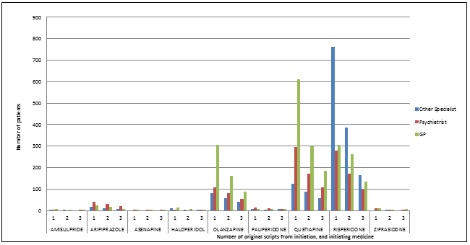
Figure 10: Original scripts dispensed by approved prescriber type for patients aged 0-19 years who initiated AP therapy between December 2011 and March 2012 inclusive, with a 12-month no-prior-script period and exactly 9 months follow-up
Source: Medicare DHS Supplied Prescription Database, accessed January 2013

For patients aged 0–19 years, scripts for antipsychotics were mostly written by GPs (Figure 10). The more frequently prescribed antipsychotics are proportionally prescribed more often by GPs, with the exception of risperidone, which was prescribed more often by other specialists (including paediatricians). This analysis is not able to distinguish when a GP wrote a prescription following consultation with a specialist. Aripiprazole, and paliperidone were prescribed more often by psychiatrists compared to the other antipsychotics (Figure 11).

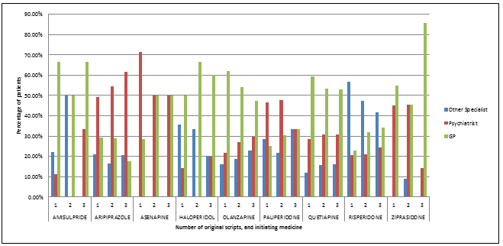Figure 11: Prescriber type distribution by original script number for patients who initiated AP therapy between December 2011 and March 2012 inclusive, with a 12-month no-prior-script period and exactly 9 months follow-up
Source: Medicare DHS Supplied Prescription Database, accessed January 2013

Discussion
Overall the pattern of use reflects substantial use of risperidone in younger children and more use of quetiapine and olanzapine in older children. The restrictions for PBS-subsidised use for risperidone are broader than for other antipsychotics as treatment of autism is included for risperidone. However, the use of risperidone in very young children, while a small number, is noteworthy. It is not clear why risperidone would be prescribed in this very young age group. There may be some use for severe behaviour problems associated with autism or intellectual disability.¹⁹ For other antipsychotics subsidised, the indications are more limited than the TGA approved indications. There are a number of non-approved uses for many atypical antipsychotics.¹¹ These include; acute sedation, insomnia associated with non-psychotic psychiatric conditions, agitation associated with non-psychotic psychiatric disorders, anorexia nervosa, nausea, treatment refractory attention deficit hyperactivity disorder, and explosive rage.^{2,20} The PBAC has not evaluated a many of the reasons for prescribing atypical antipsychotics for comparative effectiveness and cost-effectiveness. The utilisation pattern suggests that a range of uses of olanzapine and quetiapine in particular, are not for subsidised indications. Such use that is not in accordance with PBS listings or TGA approved indications is particularly concerning since no formal risk–benefit assessment has been conducted.¹²

In children and adolescents aged 0–19 years, use of the three most common atypical antipsychotics supplied between 2008 and 2011 in Australia on the PBS increased by 54%. Quetiapine had the highest rate of growth with age-standardised scripts increasing by 138%. Risperidone scripts increased by 46%, and olanzapine scripts increased by 8%. Vitiello and colleagues suggest that factors contributing to the increased use may include changes to the diagnostic construct of bipolar disorder to include extreme mood volatility and irritability, regulatory approvals for expanded uses, and a belief that atypical antipsychotics are safer and easier to use than conventional antipsychotics in these age groups.² This view is consistent with the Australian experience.¹⁹ The marked increase in the use of quetiapine could also be the result of diversion, with prescription shopping for quetiapine becoming increasingly common.^{12,13} The use of antipsychotics in a range of other conditions may also contribute to increasing use. It is probable that antipsychotic medications are being prescribed for other than approved conditions. The most likely off-label uses are for aggression associated with conditions other than autism, and agitation.²⁰ The increase in prescribing may also, in part, reflect growing experience with diagnosing conditions and prescribing antipsychotics.¹⁴ In a recent commentary, Carlson provides insight into the increased rate of antipsychotic drug use in children.²¹ Carlson attributes the increase to the following: pressure to reduce lengths of hospital stay, pressure to reduce the use of seclusion, greater number of children being discharged to residential treatment rather than home, less contact time between clinical staff and their patients because clinical staff are required to spend time inputting data, briefer resident rotations, and the influence of managed care.²¹ All but the last two are likely to be relevant to the Australian context.²⁰

The study noted two patterns of use that required further investigation: the high level of use of low-dose quetiapine (25 mg formulation) and the co-administration of antidepressants and antipsychotics in older children and adolescents.

The most commonly supplied dose of quetiapine was the 25 mg strength. The Product Information for quetiapine recommends use of the 25 mg dose for initiation only.^{6,7} Published reports indicate that quetiapine is used off-label in a low dose for the treatment of other conditions such as behavioural insomnia. Behavioural insomnia rates are reported to be high in children and adolescents with autism, attention deficit hyperactivity disorder (ADHD), and in those with mood and anxiety disorders.^{15,16} An Australian study reported use of antipsychotics in 1.2% of children with ADHD.¹⁷ There have also been reports of off-label lower than usual doses of quetiapine in combination with methylphenidate for the treatment of ADHD.¹⁸ It is also possible that there is some use for anxiety and stress, particularly in adolescents.

The analysis of therapy at the time of initiation of an antipsychotic found that more children initiated quetiapine and maintained prior treatment with an antidepressant (40%) compared to 26.1% of initiating children who added olanzapine to an antidepressant. Conversely a larger proportion of children initiated olanzapine without prior antidepressant therapy (48.4%) compared to quetiapine (30%).

Children and adolescents taking antipsychotics are at high risk of adverse effects. The harms associated with use of olanzapine have been reported widely; in 2010, the US Food and Drug Administration noted the increased potential for weight gain and hyperlipidaemia with olanzapine in adolescents compared with adults, and recommended that prescribers consider using other drugs first-line in preference to olanzapine.²² Olanzapine is also commonly sought after by prescription shoppers and the higher than expected use of olanzapine in adolescents could also signal diversion.^{12,13} The harms associated with quetiapine, in low doses, are less well characterised compared to risperidone and olanzapine but are likely to be similar. In addition the consequences of use, even for low doses and short periods, as well as the effect of developing lifetime behaviour of ‘reliance’ on pharmacotherapy to manage insomnia and stress are poorly researched. Although monitoring in Australia and other countries is recommended, monitoring is considered to be suboptimal.^{23,24} Guidelines for monitoring are available from:
www.wch.sa.gov.au/services/az/other/pharmacy/antipsychotic.html.⁴ The guidelines also include strategies for preventing and managing weight gain and metabolic abnormalities in patients taking antipsychotics.^{4,21}

Conclusion

Use of atypical antipsychotics in children and adolescents in Australia is increasing. The extent of first-line use of atypical antipsychotics that are associated with long term harms through the potential for weight gain and hyperlipidaemia in adolescents is of concern. Further investigation into the utilisation of psychotropic medicine use in children and adolescents is warranted, including whether further consideration of cost-effectiveness should be undertaken, and whether the medications are being prescribed safely²⁰. Of particular note are:
The extent to which the higher than expected use of quetiapine 25 mg could be due to off-label use for behavioural insomnia and/or ADHD;
The extent of use of both olanzapine and quetiapine associated with diversion of these medicines by prescription shoppers;
The reasons for the increase in use of risperidone in the 5–19 year age group;
Whether adequate precautions are being taken to minimise the risk of cardiovascular complications, metabolic syndrome and non-reversible neurological side effects.

The source reports for this paper were circulated to the sponsors of all antipsychotic brands listed on the PBS. Any relevant material from these has been included in this paper.

Acknowledgements
Dr Robert Adler, Child and Adolescent Psychiatrist, Millswyn Clinic South Yarra Victoria, and Professor Philip Hazell, Director, Infant Child and Adolescent Mental Health Services Sydney and South Western Sydney Local Health Districts; Head, Discipline of Psychiatry, Sydney Medical School provided comments on the report.

References
- Patten SB, Waheed W and Bresee L. A review of pharmacoepidemiologic studies of antipsychotic use in children and adolescents. Can J Psychiatry 2012;57(12):717–21.
- Vitiello B, Correll C, van Zwieten-Boot B et al. Antipsychotics in children and adolescents: Increasing use, evidence for efficacy and safety concerns. Eur Neuropsychopharmacol 2009: doi:10.1016/j.euroneuro.2009.04.008.
- Panagiotopoulos C, Ronsley R, Elbe D et al. First do no harm: Promoting an evidence-based approach to atypical antipsychotic use in children and adolescents. J Can Acad Child Adolesc Psychiatry 2010;19(2):124–37.
- Women and Children’s Health Network. WCHN Antipsychotic physical health and adverse effect monitoring package. [Online]. Accessed 4 November 2013. Available at: www.wch.sa.gov.au/services/az/other/pharmacy/antipsychotic.html.
- Risperdal (risperidone) product information. [Online]. Accessed 19 November 2013. Available at: www.ebs.tga.gov.au/ebs/picmi/picmirepository.nsf/pdf?OpenAgent&id=CP-2010-PI-01616-3
- Seroquel (quetiapine immediate release) product information. [Online]. Accessed 19 November 2013. Available at: www.ebs.tga.gov.au/ebs/picmi/picmirepository.nsf/pdf?OpenAgent&id=CP-2010-PI-07764-3
- Seroquel XR (quetiapine modified release) product information. [Online]. Accessed 19 November 2013. Available at: www.ebs.tga.gov.au/ebs/picmi/picmirepository.nsf/pdf?OpenAgent&id=CP-2010-PI-07765-3.
- Zyprexa (olanzapine) product information. [Online]. Accessed 19 November 2013. Available at: www.ebs.tga.gov.au/ebs/picmi/picmirepository.nsf/pdf?OpenAgent&id=CP-2011-PI-02804-3.
- Edmonds D, Dumbrell D, Primrose J et al. Development of an Australian Drug utilisation Database. Pharmacoeconomics 1993;3(6):427-432.
- Raymond C. Estimating Drug Regimens from Prescription Supply Data. Poster. 8th Asian Conference ISPE. 25–27 October 2013.
- Seida JC, Schouten JR, Boylan K et al. Antipsychotics for children and young adults: a comprehensive effectiveness review. Paediatrics 2012;129;e772 doi:10.1542/peds.2011-2158.
- Antipsychotics hit the street. Australian Doctor June 2011. [Online]. Accessed 7 November 2013. Available at: www.australiandoctor.com.au/news/latest-news/antipsychotics-hit-the-street.
- Death sparks doctor shopping fears. Medical Observer June 2010. [Online]. Accessed 7 November 2013. Available at: www.medicalobserver.com.au/news/death-sparks-doctor-shopping-fears.
- Eli Lilly (personal communication). Response to DUSC Review of Antipsychotics February 2013 Item 7.5.
- Vriend K and Corkum P. Clinical management of behavioural insomnia of childhood. Psych Res Beh Man 2011:4 69–79.
- Therapeutics initiative letter. Is use of quetiapine for insomnia evidence based? [Online]. Accessed 6 November 2013. Available at: www.ti.ubc.ca/letter79.
- Department of Health 2012. Western Australian Stimulant Regulatory Scheme 2011 Annual Report, Pharmaceutical Services Branch, Public Health and Clinical Services Division, Department of Health, Western Australia.
- Kronenberger W, Giauque A, Lafata D et al. Quetiapine in methylphenidate treatment-resistant adolescents with ADHD, conduct/oppositional-defiant disorder, and aggression: a prospective, open-label study. J Child Adolesc Psychopharmacol 2007;17(3):333–47.
- Adler R (personal communication). Child and Adolescent Psychiatrist, Victoria. email 12 December 2013.
- Hazell P (personal communication.). Director, Infant Child and Adolescent Mental Health Services Sydney and South Western Sydney Local Health Districts; Head, Discipline of Psychiatry, Sydney Medical School. email 16 January 2014.
- Carlson G. The dramatic rise in neuroleptic use in children: why do we do it and what does it buy us? Theories from inpatient data 1988-2010. J Child Adolesc Psychopharm 2013;23:144–7.
- Zyprexa (olanzapine): Use in adolescents. US Food and Drug Administration. [Online]. Accessed 7 November 2013. Available at: www.fda.gov./Safety/MedWatch/SafetyInformation/SafetyAlertsforHumanMedicalProducts/ucm198402.htm.
- Lambert T and Chapman L, on behalf of the Consensus Working Group. Diabetes, psychotic disorders and antipsychotic therapy: a consensus statement. Med J Aust 2004;81:544–8.
- Thompson A, Metrick S, lvarez-Jiménez M et al. Australian and New Zealand Journal of Psychiatry 2011;45:740–8.

Sponsor comments:
AstraZeneca Pty Ltd:
As manufacturers of quetiapine, AstraZeneca welcomes the DUSC reviews of utilisation of antipsychotics, and supports the conclusions of the analysis. Clinicians clearly face a range of challenging issues when considering the prescription of antipsychotic medicines to people who often have complex mental health issues. We hope that our support for limiting repeat prescriptions of 25mg quetiapine is an effective contribution towards combating any misuse of this medicine.

BNM Group, Bristol-Myers Squibb Australia Pty Ltd, Eli Lilly Australia Pty Ltd, Janssen-Cilag Pty Ltd, Lundbeck Australia Pty Ltd, and Pfizer Australia Pty Ltd:
No comment.

Actavis Australia Pty Ltd, Alphapharm Pty Ltd, Apotex Pty Ltd, Aspen Pharmacare Australia Pty Limited, Aurobindo Pharma (Australia) Pty Limited, Dr Reddy's Laboratories (Australia) Pty Ltd, Generic Health Pty Ltd, Ranbaxy Australia Pty Limited, Sandoz Pty Ltd:
No comment received.

Disclaimer
The information provided in this report does not constitute medical advice and is not intended to take the place of professional medical advice or care. It is not intended to define what constitutes reasonable, appropriate or best care for any individual for any given health issue. The information should not be used as a substitute for the judgement and skill of a medical practitioner.
The Department of Health (DoH) has made all reasonable efforts to ensure that information provided in this report is accurate. The information provided in this report was up-to-date when it was considered by the Drug Utilisation Sub-committee of the Pharmaceutical Benefits Advisory Committee. The context for that information may have changed since publication.
To the extent provided by law, DoH makes no warranties or representations as to accuracy or completeness of information contained in this report.
To the fullest extent permitted by law, neither the DoH nor any DoH employee is liable for any liability, loss, claim, damage, expense, injury or personal injury (including death), whether direct or indirect (including consequential loss and loss of profits) and however incurred (including in tort), caused or contributed to by any person’s use or misuse of the information available from this report or contained on any third party website referred to in this report.

A behavioural disturbance associated with autism is defined as severe aggression that may result in injuries to self or others, where non-pharmacological methods alone have been unsuccessful. The diagnosis of autism must be made based on the Diagnostic and Statistical Manual of Mental Disorders, Fourth Edition (DSM-IV) or ICD-10 international classification of mental and behavioural disorders.
ABS population as at 30 June 2012 report 3222b, extracted Jan 2013
ABS population as at 30 June 2012 report 3222b, extracted Jan 2013

