Use of antipsychotics in the middle aged

A Report prepared by the Drug Utilisation Subcommittee (DUSC) of the Pharmaceutical Benefits Advisory Committee (PBAC)

This report was compiled for the DUSC by the DUSC Secretariat from two examinations of utilisation of antipsychotics in Australia considered by DUSC in February 2013 and June 2013.
The initial utilisation studies were provided to the pharmaceutical sponsors of each drug and comments on the studies were provided to DUSC. These comments, where applicable, have been included in this final report. The final report was also provided to clinical specialists in the management of psychiatric problems in children and adults. These comments have also been incorporated.
The Report was compiled by O Morrison, C Raymond and M Firipis with assistance of members of DUSC. Final approval by M Robinson.

Abstract
The use of atypical antipsychotics in adults aged 20–59 years in Australia is increasing without a proportionate increase in the prevalence of currently subsidised indications. Use of selected antipsychotics in depression and anxiety disorders has been reported in the literature. In addition use of low dose quetiapine is reported as a sedative. In Australia the three most commonly used antipsychotics are quetiapine, olanzapine and risperidone. While much work has been done on elderly patients the increasing use of these drugs in middle aged people is also of concern given the lack of data for both benefits and harms for some reasons for prescribing. This study examines the patterns of utilisation of PBS-listed antipsychotics in middle aged patients in Australia.
De-identified patient level pharmacy claim data from 1 December 2010 to 31 December 2012 was extracted from the records of subsidised claims provided to the Australian Government by dispensing pharmacies. As the number of records was very large a 10% sample of the dataset was used for some analyses. Data elements extracted for each de-identified record were age at date of supply, gender, medicine form and strength. Prescriber type was determined from the de-identified prescriber approval number. Initiation to treatment was the first drug supply after a minimum of 12 months previously. Co-administration was assumed where the days of coverage of both drugs were evident based on dates of supply.
Use of antipsychotics increased from around 20 patients/1000 in the 20–24 year age population to a maximum of 36 patients/1000 aged 34–39 and 40–45 years respectively. More males received antipsychotics until aged 50. After this a larger proportion of treated patients were females. Quetiapine was the most commonly prescribed antipsychotic in all age groups. Quetiapine use has grown by 82% from 2008 to 2011 while there were small reductions in olanzapine (-3%) and risperidone (-6%). The most commonly used treatment regimen in all age groups was an antidepressant co-administered with quetiapine, with a trend to increase with age.
For the 155,630 patients receiving any antipsychotic in 2011, 37.6% received quetiapine. Around 23% of these people received prescriptions for quetiapine 25 mg without any other quetiapine strengths, about 2/3 of these in a regimen with an antidepressant and the remaining 1/3 as one single strength antipsychotic.
Quetiapine 25 mg, supplied in a pack of 60, was usually refilled around 26 days but there was a significant second peak refilling at around 60 days. This is indicative of one 25 mg tablet daily for a substantial number of people. GPs were the most common prescribers of original prescriptions for antipsychotics however it is not possible to show if this was on advice of a psychiatrist.
The patterns of prescribing antipsychotics show differences that suggest different factors in patient selection. The study showed higher than expected use of quetiapine 25 mg as a single agent, possibly related to its sedative properties and as an agent to treat anxiety. Additional use may be as either adjunctive treatment in depression or treatment to manage side effects of antidepressants. The harms associated with antipsychotics are well documented, although less so for low dose preparations. The evidence supporting antipsychotics as adjunctive treatments in major and refractory depression does not completely support the increasing use of quetiapine 25 mg in the community seen in the utilisation data. While the median age of onset for depression occurs in the mid-30s and therefore some use of antipsychotics is to be expected in this age group the high use of low dose quetiapine is poorly supported by the literature. Prescribers may not be aware of the long term harm risk. The perception of low-dose antipsychotics as ‘safer’ medicines than other medicines such as benzodiazepines as narcotics and anti-anxiety agents are poorly supported in the literature and more research needs to be done in some patient groups.

Introduction
Use of atypical antipsychotics in adults aged 20–59 years in Australia is increasing without a proportionate increase in the prevalence of indications listed on the Pharmaceutical Benefits Scheme (PBS).¹ This is of concern to the Pharmaceutical Benefits Advisory Committee (PBAC) as there has been no evaluation of cost-effectiveness in other therapeutic areas. The literature suggests that use of antipsychotics for symptom management in non-psychotic illness may mask or delay treatment of the underlying condition, add to the potential for harm from increased risk of adverse events associated with antipsychotics, and there is potential for diversion of the drugs and patient overdose.
The three most commonly used antipsychotics in middle aged adults in Australia are quetiapine, olanzapine and risperidone.
Quetiapine is approved by the Therapeutic Goods Administration (TGA) for the treatment of acute mania or depression associated with bipolar disorder (BPD), for maintenance treatment in bipolar disorder, and for schizophrenia. In the extended release form it is also approved for generalised anxiety disorder (GAD) and treatment resistant major depression. The recommended dose for schizophrenia and acute mania is 300 mg per day, increasing to 600 mg per day on day two and 800 mg per day on day three.^{2,3} The recommended dose for GAD and treatment resistant major depression is 50 mg per day on days one and two, given in two divided doses, with dose titration up to a 150 mg per day on days three and four. For bipolar depression a starting dose of 50 mg per day, increasing up to 400–600 mg per day is recommended by day eight.³
Olanzapine is approved by the TGA for the treatment of schizophrenia and related disorders at a recommended dose of 5–10 mg per day. For the treatment of acute mania associated with BPD the recommended dose is 10–15 mg once a day as monotherapy and 10 mg per day (range 5–20 mg per day) for maintenance treatment.⁴
Risperidone is approved by the TGA for the treatment of schizophrenia at a dose of 1 mg twice daily on day one and 2 mg twice daily on day two. The recommended dose range is 4–6 mg per day, given once or twice daily. In the treatment of bipolar mania the recommended dose is 2 mg once per day, increasing up to 6 mg per day. For the treatment of behavioural disorders associated with autism or dementia the starting dose for persons 50 kg or more is 0.5 mg per day.⁵
The PBAC advises the Minister on issues related to reimbursement of pharmaceuticals in Australia on the Government subsidised PBS. The committee has considered the majority of newer or atypical antipsychotics for the treatment of schizophrenia and BPD. Risperidone has additionally been considered and recommended as cost-effective as a treatment for behavioural disturbances in people with dementia and for severe behavioural disturbances in persons diagnosed with autism who have commenced treatment with risperidone before 18 years of age.
Quetiapine has been considered by the PBAC for the treatment of resistant major depression, as adjunctive therapy, but was rejected on the basis of inadequate clinical evidence to support a claim of superiority over the nominated comparator (lithium) and therefore a cost-effectiveness analysis was not acceptable.⁶ A summary of the subsidised restrictions for antipsychotics listed on the PBS is provided in Table 1.
Table 1: Summary of subsidised restrictions for PBS-listed antipsychotics
Generic name | Not restricted | Schizo-phrenia | Maintenance treatment of bipolar I disorder | Acute mania associated with bipolar I disorder | Behavioural disturbances dementia and autism | Comments
Conventional
Chlorpromazine | X |  |  |  |  | May be used to treat acute and chronic psychoses, short-term management of anxiety, agitation or disturbed behaviour in non-psychotic disorders and intractable hiccup
Fluphenazine | X |  |  |  |  | Chronic psychoses
Flupenthixol | X |  |  |  |  | Chronic psychoses
Haloperidol | X |  |  |  |  | May be used to treat acute and chronic psychoses, acute mania, Tourette's syndrome and other choreas, adjunct in treatment of alcoholic hallucinosis and intractable nausea and vomiting associated with cancer chemotherapy or radiotherapy
Pericyazine | X |  |  |  |  | Acute and chronic psychoses
Trifluoperazine | X |  |  |  |  | May be used to treat acute and chronic psychoses or short-term management of anxiety, agitation or disturbed behaviour in non-psychotic disorders
Zuclopenthixol | X |  |  |  |  | May be used for initial treatment of acute psychoses, chronic psychoses or acute mania
Atypical
Amisulpride |  | X |  |  |  | Only listed for schizophrenia
Aripiprazole |  | X |  |  |  | Only listed for schizophrenia
Asenapine |  | X | X | X |  | Treatment of acute mania associated with bipolar I disorder is monotherapy for up to 6 months
Clozapine |  | X |  |  |  | Schizophrenia in patients who are non-responsive to, or intolerant of, other antipsychotics (s100)
Olanzapine |  | X | X |  |  | Injections are only listed for schizophrenia
Paliperidone |  | X |  |  |  | Only listed for schizophrenia
Quetiapine |  | X | X | X |  | Treatment of acute mania associated with bipolar I disorder is monotherapy for up to 6 months
Risperidone |  | X |  | X | X | Treatment of acute mania associated with bipolar I disorder is adjunctive therapy to mood stabilisers for up to 6 months
Ziprasidone |  | X |  | X |  | Treatment of acute mania or mixed episodes associated with bipolar I disorder is monotherapy for up to 6 months
Source: www.pbs.gov.au, accessed January 2013
Note: The shaded boxes represent that the drug is approved by the TGA for that indication
The present study aimed to examine the patterns of utilisation of PBS-listed antipsychotics in Australia using pharmacy prescription claim data from the PBS during the period 1 December 2010 to 31 December 2012. Patients eligible for Department of Veterans Affairs subsidised supply of antipsychotics (Repatriation PBS (RPBS)) were included in the analysis. The study was designed as a staged analysis that included assessment by age, gender, formulation and strength supplied (stage 1) and assessment of co-administration of multiple psychotropic medicines (stage 2). This report focuses on the data obtained from middle aged persons between 20–59 years of age. The reports were considered by the Drug Utilisation Sub-Committee (DUSC) at two successive meetings, February 2013 and June 2013, and comments from industry sponsors of all drugs were invited for both stages of the reports.

Methods
Prescription (script) data was extracted from the Medicare Department of Human Services (DHS) Pharmacy Claims database. Medicare DHS is the Government agency that collects information on all PBS and RPBS scripts dispensed in Australia. The Pharmacy transaction database is an administrative dataset. The data used in this analysis is based on the date of supply of the prescription.

The number of scripts for antipsychotics and antidepressants in Australia over the period of study for these analyses results in a very large dataset of scripts. To aid in the computation of data, the dataset extracted from the claim data was reduced to a 10% random patient sample. This sampling method has been accepted in similar pharmacoepidemiology studies and is considered by DUSC to be reasonably representative of the full data in large prevalent patient populations. Analyses that examined small numbers of patients over time (initiating patient analysis) used the complete database.

The extracted data elements included:
- Patient’s date of birth to derive age at either date of first script supply for the initiation analysis, or at 31 October 2012 for the cross section analysis.
- Patient’s gender.
- Prescriber approval number to derive prescriber specialty.
- Original or repeat prescription supplied.

Two cohorts were investigated:
- Patients currently treated with an antipsychotic (cross-section analysis).
- Patients commencing treatment (initiation analysis).

A general analysis of scripts and expenditure was also undertaken. In this analysis, de-identified pharmacy claim data for PBS and RPBS subsidised scripts were extracted from the DUSC database for the period January 2004 to May 2012. The DUSC database combines data for PBS scripts submitted to DHS for payment of a PBS/RPBS subsidy by the Government, with an estimate of under general copayment and private scripts based on dispensing data from a sample of pharmacies. The extracted data included the number of scripts, the patient beneficiary category and Government expenditure based on the price of the medicines published in the PBS schedule and the date of supply of each script.
To determine the numbers of patients in Australia initiating treatment with an antipsychotic all de-identified patients’ PBS/RPBS pharmacy claims for antipsychotics (N05A) and antidepressants (N06A) were extracted from 1 December 2010 to 31 December 2012. An initiating patient was assumed to be a patient who had no prior PBS/RPBS-subsidised supply of any antipsychotic in a minimum period of 12 months prior to the first script being supplied. The entry criterion for this analysis was any de-identified patient record with a first supply of any antipsychotic between 1 December 2011 and 1 December 2012.

In order to examine the drug regimens for patients taking an antipsychotic a random 10% sample of all de-identified patients receiving a prescription for an antipsychotic between 1 December 2010 and 31 December 2012 were extracted. The index date for ‘on antipsychotic therapy’ of 31 October 2012 was selected. The analysis cohort was any patient who was currently having an antipsychotic medicine. A standard coverage days method based on date of supply of prescriptions⁷ was used to estimate prior, sequential or co-administered psychotropic medicines (using ATC classification N05A and N06A).

Prescriber type was determined from the speciality of the authorised prescriber in the initiating patients’ dataset first prescription supplied between 1 December 2011 and 31 March 2012. Initiators were followed up for exactly 9 months and the approved prescriber type of each of the initiator’s first three original scripts supplied in this 9-month period was determined.

Abbreviations
AC | Anticholinesterases
AD | Antidepressants
AP | Antipsychotics
Atypical Antipsychotics
AMIS | AMISULPRIDE
ARIP | ARIPIPRAZOLE
ASEN | ASENAPINE
CLOZ | CLOZAPINE
OLAN | OLANZAPINE
PALI | PALIPERIDONE
QUET | QUETIAPINE
RISP | RISPERIDONE
ZIPR | ZIPRASIDONE
Typical Antipsychotics
CHLO | CHLORPROMAZINE
FLXD | FLUPENTHIXOL DECANOATE
FLZD | FLUPHENAZINE DECANOATE
HALD | HALOPERIDOL DECANOATE
HALO | HALOPERIDOL
PERI | PERICYAZINE
TRIF | TRIFLUOPERAZINE
ZUCD | ZUCLOPENTHIXOL DECANOATE

Results

Overall use of antipsychotics in Australia
The use of atypical antipsychotics in Australia is growing (Figure 1).

Figure 1: Prescription volume between 2004 and 2011 by type of antipsychotic medicine
Source: DUSC Database accessed 9 August 2012
The growth in prescriptions is in the atypical antipsychotic group. The total number of scripts supplied for the atypical antipsychotics across all age groups from January 2004 to May 2012 is illustrated in Figure 2. Use of both quetiapine and olanzapine has increased over the period, with risperidone use plateauing. The other PBS-listed products continue to have a small and steady share of the overall market.

Figure 2: PBS/RPBS Script volume for atypical antipsychotics
Private scripts are not included. Under-copayment prescriptions (estimated to March 2012 and Medicare from April 2012) are included.
Source: DUSC Database accessed 9 August 2012

Government expenditure for atypical antipsychotics is shown in Figure 3.

Figure 3: Government expenditure for atypical antipsychotics
Note: Government expenditure excludes any patient or other third party contribution. Note that the price of risperidone decreased on 1 April 2011, and the prices of olanzapine, quetiapine and clozapine decreased on 1 April 2012.
Source: DUSC Database accessed January 2013

Government expenditure for all subsidised prescriptions appears to have decreased in 2012. This is likely to be due to price reductions for some brands, as the number of prescriptions increased in 2012 (Figure 1). The downward trend relates to a short time period at the beginning of 2012, and as expenditure tends to decrease in January and February and increase through the year, it is too early to determine whether the overall trend will continue downwards.

Utilisation of antipsychotics in the middle aged

When examined by age at the time of first script of any atypical antipsychotic the pharmacy claim data for the calendar year 2011 reveals different patterns of use according to age (Figure 4). A greater proportion of males commence treatment at younger ages (less than 50 years of age). The peak time for commencing any atypical antipsychotic is between 35 and 45 years of age for people in this group although there is a difference between males and females. Take up of antipsychotics rises rapidly from around 30 years of age and appears to plateau around 40–55 years of age then a small decrease after 55 years of age.

Figure 4: Age and gender of patients 20 to 64 years at first PBS/RPBS supply for any atypical antipsychotic in 2011 (standardised by 1000 population for each 5 year age group and gender)
Note: The age and gender of patients receiving under-copayment scripts were not collected and so are not included in this analysis.
Source: Medicare DHS Supplied Prescription Database, accessed November 2012

Figure 5 illustrates the use of antipsychotics in middle aged persons during 2011 based on age of first supply. Quetiapine was the most common antipsychotic used for initiation across all age groups within the 20–59 year age bracket with olanzapine and risperidone next in order of market share.

Figure 5: Population standardised number of patients supplied a subsidised PBS/RPBS antipsychotic medicines in 2011, by age of patient at first supply
Source: Medicare DHS Supplied Prescription Database, accessed November 2012

Quetiapine use is increasing and is the major contributor to the increasing use of antipsychotics (Figure 2). The growth in quetiapine is also seen in a comparison of the number of prescriptions dispensed (age-standardised) between 2008 and 2011 (Figure 6). This analysis shows that quetiapine use increased by 82%. The increased use of quetiapine was somewhat offset by reduced use of olanzapine (-3%) and risperidone (-6%), resulting in an overall growth rate for these three antipsychotics of 22% (Figure 7).

In the 20–55 year age group the first drug is more often quetiapine, particularly in the 20–40 year age group (Figure 5).
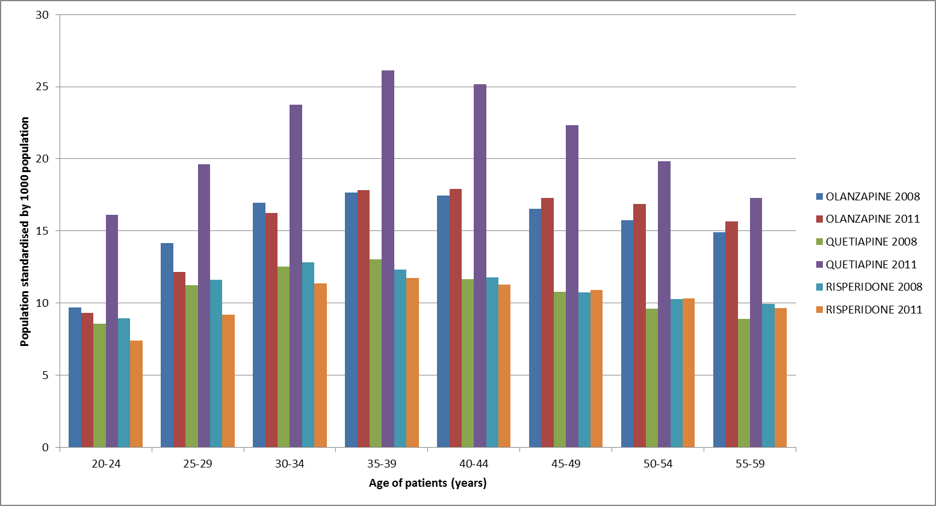
Figure 6: Population standardised number of patients supplied a subsidised PBS/RPBS atypical antipsychotic in 2008 and 2011 for the three most frequently prescribed medicines
Source: Medicare DHS Supplied Prescription Database, accessed November 2012

Co-administration analysis

The most common drug regimens for persons aged 20–59 years taking an antipsychotic are shown in Figure 7. The regimen that was widely used across all age groups in this age bracket was quetiapine plus an antidepressant. In younger adults aged 20–39 years, quetiapine and olanzapine were also commonly prescribed as single agents. In patients aged 44–59 years of age, co-administration of an antipsychotic plus an antidepressant occurred more often than prescription of any single antipsychotic agent therapy. The analysis also examined the number of patients taking an antidepressant only. As this number of patients is much larger than those taking an antipsychotic, with or without an antidepressant these have been left out of the analysis.

Figure 7: Regimens for prevalent patients taking any antipsychotic for all patients from 10% sample, for patients supplied an AD or AP medicine from December 2010 to December 2012 inclusive
Note: Only the 17 most common regimens are shown. The AD only regimen is excluded.
Source: Medicare DHS Supplied Prescription Database, accessed November 2012

Maximum quantity analysis

A defined daily dose analysis was not considered appropriate for this report. The DDD allocated to antipsychotics is based on treatment of psychosis and other uses for antipsychotics are usually at much lower doses.⁸ Therefore the analysis examined the quantity supplied per script to further explain the patterns of use.

For the period December 2011 to July 2012 the quantities supplied were compared to the maximum quantity allowed on the PBS to determine whether a large proportion of antipsychotic scripts are for an increase in the maximum quantity. The maximum quantity on the PBS is usually sufficient supply for approximately 1 month of treatment.

The vast majority (89%) of scripts supplied over all age groups were for the maximum quantity on the PBS, 6% for twice the maximum quantity, and 1.7% for three times the maximum quantity. Most supplies that involved more than the maximum quantity were for persons in the middle year age brackets.

Figure 8: Quantities of antipsychotics supplied by patient age in years
Source: Medicare DHS Supplied Prescription Database, accessed November 2012

Quetiapine analysis

The report undertook additional analysis for quetiapine as it had the largest increase and greatest use in this age bracket. A breakdown of the various dose forms of quetiapine supplied showed that the 25 mg strength of quetiapine was the most commonly supplied item (Figure 9) from 15 years of age onwards. Co-administration of quetiapine with an antidepressant increased significantly with age, with use peaking in adults aged 40–44 years (Figure 10).

Figure 9: Number of patients supplied oral quetiapine by form and strength in 2011 (age-standardised), by patient age in years
Source: Medicare DHS Supplied Prescription Database, accessed January 2013

The top ten drug regimens including quetiapine 25 mg are detailed in Figure 10. Combinations of various strengths of quetiapine are not common. When the 25 mg strength is used in combination with another strength, both strengths are usually co-administered with an antidepressant, with the most common combination being quetiapine 100 mg plus antidepressant and 25 mg plus an antidepressant.

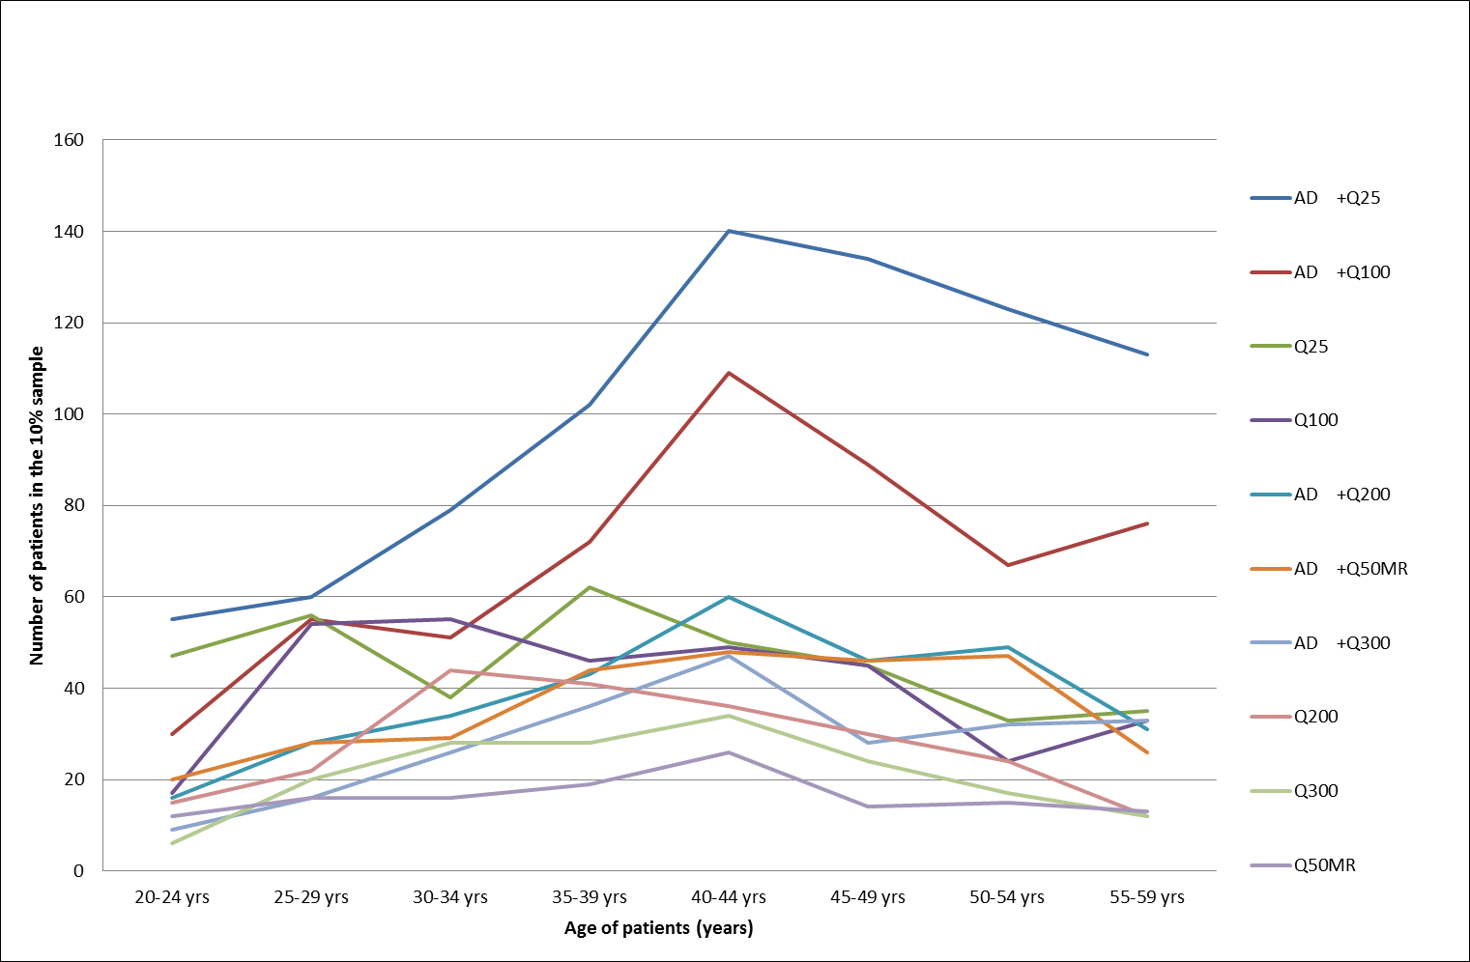
Figure 10: Regimens for patients on quetiapine supplied an AD from December 2010 to December 2012
Note: For readability, this figure only shows the top 10 regimens.
Source: Medicare DHS Supplied Prescription Database, accessed January 2013

To investigate the possibility that quetiapine 25 mg was concomitantly supplied with higher doses, the 10% sample was examined (Figure 11). From the 10% sample analysis examining drug regimens, extrapolated for the Australian population, an estimated 155,630 patients had any antipsychotic in their regimen (10 x 15,563). Of these 58,450 had a regimen containing quetiapine. Of these, a total of 23.2% (13,792/58,450) of patients had regimens that only included the 25 mg strength of quetiapine: 13.8% (8,204/58,450) received an antidepressant plus quetiapine 25 mg (AD+Q25) and 9.4% (5,588/58,450) received single agent quetiapine 25 mg (Q25).

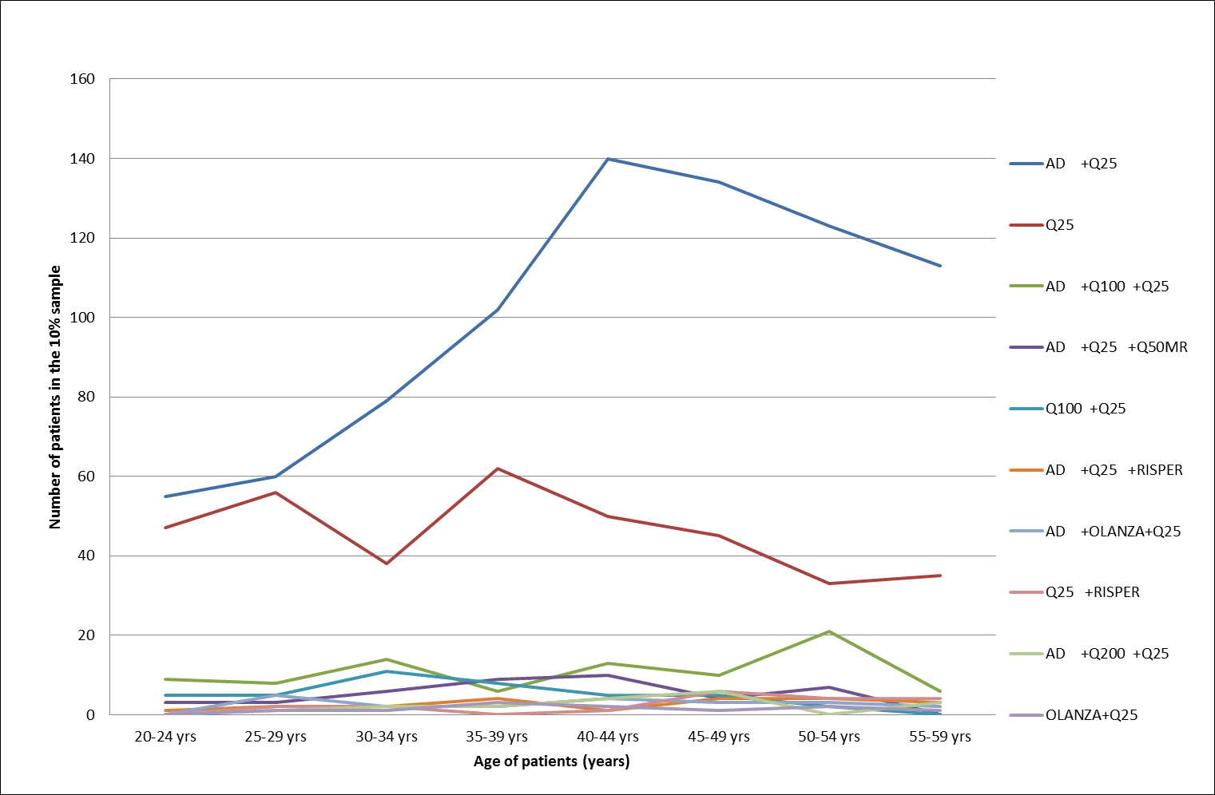
Figure 11: Regimens including quetiapine 25 mg as at 31/10/2012 for 10% sample in patients aged 20-60, for patients supplied an AD and AP.
Note: For readability, this figure only shows the top 10 regimens.
Source: Medicare DHS Supplied Prescription Database, accessed January 2013

Small numbers of people appear to be taking two antipsychotics and an antidepressant or two antidepressants.

To investigate the possibility that quetiapine 25 mg is used for other reasons than titration, an analysis of the frequency of refilling prescriptions was undertaken. Patients taking the 60 pack quantity on an as required (prn) or single daily basis would have approximately 60 days at least between refills. Figure 12 presents the frequency of refill of scripts for quetiapine 25 mg. This figure compares the time to refill of quetiapine 25 mg scripts for two patient groups whose age at last supply was in the range of 20–59 years. The first group were supplied 25 mg and another strength of quetiapine in the same period. The second group were only supplied quetiapine 25 mg in the period Dec 2010 to June 2012. Quetiapine 25 mg is supplied in a pack of 60 tablets and therefore refill at 30 days may indicate that patients are taking two tablets each day, and refill at 60 days may indicate one tablet daily. The quetiapine 25 mg only group had a slightly higher proportion of scripts resupplied around 60 days, indicating that some patients in this group may be taking only one tablet a day.

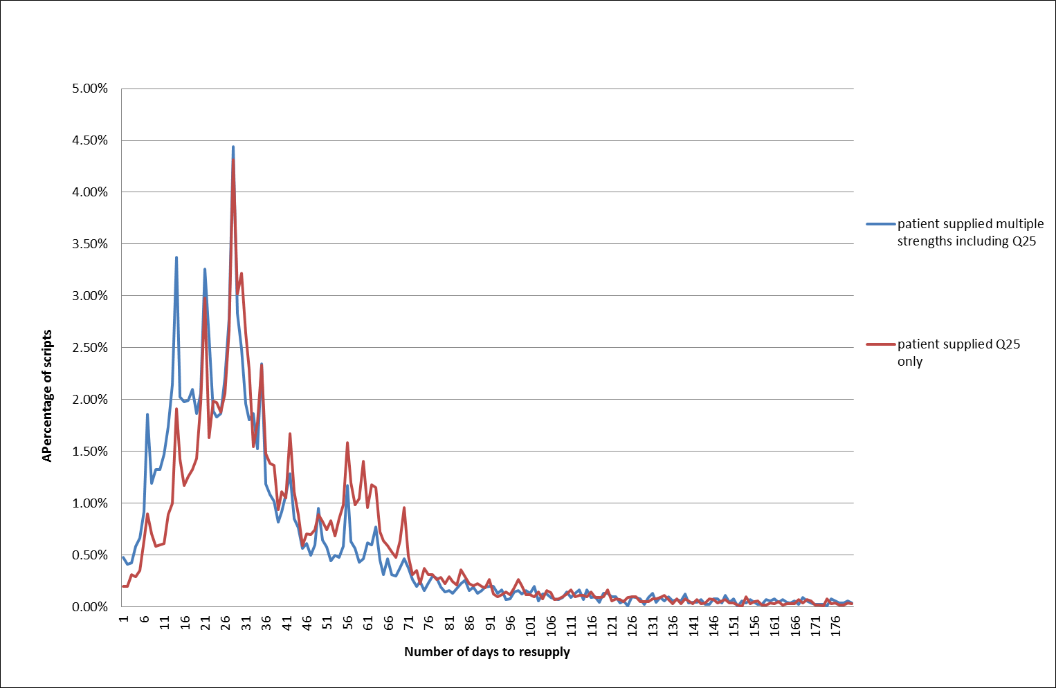
Figure 12: Quetiapine 25 mg scripts supplied from December 2010 to June 2012 with at least 6 months follow-up, by patient status
Source: Medicare DHS Supplied Prescription Database, accessed January 2013

Prescriber analysis
The pattern of uptake in the community may be influenced by the initiating physician. Medicare Australia data for first presentation of prescription (original script) was examined by de-identified patient and prescriber approval number. Figure 13 shows patient numbers by drug, original script count since initiation and prescriber specialty type (derived from Medicare Australia records). Figure 14 shows the percentage distribution of scripts by prescriber type for each drug and by the original script number. Approved prescribers are separated into general practitioner (GP), psychiatrist and other specialists.

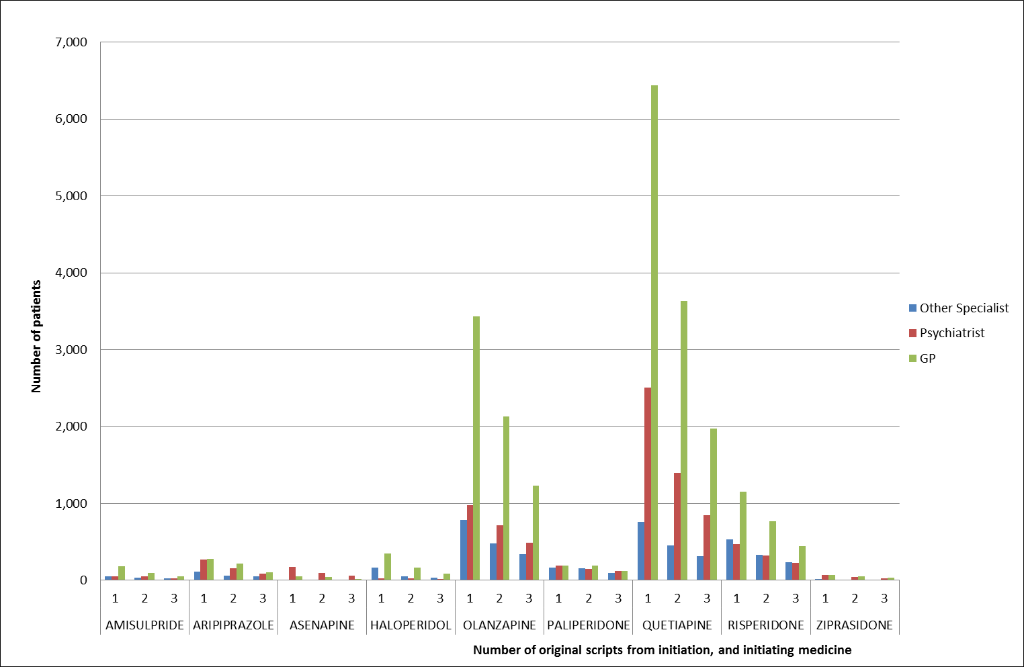
Figure 13: Original scripts dispensed by approved prescriber type for patients aged 20-59 years who initiated AP therapy between December 2011 and March 2012 inclusive, with a 12-month no-prior-script period and exactly 9 months follow-up
Source: Medicare DHS Supplied Prescription Database, accessed January 2013

For patients aged 20–59 years, GPs wrote a total of 42,880 antipsychotic original scripts (2.44 scripts per full-time GP equivalent).⁹ Psychiatrists wrote a total of 12,980 antipsychotic original scripts (4.50 scripts per full-time psychiatrist equivalent).¹⁰ The more frequently prescribed antipsychotics were proportionally prescribed more often by GPs in absolute terms, although prescribing rates were higher per physician for psychiatrists than for GPs when the number of FTE physicians was taken in to consideration. Risperidone was a possible exception (0.78 scripts per GP FTE and 0.66 scripts per psychiatrist FTE). This analysis is not able to distinguish when a GP wrote a prescription following consultation with a specialist. Aripiprazole, asenapine, paliperidone and ziprasidone were prescribed more often by psychiatrists compared to the other antipsychotics (Figure 14).

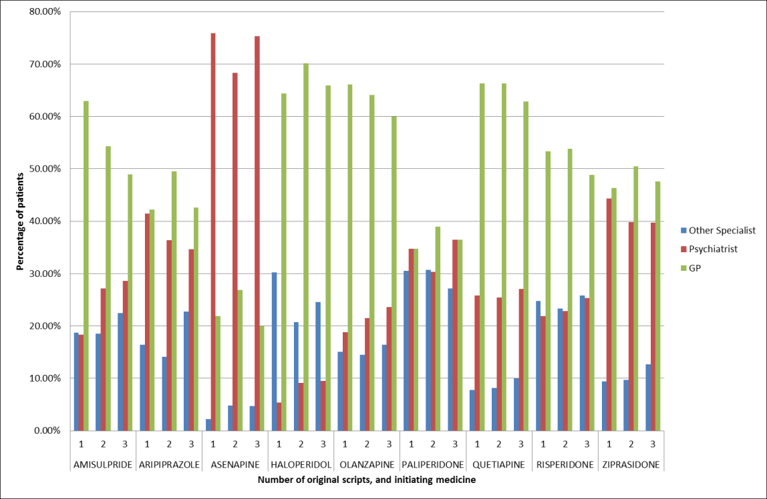
Figure 14: Prescriber type distribution by original script number for patients who initiated AP therapy between December 2011 and March 2012 inclusive, with a 12-month no-prior-script period and exactly 9 months follow-up
Source: Medicare DHS Supplied Prescription Database, accessed January 2013

Discussion

Use of atypical antipsychotics in Australia is growing. The number of scripts supplied has increased by 70% across all age groups over the past 5 years. Use is increasing in adults between 20 and 60 years (middle aged adults). During the same time period, conventional antipsychotic use has remained very steady if not decreased slightly. This trend is consistent with reported use in the USA where the largest rate of growth of atypical antipsychotics was in the 18–64 year age group¹¹. Vitiello and colleagues (2009) suggest that factors contributing to increased use of atypical antipsychotics in adolescents may include increased diagnosis, regulatory approvals for expanded uses and a belief that atypical antipsychotics are safer and easier to use than conventional antipsychotics.¹² These factors may also contribute to increasing use in middle aged adults.

The analyses above show that at least 155,630 adults within the 20–59 year age bracket were taking an antipsychotic in 2012. This equates to 1.24% of the Australian population for this age group. The numbers of people treated with antipsychotics is considerably higher than expected from estimates of the age prevalence of schizophrenia and BPD.¹³ In a 2002 Access Economics report¹ the expected prevalence was 0.18% for schizophrenia (people aged 18–64 years) and 0.776% for BPD (people aged 18–55 years). The Access Economics (2002) report is likely to underestimate the prevalence of schizophrenia to some extent as the prevalence of schizophrenia has increased since 2002 (expected to be an increase of 26% in people 45–64 years of age by 2010¹) and other authors have suggested higher prevalence particularly in specific population groups¹⁴. Overall the numbers using antipsychotics lends weight to use in conditions other than schizophrenia and BPD in people aged between 20 and 60 years of age.
There are different patterns of use in males and females across this age range. Males commence treatment earlier compared to females; however a similar proportion of females initiate each year of age after 40 years, unlike males who show a decline in the proportion initiating. The earlier take up of treatment in males might reflect earlier diagnosis of schizophrenia¹⁵ although the reported gender differences and differences in age of onset between males and females are not completely supported by epidemiological studies¹⁶ and studies in BPD do not show differences between males and females¹⁵. Studies do support later onset of schizophrenia, after 40 years of age, in females.^{15,16} This may explain why the initiation of antipsychotics remains steady in females while declining in males after 40 years of age.
Quetiapine use has grown steadily since listing and now exceeds that of olanzapine in adults aged 20–59 years. In particular the use of the 25 mg strength of quetiapine was higher than expected in the study. As this strength is sub-therapeutic for the treatment of schizophrenia, BPD, GAD and major depression (the latter two not being PBS-listed), this may indicate some ‘off-label’ use for conditions such as insomnia where reported doses of quetiapine range from 25–200 mg.^{17,18} The frequency of refill of to 60 pack of quetiapine 25 mg tablets supplied as a single antipsychotic therapy being 60 days provides additional support for use of the 25 mg once daily in many patients. There is also the possibility of diversion, with prescription shopping for this medicine becoming increasingly common.^{19,20}

The analyses showed that the peak time for commencement of any atypical antipsychotic was for patients aged between 35–45 years. The peak age of onset for schizophrenia and BPD is in mid-late adolescence and the twenties; onset in the 30s and 40s does occur, but is less likely. In Australia, the median age of onset for depression occurs in the mid-30s, and some anxiety disorders such as panic disorder and GAD also first present around this age.^{21,22} A peak at 35–45 years, suggests the possibility that at least some of this use may be for depression or for an anxiety disorder.²¹

The co-administration and sequential treatment regimen analyses show a number of different patterns of treatment. Co-administration of an antipsychotic and an antidepressant is relatively common and increases with age. While quetiapine and an antidepressant is the most common combination, other antipsychotics are also prescribed in combination with antidepressants and the extent of use of antidepressants with antipsychotic medicines might demonstrate a common therapy, albeit one that has not been considered by PBAC for treatment of either schizophrenia or BPD. There is growing evidence to support the off-label use of antipsychotics to augment antidepressant therapy in patients with antidepressant refractory depression.^{21,23} The study shows co-administration of an antipsychotic with an antidepressant becomes more common with older age and this may indicate some use in depression (perhaps comorbid with anxiety and /or insomnia).²¹

Prescribers in General Practice may receive tacit encouragement to prescribe antipsychotics in a number of non-subsidised indications. Both reported studies, consultation with psychiatrists, current practices by mental health crisis teams and concerns about harms associated with long term use of benzodiazepines contribute to increasing acceptance of low dose antipsychotics such as quetiapine, in particular, as a drug of choice in spite of a lack of good quality evidence in many of the conditions.^{24,25}

The use of quetiapine 25 mg as the only strength of any antipsychotic with an antidepressant is more difficult to explain. The proportion of people receiving quetiapine as a single antipsychotic peaks at 35 years of age then appears to decrease while olanzapine as the sole antipsychotic increases in patients after 35 years. This implies differences in prescribing choices and patient selection between olanzapine and quetiapine to some extent. Alexander and colleagues (2011) report that in 54% of encounters (all ages) involving an antipsychotic in a USA sample in 2008, an antipsychotic was prescribed where the reason for prescribing relied on uncertain evidence and/or had no US Food and Drug Administration (FDA) approved indication.¹¹ When stratified by age (18–64 years) this report found that 50% of reasons for use of atypical antipsychotics was not approved by the FDA and had uncertain evidence to support the claimed benefit. A GP practice report provided by Astra Zeneca, in their response to the DUSC report, showed similar results.¹³ It is difficult to compare the two studies owing to limitations in collection of reason for prescribing in both studies and sample methods. However, the fact of considerable prescribing for reasons other than those subsidised by the Government on the PBS is evident, if difficult to quantify with a high level of confidence without more detailed studies.

The prescriber type analysis (Figures 13 and 14) shows that more first time scripts are written for antipsychotics by GPs compared to other health providers. This is not surprising given the higher number of GPs compared to other health providers in Australia, and the corresponding easier access. Risperidone, olanzapine and quetiapine are the antipsychotics most likely to be written and continued by GPs, although many may be written within a shared care arrangement with a psychiatrist or in consultation with a psychiatrist or clinical psychologist.¹⁷ The choice of antipsychotics prescribed by GPs may reflect the type of patients seen in community practice. Only asenapine appears to be predominantly prescribed by psychiatrists.

In addition to the likely numbers of patients using antipsychotics for conditions with limited evidence of benefit there is also an additional risk of harm for these patients. Use of atypical antipsychotics in non-elderly adults can lead to weight gain, sedation, fatigue, and extrapyramidal symptoms.¹¹ When used on a long term basis, antipsychotics can also contribute to the development of diabetes, metabolic syndrome, increased total cholesterol, incident hypertension and they can lead to changes in hepatic transaminases and prolactin.²⁶ As harms associated with antipsychotics can be dose dependant, there may be a perception in the medical community that this is safe prescribing compared to other alternatives. Such perceptions may not be founded on good evidence.

Conclusion

Use of atypical antipsychotics in middle aged adults in Australia is increasing. Although use of conventional antipsychotics is declining, only a proportion of this use can be attributed to substitution. Other factors contributing to this increased use may include new TGA approved indications, and off-label use and diversion. Innovation in clinical practice and clinical need for effective treatments may contribute to the greater use of antipsychotics for unsubsidised indications that are often not approved by regulatory authorities.

It is a concern that as use in new indications rises there is often no corresponding incentive or obligation for sponsors or other parties to present the efficacy data to the regulators and the comparative effectiveness data to the ‘payers’.

In response to concerns raised in this report and with the co-operation of the pharmaceutical industry quetiapine 25 mg no longer allows repeat prescriptions. The PBAC considered that this listing would be sufficient for dose titration in bipolar disease and schizophrenia, and would encourage regular prescriber review for patients treated for non-subsidised indications.

Acknowledgements

DUSC acknowledges the assistance of Dr Graham Emblen, Deputy Director of Medical Education, General Practice Training Queensland and Professor Philip Mitchell, Scienta Professor and Head of School of Psychiatry, University of New South Wales.

References
- Costs, An analysis of the burden of schizophrenia and related suicide in Australia, An Access Economics Report for SANE Australia 2002. [Online]. Accessed 11 December 2013. Available at: www.sane.org/images/stories/information/research/0104_info_schizcosts.pdf.
- Seroquel (quetiapine immediate release) product information. [Online]. Accessed 19 November 2013. Available at: www.ebs.tga.gov.au/ebs/picmi/picmirepository.nsf/pdf?OpenAgent&id=CP-2010-PI-07764-3.
- Seroquel XR (quetiapine modified release) product information. [Online]. Accessed 19 November 2013. Available at: www.ebs.tga.gov.au/ebs/picmi/picmirepository.nsf/pdf?OpenAgent&id=CP-2010-PI-07765-3.
- Zyprexa (olanzapine) product information. [Online]. Accessed 19 November 2013. Available at: www.ebs.tga.gov.au/ebs/picmi/picmirepository.nsf/pdf?OpenAgent&id=CP-2011-PI-02804-3.
- Risperdal (risperidone) product information. [Online]. Accessed 19 November 2013. Available at: www.ebs.tga.gov.au/ebs/picmi/picmirepository.nsf/pdf?OpenAgent&id=CP-2010-PI-01616-3.
- Department of Health. Public Summary Document. Quetiapine, tablets (modified release) 50 mg, 150 mg, 200 mg, and 300 mg Seroquel XR – July 2013. [Online]. Accessed 4 December 2013. Available at: www.pbs.gov.au/info/industry/listing/elements/pbac-meetings/psd/2013-07/quetiapine.
- Raymond C. Estimating Drug Regimens from Prescription Supply Data. Poster. 8th Asian Conference ISPE. 25–27 October 2013.
- WHO Collaborating Centre for Drug Statistics Methodology. Guidelines for ATC classification and DDD assignment 2013. Oslo:2012
- Department of Health. General practice statistics. [Online]. Accessed 16 January 2014. Available at: http://www.health.gov.au/internet/main/publishing.nsf/Content/General+Practice+Statistics-1
- Australian Institute of Health and Welfare. Mental health workforce.[Online]. Accessed 16 January 2014. Available at: http://mhsa.aihw.gov.au/resources/workforce/
- Alexander G, Gallagher S, Mascola A et al. Increasing off-label use of antipsychotic medications in the United States, 1995–2008. Pharamcoepi and Drug Safety 2011: doi:10.1002/pds.
- Vitiello B, Correll C, van Zwieten-Boot B et al. Antipsychotics in children and adolescents: Increasing use, evidence for efficacy and safety concerns. Eur Neuropsychopharmacol 2009: doi:10.1016/j.euroneuro.2009.04.008.
- Astra Zeneca Pty Ltd (personal communication). Response to DUSC review of atypical antipsychotics. June 2013.
- Janssen-Cilag Australia (personal communication). Response to Item 7.4 DUSC Report on Antipsychotics. June 2013.
- Soreff S. Bipolar affective disorder. Medscape. [Online]. Accessed 12 November 2013. Available at: http://emedicine.medscape.com/article/286342-overview#a0156.
- Ochoa S, Usall J, Cobo J, Labad X & Kulkarni J. Gender differences in schizophrenia and first-episode psychosis: a comprehensive literature review. Schizophrenia Research and Treatment 2012, ID916198; doi 10.1155/2012/916198.
- Ravindran AV, Al-Subaie A and Abraham G. Quetiapine: novel uses in the treatment of depressive and anxiety disorders. Expert Opin Investig Drugs 2010; 19(10):1187–204.
- Rossi S, Ed. Australian Medicines Handbook 2013. Australian Medicines Handbook Pty Ltd. Adelaide: South Australia.
- Antipsychotics hit the street. Australian Doctor June 2011. [Online]. Accessed 7 November 2013. Available at: www.australiandoctor.com.au/news/latest-news/antipsychotics-hit-the-street.
- Death sparks doctor shopping fears. Medical Observer June 2010. [Online]. Accessed 7 November 2013. Available at: www.medicalobserver.com.au/news/death-sparks-doctor-shopping-fears.
- Mitchell P (personal communication). Scienta Professor and Head of School of Psychiatry, University of New South Wales. email 13 January 2014.
- McEvoy P, Grove R and Slade T. Epidemiology of Anxiety Disorders in the Australian General Population: Findings of the 2007 Australian National Survey of Mental Health and Wellbeing. Australian and New Zealand Journal of Psychiatry 2011;45: 957–67.
- Turner P, Kantaria R and Young A. A systematic review and meta-analysis of the evidence base for add-on treatment for patients with major depressive disorder who have not responded to antidepressant treatment: A European perspective. J Psychopharmacol. 2014;28:85–98, first published on October 9, 2013. doi:10.1177/0269881113507640
- Islam MM,Cconigrave KM, Day CA et al. Twenty-year trends in benzodiazepine dispensing in Australian population. Internal Medicines Journal 2013; doi:10.1111/imj.12315
- Emblen G (personal communication). Deputy Director of Medical Education, General Practice Training Queensland. email 6 January 2014.
- National Prescribing Service. Balancing benefits and harms of antipsychotic therapy. 2011. [Online]. Accessed 11 December 2013. Available at: www.nps.org.au/publications/health-professional/nps-news/2011/balancing-benefits-harms-of-antipsychotic-therapy.

Sponsor comments:

AstraZeneca Pty Ltd:
As manufacturers of quetiapine, AstraZeneca welcomes the DUSC reviews of utilisation of antipsychotics, and supports the conclusions of the analysis. Clinicians clearly face a range of challenging issues when considering the prescription of antipsychotic medicines to people who often have complex mental health issues. We hope that our support for limiting repeat prescriptions of 25mg quetiapine is an effective contribution towards combating any misuse of this medicine.

BNM Group, Bristol-Myers Squibb Australia Pty Ltd, Eli Lilly Australia Pty Ltd, Janssen-Cilag Pty Ltd, Lundbeck Australia Pty Ltd, and Pfizer Australia Pty Ltd:
No comment.

Actavis Australia Pty Ltd, Alphapharm Pty Ltd, Apotex Pty Ltd, Aspen Pharmacare Australia Pty Limited, Aurobindo Pharma (Australia) Pty Limited, Dr Reddy's Laboratories (Australia) Pty Ltd, Generic Health Pty Ltd, Ranbaxy Australia Pty Limited, Sandoz Pty Ltd:
No comment received.

Disclaimer

The information provided in this report does not constitute medical advice and is not intended to take the place of professional medical advice or care. It is not intended to define what constitutes reasonable, appropriate or best care for any individual for any given health issue. The information should not be used as a substitute for the judgement and skill of a medical practitioner.

The Department of Health (DoH) has made all reasonable efforts to ensure that information provided in this report is accurate. The information provided in this report was up-to-date when it was considered by the Drug Utilisation Sub-committee of the Pharmaceutical Benefits Advisory Committee. The context for that information may have changed since publication.

To the extent provided by law, DoH makes no warranties or representations as to accuracy or completeness of information contained in this report.

To the fullest extent permitted by law, neither the DoH nor any DoH employee is liable for any liability, loss, claim, damage, expense, injury or personal injury (including death), whether direct or indirect (including consequential loss and loss of profits) and however incurred (including in tort), caused or contributed to by any person’s use or misuse of the information available from this report or contained on any third party website referred to in this report.

A behavioural disturbance associated with autism is defined as severe aggression that may result in injuries to self or others, where non-pharmacological methods alone have been unsuccessful. The diagnosis of autism must be made based on the Diagnostic and Statistical Manual of Mental Disorders, Fourth Edition (DSM-IV) or ICD-10 international classification of mental and behavioural disorders.

