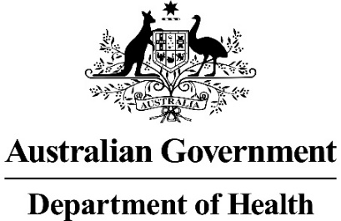

Facilitated Resolution Pathway Workshop Outcomes
FACILITATED RESOLUTION PATHWAY WORKSHOP OUTCOMES provide a succinct record of the workshop discussion. This record should capture the developments of the workshop on each of the matters identified for discussion by the PBAC in its Minutes.

Any advice provided by members of the PBAC, the applicant or the department in a workshop is in no way binding on the PBAC, the department, applicant, evaluation groups or sub-committees of the PBAC. The Procedure Guidance provides further information on the facilitated resolution workshop process.

FACILITATED RESOLUTION PATHWAY WORKSHOP OUTCOMES are to be completed by applicants. Completed workshop outcomes are submitted via the HPP in word format for acknowledgement within 10 business days of the workshop date. Please do not submit a scanned or pdf version of completed workshop outcomes.

Facilitated Resolution Workshop details
Workshop Date:
Workshop Time:
Location:
Name of Company or supplier of the Drug/Vaccine:

Drug / Vaccine name:
Brand name(s):
PBS Indication/condition to be treated:
Intended PBAC lodgement date:

Facilitated Resolution Workshop outcomes
This section should be a concise summary of the workshop discussion outcomes.
Department acknowledgement | ☐ | The above summary reflects the facilitated resolution workshop outcomes; OR
 | ☐ | The Department considers the issues and/or key points discussed were:

Attendees
Applicant attendees:
Name | Position and Organisation
Please insert additional rows if required.

Department attendees:
Name | Role/Position
Please insert additional rows if required.

Applicant acknowledgement and declaration
I understand that:
☐ | Giving false or misleading information is a serious offence.
☐ | Any advice provided by the Department of Health at the facilitated resolution workshop is non-binding on the Department of Health and its contracted evaluation groups, the Pharmaceutical Benefits Advisory Committee (PBAC), its sub-committees, and the Applicant.

Printed name:
Authorised for electronic signature.

Complete FACILITATED RESOLUTION PATHWAY WORKSHOP OUTCOMES must be submitted electronically in word format. Please do not submit a scanned or PDF version of the form.

