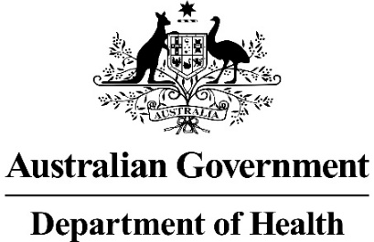

Pre-submission Meeting Outcomes
PRE-SUBMISSION MEETING OUTCOMES provide a succinct record of the pre-submission meeting discussion between the Department and applicants. Advice provided by the Department at pre-submission meetings is non-binding on the Department or applicants. The Procedure Guidance provides further information on the pre-submission meeting process.

PRE-SUBMISSION MEETING OUTCOMES are to be completed by applicants. Completed meeting outcomes are to be submitted to the PBAC pre-submission meetings team in word format for acknowledgement within 10 business days of the pre-submission meeting date. Please do not submit a scanned or pdf version of completed meeting outcomes.

Pre-submission meeting details
Meeting Date: | Click or tap to enter a date.
Meeting Time: | Click or tap here to enter text.
Location: | Choose an item.
Name of Company or supplier of the Drug/Vaccine: | Click or tap here to enter text.

Drug / Vaccine name: | Click or tap here to enter text.
Brand name(s): | Click or tap here to enter text.
PBS Indication/condition to be treated: | Click or tap here to enter text.
Applicant reference number: | Click or tap here to enter text.
Reference number to be provided by the applicant (If applicable). This reference will be quoted in any correspondence with you regarding fees).

Pre-submission meeting outcomes
This section should be a concise summary of the advice provided by the Department in response to the issues and/or key questions discussed in the meeting.
Department acknowledgement | ☐ | The above summary reflects the pre-submission meeting outcomes; OR
 | ☐ | The Department considers the issues and/or key points discussed were:

Attendees
Applicant attendees:
Name | Position and Organisation
Click or tap here to enter text. | Click or tap here to enter text.
Click or tap here to enter text. | Click or tap here to enter text.
Click or tap here to enter text. | Click or tap here to enter text.
Please insert additional rows if required.

Department attendees:
Name | Role/Position
Click or tap here to enter text. | Click or tap here to enter text.
Click or tap here to enter text. | Click or tap here to enter text.
Click or tap here to enter text. | Click or tap here to enter text.
Please insert additional rows if required.

Pre-submission meeting feedback
To assist with ongoing evaluation of pre-submission meeting processes please complete the section below.

Applicant to complete
The advice provided by the Department at the pre-submission meeting was constructive and useful?
Please select | Please provide comments below in relation to the response provided.

Department to complete
Was sufficient information provided in the briefing material for the Department to understand and advise on the issues and questions raised in the briefing paper and meeting?
Please select | Please provide comments below in relation to the response provided.

Applicant acknowledgement and declaration
I understand that:
☐ | Giving false or misleading information is a serious offence.
☐ | Any advice provided by the Department of Health at the requested pre-submission meeting is non-binding on the Department of Health and its contracted evaluation groups, the Pharmaceutical Benefits Advisory Committee (PBAC), its sub-committees, and the Applicant.

Printed name:
Authorised for electronic signature. | Click or tap to enter a date.

Complete PRE-SUBMISSION MEETING OUTCOMES must be submitted electronically in word format. Please do not submit a scanned or PDF version of the form.

