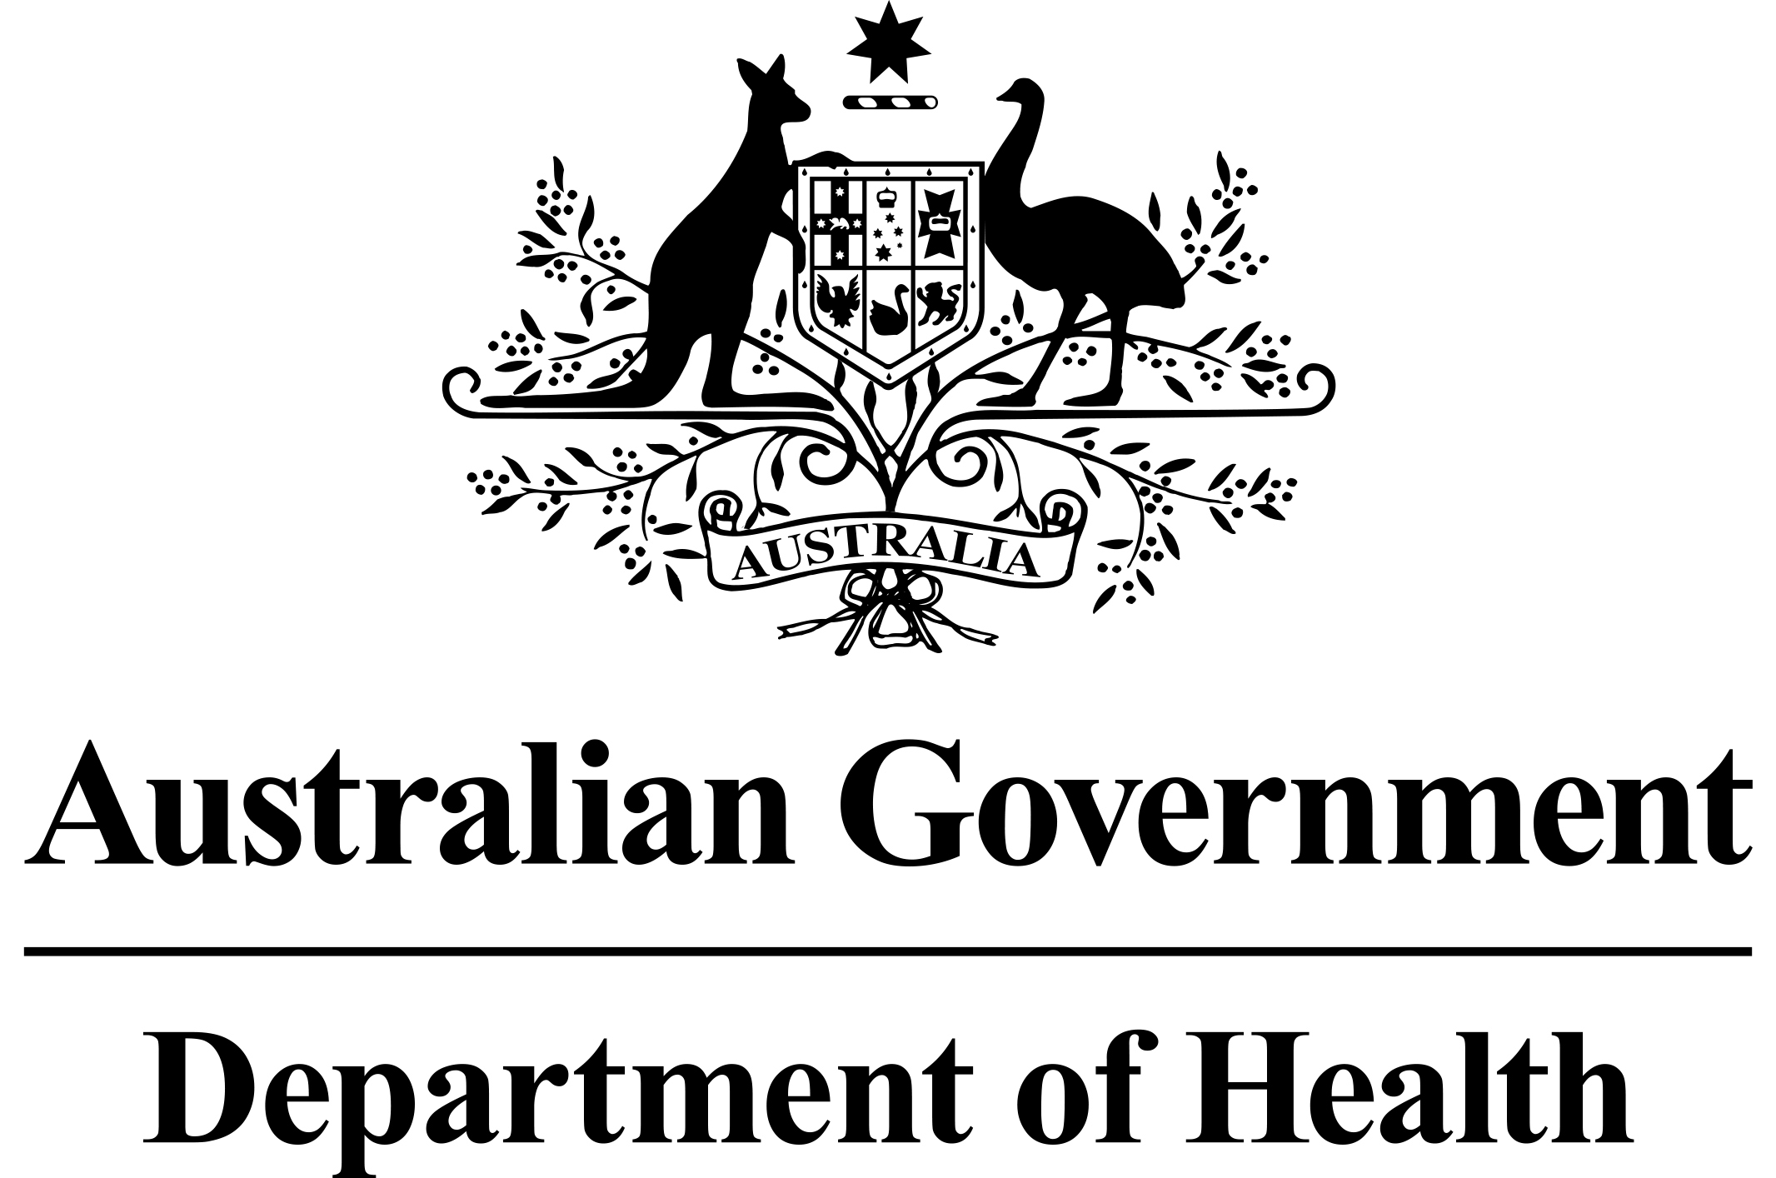
PBS Pricing Fact Sheet –

Price Change Points

Move to Six PBS Price Change Points

As part of a package of 2015 Pharmaceutical Benefits Scheme (PBS) changes, the number of dates on which the price of PBS listed medicines can change will increase from three times per year to six times per year; 1 February, 1 April, 1 June, 1 August, 1 October and 1 December.

The increase in price change points will allow some first to market generic brands of medicines (that trigger statutory price reductions) to list earlier than previously possible and increased opportunity to review premium prices or add other new listings with pricing implications for exiting PBS listed medicines.

There will continue to be three annual price review groups, with 1 April, 1 August and
1 December effective dates for price increases. Adhoc price changes will also be available where necessary. An amended price change fact sheet will be published shortly.

The submission deadlines for price change requests are included on the PBS Calendar, which is available on the PBS website under ‘useful resources’. The PBS Calendar will be updated shortly to reflect submission deadlines for all six price change points. However, the table below may be used as a guide:

Application deadline  for price increase | Application deadline for new brands with pricing flow-ons or smaller pack size and premium change | Price Change Point
 | 1 November | 1 February
Mid-August | 1 December  (2nd week of January for premium changes) | 1 April
 | 1 March | 1 June
Mid-December | 1 May | 1 August
 | 1 July | 1 October
Mid-April | 1 September | 1 December

Submissions for price changes should continue to be made to the Pricing Section via email at pbspricing@health.gov.au.

