Pharmaceutical Benefits Scheme
Post-market Review of
Medicines to treat Pulmonary Arterial Hypertension
Term of Reference 2
Final Report
November 2018

Term of Reference 2
Contents
List of Tables 3
List of Figures 3
Abbreviations 4
Section 2: ToR 2 PAH Medicines Utilisation Analysis 6
2.1 Key findings 6
PBS/RPBS Claims Data 6
Pulmonary Hypertension Society of Australia and New Zealand (PHSANZ) Registry 6
Australian Scleroderma Interest Group Registry (ASIG) 7
Overall conclusions 7
2.1.1 Stakeholder views 7
2.1.2 Consumer views 8
2.2 Introduction 8
2.3 Utilisation analysis methodology 9
2.3.1 PBS/RPBS claims data utilisation analysis methodology 9
Data sources, setting and population 9
2.3.2 PHSANZ Registry utilisation analysis methodology 10
2.3.3 ASIG utilisation analysis methodology 11
2.4 Results of utilisation analysis 12
2.4.1 Trends in PAH dispensing 12
2.4.2 Prevalence of PAH medicine use 15
2.4.3 Incidence of PAH medicine use in PBS data 20
2.4.4 Time on treatment from PBS data 21
2.4.5 Switching 22
2.4.6 Combination treatment 23

List of Tables
Table 2.1 List of PAH medicines available from 2013-2016 10
Table 2.2 Number of PBS/RPBS PAH dispensings and PBS benefits paid (in millions) by year 12
Table 2.3 Annual number of incident (new) users by first medicine dispensed 20
Table 2.4 Annual incidence of PAH use per 1,000,000 population by patient demographics 20
Table 2.5 Persistence with treatment in first 720 days among incident PAH medicine users in 2014 22
Table 2.6 Switching between PAH medicines among prevalent users 2013-2016 23
Table 2.7 Characteristics of combination treatment 24
Table 2.8 Characteristics of combination treatment – sensitivity analysis 24

List of Figures
Figure 2.1 Quarterly PBS dispensing by PAH medicine, 2013-2016 14
Figure 2.2 Quarterly PBS benefit paid by medicine (in millions AUD) 14
Figure 2.3 Quarterly prevalence per 1,000,000 population by medicine class 16
Figure 2.4 Quarterly prevalence per 1,000,000 population by sex 16
Figure 2.5 Quarterly prevalence per 1,000,000 population by sex and age group 17
Figure 2.6 Quarterly prevalence per 1,000,000 population by ''''''''''''' ''''''''' 18
Figure 2.7 PHSANZ cohort WHO FC categorisation at time of diagnosis and time of last assessment 18
Figure 2.8 ASCS cohort WHO FC categorisation at time of diagnosis and time of last assessment (index visit) 19
Figure 2.9 Quarterly incidence and prevalence of use per 1,000,000 population 20

Abbreviations
Abbreviation | Full Name / Wording
µg | micrograms
ABS | Australian Bureau of Statistics
ASCS | Australian Scleroderma Cohort Study
ASIG | Australian Scleroderma Interest Group
ATC | Anatomical Therapeutic Chemical
AUD | Australian dollars
PAH-CHD | PAH associated with congenital heart disease
PAH-CTD | PAH associated with connective tissue disease
CTEPH | Chronic thromboembolic pulmonary hypertension
DoH | Department of Health
dPAH | Drug-induced PAH
DUSC | Drug Utilisation Sub Committee
ERA | Endothelin receptor antagonist
FC | functional class
hPAH | Heritable PAH
iPAH | Idiopathic PAH
mg | milligrams
mmHg | Millimetres of mercury
n | number
PAH | Pulmonary arterial hypertension
PAP | Pulmonary arterial pressure
PAWP | Pulmonary artery wedge pressure
PBAC | Pharmaceutical Benefits Advisory Committee
PBS | Pharmaceutical Benefits Scheme
PDE-5 inhibitor | Phosphodiesterase type 5 inhibitor
PGI₂ | Prostacyclin analogue
PH | Pulmonary hypertension
PHSANZ | Pulmonary Hypertension Society of Australia and New Zealand Registry
RPBS | Repatriation Schedule of Pharmaceutical Benefits
RHC | Right heart catheterisation
sGC | Soluble guanylate cyclase
SSc | Systemic sclerosis
ToR | Term of Reference
TGA | Therapeutic Goods Administration
UNSW | University of New South Wales
WHO | World Health Organization

Section 2: ToR 2 PAH Medicines Utilisation Analysis
Review the utilisation of pulmonary arterial hypertension (PAH) medicines in Australia, including sources of data that can provide additional information on clinical use that is not available from Pharmaceutical Benefits Scheme (PBS) data.

2.1 Key findings

PBS/RPBS (Repatriation Schedule of Pharmaceutical Benefits) Claims Data
- The annual number of PAH medicine dispensings increased from 20,454 in 2014 to 23,375 in 2016; the corresponding PBS benefit paid increased from $53.22 million to $58.75 million.
- Endothelin receptor antagonists (ERAs) were the most commonly dispensed medicine class, accounting for 77% of all PBS PAH dispensings in 2016.
- Bosentan was the most commonly dispensed PBS PAH medicine in 2015 and macitentan was the most commonly dispensed PAH medicine in 2016.
- The majority of prevalent patients treated with PAH medicines were female (73% in 2016).
- The incident rate for patients newly treated with PAH medicines remained relatively stable across the study period.
- The highest treated incidence rate with PAH medicines (2014-2016) was in females 75-84 year old, followed by females 65-74 year old. Incidence drops rapidly after this, with the lowest incidence numbers recorded in the 85+ population.
- The majority of incident patients started treatment with 10 mg macitentan (57% of new patients in 2016), followed by 20 mg sildenafil (18.7% of new patients in 2016).
- Switching between PBS-listed PAH medicines was not common. Among a total of 3187 treated patients, 418 (13%) switched medicines between 2013 and 2016. Patients most commonly switched from phosphodiesterase-5 (PDE-5) inhibitors to ERAs.
- Combination treatment with PBS-listed PAH medicines was very rare; using a minimum period of overlapping use of 58 days, only 13 episodes of combination treatment were observed among a total of seven individuals.

Pulmonary Hypertension Society of Australia and New Zealand (PHSANZ) Registry
- The mean age of all PAH patients at time of diagnosis in the PHSANZ cohort (n=1071) was 49.9±20.4 years and 7.8% were aged under18 years.
- More than two thirds of patients were female.
- Overall 49.8%, 39.8% and 10.4% of patients were prescribed monotherapy, dual therapy and triple therapy respectively.
- ERAs were the most commonly prescribed medicine class amongst monotherapy patients (76.55%).
- ERA + PDE-5 inhibitors accounted for 91% of all dual therapy combinations, with the addition of a prostacyclin analogue (PGI₂) the most common regimen for triple therapy.
- PHSANZ registry data indicates that approximately 20% of patients in the PAH cohort (those alive and receiving medication in 2017) were diagnosed or presented to PAH centres with symptoms classified in World Health Organization (WHO) Functional Class (FC) II. The majority (67%) of patients entered the cohort with WHO FC III symptoms and 6% with WHO FC IV symptoms. Information on WHO FC at time of cohort entry was not available in 6.8% of patients.

Australian Scleroderma Interest Group Registry (ASIG)
- The mean age of all patients with PAH associated with connective tissue disease
(PAH-CTD) in the Australian Scleroderma Cohort Study (ASCS) cohort (n=104) at time of last assessment (index visit) was 67 years and 82% of patients were female.
- Monotherapy, dual therapy and triple therapy was used by 53%, 41% and 6% of patients respectively.
- Macitentan was the most commonly used ERA, used by 55% (57/104) of patients included in the study.

Overall conclusions
- Across all three datasets analysed, ERAs were the most commonly used class of PAH medicines followed by PDE-5 inhibitors.
- In both registries approximately 50% of patients were prescribed monotherapy, 40% dual therapy and 10% triple therapy.
- The utilisation of PBS medicines cannot be determined according to WHO FC and the both registry data analyses did not provide specific information on the extent of patients being initiated to PAH therapy in FC II.
- ERA was the most commonly prescribed monotherapy, ERA plus PDE-5 inhibitor was the most commonly prescribed dual therapy combination and ERA plus PDE-5 inhibitor plus PGI₂ was the most commonly prescribed form of triple therapy.

2.1.1 Stakeholder views
- Suggested methods for ensuring efficient and effective data capture of PAH medicine utilisation and outcomes, noting PBS prescriptions alone do not reflect the full utilisation of PAH medicines, such as including data sources available through the PHSANZ, which includes a national pulmonary hypertension (PH) registry.
- Recommend ongoing post-market surveillance / registry analysis to support evidence-based decision making for PAH.
- Some patients and prescribers noted the considerable variation in decision making across Drug Therapeutic Committees, making access to PAH medicines potentially inequitable, and dependant on the patients’ location and institution for treatment.
- Stakeholders noted the review should explore what constitutes a designated PH treatment centre and collaboration between centres to improve equity of utilisation of PAH medicines. Stakeholders pointed out that variations in clinical expertise are leading to variation in treatment and outcomes, including reported differences in mortality between designated PH treatment centres.
- Riociguat, which was recently PBS listed, is not formulary listed in any of the jurisdictions which responded to the request by the Council of Australian Therapeutic Advisory Groups (CATAG), nor have there been individual patient requests in those jurisdictions.
- Patients on combination therapies that are sourced outside the PBS note the emotional, psychological and financial stresses, which patients and families may feel due to the expense of treatments and concerns about medicine access.
- PBS data on riociguat will be uninformative given that it was PBS listed in early 2017.

2.1.2 Consumer views
- The majority of consumers at the Consumer Forum advised that they were on dual or triple therapy.
- Consumers noted that they accessed medicines through a range (and combination) of avenues, including through the PBS, hospitals, drug trials, compassionate access programs or private funding (often sildenafil).
- Consumers noted the financial burden for themselves, family and friends including cost of PBS co-payments, cost of privately funded medicines and incidental health care items and tests. This was exacerbated by reduced income due to an inability to work.

2.2 Introduction
The following utilisation report was compiled in an effort to characterise the prescribing practices of PAH medicines in Australia. This chapter summarises three separate utilisation reports conducted in the following data sources: PBS/RPBS claims data and registry data from the PHSANZ and ASIG (refer to appendices 2A, 2B and 2C).

PBS/RPBS Data
The Department of Health contracted a research team at the Centre for Big Data Research in Health from the University of New South Wales (UNSW) to undertake a medicine utilisation review of PBS listed PAH therapies in Australia. This review aimed to update and add to the Department’s previous work on PAH medicine utilisation published in February 2015 by the Drug Utilisation Sub Committee (DUSC).

Registry Data
The PHSANZ and ASIG registries include medicine utilisation data not captured by PBS/RPBS claims sources. The PBS data does not contain any clinical information on patients, e.g. diagnosis or disease severity, nor any patient characteristics beyond basic demographic information. Therefore, the current review did not provide insights to the WHO FC of patients treated with PAH medicines or other clinically relevant information beyond what was obtainable from dispensing claims data. Based on PBS data alone, the magnitude of combination treatment with PAH medicines was underestimated, as PAH medicines are only approved for PBS use as monotherapy. During the observed period, additional PAH medicines were in most cases provided through sources other than the PBS – that is, directly by hospitals, pharmaceutical companies through compassionate access schemes or drug trials, or purchased privately, and therefore did not appear in the PBS data. Including data from these sources allows for current clinical practice in the management of PAH to be compared to PBS restriction provisions and current treatment guidelines. The aim of obtaining data from the PHSANZ and ASIG registries was to identify the extent and form of combination therapy use in Australia.

2.3 Utilisation analysis methodology

2.3.1 PBS/RPBS claims data utilisation analysis methodology

Data sources, setting and population
The analyses (Appendix 2A) were based on PBS/RPBS dispensing data from 1 July 2013 through 31 December 2016 for the total Australian population dispensed a PAH medicine at least once. All analyses and resulting estimates were limited to that time-span.
Mid-year population statistics from the Australian Bureau of Statistics (ABS) were used as estimates of the underlying population (denominator) for the medicine utilisation measures described below. These are provided stratified by patient’s age and sex.
In the analyses patient age was categorised into the following groups: <35, 35-44, 45-54,
55-64, 65-74, 75-84, and 85 years and older.

Medicines of interest
There were seven PBS-listed medicines indicated for treatment of PAH in Australia in
2013-2016: bosentan, ambrisentan, macitentan, epoprostenol, iloprost, sildenafil and tadalafil. Two further medicines used to treat PAH were not PBS-listed during the time period of observation: riociguat (first listed on 1 February 2017) and sitaxentan (listed from 1 April 2008 to 31 March 2011). Macitentan was listed on the PBS on 1 September 2014 (Table 2.1). Only PBS item codes with an indication for the treatment of PAH were included in the analysis.
Table 2.1 List of PAH medicines available from 2013-2016
Drug name | Date listed on PBS
Bosentan | 1 March 2004
Iloprost | 1 April 2005
Epoprostenol | 1 August 2006
Sildenafil | 1 March 2007
Ambrisentan | 1 December 2009
Tadalafil | 1 April 2012
Macitentan | 1 September 2014

Measures and data analysis
Trends in PAH dispensings, prevalence of PAH medicine use, incidence of PAH medicine use, time on treatment, switching between PAH medicines and combination treatment with PAH medicines from 2014- 2016 were analysed.

Statistical analysis
All data analysis was performed using SAS v9.4 (SAS Institute Inc., Cary NC. USA), and R v3.3.3.

2.3.2 PHSANZ Registry utilisation analysis methodology

Data sources, setting and population
Data were derived from the PHSANZ Registry to generate a cross-sectional report from a pre-specified group of registry cases (applying standardised diagnostic criteria) (Appendix 2B).
Registry data collection commenced in December 2011, including both incidence and prevalent cases being managed by participating centres (16 in Australia and 2 in New Zealand). All patients currently registered with the PHSANZ Registry (3,535) were potentially eligible for inclusion, using a census date of 31st December 2017 (Appendix 2B, Figure 1, p.5).
These data reflect the management of PAH cases via specialist centres (as per expert recommendations). They do not reflect therefore, the management of PAH beyond these centres. This data was suitable for cross-sectional analysis only to determine the proportion of current patients’ receiving combinations of PAH targeted therapies. A number of crucial issues/factors that influence the clinical management of PAH cannot be reported from these datasets, along with and any interpretation of prescribed pharmacological therapy. These include: 1) information on what medicine(s) were prescribed initially and in what combination, 2) whether or not medicines were prescribed sequentially or combined at initiation 3) specific medicine dosages, 4) the lack inferential analyses examining the potential correlation between clinical status (including functional status and haemodynamic profile) and prescribed therapy and 5) the lack of any outcome data.

Medicines of interest
Data including current medication details updated between 1 June 2017 and December 2017 was included in the analysis. Patients with no current medication data were excluded. Monotherapy, dual therapy and triple therapy cases were recorded, with all medicines used belonging to ERA, PDE-5 inhibitor, PGI_{2,} and soluble guanylate cyclase (sGC) inhibitor medicine classes. Treprostinil was the only medicine included in the analysis, which has not been considered by PBAC or listed on the PBS.

Measures and data analysis
Characteristics of the study cohort at the point of diagnosis according to PAH subtypes was extracted. Characteristics included gender, age, WHO FC, comorbidities, and invasive haemodynamic status. All patients listed on the registry from its inception in December 2011 had potential for inclusion. Only patients who were alive at the census date of 31 December 2017, were classed as having either idiopathic PAH (iPAH), heritable PAH (hPAH), drug-induced PAH (dPAH), PAH-CTD or PAH associated with congenital heart disease (PAH-CHD), had medication details updated since 1 June 2017 and were registered via one of the 16 participating Australian Institutions were included in the final analysis (total 1,071 patients).

Statistical analysis
All data from eligible registry cases were analysed collectively and then according to three pre-specified subgroups. Given the purpose and cross-sectional nature of the study, no inferential analyses were undertaken; with discrete variables presented as a frequency and proportion and continuous variables according to their central tendency including means and standard deviation. All analyses were performed with R statistical package.

2.3.3 ASIG utilisation analysis methodology

Data sources, setting and population
Patients diagnosed with PAH in the Australian Scleroderma Cohort Study (ASCS) were eligible for this cross-sectional analysis (Appendix 2C). This registry recruits consecutive prevalent and incident patients with systemic sclerosis (SSc) and records clinical data annually. Comprehensive demographic and disease-related data, patient reported outcomes by questionnaire and the results of investigations are recorded in a single secured web-based online database. The ASCS cohort diagnosed with PAH eligible for use in the analysis was small (n=104), representing just over 4% of the prevalent PBS population in 2016.
Inclusion criteria for this analysis were: 1. patients with SSc and with mixed connective tissue disease; 2. PH confirmed on right heart catheterisation (RHC) with mean pulmonary arterial pressure (PAP) ≥ 25mmHg; 3. patients who were alive between July 2016 and June 2017.
The index visit was defined as the last visit between June 2016 and December 2017. Not all tests were done on the same date as the last assessment (index visit). For patients with multiple tests within the above date range, the last test was used.
Being a cross-sectional analysis, this cohort included some patients with long-standing disease. Due to medicine use being recorded annually, it is possible to determine when two or more medicines are taken concurrently, but not at which stage they were commenced.

Medicines of interest
PBS-reimbursed PAH medicines included: bosentan, ambrisentan, sitaxentan (de-listed from the PBS in March 2011), macitentan, sildenafil, tadalafil, epoprostenol, iloprost and riociguat. Selexipag was the only medicines used in this cohort which was not listed on the PBS. Medicine use is recorded annually, at which time it is possible to determine when two or more medicines are prescribed concurrently, but not at which stage they were commenced.

Measures and data analysis
The WHO group of PH was determined according to the physician’s judgement following RHC. Group 1 (PAH) included patients with pulmonary artery wedge pressure (PAWP) < 18mmHg as eligibility for PBS-funded PAH initially included these patients. Only Group 1 was included in this analysis. Patients in the other WHO groups of PH were excluded as PAH therapy is not indicated or reimbursed.

Statistical Analysis
Data for those patients for whom the variable was available are presented as numbers (percentages) for categorical variables, and mean ± standard deviation for continuous variables. Differences in frequencies of characteristics between FC I/II and III/IV were compared using Chi-square test for categorical variables and independent samples t-test for continuous variables. A two-tailed p value ≤0.05 was used to indicate statistically significant differences. All statistical analyses were performed using STATA 14.2 (Statacorp, College Station, TX, USA).

2.4 Results of utilisation analysis

2.4.1 Trends in PAH dispensing
The total number of PBS subsidised PAH medicine dispensings increased from 20,454 in 2014 to 23,375 in 2016; the corresponding PBS benefits paid increased from $53.22 to $58.75 million (Table 2.2). ERAs were the most commonly dispensed class, accounting for 77% of all PAH dispensings in 2016.

Table 2.2 Number of PBS/RPBS PAH dispensings and PBS benefits paid (in millions) by year
 |  |  | Year
 | 2014 |  | 2015 |  | 2016
 | Disp. | AUD  (million) | Disp. | AUD  (million) | Disp. | AUD  (million)
All medicine classes | 20,454 | $53.22 | 21,963 | $57.33 | 23,375 | $58.75
ERAs | 14,992 | $43.57 | 16,469 | $47.90 | 17,926 | $51.11
Prostacyclin analogues | 1,066 | $5.80 | 1,137 | $6.04 | 1,103 | $4.89
PDE-5 inhibitors | 4,396 | $3.85 | 4,367 | $3.39 | 4,346 | $2.75
AUD = Australian dollars, Disp = dispensings; ERAs = ambrisentan, bosentan, macitentan; Prostacyclin analogues = epoprostenol, iloprost; PDE-5 inhibitors = sildenafil, tadalafil
Figure 2.1 shows the quarterly number of PBS PAH dispensings from July 2013 through December 2016 by specific medicine. Bosentan was the most commonly dispensed PAH medicine through the year 2015. In 2016 macitentan, which was PBS-listed in September 2014, became the most commonly dispensed PAH medicine.
The quarterly number of PBS PAH medicine dispensings and corresponding PBS benefit paid remained relatively stable across the 2013-2016 period for each separate medicine and medicine strength, except for bosentan (120 mg) and macitentan (10 mg) (Figure 2.2). A simultaneous trend of decreasing bosentan and increasing macitentan dispensings occurred during the period of observation, which overlapped during the last quarter of 2015.
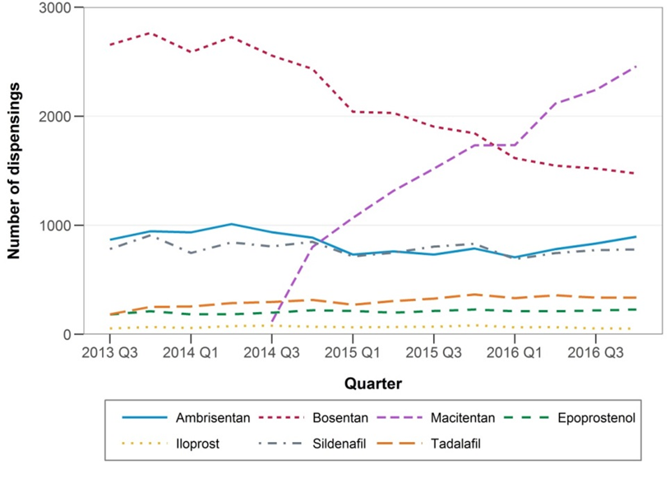
Figure 2.1 Quarterly PBS dispensing by PAH medicine, 2013-2016
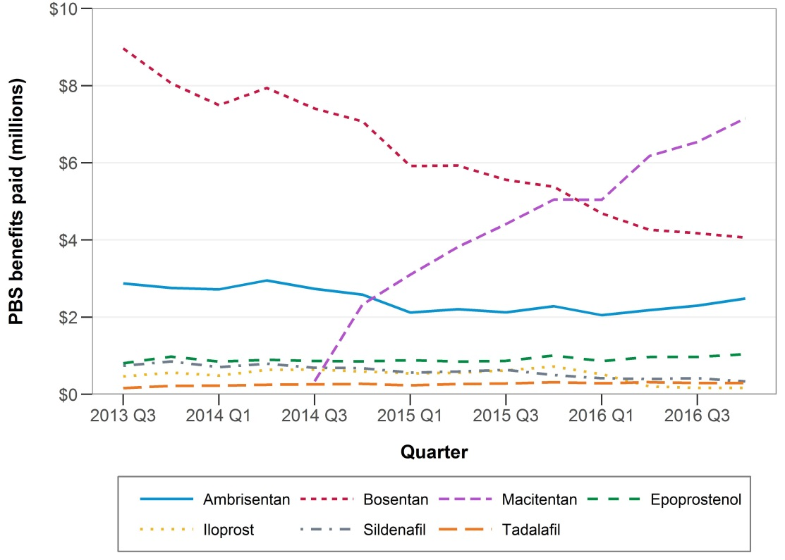
Figure 2.2 Quarterly PBS benefit paid by medicine (in millions AUD)
The PHSANZ monotherapy data reported similar results. ERAs were the most commonly used medicine class, with 76.5% of the monotherapy cohort on either ambrisentan, bosentan or macitentan compared to 76.7% of the total PBS dispensings of PAH medicines in 2016 (Appendix 2B, Appendix I, p. 16). The use of PDE-5 inhibitors in the PHSANZ monotherapy cohort also mirrored PBS numbers closely, with 23.3% of patients on either sildenafil or tadalafil, compared to 18.6% of all PBS PAH dispensings in 2016. No PGI₂’s were used amongst the PHSANZ monotherapy cohort. PGI₂’s were reserved for use in combination therapy, primarily used as part of triple therapy amongst PHSANZ patients (Appendix 2B, Appendix III, p. 18). With PGI₂’s accounting for almost 5% (1,103 dispensings) of PBS PAH dispensings in 2016, and their lack of use in monotherapy amongst the PHSANZ cohort, it could be suggested that when used in combination therapy, they are the medicine class likely to be PBS subsidised, with less expensive ERAs or PDE-5 inhibitors accessed through other means.
ERAs were also the most prescribed medicine class in the ASCS cohort, with 92% of patients (96 patients) on an ERA at the last assessment (index visit). Amongst the ASCS cohort, 50% of ERA use at the last assessment (index visit) was attributable to monotherapy (Appendix 2C, Appendix II). Amongst the monotherapy cohort, 87% were being prescribed an ERA and the remaining 13% were prescribed a PDE-5 inhibitor. Overall in the ASCS cohort, PDE-5 inhibitors were the second most utilised class of medicine, with 55 patients (53%) taking a PDE-5 inhibitor as part of monotherapy, dual therapy or triple therapy (Appendix 2C, Table 4).
According to the PHSANZ and ASIG registries combination therapy was most common in patients with WHO FC III and IV. Macitentan + sildenafil was the most commonly prescribed dual therapy, used in 46.5% of dual therapy patients (Appendix 2C, Appendix III). Macitentan + sildenafil likewise was the dual therapy of choice amongst the PHSANZ cohort, accounting for 36.1% of all dual therapy combinations and epoprostenol + macitentan + sildenafil accounted for 35.7% of all triple therapy combinations, recording the highest numbers in each category.

2.4.2 Prevalence of PAH medicine use
Figures 2.4-2.5 show the distribution of demographic characteristics among prevalent PAH patients dispensed a PBS subsidised PAH medicines in 2014-2016. During this period, the number of patients increased slightly (from 2,189 to 2,394), but the distribution of patient demographics remained similar. The majority of prevalent patients on PAH treatment were female (73% in 2016).
Figure 2.5 shows the quarterly prevalence of PAH medicine use per 1,000,000 population from Quarter 3 2013 to Quarter 4 2016 by patient sex and age group. The prevalence of PAH treatment increased over the time period among females aged 75-84 year old and >85 years, but remained it fairly stable in younger females (Figure 2.5). Prevalence of PAH treatment in males remained fairly stable across all age groups. For both females and males prevalence rates were highest among those aged 75-84 years.
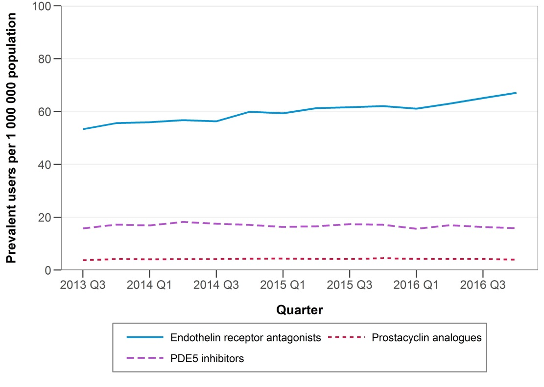
Figure 2.3 Quarterly prevalence per 1,000,000 population by medicine class

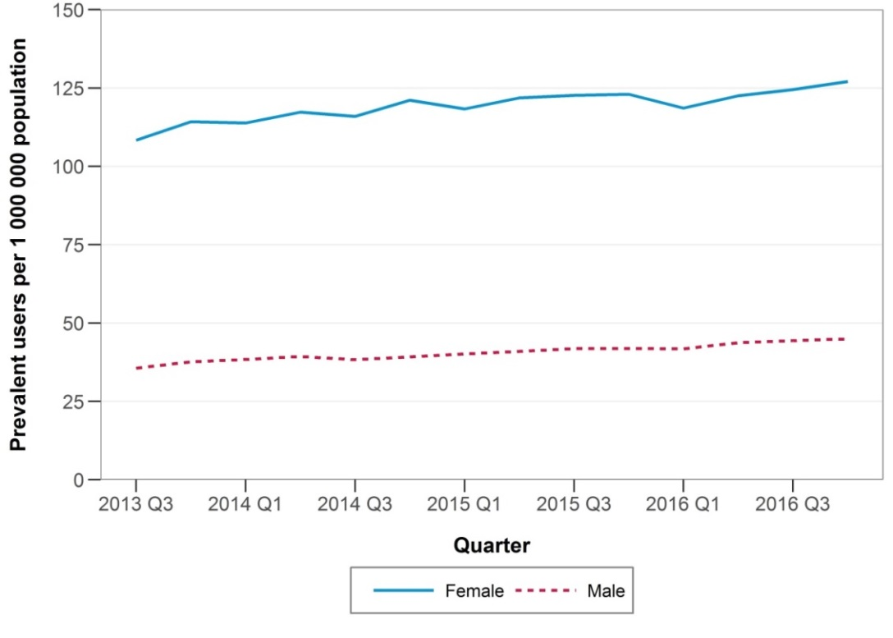
Figure 2.4 Quarterly prevalence per 1,000,000 population by sex
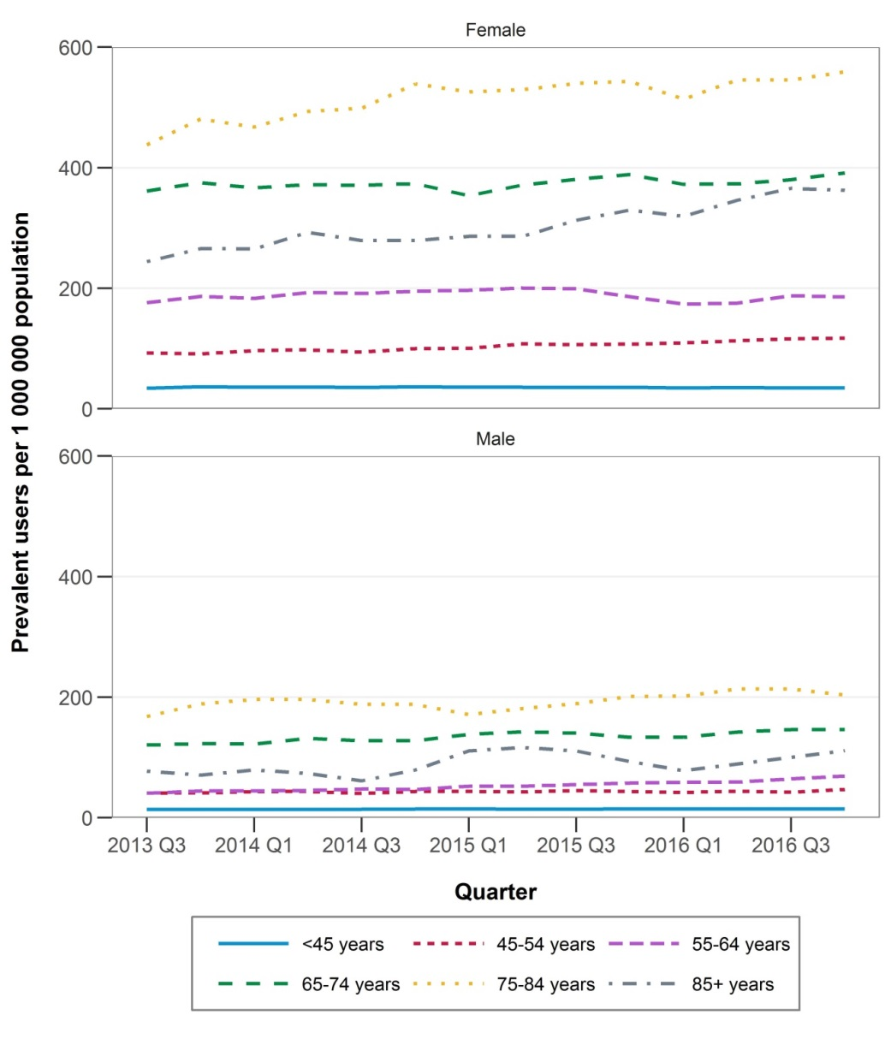
Figure 2.5 Quarterly prevalence per 1,000,000 population by sex and age group
PHSANZ data reports a slight breakdown of age groups, reporting 84 patients (7.8%) were <18 years of age at the time of diagnosis. This however, cannot be used as a surrogate of the paediatric population treated for PAH (Appendix 2B, Table 1, p. 7). PBS data reports 8.9% (n=213) of prevalent users of PAH targeted medicines were <35 years of age in 2016, suggesting an overestimation of paediatric cases within the PHSANZ cohort. This may be attributed to the PHSANZ age-related data being presented from the time of diagnosis and the data set spanning across several years. By the time of the censoring date for the cross sectional analysis , some patients may no longer be under 18 years of age, therefore skewing the data and overestimating the paediatric population.
'''''''''' ''''''''''''''''''''''' '''''''''''''''''''' '''''' '''''''''''''''''' '''''''''''''''''' ''''' '''''''''''' ''''''''''

Figure 2.7 PHSANZ cohort WHO FC categorisation at time of diagnosis and time of last assessment

Figure 2.8 ASCS cohort WHO FC categorisation at time of diagnosis/first visit where PAH medicines were given and at time of last assessment (index visit)
WHO FC information is not captured by PBS claims data, particularly for WHO FC I/II patients, as PAH medicines are not PBS-subsidised in this cohort. Both PHSANZ and ASCS reported on WHO FC at time of the last patient assessment. PHSANZ compared this to WHO FC at time of diagnosis, while ASCS recorded the WHO FC of patients at the time of diagnosis or first visit where PAH medicines were given. Information on WHO FC was not available for 11.5% of patients in the ASCS (Appendix 2C, p.26).
PHSANZ registry data indicates that approximately 20% of patients in the PAH cohort (those alive and receiving medication in 2017) were diagnosed or presented to PAH centres with symptoms classified in WHO FC II. The majority (67%) of patients entered the cohort with WHO FC III symptoms and 6% with WHO FC IV symptoms. Information on WHO FC at time of cohort entry was not available in 6.8% of patients. (Appendix 2B, p.8, Table 1).
The number patients presenting at time of enrolment according to WHO FC may be useful in understanding the when patients commence treatment in Australia, however no conclusion should be drawn from the reduction in the proportion of patients with WHO FC III and IV at last assessment.

2.4.3 Incidence of PAH medicine use in PBS data
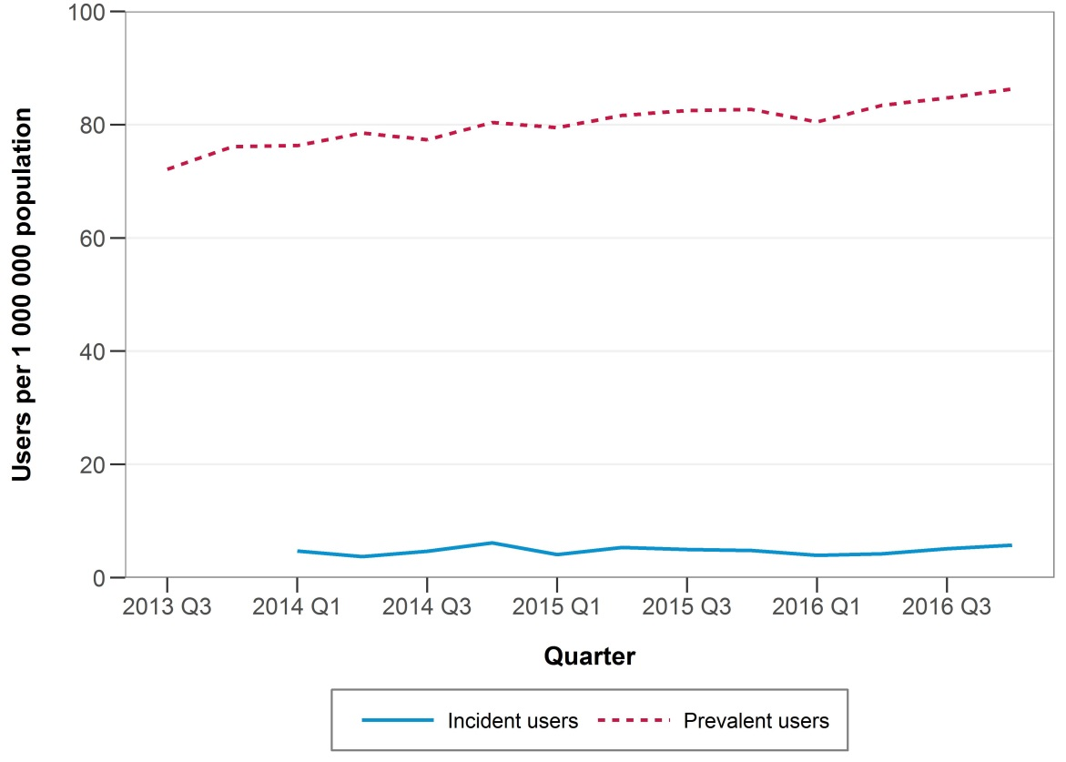
Figure 2.9 Quarterly incidence and prevalence of use per 1,000,000 population

Figure 2.9 indicates that while incident use of PBS listed PAH medicines by quarter remained relatively stable across 2013-2016, prevalent use by quarter increased slightly (from 72.3 per 1,000,000 in Quarter 3 2013 to 86.3 per 1,000,000 population in Quarter 4 2016).
Table 2.3 Annual number of incident (new) users by first medicine dispensed
 |  | Year
 | 2014 | 2015 | 2016
Number of people | N = 454 (100%) | N = 457 (100%) | N = 461 (100%)
Medicine class initiated on:
ERA | 312 (68.7) | 312 (68.3) | 346 (75.1)
Prostacyclin analogue | 11 (2.4) | 9 (2.0) | <6
PDE-5 inhibitor | 131 (28.9) | 136 (29.8) | 110 (23.9)
Medicine and strength initiated on:
Ambrisentan – 5 mg | 22 (4.8) | 21 (4.6) | 32 (6.9)
Ambrisentan – 10 mg | 26 (5.7) | 18 (3.9) | 42 (9.1)
Bosentan – 62.5 mg | 114 (25.1) | 18 (3.9) | 10 (2.2)
Bosentan – 125 mg | 7 (1.5) | <6 | <6
Macitentan – 10 mg | 143 (31.5) | 253 (55.4) | 261 (56.6)
Epoprostenol - 500 µg | <6 | <6 | <6
Epoprostenol – 1.5 mg | <6 | <6 | <6
Iloprost – 20 µg | 6 (1.3) | <6 | <6
Sildenafil – 20 mg | 106 (23.3) | 103 (22.5) | 86 (18.7)
Tadalafil – 20 mg | 25 (5.5) | 33 (7.2) | 24 (5.2)
The majority of incident patients started treatment with 10 mg macitentan (57% of new patients in 2016), followed by 20 mg sildenafil (18.7% of new patients in 2016).
Table 2.4 shows the annual incident PAH medicine use per 1,000,000 population by patient demographics. Incidence was higher among females (24.4 per 1,000,000 in 2016) than males (13.6 per 1,000,000 in 2016) with the highest incidence reported in 75-84 years olds (97.62 per 1,000,000 in 2016). ''''''' '''''''''''''' '''''''''''''''''''' ''''' ''''''''''''''''' '''''''''''''''' '''''''' '''''''''''''''''''' '''''''''''''''''' ''' ''''''''''''''''' ''''''''''''' ''''' '''''''''' '''''''''' '''''''' ''''''''''''''''''''
Table 2.4 Annual incidence of PAH use per 1,000,000 population by patient demographics
 |  | Year
 | 2014 | 2015 | 2016
Number of patients | N = 454 | N = 457 | N = 461
Incidence per 1,000,000 population
Total | 19.32 | 19.16 | 19.04
Sex
Males | 11.47 | 14.61 | 13.57
Females | 27.06 | 23.65 | 24.43
Age (years)
<35 | 3.53 | 3.57 | 2.90
34-44 | 10.24 | 6.19 | 7.11
45-54 | 13.21 | 14.40 | 14.25
55-64 | 31.30 | 24.16 | 28.38
65-74 | 65.69 | 65.24 | 69.08
75-84 | 96.51 | 120.34 | 97.62
85+ | 61.73 | 53.36 | 60.07
'''''''''''
'''''''''''''''''''''''''' | '''''''''''''' | ''''''''''''' | ''''''''''''
''''''''''' | ''''''''''''''' | '''''''''''''' | ''''''''''''
''''''''' | ''''''''''''' | ''''''''''''' | '''''''''''''
''''''' | ''''''''''''' | '''''''''''''' | '''''''''''''
'''''''' | ''''''''''''''' | '''''''''''''' | ''''''''''''''
'''''''''''' | '''''''''''''''' | '''''''''''''''''' | ''''''''''''''''
''''''' | '''''''''''''' | '''''''''''''' | '''''''''''''

2.4.4 Time on treatment from PBS data
Among people who initiated on PBS medicines in 2014, in the first 360 days 14.5% had died, but 70.9% of those still alive were still persistent (had not discontinued) (Table 2.5). By 720 days post-initiation, 24.9% had died and 61.9% of those still alive were still persistent.

Table 2.5 Persistence with treatment in first 720 days among incident PAH medicine users in 2014
 | Primary analysis | Sensitivity analysis
Number of patients | 454 | 454
360 days post-initiation
Patients surviving at 360 days post initiation, n (%) | 388 (85.5) | 388 (85.5)
Proportion of those still alive persistent on treatment, n (%)^ | 275/388 (70.9) | 299/388 (77.1)
720 days post-initiation
Patients surviving at 720 days post initiation, n (%) | 341(75.1) | 341 (75.1)
Proportion of those still alive persistent on treatment, n (%)^ | 211/341 (61.9) | 240/341 (70.4)
N=number
^Persistence was defined as still on treatment without discontinuation. Discontinuation was defined as a period of 87 days or more (3 × median number of days between dispensings) without any dispensing. In the sensitivity analysis, a period of 116 days is used (4 × median number of days between dispensings).

2.4.5 Switching
Switching between PAH medicines was not common.
Among a total of 3,187 patients treated with PAH medicines, 418 (13%) switched medicines. Of these, the majority (82%) of patients only switched once (Table 2.6). Patients most commonly switched from PDE-5 inhibitors to ERAs (37% of all switches, allowing for breaks).
Switching between medicines seemed common amongst ASCS patients, but the changing numbers between therapy at first visit and therapy at last assessment (index visit)could be accounted for by the increased use of combination therapy observed during this time (Appendix 2C, Table 4).
The most commonly observed switch on the PBS from PDE-5 inhibitors to ERAs may reflect initiation of combination therapy, with PDE-5 inhibitors being more affordable than ERAs when purchased privately or subsidised by another means. This would reflect the results of the PHSANZ and ASIG registries, reporting ERAs + PDE-5 inhibitors to be the most commonly used dual therapy combination.

Table 2.6 Switching between PAH medicines among prevalent users 2013-2016
 | Switching type
 | Not allowing for breaks* | Allowing for breaks^
Number of switches | 364 | 418
Number of people switching | 247 (7.8) | 293 (9.2)
1 switch only | 203 (82.2) | 240 (81.9)
>1 switch | 44 (17.8) | 53 (18.1)
Most common switches
ERA to:
Prostacyclin analogue | 69 (19.0) | 77 (18.4)
PDE-5 inhibitor | 91 (25.0) | 109 (26.1)
ERA/PDE-5 inhibitor in combination | <6 | <6
Prostacyclin analogue to:
ERA | 7 (1.9) | 10 (2.4)
PDE-5 inhibitor | 19 | <6
PDE-5 inhibitor to:
ERA | 128 (35.2) | 154 (36.8)
Prostacyclin analogue | 25 (6.9) | 27 (6.5)
PDE-5 inhibitor/ERA in combination | 6 (1.7) | <6
Prostacyclin analogue/PDE-5 inhibitor in combination | <6 | <6
Combination treatment to monotherapy:
ERA/PDE-5 inhibitor in combination to ERA | 7 (1.9) | 6 (1.4)
ERA/PDE-5 in combination to PDE-5 inhibitor | <6 | <6
Prostacyclin/PDE-5 inhibitor in combination to PDE-5 inhibitor | <6 | <6
*Switching (not allowing for breaks) was defined as dispensing of a new medicine class(es) within 87 days (i.e. 3 × median time between dispensings) of a dispensing for a different medicine class.
^Switching (allowing for breaks) was defined as dispensing of a new medicine class(es) after dispensing for a different medicine class allowing for a break between them.

2.4.6 Combination treatment
Based on the PBS data only, combination treatment was very rare; only 13 episodes of combination treatment were observed among a total of seven individuals. PBS data is not an accurate gauge of the prevalence of combination therapy amongst the Australian PAH population, due to PBS restrictions limiting PAH medicine subsidy to one medicine at a time.

Table 2.7 Characteristics of combination treatment
Combination type | Number (%) | Days on combination treatment, range | No. of overlapping dispensings, range
ERA and PDE-5 inhibitor | <13 | 63-294 | 4-15
Prostacyclin analogue and PDE-5 inhibitor | <6 | 91-136 | 4-8
Combination treatment was defined as overlapping treatment for a period of ≥58 days (i.e. 2 × median time between dispensings).

Sensitivity analysis
Using a less strict definition of combination treatment, 33 episodes of combination treatment were observed among a total of 13 individuals.
Table 2.8 Characteristics of combination treatment – sensitivity analysis
Combination type | Number (%) | Days on combination treatment, range | No. of overlapping dispensings, range
ERA and PDE-5 inhibitor | <33 | 30-294 | 2-8
Prostacyclin analogue and PDE-5 inhibitor | 11/33 (33) | 32-136 | 2-8
ERA and prostacyclin analogue | <6 | 31-35 | 2-2
Combination treatment was defined as overlapping treatment for a period of ≥29 days (i.e. 1 × median time between dispensings).
PHSANZ and ASIG data report all medication use by patients on their registries. It appears that use of combination therapy increases with severity of disease and ERA + PDE-5 inhibitors are the most commonly prescribed dual therapy. Triple therapy largely consists of the addition of a PGI₂. The PHSANZ and ASCS cohorts report similar numbers of monotherapy, dual therapy and triple therapy used. Approximately 50% of PHSANZ patients were on monotherapy, 40% were on dual therapy and 10% were on triple therapy (Appendix 2B, Figures 3-5, p.9). These numbers were closely replicated amongst the ASCS cohort, with 53% of patients on monotherapy, 44.3% on dual therapy and 6.3% on triple therapy (Appendix 2C, Table 4). Combining PHSANZ and ASCS cohorts (n=1,175 patients), the utilisation of monotherapy, dual therapy and triple therapy follows the same break down with approximately 50%, 40% and 10% of patients in each treatment group respectively.
The PHSANZ and ASCS patient numbers also include medicine use amongst patients with WHO FC I/II PAH for whom therapy is not PBS-subsidised. Amongst the ASCS WHO FC I/II patients at time of last assessment (index visit) (n=25), 64% were using monotherapy, 32% were on dual therapy and 4% were on triple therapy (Appendix 2C, Appendix II-IV). It is important to note however, that only one patient was confirmed to be in FC I/II at the time of first visit where PAH medicines were given. This information was missing for 12 patients included in the final analysis Patients initially diagnosed as FC III represented the majority of the cohort (77%) (Appendix 2C, Appendix I). Data reporting on therapy initiated on first visit based on initial FC categorisation in not available. PHSANZ reported a total of 222 patients (21%) initially diagnosed in FC I/II, but medicine utilisation was again reported at time of last assessment based on form of PAH (iPAH/hPAH/dPAH, PAH-CTD and PAH-CHD). Unlike ASCS data, the number of patients on monotherapy and combination therapy per WHO FC class is not available.

