Pharmaceutical Benefits Scheme
Post-market Review

Post-market Review of Medicines Used for Smoking Cessation
Report to PBAC

ToR3: Systematic Review of Comparative Efficacy and Safety

Contents
Abbreviations 4
Section 3: ToR 3 Efficacy and safety of nicotine replacement therapy, varenicline and bupropion for smoking cessation including combination therapies 6
3.1 Key findings for ToR 3 6
3.1.1 Monotherapy in the general population 6
3.1.2 Combination therapy in the general population 11
3.1.3 NRT dose, dosage form and length of therapy 15
3.1.4 Behavioural interventions in combination with pharmacotherapies 20
3.1.5 Use in populations with specific needs 21
3.1.6 Stakeholder views (Forum and public consultations) 23
3.2 Methodology and identification of relevant studies 25
3.2.1 PICO 25
3.2.2 General approach 26
3.2.3 Search results and selection of evidence 28
3.3 Summary of evidence 32
3.3.1 Monotherapy in general population 32
3.3.2 Combination therapy in the general population 119
3.3.3 NRT dose, dosage form and length of therapy 150
3.3.4 Behavioural interventions in combination with pharmacotherapies 190
3.3.5 Populations who have specific needs 201
References 213
Appendix 218
A Methodology and identification of relevant studies 218
A.1 Key outcomes previously considered by the PBAC 218
A.2 Search Strategy 218
A.3 PRISMA flow diagram 220
A.4 Characteristics of Cochrane systematic reviews 222
A.5 Risk of bias assessment for included Cochrane reviews 230
A.6 Characteristics of non-Cochrane systematic reviews 232
A.7 Risk of bias assessment for non-Cochrane evidence 234
A.8 Characteristics of Supplemental RCT evidence 235
A.9 Risk of bias assessment for supplemental evidence 251
B Summary of evidence 252
B.1 Evidence previously considered by the PBAC 252
B.2 Characteristics of individual studies 255
B.3 Results 389

Abbreviations
Abbreviation | Full Name / Wording
ACT | Acceptance and Commitment Therapy  Australian Capital Territory
AGREE | Appraisal of Guidelines for Research and Evaluation
AMSTAR | Assessing the Methodological Quality of Systematic Reviews
BNF | British National Formulary
BUP | Bupropion
CAN-ADAPTT | Canadian Action Network for the Advancement, Dissemination and Adoption of Practice-informed Tobacco Treatment
CAR | Continuous abstinence rate
CBT | Cognitive Behavioural Therapy
CI | Confidence interval
CLO | Clonidine
CO | Carbon monoxide
COPD | Chronic Obstructive Pulmonary Disease
CPD | Cigarettes Per Day
CVD | Cardiovascular Disease
CYT | Cytisine
eTG | Electronic Therapeutic Guidelines
GRADE | Grading of Recommendations, Assessment, Development and Evaluations
HCP | Healthcare Provider
MI | Motivational Interviewing
NE | Not estimable
NHMRC | National Health and Medical Research Council
NICE | National Institute for Health and Care Excellence
NOR | Nortriptyline
NRT | Nicotine Replacement Therapy
NSW | New South Wales
NR | Not reported
NZ | New Zealand
PBAC | Pharmaceutical Benefits Advisory Committee
PBS | Pharmaceutical Benefits Scheme
PPA | Point prevalence abstinence
PRISMA | Preferred Reporting Items for Systematic Reviews and Meta-analyses
QFNL | Quit For New Life
QLD | Queensland
RACGP | Royal Australian College of General Practitioners
RCT | Randomised controlled trial
RD | Risk difference
RoB | Risk of bias
RQ | Research Question
RR | Risk ratio
TGA | Therapeutic Goods Administration
ToR | Terms of Reference
UK | United Kingdom
US | United States
USPSTF | United States Preventive Services Task Force
VAR | Varenicline
VIC | Victoria
WA | Western Australia

Section 3: ToR 3
Efficacy and safety of nicotine replacement therapy, varenicline and bupropion for smoking cessation including combination therapies
Review the efficacy and safety of nicotine replacement therapy, varenicline and bupropion for smoking cessation including combination therapies not currently PBS subsidised.

Key findings for ToR 3
In the evidence reviewed, the efficacy of smoking cessation therapies was based on long-term (i.e. 6 months or more) smoking cessation rates unless otherwise indicated. Biochemically validated and continuous abstinence rates were prioritised over other measures. For safety and tolerability outcomes, key adverse events from studies with follow-up of any length are presented, where reported. A qualitative or narrative synthesis of the data from the literature review was conducted along with quantitative analysis if possible. Where supplemental evidence was found, the meta-analysis reported in the Cochrane Reviews (relative risk using fixed-effect models) was re-analysed where possible using Review Manager 5.4 software and updated using random-effect models, with outcomes reported as both absolute and relative effects.

Monotherapy in the general population
Summarise the comparative efficacy and safety of all PBS-listed smoking cessation therapies as monotherapy and compare this to evidence already considered by PBAC for each smoking cessation therapy
Bupropion
Treatment-naïve population
- Bupropion was superior to placebo in terms of efficacy, with a significantly higher incidence of adverse events, psychiatric adverse events and discontinuation due to adverse events in the bupropion arm. This is consistent with the evidence previously considered by the PBAC.
- No statistically significant differences in smoking cessation rates, adverse events, serious adverse events and discontinuation due to adverse events were shown between bupropion and nicotine replacement therapy (NRT; either as patch, lozenge or choice of NRT). This is consistent with the evidence previously considered by the PBAC to support non-inferiority.

Comparison | Included studies | Summary of evidence
Treatment-naïve population
Bupropion vs placebo | - Howes (2020)¹  - Benowitz (2018)² | - Efficacy: Statistically significant based on RR (in favour of bupropion).  - Safety: Statistically significant based on RR (any AEs, psychiatric AEs, discontinuation due to AEs; higher in bupropion); not statistically significant based on RR (SAEs).
Bupropion vs NRT (either as patch, lozenge or choice of NRT) | - Howes (2020)¹  - Benowitz (2018)² | - Efficacy: Not statistically significant based on RR.  - Safety: Not statistically significant based on RR (any AEs, SAEs, discontinuation due to AEs).
Abbreviations: AEs = adverse events; NRT = nicotine replacement therapy; RR = risk ratio, RD = risk difference; SAEs = serious adverse events.
Notes:
1 Cochrane Review.
2 Supplemental evidence (RCT).
Treatment-experienced population
- Bupropion has not previously been considered by the PBAC for treatment-experienced patients.
- No evidence was identified comparing bupropion with placebo as relapse prevention in abstainers who completed a 9-week course of initial bupropion monotherapy treatment (PBS-listed treatment duration). In other studies, irrespective of treatment duration, there were no statistically significant differences between bupropion and placebo in terms of efficacy as a relapse prevention treatment in abstainers. The adverse events reported were consistent with those expected of bupropion.
- There were no statistically significant differences between bupropion and placebo in terms of efficacy for use as retreatment in non-abstainers when based on risk ratio, noting that the results were significant when based on risk difference. While a significantly higher proportion of patients in the bupropion arm experienced adverse events compared to patients in the placebo arm, there were no statistically significant differences in serious adverse events or discontinuation due to adverse events.
Comparison | Included studies | Summary of evidence
Treatment-experienced population (relapse prevention treatment in abstainers)
Bupropion vs placebo | - Livingstone-Banks (2019)¹ | - Efficacy: Not statistically significant based on RR.  - Safety: AEs reported were consistent with those expected of bupropion.
Treatment-experienced population (retreatment in non-abstainers)
Bupropion vs placebo | - Gonzales (2001)²  - Selby (2003)² | - Efficacy: Not statistically significant based on RR but significant based on RD³.  - Safety: Statistically significant based on RR and RD (any AEs; higher in bupropion); Not statistically significant based on RR and RD (SAEs, discontinuation due to AEs).
Abbreviations: AEs = adverse events; RR = risk ratio, RD = risk difference; SAEs = serious adverse events.
Notes:
1 Cochrane Review. Of the studies identified by Livingstone-Banks et al. (2019), Croghan et al. (2007) was the only study that compared bupropion with placebo in patients who achieved abstinence after initial treatment with bupropion monotherapy; the other studies provided either NRT patches or bupropion plus NRT patches in the initial treatment phase. The key limitation of Croghan et al. (2007) was related to the duration of bupropion monotherapy administered in the initial treatment phase (3 months versus 9 weeks on the PBS) and the relapse prevention phase (9 months).
2 Included in Cochrane Review by Howes et al. (2020).
3 Not statistically significant based on risk ratio but significant based on risk difference (RR = 2.31, 95%CI: 0.90, 5.92; RD = 0.06, 95%CI: 0.02, 0.10).
Varenicline
Treatment-naïve population
- Varenicline was shown to be superior to placebo in terms of efficacy based on long-term smoking cessation rates. In terms of safety, a significantly higher incidence rate of adverse events (nausea, insomnia, abnormal dreams, headache) and serious adverse events was observed for varenicline, but the results for headache and serious adverse events were no longer statistically significant in the updated re-analysis of this review (based on risk ratio). There were no statistically significant differences between varenicline and placebo for depression, suicidal ideation, neuropsychiatric serious adverse events and cardiac serious adverse events. This is consistent with the evidence previously considered by the PBAC, noting the updated safety data for headache and serious adverse events.
- Varenicline was shown to be superior to bupropion in terms of efficacy. No statistically significant differences were found in adverse events, psychiatric adverse events, serious adverse events and discontinuation due to adverse events between varenicline and bupropion. This is consistent with the evidence previously considered by the PBAC.
Comparison | Included studies | Summary of evidence
Treatment-naïve population
Varenicline vs placebo | - Cahill (2016)¹  - Lerman (2015)²  - Littlewood (2017)²  - Benowitz (2018)²  - Hurt (2018)²  - Mercie (2018)²  - Windle (2018)²  - Ashare (2019)²  - Chen (2020)² | - Efficacy: Statistically significant based on RR and RD (in favour of varenicline).  Safety: Statistically significant based on RR and RD (nausea, insomnia, abnormal dreams; higher in varenicline); Not statistically significant based on RR (depression, suicidal ideation, serious AEs including neuropsychiatric and cardiac), but significant based on RD (headache).
Varenicline vs bupropion | - Howes (2020)¹  - Benowitz (2018)² | - Efficacy: Statistically significant based on RR and RD (in favour of varenicline).  - Safety: Not statistically significant based on RR and RD (any AEs, psychiatric AEs, SAEs, discontinuation due to AEs).
Abbreviations: AEs = adverse events; RR = risk ratio, RD = risk difference; SAEs = serious adverse events.
Notes:
1 Cochrane Review.
2 Supplemental evidence (RCT).
Treatment-experienced population
- Varenicline was shown to provide a statistically significant improvement in efficacy compared with placebo as a relapse prevention treatment in abstainers. This is largely based on and thus is consistent with the evidence previously considered by the PBAC. The adverse events reported were consistent with those expected of varenicline.
- Varenicline was shown to be superior to placebo in terms of efficacy as retreatment in non-abstainers. A significantly higher proportion of patients in the varenicline arm experienced nausea and abnormal dreams compared to patients in the placebo arm, while there were no statistically significant differences between the two treatment arms for insomnia, headache, depression, serious adverse events and cardiac serious adverse events. This is consistent with the evidence previously considered by the PBAC. It was noted the one study identified required patients to have had previously taken varenicline for two or more weeks, with the last dose taken ≥3 months before screening.
Comparison | Included studies | Summary of evidence
Treatment-experienced population (relapse prevention treatment in abstainers)
Varenicline vs placebo | - Livingstone-Banks (2019)¹  - Schnoll (2019)² | - Efficacy: Statistically significant based on RR (in favour of varenicline).  Safety: AEs reported were consistent with those expected of varenicline.
Treatment-experienced population (retreatment in non-abstainers)
Varenicline vs placebo | - Cahill (2016)¹ | - Efficacy: Statistically significant based on RR (in favour of varenicline).  - Safety: Statistically significant based on RR (nausea, abnormal dreams; higher in varenicline); Not statistically significant based on RR (insomnia, headache, depression, SAEs including cardiac).
Abbreviations: AEs = adverse events; RR = risk ratio, RD = risk difference; SAEs = serious adverse events.
Notes:
1 Cochrane Review.
2 Supplemental evidence (RCT).
Nicotine Replacement Therapy
Treatment-naïve population
- NRT patches were shown to be superior to placebo in terms of efficacy, noting that similar results were observed for NRT gum or lozenges (as monotherapy) versus placebo. There was a significantly higher incidence of palpitations, tachycardia or chest pains with NRT (various formulations) compared with placebo. This is consistent with the evidence previously considered by the PBAC.
- NRT patches were shown to be inferior to varenicline in terms of efficacy based on a statistically significant difference in point prevalence abstinence at 24 weeks, in favour of varenicline. In terms of safety, there were no statistically significant differences in side effects (including neuropsychiatric and cardiovascular safety profile) between the two treatment arms. This is consistent with the evidence previously considered by the PBAC.
- No statistically significant differences in smoking cessation rates, serious adverse events and withdrawals due to treatment were shown between NRT lozenges or gum and NRT patches. This is largely based on, and thus is consistent with the evidence previously considered by the PBAC to support non-inferiority.
Comparison | Included studies | Summary of evidence
Treatment-naïve population
NRT (patch, gum or lozenge) vs placebo | - Hartmann-Boyce  (2018)¹  - Benowitz  (2018)² | - Efficacy: Statistically significant based on RR and RD (in favour of NRT).  - Safety: Statistically significant based on OR (palpitations, tachycardia, chest pains; higher in NRT).
NRT patch vs varenicline | - Cahill (2016)¹  - Lerman (2015)²  - Tulloch (2016)²  - Rohsenow (2017)²  - Benowitz (2018)² | - Efficacy: Statistically significant based on RR and RD (in favour of varenicline).  - Safety: Not statistically significant (AEs incl. neuropsychiatric and cardiovascular safety)³.
NRT (gum or lozenge) vs NRT patch | - Lindson (2019)¹ | - Efficacy: Not statistically significant based on RR.  - Safety: Not statistically significant based on RR (SAEs, withdrawal due to treatment).
Abbreviations: AEs = adverse events; NRT = nicotine replacement therapy; OR = odds ratio; RR = risk ratio, RD = risk difference; SAEs = serious adverse events.
Notes:
1 Cochrane Review.
2 Supplemental evidence (RCT).
3 Qualitative synthesis.
Treatment-experienced population
- NRT has not previously been considered by the PBAC for treatment-experienced patients.
- There were no statistically significant differences between NRT (either as gum or inhaler) and placebo in terms of efficacy as a relapse prevention treatment in abstainers. The adverse events reported were consistent with those expected of NRT. No evidence was identified comparing NRT monotherapy (either as patch, gum or lozenge) with placebo in patients who achieved abstinence after initial treatment with NRT monotherapy using the same formulation.
- The results of Gourlay et al. (1995), based on continuous abstinence rate, demonstrated no statistically significant difference between NRT patches and placebo in non-abstainers as retreatment at 6 months. However, there was a statistically significant improvement in smoking cessation rates using NRT patches based on 28-day point prevalence abstinence (RR: 2.49; 95% CI: 1.11, 5.57) at this point in the study by Gourlay et al. (1995) only. In terms of safety, there were no statistically significant differences between the two treatment arms for palpitations, tachycardia or chest pains. It was noted that the quit rates were low in both groups with either definition of abstinence. In terms of safety, there were no statistically significant differences between the two treatment arms for palpitations, tachycardia or chest pains.

Comparison | Included studies | Summary of evidence
Treatment-experienced population (relapse prevention treatment in abstainers)
NRT (gum or inhaler) vs placebo | - Livingstone-Banks (2019)¹ | - Efficacy: Not statistically significant based on RR.  - Safety: AEs reported were consistent with those expected of NRT.
Treatment-experienced population (retreatment in non-abstainers)
NRT (patch) vs placebo | - Gourlay (1995)² | - Efficacy: Not statistically significant based on RR and RD.  - Safety: Not statistically significant based on RR and RD (palpitations, tachycardia, chest pains).
Abbreviations: AEs = adverse events; OR = odds ratio; RR = risk ratio, RD = risk difference.
Notes:
1 Cochrane Review. None of the studies identified by Livingstone-Banks et al. (2019) compared NRT monotherapy (either as patch, gum or lozenge) with placebo in patients who achieved abstinence after initial treatment with NRT monotherapy using the same formulation. In Covey et al. (2007), patients were provided bupropion plus NRT patches in the initial treatment phase while patients were provided NRT inhaler in Croghan et al. (2007).
2 Included in Cochrane Review by Hartmann-Boyce et al. (2018).

Combination therapy in the general population
Summarise the comparative efficacy and safety of PBS-listed treatments when used as combination therapy
Combination therapies for smoking cessation have not been previously considered by the PBAC. In March 2018, the PBAC noted that the latest clinical guidelines encouraged health professionals to consider recommending the use of combination NRT (e.g. NRT patch with NRT gum or lozenges).
Combination NRT
Treatment-naïve population
- Combination NRT (patch + lozenge, patch + lozenge and gum) was shown to be superior to placebo in terms of efficacy, noting the results of the updated re-analysis for NRT patch + lozenge were statistically significant based on risk ratio but not risk difference. There were no statistically significant differences in smoking cessation rates between NRT patch + gum or NRT patch + inhalator and placebo. The non-significant result of NRT patch + gum was likely due to the study design issues, such as small sample size, leading to insufficient power to detect a modest treatment effect with reasonable certainty. The incidence of adverse events comparing combination NRT with placebo was not synthesised quantitatively. However, based on one RCT, which did not detect a statistically significant difference in efficacy, no statistically significant differences between NRT patch + lozenge and placebo were reported in terms of any adverse events and serious adverse events.
- Combination NRT was shown to be superior to NRT monotherapy (patch or fast-acting) in terms of efficacy. In terms of safety, there were no statistically significant differences in cardiac adverse events, serious adverse events or withdrawals due to treatment. Additional subgroup analyses were conducted during the review to determine the comparative effectiveness of the different types of combination NRT formulations:
- Combination NRT versus NRT patches: for this comparison NRT patch + lozenge and NRT patch + gum were shown to provide a significantly higher rate of smoking cessation compared to NRT patches alone. There were no statistically significant differences observed for the other types of combination NRT formulations (patch + nasal spray, patch + inhaler, patch + oral spray) when compared to NRT patches alone.
- Combination NRT versus fast-acting NRT; for this comparison only NRT patch + lozenge was shown to provide a significantly higher rate of smoking cessation compared to fast-acting NRT alone. There were no statistically significant differences observed for the other types of combination NRT formulations (patch + gum, patch + nasal spray, patch + inhaler) when compared to fast-acting NRT alone.
- Combination NRT (patch + lozenge) was shown to be inferior to varenicline in terms of efficacy with no statistically significant differences in terms of safety based on one direct randomised controlled trial (RCT). There was a statistically significant difference in point prevalence abstinence at 6 months, in favour of varenicline, while there were no statistically significant differences across the key adverse events between the two treatment arms, except for nausea and vivid dreams which were significantly higher in the varenicline arm. However, the results of the network meta-analysis by Cahill et al. (2013) demonstrated no statistically significant difference in smoking cessation rates between combination NRT and varenicline, although the results numerically favoured varenicline. The types of formulations used in the combination NRT treatment arm were clinically heterogeneous and the results of the network meta-analysis should be interpreted with caution due to potential biases and uncertainties arising from heterogeneity and inconsistent outcomes between studies.
- Combination NRT was shown to be superior to bupropion in terms of efficacy based on the results of the network meta-analysis by Cahill et al. (2013) (no direct RCT was identified for this comparison). Similarly, this result should be interpreted with caution due to the general limitations of network meta-analyses and the types of formulations used in the combination NRT treatment arm were clinically heterogeneous.

Comparison | Included studies | Summary of evidence
Treatment-naïve population
Combination NRT¹ vs placebo | - Hartmann-Boyce (2018)⁶  - Chen (2020)⁷ | - Efficacy: Statistically significant based on RR (in favour of patch+lozenge⁸ and patch+lozenge and gum) but not RD (patch+lozenge⁸); not statistically significant based on RR (patch+gum and patch+inhaler).  - Safety: Not statistically significant based on RR and RD (any AEs, SAEs; NRT patch+lozenge).
Combination NRT² vs NRT monotherapy (patch) | - Lindson (2019)⁶  - Leung (2019)⁷ | - Efficacy: Statistically significant based on RR and RD (in favour of patch+lozenge and patch+gum); Not statistically significant  (patch+nasal spray, patch+inhaler and patch+oral spray).  - Safety: Not statistically significant based on RR (SAEs, withdrawal due to treatment), and RD (cardiac AEs).
Combination NRT³ vs NRT monotherapy (fast-acting) | - Lindson (2019)⁶ | - Efficacy: Statistically significant based on RR  (in favour of patch+lozenge); Not statistically significant based on RR (patch+gum, patch+nasal spray and patch+inhaler).  - Safety: Not statistically significant based on RR (SAEs, withdrawal due to treatment).
Combination NRT⁴ vs varenicline | - Chen (2020)⁷ | - Efficacy: Statistically significant based on RR and RD (in favour of varenicline).  - Safety: Statistically significant based on RR and RD (nausea, vivid dreams; higher in varenicline); Not statistically significant based on RR and RD (vomiting, headache, insomnia, irregular heartbeat, SAEs).
Combination NRT⁵ vs varenicline | - Cahill (2013)⁶ | - Efficacy: Not statistically significant based on OR.  - Safety: No safety comparison was conducted by the authors.
Combination NRT⁵ vs bupropion | - Cahill (2013)⁶ | - Efficacy: Statistically significant based on OR (in favour of combination NRT).  - Safety: No safety comparison was conducted by the authors.
Abbreviations: AEs = adverse events; NRT = nicotine replacement therapy; OR = odds ratio; RR = risk ratio, RD = risk difference; SAEs = serious adverse events.
Notes:
1 Combination NRT administered either as patch+lozenge, patch+gum, patch+inhaler, or patch+lozenge and gum.
2 Combination NRT administered either as patch+lozenge, patch+gum, patch+inhaler, patch+nasal spray, or patch+oral spray.
3 Combination NRT administered either as patch+lozenge, patch+gum, patch+inhaler, or patch+nasal spray.
4 Combination of NRT patches and lozenges.
5 The types of formulations used in the combination NRT treatment arm were clinically heterogeneous.
6 Cochrane Review.
7 Supplemental evidence (RCT).
8 Statistically significant based on risk ratio but not significant based on risk difference (RR = 1.60, 95% CI: 1.10, 2.32; RD = 0.10, 95% CI: 0.10, -0.04, 0.23).

Combination varenicline
Treatment-naïve population
- Varenicline in combination with NRT patch was shown to be superior to varenicline alone in terms of efficacy, but the results were no longer significant after excluding one RCT identified to be different in study design (pre-cessation treatment with patch) and participant characteristics (more females than males). There were no statistically significant differences between varenicline plus NRT patch and varenicline alone in terms of nausea, insomnia, abnormal dreams or headache.
- There were no statistically significant differences between varenicline plus bupropion compared to varenicline alone in terms of efficacy. While a significantly higher proportion of patients in the varenicline plus bupropion arm experienced any adverse events and psychiatric adverse events compared with patients in the varenicline alone arm, there were no statistically significant differences in serious adverse events and discontinuation due to adverse events.
Comparison | Included studies | Summary of evidence
Treatment-naïve population
Varenicline + NRT patch vs varenicline alone | - Chang (2015)² | - Efficacy: Statistically significant³ based on OR (in favour of varenicline+NRT patch).  - Safety: Not statistically significant based on OR (nausea, insomnia, abnormal dreams, headache).
Varenicline + bupropion vs vs varenicline alone | - Howes (2020)¹ | - Efficacy: Not statistically significant based on RR.  - Safety: Statistically significant based on RR (any AEs, psychiatric AEs; higher in varenicline+bupropion);  Not statistically significant based on RR (SAEs, discontinuation due to AEs).
Abbreviations: AEs = adverse events; NRT = nicotine replacement therapy; OR = odds ratio; RR = risk ratio, RD = risk difference; SAEs = serious adverse events.
Notes:
1 Cochrane Review.
2 Non-Cochrane systematic review.
3 The results were no longer significant after excluding one RCT identified to be different in study design (pre-cessation treatment with patch) and participant characteristics (more females than males).
Combination bupropion
Treatment-naïve population
- There were no statistically significant differences between bupropion in combination with NRT compared to NRT alone (either as patch, lozenge or choice of NRT) in terms of efficacy. While a significantly higher proportion of patients in the bupropion plus NRT arm experienced any adverse events compared with patients in the NRT alone arm, there were no statistically significant differences in serious adverse events and discontinuation due to adverse events.
Comparison | Included studies | Summary of evidence
Treatment-naïve population
Bupropion + NRT¹ vs NRT monotherapy | - Howes (2020)² | - Efficacy: Not statistically significant based on RR.  - Safety: Statistically significant based on RR (any AEs; higher in bupropion+NRT); Not statistically significant based on RR (SAEs, discontinuation due to AEs).
Abbreviations: AEs = adverse events; NRT = nicotine replacement therapy; RR = risk ratio; SAEs = serious adverse events.
Notes:
1 NRT administered either as patch, lozenge or choice of NRT.
2 Cochrane Review.
Treatment-experienced population
- There were no statistically significant differences between bupropion in combination with NRT (either as gum or inhaler) compared to placebo as a relapse prevention treatment in abstainers. The adverse events reported were consistent with those expected of bupropion and NRT.
Comparison | Included studies | Summary of evidence
Treatment-experienced population (relapse prevention treatment in abstainers)
Bupropion + NRT¹ vs placebo | - Livingstone-Banks (2019)² | - Efficacy: Not statistically significant based on RR.  - Safety: AEs reported were consistent with those expected of bupropion and NRT.
Abbreviations: AEs = adverse events; NRT = nicotine replacement therapy; RR = risk ratio.
Notes:
1 NRT administered either as gum or inhaler.
2 Cochrane Review.

NRT dose, dosage form and length of therapy
Examine the efficacy and safety of NRT with respect to dose, dosage form, length of therapy and combination therapy
NRT dose
- Higher strength NRT patches (21 mg/24-hour) were shown to be superior to lower strength patches (14 mg/24-hour) in terms of efficacy based on trials that primarily involved participants who smoked 20 or more cigarettes a day. There were no statistically significant differences in smoking cessation rates for the other comparisons (25 mg/16-hour versus 15 mg/16-hour patches; 42/44 mg/24-hour versus 21/22 mg/24-hour patches). In Lindson et al. (2019), studies comparing 42 mg/24-hour versus 21 mg/24-hour and 44 mg/24-hour versus 22 mg/24-hour patches were pooled. For safety, there were no statistically significant differences in the key adverse events between higher strength and lower strength NRT patches for all comparisons except for treatment withdrawals comparing the 42/44 mg with 21/22 mg (24-hour) patches, with a significantly higher treatment withdrawal rate observed in patients treated with 42/44 mg (24-hour) patches.
- Higher strength NRT gum (4 mg) was shown to be superior to lower strength gum (2 mg) in terms of efficacy based on the pooled results of high-dependency and low-dependency smokers. However, the results of the subgroup analysis suggest that only smokers who are highly dependent may benefit from the higher strength NRT gum. There were no statistically significant differences in palpitations and treatment withdrawals between the two treatment arms.

Comparison | Included studies | Summary of evidence
Higher strength NRT patch¹ vs lower strength NRT patch | - Lindson (2019)³ | - Efficacy: Statistically significant based on RR (in favour of higher strength, 21 mg/24-hour versus 14 mg/24-hour);  Not statistically significant based on RR (other comparisons).  - Safety: Statistically significant based on RR (treatment withdrawals; higher in 42/44 mg/24-hour patch);  Not statistically significant based on RR (AEs incl. treatment withdrawals for other comparisons).
Higher strength NRT gum² vs lower strength NRT gum | - Lindson (2019)³ | - Efficacy: Statistically significant² based on RR (in favour of higher strength).  - Safety: Not statistically significant based on RR (palpitations, treatment withdrawals).
Abbreviations: AEs = adverse events; NRT = nicotine replacement therapy; RR = risk ratio.
Notes:
1 Comparisons include 21 mg/24-hour versus 14 mg/24-hour patches, 25 mg/16-hour versus 15 mg/16-hour patches, and 42/44 mg/24-hour versus 21/22 mg/24-hour patches. Studies comparing 42 mg/24-hour versus 21 mg/24-hour and 44 mg/24-hour versus 22 mg/24-hour patches were pooled.
2 Comparisons include 4 mg versus 2 mg gum. Based on the pooled results of high-dependency and low-dependency smokers. The results of the subgroup analysis suggest that only smokers who are highly dependent may benefit from the higher strength NRT gum.
3 Cochrane Review.
Length of therapy
- There were no statistically significant differences between longer duration NRT and shorter duration NRT in terms of efficacy and safety (serious adverse events and treatment withdrawals). For this comparison, NRT was administered either as monotherapy (patch or gum) or combination therapy. Of note, the CEASE (1999) study compared 28 weeks with 12 weeks of NRT patches, with two patch doses (25 mg and 15 mg) examined in each duration showed no statistically significant differences consistent with the other studies identified.
- For other variations in NRT use (24-hour versus 16-hour patches, continue versus stop patch use on relapse, and 22 weeks of a combination of 35 mg patches and fast-acting NRT versus 10 weeks of 21 mg patches), there were no statistically significant differences in smoking cessation rates, serious adverse events, treatment withdrawals and cardiac events in all comparisons.
Comparison | Included studies | Summary of evidence
Longer duration NRT¹ vs shorter duration NRT | - Lindson (2019)³  - Ellerbeck (2018)⁴ | - Efficacy: Not statistically significant based on RR.  - Safety: Not statistically significant based on RR (overall SAEs, treatment withdrawals, and midsternal pressure).
Other variations in NRT use² vs other variations in NRT use | - Lindson (2019)³ | - Efficacy: Not statistically significant based on RR.  - Safety: Not statistically significant based on RR (cardiac AEs, SAEs, treatment withdrawals).
Abbreviations: AEs = adverse events; NRT = nicotine replacement therapy; RR = risk ratio; SAEs = serious adverse events
Notes:
1 Comparisons include various durations of longer duration NRT versus shorter duration NRT (either as patch, gum or combination therapy).
2 Comparisons include 24-hour versus 16-hour patches, continue versus stop patch use on relapse, and 22 weeks of a combination of 35 mg patches and fast-acting NRT (gum or inhaler) versus 10 weeks of 21 mg patches.
3 Cochrane Review.
4 Supplemental evidence (RCT).

Dosing schedule
- There were no statistically significant differences between abrupt withdrawal of NRT patches compared to tapering patch dose in terms of efficacy and safety (treatment withdrawal). This is consistent with previous PBAC considerations, whereby gradual tapering compared with abrupt withdrawal was expected to result in minimal changes in clinical outcomes.
- There were no statistically significant differences between fixed dosing schedules for fast-acting NRT compared to ad lib dosing schedule in terms of efficacy and safety (serious adverse events and treatment withdrawals) for all comparisons (gum, nasal spray and pooled analysis).
- Preloading use of NRT (prior to smoking cessation) was shown to be superior to standard use of NRT (commencing at the time of smoking cessation) in terms of efficacy. However, the results were only statistically significant in the NRT patches subgroup and not in the NRT gum or NRT patch in combination with gum subgroups. For safety, there was a significantly higher proportion of patients in the preloading arm experiencing palpitations compared with patients in the standard use arm, however, there were no statistically significant differences in cardiac adverse events, cardiac serious adverse events, overall serious adverse events and treatment withdrawals.
- Reduction in cigarettes per day (‘cutting down to quit’) with pharmacotherapy was shown to be superior to reduction alone in terms of efficacy in the fast-acting NRT subgroup, noting that there were no statistically significant differences between the two treatment arms in either combination NRT or NRT patches subgroups. There were no statistically significant differences in pre-quit adverse events and pre-quit serious adverse events between cutting down to quit with pharmacotherapy and cutting down alone.

Comparison | Included studies | Summary of evidence
Abrupt withdrawal of NRT patch vs gradual tapering of NRT patch | - Lindson (2019)⁴ | - Efficacy: Not statistically significant based on RR.  - Safety: Not statistically significant based on RR (treatment withdrawals).
Fixed dosing schedule¹ vs ad lib dosing schedule | - Lindson (2019)⁴ | - Efficacy: Not statistically significant based on RR.  - Safety: Not statistically significant based on RR (SAEs, treatment withdrawals).
Preloading use of NRT² vs standard use of NRT | - Lindson (2019)⁴  - Dedert (2018)⁵ | - Efficacy: Statistically significant based on RR and RD (in favour of preloading use for NRT patch); not statistically significant based on RR (other comparisons).  - Safety: Statistically significant based on RR (palpitations; higher in preloading use); Not statistically significant based on RR (cardiac AEs, cardiac SAEs, treatment withdrawals), and RD (overall SAEs).
Reduction with pharmacotherapy (pre-quit)³ vs reduction alone | - Lindson (2019b)⁴ | - Efficacy: Statistically significant based on RR (in favour of reduction with pharmacotherapy for fast-acting NRT); not statistically significant based on RR (other comparisons).  - Safety: Not statistically significant based on RR (pre-quit SAEs); Inconclusive for pre-quit AEs (statistically significant in one RCT but not statistically significant in another RCT).
Abbreviations: AEs = adverse events; NRT = nicotine replacement therapy; RR = risk ratio, RD = risk difference; SAEs = serious adverse events.
Notes:
1 Comparisons include gum, nasal spray and pooled analysis.
2 Comparisons include preloading use (prior to smoking cessation) versus standard use (commencing at the time of smoking cessation) of NRT patches, NRT gum or NRT patch in combination with gum. Pooled analysis of efficacy was statistically significant, in favour of preloading use.
3 Comparisons include NRT patches, fast-acting NRT, and combination NRT. Reduction in cigarettes per day refers to ‘cutting down to quit’.
4 Cochrane Review.
5 Supplemental evidence (RCT).
Non-PBS listed NRT dosage forms
Inhalator
- There were no statistically significant differences between NRT inhalators and placebo in terms of efficacy based on the results of the updated re-analysis after including the study identified in the supplemental literature search (Oncken et al. 2019), noting that the results were statistically significant in Hartmann-Boyce et al. (2018). For safety, there were no statistically significant difference in adverse events between the two treatment arms (risk ratio), noting that the results were statistically significant based on risk difference.
- There were no statistically significant differences between NRT inhalators compared to patches in terms of efficacy. For safety, there were no serious adverse events reported in either treatment arm.

Comparison | Included studies | Summary of evidence
NRT inhalator vs placebo | - Hartmann-Boyce (2018)¹  - Oncken (2019)² | - Efficacy: Not statistically significant based on RR and RD.  - Safety: Not statistically significant³ based on RR and RD (any AEs).
NRT inhalator vs NRT patch | - Lindson (2019)¹ | - Efficacy: Not statistically significant based on RR.  - Safety: No SAEs reported in either arm.
Abbreviations: AEs = adverse events; NRT = nicotine replacement therapy; RR = risk ratio, RD = risk difference; SAEs = serious adverse events.
Notes:
1 Cochrane Review.
2 Supplemental evidence (RCT).
3 Not statistically significant based on risk ratio but significant based on risk difference (RR = 16.28, 95%CI: 0.96, 276.65; RD = 0.11, 95%CI: 0.04, 0.19).
Nasal spray
- NRT nasal spray was shown to be superior to placebo in terms of efficacy. In terms of safety, the results of the meta-analysis comprising three RCTs demonstrated a significantly higher incidence of palpitations/chest pains adverse events in the nasal spray arm compared to placebo.
- There were no statistically significant differences between NRT nasal spray and NRT patches in terms of efficacy. Among the studies comparing nasal spray with patches, Lerman et al. (2004) reported no serious adverse events in either treatment arms, while Croghan et al. (2003) showed a significantly higher rate of treatment withdrawals in the nasal spray treatment arm.
Comparison | Included studies | Summary of evidence
NRT nasal spray vs placebo | - Hartmann-Boyce (2018)¹ | - Efficacy: Statistically significant based on RR (in favour of NRT nasal spray).  - Safety: Statistically significant based on RR (palpitations/chest pains; higher in NRT nasal spray).
NRT nasal spray vs NRT patch | - Lindson (2019)¹ | - Efficacy: Not statistically significant based on RR.  - Safety: Statistically significant based on RR (treatment withdrawals; higher in NRT nasal spray); No SAEs reported in either arm.
Abbreviations: NRT = nicotine replacement therapy; RR = risk ratio; SAEs = adverse events.
Notes:
1 Cochrane Review.
Oral spray
- NRT oral spray was shown to be superior to placebo in terms of efficacy, noting that the results of the updated re-analysis were not statistically significant based on risk difference (absolute effect). A significantly higher proportion of patients in the oral spray arm experienced any adverse events and discontinuation due to adverse events compared with patients in the placebo arm. No patients in either arm experienced treatment-related serious adverse events.

Comparison | Included studies | Summary of evidence
NRT oral spray vs placebo | - Hartmann-Boyce (2018)¹  - Nides (2020)² | - Efficacy: Statistically significant ^{based} on RR (in favour of NRT oral spray), but not statistically significant for RD³.  - Safety: Statistically significant based on RR and RD (any AEs, discontinuation due to AEs; higher in NRT oral spray); No SAEs reported in either arm.
Abbreviations: AEs = adverse events; NRT = nicotine replacement therapy; RR = risk ratio, RD = risk difference; SAEs = serious adverse events.
Notes:
1 Cochrane Review.
2 Supplemental evidence (RCT).
3 Statistically significant based on risk ratio but not significant based on risk difference (RR = 2.63, 95% CI: 1.54, 4.50; RD = 0.05, 95%CI: -0.02, 0.12).
Inhalator and patch
- There were no statistically significant differences between inhalator + patch and placebo in terms of efficacy based on long-term smoking cessation rates. The one study identified by Hartmann-Boyce et al. (2018) did not assess the comparative safety of NRT inhalator + patch versus placebo.
Comparison | Included studies | Summary of evidence
NRT inhalator and patch vs placebo | - Hartmann-Boyce (2018)¹ | - Efficacy: Not statistically significant based on RR.  - Safety: Safety outcomes were not assessed by the study.
Abbreviations: NRT = nicotine replacement therapy; RR = risk ratio.
Notes:
1 Cochrane Review.

Behavioural interventions in combination with pharmacotherapies
Examine the importance of comprehensive support and counselling in combination with pharmacotherapies
- The evidence presented from six identified Cochrane Reviews comparing the efficacy of specific behavioural support with minimal or no behavioural interventions (both in combination with pharmacotherapies) was inconclusive. The type of behavioural interventions examined were different for each review.
- The results of smoking cessation rates from three Cochrane Reviews (Lancaster 2017, Carson-Chahhoud 2019, and Matkin 2019) were statistically significantly different, in favour of behavioural intervention when used in combination with pharmacotherapies. The behavioural interventions examined were proactive telephone counselling, more intensive face-to-face behavioural interventions delivered by community pharmacy personnel, and individual face-to-face counselling by a trained smoking cessation counsellor. The primary evidence previously considered by the PBAC for bupropion, varenicline, and NRT patches included the provision of individual counselling sessions in addition to pharmacotherapy.
- In contrast, two of the Cochrane Reviews (Stead 2017, Livingstone-Banks 2019b) that examined group therapy and print-based self-help materials respectively demonstrated no statistically significant difference in smoking cessation rates between the two treatment arms, noting that the results numerically favoured the behavioural intervention in combination with pharmacotherapy treatment arm.
- In Hartmann-Boyce et al. (2019), comparing more intensive with less intensive behavioural therapy, a statistically significant improvement in smoking cessation rates was observed in patients receiving more intensive behavioural intervention when used in combination with NRT or bupropion. There were no statistically significant differences in smoking cessation rates between the more intensive and the less intensive arms when used in combination with varenicline or NRT plus bupropion, which was likely due to the smaller number of studies leading to lower precision rather than a true difference in effect. The results of the overall estimated pooled risk ratio irrespective of the type of pharmacotherapy (PBS-listed and non-PBS listed) were statistically significantly different, in favour of the more intensive behavioural intervention.

Use in populations with specific needs
The evidence reviewed focused on populations in which the clinical guideline recommendations differed from the general population. Term of Reference 1 presents the review of clinical guidelines and includes Aboriginal and Torres Strait Islander people and incarcerated persons amongst other populations, however the guidelines did not recommend any differential use of smoking cessation therapies or indicate any differential effect of these therapies in any populations other than pregnancy and adolescents. This analysis excluded prescribing contraindications and precautions, as they are not typically handled via a PBS restriction.
Examine the evidence of efficacy and safety of smoking cessation medicines during pregnancy and for adolescents.
Pregnancy and lactation
- NRT was shown to be superior to placebo/control in terms of efficacy based on self-reported abstinence from smoking at the latest time point in pregnancy (biochemically validated where available), noting the results were statistically significant in the long-acting NRT subgroup but not the fast-acting NRT subgroup. In terms of safety, there were no statistically significant differences in rates of preterm births, neonatal intensive care unit admissions, neonatal deaths, congenital abnormalities, caesarean birth, mean birthweight and risk of miscarriage/spontaneous abortion between the two treatment arms.
- There were no statistically significant differences between bupropion and placebo in terms of efficacy based on self-reported abstinence from smoking at the latest time point in pregnancy (biochemically validated where available), noting the relatively small sample size of the individual studies. It was noted that women across all studies reported known adverse effects of bupropion (i.e. vomiting, headache, difficulty sleeping).

Comparison | Included studies | Summary of evidence
NRT vs placebo/control | - Claire (2020)¹ | - Efficacy: Statistically significant^{2,3} based on RR (in favour of NRT).  - Safety: Not statistically significant based on RR (preterm births, neonatal intensive care unit admissions, neonatal deaths, congenital abnormalities, caesarean birth, mean birthweight, risk of miscarriage/spontaneous abortion).
Bupropion vs placebo | - Claire (2020)¹ | - Efficacy: Not statistically significant³ based on RR.  - Safety: Not statistically significant (mean birthweight, mean length of infants and systolic of diastolic blood pressure at the end of pregnancy)⁴.
Abbreviations: NRT = nicotine replacement therapy; RR = risk ratio.
Notes:
1 Cochrane Review.
2 Statistically significant in overall pooled analysis (RR = 1.37, 95%CI: 1.08, 1.74). Statistically significant in the long-acting NRT subgroup (RR = 1.53, 95%CI: 1.16, 2.01) but not the fast-acting NRT subgroup (RR = 0.91, 95%CI: 0.55, 1.51).
3 Based on self-reported abstinence from smoking at the latest time point in pregnancy (biochemically validated where available).
4 Qualitative synthesis.
Adolescents
- Studies which assessed the use of pharmacotherapy for smoking cessation in adolescents may be underpowered given the small number of individuals in both the intervention and control groups who achieved smoking cessation at any point during follow-up. As such, the results from these studies should be interpreted with caution.
- There were no statistically significant differences between NRT (either as patch, gum or nasal spray) and placebo in terms of efficacy based on smoking cessation rates (short-term and long-term). For safety, the studies reported a significantly higher incidence of adverse events in the NRT arm compared to placebo arm, specifically sore throat, hiccups, erythema, pruritus, shoulder/arm pain, headache, cough, abnormal dreams and muscle pain.
- There were no statistically significant differences between bupropion and placebo in terms of long-term efficacy based on the one study identified by Fanshawe et al. (2017). However, bupropion was shown to significantly improve smoking cessation rates compared with placebo based on the meta-analysis conducted by Myung et al. (2019), noting that the two additional studies included in the meta-analysis measured smoking cessation outcomes at three months, had a relatively small sample size and wide confidence intervals. For safety, there were no significant differences between bupropion and placebo (i.e. headache, irritability, insomnia), except for dream disturbances which was significantly higher in the bupropion arm.
- There were no statistically significant differences between bupropion plus NRT patch and placebo plus NRT patch in terms of efficacy based on long-term smoking cessation rates. For safety, none of the 47 self-reported adverse events in the study (nausea being the most common) were classified as severe; no statistical comparison was conducted by the authors of the study.

Comparison | Included studies | Summary of evidence
NRT¹ vs placebo | - Fanshawe (2017)²  - Myung (2019)³  - Selph (2020)³ | - Efficacy: Not statistically significant⁴ based on RR.  - Safety: Statistically significant (sore throat, hiccups, erythema, pruritus, shoulder/arm pain, headache, cough, abnormal dreams and muscle pain; higher in NRT)⁵.
Bupropion vs placebo | - Fanshawe (2017)²  - Myung (2019)³  - Selph (2020)³ | - Efficacy: Not statistically significant⁶ based on RR.  - Safety: Statistically significant (dream disturbances; higher in bupropion); Not statistically significant (headache, irritability, insomnia)⁵.
Bupropion+ NRT patch vs placebo + NRT patch | - Fanshawe (2017)² | - Efficacy: Not statistically significant based on RR.  - Safety: No statistical comparison was conducted by the authors.
Abbreviations: NRT = nicotine replacement therapy; RR = risk ratio.
Notes:
1 NRT administered either as patch, gum or nasal spray.
2 Cochrane Review.
3 Non-Cochrane systematic review.
4 Based on short-term and long-term smoking cessation rates.
5 Qualitative synthesis.
6 Based on long-term smoking cessation rates. In Myung et al. (2019), the results were statistically significant based on a meta-analysis which included two additional studies, noting these studies measured smoking cessation outcomes at three months, had a relatively small sample size and wide confidence intervals.

Stakeholder views (Forum and public consultations)
Clinicians indicated that they routinely prescribe combination NRT.
Stakeholders considered that the effectiveness of PBS-listed smoking cessation medicines could be improved by allowing:
- Combination therapy;
- Longer durations of nicotine replacement therapy (NRT);
- Multiple courses per year; and
- Higher doses (increased quantities) of NRT.
Stakeholders also considered that Smoking cessation medicines combined with behavioural intervention is the most effective way to quit.
Stakeholders identified common causes of treatment failures as:
- under dosing (dose and/or duration) of NRT
- insufficient management, follow-up and support
- access issues, especially for people in rural and remote areas
Stakeholders noted several issues with study populations, including:
- Priority populations (such as people with mental illness and pregnant women) are usually excluded from studies, which may bias results in favour of the smoking cessation medicine.
- Study participants may not represent the broader community of smokers in terms of health literacy and willingness to engage in treatment, and the monitoring and follow-up built into the trial may serve as motivation.
- Health benefits are not usually a primary or secondary outcome that is measured in clinical studies, and studies focus on quit attempts.
- The time frame for study follow-up does not allow long-term monitoring of abstinence or subsequent relapse treatment, and does not allow long-term health benefits (such as cardiovascular benefits) to be captured.

Methodology and identification of relevant studies
This section outlines the methodology that underpinned the evidence review undertaken to address ToR3. Newer studies that add to the existing evidence base are discussed in light of findings previously submitted to the PBAC, with consideration of whether the newer evidence aligns with evidence previously considered by the PBAC.
The research questions for ToR3 and the corresponding sections are presented in the following order:
- Research Question 1: Summarise the comparative efficacy and safety of all PBS-listed smoking cessation therapies as monotherapy and compare this to evidence already considered by PBAC for each smoking cessation therapy (Section 3.3.1)
- Research Question 2: Summarise the comparative efficacy and safety of PBS-listed treatments when used as combination therapy (Section 3.3.2)
- Research Question 3: Examine the efficacy and safety of NRT with respect to dose, dosage form and length of therapy (Section 3.3.3)
- Research Question 4: Examine the importance of comprehensive support and counselling in combination with pharmacotherapies (Section 3.3.4)
- Research Question 5: Examine the evidence of efficacy and safety of smoking cessation medicines for adolescents and during pregnancy (Section 3.3.5)

PICO
A summary of the PICO (population, intervention, comparator, and outcome) is presented in Table 1.
Table 1: PICO criteria
Population | Smokers
Intervention | PBS-listed therapies (varenicline, bupropion, NRT), administered either as monotherapy, combination therapy, or with concomitant behavioural therapy/counselling.
Comparator | PBS-listed monotherapy (or placebo where appropriate), with or without behavioural therapy/counselling.
Outcomes¹ | Efficacy: smoking cessation defined as sustained or continuous abstinence and/or the relevant point prevalence abstinence as described by the authors.  Safety: adverse events of interventions including any adverse events, psychiatric adverse events, serious adverse events and dropouts due to adverse events.
Abbreviations: NRT = nicotine replacement therapy; PBS = Pharmaceutical Benefits Scheme
1 A summary of key outcomes previously assessed by the PBAC is presented in Appendix Table 135.
The population, intervention and comparator presented in this report are informed by the research questions and the evidence identified in the literature search. Evidence for e‑cigarette devices and nicotine liquids are out of scope of this review and were not included in this report.
The primary outcome presented for efficacy is smoking cessation rates based on the longest follow-up data, where reported. The two most common outcome measures in clinical trials of smoking cessation are prolonged abstinence (also known as sustained or continuous abstinence) and point prevalence abstinence (Hughes et al. 2003). Prolonged abstinence is typically defined as not smoking for a period of several months after a quit attempt. Point prevalence abstinence is typically defined as not smoking on the day of follow-up or for a few days before a follow-up. These two outcomes were considered closely related and were shown to produce similar effect sizes when odds ratio and relative risk were used as effect sizes (Hughes et al. 2003). In this report, the strictest of these definitions were used when possible (e.g. prolonged/continuous abstinence over point prevalence abstinence and biochemical validation of abstinence over self-reported abstinence). The PBAC has previously considered continuous abstinence rate (at the longest follow-up) to be the most relevant patient outcome.
For safety and tolerability outcomes, key adverse events from studies with follow-up of any length are presented, where reported. The main safety outcome measures include adverse events, psychiatric adverse events, serious adverse events and dropouts due to adverse events.

General approach
The following approach, as agreed at the second Reference Group meeting, was used to address ToR3:
- Identify the most recent updated Cochrane systematic reviews from the published literature that addressed the research questions.
- Identify systematic reviews (non-Cochrane) from the published literature that addressed any research questions that had not been adequately answered within the Cochrane Reviews identified in 1, or which had been published subsequent to the most recent Cochrane Review and included additional evidence.
- Where needed and as agreed with the Department, supplement the evidence base from 1 and 2 with the most recent primary evidence.
- Compare the evidence base from 1-3 with the evidence previously reviewed by the PBAC.

Literature search methods
A systematic literature review was conducted in July 2020 to identify relevant publications based on the PICO criteria. Systematic searches were conducted in the following electronic databases: Ovid Embase + MEDLINE + Epub Ahead of Print, In-Process & Other Non-Indexed Citations, and the Cochrane Library databases; using the search strategies outlined in Appendix Table 136. The search was not limited by date but was restricted to English language. Search terms comprising indexed keywords (subject headings) and free text terms appearing in titles and/or abstracts of records were used to filter the search retrieval in the first instance to meta-analyses, pooled analyses and systematic reviews.
As requested by the Department, a supplemental search was conducted to update the primary evidence base for the systematic reviews that provided comparative efficacy and/or safety of PBS-listed monotherapies used alone or in combination for smoking cessation or that compared NRT combinations, forms and dosing. The search strategy replicated the original search without the limitation to systematic reviews/meta-analyses. The date limitations for each comparison outlined in Table 2 were based on the upper date of the search limit in the relevant Cochrane review.

Inclusion/Exclusion Criteria
A summary of the study inclusion criteria is presented below. Papers not meeting these criteria were excluded from further review. Citations deemed potentially relevant were further assessed against these criteria upon review of full text publications.
Primary literature search:
- Systematic review
- Meta-analysis
- Human
- English language
- Providing data that can answer one or more of the research questions. For research question 5, the populations of interest identified from ToR1 for review were pregnancy and adolescents.
- For non-Cochrane systematic reviews: published after the upper search date limit of the relevant Cochrane review.
Supplemental literature search:
- Phase 3+ randomised controlled trials
- Human
- English language
- Efficacy, measured as smoking cessation rates, intended to be reported at least 6 months after baseline
- Adult smokers (bupropion or varenicline). No age restriction was placed on trials testing NRT.
- For studies comparing different NRT regimes in which an additional intervention component was received in one study arm, the effect resulting from the difference in NRT use must be discernible from that additional component.

Study selection and screening
The screening and selection phases were conducted by two reviewers using Endnote. Following the removal of duplicates, articles were reviewed by title and abstract to identify potentially relevant reviews. All reviews that clearly did not meet the inclusion criteria in terms of study type, population or interventions were excluded. Full-text articles were retrieved and further reviewed against the inclusion/exclusion criteria. Any publications for which the full-text articles were not accessible were also excluded. Discrepancies were resolved by consensus with a third reviewer.

Data extraction
Data were extracted using pre-determined data extraction forms developed in Microsoft Excel. Data points included (but were not limited to): author, year of review, method, review question, database used, inclusion criteria and exclusion criteria, total number of participants (n-values) studied, at risk population, total number of included studies, description of intervention and comparator used, duration of treatment, dose, formulation, combination of pharmacotherapy studied, outcomes, and key conclusions.

Quality assessment
Two reviewers assessed the quality of the included systematic reviews quality as per the AMSTAR 2 instrument with a corresponding summary measure of quality produced.
The risk of bias of randomised controlled trials (RCTs) included in the supplemental search was assessed using the Cochrane Risk of Bias 2.0 Tool and the Cochrane Tobacco Addiction Group guidelines on assessing risk of bias.

Data synthesis
A qualitative or narrative synthesis of the data from the literature review was conducted along with quantitative analysis if possible. Where supplemental evidence was found, the meta-analysis reported in the Cochrane reviews was re-analysed using Review Manager 5.4 software and updated using random-effect models, with outcomes reported as both absolute and relative effects. Findings were presented in summary tables and then compared to the clinical evidence previously reviewed by PBAC.

Search results and selection of evidence
A total of 1,052 records were identified through database searching for systematic reviews/meta-analyses, resulting in 778 abstracts for review after duplicates were removed. Of these, 137 abstracts were Cochrane systematic reviews. Following abstract screening, 30 Cochrane Reviews were eligible for full-text review. Fifteen studies were removed upon full-text review due to: incorrect intervention (n=2), incorrect comparator (n=2), special population/s not identified in TOR1 as a priority for review (n=11), resulting in 15 Cochrane Reviews eligible for qualitative synthesis.
641 of the 778 abstracts identified were not Cochrane Reviews and, after initial abstract screening, 157 abstracts were eligible for review. Upon comparison with the included Cochrane reviews, 148 of these were subsequently excluded as they were published before the most recent Cochrane systematic review that was already included or provided information about smoking cessation therapy in populations that were not prioritised for review in this PMR. Upon full-text review, 6 were removed as they did not provide additional data to the evidence base from the included Cochrane Reviews, resulting in 3 non-Cochrane reviews for inclusion.
For the supplemental literature search, 3,093 records were identified through database searching, resulting in 1,124 abstracts for review after duplicates were removed. Following abstract screening, 79 were eligible for full-text review. Fifty-eight studies were removed upon full-text review due to: incorrect population (n=5), incorrect intervention (n=9), incorrect comparator (n=8), irrelevant outcome (n=19), incorrect study design (=2), included in Cochrane systematic review (n=15), resulting in 19 RCTs with data to update primary evidence base with the remaining two studies being ongoing.
The PRISMA diagrams for the primary literature search and the supplemental literature search are presented in Appendix A.3, Figure 46 and Figure 47.
Table 2: Search limits for PBS-listed therapy comparisons
Search | PBS-listed therapy | Comparators | Search limits
1 | Bupropion | Placebo, NRT, Varenicline | May 2019 to current
2 | Varenicline | Placebo, NRT, Bupropion | May 2015 to current
3 | NRT (patch, lozenge, gum) | Placebo | July 2017 to current
4 | NRT (any dose, form, duration, schedule) | Other NRT dose, form, duration, schedule | April 2018 to current
Abbreviations: NRT = nicotine replacement therapy.

Cochrane systematic reviews
The characteristics of the included Cochrane systematic reviews (n=15) are presented in Appendix A.4, Table 137. A matrix of included Cochrane reviews which indicates research questions addressed by each review is presented in Table 3. If multiple reviews provided estimates for the same comparison, the most recent review was used. The risk of bias assessment for the Cochrane systematic reviews is presented in Appendix A.5, Table 138 and Table 139.
Overall, the included Cochrane systematic reviews were assessed to be of high quality. There were no critical flaws identified in any of the reviews.

Non-Cochrane evidence
The characteristics of the included non-Cochrane systematic reviews (n=3) are presented in Appendix A.6, Table 140. The risk of bias assessment for the non-Cochrane systematic reviews is presented in Appendix A.7, Table 141.
The three non-Cochrane systematic reviews (Chang 2015, Myung 2019, and Selph 2020) were assessed to be of low to moderate quality due to flaws identified in the AMSTAR 2 critical domains. None of the studies stated whether a protocol was registered before commencement of the review. Chang et al. (2015) did not provide a list and justification of excluded studies. Selph et al. (2020) did not assess the presence and likely impact of publication bias.

Supplemental literature search
The characteristics of the RCTs (n=21) included in the supplemental literature search are presented in Appendix A.8, Table 142. The risk of bias assessment for the additional evidence (completed studies, n=19) identified in the supplemental literature search is presented in Appendix A.9, Figure 48.
The majority of RCTs (n=12) included from the supplemental literature search had a low risk of bias. Four studies were assessed to have some concerns (Dedert 2018, Leung 2019, Schnoll 2019, Nides 2020) while three studies were assessed to have a high risk of bias (Tuisku 2016, Benowitz 2018, Ellerbeck 2018).
In Dedert et al. (2018) and Nides et al. (2020), the concealment of the allocation sequence was not reported. In Leung et al. (2019), both the patients and counsellors were aware of treatment allocation (i.e. open-label study) while there were no information reported in Schnoll et al. (2019) for blinding of patients. Notwithstanding the limitations of these studies, the smoking cessation rates measured in these studies were biochemically validated (objective measurement).
In Tuisku et al. (2016), long-term smoking cessation rates were self-reported and not biochemically validated. Benowitz et al. (2018) was a non-treatment extension of EAGLES (Anthenelli et al. 2016) with a considerable amount of missing data due to lost to follow-up, extension study nonenrollees, no longer willing to participate and death. Ellerbeck et al. (2018) was an open-label study and outcome assessors were likely aware of the interventions received by the patients. Tuisku et al. (2016) was excluded from data synthesis due to non-biochemically validated outcomes while Benowitz et al. (2018) was summarised qualitatively. Ellerbeck et al. (2018) was presented as a separate analysis and was not meta-analysed with the other studies.

Table 3: Matrix of included Cochrane reviews by research questions addressed
No. | Cochrane Review | Date of search limit | RQ1: Monotherapy³ | RQ2: Combination therapy | RQ3: NRT dose, form, length | RQ4: Behavioural strategies | RQ5: Populations with specific needs
 |  |  |  |  |  |  | Pregnancy | Adolescents
1 | Howes 2020 | May 2019 | X | X
2 | Claire 2020 | May 2019 |  |  |  |  | X
3 | Matkin 2019 | May 2018 |  |  |  | X⁴
4 | Livingstone-Banks 2019 (a)¹ | May 2019 | X | X
5 | Livingstone-Banks 2019 (b) | May 2018 |  |  |  | X⁵
6 | Lindson 2019 (a) | April 2018 | X |  | X
7 | Lindson 2019 (b)² | Oct 2018 |  |  | X
8 | Hartmann-Boyce 2019 | Jun 2018 |  |  |  | X⁶
9 | Carson-Chahhoud 2019 | Jan 2019 |  |  |  | X⁷
10 | Hartmann-Boyce 2018 | Jul 2017 | X
11 | Stead 2017 | May 2018 |  |  |  | X⁸
12 | Lancaster 2017 | May 2016 |  |  |  | X⁹
13 | Fanshawe 2017 | Jun 2017 |  |  |  |  |  | X
14 | Cahill 2016 | May 2015 | X
15 | Cahill 2013 | Nov 2012 |  | X
Abbreviations: RQ = research question
Notes:
1 Relapse prevention intervention.
2 Reduction to quit intervention.
3 Against placebo or usual care unless otherwise specified.
4 Telephone counselling + pharmacotherapy versus pharmacotherapy alone.
5 NRT + self-help versus NRT.
6 Adding behavioural support to pharmacotherapy (primary evidence).
7 Provision of behavioural support by community pharmacists in addition to pharmacotherapy (Note: removal of one study which did not provide pharmacotherapy to each arm didn’t impact on the findings).
8 Group therapy + pharmacotherapy versus brief support + pharmacotherapy.
9 Individual counselling adjunct/intensity of individual counselling.

Summary of evidence
The following sections summarise the identified evidence comparing the efficacy and safety of pharmacological interventions for smoking cessation and are presented based on five categories:
- Section 3.3.1: Monotherapy in general population
- Section 3.3.2: Combination therapies in general population
- Section 3.3.3: NRT dose, dosage form and length of therapy
- Section 3.3.4: Behavioural intervention in combination with pharmacotherapies
- Section 3.3.5: Populations who have specific needs

Monotherapy in general population
The aim of this section was to summarise the comparative efficacy and safety of all PBS-listed smoking cessation therapies as monotherapy and compare this to evidence already considered by PBAC for each smoking cessation therapy.
A summary of new evidence identified comparing monotherapy interventions for smoking cessation is presented in Table 4. The evidence is presented according to the population type (treatment-naïve or treatment-experienced) and in chronological order (date of listing). Treatment-naïve was defined as patients who have never been treated before with the intervention of interest. Treatment-experienced was defined as patients who were previously treated with the intervention of interest irrespective of prior treatment duration.
The choice of comparison is presented according to the evidence reviewed by the PBAC. For example, varenicline versus bupropion was previously considered in the varenicline submission. As such, this comparison is presented under the varenicline section instead of bupropion section. If the comparison was considered more than once (e.g. bupropion versus NRT), the comparison with the earliest date was selected as the base case and the additional evidence presented at a later date was checked to ensure that the additional studies were included.
Table 4: New evidence identified comparing monotherapy interventions for smoking cessation
Intervention  (Date of listing) | Intervention and comparator | Evidence seen by the PBAC | New evidence identified  (Cochrane Review) | Additional empirical evidence identified
Treatment-naïve population
Bupropion  (1 Feb 2001) | Bupropion versus placebo | '''''''''''''''' '''''''''' '''''''' '''''''''' | Howes 2020 | Benowitz 2018
 | Bupropion versus NRT | Jorenby 1999, Gorecka 2003, Uyar 2007, Piper 2009 | Howes 2020 | Benowitz 2018
Varenicline  (1 Jan 2008) | Varenicline versus placebo | Anthenelli 2016 | Cahill 2016 | Lerman 2015, Littlewood 2017, Benowitz 2018, Hurt 2018, Mercie 2018, Windle 2018, Ashare 2019, Chen 2020
 | Varenicline versus bupropion | Gonzales 2006, Jorenby 2006, Anthenelli 2016 | Howes 2020 | Benowitz 2018
NRT patch¹  (1 Dec 2008²/  1 Feb 2011³) | NRT versus placebo | ''''''''''''''''''''' ''''''' ''''''''''''' '''''''''' '''''''''''''''' ''''''''''''''''''''''' '''''''' '''''''''' ''''''''' ''''''''''' '''''''''' ''''''''''' '''''''''''' '''''''''' | Hartmann-Boyce 2018 | Benowitz 2018, Shiffman 2020 (gum), Xiao 2020 (lozenge)
 |  | Stead 2008, ''''''''''''''''' ''''''''''
 | NRT versus varenicline | Aubin 2008, Anthenelli 2016 | Cahill 2016 | Lerman 2015, Tulloch 2016, Rohsenow 2017, Benowitz 2018
NRT lozenge  (1 Feb 2019) | NRT lozenge versus NRT patch | Piper 2009, Smith 2009, Schnoll 2010 | Lindson 2019 | None identified
NRT gum  (1 Feb 2019) | NRT gum versus NRT patch | Indirect comparison via placebo: Moolchan 2005, Stead 2012 | Lindson 2019 | None identified
 |  | Indirect comparison via lozenge: ''''''''' ''''''''''''', Piper 2009
Treatment-experienced population
Varenicline  (1 Feb 2011⁴/  1 Oct 2014⁵) | Varenicline versus placebo | Abstainer  Tonstad 2006 | Livingstone-Banks 2019 | Schnoll 2019
 |  | Non-abstainer  Gonzales 2014⁷, Gonzales 2006⁸, Jorenby 2006⁸, Nakamura 2007⁸, Rigotti 2010⁸, Tashkin 2011⁸ , Tsai 2007⁸, Wang 2009⁸, Bolliger 2011⁸ and Rennard 2012⁸ | Cahill 2016 | None identified
 | Varenicline versus bupropion | Non-abstainer  Gonzales 2006², Jorenby 2006² | See treatment-naïve population
 | Varenicline versus NRT | Non-abstainer  Aubin 2008² | See treatment-naïve population
Bupropion | Bupropion versus placebo | Not previously considered | Livingstone-Banks 2019, Howes 2020 | None identified
NRT | NRT versus placebo | Not previously considered | Livingstone-Banks 2019,  Hartmann-Boyce 2018 | None identified
Abbreviations: NRT = nicotine replacement therapy
Notes: Additional details on the evidence previously considered by the PBAC in Appendix Table 143.
1 NRT patch was listed on the Repatriation Schedule on 1 May 2000.
2 Aboriginal and Torres Strait Islander population.
3 General population.
4 Additional 12-week treatment of varenicline for abstainers.
5 Retreatment with varenicline for non-abstainers reduced from 12 months to 6 months.
6 ''''''''''''''''''' '''''''''''' '''''' ''''''''''''''''''''' '''''' ''''''' '''''''' '''''''''' '''''''''' '''''''''''''''' '''''''' '''''''''' ''''''''' '''''''''''''''''' ''''''''''''' '''''''' ''''''''' '''''''' '''''''''' '''' '''''''''''''' ''''' '''''''''''''''''''' '''''''''''''' '''''''''''''''''''''' '''''''''''''''' '''''''' '''''''''''''''' ''''''' ''''''''' '''''''''''''''' ''''''''''' '''''''' '''''''' ''''' '''''' '''''''''''''''' '''''''''''''''''''''''
7 Referred to as Trial A3051139 in March 2014 PBAC meeting.
8 '''''''''''''''''' ''''''''''''''''' '''' ''''''' ''''''''''''''''''' '''''''' '''' '''''''''''''''''''''''''''''''' ''''''''''''''''' ''''''' ''''''''''' ''''''''''''''''''' '''''''' ''''''' '''''''''''''''' '''''''''''''''''''' ''''''' ''''''' '''''''''''''''''''''''''' '''' ''''''' ''''''''''''''''''' ''''''''''''''''''' ''''''' ''''''''''''''''''''''' ''''''''''''''''''''''''' '''' '''''''''' ''''''''''' '''''''''''''' ''''''''' ''''''''''''''''''''' ''''''''''' '''''' ''''''''''''''''''''''''''''''' '''''''''''''''''''''' '''''''''''''' '''' ''''''' '''''''''''''

Treatment-naïve population

Bupropion
Bupropion was recommended for listing on the PBS in September 2000 ''''''''''' '''''' ''' '''''''''''' '''''''''' '''''''''''''''' ''''' ''''' ''''''''''' '''''''' ''' '''''''''''''''''' ''''''''''' ''''''''''' ''''' ''''' ''''''''''' '''''''''''''''' '''' ''''' ''''''''''''' ''''''' ''' ''''''''''''''''''''''''' ''''''''''''''''''''''''''''''''''' '''''''''''''''''''''' ''''' '''''''''''''''''''''''''''''''''' '''''''''''''''''''' '' ''''''''''''''' ''''''''''' '''''''''''''''''''''''''''''' ''''''''''''''''''''' ''''''' ''' '''''''''''''' '''''''''''' '''''''' '''''''''''''''' '''''' '''''''''''''' '''''''''''''''''''' ''''''''' ''''' ''''' '''''''''''' '''''''' ''' ''''''''''''''''''''''''''' '''''''''''''''''''''''''''''''''' ''''''' '''' '''''''''''''''''''''''''''''''''' ''''''''''''''''''''' ''''' '''''''''''''''' ''''''''''''''''''
'''''''''''' '''''' '''''' '''''''''''''' ''''''''''''' ''''''' '''''''''''''''''''''' ''''''''''''''' ''''''' '''''''''''''''''''''' ''''''' ''''''''''''''''''' '''''''''''' ''''''''''''''''''''''' '''''''' '''''''''''''' ''''''' '''''''' '''''''''''''''''' '''''''' ''''''''''''' '''''''''''''' '''''''''''''''''''' ''''''''''''''' ''''''' '''''' '''''''''''''''''''' '''' ''''''''''''''''''' ''''''''''' ''''''''' '''''''''''''''''''' '''''''' '''''''''''''''''' '''''''''''' ''''''''''''''''''''' '''''''' ''''''' ''''''' '''''''' ''''''''''''''''''''' ''''''''' ''''''''''' '''''''''''''''' ''''''''''' ''''''''''' '''''''''' '''''''''''''''' ''''' '''''' '''''''''' '''''''''''''''''''' '''''''''''''''''''''''' ''''''''''''''''' '''''''''''''''''''''' '''''''''' ''''''''''' '''''''''''''''''''' The listing allowed for a maximum of 9 weeks of PBS-subsidised bupropion treatment per year.
In March 2010, the PBAC recommended to extend the PBS listing of NRT patches to include patients in the general community. Four studies comparing bupropion with NRT patches were considered by the PBAC at this meeting (Jorenby et al. 1999, Gorecka et al. 2003, Uyar et al. 2007 and Piper et al. 2009). ''''''''''''''' '''' '''' '''''''''''''' '''''''' '''''''''' ''''''''''''''''''' '''''''''''''''''''' ''''' ''''''' '''''''''' ''''' ''''''' '''''''''''''''''''''' ''''''''' '''''''''''''''' '''' ''''''''''''''' ''''' '''''' '''''''''''' '''''''''' ''''''''''' '''''''' ''''''''''''''''' '''' '''''' '''''''''''''''' ''''''''''''''' '''''''' '''''''''''''''''' ''''''' ''''''''''''''''''''' '''''''''''' '''''''''''''''''''''' ''''''''' ''''''''', the meta-analysis of the four studies demonstrated bupropion to be non-inferior to NRT patches for sustained abstinence at six months or greater (NRT PSD, March 2010 PBAC meeting).
Bupropion versus placebo
A summary of the citation details for the studies comparing bupropion with placebo is presented in Table 5. '''''''' '''''''''''''' ''''''''' ''''''''''''''''''''' '''''''''''''''''''' ''''' ''''''' '''''''''' ''''''''' '''' '''' ''''''''' ''''''' '''''''''''''''' ''''' ''''' ''''''''''' A recently conducted Cochrane Review by Howes et al. (2020) was identified as well as one new RCT in the supplemental literature search (Benowitz et al. 2018) both of which were included in this report.
Table 5: List of studies comparing bupropion with placebo
Study | Citation
Hurt (1997)¹ | Hurt RD, Sachs DP, Glover ED, Offord KP, Johnston JA, Dale LC, Khayrallah MA, Schroeder DR, Glover PN, Sullivan CR, Croghan IT, Sullivan PM. A comparison of sustained-release bupropion and placebo for smoking cessation. N Engl J Med. 1997 Oct 23;337(17):1195-202.
Jorenby (1999)² | Jorenby DE, Leischow SJ, Nides MA, Rennard SI, Johnston JA, Hughes AR, Smith SS, Muramoto ML, Daughton DM, Doan K, Fiore MC, Baker TB. A controlled trial of sustained-release bupropion, a nicotine patch, or both for smoking cessation. N Engl J Med. 1999 Mar 4;340(9):685-91.
Howes (2020)³ | Howes S, Hartmann‐Boyce J, Livingstone‐Banks J, Hong B, Lindson N. Antidepressants for smoking cessation. Cochrane Database of Systematic Reviews 2020, Issue 4. Art. No.: CD000031.
Benowitz (2018)⁴ | Benowitz NL, Pipe A, West R, Hays JT, Tonstad S, McRae T, Lawrence D, St Aubin L, Anthenelli RM. Cardiovascular Safety of Varenicline, Bupropion, and Nicotine Patch in Smokers: A Randomized Clinical Trial. JAMA Intern Med. 2018 May 1;178(5):622-631.
Notes: ''''''''' '''' '''' '''''''''''' '''''''' '''''''''''''''' '''' ''''' ''''''''''' '''''''''' ''''''''''''''''''''' '''' ''''''' ''''''''''''''''''' '''''''''' ''''''''' ''''''''''''''''''
A summary of the characteristics of the studies comparing bupropion with placebo is presented in Table 6. A total of 46 randomised controlled trials (RCTs) comparing bupropion with placebo were identified by Howes et al. (2020). ''''' ''''''''''' ''''''' ''''''''''''' ''''''''' '''''''' '''' ''''' '''''''''''''' '''''''' ''''''''''''' '''' '''' '''''''''''''' The characteristics of the individual studies are presented in Appendix Table 144.
Benowitz et al. (2018) was a safety study (non-treatment extension) of EAGLES (Anthenelli et al. 2016) comparing NRT patches (21 mg per day with taper), varenicline (1 mg twice a day), bupropion (150 mg twice a day) and placebo. The study aimed to collect data on cardiovascular safety for all participants in EAGLES (2016) for an additional 28 weeks, allowing for a total of 52 weeks of cardiovascular safety data collection.

Table 6: Characteristics of the studies comparing bupropion with placebo
Study | Study type | N¹ | Population | Intervention and comparator | Outcomes
Hurt (1997) | RCT | N=615  Bupropion (n=156), Placebo (n=153) | Inclusion: ≥18 years old, ≥15 cigarettes per day for the past year, motivated to stop smoking.  Exclusion: family history of a seizure disorder, a history of severe head trauma, predisposition to seizures, a history or current diagnosis of anorexia nervosa or bulimia, the presence of an unstable medical or psychiatric condition, pregnancy, lactation, depression, a history of dependence on alcohol or a non-nicotine substance within the past year, current use of psychotropic medications, previous use of bupropion, current use of tobacco products other than cigarettes, and current use of any NRT, fluoxetine, clonidine, buspirone, or doxepin. | Bupropion: 150 mg once daily Day 1-3, followed by 150 mg twice daily for 7 weeks; Placebo: placebo tablet for 7 weeks.  Behavioural support provided in both arms. | Primary: 7-day PPA and CAR at Week 6, 3 months, 6 months and 12 months. Validated by CO ≤10 ppm.  Secondary: withdrawal symptoms, body weight, and BDI scores.
Jorenby (1999) | RCT | N=893  Bupropion (n=244),  Placebo (n=160) | Inclusion: ≥18 years old, ≥15 cigarettes per day, weigh at least 45.4 kg, motivated to quit smoking.  Exclusion: serious or unstable cardiac, renal, hypertensive, pulmonary, endocrine, or neurologic disorders; ulcers; seizure or dermatologic disorders; a current diagnosis of major depressive episode or a history of panic disorder, psychosis, bipolar disorder, or eating disorders; use of a NRT within six months before study enrolment; pregnancy or lactation; abuse of alcohol or a non–nicotine-containing drug within the preceding year; use of a psychoactive drug within the week before enrolment; use of an investigational drug within the month before enrolment; prior use of bupropion; current use of other smoking-cessation treatments; and regular use of any non-cigarette tobacco product. | Bupropion: 150 mg once daily Day 1-3, followed by 150 mg twice daily Day 4-63 (9 weeks); Placebo: placebo tablet Day 1-63 (9 weeks).  Behavioural support provided in both arms. | Primary: 7-day PPA at 6 and 12 months of follow-up. CAR at all clinic visits over 12 months. Validated by CO ≤10 ppm.  Secondary: withdrawal symptoms, body weight, and BDI scores.
Howes (2020) | Cochrane Review (46 RCTs²) | N=17,866  Bupropion (n=9,714),  Placebo (n=8,152) | Inclusion: tobacco smokers of any age, with or without a history of mental illness.  Exclusion: pregnant women and trials investigating use for smoking harm reduction or relapse prevention. | Bupropion: 150 mg twice daily including titration (i.e. 150 mg once daily for 3 days, then 150 mg twice daily); Placebo: placebo tablets, same regimen. | Primary: smoking cessation rates of at least six months after baseline.  Secondary: safety including any adverse events, psychiatric adverse events, serious adverse events and dropouts due to adverse events.
Benowitz (2018) | Non-treatment extension safety study of EAGLES (2016)³ | N=4,595  Bupropion (n=1,166), Placebo (n=1,121) | Inclusion: 18-75 years old, ≥10 cigarettes per day, interested in quitting smoking, had been randomised to treatment in and had completed the week 24 visit of EAGLES.  Exclusion: unstable psychiatric illness, active substance abuse, clinically significant CVD in the 2 months prior to study entry, clinically significant cerebrovascular disease in the 2 months prior to study entry, or inadequate control of hypertension. | No treatment was provided during this study. Prior bupropion and placebo treatments were administered in EAGLES (2016). | Primary: Time to major adverse cardiovascular event  Secondary: Occurrence of major adverse cardiovascular event
Abbreviations: BDI = Beck Depression Inventory; CAR = continuous abstinence rate; CO = carbon monoxide; NRT = nicotine replacement therapy; PPA = point prevalence abstinence; RCT = randomised controlled trial
1 Only the number of patients (n) in the relevant arms were included.
2 The characteristics of the individual studies comparing bupropion with placebo included in Howes et al. (2020) are presented in Appendix Table 144. ''''''''' '''''''''''''' '''''''''''''''''''' '''''''''''''''''''''' ''''' ''''''' '''''''''' ''''''''''''''' '''' '''' '''''''''' ''''''' ''''''''' '''' ''''' ''''''''''' ''''''''''' ''''''''''''''''' '''' ''''''' '''''''''''''''' '''''''''''''' '''''''''''''''' ''''' '''''''''''' '''' '''' ''''''''''''''
3 Benowitz et al. (2018) was a non-treatment extension of EAGLES (Anthenelli et al. 2016) with a considerable amount of missing data due to lost to follow-up, extension study nonenrollees, no longer willing to participate and death.

Efficacy
A summary of the smoking cessation rates for at least six months follow-up comparing bupropion with placebo is presented in Table 7. The results of Jorenby et al. (1999) demonstrated a statistically significant difference in continuous abstinence rate, in favour of bupropion. In contrast, no statistically significant difference was observed between the two treatment arms in Hurt et al. (1997), although the results numerically favoured bupropion. The non-significant results in Hurt et al. (1997) could be attributed to the small sample size as the study was only powered to detect a difference at the end of treatment (i.e. at Week 6) instead of 12 months. At Week 6, the continuous abstinence rate was significantly higher in the bupropion group (24.4%) compared with the placebo group (10.5%, P=0.001).
Based on the Cochrane Review by Howes et al. (2020), the results of the meta-analysis comprising 46 RCTs demonstrated a statistically significant difference in long-term smoking cessation rates, in favour of bupropion.
Table 7: Results of smoking cessation for at least six months follow-up, bupropion versus placebo
Study | Study type | Bupropion | Placebo | RR (95% CI)³
Hurt  (1997)¹ | RCT | 21/156  (13.5%) | 15/153  (9.8%) | 1.37  (0.74, 2.56)
Jorenby (1999)¹ | RCT | 45/244  (18.4%) | 9/160  (5.6%) | 3.28  (1.65, 6.52)
Howes  (2020)² | Cochrane Review  (46 RCTs) | 1,846/9,714  (19.0%) | 900/8,152  (11.0%) | 1.64  (1.52, 1.77)
Source: Howes et al. (2020)
Abbreviations: CI = confidence interval; RCT = randomised controlled trial; RR = risk ratio
Notes: Bold indicates statistically significant difference.
1 Continuous abstinence rate at 12 months.
2 Where cessation was assessed at multiple intervals, the longest follow-up data were used. Where multiple definitions of abstinence were assessed, the strictest of these definitions was used (e.g. continuous/prolonged abstinence over point prevalence abstinence). See Appendix Table 144 for the definition used in each study. Studies previously considered by the PBAC were included in the meta-analysis of Howes et al. (2020).
3 Calculated by Cochrane Review authors using a fixed-effect model.
The results of the individual studies included in Howes et al. (2020) are presented using a forest plot in Figure 1.
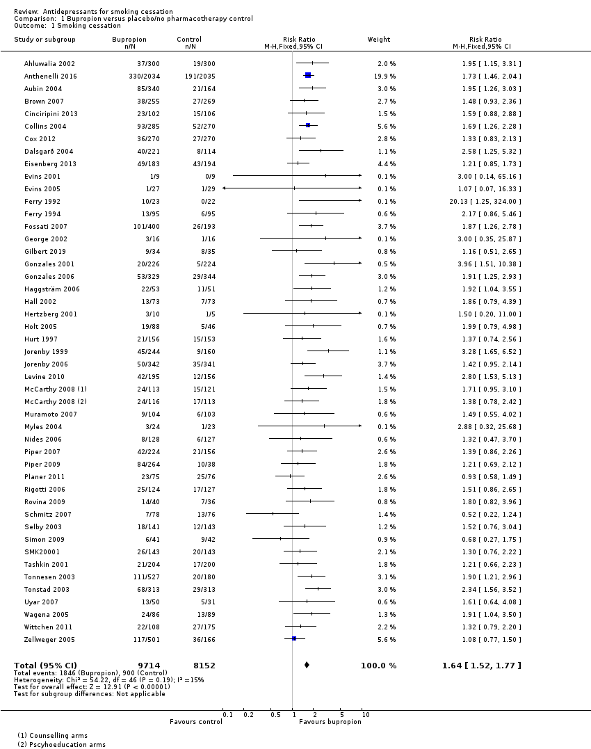
Figure 1: Results of smoking cessation for at least six months follow-up in Howes et al. (2020), bupropion versus placebo
Source: Howes et al. (2020)
Abbreviations: CI = confidence interval
Notes: McCarthy 2008 (1) and McCarthy 2008 (2) refer to the same study.

Howes et al. (2020) conducted subgroup analyses to determine whether bupropion had differential effects based on the level of behavioural support and mental health diagnoses. The authors stated that there was no evidence of a differential effect of bupropion on smoking cessation between subgroups. The test for subgroup differences was not significant in both subgroup analyses (P=0.7 for behavioural support and P=0.86 for mental health disorders).
Safety
A summary of key adverse events comparing bupropion with placebo is presented in Table 8. The incidence of any adverse events and psychiatric adverse events was not reported in Hurt et al. (1997) and Jorenby et al. (1999). Based on the meta-analysis conducted by Howes et al. (2020), a significantly higher proportion of patients in the bupropion arm experienced any adverse events, psychiatric adverse events and discontinuation due to adverse events compared with patients in the placebo arm. There were no statistically significant differences between the two treatment arms in terms of serious adverse events in Hurt et al. (1997), Jorenby et al. (1999) nor Howes et al. (2020), although the proportion of patients experiencing serious adverse events was numerically higher in the bupropion arm in Hurt et al. (1997) and Jorenby et al. (1999).
Table 8: Summary of key adverse events, bupropion versus placebo
Study | Study type | Previously considered studies included¹ | Bupropion | Placebo | RR (95% CI)²
Adverse events
Howes  (2020) | Cochrane Review (19 RCTs) | No | 3,917/5,978  (65.5%) | 2,827/4,915  (57.5%) | 1.14  (1.11, 1.18)
Psychiatric adverse events
Howes  (2020) | Cochrane Review (6 RCTs) | No | 790/2,211  (35.7%) | 632/2,228  (28.4%) | 1.25  (1.15, 1.37)
Serious adverse events
Howes  (2020) | Cochrane Review (21 RCTs) | '''''''' ''''''''''' '''''''' '''''''''''''' ''''''''''''' | 139/6,094  (2.3%) | 107/4,531  (2.4%) | 1.16  (0.9, 1.48)
Discontinuation due to adverse events
Howes  (2020) | Cochrane Review (25 RCTs) | '''''''''' '''''''''''' ''''''' '''''''''''''' ''''''''''' | 606/6,888  (8.8%) | 359/5,452  (6.6%) | 1.37  (1.21, 1.56)
Source: Howes et al. (2020)
Abbreviations: CI = confidence interval; NR = not reported; RCT = randomised controlled trial; RR = risk ratio
Notes: Bold indicates statistically significant difference. See Appendix Figure 49 to Figure 52 for forest plots of the respective outcomes which included the results of individual studies.
1 Where previously considered studies were not included, this was due to the outcome not being reported.
2 Calculated by Cochrane Review authors using a fixed-effect model.
In a recently conducted study (EAGLES extension) comparing the relative cardiovascular safety risk of smoking cessation treatments using a placebo comparator, no significant treatment differences were observed in time to cardiovascular events, blood pressure, or heart rate between bupropion and placebo (Benowitz et al. 2018).
Bupropion versus NRT
A summary of the citation details for the studies comparing bupropion with NRT is presented in Table 9. Four studies were previously considered by the PBAC for this comparison (Jorenby et al. 1999, Gorecka et al. 2003, Uyar et al. 2007 and Piper et al. 2009). A recently conducted Cochrane Review by Howes et al. (2020) was identified in the systematic literature review that compared bupropion with NRT and was included in this report. One new study was identified in the supplemental literature search that informed this comparison and was included in this report (Benowitz et al. 2018).
Table 9: List of studies comparing bupropion with NRT
Study | Citation
Jorenby (1999)² | Jorenby DE, Leischow SJ, Nides MA, Rennard SI, Johnston JA, Hughes AR, Smith SS, Muramoto ML, Daughton DM, Doan K, Fiore MC, Baker TB. A controlled trial of sustained-release bupropion, a nicotine patch, or both for smoking cessation. N Engl J Med. 1999 Mar 4;340(9):685-91.
Gorecka (2003)⁵ | Górecka D, Bednarek M, Nowiński A, Puścińska E, Goljan-Geremek A, Zieliński J. Effect of treatment for nicotine dependence in patients with COPD. Pneumonologia i alergologia polska. 2003;71(9-10):411-7.
Uyar  (2007)⁶ | Uyar M, Filiz A, Bayram N, Elbek O, Herken H, Topcu A, Dikensoy O, Ekinci E. A randomized trial of smoking cessation. Medication versus motivation. Saudi medical journal. 2007 Jun 1;28(6):922-6.
Piper  (2009)⁷ | Piper ME, Smith SS, Schlam TR, Fiore MC, Jorenby DE, Fraser D, Baker TB. A randomized placebo-controlled clinical trial of 5 smoking cessation pharmacotherapies. Archives of general psychiatry. 2009 Nov 1;66(11):1253-62.
Howes (2020)³ | Howes S, Hartmann‐Boyce J, Livingstone‐Banks J, Hong B, Lindson N. Antidepressants for smoking cessation. Cochrane Database of Systematic Reviews 2020, Issue 4. Art. No.: CD000031.
Benowitz (2018)⁴ | Benowitz NL, Pipe A, West R, Hays JT, Tonstad S, McRae T, Lawrence D, St Aubin L, Anthenelli RM. Cardiovascular Safety of Varenicline, Bupropion, and Nicotine Patch in Smokers: A Randomized Clinical Trial. JAMA Intern Med. 2018 May 1;178(5):622-631.
Shaded = previously considered by the PBAC
Notes: ''''''''''''''' '''' '''' ''''''''''' '''''''' '''''''''''''''''''''' ''''' ''''''' '''''''''''''''''''' '''''''''' ''''''''' '''''''''''''''. Jorenby et al. (1999), Gorecka et al. (2003), Uyar et al. (2007) and Piper et al. (2009) were considered at the March 2010 PBAC meeting.
A summary of the characteristics of the studies comparing bupropion with NRT is presented in Table 10. A total of 10 RCTs comparing bupropion with NRT were identified by Howes et al. (2020). Of these, four studies were Jorenby et al. (1999), Gorecka et al. (2003), Uyar et al. (2007) and Piper et al. (2009). The characteristics of the individual studies are presented in Appendix Table 145.
Benowitz et al. (2018) was a safety study (non-treatment extension) of EAGLES (Anthenelli et al. 2016) comparing NRT patches (21 mg per day with taper), varenicline (1 mg twice a day), bupropion (150 mg twice a day) and placebo. The study aimed to collect data on cardiovascular safety for all participants in EAGLES (2016) for an additional 28 weeks, allowing for a total of 52 weeks of cardiovascular safety data collection.

Table 10: Characteristics of the studies comparing bupropion with NRT
Study | Study type | N¹ | Population | Intervention and comparator | Outcomes
Jorenby (1999) | RCT | N=893  Bupropion (n=244),  NRT (n=244) | Inclusion: ≥18 years old, ≥15 cigarettes per day, weigh at least 45.4 kg, motivated to quit smoking.  Exclusion: serious or unstable cardiac, renal, hypertensive, pulmonary, endocrine, or neurologic disorders; ulcers; seizure or dermatologic disorders; a current diagnosis of major depressive episode or a history of panic disorder, psychosis, bipolar disorder, or eating disorders; use of a NRT within six months before study enrolment; pregnancy or lactation; abuse of alcohol or a non–nicotine-containing drug within the preceding year; use of a psychoactive drug within the week before enrolment; use of an investigational drug within the month before enrolment; prior use of bupropion; current use of other smoking-cessation treatments; and regular use of any non-cigarette tobacco product. | Bupropion: 150 mg once daily Day 1-3, followed by 150 mg twice daily Day 4-63;  NRT patch: one patch per day for 8 weeks (21 mg patch Week 2-7, 14 mg patch Week 8 and 7 mg patch Week 9).  Behavioural support provided in both arms. | Primary: 7-day PPA at 6 and 12 months of follow-up. CAR at all clinic visits over 12 months. Validated by CO ≤10 ppm.  Secondary: withdrawal symptoms, body weight, and BDI scores.
Gorecka (2003) | RCT | N=70  Bupropion (n=32), NRT  (n=38) | 43% female; average age 56 years old; average 24 cigarettes per day.  Note: full-text article not readily accessible. | Bupropion: 300 mg per day for 7 weeks; NRT patch: 15 mg per day for 8 weeks.  Behavioural support provided in both arms. | Primary: CAR at 1 year. Validated by CO <10 ppm.  Secondary: adverse events measured for unspecified period.
Uyar (2007) | RCT | N=131  Bupropion (n=50), NRT  (n=50) | 19% female, average age 36 years old.  Note: full-text article not readily accessible. | Bupropion: 300 mg for 7 weeks; NRT patch: 21 mg for 6 weeks including tapering.  Behavioural support provided in both arms. | Primary: abstinence at 24 weeks (definition not specified). Validated by CO <10 ppm.  Secondary: adverse events measured for unspecified period.
Piper (2009) | RCT | N=1,504  Bupropion (n=264), NRT patch (n=262), NRT lozenge (n=260) | Inclusion: >9 cigarettes per day for at least the past 6 months, alveolar CO >9 ppm, motivated to quit smoking.  Exclusion: using any form of tobacco other than cigarettes, currently taking bupropion, or having a current psychosis or schizophrenia diagnosis, medical contraindications for any of the study medications, including high alcohol consumption (6 drinks per day on 6 or 7 days of the week), a history of seizure, high blood pressure (>160/100 mm Hg), bipolar disorder, an eating disorder, a recent cardiac event, or allergies to any of the medications, pregnancy or breastfeeding. | Bupropion: 150 mg twice daily for 9 weeks (1 week pre-quit and 8 weeks post-quit); NRT patch: 24-hour patch (21, 14, and 7 mg); titrated down over 8 weeks post-quit; NRT lozenge: 2 or 4 mg for 12 weeks post-quit (based on appropriate dose for dependence level per package instructions).  Behavioural support provided in both arms. | Primary: 7-day PPA at 6 months. Validated by CO <10 ppm.  Secondary: adverse events measured for 10 weeks.
Howes (2020) | Cochrane Review (10 RCTs²) | N=8,230  Bupropion (n=3,563),  NRT (n=4,667) | Inclusion: tobacco smokers of any age, with or without a history of mental illness.  Exclusion: pregnant women and trials investigating use for smoking harm reduction or relapse prevention. | Bupropion: 150 mg twice daily including titration (i.e. 150 mg once daily for 3 days, then 150 mg twice daily); NRT: patch, lozenge, patch + lozenge, choice of NRT. | Primary: smoking cessation rates of at least six months after baseline.  Secondary: safety including any adverse events, psychiatric adverse events, serious adverse events and dropouts due to adverse events.
Benowitz (2018) | Non-treatment extension safety study of EAGLES (2016)³ | N=4,595  Bupropion (n=1,166), NRT  (n=1,116) | Inclusion: 18-75 years old, ≥10 cigarettes per day, interested in quitting smoking, had been randomised to treatment in and had completed the week 24 visit of EAGLES.  Exclusion: unstable psychiatric illness, active substance abuse, clinically significant CVD in the 2 months prior to study entry, clinically significant cerebrovascular disease in the 2 months prior to study entry, or inadequate control of hypertension. | No treatment was provided during this study. Prior bupropion and NRT treatments were administered in EAGLES (2016). | Primary: Time to major adverse cardiovascular event.  Secondary: Occurrence of major adverse cardiovascular event.
Abbreviations: BDI = Beck Depression Inventory; CAR = continuous abstinence rate; CO = carbon monoxide; NRT = nicotine replacement therapy; PPA = point prevalence abstinence; RCT = randomised controlled trial
Shaded = previously considered by the PBAC
1 Only the number of patients (n) in the relevant arms were included.
2 The characteristics of the individual studies comparing bupropion with NRT included in Howes et al. (2020) are presented in Appendix Table 145. Howes et al. (2020) included studies comparing bupropion with NRT irrespective of NRT formulation. The comparisons of bupropion versus lozenges and bupropion versus choice of NRT were included for additional information purposes. Four studies previously considered by the PBAC (Jorenby et al. 1999, Gorecka et al. 2003, Uyar et al. 2007 and Piper et al. 2009) were included in the primary efficacy analysis of Howes et al. (2020).
3 Benowitz et al. (2018) was a non-treatment extension of EAGLES (Anthenelli et al. 2016) with a considerable amount of missing data due to lost to follow-up, extension study nonenrollees, no longer willing to participate and death.

Efficacy
A summary of the smoking cessation rates for at least six months follow-up comparing bupropion with NRT is presented in Table 11. For the comparison of bupropion versus NRT patches, the results of Jorenby et al. (1999) demonstrated a statistically significant difference in continuous abstinence rate, in favour of bupropion. In comparison, the results of Gorecka et al. (2003), Uyar et al. (2007) and Piper et al. (2009) were not statistically significant. As previously noted, the PBAC had previously considered the meta-analysis of the four studies in March 2010 and concluded the lack of significant difference between NRT patches and bupropion (RR: 0.91; 95% CI: 0.75, 1.12) supported non-inferiority of NRT patches to bupropion for sustained abstinence at six months or greater.
Based on the Cochrane Review by Howes et al. (2020), the results of the meta-analysis comprising eight RCTs, which included the four studies previously considered by the PBAC, were not statistically significant. The point estimate of the relative treatment effect was close to unity, demonstrating similar efficacy between bupropion and NRT patches.
For the comparison of bupropion versus NRT lozenges, the meta-analysis conducted by Howes et al. (2020) showed no statistically significant difference between the two interventions. Similarly, no statistically significant difference was observed for the comparison of bupropion versus choice of NRT.
Table 11: Results of smoking cessation for at least six months follow-up, bupropion versus NRT
Study | Study type | Bupropion | NRT | RR (95% CI)⁵
Bupropion versus NRT patch
Jorenby (1999)¹ | RCT | 45/244  (18.4%) | 24/244  (9.8%) | 1.88  (1.18, 2.98)
Gorecka (2003)¹ | RCT | 5/31  (16.1%) | 8/38  (21.1%) | 0.77  (0.28, 2.11)
Uyar  (2007)² | RCT | 13/50  (26.0%) | 13/50  (26.0%) | 1.00  (0.52, 1.94)
Piper  (2009)³ | RCT | 28/88ª  (31.8%) | 90/262  (34.4%) | 0.93  (0.65, 1.31)
Howes  (2020)⁴ | Cochrane Review  (8 RCTs) | 465/2699  (17.2%) | 543/3079  (17.6%) | 1.04  (0.92, 1.16)
Bupropion versus NRT lozenge
Howes  (2020)⁴ | Cochrane Review  (2 RCTs) | 42/173  (24.3%) | 139/521  (26.7%) | 0.91  (0.67, 1.22)
Bupropion versus choice of NRT
Howes  (2020)⁴ | Cochrane Review  (2 RCTs) | 131/517  (25.3%) | 123/521  (23.6%) | 1.08  (0.87, 1.33)
Source: Howes et al. (2020)
Abbreviations: CI = confidence interval; NRT = nicotine replacement therapy; RCT = randomised controlled trial; RR = risk ratio
Shaded = previously considered by the PBAC
Notes: Bold indicates statistically significant difference.
1 Continuous abstinence rate at 12 months.
2 Continuous abstinence rate at 6 months.
3 7-day point prevalent abstinence at 6 months.
4 Where cessation was assessed at multiple intervals, the longest follow-up data were used. Where multiple definitions of abstinence were assessed, the strictest of these definitions was used (e.g. continuous/prolonged abstinence over point prevalence abstinence). See Appendix Table 145 for the definition used in each study. Studies of bupropion versus NRT patches previously considered by the PBAC were included in the meta-analysis of Howes et al. (2020).
5 Calculated by Cochrane Review authors using a fixed-effect model.
a Number of patients in bupropion arm divided between three subgroups in Howes et al. (2020).
The results of the individual studies included in Howes et al. (2020) are presented using a forest plot in Figure 2. The results comparing bupropion with combination NRT (i.e. patch + lozenge) are discussed in the combination therapy section.
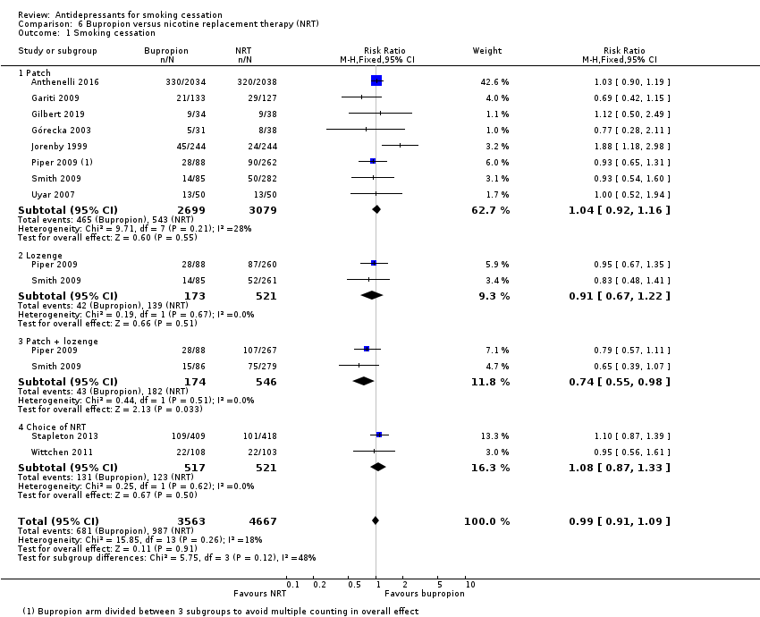
Figure 2: Results of smoking cessation for at least six months follow-up in Howes et al. (2020), bupropion versus NRT
Source: Howes et al. (2020)
Abbreviations: CI = confidence interval
Note: The meta-analysis conducted by Howes et al. (2020) pooled the studies for monotherapy and combination NRT therapies. The results for monotherapy and combination therapies are presented separately in this report.
Safety
A summary of key adverse events comparing bupropion with NRT is presented in Table 12. Based on the meta-analysis conducted by Howes et al. (2020), there were no statistically significant differences in terms of any adverse events, serious adverse events or discontinuation due to adverse events between bupropion and NRT, although the proportion of patients experiencing these events were numerically higher in the bupropion arm. It was observed that the discontinuation rate due to adverse events was significantly higher in the bupropion arm compared with the NRT arm based on Jorenby et al. (1999). The meta-analysed result for psychiatric adverse events was not reported in Howes et al. (2020) due to the high level of heterogeneity across studies (I²=92%).
Table 12: Summary of key adverse events, bupropion versus NRT
Study | Study type | Previously considered studies included¹ | Bupropion | NRT | RR (95% CI)²
Adverse events
Howes  (2020) | Cochrane Review (2 RCTs) | No | 1,467/2,040  (71.9%) | 1,452/2,057  (70.6%) | 1.02  (0.98, 1.06)
Serious adverse events
Howes  (2020) | Cochrane Review (5 RCTs) | Jorenby (1999) | 56/2,800  (2.0%) | 46/2,824  (1.6%) | 1.22  (0.83, 1.8)
Discontinuation due to adverse events
Howes  (2020) | Cochrane Review (4 RCTs) | Jorenby (1999) and Uyar (2007) | 216/2,407  (9.0%) | 190/2,418  (7.9%) | 1.14  (0.95, 1.38)
Source: Howes et al. (2020)
Abbreviations: CI = confidence interval; NR = not reported; RCT = randomised controlled trial; RR = risk ratio
Notes: Bold indicates statistically significant difference. See Appendix Figure 53 to Figure 55 for forest plots of the respective outcomes which included the results of individual studies.
1 Where previously considered studies were not included, this was due to the outcome not being reported.
2 Calculated by Cochrane Review authors using a fixed-effect model.
In a recently conducted study (EAGLES extension) comparing the relative cardiovascular safety risk of smoking cessation treatments using a placebo comparator, no significant treatment differences were observed in time to cardiovascular events, blood pressure, or heart rate between bupropion and NRT patches (Benowitz et al. 2018).

Varenicline
Varenicline was recommended for listing on the PBS in July 2007 based on two double-blind RCTs (Gonzales et al. 2006 and Jorenby et al. 2006) comparing varenicline (1 mg twice daily after initial titration), bupropion (150 mg twice daily after initial titration) and placebo in smokers over 52 weeks. Based on the two studies, the submission described varenicline as having significant advantages in effectiveness over bupropion and having similar or less toxicity.
The PBAC accepted the superiority claim in efficacy based on the higher quit and continuous abstinence rates demonstrated in the meta-analysis of two head-to-head trials comparing varenicline with bupropion, in favour of varenicline. While the PBAC noted that significantly more patients on varenicline treatment experienced nausea, abnormal dreams and headache compared with patients on bupropion, the Committee accepted that the pooled rate of discontinuations due to adverse events was lower with varenicline compared with bupropion (Varenicline PSD, July 2007 PBAC meeting).
In November 2007 and March 2008, the PBAC recommended amendment to the restriction of bupropion and varenicline to allow treatment with both varenicline and bupropion within a 12-month period with 6 months between commencing a course of the second product (PBAC Outcomes, November 2007 and March 2008 PBAC meetings). '''''''' '''''''''' '''''''''''' ''''''''' ''''''''''''' '''''''' ''''''''' '''''''''''''''' ''''''''' '''''''''''''' '''''''''' ''''''''''''' '''''''''''' ''''' '''''''''''''' '''''''''''''''''''''''''' '''' ''''''''''''''''''' '''''''' ''''''''''''' ''''''''''''''''''' ''''' '''''''''''''''''''''' ''''''' '''''''' ''''''' ''''''''''''''''''''''' ''''' '''''''''''' ''''' '''''''''''''''''''' ''''''' '''''''''''''''''''''' ''''''' ''''''''''''''''' ''''''' ''''''''' ''''''''''''' '''''''' ''' '''''''' ''''''''''''''''''''' ''''' ''''''''''''' ''''''''' ''''''''''''' ''''''''''''' '''' '''''''' ''''''''''''''''' ''''''''''''''''''' '''''''''''' ''''''''''''''''''' '''''''''''''' '''''''' ''''' '''''''''''''''''''' ''''''''''' ''''''''''' ''''''' '''''' ''''''''''''''''' '''''''''''''''''''' '''''''''''''' ''''''''''''''' '''''''''''''''''' ''''''''' '''''''''' ''''''''''''''''''' Prior to these meetings, only one course of PBS-subsidised smoking cessation therapy (bupropion or varenicline) was authorised per year.
Additional 12-week course for abstainers
In November 2009, the PBAC recommended the listing of varenicline on the PBS be extended to make available a second 12-week course for patients who have successfully completed an initial 12-week course of varenicline, but require a further 12-week course to aid in maintaining abstinence (i.e. treatment-experienced patients). The listing allowed for only one 12-24 week course of varenicline per year (i.e. an additional 12 weeks of treatment for those who have abstained from smoking) (Varenicline PSD, November 2009 PBAC meeting). The clinical evidence for the use of varenicline as completion of a short-term (24 weeks) course of treatment is presented under the treatment-experienced population section.
Retreatment (non-abstainers)
In November 2012 and March 2014, the PBAC considered a request to reduce the time to retreatment with varenicline from 12 to 6 months. In March 2014, the PBAC recommended a change to the listing of varenicline to allow an additional course within a 12-month period for patients who have been unsuccessful in achieving abstinence from smoking during or after a course of PBS-subsidised varenicline (Varenicline PSD, March 2014 PBAC meeting). The listing required the period between commencing varenicline and a further course of varenicline to be at least 6 months, with a total of 24 weeks of PBS-subsidised varenicline allowed per 12-month period. The clinical evidence for the use of varenicline as retreatment is presented under the treatment-experienced population section.
While the request made in November 2012 and March 2014 was for treatment-experienced patients, the submission presented trial evidence in varenicline-naïve patients as supportive evidence (Gonzales et al. 2006, Jorenby et al. 2006, Oncken et al. 2006, Nakamura et al. 2007, Rigotti et al. 2010 and Tashkin et al. 2011). Four additional studies in varenicline-naïve patients presented in the November 2012 submission were not included in the March 2014 resubmission (Tsai et al. 2007, Wang et al. 2009, Bolliger et al. 2011 and Rennard et al. 2012) (Varenicline PSD, November 2012 and March 2014 PBAC meetings).
Authority Required (STREAMLINED) listing
In March 2015, the PBAC reviewed the restriction level of varenicline as part of the Post-market Review of Authority Required PBS listings, and recommended varenicline remain Authority Required (telephone). At that time, the PBAC noted that the market for smoking cessation aids was not yet stable. In response to a subsequent request from the sponsor, prompted by the February 2016 DUSC analysis of smoking cessation therapies, the PBAC advised that a formal submission would be required to address safety concerns regarding psychiatric adverse events (Varenicline PSD, November 2016 PBAC meeting).
In November 2016, the PBAC recommended to amend the listing of varenicline from Authority Required to Authority Required (STREAMLINED). One study assessing the neuropsychiatric safety and efficacy of varenicline, bupropion and NRT patches was considered by the PBAC at this meeting (Anthenelli et al. 2016; EAGLES). The PBAC considered that the results of the EAGLES trial (four-arm study) supported the comparative safety of varenicline, bupropion, NRT and placebo. Based on the evidence presented, the PBAC considered that varenicline was non-inferior to bupropion with regards to comparative safety, and likely to be non-inferior to NRT and placebo. The PBAC had previously considered that varenicline was non-inferior to bupropion, and inferior to NRT and placebo with regards to safety. In terms of comparative efficacy, the PBAC considered that varenicline was superior to bupropion, NRT and placebo (Varenicline PSD, November 2016 PBAC meeting).
Varenicline versus placebo
A summary of the citation details for the studies comparing varenicline with placebo is presented in Table 13. Eleven studies were previously considered by the PBAC (Gonzales et al. 2006, Jorenby et al. 2006, Oncken et al. 2006, Nakamura et al. 2007, Tsai et al. 2007, Wang et al. 2009, Bolliger et al. 2011, Rigotti et al. 2010, Tashkin et al. 2011, Rennard et al. 2012 and EAGLES 2016). A recently conducted Cochrane Review by Cahill et al. (2016) was identified in the systematic literature review that compared varenicline with placebo and was included in this report.
Eight new studies were identified in the supplemental literature search that informed this comparison and were included in the updated re-analysis of the Cochrane Review (Lerman et al. 2015, Littlewood et al. 2017, Benowitz et al. 2018, Hurt et al. 2018, Mercie et al. 2018, Windle et al. 2018, Ashare et al. 2019, Chen et al. 2020).
Table 13: List of studies comparing varenicline with placebo
Study | Citation
Gonzales (2006)⁸ | Gonzales D, Rennard SI, Nides M, Oncken C, Azoulay S, Billing CB, Watsky EJ, Gong J, Williams KE, Reeves KR, Varenicline Phase 3 Study Group. Varenicline, an α4β2 nicotinic acetylcholine receptor partial agonist, vs sustained-release bupropion and placebo for smoking cessation: a randomized controlled trial. Jama. 2006 Jul 5;296(1):47-55.
Jorenby (2006)⁹ | Jorenby DE, Hays JT, Rigotti NA, Azoulay S, Watsky EJ, Williams KE, Billing CB, Gong J, Reeves KR, Varenicline Phase 3 Study Group. Efficacy of varenicline, an α4β2 nicotinic acetylcholine receptor partial agonist, vs placebo or sustained-release bupropion for smoking cessation: a randomized controlled trial. Jama. 2006 Jul 5;296(1):56-63.
Oncken (2006)¹⁰ | Oncken C, Gonzales D, Nides M, Rennard S, Watsky E, Billing CB, Anziano R, Reeves K. Efficacy and safety of the novel selective nicotinic acetylcholine receptor partial agonist, varenicline, for smoking cessation. Archives of internal medicine. 2006 Aug 14;166(15):1571-7.
Nakamura (2007)¹¹ | Nakamura M, Oshima A, Fujimoto Y, Maruyama N, Ishibashi T, Reeves KR. Efficacy and tolerability of varenicline, an α4β2 nicotinic acetylcholine receptor partial agonist, in a 12-week, randomized, placebo-controlled, dose-response study with 40-week follow-up for smoking cessation in Japanese smokers. Clinical therapeutics. 2007 Jun 1;29(6):1040-56.
Tsai (2007)¹² | Tsai ST, Cho HJ, Cheng HS, Kim CH, Hsueh KC, Billing Jr CB, Williams KE. A randomized, placebo-controlled trial of varenicline, a selective α4β2 nicotinic acetylcholine receptor partial agonist, as a new therapy for smoking cessation in Asian smokers. Clinical therapeutics. 2007 Jun 1;29(6):1027-39.
Wang (2009)¹³ | Wang C, Xiao D, Chan KP, Pothirat C, Garza D, Davies S. Varenicline for smoking cessation: a placebo‐controlled, randomized study. Respirology. 2009 Apr;14(3):384-92.
Bolliger (2011)¹⁴ | Bolliger CT, Issa JS, Posadas-Valay R, Safwat T, Abreu P, Correia EA, Park PW, Chopra P. Effects of varenicline in adult smokers: a multinational, 24-week, randomized, double-blind, placebo-controlled study. Clinical therapeutics. 2011 Apr 1;33(4):465-77.
Rigotti (2010)¹⁵ | Rigotti NA, Pipe AL, Benowitz NL, Arteaga C, Garza D, Tonstad S. Efficacy and safety of varenicline for smoking cessation in patients with cardiovascular disease: a randomized trial. Circulation. 2010 Jan 19;121(2):221-9.
Tashkin (2011)¹⁶ | Tashkin DP, Rennard S, Hays JT, Ma W, Lawrence D, Lee TC. Effects of varenicline on smoking cessation in patients with mild to moderate COPD: a randomized controlled trial. Chest. 2011 Mar 1;139(3):591-9.
Rennard (2012)¹⁷ | Rennard S, Hughes J, Cinciripini PM, Kralikova E, Raupach T, Arteaga C, St Aubin LB, Russ C. A randomized placebo-controlled trial of varenicline for smoking cessation allowing flexible quit dates. Nicotine & tobacco research. 2012 Mar 1;14(3):343-50.
Anthenelli (EAGLES, 2016)¹⁸ | Anthenelli RM, Benowitz NL, West R, St Aubin L, McRae T, Lawrence D, Ascher J, Russ C, Krishen A, Evins AE. Neuropsychiatric safety and efficacy of varenicline, bupropion, and nicotine patch in smokers with and without psychiatric disorders (EAGLES): a double-blind, randomised, placebo-controlled clinical trial. Lancet. 2016 Jun 18;387(10037):2507-20.
Cahill (2016)¹⁹ | Cahill K, Lindson‐Hawley N, Thomas KH, Fanshawe TR, Lancaster T. Nicotine receptor partial agonists for smoking cessation. Cochrane Database of Systematic Reviews 2016, Issue 5. Art. No.: CD006103.
Lerman (2015)²⁰ | Lerman C, Schnoll RA, Hawk LW Jr, Cinciripini P, George TP, Wileyto EP, Swan GE, Benowitz NL, Heitjan DF, Tyndale RF; PGRN-PNAT Research Group. Use of the nicotine metabolite ratio as a genetically informed biomarker of response to nicotine patch or varenicline for smoking cessation: a randomised, double-blind placebo-controlled trial. Lancet Respir Med. 2015 Feb;3(2):131-138.
Littlewood (2017)²¹ | Littlewood RA, Claus ED, Wilcox CE, Mickey J, Arenella PB, Bryan AD, Hutchison KE. Moderators of smoking cessation outcomes in a randomized-controlled trial of varenicline versus placebo. Psychopharmacology (Berl). 2017 Dec;234(23-24):3417-3429.
Benowitz (2018)⁴ | Benowitz NL, Pipe A, West R, Hays JT, Tonstad S, McRae T, Lawrence D, St Aubin L, Anthenelli RM. Cardiovascular Safety of Varenicline, Bupropion, and Nicotine Patch in Smokers: A Randomized Clinical Trial. JAMA Intern Med. 2018 May 1;178(5):622-631.
Hurt (2018)²² | Hurt RT, Ebbert JO, Croghan IT, Schroeder DR, Hurt RD, Hays JT. Varenicline for tobacco-dependence treatment in alcohol-dependent smokers: A randomized controlled trial. Drug Alcohol Depend. 2018 Mar 1;184:12-17
Mercie (2018)²³ | Mercié P, Arsandaux J, Katlama C, Ferret S, Beuscart A, Spadone C, Duvivier C, Reynes J, Wirth N, Moinot L, Bénard A, Zucman D, Duval X, Molina JM, Spire B, Fagard C, Chêne G; ANRS 144 Inter-ACTIV study group. Efficacy and safety of varenicline for smoking cessation in people living with HIV in France (ANRS 144 Inter-ACTIV): a randomised controlled phase 3 clinical trial. Lancet HIV. 2018 Mar;5(3):e126-e135.
Windle (2018)²⁴ | Windle SB, Dehghani P, Roy N, Old W, Grondin FR, Bata I, Iskander A, Lauzon C, Srivastava N, Clarke A, Cassavar D, Dion D, Haught H, Mehta SR, Baril JF, Lambert C, Madan M, Abramson BL, Eisenberg MJ; EVITA Investigators. Smoking abstinence 1 year after acute coronary syndrome: follow-up from a randomized controlled trial of varenicline in patients admitted to hospital. CMAJ. 2018 Mar 26;190(12):E347-E354.
Ashare (2019)²⁵ | Ashare RL, Thompson M, Serrano K, Leone F, Metzger D, Frank I, Gross R, Hole A, Mounzer K, Collman RG, Wileyto EP, Schnoll R. Placebo-controlled randomized clinical trial testing the efficacy and safety of varenicline for smokers with HIV. Drug Alcohol Depend. 2019 Jul 1;200:26-33.
Chen (2020)²⁶ | Chen LS, Baker TB, Miller JP, Bray M, Smock N, Chen J, Stoneking F, Culverhouse RC, Saccone NL, Amos CI, Carney RM. Genetic Variant in CHRNA5 and Response to Varenicline and Combination Nicotine Replacement in a randomized placebo‐controlled trial. Clinical Pharmacology & Therapeutics. 2020 Dec;108(6):1315-25.
Shaded = previously considered by the PBAC
Notes: Gonzales et al. (2006) and Jorenby et al. (2006) were considered at the July 2007 PBAC meeting. EAGLES (2016) was considered at the November 2016 PBAC meeting. The remaining shaded studies (including Gonzales 2006 and Jorenby 2006) were considered at the November 2012 and March 2014 PBAC meeting.
A summary of the characteristics of the studies comparing varenicline with placebo is presented in Table 14. A total of 34 RCTs comparing varenicline with placebo were identified by Cahill et al. (2016), with 27 RCTs included in the primary efficacy analysis. Of the 27 RCTs, 11 studies were previously considered by the PBAC. The characteristics of the individual studies are presented in Appendix Table 146.
Of the eight new studies identified in the supplemental literature search, seven studies were included in the updated efficacy re-analysis (Lerman et al. 2015, Littlewood et al. 2017, Hurt et al. 2018, Mercie et al. 2018, Windle et al. 2018, Ashare et al. 2019, Chen et al. 2020). One study was a safety study with no efficacy outcomes reported (Benowitz et al. 2018). The eight studies were included in the updated safety re-analysis where relevant outcomes were reported.

Table 14: Characteristics of the studies comparing varenicline with placebo
Study | Study type | N¹ | Population | Intervention and comparator | Outcomes
Gonzales  (2006) | RCT | N=1,025  Varenicline (n=352), Placebo (n=344) | Inclusion: 18-75 years old, ≥10 or more cigarettes per day, <3 months of smoking abstinence in the past year, motivated to stop smoking.  Exclusion: any serious or unstable disease within 6 months, seizure risk, diabetes mellitus requiring insulin or oral hypoglycaemic medications, hepatic or renal impairment,  clinically significant cardiovascular disease within 6 months, uncontrolled hypertension, severe chronic obstructive pulmonary disease, history of cancer, history of clinically significant allergic reactions, major depressive disorder within the past year requiring treatment, history of panic disorder,  psychosis, bipolar disorder, or eating disorders, alcohol or drug abuse/dependency within the past year, use of tobacco products other than cigarettes, use of NRT, clonidine, or nortriptyline within the month prior to enrolment; and body mass index <15 or >38 or weight <45.5 kg, prior exposure to bupropion or varenicline, pregnancy and breastfeeding. | Varenicline: 1 mg twice daily titrated over 12 weeks (i.e. 0.5 mg once daily for 3 days, then 0.5 mg twice daily for 4 days, then 1 mg twice daily); Placebo: placebo tablet for 12 weeks, same regimen.  Behavioural support provided in both arms. | Primary: CAR at Week 9-12. Validated by CO ≤10 ppm.  Secondary: CAR at Week 9-24 and Week 9-52; 7-day PPA at Week 12, 24 and 52. Validated by CO ≤10 ppm.  Other: weight change, withdrawal symptoms (using MNWS, QSU-brief and mCEQ), adverse events.
Jorenby  (2006) | RCT | N=1,027  Varenicline (n=344), Placebo (n=341) | Inclusion: 18-75 years old, ≥10 cigarettes per day during the previous year, no period of smoking abstinence longer than 3 months in the past year.  Exclusion: previous use of bupropion, contraindications for use of bupropion, serious or unstable disease within the previous 6 months, clinically significant cardiovascular disease in the previous 6 months, uncontrolled hypertension, baseline systolic blood pressure >150 mmHg or diastolic blood pressure >95 mmHg, severe chronic obstructive pulmonary disease, history of cancer, clinically significant allergic reactions, body mass index <15 or >38; body weight <45 kg, history of alcohol or other drug abuse or dependence in the previous 12 months (nicotine excepted), treatment for major depression in the previous 12 months, history of or current panic disorder, psychosis, or bipolar disorder; use of another investigational drug within 30 days, previous participation in any varenicline study, use in the previous month or intention to use medications that might interfere with study medication evaluation, use of marijuana or other tobacco products during the study, clinically significant abnormalities in the screening laboratory values, pregnancy. | Varenicline: 1 mg twice daily titrated over 12 weeks (i.e. 0.5 mg once daily for 3 days, then 0.5 mg twice daily for 4 days, then 1 mg twice daily);  Placebo: placebo tablet for 12 weeks, same regimen.  Behavioural support provided in both arms. | Primary: CAR at Week 9-12. Validated by CO ≤10 ppm.  Secondary: CAR at Week 9-24 and Week 9-52; 7-day PPA at Week 12, 24 and 52. Validated by CO ≤10 ppm.  Other: weight change, withdrawal symptoms (using MNWS, QSU-brief and mCEQ), adverse events.
Oncken (2006) | RCT | N=647  Varenicline (n=259)², Placebo (n=129) | Inclusion: healthy cigarette smokers, 18-65 years old, ≥10 cigarettes per day.  Exclusion: treatment with an investigational drug within the previous month, major depression within the prior year, panic disorder, psychosis, or bipolar disorder; use of NRT or bupropion within the previous 3 months, cardiovascular disease, clinically significant medical disease, drug or alcohol abuse or dependence within the past year, and use of tobacco products other than cigarettes or marijuana use within the previous month. | Varenicline: 1 mg twice daily non-titrated (i.e. 1mg twice daily for 12 weeks) or 1 mg twice daily titrated (i.e. 0.5 mg once daily for 3 days, then 0.5 mg twice daily for 4 days, then 1 mg twice daily for 11 weeks);  Placebo: placebo tablet for 12 weeks, same regimen.  Behavioural support provided in both arms. | Primary: CAR at Week 4-7, 9-12 and 9-52. Validated by CO ≤10 ppm.  Secondary: 7-day PPA throughout  treatment phase and at Week 12, 24 and 52. Validated by CO ≤10 ppm.  Other: weight change; craving and withdrawal changes using MNWS and mCEQ; adverse events.
Nakamura (2007) | RCT | N=619  Varenicline (n=156), Placebo (n=154) | Inclusion: Japanese smokers aged 20-75 years who were motivated to stop smoking, ≥10 cigarettes per day during the preceding year without a period of abstinence >90 days.  Exclusion: pregnancy and breastfeeding; cardiovascular, cerebrovascular, and pulmonary disease, cancer, significant hepatic or renal impairment, neurologic and psychiatric disorder, significant laboratory abnormalities; body mass index of <15 kg/m² or >38 kg/m², body weight <45 kg, history of drug (except nicotine) or alcohol abuse or dependence within the previous 12 months, and use of NRT within the previous 30 days. | Varenicline: 1 mg twice daily titrated over 12 weeks (i.e. 0.5 mg once daily for 3 days, then 0.5 mg twice daily for 4 days, then 1 mg twice daily);  Placebo: placebo tablet for 12 weeks, same regimen  Behavioural support provided in both arms. | Primary: CAR at Week 9-12. Validated by CO ≤10 ppm.  Secondary: CAR at Week 9-24 and 9-52. 7-day PPA at Week 2 through to 12, 24 and 52. Validated by CO ≤10 ppm.  Other: withdrawal symptoms (using MNWS, QSU-brief and mCEQ), adverse events.
Tsai  (2007) | RCT | N=250  Varenicline (n=126), Placebo (n=124) | Inclusion: 18-75 years old, ≥10 cigarettes per day during the past year with no period of abstinence >3 months in the past year, motivated to stop smoking.  Exclusion: pregnancy and breastfeeding, past or present history of a serious or unstable clinical disease requiring treatment, body mass index <15 or >38 kg/m², body weight <45 kg, and a history of drug (except nicotine) or alcohol abuse. | Varenicline: 1 mg twice daily titrated over 12 weeks (i.e. 0.5 mg once daily for 3 days, then 0.5 mg twice daily for 4 days, then 1 mg twice daily);  Placebo: placebo tablet for 12 weeks, same regimen.  Behavioural support provided in both arms. | Primary: CAR at Week 9-12. Validated by CO ≤10 ppm.  Secondary: CAR at Week 9-24. 7-day PPA at Week 12 and 24. Validated by CO ≤10 ppm.  Other: withdrawal symptoms (using MNWS, QSU-brief and mCEQ), adverse events.
Wang  (2009) | RCT | N=334  Varenicline (n=165), Placebo (n=168) | Inclusion:18–75 years old, BMI of 15–38 kg/m² (and a weight of ≥45.5 kg), ≥10 cigarettes per day during the year prior to the screening visit with no period of abstinence greater than 3 months, motivated to stop smoking.  Exclusion: pregnancy and breastfeeding, diagnosed with or treated for depression during the previous 12 months, a history of psychosis, panic disorder, bipolar disorder, clinically significant endocrine disorders or gastrointestinal diseases, severe COPD, clinically significant cardiovascular disease, neurologic disorders or cerebrovascular disease during the previous 6 months, uncontrolled hypertension or systolic blood pressure >150 mmHg or diastolic blood pressure >95 mmHg at baseline screening, significant hepatic or renal impairment or other clinically significant abnormal laboratory test values, a history of cancer, serious or life-threatening allergic reactions to drugs, drug or alcohol abuse or dependence, or a positive urine drug screen, participated in a study with an experimental smoking cessation drug in the prior year, had used NRT or bupropion within the previous 6 months or were taking any medications that might interfere with the outcome of the trial. | Varenicline: 1 mg twice daily titrated over 12 weeks (i.e. 0.5 mg once daily for 3 days, then 0.5 mg twice daily for 4 days, then 1 mg twice daily);  Placebo: placebo tablet for 12 weeks, same regimen.  Behavioural support provided in both arms. | Primary: CAR at Week 9-12. Validated by CO ≤10 ppm.  Secondary: CAR at Week 9-24. 7-day PPA at Week 24. Validated by CO ≤10 ppm.  Other: adverse events; long-term quit rates.
Bolliger  (2011) | RCT | N=593  Varenicline (n=394), Placebo (n=199) | Inclusion: 18-75 years old, body mass index of 15 to 38kg/m² (and a weight of ≥45.5 kg), motivated to stop smoking, ≥10 cigarettes per day during the previous 12 months and during the month before the screening visit with no cumulative period of abstinence >3 months in the previous 12 months.  Exclusion: pregnancy and breastfeeding, smokers with serious or unstable disease within the 6 months before study entry, a diagnosis of or treatment for depression during the previous 12 months, a history of or current psychosis, panic disorder, or bipolar disorder, severe COPD, uncontrolled hypertension or systolic blood pressure >150 mmHg or diastolic blood pressure >95 mmHg, a clinically significant endocrine disorder or gastrointestinal disease, clinically significant hepatic or renal impairment or other clinically significant laboratory abnormality, a history of a cancer (excluding basal cell or squamous cell carcinoma), a history of a clinically significant allergic reaction to a medication, a history of drug (with the exception of nicotine) or alcohol abuse or dependence within the previous 12 months, use of NRT, bupropion, clonidine, or nortriptyline within the previous 6 months, and/or participation in another study of an experimental drug for smoking cessation within the previous 12 months, or treatment with any medications that might interfere with the outcome of the trial. | Varenicline: 1 mg twice daily titrated over 12 weeks (i.e. 0.5 mg once daily for 3 days, then 0.5 mg twice daily for 4 days, then 1 mg twice daily);  Placebo: placebo tablet for 12 weeks, same regimen  Behavioural support provided in both arms. | Primary: CAR at Week 9-12. Validated by CO ≤10 ppm.  Secondary: CAR at Week 9-24. 7-day PPA at Week 12 and 24. Validated by CO ≤10 ppm.  Other: adverse events, clinically significant changes in vital signs, serious adverse events.
Rigotti  (2010) | RCT | N=714  Varenicline (n=355), Placebo (n=359) | Inclusion: 35-75 years old, ≥10 cigarettes daily in the year before enrolment, wanted to stop smoking but had not tried to quit in the past 3 months, and had stable, documented CVD (other than hypertension) that had been diagnosed for >2 months.  Exclusion: undergone a cardiovascular procedure or had cardiovascular instability in the past 2 months, moderate or severe COPD, uncontrolled gastrointestinal, hepatic, or endocrine disease, severe renal impairment, cancer, diagnosis of depression, treatment with antidepressants in the past year, history of psychosis, panic disorder, or bipolar disorder, drug or alcohol abuse or dependence in the past year, or smoking cessation medication use (NRT, bupropion, clonidine, or nortriptyline) in the past month. | Varenicline: 1 mg twice daily titrated over 12 weeks (i.e. 0.5 mg once daily for 3 days, then 0.5 mg twice daily for 4 days, then 1 mg twice daily);  Placebo: placebo tablet for 12 weeks, same regimen.  Behavioural support provided in both arms. | Primary: CAR at Week 9-12. Validated by CO ≤10 ppm.  Secondary: CAR at Week 9-24 and 9-52. 7-day PPA at Week 12, 24 and 52. Validated by CO ≤10 ppm.  Other: adverse events; serious adverse events; cardiovascular events; changes in blood pressure and heart rate.
Tashkin  (2011) | RCT | N=504  Varenicline (n=250), Placebo (n=254) | Inclusion: men and women aged ≥35 years who received a clinical diagnosis of mild to moderate COPD (confirmed with a post bronchodilator FEV₁/FVC <70% and FEV₁ % predicted normal value ≥50% [GOLD stages I and II]) and motivated to stop smoking. Each participant smoked an average of ≥10 cigarettes/day over the past year with no period of abstinence >3 months over that time.  Exclusion: treated with systemic corticosteroids or hospitalised for a COPD exacerbation during the 4-week period prior to screening; unstable or uncontrolled medical conditions; a diagnosis of depression or treatment with antidepressants in the past year; drug or alcohol abuse (other than nicotine) in the past year; history of psychosis, panic disorder, or bipolar disorder; and use of a smoking cessation medication in the past month. | Varenicline: 1 mg twice daily titrated over 12 weeks (i.e. 0.5 mg once daily for 3 days, then 0.5 mg twice daily for 4 days, then 1 mg twice daily);  Placebo: placebo tablet for 12 weeks, same regimen.  Behavioural support provided in both arms. | Primary: CAR at Week 9-12. Validated by CO ≤10 ppm.  Secondary: CAR at Week 9-24 and 9-52. 7-day PPA at Week 12, 24 and 52. Validated by CO ≤10 ppm.  Other: adverse events; serious adverse events; weight change.
Rennard  (2012) | RCT | N=659  Varenicline (n=493), Placebo (n=166) | Inclusion: 18-75 years old, ≥10 cigarettes per day during the previous year with no longer than 3 months abstinence during that time, motivated to stop smoking.  Exclusion: had used a NRT, bupropion, clonidine, or nortriptyline within the past 3 months or had taken varenicline previously, serious or unstable psychiatric disorders in the past 6 months or on the basis of medical history, including current depression or depression diagnosed or treated within the past 12 months; any history of suicidal ideation or suicidal behaviour in the past 5 years, past history of or present psychosis, panic attacks, or anxiety disorders, or bipolar disorder; a history of drug (except nicotine) or alcohol abuse/dependence within the past 12 months and those with a positive urine drug screen for drugs of abuse/potential abuse not prescribed for the treatment of a medical condition. | Varenicline: 1 mg twice daily titrated over 12 weeks (i.e. 0.5 mg once daily for 3 days, then 0.5 mg twice daily for 4 days, then 1 mg twice daily);  Placebo: placebo tablet for 12 weeks, same regimen.  Behavioural support provided in both arms. | Primary: CAR at Week 9-12. Validated by CO ≤10 ppm.  Secondary: CAR at Week 9-24. 7-day PPA at Week 12 and 24. Validated by CO ≤10 ppm.  Other: adverse events, serious adverse events; timing and number of quit attempts.
Anthenelli (EAGLES, 2016) | RCT | N=8,144  Varenicline (n=2,037), Placebo (n=2,035) | Inclusion: 18–75 years old, with and without prespecified psychiatric diagnoses per the DSM-IV-TR, ≥10 cigarettes per day during the previous year, exhaled CO concentration >10ppm, motivated to stop smoking.  Exclusion: past or current diagnosis of schizophreniform or delusional disorders, all delirium, dementia, and other cognitive disorders, and all substance-induced disorders (other than nicotine). | Varenicline: 1 mg twice daily titrated over 12 weeks (i.e. 0.5 mg once daily for 3 days, then 0.5 mg twice daily for 4 days, then 1 mg twice daily);  Placebo: placebo tablet for 12 weeks, same regimen.  Behavioural support provided in both arms. | Primary: safety including adverse events.  Primary efficacy: CAR at Week 9-12. Validated by CO ≤10 ppm.  Secondary efficacy: CAR at Week 9-24. 7-day PPA at all visits. Validated by CO ≤10 ppm.
Cahill  (2016) | Cochrane review (34 RCTs³) | Efficacy (27 RCTs)  N=12,625  Varenicline (n=6,632),  Placebo (n=5,993) | Inclusion: adult smokers.  Exclusion: trials which target users of smokeless tobacco. | Varenicline: 1 mg twice daily including titration (i.e. 0.5 mg once daily for 3 days, then 0.5 mg twice daily for 4 days, then 1 mg twice daily); Placebo: placebo tablets, same regimen. | Primary: smoking cessation rates of at least six months after baseline.  Secondary: safety including nausea, insomnia, abnormal dreams, headaches and serious adverse events.
Lerman (2015) | RCT | N=1,246  Varenicline (n=420), Placebo (n=408) | Inclusion: 18-65 years old, ≥10 cigarettes per day for ≥6 months (verified by CO >10 ppm).  Exclusion: use of non-cigarette tobacco products, e-cigarettes, or current smoking treatment; history of substance abuse treatment, current use of cocaine or methamphetamine, or >25 alcoholic drinks/week; medical contraindications; history of DSM-IV Axis 1 psychiatric disorder or suicide risk score on the MINI International Neuropsychiatric Interview (MINI)>1,or current major depression; current use of anti-psychotics, stimulants, opiate medications, anti-coagulants, rescue inhalers, anti-arrythmics, or medications altering CYP2A6 activity; and inability to provide informed consent or any condition that could compromise safety. | Varenicline: 1 mg twice daily titrated over 12 weeks (i.e. 0.5 mg once daily for 3 days, then 0.5 mg twice daily for 4 days, then 1 mg twice daily);  Placebo: placebo tablet for 12 weeks, same regimen.  Behavioural support provided in both arms. Both arms received placebo patch. | Primary: 7-day PPA at Week 11 (end of treatment). Validated by CO <8 ppm.  Secondary: 7-day PPA at 6 and 12 months, adverse events, withdrawal symptoms (using MNWS).
Littlewood (2017) | RCT | N=205  Varenicline (n=111), Placebo (n=94) | Inclusion: 18-55 years old, ≥10 cigarettes per day, have not previously taken varenicline, no serious medical or psychiatric condition in the past 6 months, not currently pregnant or nursing, and no illicit drug use (excluding marijuana) in the past 60 days.  Exclusion: self-reported or physician identified health concerns; currently taking insulin or oral hypoglycaemic medication; self-reported use of cocaine, methamphetamine, heroin, or other illicit drugs (excluding marijuana) in the previous 60 days or a positive urine toxicology screen; met DSM-IV criteria for psychotic disorder, bipolar disorder, or major depression in the past year. | Varenicline: 1 mg twice daily titrated over 12 weeks (i.e. 0.5 mg once daily for 3 days, then 0.5 mg twice daily for 4 days, then 1 mg twice daily);  Placebo: placebo tablet for 12 weeks, same regimen.  Behavioural support provided in both arms. | Primary: CAR at Week 9-12 and Week 32-36. Validated by CO <6 ppm.  Secondary: 7-day PPA at Week 6, 12 and 36. Validated by CO <6 ppm; average number of cigarettes smoked per day; adverse events.
Benowitz (2018) | Non-treatment extension safety study of EAGLES (2016)⁵ | N=4,595  Varenicline (n=1,192), Placebo (n=1,121) | Inclusion: 18-75 years old, ≥10 cigarettes per day, interested in quitting smoking, had been randomised to treatment in and had completed the week 24 visit of EAGLES.  Exclusion: unstable psychiatric illness, active substance abuse, clinically significant CVD in the 2 months prior to study entry, clinically significant cerebrovascular disease in the 2 months prior to study entry, or inadequate control of hypertension. | No treatment was provided during this study. Prior varenicline and placebo treatments were administered in EAGLES (2016). | Primary: Time to major adverse cardiovascular event.  Secondary: Occurrence of major adverse cardiovascular event.
Hurt (2018) | RCT⁴ | N=33  Varenicline (n=16), Placebo (n=17) | Inclusion: ≥ 18 years old, ≥10 cigarettes per day for ≥6 months, alcohol dependence or abuse, interested in quitting smoking.  Exclusion: had a cardiac condition, an untreated cardiac dysrhythmia, kidney disease, or cancer; had psychosis, bipolar disorder, or unstable or untreated moderate or severe depression; had current nonspecific suicidal thoughts or had ever made a suicide attempt; had a varenicline allergy; another member of their household was already participating in the study; undergoing current treatment with another investigational drug within the past 30 days; had untreated hypertension or a baseline blood pressure higher than 180 mm Hg systolic or 100 mm Hg diastolic; currently using a tobacco-dependence treatment involving a drug, behavioural intervention, or both; concurrently using another nicotine product other than cigarettes; women of childbearing potential or women who were pregnant, breastfeeding, or likely to become pregnant and who were not willing to use contraception during the medication phase of the trial. | Varenicline: 1 mg twice daily titrated over 12 weeks (i.e. 0.5 mg once daily for 3 days, then 0.5 mg twice daily for 4 days, then 1 mg twice daily);  Placebo: placebo tablet for 12 weeks, same regimen.  Behavioural support provided in both arms. | Primary: 7-day PPA at Week 12. Validated by CO ≤8 ppm.  Secondary: 7-day PPA at Week 26, adverse events, alcohol use.
Mercie (2018) | RCT | N=248  Varenicline (n=123), Placebo (n=125) | Inclusion: ≥18 years old with documented HIV infection, ≥10 cigarettes daily for a year or more, volunteered to stop smoking after completing a Q-MAT smoking cessation motivation questionnaire, regularly followed up in one of the participating French hospitals.  Exclusion: co-dependent on a psychoactive substance other than tobacco, had a depressive episode during enrolment diagnosed by a psychiatrist, had ever attempted suicide, were having ongoing treatment with interferon, had been taking efavirenz for less than 3 months or had neuropsychological drug-related adverse events while taking efavirenz, previous treatment with varenicline (or known hypersensitivity to varenicline) or bupropion or ongoing nicotine replacement therapy, being pregnant, or ongoing breastfeeding. | Varenicline: 1 mg twice daily titrated over 12 weeks (i.e. 0.5 mg once daily for 3 days, then 0.5 mg twice daily for 4 days, then 1 mg twice daily);  Placebo: placebo tablet for 12 weeks, same regimen.  Behavioural support provided in both arms. | Primary: CAR at Week 9-48. Validated by CO ≤10 ppm.  Secondary: CAR at Week 9-12, incidence of episodes of depression, cardiovascular and cerebrovascular events, adverse events.
Windle (2018) | RCT | N=302  Varenicline (n=151), Placebo (n=151) | Inclusion: ≥10 cigarettes per day for the past year, motivated to quit.  Exclusion: history of mental illness. | Varenicline: 1 mg twice daily titrated over 12 weeks (i.e. 0.5 mg once daily for 3 days, then 0.5 mg twice daily for 4 days, then 1 mg twice daily);  Placebo: placebo tablet for 12 weeks, same regimen.  Behavioural support provided in both arms. | Primary: 7-day PPA at Week 24. Validated by CO ≤10 ppm.  Secondary: 7-day PPA at all follow-ups (up to Week 52), reduction in daily cigarette consumption by ≥50%, adverse events, serious adverse events.
Ashare (2019) | RCT | N=179  Varenicline (n=89), Placebo (n=90) | Inclusion: >18 years old, confirmed HIV diagnosis, be treated with ART with HIV viral loads <1000 copies/ml and CD4+ counts >200 cells/mm³, report daily smoking, ALT and AST <2 times upper limit of normal, and creatinine clearance >50 mL/min.  Exclusion: self-reported history of psychosis or a suicide attempt, self-reported current or planned pregnancy, self-reported current use of smoking cessation medications, unstable or untreated alcohol/substance abuse, and uncontrolled hypertension (systolic >160 or diastolic >100). | Varenicline: 1 mg twice daily titrated over 12 weeks (i.e. 0.5 mg once daily for 3 days, then 0.5 mg twice daily for 4 days, then 1 mg twice daily);  Placebo: placebo tablet for 12 weeks, same regimen  Behavioural support provided in both arms. | Primary: 7-day PPA at Week 12 and 24. Validated by CO ≤8 ppm.  Secondary: 7-day PPA at Week 18. CAR at Week 9-12, 9-18 and 9-24. Validated by CO ≤8 ppm; Time to relapse across the 24-week trial.  Other: safety measures including treatment-related side effects, adverse events, blood pressure, viral load, and ART adherence.
Chen (2020) | RCT | N=822  Varenicline (n=274), Placebo (n=273) | Inclusion: ≥21 years old, seeking treatment for smoking cessation, ≥5 cigarettes per day, exhaled CO ≥8 ppm.  Exclusion: pregnancy or breast feeding, active use or recent use of medication or e-cigarettes for nicotine dependence/smoking cessation, or use of e-cigarettes for more than 9 days in the prior month, allergy to nicotine patch, lozenge, or varenicline, unwillingness to prevent pregnancy during the medication phase and 1 month afterwards (women only), significant cardiac conditions or serious arrhythmia in past 6 months, current heavy alcohol consumption (≥6 drinks/day, 6 days/week), active psychosis or poorly controlled depression within the past 6 months, any prior suicide attempt or suicidal ideation within the past 6 months, end stage renal disease with haemodialysis. | Varenicline: 1 mg twice daily titrated over 12 weeks (i.e. 0.5 mg once daily for 3 days, then 0.5 mg twice daily for 4 days, then 1 mg twice daily);  Placebo: placebo tablet for 12 weeks, same regimen; or placebo NRT lozenge/patch for 12 weeks.  Behavioural support provided in both arms. | Primary: 7-day PPA at Week 12. Validated by CO <8 ppm.  Secondary: 7-day PPA at 6 months. Validated by CO <8 ppm; 7-day PPA at 1 year by self-report, adverse events, adherence.
Abbreviations: ART = antiretroviral therapy; BDI = Beck Depression Inventory; CAR = continuous abstinence rate; CO = carbon monoxide; COPD = chronic obstructive pulmonary disease; CVD = cardiovascular disease; mCEQ = modified Cigarette Evaluation Questionnaire; MNWS = Minnesota Tobacco Withdrawal Scale; NRT = nicotine replacement therapy; PPA = point prevalence abstinence; QSU = Questionnaire of Smoking Urges; RCT = randomised controlled trial
Shaded = previously considered by the PBAC
1 Only the number of patients (n) in the relevant arms were included.
2 The varenicline arm includes 1mg twice daily regimen of titrated and non-titrated (pooled).
3 A total of 34 RCTs comparing varenicline with placebo were identified. Of the 34 RCTs, 27 RCTs were included in the primary efficacy analysis. The characteristics of the individual studies comparing varenicline with placebo included in Cahill et al. (2016) are presented in Appendix Table 146. 11 studies previously considered by the PBAC (Gonzales et al. 2006, Jorenby et al. 2006, Oncken et al. 2006, Nakamura et al. 2007, Tsai et al. 2007, Wang et al. 2009, Bolliger et al. 2011, Rigotti et al. 2010, Tashkin et al. 2011, Rennard et al. 2012 and EAGLES 2016) were included in the primary efficacy analysis of Cahill et al. (2016).
4 Hurt et al. (2018) was a publication of NCT01347112, of which the results were previously included in Cahill et al. (2016).
5 Benowitz et al. (2018) was a non-treatment extension of EAGLES (Anthenelli et al. 2016) with a considerable amount of missing data due to lost to follow-up, extension study nonenrollees, no longer willing to participate and death.

Efficacy
A summary of the smoking cessation rates for at least six months follow-up comparing varenicline with placebo is presented in Table 15. The results of the 11 individual studies comparing varenicline with placebo previously considered by the PBAC demonstrated a statistically significant difference in continuous abstinence rate, in favour of varenicline. Similarly, the results of the meta-analysis comprising 27 RCTs by Cahill et al. (2016) demonstrated a significantly higher rate of long-term smoking cessation with varenicline compared with placebo.
The results of the updated re-analysis comprising 32 RCTs were consistent with the results from Cahill et al. (2016) (RR = 2.16, 95% CI: 1.88, 2.48; RD = 0.13, 95% CI: 0.10, 0.15).
Table 15: Results of smoking cessation for at least six months follow-up, varenicline versus placebo
Study | Study type | Varenicline | Placebo | RR (95% CI) | RD (95% CI)
Gonzales (2006)¹ | RCT | 77/352  (21.9%) | 29/344  (8.4%) | 2.59  (1.74, 3.87) | 0.13  (0.08, 0.19)
Jorenby (2006)¹ | RCT | 79/344  (23.0%) | 35/341  (10.3%) | 2.24  (1.55, 3.24) | 0.13  (0.07, 0.18)
Oncken  (2006)¹ | RCT | 58/259  (22.4%) | 5/129  (3.9%) | 5.78  (2.38, 14.05) | 0.19  (0.12, 0.25)
Nakamura (2007)¹ | RCT | 56/156ª  (35.9%) | 35/154ª  (22.7%) | 1.58  (1.10, 2.26) | 0.13  (0.03, 0.23)
Tsai  (2007)² | RCT | 59/126  (46.8%) | 27/124  (21.8%) | 2.15  (1.47, 3.15) | 0.25  (0.14, 0.36)
Wang  (2009)² | RCT | 63/165  (38.2%) | 42/168  (25.0%) | 1.53  (1.1, 2.12) | 0.13  (0.03, 0.23)
Bolliger  (2011)² | RCT | 155/394  (39.3%) | 26/199  (13.1%) | 3.01  (2.06, 4.4) | 0.26  (0.20, 0.33)
Rigotti  (2010)¹ | RCT | 68/355ª  (19.2%) | 26/359ª  (7.2%) | 2.64  (1.72, 4.06) | 0.12  (0.07, 0.17)
Tashkin  (2011)¹ | RCT | 46/250ª  (18.4%) | 14/254ª  (5.5%) | 3.34  (1.88, 5.92) | 0.13  (0.07, 0.18)
Rennard (2012)² | RCT | 171/493  (34.7%) | 21/166  (12.7%) | 2.74  (1.81, 4.16) | 0.22  (0.15, 0.29)
Anthenelli (EAGLES, 2016)² | RCT | 445/2,037ª  (21.8%) | 191/2,035ª  (9.4%) | 2.33  (1.98, 2.73) | 0.12  (0.10, 0.15)
Cahill (2016)^{3,4} | Cochrane Review (27 RCTs) | 1,695/6,632  (25.6%) | 668/5,993  (11.1%) | 2.24  (2.06, 2.43) | NR
Meta-analysis of Cahill (2016)⁶ and six RCTs⁷ (Lerman 2015, Littlewood 2017, Mercie 2018, Windle 2018, Ashare 2019, Chen 2020)
Updated  re-analysis⁵ | 32 RCTs | 1,841/7,667  (24.0%) | 740/6,951  (10.6%) | 2.16  (1.88, 2.48) | 0.13  (0.10, 0.15)
Source: Cahill et al. (2016), Lerman et al. (2015), Littlewood et al. (2017), Hurt et al. (2018), Mercie et al. (2018), Windle et al. (2018), Ashare et al. (2019), Chen et al. (2020)
Abbreviations: CI = confidence interval; NR = not reported; RCT = randomised controlled trial; RR = risk ratio
Shaded = previously considered by the PBAC
Notes: Bold indicates statistically significant difference.
1 Continuous abstinence rate at 12 months (Week 9-52).
2 Continuous abstinence rate at 6 months (Week 9-24).
3 Where cessation was assessed at multiple intervals, the longest follow-up data were used. Where multiple definitions of abstinence were assessed, the strictest of these definitions was used (e.g. continuous/prolonged abstinence over point prevalence abstinence). See Appendix Table 146 for the definition used in each study. Studies previously considered by the PBAC were included in the meta-analysis of Cahill et al. (2016).
4 Calculated by Cochrane Review authors using a fixed-effect model.
5 Calculated during the review using a random-effect model.
6 Excluded 2 RCTs (NCT00828113 and Evins 2014; exceeded standard 12 weeks treatment duration) and included 1 RCT (Williams 2012; excluded by error in Cahill 2016). Eisenberg et al. (2016) in Cahill et al. (2016) replaced by Windle et al. (2018); long-term data from the same study.
7 Hurt et al. (2018) was a publication of NCT01347112, of which the results were previously included in Cahill et al. (2016).
a Corrected error identified in Cahill et al. (2016) for n/N.
The results of the individual studies included in the updated re-analysis are presented using a forest plot in Figure 3.
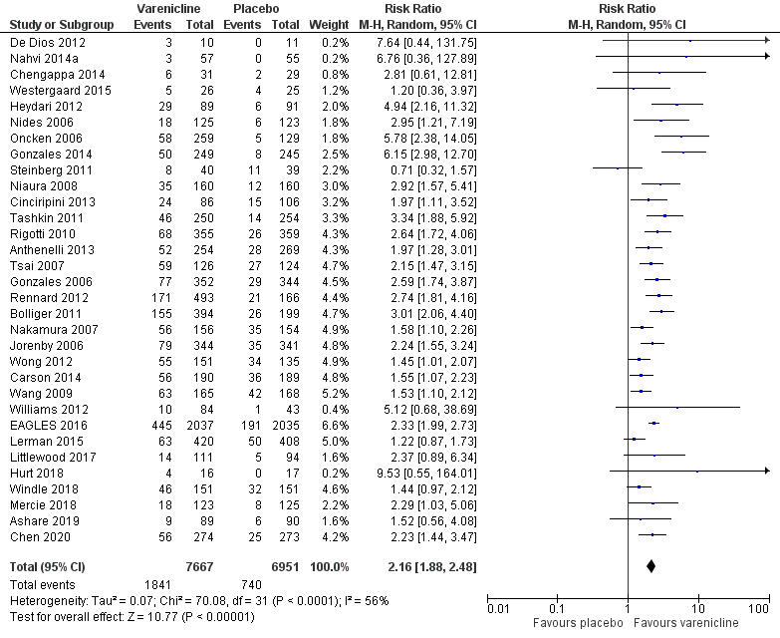
Figure 3: Results of smoking cessation for at least six months follow-up based on updated re-analysis, varenicline versus placebo
Source: Cahill et al. (2016), Lerman et al. (2015), Littlewood et al. (2017), Hurt et al. (2018), Windle et al. (2018), Mercie et al. (2018), Ashare et al. (2019), Chen et al. (2020)
Abbreviations: CI = confidence interval
Note: A sensitivity analysis was conducted during the review by removing Gonzales et al. (2014), a retreatment study in patients who had previously failed varenicline. The results remained statistically significant in favour of varenicline; RR = 2.09 (1.83, 2.39), RD = 0.12 (0.10, 0.15).
Safety
A summary of key adverse events is presented in Table 16. Based on the meta-analysis conducted by Cahill et al. (2016), a significantly higher proportion of patients in the varenicline arm experienced adverse events (nausea, insomnia, abnormal dreams, and headache) and serious adverse events compared to patients in the placebo arm. There were no statistically significant differences between the two treatment arms for depression, suicidal ideation, neuropsychiatric serious adverse events and cardiac serious adverse events. The PBAC had previously considered that varenicline was inferior to placebo with regards to safety. However, the PBAC considered that varenicline was likely to be non-inferior to placebo in terms of neuropsychiatric safety profile based on the EAGLES (2016) study presented in November 2016 (Varenicline PSD, November 2016 PBAC meeting).
In Cahill et al. (2016), studies assessing extended varenicline treatment (i.e. greater than standard 12 weeks therapy) were excluded from the main efficacy analysis but were included in the safety analysis (NCT00828113, Williams 2007, Stein 2013, and Ebbert 2015). As the use of varenicline in these studies was not consistent with the Australian setting, these studies were excluded from the updated re-analysis. In addition, the study by Evins et al. (2014) was excluded because varenicline was administered continuously over 52 weeks.
The results of the updated re-analysis were consistent with the results from Cahill et al. (2016), except for adverse event (headache) and serious adverse events which were no longer statistically significant. The proportion of patients experiencing these events was observed to be numerically higher in the varenicline arm compared to patients in the placebo arm.
Table 16: Summary of key adverse events, varenicline versus placebo
Study | Study type | Previously considered studies included¹ | Varenicline | Placebo | RR (95% CI) | RD (95% CI)
Adverse event – nausea
Cahill  (2016)² | Cochrane Review (32 RCTs) | All studies | 2,207/7,929  (27.8%) | 596/7,034  (8.5%) | 3.27  (3, 3.55) | NR
Updated re-analysis³ | 30 RCTs |  | 2,208/7,543  (29.3%) | 701/6,820  (10.3%) | 2.82  (2.41, 3.30) | 0.19  (0.16, 0.22)
Adverse event - insomnia
Cahill  (2016)² | Cochrane Review (29 RCTs) | All studies except Nakamura (2007) | 976/7,670  (12.7%) | 562/6,777  (8.3%) | 1.49  (1.35, 1.65) | NR
Updated re-analysis³ | 29 RCTs |  | 1,031/7,419  (13.9%) | 667/6,708  (9.9%) | 1.42  (1.27, 1.59) | 0.04  (0.02, 0.05)
Adverse event – abnormal dreams
Cahill  (2016)² | Cochrane Review (26 RCTs) | All studies except Nakamura (2007) and Wang (2009) | 912/7,289  (12.5%) | 365/6,393  (5.7%) | 2.12  (1.88, 2.38) | NR
Updated re-analysis³ | 25 RCTs |  | 1,066/6,936  (15.4%) | 510/6,213  (8.2%) | 1.98  (1.63, 2.41) | 0.07  (0.05, 0.09)
Adverse event – headache
Cahill  (2016)² | Cochrane Review (25 RCTs) | All studies except Tsai (2007) | 894/7,304  (12.2%) | 668/6,531  (10.2%) | 1.17  (1.07, 1.29) | NR
Updated re-analysis³ | 27 RCTs |  | 1,071/7,409  (14.5%) | 855/6,693  (12.8%) | 1.11  (0.99, 1.25) | 0.02  (0.01, 0.03)
Adverse event – depression
Cahill  (2016)² | Cochrane Review (36 RCTs) | All studies except Nakamura (2007) and Wang (2009) | 202/8,537  (%) | 184/7,652  (%) | 0.94  (0.77, 1.14) | NR
Updated re-analysis³ | 36 RCTs |  | 230/7,955  (2.9%) | 208/7,265  (2.9%) | 1.02  (0.86, 1.23) | 0  (-0.00, 0.00)
Adverse event – suicidal ideation
Cahill  (2016)² | Cochrane Review (24 RCTs) | Jorenby (2006), Bolliger (2011), Tashkin (2011), Rennard (2012), EAGLES (2016) | 29/5,905  (%) | 37/5,288  (%) | 0.68  (0.43, 1.07) | NR
Updated re-analysis³ | 24 RCTs |  | 23/5,512  (0.4%) | 28/4,964  (0.6%) | 0.74  (0.43, 1.26) | -0.00  (-0.00, 0.00)
Serious adverse events
Cahill  (2016)² | Cochrane Review (29 RCTs) | All studies | 269/8,125  (3.3%) | 196/7,245  (2.7%) | 1.25  (1.04, 1.49) | NR
Updated re-analysis³ | 28 RCTs |  | 283/7,828  (3.6%) | 242/7,121  (3.4%) | 1.08  (0.91, 1.27) | 0.01  (-0, 0.01)
Serious adverse events – neuropsychiatric (excluding deaths)
Cahill  (2016)² | Cochrane Review (23 RCTs) | All studies except EAGLES (2016) | 41/4,920  (0.8%) | 43/4,035  (1.1%) | 0.82  (0.57, 1.19) | NR
Updated re-analysis³ | 22 RCTs |  | 41/5,027  (0.8%) | 41/4,327  (0.9%) | 0.80  (0.55, 1.18) | 0  (-0, 0)
Serious adverse events – cardiac (including deaths)
Cahill  (2016)² | Cochrane Review (21 RCTs) | All studies except Wang (2009) and EAGLES (2016) | 57/4,696  (1.2%) | 35/3,891  (0.9%) | 1.36  (0.91, 2.04) | NR
Updated re-analysis³ | 22 RCTs |  | 62/7,115  (0.9%) | 42/6,413  (0.7%) | 1.27  (0.85, 1.89) | 0  (0, 0.01)
Source: Cahill et al. (2016), Lerman et al. (2015), Littlewood et al. (2017), Benowitz et al. (2018), Hurt et al. (2018), Mercie et al. (2018), Windle et al. (2018), Ashare et al. (2019), Chen et al. (2020)
Abbreviations: CI = confidence interval; NR = not reported; RCT = randomised controlled trial; RR = risk ratio
Notes: Bold indicates statistically significant difference. See Appendix Figure 56 to Figure 64 for forest plots of the respective outcomes which included the results of individual studies.
1 Where previously considered studies were not included, this was due to the outcome not being reported.
2 Calculated by Cochrane Review authors using a fixed-effect model.
3 Calculated during the review using a random-effect model. Excluded the following studies from updated safety re-analysis due to incorrect treatment duration (NCT00828113, Williams 2007, Stein 2013, Evins 2014, Ebbert 2015; exceeded standard 12 weeks therapy). A sensitivity analysis was conducted during the review by including these studies (as per Cahill 2014) and the results were consistent (in terms of statistical significance) with the updated re-analysis for all outcomes.
Varenicline versus bupropion
A summary of the citation details for the studies comparing varenicline with bupropion is presented in Table 17. Three studies were previously considered by the PBAC (Gonzales et al. 2006, Jorenby et al. 2006 and EAGLES 2016). A recently conducted Cochrane Review by Howes et al. (2020) was identified in the systematic literature review that compared varenicline with bupropion and was included in this report. One new study was identified in the supplemental literature search that informed this comparison and was included in this report (Benowitz et al. 2018).
Table 17: List of studies comparing varenicline with bupropion
Study | Citation
Gonzales (2006)⁸ | Gonzales D, Rennard SI, Nides M, Oncken C, Azoulay S, Billing CB, Watsky EJ, Gong J, Williams KE, Reeves KR, Varenicline Phase 3 Study Group. Varenicline, an α4β2 nicotinic acetylcholine receptor partial agonist, vs sustained-release bupropion and placebo for smoking cessation: a randomized controlled trial. Jama. 2006 Jul 5;296(1):47-55.
Jorenby (2006)⁹ | Jorenby DE, Hays JT, Rigotti NA, Azoulay S, Watsky EJ, Williams KE, Billing CB, Gong J, Reeves KR, Varenicline Phase 3 Study Group. Efficacy of varenicline, an α4β2 nicotinic acetylcholine receptor partial agonist, vs placebo or sustained-release bupropion for smoking cessation: a randomized controlled trial. Jama. 2006 Jul 5;296(1):56-63.
Anthenelli (EAGLES, 2016)¹⁸ | Anthenelli RM, Benowitz NL, West R, St Aubin L, McRae T, Lawrence D, Ascher J, Russ C, Krishen A, Evins AE. Neuropsychiatric safety and efficacy of varenicline, bupropion, and nicotine patch in smokers with and without psychiatric disorders (EAGLES): a double-blind, randomised, placebo-controlled clinical trial. Lancet. 2016 Jun 18;387(10037):2507-20.
Howes (2020)³ | Howes S, Hartmann‐Boyce J, Livingstone‐Banks J, Hong B, Lindson N. Antidepressants for smoking cessation. Cochrane Database of Systematic Reviews 2020, Issue 4. Art. No.: CD000031.
Benowitz (2018)⁴ | Benowitz NL, Pipe A, West R, Hays JT, Tonstad S, McRae T, Lawrence D, St Aubin L, Anthenelli RM. Cardiovascular Safety of Varenicline, Bupropion, and Nicotine Patch in Smokers: A Randomized Clinical Trial. JAMA Intern Med. 2018 May 1;178(5):622-631.
Shaded = previously considered by the PBAC
Notes: Gonzales et al. (2006) and Jorenby et al. (2006) were considered at the July 2007 PBAC meeting. EAGLES (2016) was considered at the November 2016 PBAC meeting.
A summary of the characteristics of the studies comparing varenicline with bupropion is presented in Table 18. A total of 10 RCTs comparing varenicline with bupropion were identified by Howes et al. (2020), with six RCTs included in the primary efficacy analysis. Of the six RCTs, three studies were the studies previously considered by the PBAC (Gonzales et al. 2006, Jorenby et al. 2006 and EAGLES 2016). The characteristics of the individual studies are presented in Appendix Table 147.
Benowitz et al. (2018) was a safety study (non-treatment extension) of EAGLES (Anthenelli et al. 2016) comparing NRT patches (21 mg per day with taper), varenicline (1 mg twice a day), bupropion (150 mg twice a day) and placebo. The study aimed to collect data on cardiovascular safety for all participants in EAGLES (2016) for an additional 28 weeks, allowing for a total of 52 weeks of cardiovascular safety data collection.

Table 18: Characteristics of the studies comparing varenicline with bupropion
Study | Study type | N¹ | Population | Intervention and comparator | Outcomes
Gonzales  (2006) | RCT | N=1025  Varenicline (n=352), Bupropion (n=329) | See Table 14 for inclusion and exclusion criteria of this study. | Varenicline: 0.5 mg/d for Day 1-3, 0.5 mg twice per day for Day 4-7, then 1 mg twice per day through week 12; Bupropion: 150 mg Day 1-3, followed by 150 mg twice per day through week 12.  Behavioural support provided in both arms. | Primary: CAR at Week 9-12. Validated by CO ≤10 ppm.  Secondary: CAR at Week 9-24 and Week 9-52; 7-day PPA at Week 12, 24 and 52. Validated by CO ≤10 ppm.  Other: weight change, withdrawal symptoms (using MNWS, QSU-brief and mCEQ), adverse events.
Jorenby  (2006) | RCT | N=1027  Varenicline (n=344), Bupropion (n=342) | See Table 14 for inclusion and exclusion criteria of this study. | Varenicline: 0.5 mg/d for Day 1-3, 0.5 mg twice per day for Day 4-7, then 1 mg twice per day through week 12; Bupropion: 150 mg twice daily including titration through week 12.  Behavioural support provided in both arms. | Primary: CAR at Week 9-12. Validated by CO ≤10 ppm.  Secondary: CAR at Week 9-24 and Week 9-52; 7-day PPA at Week 12, 24 and 52. Validated by CO ≤10 ppm.  Other: weight change, withdrawal symptoms (using MNWS, QSU-brief and mCEQ), adverse events.
Anthenelli (EAGLES, 2016) | RCT | N=8,144  Varenicline (n=2,037), Bupropion (n=2,034) | See Table 14 for inclusion and exclusion criteria of this study. | Varenicline: 1 mg twice daily titrated over 12 weeks (i.e. 0.5 mg once daily for 3 days, then 0.5 mg twice daily for 4 days, then 1mg twice daily);  Bupropion: 150 mg twice daily including titration over 12 weeks.  Behavioural support provided in both arms. | Primary: safety including adverse events.  Primary efficacy: CAR at Week 9-12. Validated by CO ≤10 ppm.  Secondary efficacy: CAR at Week 9-24. 7-day PPA at all visits. Validated by CO ≤10 ppm.
Howes (2020) | Cochrane Review  (10 RCTs²) | Efficacy  (6 RCTs)  N=6,286  Varenicline (n=3,190),  Bupropion (n=3,096) | Inclusion: tobacco smokers of any age, with or without a history of mental illness.  Exclusion: pregnant women and trials investigating use for smoking harm reduction or relapse prevention. | Varenicline: 1 mg twice daily including titration (i.e. 0.5 mg once daily for 3 days, then 0.5 mg twice daily for 4 days, then 1 mg twice daily);  Bupropion: 150 mg twice daily including titration (i.e. 150 mg once daily for 3 days, then 150 mg twice daily). | Primary: smoking cessation rates of at least six months after baseline.  Secondary: safety including any adverse events, psychiatric adverse events, serious adverse events and dropouts due to adverse events.
Benowitz (2018) | Non-treatment extension safety study of EAGLES (2016)³ | N=4,595  Varenicline (n=1,192), Bupropion (n=1,166) | Inclusion: 18-75 years old, ≥10 cigarettes per day, interested in quitting smoking, had been randomised to treatment in and had completed the week 24 visit of EAGLES.  Exclusion: unstable psychiatric illness, active substance abuse, clinically significant CVD in the 2 months prior to study entry, clinically significant cerebrovascular disease in the 2 months prior to study entry, or inadequate control of hypertension. | No treatment was provided during this study. Prior varenicline and bupropion treatments were administered in EAGLES (2016). | Primary: Time to major adverse cardiovascular event.  Secondary: Occurrence of major adverse cardiovascular event.
Abbreviations: CAR = continuous abstinence rate; CO = carbon monoxide; mCEQ = modified Cigarette Evaluation Questionnaire; MNWS = Minnesota Tobacco Withdrawal Scale; NRT = nicotine replacement therapy; PPA = point prevalence abstinence; QSU = Questionnaire of Smoking Urges; RCT = randomised controlled trial
Shaded = previously considered by the PBAC
1 Only the number of patients (n) in the relevant arms were included.
2 A total of 10 RCTs comparing varenicline with bupropion were identified. Of the 10 RCTs, 6 RCTs were included in the primary efficacy analysis. The characteristics of the individual studies comparing varenicline with bupropion included in Howes et al. (2020) are presented in Appendix Table 147. Three studies previously considered by the PBAC (Gonzales et al. 2006, Jorenby et al. 2006 and Anthenelli et al. 2016) were included in the primary efficacy analysis of Howes et al. (2020).
3 Benowitz et al. (2018) was a non-treatment extension of EAGLES (Anthenelli et al. 2016) with a considerable amount of missing data due to lost to follow-up, extension study nonenrollees, no longer willing to participate and death.

Efficacy
A summary of the smoking cessation rates for at least six months follow-up comparing varenicline with bupropion is presented in Table 19. The results of Jorenby et al. (2006) and EAGLES (2016) demonstrated a statistically significant difference in continuous abstinence rate, in favour of varenicline. However, there was no statistically significant difference between the two treatment arms in Gonzales et al. (2006), although the results numerically favoured varenicline. In July 2007 and November 2016, the PBAC considered that varenicline was superior to bupropion (Varenicline PSD, July 2007 and November 2016 PBAC meetings). The meta-analysis comprising Gonzales et al. (2006) and Jorenby et al. (2006) presented in the July 2007 submission demonstrated a statistically significant difference in continuous abstinence rate from Weeks 9 to 52, in favour of varenicline (RR: 1.43; 95% CI: 1.14, 1.79).
Based on the Cochrane Review by Howes et al. (2020), the results of the meta-analysis comprising six RCTs demonstrated a statistically significant difference in long-term smoking cessation rates, in favour of varenicline.
Table 19: Results of smoking cessation for at least six months follow-up, varenicline versus bupropion
Study | Study type | Varenicline | Bupropion | RR (95% CI) | RD (95% CI)
Gonzales (2006)¹ | RCT | 77/352  (21.9%) | 53/329⁵  (16.1%) | 1.36  (0.99, 1.86) | 0.06  (-0, 0.12)
Jorenby (2006)¹ | RCT | 79/344  (23.0%) | 50/342⁵  (14.6%) | 1.57  (1.14, 2.17) | 0.08  (0.03, 0.14)
Anthenelli (EAGLES, 2016)² | RCT | 445/2,037  (21.8%) | 330/2,034  (16.2%) | 1.35  (1.18, 1.53) | 0.06  (0.03, 0.08)
Howes  (2020)^{3,4} | Cochrane Review (6 RCTs) | 677/3,190  (21.2%) | 474/3,096  (15.3%) | 1.40  (1.25, 1.55) | 0.06  (0.04, 0.08)
Source: Howes et al. (2020)
Abbreviations: CI = confidence interval; RCT = randomised controlled trial; RR = risk ratio
Shaded = previously considered by the PBAC
Notes: Bold indicates statistically significant difference.
1 Continuous abstinence rate at 12 months (Week 9-52).
2 Continuous abstinence rate at 6 months (Week 9-24).
3 Where cessation was assessed at multiple intervals, the longest follow-up data were used. Where multiple definitions of abstinence were assessed, the strictest of these definitions was used (e.g. continuous/prolonged abstinence over point prevalence abstinence). See Appendix Table 147 for the definition used in each study. Studies previously considered by the PBAC were included in the meta-analysis of Howes et al. (2020).
4 Howes et al. (2020) presented this comparison as bupropion versus varenicline (inverse) using a fixed-effect model. Re-calculated during the review for varenicline versus bupropion using a random-effect model.
5 The number of events (n) reported in Howes et al. (2020) differed from the numbers stated in the Varenicline PSD (2007); (Gonzales 2006, n=53 versus 54; Jorenby 2006, n=50 versus 51). The numbers reported in Howes et al. (2020) were used as these numbers corresponded with the percentages reported in the key publications.
The results of the individual studies included in Howes et al. (2020) are presented using a forest plot in Figure 4.
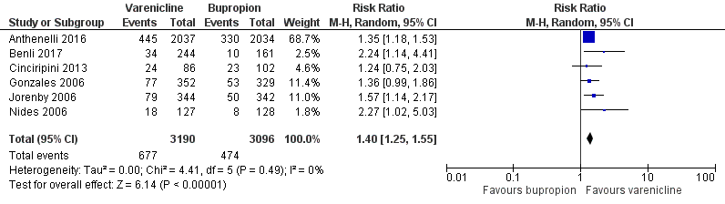
Figure 4: Results of smoking cessation for at least six months follow-up in Howes et al. (2020), varenicline versus bupropion
Source: Howes et al. (2020)
Abbreviations: CI = confidence interval
Note: Howes et al. (2020) presented this comparison as bupropion versus varenicline (inverse) using a fixed-effect model. Re-calculated during the review for varenicline versus bupropion using a random-effect model.

Safety
A summary of key adverse events comparing varenicline with bupropion is presented in Table 20. Based on the meta-analysis conducted by Howes et al. (2020), there were no statistically significant differences between varenicline and bupropion in terms of any adverse events, psychiatric adverse events, serious adverse events and discontinuation due to adverse events. The PBAC had previously considered that varenicline was non-inferior to bupropion with regards to safety (Varenicline PSD, November 2016 PBAC meeting).
Table 20: Summary of key adverse events, varenicline versus bupropion
Study | Study type | Previously considered studies included¹ | Varenicline | Bupropion | RR (95% CI) | RD (95% CI)
Adverse events
Howes  (2020)² | Cochrane Review (5 RCTs) | Gonzales (2006) and EAGLES (2016) | 2,335/3,062  (76.3%) | 1,997/2,718  (73.5%) | 1.03  (1.00, 1.06) | 0.02  (-0, 0.04)
Psychiatric adverse events
Howes  (2020)² | Cochrane Review (2 RCTs) | EAGLES (2016) | 724/2,031  (35.6%) | 771/2,020  (38.2%) | 0.93  (0.86, 1.01) | -0.02  (-0.05, 0)
Serious adverse events
Howes  (2020)² | Cochrane Review (4 RCTs) | EAGLES (2016) | 42/2,494  (1.7%) | 55/2,248  (2.4%) | 0.73  (0.49, 1.08) | -0.01  (-0.01, 0)
Discontinuation due to adverse events
Howes  (2020)² | Cochrane Review (6 RCTs) | Gonzales (2006), Jorenby (2006) and EAGLES (2016) | 328/3,186  (10.3%) | 281/2,917  (9.6%) | 0.90  (0.74, 1.09) | -0.01  (-0.03, 0.01)
Source: Howes et al. (2020)
Abbreviations: CI = confidence interval; RCT = randomised controlled trial; RR = risk ratio
Notes: Bold indicates statistically significant difference. See Appendix Figure 65 to Figure 68 for forest plots of the respective outcomes which included the results of individual studies.
1 Where previously considered studies were not included, this was due to the outcome not being reported.
2 Howes et al. (2020) presented this comparison as bupropion versus varenicline (inverse) using a fixed-effect model. Re-calculated during the review for varenicline versus bupropion using a random-effect model.
In a recently conducted study (EAGLES extension) comparing the relative cardiovascular safety risk of smoking cessation treatments using a placebo comparator, no significant treatment differences were observed in time to cardiovascular events, blood pressure, or heart rate between varenicline and bupropion (Benowitz et al. 2018).

Nicotine replacement therapy
Nicotine replacement therapy (NRT) patches 15 mg per 16 hours were recommended for listing on the PBS in March 2008 for the Aboriginal and Torres Strait Islander population '''''''''''' ''''' ''' ''''''''''''''''' ''''''''''''''' ''''''''''' '''' '''' ''''''''''' ''''''' '''''''''' ''''''''''''''''''''''''''''''' ''''''''''''' ''''''''''' '''' ''''' '''''''''' '''''''''' ''''' ''''' '''''''''' ''''''' '''''''''''''' '''' ''''' ''''''''''''' ''''''' ''''''''''''''''''''''''''''''''''' '''''''''''' '''''''' '''' ''''''' ''''''''' '''''' ''''''''''''''''''''''''''' '''''''''''' '''' '''''''''''''' ''''''''''''' ''''' '''''''''''''''''''''''''' ''''''''''' '''''' ''''''' '''''''''''''''''' ''''''' ''''''''''' ''''''''' ''''''''''''''' ''''''''''''''''''''' ''''''' ''''''''''''''''''''' ''''' ''''''' ''''''''' '''''''''' '''' ''''''' '''''''''''''''''''''' ''''''' ''''''''''' '''''''''''' ''''''' ''''''' '''''''''''''''''' ''''''' ''''''''''''' ''''''''' '''''''''''''' '''''''''''''''''''''' '''''''''''''''''' ''''''' ''''' '''''' ''''''''''''''''''' '''''''' ''''''' ''''''' ''''''' '''''''''''''''''''' ''''''''''' '''''''''''''''''''' ''''''' ''''''' ''''''''' ''''''''''''''''''''''''' ''''''''''''' ''''''''''' '''''''''''' '''''''' '''''''''''' '''''''''''''''''''''' '''' ''''''' '''''''''''''''''''''' ''''''''' '''''''''''''''''''''''' '''''''''''''''' '''''''''''' '''''''''' ''''''''''' '''''''''''''''''''' The listing allowed Aboriginal and Torres Strait Islander for a maximum of two courses of PBS-subsidised NRT per year.
General population
In March 2010, the PBAC recommended the listing of NRT patches 15 mg per 16 hours on the PBS as an Authority Required listing as an aid to cessation of smoking in patients who have entered or are entering a comprehensive support and counselling program in the context of a public health priority area. One study comparing NRT patches with varenicline (Aubin et al. 2008), four studies comparing NRT patches with bupropion (Jorenby et al. 1999, Gorecka et al. 2003, Uyar et al. 2007 and Piper et al. 2009) and one Cochrane Review comparing NRT with placebo (Stead et al. 2008) were considered by the PBAC at this meeting.
Based on the totality of the evidence, the PBAC considered that the claim of non-inferiority of NRT patches to varenicline to be uncertain with the evidence suggesting that varenicline was more effective and more toxic, that the evidence supported NRT patches being more effective and less safe than placebo, and that NRT patches were of non-inferior efficacy to bupropion and of superior safety (NRT PSD, March 2010 PBAC meeting). The listing allowed for a maximum of 12 weeks of PBS-subsidised NRT treatment per year.
It was noted that the listing was implemented in February 2011 and was for the 21 mg per 24 hours NRT patches. The PBAC previously noted that the use of different strength patches such as 21 mg for 24 hours or 15 mg for 16 hours, and gradual tapering compared with abrupt withdrawal, are likely to result in minimal changes in clinical outcomes (NRT PSD, March 2010 PBAC meeting).
Lower strength – 14 mg per 24 hours and 7 mg per 24 hours NRT patches
In August 2011, the PBAC recommended the listing of two new lower strength NRT patches that release approximately 14 mg of nicotine per 24 hours and approximately 7 mg nicotine per 24 hours '''''''''' '''''''''''''''''''''' ''''''''''''''''' ''''''''''''' '''''''''' ''''''''' ''''''''''''''''' The listing allowed for a maximum of 12 weeks of PBS-subsidised NRT treatment per year.
Higher strength – 25 mg per 16 hours NRT patches
In November 2011, the PBAC recommended the listing of a 25 mg per 16 hours NRT patches on the PBS as an Authority Required benefit under the same listing conditions as 21 mg per 24 hours NRT patches (PBAC Outcomes, November 2011 PBAC meeting). '''' ''''''' ''''''''' '''''' ''''' '''''' ''''''' '''''' '''''''''''' '''''''' ''''''''''''''' '''''''''' ''''''' '''''''''''''''' ''''' ''''''' '''''''''''''''''''' ''''''' ''''''''''' '''''''''' ''''''''''''''' '''''''''''''''''''' '''''''' ''''''''' ''''''''''''''''''''' '''''''' '''''''''''''''' '''''''' '''''''''''''' '''''''''''''''''''' '''' ''''' ''''''''''' '''''''''' '''''''' ''''''''''''''''''' ''''' ''''''' ''''''''' '''' ''''''' '''''''''''''''' '''''''' '''''''''''''''''' ''''''''''' '''''''' '''''' '''''''''''''''''''''' '''''''''' '''''''''''''''''''' '''''''''''' '''''''''''' '''''' ''''''' '''''''''' ''''''' '''''''''''''''''''''' '''' ''''''' '''''' '''''' ''''''' ''''' '''''''''' ''''''''''''''''' ''''''''''' ''''''''''''''''''''''''' ''''''''''''''' ''''''''''''''''''' '''' ''''''' ''''''''''''' '''''''''''''''''''''' '''''''' ''''''' '''''''''''''''''' ''''''' ''''''''''''' '''''''''' '''''''''''''' '''''''''''''''''''' ''''''''' ''''' ''''''' '''''' '''''' ''''''''''' '''''''''''''''' ''''''''''''''''''''''''''''' '''' ''''''''''' ''''''''' '''''' ''''''''''''' '''''''''''''''''' ''''''''' ''''''''''''''''''''''''' ''''''''''' '''' '''''' '''''' '''''' ''''' '''''''''' '''''''''''''''''' ''' '''''''' ''''''''''''''' ''''''''' '''''' '''''''''''''''''''''' ''''''''' '''''''''' ''''''''''''''''''''''''''''''' ''''''''''''' ''''''' '''''''''' ''''' '''''' ''''''''''''''''''''' '''''''' '''''''''''' '''''''''' ''''''''''''''' ''''''''''''''''''''' ''''''''' '''''''''''''' '''''''''''''''''' '''''''''''''''''''' ''''''''' ''''''''''' ''''''''''''''''''
Authority Required (STREAMLINED) listing
In December 2012, the PBAC recommended the Authority required listings for NRT patches be made Authority required (STREAMLINED) ''''''''''' '''''' ''''''' '''''''''''''''' '''' '''''' '''''''''''''''' '''''''''' '''''''''' ''''''''''''''''''''' '''''''''''''''''''''''''''''' ''''''''''''' '''''''''''' '''' ''''''''' ''''''''''''''''''' '''''''''' '''''''''''''' '' ''''''''''' '''''''''' '''''''''''''''' ''''''''''''''''''' ''''' '''''' ''''''''''''' ''''''''' ''' '''''''''''''''''' ''''''''''' ''''' ''''' ''''''''''''''''' ''''''''' '''''''''' '''''''''''''''' '''''''''''''''''' ''''''''''''''''''''' ''''''''''' '''''''''' ''''''''''''''''
'''''''' ''''''''''' '''''''''''''''''''''''''''''' '''''''' '''''' '''''''''''''''''''' ''''''''''''''' ''''' ''''''''''''''''''' '''' ''''''''''''' '''''''''''''' ''''' '''''' '''''''''''''' '''''''' '''''''''''''''''''' '''''''''''''''' '''''''''''''''''''''''''''''' ''''' ''''''' ''''''''''''' ''''' ''''' ''''''''''''''''''''''''' '''' ''''''' ''''''''''''''' '''''''''''''''' ''''''''''''''' '''' '''''''''''''''' ''''''' ''''''''' ''''''''''''''''''''''''''' ''''''' ''''''''''''''''''''' ''''''''''''''' ''''''''''''''' ''''''''''''''''''''' ''''' ''' ''''''''''''''''' '''' ''''' ''''''''''' '''' '''''''''''''''''''''''''''' '''''''' '''''''' '''''''''' ''''' '''''''''''''''' '''' '''''''' ''''''''''''''''''' ''''''''''''' '''' '''''''''''''''' ''''''''''''' ''''''' ''''''''' '''''''' ''''''''''''''''''''''''''' '''''''' ''' '''''''''''''''''''' '''' ''' '''''''''''''' '''''''''''''' ''''' '''''''''''''''' '''' ''''''' '''''''''''''' ''''' ''''''''' '''''''''''''''''' '''''''' '''''''''''' ''''''''' '''''''''''''''' '''''''''''''''''
'''' '''''''''''''''''''''' ''''''''''' ''''''' '''''''''' ''''''''''''''''''''''''''' '''''' '''''''''''''''''''''' ''''''''''' ''''' ''''''''''''' '''' ''''''' '''''''''''''''''''''' '''''''''' ''''''''' ''''''''''''''''''''''''''''''''''' '''''' ''''' ''''''' ''''''' '''''' '''''''''''' '''''''''''''' '''''''' '''''''''''''''' '''' ''''''''''''' '''''' '''''''''''''''''''' '''''''' '''''''''''' '''''''''' '''''''''''''''' '''''''''''''''''''''' '''''''''' '''''''''''''' ''''''''''''''''' '''''''''''''''''''''' ''''''''' ''''''''' '''''''''''''''''
NRT lozenge and gum
In July 2017 and March 2018, the PBAC considered a request that NRT lozenges and gum be listed as monotherapies on the PBS as a restricted benefit for treating nicotine dependence in cigarette smokers who wish to quit and enter into a behavioural support program. In March 2018, the PBAC recommended the listing of nicotine lozenges and gum, as monotherapies on the PBS (NRT PSD, July 2017 and March 2018 PBAC meetings).
For the comparison of NRT lozenges with NRT patches, three direct head-to-head RCTs were considered by the PBAC (Piper et al. 2009, Smith et al. 2009 and Schnoll et al. 2010). ''''''''''' ''''''' ''''''''''''''''''''' '''''' '''''' ''''''' ''''''''' '''''''''' '''''''''''''''''' ''' '''''''' ''''''''''' '''''''''' '''''''' ''''''''''''''''' ''''''''''''''''''''' ''''''' '''''''''''''''''' ''''''''' ''''''''' '''''''''' '''''''''''' ''''''' '''''''''' '''' ''''''''''''' ''''' '''''''''''''''''''' ''''''''''''''' '''''''''''''''''''''' '''''''''''''''''' ''''''''' ''''''''''''''' ''''''' '''''''' ''''''''''''''' '''''''''' '''''''' ''''''''' '''' '''''' ''''''''''''''''' ''''''''''''''''''''''' ''''''''' ''''''''''''''''''''''''''' ''''''' '''''''''' '''''''''' '''''''''''''''''' For the comparison of NRT gum with NRT patches, an indirect comparison was conducted using control as a common reference. The studies of NRT gum versus control (n=56) and NRT patches versus control (n=54) were based on a meta-analysis from a Cochrane Review (Stead et al. 2012), which was updated in the submission with an additional 11 studies comparing NRT patches with control. A single direct RCT of NRT gum versus patches (Moolchan et al. 2005) was identified by the submission and was considered to provide inadequate evidence for the relative efficacy and safety of NRT gum to patches (NRT PSD, July 2017 PBAC meeting). The PBAC considered that on balance, despite the absence of a non-inferiority margin, the submission’s overall claim of non-inferiority in terms of comparative efficacy and safety for NRT lozenges and gum compared with NRT patches, was reasonable (NRT PSD, July 2017 and March 2018 PBAC meetings).
NRT patch versus placebo
A summary of the citation details for the studies comparing NRT patches with placebo is presented in Table 21. ''''''''' Cochrane Reviews comprising studies that compared NRT patches with placebo ''''''''''''' '''' ''''' ''''''''' ''''''' Stead et al. 2008) and '''''''' '''''''' '''''''''''''''''''' ''''''''''' ''''''''''' ''''' ''''''' '''''''''''''' '''''''' ''''''''''''''' '''''''''''''' ''''''''''' were previously considered by the PBAC. A recently conducted Cochrane Review by Hartmann-Boyce et al. (2018) was identified in the systematic literature review that compared NRT patches with placebo and was included in this report. One new study was identified in the supplemental literature search that informed this comparison and was included in this report (Benowitz et al. 2018).
Hartmann-Boyce et al. (2018) was an updated review of '''''''''''' '''' ''''' ''''''''''' ''''''' Stead et al. (2008). This review was first published over 20 years ago, in 1996, and has been regularly updated since. In previous versions, this review addressed not only the effect of NRT in comparison to placebo for helping people stop smoking, but also looked at comparisons between different forms and doses of NRT, and between NRT and different pharmacotherapies. Hartmann-Boyce et al. (2018) have split the previous version of this review on the basis that the evidence of NRT in smoking cessation is well established and many clinical guidelines recommend NRT as a first-line treatment for people seeking pharmacological help to stop smoking. This updated review now only looks at NRT versus placebo or no pharmacotherapy, with the intention that, given the stability of this comparison, this review will no longer require regular updates.
Table 21: List of studies comparing NRT patch with placebo
Study | Citation
Tonnesen  (CEASE, 1999)²⁷ | Tønnesen P, Paoletti P, Gustavsson G, Russell MA, Saracci R, Gulsvik A, Rijcken B, Sawe U. Higher dosage nicotine patches increase one-year smoking cessation rates: results from the European CEASE trial. Collaborative European Anti-Smoking Evaluation. European Respiratory Society. Eur Respir J. 1999 Feb;13(2):238-46.
Silagy  (2004)²⁸ | Silagy C, Lancaster T, Stead LF, Mant D, Fowler G. Nicotine replacement therapy for smoking cessation. Cochrane Database of Systematic Reviews 2004, Issue 3. Art. No.: CD000146.
Stead  (2008)²⁹ | Stead LF, Perera R, Bullen C, Mant D, Lancaster T. Nicotine replacement therapy for smoking cessation. Cochrane Database of Systematic Reviews 2008, Issue 1. Art. No.: CD000146.
Hartmann-Boyce  (2018)³⁰ | Hartmann‐Boyce J, Chepkin SC, Ye W, Bullen C, Lancaster T. Nicotine replacement therapy versus control for smoking cessation. Cochrane Database of Systematic Reviews 2018, Issue 5. Art. No.: CD000146.
Benowitz  (2018)⁴ | Benowitz NL, Pipe A, West R, Hays JT, Tonstad S, McRae T, Lawrence D, St Aubin L, Anthenelli RM. Cardiovascular Safety of Varenicline, Bupropion, and Nicotine Patch in Smokers: A Randomized Clinical Trial. JAMA Intern Med. 2018 May 1;178(5):622-631.
Notes: ''''''''''' '''' '''' ''''''''''' ''''''' ''''''''''''''''''''' '''' ''''''' ''''''''''' ''''''''' '''''''''' ''''''''''''''''. Stead et al. (2008) was considered at the March 2010 PBAC meeting. ''''''''''''' ''''''''''' ''''''' ''''''''''''''''''''' '''' '''''' '''''''''''''''''' ''''''''' '''''''''' ''''''''''''''''''
A summary of the characteristics of the studies comparing NRT patches with placebo is presented in Table 22. A total of 51 RCTs comparing NRT patches with placebo were identified by Hartmann-Boyce et al. (2018). Of these, 39 RCTs were studies included in ''''''''''''' '''' ''''''' ''''''' Cochrane Reviews previously considered by the PBAC (''''''''''' ''''' ''''' ''''''''' and Stead et al. 2008). ''''''''''''' '''''''''''''' '''''''' ''''''''''''''' '''' ''''''' ''''''''''''' '''''''''''''''' ''''''''''''' '''' '''''''''' '''' ''''' '''''''''''''' ''''''' ''''''''''' '''' ''''' '''''''''''' '''''' '''''' ''''''''''''''''''''''''''''' '''' ''''' '''''''''''' ''''''''''' '''''''''''''' ''''''' ''''''''''''''' '''' '''''' '''''''''' ''''''''''''''' '''' '''''''''''''''''''''''''''''''''' '''' ''''' ''''''''''''' The characteristics of the individual studies are presented in Appendix Table 148.
Benowitz et al. (2018) was a safety study (non-treatment extension) of EAGLES (Anthenelli et al. 2016) comparing NRT patches (21 mg per day with taper), varenicline (1 mg twice a day), bupropion (150 mg twice a day) and placebo. The study aimed to collect data on cardiovascular safety for all participants in EAGLES (2016) for an additional 28 weeks, allowing for a total of 52 weeks of cardiovascular safety data collection.

Table 22: Characteristics of the studies comparing NRT patch with placebo
Study | Study type | N¹ | Population | Intervention and comparator | Outcomes
Tonnesen  (CEASE, 1999) | RCT | N=3,575  NRT patch (n=2,861),  Placebo (n=714) | Inclusion: 20-70 years old, >14 cigarettes per day for at least 3 years, motivated to stop smoking, made at least one prior quit attempt.  Exclusion: myocardial infarction in the preceding 3 months; unstable angina, severe cardiac arrhythmia, pregnant or lactating females, under psychiatric care or medication, alcohol or any other drug abuse, eczema, severe or malignant disease, existing use of nicotine substitution products and/or participation in formal smoking cessation programmes in the last 6 months. | NRT: 2 patch doses and 2 treatment durations. (1) 25 mg for 28 weeks, (2) 25 mg for 12 weeks, (3) 15 mg for 28 weeks, (4) 15 mg for 12 weeks; Placebo: placebo patch for 26 weeks. Behavioural support provided in both arms. | Primary: prolonged abstinence at 12 months (from Week 2). Validated by CO ≤10 ppm.  Secondary: withdrawal symptoms, compliance, body weight change, adverse events.
Silagy (2004) | Cochrane Review (38 RCTs²) | N=16,691  NRT patch (n=10,216),  Placebo (n=6,475) | Inclusion: men or women who smoked and were motivated to  quit, irrespective of the setting from which they were recruited  or their initial level of nicotine dependence, or both.  Exclusion: trials that randomised physicians or other therapists to receive an educational intervention, which included encouraging their patients to use NRT. | NRT: NRT patch; Placebo: placebo or no NRT control. | Primary: smoking cessation rates of at least six months after baseline.
Stead  (2008) | Cochrane Review (41 RCTs²) | N=18,237  NRT patch (n=10,963),  Placebo (n=7,274) | Same inclusion and exclusion criteria as Silagy (2004). | NRT: NRT patch; Placebo: placebo or no NRT control. | Primary: smoking cessation rates of at least six months after baseline.
Hartmann-Boyce (2018) | Cochrane Review (51 RCTs²) | N=25,754  NRT patch (n=13,773),  Placebo (n=11,981) | Same inclusion and exclusion criteria as Silagy (2004). | NRT: NRT patch; Placebo: placebo or no NRT control. | Primary: smoking cessation rates of at least six months after baseline.  Secondary: adverse event including palpitations/chest pains.
Benowitz (2018) | Non-treatment extension safety study of EAGLES (2016)³ | N=4,595  Bupropion (n=1,166), Placebo (n=1,121) | Inclusion: 18-75 years old, ≥10 cigarettes per day, interested in quitting smoking, had been randomised to treatment in and had completed the week 24 visit of EAGLES.  Exclusion: unstable psychiatric illness, active substance abuse, clinically significant CVD in the 2 months prior to study entry, clinically significant cerebrovascular disease in the 2 months prior to study entry, or inadequate control of hypertension. | No treatment was provided during this study. Prior NRT and placebo treatments were administered in EAGLES (2016). | Primary: Time to major adverse cardiovascular event.  Secondary: Occurrence of major adverse cardiovascular event.
Abbreviations: NRT = nicotine replacement therapy; RCT = randomised controlled trial
1 Only the number of patients (n) in the relevant arms were included.
2 The characteristics of the individual studies comparing NRT patch with placebo (or no NRT control) included in Hartmann-Boyce et al. (2018) are presented in Appendix Table 148. ''''''''' Cochrane reviews were previously considered by the PBAC ('''''''''''' '''' ''''' '''''''''' ''''''' Stead et al. 2008). Three studies in '''''''''''' '''' ''''' ''''''''''' ''''''' Stead et al. (2008) were excluded from the primary efficacy analysis of Hartmann-Boyce et al. (2018).
3 Benowitz et al. (2018) was a non-treatment extension of EAGLES (Anthenelli et al. 2016) with a considerable amount of missing data due to lost to follow-up, extension study nonenrollees, no longer willing to participate and death.

Efficacy
A summary of the smoking cessation rates for at least six months follow-up comparing NRT patches with placebo is presented in Table 23. The results of ''''''''''' '''''''''''' and the meta-analysis by '''''''''' ''''' '''' ''''''''''' ''''''' Stead et al. (2008) demonstrated a statistically significant difference in long-term smoking cessation rates, in favour of NRT patches. Similarly, the results of the meta-analysis comprising 51 RCTs based on the updated Cochrane Review by Hartmann-Boyce et al. (2018) demonstrated a statistically significant difference in long-term smoking cessation rates, in favour of NRT patches.
Table 23: Results of smoking cessation for at least six months follow-up, NRT patch versus placebo
Study | Study type | NRT patch | Placebo | RR (95% CI)
Tonnesen  (CEASE, 1999)¹ | RCT | 406/2,861  (14.2%) | 71/714  (9.9%) | 1.43  (1.12, 1.81)
Silagy  (2004)² | Cochrane Review (38 RCTs) | 1,493/10,216  (14.6%) | 555/6,475  (8.6%) | 1.81  (1.63, 2.02)
Stead  (2008)² | Cochrane Review (41 RCTs) | 1,734/10,963  (15.8%) | 718/7,274  (9.9%) | 1.66  (1.53, 1.81)
Hartmann-Boyce  (2018)^{2,3} | Cochrane Review (51 RCTs) | 2,160/13,773  (15.7%) | 1,131/11,981  (9.4%) | 1.64  (1.53, 1.75)
Source: Hartmann-Boyce et al. (2018), Stead et al. (2008) ''''''' ''''''''''' '''' ''''' ''''''''''''
Abbreviations: CI = confidence interval; RCT = randomised controlled trial; RD = risk difference; RR = risk ratio
Notes: Bold indicates statistically significant difference.
''' ''''''''''''''''''''' '''''''''''''''''''''' '''' ''''' ''''''''''''''''' '''''''''' '''' ''''' '''''''''''' '''''''' '''''''''' '''' ''''' ''''''''''''' '''''''''''' '''''' '''''''' ''''''''' '''' '''''''' '''''''''''''''''
2 Where cessation was assessed at multiple intervals, the longest follow-up data were used. Where multiple definitions of abstinence were assessed, the strictest of these definitions was used (e.g. continuous/prolonged abstinence over point prevalence abstinence). See Appendix Table 148 for the definition used in each study.
3 Calculated by Cochrane Review authors using a fixed-effect model
The results of the individual studies included in Hartmann-Boyce et al. (2018) are presented using a forest plot in Figure 5. Of the 51 RCTs in Hartmann-Boyce et al. (2018), 39 RCTs were studies included in '''''''''''' ''''' '''''' ''''''' Cochrane reviews previously considered by the PBAC '''''''''''' '''' ''''' '''''''''' '''''''' Stead et al. 2008).
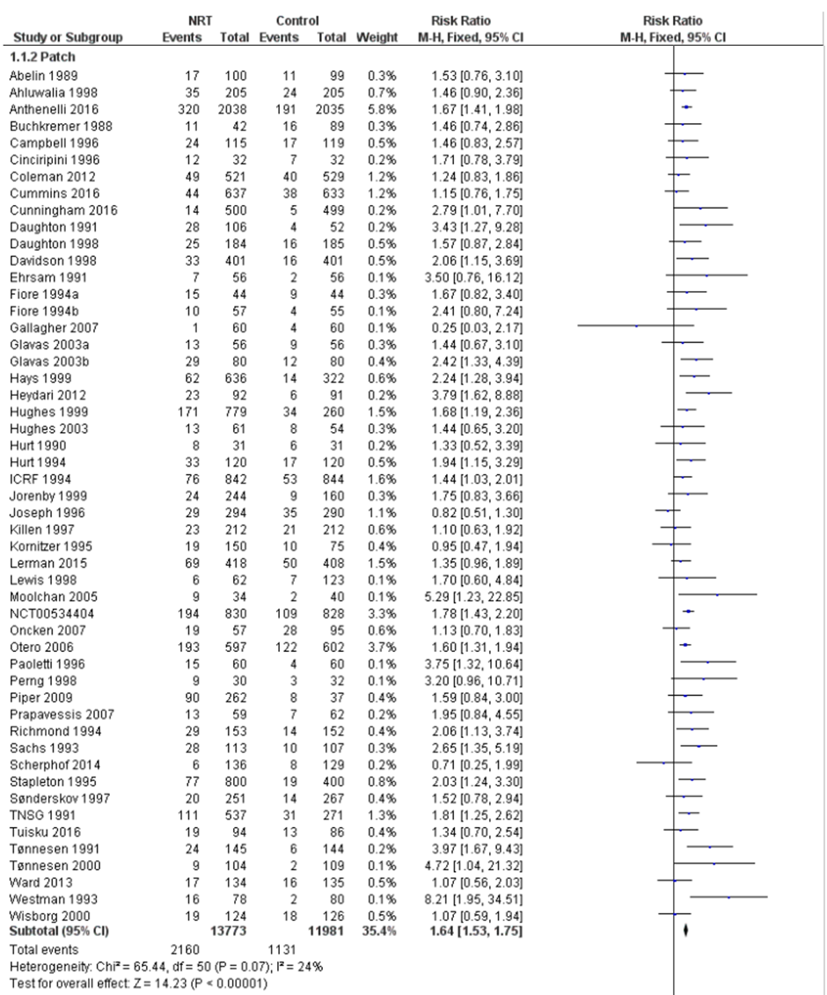
Figure 5: Results of smoking cessation for at least six months follow-up in Hartmann-Boyce et al. (2018), NRT patch versus placebo
Source: Hartmann-Boyce et al. (2018)
Abbreviations: CI = confidence interval
Hartmann-Boyce et al. (2018) also performed meta-analyses comparing NRT gum versus placebo and NRT tablets/lozenges versus placebo. The results of these comparisons are presented in Table 24 for information purposes. The results of the meta-analyses demonstrated a statistically significant difference in long-term smoking cessation rates, in favour of NRT irrespective of the type of formulation.
Two new studies comparing NRT gum or lozenges with placebo were identified in the supplemental literature search and were included in the updated re-analysis for this comparison (Shiffman et al. 2020, NRT gum versus placebo; Xiao et al. 2020, NRT lozenges versus placebo). The results of the updated re-analysis were consistent with the results from Hartmann-Boyce et al. (2018).
Table 24: Results of smoking cessation of at least six months follow-up in Hartmann-Boyce et al. (2018) and updated re-analysis, different NRT formulations versus placebo
Formulation | No. of studies | NRT | Placebo | RR (95% CI) | RD (95% CI)
NRT patch | Cochrane Review  (51 RCTs)¹ | 2,160/13,773  (15.7%) | 1,131/11,981  (9.4%) | 1.64  (1.53, 1.75) | NR
NRT gum | Cochrane Review  (56 RCTs)¹ | 1,732/10,596  (16.3%) | 1,196/11,985  (10.0%) | 1.49  (1.40, 1.60) | NR
 | Updated re-analysis (57 RCTs)² | 1,745/10,777  (16.2%) | 1,206/12,173  (9.9%) | 1.49  (1.35, 1.64) | 0.05  (0.04, 0.07)
NRT tablets/ lozenges | Cochrane Review  (8 RCTs)¹ | 488/2,326  (21.0%) | 273/2,113  (12.9%) | 1.52  (1.32, 1.74) | NR
 | Updated re-analysis (9 RCTs)² | 533/2,687  (19.8%) | 312/2,475  (12.6%) | 1.62  (1.24, 2.10) | 0.06  (0.04, 0.09)
Source: Hartmann-Boyce et al. (2018), Shiffman et al. (2020), Xiao et al. (2020)
Abbreviations: CI = confidence interval; NR = not reported; RCT = randomised controlled trial; RD = risk difference; RR = risk ratio
Notes: Bold indicates statistically significant difference. See Appendix Figure 69 and Figure 70 for forest plots of the updated re-analysis which included the results of individual studies.
1 Calculated by Cochrane Review authors using a fixed-effect model.
2 Calculated during the review using a random-effect model.
Hartmann-Boyce et al. (2018) conducted subgroup analyses to determine whether NRT patches or gum had differential effects based on the definition of abstinence and level of behavioural support. For NRT patches, the authors stated that there was no evidence of a differential effect on smoking cessation between subgroups. The test for subgroup differences was not significant in both subgroup analyses (P=0.66 for definition of abstinence and P=0.65 for behavioural support).
For NRT gum, the test for subgroup differences was significant in both subgroup analyses (P<0.0001 for definition of abstinence and P=0.03 for behavioural support). For definition of abstinence, the confidence interval of the subgroup reporting sustained abstinence at six months did not overlap with sustained abstinence at 12 months, point prevalence or unclear definition at 12 months, and point prevalence or unclear definition at six months subgroups. For level of behavioural support, the authors stated there was no evidence of a significantly different effect between groups. It was observed that all subgroups were statistically significant, in favour of NRT gum, irrespective of the definition of abstinence and level of behavioural support. However, the test for subgroup differences was statistically significant and this may be attributed to the high level of heterogeneity across studies (I²=72.83%).
Safety
The incidence of any adverse events was not synthesised quantitatively by either of the Cochrane Reviews due to the extensive variation in reporting of the nature, timing and duration of symptoms.
Hartmann-Boyce et al. (2018) stated that the only adverse event that appeared to interfere with use of the patch was skin sensitivity and local skin irritation; this may have affected up to 54% of patch users, but it was usually mild and rarely led to withdrawal of patch use. The most common adverse events usually reported with nicotine gum include hiccoughs, gastrointestinal disturbances, jaw pain, and orodental problems.
The results of the meta-analysis of reports of palpitations, tachycardia or chest pains based on the updated re-analysis of Hartmann-Boyce et al. (2018) are presented in Figure 6, noting that the studies included in this analysis comprised various forms of NRTs. The odds ratio of chest pains or palpitations for any form of NRT relative to control was statistically significant (OR: 1.84; 95% CI: 1.32, 2.56). The authors of the study highlighted that chest pains and heart palpitations were an extremely rare event, occurring at a rate of 2.5% in the NRT groups compared with 1.4% in the control groups in the 15 trials in which they were reported.
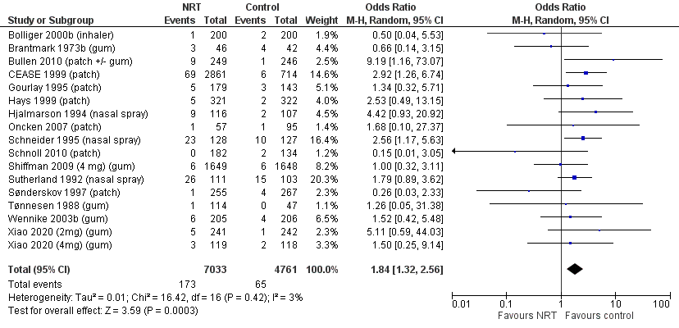
Figure 6: Results of palpitations or chest pains based on updated re-analysis, NRT versus placebo
Source: Hartmann-Boyce et al. (2018), Xiao et al. (2020)
Abbreviations: CI = confidence interval
Note: Calculated during the review using a random-effect model. Hartmann-Boyce et al. (2018) calculated odds ratio using a fixed-effect model (OR: 1.88; 95% CI: 1.37, 2.57).
In a recently conducted study (EAGLES extension) comparing the relative cardiovascular safety risk of smoking cessation treatments using a placebo comparator, no significant treatment differences were observed in time to cardiovascular events, blood pressure, or heart rate between NRT patches and placebo (Benowitz et al. 2018).
NRT patch versus varenicline
A summary of the citation details for the studies comparing NRT patches with varenicline is presented in Table 25. Two studies were previously considered by the PBAC (Aubin et al. 2008 and Anthenelli et al. 2016). A recently conducted Cochrane Review by Cahill et al. (2016) was identified in the systematic literature review that compared NRT patches with varenicline and was included in this report.
Four new studies were identified in the supplemental literature search that informed this comparison and were included in the updated re-analysis of the Cochrane Review (Lerman et al. 2015, Tulloch et al. 2016, Rohsenow et al. 2017, and Benowitz et al. 2018).
Table 25: List of studies comparing NRT patch with varenicline
Study | Citation
Aubin  (2008)³¹ | Aubin HJ, Bobak A, Britton JR, Oncken C, Billing CB Jr, Gong J, Williams KE, Reeves KR. Varenicline versus transdermal nicotine patch for smoking cessation: results from a randomised open-label trial. Thorax. 2008 Aug;63(8):717-24.
Anthenelli (EAGLES, 2016)¹⁸ | Anthenelli RM, Benowitz NL, West R, St Aubin L, McRae T, Lawrence D, Ascher J, Russ C, Krishen A, Evins AE. Neuropsychiatric safety and efficacy of varenicline, bupropion, and nicotine patch in smokers with and without psychiatric disorders (EAGLES): a double-blind, randomised, placebo-controlled clinical trial. Lancet. 2016 Jun 18;387(10037):2507-20.
Cahill (2016)¹⁹ | Cahill K, Lindson‐Hawley N, Thomas KH, Fanshawe TR, Lancaster T. Nicotine receptor partial agonists for smoking cessation. Cochrane Database of Systematic Reviews 2016, Issue 5. Art. No.: CD006103.
Lerman (2015)²⁰ | Lerman C, Schnoll RA, Hawk LW Jr, Cinciripini P, George TP, Wileyto EP, Swan GE, Benowitz NL, Heitjan DF, Tyndale RF; PGRN-PNAT Research Group. Use of the nicotine metabolite ratio as a genetically informed biomarker of response to nicotine patch or varenicline for smoking cessation: a randomised, double-blind placebo-controlled trial. Lancet Respir Med. 2015 Feb;3(2):131-138.
Tulloch  (2016)³² | Tulloch HE, Pipe AL, Els C, Clyde MJ, Reid RD. Flexible, dual-form nicotine replacement therapy or varenicline in comparison with nicotine patch for smoking cessation: a randomized controlled trial. BMC Med. 2016 Jun 7;14:80.
Rohsenow (2017)³³ | Rohsenow DJ, Tidey JW, Martin RA, Colby SM, Swift RM, Leggio L, Monti PM. Varenicline versus nicotine patch with brief advice for smokers with substance use disorders with or without depression: effects on smoking, substance use and depressive symptoms. Addiction. 2017 Oct;112(10):1808-1820.
Benowitz (2018)⁴ | Benowitz NL, Pipe A, West R, Hays JT, Tonstad S, McRae T, Lawrence D, St Aubin L, Anthenelli RM. Cardiovascular Safety of Varenicline, Bupropion, and Nicotine Patch in Smokers: A Randomized Clinical Trial. JAMA Intern Med. 2018 May 1;178(5):622-631.
Shaded = previously considered by the PBAC
Notes: Aubin et al. (2008) was considered at the March 2010 PBAC meeting. EAGLES (2016) was considered at the November 2016 PBAC meeting.
A summary of the characteristics of the studies comparing NRT patches with varenicline is presented in Table 26. A total of eight RCTs comparing NRT patches with varenicline were identified by Cahill et al. (2016) and were included in the efficacy analysis. The characteristics of the individual studies are presented in Appendix Table 149.
Of the four new studies identified in the supplemental literature search, three studies were included in the updated efficacy re-analysis (Lerman et al. 2015, Tulloch et al. 2016, and Rohsenow et al. 2017). One study was a safety study with no efficacy outcomes reported (Benowitz et al. 2018).

Table 26: Characteristics of the studies comparing NRT patch with varenicline
Study | Study type | N¹ | Population | Intervention and comparator | Outcomes
Aubin  (2008) | RCT | N=757  NRT (n=379),  Varenicline (n=378) | Inclusion: 18–75 years old, weight >45.5 kg and body mass index 15–38 kg/m^{2,} ≥15 cigarettes per day with no period of abstinence >3 months in the previous year; motivated to stop smoking.  Exclusion: a history of cancer, any other serious or unstable disease within the previous 6 months, diagnoses of or treatment for depression or other psychological disorder, or drug or alcohol dependence within the previous 12 months, clinically significant allergic reactions to drugs or adhesive tapes, skin disorders, systolic blood pressure >150 mmHg or diastolic blood pressure >95 mm Hg, clinically significant renal or hepatic impairment, evidence of liver dysfunction or other abnormal laboratory tests, taking medication that may interfere with the study outcome, had previously participated in a varenicline study in the previous year or had used of any form of NRT in the previous 6 months, pregnancy and breastfeeding. | NRT: NRT patch over 10 weeks (21 mg/day first 6 weeks, 14 mg/day for 2 weeks then 7 mg/day for 2 weeks); Varenicline: 1 mg twice daily including titration over 12 weeks (i.e. 0.5 mg once daily for 3 days, then 0.5 mg twice daily for 4 days, then 1 mg twice daily).  Behavioural support provided in both arms. | Primary: CAR at Week 9-12. Validated by CO ≤10 ppm.  Secondary: CAR (NRT, Week 8-24 and 8-52; Varenicline, Week 9-24 and 9-52); 7-day PPA at Week 24 and 52. Validated by CO ≤10 ppm.  Other: weight change, withdrawal symptoms (using MNWS and mCEQ), adverse events.
Anthenelli (EAGLES, 2016) | RCT | N=8,144  NRT (n=2,038),  Varenicline (n=2,037) | See Table 14 for inclusion and exclusion criteria of this study. | NRT: NRT patch 21 mg/day with taper over 12 weeks; Varenicline: 1 mg twice daily including titration over 12 weeks (i.e. 0.5 mg once daily for 3 days, then 0.5 mg twice daily for 4 days, then 1 mg twice daily).  Behavioural support provided in both arms. | Primary: safety including adverse events  Primary efficacy: CAR at Week 9-12. Validated by CO ≤10 ppm.  Secondary efficacy: CAR at Week 9-24. 7-day PPA at all visits. Validated by CO ≤10 ppm.
Cahill  (2016) | Cochrane Review  (8 RCTs²) | N=6,264  NRT (n=3,037),  Varenicline (n=3,227) | Inclusion: adult smokers.  Exclusion: trials which target users of smokeless tobacco. | NRT: NRT patch; Varenicline: 1mg twice daily including titration (i.e. 0.5 mg once daily for 3 days, then 0.5 mg twice daily for 4 days, then 1 mg twice daily). | Primary: point prevalence abstinence at 24 weeks.
Lerman (2015) | RCT | N=1,246  NRT (n=418),  Varenicline (n=420) | Inclusion: 18-65 years old, ≥10 cigarettes per day for ≥6 months (verified by CO >10 ppm).  Exclusion: use of non-cigarette tobacco products, e-cigarettes, or current smoking treatment; history of substance abuse treatment, current use of cocaine or methamphetamine, or >25 alcoholic drinks/week; medical contraindications; history of DSM-IV Axis 1 psychiatric disorder or suicide risk score on the MINI International Neuropsychiatric Interview (MINI)>1,or current major depression; current use of anti-psychotics, stimulants, opiate medications, anti-coagulants, rescue inhalers, anti-arrythmics, or medications altering CYP2A6 activity; and inability to provide informed consent or any condition that could compromise safety. | NRT: NRT patch over 11 weeks (21 mg/day first 6 weeks, 14 mg/day for 2 weeks then 7 mg/day for 3 weeks); Varenicline: 1 mg twice daily including titration over 12 weeks (i.e. 0.5 mg once daily for 3 days, then 0.5 mg twice daily for 4 days, then 1 mg twice daily).  Behavioural support provided in both arms. | Primary: 7-day PPA at Week 11 (end of treatment). Validated by CO <8 ppm.  Secondary: 7-day PPA at 6 and 12 months, adverse events, withdrawal symptoms (using MNWS).
Tulloch  (2016) | RCT | N=737  NRT (n=245),  Varenicline (n=247) | Inclusion: ≥18 years old, ≥10 cigarettes per day, willing to make a quit attempt in the next 2–4 weeks.  Exclusion: use of NRT or varenicline for more than 72 consecutive hours in the past month; presence of contra-indications to the use of study medications; serious cardiac arrhythmias or a myocardial infarction or cerebral vascular accident within the previous 10 days; severe or unstable angina pectoris; end-stage renal disease or use of cimetidine; alcohol or substance abuse in the previous 3 months; unstable psychiatric symptoms precluding informed consent; pregnant, lactating, or likely to become pregnant in the next year. | NRT: NRT patch over 10 weeks (≥20 cigarettes per day: 21 mg/day first 6 weeks, 14 mg/day for 2 weeks then 7 mg/day for 2 weeks; <20 cigarettes per day: 14 mg/day for 6 weeks then 7 mg/day for 4 weeks); Varenicline: 1 mg twice daily including titration over 12 weeks (i.e. 0.5 mg once daily for 3 days, then 0.5 mg twice daily for 4 days, then 1 mg twice daily).  Behavioural support provided in both arms. | Primary: CAR at Week 5-52. Validated by CO ≤9 ppm.  Secondary: CAR at Week 5-10 and 5-22, 7-day PPA at Week 1-, 22 and 52, validated by CO ≤9 ppm; adverse events.
Rohsenow (2017) | RCT | N=137  NRT (n=60),  Varenicline (n=77) | Inclusion: aged 18–75 years old, ≥10 cigarettes per day for the past 6 months, substance use disorder diagnosis.  Exclusion: evidence of hallucinations or delusions, current smoking cessation treatment, contraindications for either medication, using medications affected by smoking cessation, suicidal plan or attempts in past 5 years, not willing to try to quit smoking, substance use reported on the day of or before recruitment or positive breath alcohol at recruitment. | NRT: NRT patch over 12 weeks (21 mg/day first 4 weeks, 14 mg/day for 4 weeks then 7 mg/day for 4 weeks); Varenicline: 1 mg twice daily including titration over 12 weeks (i.e. 0.5 mg once daily for 3 days, then 0.5 mg twice daily for 4 days, then 1 mg twice daily).  Behavioural support provided in both arms. | Primary: 7-day PPA at 3 months (Week 12). Validated by CO ≤4 ppm.  Secondary: 7-day PPA at 6 months, validated by CO ≤4 ppm; average number of cigarettes per day at 3 and 6 months, percentage of smoking days, adverse events, depressive symptoms, substance use, medication adherence.
Benowitz (2018) | Non-treatment extension safety study of EAGLES (2016)³ | N=4,595  NRT  (n=1,116),  Varenicline (n=1,192) | Inclusion: 18-75 years old, ≥10 cigarettes per day, interested in quitting smoking, had been randomised to treatment in and had completed the week 24 visit of EAGLES.  Exclusion: unstable psychiatric illness, active substance abuse, clinically significant CVD in the 2 months prior to study entry, clinically significant cerebrovascular disease in the 2 months prior to study entry, or inadequate control of hypertension. | No treatment was provided during this study. Prior NRT and varenicline treatments were administered in EAGLES (2016). | Primary: Time to major adverse cardiovascular event.  Secondary: Occurrence of major adverse cardiovascular event.
Abbreviations: CAR = continuous abstinence rate; CO = carbon monoxide; mCEQ = modified Cigarette Evaluation Questionnaire; MNWS = Minnesota Tobacco Withdrawal Scale; NRT = nicotine replacement therapy; PPA = point prevalence abstinence; RCT = randomised controlled trial
Shaded = previously considered by the PBAC
1 Only the number of patients (n) in the relevant arms were included.
2 The characteristics of the individual studies comparing NRT patches with varenicline included in Cahill et al. (2016) are presented in Appendix Table 149. Two studies previously considered by the PBAC (Aubin et al. 2008 and EAGLES 2016) were included in the efficacy analysis of Cahill et al. (2016).
3 Benowitz et al. (2018) was a non-treatment extension of EAGLES (Anthenelli et al. 2016) with a considerable amount of missing data due to lost to follow-up, extension study nonenrollees, no longer willing to participate and death.

Efficacy
A summary of the point prevalence abstinence at 24 weeks comparing NRT patches with varenicline is presented in Table 27. The results of EAGLES (2016) demonstrated a statistically significant difference in point prevalence abstinence at 24 weeks, in favour of varenicline, noting that the outcome used was continuous abstinence rate. In contrast, no statistically significant difference was observed between the two treatment arms in Aubin et al. (2008), although the results numerically favoured varenicline.
The PBAC had previously considered that the evidence from Aubin et al. (2008) suggested that varenicline was more effective based on the statistically significant results of the primary outcome in the trial (i.e. continuous abstinence rate in last four weeks of treatment). It was noted that point prevalence abstinence at 24 weeks was a secondary outcome in Aubin et al. (2008). As such, the trial may not have been powered for this endpoint (NRT PSD, March 2010 PBAC meeting).
Based on the Cochrane Review by Cahill et al. (2016), the results of the meta-analysis comprising eight RCTs demonstrated a statistically significant difference in point prevalence abstinence at 24 weeks, in favour of varenicline. The results of the updated re-analysis comprising nine RCTs were consistent with the results from Cahill et al. (2016) (RR = 0.83, 95% CI: 0.71, 0.96; RD = -0.05, 95% CI: -0.08, -0.01).
Table 27: Results of point prevalence abstinence at 24 weeks, NRT patch versus varenicline
Trial | Study type | NRT patch | Varenicline | RR (95% CI) | RD (95% CI)
Aubin  (2008)¹ | RCT | 126/379ª  (33.2%) | 145/378ª  (38.4%) | 0.87  (0.72, 1.05) | -0.05  (-0.12, 0.02)
Anthenelli (EAGLES, 2016)² | RCT | 320/2,038ª  (15.7%) | 445/2,037ª  (21.8%) | 0.72  (0.63, 0.82) | -0.06  (-0.09, -0.04)
Cahill  (2016)^{3,4} | Cochrane Review (8 RCTs) | 575/3,059ª  (18.8%) | 768/3,239ª  (23.7%) | 0.85  (0.73, 0.99) | NR
Meta-analysis of Cahill (2016)⁶ and three RCTs (Lerman 2015, Tulloch 2016, Rohsenow 2017)
Updated  re-analysis⁵ | 9 RCTs | 664/3,500  (19.0%) | 887/3,698  (24.0%) | 0.83  (0.71, 0.96) | -0.05  (-0.08, -0.01)
Source: Cahill et al. (2016), Lerman 2015, Tulloch 2016, Rohsenow 2017
Abbreviations: CI = confidence interval; NR = not reported; RCT = randomised controlled trial; RD = risk difference; RR = risk ratio
Shaded = previously considered by the PBAC
Notes: Bold indicates statistically significant difference.
1 Primary analysis set (randomised and treated patients) was used instead of ITT (randomised patients).
2 Continuous abstinence rate at 6 months (Week 9-24), point prevalence abstinence was not an outcome in EAGLES (2016). Cahill et al. (2016) used continuous abstinence rate instead.
3 Studies previously considered by the PBAC were included in the meta-analysis of Cahill et al. (2016)
4 Cahill et al. (2016) presented this comparison as varenicline versus NRT patch (inverse) using a fixed-effect model. Re-calculated during the review for NRT patch versus varenicline using a random-effect model, corrected n/N for Aubin 2008, EAGLES 2016 and Rose 2013.
5 Calculated during the review using a random-effect model.
6 Excluded Stein (2013) due to incorrect treatment duration (exceeded standard 12 weeks treatment duration) and Rose (2013) due to incorrect comparator (NRT for pre-cessation NRT non-responders).
a Corrected error identified in Cahill et al. (2016) for n/N.
The results of the individual studies included in the updated re-analysis are presented using a forest plot in Figure 7. Of the nine RCTs, the outcome used in the meta-analysis for EAGLES (2016) was based on continuous abstinence rate at 24 weeks as the absolute numbers for the point prevalence abstinence were not reported.
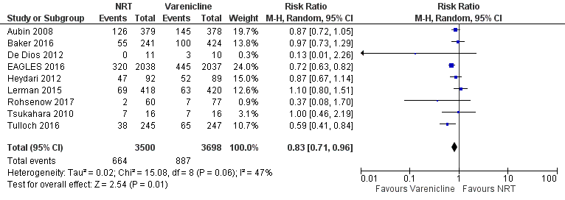
Figure 7: Results for point prevalence abstinence at 24 weeks based on updated re-analysis, NRT patch versus varenicline
Source: Cahill et al. (2016), Lerman 2015, Tulloch 2016, Rohsenow 2017
Abbreviations: CI = confidence interval
Note: A sensitivity analysis was conducted during the review by using continuous abstinence rate (where reported) at longest follow-up. The results remained statistically significant in favour of varenicline; RR = 0.79 (0.69, 0.91), RD = -0.04 (-0.07, -0.02).

Safety
The incidence of adverse events comparing NRT patches with varenicline was not synthesised quantitatively by Cahill et al. (2016). In March 2010, the PBAC considered that NRT patches were less toxic than varenicline based on the evidence from Aubin et al. (2008) (NRT PSD, March 2010 PBAC meeting). In November 2016, the PBAC considered that varenicline may be non-inferior to NRT patches based on the evidence from EAGLES (2016) (Varenicline PSD, November 2016 PBAC meeting).
In a recently conducted study (EAGLES extension) comparing the relative cardiovascular safety risk of smoking cessation treatments using a placebo comparator, no significant treatment differences were observed in time to cardiovascular events, blood pressure, or heart rate between NRT patches and varenicline (Benowitz et al. 2018).
In Lerman et al. (2015), a significant nicotine metabolite ratio (NMR)-by-treatment interaction was observed in side effects for varenicline versus placebo while it was not significant for NRT patches versus placebo. In Tulloch et al. (2016), patients in the varenicline group experienced more fatigue, digestive symptoms (e.g. nausea, diarrhoea), and sleep-related concerns (e.g. abnormal dreams, insomnia), but less dermatologic symptoms than those in the NRT patches group. In Rohsenow et al. (2017), there were no medication-attributable serious adverse events reported in both arms; 20 patients were discontinued from treatment due to non-serious adverse events, 11 in varenicline arm and eight in NRT patches arm.
NRT (lozenge/gum) versus NRT patch
A summary of the citation details for the studies comparing NRT lozenges/gum with NRT patches is presented in Table 28. Three studies comparing NRT lozenges with NRT patches were previously considered by the PBAC (Piper et al. 2009, Smith et al. 2009 and Schnoll et al. 2010). '''''''''''' ''''''' ''''''''''''''''''' '''''' '''''' '''''''' ''''''''' ''''''''''' '''''''''''''''' '' ''''''' '''''''''' ''''''''''' '''''''' ''''''''''''''''' ''''''''''''''''''' ''''''' '''''''''''''''''' '''''''' '''''''' ''''''''' '''''''''''' '''''''' '''''''''' '''' '''''''''''''''' ''''' ''''''''''''''''' '''''''''''''' ''''''''''''''''''''''' '''''''''''''''''' '''''''' '''''''''''''''' ''''''' '''''''' '''''''''''''' '''''''''' '''''''' '''''''' '''' '''''' ''''''''''''''''' '''''''''''''''''''''''' ''''''''' ''''''''''''''''''''''''''' '''''''' '''''''''' ''''''''''' ''''''''''''''''''' For the comparison of NRT gum with NRT patches, a single direct RCT was identified previously (Moolchan et al. 2005). Due to inadequate evidence from Moolchan (2005), an indirect comparison using a Cochrane Review of NRT (Stead et al. 2012), updated with an additional 11 studies, was conducted using control as a common reference and presented to the PBAC for consideration. A recently conducted Cochrane Review by Lindson et al. (2019) was identified in the systematic literature review that specifically compared different formulations of NRT (including lozenges and gum) with NRT patches and was included in this report. Additionally, Hartmann-Boyce et al. (2018) was identified in the systematic review that compared different formulations of NRT (including lozenges, gum and patches) to placebo. Collectively, Lindson et al. (2019) and Hartmann-Boyce et al. (2018) represent the most recent update to Stead et al. (2012) which, in 2017 was split into these two reviews of NRT versus control and NRT versus NRT. No new studies comparing NRT lozenges or gum with patches were identified in the supplemental literature search.
Table 28: List of studies comparing NRT lozenge or gum with NRT patch
Study | Citation
Moolchan (2005)³⁴ | Moolchan ET, Robinson ML, Ernst M, Cadet JL, Pickworth WB, Heishman SJ, Schroeder JR. Safety and efficacy of the nicotine patch and gum for the treatment of adolescent tobacco addiction. Pediatrics. 2005 Apr;115(4):e407-14.
Piper (2009)⁷ | Piper ME, Smith SS, Schlam TR, Fiore MC, Jorenby DE, Fraser D, Baker TB. A randomized placebo-controlled clinical trial of 5 smoking cessation pharmacotherapies. Arch Gen Psychiatry. 2009 Nov;66(11):1253-62.
Smith (2009)³⁵ | Smith SS, McCarthy DE, Japuntich SJ, Christiansen B, Piper ME, Jorenby DE, Fraser DL, Fiore MC, Baker TB, Jackson TC. Comparative effectiveness of 5 smoking cessation pharmacotherapies in primary care clinics. Arch Intern Med. 2009 Dec 14;169(22):2148-55.
Schnoll (2010)³⁶ | Schnoll RA, Martinez E, Tatum KL, Glass M, Bernath A, Ferris D, Reynolds P. Nicotine patch vs. nicotine lozenge for smoking cessation: an effectiveness trial coordinated by the Community Clinical Oncology Program. Drug Alcohol Depend. 2010 Mar 1;107(2-3):237-43.
Stead (2012)³⁷ | Stead, Lindsay F, et al. Nicotine Replacement Therapy for Smoking Cessation. Cochrane Database of Systematic Reviews 2012; 11
Lindson (2019)³⁸ | Lindson N, Chepkin SC, Ye W, Fanshawe TR, Bullen C, Hartmann‐Boyce J. Different doses, durations and modes of delivery of nicotine replacement therapy for smoking cessation. Cochrane Database of Systematic Reviews 2019, Issue 4. Art. No.: CD013308.
Shaded = previously considered by the PBAC
Notes: Moolchan et al. (2005), Piper et al. (2009), Smith et al. (2009) and Schnoll et al. (2010) were considered at the July 2017 and March 2018 PBAC meeting.
A summary of the characteristics of the studies comparing NRT lozenges/gum with NRT patches is presented in Table 29. A total of three RCTs comparing NRT lozenges with NRT patches and two RCTs comparing NRT gum with NRT patches were identified by Lindson et al. (2019). Of these, all three RCTs comparing NRT lozenges with NRT patches (Piper et al. 2009, Smith et al. 2009 and Schnoll et al. 2010) and one RCT comparing NRT gum with NRT patches (Moolchan et al. 2005) were studies previously considered by the PBAC. The additional study comparing NRT gum with NRT patches (Kupecz et al. 1996) that was included in Lindson et al. (2019) was judged as high risk of bias as it was described as quasi-experimental, with month of recruitment randomised to study arm, and all people recruited in each month provided with the allotted treatment. This study was excluded from Hartmann-Boyce et al. (2018) and Stead et al. (2018) and has thus not been considered by the PBAC. The characteristics of the individual studies are presented in Appendix Table 150.

Table 29: Characteristics of the studies comparing NRT lozenge or gum with NRT patch
Study | Study type | N¹ | Population | Intervention and comparator | Outcomes
Moolchan (2005) | RCT | N=120  NRT gum (n=46),  NRT patch (n=34) | Inclusion: 13-17 years old, ≥10 CPD for ≥6 months, a minimal score of 5 on the Fagerstrom Test of Nicotine Dependence, motivated to stop smoking.  Exclusion: pregnancy, lactation, chronic skin conditions, use of other tobacco products, and current use (within the past 30 days) of medications for smoking cessation (e.g. NRT or bupropion); drug or alcohol dependence other than nicotine and current mania, psychosis, and acute depression, according to the Diagnostic Interview of Children and Adolescents, which was based on the Diagnostic and Statistical Manual of Mental Disorders, Fourth Edition. | NRT gum: 4 mg or 2 mg (for <24 cigarettes/day) for 6 weeks + placebo patch; NRT patch: 21 mg, or 14 mg (for <20 cigarettes/day) for 6 weeks + placebo gum.  Behavioural support provided in both arms. | Primary: Adverse events measured during treatment visits.  Secondary: CO-validated prolonged abstinence at 3 months; 7-day PPA at Week 1, Week 12 and 26. Validated by CO ≤6 ppm.
Piper (2009) | RCT | N=1,504  NRT lozenge (n=260),  NRT patch (n=262) | See Table 10 for inclusion and exclusion criteria of this study. | NRT lozenge: 2 mg or 4 mg for 12 weeks (based on dose-for-dependence level as per instructions); NRT patch: 24-hour patch; 21 mg, 14 mg, and 7 mg titrated down over 8-week period post-quit.  Behavioural support provided in both arms. | Primary: 7-day PPA at 6 months. Validated by CO <10 ppm.  Secondary: adverse events measured for 10 weeks.
Smith (2009) | RCT | N=1,346  NRT lozenge (n=261),  NRT patch (n=282) | Inclusion: ≥18 years old, ≥10 cigarettes per day for the past 6 months; motivated to quit smoking.  Exclusion: history of seizures or convulsions, bipolar disorder, psychosis, bulimia, or anorexia nervosa, head injury requiring hospitalisation, myocardial infarction in past month, current use of bupropion or use of a monoamine oxidase inhibitor in the previous 2 weeks; blood pressure >160/100 mmHg, allergy to any of the study medications, serious thoughts of self-harm in the previous 2 weeks, drug or alcohol dependence in the past 6 months, currently pregnant or breastfeeding or planning to become pregnant within the next 3 months. | NRT lozenge: 4 mg for participants who smoked first cigarette of day within 30 mins of waking; 2 mg for all other participants. 9/day for first 6 weeks, 5/day for Week 7-9, 3/day for Week 10-12; NRT patch: 21 mg/day for first 6 weeks, 14 mg/day for Week 7+8, 7 mg/day for Week 9-12.  Behavioural support provided in both arms. | Primary: 7-day PPA at Week 1, Week 8 and 6 months. Number of days to relapse. No validation.  Secondary: use of Wisconsin Tobacco Quit Line.
Schnoll (2010) | RCT | N=642  NRT lozenge (n=321),  NRT patch (n=321) | Inclusion: ≥18 years of age, plan to reside in the geographic area for ≥6 months, ≥10 cigarettes per day, and be willing to defer use of other forms of smoking cessation treatments for 6 months.  Exclusion: allergy to adhesive tape or latex, had been diagnosed with cancer within the previous 5 years, were HIV positive, had taken an antidepressant within the past 6 months, were pregnant, nursing, or planning on becoming pregnant during the course of the study, or were taking bupropion, monoamine oxidase inhibitors, benzodiazepines, or antipsychotics, current alcohol dependence/abuse. | NRT lozenge: 4 mg if first cigarette of day smoked >30 mins after waking, 2 mg otherwise. 1 lozenge every 1-2 hrs post-quit (Week 1-6); 1 lozenge every 2-4 hrs (Week 7-9); 1 lozenge every 4-8 hrs (Week 10-12); NRT patch: 21 mg post-quit Week 1-4; 14 mg Week 5-6; 7 mg Week 7-8.  Behavioural support provided in both arms. | Primary: 24-hour PPA at end of treatment and 6 months. Validated by CO <10 ppm.  Secondary: adverse events measured at end of treatment (12 weeks) and at 6 months follow-up.
Stead (2012) | Cochrane Review² | N=52,593  NRT gum v control (n=24, 534)  NRT patch v control (n=28,059) | Inclusion: men or women who smoked and were motivated to quit were included irrespective of the setting from which they were recruited and/or their initial level of nicotine dependence.  Exclusion: trials that randomized physicians or other therapists to receive an educational intervention, which included encouraging their patients to use NRT. | NRT: comparisons of any type of NRT versus placebo or no NRT control and comparisons of different doses of NRT, comparing more than one type of NRT to a single type, comparing NRT with bupropion and combinations of the two, and comparing use of NRT prior to quit date as opposed to from quit date only. | Primary: smoking cessation rates of at least six months after baseline.  Secondary: safety including cardiac adverse events, serious adverse events and withdrawals due to treatment.
Lindson  (2019) | Cochrane Review  (3 RCTs of lozenge versus patch, 2 RCTs of gum versus patch)³ | N=3,319  NRT lozenge  (n=842),  NRT patch (n=865); NRT gum (n=63), NRT patch (n=55) | Inclusion: men or women who smoked and were motivated to  quit, irrespective of the setting from which they were recruited  or their initial level of nicotine dependence, or both.  Exclusion: trials that randomised physicians or other therapists to receive an educational intervention, which included encouraging their patients to use NRT. | NRT: comparison of any type of NRT with another type of NRT, i.e. patch, lozenge, gum etc. | Primary: smoking cessation rates of at least six months after baseline.  Secondary: safety including cardiac adverse events, serious adverse events and withdrawals due to treatment.
Abbreviations: CAR = continuous abstinence rate; CO = carbon monoxide; NRT = nicotine replacement therapy; PPA = point prevalence abstinence; RCT = randomised controlled trial
Shaded = previously considered by the PBAC
1 Only the number of patients (n) in the relevant arms were included.
2 The studies of NRT gum versus control (n=56) and NRT patches versus control (n=54) were updated in the July 2017 submission with an additional 11 studies comparing NRT patches with control.
3 The characteristics of the individual studies comparing NRT lozenge or gum with NRT patches included in Lindson et al. (2019) are presented in Appendix Table 150. Four studies previously considered by the PBAC (Moolchan et al. 2005, Piper et al. 2009, Smith et al. 2009 and Schnoll et al. 2010) were included in the primary efficacy analysis of Lindson et al. (2019).

Efficacy
A summary of the smoking cessation rates for at least six months follow-up comparing NRT lozenges or gum with NRT patches is presented in Table 30. The results of the four studies previously considered by the PBAC demonstrated no statistically significant difference in long-term cessation rates between NRT lozenges or gum and NRT patches.
For NRT lozenges versus NRT patches, the meta-analysis of the three studies comparing NRT lozenges to NRT patches (RR: 0.94; 95% CI: 0.74, 1.18) that was previously considered by the PBAC to support the claim of non-inferiority was composed of the same studies that were included in the meta-analysis by Lindson et al. (2019) identified in this review. The slight difference in 95% CI was likely due to the application of a fixed-effects model by Lindson et al. (2019).
For NRT gum versus NRT patches, the indirect comparison of NRT gum to NRT patches (RR: 0.91; 95% CI: 0.80, 1.04) using evidence from the Cochrane Review by Stead et al. (2012) and considered by the PBAC demonstrated no statistically significant differences and was considered to support the claim of non-inferiority. Similarly, the results of the meta-analysis based on the Cochrane Review by Lindson et al. (2019) demonstrated no statistically significant difference in long-term smoking cessation rates between the two treatment arms however with a less precise estimate. However, only two studies were included in the meta-analysis by Lindson et al. (2019), as compared to the 110 trials included in the indirect comparison considered by the PBAC. Furthermore, the two studies included in the meta-analysis by Lindson et al. (2019) had small sample sizes, was at high risk of bias (Kupecz 2006) or was previously considered by the PBAC to provide inadequate evidence for the relative efficacy and safety of NRT gum to patches (Moolchan 2005).
As reported in the NRT patches versus placebo section, the effect estimates (RR) for NRT patches and gum versus placebo/control reported in Hartmann-Boyce et al. (2018) were 1.64 (95% CI: 1.53, 1.75) and 1.49 (95% CI: 1.40, 1.60), respectively. These were consistent with the effect estimates for NRT patches (RR: 1.63; 95% CI: 1.49, 1.79) and NRT gum (RR: 1.49; 95% CI: 1.36, 1.64) that were updated from Stead et al. (2012) - an earlier version of Hartmann-Boyce et al. (2018) - and used to inform the indirect comparison of NRT gum to NRT patches considered by the PBAC. The stability of this evidence base between updates is consistent with the conclusions drawn by Hartmann-Boyce et al. (2018), and subsequent decision for Hartmann-Boyce et al. (2018) to cease updating this Cochrane review.
Table 30: Results of smoking cessation for at least six months follow-up, NRT lozenge or gum versus NRT patch
Study | Study type | NRT lozenge/gum | NRT patch | RR (95% CI)
NRT lozenge versus NRT patch⁶
Piper  (2009)¹ | RCT | 87/260  (33.5%) | 90/262  (34.4%) | 0.97  (0.77, 1.24)
Smith  (2009)¹ | RCT | 52/261  (19.9%) | 50/282  (17.7%) | 1.12  (0.79, 1.59)
Schnoll  (2010)² | RCT | 35/321  (10.9%) | 50/321  (15.6%) | 0.7  (0.47, 1.05)
Lindson  (2019)^{3,5} | Cochrane Review (3 RCTs) | 174/842  (20.7%) | 190/865  (22.0%) | 0.94  (0.79, 1.12)
NRT gum versus NRT patch⁷
Moolchan  (2005)⁴ | RCT | 8/46  (17.4%) | 9/34  (26.5%) | 0.66  (0.28, 1.53)
Lindson  (2019)^{3,5} | Cochrane Review (2 RCTs) | 8/63  (12.7%) | 11/55  (20.0%) | 0.58  (0.26, 1.31)
Source: Lindson et al. (2019)
Abbreviations: CI = confidence interval; RCT = randomised controlled trial; RD = risk difference; RR = risk ratio
Shaded = previously considered by the PBAC
Notes: Bold indicates statistically significant difference.
1 7-day point prevalence abstinence at 6 months.
2 24-hour point prevalence abstinence at 6 months.
3 Where cessation was assessed at multiple intervals, the longest follow-up data were used. Where multiple definitions of abstinence were assessed, the strictest of these definitions was used (e.g. continuous/prolonged abstinence over point prevalence abstinence). See Appendix Table 150 for the definition used in each study. Studies previously considered by the PBAC were included in the meta-analysis of Lindson et al. (2019).
4 7-day point prevalence abstinence at 1 week after quit date.
5 Calculated by Cochrane Review authors using a fixed-effect model.
6 ''''''' '''''''''' '''''''''' ''''' '''''' '''''''''''''' '''''''''''''''''''' '''''''''' ''''''''' '''' ''''''' ''''''''''''''' ''''''''''''''''''''''''' '''''''''''''''''''' ''''''''''''' ''''''' '''''''''''''''''' '''''' ''''''' '''''''' ''''''''' ''''''''''''''''''' '''''''' '''''''' ''''''''' ''''' ''''''''' ''''''''''' '''''''''' ''''''''''''''''''''''' '''''''' ''''''''' '''''''''' ''''''''''''''''''
7 The risk ratio of the indirect comparison conducted for the July 2017 submission was 0.91 (95% CI: 0.80, 1.04) (NRT PSD, July 2017 PBAC meeting).
The results of the individual studies included in Lindson et al. (2019) are presented using a forest plot in Figure 8. The results comparing other NRT formulations (e.g. inhaler) are discussed in Section 3.3.3.
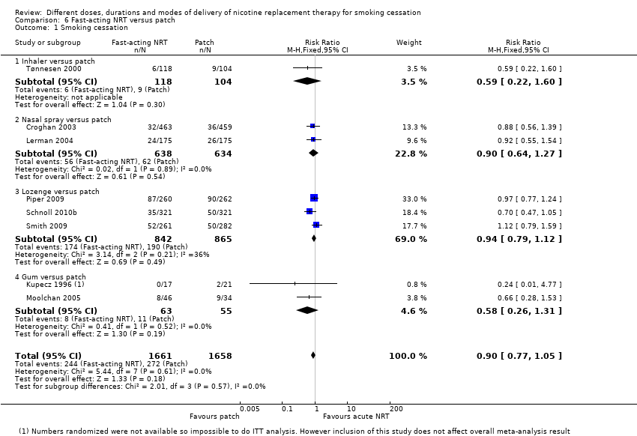
Figure 8: Results of smoking cessation for at least six months follow-up in Lindson et al. (2019), NRT lozenge or gum versus NRT patch
Source: Lindson et al. (2019)
Abbreviations: CI = confidence interval
Safety
A summary of key adverse events comparing NRT lozenges or gum with NRT patches is presented in Table 31. Based on the Cochrane Review by Lindson et al. (2019), there were no statistically significant differences in serious adverse events and withdrawals due to treatment between NRT lozenges or gum and NRT patches. For cardiac adverse events, only one small study comparing NRT gum with NRT patches reported this outcome (Kupecz et al. 1996). In this study, there were no events in either the NRT gum or patches groups. It was noted that only a limited number of studies reported the key safety outcomes.
Table 31: Summary of key adverse events, NRT lozenge or gum versus NRT patch
Study | Study type | Previously considered studies included¹ | NRT lozenge/gum | NRT patch | RR (95% CI)²
Cardiac adverse event
Lozenge | NR | NR | NR | NR | NR
Gum; Lindson  (2019) | Cochrane Review (1 RCT) | No | 0/17  (0%) | 0/21  (0%) | NE
Serious adverse events
Lozenge; Lindson  (2019) | Cochrane Review (1 RCT) | Schnoll (2010) | 7/321  (21.8%) | 4/321  (1.2%) | 1.75  (0.52, 5.92)
Gum; Lindson  (2019) | Cochrane Review (1 RCT) | No | 0/17  (0%) | 0/21  (0%) | NE
Withdrawals due to treatment
Lozenge; Lindson  (2019) | Cochrane Review (1 RCT) | Piper (2009) | 0/260  (0%) | 0/262  (0%) | NE
Gum; Lindson  (2019) | Cochrane Review (1 RCT) | No | 4/17  (23.5%) | 0/21  (0%) | 11  (0.63, 191.04)
Source: Lindson et al. (2019)
Abbreviations: CI = confidence interval; NE = not estimable; NR = not reported; RCT = randomised controlled trial; RR = risk ratio
Notes: Bold indicates statistically significant difference. See Appendix Figure 71 to Figure 73 for forest plots of the respective outcomes which included the results of individual studies.
1 Where previously considered studies were not included, this was due to the outcome not being reported.
2 Calculated by Cochrane Review authors using a fixed-effect model.

Treatment-experienced population

Varenicline
In November 2009, the PBAC recommended the listing of varenicline on the PBS be extended to make available a second 12-week course for patients who have successfully completed an initial 12-week course of varenicline, but require a further 12-week course to aid in maintaining abstinence (i.e. treatment-experienced patients). The recommendation was based on an RCT comparing varenicline 1 mg twice a day with placebo in patients who were abstinent after an initial 12 weeks of treatment with varenicline (Tonstad et al. 2006). The PBAC accepted the clinical claim that varenicline was of superior efficacy and inferior safety to placebo (Varenicline PSD, November 2009 PBAC meeting). The updated listing allowed for only one 12-24 week course of varenicline per year (i.e. an additional 12 weeks of treatment for those who had abstained from smoking).
In November 2012 and March 2014, the PBAC considered a request to reduce the time to retreatment with varenicline from 12 to 6 months. In March 2014, the PBAC recommended a change to the listing of varenicline to allow an additional course within a 12-month period for patients who were unsuccessful in achieving abstinence from smoking during or after a course of PBS-subsidised varenicline. The recommendation was based on a pivotal trial which compared varenicline with placebo in a varenicline experienced population (Gonzales et al. 2014; referred to as Trial A3051139 in March 2014 PBAC meeting) and trial evidence in varenicline-naïve patients as supportive evidence. The PBAC accepted the clinical claim that varenicline was of superior efficacy to placebo, bupropion and NRT, and no worse in terms of safety to bupropion. The PBAC considered that varenicline was of inferior safety to placebo and NRT (Varenicline PSD, March 2014 PBAC meeting). The current listing required the period between commencing varenicline and a further course of varenicline for non-abstainers to be at least 6 months, with a total of 24 weeks of PBS-subsidised varenicline allowed per 12-month period.
Varenicline versus placebo – abstainers (relapse prevention)
A summary of the citation details for the studies comparing varenicline with placebo in abstainers for relapse prevention is presented in Table 32. One study was previously considered by the PBAC (Tonstad et al. 2006). A recently conducted Cochrane Review by Livingstone-Banks et al. (2019) was identified in the systematic literature review that compared varenicline with placebo for relapse prevention and was included in this report. One new study was identified in the supplemental literature search that informed this comparison and was included in this report (Schnoll et al. 2019).
Table 32: List of studies comparing varenicline with placebo in abstainers for relapse prevention
Study | Citation
Tonstad  (2006)³⁹ | Tonstad S, Tønnesen P, Hajek P, Williams KE, Billing CB, Reeves KR; Varenicline Phase 3 Study Group. Effect of maintenance therapy with varenicline on smoking cessation: a randomized controlled trial. JAMA. 2006 Jul 5;296(1):64-71.
Livingstone-Banks (2019)⁴⁰ | Livingstone‐Banks J, Norris E, Hartmann‐Boyce J, West R, Jarvis M, Hajek P. Relapse prevention interventions for smoking cessation. Cochrane Database of Systematic Reviews 2019, Issue 2. Art. No.: CD003999.
Schnoll (2019)⁴¹ | Schnoll R, Leone F, Veluz-Wilkins A, Miele A, Hole A, Jao NC, Paul Wileyto E, Carroll AJ, Kalhan R, Patel J, Langer C, Lubitz SF, Hitsman B. A randomized controlled trial of 24 weeks of varenicline for tobacco use among cancer patients: Efficacy, safety, and adherence. Psychooncology. 2019 Mar;28(3):561-569
Shaded = previously considered by the PBAC
Notes: Tonstad et al. (2006) was considered at the November 2009 PBAC meeting.
A summary of the characteristics of the studies comparing varenicline with placebo in abstainers for relapse prevention is presented in Table 33. A total of two RCTs comparing varenicline with placebo were identified by Livingstone-Banks et al. (2019). Of these, one study was previously considered by the PBAC (Tonstad et al. 2006). The characteristics of the individual studies are presented in Appendix Table 151.
Schnoll et al. (2019) was a placebo-controlled randomised trial comparing 12 weeks of varenicline plus 12 weeks of placebo versus 24 weeks of varenicline in treatment-seeking cancer patients who smoked (N=207). In this study, patients were not required to have successfully abstained at 12 weeks to receive another 12 weeks of varenicline or placebo treatment. As such, both arms of the study may have included both abstainers and non-abstainers after receiving 12 weeks of varenicline treatment.

Table 33: Characteristics of the studies comparing varenicline with placebo in abstainers for relapse prevention
Study | Study type | N¹ | Population | Intervention and comparator | Outcomes
Tonstad  (2006) | RCT | N=1,210  Varenicline (n=603), Placebo (n=607) | Inclusion: 18-75 years old, ≥10 cigarettes per day during the past year and over the month prior to the screening visit with no period of abstinence longer than 3 months in the past year, motivated to quit.  Exclusion: serious or unstable disease within the past 6 months, required treatment for depression within the past 12 months, a history of or current panic disorder, psychosis, or bipolar disorder, severe COPD, a history of cancer, evidence or history of clinically significant allergic reactions, laboratory abnormalities, cardiovascular disease within the past 6 months, uncontrolled hypertension, or a history of drug or alcohol abuse or dependence within the past 12 months, used a smoking cessation aid (i.e. NRT, bupropion, clonidine, or nortriptyline) within the previous month, used tobacco products other than cigarettes or marijuana within the past month and did not agree to abstain from use of these products during study participation, a body mass index of <15 or >38, used any of the following medications: NRT, antidepressants, antipsychotics, mood stabilizers/anticonvulsants, naltrexone, steroids, or insulin, pregnancy. | Varenicline: 1 mg twice per day for 12 weeks;  Placebo: placebo tablet for 12 weeks, same regimen.  Behavioural support provided in both arms.  Prior to randomisation, all participants had 12 weeks of open-label treatment with varenicline. Only participants who had successfully abstained from smoking and use of tobacco and NRT for at least the last 7 days of the treatment period were eligible. | Primary: CAR at Week 13-24. Validated by CO ≤10 ppm.  Secondary: CAR at Week 13-52; 7-day PPA at Week 24 and 52. Validated by CO ≤10 ppm.  Other: time to first lapse, withdrawal symptoms (using MNWS), adverse events.
Livingstone-Banks (2019) | Cochrane Review (2 RCTs²) | N=1,297  Varenicline (n=643),  Placebo (n=654) | Inclusion: smokers who quit on their own, were undergoing enforced abstinence, or were participating in treatment programmes to assist initial cessation.  Exclusion: NR. | Varenicline: 1 mg twice daily; Placebo: placebo tablets, same regimen. | Primary: smoking cessation rates of at least six months after baseline.
Schnoll (2019) | RCT³ | N=207  Varenicline (n=105), Placebo (n=102) | Inclusion: ≥18 years old, diagnosis of cancer or a recurrence within the past 5 years, ≥5 cigarettes per week, self-report an interest in quitting smoking.  Exclusion: daily use of nicotine products other than cigarettes, and unstable substance abuse/dependence in the last year. | Varenicline: 1 mg twice daily titrated over 12 weeks (i.e. 0.5 mg once daily for 3 days, then 0.5 mg twice daily for 4 days, then 1 mg twice daily) followed by 1 mg twice per day for 12 weeks;  Placebo: 1 mg twice daily titrated over 12 weeks (i.e. 0.5 mg once daily for 3 days, then 0.5 mg twice daily for 4 days, then 1 mg twice daily) followed by placebo tablet for 12 weeks, same regimen.  Behavioural support provided in both arms. | Primary: 7-day PPA at Week 24 and 52. Validated by CO <10 ppm.  Secondary: CAR at Week 9-24 and 9-52. Validated by CO <10 ppm.  Other: treatment adherence, adverse events.
Abbreviations: CAR = continuous abstinence rate; CO = carbon monoxide; COPD = chronic obstructive pulmonary disease; MNWS = Minnesota Tobacco Withdrawal Scale; NRT = nicotine replacement therapy; PPA = point prevalence abstinence; RCT = randomised controlled trial
Shaded = previously considered by the PBAC
1 Only the number of patients (n) in the relevant arms were included.
2 The characteristics of the individual studies comparing varenicline with placebo included in Livingstone-Banks et al. (2019) are presented in Appendix Table 151. One study previously considered by the PBAC (Tonstad et al. 2006) was included in the primary efficacy analysis of Livingstone-Banks et al. (2019).
3 In Schnoll et al. (2019), there was no information reported on the blinding of patients.

Efficacy
A summary of the smoking cessation rates at 12 months comparing varenicline with placebo in abstainers for relapse prevention is presented in Table 34. The results of Tonstad et al. (2006) demonstrated a statistically significant difference in continuous abstinence rate, in favour of varenicline. Similarly, the results of the meta-analysis comprising two RCTs conducted by Livingstone-Banks et al. (2019) demonstrated a statistically significant difference in long-term smoking cessation rates, in favour of varenicline.
Table 34: Results of smoking cessation at 12 months after quit date, varenicline versus placebo in abstainers for relapse prevention
Study | Study type | Varenicline | Placebo | RR (95% CI)
Tonstad (2006)¹ | RCT | 263/603⁴  (43.6%) | 224/607  (36.9%) | 1.18  (1.03, 1.36)
Livingstone-Banks  (2019)^{2,3} | Cochrane Review (2 RCTs) | 281/643  (43.7%) | 231/654  (35.3%) | 1.23  (1.08, 1.41)
Source: Livingstone-Banks et al. (2019)
Abbreviations: CI = confidence interval; RCT = randomised controlled trial; RR = risk ratio
Shaded = previously considered by the PBAC
Notes: Bold indicates statistically significant difference.
1 Continuous abstinence rate at 12 months (Week 13-52).
2 Where cessation was assessed at multiple intervals, the longest follow-up data were used. Where multiple definitions of abstinence were assessed, the strictest of these definitions was used (e.g. continuous/prolonged abstinence over point prevalence abstinence). See Appendix Table 151 for the definition used in each study. Study previously considered by the PBAC was included in the meta-analysis of Livingstone-Banks et al. (2019).
3 Calculated by Cochrane Review authors using a fixed-effect model.
4 The number of events (n) reported in Livingstone-Banks et al. (2019) differed from the number stated in the Varenicline PSD (2009); (Varenicline, n=263 versus 265). The number reported in Livingstone-Banks et al. (2019) was used as this number corresponded with the number reported in the key publication.
The results of the individual studies included in Livingstone-Banks et al. (2019) are presented using a forest plot in Figure 9. It was noted the other RCT that was included in the meta-analysis (Evins et al. 2014) administered varenicline over 40 weeks (Week 12 to 52) as a relapse prevention treatment instead of a standard 12-week treatment regimen.
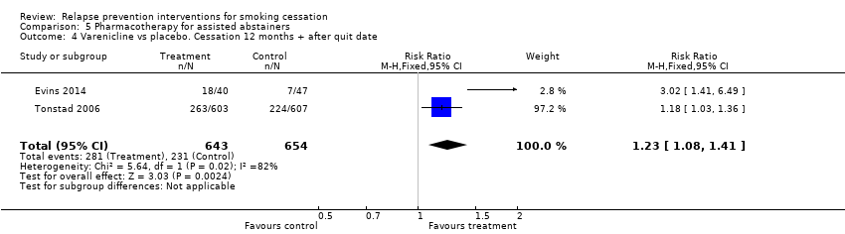
Figure 9: Results of smoking cessation at 12 months after quit date in Livingstone-Banks et al. (2019), varenicline versus placebo in abstainers for relapse prevention
Source: Livingstone-Banks et al. (2019)
Abbreviations: CI = confidence interval
As Schnoll et al. (2019) did not require patients to have successfully abstained at 12 weeks to receive another 12 weeks of varenicline or placebo treatment, the results of this study were not directly applicable in the Australian setting and were presented separately. The point prevalence and continuous abstinence quit rates at weeks 24 and 52 were not significantly different across the two treatment arms. When stratified based on medication adherence, adherent patients who received 24 weeks of varenicline reported significantly higher abstinence rates compared with adherent patients who received 12 weeks of varenicline plus 12 weeks of placebo; the results were not statistically significant between treatment arms in non-adherent patients. A sensitivity analysis was conducted during the review by meta-analysing Schnoll et al. (2019) with Evins et al. (2014) and Tonstad et al. (2006). The results of the meta-analysis were no longer statistically significant between the two treatment arms, although the results numerically favoured varenicline (RR: 1.30, 95% CI: 0.69, 2.45).
Safety
The safety of varenicline versus placebo in abstainers for relapse prevention was not assessed by Livingstone-Banks et al. (2019). In November 2009, the PBAC accepted the clinical claim that varenicline was inferior to placebo in terms of comparative safety in patients who were abstinent from smoking after an initial 12-week course of varenicline (Varenicline PSD, November 2009 PBAC meeting).
In Tonstad et al. (2006), the most commonly reported adverse events during the initial open-label varenicline treatment phase were nausea (33.5%), insomnia (19.6%), abnormal dreams (14.3%) and headache (15.8%). The incidence of adverse events during the double-blind treatment phase was similar for the varenicline and placebo groups (46% and 45%, respectively).
In Evins et al. (2014), the most commonly reported adverse events during open-label varenicline treatment (after quit date, week 5 to 12) were agitation (32%), anxiety (30%), headache (30%) and excitement (28%). There were no statistically significant differences in nausea, insomnia, abnormal dreams, headache, depression, suicidal ideation and serious adverse events during the double-blind treatment phase, as reported by Cahill et al. (2016).
In Schnoll et al. (2019), there were no significant differences in side effects, adverse and serious adverse events and rates of high blood pressure between patients receiving 12 weeks of varenicline plus 12 weeks of placebo versus 24 weeks of varenicline.
Varenicline versus placebo – non-abstainers (retreatment)
A summary of the citation details for the studies comparing varenicline with placebo in non-abstainers as retreatment is presented in Table 35. One study was previously considered by the PBAC (Gonzales et al. 2014; referred to as Trial A3051139 in March 2014 PBAC meeting). A recently conducted Cochrane Review by Cahill et al. (2016) was identified in the systematic literature review that compared varenicline with placebo as retreatment and was included in this report. No new studies comparing varenicline with placebo in non-abstainers as retreatment were identified in the supplemental literature search.
Table 35: List of studies comparing varenicline with placebo in non-abstainers as retreatment
Study | Citation
Gonzales  (2014)⁴² | Gonzales D, Hajek P, Pliamm L, Nackaerts K, Tseng LJ, McRae TD, Treadow J. Retreatment with varenicline for smoking cessation in smokers who have previously taken varenicline: a randomized, placebo-controlled trial. Clin Pharmacol Ther. 2014 Sep;96(3):390-6.
Cahill (2016)¹⁹ | Cahill K, Lindson‐Hawley N, Thomas KH, Fanshawe TR, Lancaster T. Nicotine receptor partial agonists for smoking cessation. Cochrane Database of Systematic Reviews 2016, Issue 5. Art. No.: CD006103.
Shaded = previously considered by the PBAC
Notes: Gonzales et al. (2014; referred to as Trial A3051139) was considered at the March 2014 PBAC meeting.
A summary of the characteristics of the studies comparing varenicline with placebo in non-abstainers as retreatment is presented in Table 36. One RCT comparing varenicline with placebo was identified by Cahill et al. (2016). This study was previously considered by the PBAC (Gonzales et al. 2014; referred to as Trial A3051139). The characteristics of the individual studies are presented in Appendix Table 152.

Table 36: Characteristics of the studies comparing varenicline with placebo in non-abstainers as retreatment
Study | Study type | N¹ | Population | Intervention and comparator | Outcomes
Gonzales  (2014) | RCT | N=498  Varenicline (n=251),  Placebo (n=247) | Inclusion: ≥18 years of age, smoked ≥10 cigarettes per day during the 4 weeks before screening, exhaled CO >10ppm at screening, no quit attempts in the previous 3 months, previously taken varenicline for 2 or more weeks, with the last dose taken ≥3 months before screening, motivated to stop smoking.  Exclusion: any previous significant adverse reaction to varenicline, previous participation in a varenicline study, severe COPD, recent history of cancer, clinically significant cardiovascular disease or cerebrovascular disease in the previous 2 months, history of a suicide attempt or any suicidal behaviour in the past 2 years or current suicidal ideation, current depression self-reported at screening or with a diagnosis of depression or treatment with antidepressants during the previous 12 months, lifetime diagnosis of psychosis, panic disorder, other anxiety disorders, or bipolar disorder, active alcohol or substance abuse/dependence (except nicotine) within the past 12 months, severe medical or psychiatric condition or laboratory abnormality, use of NRT, bupropion, or other smoking cessation aids during treatment, and use of other tobacco products, electronic cigarettes, marijuana, or illegal or street drugs at any time during the study, pregnancy and breastfeeding. | Varenicline: 1 mg twice daily titrated over 12 weeks (i.e. 0.5 mg once daily for 3 days, then 0.5 mg twice daily for 4 days, then 1 mg twice daily);  Placebo: placebo tablet for 12 weeks, same regimen.  Behavioural support provided in both arms. | Primary: CAR at Week 9-12. Validated by CO ≤10 ppm.  Secondary: CAR at Week 9-24 and 9-52; 7-day PPA at Week 12, 24 and 52. Validated by CO ≤10 ppm.  Other: adverse events
Cahill  (2016) | Cochrane Review (1 RCT²) | N=498  Varenicline (n=251),  Placebo (n=247) | Inclusion: adult smokers.  Exclusion: trials which target users of smokeless tobacco. | Varenicline: 1 mg twice daily including titration (i.e. 0.5 mg once daily for 3 days, then 0.5 mg twice daily for 4 days, then 1 mg twice daily); Placebo: placebo tablets, same regimen. | Primary: smoking cessation rates of at least six months after baseline.
Abbreviations: CAR = continuous abstinence rate; CO = carbon monoxide; COPD = chronic obstructive pulmonary disease; NRT = nicotine replacement therapy; PPA = point prevalence abstinence; RCT = randomised controlled trial
Shaded = previously considered by the PBAC
1 Only the number of patients (n) in the relevant arms were included
2 The characteristics of the individual studies comparing varenicline with placebo included in Cahill et al. (2016) are presented in Appendix Table 152. One study previously considered by the PBAC (Gonzales et al. 2014; referred to as Trial A3051139) was included in the primary efficacy analysis of Cahill et al. (2016).

Efficacy
A summary of the smoking cessation rates at 12 months comparing varenicline with placebo in non-abstainers as retreatment is presented in Table 37. The results of Gonzales et al. (2014), which was the only study identified by Cahill et al. (2016), demonstrated a statistically significant difference in continuous abstinence rate, in favour of varenicline. It was noted that the results of this study were included in the primary efficacy analysis of varenicline versus placebo conducted by Cahill et al. (2016), as presented in the treatment-naïve population section.
Table 37: Results of smoking cessation at 12 months, varenicline versus placebo in non-abstainers as retreatment
Study | Study type | Varenicline | Placebo | RR (95% CI)
Gonzales (2014)¹ | RCT | 50/251  (19.9%) | 8/247  (3.2%) | 6.15  (2.98, 12.7)
Cahill  (2016)² | Cochrane Review (1 RCT) | See above³ | See above³ | See above
Source: Cahill et al. (2016)
Abbreviations: CI = confidence interval; RCT = randomised controlled trial; RD = risk difference; RR = risk ratio
Shaded = previously considered by the PBAC
Notes: Bold indicates statistically significant difference.
1 Continuous abstinence rate at 12 months (Week 9-52).
2 The RCT included in Cahill et al. (2016) is the same study previously considered by the PBAC (Gonzales et al. 2014; referred to as Trial A3051139).
3 The number of patients (N) reported in Cahill et al. (2016) was based on treated patients instead of randomised patients (Varenicline, N=249 versus 251; Placebo, N=245 versus 247). The number of randomised patients was used instead as this represents the ITT population.
Safety
The incidence of adverse events comparing varenicline with placebo in non-abstainers as retreatment was not synthesised quantitatively by Cahill et al. (2016). It was noted that the safety results of Gonzales et al. (2014) were included in the overall safety analysis of varenicline versus placebo conducted by Cahill et al. (2016), as presented in the treatment-naïve population section. In March 2014, the PBAC considered that varenicline was of inferior safety to placebo (Varenicline PSD, 2014).
Based on the study by Gonzales et al. (2014), a significantly higher proportion of patients in the varenicline arm experienced nausea and abnormal dreams compared to patients in the placebo arm (Table 38). There were no statistically significant differences between the two treatment arms for insomnia, headache, depression, serious adverse events and cardiac serious adverse events, although a numerically higher incidence rate was observed in the varenicline arm except for cardiac serious adverse events. There were no suicidal ideation events observed in either arm.
Table 38: Summary of key adverse events, varenicline versus placebo in non-abstainers as retreatment
Outcome | Study type | Varenicline | Placebo | RR (95% CI)¹
Adverse event – nausea | RCT | 66/249  (26.5%) | 22/245  (9.0%) | 2.95  (1.88, 4.63)
Adverse event – insomnia | RCT | 17/249  (6.8%) | 10/245  (4.1%) | 1.67  (0.78, 3.58)
Adverse event – abnormal dreams | RCT | 36/249  (14.5%) | 8/245  (3.3%) | 4.43  (2.1, 9.33)
Adverse event – headache | RCT | 26/249  (10.4%) | 24/245  (9.8%) | 1.07  (0.63, 1.8)
Adverse event – depression | RCT | 5/249  (2.0%) | 2/245  (0.8%) | 2.46  (0.48, 12.56)
Adverse event – suicidal ideation | RCT | 0/249  (0%) | 0/245  (0%) | NE
Serious adverse events | RCT | 7/249  (2.8%) | 4/245  (1.6%) | 1.72  (0.51, 5.81)
Serious adverse events – cardiac (including deaths) | RCT | 1/249  (0.4%) | 1/245  (0.4%) | 0.98  (0.06, 15.64)
Source: Cahill et al. (2016)
Abbreviations: CI = confidence interval; RR = risk ratio
Notes: Bold indicates statistically significant difference.
1 Calculated by Cochrane Review authors using a fixed-effect model.

Bupropion
Bupropion has not been previously considered by the PBAC for relapse prevention in abstainers or retreatment in non-abstainers. As previously noted, the current listing allowed for a maximum of 9 weeks of PBS-subsidised bupropion treatment per year. Accordingly, patients who have been unsuccessful in achieving abstinence from smoking during or after a course of PBS-subsidised bupropion may access another course of PBS-subsidised bupropion have to wait for a subsequent 12-month period.
Bupropion versus placebo – abstainers (relapse prevention)
A summary of the citation details for the studies comparing bupropion with placebo in abstainers for relapse prevention is presented in Table 39. A recently conducted Cochrane Review by Livingstone-Banks et al. (2019) was identified in the systematic literature review that compared bupropion with placebo for relapse prevention and was included in this report. No new studies comparing bupropion with placebo in abstainers for relapse prevention were identified in the supplemental literature search.
Table 39: List of studies comparing bupropion with placebo in abstainers for relapse prevention
Study | Citation
Livingstone-Banks (2019)⁴⁰ | Livingstone‐Banks J, Norris E, Hartmann‐Boyce J, West R, Jarvis M, Hajek P. Relapse prevention interventions for smoking cessation. Cochrane Database of Systematic Reviews 2019, Issue 2. Art. No.: CD003999.

A summary of the characteristics of the studies comparing bupropion with placebo in abstainers for relapse prevention is presented in Table 40. A total of six RCTs comparing bupropion with placebo were identified by Livingstone-Banks et al. (2019). The characteristics of the individual studies are presented in Appendix Table 153.
Table 40: Characteristics of the studies comparing bupropion with placebo in abstainers for relapse prevention
Study | Study type | N¹ | Population | Intervention and comparator | Outcomes
Livingstone-Banks (2019) | Cochrane Review (6 RCTs³) | N=1,697  Bupropion (n=852),  Placebo (n=845) | Inclusion: smokers who quit on their own, were undergoing enforced abstinence, or were participating in treatment programmes to assist initial cessation.  Exclusion: NR | Bupropion: 150 mg twice daily including titration (i.e. 150 mg once daily for 3 days, then 150 mg twice daily); Placebo: placebo tablets, same regimen. | Primary: smoking cessation rates of at least six months after baseline.
Abbreviations: NR = not reported; RCT = randomised controlled trial
1 Only the number of patients (n) in the relevant arms were included.
2 The characteristics of the individual studies comparing bupropion with placebo included in Livingstone-Banks et al. (2019) are presented in Appendix Table 153.
Efficacy
A summary of the smoking cessation rates at 12 months comparing bupropion with placebo in abstainers for relapse prevention is presented in Table 41. The results of the meta-analysis comprising six RCTs by Livingstone-Banks et al. (2019) demonstrated no statistically significant difference in long-term smoking cessation rates between bupropion and placebo for relapse prevention.
Table 41: Results of smoking cessation at 12 months after quit date, bupropion versus placebo in abstainers for relapse prevention
Study | Study type | Bupropion | Placebo | RR (95% CI)²
Livingstone-Banks  (2019)¹ | Cochrane Review (6 RCTs) | 238/852  (27.9%) | 205/845  (24.3%) | 1.15  (0.98, 1.35)
Source: Livingstone-Banks et al. (2019)
Abbreviations: CI = confidence interval; RCT = randomised controlled trial; RD = risk difference; RR = risk ratio
Notes: Bold indicates statistically significant difference.
1 Where cessation was assessed at multiple intervals, the longest follow-up data were used. Where multiple definitions of abstinence were assessed, the strictest of these definitions was used (e.g. continuous/prolonged abstinence over point prevalence abstinence). See Appendix Table 153 for the definition used in each study.
2 Calculated by Cochrane Review authors using a fixed-effect model.
The results of the individual studies included in Livingstone-Banks et al. (2019) are presented using a forest plot in Figure 10. There were no statistically significant differences detected in any of the individual RCTs included in the meta-analysis. The authors of the review stated that while there was no evidence of statistical heterogeneity, some clinical heterogeneity was noted in the intervention used for the cessation induction phase, the duration of treatment, and the duration of follow-up after cessation of medication.
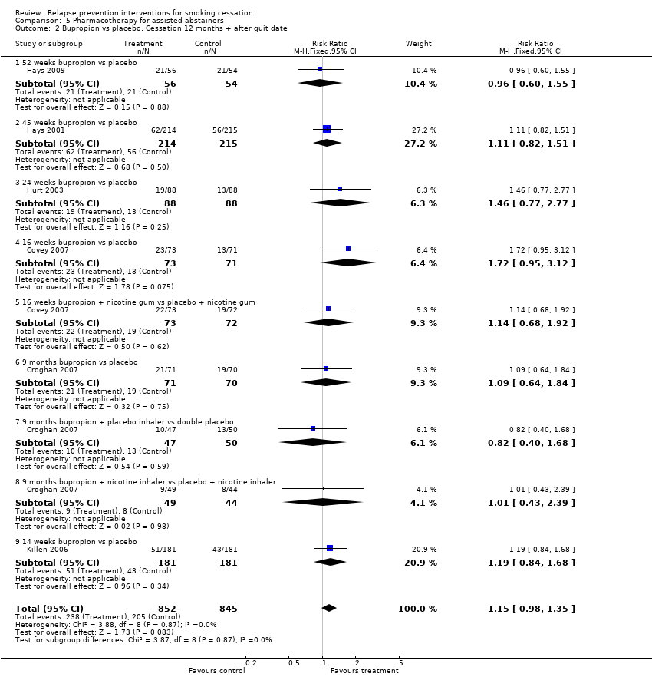
Figure 10: Results of smoking cessation at 12 months after quit date in Livingstone-Banks et al. (2019), bupropion versus placebo in abstainers for relapse prevention
Source: Livingstone-Banks et al. (2019)
Abbreviations: CI = confidence interval
Note: In Hays et al. (2009) and Hurt et al. (2003), patients were provided NRT patches in the open-label treatment phase followed by bupropion and placebo in the double-blind treatment phase. In Covey et al. (2007), patients were provided bupropion and NRT patches in the open-label treatment phase followed by bupropion, NRT gum, or both and placebo in the double-blind treatment phase. In Croghan et al. (2007), patients were provided bupropion, NRT inhaler or both, followed by the same medications or placebo in the double-blind treatment phase. In Killen et al. (2006), patients were provided bupropion and NRT patches in the open-label phase followed by bupropion and placebo in the double-blind treatment phase.
Of the studies identified by Livingstone-Banks et al. (2019), Croghan et al. (2007) was the only study that compared bupropion with placebo in patients who achieved abstinence after initial treatment with bupropion monotherapy; the other studies provided either NRT patches or bupropion plus NRT patches in the initial treatment phase. The key limitation of Croghan et al. (2007) was related to the duration of bupropion monotherapy administered in the initial treatment phase (3 months versus 9 weeks on the PBS) and the relapse prevention phase (9 months). No evidence was identified comparing bupropion with placebo as relapse prevention treatment (9 weeks) in abstainers who completed a 9-week course of initial bupropion monotherapy treatment.
Safety
The safety of bupropion versus placebo in abstainers for relapse prevention was not assessed by Livingstone-Banks et al. (2019) and Croghan et al. (2007).
In Hays et al. (2009), there were no significant differences between bupropion and placebo in the rates of any adverse events. No serious adverse events nor deaths occurred during the randomised phase of the trial. However, four participants dropped out of the study due to adverse events (all assigned to bupropion).
In Hays et al. (2001), the most commonly reported adverse events during open-label bupropion treatment were insomnia (49.5%), headache (33.3%), dry mouth (15.3%), nausea (12.9%) and restlessness (12.0%). There were no statistically significant differences in the frequency of any adverse events during the double-blind treatment phase.
In Hurt et al. (2003), there were no statistically significant differences between bupropion and placebo in the reported adverse events during the double-blind treatment phase. In Covey et al. (2007), the number of reported adverse events such as nervousness, constipation, insomnia, stomach-ache and depressed mood was low, and did not vary by treatment group (P = 0.69).
In Killen et al. (2006), the most commonly reported adverse events during open-label bupropion and NRT patches treatment were insomnia (53%), dry mouth (47%), vivid dreams (44%), nausea (23%) and headache (22%). A total of 13 adverse events were reported by patients in the bupropion treatment group, and a total of 17 adverse events were reported by those receiving placebo during extended treatment.
Bupropion versus placebo – non-abstainers (retreatment)
A summary of the citation details for the studies comparing bupropion with placebo in non-abstainers as retreatment is presented in Table 42. Two RCTs that compared bupropion with placebo as retreatment (Gonzales et al. 2001 and Selby et al. 2003) were identified in a recently conducted Cochrane Review by Howes et al. (2020) and were included in this report. These studies enrolled smokers who had previously failed to quit smoking using bupropion. No new studies comparing bupropion with placebo in non-abstainers as retreatment were identified in the supplemental literature search.
Table 42: List of studies comparing bupropion with placebo in non-abstainers as retreatment
Study | Citation
Gonzales  (2001)⁴³ | Gonzales DH, Nides MA, Ferry LH, Kustra RP, Jamerson BD, Segall N, Herrero LA, Krishen A, Sweeney A, Buaron K, Metz A. Bupropion SR as an aid to smoking cessation in smokers treated previously with bupropion: a randomized placebo-controlled study. Clin Pharmacol Ther. 2001 Jun;69(6):438-44.
Selby  (2003)⁴⁴ | Selby P, Ainslie M, Stepner N, Roberts J. Sustained‐release bupropion (Zybanr) is effective in the re‐treatment of relapsed adult smokers. American Journal of Respiratory and Critical Care Medicine. 2003;167(7):A47.
Notes: Gonzales et al. (2001) and Selby et al. (2003) were included in the Cochrane Review by Howes et al. (2020). Howes et al. (2020) did not conduct a subgroup analysis on retreatment.
A summary of the characteristics of the studies comparing bupropion with placebo in non-abstainers as retreatment is presented in Table 43.

Table 43: Characteristics of the studies comparing bupropion with placebo in non-abstainers as retreatment
Study | Study type | N¹ | Population | Intervention and comparator | Outcomes
Gonzales  (2001) | RCT | N=450  Bupropion (n=226),  Placebo (n=224) | Inclusion: ≥18 years old, ≥15 cigarettes per day during the previous month, exhaled CO >10 ppm, motivated to stop smoking, not had more than 24 hours’ abstinence during the previous month, used bupropion as an aid to smoking cessation for at least 2 weeks without experiencing serious adverse events.  Exclusion: any predisposition to seizure, history of bulimia or anorexia nervosa, history of severe renal, hepatic, neurologic, or chronic pulmonary disease, current diagnosis of major depression, or were currently using another treatment for smoking cessation.  The duration between previous bupropion treatment and retreatment was not reported. Mean duration of previous bupropion treatment was 6.5 weeks (bupropion arm) and 6.3 weeks (placebo arm). | Bupropion: 150 mg twice daily including titration over 12 weeks (i.e. 150 mg once daily for 3 days, then 150 mg twice daily);  Placebo: placebo tablets, same regimen.  Behavioural support provided in both arms. | Primary: CAR at Week 4-7. Validated by expired CO ≤10 ppm.  Secondary: CAR at Week 9-12 and Week 4-26. 7-day PPA at each clinic visit throughout the treatment phase and at the follow-up visit at month 6. CAR from day 22 through each clinic visit during the treatment phase. Validated by CO ≤10 ppm.
Selby  (2003) | RCT | N=284  Bupropion (n=141),  Placebo (n=143) | Inclusion: ≥18 years old, ≥15 cigarettes per day during the previous month and not to have quit for more than 24 hours during that month, previous exposure to bupropion for a minimum of 2 weeks, motivated to quit smoking.  Exclusion: Uncontrolled chronic disease, any predisposition to seizures, a history of psychiatric disorder, or a current history of chemical dependency, including alcohol.  The duration between previous bupropion treatment and retreatment was not reported. Duration of previous bupropion treatment was at least 2 weeks. | Bupropion: 150 mg twice daily including titration over 12 weeks (i.e. 150 mg once daily for 3 days, then 150 mg twice daily);  Placebo: placebo tablets, same regimen.  Behavioural support not described. | Primary: CAR at Week 4-7. Validated by CO ≤10 ppm.  Secondary: CAR at Week 9-12. 7-day PPA during the treatment period and at 12 months. Validated by CO ≤10 ppm.
Abbreviations: CAR = continuous abstinence rate; CO = carbon monoxide; PPA = point prevalence abstinence; RCT = randomised controlled trial
Notes: Gonzales et al. (2001) and Selby et al. (2003) were included in the Cochrane Review by Howes et al. (2020).
1 Only the number of patients (n) in the relevant arms were included.
Efficacy
A summary of the smoking cessation rates at 12 months comparing bupropion with placebo in non-abstainers as retreatment is presented in Table 44. The results of Gonzales et al. (2001) demonstrated a statistically significant difference in continuous abstinence rate, in favour of bupropion. In contrast, no statistically significant difference was observed between the two treatment arms in Selby et al. (2003), although the results numerically favoured bupropion. It was noted that the results of these studies were included in the primary efficacy analysis of bupropion versus placebo conducted by Howes et al. (2020), presented in the treatment-naïve population section.
The results of the meta-analysis of the two studies conducted during the review demonstrated no statistically significant difference between the two treatment arms in terms of risk ratio. However, the results were statistically significant, in favour of bupropion, when risk difference (absolute measure of effect) was used.
Table 44: Results of smoking cessation at 12 months, bupropion versus placebo in non-abstainers as retreatment
Study | Study type | Bupropion | Placebo | RR (95% CI) | RD (95% CI)
Gonzales (2001)¹ | RCT | 20/226  (8.8%) | 5/224  (2.2%) | 3.96  (1.51, 10.38) | 0.07  (0.02, 0.11)
Selby  (2003)² | RCT | 18/141  (12.8%) | 12/143  (8.4%) | 1.52  (0.76, 3.04) | 0.04  (-0.03, 0.12)
Meta-analysis³ | 2 RCTs | 38/367  (10.4%) | 17/367  (4.6%) | 2.31  (0.90, 5.92) | 0.06  (0.02, 0.10)
Source: Howes et al. (2020)
Abbreviations: CI = confidence interval; RCT = randomised controlled trial; RR = risk ratio
Notes: Bold indicates statistically significant difference.
1 Continuous abstinence rate at 12 months (Week 4-52).
2 Point prevalence abstinence at 12 months.
3 Calculated during the review using a random-effect model.
The results of the individual studies included in the meta-analysis are presented using a forest plot in Figure 11.
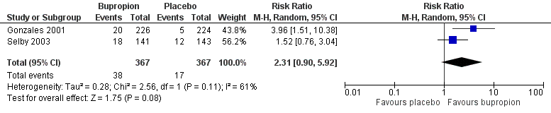
Figure 11: Results of smoking cessation at 12 months, bupropion versus placebo in non-abstainers as retreatment
Source: Howes et al. (2020)
Abbreviations: CI = confidence interval
Safety
The incidence of adverse events comparing bupropion with placebo in non-abstainers as retreatment was not synthesised quantitatively by Howes et al. (2020). It was noted that the safety results of Gonzales et al. (2001) were included in the overall safety analysis of bupropion versus placebo conducted by Howes et al. (2020), presented in the treatment-naïve population section.
Based on the meta-analysis of Gonzales et al. (2001) and Selby et al. (2003), a significantly higher proportion of patients in the bupropion arm experienced any adverse events compared to patients in the placebo arm (Table 45). There were no statistically significant differences between the two treatment arms for serious adverse events and discontinuation due to adverse events, although a numerically higher incidence rate was observed in the bupropion arm, noting that the outcome of discontinuation due to adverse events was not reported in Selby et al. (2003).
Table 45: Summary of key adverse events, bupropion versus placebo in non-abstainers as retreatment
Outcome | Study type | Bupropion | Placebo | RR (95% CI) | RD (95% CI)
Adverse events¹ | 2 RCTs | 284/367  (77.4%) | 229/367  (62.4%) | 1.25  (1.13, 1.37) | 0.15  (0.09, 0.22)
Serious adverse events¹ | 2 RCTs | 6/367  (1.6%) | 4/367  (1.1%) | 1.49  (0.42, 5.32) | 0.01  (-0.01, 0.02)
Discontinuation due to adverse events | 1 RCT  (Gonzales 2001) | 19/226  (8.4%) | 11/224  (4.9%) | 1.71  (0.83, 3.51) | 0.03  (-0.01, 0.08)
Source: Howes et al. (2020), Gonzales et al. (2001), Selby et al. (2003)
Abbreviations: CI = confidence interval; RD = risk difference; RR = risk ratio
Notes: Bold indicates statistically significant difference. See Appendix Figure 74 and Figure 75 for forest plots of the respective outcomes which included the results of individual studies.
1 Calculated during the review using a random-effect model.

Nicotine replacement therapy
NRT has not been previously considered by the PBAC for relapse prevention in abstainers or retreatment in non-abstainers. As previously noted, the current listing allowed for a maximum of 2 courses of PBS-subsidised NRT treatment per 12-month period in the Aboriginal and Torres Strait Islander population or 12 weeks of PBS-subsidised NRT treatment per 12-month period in the general population, irrespective of formulation (patch, lozenge or gum). Accordingly, patients who have been unsuccessful in achieving abstinence from smoking after a course of PBS-subsidised NRT may access another course of PBS-subsidised NRT after 12 months.
NRT versus placebo – abstainers (relapse prevention)
A summary of the citation details for the studies comparing NRT with placebo in abstainers for relapse prevention is presented in Table 46. A recently conducted Cochrane Review by Livingstone-Banks et al. (2019) was identified in the systematic literature review that compared NRT with placebo for relapse prevention and was included in this report. No new studies comparing NRT with placebo in abstainers for relapse prevention were identified in the supplemental literature search.
Table 46: List of studies comparing NRT with placebo in abstainers for relapse prevention
Study | Citation
Livingstone-Banks (2019)⁴⁰ | Livingstone‐Banks J, Norris E, Hartmann‐Boyce J, West R, Jarvis M, Hajek P. Relapse prevention interventions for smoking cessation. Cochrane Database of Systematic Reviews 2019, Issue 2. Art. No.: CD003999.
A summary of the characteristics of the studies comparing NRT with placebo in abstainers for relapse prevention is presented in Table 47. A total of two RCTs comparing NRT with placebo were identified by Livingstone-Banks et al. (2019). The characteristics of the individual studies are presented in Appendix Table 154.
Table 47: Characteristics of the studies comparing NRT with placebo in abstainers for relapse prevention
Study | Study type | N¹ | Population | Intervention and comparator | Outcomes
Livingstone-Banks (2019) | Cochrane Review (2 RCTs²) | N=553  NRT (n=275),  Placebo (n=278) | Inclusion: smokers who quit on their own, were undergoing enforced abstinence, or were participating in treatment programmes to assist initial cessation.  Exclusion: NR. | NRT: NRT of various formulation;  Placebo: placebo, same regimen. | Primary: smoking cessation rates of at least six months after baseline.
Abbreviations: NR = not reported; RCT = randomised controlled trial
1 Only the number of patients (n) in the relevant arms were included.
2 The characteristics of the individual studies comparing NRT with placebo included in Livingstone-Banks et al. (2019) are presented in Appendix Table 154.
Efficacy
A summary of the smoking cessation rates at 12 months comparing NRT with placebo in abstainers for relapse prevention is presented in Table 48. The results of the meta-analysis comprising two RCTs by Livingstone-Banks et al. (2019) demonstrated no statistically significant difference in long-term smoking cessation rates between NRT and placebo for relapse prevention.
Table 48: Results of smoking cessation at 12 months after quit date, NRT versus placebo in abstainers for relapse prevention
Study | Study type | NRT | Placebo | RR (95% CI)
Livingstone-Banks  (2019)^{1,2} | Cochrane Review (2 RCTs) | 67/275  (24.4%) | 65/278  (23.4%) | 1.04  (0.77, 1.4)
Source: Livingstone-Banks et al. (2019)
Abbreviations: CI = confidence interval; RCT = randomised controlled trial; RD = risk difference; RR = risk ratio
Notes: Bold indicates statistically significant difference.
1 Where cessation was assessed at multiple intervals, the longest follow-up data were used. Where multiple definitions of abstinence were assessed, the strictest of these definitions was used (e.g. continuous/prolonged abstinence over point prevalence abstinence). See Appendix Table 154 for the definition used in each study.
2 Calculated by Cochrane Review authors using a fixed-effect model.
The results of the individual studies included in Livingstone-Banks et al. (2019) are presented using a forest plot in Figure 12. There were no statistically significant differences between NRT and placebo in any of the individual RCTs included in the meta-analysis, noting that the formulation and duration of NRT treatment differed across the RCTs.
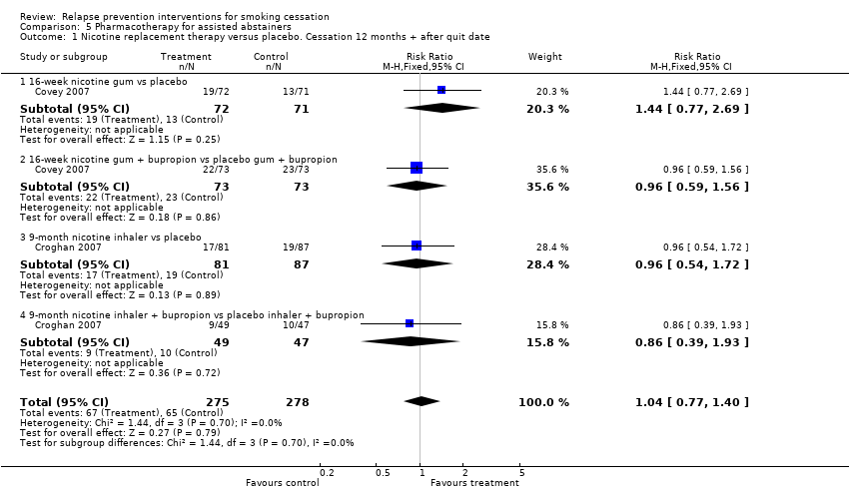
Figure 12: Results of smoking cessation at 12 months after quit date in Livingstone-Banks et al. (2019), NRT versus placebo in abstainers for relapse prevention
Source: Livingstone-Banks et al. (2019)
Abbreviations: CI = confidence interval
Notes: In Covey et al. (2007), patients were provided bupropion and NRT patches in the open-label treatment phase followed by bupropion, NRT gum, or both and placebo in the double-blind treatment phase. In Croghan et al. (2007), patients were provided bupropion, NRT inhaler or both, followed by the same medications or placebo in the double-blind treatment phase.
None of the studies identified by Livingstone-Banks et al. (2019) compared NRT monotherapy (either as patch, gum or lozenge) with placebo in patients who achieved abstinence after initial treatment with NRT monotherapy using the same formulation. In Covey et al. (2007), patients were provided bupropion plus NRT patches in the initial treatment phase while patients were provided NRT inhaler in Croghan et al. (2007).
Safety
The safety of NRT versus placebo in abstainers for relapse prevention was not assessed by Livingstone-Banks et al. (2019) and Croghan et al. (2007).
In Covey et al. (2007), the number of reported adverse events such as nervousness, constipation, insomnia, stomach-ache and depressed mood was low, and did not vary by treatment group (P = 0.69).
NRT versus placebo – non-abstainers (retreatment)
A summary of the citation details for the studies comparing NRT with placebo in non-abstainers as retreatment is presented in Table 49. One RCT that compared NRT patches with placebo as retreatment (Gourlay et al. 1995) was identified in a recently conducted Cochrane Review by Hartmann-Boyce et al. (2018) and was included in this report. Gourlay et al. (1995) enrolled smokers who had previously failed to quit smoking using NRT patches. No new studies comparing NRT with placebo in non-abstainers as retreatment were identified in the supplemental literature search.
Table 49: List of studies comparing bupropion with placebo in non-abstainers as retreatment
Study | Citation
Gourlay  (1995)⁴⁵ | Gourlay SG, Forbes A, Marriner T, Pethica D, McNeil JJ. Double blind trial of repeated treatment with transdermal nicotine for relapsed smokers. BMJ. 1995 Aug 5;311(7001):363-6.
Notes: Gourlay et al. (1995) was included in the Cochrane Review by Hartmann-Boyce et al. (2018). Hartmann-Boyce et al. (2018) did not conduct a subgroup analysis on retreatment (summarised qualitatively).
A summary of the characteristics of the studies comparing NRT patches with placebo in non-abstainers as retreatment is presented in Table 50.

Table 50: Characteristics of the studies comparing NRT patch with placebo in non-abstainers as retreatment
Study | Study type | N¹ | Population | Intervention and comparator | Outcomes
Gourlay  (1995) | RCT | N=629  NRT patch (n=315),  Placebo (n=314) | Inclusion: smokers who are motivated to quit again and had relapsed to regular smoking of ≥15 cigarettes a day (from Phase I of the study).  Exclusion: medications that might interfere with symptoms of tobacco withdrawal, pregnancy, lactation, or potential pregnancy, mental or psychiatric illness, symptomatic ischaemic heart disease or cerebrovascular disease within the past three months, alcoholism, active malignancy, major medical disorders, extensive skin lesions precluding application of patches, had experienced adverse reactions to transdermal nicotine that caused permanent discontinuation of the initial treatment.  The duration between previous NRT treatment and retreatment was around 17-30 weeks (first quit date to second attempt at quitting). Duration of previous NRT treatment was 12 weeks. | NRT patch: four weeks each of a 30 cm² patch (active 21 mg/24 hours), a 20 cm² patch (active 14 mg/24 hours), and a 10 cm² patch (active 7 mg/24 hours), over 12 weeks.; Placebo: four weeks each of a 30 cm² patch (placebo 2-7 mg/24 hours), a 20 cm² patch (placebo 1.8 mg/24 hours), and a 10 cm² patch (placebo 0.9 mg/24 hours), over 12 weeks.  Behavioural support provided in both arms. | Primary: Sustained abstinence for 28 days before visit at week 12. Validated by CO ≤8 ppm.  Secondary: CAR at Week 4, 8, 12 and 26. Validated by CO ≤8 ppm.
Abbreviations: CAR = continuous abstinence rate; CO = carbon monoxide; RCT = randomised controlled trial
Notes: Gourlay et al. (1995) was included in the Cochrane review by Hartmann-Boyce et al. (2018).
1 Only the number of patients (n) in the relevant arms were included.

Efficacy
A summary of the smoking cessation rates at 6 months comparing NRT patches with placebo is presented in Table 51. The results of Gourlay et al. (1995) based on continuous abstinence rate demonstrated no statistically significant difference between NRT patches and placebo in non-abstainers as retreatment. However, there was a statistically significant improvement in smoking cessation rates using NRT patches based on 28-day point prevalence abstinence (RR: 2.49; 95% CI: 1.11, 5.57). It was noted that the quit rates were low in both groups with either definition of abstinence.
Table 51: Results of smoking cessation at 6 months, NRT patch versus placebo in non-abstainers as retreatment
Study | Study type | NRT patch | Placebo | RR (95% CI) | RD (95% CI)
Gourlay (1995)^{1,2} | RCT | 5/315  (1.6%) | 4/314  (1.3%) | 1.25  (0.34, 4.60) | 0.00  (-0.02, 0.02)
Source: Hartmann-Boyce et al. (2018) and Gourlay et al. (1995)
Abbreviations: CI = confidence interval; RCT = randomised controlled trial; RR = risk ratio
Notes: Bold indicates statistically significant difference.
1 Continuous abstinence rate at 6 months (Quit day to Week 26).
2 Calculated during the review.
Safety
The incidence of adverse events comparing NRT with placebo in non-abstainers as retreatment was not synthesised quantitatively by Hartmann-Boyce et al. (2018). It was noted that the safety results of Gourlay et al. (1995) were included in the general safety analysis of NRT versus placebo conducted by Hartmann-Boyce et al. (2018), as presented in the treatment-naïve population section.
Based on the study by Gourlay et al. (1995), there were no statistically significant differences between the two treatment arms for palpitations, tachycardia or chest pain, although a numerically higher incidence rate was observed in the NRT patches arm (Table 52).
Table 52: Results of palpitations or chest pains in Gourlay et al. (1995), NRT patch versus placebo in non-abstainers as retreatment
Outcome | NRT patch | Placebo | RR (95% CI) | RD (95% CI)
Palpitations or chest pain¹ | 5/179  (2.8%) | 3/143  (2.1%) | 1.33  (0.32, 5.48) | 0.01  (-0.03, 0.04)
Source: Hartmann-Boyce et al. (2018) and Gourlay et al. (1995)
Abbreviations: CI = confidence interval; RCT = randomised controlled trial; RR = risk ratio
Notes: Bold indicates statistically significant difference.
1 Calculated during the review.

Summary of evidence for monotherapy
Bupropion
Treatment-naïve population
Based on the evidence presented (Howes et al. 2020, Benowitz et al. 2018), bupropion was shown to provide a statistically significant improvement in long-term smoking cessation rates compared with placebo, noting the significantly higher incidence of adverse events, psychiatric adverse events and discontinuation due to adverse events in the bupropion arm. This is consistent with the evidence previously considered by the PBAC ''''''''''''''''' ''''' ''''' ''''''''''' ''''''''' ''''' ''''' '''''''''''
For the comparison of bupropion versus NRT (either as patch, lozenge or choice of NRT), there were no statistically significant differences in long-term smoking cessation rates, adverse events, serious adverse events and discontinuation due to adverse events between the two treatment arms (Howes et al. 2020, Benowitz et al. 2018). This is consistent with the evidence previously considered by the PBAC to support non-inferiority (Jorenby et al. 1999, Gorecka et al. 2003, Uyar et al. 2007, Piper et al. 2009).
Treatment-experienced population
Bupropion has not been previously considered by the PBAC for relapse prevention in abstainers or retreatment in non-abstainers. Based on the evidence presented (Livingstone-Banks et al. 2019), there were no statistically significant differences in long-term smoking cessation rates between bupropion and placebo as a relapse prevention treatment in abstainers, irrespective of treatment duration. The safety of bupropion versus placebo in abstainers for relapse prevention was not assessed by Livingstone-Banks et al. (2019) and Croghan et al. (2007), however the adverse events reported were consistent with those expected of bupropion. No evidence was identified comparing bupropion with placebo as relapse prevention treatment (9 weeks) in abstainers who completed a 9-week course of initial bupropion monotherapy treatment.
For use as retreatment in non-abstainers, there were no statistically significant differences (risk ratio) in long-term smoking cessation rates between bupropion and placebo based on the meta-analysis of Gonzales et al. (2001) and Selby et al. (2003), noting that the results were statistically significant based on risk difference. While a significantly higher proportion of patients in the bupropion arm experienced any adverse events compared to patients in the placebo arm, there were no statistically significant differences in serious adverse events and discontinuation due to adverse events.
Varenicline
Treatment-naïve population
Based on the evidence presented (Lerman et al. 2015, Littlewood et al. 2017, Benowitz et al. 2018, Hurt et al. 2018, Mercie et al. 2018, Windle et al. 2018, Ashare et al. 2019, Chen et al. 2020), varenicline was shown to provide a statistically significant improvement in long-term smoking cessation rates compared with placebo. In terms of safety, a significantly higher incidence rate of adverse events (nausea, insomnia, abnormal dreams, and headache) and serious adverse events were observed in the varenicline arm, noting that the results for headache and serious adverse events were no longer statistically significant in the updated re-analysis. There were no statistically significant differences between the two treatment arms for depression, suicidal ideation, neuropsychiatric serious adverse events and cardiac serious adverse events. This is consistent with the evidence previously considered by the PBAC (Gonzales et al. 2006, Jorenby et al. 2006, Oncken et al. 2006, Nakamura et al. 2007, Tsai et al. 2007, Wang et al. 2009, Bolliger et al. 2011, Rigotti et al. 2010, Tashkin et al. 2011, Rennard et al. 2012, EAGLES 2016).
For the comparison of varenicline versus bupropion, there was a statistically significant difference in long-term smoking cessation rates, in favour of varenicline, while there were no statistically significant differences in adverse events, psychiatric adverse events, serious adverse events and discontinuation due to adverse events between the two treatment arms (Howes et al. 2020, Benowitz et al. 2018). This is consistent with the evidence previously considered by the PBAC (Gonzales et al. 2006, Jorenby et al. 2006, and EAGLES 2016).
Treatment-experienced population
Based on the evidence presented (Livingstone-Banks et al. 2019), varenicline was shown to provide a statistically significant improvement in long-term smoking cessation rates compared with placebo as a relapse prevention treatment in abstainers. This is largely based on and thus is consistent with the evidence previously considered by the PBAC (Tonstad et al. 2006). The safety of varenicline versus placebo in abstainers for relapse prevention was not assessed by Livingstone-Banks et al. (2019), however the adverse events reported were consistent with those expected of varenicline.
For use as retreatment in non-abstainers, varenicline was shown to provide a statistically significant improvement in long-term smoking cessation rates compared with placebo (Cahill et al. 2016). A significantly higher proportion of patients in the varenicline arm experienced nausea and abnormal dreams compared to patients in the placebo arm, while there were no statistically significant differences between the two treatment arms for insomnia, headache, depression, serious adverse events and cardiac serious adverse events, although a numerically higher incidence rate was observed in the varenicline arm except for cardiac serious adverse events. This is consistent with the evidence previously considered by the PBAC (Gonzales et al. 2014; referred to as Trial A3051139 in March 2014 PBAC meeting). It was noted that the one study (Gonzales et al. 2014) identified by Cahill et al. (2014) required patients to have had previously taken varenicline for two or more weeks, with the last dose taken ≥3 months before screening.
Nicotine Replacement Therapy
Treatment-naïve population
Based on the evidence presented (Hartmann-Boyce et al. 2018), NRT patches were shown to provide a statistically significant improvement in long-term smoking cessation rates compared with placebo, noting that similar results were observed for NRT gum or lozenges versus placebo. There were significantly higher incidence of palpitations, tachycardia or chest pains with NRT (various formulation) compared with placebo. This is consistent with the evidence previously considered by the PBAC (''''''''''' '''''''''''' Stead et al. 2008, ''''''''''' '''' ''''' '''''''''').
For the comparison of NRT patches versus varenicline, NRT patches was shown to be inferior to varenicline in terms of efficacy based on a statistically significant difference in point prevalence abstinence at 24 weeks, in favour of varenicline (Cahill et al. 2016, Lerman et al. 2015, Tulloch et al. 2016, Rohsenow et al. 2017, Benowitz et al. 2018). In terms of safety, there were no statistically significant differences in side effects (including neuropsychiatric and cardiovascular safety profile) between the two treatment arms. This is consistent with the evidence previously considered by the PBAC (Aubin et al. 2008, EAGLES 2016).
There were no statistically significant differences in long-term smoking cessation rates, serious adverse events and withdrawals due to treatment between NRT lozenges or gum (as a monotherapy) versus NRT patches (Lindson et al. 2019). This is consistent with the evidence previously considered by the PBAC to support non-inferiority (Piper et al. 2009, Smith et al. 2009, Schnoll et al. 2010, and Moolchan et al. 2005).
Treatment-experienced population
NRT has not been previously considered by the PBAC for relapse prevention in abstainers or retreatment in non-abstainers. Based on the evidence presented (Livingstone-Banks et al. 2019), there were no statistically significant differences in long-term smoking cessation rates between NRT (either as gum or inhaler) and placebo as a relapse prevention treatment in abstainers. The safety of NRT (either as gum or inhaler) versus placebo in abstainers for relapse prevention was not assessed by Livingstone-Banks et al. (2019) and Croghan et al. 2007, however the adverse events reported were consistent with those expected of NRT. No evidence was identified comparing NRT monotherapy (either as patch, gum or lozenge) with placebo in patients who achieved abstinence after initial treatment with NRT monotherapy using the same formulation.
For use as retreatment in non-abstainers, there were no statistically significant differences in long-term smoking cessation rates (continuous abstinence rate) between NRT patches and placebo based on one RCT (Gourlay et al. 1995) identified by Hartmann-Boyce et al. (2018). However, there was a statistically significant improvement in smoking cessation rates using NRT patches based on 28-day point prevalence abstinence (RR: 2.49; 95% CI: 1.11, 5.57). It was noted that the quit rates were low in both groups with either definition of abstinence. For safety, there were no statistically significant differences between the two treatment arms for palpitations, tachycardia or chest pains.

Combination therapy in the general population
The aim of this section was to summarise the comparative efficacy and safety of PBS-listed treatments when used as combination therapy.
A summary of the new evidence identified assessing the use of combination therapies for smoking cessation is presented in Table 53. The evidence is presented according to the population type (treatment-naïve or treatment-experienced).
Combination therapies for smoking cessation have not been previously considered by the PBAC. In March 2018, the PBAC noted that the latest clinical guidelines encouraged health professionals to consider recommending the use of combination NRT (e.g. NRT patch with NRT gum or lozenges) (NRT PSD, March 2018 PBAC meeting). As such, the comparison of combination NRT is presented first, followed by different combinations including varenicline and different combinations including bupropion.
Table 53: New evidence identified comparing combination therapy intervention in smoking cessation
Intervention | Intervention and comparator | New evidence identified  (Cochrane Review) | Additional empirical evidence identified
Treatment-naïve population
Combination NRT | Combination NRT versus placebo | Hartmann-Boyce 2018 | Chen 2020¹
 | Combination NRT versus NRT monotherapy | Lindson 2019 | Leung 2019
 | Combination NRT versus varenicline | Cahill 2013² | Chen 2020¹
 | Combination NRT versus bupropion | Cahill 2013² | None identified
Combination varenicline | Varenicline + NRT versus varenicline | Chang 2015³ | None identified
 | Varenicline + bupropion versus varenicline | Howes 2020 | None identified
Combination bupropion | Bupropion + NRT versus NRT | Howes 2020 | None identified
Treatment-experienced population
Combination bupropion | Bupropion + NRT versus placebo | Livingstone-Banks 2019 | None identified
Abbreviations: NRT = nicotine replacement therapy
Notes:
1 Chen et al. (2020) is a direct evidence (RCT) identified in the updated literature search. This RCT was a three-arm study comparing combination NRT (patch and lozenge), varenicline and placebo.
2 Network meta-analysis included as supportive evidence. No direct evidence identified for combination NRT versus bupropion.
3 Chang et al. (2015) is a systematic review and meta-analysis identified in the systematic literature review.

Treatment-naïve population

Combination NRT
In July 2017 and March 2018, the PBAC considered a request that NRT lozenges and gum be listed as monotherapies on the PBS. While the requested listing was for monotherapy, the PBAC considered that the likely place in clinical therapy for nicotine lozenges and gum would be as combination therapy with long-acting forms of currently listed NRTs (nicotine patches, varenicline or bupropion) (NRT PSD, July 2017 PBAC meeting).
The PBAC noted that varenicline was proposed as a relevant comparator for combination use of NRTs in the pre-PBAC response. The PBAC considered that while varenicline was likely to be an appropriate comparator for the use of nicotine lozenges or gum in combination with nicotine patches, nicotine lozenges or gum could be used in combination with varenicline as well in practice. The PBAC noted that no clinical evidence on the potential comparator/s for either of the combinations was presented in the submission or the pre-PBAC response (NRT PSD, July 2017 PBAC meeting).
Combination NRT versus placebo
A summary of the citation details for the studies comparing combination NRT with placebo is presented in Table 54. A recently conducted Cochrane Review by Hartmann-Boyce et al. (2018) was identified in the systematic literature review that compared combination NRT with placebo and was included in this report. One RCT was identified in the supplemental literature search that informed this comparison and was included in this report (Chen et al. 2020).
Table 54: List of studies comparing combination NRT with placebo
Study | Citation
Hartmann-Boyce (2018)³⁰ | Hartmann‐Boyce J, Chepkin SC, Ye W, Bullen C, Lancaster T. Nicotine replacement therapy versus control for smoking cessation. Cochrane Database of Systematic Reviews 2018, Issue 5. Art. No.: CD000146.
Chen  (2020)⁴⁶ | Chen LS, Baker TB, Miller JP, Bray M, Smock N, Chen J, Stoneking F, Culverhouse RC, Saccone NL, Amos CI, Carney RM. Genetic Variant in CHRNA5 and Response to Varenicline and Combination Nicotine Replacement in a randomized placebo‐controlled trial. Clinical Pharmacology & Therapeutics. 2020 Jun 29.

A summary of the characteristics of the studies comparing combination NRT with placebo is presented in Table 55. A total of five RCTs comparing combination NRT with placebo were identified by Hartmann-Boyce et al. (2018) and were included in this report. The characteristics of the individual studies are presented in Appendix Table 155.
Chen et al. (2020) was a genotype-stratified randomised, double-blind, placebo-controlled clinical trial comparing 12 weeks of placebo, combination nicotine patch and lozenge and varenicline. This study was included in the updated efficacy and safety re-analysis where outcomes were reported.

Table 55: Characteristics of the studies comparing combination NRT with placebo
Study | Study type | N¹ | Population | Intervention and comparator | Outcomes
Hartmann-Boyce (2018) | Cochrane review (5 RCTs²) | NRT patch and lozenge  N=308 (1 RCT)  Intervention (n=267),  Placebo (n=41)  NRT patch and gum  N=259 (2 RCTs)  Intervention (n=173),  Placebo (n=86)  NRT patch and inhalator  N=245 (1 RCT)  Intervention (n=136),  Placebo (n=109)  NRT patch, gum and lozenge  N=424 (1 RCT)  Intervention (n=212),  Placebo (n=212) | Inclusion: men or women who smoked and were motivated to quit, irrespective of the setting from which they were recruited or their initial level of nicotine dependence, or both.  Exclusion: trials that randomised physicians or other therapists to receive an educational intervention, which included encouraging their patients to use NRT. | NRT: combination NRT; Placebo: placebo or no NRT control. | Primary: smoking cessation rates of at least six months after baseline.  Secondary: adverse event including palpitations/chest pains.
Chen  (2020) | RCT | N=822  NRT patch and lozenge (n=275),  Placebo (n=273) | Inclusion: ≥21 years old seeking treatment for smoking cessation, ≥5 cigarettes per day, exhaled CO ≥8 ppm.  Exclusion: pregnancy or breast feeding, active use or recent use of medication or e-cigarettes for nicotine dependence/smoking cessation, allergy to nicotine patch, lozenge, or varenicline, significant cardiac conditions or serious arrhythmia in past 6 months, current heavy alcohol consumption, active psychosis or poorly controlled depression within the past 6 months, any prior suicide attempt or suicidal ideation within the past 6 months, end stage renal disease with haemodialysis. | NRT: 12 weeks of patches (21 mg for 8 weeks, 14 mg for 2 weeks, and 7 mg for 2 weeks) as well as 13 weeks of nicotine lozenges for use as needed (4 mg for those who smoke within 30 min of awaking and 2 mg otherwise; Placebo: placebo patch and lozenge or placebo varenicline for 12 weeks.  Behavioural support provided in both arms. | Primary: 7-day PPA at Week 12. Validated by CO <8 ppm.  Secondary: 7-day PPA at 6 (CO-validated) and 12 months (self-report), adverse events, adherence.
Abbreviations: CO = carbon monoxide; NRT = nicotine replacement therapy; RCT = randomised controlled trial
1 Only the number of patients (n) in the relevant arms were included.
2 The characteristics of the individual studies comparing combination NRT with placebo included in Hartmann-Boyce et al. (2018) are presented in Appendix Table 155.

Efficacy
A summary of the smoking cessation rates for at least six months follow-up comparing combination NRT with placebo is presented in Table 56. For the comparison of NRT patch + lozenge versus placebo, there was a statistically significant difference in long-term smoking cessation rates between the two treatment arms, in favour of combination NRT (Piper et al. 2009). In Chen et al. (2020), there were no statistically significant differences between the two treatment arms, although the results numerically favoured NRT patch + lozenge. The results of the meta-analysis based on the updated re-analysis were statistically significant based on risk ratio but not risk difference.
For the comparison of NRT patch + gum versus placebo, there were no statistically significant differences between the two treatment arms based on the meta-analysis of two studies conducted by Hartmann-Boyce et al. (2018), although the results numerically favoured NRT patch + gum. The non-significant result of NRT patch + gum was likely due to the study design, such as small sample size, leading to insufficient power to detect a modest treatment effect with reasonable certainty.
The comparisons of NRT patch + inhalator and NRT patch + lozenge and gum versus placebo were included for additional information purposes. For the comparison of NRT patch + inhalator versus placebo, there were no statistically significant differences between the two treatment arms (Hand et al. 2002). For the comparison of NRT patch + lozenge and gum versus placebo, there was a statistically significant difference in long-term smoking cessation rates between the two treatment arms, in favour of combination NRT (Heydari et al. 2013).
Table 56: Results of smoking cessation for at least six months follow-up, combination NRT versus placebo
Study | Study type | Combination NRT | Placebo | RR (95% CI) | RD (95% CI)
NRT patch + lozenge versus placebo
Hartmann-Boyce  (2018)¹ | Cochrane Review  (1 RCT²) | 107/267  (40.1%) | 9/41  (22.0%) | 1.83  (1.01, 3.31) | NR
Chen  (2020)² | RCT | 37/275  (13.5%) | 25/273  (9.2%) | 1.47  (0.91, 2.37) | 0.04  (-0.01, 0.10)
Updated  re-analysis³ | 2 RCTs | 144/542  (26.6%) | 34/314  (10.8%) | 1.60  (1.10, 2.32) | 0.10  (-0.04, 0.23)
NRT patch + gum versus placebo
Hartmann-Boyce  (2018)¹ | Cochrane Review  (2 RCTs²) | 24/173  (13.9%) | 16/86  (18.6%) | 1.15  (0.64, 2.06) | NR
NRT patch + inhalator versus placebo
Hartmann-Boyce  (2018)¹ | Cochrane Review  (1 RCT⁴) | 20/136  (14.7%) | 15/109  (13.8%) | 1.07  (0.57, 1.99) | NR
NRT patch + lozenge and gum versus placebo
Hartmann-Boyce  (2018)¹ | Cochrane Review  (1 RCT⁵) | 15/212  (7.1%) | 1/212  (0.5%) | 15.00  (2, 112.54) | NR
Source: Hartmann-Boyce et al. (2018), Chen et al. (2020)
Abbreviations: CI = confidence interval; NR = not reported; RCT = randomised controlled trial; RD = risk difference; RR = risk ratio
Notes: Calculated during the review. Bold indicates statistically significant difference.
1 Calculated by Cochrane Review authors using a fixed-effect model.
2 7-day point prevalence abstinence at 6 months.
3 Calculated during the review using a random-effect model.
4 Sustained abstinence at 12 months.
5 Abstinence at 6 months (type of measure not specified).
The results of the individual studies included in Hartmann-Boyce et al. (2018) are presented using a forest plot in Figure 13.
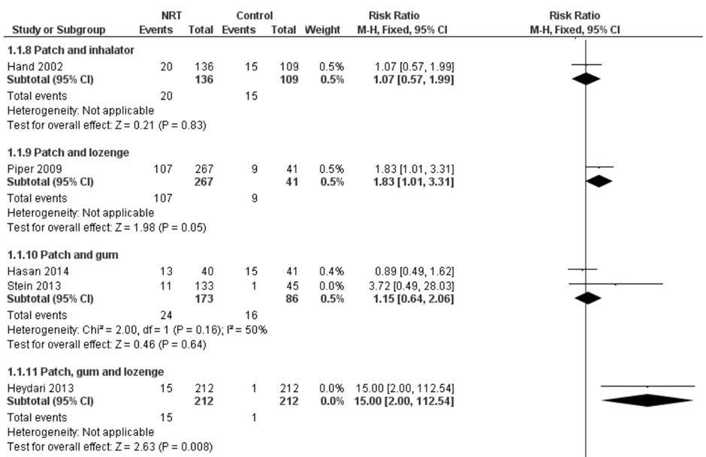
Figure 13: Results of smoking cessation for at least six months follow-up in Hartmann-Boyce et al. (2018), combination NRT versus placebo
Source: Hartmann-Boyce et al. (2018)
Abbreviations: CI = confidence interval
The results of the individual studies included in the updated re-analysis for NRT patch + lozenge versus placebo are presented using a forest plot in Figure 14.
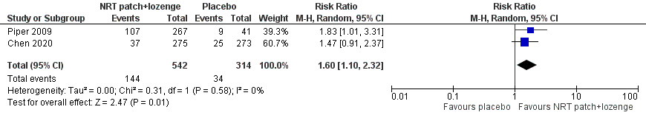
Figure 14: Results of smoking cessation of at least six months follow-up based on updated re-analysis, combination NRT patch and lozenge versus placebo
Source: Hartmann-Boyce et al. (2018), Piper et al. (2009), Chen et al. (2020)
Abbreviations: CI = confidence interval
Safety
The incidence of adverse events comparing combination NRT with placebo was not synthesised quantitatively by Hartmann-Boyce et al. (2018). Based on the study by Chen et al. (2020), there were no statistically significant differences between NRT patch + lozenge and placebo in terms of any adverse events and serious adverse events (Table 57).
Table 57: Summary of key adverse events in Chen et al. (2020), combination NRT versus placebo
Outcome | NRT patch + lozenge | Placebo | RR (95% CI) | RD (95% CI)
Any adverse events | 193/275  (70.2%) | 175/273  (64.1%) | 1.09  (0.97, 1.23) | 0.06  (-0.02, 0.14)
Nausea | 53/275  (19.3%) | 59/273  (21.6%) | 0.89  (0.64, 1.24) | -0.02  (-0.09, 0.04)
Vomiting | 28/275  (10.2%) | 27/273  (9.9%) | 1.03  (0.62, 1.70) | 0.00  (-0.05, 0.05)
Headache | 81/275  (29.5%) | 71/273  (26.0%) | 1.13  (0.86, 1.49) | 0.03  (-0.04, 0.11)
Rapid, slow, pounding or  irregular heartbeat | 27/275  (9.8%) | 17/273  (6.2%) | 1.58  (0.88, 2.83) | 0.04  (-0.01, 0.08)
Insomnia | 49/275  (17.8%) | 42/273  (15.4%) | 1.16  (0.79, 1.69) | 0.02  (-0.04, 0.09)
Vivid dreams | 63/275  (22.9%) | 60/273  (22.0%) | 1.04  (0.76, 1.42) | 0.01  (-0.06, 0.08)
Serious adverse events | 23/275  (8.4%) | 27/273  (9.9%) | 0.85  (0.50, 1.44) | -0.02  (-0.06, 0.03)
Source: Chen et al. (2020)
Abbreviations: CI = confidence interval; NRT = nicotine replacement therapy; RCT = randomised controlled trial; RD = risk difference; RR = risk ratio
Notes: Calculated during the review. Bold indicates statistically significant difference.
Combination NRT versus NRT monotherapy
A summary of the citation details for the studies comparing combination NRT with NRT monotherapy is presented in Table 58. A recently conducted Cochrane Review by Lindson et al. (2019) was identified in the systematic literature review that compared combination NRT with NRT monotherapy and was included in this report. One RCT was identified in the supplemental literature search that informed this comparison and was included in this report (Leung et al. 2019).
Table 58: List of studies comparing combination NRT with NRT monotherapy
Study | Citation
Lindson  (2019)³⁸ | Lindson N, Chepkin SC, Ye W, Fanshawe TR, Bullen C, Hartmann‐Boyce J. Different doses, durations and modes of delivery of nicotine replacement therapy for smoking cessation. Cochrane Database of Systematic Reviews 2019, Issue 4. Art. No.: CD013308.
Leung  (2019)⁴⁷ | Leung MKW, Bai D, Yip BHK, Fong MY, Lai PMH, Lai P, Lai ISY, Lam ZHW, Leung ATF, To DKY, Wong MT, Wong TK, Chao DVK. Combined nicotine patch with gum versus nicotine patch alone in smoking cessation in Hong Kong primary care clinics: a randomised controlled trial. BMC Public Health. 2019 Oct 16;19(1):1302.

A summary of the characteristics of the studies comparing combination NRT with NRT monotherapy is presented in Table 59. A total of 14 RCTs comparing combination NRT with NRT monotherapy were identified by Lindson et al. (2019) and were included in this report. Four RCTs compared combination NRT with NRT patch or fast-acting NRT (Croghan et al. 2003, Piper et al. 2009, Smith et al. 2009 and Tonnesen et al. 2000). The characteristics of the individual studies are presented in Appendix Table 156.
Leung et al. (2019) was a one-year, two-arm, parallel randomised trial comparing combination NRT patch and gum with NRT patch alone. This study was included in the updated efficacy and safety re-analysis where outcomes were reported.
Table 59: Characteristics of the studies comparing combination NRT with NRT monotherapy
Study | Study type | N¹ | Population | Intervention and comparator | Outcomes
Lindson  (2019) | Cochrane Review (14 RCTs²) | Combination NRT versus NRT patch  N=8,992 (12 RCTs)  Combination NRT (n=4,306),  NRT patch (n=4,686)  Combination NRT versus fast-acting NRT  N=2,364 (6 RCTs)  Combination NRT (n=912),  Fast-acting NRT (n=1,452) | Inclusion: men or women who smoked and were motivated to  quit, irrespective of the setting from which they were recruited  or their initial level of nicotine dependence, or both.  Exclusion: trials that randomised physicians or other therapists to receive an educational intervention, which included encouraging their patients to use NRT | Combination NRT versus NRT monotherapy (patch or fast-acting) | Primary: smoking cessation rates of at least six months after baseline  Secondary: safety including cardiac adverse events, serious adverse events and withdrawals due to treatment
Leung  (2019) | RCT³ | N=560  NRT patch and gum (n=274),  NRT patch alone (n=286) | Inclusion: current smokers, ≥10 cigarettes per day for at least 1 year  Exclusion: smokers with unstable angina, severe cardiac arrhythmia, recent acute myocardial infarction or cerebrovascular accident in preceding 3 months, below 18 years old, pregnant or breastfeeding, unable to use gum, previous history of failure to NRT | Combination NRT: 8 weeks of patches (≥20 cigarettes per day: 21 mg for 4 weeks, 14 mg for 2 weeks, and 7 mg for 2 weeks; 10-19 cigarettes per day: 14 mg for 4 weeks, and 7 mg for 4 weeks) as well as 2 mg gum every 1-2 hours when required; NRT alone: NRT patch, same regimen  Behavioural support provided in both arms. | Primary: 7-day PPA at Week 52. Validated by CO ≤6 ppm.  Secondary: 7-day PPA at Week 4, 12 and 26 (CO-validated), adverse events
Abbreviations: NRT = nicotine replacement therapy; RCT = randomised controlled trial
1 Only the number of patients (n) in the relevant arms were included
2 The characteristics of the individual studies comparing combination NRT with NRT monotherapy included in Lindson et al. (2019) are presented in Appendix Table 156.
3 In Leung et al. (2019), both the patients and counsellors were aware of treatment allocation (i.e. open-label study).
Efficacy
A summary of the smoking cessation rates of at least six months follow-up comparing combination NRT with NRT monotherapy is presented in Table 60. For the comparison of combination NRT versus NRT patches alone, the results of the meta-analysis comprising 12 RCTs by Lindson et al. (2019) demonstrated a significantly higher rate of long-term smoking cessation with combination NRT compared with patches alone. The results of the updated re-analysis comprising 13 RCTs (including Leung et al. 2019) were consistent with the results from Lindson et al. (2019) (RR: 1.26, 95% CI: 1.11, 1.42).
For the comparison of combination NRT versus fast-acting NRT, the results of the meta-analysis comprising six RCTs demonstrated a significantly higher rate of long-term smoking cessation with combination NRT compared with fast-acting NRT monotherapy.
By pooling the two comparisons, the results of the updated re-analysis remained statistically significantly different, in favour of combination NRT (RR: 1.24; 95% CI: 1.14, 1.35). The test of interaction for subgroup effects was not statistically significant.
Table 60: Results of smoking cessation for at least six months follow-up, combination NRT versus NRT monotherapy
Study | Study type | Combination NRT | NRT monotherapy | RR (95% CI) | RD (95% CI)
Combination NRT versus patch alone
Lindson  (2019)^{1,2} | Cochrane Review  (12 RCTs) | 691/4,306  (16.0%) | 621/4,686  (13.3%) | 1.23  (1.12, 1.36) | NR
Leung  (2019) | RCT | 55/274  (20.1%) | 41/286  (14.3%) | 1.40  (0.97, 2.02) | 0.06  (-0.01, 0.12)
Meta-analysis of Lindson (2019) and Leung (2019)
Updated  re-analysis³ | 13 RCTs | 746/4,580  (16.3%) | 662/4,972  (13.3%) | 1.26  (1.11, 1.42) | 0.04  (0.01, 0.06)
Combination NRT versus fast-acting NRT
Lindson  (2019)^{1,2} | Cochrane Review  (6 RCTs) | 190/912  (20.8%) | 231/1,452  (15.9%) | 1.3  (1.09, 1.54) | NR
Combination NRT versus patch alone/fast-acting NRT
Lindson  (2019)^{1,2} | Cochrane Review  (14 RCTs) | 881/5,218  (16.9%) | 852/6,138  (13.9%) | 1.25  (1.15, 1.36) | NR
Updated re-analysis³ | 15 RCTs | 936/5,492  (17.0%) | 893/6,424  (13.9%) | 1.24  (1.14, 1.35) | 0.04  (0.02, 0.05)
Source: Lindson et al. (2019), Leung et al. (2019)
Abbreviations: CI = confidence interval; RCT = randomised controlled trial; RD = risk difference; RR = risk ratio
Notes: Bold indicates statistically significant difference.
1 Where cessation was assessed at multiple intervals, the longest follow-up data were used. Where multiple definitions of abstinence were assessed, the strictest of these definitions was used (e.g. continuous/prolonged abstinence over point prevalence abstinence). See Appendix Table 156 for the definition used in each study.
2 Calculated by Cochrane Review authors using a fixed-effect model
3 Calculated during the review using a random-effect model
The results of the individual studies included in the updated re-analysis are presented using a forest plot in Figure 15. To avoid double counting, Lindson et al. (2019) split the intervention group (combination NRT) in half for the four studies (Croghan et al. 2003, Piper et al. 2009, Smith et al. 2009 and Tonnesen et al. 2000) in the pooled analysis.
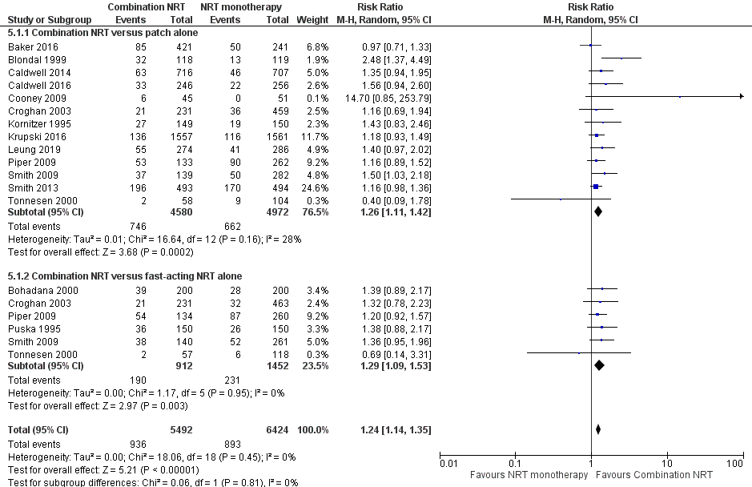
Figure 15: Results of smoking cessation for at least six months follow-up based on updated re-analysis, combination NRT versus NRT monotherapy
Source: Lindson et al. (2019), Leung et al. (2019)
Abbreviations: CI = confidence interval
Notes: The type of formulation used in the combination NRT treatment arm were: NRT patch + lozenge (Piper 2009, Smith 2009, Baker 2016, and Krupski 2016), NRT patch + gum (Kornitzer 1995, Puska 1995, Cooney 2009, Smith 2013, Leung 2019), NRT patch + nasal spray (Blondal 1999, Croghan 2003), NRT patch + inhaler (Bohadana 2000, Tonnesen 2000, Caldwell 2016), NRT patch + oral spray (Caldwell 2014).

To determine the comparative effectiveness of the different types of combination NRT formulations, additional subgroup analyses were conducted during the review based on the type of formulation used in the combination NRT treatment arm. The results of the meta-analysis for combination NRT (subgroup based on formulation) versus NRT patches and combination NRT (subgroup based on formulation) versus fast-acting NRT are presented in Figure 16 and Figure 17, respectively.
For combination NRT versus NRT patches, NRT patch + lozenge and NRT patch + gum were shown to provide a significantly higher rate of long-term smoking cessation compared to NRT patches alone. There were no statistically significant differences observed for the other types of combination NRT formulations (patch + nasal spray, patch + inhaler, patch + oral spray).
For combination NRT versus fast-acting NRT, only NRT patch + lozenge was shown to provide a significantly higher rate of long-term smoking cessation compared to fast-acting NRT alone. There were no statistically significant differences observed for the other types of combination NRT formulations (patch + gum, patch + nasal spray, patch + inhaler).

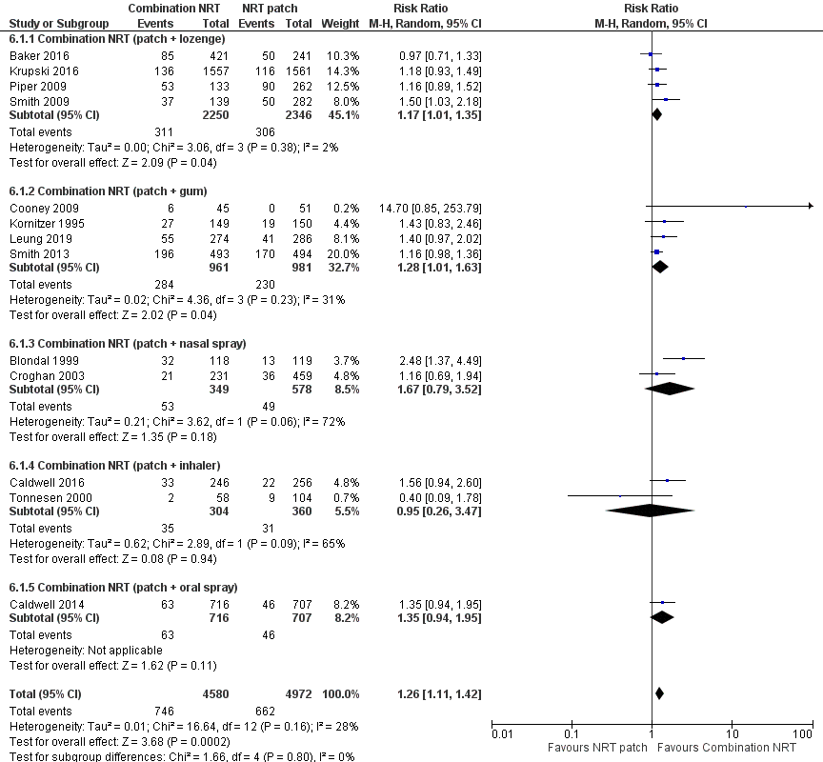
Figure 16: Results of smoking cessation for at least six months follow-up based on updated re-analysis, combination NRT (subgroup based on formulation) versus NRT patch
Source: constructed during the review based on Lindson et al. (2019), Leung et al. (2019)
Abbreviations: CI = confidence interval
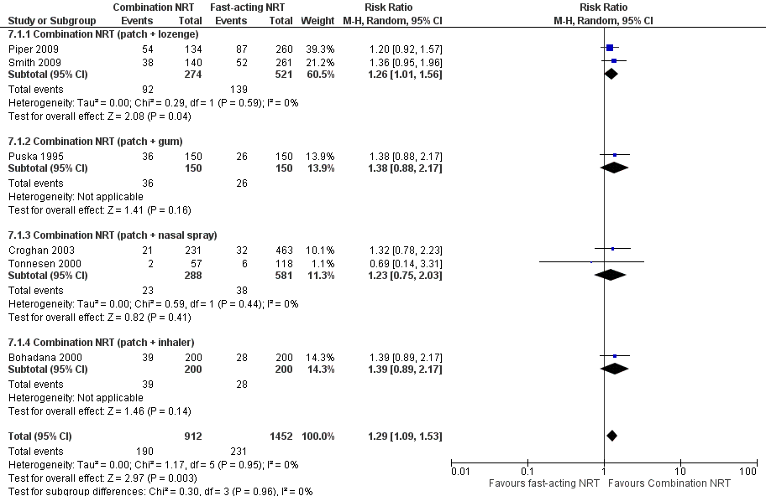
Figure 17: Results of smoking cessation for at least six months follow-up based on updated re-analysis, combination NRT (subgroup based on formulation) versus fast-acting NRT
Source: constructed during the review based on Lindson et al. (2019), Leung et al. (2019)
Abbreviations: CI = confidence interval
Safety
A summary of key adverse events comparing combination NRT with NRT monotherapy is presented in Table 61. Based on the Cochrane Review by Lindson et al. (2019), there were no statistically significant differences between combination NRT and NRT monotherapy (NRT patches alone or fast-acting NRT) in terms of cardiac adverse events, serious adverse events or withdrawals due to treatment.
The results of the updated re-analysis for cardiac adverse events were consistent with the results from Lindson et al. (2019), although the point estimate was now less than 1 which suggests that cardiac adverse events were lower in the combination NRT treatment arm.
Table 61: Summary of key adverse events in Lindson et al. (2019), combination NRT versus NRT monotherapy
Outcome | Study type | Combination NRT | NRT monotherapy | RR (95% CI) | RD (95% CI)
Cardiac adverse events
Combination NRT versus NRT patch | Cochrane Review  (1 RCT)⁴ | 4/45  (8.9%) | 4/51  (7.8%) | 1.13  (0.3, 4.27) | NR
 | Updated re-analysis (2 RCTs)⁵ | 4/319  (1.3%) | 7/337  (2.1%) | 0.63  (0.10, 4.05) | -0.01  (-0.02, 0)
Combination NRT versus fast-acting NRT | Cochrane Review  (NR) | NR | NR | NR | NR
Serious adverse events
Combination NRT versus NRT patch | Cochrane Review  (4 RCTs)^{1,4} | 5/1,218  (0.4%) | 0/1,095  (0%) | 11.45  (0.64, 205.9) | NR
Combination NRT versus fast-acting NRT | Cochrane Review  (2 RCTs)^{2,4} | 1/257  (0.4%) | 1/318  (0.3%) | 1  (0.06, 15.88) | NR
Meta-analysis⁴ |  | 6/1,475  (0.4%) | 1/1,413  (0.1%) | 4.44  (0.76, 25.85) | NR
Withdrawals due to treatment
Combination NRT versus NRT patch | Cochrane Review  (5 RCTs)^{3,4} | 17/804  (2.1%) | 9/1,178  (0.8%) | 2.32  (0.99, 5.4) | NR
Combination NRT versus fast-acting NRT | Cochrane Review  (2 RCTs)^{2,4} | 1/365  (0.3%) | 14/723  (1.9%) | 0.14  (0.02, 1.08) | NR
Meta-analysis⁴ |  | 18/1,169  (1.5%) | 23/1,901  (1.2%) | 1.12  (0.57, 2.2) | NR
Source: Lindson et al. (2019)
Abbreviations: CI = confidence interval; NR = not reported; RCT = randomised controlled trial; RD = risk difference; RR = risk ratio
Notes: Bold indicates statistically significant difference. See Appendix Figure 76 to Figure 78 for forest plots of the respective outcomes which included the results of individual studies.
1 No event was observed in both arms in three RCTs.
2 No event was observed in both arms in one RCT.
3 No event was observed in both arms in two RCTs.
4 Calculated by Cochrane Review authors using a fixed-effect model.
5 Calculated during review using a random-effect model.
Combination NRT versus varenicline or bupropion
A summary of the citation details for the studies comparing combination NRT with varenicline or bupropion is presented in Table 62. A Cochrane Review by Cahill et al. (2013) was identified in the systematic literature review that compared combination NRT with varenicline or bupropion and was included in this report. One RCT was identified in the supplemental literature search that informed this comparison and was included in this report (Chen et al. 2020). It was noted that one of the new studies included in the NRT patch monotherapy versus varenicline section had a combination NRT arm (Tulloch et al. 2016); this study was excluded from this section due to the incorrect dose (i.e. up to 35 mg per day).
Table 62: List of studies comparing combination NRT with varenicline or bupropion
Study | Citation
Cahill (2013)⁴⁸ | Cahill K, Stevens S, Perera R, Lancaster T. Pharmacological interventions for smoking cessation: an overview and network meta‐analysis. Cochrane Database of Systematic Reviews 2013, Issue 5. Art. No.: CD009329.
Chen  (2020)⁴⁶ | Chen LS, Baker TB, Miller JP, Bray M, Smock N, Chen J, Stoneking F, Culverhouse RC, Saccone NL, Amos CI, Carney RM. Genetic Variant in CHRNA5 and Response to Varenicline and Combination Nicotine Replacement in a randomized placebo‐controlled trial. Clinical Pharmacology & Therapeutics. 2020 Jun 29.

A summary of the characteristics of the studies comparing combination NRT with varenicline or bupropion is presented in Table 54. No direct RCTs comparing combination NRT with varenicline or bupropion were identified by Cahill et al. (2013). Cahill et al. (2013) conducted an overview of Cochrane reviews which assessed the efficacy and safety of pharmacological interventions designed to support smoking cessation attempts. Using study level data and a Bayesian hierarchical model approach, the authors conducted a network meta-analysis comparing NRT (including combination), varenicline and bupropion.
A general limitation of network meta-analyses is that the indirect comparisons made may be influenced by potential biases and uncertainties due to heterogeneity and inconsistent outcomes between studies. As such, the results of the network meta-analysis should be interpreted with caution.
As direct evidence was available for the comparison of combination NRT versus varenicline, Chen et al. (2020) was included as primary evidence while the network meta-analysis by Cahill et al. (2013) was included as supportive evidence. For the comparison of combination NRT versus bupropion, no direct evidence was identified in the updated literature search.

Table 63: Characteristics of the studies comparing combination NRT with varenicline or bupropion
Study | Study type | N¹ | Population | Intervention and comparator | Outcomes
Cahill (2013) | Cochrane Review  (NMA) | Combination NRT versus placebo  2 RCTs  Combination NRT versus NRT patch  3 RCTs  Combination NRT versus NRT gum  1 RCT  Combination NRT versus other NRT  1 RCT  Varenicline versus placebo  15 RCTs  Bupropion versus placebo  36 RCTs  Bupropion versus NRT patch  6 RCTs  Bupropion versus other NRT  2 RCTs | Inclusion: all participants covered by the pharmacotherapy-based (primary) reviews, adult smokers, of either gender, and of any nationality and ethnicity. | Smoking cessation interventions, including NRT, varenicline and bupropion. These interventions may be delivered as monotherapies or in combination. | Primary: smoking cessation rates of at least six months after baseline².  Secondary: reduction of withdrawal symptoms, reduction of craving, safety including adverse events.
Chen  (2020) | RCT | N=822  Combination NRT (n=275),  Varenicline (n=274) | See Table 55 for inclusion and exclusion criteria of this study. | NRT: 12 weeks of patches (21 mg for 8 weeks, 14 mg for 2 weeks, and 7 mg for 2 weeks) as well as 13 weeks of nicotine lozenges for use as needed (4 mg for those who smoke within 30 min of awaking and 2 mg otherwise; Varenicline: 1 mg twice daily titrated over 12 weeks (i.e. 0.5 mg once daily for 3 days, then 0.5 mg twice daily for 4 days, then 1 mg twice daily).  Behavioural support provided in both arms. | Primary: 7-day PPA at Week 12. Validated by CO <8 ppm.  Secondary: 7-day PPA at 6 (CO-validated) and 12 months (self-report), adverse events, adherence.
Abbreviations: CO = carbon monoxide; NMA = network meta-analysis; NRT = nicotine replacement therapy; PPA = point prevalence abstinence; RCT = randomised controlled trial
1 Only the number of patients (n) in the relevant arms were included.
2 Where cessation was assessed at multiple intervals, the longest follow-up data were used. Where multiple definitions of abstinence were assessed, the strictest of these definitions was used (e.g. continuous/prolonged abstinence over point prevalence abstinence).

Primary evidence (Chen et al. 2020) – combination NRT versus varenicline
Efficacy – combination NRT versus varenicline
A summary of the point prevalence abstinence at six months comparing combination NRT (NRT patch plus lozenge) with varenicline in Chen et al. (2020) is presented in Table 64. The results demonstrated a statistically significant difference in point prevalence abstinence between the two treatment arms, in favour of varenicline.
Table 64: Results of 7-day point prevalence abstinence at 6 months, combination NRT versus varenicline
Study | Study type | Combination NRT  (patch + lozenge) | Varenicline | RR (95% CI) | RD (95% CI)
Chen  (2020)^{1,2} | RCT | 37/275  (13.5%) | 56/274  (20.4%) | 0.66  (0.45, 0.96) | -0.07  (-0.13, -0.01)
Source: Chen et al. (2020)
Abbreviations: CI = confidence interval; NRT = nicotine replacement therapy; RCT = randomised controlled trial; RD = risk difference; RR = risk ratio
Notes: Bold indicates statistically significant difference.
1 PPA at 6 months was chosen because PPA at 12 months was not CO-validated (i.e. self-reported).
2 Calculated during the review.
Safety – combination NRT versus varenicline
A summary of key adverse events reported in Chen et al. (2020) is presented in Table 65. Overall, there were no statistically significant differences between the two treatment arms across the key adverse events, except for nausea and vivid dreams which were significantly higher in the varenicline arm compared with patients in the combination NRT arm.
Table 65: Summary of key adverse events, combination NRT versus varenicline
Outcome | Combination NRT  (patch + lozenge) | Varenicline | RR (95% CI) | RD (95% CI)
Any adverse events | 193/275  (70.2%) | 204/274  (74.5%) | 0.94  (0.85, 1.05) | -0.04  (-0.12, 0.03)
Nausea | 53/275  (19.3%) | 92/274  (33.6%) | 0.57  (0.43, 0.77) | -0.14  (-0.22, -0.07)
Vomiting | 28/275  (10.2%) | 36/274  (13.1%) | 0.77  (0.49, 1.23) | -0.03  (-0.08, 0.02)
Headache | 81/275  (29.5%) | 81/274  (29.6%) | 1.00  (0.77, 1.29) | 0.00  (-0.08, 0.08)
Rapid, slow, pounding or  irregular heartbeat | 27/275  (9.8%) | 24/274  (8.8%) | 1.12  (0.66, 1.89) | 0.01  (-0.04, 0.06)
Insomnia | 49/275  (17.8%) | 55/274  (20.1%) | 0.89  (0.63, 1.26) | -0.02  (-0.09, 0.04)
Vivid dreams | 63/275  (22.9%) | 100/274  (36.5%) | 0.63  (0.48, 0.82) | -0.14  (-0.21, -0.06)
Serious adverse events | 23/275  (8.4%) | 17/274  (6.2%) | 1.35  (0.74, 2.47) | 0.02  (-0.02, 0.07)
Source: Chen et al. (2020)
Abbreviations: CI = confidence interval; NRT = nicotine replacement therapy; RCT = randomised controlled trial; RD = risk difference; RR = risk ratio
Notes: Calculated during the review. Bold indicates statistically significant difference.
Supportive evidence (Cahill et al. 2013) – combination NRT versus varenicline or bupropion
Efficacy – combination NRT versus varenicline or bupropion
The results of the network meta-analysis by Cahill et al. (2013) based on smoking cessation rates for at least six months follow-up is presented using a forest plot in Figure 18. Combination NRT, NRT monotherapy, varenicline and bupropion significantly increased the odds of quitting compared with placebo.
For the comparison of combination NRT versus varenicline, the results of the network meta-analysis demonstrated no statistically significant difference between the two treatment arms, although the results numerically favoured varenicline (OR: 1.06; 95% CI: 0.75, 1.48). As previously noted, the primary evidence by Chen et al. (2020, head-to-head RCT) demonstrated a statistically significant difference in point prevalence abstinence, in favour of varenicline.
For the comparison of combination NRT versus bupropion, the results demonstrated a statistically significant difference between the two treatment arms, in favour of combination NRT (OR: 0.68; 95% CI: 0.5, 0.91).
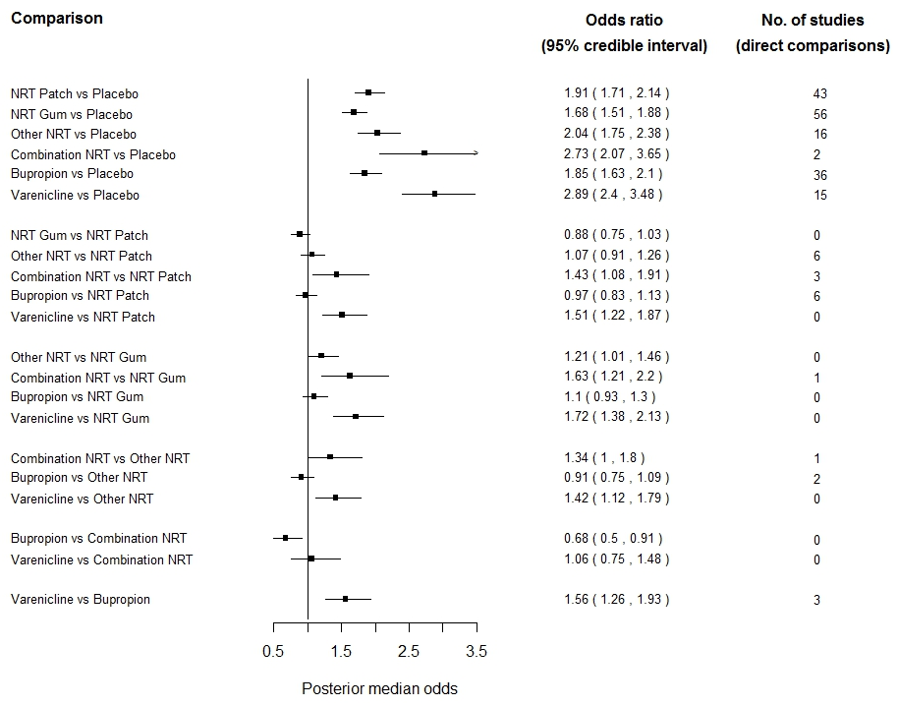
Figure 18: Network meta-analysis of first-line pharmacotherapies versus placebo and versus each other, with NRT
Source: Cahill et al. (2013)
Note: It was not stated in Cahill et al. (2013) the type of formulation used in the combination NRT treatment arm. Based on one of the included reviews (NRT 2012, also known as Stead 2008) in Cahill et al. (2013), 6 RCTs compared combinations of two forms of nicotine therapy with only one form; patch with gum to patches alone (Kornitzer 1995); patch with gum to gum alone (Puska 1995); patch with nasal spray to patches alone (Blondal 1999); patch with inhaler to inhaler alone (Bohadana 2000), patch with inhaler to either one alone (Tonnesen 2000) and patch with nasal spray to either one alone (Croghan 2003). In addition to these last two trials allowing a direct comparison between two single types, Lerman (2004) compared patches to nasal spray. A factorial trial compared nicotine and bupropion (Jorenby 1999).
Safety – combination NRT versus varenicline or bupropion
The incidence of adverse events comparing combination NRT with varenicline or bupropion was not synthesised quantitatively by Cahill et al. (2013). The authors of the Cochrane Review assessed adverse events of the interventions based on the individual trials instead of a network meta-analysis.

Combination varenicline
Varenicline in combination with NRT or bupropion has not been previously considered by the PBAC. The PBAC previously considered that in clinical practice, nicotine lozenges or gum could be used in combination with varenicline (NRT PSD, July 2017 PBAC meeting).
Varenicline in combination with NRT versus varenicline alone
A summary of the citation details for the studies comparing varenicline plus NRT with varenicline alone is presented in Table 66. A recently conducted systematic review and meta-analysis by Chang et al. (2015) was identified in the systematic literature review that compared varenicline plus NRT with varenicline plus placebo (i.e. varenicline alone) and was included in this report. No new studies comparing varenicline plus NRT with varenicline alone were identified in the supplemental literature search.
Table 66: List of studies comparing varenicline plus NRT with varenicline alone
Study | Citation
Chang  (2015)⁴⁹ | Chang PH, Chiang CH, Ho WC, Wu PZ, Tsai JS, Guo FR. Combination therapy of varenicline with nicotine replacement therapy is better than varenicline alone: a systematic review and meta-analysis of randomized controlled trials. BMC Public Health. 2015 Jul 22;15:689.

A summary of the characteristics of the studies comparing varenicline plus NRT with varenicline alone is presented in Table 67. A total of three RCTs comparing varenicline plus NRT patch with varenicline plus placebo patch (i.e. varenicline alone) were identified by Chang et al. (2015). The characteristics of the individual studies are presented in Appendix Table 157.
Table 67: Characteristics of the studies comparing varenicline plus NRT with varenicline alone
Study | Study type | N¹ | Population | Intervention and comparator | Outcomes
Chang  (2015) | SR & MA (3 RCTs²) | N=904 (3 RCTs)  Varenicline plus NRT (n=450),  Varenicline plus placebo (n=454) | Inclusion: adult population.  Exclusion: trials using smoking cessation medications but not aiming to stop cigarette smoking (e.g. stop alcohol use or long term NRT use). | Varenicline plus NRT patch versus varenicline plus placebo patch. | Efficacy: early outcome³ and late outcome⁴.  Safety: adverse events (nausea, insomnia, abnormal dreams, headache).
Abbreviations: MA = meta-analysis; NRT = nicotine replacement therapy; RCT = randomised controlled trial; SR = systematic review
1 Only the number of patients (n) in the relevant arms were included.
2 The characteristics of the individual studies comparing varenicline plus NRT patch with varenicline plus placebo patch included in Chang et al. (2015) are presented in Appendix Table 157. Chang et al. (2015) did not state whether a protocol was registered before commencement of the review and did not provide a list and justification of excluded studies (AMSTAR 2 critical domain).
3 Early outcome was defined as the quit rate assessed before or at the end of treatment completion.
4 Late outcome was defined as the quit rate assessed for a period of time after the end of treatment completion, majorly at 24 or more weeks.
Treatment interventions differed among the three studies. One study administered the trial patches two weeks before the treatment quit date (Koegelenberg et al. 2014), while the other two studies started patch use on the treatment quit date (Hajek et al. 2013, Ramon et al. 2014). Two studies used a 15 mg/16 hours patches (Hajek et al. 2013, Koegelenberg et al. 2014), while the other study used a 21 mg/24 hours patches (Ramon et al. 2014). The use of varenicline was similar among the studies. All started at 0.5 mg per day one week before treatment quit date, with increase to 2 mg/day on treatment quit date and continued for 12 weeks. One study tapered the dose of varenicline on the 13th week (Koegelenberg et al. 2014). All studies provided concurrent behavioural counselling during the treatment phase.
In terms of outcomes, all studies used exhaled carbon monoxide to confirm continuous abstinence based on early and late outcomes. Early outcome was defined as the quit rate assessed before or at the end of treatment completion, while late outcome was defined as the quit rate assessed for a period of time after the end of treatment completion. Outcomes without biochemical verification were excluded from the analysis. One study measured the early outcome at 4 weeks (Hajek et al. 2013), while the other two measured it at 12 weeks (Koegelenberg et al. 2014, Ramon et al. 2014). For the late outcome, Koegelenberg et al. (2014) measured 9 to 24 weeks of continuous abstinence, Ramon et al. (2014) measured 2 to 24 weeks of continuous abstinence, and Hajek et al. (2013) did not measure outcomes after the treatment phase.
Efficacy
A summary of the smoking cessation rates comparing varenicline plus NRT with varenicline alone in terms of early and late outcomes is presented in Table 68. For early outcomes, the results of the meta-analysis comprising three RCTs demonstrated a statistically significant difference in favour of varenicline plus NRT patch. For late outcomes, the results of the meta-analysis comprising two RCTs demonstrated a statistically significant difference in favour of varenicline plus NRT patch.
Table 68: Results of smoking cessation in terms of early and late efficacy outcomes, varenicline plus NRT versus varenicline alone
Study | Study type | Varenicline plus NRT patch | Varenicline plus placebo patch | OR (95% CI)¹
Early outcome²
Chang  (2015) | SR & MA  (3 RCTs) | 200/450  (44.4%) | 159/454  (35.0%) | 1.50  (1.14, 1.97)
Late outcome³
Chang  (2015) | SR & MA  (3 RCTs) | 127/392  (32.4%) | 90/395  (22.8%) | 1.62  (1.18, 2.23)
Source: Chang et al. (2015)
Abbreviations: CI = confidence interval; MA = meta-analysis; OR = odds ratio; RCT = randomised controlled trial; SR = systematic review
Notes: Calculated during the review. Bold indicates statistically significant difference.
1 Calculated by Chang et al. (2015) using a fixed-effect model. Odds ratio was reported in the original publication.
2 Early outcome was defined as the quit rate assessed before or at the end of treatment completion.
3 Late outcome was defined as the quit rate assessed for a period of time after the end of treatment completion, majorly at 24 or more weeks.

The results of the individual studies included in Chang et al. (2015) are presented using a forest plot in Figure 19 and Figure 20. Chang et al. (2015) conducted a sensitivity analysis by excluding one RCT (Koegelenberg et al. 2014) identified to be different in study design (pre-cessation treatment with patch) and participant characteristics (more females than males). It was noted that the results were not significantly different between treatment arms in both early and late outcomes after excluding Koegelenberg et al. (2014).
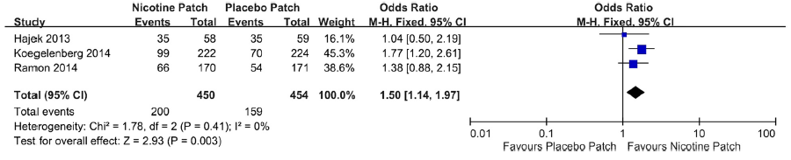
Figure 19: Results of smoking cessation in terms of early efficacy outcome in Chang et al. (2015), varenicline plus NRT versus varenicline alone
Source: Chang et al. (2015)
Abbreviations: CI = confidence interval

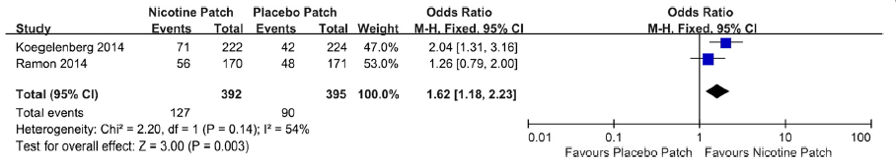
Figure 20: Results of smoking cessation in terms of late efficacy outcome in Chang et al. (2015), varenicline plus NRT versus varenicline alone
Source: Chang et al. (2015)
Abbreviations: CI = confidence interval
Safety
A summary of adverse events comparing varenicline plus NRT patch with varenicline alone is presented in Table 69. Based on the meta-analysis by Chang et al. (2015), there were no statistically significant differences between varenicline plus NRT patch and varenicline plus placebo patch (i.e. varenicline alone) in terms of nausea, insomnia, abnormal dreams or headache, although a numerically higher incidence rate was observed in the varenicline plus NRT patch arm.
Table 69: Summary of adverse events in Chang et al. (2015), varenicline plus NRT versus varenicline alone
Outcome | Study type | Varenicline plus NRT patch¹ | Varenicline plus placebo patch¹ | OR (95% CI)²
Nausea | SR & MA  (3 RCTs) | 123/444  (27.7%)ª | 113/449  (25.2%)ª | 1.15  (0.85, 1.56)
Insomnia | SR & MA  (3 RCTs) | 83/444  (18.7%) | 69/449  (15.4%) | 1.27  (0.89, 1.80)
Abnormal dreams | SR & MA  (3 RCTs) | 51/444  (11.5%)ª | 44/449  (9.8%)ª | 1.20  (0.78, 1.84)
Headache | SR & MA  (3 RCTs) | 30/444  (6.8%)ª | 30/449  (6.7%)ª | 1.01  (0.60, 1.72)
Source: Chang et al. (2015)
Abbreviations: CI = confidence interval; MA = meta-analysis; NRT = nicotine replacement therapy; RCT = randomised controlled trial; SR = systematic review
Notes: Bold indicates statistically significant difference.
1 Pooled safety population (N) was not reported in Chang et al. (2015). Calculated based on the numbers reported in individual studies.
2 Calculated by Chang et al. (2015) using a fixed-effect model. Odds ratio was reported in the original publication.
a While the total number of events (n) was correct, the percentages reported in Chang et al. (2015) did not correspond to the n/N calculated. Accordingly, the percentages from the n/N calculation was adopted in this table.
Varenicline in combination with bupropion versus varenicline alone
A summary of the citation details for the studies comparing varenicline plus bupropion with varenicline alone is presented in Table 70. A recently conducted Cochrane Review by Howes et al. (2020) was identified in the systematic literature review that compared varenicline plus bupropion with varenicline and was included in this report. No new studies comparing varenicline plus bupropion with varenicline alone were identified in the supplemental literature search.
Table 70: List of studies comparing varenicline plus bupropion with varenicline alone
Study | Citation
Howes (2020)³ | Howes S, Hartmann‐Boyce J, Livingstone‐Banks J, Hong B, Lindson N. Antidepressants for smoking cessation. Cochrane Database of Systematic Reviews 2020, Issue 4. Art. No.: CD000031.

A summary of the characteristics of the studies comparing varenicline plus bupropion with varenicline alone is presented in Table 71. A total of five RCTs comparing varenicline plus bupropion with varenicline plus placebo (i.e. varenicline alone) were identified by Howes et al. (2020), with three RCTs (Cinciripini et al. 2018, Ebbert et al. 2014 and Rose et al. 2014) included in the primary efficacy analysis. The characteristics of the individual studies are presented in Appendix Source: Chang et al. (2015).
Table 158.
Table 71: Characteristics of the studies comparing varenicline plus bupropion with varenicline alone
Study | Study type | N¹ | Population | Intervention and comparator | Outcomes
Howes (2020) | Cochrane Review (5 RCTs²) | Efficacy  (3 RCTs)  N=1,057  Varenicline plus bupropion (n=525),  Varenicline (n=532) | Inclusion: tobacco smokers of any age, with or without a history of mental illness.  Exclusion: pregnant women and trials investigating use for smoking harm reduction or relapse prevention. | Varenicline plus bupropion: 1 mg varenicline twice daily including titration and 150 mg bupropion twice daily including titration (over 12 weeks); Varenicline alone: standard varenicline regimen including titration and matching placebo for bupropion (over 12 weeks). | Primary: smoking cessation rates of at least six months after baseline.  Secondary: safety including any adverse events, psychiatric adverse events, serious adverse events and dropouts due to adverse events.
Abbreviations: NRT = nicotine replacement therapy; RCT = randomised controlled trial
1 Only the number of patients (n) in the relevant arms were included
2 A total of five RCTs comparing varenicline plus bupropion with varenicline alone were identified. Of the five RCTs, three RCTs (Cinciripini et al. 2018, Ebbert et al. 2014 and Rose et al. 2014) were included in the primary efficacy analysis. The characteristics of the individual studies comparing varenicline plus bupropion with varenicline alone included in Howes et al. (2020) are presented in Appendix Source: Chang et al. (2015).
Table 158.
Efficacy
A summary of the smoking cessation rates for at least six months follow-up comparing varenicline plus bupropion with varenicline alone is presented in Table 72. The results of the meta-analysis comprising three RCTs by Howes et al. (2020) demonstrated no significant differences in long-term smoking cessation rates between the two treatment arms, although the results numerically favoured varenicline plus bupropion.
Table 72: Results of smoking cessation for at least six months follow-up, varenicline plus bupropion versus varenicline alone
Study | Study type | Varenicline plus bupropion | Varenicline alone | RR (95% CI)²
Howes  (2020)¹ | Cochrane Review  (3 RCTs) | 136/525  (25.9%) | 114/532  (21.4%) | 1.21  (0.95, 1.55)
Source: Howes et al. (2020)
Abbreviations: CI = confidence interval; RCT = randomised controlled trial; RR = risk ratio
Notes: Bold indicates statistically significant difference.
1 Where cessation was assessed at multiple intervals, the longest follow-up data were used. Where multiple definitions of abstinence were assessed, the strictest of these definitions was used (e.g. continuous/prolonged abstinence over point prevalence abstinence). See Appendix Source: Chang et al. (2015).
Table 158 for the definition used in each study.
2 Calculated by Cochrane Review authors using a fixed-effect model.
The results of the individual studies included in Howes et al. (2020) are presented using a forest plot in Figure 21.
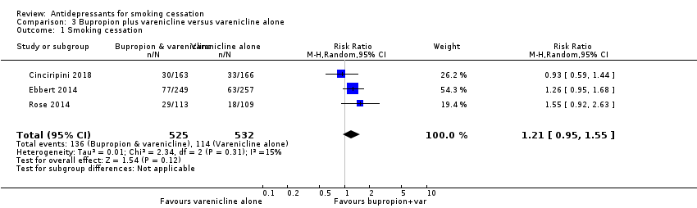
Figure 21: Results of smoking cessation for at least six months follow-up in Howes et al. (2020), varenicline plus bupropion versus varenicline alone
Source: Howes et al. (2020)
Abbreviations: CI = confidence interval
Safety
A summary of key adverse events comparing varenicline plus bupropion with varenicline alone is presented in Table 73. Based on the meta-analysis conducted by Howes et al. (2020), a significantly higher proportion of patients in the varenicline plus bupropion arm experienced any adverse events and psychiatric adverse events compared with patients in the varenicline alone arm. There were no statistically significant differences between the two treatment arms in terms of serious adverse events and discontinuation due to adverse events. It was noted that the proportion of patients experiencing serious adverse events was numerically higher in the varenicline plus bupropion arm. Conversely, the proportion of patients who discontinued treatment due to adverse events was numerically higher in the varenicline alone arm.
Table 73: Summary of key adverse events, varenicline plus bupropion versus varenicline alone
Study | Study type | Varenicline plus bupropion | Varenicline alone | RR (95% CI)¹
Adverse events
Howes  (2020) | Cochrane Review (4 RCTs) | 384/515  (74.6%) | 362/528  (68.6%) | 1.09  (1.02, 1.17)
Psychiatric adverse events
Howes  (2020) | Cochrane Review (2 RCTs) | 145/412  (35.2%) | 128/423  (30.3%) | 1.15  (1.03, 1.3)
Serious adverse events
Howes  (2020) | Cochrane Review (5 RCTs) | 18/629  (2.9%) | 15/639  (2.3%) | 1.23  (0.63, 2.42)
Discontinuation due to adverse events
Howes  (2020) | Cochrane Review (4 RCTs) | 19/609  (3.1%) | 24/621  (3.9%) | 0.8  (0.45, 1.45)
Source: Howes et al. (2020)
Abbreviations: CI = confidence interval; RCT = randomised controlled trial; RD = risk difference; RR = risk ratio
Notes: Bold indicates statistically significant difference. See Appendix Figure 79 to Figure 82 for forest plots of the respective outcomes which included the results of individual studies.
1 Calculated by Cochrane Review authors using a fixed-effect model.

Combination bupropion
Bupropion in combination with NRT has not been previously considered by the PBAC (see combination varenicline section for the use of bupropion in combination with varenicline).
Bupropion in combination with NRT versus NRT
A summary of the citation details for the studies comparing bupropion plus NRT with NRT alone is presented in Table 74. A recently conducted Cochrane Review by Howes et al. (2020) was identified in the systematic literature review that compared bupropion plus NRT with NRT alone and was included in this report. No new studies comparing bupropion plus NRT with NRT alone were identified in the supplemental literature search.
Table 74: List of studies comparing bupropion plus NRT with NRT alone
Study | Citation
Howes (2020)³ | Howes S, Hartmann‐Boyce J, Livingstone‐Banks J, Hong B, Lindson N. Antidepressants for smoking cessation. Cochrane Database of Systematic Reviews 2020, Issue 4. Art. No.: CD000031.

A summary of the characteristics of the studies comparing bupropion plus NRT with NRT alone is presented in Table 6. A total of 12 RCTs comparing bupropion plus NRT with NRT alone were identified by Howes et al. (2020). The characteristics of the individual studies are presented in Appendix Table 159.
Table 75: Characteristics of the studies comparing bupropion plus NRT with NRT alone
Study | Study type | N¹ | Population | Intervention and comparator | Outcomes
Howes (2020) | Cochrane Review (12 RCTs²) | N=3,487  Bupropion plus NRT (n=1,648),  NRT alone (n=1,839) | Inclusion: tobacco smokers of any age, with or without a history of mental illness.  Exclusion: pregnant women and trials investigating use for smoking harm reduction or relapse prevention. | Bupropion plus NRT versus NRT alone (NRT as patch alone, lozenge alone or choice of NRT). | Primary: smoking cessation rates of at least six months after baseline.  Secondary: safety including any adverse events, serious adverse events and dropouts due to adverse events.
Abbreviations: NRT = nicotine replacement therapy; RCT = randomised controlled trial
1 Only the number of patients (n) in the relevant arms were included
2 Of the 12 RCTs, nine RCTs compared bupropion plus NRT with NRT patches alone, two RCTs compared bupropion plus NRT with NRT lozenges alone and one RCT compared bupropion plus NRT with choice of NRT. The characteristics of the individual studies comparing bupropion plus NRT with NRT alone included in Howes et al. (2020) are presented in Appendix Table 159.
Efficacy
A summary of the smoking cessation rates for at least six months follow-up comparing bupropion plus NRT with NRT alone is presented in Table 76. For the comparison of bupropion plus NRT versus NRT patches alone, the results of the meta-analysis comprising nine RCTs by Howes et al. (2020) demonstrated no significant difference in long-term smoking cessation rates between the two treatment groups. Similarly, the results of the meta-analysis comprising two RCTs for the comparison of bupropion plus NRT versus NRT lozenges alone demonstrated no significant difference in long-term smoking cessation rates between the two treatment groups. For the comparison of bupropion plus NRT versus choice of NRT, one RCT was identified by Howes et al. (2020) which demonstrated no significant difference in long-term smoking cessation rates between the two treatment groups.
Overall, the results of the pooled meta-analysis (comprising the three comparisons) remained consistent with no significant difference in long-term smoking cessation rates between bupropion plus NRT and NRT alone (RR: 1.19; 95% CI: 0.94, 1.51). The test of interaction for subgroup effects was not statistically significant.
Table 76: Results of smoking cessation for at least six months follow-up, bupropion plus NRT versus NRT alone
Study | Study type | Bupropion plus NRT | NRT alone | RR (95% CI)²
Bupropion plus NRT versus NRT patch alone subgroup
Howes  (2020)¹ | Cochrane Review  (9 RCTs) | 136/874  (15.6%) | 102/900  (11.3%) | 1.24  (0.84, 1.84)
Bupropion plus NRT versus NRT lozenge alone subgroup
Howes  (2020)¹ | Cochrane Review  (2 RCTs) | 167/530  (31.5%) | 139/521  (26.7%) | 1.21  (0.81, 1.81)
Bupropion plus NRT versus choice of NRT subgroup
Howes  (2020)¹ | Cochrane Review  (1 RCTs) | 57/244  (23.4%) | 101/418  (24.2%) | 0.97  (0.73, 1.28)
Bupropion plus NRT versus NRT alone (pooled)
Howes  (2020)¹ | Cochrane Review  (12 RCTs) | 360/1,648  (21.8%) | 342/1,839  (18.6%) | 1.19  (0.94, 1.51)
Source: Howes et al. (2020)
Abbreviations: CI = confidence interval; RCT = randomised controlled trial; RR = risk ratio
Notes: Bold indicates statistically significant difference.
1 Where cessation was assessed at multiple intervals, the longest follow-up data were used. Where multiple definitions of abstinence were assessed, the strictest of these definitions was used (e.g. continuous/prolonged abstinence over point prevalence abstinence). See Appendix Table 159 for the definition used in each study.
2 Calculated by Cochrane Review authors using a random-effect model.
The results of the individual studies included in Howes et al. (2020) are presented using a forest plot in Figure 22.
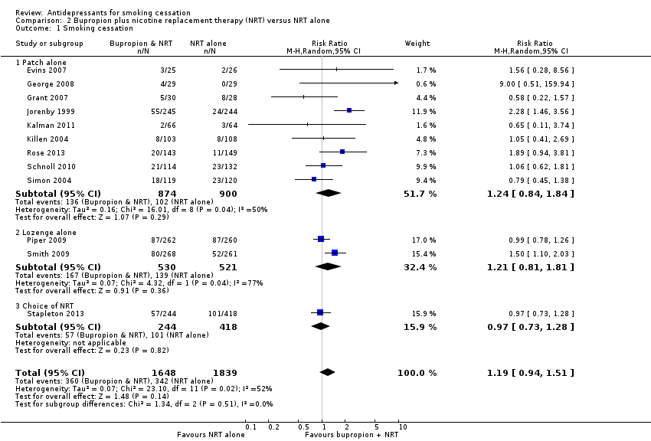
Figure 22: Results of smoking cessation for at least six months follow-up in Howes et al. (2020), bupropion plus NRT versus NRT alone
Source: Howes et al. (2020)
Abbreviations: CI = confidence interval
Safety
A summary of key adverse events comparing bupropion plus NRT with NRT alone is presented in Table 77. Based on the meta-analysis conducted by Howes et al. (2020), a significantly higher proportion of patients in the bupropion plus NRT arm experienced any adverse events compared with patients in the NRT alone arm. There were no statistically significant differences between the two treatment arms in terms of serious adverse events and discontinuation due to adverse events. It was noted that the proportions of patients who experienced serious adverse events and discontinued treatment due to adverse events were numerically higher in the bupropion plus NRT arm.
Table 77: Summary of key adverse events, bupropion plus NRT versus NRT alone
Study | Study type | Bupropion plus NRT | NRT alone | RR (95% CI)¹
Adverse events
Howes  (2020) | Cochrane Review (2 RCTs) | 104/155  (67.1%) | 88/158  (55.7%) | 1.21  (1.02, 1.43)
Serious adverse events
Howes  (2020) | Cochrane Review (3 RCTs) | 3/303  (1.0%) | 2/304  (0.7%) | 1.52  (0.26, 8.89)
Discontinuation due to adverse events
Howes  (2020) | Cochrane Review (2 RCTs) | 30/269  (11.2%) | 18/269  (6.7%) | 1.67  (0.95, 2.92)
Source: Howes et al. (2020)
Abbreviations: CI = confidence interval; RCT = randomised controlled trial; RR = risk ratio
Notes: Bold indicates statistically significant difference. See Appendix Figure 83 to Figure 85 for forest plots of the respective outcomes which included the results of individual studies.
1 Calculated by Cochrane Review authors using a fixed-effect model.

Treatment-experienced population

Combination bupropion
Bupropion in combination with NRT in the treatment-experienced population has not been previously considered by the PBAC.
Bupropion in combination with NRT versus placebo – abstainers (relapse prevention)
A summary of the citation details for the studies comparing bupropion plus NRT with placebo is presented in Table 78. A recently conducted Cochrane Review by Livingstone-Banks et al. (2019) was identified in the systematic literature review that compared bupropion plus NRT with placebo for relapse prevention and was included in this report. No new studies comparing bupropion plus NRT with placebo in abstainers for relapse prevention were identified in the supplemental literature search.
Table 78: List of studies comparing bupropion plus NRT with placebo in abstainers for relapse prevention
Study | Citation
Livingstone-Banks (2019)⁴⁰ | Livingstone‐Banks J, Norris E, Hartmann‐Boyce J, West R, Jarvis M, Hajek P. Relapse prevention interventions for smoking cessation. Cochrane Database of Systematic Reviews 2019, Issue 2. Art. No.: CD003999.

A summary of the characteristics of the studies comparing bupropion plus NRT with placebo is presented in Table 79. A total of two RCTs comparing bupropion plus NRT with placebo were identified by Livingstone-Banks et al. (2019). The characteristics of the individual studies are presented in Appendix Table 160. To be eligible for additional treatment for relapse prevention (i.e. study phase comparing bupropion plus NRT with placebo), patients were required to be abstinent from smoking after receiving initial treatment with bupropion plus NRT.
Table 79: Characteristics of the studies comparing bupropion plus NRT with placebo in abstainers for relapse prevention
Study | Study type | N¹ | Population | Intervention and comparator | Outcomes
Livingstone-Banks (2019) | Cochrane Review (2 RCTs²) | N=243  Bupropion plus NRT (n=122),  Placebo (n=121) | Inclusion: smokers who quit on their own, were undergoing enforced abstinence, or were participating in treatment programmes to assist initial cessation.  Exclusion: NR. | Bupropion plus NRT versus placebo (same regimen). | Primary: smoking cessation rates of at least six months after baseline.
Abbreviations: NR = not reported; RCT = randomised controlled trial
1 Only the number of patients (n) in the relevant arms were included
2 The characteristics of the individual studies comparing bupropion plus NRT with placebo included in Livingstone-Banks et al. (2019) are presented in Appendix Table 160. Of the two RCTs, one RCT (Covey 2007) compared bupropion plus NRT gum versus placebo and one RCT (Croghan 2007) compared bupropion plus NRT inhaler versus placebo.
Efficacy
A summary of the smoking cessation rates at the longest follow-up comparing bupropion plus NRT with placebo is presented in Table 80. The results of the meta-analysis comprising two RCTs by Livingstone-Banks et al. (2019) demonstrated no statistically significant difference in long-term smoking cessation rates between bupropion plus NRT (gum, inhaler) and placebo for relapse prevention, although the point estimate numerically favoured the combination therapy.
Table 80: Results of smoking cessation at longest follow-up, bupropion plus NRT versus placebo in abstainers for relapse prevention
Study | Study type | Bupropion plus NRT | Placebo | RR (95% CI)²
Livingstone-Banks  (2019)¹ | Cochrane Review (2 RCTs) | 31/122  (25.4%) | 26/121  (21.5%) | 1.18  (0.75, 1.87)
Source: Livingstone-Banks et al. (2019)
Abbreviations: CI = confidence interval; RCT = randomised controlled trial; RD = risk difference; RR = risk ratio
Notes: Bold indicates statistically significant difference.
1 Where cessation was assessed at multiple intervals, the longest follow-up data were used. Where multiple definitions of abstinence were assessed, the strictest of these definitions was used (e.g. continuous/prolonged abstinence over point prevalence abstinence). See Appendix Table 160 for the definition used in each study.
2 Calculated by Cochrane Review authors using a fixed-effect model.
The results of the individual studies included in Livingstone-Banks et al. (2019) are presented using a forest plot in Figure 23. It was noted that there was a moderate level of heterogeneity in the meta-analysed results (I² = 66%).
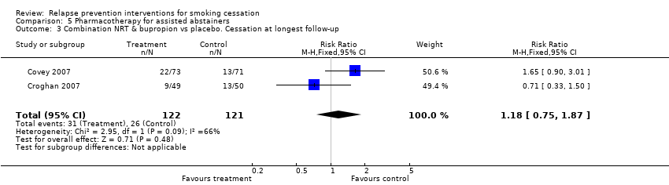
Figure 23: Results of smoking cessation at longest follow-up in Livingstone-Banks et al. (2019), bupropion plus NRT versus placebo
Source: Livingstone-Banks et al. (2019)
Abbreviations: CI = confidence interval
Note: In Covey (2007), bupropion was administered in combination with NRT gum while in Croghan (2007), bupropion was administered in combination with NRT inhaler.
Notes: In Covey et al. (2007), patients were provided bupropion and NRT patches in the open-label treatment phase followed by bupropion, NRT gum, or both and placebo in the double-blind treatment phase. In Croghan et al. (2007), patients were provided bupropion, NRT inhaler or both, followed by the same medications or placebo in the double-blind treatment phase.
Safety
The safety of bupropion plus NRT versus placebo in abstainers for relapse prevention was not assessed by Livingstone-Banks et al. (2019) and Croghan et al. (2007).
In Covey et al. (2007), the number of reported adverse events such as nervousness, constipation, insomnia, stomach-ache and depressed mood was low, and did not vary by treatment group (P = 0.69).

Summary of evidence for combination therapy
Combination therapies for smoking cessation have not been previously considered by the PBAC. In March 2018, the PBAC noted that the latest clinical guidelines encourage health professionals to consider recommending the use of combination NRT (e.g. NRT patch with NRT gum or lozenges) (NRT PSD, March 2018 PBAC meeting).
Combination NRT
Treatment-naïve population
Based on the evidence presented (Hartmann-Boyce et al. 2018, Chen et al. 2020), combination NRT (patch + lozenge, patch + lozenge and gum) was shown to provide a statistically significant improvement in long-term smoking cessation rates compared with placebo, noting the results of the updated re-analysis for NRT patch + lozenge were statistically significant based on risk ratio but not risk difference. There were no statistically significant differences in long-term smoking cessation rates between NRT patch + gum or NRT patch + inhalator and placebo. The non-significant result of NRT patch + gum was likely due to the study design, such as small sample size, leading to insufficient power to detect a modest treatment effect with reasonable certainty. Based on the study by Chen et al. (2020), there were no statistically significant differences between NRT patch + lozenge and placebo in terms of any adverse events and serious adverse events.
For the comparison of combination NRT versus NRT monotherapy, combination NRT was shown to provide a statistically significant improvement in long-term smoking cessation rates compared with NRT monotherapy (patch or fast-acting) (Lindson et al. 2019, Leung et al. 2019). There were no statistically significant differences between combination NRT and NRT monotherapy (patch or fast-acting) in terms of cardiac adverse events, serious adverse events or withdrawals due to treatment. Additional subgroup analyses were conducted during the review to determine the comparative effectiveness of the different types of combination NRT formulations:
- For combination NRT versus NRT patches, NRT patch + lozenge and NRT patch + gum were shown to provide a significantly higher rate of long-term smoking cessation compared to NRT patches alone. There were no statistically significant differences observed for the other types of combination NRT formulations (patch + nasal spray, patch + inhaler, patch + oral spray).
- For combination NRT versus fast-acting NRT, only NRT patch + lozenge was shown to provide a significantly higher rate of long-term smoking cessation compared to fast-acting NRT alone. There were no statistically significant differences observed for the other types of combination NRT formulations (patch + gum, patch + nasal spray, patch + inhaler).
For the comparison of combination NRT versus varenicline, combination NRT (patch + lozenge) was shown to be inferior to varenicline in terms of efficacy based on a statistically significant difference in point prevalence abstinence at 6 months, in favour of varenicline (Chen et al. 2020; direct RCT). In terms of safety, there were no statistically significant differences across the key adverse events between the two treatment arms, except for nausea and vivid dreams which were significantly higher in the varenicline arm. However, the results of the network meta-analysis by Cahill et al. (2013) demonstrated no statistically significant difference in smoking cessation rates between combination NRT and varenicline, although the results numerically favoured varenicline, noting the types of formulations used in the combination NRT treatment arm were clinically heterogeneous. The results of the network meta-analysis should be interpreted with caution due to potential biases and uncertainties arising from heterogeneity and inconsistent outcomes between studies.
For the comparison of combination NRT versus bupropion, the results of the network meta-analysis by Cahill et al. (2013) demonstrated a statistically significant difference in smoking cessation rates between the two treatment arms, in favour of combination NRT (no direct RCT was identified for this comparison). Similarly, this result should be interpreted with caution due to the general limitations of network meta-analyses and the types of formulations used in the combination NRT treatment arm were clinically heterogeneous.
Combination varenicline
Treatment-naïve population
Based on the evidence presented (Chang et al. 2015), varenicline in combination with NRT patch was shown to provide a statistically significant improvement in long-term smoking cessation rates compared with varenicline alone, noting that the results were no longer significant after excluding one RCT (Koegelenberg et al. 2014) identified to be different in study design (pre-cessation treatment with patch) and participant characteristics (more females than males). There were no statistically significant differences between varenicline plus NRT patch and varenicline alone in terms of nausea, insomnia, abnormal dreams or headache.
For the comparison of varenicline in combination with bupropion versus varenicline alone, there were no statistically significant differences in long-term smoking cessation rates between the two treatments (Howes et al. 2020). While a significantly higher proportion of patients in the varenicline plus bupropion arm experienced any adverse events and psychiatric adverse events compared with patients in the varenicline alone arm, there were no statistically significant differences in serious adverse events and discontinuation due to adverse events.
Combination bupropion
Treatment-naïve population
Based on the evidence presented (Howes et al. 2020), there were no statistically significant differences in long-term smoking cessation rates between bupropion in combination with NRT and NRT alone (either as patch, lozenge or choice of NRT). While a significantly higher proportion of patients in the bupropion plus NRT arm experienced any adverse events compared with patients in the NRT alone arm, there were no statistically significant differences in serious adverse events and discontinuation due to adverse events.
Treatment-experienced population
Based on the evidence presented (Livingstone-Banks et al. 2019), there were no statistically significant differences in long-term smoking cessation rates between bupropion in combination with NRT (either as gum or inhaler) and placebo as a relapse prevention treatment in abstainers. The safety of bupropion in combination with NRT versus placebo in abstainers for relapse prevention was not assessed by Livingstone-Banks et al. (2019) and Croghan et al. (2007), however the adverse events reported were consistent with those expected of bupropion and NRT.

NRT dose, dosage form and length of therapy
The aim of this section was to examine the efficacy and safety of NRT with respect to dose, dosage form and length of therapy. The efficacy and safety of NRT as monotherapy (PBS-listed) and combination therapy have been summarised in Section 3.3.1 and Section 3.3.2.
A summary of new evidence identified comparing different NRT dose, dosage form, and length of therapy is presented in Table 81.
Table 81: New evidence identified comparing different NRT dose, dosage form, and length of therapy
 | New evidence identified  (Cochrane Review) | Additional empirical evidence identified
NRT dose | Lindson (2019) | None identified
Length of therapy | Lindson (2019) | Ellerbeck (2018)
Dosing schedule | Lindson (2019), Lindson (2019b) | Dedert (2018)
Non-PBS listed NRT dosage forms | Hartmann-Boyce (2018), Lindson (2019) | Oncken (2019), Nides (2020)
Abbreviations: NRT = nicotine replacement therapy; PBS = Pharmaceutical Benefits Scheme
Three Cochrane Reviews were identified in the systematic literature search and were included in this report. Lindson et al. (2019) examined different NRT dose, dosage form, length of therapy in terms of comparative effectiveness and safety for achieving long-term smoking cessation. Lindson et al. (2019b) and Hartmann-Boyce et al. (2018) assessed the comparative effectiveness and safety of cut-down-to quit, or smoking reduction, dosing schedule interventions and non-PBS listed dosage forms.
Four new studies were identified in the supplemental literature search that informed this comparison and were included in this report (Ellerbeck 2018, Dedert 2018, Oncken 2019, and Nides 2020.
A summary of the citation details for the studies comparing different NRT dose, dosage form, and duration is presented in Table 82.
Table 82: List of studies comparing different NRT dose, dosage form, and length of therapy
Study | Citation
Cochrane Review
Hartmann-Boyce (2018)³⁰ | Hartmann-Boyce J, Chepkin SC, Ye W, Bullen C, Lancaster T. Nicotine replacement therapy versus control for smoking cessation. Cochrane Database of Systematic Reviews 2018, Issue 5. Art. No.: CD000146. DOI: 10.1002/14651858.CD000146.pub5.
Lindson  (2019)³⁸ | Lindson N, Chepkin SC, Ye W, Fanshawe TR, Bullen C, Hartmann-Boyce J. Different doses, durations and modes of delivery of nicotine replacement therapy for smoking cessation. Cochrane Database of Systematic Reviews 2019, Issue 4. Art. No.: CD013308. DOI: 10.1002/14651858.CD013308.
Lindson  (2019b)⁵⁰ | Lindson N, Klemperer E, Hong B, Ordóñez-Mena M, Aveyard P. Smoking reduction interventions for smoking cessation. Cochrane Database of Systematic Reviews 2019, Issue 9. Art. No.: CD013183. DOI: 10.1002/14651858.CD013183.pub2.
Additional evidence
Ellerbeck  (2018)⁵¹ | Ellerbeck EF, Nollen N, Hutcheson TD, Phadnis M, Fitzgerald SA, Vacek J, et al. Effect of Long-term Nicotine Replacement Therapy vs Standard Smoking Cessation for Smokers With Chronic Lung Disease: A Randomized Clinical Trial. JAMA network open. 2018;1(5):e181843.
Dedert  (2018)⁵² | Dedert EA, Dennis PA, Calhoun PS, Dennis MF, Beckham JC. A Randomized Clinical Trial of Nicotine Preloading for Smoking Cessation in People with Posttraumatic Stress Disorder. Journal of dual diagnosis. 2018;14(3):148‐57.
Oncken  (2019)⁵³ | Oncken C, Dornelas EA, Kuo CL, Sankey HZ, Kranzler HR, Mead EL, et al. Randomized trial of nicotine inhaler for pregnant smokers. American journal of obstetrics and gynecology MFM. 2019;1(1):10‐8.
Nides  (2020)⁵⁴ | Nides M, Danielsson T, Saunders F, Perfekt R, Kapikian R, Solla J, et al. Efficacy and Safety of a Nicotine Mouth Spray for Smoking Cessation: a Randomized, Multicenter, Controlled Study in a Naturalistic Setting. Nicotine & tobacco research. 2020;22(3):339‐45.

NRT dose
A summary of the characteristics of the studies comparing the use of different NRT doses for achieving long-term smoking cessation is presented in Table 83. The evidence is presented according to the dosage administered for each dosage form (patch or gum). A total of nine and five RCTs comparing different doses of NRT patches and gum, respectively, were identified in a recently conducted Cochrane Review by Lindson et al. (2019) and were included in this report. The characteristics of the individual studies are presented in Appendix Table 161.
Table 83: Characteristics of the studies comparing different NRT dose
Study | Study type | N¹ | Population | Intervention and comparator | Outcomes
Patch dose
Lindson (2019) | Cochrane Review  (9 RCTs²) | 21 mg versus 14 mg (24-hour)  N=537 (1 RCT)  Higher dose (n=262),  Lower dose (n=275)  25 mg versus 15 mg (16-hour)  N=3,446 (3 RCTs)  Higher dose (n=1,723),  Lower dose (n=1,723)  42/44 mg versus 21/22 mg (24-hour)  N=1,655 (5 RCTs)  Higher dose (n=828),  Lower dose (n=827) | Inclusion:  Adult smokers with an average age of approximately 45, who smoked at least 15 cigarettes a day, studies lasted for at least six months.  Exclusion: Trials that did not assess cessation as an outcome, with follow-up less than six months, and with additional intervention components not matched between arms. Trials comparing NRT to control, and trials comparing NRT to other pharmacotherapies. | Higher dose patch  Lower dose patch | Primary: smoking cessation rates of at least six months after baseline.  Secondary: safety including cardiac adverse events, serious adverse events and withdrawals due to treatment.
Gum dose
Lindson (2019) | Cochrane Review  (5 RCTs²) | High-dependency smokers  4 mg versus 2 mg gum  N= 618 (4 RCTs)  4 mg gum (n=303),  2 mg gum (n=315)  Low-dependency smokers  4 mg versus 2 mg gum  N= 238 (3 RCTs)  4 mg gum (n=123),  2 mg gum (n=115)  General population (high- and low-dependency)  4 mg versus 2 mg gum  N=856 (5 RCTs)  4 mg gum (n=426),  2 mg gum (n=430) | Inclusion:  Adult smokers with an average age of approximately 45, who smoked at least 15 cigarettes a day, studies lasted for at least six months.  Exclusion: Trials that did not assess cessation as an outcome, with follow-up less than six months, and with additional intervention components not matched between arms. Trials comparing NRT to control, and trials comparing NRT to other pharmacotherapies. | 4 mg gum  2 mg gum | Primary: smoking cessation rates of at least six months after baseline.  Secondary: safety including cardiac adverse events, serious adverse events and withdrawals due to treatment.
Abbreviations: NRT = nicotine replacement therapy; RCT = randomised controlled trial
Notes:
1 Only the number of patients (n) in the relevant arms were included.
2 The characteristics of the individual studies included in Lindson et al. (2019) are presented in Appendix Table 161. Based on Lindson et al. (2019), trials typically recruited people who smoked at least 15 cigarettes a day. Although some trials included lighter smokers as well (12 of the 63 trials (19%)), the average number smoked was greater than or equal to 20 a day in most studies (46 of the 63 trials (73%)).
There were three groups of studies that compared different NRT patches doses; (1) 42/44 mg versus 21/22 mg patches (24-hour); (2) 25 mg versus 15 mg patches (16-hour); (3) 21 mg versus 14 mg patches (24-hour). Although the doses included in groups 2 and 3 appear comparable, the patches used in these groups did not have comparable delivery systems, meaning the doses delivered to participants per hour were likely to be different across the two groups.
The three studies comparing the 25 mg dose to the 15 mg dose (Paoletti 1996, CEASE 1999, Killen 1999) all used patches that delivered nicotine over a 16-hour period (to be worn during waking hours), so the doses delivered per hour were approximately 1.6 mg and 0.9 mg. However, in TNSG 1991, which compared a 21 mg dose with a 14 mg dose, the patches used delivered nicotine over 24 hours (to be worn continuously, including overnight), resulting in doses of approximately 0.9 mg and 0.6 mg per hour. The five studies comparing 42/44 mg doses with 21/22 mg doses (Dale 1995, Hughes 1999, Jorenby 1995, Kalman 2006, Rose 2010) all used patches that delivered nicotine over 24 hours, so that the approximate doses delivered per hour were 1.8 mg and 0.9 mg respectively.
Efficacy
A summary of the smoking cessation rates for at least six months follow-up comparing different NRT patches and gum doses is presented in Table 84 and Table 85, respectively. For the comparison of a higher dose versus lower dose of NRT patches, the results demonstrated a statistically significant difference in smoking cessation rates between the 21 mg/24-hour and 14 mg/24-hour patches, in favour of the higher strength patches. There were no statistically significant differences between the 25 mg/16-hour and 15 mg/16-hour patches nor the 42/44 mg and 21/22 mg (24-hour) patches, although the results numerically favoured the higher strength patches. The PBAC previously noted that the use of different strength patches such as 21 mg for 24 hours or 15 mg for 16 hours were likely to result in minimal changes in clinical outcomes (NRT PSD, March 2010 PBAC meeting). No evidence was found comparing the efficacy of 21 mg/24 hours patches with 15 mg/16 hours patches. However, a study (Daughton 1991) identified by Lindson et al. (2019) showed no statistically significant difference in smoking cessation rates between 24-hour and 16-hour patches, noting the strength of the patches was not stated.
For the comparison of 4 mg versus 2 mg NRT gum, the pooled analysis results (high-dependency and low-dependency smokers) demonstrated a statistically significant difference in smoking cessation rates between the two treatment arms, in favour of the higher strength gum. However, the results of the subgroup analysis suggest that only smokers who are highly dependent may benefit from the higher strength NRT gum (i.e. not statistically significantly different in low-dependency smokers).
Table 84: Results of smoking cessation for at least six months follow-up, different NRT patch doses
Study | Study type | Higher dose | Lower dose | RR (95% CI)¹
21 mg versus 14 mg (24-hour)
Lindson (2019) | Cochrane Review  (1 RCT) | 65/262  (24.8%) | 46/275  (16.7%) | 1.48  (1.06, 2.08)
25 mg versus 15 mg (16-hour)
Lindson (2019) | Cochrane Review  (3 RCTs) | 252/1,723  (14.6%) | 212/1,723  (12.3%) | 1.19  (1, 1.41)
42/44 mg versus 21/22 mg (24-hour)
Lindson (2019) | Cochrane Review  (5 RCTs) | 216/828  (26.1%) | 197/827  (23.8%) | 1.09  (0.93, 1.29)
Source: Lindson et al. (2019)
Abbreviations: CI = confidence interval; RCT = randomised controlled trial; RR = risk ratio
Notes: Bold indicates statistically significant difference.
1 Calculated by Cochrane Review authors using fixed-effect model.
Table 85: Results of smoking cessation for at least six months follow-up, different NRT gum doses
Study | Study type | 4 mg dose | 2 mg dose | RR (95% CI)¹
High-dependency smokers subgroup
Lindson (2019) | Cochrane Review  (4 RCTs) | 90/303  (29.7%) | 51/315  (16.2%) | 1.85  (1.36, 2.5)
Low-dependency smokers subgroup
Lindson (2019) | Cochrane Review  (3 RCTs) | 26/123  (21.1%) | 30/115  (26.1%) | 0.77  (0.49, 1.21)
Irrespective of dependency level (pooled)
Lindson (2019) | Cochrane Review  (7 RCTs) | 116/426  (27.2%) | 81/430  (18.8%) | 1.43  (1.12, 1.83)
Source: Lindson et al. (2019)
Abbreviations: CI = confidence interval; RCT = randomised controlled trial; RR = risk ratio
Notes: Bold indicates statistically significant difference.
1 Calculated by Cochrane Review authors using fixed-effect model.
The results of the individual studies included in Lindson et al. (2019) are presented using a forest plot in Figure 24 and Figure 25.

Figure 24: Results of smoking cessation for at least six months follow-up in Lindson et al. (2019), different NRT patch doses
Source: Lindson et al. (2019)
Abbreviations: CI = confidence interval

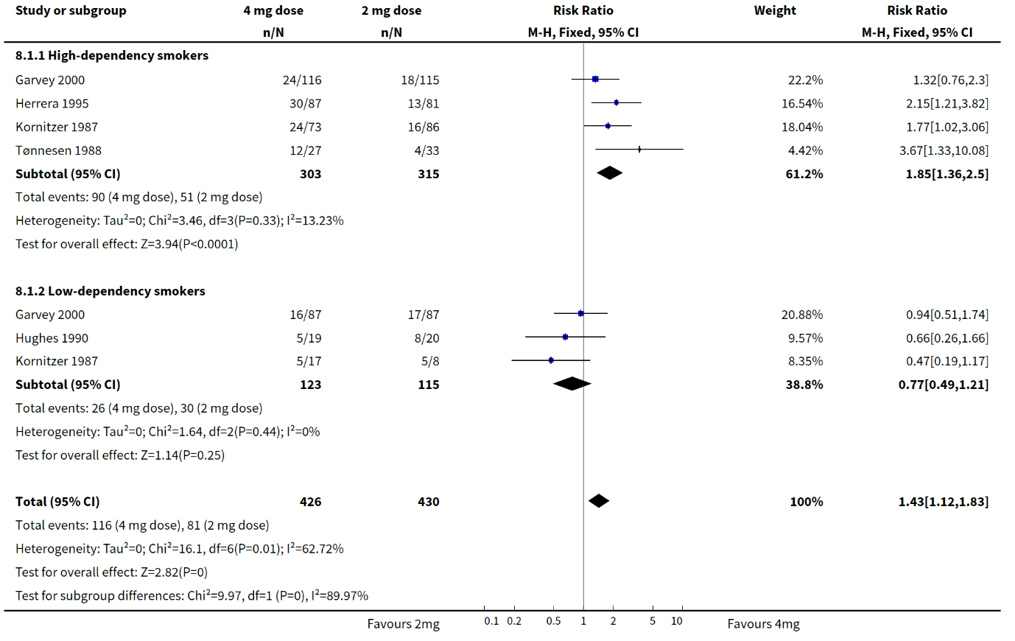
Figure 25: Results of smoking cessation for at least six months follow-up in Lindson et al. (2019), different NRT gum doses
Source: Lindson et al. (2019)
Abbreviations: CI = confidence interval
Safety
A summary of key adverse events comparing the higher dose with lower dose of NRT patches and NRT gum is presented in Table 86. Based on the meta-analysis conducted by Lindson et al. (2019), there were no statistically significant differences between the two treatment arms in all outcomes except for treatment withdrawals comparing the 42/44 mg with 21/22 mg (24-hour) patches. A significantly higher treatment withdrawal rate was observed in patients treated with the 42/44 mg (24-hour) patches compared to patients treated with the 21/22 mg (24-hour) patches.
Table 86: Summary of key adverse events in Lindson et al. (2019), higher dose versus lower dose NRT (patch and gum)
Outcome | Study type | Higher dose | Lower dose | RR (95% CI)¹
NRT patch
Fast or irregular heartbeat | Cochrane Review  (2 RCTs) | 53/1636  (3.2%) | 57/1633  (3.5%) | 0.92  (0.64, 1.33)
Myocardial infarction | Cochrane Review  (1 RCT) | 1/1430  (0.07%) | 2/1431  (0.14%) | 0.5  (0.05, 5.51)
Overall SAEs  (42/44 mg versus 21/22 mg) | Cochrane Review  (2 RCTs) | 7/511  (1.4%) | 1/512  (0.2%) | 5.01  (0.87, 28.82)
Overall SAEs  (21 mg versus 14 mg) | Cochrane Review  (1 RCT) | 0/262  (0%) | 0/275  (0%) | NE
Treatment withdrawals  (42/44 mg versus 21/22 mg) | Cochrane Review  (2 RCTs) | 1/18  (5.6%) | 0/17  (0%) | 4.99  (1.6, 15.5)
Treatment withdrawals  (21 mg versus 14 mg) | Cochrane Review  (1 RCT) | 11/262  (4.2%) | 15/275  (5.5%) | 0.77  (0.36, 1.64)
NRT gum
Palpitations | Cochrane Review  (1 RCT) | 1/27  (3.7%) | 0/33  (0%) | 3.64  (0.15, 85.97)
Treatment withdrawals | Cochrane Review  (2 RCTs) | 2/230  (0.9%) | 2/235  (0.9%) | 1.08  (0.18, 6.36)
Source: Lindson et al. (2019)
Abbreviations: CI = confidence interval; NE = not estimable; RCT = randomised controlled trial; RR = risk ratio; SAEs = serious adverse events.
Notes: Bold indicates statistically significant difference. See Appendix Figure 86, Figure 87, and Figure 88 for forest plots of the respective outcomes which included the results of individual studies.
1 Calculated by Cochrane Review authors using a fixed-effect model.

Length of therapy
A summary of the characteristics of the studies comparing duration of NRT patches, gum, combination therapy, and other variations in use from Lindson et al. (2019) and Ellerbeck et al. (2018) is presented in Table 87. The characteristics of the individual studies are presented in Appendix Table 162.
The relevant studies identified for inclusion are presented in this section based on four categories:
- Monotherapy (NRT patches, 7 RCTs from Lindson et al. 2019; NRT gum, 1 RCT from Lindson et al. 2019)
- Combination therapy (3 RCTs; 2 RCTs from Lindson et al. 2019; 1 RCT by Ellerbeck et al. 2018)
- Other variations in NRT use (3 RCTs from Lindson et al. 2019)

Table 87: Characteristics of the studies comparing different length of therapy for NRT patch, gum, combination therapy, and other variations in use
Study | Study type | Subgroup title/N¹ | Population | Intervention and comparator | Outcomes
Patch therapy (monotherapy)
Lindson (2019) | Cochrane Review  (7 RCTs²) | 52 weeks versus 24 weeks  N= 345 (1 RCT)  52 weeks versus 8 weeks  N= 352 (1 RCT)  28 weeks versus 12 weeks  N= 2,861 (1 RCT)  24 weeks versus 8 weeks  N= 921 (2 RCTs)  12 weeks versus 6 weeks  N= 140 (1 RCT)  12 weeks versus 3 weeks  N= 98 (1 RCT)  6 weeks versus 4 weeks  N= 1,873 (1 RCT)  6 weeks versus 2 - 3 weeks  N= 1,957 (2 RCTs)  4 weeks versus 2 weeks  N= 1,862 (1 RCT) | Inclusion:  Adult smokers with an average age of approximately 45, who smoked at least 15 cigarettes a day, studies lasted for at least six months.  Exclusion: Trials that did not assess cessation as an outcome, with follow-up less than six months, and with additional intervention components not matched between arms. Trials comparing NRT to control, and trials comparing NRT to other pharmacotherapies. | Longer duration patch versus shorter duration patch. | Primary: smoking cessation rates of at least six months after baseline.  Secondary: safety including serious adverse events and withdrawals due to treatment.
Gum therapy (monotherapy)
Lindson (2019) | Cochrane Review  (1 RCT²) | 50 weeks versus 10 weeks gum  N= 402 | Same as patch (monotherapy). | Longer duration gum versus shorter duration gum. | Same as patch (monotherapy).
Combination NRT therapy
Lindson (2019) | Cochrane Review  (2 RCTs²) | 16 weeks versus 8 weeks  N= 637 (1 RCT)  Longer duration (n=304),  Shorter duration (n=333)  6 weeks versus 2 weeks  N= 987 (1 RCT)  Longer duration (n=497),  Shorter duration (n=490) | Same as patch (monotherapy). | Longer duration use of combination NRT versus shorter duration. | Same as patch (monotherapy).
Ellerbeck (2018) | RCT³ | Standard smoking cessation treatment versus long-term NRT  N= 394  Standard treatment (n=197), long-term treatment (n=197) | Inclusion:  ≥18 years old, ≥5 cigarettes per day on at least 25 of the last 30 days, reported physician-diagnosed COPD.  Exclusion:  terminal medical condition, would be pregnant or breastfeeding in the next year, resided in a long-term care facility that restricted smoking, exhibited severe cognitive impairment, had another household member enrolled in the study, had no home address, or had been hospitalized with a heart attack, experienced an irregular heartbeat, or reported increasing angina in the past 30 days. | Standard smoking cessation treatment (combination NRT for 10 weeks) versus long-term (combination NRT for 12 months).⁴  Both arms received follow-up counselling sessions. | Primary: 7-day abstinence verified by CO levels of no greater than 10 ppm at 12 months.  Secondary: cigarettes smoked per day, exposure to CO, urinary excretion of 4-methylnitrosamino-1-3-pyridyl-1-butanol, and adverse events.
Other variations in NRT use
Lindson (2019) | Cochrane Review  (3 RCTs²) | 24-hour versus 16-hour patch  N= 106 (1 RCT)  Continue versus stop patch use on lapse  N= 701 (1 RCT)  35 mg patch + fast-acting for 22 weeks versus 21 mg patch for 10 weeks  N= 486 (1 RCT) | Same as patch (monotherapy). | N/A. | Same as patch (monotherapy).
Abbreviations: CO = carbon monoxide; NRT = nicotine replacement therapy; N/A = not applicable; RCT = randomised controlled trial
Notes:
1 Only the number of patients (n) in the relevant arms were included.
2 The characteristics of the individual studies included in Lindson et al. (2019) are presented in Appendix Table 162.
3 Ellerbeck et al. (2018) was an open-label study and outcome assessors were likely aware of the interventions received by the patients.
4 Combination NRT (both arms) included nicotine patches plus 2 mg of nicotine gum and/or lozenges. The dose of nicotine patches (14-42 mg) provided to participants was based on their current cigarette consumption.

Monotherapy
Efficacy
A summary of smoking cessation rates for at least six months follow-up comparing longer duration with shorter duration of NRT patches and gum (monotherapy) is presented in Table 88. Overall, there were no statistically significant differences in smoking cessation rates between longer duration therapy and shorter duration therapy in all comparisons for NRT patches or gum.
Table 88: Results of smoking cessation for at least six months follow-up in Lindson et al. 2019, duration of patch or gum therapy
Study | Study type | Longer duration | Shorter duration | RR (95% CI)¹
52 weeks versus 24 weeks patch
Lindson  (2019) | Cochrane Review (1 RCT) | 35/172  (20.3%) | 45/173  (26%) | 0.78  (0.53, 1.15)
52 weeks versus 8 weeks patch
Lindson  (2019) | Cochrane Review (1 RCT) | 35/172  (20.3%) | 39/180  (21.7%) | 0.94  (0.63, 1.41)
28 weeks versus 12 weeks patch
Lindson  (2019) | Cochrane Review (1 RCT) | 208/1430  (14.5%) | 198/1431  (13.8%) | 1.05  (0.88, 1.26)
24 weeks versus 8 weeks patch
Lindson  (2019) | Cochrane Review (2 RCTs) | 86/455  (18.9%) | 80/466  (17.2%) | 1.1  (0.84, 1.45)
12 weeks versus 6 weeks patch
Lindson  (2019) | Cochrane Review (1 RCT) | 21/69  (30.4%) | 21/71  (29.6%) | 1.03  (0.62, 1.71)
12 weeks versus 3 weeks patch
Lindson  (2019) | Cochrane Review (1 RCT) | 7/48  (14.6%) | 12/50  (24%) | 0.61  (0.26, 1.41)
6 weeks versus 4 weeks patch
Lindson  (2019) | Cochrane Review (1 RCT) | 134/944  (14.2%) | 124/929  (13.3%) | 1.06  (0.85, 1.33)
6 weeks versus 2-3 weeks patch
Lindson  (2019) | Cochrane Review (2 RCTs) | 148/984  (15.0%) | 130/973  (13.4%) | 1.13  (0.91, 1.4)
4 weeks versus 2 weeks patch
Lindson  (2019) | Cochrane Review (1 RCT) | 124/929  (13.3%) | 115/933  (12.3%) | 1.08  (0.85, 1.37)
50 weeks versus 10 weeks gum
Lindson  (2019) | Cochrane Review (1 RCT) | 85/203  (41.9%) | 80/199  (40.2%) | 1.04  (0.82, 1.32)
Source: Lindson et al. (2019)
Abbreviations: CI = confidence interval; RCT = randomised controlled trial; RR = risk ratio
Notes:
1 Calculated by Cochrane Review authors using a fixed-effect model.
The results of the individual studies included in Lindson et al. (2019) are presented using a forest plot in Figure 26 and Figure 27. There were no statistically significant differences in any of the individual RCTs included in the meta-analysis. Of note, the CEASE (1999) study compared 28 weeks with 12 weeks of NRT patches, with two patch doses (25 mg and 15 mg) examined in each duration. ''''''' '''''''''' ''''''' '''''' '''''''''''''' '''''''''''''''''' '''''''''''''''''''' '''' ''''''' '''''''''''''''''' ''''''''''' ''''''''''''''''' ''''''''''''''''' ''''''' ''''''''''' ''''''''''''''''''''''''''''' '''''' ''''''''''' '''' ''' ''''' '''''' ''''''' ''''' '''''''''' ''''''' ''''''''''''' '''''' ''''''' ''''''' ''''''''''' '''''' '''''''''' ''''''''''' '''''''''''''''''' '''' ''''' ''''''' '''''' ''''' ''''''''''' '''''''' '''''''''''''''''

Figure 26: Results of smoking cessation for at least six months follow-up in Lindson et al. 2019, duration of patch therapy
Source: Lindson et al. (2019)
Abbreviations: CI = confidence interval

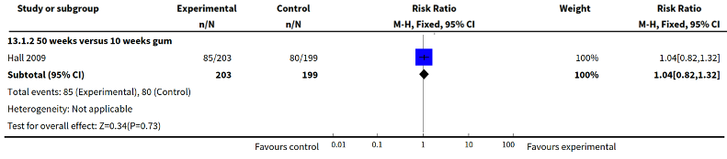
Figure 27: Results of smoking cessation for at least six months follow-up in Lindson et al. 2019, duration of gum therapy
Source: Lindson et al. (2019)
Abbreviations: CI = confidence interval
Safety
A summary of key adverse events in Lindson et al. (2019) comparing longer duration with shorter duration of patches and gum therapy is presented in Table 89 and Table 90, respectively. Overall, there were no statistically significant differences in serious adverse events and treatment withdrawals between longer duration and shorter duration therapy in all comparisons for NRT patches. Similarly, there were no statistically significant differences in serious adverse events and midsternal pressure between 50-week and 10-week duration of NRT gum.
Table 89: Summary of key adverse events in Lindson et al. (2019), longer duration versus shorter duration NRT patch
Outcome | Study type | Longer duration | Shorter duration | RR (95% CI)¹
Overall SAEs
52 weeks versus 24 weeks | Cochrane Review  (1 RCT) | 8/172  (4.7%) | 2/173  (1.2%) | 4.02  (0.87, 18.67)
52 weeks versus 8 weeks | Cochrane Review  (1 RCT) | 8/172  (4.7%) | 4/180  (2.2%) | 2.09  (0.64, 6.82)
24 weeks versus 8 weeks | Cochrane Review  (2 RCTs) | 5/455  (1.1%) | 5/466  (1.1%) | 1.03  (0.3, 3.54)
6 weeks versus 2 - 3 weeks | Cochrane Review  (1 RCT) | 0/40  (0%) | 0/40  (0%) | NE
Treatment withdrawals
24 weeks versus 8 weeks | Cochrane Review  (1 RCT) | 1/282  (0.4%) | 0/286  (0%) | 3.04  (0.12, 74.37)
6 weeks versus 2 - 3 weeks | Cochrane Review  (1 RCT) | 2/40  (5%) | 2/40  (5%) | 1  (0.15, 6.76)
Source: Lindson et al. (2019)
Abbreviations: CI = confidence interval; NE = not estimable; RCT = randomised controlled trial; RR = risk ratio; SAEs = serious adverse events.
Notes: See Appendix Figure 86 and Figure 87 for forest plots of the respective outcomes which included the results of individual studies.
1 Calculated by Cochrane Review authors using a fixed-effect model.
Table 90: Summary of key adverse events in Lindson et al. (2019), 50-week duration versus 10-week duration NRT gum
Outcome | Study type | Longer duration | Shorter duration | RR (95% CI)¹
Midsternal pressure
50 weeks versus 10 weeks | Cochrane Review  (1 RCT) | 1/203  (0.5%) | 0/199  (0%) | 2.94  (0.12, 71.77)
Overall SAEs
50 weeks versus 10 weeks | Cochrane Review  (1 RCT) | 9/203  (4.4%) | 4/199  (2%) | 2.21  (0.69, 7.05)
Source: Lindson et al. (2019)
Abbreviations: CI = confidence interval; NE = not estimable; RCT = randomised controlled trial; RR = risk ratio; SAEs = serious adverse events.
Notes: See Appendix Figure 92 and Figure 93 for forest plots of the respective outcomes which included the results of individual studies.
1 Calculated by Cochrane Review authors using a fixed-effect model.

Combination therapy
Efficacy
A summary of smoking cessation rates for at least six months follow-up comparing longer duration with shorter duration of NRT combination therapy is presented in Table 91. Based on the two studies included in Lindson et al. (2019), there were no statistically significant differences in smoking cessation rates between longer duration and shorter duration of combination therapy. Similarly, the results of the new study (Ellerbeck 2018) identified in the supplemental literature search demonstrated no statistically significant differences between the two treatment arms.
Table 91: Results of smoking cessation for at least six months follow-up, longer duration versus shorter duration of combination therapy
Study | Study type | Longer duration | Shorter duration | RR (95% CI) | RD (95% CI)
16 weeks versus 8 weeks
Lindson  (2019)¹ | Cochrane Review  (1 RCT) | 83/304  (27.3%) | 95/333  (28.5%) | 0.96  (0.75, 1.23) | NR
6 weeks versus 2 weeks
Lindson  (2019)¹ | Cochrane Review  (1 RCT) | 194/497  (39%) | 172/490  (35.1%) | 1.11  (0.94, 1.31) | NR
12 months versus 10 weeks
Ellerbeck (2018)^{3,4} | RCT | 12/200  (6%) | 15/198  (7.6%) | 0.79  (0.38, 1.65) | -1.5  (-6.5, 3.5)
Source: Lindson et al. (2019), Ellerbeck et al. (2018)
Abbreviations: CI = confidence interval; RCT = randomised controlled trial; RD = risk difference; RR = risk ratio
Notes:
1 Calculated by Cochrane Review authors using a random-effect model.
2 Sustained abstinence at 6 months.
3 Calculated during the review.

The results of the individual studies comparing the duration of combination therapy are presented using a forest plot in Figure 28.

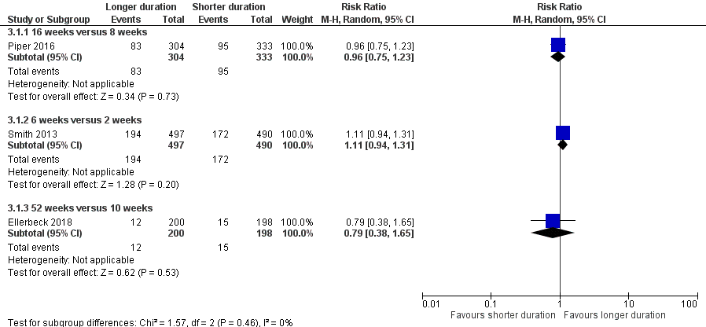
Figure 28: Results of smoking cessation for at least six months follow-up in Lindson et al. 2019 and Ellerbeck et al. (2018), longer duration versus shorter duration of combination therapy
Source: Lindson et al. (2019) and Ellerbeck et al. (2018)
Abbreviations: CI = confidence interval
Safety
A summary of key adverse events included in Lindson et al. (2019) and Ellerbeck et al. (2018) comparing longer duration with shorter duration of combination NRT is presented in Table 92. Overall, there were no statistically significant differences in serious adverse events and cardiac events between longer duration and shorter duration of combination NRT.
Table 92: Summary of key adverse events in Lindson (2019) and Ellerbeck (2018), longer duration versus shorter duration combination NRT
Outcome | Study type | Longer duration | Shorter duration | RR (95% CI) | RD (95% CI)
Overall SAEs¹
26 weeks versus 8 weeks | Cochrane Review  (1 RCT) | 10/275  (3.6%) | 6/269  (2.2%) | 1.63  (0.6, 4.42) | NR
16 weeks versus 8 weeks | Cochrane Review  (1 RCT) | 0/304  (0%) | 0/333  (0%) | NE | NR
6 weeks versus 2 weeks | Cochrane Review  (1 RCT) | 0/497  (0%) | 0/490  (0%) | NE | NR
Adverse events²
Cardiac events | Ellerbeck 2018 (RCT) | 8/200  (4%) | 9/189  (4.8%) | 0.84  (0.33, 2.13) | -0.01  (-0.05, 0.03)
Source: Lindson et al. (2019), Ellerbeck et al. (2018)
Abbreviations: CI = confidence interval; NE = not estimable; NR = not reported; RCT = randomised controlled trial; RD = risk difference; RR = risk ratio; SAEs = serious adverse events.
Notes: See Appendix Figure 94 for forest plots of the respective outcomes which included the results of individual studies.
1 Calculated by Cochrane Review authors using a fixed-effect model.
2 Calculated during the review.

Other variations in NRT use analysis
Efficacy
A summary of smoking cessation rates for at least six months follow-up for other variations in NRT use (24-hour versus 16-hour patches, continue versus stop patch use on relapse, and 22 weeks of combination of 35 mg patches and fast-acting versus 10 weeks of 21 mg) is presented in Table 93. Overall, there were no statistically significant differences in smoking cessation rates in all comparisons examining other variations in NRT use.
Table 93: Results of smoking cessation for at least six months follow-up in Lindson et al. 2019, other variations in NRT use
Study | Study type | Experimental | Control | RR (95% CI)¹
24-hour versus 16-hour patch
Lindson  (2019) | Cochrane Review (1 RCT) | 11/51  (21.6%) | 17/55  (30.9%) | 0.7  (0.36, 1.34)
Continue versus stop patch use on lapse
Lindson  (2019) | Cochrane Review (1 RCT) | 174/356  (48.9%) | 190/345  (55%) | 0.89  (0.77, 1.02)
35 mg patch + fast-acting for 22 weeks versus 21 mg patch for 10 weeks
Lindson  (2019) | Cochrane Review (1 RCT) | 29/244  (11.9%) | 23/242  (9.5%) | 1.25  (0.75, 2.1)
Source: Lindson et al. (2019)
Abbreviations: CI = confidence interval; RCT = randomised controlled trial; RR = risk ratio
Notes:
1 Calculated by Cochrane Review authors using a fixed-effect model.
The results of the individual studies included in Lindson et al. (2019) for other variations in NRT use are presented using a forest plot in Figure 29.

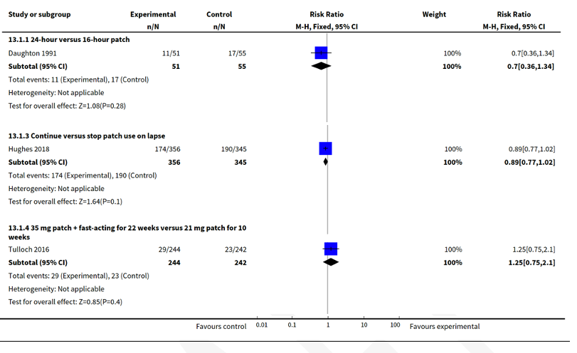
Figure 29: Results of smoking cessation for at least six months follow-up in Lindson et al. 2019, other variations in NRT use
Source: Lindson et al. (2019)
Abbreviations: CI = confidence interval
Safety
A summary of key adverse events included in Lindson et al. (2019) related to other variations in NRT use is presented in Table 94. Overall, there were no statistically significant differences in serious adverse events, treatment withdrawals and cardiac events in all comparisons examining other variations in NRT use.
Table 94: Summary of key adverse events in Lindson et al. (2019), other variations in NRT use
Outcome | Study type | Experimental (former) | Control (latter) | RR (95% CI)¹
Overall SAEs
Continue versus stop patch use on lapse | Cochrane Review  (1 RCT) | 4/356  (1.1%) | 4/345  (1.2%) | 0.97  (0.24, 3.84)
35 mg patch + fast-acting for 22  weeks versus 21 mg patch for 10 weeks | Cochrane Review  (1 RCT) | 6/245  (2.4%) | 9/245  (3.7%) | 0.67  (0.24, 1.84)
Treatment withdrawals
35 mg patch + fast-acting for 22  weeks versus 21 mg patch for 10 weeks | Cochrane Review  (1 RCT) | 5/245  (2%) | 4/245  (1.6%) | 1.25  (0.34, 4.6)
Cardiac AEs
35 mg patch + fast-acting for 22  weeks versus 21 mg patch for 10 weeks | Cochrane Review  (1 RCT) | 3/245  (1.2%) | 5/245  (2%) | 0.6  (0.14, 2.48)
Source: Lindson et al. (2019)
Abbreviations: AEs = adverse events; CI = confidence interval; NE = not estimable; RCT = randomised controlled trial; RR = risk ratio; SAEs = serious adverse events.
Notes: See Appendix Figure 93, Figure 95 and Figure 96 for forest plots of the respective outcomes which included the results of individual studies.
1 Calculated by Cochrane Review authors using a fixed-effect model.

Dosing schedule
A summary of the characteristics of the studies comparing different dosing schedules of NRT is presented in Table 95. The characteristics of the individual studies are presented in Appendix Table 163.
The relevant studies identified for inclusion are presented in this section based on four categories:
- Effect of tapering dose (2 RCTs comparing abrupt withdrawal versus tapering)
- Fixed versus ad lib dosing schedule (4 RCTs comparing gum and nasal spray)
- Preloading versus standard use (10 RCTs; 9 RCTs in Lindson et al. 2019; and 1 RCT by Dedert et al. 2018, comparing use of patch, gum, and combination of both forms),
- Cut down to quit (11 RCTs comparing reduction with pharmacotherapy versus reduction alone).

Table 95: Characteristics of the studies comparing different NRT dose schedule
Study | Study type | Subgroup title/N¹ | Population | Intervention and comparator | Outcomes
Effect of tapering patch dose
Lindson (2019) | Cochrane Review  (2 RCTs²) | Abrupt withdrawal versus tapering  N= 264 (2 RCTs) | Inclusion:  Adult smokers with an average age of approximately 45, who smoked at least 15 cigarettes a day, studies lasted for at least six months.  Exclusion: Trials that did not assess cessation as an outcome, with follow-up less than six months, and with additional intervention components not matched between arms. Trials comparing NRT to control, and trials comparing NRT to other pharmacotherapies. | Abrupt withdrawal versus tapering. | Primary: smoking cessation rates of at least six months after baseline.  Secondary: safety including treatment withdrawals.
Fixed versus ad lib dose schedule
Lindson (2019) | Cochrane Review  (4 RCTs²) | Gum fixed dosing versus ad lib dosing  N= 689  Nasal spray fixed dosing versus ad lib dosing  N= 139 | Inclusion:  Adult smokers with an average age of approximately 45, who smoked at least 15 cigarettes a day, studies lasted for at least six months.  Exclusion: Trials that did not assess cessation as an outcome, with follow-up less than six months, and with additional intervention components not matched between arms. Trials comparing NRT to control, and trials comparing NRT to other pharmacotherapies. | Fixed dosing versus ad lib dosing. | Primary: smoking cessation rates of at least six months after baseline.  Secondary: safety including serious adverse events and treatment withdrawals.
Preloading versus standard use
Lindson (2019) | Cochrane review  (9 RCTs²) | Patch preloading versus standard use  N= 3830 (9 RCT)  Preloading (n=1988), standard use (n=1842)  Gum preloading versus standard use  N= 306 (2 RCT)  Preloading (n=199), standard use (n=107)  Patch + gum preloading versus standard use  N= 259 (2 RCT)  Preloading (n=191), standard use (n=68) | Inclusion:  Adult smokers with an average age of approximately 45, who smoked at least 15 cigarettes a day, studies lasted for at least six months.  Exclusion: Trials that did not assess cessation as an outcome, with follow-up less than six months, and with additional intervention components not matched between arms. Trials comparing NRT to control, and trials comparing NRT to other pharmacotherapies. | Preloading versus standard use. | Primary: smoking cessation rates of at least six months after baseline.  Secondary: safety including palpitations, cardiac adverse events, cardiac and overall serious adverse events, and treatment withdrawals.
Dedert  (2018) | RCT³ | Patch preloading versus placebo  N= 81  Preloading (n=37),  Placebo (n=44) | Inclusion:  Adult smokers aged 18–70 years with PTSD (interview-based diagnosis), smoking at least 10 cigarettes daily for the past year, willingness to make a smoking cessation attempt, and fluency in English.  Exclusion:  Smoked non-cigarette forms of nicotine (non-combustible forms of nicotine such as electronic cigarettes were not excluded), were pregnant, had major unstable medical problems or unstable medication regimens, current manic syndrome, psychotic disorder, current drug or alcohol use disorder, or used bupropion or benzodiazepines. | NRT patch preloading versus placebo patch preloading.  All participants received standard pharmacotherapy and behavioural treatment for smoking cessation after the quit date. | Primary:  smoking cessation rates (7-day PPA) of at 6 weeks, and 6 months after baseline biochemically verified with breath CO at six weeks post-quit date.  Secondary:  change in craving, withdrawal symptoms, and PTSD symptoms that occur when smoking a cigarette during the patch preloading phase.
Cut down to quit
Lindson (2019b) | Cochrane review  (11 RCTs²) | Combination NRT  N= 1124 (3 RCT)  Reduction with pharmacotherapy (n=578), reduction alone (n=546)  NRT patch  N= 85 (1 RCT)  Reduction with pharmacotherapy (n=65), reduction alone (n=20)  Fast acting NRT  N= 5323 (7 RCT)  Reduction with pharmacotherapy (n=2737), reduction alone (n=2586)  Varenicline  N= 1510 (1 RCT)  Reduction with pharmacotherapy (n=760), reduction alone (n=750)  Bupropion  N= 594 (1 RCT)  Reduction with pharmacotherapy (n=295), reduction alone (n=299) | Inclusion:  Most were adults, and people typically smoked at least 23 cigarettes a day at the start of the studies. All studies included at least one group of people who were asked to cut down their smoking and then quit tobacco smoking altogether.  Exclusion:  Studies which asked people to cut down without quitting, and studies lasted less than six months. | Reduction with pharmacotherapy versus reduction alone.  Pharmacotherapy used were combination NRT, patch, fast acting NRT, varenicline, and bupropion. | Primary: smoking cessation rates of at least six months after baseline.  Secondary: safety including pre-quit adverse events, pre-quit serious adverse events, and pre-quit tobacco withdrawal.
Abbreviations: NRT = nicotine replacement therapy; N/A = not applicable; RCT = randomised controlled trial
Notes:
1 Only the number of patients (n) in the relevant arms were included.
2 The characteristics of the individual studies included in Lindson et al. (2019) are presented in Appendix Table 163.
3 In Dedert et al. (2018), the concealment of the allocation sequence was not reported.

Effect of tapering patch dose
Efficacy
A summary of the smoking cessation rates for at least six months follow-up comparing abrupt withdrawal with tapering patch dose is presented in Table 96. Based on the Cochrane Review by Lindson et al. (2019), the results of the meta-analysis comprising two RCTs demonstrated no statistically significant differences in smoking cessation rates between abrupt withdrawal and tapering of NRT patch dose. The PBAC previously noted that gradual tapering compared with abrupt withdrawal was likely to result in minimal changes in clinical outcomes (NRT PSD, March 2010 PBAC meeting).
Table 96: Results of smoking cessation for at least six months follow-up, effect of tapering patch dose
Study | Study type | Abrupt withdrawal | Tapering | RR (95% CI)¹
Lindson (2019) | Cochrane Review  (2 RCTS) | 55/137  (40.1%) | 50/127  (39.4%) | 0.99  (0.74, 1.32)
Source: Lindson et al. (2019)
Abbreviations: CI = confidence interval; RCT = randomised controlled trial; RD = risk difference; RR = risk ratio
Notes:
1 Calculated by Cochrane Review authors using a fixed-effect model.
The results of the individual studies included in Lindson et al. (2019) are presented using a forest plot in Figure 30.
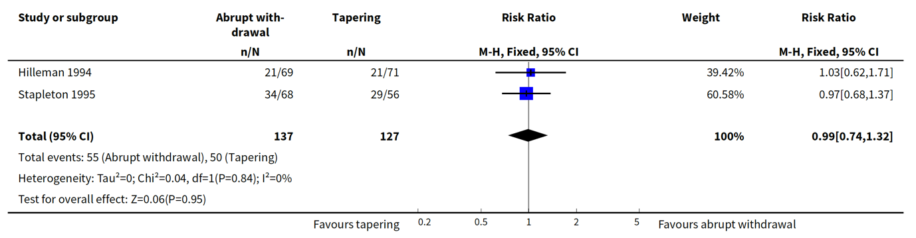
Figure 30: Results of smoking cessation for at least six months follow-up, effect of tapering patch dose
Source: Lindson et al. (2019)
Abbreviations: CI = confidence interval
Safety
A summary of key adverse events in Lindson et al. (2019) comparing abrupt withdrawal with tapering patch dose is presented in Table 97. Based on the Cochrane Review by Lindson et al. (2019), there were no statistically significant differences in treatment withdrawals between the two treatment arms.
Table 97: Summary of key adverse events in Lindson et al. (2019), tapering patch dose
Outcome | Study type | Abrupt | Tapering | RR (95% CI)¹
Treatment withdrawals | Cochrane Review  (1 RCT) | 7/69  (10.1%) | 8/71  (11.3%) | 0.9  (0.35, 2.35)
Source: Lindson et al. (2019)
Abbreviations: CI = confidence interval; RCT = randomised controlled trial; RR = risk ratio.
Notes: See Appendix Figure 97 for forest plots of the respective outcomes which included the results of individual studies.
1 Calculated by Cochrane Review authors using a fixed-effect model.

Fixed versus ad lib dose schedule
Efficacy
A summary of the smoking cessation rates for at least six months follow-up for fixed versus ad lib dosing schedule is presented in Table 98. Overall, there were no statistically significant differences in smoking cessation rates between fixed and ad lib dosing of fast-acting NRT (gum, nasal spray and pooled analysis).
Table 98: Results of smoking cessation for at least six months follow-up, fixed versus ad lib dose schedule
Study | Study type | Fixed dosing | Ad lib dosing | RR (95% CI)
Gum fixed dosing versus ad lib dosing subgroup
Lindson (2019) | Cochrane Review  (2 RCTs) | 85/346  (24.6%) | 69/343  (20.1%) | 1.22  (0.92, 1.61)
Nasal spray fixed dosing versus ad lib dosing subgroup
Lindson (2019) | Cochrane Review  (2 RCTs) | 10/69  (14.5%) | 15/70  (21.4%) | 0.67  (0.35, 1.3)
Fixed versus ad lib dose dosing (pooled)
Lindson (2019) | Cochrane Review  (4 RCTs) | 95/415  (22.9%) | 84/413  (20.3%) | 1.12  (0.87, 1.45)
Source: Lindson et al. (2019)
Abbreviations: CI = confidence interval; RCT = randomised controlled trial; RD = risk difference; RR = risk ratio
Notes:
1 Calculated by Cochrane Review authors using a fixed-effect model.

The results of the individual studies relevant to fixed versus ad lib dosing schedule comparison which included in Lindson et al. (2019) are presented using a forest plot in Figure 31.
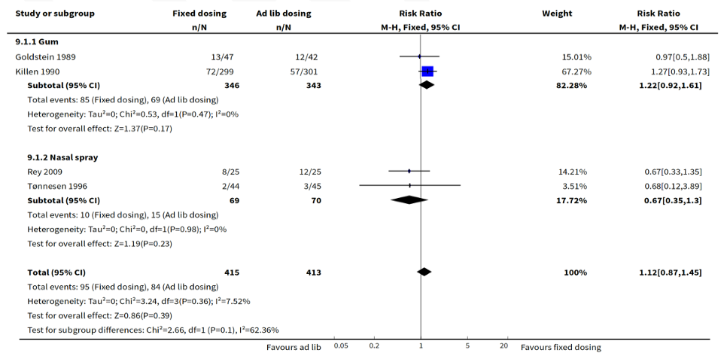
Figure 31: Results of smoking cessation for at least six months follow-up, fixed versus ad lib dose schedule
Source: Lindson et al. (2019)
Abbreviations: CI = confidence interval
Safety
A summary of key adverse events in Lindson et al. (2019) comparing fixed with ad lib dosing schedule is presented in Table 99. Overall, there were no statistically significant differences in serious adverse events and treatment withdrawals between the two treatment arms for NRT nasal spray and gum.
Table 99: Summary of key adverse events in Lindson et al. (2019), fixed versus ad lib dosing
Outcome | Study type | Fixed dosing | Ad lib dosing | RR (95% CI)¹
Overall SAEs
Nasal spray | Cochrane Review  (1 RCT) | 0/44  (0%) | 0/45  (0%) | NE
Treatment withdrawals
Nasal spray | Cochrane Review  (1 RCT) | 0/44  (0%) | 0/45  (0%) | NE
Gum | Cochrane Review  (1 RCT) | 18/147  (12.2%) | 21/152  (13.8%) | 0.89  (0.49, 1.59)
Source: Lindson et al. (2019)
Abbreviations: CI = confidence interval; NE = not estimable; RCT = randomised controlled trial; RD = risk difference; RR = risk ratio; SAEs = serious adverse events.
Notes: See Appendix Figure 98 and Figure 99 for forest plots of the respective outcomes which included the results of individual studies.
1 Calculated by Cochrane Review authors using a fixed-effect model.

Preloading versus standard use
Efficacy
A summary of the smoking cessation rates for at least six months follow-up for preloading versus standard use of NRT is presented in Table 100. Based on the Cochrane Review by Lindson et al. (2019), the results of the meta-analysis demonstrated a significantly higher rate of smoking cessation in the preloading use of NRT compared with standard use of NRT. However, the results were only statistically significant in the NRT patches subgroup and not in the NRT gum or patch in combination with gum subgroups.
The results of the updated re-analysis for the NRT patches subgroup were consistent with the results from Lindson et al. (2019) (RR: 1.32, 95% CI: 1.09, 1.58).
Table 100: Results of smoking cessation for at least six months follow-up, preloading versus standard use
Study | Study type | Preloading | Standard use | RR (95% CI) | RD (95% CI)^
Patch subgroup
Lindson (2019)¹ | Cochrane Review  (8 RCTs) | 337/1,988  (17%) | 235/1,842  (12.8%) | 1.28  (1.09, 1.49) | NR
Updated  re-analysis² | Lindson 2019 (8 RCTs) and Dedert 2018 | 343/2,025  (16.9%) | 236/1,886  (12.5%) | 1.32  (1.09, 1.58) | 0.04  (0.01, 0.05)
Gum subgroup
Lindson (2019)¹ | Cochrane Review  (2 RCTs) | 50/199  (25.1%) | 26/107  (24.3%) | 0.93  (0.58, 1.49) | NR
Patch + gum subgroup
Lindson (2019)¹ | Cochrane Review  (2 RCTs) | 59/191  (30.9%) | 14/68  (20.6%) | 1.35  (0.8, 2.28) | NR
Preloading versus standard use (pooled analysis)
Lindson (2019)¹ | Cochrane Review  (12 RCTs) | 446/2,378  (18.8%) | 275/2,017  (13.6%) | 1.25  (1.08, 1.44) | NR
Source: Lindson et al. (2019) and Dedert et al. 2018.
Abbreviations: CI = confidence interval; RCT = randomised controlled trial; RD = risk difference; RR = risk ratio; NE = not estimable.
Notes: Bold indicates statistically significant difference.
1 Calculated by Cochrane Review authors using a fixed-effect model.
2 Calculated during review using a random-effect model.
The results of the individual studies included in Lindson et al. (2019) and in the updated re-analysis for the NRT patches subgroup are presented using a forest plot in Figure 32 and Figure 33, respectively.
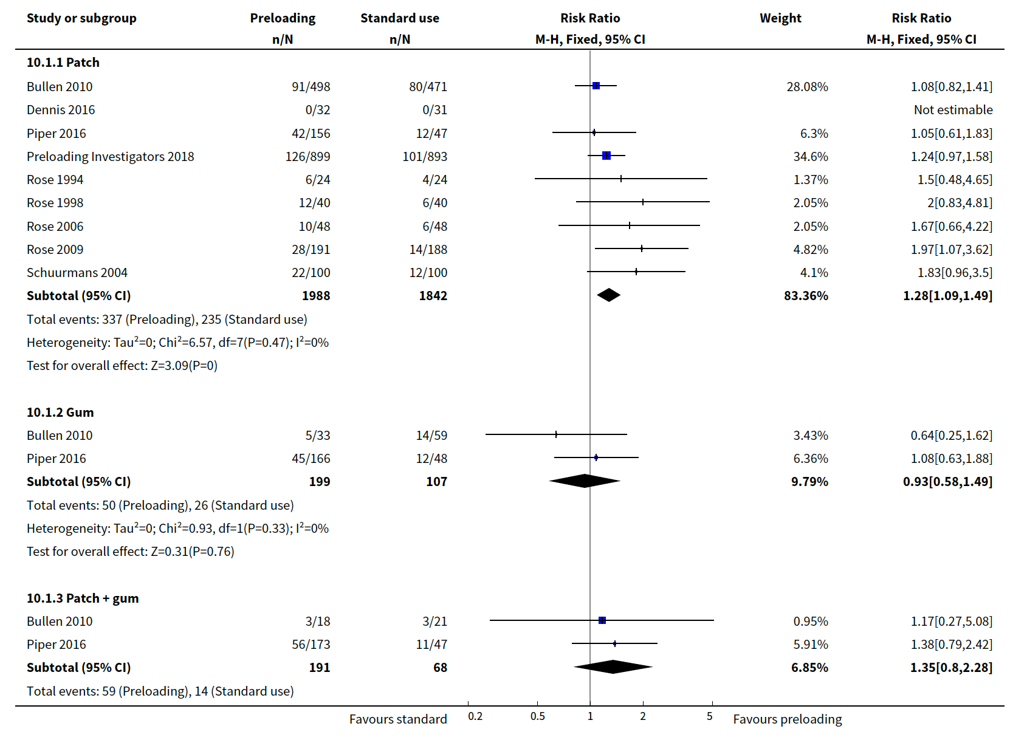
Figure 32: Results of smoking cessation for at least six months follow-up in Lindson et al. (2019), preloading versus standard use
Source: Lindson et al. (2019)
Abbreviations: CI = confidence interval

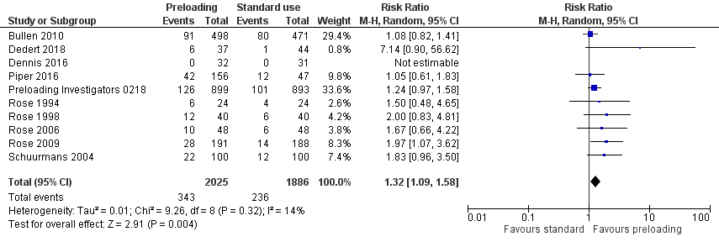
Figure 33: Results of smoking cessation for at least six months follow-up based on updated re-analysis, preloading versus standard use
Source: Lindson et al. (2019), Dedert et al. (2018)
Abbreviations: CI = confidence interval
Safety
A summary of key adverse events in Lindson et al. (2019) comparing preloading with standard use is presented in Table 101. Based on the Cochrane Review by Lindson et al. (2019), there was a significantly higher proportion of patients in the preloading arm experiencing palpitations compared with patients in the standard use arm. There were no statistically significant differences in cardiac adverse events, cardiac serious adverse events, overall serious adverse events and treatment withdrawals between the two treatment arms.
The results of the updated re-analysis for the overall serious adverse events were consistent with the results from Lindson et al. (2019) (RR: 1.05, 95% CI: 0.56, 1.98).
Table 101: Summary of key adverse events in Lindson et al. (2019), preloading versus standard use
Study | Study type | Preloading | Standard use | RR (95% CI) | RD (95% CI)
Palpitations
Lindson (2019)¹ | Cochrane Review  (1 RCT) | 35/899  (3.9%) | 17/893  (1.9%) | 2.05  (1.15, 3.62) | NR
Cardiac AEs
Lindson (2019)¹ | Cochrane Review  (1 RCT) | 10/549  (1.8%) | 8/551  (1.5%) | 1.25  (0.5, 3.15) | NR
Cardiac SAEs
Lindson (2019)¹ | Cochrane Review  (3 RCTs) | 14/1,943  (0.7%) | 7/1,586  (0.4%) | 1.94  (0.81, 4.65) | NR
Overall SAEs
Lindson (2019)¹ | Cochrane Review  (4 RCTs) | 20/2,134  (0.9%) | 18/1,774  (1%) | 1.11  (0.59, 2.09) | NR
Updated  re-analysis² | Lindson (2019) and Dedert (2018) | 20/2,172  (0.9%) | 20/1,818  (1.1%) | 1.05  (0.56, 1.98) | -0.00  (-0.01, 0.01)
Treatment withdrawals
Lindson (2019)¹ | Cochrane Review  (1 RCT) | 0/40  (0%) | 1/40  (2.5%) | 0.33  (0.01, 7.95) | NR
Source: Lindson et al. (2019), Dedert et al. (2018)
Abbreviations: AEs = adverse events; CI = confidence interval; NR = not reported; RCT = randomised controlled trial; RD = risk difference; RR = risk ratio; SAEs = serious adverse events.
Notes: Bold indicates statistically significant difference. See Appendix Figure 100, Figure 101, Figure 102, Figure 103, and Figure 104 for forest plots of the respective outcomes which included the results of individual studies.
1 Calculated by Cochrane Review authors using a fixed-effect model.
2 Calculated during the review using a random-effect model.

Cut down to quit
Efficacy
A summary of the smoking cessation rates for at least six months follow-up for reduction with pharmacotherapy versus reduction alone is presented in Table 102. Based on the Cochrane Review conducted by Lindson et al. (2019b), the results of the meta-analysis demonstrated a significantly higher rate of smoking cessation in reduction with pharmacotherapy versus reduction alone in the fast acting NRT subgroup. There were no statistically significant differences between the two treatment arms in either combination NRT or NRT patches subgroups.
Table 102: Results of smoking cessation for at least six months follow-up, reduction with pharmacotherapy versus reduction alone
Study | Study type | Reduction + pharmacotherapy | Reduction alone | RR (95% CI)
Combination NRT
Lindson (2019b) | Cochrane Review  (4 RCTs) | 85/578  (14.7%) | 81/546  (14.8%) | 1.02  (0.61, 1.69)
Patch
Lindson (2019b) | Cochrane Review  (2 RCTs) | 3/65  (4.6%) | 3/20  (15%) | 0.34  (0.02, 5.31)
Fast acting NRT
Lindson (2019b) | Cochrane Review  (8 RCTs) | 193/2,737  (7.1%) | 62/2,586  (2.4%) | 2.56  (1.93, 3.39)
Source: Lindson et al. (2019b)
Abbreviations: CI = confidence interval; RCT = randomised controlled trial; RR = risk ratio.
Notes: Bold indicates statistically significant difference.
1 Calculated by Cochrane Review authors using a fixed-effect model.

The results of the individual studies relevant to cut down to quit comparisons are presented using a forest plot in Figure 34.
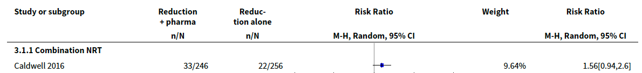
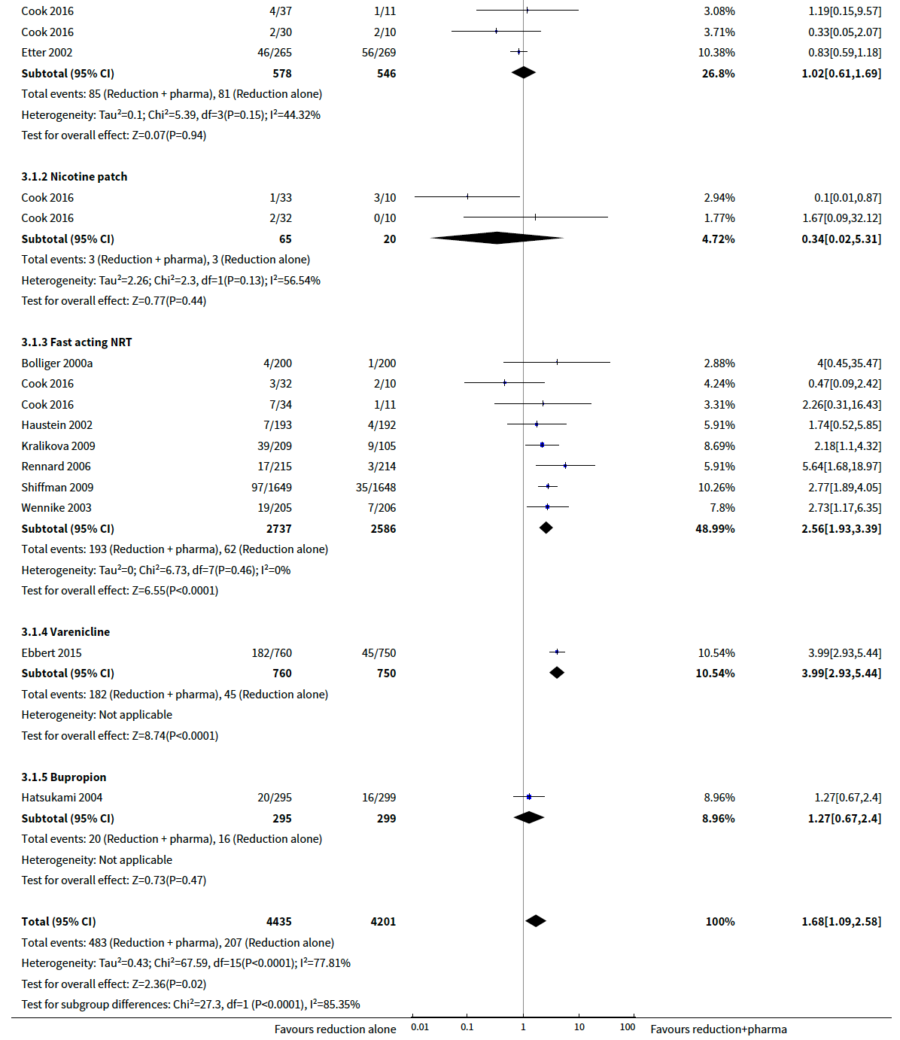
Figure 34: Results of smoking cessation for at least six months follow-up in Lindson et al. (2019b), reduction with pharmacotherapy versus reduction alone
Source: Lindson et al. (2019b)
Abbreviations: CI = confidence interval

Safety
A summary of key adverse events in Lindson et al. (2019b) comparing reduction with pharmacotherapy with reduction alone for cut down to quit is presented in Table 103.
Based on Bolliger (2000a), there was no statistically significant difference between reduction with pharmacotherapy and reduction alone in pre-quit adverse events. However, there was a significantly higher proportion of patients in the reduction with pharmacotherapy arm experiencing pre-quit adverse events compared with patients in the reduction alone arm in ShiIman (2009).
For pre-quit serious adverse events, there were no statistically significant differences between the two treatment arms based on the meta-analysis conducted by Lindson (2019b). It was noted that the number of events were low across both arms.
Table 103: Summary of key adverse events in Lindson et al. (2019), reduction with pharmacotherapy versus reduction alone
Study | Study type | Reduction with pharmacotherapy | Reduction alone | RR (95% CI)¹
Pre-quit AEs
Bolliger (2000a) | RCT | 113/200  (56.5%) | 114/200  (57%) | 0.99  (0.84, 1.18)
Shiffman (2009) | RCT | 795/1,649  (48.2%) | 603/1,648  (36.6%) | 1.32  (1.22, 1.43)
Pre-quit SAEs
Lindson (2019b) | Cochrane Review  (2 RCTs) | 3/444  (0.7%) | 0/318  (0%) | 7.28  (0.38, 140.28)
Source: Lindson et al. (2019b)
Abbreviations: AEs = adverse events; CI = confidence interval; RCT = randomised controlled trial; RR = risk ratio; SAEs = serious adverse events.
Notes: Bold indicates statistically significant difference. See Appendix Figure 105 and Figure 106 for forest plots of the respective outcomes which included the results of individual studies.
1 Calculated by Cochrane Review authors using a fixed-effect model.

Non-PBS listed NRT dosage forms (TGA-registered)
A summary of the characteristics of the studies comparing efficacy and safety of non-PBS listed NRT dosage forms which are TGA registered is presented in Table 104. The characteristics of the individual studies are presented in Appendix Table 164.
The relevant studies identified for inclusion are presented in this section based on four categories:
- Inhalator/inhaler (versus placebo and patches)
- Intranasal/nasal spray (versus placebo and patches)
- Oral spray (versus placebo)
- Inhalator + patch (versus placebo)

Table 104: Characteristics of the studies comparing non-PBS listed NRT dosage forms
Study | Study type | Subgroup title/N¹ | Population | Intervention and comparator | Outcomes
Inhalator/inhaler
Hartmann-Boyce (2018) | Cochrane Review  (4 RCTs²) | Inhalator versus placebo  N= 976 (4 RCTs)  Inhalator (n=490), Placebo (n=486) | Inclusion: men or women who smoked and were motivated to quit, irrespective of the setting from which they were recruited or their initial level of nicotine dependence, or both.  Exclusion: trials that randomised physicians or other therapists to receive an educational intervention, which included encouraging their patients to use NRT. | NRT inhalator  Placebo | Primary: smoking cessation rates of at least six months after baseline.  Secondary: NR.
Oncken (2019) | RCT | Inhalator versus placebo  N= 137 (1 RCT)  Inhalator (n=70),  Placebo (n=67) | Inclusion: Pregnant women who were smoking ≥5 cigarettes per day, 13-26 weeks’ gestation, ≥16 years of age, intending to carry their pregnancy to term, living in a stable residence.  Exclusion: current drug abuse or dependence by self-report, twins or other multiple gestation, an unstable psychiatric or medical problem, and a congenital abnormality. | NRT inhalator  Placebo  Behavioural support provided in both arms. | Primary: 7-day PPA at the end of pregnancy (biochemically verified with exhaled breath carbon monoxide (CO) <4 ppm).  Secondary: adverse events and serious adverse events.  Other: abstinence rates during treatment, smoking reduction, birthweight, and gestational age.
Lindson (2019) | Cochrane Review  (1 RCTs³) | Inhalator versus patch  N= 222 (1 RCT)  Inhaler (n= 118),  Patch (n= 104) | Inclusion:  Adult smokers with an average age of approximately 45, ≥15 cigarettes a day, studies lasted for at least six months.  Exclusion: Trials that did not assess cessation as an outcome, with follow-up less than six months, and with additional intervention components not matched between arms. Trials comparing NRT to control, and trials comparing NRT to other pharmacotherapies. | NRT inhalator  NRT patch | Primary: smoking cessation rates of at least six months after baseline.  Secondary: adverse events including overall serious adverse events.
Nasal/intranasal spray
Hartmann-Boyce (2018) | Cochrane Review  (4 RCTs²) | Nasal spray versus placebo  N= 887 (4 RCT)  Nasal spray (n=448), Placebo (n=439) | Inclusion: men or women who smoked and were motivated to quit, irrespective of the setting from which they were recruited or their initial level of nicotine dependence, or both.  Exclusion: trials that randomised physicians or other therapists to receive an educational intervention, which included encouraging their patients to use NRT. | NRT nasal spray  Placebo | Primary: smoking cessation rates of at least six months after baseline.  Secondary: adverse event including palpitations/chest pains.
Lindson (2019) | Cochrane Review  (2 RCTs³) | Nasal spray versus patch  N= 1,272 (2 RCT)  Nasal spray (n=638), Patch (n=634) | Inclusion:  Adult smokers with an average age of approximately 45, ≥15 cigarettes a day, studies lasted for at least six months.  Exclusion: Trials that did not assess cessation as an outcome, with follow-up less than six months, and with additional intervention components not matched between arms. Trials comparing NRT to control, and trials comparing NRT to other pharmacotherapies. | NRT nasal spray  NRT patch | Primary: smoking cessation rates of at least six months after baseline.  Secondary: adverse events including overall serious adverse events and treatment withdrawal.
Oral spray
Hartmann-Boyce (2018) | Cochrane Review  (1 RCT²) | Oral spray versus placebo  N= 479 (1 RCT)  Oral spray (n=318), Placebo (n=161) | Inclusion: men or women who smoked and were motivated to quit, irrespective of the setting from which they were recruited or their initial level of nicotine dependence, or both.  Exclusion: trials that randomised physicians or other therapists to receive an educational intervention, which included encouraging their patients to use NRT. | NRT oral spray  Placebo | Primary: smoking cessation rates of at least six months after baseline.  Secondary: adverse event.
Nides (2020) | RCT⁴ | Oral spray versus placebo  N= 1,198 (1 RCT)  Oral spray (n=597), Placebo (n=601) | Inclusion: smokers, motivated to quit smoking, ≥18 years old, exhaled CO ≥10 ppm at baseline, male or non-pregnant or non-lactating female, agree to refrain from the use of cigarettes and other forms of tobacco/nicotine (including nicotine-containing electronic cigarettes), and agree to practice birth control during the 26-week study.  Exclusion: history of cardiovascular disease, stomach ulcer, or diabetes; use of other forms of tobacco or nicotine-containing products other than cigarettes within 30 days before the baseline visit; use of any NRTs, medicinal aids, or nondrug therapies for smoking cessation within 30 days before the baseline visit; those who participated in another clinical study or had used any investigational product within 30 days before the initial baseline visit; suspected alcohol or substance abuse or his- tory of significant psychiatric illness within the previous 12 months; and presence of an oral lesion found at the baseline visual mouth inspection, requiring further investigation such as biopsy. | NRT oral spray  Placebo  No behavioural support, counselling, or encouragement provided. | Primary: CAR at Week 2-12 and Week 2-26.  CO-validated (A CO level at least 10 ppm classified the subject as a smoker).  Secondary: number of cigarettes smoked, craving and withdrawal symptoms.
Inhalator + patch
Hartmann-Boyce (2018) | Cochrane Review  (1 RCTs²) | Inhalator + patch versus placebo  N= 245 (1 RCT)  Combination NRT (n=136),  Placebo (n=109) | Inclusion: men or women who smoked and were motivated to quit, irrespective of the setting from which they were recruited or their initial level of nicotine dependence, or both.  Exclusion: trials that randomised physicians or other therapists to receive an educational intervention, which included encouraging their patients to use NRT. | NRT inhalator + patch  Placebo | Primary: smoking cessation rates of at least six months after baseline.  Secondary: NR.
Abbreviations: CAR = continuous abstinence rate; CO = carbon monoxide; NRT = nicotine replacement therapy; N/A = not applicable; RCT = randomised controlled trial
Notes:
1 Only the number of patients (n) in the relevant arms were included.
2 The characteristics of the individual studies included in Hartmann-Boyce et al. (2018) are presented in Table 164 in the Appendix
3 The characteristics of the individual studies included in Lindson et al. (2019) are presented in Table 164 in the Appendix.
4 In Nides et al. (2020), the concealment of the allocation sequence was not reported.

Inhalator/inhaler
Efficacy
A summary of smoking cessation rates for at least six months follow-up for the comparison of NRT inhalator versus placebo as well as inhaler versus patches is presented in Table 105 and Table 106. Based on the Cochrane Review by Hartmann-Boyce et al. (2018), the results of the meta-analysis comprising four RCTs demonstrated a statistically significant difference in smoking cessation rates between the two treatment arms, in favour of NRT inhalator. The results of the updated re-analysis were no longer statistically significant after including the results from Oncken et al. (2019) (RR: 1.57; 95% CI: 0.97, 2.54).
Based on the Cochrane Review by Lindson et al. (2019), the results demonstrated no statistically significant difference in smoking cessation rates between NRT inhalator and patches.
Table 105: Results of smoking cessation for at least six months follow-up, inhalator versus placebo
Study | Study type | Inhalator | Placebo | RR (95% CI) | RD (95% CI)
Hartmann-Boyce (2018)¹ | Cochrane Review  (4 RCTs) | 84/490  (17.1%) | 44/486  (9.1%) | 1.9  (1.36, 2.67) | NR
Oncken  (2019)² | RCT | 7/70  (10%) | 12/67  (17.9%) | 0.56  (0.23, 1.33) | -0.08  (-0.19, 0.04)
Meta-analysis of Hartmann-Boyce (2018) and Oncken (2019)
Updated  re-analysis³ | 5 RCTs | 91/560  (16.3%) | 56/553  (10.1%) | 1.57  (0.97, 2.54) | 0.06  (0.00, 0.11)
Source: Hartmann-Boyce et al. (2018), Oncken et al. (2019)
Abbreviations: CI = confidence interval; NR = not reported; RCT = randomised controlled trial; RD = risk difference; RR = risk ratio
Notes: Bold indicates statistically significant difference.
1 Calculated by Cochrane Review authors using a fixed-effect model.
2 7-day PPA.
3 Calculated during the review using a random-effect model.
Table 106: Results of smoking cessation for at least six months follow-up, inhalator versus patch
Study | Study type | Inhalator | Patch | RR (95% CI)¹
Lindson  (2019) | Cochrane Review  (1 RCT) | 6/118  (5.1%) | 9/104  (8.7%) | 0.59  (0.22, 1.6)
Source: Lindson et al. (2019).
Abbreviations: CI = confidence interval; RCT = randomised controlled trial; RR = risk ratio
Notes:
1 Calculated by Cochrane Review authors using a fixed-effect model.
The results of the individual studies included in Hartmann-Boyce et al. (2018, based on updated re-analysis) and Lindson et al. (2019) are presented using a forest plot in Figure 35 and Figure 36.

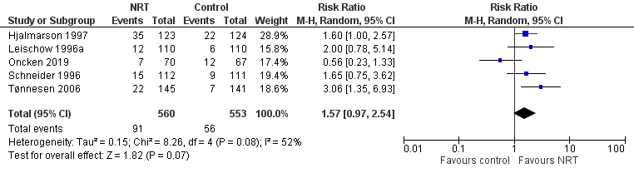
Figure 35: Results of smoking cessation for at least six months follow-up based on updated re-analysis of Hartmann-Boyce et al. (2018), inhalator versus placebo
Source: Hartmann-Boyce et al. (2018)
Abbreviations: CI = confidence interval

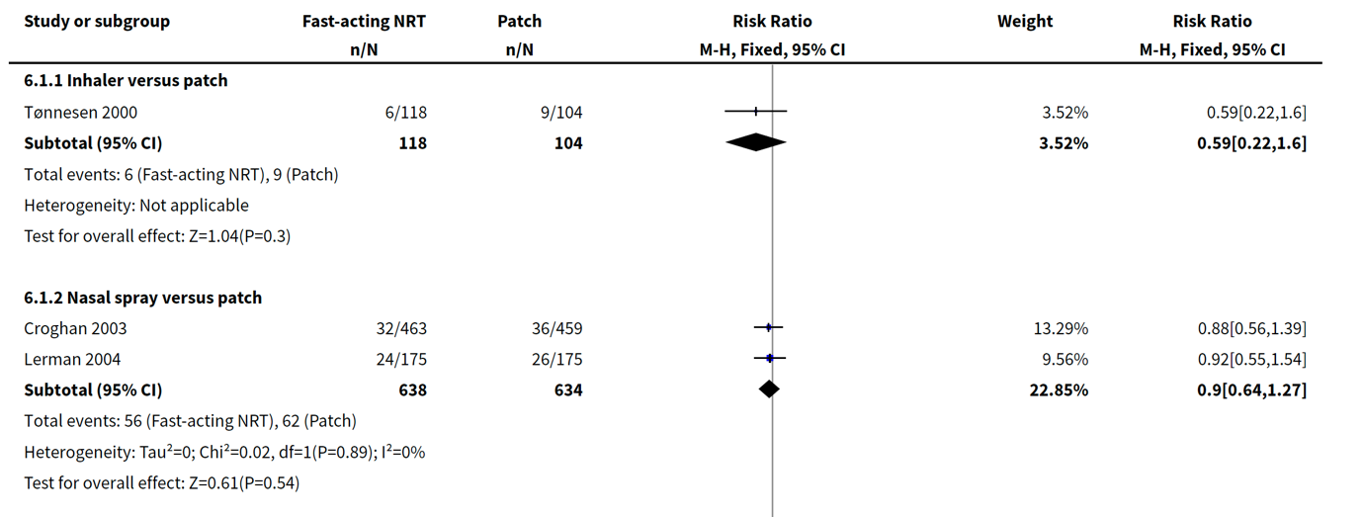
Figure 36: Results of smoking cessation for at least six months follow-up Lindson et al. (2019), inhaler versus patch
Source: Lindson et al. (2019)
Abbreviations: CI = confidence interval
Safety
A summary of key adverse events in Oncken et al. (2019) for comparison of NRT inhalator against placebo is presented in Table 107. There were no safety results reported from Hartmann-Boyce et al. (2018) for the study comparing inhalator with placebo.
The results demonstrated no statistically significant difference in terms of adverse events between the two treatment arms (based on risk ratio), noting that the results were statistically significant based on risk difference (absolute effect). The incidence of preterm delivery was higher in the placebo than the nicotine group: 15% (10/67) versus 4% (3/67), respectively (p=0.030). Similarly, the incidence of delivering a low-birth-weight infant was higher in the placebo than the nicotine group: 15% (10/67) versus 6% (4/67), respectively (p=0.035), but not after adjusting for preterm delivery (p=0.268).
Table 107: Summary of key adverse events in Oncken et al. (2019), NRT inhalator versus placebo
Study | Study type | Inhalator | Placebo | RR (95% CI)¹ | RD (95% CI)¹
Adverse events
Oncken  (2019) | RCT | 8/70  (11.4%) | 0/67  (0%) | 16.28  (0.96, 276.65) | 0.11  (0.04, 0.19)
Source: Oncken et al. (2019)
Abbreviations: CI = confidence interval; RCT = randomised controlled trial; RD = risk difference; RR = risk ratio
Notes: Bold indicates statistically significant difference. The calculated odds ratio was 18.36 (1.04, 324.74).
1 Calculated during the review.
A summary of key adverse events in Lindson et al. (2019) for comparison of NRT inhalator against patches is presented in Table 108. Based on Tønnesen et al. (2000), no serious adverse events were reported in both treatment arms.
Table 108: Summary of key adverse events in Lindson et al. (2019), NRT inhalator versus patch
Study | Study type | Inhalator | Patch | RR (95% CI)¹
Overall SAEs
Lindson  (2019) | Cochrane Review  (1 RCT) | 0/118  (0%) | 0/104  (0%) | NE
Source: Lindson et al. (2019)
Abbreviations: CI = confidence interval; NE = not estimable; RCT = randomised controlled trial; RR = risk ratio; SAE = serious adverse event.
Notes: See Appendix Figure 107 for forest plots of the respective outcomes which included the results of individual studies.
1 Calculated by Cochrane Review authors using a fixed-effect model.

Nasal/intranasal spray
Efficacy
A summary of smoking cessation rates for at least six months follow-up for the comparison of NRT nasal spray versus placebo is presented in Table 109 and Table 110. Based on the Cochrane Review by Hartmann-Boyce et al. (2018), the results of the meta-analysis comprising four RCTs demonstrated a statistically significant difference in smoking cessation rates between the two treatment arms, in favour of nasal spray.
In contrast, the results of the meta-analysis comprising two RCTs conducted by Lindson et al. (2019) demonstrated no statistically significant difference in smoking cessation rates between NRT nasal spray and patches (RR 0.9, 95% CI 0.64, 1.27).
Table 109: Results of smoking cessation for at least six months follow-up, nasal spray versus placebo
Study | Study type | Nasal spray | Placebo | RR (95% CI)¹
Hartmann-Boyce (2018) | Cochrane Review  (4 RCTs) | 107/448  (23.9%) | 52/439  (11.8%) | 2.02  (1.49, 2.73)
Source: Hartmann-Boyce et al. (2018).
Abbreviations: CI = confidence interval; RCT = randomised controlled trial; RR = risk ratio
Notes: Bold indicates statistically significant difference.
1 Calculated by Cochrane Review authors using a fixed-effect model.
Table 110: Results of smoking cessation for at least six months follow-up, nasal spray versus patch
Study | Study type | Nasal spray | Patch | RR (95% CI)¹
Lindson  (2019) | Cochrane Review  (2 RCTs) | 56/638  (8.8%) | 62/634  (9.8%) | 0.9  (0.64, 1.27)
Source: Lindson et al. (2019).
Abbreviations: CI = confidence interval; RCT = randomised controlled trial; RD = risk difference; RR = risk ratio
Notes:
1 Calculated by Cochrane Review authors using a fixed-effect model.
The results of the individual studies relevant to NRT nasal dosage form included in Hartmann-Boyce et al. (2018) and Lindson et al. (2019) are presented using a forest plot in Figure 37 and Figure 38.
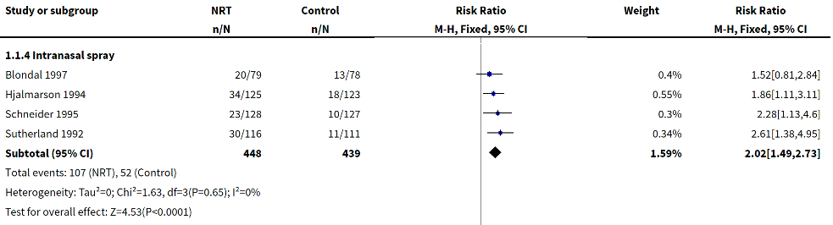
Figure 37: Results of smoking cessation for at least six months follow-up in Hartmann-Boyce et al. (2018), nasal spray versus placebo
Source: Hartmann-Boyce et al. (2018)
Abbreviations: CI = confidence interval

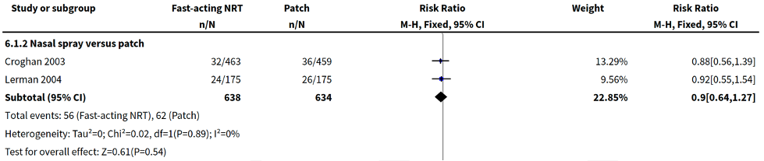
Figure 38: Results of smoking cessation for at least six months follow-up in Hartmann-Boyce et al. (2018), nasal spray versus patch
Source: Hartmann-Boyce et al. (2018)
Abbreviations: CI = confidence interval
Safety
A summary of key adverse events in Hartmann-Boyce et al. (2018) for the comparison of intranasal spray versus placebo, and Lindson et al. (2019) for comparison of NRT nasal spray against patches is presented in Table 111 and Table 112, respectively.
Out of three RCTs comparing nasal spray against placebo which reported palpitations/chest pains adverse events, only one study (Schneider 1995) demonstrated a significantly higher rate in the nasal spray arm. The results of the meta-analysis comprising the three RCTs demonstrated a significantly higher incidence of palpitations/chest pains adverse events in the nasal spray arm compared to placebo.
Among studies comparing nasal spray versus patches, Lerman et al. (2004) reported no serious adverse events in either treatment arm, while Croghan 2003 showed a significantly higher rate of treatment withdrawals in the nasal spray arm.
Table 111: Summary of key adverse events in Hartmann-Boyce et al. (2018), NRT nasal spray versus placebo
Study | Study type | Nasal spray | Placebo | RR (95% CI)
Palpitations/chest pains
Hjalmarson  (1994) | RCT | 6/116  (5.2%) | 2/107  (1.9%) | 4.42  (0.93, 20.92)
Schneider  (1995) | RCT | 23/128  (18%) | 10/127  (7.9%) | 2.56  (1.17,5.63)
Sutherland  (1992) | RCT | 26/111  (23.4%) | 15/103  (14.6%) | 1.79  (0.89, 3.62)
Meta-analysis of Hjalmarson (1994), Schenider (1995) and Sutherland (1992)
Meta-analysis¹ | 3 RCTs | 58/355  (16.3%) | 27/337  (8.0%) | 2.27  (1.38, 3.72)
Source: Hartmann-Boyce et al. 2018.
Abbreviations: CI = confidence interval; RCT = randomised controlled trial; RR = risk ratio.
Notes: Bold indicates statistically significant difference. See Appendix Figure 108 for forest plot which included the results of individual studies.
1 Calculated during the review using a random-effect model.
Table 112: Summary of key adverse events in Lindson et al. (2019), NRT nasal spray versus patch
Study | Study type | Nasal spray | Patch | RR (95% CI)¹
Overall SAEs
Lindson (2019) | Cochrane Review  (1 RCT) | 0/175  (0%) | 0/175  (0%) | NE
Treatment withdrawals
Lindson  (2019) | Cochrane Review  (1 RCT) | 14/463  (3%) | 4/459  (0.9%) | 3.47  (1.15, 10.46)
Source: Lindson et al. (2019)
Abbreviations: CI = confidence interval; NE = not estimable; RCT = randomised controlled trial; RR = risk ratio.
Notes: Bold indicates statistically significant difference.
1 Calculated by Cochrane Review authors using a fixed-effect model.

Oral spray
Efficacy
A summary of smoking cessation rates for at least six months follow-up for the comparison of NRT oral spray versus placebo is presented in Table 113. Based on the Cochrane Review by Hartmann-Boyce et al. (2018), the results of the identified RCT demonstrated a statistically significant difference in smoking cessation rates between the two treatment arms, in favour of NRT oral spray. The results of the updated re-analysis were consistent with the results from Hartmann-Boyce et al. (2018) after including the results from Nides et al. (2020). It was noted that the results of the updated re-analysis were not statistically significant based on risk difference (absolute effect).
Table 113: Results of smoking cessation for at least six months follow-up, oral spray versus placebo
Study | Study type | Oral spray | Placebo | RR (95% CI) | RD (95% CI)
Hartmann-Boyce  (2018)¹ | Cochrane Review  (1 RCT) | 44/318  (13.8%) | 9/161  (5.6%) | 2.48  (1.24, 4.94) | NR
Nides (2020)² | RCT | 20/597  (3.4%) | 7/601  (1.2%) | 2.87  (1.23, 6.71) | 0.08  (0.03, 0.13)
Meta-analysis of Hartmann-Boyce (2018) and Nides (2020)
Updated  re-analysis³ | 2 RCTs | 64/915  (7%) | 16/762  (2.1%) | 2.63  (1.54, 4.50) | 0.05  (-0.02, 0.12)
Source: Hartmann-Boyce et al. (2018), Nides et al. (2020).
Abbreviations: CI = confidence interval; NR = not reported; RCT = randomised controlled trial; RD = risk difference; RR = risk ratio
Notes: Bold indicates statistically significant difference.
1 Calculated by Cochrane Review authors using a fixed-effect model.
2 Continuous abstinence at week 26.
3 Calculated during the review using a random-effect model.

The results of the individual studies relevant to NRT oral spray dosage form based on the updated re-analysis are presented using a forest plot in Figure 39.

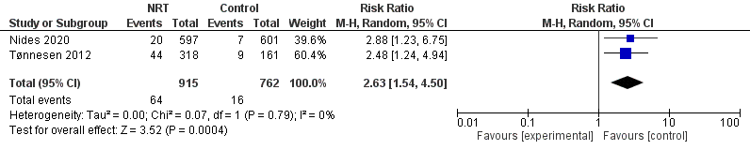
Figure 39: Results of smoking cessation for at least six months follow-up in Hartmann-Boyce et al. 2018 and Nides (2020), oral spray versus placebo
Source: Hartmann-Boyce et al. (2018) and Nides (2020)
Abbreviations: CI = confidence interval
Safety
A summary of key adverse events in Nides et al. (2020) for comparison of NRT oral spray against placebo is presented in Table 114. There were no safety results reported from Hartmann-Boyce et al. (2018) for the study comparing oral spray with placebo.
Overall, a significantly higher proportion of patients in the oral spray arm experienced any adverse events and discontinuation due to adverse events compared with patients in the placebo arm. There were no patients in either arm who experienced treatment-related serious adverse events.
Table 114: Summary of key adverse events in Nides et al. (2020), NRT oral spray versus placebo
Outcome | Oral spray | Placebo | RR (95% CI)² | RD (95% CI)²
Adverse event¹ | 345/597  (57.8%) | 157/601  (26.1%) | 2.21  (1.90, 2.57) | 0.32  (0.26, 0.37)
Serious adverse event | 0/597  (0%) | 0/601  (0%) | NE | 0  (-0. 0)
Discontinuation due to adverse event | 24/597  (4.0%) | 7/601  (1.2%) | 3.45  (1.50, 7.95) | 0.03  (0.01, 0.05)
Source: Nides et al. 2020.
Abbreviations: CI = confidence interval; NR = not reported; RCT = randomised controlled trial; RD = risk difference; RR = risk ratio.
Notes: Bold indicates statistically significant difference.
1 Adverse event presented by number of subjects in either treatment group who reported a treatment-related adverse event at least once.
2 Calculated during the review.

Inhalator and patch
Efficacy
A summary of smoking cessation rates for at least six months follow-up for the comparison of NRT inhalator plus patch versus placebo is presented in Table 115. The results demonstrated no statistically significant difference in smoking cessation rates (abstinence rate at 12 months) between the two treatment arms, although the results numerically favoured the inhalator and patch combination.
Table 115: Results of smoking cessation for at least six months follow-up, inhalator and patch versus placebo
Study | Study type | Inhalator + patch | Placebo | RR (95% CI)
Hartmann-Boyce  (2018)¹ | Cochrane Review  (1 RCT) | 20/136  (14.7%) | 15/109  (13.8%) | 1.07  (0.57, 1.99)
Source: Hartmann-Boyce et al. (2018).
Abbreviations: CI = confidence interval; RCT = randomised controlled trial; RR = risk ratio
Notes:
1 Calculated by Cochrane Review authors using a fixed-effect model.
The results of the individual studies relevant to the combination of NRT inhalator and patch included in Hartmann-Boyce et al. (2018) are presented using a forest plot in Figure 40.
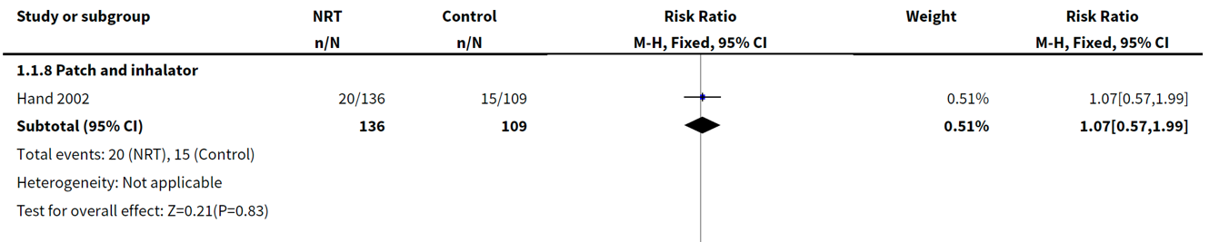
Figure 40: Results of smoking cessation of at least six months follow-up in Hartmann-Boyce et al. 2018, combination of NRT inhalator and patch versus placebo
Source: Hartmann-Boyce et al. (2018)
Abbreviations: CI = confidence interval
Safety
No adverse events were reported by Hartmann-Boyce et al. (2018) nor Hand et al. (2002) for the comparison of inhalator + patch versus placebo.

Summary of evidence for NRT dose, dosage form and length of therapy
NRT dose
Higher strength NRT patches (21 mg/24-hour) was shown in Lindson (2019) to provide a statistically significant improvement in long-term smoking cessation rates compared with lower strength patches (14 mg/24-hour) based on trials that primarily involved participants who smoked 20 or more cigarettes a day. There were no statistically significant differences in long-term smoking cessation rates for the other comparisons (25 mg/16-hour versus 15 mg/16-hour patches; 42/44 mg/24-hour versus 21/22 mg/24-hour patches). For safety, there were no statistically significant differences in the key adverse events between higher strength and lower strength NRT patches for all comparisons except for treatment withdrawals comparing the 42/44 mg with 21/22 mg (24-hour) patches. A significantly higher treatment withdrawal rate was observed in patients treated with 42/44 mg (24-hour) patches compared to patients treated with 21/22 mg (24-hour) patches.
Based on the evidence presented (Lindson et al. 2019), the higher strength NRT gum (4 mg) demonstrated a statistically significant benefit in long-term smoking cessation rates over the lower strength gum (2 mg) based on the pooled results of high-dependency and low-dependency smokers. However, the results of the subgroup analysis suggest that only smokers who are highly dependent may benefit from the higher strength NRT gum (i.e. not statistically significantly different in low-dependency smokers). There were no statistically significant differences in palpitations and treatment withdrawals between the two treatment arms.
Length of therapy
For the comparison of longer duration versus shorter duration of NRT monotherapy (patch or gum) and combination NRT therapy, there were no statistically significant differences in long-term smoking cessation rates and any of the key adverse events assessed (Lindson et al. 2019, Ellerbeck et al. 2018). Of note, the CEASE (1999) study compared 28 weeks with 12 weeks of NRT patches, with two patch doses (25 mg and 15 mg) examined in each duration. '''''''' '''''''''' ''''''' '''''' '''''''''''''' '''''''''''''''' '''''''''''''''''''' '''' '''''' '''''''''''''''''''' '''''''''' '''''''''''''''''' '''''''''''''''' '''''' ''''''''''' ''''''''''''''''''''''''''''' '''''' ''''''''''' '''' '' '''''' '''''' ''''''' ''''' '''''''''' '''''''' ''''''''''''''' ''''' '''''' '''''''' '''''''''''' ''''''' ''''''''''' '''''''''''' ''''''''''''''''''''' '''' ''''' '''''' ''''''' ''''' '''''''''' '''''''' '''''''''''''''''
For other variations in NRT use (24-hour versus 16-hour patches, continue versus stop patch use on relapse, and 22 weeks of combination of 35 mg patches and fast-acting versus 10 weeks of 21 mg patches), there were no statistically significant differences in long-term smoking cessation rates, serious adverse events, treatment withdrawals and cardiac events in all comparisons (Lindson et al. 2019).
Dosing schedule
For the comparison of abrupt withdrawal versus tapering patch dose, there were no statistically significant differences in long-term smoking cessation rates and treatment withdrawals between the two treatment arms (Lindson et al. 2019). This is consistent with previous PBAC considerations, whereby gradual tapering compared with abrupt withdrawal was noted to result in minimal changes in clinical outcomes (NRT PSD, March 2010 PBAC meeting).
For the comparison of fixed versus ad lib dosing schedules, there were no statistically significant differences in long-term smoking cessation rates, serious adverse events, and treatment withdrawals between the two treatment arms for all comparisons (gum, nasal spray and pooled analysis) (Lindson et al. 2019).
Preloading use of NRT was demonstrated to significantly improve long-term smoking cessation rates compared with standard use of NRT (Lindson et al. 2019). However, the results were only statistically significant in the NRT patches subgroup and not in the NRT gum or patch in combination with gum subgroups. The results of the updated re-analysis (adding Dedert 2018) for the NRT patches subgroup were consistent with the results from Lindson et al. (2019). For safety, there was a significantly higher proportion of patients in the preloading arm experiencing palpitations compared with patients in the standard use arm. There were no statistically significant differences in cardiac adverse events, cardiac serious adverse events, overall serious adverse events and treatment withdrawals between the two treatment arms. The results of the updated re-analysis for the overall serious adverse events were consistent with the results from Lindson et al. (2019).
Based on evidence presented (Lindson et al. 2019b), reduction (cut down to quit) with pharmacotherapy demonstrated a significantly higher rate of smoking cessation compared with reduction alone in the fast acting NRT subgroup, noting that there were no statistically significant differences between the two treatment arms in either combination NRT or NRT patches subgroups. There was no statistically significant difference between reduction with pharmacotherapy and reduction alone in pre-quit adverse events (1 RCT; Bolliger 2000a) and pre-quit serious adverse events. However, there was a significantly higher proportion of patients in the reduction with pharmacotherapy arm experiencing pre-quit adverse events in another study (1 RCT; ShiIman 2009) compared with patients in the reduction alone arm.
Non-PBS listed NRT dosage forms
Use of an NRT inhalator demonstrated a statistically significant improvement in long-term smoking cessation rates compared to placebo (Hartmann-Boyce et al. 2018). The results of the updated re-analysis were no longer statistically significant after including the results from the new study (Oncken et al. 2019). For safety, there were no statistically significant difference in adverse events between the two treatment arms (based on risk ratio), noting that the results were statistically significant based on risk difference (absolute effect).
For the comparison of inhalator versus patches, there were no statistically significant differences in long-term smoking cessation rates between the two treatment arms. For safety, there were no serious adverse events reported in either treatment arm.
Nasal spray demonstrated a statistically significant benefit in long-term smoking cessation rates compared to placebo (Hartmann-Boyce et al. 2018). The results of the meta-analysis comprising three RCTs demonstrated a significantly higher incidence of palpitations/chest pains adverse events in the nasal spray arm compared to placebo.
For the comparison of nasal spray versus patches, in contrast, the results from Lindson et al. (2019) demonstrated no statistically significant difference in long-term smoking cessation rates between the two treatment arms when NRT nasal spray was compared to patches. Among studies comparing nasal spray versus patches, Lerman et al. (2004) reported no serious adverse events in either treatment arms, while Croghan et al. (2003) showed a significantly higher rate of treatment withdrawals in the nasal spray treatment arm.
NRT oral spray demonstrated a statistically significant benefit in long-term smoking cessation rates compared to placebo (Hartmann-Boyce et al. 2018). The results of the updated re-analysis were consistent with the results from Hartmann-Boyce et al. (2018) after including the results from Nides et al. (2020). It was noted that the results of the updated re-analysis were not statistically significant based on risk difference (absolute effect).
There were no safety results reported from Hartmann-Boyce et al. (2018) for the study comparing oral spray versus placebo. In Nides et al. (2020), a significantly higher proportion of patients in the oral spray arm experienced any adverse events and discontinuation due to adverse events compared with patients in the placebo arm. There were no patients in either arm who experienced treatment-related serious adverse event.
Results from Hartmann-Boyce et al. 2018 demonstrated no statistically significant difference in long-term smoking cessation rates between inhalator + patch and placebo, although the results numerically favoured inhalator and patch combination. In terms of safety, no adverse events were reported by Hartmann-Boyce et al. (2018) nor Hand et al. (2002) for the comparison of inhalator + patch versus placebo.

Behavioural interventions in combination with pharmacotherapies
The aim of this section was to examine the importance of comprehensive support and counselling in combination with pharmacotherapies. In this report, only studies that assessed the comparative efficacy of behavioural interventions versus minimal or no behavioural interventions (both in combination with pharmacotherapies) were included. Studies that compared the different types of behavioural strategies were included in the search strategy. However, no review was identified that examined the comparative effectiveness and safety of different behavioural strategies used in conjunction with pharmacotherapy. .
To access PBS-subsidised NRT on the general and repatriation schedules, patients must have entered or be entering into a comprehensive support and counselling program. Details about the program must be documented in the patient’s medical records under the general schedule only. For the Aboriginal and Torres Strait Islander listings, the prescribing note indicated “improved benefit from NRT if used in conjunction with a comprehensive support and counselling program”.
For bupropion and varenicline, the PBS treatment criteria also indicated that the patient must be undergoing concurrent counselling for smoking cessation through a comprehensive counselling and support program. For varenicline, patients could also be about to enter such a program at the time of treatment initiation. Details of the program were required to be entered into patients’ medical records upon initiation of bupropion or varenicline but not during other treatment phases. Use of a counselling and support program was also required throughout the course of treatment with varenicline or bupropion.
Specific details about the nature of the support and counselling program were not articulated in the PBS listings for smoking cessation therapies.
A summary of behavioural interventions included in the primary evidence for bupropion, varenicline and NRT patches reviewed by PBAC (5 RCTs) is presented in Table 116. The behavioural interventions provided in these studies comprised brief individual counselling sessions (10 to 15 minutes or less) administered to both arms at each follow-up visit. Only one RCT (Gonzales 2006) reported that the counselling sessions were standardised, and one RCT ('''''''''''''''' ''''''''') reported the counselling topics included motivation, identification of smoking triggers, coping responses, weight management, and use of the medications. In four studies ('''''''''''''' '''''''''''' '''''''' ''''''''''' Gonzales 2006 and Aubin 2008), self-help material was provided at baseline in addition to counselling.
Table 116: Summary of behavioural interventions provided in the pivotal PBAC evidence
Study | Intervention and comparator | Behavioural intervention
''''''''' ''''''''''' | ∋∋∋∋∋∋∋∋∋∋∋∋∋∋∋∋∋∋∋∋∋∋∋∋∋∋∋∋∋∋ ∋∋∋∋∋∋∋∋∋∋∋∋∋∋ ∋∋∋∋∋∋ ∋∋∋ ∋∋∋∋∋∋∋∋∋∋∋∋  ∋∋∋∋∋∋∋∋∋∋∋∋∋∋∋∋∋∋∋∋∋∋∋ ∋∋∋∋∋∋∋∋ ∋∋∋∋∋∋∋∋∋∋∋∋∋∋∋  ∋∋∋∋∋∋∋∋∋∋∋∋∋∋∋∋∋∋∋∋∋∋ ∋∋∋∋∋∋∋∋ ∋∋∋∋∋∋∋∋∋∋∋∋∋∋  ∋∋∋∋∋∋∋∋∋∋∋∋∋∋∋ | ''''''''' ''''''''''''''''''' ''''''''''''''''''' ''''''''''''''''''''''''''' ''''' ''''' ''''' '''''''''''''''' ''''' ''''''' ''''''''' '''''''' '''''''''' '''''''''''''' '''''''''''''''' ''''''''''''''''''''''''' ''''''''''''''' ''''' '''''''' ''''''''''''''''' ''''''''' ''''''' '''''''''''''''''' ''''''' ''''''''''''''' ''''''''''''''' ''''''''''' '''''' ''''''' ''''''''''''''''' ''''''''''''' '''''''''''''''''' '''''''''''''''' '''' ''''''' ''''''''''''''''' '''''''''''''''''' '''''' ''''''''''''''''''' '''''''' '''''''''' ''''''''''''' ''''''''''''''''' ''''' ''''' ''''''' ''''''''''''''' '''''''''''''' '''' ''''''''''''''''' '''' '''''''' '''''''''''''''''' ''''''''''' '''''' '''''''''''''' ''''' ''' '''''''''''''' ''''''''' ''''''' '''''''''''''''' ''' ''''''''''''''''''' '''''''''
'''''''''''''''' ''''''''''' | ∋∋∋∋∋∋∋∋∋∋∋ ∋∋∋∋∋∋∋∋∋∋∋∋ ∋∋∋∋∋∋∋∋ ∋∋∋∋∋∋∋∋∋∋∋∋∋∋∋∋∋∋ ∋∋∋∋∋∋∋ ∋∋∋∋∋∋∋∋ ∋∋∋∋∋∋∋∋∋∋∋ ∋∋∋∋∋∋∋∋∋∋∋∋ ∋∋∋∋∋∋∋ ∋∋∋∋∋∋∋∋∋∋∋∋∋∋∋∋∋ ∋∋∋∋∋ ∋∋∋∋∋∋ ∋∋∋∋∋ ∋∋∋∋∋∋∋ ∋∋∋∋∋∋ ∋∋∋ ∋∋∋∋∋∋∋∋∋∋∋∋∋∋ ∋∋∋∋∋∋∋∋∋∋∋∋∋∋∋ ∋∋∋∋∋∋ ∋∋∋ ∋∋∋∋∋∋∋∋∋∋∋∋ ∋∋∋∋∋∋∋∋∋∋∋∋∋∋∋∋∋∋∋∋ ∋∋∋∋∋∋∋∋∋∋∋∋ ∋∋∋∋∋∋∋ ∋∋∋∋∋∋∋∋∋∋∋∋∋∋∋∋ ∋∋∋∋∋∋∋ ∋∋∋∋∋∋∋ ∋∋∋∋∋∋ ∋∋∋∋∋ ∋∋∋ ∋∋∋∋∋∋∋∋∋∋∋∋ ∋∋∋∋∋∋∋∋∋ ∋∋∋ ∋∋∋∋∋∋∋∋∋∋∋ ∋∋∋∋∋∋∋∋∋∋∋∋∋∋ ∋∋∋∋∋∋∋∋ ∋∋∋∋∋∋∋  ∋∋∋∋∋∋∋∋∋∋∋∋∋∋∋∋∋∋∋∋∋∋∋ ∋∋∋∋∋∋∋∋ ∋∋∋∋∋∋∋∋∋∋∋∋∋∋∋∋ ∋∋∋∋∋∋∋∋∋∋∋∋  ∋∋∋∋∋∋∋∋∋∋∋ ∋∋∋∋∋∋∋∋∋∋ ∋∋∋∋∋∋∋ ∋∋∋∋∋∋∋∋∋∋∋∋∋∋ ∋∋∋∋∋∋∋∋∋∋∋∋∋∋  ∋∋∋∋∋∋∋∋∋∋∋∋∋∋∋∋ ∋∋∋∋∋∋∋∋∋∋∋∋ ∋∋∋∋∋∋∋ ∋∋∋∋∋∋∋∋∋∋∋∋∋∋∋ ∋∋∋∋∋∋∋∋∋∋∋∋∋∋ | ''''''''' ''''''''' '''''''''' '''''''''''''''''''' '''''''''''''''''''''' ''''''''''''''' '''' ''''''''' ''''''''''''' '''''''''''''''''''''''' '''''''' ''''''''''''''''''' ''''''' ''' ''''''''' ''''''''' ''''''' '''''''' '''''''''''''''''''' '''''''''''' ''''''''''''''' '''''''''''''''''''' ''''''''''''''''''''''''''' ''''' ''''''''''''''''' '''''''''''''''' '''''''''''' '''''''''''''''''' ''''''''''''' '''''''''''''''''''''''''' ''''''' ''''''' '''' ''''''' ''''''''''''''''''''''''
Gonzales (2006) | - Bupropion, 300 mg/day for 12 weeks, begun 7 days pre-TQD  - Varenicline, 2 mg/day  - Placebo | Brief (<10 mins) standardised individual counselling at 12 weekly visits during drug phase and follow-up to assist in problem solving and skills training for relapse prevention. All participants also received ‘’Clearing the Air: Quit Smoking Today’’ a smoking cessation self-help booklet as a guide to the quitting  Process.
Jorenby (2006) | - Bupropion 300 mg for 12 weeks + placebo varenicline  - Varenicline 2 mg for 12 weeks + placebo bupropion  - Placebo bupropion and placebo varenicline | Brief (< 10 mins) individual counselling at each weekly assessment for 12 weeks and 5 follow-up visits. One telephone call 3 days after quit day.
Aubin (2008) | - Varenicline 1mg x 2/day for 12 weeks, titrated 1st week.  - NRT patch (21 mg weeks 2 - 6, 14 mg weeks 7 - 9, 7 mg weeks 10 - 11).  - No placebo control group | Brief counselling (≤ 10 mins) at each clinic visit or by phone. TQD was at week 1 visit. Clearing the Air Self-Help booklet was also provided at baseline.
Source: '''''''' ''''''''''' '''''''''''''''' '''''''''' Gonzales 2006; Jorenby 2006; Aubin 2008.
Abbreviations: NRT = nicotine replacement therapy; SR = sustained release; TQD = target quit date.
A summary of the citation details for the studies examining the comparative efficacy of behavioural support in addition to pharmacotherapies is presented in Table 117. Six Cochrane Reviews were identified in the systematic literature review that provide evidence for the comparative efficacy of behavioural support in addition to pharmacotherapies and were included in this report (Lancaster 2017, Stead 2017, Carson-Chahhoud 2019, Hartmann-Boyce 2019, Livingstone-Banks 2019b, and Matkin 2019).
Table 117: List of studies examining behavioural support in addition to pharmacotherapies
Study | Citation
Lancaster  (2017)⁵⁵ | Lancaster T, Stead LF. Individual behavioural counselling for smoking cessation. Cochrane Database of Systematic Reviews 2017, Issue 3. Art. No.: CD001292. DOI: 10.1002/14651858.CD001292.pub3
Stead  (2017)⁵⁶ | Stead LF, Carroll AJ, Lancaster T. Group behaviour therapy programmes for smoking cessation. Cochrane Database of Systematic Reviews 2017, Issue 3. Art. No.: CD001007. DOI: 10.1002/14651858.CD001007.pub3.
Carson-Chahhoud  (2019)⁵⁷ | Carson-Chahhoud KV, Livingstone-Banks J, Sharrad KJ, Kopsaftis Z, Brinn MP, To-A-Nan R, Bond CM. Community pharmacy personnel interventions for smoking cessation. Cochrane Database of Systematic Reviews 2019, Issue 10. Art. No.: CD003698. DOI: 10.1002/14651858.CD003698.pub3.
Hartmann-Boyce (2019)⁵⁸ | Hartmann-Boyce J, Hong B, Livingstone-Banks J, Wheat H, Fanshawe TR. Additional behavioural support as an adjunct to pharmacotherapy for smoking cessation. Cochrane Database of Systematic Reviews 2019, Issue 6. Art. No.: CD009670. DOI: 10.1002/14651858.CD009670.pub4.
Livingstone-Banks (2019b)⁵⁹ | Livingstone-Banks J, Ordóñez-Mena JM, Hartmann-Boyce J. Print-based self-help interventions for smoking cessation. Cochrane Database of Systematic Reviews 2019, Issue 1. Art. No.: CD001118. DOI: 10.1002/14651858.CD001118.pub4.
Matkin  (2019)⁶⁰ | Matkin W, Ordóñez-Mena JM, Hartmann-Boyce J. Telephone counselling for smoking cessation. Cochrane Database of Systematic Reviews 2019, Issue 5. Art. No.: CD002850. DOI: 10.1002/14651858.CD002850.pub4.

A summary of the characteristics of the six Cochrane Reviews examining behavioural support in addition to pharmacotherapies is presented in Table 118.

Table 118: Characteristics of the studies examining behavioural support in addition to pharmacotherapies
Study | Study Type | N¹ | Population | Intervention and comparator | Outcomes
Lancaster (2017) | Cochrane Review  (33 RCTs²) | Efficacy (6 RCTs)  N=2,662  Counselling + pharmacotherapy (n=1,196),  Pharmacotherapy alone (n=1,466) | Inclusion: any smokers.  Exclusion: pregnant women, children, adolescents. | Individual counselling plus pharmacotherapy versus minimal contact plus pharmacotherapy. | Primary: smoking cessation at longest follow-up (at least 6 months after the start of counselling).
Stead  (2017) | Cochrane Review  (5 RCTs) | N=1,523  Group counselling + pharmacotherapy (n=843), Pharmacotherapy alone (n=680) | Inclusion: adult smokers of either gender, irrespective of their initial level of nicotine dependency, recruited from any setting.  Exclusion: trials recruiting pregnant women and adolescent smokers. | Group behavioural counselling + pharmacotherapy versus brief behavioural intervention + pharmacotherapy. | Primary: abstinence from cigarettes at follow-up (at least six months after the start of treatment).
Carson-Chahhoud (2019) | Cochrane Review  (7 RCTs³) | Efficacy (6 RCTs)  N=1,614  More intensive (n=845),  Less intensive (n=769) | Inclusion: community pharmacy clients who were current tobacco smokers and motivated to change their smoking behaviour. | More intensive, face-to-face behavioural interventions versus no or less intensive behavioural interventions (both with pharmacotherapy). | Primary: abstinence from smoking six months or more after the start  of the intervention.
Hartmann-Boyce  (2019) | Cochrane Review  (65 RCTs⁴) | Efficacy (59 RCTs)  NRT (N=16,541),  Bupropion (N=2,298),  Varenicline (N=1,111),  NRT & bupropion (N=719) | Inclusion: people who smoke, recruited in any setting.  Exclusion: trials only recruiting pregnant women. | Intensive behavioural support versus less intensive or no support (both with pharmacotherapy). | Primary: abstinence at longest follow-up (i.e., 6 months or longer).
Livingstone-Banks  (2019b) | Cochrane Review  (3 RCTs) | N=1,769  Self-help + NRT (n=881),  NRT alone (n=888) | Inclusion: any smokers except pregnant smokers and adolescent smokers. | Self-help materials & NRT versus NRT alone. | Primary: sustained abstinence, or point prevalence (at least 6 months follow-up).
Matkin  (2019) | Cochrane Review  (65 RCTs⁵) | Efficacy (18 RCTs)  N=12,865  Proactive counselling + pharmacotherapy (n=6,714),  Pharmacotherapy alone (n=6,151) | Inclusion: current smokers, trials with a mixture of current smokers and recent quitters if the recent quitters were only a small proportion of the entire study population.  Exclusion: trials exclusively recruiting quitters or were focused on telephone counselling as an intervention for relapse. | Proactive telephone counselling + pharmacotherapy versus pharmacotherapy. | Primary: long-term smoking abstinence (at least 6 months after the start of intervention).
Abbreviations: NRT = nicotine replacement therapy; RCT = randomised controlled trial
Notes: Only studies that assessed behavioural interventions in combination with pharmacotherapies were included.
1 Only the number of patients (n) in the relevant arms were included.
2 A total of 33 RCTs comparing individual counselling with minimal contact control (irrespective of adjunct pharmacotherapy) were identified. Of the 33 RCTs, 6 RCTs were studies assessing counselling as an adjunct to pharmacotherapy. Please refer to Lancaster et al. (2019) for the characteristics of the individual studies. Individual counselling was defined as a face-to face encounter between a smoker and a trained smoking cessation counsellor.
3 A total of 7 RCTs comparing more intensive versus less intensive behavioural interventions were identified. Of the 7 RCTs, 6 RCTs were included in the primary efficacy analysis due to clinical heterogeneity with other studies and did not include pharmacotherapy. Please refer to Carson-Chahhoud et al. (2019) for the characteristics of the individual studies.
4 A total of 65 RCTs comparing more intensive with less intensive behavioural interventions (both in combination with pharmacotherapy) were identified. Of the 65 RCTs, 59 RCTs were studies assessing PBS-listed pharmacotherapies. Please refer to Hartmann-Boyce et al. (2019) for the characteristics of the individual studies.
5 A total of 65 RCTs assessing proactive counselling (not initiated by calls to quitlines) were identified. Of the 65 RCTs, 18 RCTs were studies assessing telephone counselling as an adjunct to pharmacotherapy. Please refer to Matkin et al. (2019) for the characteristics of the individual studies. Proactive counselling involves the counsellor initiating one or more calls to provide support in making a quit attempt or avoiding relapse.

Individual counselling plus pharmacotherapy versus minimal contact (usual care, brief advice or self-help materials) plus pharmacotherapy
Lancaster et al. (2017) identified 33 studies that examined individual counselling compared to minimal contact (i.e. usual care, brief advice or self-help materials). The authors of the Cochrane Review defined individual counselling as a face-to face encounter between a smoker and a trained smoking cessation counsellor. Studies that evaluated counselling delivered by doctors and nurses as a part of a clinical encounter, or interventions that combined counselling with pharmacotherapy compared to brief support alone, or studies of motivational interviewing were excluded.
A summary of the smoking cessation rates for at least six months follow-up comparing individual counselling with minimal contact based on use with or without pharmacotherapy is presented in Table 119. The results of the meta-analysis comprising six studies (NRT=5, bupropion=1) that offered pharmacotherapy to all participants demonstrated a statistically significant difference in long-term smoking cessation rates, in favour of individual counselling in combination with pharmacotherapy.
The overall pooled results comprising 33 RCTs (irrespective of use in combination with pharmacotherapy) conducted by Lancaster et al. (2017) were consistent with the results of the use in combination with pharmacotherapy subgroup.
Table 119: Results of smoking cessation for at least six months follow-up in Lancaster et al. (2017), individual counselling versus minimal contact control
Study | Study Type | Individual counselling | Minimal contact | RR (95% CI)¹
Use in combination with pharmacotherapy subgroup
Lancaster  (2017) | Cochrane Review  (6 RCTs) | 161/1,196  (13.5%) | 154/1,466  (10.5%) | 1.24  (1.01, 1.51)
Irrespective of use in combination with pharmacotherapy (with or without)
Lancaster  (2017) | Cochrane Review  (33 RCTs) | 765/6,715  (11.4%) | 546/7,047  (7.7%) | 1.48  (1.34, 1.64)
Source: Lancaster et al. (2017)
Abbreviations: CI = confidence interval; RCT = randomised controlled trial; RR = risk ratio
Notes: Bold indicates statistically significant difference. See Appendix Figure 109 for forest plot which included the results of individual studies, the results of use without pharmacotherapy subgroup were not presented in this table.
1 Calculated by Cochrane Review authors using a fixed-effect model.
Lancaster et al. (2017) also pooled 11 studies to investigate the additional benefit of more intensive individual counselling compared to less intensive interventions. The results of the meta-analysis comprising 11 RCTs demonstrated a statistically significant difference in long-term smoking cessation rates, in favour of more intensive counselling. Of these, eight studies provided pharmacotherapy to all participants. The pooled risk ratio of the eight studies was consistent with the overall results (RR: 1.26; 95% CI: 1.04, 1.52), which overlapped with the remaining studies that did not offer pharmacotherapy to all participants.
Group therapy interventions plus pharmacotherapy versus brief cessation support plus pharmacotherapy
Stead et al. (2017) identified five studies that examined group therapy plus pharmacotherapy as compared to pharmacotherapy with brief support. Three of these studies provided NRT while the remaining studies provided bupropion. In addition to pharmacotherapy, the control conditions ranged from minimal contact and medication instructions only, to fewer and less intense group sessions.
A summary of the smoking cessation rates for at least six months follow-up comparing group therapy plus pharmacotherapy versus pharmacotherapy alone is presented in Table 120. The results of the meta-analysis comprising five RCTs conducted by Stead et al. (2017) demonstrated no statistically significant differences in long-term smoking cessation rates between the two treatment arms, although the results numerically favoured group therapy plus pharmacotherapy. It was observed that none of the individual studies reported a statistically significant result.
Table 120: Results of smoking cessation for at least six months follow-up in Stead et al. (2017), group therapy plus pharmacotherapy versus pharmacotherapy alone
Study | Study Type | Group therapy plus pharmacotherapy | Pharmacotherapy alone | RR (95% CI)¹
Stead  (2017) | Cochrane Review  (5 RCTs) | 238/843  (28.2%) | 156/680  (22.9%) | 1.11  (0.93, 1.33)
Source: Stead et al. (2017)
Abbreviations: CI = confidence interval; RCT = randomised controlled trial; RR = risk ratio
Notes: Bold indicates statistically significant difference. See Appendix Figure 110 for forest plot which included the results of individual studies.
1 Calculated by Cochrane Review authors using a fixed-effect model.
More intensive behavioural support delivered by community pharmacy personnel interventions versus less intensive smoking cessation support (both in combination with pharmacotherapy)
Carson-Chahhoud et al. (2019) identified seven studies that examined face-to-face behavioural interventions delivered by community pharmacy personnel as compared to “usual care”. The behavioural interventions were broadly based on various psychological theories of behaviour change but varied in content and the frequency of interactions (i.e. contact time). Usual care also varied between the studies, ranging from one-off-brief behavioural advice to print-based interventions and less intensive smoking cessation programmes. Participants in both groups had access to pharmacotherapy in all but one study where pharmacotherapy was not provided or available to participants in either group (Burford et al. 2013). Additionally, another study (El Hajj et al. 2017) reported that pharmacotherapy was provided to intervention group participants but was only offered to control group participants. It was unclear whether the pharmacotherapy provided in both arms was matched.
A summary of the smoking cessation rates for at least six months follow-up comparing more intensive with less intensive smoking cessation support is presented in Table 121. The results of the meta-analysis comprising six RCTs (excluding Burford 2013) conducted by Carson-Chahhoud et al. (2019) demonstrated a statistically significant difference in long-term smoking cessation rates, in favour of more intensive face-to-face behavioural smoking cessation in combination with pharmacotherapy. An additional sensitivity analysis conducted by the Cochrane Review authors by removing El Hajj et al. (2017) did not have any notable effect on this estimate.
Table 121: Results of smoking cessation for at least six months follow-up in Carson-Chahhoud et al. (2019), more versus less intensive smoking cessation support
Study | Study Type | More intensive | Less intensive | RR (95% CI)¹
Carson-Chahhoud  (2019) | Cochrane Review  (6 RCTs) | 111/845  (13.1%) | 46/769  (6.0%) | 2.30  (1.33, 3.97)
Source: Carson-Chahhoud et al. (2019)
Abbreviations: CI = confidence interval; RCT = randomised controlled trial; RR = risk ratio
Notes: Bold indicates statistically significant difference. See Appendix Figure 111 for forest plot which included the results of individual studies.
1 Calculated by Cochrane Review authors using a random-effect model.
More intensive behavioural support (in-person or via telephone) versus less intensive/no behavioural support (both in combination with pharmacotherapy)
Hartmann-Boyce et al. (2019) pooled 65 studies comparing more intensive behavioural support to less intensive or no support as an adjunct to pharmacotherapy. In these studies, all participants had access to a smoking cessation pharmacotherapy. The behavioural support intervention could comprise different or additional types of therapy content but had to involve person-to-person contact which could be in-person or via telephone. The control group could offer any level of behavioural support from minimal to multi-session counselling as long as it was less intensive than the intervention group.
Of the 65 RCTs, 49 studies provided NRT, five studies provided bupropion, two studies provided varenicline and three studies provided NRT plus bupropion. The remaining studies provided nortriptyline (two studies) and choice of pharmacotherapy (5 studies).
A summary of the smoking cessation rates for at least six months follow-up comparing more intensive with less intensive behavioural support based on subgroup of PBS-listed pharmacotherapies is presented in Table 122. The results demonstrated that increasing the intensity of behavioural support for people making a cessation attempt with the aid of NRT or bupropion alone resulted in a statistically significant improvement in the proportion who had quit at six to 12 months.
For varenicline and NRT plus bupropion, which included fewer studies, there were no statistically significant differences between more intensive with less intensive behavioural support, although the results numerically favoured the more intensive intervention. This was likely due to the smaller number of studies leading to lower precision rather than a true difference in effect.
The overall estimated pooled risk ratio irrespective of the type of pharmacotherapy was 1.15 (95% CI: 1.08, 1.22). The effect size across all PBS-listed and non-PBS listed pharmacotherapy subgroups were similar (test for subgroup differences; P=0.45, I² = 0%).
Table 122: Results of smoking cessation for at least six months follow-up in Hartmann-Boyce et al. (2019), more versus less intensive behavioural support
Study | Study Type | More support | Less support | RR (95% CI)¹
Use in combination with NRT subgroup
Hartmann-Boyce (2019) | Cochrane Review  (49 RCTs) | 1,435/8,265  (17.4%) | 1,291/8,276  (15.6%) | 1.12  (1.04, 1.21)
Use in combination with bupropion subgroup
Hartmann-Boyce (2019) | Cochrane Review  (5 RCTs) | 322/1,120  (28.8%) | 262/1,178  (22.2%) | 1.27  (1.10, 1.46)
Use in combination with varenicline subgroup
Hartmann-Boyce (2019) | Cochrane Review  (2 RCTs) | 159/555  (28.6%) | 152/556  (27.3%) | 1.05  (0.87, 1.27)
Use in combination with NRT and bupropion subgroup
Hartmann-Boyce (2019) | Cochrane Review  (3 RCTs) | 127/363  (35.0%) | 100/356  (28.1%) | 1.24  (1.00, 1.54)
Irrespective of type of pharmacotherapy (PBS-listed and non-PBS-listed)
Hartmann-Boyce (2019) | Cochrane Review  (65 RCTs) | 2,291/11,630  (19.7%) | 2,006/11,701  (17.1%) | 1.15  (1.08, 1.22)
Source: Hartmann-Boyce et al. (2019)
Abbreviations: CI = confidence interval; RCT = randomised controlled trial; RR = risk ratio
Notes: Bold indicates statistically significant difference. See Appendix Figure 112 for forest plot which included the results of individual studies, the results of non-PBS listed pharmacotherapy subgroups were not presented in this table.
1 Calculated by Cochrane Review authors using a random-effect model.
Other subgroup analyses conducted by Hartmann-Boyce et al. (2019) showed there was little evidence of subgroup differences based on the relative difference in the number of contacts between groups, no evidence of any dose-response relationship and, from a non-prespecified sub-group analysis, no difference based on the level of control group contact (i.e. brief intervention up to 30 minutes, more than 30 minutes, and no advice or contact). A second non-prespecified analysis did find a significant subgroup difference in favour of studies providing telephone counselling relative to face-to-face support (P=0.03, I² = 78%), however both subgroups demonstrated evidence of benefit of additional behavioural support (telephone counselling, RR: 1.25, 95% CI: 1.15 to 1.37; face-to face, RR: 1.11, 95% CI: 1.03 to 1.19).
Print-based self-help materials versus NRT alone
Livingstone-Banks et al. (2019b) identified four studies that examined print-based self-help materials in addition to NRT compared to NRT alone. One study (Fraser et al. 2014) was excluded from the analysis by the Cochrane Review authors due to insufficient data.
A summary of the smoking cessation rates for at least six months follow-up comparing self-help plus NRT with NRT alone is presented in Table 123. The results of the meta-analysis comprising three RCTs (excluding Fraser 2014) conducted by Livingstone-Banks et al. (2019b) demonstrated no statistically significant differences in long-term smoking cessation rates between self-help plus NRT and NRT alone.
Table 123: Results of smoking cessation for at least six months follow-up in Livingstone-Banks et al. (2019b), self-help plus NRT versus NRT alone
Study | Study Type | Self-help plus NRT | NRT alone | RR (95% CI)¹
Livingstone-Banks  (2019b) | Cochrane Review  (3 RCTs) | 141/881  (16.0%) | 133/888  (15.0%) | 1.05  (0.86, 1.30)
Source: Livingstone-Banks et al. (2019b)
Abbreviations: CI = confidence interval; RCT = randomised controlled trial; RR = risk ratio
Notes: Bold indicates statistically significant difference. See Appendix Figure 113 for forest plot which included the results of individual studies.
1 Calculated by Cochrane Review authors using a random-effect model.
Proactive telephone counselling plus pharmacotherapy versus pharmacotherapy alone
Matkin et al. (2019) identified and pooled 65 studies comparing proactive telephone counselling for smokers not calling quitlines compared to those that did not receive telephone counselling. Of the 65 RCTs, 18 RCTs were studies assessing telephone counselling as an adjunct to pharmacotherapy, specifically, the systematic use or offer of NRT patches or gum (n=15), varenicline (n=1) or either NRT or bupropion (n=2).
A summary of the smoking cessation rates for at least six months follow-up comparing proactive telephone counselling for smokers not calling quitlines with those that did not receive telephone counselling based on the subgroup of telephone counselling as an adjunct to pharmacotherapy is presented in Table 124. The results of the meta-analysis comprising 18 RCTs by Matkin et al. (2019) demonstrated a statistically significant difference in smoking cessation rates the two treatment arms, in favour of proactive telephone counselling in combination with pharmacotherapy.
The overall estimated pooled risk ratio for proactive telephone counselling (irrespective of type of adjunctive intervention) suggested a modest benefit in smoking cessation rates (RR: 1.25; 95% CI: 1.15, 1.35).
Table 124: Results of smoking cessation for at least six months follow-up in Matkin et al. (2019), proactive telephone counselling versus no counselling
Study | Study Type | Proactive counselling | No counselling | RR (95% CI)¹
Adjunct to pharmacotherapy subgroup
Matkin  (2019) | Cochrane Review  (18 RCTs) | 1,330/6,714  (19.8%) | 1,056/6,151  (17.2%) | 1.14  (1.03, 1.26)
Irrespective of type of adjunctive intervention
Matkin  (2019) | Cochrane Review  (65 RCTs) | 2,924/21,001  (13.9%) | 2,229/20,232  (11.0%) | 1.25  (1.15, 1.35)
Source: Matkin et al. (2019)
Abbreviations: CI = confidence interval; RCT = randomised controlled trial; RR = risk ratio
Notes: Bold indicates statistically significant difference. See Appendix Figure 114 for forest plot which included the results of individual studies, the results of other adjunctive interventions (self-help or minimal intervention, brief intervention or counselling, incentives for smoking cessation) subgroups were not presented in this table.
1 Calculated by Cochrane Review authors using a random-effect model.

Summary of evidence for behavioural interventions in combination with pharmacotherapies
The evidence presented from the six Cochrane Reviews (Lancaster 2017, Stead 2017, Carson-Chahhoud 2019, Hartmann-Boyce 2019, Livingstone-Banks 2019b, Matkin 2019) comparing the efficacy of behavioural support with minimal or no behavioural interventions (both in combination with pharmacotherapies) were inconclusive, noting the different types of behavioural interventions examined across the reviews.
The results of long-term smoking cessation rates from three Cochrane Reviews (Lancaster 2017, Carson-Chahhoud 2019, and Matkin 2019) were statistically significantly different, in favour of behavioural intervention when used in combination with pharmacotherapies. The behavioural interventions were proactive telephone counselling, more intensive face-to-face behavioural interventions delivered by community pharmacy personnel, and individual face-to-face counselling by a trained smoking cessation counsellor. The primary evidence previously considered by the PBAC for bupropion, varenicline, and NRT patches included the provision of individual counselling sessions in addition to pharmacotherapy.
In contrast, two of the Cochrane Reviews (Stead 2017, Livingstone-Banks 2019b) that examined group therapy and print-based self-help materials in addition to NRT respectively demonstrated no statistically significant difference in long-term smoking cessation rates between the two treatment arms, noting that the results numerically favoured the behavioural intervention in combination with pharmacotherapy treatment arm.
In Hartmann-Boyce et al. (2019), a statistically significant improvement in long-term smoking cessation rates was observed in patients receiving more intensive behavioural intervention when used in combination with NRT or bupropion. There were no statistically significant differences in smoking cessation rates between the more intensive and the less intensive arms when used in combination with varenicline or NRT plus bupropion, which was likely due to the smaller number of studies leading to lower precision rather than a true difference in effect. The results of the overall estimated pooled risk ratio irrespective of the type of pharmacotherapy (PBS-listed and non-PBS listed) were statistically significantly different, in favour of the more intensive behavioural intervention.

Populations who have specific needs
The aim of this section was to examine the evidence of efficacy and safety of smoking cessation medicines for populations who have specific needs.
Most of the national and international guidelines identified in ToR 1 addressed the general population (all smokers) within the targeted setting. While populations with specific needs were mentioned in many national and international guidelines, the overall approach to pharmacotherapies for smoking cessation did not markedly differ aside from observing drug-specific precautions or contraindications. The only exceptions were in pregnancy and breastfeeding women, and adolescents.
For pregnancy and breastfeeding, there was consensus that pharmacotherapy should be avoided if possible, but if smoking cessation could not be achieved with behavioural support alone, then NRT was the preferred pharmacotherapy (specifically short-acting options if possible). For adolescents, there was general agreement that NRT could be used if needed.

Pregnancy and lactation
A summary of the citation details for the studies evaluating the efficacy and safety of smoking cessation pharmacotherapies used in later pregnancy and after childbirth is presented in Table 125. A recently conducted Cochrane Review by Claire et al. (2020) was identified in the systematic literature review that compared smoking cessation pharmacotherapies during pregnancy.
Table 125: List of studies evaluating pharmacotherapy for smoking cessation during pregnancy/lactation
Study | Citation
Claire  (2020)⁶¹ | Claire R, Chamberlain C, Davey MA, Cooper SE, Berlin I, Leonardi-Bee J, Coleman T. Pharmacological interventions for promoting smoking cessation during pregnancy. Cochrane Database of Systematic Reviews 2020, Issue 3. Art. No.: CD010078. DOI: 10.1002/14651858.CD010078.pub3.

A summary of the characteristics of the studies evaluating pharmacotherapy for smoking cessation during pregnancy and lactation is presented in Table 126. A total of 11 RCTs were identified by Claire et al. (2020). Nine studies investigated the efficacy and safety of different forms of NRT (6 studies, patch; 1 study, gum; 1 study, inhaler; 1 study; patch or gum or lozenges) as an adjunct to behavioural support while two studies investigated bupropion. The characteristics of the individual studies are presented in Appendix Table 165.
Table 126: Characteristics of the studies evaluating pharmacotherapy for smoking cessation during pregnancy/lactation
Study | Study Type | N¹ | Population | Intervention and comparator | Outcomes
Claire  (2020) | Cochrane Review  (11 RCTs²) | N=2,412  NRT (n=2,336),  Bupropion (n=76) | Inclusion: women who were pregnant and who also smoked tobacco at study baseline. | Pharmacological treatments (including electronic cigarettes) aimed at promoting smoking cessation including, but not limited to, treatments that have been proven effective in non-pregnant adults (e.g. NRT, bupropion, varenicline, and ECs. Placebo control or no smoking cessation  pharmacotherapy/EC. | Primary: self-reported abstinence from smoking at the latest time point in pregnancy at which this was measured and, where available, validated biochemically.
Abbreviations: EC = electronic cigarettes; NRT = nicotine replacement therapy; RCT = randomised controlled trial
Notes:
1 Only the number of patients (n) in the relevant arms were included.
2 The characteristics of the individual studies included in Claire et al. (2020) are presented in Appendix Table 165.
NRT
Efficacy
A summary of the smoking cessation rates at the longest follow-up comparing NRT (long-acting and fast-acting) with control is presented in Table 127. The results of the meta-analysis comprising nine RCTs by Claire et al. (2020) demonstrated a significant improvement in smoking cessation rates with the use of NRT relative to control. Subgroup analysis by fast-acting and nicotine patches did not reveal evidence that the effect differed by NRT type (P=0.08), although the results were not statistically significant in the fast-acting NRT subgroup.
By contrast, a significant subgroup difference was detected when splitting the studies by comparator type – placebo or no placebo; when compared against placebo, the CIs incorporated zero but numerically favoured NRT and was more precise (RR: 1.21; 95% CI: 0.95, 1.55), but when compared with non-placebo controls the effect estimate significantly favoured NRT but was imprecise (RR: 8.55; 95% CI: 2.05, 35.71). It was observed that the sample sizes of the non-placebo-controlled trials were relatively small which may have resulted in the wide confidence interval. Because of this, Claire et al. (2020) stated that the pooled estimate should be interpreted with caution, suggesting a lower efficacy of NRT than the pooled estimate.
Table 127: Results of smoking cessation in later pregnancy in Claire et al. (2020), NRT versus control
Study | Study Type | NRT | Control/Placebo | RR (95%CI)¹
Claire (2020) | Cochrane Review  (9 RCTs) | 150/1,203  (12.5%) | 103/1,133  (9.1%) | 1.37  (1.08, 1.74)
Source: Claire et al. (2020)
Abbreviations: CI = confidence interval; RCT = randomised controlled trial; RR = risk ratio
Notes: Bold indicates statistically significant difference.
1 Calculated by Cochrane Review authors using a fixed-effect model.
The results of the individual studies included in Claire et al. (2020) and sub-grouped by NRT type are presented using a forest plot in Figure 41.
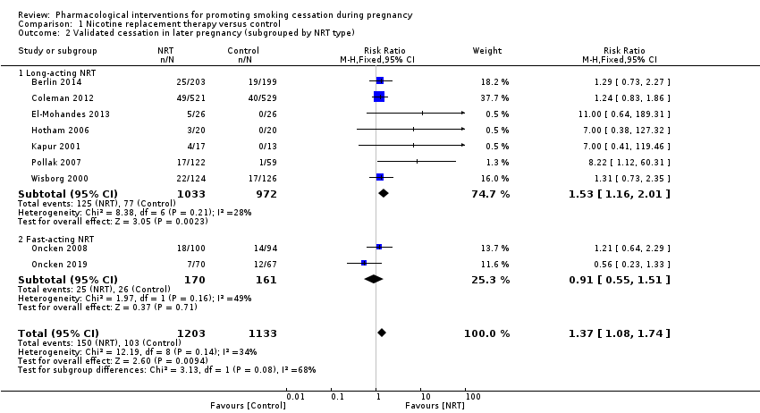
Figure 41: Results of smoking cessation in later pregnancy in Claire et al. (2020), NRT versus control
Source: Claire et al. (2020)
Abbreviations: CI = confidence interval
Claire et al. (2020) also investigated the impact of NRT on smoking cessation after childbirth. There was no evidence of clear benefit for NRT when pooling the three studies that reported non-validated 7-day PPA of up to 6 months after childbirth (RR: 1.22; 95% CI: 0.84, 1.78; 625 women) or when pooling the two studies that reported non-validated 7-day PPA one year after childbirth (RR: 1.35; 95% CI: 0.97, 1.88; 1,296 women).
Safety
A summary of key adverse events comparing NRT with control is presented in Table 128. Based on the meta-analysis by Claire et al. (2020), there were no statistically significant differences in rates of preterm births, neonatal intensive care unit admissions, neonatal deaths, congenital abnormalities and caesarean birth between the two treatment arms. Similarly, no statistically significant differences were observed for mean birthweight (mean difference: 99.73g; 95% CI: -6.65, 206.10) and the risk of miscarriage/spontaneous abortion (RR: 1.60; 95% CI: 0.53, 4.83).
Table 128: Summary of key adverse events, NRT versus control
Study | Study Type | NRT | Control/Placebo | RR (95%CI)¹
Preterm births
Claire  (2020) | Cochrane Review (7 RCTs) | 104/1,120  (9.3%) | 114/1,062  (10.7%) | 0.81  (0.59 to 1.11)
Neonatal intensive care unit admissions
Claire  (2020) | Cochrane Review (4 RCTs) | 63/908  (6.9%) | 63/848  (7.4%) | 0.90  (0.63 to 1.27)
Neonatal deaths
Claire  (2020) | Cochrane Review (4 RCTs) | 4/898  (0.4%) | 5/848  (0.6%) | 0.66  (0.17 to 2.62)
Congenital abnormalities
Claire  (2020) | Cochrane Review (2 RCTs) | 13/696  (1.9%) | 18/705  (2.6%) | 0.73  (0.36 to 1.48)
Caesarean birth
Claire  (2020) | Cochrane Review (2 RCTs) | 133/696  (19.1%) | 109/705  (15.5%) | 1.18  (0.83 to 1.69)
Source: Claire et al. (2020)
Abbreviations: CI = confidence interval; RCT = randomised controlled trial; RR = risk ratio
Notes: Bold indicates statistically significant difference. See Appendix Figure 115 to Figure 119 for forest plots of the respective outcomes which included the results of individual studies.
1 Calculated by Cochrane Review authors using a random-effect model.
Claire et al. (2020) provided a narrative synthesis of non-serious adverse effects reported from 6 RCTs. Only one study (Oncken et al. 2019) reported a significantly higher number of non-serious adverse events (i.e. throat irritation, cough, nausea) in women using NRT inhaler (11%) than placebo inhaler (0%), and two women in this study discontinuing treatment due to persistently elevated cotinine concentrations.
Bupropion
Efficacy
A summary of the smoking cessation rates at the longest follow-up comparing bupropion with placebo is presented in Table 129. The results of the meta-analysis comprising two RCTs by Claire et al. (2020) demonstrated no statistically significant difference in smoking cessation rates between the two treatment arms, noting the relatively small sample size.
Table 129: Results of smoking cessation in later pregnancy in Claire et al. (2020), bupropion versus placebo
Study | Study Type | Bupropion | Placebo | RR (95%CI)¹
Claire  (2020) | Cochrane Review  (2 RCTs) | 3/35  (8.6%) | 5/41  (12.2%) | 0.74  (0.21, 2.64)
Source: Claire et al. (2020)
Abbreviations: CI = confidence interval; RCT = randomised controlled trial; RR = risk ratio
Notes: Bold indicates statistically significant difference.
1 Calculated by Cochrane Review authors using a fixed-effect model.
The results of the individual studies included in Claire et al. (2020) are presented using a forest plot in Figure 42. It was observed that the results of the individual studies were not statistically significant.
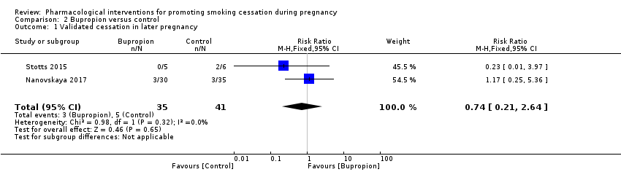
Figure 42: Results of smoking cessation in later pregnancy in Claire et al. (2020), bupropion versus placebo
Source: Claire et al. (2020)
Abbreviations: CI = confidence interval
Safety
The pooled estimate for mean birthweight estimated by Claire et al. (2020) was not statistically significant different for bupropion versus placebo (mean difference: 122.64g; 95% CI: -98.82, 344.10; 2 studies). Neither study detected a difference between groups in mean length of infants. One study (Nanovskaya et al. 2017) did not report a difference in systolic of diastolic blood pressure at the end of pregnancy.
Non-serious adverse effects from the two bupropion studies were synthesised qualitatively by Claire et al. (2020), noting that women across all studies reported known adverse effects of bupropion (i.e. vomiting, headache, difficulty sleeping). Nanovskaya et al. (2017) reported no statistically significant differences between the bupropion and control groups.

Adolescents
A summary of the citation details for the studies evaluating the efficacy and safety of smoking cessation pharmacotherapies in adolescents is presented in Table 130. A recently conducted Cochrane review by Fanshawe et al. (2017) was identified in the systematic literature review that compared smoking cessation pharmacotherapies in adolescents. Two subsequent systematic reviews (Myung 2019, Selph 2019) were also identified in the systematic literature review. No new studies comparing smoking cessation pharmacotherapies in adolescents were identified in the supplemental literature search.
Table 130: List of studies evaluating pharmacotherapy for smoking cessation in adolescents
Study | Citation
Fanshawe  (2017)⁶² | Fanshawe TR, Halliwell W, Lindson N, Aveyard P, Livingstone-Banks J, Hartmann-Boyce J. Tobacco cessation interventions for young people. Cochrane Database of Systematic Reviews 2017, Issue 11. Art. No.: CD003289. DOI: 10.1002/14651858.CD003289.pub6.
Myung  (2019)⁶³ | Myung S-K, Park J-Y. Efficacy of pharmacotherapy for smoking cessation in adolescent smokers: a meta-analysis of randomized controlled trials. Nicotine & tobacco research 2019, 21(11): 1473-1479. doi: 10.1093/ntr/nty180
Selph  (2020)⁶⁴ | Selph S, Patnode C, Bailey SR, Pappas M, Stoner R, Chou R. Primary Care–Relevant Interventions for Tobacco and Nicotine Use Prevention and Cessation in Children and Adolescents Updated Evidence Report and Systematic Review for the US Preventive Services Task Force. JAMA. 2020;323(16):1599-1608. doi:10.1001/jama.2020.3332

A summary of the characteristics of the studies evaluating pharmacotherapy in adolescents is presented in Table 131. A total of five RCTs were identified by Fanshawe et al. (2017), with four RCTs contributing to the primary efficacy analysis. Myung et al. (2019) and Selph et al. (2019) identified nine and four RCTs, respectively. Four RCTs in Myung (2019) and three RCTs in Selph (2019) were previously included in Fanshawe (2017). The characteristics of the individual studies are presented in Appendix Table 166 to Table 168.

Table 131: Characteristics of the studies evaluating pharmacotherapy for smoking cessation in adolescents
Study | Study Type | N¹ | Population | Intervention and comparator | Outcomes
Fanshawe (2017) | Cochrane  Review  (5 RCTs²) | Efficacy (4 RCTs)  NRT versus placebo (N=385),  Bupropion versus placebo (N=207),  NRT + bupropion versus NRT + placebo (N=211) | Inclusion: participants were young people, aged under 20 years, who were regular, current tobacco smokers⁵.  Exclusion: participants who were not current smokers, or if the majority of participants included were beyond their 20th birthday. | Pharmacotherapy (monotherapy or combination), Placebo. | Primary: change in smoking behaviour (being a smoker at baseline and becoming and ex-smoker at follow-up) at six months follow-up or longer.
Myung  (2019) | SR and MA  (9 RCTs³) | N=1,188 | Inclusion: adolescent smokers aged less than 20 years. | Pharmacotherapy (monotherapy or in combination), Placebo. | Primary: smoking abstinence, biochemically validated, longest follow-up (could be <6 months).
Selph  (2020) | SR  (4 RCTs⁴) | Efficacy (3 RCTs)  NRT (N=257),  Bupropion (N=523) | Inclusion: children and adolescent smokers. | Pharmacological interventions, Minimal or no tobacco use interventions. | Primary: smoking abstinence at longest follow-up (minimum of 6 months).
Abbreviations: MA = meta-analysis; NRT = nicotine replacement therapy; RCT = randomised controlled trial; SR = systematic review
Notes:
1 Only the number of patients (n) in the relevant arms were included.
2 A total of 5 RCTs were identified, with 4 RCTs contributing to primary efficacy analysis. Of the 4 RCTs, 2 RCTs compared NRT with placebo, 1 RCT compared bupropion with placebo and 1 RCT compared NRT patch + bupropion with NRT patch + placebo. The characteristics of the individual studies included in Fanshawe et al. (2017) are presented in Appendix Table 166.
3 Of the 9 RCTs, 5 RCTs compared NRT with placebo, 3 RCTs compared bupropion with placebo and 1 RCT compared NRT patch + bupropion with NRT patch + placebo. 4 RCTs (Killen 2004, Moolchan 2005, Muramoto 2007, Scherphof 2014) were previously included in Fanshawe et al. (2017) and the remaining studies excluded from Fanshawe (2017) because the outcomes were assessed at <6 months. The characteristics of the individual studies included in Myung et al. (2019) are presented in Appendix Table 167. Myung et al. (2019) did not state whether a protocol was registered before commencement of the review (AMSTAR 2 critical domain).
4 A total of 4 RCTs were identified, with 3 RCTs contributing to primary efficacy analysis. Of the 3 RCTs, 1 RCT compared NRT with placebo, 1 RCT compared bupropion with placebo and 1 RCT compared NRT patch + bupropion with NRT patch + placebo. The 3 RCTs (Killen 2004, Muramoto 2007, and Scherpof 2014) were previously included in Fanshawe et al. (2017). The characteristics of the individual studies included in Selph et al. (2019) are presented in Appendix Table 168. Selph et al. (2020) did not state whether a protocol was registered before commencement of the review and did not assess the presence and likely impact of publication bias. (AMSTAR 2 critical domain).
5 Regular smokers were defined as a young person who smokes an average of at least one cigarette a week, and has done so for at least six months.

While Myung et al. (2019) and Selph et al. (2019) were published after Fanshawe et al. (2017), there was no new evidence identified since 2017 (i.e. the latest RCT identified was Scherphof et al. 2014 included in Fanshawe et al. 2017). It was noted that five RCTs in Myung et al. (2019) were excluded by Fanshawe et al. (2017) because the outcomes in those trials were assessed at less than 6 months. Of the five RCTs, three RCTs involved NRT (Hanson 2003, Roddy 2006, Rubinstein 2008) and two RCTs involved bupropion (Niederhofer 2004, Gray 2011).
Accordingly, the Cochrane Review by Fanshawe et al. (2017) was presented as the primary evidence for adolescents in this report while Myung et al. (2019) and Selph et al. (2019) are presented as supportive evidence.
NRT
Efficacy
A summary of the smoking cessation rates at the longest follow-up comparing NRT (patch or gum) with placebo is presented in Table 132. The results of the meta-analysis comprising two RCTs by Fanshawe et al. (2017) demonstrated no statistically significant difference in smoking cessation rates between the two treatment arms. Subgroup analysis by NRT patches and NRT gum did not reveal evidence that the effect differed by NRT type (P=0.65). Fanshawe et al. (2017) noted that the wide confidence intervals and small number of events in both arms suggest that the studies were underpowered to detect any differences.
Table 132: Results of smoking cessation in adolescents in Fanshawe et al. (2017), NRT versus placebo
Study | Study Type | NRT | Placebo | RR (95%CI)¹
Fanshawe  (2017) | Cochrane Review  (2 RCTs) | 17/216  (7.9%) | 10/169  (5.9%) | 1.11  (0.48, 2.58)
Source: Fanshawe et al. (2017)
Abbreviations: CI = confidence interval; RCT = randomised controlled trial; RR = risk ratio
Notes: Bold indicates statistically significant difference.
1 Calculated by Cochrane Review authors using a fixed-effect model.
The results of the individual studies included in Fanshawe et al. (2017) and sub-grouped by NRT type are presented using a forest plot in Figure 43.
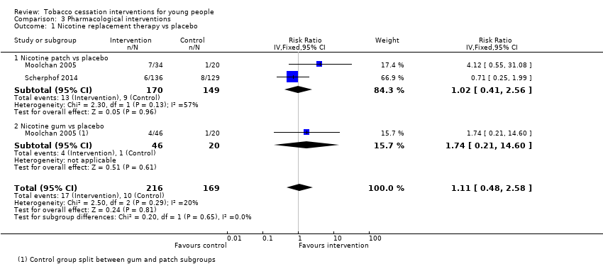
Figure 43: Results of smoking cessation in adolescents in Fanshawe et al. (2017), NRT versus placebo
Source: Fanshawe et al. (2017)
Abbreviations: CI = confidence interval
Myung et al. (2019) meta-analysed an additional three trials that measured the impact of NRT (patch or nasal spray) on smoking cessation outcomes earlier than 6 months, and similarly found no evidence of benefit in the use of NRT (RR: 1.38; 95% CI: 0.79, 2.42). Selph et al. (2019) provided only a narrative review of one NRT study (Scherphof et al. 2014) which was included in both reviews by Fanshawe et al. (2017) and Myung et al. (2019) and concluded that there was no evidence of an effect of NRT on adolescents.
Safety
Fanshawe et al. (2017) provided a narrative summary of adverse events that were reported in three NRT RCTs. In Moolchan et al. (2005), a significant increase in adverse events was observed in the NRT arm compared to placebo arm, specifically sore throat, hiccups, erythema, pruritus and shoulder/arm pain. In Scherphof et al. (2014), a significantly higher incidence of headache, cough, abnormal dreams, muscle pain and all patch-related adverse events were reported with NRT compared to placebo. Scherphof et al. (2014) reported a lower level of insomnia in the NRT arm compared with placebo and attributed this observation to withdrawal effects. In Bailey et al. (2013), 73 unspecified adverse events were reported during the open-label NRT patch treatment phase, but none of these were considered medically serious.
Myung et al. (2019) tabulated the adverse events and serious adverse events reported in each trial along with a narrative summary. The profile of adverse events reported by Myung et al. (2019) were aligned with those reported in Fanshawe et al. (2017). Selph et al. (2019) reported the same findings in their narrative review of one NRT trial, highlighting the absence of serious adverse events in either arm.
Bupropion
Efficacy
A summary of the smoking cessation rates at the longest follow-up comparing bupropion with placebo is presented in Table 133. Based on the Cochrane Review by Fanshawe et al. (2017), the results of the one RCT (Muramoto et al. 2007) demonstrated no statistically significant difference in smoking cessation rates between the two treatment arms, although the results numerically favoured bupropion. The wide confidence intervals and small number of events in both arms suggest that the study was underpowered to detect any differences.
Table 133: Results of smoking cessation in adolescents in Fanshawe et al. (2017), bupropion versus placebo
Study | Study Type | Bupropion | Placebo | RR (95%CI)¹
Fanshawe  (2017) | Cochrane Review (1 RCT) | 9/104  (8.7%) | 6/103  (5.8%) | 1.49  (0.55, 4.02)
Source: Fanshawe et al. (2017)
Abbreviations: CI = confidence interval; RCT = randomised controlled trial; RR = risk ratio
Notes: Bold indicates statistically significant difference.
1 Calculated by Cochrane Review authors using a fixed-effect model.
The results of the study included in Fanshawe et al. (2017) are presented using a forest plot in Figure 44.
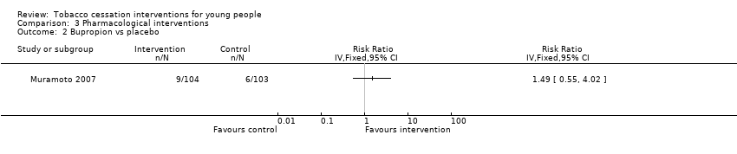
Figure 44: Results of smoking cessation in adolescents in Fanshawe et al. (2017), bupropion versus placebo
Source: Fanshawe et al. (2017)
Abbreviations: CI = confidence interval
Myung et al. (2019) identified a further three RCTs that measured the impact of bupropion on smoking cessation outcomes at follow-ups of less than 6 months. One of the studies included Killen (2014) which evaluated bupropion in combination with NRT compared with placebo in combination with NRT. Based on the meta-analysis conducted by Myung et al. (2019), bupropion was shown to significantly improve smoking cessation rates compared with placebo (RR: 2.03; 95% CI: 1.09, 3.77). However, two of the additional studies included in the meta-analysis by Myung et al. (2019) were found to have substantially influenced the pooled estimate. The smoking cessation outcomes in these studies were measured at 3 months with a relatively small sample size and very wide confidence intervals (Gray 2011: RR: 2.51, 95% CI: 0.52, 11.97; Niederhofer 2004: RR: 3.00. 95% CI: 0.77, 11.74). Further, the study by Niederhofer et al. (2004) used a lower dose of bupropion (150 mg/day).
Selph et al. (2019) concluded that there was an absence of benefit of bupropion on smoking cessation in adolescents compared with placebo based on one RCT (Muramoto 2007) which was included in Fanshawe et al. (2017) and Myung et al. (2019).
Safety
Fanshawe et al. (2017) provided a narrative summary of adverse events based on the study by Muramoto et al. (2007). The Cochrane Review authors stated that a large number of patients in both treatment arms reported adverse events which include headache, cough, throat symptoms, sleep disturbance and nausea. Additionally, treatment discontinuation due to adverse events was reported by eight patients in the bupropion arm and a further two patients in the same arm experienced serious adverse events which led to hospitalisation: one patient was admitted for anticholinergic crisis after ingesting Datura innoxia and one patient intentionally overdosed on study medication and other substances.
Myung et al. (2019) reported the following common adverse events were related to the use of bupropion: headache, irritability, insomnia and dream disturbances. The authors noted that there were no significant differences between the intervention and control groups, except for dream disturbances in Gray et al. (2011).
Selph et al. (2019) stated that there were no increases in body mass index with the use of bupropion, either among those who achieved smoking abstinence or not, based on the study by Muramoto et al. (2007). Additionally, Selph et al. (2019) highlighted the association of bupropion with abnormal dreams based on the study by Gray et al. (2011), however the results should be interpreted with caution due to the wide confidence interval (RR: 15.92; 95% CI: 0.95, 268).
Bupropion plus NRT patch versus placebo plus NRT patch
Efficacy
A summary of the smoking cessation rates at the longest follow-up comparing bupropion plus NRT patch with placebo plus NRT patch is presented in Table 134. Based on the Cochrane Review by Fanshawe et al. (2017), the results of the one RCT (Killen et al. 2004) demonstrated no statistically significant difference in smoking cessation rates between the two treatment arms, although the results numerically favoured bupropion plus NRT patch. The wide confidence intervals and small number of events in both arms suggest that the study was underpowered to detect any differences.
Table 134: Results of smoking cessation in adolescents in Fanshawe et al. (2017), bupropion + NRT patch versus placebo + NRT patch
Study | Study Type | Bupropion + NRT patch | Placebo + NRT patch | RR (95%CI)¹
Fanshawe  (2017) | Cochrane Review (1 RCT) | 8/103  (7.8%) | 8/108  (7.4%) | 1.05  (0.41, 2.69)
Source: Fanshawe et al. (2017)
Abbreviations: CI = confidence interval; NRT = nicotine replacement therapy; RCT = randomised controlled trial; RR = risk ratio
Notes: Bold indicates statistically significant difference.
1 Calculated by Cochrane Review authors using a fixed-effect model.
The results of the study included in Fanshawe et al. (2017) are presented using a forest plot in Figure 45.
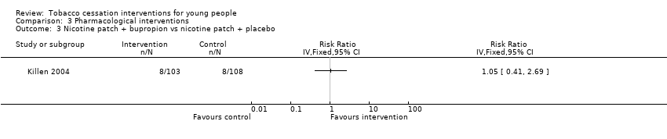
Figure 45: Results of smoking cessation in adolescents in Fanshawe et al. (2017), bupropion + NRT patch versus placebo + NRT patch
Source: Fanshawe et al. (2017)
Abbreviations: CI = confidence interval
No other studies comparing bupropion plus NRT patch versus placebo plus NRT patch were identified by Myung et al. (2019) or Selph et al. (2019).
Safety
Fanshawe et al. (2017) provided a narrative summary of adverse events based on the study by Killen et al. (2004). The Cochrane Review authors stated that none of the 47 self-reported adverse events in the study (nausea being the most common) were classified as severe. Neither Myung et al. (2019) nor Selph et al. (2019) provided any further safety information.

Summary of evidence for use in populations who have specific needs
Pregnancy and lactation
Based on the evidence presented (Claire et al. 2020), NRT was shown to provide a statistically significant improvement in smoking cessation rates (self-reported abstinence from smoking at the latest time point in pregnancy; biochemically validated where available) compared with placebo/control, noting the results were statistically significant in the long-acting NRT subgroup but not the fast-acting NRT subgroup which had fewer studies and participants included in the analysis. In terms of safety, there were no statistically significant differences in rates of preterm births, neonatal intensive care unit admissions, neonatal deaths, congenital abnormalities, caesarean birth, mean birthweight and risk of miscarriage/spontaneous abortion between the two treatment arms.
For the comparison of bupropion versus placebo, there were no statistically significant difference in smoking cessation rates, mean birthweight, mean length of infants and systolic of diastolic blood pressure at the end of pregnancy between the two treatment arms, noting the relatively small sample size. It was noted that women across all studies reported known adverse effects of bupropion (i.e. vomiting, headache, difficulty sleeping).
Adolescents
Studies which assessed the use of pharmacotherapy for smoking cessation in adolescents may be underpowered given the small number of individuals in both the intervention or control groups who achieved smoking cessation at any point during follow-up. As such, the results from these studies should be interpreted with caution.
Based on the evidence presented (Fanshawe et al. 2017, Myung et al. 2019, Selph et al. 2019), there were no statistically significant differences in smoking cessation rates (short-term and long-term) between NRT (patch, gum, nasal spray) and placebo. In terms of safety, the studies reported a significantly higher incidence of adverse events in the NRT arm compared to placebo arm, specifically sore throat, hiccups, erythema, pruritus, shoulder/arm pain, headache, cough, abnormal dreams, and muscle pain.
For the comparison of bupropion versus placebo, there were no statistically significant differences in long-term smoking cessation rates between the two treatment arms based on the one study (Muramoto et al. 2007) identified by Fanshawe et al. (2017). However, bupropion was shown to significantly improve smoking cessation rates compared with placebo based on the meta-analysis conducted by Myung et al. (2019), noting that the two additional studies included in the meta-analysis measured smoking cessation outcomes at 3 months, had a relatively small sample size and wide confidence intervals. For safety, there were no significant differences in common adverse events between bupropion and placebo (i.e. headache, irritability, insomnia), except for dream disturbances which was significantly higher in the bupropion arm (Fanshawe et al. 2017, Myung et al. 2019, Selph et al. 2019).
For the comparison of bupropion plus NRT patch versus placebo plus NRT patch, there were no statistically significant differences in long-term smoking cessation rates between the two treatment arms based on the one study (Killen 2004) identified by Fanshawe et al. (2017). For safety, Fanshawe et al. (2017) stated that none of the 47 self-reported adverse events in the study (nausea being the most common) were classified as severe; no statistical comparison was conducted by the authors of the study.

References
''''''''''''' ''''''' '''''''''' ''''''' ''''''''''''' '''''' '''' '''' ''' ''''''''''''''''''''''' '''' ''''''''''''''''''''''''''''' '''''''''''''''''' ''''''' '''''''''''''' '''''' '''''''''''''''' ''''''''''''''''''' '''' ''''''''' '' '''''''' '''''''''' ''''''''''''''''' '''''''''''''''''''''
'''''''''''''''''' ''''''' ''''''''''''''''' '''' ''''''''''' ''''''' '''' '''' ''' '''''''''''''''''' ''''''' '''' ''''''''''''''''''''''''''''' '''''''''''''''''''' ''' ''''''''''''''' ''''''''''' ''''' '''''''''' '''''' ''''''''''''''' '''''''''''''''''' ''' '''''''' '' ''''''''' ''''''''''' '''''''''''''' '''''''''''''''
3. Howes S, Hartmann‐Boyce J, Livingstone‐Banks J, Hong B, Lindson N. Antidepressants for smoking cessation. Cochrane Database of Systematic Reviews 2020; (4).
4. Benowitz NL, Pipe A, West R, et al. Cardiovascular Safety of Varenicline, Bupropion, and Nicotine Patch in Smokers: a Randomized Clinical Trial. JAMA internal medicine 2018; 178(5): 622‐31.
5. Gorecka D, Bednarek M, Nowinski A, Puscinska E, Goljan-Geremek A, Zielinski J. [Effect of treatment for nicotine dependence in patients with COPD]. Pneumonol Alergol Pol 2003; 71(9-10): 411-7.
6. Uyar M, Filiz A, Bayram N, et al. A randomized trial of smoking cessation. Medication versus motivation. Saudi Med J 2007; 28(6): 922-6.
7. Piper ME, Smith SS, Schlam TR, et al. A randomized placebo-controlled clinical trial of 5 smoking cessation pharmacotherapies. Arch Gen Psychiatry 2009; 66(11): 1253-62.
8. Gonzales D, Rennard SI, Nides M, et al. Varenicline, an alpha4beta2 nicotinic acetylcholine receptor partial agonist, vs sustained-release bupropion and placebo for smoking cessation: a randomized controlled trial. JAMA 2006; 296(1): 47-55.
9. Jorenby DE, Hays JT, Rigotti NA, et al. Efficacy of varenicline, an alpha4beta2 nicotinic acetylcholine receptor partial agonist, vs placebo or sustained-release bupropion for smoking cessation: a randomized controlled trial. JAMA 2006; 296(1): 56-63.
10. Oncken C, Gonzales D, Nides M, et al. Efficacy and safety of the novel selective nicotinic acetylcholine receptor partial agonist, varenicline, for smoking cessation. Arch Intern Med 2006; 166(15): 1571-7.
11. Nakamura M, Oshima A, Fujimoto Y, Maruyama N, Ishibashi T, Reeves KR. Efficacy and tolerability of varenicline, an alpha4beta2 nicotinic acetylcholine receptor partial agonist, in a 12-week, randomized, placebo-controlled, dose-response study with 40-week follow-up for smoking cessation in Japanese smokers. Clin Ther 2007; 29(6): 1040-56.
12. Tsai ST, Cho HJ, Cheng HS, et al. A randomized, placebo-controlled trial of varenicline, a selective alpha4beta2 nicotinic acetylcholine receptor partial agonist, as a new therapy for smoking cessation in Asian smokers. Clin Ther 2007; 29(6): 1027-39.
13. Wang C, Xiao D, Chan KP, Pothirat C, Garza D, Davies S. Varenicline for smoking cessation: a placebo-controlled, randomized study. Respirology 2009; 14(3): 384-92.
14. Bolliger CT, Issa JS, Posadas-Valay R, et al. Effects of varenicline in adult smokers: a multinational, 24-week, randomized, double-blind, placebo-controlled study. Clin Ther 2011; 33(4): 465-77.
15. Rigotti NA, Pipe AL, Benowitz NL, Arteaga C, Garza D, Tonstad S. Efficacy and safety of varenicline for smoking cessation in patients with cardiovascular disease: a randomized trial. Circulation 2010; 121(2): 221-9.
16. Tashkin DP, Rennard S, Hays JT, Ma W, Lawrence D, Lee TC. Effects of varenicline on smoking cessation in patients with mild to moderate COPD: a randomized controlled trial. Chest 2011; 139(3): 591-9.
17. Rennard S, Hughes J, Cinciripini PM, et al. A randomized placebo-controlled trial of varenicline for smoking cessation allowing flexible quit dates. Nicotine Tob Res 2012; 14(3): 343-50.
18. Anthenelli RM, Benowitz NL, West R, et al. Neuropsychiatric safety and efficacy of varenicline, bupropion, and nicotine patch in smokers with and without psychiatric disorders (EAGLES): a double-blind, randomised, placebo-controlled clinical trial. Lancet 2016; 387(10037): 2507-20.
19. Cahill K, Lindson-Hawley N, Thomas KH, Fanshawe TR, Lancaster T. Nicotine receptor partial agonists for smoking cessation. Cochrane Database of Systematic Reviews 2016; (5): CD006103.
20. Lerman C, Schnoll RA, Hawk LW, et al. Use of the nicotine metabolite ratio as a genetically informed biomarker of response to nicotine patch or varenicline for smoking cessation: a randomised, double-blind placebo-controlled trial. The lancet Respiratory medicine 2015; 3(2): 131‐8.
21. Littlewood RA, Claus ED, Wilcox CE, et al. Moderators of smoking cessation outcomes in a randomized-controlled trial of varenicline versus placebo. Psychopharmacology 2017; 234(23‐24): 3417‐29.
22. Hurt RT, Ebbert JO, Croghan IT, Schroeder DR, Hurt RD, Hays JT. Varenicline for tobacco-dependence treatment in alcohol-dependent smokers: a randomized controlled trial. Drug and alcohol dependence 2018; 184: 12‐7.
23. Mercie P, Arsandaux J, Katlama C, et al. Efficacy and safety of varenicline for smoking cessation in people living with HIV in France (ANRS 144 Inter-ACTIV): a randomised controlled phase 3 clinical trial. Lancet HIV 2018; 5(3): e126-e35.
24. Windle SB, Dehghani P, Roy N, et al. Smoking abstinence 1 year after acute coronary syndrome: follow-up from a randomized controlled trial of varenicline in patients admitted to hospital. CMAJ : Canadian Medical Association journal 2018; 190(12): E347‐E54.
25. Ashare RL, Thompson M, Serrano K, et al. Placebo-controlled randomized clinical trial testing the efficacy and safety of varenicline for smokers with HIV. Drug & Alcohol Dependence 2019; 200: 26-33.
26. Chen LS, Baker TB, Miller JP, et al. Genetic Variant in CHRNA5 and Response to Varenicline and Combination Nicotine Replacement in a Randomized Placebo-Controlled Trial. Clinical Pharmacology and Therapeutics 2020.
''''''''''''''''''''''' '''' '''''''''''''' ''' ''''''''''''''''''''''' '''' '''' ''''' '''''''''''' '''''''''''' '''''''''''''' ''''''''''''' ''''''''''''''' '''''''''''''''' ''''''''''''''''' ''''''''''''''''' ''''''''''' ''''''''''''' ''''''''' ''''''' '''''''''''''''' ''''''''''''' '''''''' '''''''''''''''''''''''''' ''''''''''''''''''' ''''''''''''''''''''''''' '''''''''''''''''''''' ''''''''''''''''' '''''''''''''''''''''' ''''''''''''''' '''''''' ''''''''''''' '' '''''''''' '''''''''''' ''''''''''''''
''''''''''''''' ''' '''''''''''''''' '''' '''''''''' ''''' ''''''''' '''' '''''''''''' '''' '''''''''''''' '''''''''''''''''''''' '''''''''''''''' '''''' '''''''''''''''' ''''''''''''''''''' '''''''''''''''' ''''''''''''''''''' '''' '''''''''''''''''''' ''''''''''''''' ''''''''''' '''''''
29. Stead LF, Perera R, Bullen C, Mant D, Lancaster T. Nicotine replacement therapy for smoking cessation. Cochrane Database of Systematic Reviews 2008; (1).
30. Hartmann-Boyce J, Chepkin SC, Ye W, Bullen C, Lancaster T. Nicotine replacement therapy versus control for smoking cessation. Cochrane Database Syst Rev 2018; 5: CD000146.
31. Aubin HJ, Bobak A, Britton JR, et al. Varenicline versus transdermal nicotine patch for smoking cessation: results from a randomised open-label trial. Thorax 2008; 63(8): 717-24.
32. Tulloch HE, Pipe AL, Els C, Clyde MJ, Reid RD. Flexible, dual-form nicotine replacement therapy or varenicline in comparison with nicotine patch for smoking cessation: A randomized controlled trial. BMC Medicine 2016; 14(1).
33. Rohsenow DJ, Tidey JW, Martin RA, et al. Varenicline versus nicotine patch with brief advice for smokers with substance use disorders with or without depression: effects on smoking, substance use and depressive symptoms. Addiction (Abingdon, England) 2017; 112(10): 1808-20.
34. Moolchan ET, Robinson ML, Ernst M, et al. Safety and efficacy of the nicotine patch and gum for the treatment of adolescent tobacco addiction. Pediatrics 2005; 115(4): e407-14.
35. Smith SS, McCarthy DE, Japuntich SJ, et al. Comparative effectiveness of 5 smoking cessation pharmacotherapies in primary care clinics. Arch Intern Med 2009; 169(22): 2148-55.
36. Schnoll RA, Martinez E, Tatum KL, et al. Nicotine patch vs. nicotine lozenge for smoking cessation: an effectiveness trial coordinated by the Community Clinical Oncology Program. Drug Alcohol Depend 2010; 107(2-3): 237-43.
37. Stead LF, Perera R, Bullen C, et al. Nicotine replacement therapy for smoking cessation. Cochrane Database of Systematic Reviews 2012; (11).
38. Lindson N, Chepkin SC, Ye W, Fanshawe TR, Bullen C, Hartmann‐Boyce J. Different doses, durations and modes of delivery of nicotine replacement therapy for smoking cessation. Cochrane Database of Systematic Reviews 2019; (4).
39. Tonstad S, Tonnesen P, Hajek P, et al. Effect of maintenance therapy with varenicline on smoking cessation: a randomized controlled trial. JAMA 2006; 296(1): 64-71.
40. Livingstone-Banks J, Norris E, Hartmann-Boyce J, et al. Relapse prevention interventions for smoking cessation. Cochrane Database Syst Rev 2019; 2019(10).
41. Schnoll R, Leone F, Veluz-Wilkins A, et al. A randomized controlled trial of 24 weeks of varenicline for tobacco use among cancer patients: Efficacy, safety, and adherence. Psycho-Oncology 2019; 28(3): 561-9.
42. Gonzales D, Hajek P, Pliamm L, et al. Retreatment with varenicline for smoking cessation in smokers who have previously taken varenicline: a randomized, placebo-controlled trial. Clin Pharmacol Ther 2014; 96(3): 390-6.
43. Gonzales DH, Nides MA, Ferry LH, et al. Bupropion SR as an aid to smoking cessation in smokers treated previously with bupropion: a randomized placebo‐controlled study. Clinical Pharmacology & Therapeutics 2001; 69(6): 438-44.
44. Selby P, Ainslie M, Stepner N, Roberts J. Sustained‐release bupropion (Zybanr) is effective in the re‐treatment of relapsed adult smokers. American Journal of Respiratory and Critical Care Medicine 2003; 167(7): A47.
45. Gourlay SG, Forbes A, Marriner T, Pethica D, McNeil JJ. Double blind trial of repeated treatment with transdermal nicotine for relapsed smokers. BMJ 1995; 311(7001): 363-6.
46. Chen LS, Baker TB, Miller JP, et al. Genetic Variant in CHRNA5 and Response to Varenicline and Combination Nicotine Replacement in a Randomized Placebo-Controlled Trial. Clin Pharmacol Ther 2020.
47. Leung MKW, Bai D, Yip BHK, et al. Combined nicotine patch with gum versus nicotine patch alone in smoking cessation in Hong Kong primary care clinics: a randomised controlled trial. BMC public health 2019; 19(1): 1302.
48. Cahill K, Stevens S, Perera R, Lancaster T. Pharmacological interventions for smoking cessation: an overview and network meta-analysis. The Cochrane database of systematic reviews 2013; 5: CD009329.
49. Chang PH, Chiang CH, Ho WC, Wu PZ, Tsai JS, Guo FR. Combination therapy of varenicline with nicotine replacement therapy is better than varenicline alone: a systematic review and meta-analysis of randomized controlled trials. BMC Public Health 2015; 15: 689.
50. Lindson N, Klemperer E, Hong B, Ordonez-Mena JM, Aveyard P. Smoking reduction interventions for smoking cessation. Cochrane Database Syst Rev 2019; 9: CD013183.
51. Ellerbeck EF, Nollen N, Hutcheson TD, et al. Effect of Long-term Nicotine Replacement Therapy vs Standard Smoking Cessation for Smokers With Chronic Lung Disease: A Randomized Clinical Trial. JAMA Netw Open 2018; 1(5): e181843.
52. Dedert EA, Dennis PA, Calhoun PS, Dennis MF, Beckham JC. A Randomized Clinical Trial of Nicotine Preloading for Smoking Cessation in People with Posttraumatic Stress Disorder. J Dual Diagn 2018; 14(3): 148-57.
53. Oncken C, Dornelas EA, Kuo CL, et al. Randomized Trial of Nicotine Inhaler for Pregnant Smokers. Am J Obstet Gynecol MFM 2019; 1(1): 10-8.
54. Nides M, Danielsson T, Saunders F, et al. Efficacy and Safety of a Nicotine Mouth Spray for Smoking Cessation: A Randomized, Multicenter, Controlled Study in a Naturalistic Setting. Nicotine Tob Res 2020; 22(3): 339-45.
55. Lancaster T, Stead LF. Individual behavioural counselling for smoking cessation. Cochrane Database Syst Rev 2017; 3: CD001292.
56. Stead LF, Carroll AJ, Lancaster T. Group behaviour therapy programmes for smoking cessation. Cochrane Database Syst Rev 2017; 3: CD001007.
57. Carson-Chahhoud KV, Livingstone-Banks J, Sharrad KJ, et al. Community pharmacy personnel interventions for smoking cessation. Cochrane Database Syst Rev 2019; 2019(10).
58. Hartmann-Boyce J, Hong B, Livingstone-Banks J, Wheat H, Fanshawe TR. Additional behavioural support as an adjunct to pharmacotherapy for smoking cessation. Cochrane Database Syst Rev 2019; 6: CD009670.
59. Livingstone-Banks J, Ordonez-Mena JM, Hartmann-Boyce J. Print-based self-help interventions for smoking cessation. Cochrane Database Syst Rev 2019; 1: CD001118.
60. Matkin W, Ordonez-Mena JM, Hartmann-Boyce J. Telephone counselling for smoking cessation. Cochrane Database Syst Rev 2019; 5: CD002850.
61. Claire R, Chamberlain C, Davey MA, et al. Pharmacological interventions for promoting smoking cessation during pregnancy. Cochrane Database Syst Rev 2020; 3: CD010078.
62. Fanshawe TR, Halliwell W, Lindson N, Aveyard P, Livingstone-Banks J, Hartmann-Boyce J. Tobacco cessation interventions for young people. Cochrane Database Syst Rev 2017; 11: CD003289.
63. Myung SK, Park JY. Efficacy of Pharmacotherapy for Smoking Cessation in Adolescent Smokers: A Meta-analysis of Randomized Controlled Trials. Nicotine Tob Res 2019; 21(11): 1473-9.
64. Selph S, Patnode C, Bailey SR, Pappas M, Stoner R, Chou R. Primary Care-Relevant Interventions for Tobacco and Nicotine Use Prevention and Cessation in Children and Adolescents: Updated Evidence Report and Systematic Review for the US Preventive Services Task Force. JAMA 2020; 323(16): 1599-608.

Appendix

A Methodology and identification of relevant studies

A.1 Key outcomes previously considered by the PBAC
Table 135: Key outcomes previously considered by the PBAC
PBAC meeting | Drug | Comparison | Key outcomes¹
Jul 2007 | VAR | VAR versus BUP | Primary: 4-week continuous quit rate week 9-12  Secondary: continuous abstinence week 9-52, safety including discontinuation due to AE
Nov 2009 | VAR | VAR versus PBO | Primary: continuous abstinence week 13-24  Secondary: continuous abstinence week 13-52, safety
Mar 2010 | NRT | NRT versus VAR,  NRT versus BUP | Primary: 4-week continuous abstinence week 9-12  Secondary: continuous abstinence at 24 weeks and at 52 weeks, measures of craving, withdrawal and smoking cessation
Nov 2012 | VAR | VAR versus PBO,  VAR versus BUP/PBO,  VAR versus NRT | Primary: continuous abstinence week 9-52  Secondary: safety
Mar 2014 | VAR | VAR versus PBO,  VAR versus BUP/PBO | Primary: continuous quit rate week 9-12  Secondary: continuous abstinence rate week 9-24 and week 9-52, safety
Nov 2016 | VAR | VAR versus BUP/PBO/NRT | Primary: continuous abstinence from smoking week 9-24 (stratified based on psychiatric history)  Secondary: neuropsychiatric adverse events (stratified based on psychiatric history)
Jul 2017 | NRT | NRT lozenge versus patch, NRT gum versus patch | Primary: sustained abstinence (six-month)  Secondary: nausea/vomiting, sleep problems, skin reaction, oral reaction, hiccups
Nov 2017 | VAR | Not applicable | Not applicable – clinical criteria amendment
Mar 2018 | NRT | Unchanged from Jul 17 | Unchanged from Jul 17
Abbreviations: BUP = bupropion; NRT = nicotine replacement therapy; PBO = placebo; VAR = varenicline
Note: Compiled during the review using public summary documents available since July 2005. Bupropion was considered prior to this date.
1 The PBAC has previously considered continuous abstinence rate to be the most relevant patient outcome.

A.2 Search Strategy
Table 136: Search Strategy, Search date: 22/7/2020
Ovid MEDLINE (R) and In-Process & Other Non-Indexed Citations and Daily
 | Search ID | Search Terms
Patient, Population, Problem terms | S1 | smoking cessation/
 | S2 | "tobacco use cessation"/
 | S3 | smoking/dt [drug therapy]
 | S4 | smoking/th [therapy]
 | S5 | exp tobacco smoking/dt [drug therapy]
 | S6 | exp tobacco smoking/th [therapy]
 | S7 | S1 or S2 or S3 or S4 or S5 or S6
Intervention – Varenicline terms | S8 | varenicline/
 | S9 | (varenicline or champix* or chantix* or cp 526555-18 or unii-82269asb48).tw,kf.
Intervention – Bupropion terms | S10 | amfebutamone.mp. or bupropion/
 | S11 | (bupropion* or wellbutrin or zyban or zyntabac* or 249296-44-4).tw,kf.
 | S12 | S8 or S9 or S10 or S11
Comparator – Nicotine Replacement Therapy (NRT) | S13 | "tobacco use cessation products".mp. or "tobacco use cessation devices"/
 | S14 | (nicotine adj2 replac*).tw,kf.
 | S15 | (nicotine adj3 (gum* or lozenge* or patch* or tablet* or transdermal* or inhaler* or spray*)).tw,kf.
 | S16 | (nrt adj3 (gum* or lozenge* or tablet* or patch* or transdermal* or inhaler* or spray*)).tw,kf.
 | S17 | S13 or S14 or S15 or S16
Comparator – Behavioural interventions for smoking cessation | S18 | behavior therapy/ or cognitive behavioral therapy/ or "acceptance and commitment therapy"/ or relaxation therapy/ or meditation/ or motivational interviewing/ or residential treatment/ or peer group/ or mindfulness/ or counseling/
 | S19 | ((behavio?r therapy or cognitive behavio?al therapy or "acceptance and commitment therapy" or relaxation therapy or meditation or motivational interview* or mindful* or positive psychotherapy or peer support program* or residential treat* or counsel*).kw,ti,ab
 | S20 | 18 or 19
 | S21 | S12 OR S17 OR (S20 AND S12) OR (S20 AND S17)
 | S22 | S7 and S26
Limit to systematic review/meta-analysis | S23 | "Systematic Review"/
 | S24 | Meta-Analysis/
 | S25 | (systematic review or meta?analysis).ti,ab.
 | S26 | S23 or S24 or S25
 | S27 | S22 and S26

A.3 PRISMA flow diagram
Figure 46: PRISMA diagram for the primary literature search
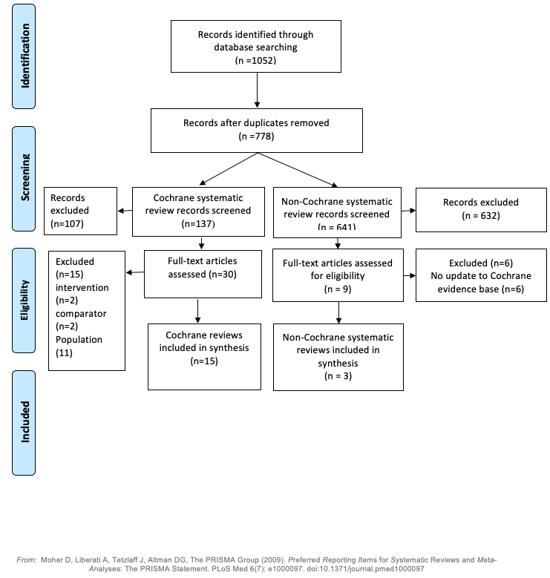

Figure 47: PRISMA diagram for the supplemental literature search
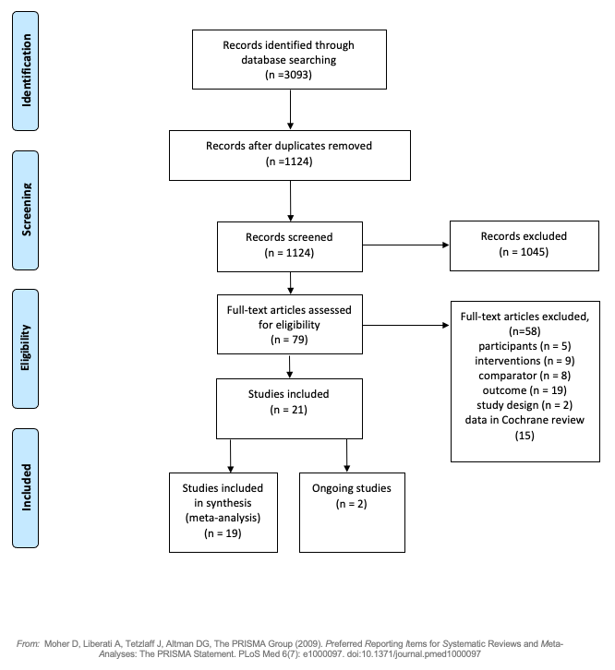

A.4 Characteristics of Cochrane systematic reviews
Table 137: Characteristics of Cochrane systematic reviews included in qualitative synthesis (n=15)
No | Author (year) | Aim | Type of studies and participants | Interventions /  comparisons | Types of outcome measures |  |  | Analysis | Number studies | Total participants (n)
 |  |  |  |  | Primary outcomes | Secondary outcomes | Harmful outcomes
 | Howes 2020 | To assess the efficacy, safety and tolerability of medications with antidepressant properties in assisting long-term tobacco smoking cessation in people who smoke cigarettes | RCTs and cluster-RCTs  Tobacco smokers | Pharmacotherapies with antidepressant, behavioural strategies  Placebo, no pharmacotherapy, alternative therapeutic control, or different dosages. | Smoking cessation rates at least six months after baseline | N/A | Adverse events (AEs) of any severity  Psychiatric AEs  Serious adverse events (SAEs) | Meta-analysis | 115 | BUP versus PBO = 40,831;  BUP + NRT versus NRT = 4,632;  BUP + VAR versus VAR = 3,381
 | Claire 2020 | Determine the efficacy and safety of smoking cessation pharmacotherapies and ECs used during pregnancy for smoking cessation in later pregnancy and after childbirth. Determine adherence to smoking cessation pharmacotherapies and ECs for smoking cessation during pregnancy | Parallel- or cluster-RCTs  Pregnant smokers | NRT and BUP  Placebo, no smoking, other pharmacotherapy | Prolonged or continuous abstinence measures | N/A | Safety  Non-SAEs  Any reported long-term effects of smoking cessation pharmacotherapies on safety | Meta-analysis | 11 | 2412
 | Matkin 2019 | Evaluate the effect of telephone support to help smokers quit, including proactive or reactive counselling, or the provision of other information to smokers calling a helpline | RCTs or quasi-RCTs  Adult smokers from the general population  Individuals who were current smokers | Behavioural interventions, pharmacotherapy | Long-term smoking cessation | N/A | N/A | Meta-analysis | 104 | 111,653
 | Livingstone-Banks 2019a | To assess whether specific interventions for relapse prevention reduce the proportion of recent quitters who return to smoking | RCTs or quasi-RCTs  People who had quit smoking on their own  People who were undergoing enforced abstinence  Smokers participating in treatment programmes to assist initial cessation | Extended use of smoking cessation medications, behavioural support/no intervention, shorter intervention or an intervention not oriented towards relapse prevention | Prolonged or multiple point prevalence abstinence  Reported only point prevalence abstinence | N/A | N/A | Meta-analysis | 81 | 69,094
 | Livingstone-Banks 2019b | The aims of this review were to determine the effectiveness of different forms of print-based self-help materials that provide a structured programme for smokers to follow, compared with no treatment and with other minimal contact strategies, and to determine the comparative effectiveness of different components and characteristics of print-based self-help, such as computer-generated feedback, additional materials, tailoring of materials to individuals, and targeting of materials at specific groups | RCTs  Any smoker | Print-based self-help materials/no treatment and with other minimal contact strategies | Sustained abstinence, or point prevalence  Self‐report of cessation alone or biochemically validated cessation | N/A | N/A | Meta-analysis | 75 | Not mentioned
 | Lindson 2019a | To determine the effectiveness and safety of different forms, deliveries, doses, durations and schedules of NRT, for achieving long-term smoking cessation, compared to one another | RCTs  People of any age who smoked and were motivated to quit | Any form, dose, duration, schedule of NRT use/any other form(s), dose(s), duration(s), schedule(s) of NRT use | Smoking cessation  AEs and SAEs). | N/A | N/A | Meta-analysis | 63 | 41,509
 | Lindson 2019b | To assess the effect of reduction-to-quit interventions on long-term smoking cessation | RCTs  Cigarette smokers of any age | NRT, VAR, and behavioural interventions/no smoking cessation, treatment or advice | Smoking abstinence at long-term follow-up | Reduction in smoking behaviour  Proportion of participants who made a quit attempt  AEs | N/A | Meta-analysis | 51 | 22,509
 | Hartmann-Boyce 2019 | To evaluate the effect of adding or increasing the intensity of behavioural support for people using smoking cessation medications, and to assess whether there are different effects depending on the type of pharmacotherapy, or the amount of support in each condition.  We also looked at studies which directly compare behavioural interventions matched for contact time, where pharmacotherapy is provided to both groups (e.g. tests of different components or approaches to behavioural support as an adjunct to pharmacotherapy) | RCTs, including cluster-RCTs  People who smoke | NRT, BUP, VAR, or nortriptyline and behavioural support/NA | Smoking cessation | N/A | N/A | Meta-analysis | 83 | 29,536
 | Carson-Chahhoud 2019 | To assess the effectiveness of interventions delivered by community pharmacy personnel to assist people to stop smoking, with or without concurrent use of pharmacotherapy | RCTs, including cluster-RCTs  Community pharmacy clients who were current tobacco smokers and motivated to change their smoking behaviour | Behavioural interventions provided by community pharmacy personnel/no or less intensive behavioural support. | Abstinence from smoking | Cost-effectiveness | AEs | Meta-analysis | 7 | 1,774
 | Hartmann-Boyce 2018 | To determine the effectiveness and safety of nicotine replacement therapy (NRT), including gum, transdermal patch, intranasal spray and inhaled and oral preparations, for achieving long-term smoking cessation, compared to placebo or 'no NRT' interventions | RCTs  Men or women who smoked and were motivated to quit | NRT/placebo or no NRT | Smoking cessation | N/A | AEs | Meta-analysis | 134 | 64,640
 | Stead 2017 | To determine the effect of group-delivered behavioural interventions in achieving long-term smoking cessation | RCTs  Trials that compared more than one group programme  Trials with a minimum of two group meetings, and follow-up of smoking status at least six months  Adult smokers of either gender | Group therapy and pharmacotherapy/self-help programmes, other less intensive interventions, pharmacotherapy alone, individual counselling sessions, no intervention | Abstinence from cigarettes | N/A | N/A | Meta-analysis | Group programme compared to self-help programme = 13;  Group programme compared to brief support = 16;  Group programme compared to face-to-face in- dividual intervention = 6;  Group programme plus pharmacotherapy versus pharmacotherapy and brief support alone = 5;  Group programme versus 'no intervention' controls = 9 | Group programme compared to self-help programme =4395;  Group programme compared to brief support: 7601;  Group programme compared to face-to-face in- dividual intervention: 980;  Group programme plus pharmacotherapy versus pharmacotherapy and brief support alone: 1523;  Group programme versus 'no intervention' controls = 1098
 | Lancaster 2017 | The review addresses the following hypotheses:  Individual counselling is more effective than no treatment or brief advice in promoting smoking cessation;  Individual counselling is more effective than self-help materials in promoting smoking cessation; and  A more intensive counselling intervention is more effective than a less intensive intervention | RCTs or quasi-RCTs with a minimum follow-up of six months  Any smokers | Individual counselling/no treatment or brief advice or self-help materials or less intensive intervention | Smoking cessation at the longest reported follow-up | N/A | N/A | Meta-analysis | 49 | 19,000
 | Fanshawe 2017 | To evaluate the effectiveness of strategies that help young people to stop smoking tobacco | RCTs  Young people, aged under 20 years, who were regular, current tobacco smokers | NRT, BUP, nicotine patch + BUP, individual counselling, group counselling, computer-based interventions/  Placebo | Change in smoking behaviour (being a smoker at baseline and becoming an ex-smoker at follow- up) at six months' follow-up or longer | N/A | N/A | Meta-analysis | 41 | Around 13,000
 | Cahill 2016 | To review the efficacy of nicotine receptor partial agonists, including varenicline and cytisine, for smoking cessation | RCTs  Adult smokers | Selective nicotine receptor partial agonists  Placebo, NRT, both NRT and placebo, quitline counselling alone | A minimum of six months abstinence is the primary outcome measure. | N/A | Adverse event: nausea, insomnia, abnormal dreams, headache, depression, suicidal ideation;  Serious adverse events: neuropsychiatric SAEs (not deaths), Cardiac SAEs, including deaths | Meta-analysis | 44 trials | Not mentioned
 | Cahill 2013 | To conduct an overview of Cochrane reviews which assess the efficacy and safety of pharmacological interventions designed to support smoking cessation attempts | RCTs  Post-marketing surveillance data where these are available and appropriate  Adult smokers, of either gender, and of any nationality and ethnicity | NRT, antidepressants (bupropion and nortriptyline), nicotine receptor partial agonists (varenicline and cytisine), anxiolytics, selective type 1 cannabinoid receptor antagonists (rimonabant), clonidine, lobeline, dianicline, mecamylamine, Nicobrevin, opioid antagonists, nicotine vaccines, and silver acetate. These interventions may be delivered as monotherapies or in combination.  Placebo, other pharmacological treatments or combinations of treatments, and usual or standard care. | Sustained smoking cessation, i.e. for six months or longer. | Reduction of withdrawal symptoms and reduction of craving | N/A | Network meta-analysis | 24 | 101,804
Abbreviations: AE = adverse event; BUP = bupropion; COPD = chronic obstructive pulmonary disease; EC = e-cigarette; NRT = nicotine replacement therapy; PBO = placebo; PLWHA = people living with HIV/AIDS; QoL = quality of life; RCT = randomised controlled trial; SAE = serious adverse event; SNP = single-nucleotide polymorphisms VAR = varenicline.

A.5 Risk of bias assessment for included Cochrane reviews
Table 138: Quality assessment for Cochrane Reviews using AMSTAR 2 (1 of 2)
 | Assessment criteria | Howes 2020 | Claire 2020 | Matkin 2019 | Livingstone-Banks 2019a | Livingstone-Banks 2019b | Lindson 2019a | Lindson 2019b | Hartmann-Boyce 2019
1 | Did the research questions and inclusion criteria for the review include the components of PICO? | Yes | Yes | Yes | Yes | Yes | Yes | Yes | Yes
2 | Did the report of the review contain an explicit statement that the review methods were established prior to the conduct of the review and did the report justify any significant deviations from the protocol? | Yes | Yes | Yes | Yes | Yes | Yes | Yes | Yes
3 | Did the review authors perform study selection in duplicate? | Yes | Yes | Yes | Yes | Yes | Yes | Yes | Yes
4 | Did the review authors use a comprehensive literature search strategy? | Yes | Yes | Partial  yes | Yes | Yes | Yes | Yes | Yes
5 | Did the review authors perform study selection in duplicate? | Yes | Yes | No | Yes | Yes | Yes | Yes | Yes
6 | Did the review authors perform data extraction in duplicate? | Yes | Yes | Yes | Yes | Yes | Yes | Yes | Yes
7 | Did the review authors provide a list of excluded studies and justify the exclusions? | Yes | Yes | Yes | Yes | Yes | Yes | Yes | Yes
8 | Did the review authors describe the included studies in adequate detail? | Yes | Yes | Yes | Yes | Yes | Yes | Yes | Yes
9 | Did the review authors use a satisfactory technique for assessing the risk of bias (RoB) in individual studies that were included in the review? | Yes | Yes | Yes | Yes | Yes | Yes | Yes | Yes
10 | Did the review authors report on the sources of funding for the studies included in the review? | Yes | Yes | Yes | Yes | Yes | Yes | Yes | Yes
11 | If meta-analysis was performed did the review authors use appropriate methods for statistical combination of results? | Yes | Yes | Yes | Yes | Yes | Yes | Yes | Yes
12 | If meta-analysis was performed, did the review authors assess the potential impact of RoB in individual studies on the results of the meta-analysis or other evidence synthesis? | Yes | Yes | Yes | Yes | Yes | Yes | Yes | Yes
13 | Did the review authors account for RoB in individual studies when interpreting/ discussing the results of the review? | Yes | Yes | Yes | Yes | Yes | Yes | Yes | Yes
14 | Did the review authors provide a satisfactory explanation for, and discussion of, any heterogeneity observed in the results of the review? | Yes | Yes | Yes | Yes | Yes | Yes | Yes | Yes
15 | If they performed quantitative synthesis did the review authors carry out an adequate investigation of publication bias (small study bias) and discuss its likely impact on the results of the review? | Yes | Yes | Yes | Yes | Yes | Yes | Yes | Yes
16 | Did the review authors report any potential sources of conflict of interest, including any funding they received for conducting the review? | Yes | Yes | Yes | Yes | Yes | Yes | Yes | Yes
Abbreviations: AMSTAR = Assessing the Methodological Quality of Systematic Reviews; RoB = risk of bias
Table 139: Quality assessment for Cochrane Reviews using AMSTAR 2 (2 of 2)
 | Assessment criteria | Carson-Chahhoud 2019 | Hartmann-Boyce 2018 | Stead 2017 | Lancaster 2017 | Fanshawe 2017 | Cahill 2016 | Cahill 2013
1 | Did the research questions and inclusion criteria for the review include the components of PICO? | Yes | Yes | Yes | Yes | Yes | Yes | Yes
2 | Did the report of the review contain an explicit statement that the review methods were established prior to the conduct of the review and did the report justify any significant deviations from the protocol? | Yes | Yes | Yes | Yes | Yes | Yes | Yes
3 | Did the review authors perform study selection in duplicate? | Yes | Yes | Yes | Yes | Yes | Yes | Yes
4 | Did the review authors use a comprehensive literature search strategy? | Yes | Yes | Yes | Yes | Yes | Yes | Yes
5 | Did the review authors perform study selection in duplicate? | Yes | Yes | Yes | Yes | Yes | Yes | Yes
6 | Did the review authors perform data extraction in duplicate? | Yes | Yes | Yes | Yes | Yes | Yes | Yes
7 | Did the review authors provide a list of excluded studies and justify the exclusions? | Yes | Yes | Yes | Yes | Yes | Yes | Yes
8 | Did the review authors describe the included studies in adequate detail? | Yes | Yes | Yes | Yes | Yes | Yes | Yes
9 | Did the review authors use a satisfactory technique for assessing the risk of bias (RoB) in individual studies that were included in the review? | Yes | Yes | Yes | Yes | Yes | Yes | Yes
10 | Did the review authors report on the sources of funding for the studies included in the review? | Yes | Yes | Yes | Yes | Yes | Yes | Yes
11 | If meta-analysis was performed did the review authors use appropriate methods for statistical combination of results? | Yes | Yes | Yes | Yes | Yes | Yes | Yes
12 | If meta-analysis was performed, did the review authors assess the potential impact of RoB in individual studies on the results of the meta-analysis or other evidence synthesis? | Yes | Yes | Yes | Yes | Yes | Yes | Yes
13 | Did the review authors account for RoB in individual studies when interpreting/ discussing the results of the review? | Yes | Yes | Yes | Yes | Yes | Yes | Yes
14 | Did the review authors provide a satisfactory explanation for, and discussion of, any heterogeneity observed in the results of the review? | Yes | Yes | Yes | Yes | Yes | Yes | Yes
15 | If they performed quantitative synthesis did the review authors carry out an adequate investigation of publication bias (small study bias) and discuss its likely impact on the results of the review? | Yes | Yes | Yes | Yes | Yes | Yes | Yes
16 | Did the review authors report any potential sources of conflict of interest, including any funding they received for conducting the review? | Yes | Yes | Yes | Yes | Yes | Yes | Yes
Abbreviations: AMSTAR = Assessing the Methodological Quality of Systematic Reviews; RoB = risk of bias

A.6 Characteristics of non-Cochrane systematic reviews
Table 140: Characteristics of non-Cochrane systematic reviews included in qualitative synthesis (n=3)
No | Author (year) | Aim | Type of studies and participants | Interventions /  comparisons | Types of outcome measures |  |  | Analysis | Number studies | Total participants (n)
 |  |  |  |  | Primary outcomes | Secondary outcomes | Harmful outcomes
1 | Selph 2020 | To update the 2013 review on primary care–relevant interventions for tobacco use prevention and cessation in children and adolescents to inform the US Preventive Services Task Force | RCTs, non-RCTs, cohorts (harms only)  Children and adolescents, parents/caregivers or both | Primary-care relevant pharmacotherapy, behavioural counselling interventions, and complementary and alternative medicine treatments  Usual care, attention control, wait-list control, or other non-smoking or minimal smoking intervention | Prevention of tobacco initiation  Cessation of current tobacco use | N/A | SAE  Withdrawals due to AE  AEs | Qualitative | 3 | 780
2 | Myung 2019 | To evaluate the efficacy of pharmacotherapy for smoking cessation among adolescent smokers by using a meta-analysis of randomized controlled trials (RCTs). | RCT | Pharmacotherapy for smoking cessation  Control/placebo | Smoking abstinence (validated) rates at longest follow-up | N/A | N/A | Meta-analysis | 9 | 1188
3 | Chang 2015 | To investigate the efficacy and safety of varenicline combined with NRT. | RCT  Adults | Varenicline and nicotine replacement therapy  Varenicline | Abstinence rates with biochemical verification | N/A | Safety profile, or tolerability of the therapy. | Meta-analysis | 3 | 893
Abbreviations: AE = adverse event; RCT = randomised controlled trial; N/A = not applicable; SAE = serious adverse event.

A.7 Risk of bias assessment for non-Cochrane evidence
Table 141: Quality assessment for non-Cochrane reviews using AMSTAR 2
 | Assessment criteria | Selph 2020 | Myung 2019 | Chang 2015
1 | Did the research questions and inclusion criteria for the review include the components of PICO? | Yes | Yes | Yes
2 | Did the report of the review contain an explicit statement that the review methods were established prior to the conduct of the review and did the report justify any significant deviations from the protocol? | No | No | No
3 | Did the review authors perform study selection in duplicate? | Yes | Yes | Yes
4 | Did the review authors use a comprehensive literature search strategy? | Partial yes | Partial yes | Partial yes
5 | Did the review authors perform study selection in duplicate? | Yes | Yes | Yes
6 | Did the review authors perform data extraction in duplicate? | Yes | No | Yes
7 | Did the review authors provide a list of excluded studies and justify the exclusions? | Yes | Yes | No
8 | Did the review authors describe the included studies in adequate detail? | Yes | Yes | Yes
9 | Did the review authors use a satisfactory technique for assessing the risk of bias (RoB) in individual studies that were included in the review? | Yes | Yes | Yes
10 | Did the review authors report on the sources of funding for the studies included in the review? | No | No | No
11 | If meta-analysis was performed did the review authors use appropriate methods for statistical combination of results? | Yes | Yes | Yes
12 | If meta-analysis was performed, did the review authors assess the potential impact of RoB in individual studies on the results of the meta-analysis or other evidence synthesis? | Yes | Yes | Yes
13 | Did the review authors account for RoB in individual studies when interpreting/ discussing the results of the review? | Yes | Yes | Yes
14 | Did the review authors provide a satisfactory explanation for, and discussion of, any heterogeneity observed in the results of the review? | Yes | No | Yes
15 | If they performed quantitative synthesis did the review authors carry out an adequate investigation of publication bias (small study bias) and discuss its likely impact on the results of the review? | No | Yes | Yes
16 | Did the review authors report any potential sources of conflict of interest, including any funding they received for conducting the review? | Yes | Yes | Yes
Abbreviations: AMSTAR = Assessing the Methodological Quality of Systematic Reviews; RoB = risk of bias

A.8 Characteristics of Supplemental RCT evidence
Table 142: Characteristics of supplemental RCT evidence (n=22)
No. | Study | Study type | Countries | N¹ | Population | Intervention and comparator | Outcomes
 | Xiao 2020 | RCT | China | N=723;  High dependence  n=120,  Low dependence  n=241 (bupropion), High dependence  n=120,  Low dependence  n=242 (placebo). | Adult (≥ 18 years) daily smokers (≥ 1 year) motivated to quit.  Exclusions: Non-cigarette tobacco use or other NRT, illicit substance use, smoking cessation aids within 30 days, history of drug or alcohol use, involvement in other clinical trial, pregnant, breastfeeding, childbearing potential refusing medical contraception, unstable or uncontrolled medical conditions, hyperthyroidism or used medical insulin for diabetes, recent MI or cerebral vascular accidents, allergy to aspartame or phenylpyruvic acid, phenylketonuria diagnosis, medical history endangering subject safety or study result validity. | - NRT lozenge (2 mg or 4 mg) daily, 12 weeks, dose tapered down, then occasional use for relapse prevention until week 24  - Placebo  Common elements:  Low-intensity behavioural support week (0,1,2,4). | Efficacy:  Primary  28-day continuous abstinence 6 week, CO-verified (≤ 10ppm).  Secondary:  7-day PPA, time points through to week 24.  Long-term successful cessation, week 24 (Primary endpoint AND smoking on ≤6 days between week 6=24).  Continuous successful smoking cessation (Primary endpoint AND complete cessation), week 12, week 24, month 12.  Safety: Adverse events.
 | Shiffman 2020 | RCT | USA | N=369  n=181 (NRT)  n=188 (placebo) | Adult (≥ 18 years) intermittent smokers (4-27 days per month for 1 year or more and smoking for 3 years or more), interested in quitting, willing to use nicotine gum.  Exclusion: received smoking cessation counselling or any NRT in previous 2 months, contraindications for NRT, unstable psychiatric status, pregnant (current or planning), breastfeeding. | - NRT (gum) 2 mg with cravings, 8 weeks,  - Dentyne Arctic Chill mint gum.  Common elements:  - Counselling (enrolment to week 6): cues and use of gum to threats in abstinence | Efficacy:  Primary  CAR CO-verified (<10ppm), week 2-6.  Secondary  CAR CO-verified (<10ppm), week 2-12 and 2-26, 2-8, 2-16, 2-20.  Safety: Any adverse event, death  any SAE, treatment related AE (>4%).
 | Nides 2020 | RCT | USA | 1198  n=597 (NRT) n=601 (placebo) | Adult (18-65yrs) daily smokers willing to quit, exhaled CO ppm> 10ppm  Exclusion:  Pregnant/lactating, history of cardiovascular disease, stomach ulcer, diabetes (unless with physician approval), use of other forms of nicotine containing products (except cigarettes), NRT or other medical aids or non-drug therapies for smoking cessation within 30days, participating in another study or investigational drugs within 30 days, suspected alcohol or other substance abuse or history of significant psychiatric illness within previous 12 months, presence of oral lesion requiring further investigation at baseline. | - NRT (1 mg spray) with cravings, 12 weeks, dose tapered down; additional product up to week 26 if requested by subject  - Placebo | Efficacy:  Primary  CAR CO-verified (<10ppm), week 2-6,  Secondary  CAR CO-verified (<10ppm), week 2-12 and 2-26, 2-8, 2-16, 2-20  Safety:  Any adverse event, death, any SAE, treatment related AE (>4%).
 | Chen 2020 | RCT | USA | 822  n=275 (NRT) n=274 (varenicline)  n=273 (placebo) | Adults (21+) English speaking smokers (>=5 cigarettes per day and exhaled CO >=8 ppm), seeking treatment for cessation.  Pregnancy or breastfeeding, active or recent use of medications or e-cigarettes for smoking cessation, allergy to interventions, unwillingness to prevent pregnancy during treatment or 1 month after, significant cardiac conditions, current heavy alcohol consumption, active psychosis or poorly controlled depression at 6 months, any prior suicide attempt or suicide ideation in past 6 months, end stage renal disease with haemodialysis. | - Varenicline, 12 weeks with 1 week titration prior to quit date  - NRT patches and lozenges, 12 weeks with lozenges 1 wk prior to planned quit date  - Placebo  Common elements:  - Counselling | Efficacy:  Primary:  7-day PPA,12 week; CO; verification (<8ppm)  Secondary:  CAR, 12 week, 7-day PPA, 6 months  Safety: All AE, 12 week.
 | Schnoll 2019 | RCT | USA | 207  n=105 (varenicline) n=102 (placebo) | Adults (18+) smokers (5 cigarettes per week), motivated to quit with a diagnosis of cancer or a recurrence within the past 5 years and Participants were required to a Karnofsky score ≥50 or an ECOG Performance status ≤2  Exclusions:  Daily use of nicotine products other than cigarettes, unstable substance abuse/dependence in the last year, a current medical problem for which varenicline use is contraindicated (e.g., allergy), a lifetime DSM-IV diagnosis of psychotic or bipolar disorder or current unstable or untreated major depression, current suicidality or a past attempt as identified by the Mini International Neuropsychiatric Interview (MINI) or the Columbia-Suicide Severity Rating Scale, unable to communicate in English, pregnant, planning a pregnancy, or lactating. | - Varenicline, 1mg b.d, 12 weeks from wks 12-24  - Placebo, 12wks from wks 12-24  Common elements:  - Varenicline, 1mg b.d, weeks 0-12, with 1 week titrated dose prior to quit date  - Smoking cessation counselling at Quit date then week 4,8,12,14,18. | Efficacy  Primary  7-day PPA, CO-confirmed (<10ppm), week 24 and 52.  Secondary  CAR, CO-confirmed (<10ppm), weeks 9-24 and weeks 9-52
 | Oncken 2019 | RCT | USA | 137  n=70 (NRT)  n=67 (placebo) | Pregnant female (>15 years) English speaking smokers (>5 cigarettes per day), 13-26 weeks gestation, intending to carry pregnancy to term, living in stable residence  Exclusions:  Current drug abuse or dependence (self-report, excluding methadone maintenance), twins or other multiple gestation, unstable psychiatric (PRIME MD questionnaire) or medical condition, congenital abnormality | - NRT (inhaler) while actively trying to quit (6 weeks, followed by additional 6 weeks if abstinent)  - Placebo  Common elements:  - Individual smoking cessation counselling (motivational interviews) (baseline and 1 week after quit date  - Written educational material | Efficacy: 7-day PPA, end of pregnancy, CO-confirmed (<4ppm).  Safety: AEs, SAEs.
 | Leung 2019 | RCT | Hong Kong | 560  n=274 (NRT patch + gum)  n=286 (NRT patch) | Adult smokers (>=10 CPD for >=1 yr)  Exclusions:  Unstable angina, severe cardiac arrhythmia, recent AMI or cerebrovascular accident in previous 3mo, pregnant or breastfeeding, unable to use gum, previous history of failure to NRT | - NRT patch, 8 wks, dose tapered down, initial dose by CPD, PLUS NRT 2 mg gum when required  - NRT patch 8 weeks, dose tapered down, initial dose by CPD.  Common elements:  - Counselling based on the 2013 service framework from the Hospital Authority. | Efficacy:  Primary  7-day PPA CO-verified (=<6ppm), 52wks  Secondary  7-day PPA CO-verified (=<6ppm), 4, 12, 24 weeks.  Safety: Specific AE.
 | Ashare 2019 | RCT | USA | 179  n= 89 (varenicline)  n=90 (placebo) | Adult (18+ yrs) daily smokers with a confirmed HIV diagnosis, and treated with ART with HIV viral loads<1000 copies/ml and CD4+ counts>200 cells/mm3, ALT and AST < 2 times upper limit of normal, and creatinine clearance>50 mL/min  Exclusions:  Self-reported history of psychosis or a suicide attempt, self-reported current or planned pregnancy, self-reported current use of smoking cessation medications, unstable or untreated alcohol/substance abuse [those with current alcohol/substance use disorder were considered stable if they were currently receiving treatment (e.g., medication, group therapy, etc.) and had been in treatment and/or not using for more than 30 days], and uncontrolled hypertension (systolic > 160 or diastolic > 100). | - Varenicline, 1 mg bd, 12 weeks with 1 week titrated dose prior to quit date  - Placebo  Common elements:  - 6 smoking cessation behavioural counselling sessions | Efficacy  Primary  7-day PPA, CO-confirmed <=8ppm, 12, 24 weeks  Secondary  Continuous abstinence, 9-12 week, 9-18 week, 9-24 week  7-day PPA CO-confirmed, week 18.  Safety: SAEs and AEs.
 | Windle 2018 | RCT | Canada, USA | 302  n= 151 (varenicline)  n=151 (placebo) | Adult (18yr+) smokers, (10+ CPD), motivated to quit, hospitalised for acute coronary syndrome (MI or unstable angina).  Exclusions:  Excessive alcohol, history of panic disorder, psychosis, bipolar disease, dementia, renal or hepatic impairment, current or recent drug use, history of suicidal ideation/attempt or family history of suicide | - Varenicline, 1 mg bd, 12 weeks, with titrated dose 1 week before quit date  - Placebo  Common elements:  - Medication began in hospital  - Low-intensity counselling for smoking cessation and relapse prevention | Efficacy  Primary  7-dayPPA, CO-confirmed <=10ppm, 24 weeks  Secondary  CA, CO-confirmed (<=10ppm and 7-day PPA at all follow-up visits since baseline), all follow-up visits, week 52  7-day PPA CO-confirmed , other follow-up visits  Safety: SAEs and AEs.
 | Mercie 2018 | RCT | France | 248  n= 123(varenicline)  n=125 (placebo) | Adults (18 years +) smokers (10+ CPD for a year or more) with documented HIV infection, volunteered to stop smoking after completing a Q-MAT smoking cessation motivation questionnaire and were regularly followed up in one of the participating French hospitals.  Exclusions:  Co-dependent on a psychoactive substance other than tobacco, depressive episode during enrolment diagnosed by a psychiatrist, ever attempted suicide, receiving ongoing treatment with interferon, taking efavirenz for less than 3 months, had neuropsychological drug-related adverse events while taking efavirenz. Previous treatment with varenicline (or known hypersensitivity to varenicline) or bupropion or ongoing nicotine replacement therapy, pregnant, or ongoing breastfeeding. Participants were not eligible if they had occupations requiring high vigilance or if they were not affiliated to the health-care system. | - Varenicline, 1mg bd, 12 weeks, with titrated dose 1 week before quit date  - Placebo  Common elements:  - Additional open-label 12 weeks of therapy if smoking at week 24 and motivated to stop  - Counselling (behavioural change) 4 weeks prior to quit date and 10-15 sessions over 1 year | Efficacy:  Primary  CAR, week 9-48 (non-validated).  Secondary  CAR, week 9-12.  Safety  Depression, cardiovascular and cerebrovascular events.
 | Hurt 2018 | RCT | USA | 33  n= 16 (varenicline)  n=17 (placebo) | Adult (18 yr+) smokers ( 10 or more CPD for 6 months or more) motivated to quit with alcohol dependence or abuse as assessed by the Mini-International Neuropsychiatric Interview and the physician investigator, currently drinking; and 5)  Exclusions:  Cardiac condition (angina, myocardial infarction, or coronary angioplasty within the past 3 months), untreated cardiac dysrhythmia, kidney disease, or cancer; psychosis, bipolar disorder, or unstable or untreated moderate or severe depression as assessed by the Center for Epidemiologic Studies-Depression scale , current nonspecific suicidal thoughts as defined by the Columbia-Suicide Severity Rating Scale or had ever made a suicide attempt, varenicline allergy, another member of their household participating in the study; undergoing current treatment with another investigational drug within the past 30 days, untreated hypertension or a baseline blood pressure higher than 180mm Hg systolic or 100mm Hg diastolic, currently using a tobacco-dependence treatment involving a drug, behavioural intervention, or both; concurrently using another nicotine product other than cigarettes, women of childbearing potential or women who were pregnant, breastfeeding, or likely to become pregnant and who were not willing to use contraception during the medication phase of the trial . | - Varenicline, 1 mg bd, 12 weeks, titrated dose 1 week before quit date  - Placebo  Common elements:  - Brief behavioural counselling during study visits (week 1-4, then q2w weeks 6-12. | Efficacy:  Primary  7-day PPA, CO-verified (<=8ppm), 12 weeks.  Secondary  7-day PPA, CO-verified (<=8ppm), 24 weeks.  Prolonged smoking abstinence, 12 weeks, 24 weeks*  *answer of “no” to both questions: 1) Since 14 days after your target quit date, have you used any tobacco on each of 7 consecutive days? and 2) Since 14 days after your target quit date, have you used any tobacco on at least 1 day in each of 2 consecutive weeks?
 | Ellerbeck 2018 | RCT | USA | 398  n=200 (NRT, 10wks)  n=198 (NRT, 52wks) | Adult smokers (>4 daily for 25 or last 30 days) with physician diagnosed COPD from academic medical centres  Exclusions:  Pregnant or breastfeeding in next year, Terminal illness, long-term facility resident, severe cognitive impairment, another household member in the study, no home address, hospitalised with MI or experiencing irregular heartbeat or increasing angina in last 30 days. | - Combination NRT (patch and gum/lozenge) for 10 weeks and 4 follow-up counselling sessions  - Combination NRT (patch and gum/lozenge) for 52 weeks and 6 follow-up counselling sessions  *counselling included motivational techniques, setting a quit date and personalised quit plans | Efficacy  Primary  12 months, 7-day point prevalence of smoking abstinence verified by exhaled CO<10 ppm.  Secondary  6 months sustained abstinence (CO-verified at 6 months & 12 months); cumulative number of quit attempts  Safety: Cardiovascular events.
 | Dedert 2018 | RCT | USA | 81  n=37 (NRT)  n=44 (placebo) | Military veterans and civilian adult (18-70 years) smokers (>9 per day) with interview-verified PTSD, from outpatient clinics, and willing to make a quit attempt and fluent in English.  Exclusion:  Non-cigarette forms of nicotine, pregnant, major unstable medical problems or medication regimens, current manic syndrome, psychotic disorder, current drug or alcohol use disorder, using bupropion or benzodiazepines. | - 21mg/24hour NRT patch daily, 3-week prior to quit date  - Placebo patch daily, 3 wk prior to quit date  Common elements:  - Counselling  - Low nicotine cigarettes pre-quit phase  - Bupropion 1wk prior to quit date until study completion  - NRT for 6wks(patch: 21mg 2 weeks, 14mg 2 weeks, 7 mg 2 weeks and rescue NRT (gum/lozenge) as required) | Primary  6 week 7-day self-reported abstinence verified by exhaled CO <4 ppm.  Secondary  6mo 7-day self-reported abstinence verified by exhaled CO < 4ppm.
 | Benowitz 2018 | RCT | USA, Australia, Canada, Denmark, Finland, Germany, New Zealand, South Africa, Spain, Bulgaria, Russian Federation, Slovakia, Argentina, Brazil, Chile, and Mexico | EAGLES: 8058  EAGLES Extension: 4595  n=2022 (NRT)  n=2016 (varenicline)  n= 2014 (placebo) | Adults (18 to 75 years), smokers (10 or more CPD), motivated to quit, randomized to treatment in—and had completed the week 24 visit of—EAGLES. By definition, these participants met the inclusion or exclusion criteria for EAGLES. Participants were eligible for inclusion if they stopped study medication prematurely during EAGLES, so long as they had completed all EAGLES study visits.  Exclusions: unstable psychiatric illness, active substance abuse, clinically significant CVD in the 2 months prior to study entry (eg, MI or coronary artery bypass graft), clinically significant cerebrovascular disease in the 2 months prior to study entry (eg, stroke or documented transient ischemic attack), or inadequate control of hypertension as judged by investigators at screening and baseline. | - Varenicline, 1 mg bd, 12 weeks;  - Bupropion 150 mg bd, 12 weeks  - NRT patch, 12 weeks, 21 mg dose tapered down  - Placebo, 12 weeks  Common elements  - Smoking cessation counselling consisting of 10 minute sessions at each of the 15 clinic visits, totalling 2 hours and 30 minutes | Safety  MACE (time to major CV Event during treatment, i.e. CV death, nonfatal MI, nonfatal stroke)  MACE (treatment-emergent)  MACE (end-of-study, week 52 for extension study and 24 week for others)  Secondary  Occurrence of MACE, evaluation of MACE+ (i.e. new or worsening PVD)  CV deaths, nonfatal MI, nonfatal stroke  Hospitalisations for CHF.
 | Rohsenow 2017 | RCT | USA | 137 | Adult (18-75yrs) smokers (10+ CPD for the past 6 months) with SUD diagnosis and enrolled in any out-patient SUD treatment. Did not need to be motivated to quit  Exclusions:  Evidence of hallucinations or delusions, current smoking cessation treatment, contraindications for either medication (such as pregnancy, uncontrolled hypertension or severe renal impairment), using medications affected by smoking cessation (antipsychotics, warfarin, theophylline and insulin), suicidal plan or attempts in past 5 yrs, not willing to try to quit smoking and substance use reported on the day of or before recruitment or positive breath alcohol at recruitment. | - Varenicline, 1 mg bd, 12 weeks with 1 week titrated dose prior to quit date  - NRT patch, 12 weeks, 21 mg/24hours, dose tapered down  Common elements:  - Brief advice sessions (pre-quit, quit day, 8 weekly 5-10 minute sessions) | Efficacy:  Primary  7-day PPA, CO-confirmed (<=4ppm and salivary cotinine <=15ng/mL), 3 months.  Secondary  7-day confirmed PPA, 6 month  Safety: Beck Depression Inventory (BDI), AEs.
 | Littlewood 2017 | RCT | USA | 205  n=111 (varenicline)  n=94 (placebo) | Adults (18-55) smokers (>=10 CPD), motivated to quit,  Exclusions:  Previous varenicline use, serious medical of psychiatric condition in the past 6mo,illicit drug use (excluding marijuana in past 60 days, self-reported or physician identified health concerns (e.g. cardiovascular disease, uncontrolled hypertension, hepatic, or renal disease), currently taking insulin or oral hypoglycaemic medication; self-reported use of cocaine, methamphetamine, heroin, or other illicit drugs (excluding marijuana) in the previous 60 days or a positive urine toxicology screen; (d) met DSM-I criteria for psychotic disorder, bipolar disorder, or major depression in the past year. | - Varenicline, 1 mg bd, 12 weeks with dose titration 1 week prior to quit date  - Placebo  Common elements:  - 30 minute baseline counselling (motivational interviewing) plus 10-20 minute enhancement counselling at week 2, 6, 12)  - *if unsuccessful quit attempt, encouraged to continue making quit attempts or gradually reduce smoking until abstinent | Efficacy:  Primary  CAR, week 9-12 and week 32-36, CO-verified (<6ppm).  Secondary  7-day PPA, CO-confirmed (<6ppm)  Safety: AE, SAE, treatment discontinuation.
 | Tulloch 2016 | RCT | Canada | 737  n=245 (NRT, standard)  n=245 (NRT, flexible)  n=247 (varenicline) | Adult smokers (>=10 CPD), willing to quit in 2-4wks  Exclusions  Use of NRT or varenicline for > 3 days in the previous month, contraindications to study medications, serious cardiac arrhythmias or myocardial infarction or cerebral vascular accident within 10 days, severe or unstable angina pectoris, end-stage renal disease or use of cimetidine, alcohol or substance abuse in the previous 3 months, unstable psychiatric symptoms precluding informed consent, inability to understand English or French, pregnant, lactating or likely to become pregnant in the next year, another household member enrolled in the trial. | - NRT patch, 10 weeks, dose tapered down, initial dose by CPD  - NRT patch, up to 22 weeks, titrated dosing by withdrawal symptoms up to 35mg/day using Minessota Nicotine withdrawal Scale used to titrate dose with scores>=2 signalling increased dose, PLUS NRT gum or inhalers when required  - Varenicline: 12 weeks including 1 week titration dose before quit date. Additional 12 weeks supply if interested and recommended by study nurse or physician. | Efficacy:  Primary  CAR, CO-confirmed (<=9ppm), week 5-52  Secondary  CAR, CO-confirmed, weeks 5-10, 5-22  7-day PPA, CO-confirmed, weeks, 5, 10, 22, 52.  Safety: AE, specific AE, treatment discontinuation, SAE.
 | Tuisku 2016 | RCT | Finland | 291  Heavy smokers  n=51 (NRT)  n=60 (varenicline)  *light smokers (n=180) data already included in Hartmann-Boyce 2018 | 18-26yo smokers (daily for the past month and 100 or more lifetime cigarettes), motivated to quit  Exclusions:  Current drug or alcohol abuse, known allergy to study medications, lactation, pregnancy or intention to become pregnant during study period. | HIS 0-2 points (light smokers):  - NRT patch (10 mg/16hr), 8wks  - Placebo patch  HIS 3-6 points (heavy smokers)  - NRT patch (15 mg/16hr) 8 wks)  - Varenicline, 1 mg bd, 12 weeks with 1 week dose titration  Common elements:  - Motivational interviewing (30 minutes), week 0, 4, 52) | Efficacy:  Primary  7-day PPA, non-validated (=<10ng/mL), 12 weeks  Secondary  7-day PPA, (non-validated), 1mo, 6mo  7-day PPA, continine-validated (=<10ng/mL), 12 weeks  Safety: Treatment discontinuations due to AE, SAE.
 | Lerman 2015 | RCT | USA, Canada | 1246  n=418 (NRT)  n=420 (varenicline)  n=408 (placebo) | Adults (18-65yrs) smokers (10 or more CPD for 6mo or longer, CO>10ppm)  Exclusions:  Non-cigarette tobacco products, e-cigarettes, or current smoking treatment; history of substance misuse, current use of cocaine or methamphetamine, more than 25 alcoholic drinks per week, medical contraindications (pregnancy, history of cancer, kidney or liver disease, or transplant, clinically significance cardiac dysrhythmias, stroke, angina, heart attack, uncontrolled hypertension), history of DSM-IV Axis 1 psychiatric disorder or suicide risk score on MINI interview more than 1, current major depression, current use of antipsychotics, stimulants, opiates, anticoagulants, rescue inhalers, antiarrhythimics, medications altering CYP2A6 activity, inability to provide consent or any condition that could compromise safety. | - NRT patch, 11 week, dose tapered down  - Varenicline , 1 mg bd, 12 weeks with 1 week pre-quit dose titration  - Placebo (11 week)  Common elements  - Behavioural counselling | Efficacy:  Primary  7-day PPA, week 11, CO-confirmed <=8ppm  Secondary  7-day PPA 6 months, 12 months.  Safety: Serious Adverse events.
Ongoing studies
 | Zawertailo 2020 | RCT | Canada |  | Adults (18-75) treatment-seeking daily tobacco smokers (at least 10 cigarettes per day), interested in using a nicotine patch for smoking cessation, and intending to make a quit attempt within the next 30 days.  Exclusion  At least weekly use of tobacco products other than cigarettes (e.g., oral tobacco, e-cigarettes); breastfeeding, pregnancy or not using a reliable form of birth control; any generalized skin disorders precluding use of the patch; any known hypersensitivity or allergies to any of the components of the nicotine patch; any life-threatening arrhythmias or severe/worsening angina pectoris; myocardial infarction or cerebral vascular accident in the past 2 weeks; currently using or has used NRT or other smoking cessation pharmacotherapy within the past 2 weeks; current (in the past month) active substance dependence (excluding caffeine) or unstable psychiatric condition which would compromise study compliance; diagnosed with a terminal illness; current regular use of e-cigarettes or other vaping devices containing nicotine (and not willing to stop using these devices for the duration of the study) | - NRT patch, 21 mg + titration of active NRT patch doses until 7 consecutive days of abstinence, max dose 84mg  - NRT patch 21 mg + placebo patch until 7 consecutive days of abstinence; max dose of 21 mg NRT and 3*21 mg placebo  - NRT patch 21 mg, open-label  Common elements:  - Weekly 10-minute brief behavioural support  - 2-week run-in with NRT 21 mg. | Efficacy  Primary  CAR week 9-12, CO-confirmed and urine confirmed  Secondary  CAR, urinary confirmed week 9-26, week 9-52.
 | NCT04188873 | RCT | USA |  | Smoking >4 cigarettes/day for the previous 6 months Able to read, write, and speak English If currently using nicotine replacement therapy (NRT), agreeing to use only study medication for the duration of the study Medically eligible to use study medications If the participant is a woman of childbearing potential, using an approved method of birth control during treatment  Exclusion  Currently taking bupropion or varenicline Suicidal ideation in the last 12 months or any suicide attempts in the past 10 years | - Standard 12-week Varenicline + 2 brief phone or video counselling sessions  - 15 weeks of varenicline starting 4 weeks pre-quit +2 brief phone or video counselling sessions  - 24 weeks of varenicline + 2 brief phone or video counselling sessions  - 27 weeks of varenicline starting 4 weeks pre-quit + 2 brief phone or video counselling sessions  - 12 weeks of varenicline + 4 brief phone or video counselling sessions  - 15 weeks of varenicline starting 4 weeks pre-quit +4 brief phone or video counselling sessions  - 24 weeks of varenicline + 4 brief phone or video counselling sessions  - 27 weeks of varenicline starting 4 weeks pre-quit + 4 brief phone or video counselling sessions  - 12 weeks of nicotine patch + nicotine mini-lozenge + 2 brief phone or video counselling sessions  - 16 weeks of nicotine patch + nicotine mini-lozenge starting 4 weeks pre-quit + 2 brief phone or video counselling sessions  - 24 weeks of nicotine patch + nicotine mini-lozenge + 2 brief phone or video counselling sessions  - 28 weeks of nicotine patch + nicotine mini-lozenge starting 4 weeks pre-quit + 2 brief phone or video counselling sessions  - 12 weeks of nicotine patch + nicotine mini-lozenge + 4 brief phone or video counselling sessions  - 16 weeks of nicotine patch + nicotine mini-lozenge starting 4 weeks pre-quit + 2 brief phone or video counselling sessions  - 24 weeks of nicotine patch + nicotine mini-lozenge + 4 brief phone or video counselling sessions  - 28 weeks of nicotine patch + nicotine mini-lozenge starting 4 weeks pre-quit + 4 brief phone or video counselling sessions | Efficacy  Primary  7-day PPA, CO-confirmed (<5ppm)  Secondary  Cost-effectiveness
Abbreviations: PPA= point prevalence smoking abstinence; b.d = twice daily; CAR= continuous abstinence rate; CHF = congestive heart failure; COPD = Chronic obstructive pulmonary disease; PTSD = post-traumatic stress disorder; RCT= randomised controlled trial; CO= carbon monoxide; ppm= part per million; CPD= cigarette per day; AEs= adverse events; SAEs= serious adverse events; MI = myocardial infarction; NRT = nicotine replacement therapy.
Note: 1. Total number of participants.

A.9 Risk of bias assessment for supplemental evidence
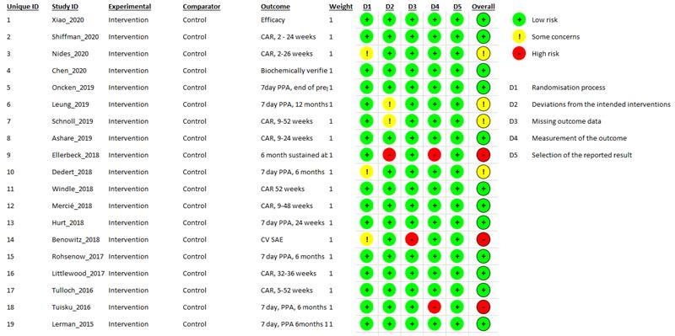
Figure 48: Risk of bias assessment for supplemental evidence using RoB 2 tool
Abbreviations: CAR = continuous abstinence rate; CV = cardiovascular; PPA = point prevalence abstinence; RoB = risk of bias; SAE = serious adverse events

B Summary of evidence

B.1 Evidence previously considered by the PBAC
Table 143: Details of the evidence previously considered by the PBAC and new evidence identified in this review
PBAC recommendation | Comparator | Evidence used | Evidence synthesis | Accepted Clinical Claim | Therapeutic Relativity | Updated Cochrane evidence | No. of trials in Cochrane review | No. of trials in supplemental evidence
Bupropion
2000  (New listing) | Placebo | '''''''''''''' ''''''''''''' | ''''''''''' ''''''''''''''''''''' | '''''''''''''''' '''''''''''''' '''''''''''''' ''''''''''' | ''''''''''''''''''''''' ''''''''''''''''''''''''''''''''''' '''''''''' | Howes (2020) (efficacy and safety) | 46 trials (PBAC evidence included) | 1
 | NRT | '''''''''''''''' '''''''''''' | '''''''''' ''''''''''''''''''''''' | '''''''''''''''' '''''''''''''''''  ''''''''''''''''''''' '''''''''''' '''''''''''''' ''''''''''''''''' | ''''''''''''''''''''' | Howes (2020) (efficacy and safety) | 10 trials (PBAC evidence included) | 1
 | Placebo | '''''''' ''''''''''' | '''''''''''' ''''''''''''''''''''''' ''''''' | ''''''''''''''''''''''  '''''''''''''''' '''''''''''''''' | ''''''' | Howes (2020) (efficacy and safety) | 46 trials (PBAC evidence included) | 1
Varenicline
2007  (New listing) | Bupropion | Gonzales (2006)  Jorenby (2006) | Direct comparison/ Meta-analysis | Superior effectiveness,  Similar or less toxicity | Acceptable cost-effectiveness ratio | Howes (2020) (efficacy and safety) | 6 trials  (PBAC evidence included) | 1
2009  (Additional 12 weeks, abstainers) | Placebo | Tonstad (2006) | Direct comparison | Superior efficacy and inferior safety | Acceptable cost-effectiveness ratio | Livingstone-Banks (2019) (efficacy) | 2 trials  (PBAC evidence included) | 1
2014,  (Re-treatment, non- abstainers) | Placebo | Gonzales (2014) | Direct comparison | Pivotal, non- abstainers  Superior efficacy, Inferior safety | Acceptable cost-effectiveness ratio | Cahill (2016) (efficacy) | 1  (PBAC evidence included) | 8
 | Bupropion | Gonzales (2006)  Jorenby (2006) | Direct comparison/ Meta-analysis | Supportive, Tx naive  Superior efficacy,  Non-inferior safety | Acceptable cost-effectiveness ratio | Howes (2020) (efficacy and safety) | 6 trials  (PBAC evidence included) | 0
 | NRT | Aubin (2008) | Direct comparison (open-label) | Supportive, Tx naive  Superior efficacy, Inferior safety | Acceptable cost effectiveness ratio | Cahill (2016) (efficacy) | 8 trials  (PBAC evidence included) | 4
 | Placebo | Gonzales (2006), Jorenby (2006), Nakamura (2007), Rigotti (2010), Tashkin (2011) | Direct comparison/ Meta-analysis | Supportive, Tx naive  Superior efficacy, Inferior safety | Acceptable cost-effectiveness ratio | Cahill (2016) (efficacy and safety) | 27 trials (PBAC evidence included) | 8
2016  (Authority Required -STREAMLINED) | Placebo | Anthenelli (2016) EAGLES trial | Direct comparison | Primary comparison  Superior efficacy,  Non-inferior safety | N/A | Cahill (2016) (safety) | 36 trials (PBAC evidence included) | 0
 | Bupropion | Anthenelli (2016) EAGLES trial | Direct comparison | Secondary comparison  Superior efficacy,  Non-inferior safety | N/A | Howes (2020) (safety) | 5 trials (PBAC evidence included) | 0
 | NRT | Anthenelli (2016) EAGLES trial | Direct comparison | Secondary comparison  Superior efficacy,  Non-inferior safety | N/A | No updated safety evidence | N/A | 4
NRT patch
2008  (New listing – Aboriginal and Torres Strait Islander population) | No control/ control group | '''''''''' ''''''''''''' ''''''''''' ''''''''''''''' '''''''''''''' ''''''''''''' | ''''''''''' ''''''''''''''''''''''''' ''''''''''''''''''''''''''''''''' '''''''' | '''''' '''''''''''' ''''''''''''''''' '''''''''''' | ''''' ''''''''''''''''''''''''''''''''' '''''''''''''''' ''''''''''''''''' | Hartmann-Boyce (2018) (efficacy) | 51 trials (PBAC evidence not included) | 0
 | Placebo | '''''''''' '''''''''''' | ''''''''''''''''' '''''''''''' | '''''' '''''''''''' '''''''''''''''' '''''''''''' | ''''' ''''''''''''''''''''''''''''''''' '''''''''''''' '''''''''''''''''''' | Hartmann-Boyce (2018) (efficacy) | 51 trials (PBAC evidence included) | 0
2010  (General population) | Varenicline | Aubin (2008) | Direct comparison/ RCT | Uncertain (or inferior) efficacy, superior safety | Lower cost (cost analysis) | Cahill (2016) (efficacy) | 8 trials  (PBAC evidence included) | 4
 | Bupropion | Gorecka (2003), Jorenby (1999), Uyar (2007), Piper (2009) | Direct comparison/ meta-analysis | Non-inferior efficacy, superior safety | Lower cost (cost analysis) | Howes (2020)  (efficacy and safety) | 8 trials  (PBAC evidence included) | 0
 | Placebo | Stead (2008) | Direct comparison/ meta-analysis | Supportive,  Superior efficacy,  Inferior safety | N/A | Hartmann-Boyce (2018) (efficacy and safety) | 51 trials  (PBAC evidence included) | 3
2011  (Higher strength) | Placebo | ''''''''''''''''''' ''''''''''' | '''''''''' '''''''''''''''''''''''''  '''''''' | '''''' ''''''''''' | '''''''' | Hartmann-Boyce (2018) (efficacy and safety) | 51 trials (PBAC evidence included) | 0
NRT lozenge
2018  (New listing) | NRT patches | Schnoll (2010), Piper (2009), Smith (2009) | Direct comparison/Meta-analysis | Non inferior efficacy, non-inferior safety | Acceptable cost-minimisation analysis | Lindson (2019)(a) (efficacy and safety) | 3 trials  (PBAC evidence included) | 0
NRT gum
2018  (New listing) | NRT Patch  (Placebo as common comparator) | Stead (2012), Moolchan, (2005) | Indirect comparison/ Meta-analysis | Non inferior efficacy, non-inferior safety | Acceptable cost-minimisation analysis | Lindson (2019)(a) (efficacy and safety) | 2 trials  (PBAC evidence included) | 0
 | NRT Patch  ''''''''' ''''''''''''''''' '''' ''''''''''''''' '''''''''''''''''''''' | ''''''''' '''''''''''' ''''''' Piper (2009) | '''''''''''''''' ''''''''''''''''''''''''' RCT ''''''''''''''' '''''''''''''''''''' | ''''''''''''''''''''' ''''''''''' '''''''''''''''''''' | N/A | Lindson (2019)(a) (efficacy and safety) | 2 trials  '''''''''' ''''''''''' ''''''' ''''''''''''''''' | 0
Abbreviations: NRT = nicotine replacement therapy

B.2 Characteristics of individual studies
Table 144: Characteristics of studies included in Howes et al. (2020), bupropion versus placebo
Study | Study type | Countries | N | Population | Intervention and comparator | Outcomes
Ahluwalia (2002) | RCT | USA | N=600;  n=300 (bupropion), n=300 (placebo) | African American smokers, 70% female, average age 44, average cigarettes per day 17, 27% had possible clinical depression CES-D > 16. | - Bupropion, 150 mg/day for 3 days, then 300 mg/day for a total of 7 weeks  - Placebo  Common components: 8 sessions of in-person or telephone counselling and self-help guide. | Efficacy: prolonged abstinence at 26 weeks. Validated by CO ≤ 10 ppm, discrepancies resolved with cotinine ≤20 mg.  Safety: adverse events measured for 26 weeks.
Anthenelli (2016) | RCT | USA, Australia, Canada, Denmark, Finland, Germany, New Zealand, South Africa, Spain, Bulgaria,  Russian Federation, Slovakia, Argentina, Brazil, Chile, and Mexico | N= 8144  Special population: participants psychiatric cohort (n= 4074), non-psychiatric cohort (n= 3984) | 56% female, average age 46.5, average cigarettes per day 21, mean FTND 5.8.  Participants were included in the psychiatric cohort if they met Diagnostic and Statistical Manual of DSM-IV-TR diagnostic criteria for mood disorders including major depressive disorder or bipolar disorder; anxiety disorders including panic disorder, with or without agoraphobia, post-traumatic stress disorder, obsessive-compulsive disorder, social phobia, and generalized anxiety disorder; psychotic disorders including schizophrenia and schizoaffective disorders; or borderline personality disorder. Participants in the non-psychiatric cohort had no confirmed history of DSM-IV-TR Axis I or II disorders. | - Bupropion sustained release 150 mg twice a day, and placebo varenicline and placebo nicotine patch  - Varenicline 1 mg twice a day, and placebo bupropion sustained release and placebo nicotine patch  - Transdermal nicotine patch 21 mg per day with taper for 12 weeks, and placebo varenicline and placebo bupropion sustained release  - Placebo bupropion sustained release and placebo varenicline and placebo nicotine patch  Treatment duration was 12 weeks.  Common components: smoking cessation counselling consisting of 10-minute sessions at each of the 15 clinic visits, totalling 2 hours and 30 minutes. | Efficacy: continuous abstinence from week 9 to week 24 post-quit date (validated by CO  ≤ 10 ppm).  Safety: measured within 12-week treatment period, or for 30 days thereafter.
Aubin (2004) | RCT | France | N=504; n=340 (bupropion), n=164 (placebo) | 56% female, average age 41, average cigarettes per day was not stated. | - Bupropion 300 mg/day for 7 weeks  - Placebo  Common components: Motivational support at clinic visits at baseline (week 3, 7, and 12) and 3 phone calls TQD, 2 to 3 days later (week 5 and 18) | Efficacy:  The primary efficacy criterion was point prevalence abstinence (PPA) at week 26.  Secondary efficacy criteria were point prevalence abstinence  at the end of the treatment phase (week 7), the rates of continuous abstinence over the treatment period (from weeks 4 to 7) and over the follow-up period (weeks 4–26).  Validation: CO < 10 ppm  Safety: Adverse events, serious adverse events.
Brown (2007) | RCT | USA | N=524 | 48% female, average age 44, average cigarettes per day 25. | - Bupropion 300 mg/day for 12 weeks  - Placebo  Common components: Alternative psychosocial treatments were standard cessation therapy or plus CBT for depression. Both had 12 x 90 min groups twice weekly/weekly/monthly for 12 weeks. TQD 5th session. | Efficacy: abstinence at 12 months (sustained at 4 visits). Validated by CO ≤ 10 ppm, saliva  cotinine ≤ 15 ng/mL  Safety: measured for 12 weeks.
Cinciripini (2013) | RCT | USA | N=294 | 39% female, average age 44, average cigarettes per day 20, mean FTND 4.5. | - Bupropion, 12 weeks, started 12 to 19 days before TQD (150 mg/d days 1 to 3, 300 mg/d thereafter)  - Varenicline, 12 weeks on same schedule (0.5 mg/day days 1 to 3, 1.0 mg/day, days 4 to 7, 2.0 mg/day hereafter)  - Placebo, same schedule as above  Common components: 10 individual counselling sessions (6 in person, 4 via phone, 240 mins total) | Efficacy: prolonged abstinence after 2-week grace period at 6 months (validated by CO < 10 ppm or salivary cotinine < 15 ng/mL).  Safety: measured for 12 weeks.
Collins (2004) | RCT | USA | N=555 | Excluding history of psychiatric disorder including MDD, 57% female, average age 46, average cigarettes per day 21. | - Bupropion 300 mg/day for 10 weeks beginning 2 weeks before TQD  - Placebo  Common components: 7 sessions group behavioural counselling. | Efficacy: prolonged abstinence at 6 months (from week 2, 7 consecutive days of smoking defined as relapse). Validated by saliva cotinine ≤ 15 ng/ml.  Safety: measured for unspecified period.
Cox (2012) | RCT | USA | N=540; n=270 (Bupropion), n=270 (placebo). | African American light smokers (≥ 10 cigarettes per day for ≥ 2 years, smoked on ≥ 25 days in past month), 66% female, average age 47 years, average cigarettes per day 8, average FTND 3.2. | - Bupropion, 300 mg for 7 weeks (150 mg 1 x day for 3 days, then 150 mg 2 x day for remainder)  - Placebo, same schedule as bupropion  Common components: up to 6 one-to-one 15-20 minute individual counselling sessions, self-help guide at start. | Efficacy: 7-day PPA at 6 months. Validated by salivary cotinine < 15 ng/mL  Safety: measured for 16 weeks.
Dalsgaro (2004) | RCT | Denmark | N=335 n=221 (bupropion), n=114 (placebo). | Hospital employees including physicians, nurses, other hospital service and admin staff who smoked at least 10 cigarettes.  75% female, average age 43 years, average cigarettes per day 19. | - Bupropion, 300 mg/day for 7 weeks  - Placebo  Common components: Motivational support around TQD, at weeks 3 and 7, and at 12-week follow-up | Efficacy: Prolonged abstinence at 6 months (starting from week 4) Validated by CO < 10 ppm.  Safety: NR
Eisenberg (2013) | RCT | Canada | N=392; n=192 (bupropion), n=200 (placebo) | Smokers of at least 10 cigarettes per day, hospitalized with enzyme positive acute myocardial infarction.  16% female; average age 54 years, average cigarettes per day 23, average FTND not specified. | - Bupropion, 300 mg/day for 9 weeks (150 mg for 3 days, then 150 mg 2 x day for remainder)  - Placebo, same schedule as bupropion  Common components: 7 one-to-one counselling sessions by research nurses at baseline and all follow-ups of < 20 mins (average 5) – mix of phone and in-person | Efficacy: 12 months continuous abstinence (7 days PPA also reported). Validated by CO ≤ 10 ppm  Safety: non-SAEs measured for 9 weeks. SAEs measured for 12 months.
Evins (2001) | RCT | USA | N=18; n=9 bupropion), n=9 (placebo). | Smokers with stable schizophrenia (excluding 1 dropout prior to medication), 39% female, average age 45.5/42.7, average cigarettes per day 34. | - Bupropion, 300 mg/day for 3 months, TQD after week 3  - Placebo  Common components: 9x1 hour weekly group CBT | Efficacy: prolonged abstinence at 6 months. Validated by CO < 9 ppm or serum cotinine < 14 ng/mL  Safety: measured for 24 weeks
Evins (2005) | RCT | USA | N=56; n=25 (bupropion), n= 28 (placebo). | Smokers with schizophrenia (excluding 6 dropouts prior to medication), 27% female, average age 45 years, average cigarettes per day 37/26. | - Bupropion, 300 mg/day for 3 months  - Placebo  Common components: 12 session group CBT | Efficacy: 7-day PPA at 6 months. Validated by CO < 9 ppm.  Safety: measured for unspecified period
Ferry (1992) | RCT | USA | N=42 | Male smokers | - Bupropion, 300 mg/day for 3 months  - Placebo  Common components: group smoking cessation and relapse prevention counselling | Efficacy: sustained abstinence at 6m from end of treatment. Validated by saliva cotinine.  Safety: measured for unspecified period.
Ferry (1994) | RCT | USA | N=190 | Smokers | - Bupropion, 100 mg x 3/day for 12 weeks  - Placebo  Common components: group smoking cessation and relapse prevention counselling; TQD within first 4  weeks | Efficacy: prolonged abstinence at 12 months (from day 29). Validated by saliva cotinine ≤ 15 ng/mL at 6 months and 12 months  Safety: measured for unspecified period.
Fossati (2007) | RCT | Italy | N=593 | Smokers, 40% female, average age 49 years, average cigarettes per day 22 | - Bupropion, 300 mg/day for 7 weeks  - Placebo  Common components: GP visits at enrolment and 4, 7, 26 & 52 weeks, phone calls 1-day pre-TQD, 3 days post-TQD, 10 weeks post-enrolment. Classified as low intensity | Efficacy: abstinence at 12 months (continuous from week 4). Validated by CO ≤ 10 ppm at each visit  Safety: measured for 52 weeks
George (2002) | RCT | USA | N=32 | Smokers with schizophrenia motivated to quit, 44% female, average age 41/45, average cigarettes per day 24 | - Bupropion, 300 mg/day for 9 weeks. TQD 3 weeks  - Placebo  Common components: 10 x 60-minute weekly group therapy | Efficacy: 7-day PPA at 6 months. Validated by expired CO < 10 ppm  Safety: measured for unspecified period.
Gilbert (2019) | RCT | USA | N=105 | 42% female, average age 26.4, average cigarettes per day 17.9, mean FTND  4.2 | - Bupropion SR and placebo nicotine patch. 150 mg pill once daily for 3 days, then twice daily for 56 days, then once daily for three days. Placebo nicotine patch schedule given below  - Nicotine patch and placebo bupropion. Beginning on first day of cessation: 21 mg for 24 days, 14 mg for 14 days, then 7 mg for 7 days. Placebo bupropion schedule as given above  - Matched placebos, according to the schedules given above  Common components: an abbreviated form of the American Lung Association smoking cessation program | Efficacy: prolonged abstinence at 12 months. Validation method not specified  Safety: measured for 62 days
Gonzales (2001) | RCT | USA | N=450 | Smokers who had previously used bupropion for at least 2 weeks without adverse effects and failed  to quit; 55% female in placebo arm, 48% female in bupropion arm, average age 45 years, average cigarettes  per day not specified | - Bupropion, 300 mg/day for 12 weeks, begun 7 days pre-TQD  - Placebo  Common components: brief individual counselling at visits weeks 1-7, 9, 12, + telephone counselling at 4 months and 5 months | Efficacy: prolonged abstinence 12 months, starting from week 4. Validated by CO ≤ 10 ppm  at each visit  Safety: measured for unspecified duration
Gonzales (2006) | RCT | USA | N=673 | Participants with prior exposure to bupropion excluded, 46% female, average age 42, average cigarettes per day 21 | - Bupropion, 300 mg/day for 12 weeks, begun 7 days pre-TQD  - Varenicline, 2 mg/day  - Placebo  Common components: brief (<10-minute) standardized individual counselling at 12 weekly visits during drug phase and 11 clinic/phone visits during follow-up, problem solving and relapse prevention. | Efficacy: sustained abstinence at 1 year (starting from week 4). Validated by CO ≤ 10 ppm at each visit  Safety: measured for 13 weeks.
Haggsträm (2006) | RCT | Brazil | N=156 | FTND > 4; 70% female in placebo and nortriptyline arms, 59% in bupropion arm, average age 44 years, average cigarettes per day not specified | - Bupropion, 300 mg/day for 60 days, placebo nortriptyline, TQD during week 2  - Nortriptyline, 75 mg/day for 60 days, placebo bupropion  - Double placebo  Common components: 6 x 15-min individual CBT, weekly then bi-weekly | Efficacy: continuous abstinence at 6 metres (starting from TQD). Validated by CO ≤ 10 ppm at 3 months and 6 months  Safety: measured for 26 weeks.
Hall (2002) | RCT | USA | N=220 | Smokers; 40% to 47% female, average age 37-43 years, average cigarettes per day 20-23 | - Bupropion, 300 mg/day, 12 weeks  - Nortriptyline, titrated to therapeutic levels, 12 weeks  - Placebo  3 x 2 factorial design. Alternative psychological interventions were Medical Management (MM, physician  advice, S-H, 10 mins to 20 mins 1st visit, 5 minds at 2, 6, 11 weeks) or Psychosocial Intervention (PI, as MM plus 5 x 90-min group sessions at 4, 5, 7, 11 weeks). | Efficacy: prolonged abstinence at 1 year (47 weeks post-quit date). Validated by CO ≤ 10 ppm, urine cotinine h 60 ng/mL  Safety: measured for unspecified period.
Hertzberg (2001) | RCT | USA | N=15 | male veterans with post-traumatic stress disorder, average age 50 years, average cigarettes per day 33 | - Bupropion, 300 mg/day, 12 weeks begun at least 1 week before TQD  - Placebo  Common components: individual counselling pre-quit, weeks 1, 2, 4, 8, 12. | Efficacy: prolonged abstinence at 6 months. Validated at weeks 2, 8 by CO ≤ 10 ppm  Safety: measured for 12 weeks.
Holt (2005) | RCT | New Zealand | N=134 | 72% female, average age 42/38 years | - Bupropion, 300 mg/day for 7 weeks  - Placebo  Common components: counselling at 3 clinic visits during medication and 3 monthly follow-ups, motivational phone call 1 day before and 2 days after TQD. | Efficacy: continuous abstinence at 12 months. Validated by CO at each visit  Safety: measured for 12 months.
Hurt (1997) | RCT | USA | N=615 | Smokers; 55% female, average age 44 years, average cigarettes per day 27 | - Bupropion,100 mg/day for 7 weeks  - Bupropion, 150 mg/day  - Bupropion, 300 mg/day  - Placebo  Common components: physician advice, S-H materials, and brief individual counselling by study assistant at each visit. | Efficacy: prolonged abstinence at 12 months (starting from day 22). Validated by CO ≤ 10 ppm  Safety: measured for 52 weeks.
Jorenby (1999) | RCT | USA | N=893 | Smokers, 52% female, average age 43 years, average cigarettes per day 25 | - Nicotine patch and bupropion SR. Nicotine patch dosing and schedule 24 hr, 21 mg for 6 weeks, tapered for 2 weeks. Bupropion dosing and schedule was 300 mg for 9 weeks from 1 week before quit day  - Bupropion and placebo patch  - Nicotine patch and placebo tablets  - Placebo patch and placebo tablets  Common components: brief (< 15 min) individual counselling session at each weekly assessment. One telephone call 3 days after quit day | Efficacy: continuous PPA at 12 months. Validated by CO < 10 ppm at each clinic visit  Safety: measured for unspecified period.
Jorenby (2006) | RCT | USA | N=683 | Smokers (in relevant arms), with prior exposure to bupropion excluded, 41% female, average age  42, average cigarettes per day 22 | - Bupropion 300 mg for 12 weeks + placebo varenicline  - Varenicline 2 mg for 12 weeks + placebo bupropion  - Placebo bupropion and placebo varenicline  Common components: brief (< 10 min) individual counselling at each weekly assessment for 12 weeks and 5 follow-up visits. One telephone call 3 days after quit day. | Efficacy: sustained abstinence at 12 months, from week 9. Validated by CO < 10 ppm at each  clinic visit  Safety: N/A.
Levine (2010) | RCT | USA | N=349 | Weight-concerned women smokers, average age 42 years, average cigarettes per day 21, mean FTND 5.2 | - Bupropion SR. 26 weeks. 150 mg/day for first 2 days and 300 mg/day for remainder of treatment  - Placebo, same schedule  Counselling conditions  - Standard cessation counselling  - Standard cessation counselling + material on weight concerns  Common components: 12 x 90-minute group counselling sessions delivered over 3 months. | Efficacy: prolonged abstinence at 12 months. Validated by CO ≤ 8 ppm and salivary cotinine  ≤ 15 mg  Safety: measured for 26 weeks.
McCarthy (2008) | RCT | USA | N=463 | Smokers, 50% female, average age 36-41, average cigarettes per day 22 | - Bupropion SR 300 mg for 8 weeks  - Placebo  Counselling conditions  - 8 x 10-min session, 2 pre-quit, TQD, 5 over 4 weeks  - Psychoeducation about medication, support and encouragement. Same number of sessions, 80 mins less contact time | Efficacy: 7-day PPA at 12 months. Validated by CO ≤ 10 ppm. Prolonged self-reported abstinence  also assessed  Safety: measured for 9 weeks.
Muramoto (2007) | RCT | USA | N=312 | Adolescents (14 to 17), 46% females, median age 16, median cigarettes per day 11 | - Bupropion, 300 mg for 7 weeks  - Bupropion, 150 mg for 7 weeks  - Placebo  Common components: brief (10-20 mins) individual counselling session pre-quit and at each weekly assessment | Efficacy: 7-day PPA at 6 months. Validated by CO < 10 ppm (cotinine at weeks 2 and 6 only)  Safety: measured for 26 weeks.
Myles (2004) | RCT | Australia | N=47 | Smokers expected to undergo surgery within 8-14 weeks, 34% female, average age 45/40 years, 49%  smoked 21-30 cigarettes per day | - Bupropion, 300 mg for 7 weeks  - Placebo  Common components: advice at baseline, 1 phone call 2-4 days after TQD. Low intensity. | Efficacy: 28-day PPA at 6 months. Validated by CO ≤ 10 ppm  Safety: not clearly specified.
Nides (2006) | RCT | USA | N=638 | Smokers (255 in relevant arms, including 2 bupropion and 4 placebo who did not start medication), 51% female, average age 41 years, average cigarettes per day 20 | - Bupropion, 300 mg for 7 weeks  - Varenicline, 2 mg for 7 weeks (other dose regimens not used in review)  - Placebo  Common components: up to 10 mins counselling at 7 weekly clinic visits, 12 weeks and 24 weeks | Efficacy: continuous abstinence at 12 months (starting from week 4). Validated by CO  Safety: measured for 11 weeks.
Piper (2007) | RCT | USA | N=608 | Smokers, 58% female, average age 42, average cigarettes per day 22 | - Nicotine gum and bupropion. Gum at 4 mg. Bupropion at 300 mg  - Placebo gum and bupropion  - Double placebo  Common components: three 10-min counselling sessions over 3 weeks | Efficacy: PPA at 12 months. Validated by CO or blood cotinine  Safety: measured for unspecified period.
Piper (2009) | RCT | USA | N=1504 | Smokers, 58% female, average age 45, average cigarettes per day 21.4 | - Bupropion SR. 150 mg twice/day, 1 week pre-quit, 8 weeks post-quit  - Bupropion and nicotine lozenge. Duration and dosage as below  - Nicotine lozenge. 2 mg or 4 mg for 12 weeks (based on dose-for-dependence level as per instructions)  - Nicotine patch (24 hr, 21, 14, and 7 mg titrated down over 8-week period post-quit)  - Nicotine lozenge and nicotine patch. Duration and dosage as above  - Placebo bupropion  - Placebo bupropion and placebo lozenge  - Placebo lozenge  - Placebo patch  - Placebo lozenge and placebo patch  Common components: 7 one-to-one 10 to 20-min counselling sessions | Efficacy: 7-day PPA at 6 months. Validated by CO < 10 ppm  Safety: measured for 10 weeks.
Planer (2011) | RCT | Israel | N=151 | Smokers with diagnosis of acute coronary syndrome, motivated to quit, average age 51.9, 20.1% female, average cigarettes per day 31 | - Bupropion, 150 mg 1 x day for 3 days, then 2 x day for 2 months  - Placebo, same schedule as above  Common components: counselling (at least 15 min of motivational support) during hospitalization  and continued after discharge (at least 2 visits with physician and nurse at 1 month and 2 months and weekly telephone call by nurse during first and second month, then monthly telephone calls during rest  of the year) | Efficacy: self-reported continuous abstinence at 12 months  Safety: measured for 12 months.
Rigotti (2006) | RCT | USA | N=248 | Smokers hospitalized with cardiovascular disease (excludes 3/3 dropped prior to treatment and 2  placebo deaths during follow-up), 31% female, average age 56 years, average cigarettes per day 23/21 | - Bupropion 300 mg for 12 weeks  - Placebo, same schedule as above  Common components: multicomponent CBT cessation and relapse prevention programme, motivational interviewing approach. Begun in hospital, 30-45 mins, 5 x 10 min post-discharge contacts (2 days,  1 week, 3 weeks, 8 weeks, 12 weeks), self-help, chart prompt for physician. Total time 80-95 mins | Efficacy: sustained abstinence at 12 months (at multiple follow-ups) Validated by saliva cotinine at 12 weeks and 52 weeks, CO at 2 weeks and 4 weeks  Safety: measured for 52 weeks.
Rovina (2009) | RCT | Greece | N=205 | Smokers, 40% female, average age 45, average cigarettes per day 37 | - Bupropion 300 mg/day for 19 weeks + 15 mins physician counselling  - Bupropion 300 mg/day for 19 weeks + nonspecific group therapy, 1-hour weekly for 1 month, then every 3 weeks until 19 weeks  - Bupropion 300 mg/day for 19 weeks + CBGT, same schedule  - CBGT without bupropion | Efficacy: continuous abstinence at 12 months after end of treatment. Validated by CO ≤ 10 ppm  Safety: measured for 31 weeks.
Schmitz (2007) | RCT | USA | N=154 | Smokers, average age 48, average cigarettes per day 21 | - Bupropion 300 mg/day for 7 weeks  - Placebo  Common components: either CBT based on relapse prevention model, or group support therapy, both 7 weekly 60-min meetings, TQD morning of 1st session, 10 days after start of medications | Efficacy: 7-day PPA at 12 months. Validated by CO ≤ 10 ppm, saliva cotinine < 15ng/mL  Safety: adverse events at 7 weeks.
Selby (2003) | RCT | Canada | N=284 | Smokers previously exposed to bupropion for at least 2weeks, not quit for more than 24 hours in  previous month | - Bupropion 300 mg for 12 weeks  - Placebo  Behavioural support not described | Efficacy: PPA at 12 months. Validated by CO ≤ 10 ppm at treatment visits  Safety: adverse events measured for unspecified period.
Simon (2009) | RCT | USA | N=83 | Inpatients smoking at least 5 cigarettes per day in previous year, smoking in week before admission, in contemplation or preparation stage of change | - Bupropion 300 mg for 7 weeks  - Placebo  Common components: individual CBT 30-60 min during hospital stay + 5 phone calls at week 1, week 3, week 5, week 8, week 12, recycling encouraged | Efficacy: continuous abstinence at 6 months. Validated at each visit by saliva cotinine < 15 ng/mL  Safety: adverse events measured for 7 weeks.
SMK20001 | RCT | USA | N=286 | Smokers, 48% female, average age 42, average cigarettes per day not specified | - Bupropion 300 mg for 7 weeks and placebo novel therapy  - Double placebo | Efficacy: continuous abstinence at 12 months. Validated by CO ≤ 10 ppm  Safety: N/A.
Tashkin (2001) | RCT | USA | N=404 | Smokers with mild to moderate COPD (excludes 7 early dropouts who did not take any study medication), 45% female, average age 53-54 years, average cigarettes per day 28 | - Bupropion SR 300 mg/day for 12 weeks from 1 week before TQD  - Placebo  Common components: brief face-to-face counselling at each clinic visit (weeks 1-7, 10, 12), telephone counselling 3 days after TQD | Efficacy: sustained abstinence at 52 weeks (starting from week 4). Validated by CO ≤ 10 ppm at each visit  Safety: adverse events measured for 12 weeks
Tonnesen (2003) | RCT | 8 European countries, Australia, New Zealand | N=710 | Smokers, 51% female, average age 42, median cigarettes per day 20 | - Bupropion SR 300 mg/day for 7 weeks  - Placebo  Common components: brief motivational support at weekly clinic visits and telephone support during  follow-up. 11 clinic visits and 10 phone calls scheduled | Efficacy: prolonged abstinence at 52 weeks (starting from week 4). Validated by CO ≤ 10 ppm  Safety: adverse events measured for 52 weeks.
Tonstad (2003) | RCT | 10 countries including European countries, Australia, and NZ | N=629 | Smokers with stable CVD, 23% female, average age 55 years, average cigarettes per day 25, 49% had history of MI | - Bupropion SR 300 mg/day for 7 weeks, begun 1-2 weeks before TQD  - Placebo  Common components: brief motivational support at weekly clinic visits and telephone support during  follow-up. 9 clinic visits and 10 phone calls scheduled | Efficacy: prolonged abstinence at 12 months (starting from week 4). Validated by CO ≤ 10 ppm  Safety: adverse events measured for 9 weeks.
Uyar (2007) | RCT | Turkey | N=131 | Smokers, 19% female, average age 36 | - Bupropion 300 mg for 7 weeks  - Nicotine patch 21 mg for 6 weeks including tapering  - Advice and follow-up only  Common components: brief counselling on consequences of smoking with follow-up for 24 weeks more than low intensity | Efficacy: abstinence at 24 weeks (definition not specified). Validated by CO < 10 ppm  Safety: adverse events measured for unspecified period.
Wagena (2005) | RCT | Netherlands | N=255 | Smokers with or at risk of COPD, 51% female, average age 51 years, average cigarettes per day 23 | - Bupropion SR 300 mg/day for 12 weeks  - Nortriptyline 75 mg/day for 12 weeks  - Placebo bupropion or placebo nortriptyline  Common components: individual counselling 10-20 mins at baseline, 1 week and 3 weeks post-TQD (TQD typically day 11). Telephone support TQD, 2 weeks, 4 weeks, 6 weeks, 8 weeks, 11 weeks | Efficacy: prolonged abstinence at 26 weeks (puff-free from week 4). Validated by urine cotinine h 60 ng/mL at 4 weeks, 12 weeks and 26 weeks  Safety: adverse events none specified.
Wittchen (2011) | RCT | Germany | N=467 | "current regular smokers"; 52% female, average age 43 years, average cigarettes per day 20 | - CBT 4-5 one-on-one counselling sessions for 20-30 mins  - CBT and bupropion SR. CBT as above. Bupropion SR (9-12 weeks, 150 mg; 1/day for first 6 days; 2/day thereafter)  - CBT and NRT. CBT as above. NRT for 9-12 weeks, patient's choice of patch (7 mg to 52.5 mg), gum (2 or 4 mg) or spray (10 mg/mL)  - Minimal intervention (not used in review) | Efficacy: abstinence at 12 months (from EoT). Validation method not specified  Safety: adverse events measured for 12 weeks.
Zellweger (2005) | RCT | 12 European countries | N=667 | Smokers (excludes 1 centre enrolling 20 people, and 3 people who took no medication), 64% female, average age 40 years, average cigarettes per day 23, 32% doctor, 68% nurse | - Bupropion SR. 300 mg/day for 7 weeks  - Placebo  Common components: Brief (10-15 min) motivational support at weekly clinic visits and telephone support one day before TQD, 3 days after TQD, monthly during follow-up | Efficacy: Prolonged abstinence at 52 weeks (starting from week 4). Validated by CO ≤ 10 ppm  Safety: N/A.
Source: Howes et al. (2020)
Abbreviations: NR= not reported; PPA= point prevalence smoking abstinence; CA= continuous abstinence; RCT= randomised controlled trial; N= total participants; TQD= target quit date; ITT= intention to treat; DSM-IV-TR= Mental Disorders, Fourth Edition, Text Revision; CES-D=Centre for Epidemiological Studies Depression Scale; CO= carbon monoxide; ppm= part per million; EoT= end of treatment; FTND= Fagerström test for nicotine dependence; CBT= cognitive behavioural therapy; MDD= major depressive disorder; MI= myocardial infarction; COPD= chronic obstructive pulmonary disease; SR= sustained release.
Table 145: Characteristics of studies included in Howes et al. (2020), bupropion versus NRT
Study | Study type | Country | N | Population | Intervention and comparator | Outcomes
Anthenelli (2016) | RCT | USA, Australia, Canada, Denmark, Finland, Germany, New Zealand, South Africa, Spain, Bulgaria,  Russian Federation, Slovakia, Argentina, Brazil, Chile, and Mexico | N= 8144  Specialist population: participants psychiatric cohort (n= 4074), non-psychiatric cohort (n= 3984) | 56% female, average age 46.5 years, average cigarettes per day 21, mean FTND 5.8  Participants were included in the psychiatric cohort if they met  Diagnostic and Statistical Manual of DSM-IV-TR diagnostic criteria for mood disorders including major depressive disorder or bipolar disorder; anxiety disorders  including panic disorder, with or without agoraphobia, post-traumatic stress disorder, obsessive- compulsive disorder, social phobia, and generalized anxiety disorder; psychotic disorders including  schizophrenia and schizoaffective disorders; or borderline personality disorder. Participants in the  non-psychiatric cohort had no confirmed history of DSM-IV-TR Axis I or II disorders. | - Bupropion sustained release and placebo varenicline and placebo nicotine patch (150 mg twice a day for 12 weeks)  - Varenicline and placebo bupropion sustained release and placebo nicotine patch (1 mg twice a day for 12 weeks)  - Transdermal nicotine patch and placebo varenicline and placebo bupropion sustained release (21 mg per day with taper for 12 weeks)  - Placebo bupropion sustained release and placebo varenicline and placebo nicotine patch for 12 weeks  Common components: smoking cessation counselling consisting of 10-minute sessions at each of the 15 clinic visits, totalling 2 hours and 30 minutes. | Efficacy: continuous abstinence from week 9 to week 24 post-quit date (validated by CO ≤ 10 ppm)  Safety: measured within 12-week treatment period, or for 30 days thereafter
Gariti (2009) | RCT | USA | N=260 | Light smokers (6-15 cigarettes per day) motivated to quit, 57% female, average age 54, average cigarettes  per day 11, average FTND 4 | - Bupropion SR and placebo patch. Bupropion for 9 weeks. Patch for 8 weeks. 10 weeks individualized counselling sessions  - Bupropion SR and placebo patch. Bupropion for 9 weeks. Patch for 8 weeks. Four 5-10 minutes counselling sessions  - Bupropion SR and nicotine patch. Bupropion for 9 weeks. Patch for 8 weeks. 10 weeks individualized counselling sessions  - Bupropion SR and nicotine patch. Bupropion for 9 weeks. Patch for 8 weeks. Four 5-10 minutes counselling sessions | Efficacy: 7-day PPA at 12 months. Validated by CO < 10 ppm; urinary cotinine < 200 ng/mL  Safety: adverse events: measured for unspecified period
Gilbert (2019) | RCT | USA | N=105 | 42% female, average age 26.4, average cigarettes per day 17.9, mean FTND  4.2 | - Bupropion SR and placebo nicotine patch. 150 mg pill once daily for 3 days, then twice daily for 56 days, then once daily for three days. Placebo nicotine patch schedule given below  - Nicotine patch and placebo bupropion. Beginning on first day of cessation: 21 mg for 24 days, 14 mg for 14 days, then 7 mg for 7 days. Placebo bupropion schedule as given above  - Matched placebos, according to the schedules given above  Common components: an abbreviated form of the American Lung Association smoking cessation program | Efficacy: prolonged abstinence at 12 months. Validation method not specified  Safety: measured for 62 days
Górecka (2003) | RCT | Poland | N=70 | Smokers with COPD, 43% female, average age 56 years, average cigarettes per day 24 | - Bupropion, 300 mg/day for 7 weeks  - Nicotine patch, 15 mg/day for 8 weeks  Common components: support at clinic visits at baseline, 2 weeks, EOT | Efficacy: sustained abstinence at 1 year. Validated by CO < 10 ppm  Safety: adverse events: period of measurement unspecified
Jorenby (1999) | RCT | USA | N=893 | Smokers, 52% female, average age 43 years, average cigarettes per day 25 | - Nicotine patch and bupropion SR. Nicotine patch dosing and schedule 24 hr, 21 mg for 6 weeks, tapered for 2 weeks. Bupropion dosing and schedule was 300 mg for 9 weeks from 1 week before quit day  - Bupropion and placebo patch  - Nicotine patch and placebo tablets  - Placebo patch and placebo tablets  Common components: brief (< 15 min) individual counselling session at each weekly assessment. One telephone call 3 days after quit day | Efficacy: continuous PPA at 12 months. Validated by CO < 10 ppm at each clinic visit  Safety: measured for unspecified period
Piper (2009) | RCT | USA | N=1504 | Smokers, 58% female, average age 45 years, average cigarettes per day 21.4 | - Bupropion SR. 150 mg twice/day, 1 week pre-quit, 8 weeks post-quit  - Bupropion and nicotine lozenge. Duration and dosage as below  - Nicotine lozenge. 2 mg or 4 mg for 12 weeks (based on dose-for-dependence level as per instructions)  - Nicotine patch (24 hr, 21, 14, and 7 mg titrated down over 8-week period post-quit)  - Nicotine lozenge and nicotine patch. Duration and dosage as above  - Placebo bupropion  - Placebo bupropion and placebo lozenge  - Placebo lozenge  - Placebo patch  - Placebo lozenge and placebo patch  Common components: 7 one-to-one 10 to 20-min counselling sessions | Efficacy: 7-day PPA at 6 months. Validated by CO < 10 ppm  Safety: measured for 10 weeks
Smith (2009) | RCT | USA | N=1346 | Smokers, 56% female, average age 44, average cigarettes per day 20.3 | - Bupropion, up-titrated during week pre-quitting, 150 mg twice/day for 8 weeks post-quit  - Nicotine lozenge. 4 mg lozenge if first cigarette of day smoked > 30 min after waking, 2 mg otherwise. 1 lozenge every 1-2 hrs post-quit week 1-6; 1 lozenge every 2-4 hrs week 7-9; 1 lozenge every 4-8 hours week 10-12  - Nicotine patch. 21 mg post-quit week 1-4; 14 mg week 5-6; 7 mg week 7-8  - Bupropion and nicotine lozenge. Dosing as above  - Nicotine patch and nicotine lozenge. Dosing as above  Common components: quitline counselling (state provided). All participants received initial session, then could elect to receive up to 4 additional calls + could call for additional support if required. | Efficacy: 7-day PPA at 6 months. No validation method specified  Safety: adverse events measured for unspecified period
Uyar (2007) | RCT | Turkey | N=131 | Smokers, 19% female, average age 36 | - Bupropion 300 mg for 7 weeks  - Nicotine patch 21 mg for 6 weeks including tapering  - Advice and follow-up only  Common components: brief counselling on consequences of smoking with follow-up for 24 weeks more than low intensity | Efficacy: abstinence at 24 weeks (definition not specified). Validated by CO < 10 ppm  Safety: adverse events measured for unspecified period
Stapleton (2013) | RCT | UK | N=1071 | daily smokers, 53% female, average age 41 years, average cigarettes per day 20 | - Bupropion 8 weeks, started prior to TQD (exact period not specified), 150 mg/d for first 6 day, then 300 mg for remainder  - Bupropion and NRT. Bupropion as above. NRT given as choice of single product, 12 weeks started on TQD, dosage determined on individual basis  - NRT. As above  Common components: 7 weekly behavioural support sessions as per standard service protocol. Mainly  group, 60-90 mins each | Efficacy: prolonged abstinence at 6 months. Validated by CO < 10 ppm  Safety: adverse events measured for unspecified period
Wittchen (2011) | RCT | Germany | N=467 | "current regular smokers"; 52% female, average age 43 years, average cigarettes per day 20 | - CBT 4-5 one-on-one counselling sessions for 20-30 mins  - CBT and bupropion SR. CBT as above. Bupropion SR (9-12 weeks, 150 mg; 1/day for first 6 days; 2/day thereafter)  - CBT and NRT. CBT as above. NRT for 9-12 weeks, patient's choice of patch (7 mg to 52.5 mg), gum (2 or 4 mg) or spray (10 mg/mL)  Minimal intervention (not used in review) | Efficacy: abstinence at 12 months (from EoT). Validation method not specified  Safety: adverse events measured for 12 weeks
Source: Howes et al. (2020)
Abbreviations: NR= not reported; PPA= point prevalence smoking abstinence; CA= continuous abstinence; RCT= randomised controlled trial; N= total participants; TQD= target quit date; ITT= intention to treat; DSM-IV-TR= Mental Disorders, Fourth Edition, Text Revision; CO= carbon monoxide; ppm= part per million; EoT= end of treatment; FTND= Fagerström test for nicotine dependence; CBT= cognitive behavioural therapy; MI= myocardial infarction; COPD= chronic obstructive pulmonary disease; SR= sustained release; AEs= adverse events; SAEs= serious adverse events.
Table 146: Characteristics of studies included in Cahill et al. (2016), varenicline versus placebo
Study | Study type | Countries | N | Population | Intervention and comparator | Outcomes
Anthenelli (2013) | RCT | Country: USA (9 centres) and international (24 centres, across Bosnia & Herzegovina, Croatia, Germany,  Hungary, Romania, Russian Federation, Spain) | N=525; n= 256 (varenicline), n= 269 (placebo) | Adult smokers, aged 18 - 75, smoking at least 10 CPD, motivated to quit, diagnosed with unipolar MDD without psychotic features.  37% male; mean age 46 years, average CPD at baseline 22, mean FTND 5.9.  Exclusion criteria: Current or past diagnosis of dementia, schizophrenia, schizoaffective disorder, or other psychotic disorder, bipolar I disorder, bipolar II disorder.  People with antisocial, schizotypal, or any other personality disorder severe enough to compromise their ability to comply with the study requirements | - Varenicline 1 mg x 2/day, titrated for first week  - Placebo inactive tablets, same regimen  Common components: All participants received manual-guided SC support, telephone support and one-to-one 10-minute counselling by the same person where possible. Participants in both groups could reduce the dosage if they wished.  TQD was set for week 1 visit  Treatment period was 12 wks. Visits at screening, baseline, weekly for weeks 1 - 12, and then at weeks 13,  16, 24, 32, 40, 52 (or early termination); phone calls at weeks 14, 20, 28, 36, 44 and 48. Weekly pill counts to assess adherence. | Efficacy:  Primary: CO-confirmed CAR for weeks (9 – 12)  Secondary: CO-confirmed CAR for weeks (9 – 24), (9 – 52);  7-day PPA at weeks 12, 24, 52  Verification: CO < 10 ppm  Safety: AEs and SAEs
Bolliger (2011) | RCT | Brazil, Colombia, Costa Rica, Egypt, Jordan, Lebanon, Mexico, Saudi Arabia, South Africa, United Arab Emirates, Venezuela | N=593; n=394 (varenicline), n=199 (placebo) | Adults, recruited from smoking cessation clinics, aged 18 – 75 years, weight > 45.5 kg, BMI 15 - 38, smoking ≥ 10 CPD, motivated to quit.  Mean age 43.5, 63.6% men, mean CPD 23.8, mean FTND 6.0. 55% had no prior quit attempt  Exclusion criteria: Standard pharmacotherapy trial criteria, + participants must not have used NRT,  bupropion, clonidine or nortriptyline in previous 6 months. | - Varenicline 1 mg x 2/day, titrated during week 1  - Placebo inactive tablets, same regimen  Treatment period was 12 weeks.  Common components: All participants received ‘’You can quit smoking self-help booklet’’ at baseline, and brief counselling (≤ 10 mins) at each clinic or telephone contact.  TQD set for week 1. Clinic visits at weeks 2, 3, 4, 6, 8, 10 and 12 throughout treatment phase, plus a phone call 3 days post-TQD  In follow-up phase, clinic visits at weeks 13, 16, 20 and 24, plus brief phone calls at weeks 14, 18 and 22. | Efficacy:  Primary outcome: CO-validated CAR at 9 -12 weeks.  Secondary outcomes: CO-validated CAR at 9 - 24 weeks, 7-day PPA at weeks 12 and 24  Safety: Adverse events, clinically significant changes in vital signs, SAEs.  Abstinence was assessed using the Nicotine-Use Inventory (NUI); validation was by expired CO ≤ 10 ppm
Carson (2014) | RCT | Australia | N=392; n=196 (varenicline + counselling), n=196 (counselling alone) | Adult smokers, aged 18 – 75 years, smoking 10 CPD+, willing to quit, admitted with acute smoking-related illnesses; mean age 53 years, 32% women, 96% white, mean CPD 25, mean FTND 5.6, mean baseline LoS 6.5 days  Exclusion criteria: Standard pharmacotherapy criteria, acute or pre-existing psychiatric illness, history of psychosis or suicidal ideation, use of varenicline in past 12 months | - Varenicline 1.0 mg x 2/d for 12 weeks, including week 1 at titrated dose (described as standard MIMS dosing schedule), + counselling  - Counselling only  Common components: Both groups received ‘’Quit SA 5A behavioural counselling’’, i.e. maximum of 8 calls over 3 months.  Also, booklet ‘’Quit because you can’’, + stickers and fridge magnets.  Participants had to set a TQD within 1st 2 weeks Contacts were attempted with all participants at days 3 and 5, weeks 1, 2, 3, 4, 12 (EoT). Additional contacts at weeks 26 and 52. | Efficacy:  Primary outcome: Self-reported CAR (< 5 cigs in total) (2 weeks – 12 months);  Secondary outcomes: CAR at 4, 12 and 26 weeks. 7-day PPA each week for 1st 4 weeks.  CO validation ≤ 10 ppm used only in "a random sub-set of  subjects"  Safety: N/A  Other: craving; prevalence of I/P smoking; Reduced hospital bed utilisation; Reduction in healthcare costs
Chengappa (2014) | RCT | USA | N=60; n=31 (varenicline), n=29 (placebo) | Outpatient smokers with DSMIV-diagnosed bipolar disorder, aged 18 – 65 years, stable state or on medication, willing to quit in the next 30 days, 10+ CPD.  Mean age 46 years, 69% women, 66% white, mean CPD 18.1, mean FTND 6.2  Exclusions: Bupropion use (for SC); usual pharmacological criteria | - Varenicline 1 mg x 2/day, titrated for first week  - Placebo inactive tablets, same regimen  Common components: All participants received 15-minute SC counselling at each visit.  Participants in both groups could reduce the dosage if they wished.  TQD was set for week 2 onwards (i.e. full dosage reached)  Treatment period was 12 weeks.  Weekly pill counts to assess adherence | Efficacy:  Primary: 7-day PPA, CO-verified at 12 weeks;  Secondary outcomes: 7-day PPA at 24 weeks; CA at 12 and 24 weeks.  Validation: CO < 10 ppm  Safety: NR
Cinciripini (2013) | RCT | USA | N=294; n=86 (varenicline), n=102 (bupropion), n=106 (placebo) | Volunteer smokers, aged 18 - 65, 5+ CPD, fluent in English, no uncontrolled chronic illness, baseline CO > 6 ppm. Mean age 44, 39% women, 66% white, mean CPD 20, mean FTND 4.5, mean baseline CO 24.5 ppm.  Exclusions: Usual pharma exclusions, current or history of psychotic disorder, moderate or high risk of suicidality, contra-indications to varenicline or bupropion. | - Varenicline: 12-week course (1 mg x 2/day) + non-active bupropion course (placebo)  - Bupropion: 12-week course (150 mg x 2/day) + non-active varenicline course (placebo)  - Placebo: 12-week course (placebo pill x 2/day)  Common components: All participants got intensive counselling, i.e. 6 x in-person 30-minute individual counselling sessions and 4 x 15-minute phone calls during treatment phase, based on MI techniques.  During follow-up, each  participant got a 15-minute in-person visit at 3 months and 6 months, and a 15-minute phone call at 4 months. | Efficacy:  Primary: PA at EoT;  Secondary: PA at 3-month post-quit, 6-month post-quit;  CA at 3-month post-quit, 6-month post-quit; 7-day PPA at EoT, 3, 6 months post-quit.  Validation: CO < 10 ppm. Self-reported abstainers were asked to send a salivary cotinine sample (< 15  ng/mL) by post  Safety: NR
De Dios (2012) | RCT | USA | N=32; n=10 (varenicline), n=11 (NRT), n=11 (placebo) | 32 Latino volunteer light smokers (k 10 CPD), aged 18+, willing to set a quit date. Mean age 42, 53.1%  women, mean CPD 7.6, mean FTND 2.9.  Exclusions: Usual pharmacological conditions, on NRT or smokeless tobacco, history of suicide attempts, chronic or acute psychiatric disorder, employed as a pilot, driver or heavy machinery operator. | - Varenicline 12-wk treatment course, titrated 1st week.  - NRT 24-hour patch for 12 weeks; 4 weeks at 14 mg, and 8 weeks at 7 mg.  - Varenicline-placebo, i.e. identical tablet, same regimen.  Common components: All participants received a 30-minute face-to-face "culturally informed" smoking cessation behavioural intervention, + a non-tailored self-help brochure, all available in both English and Spanish. | Efficacy:  Primary: 7-day PPA at 6-month;  Secondary: 7-day PPA at weeks 1, 2, 1m, 2m, 3m, 4m; adherence.  Validation: CO < 5 ppm; salivary cotinine (not for the NRT group) > 10 ng/mL  Safety: Adverse events not reported in detail, although study reports that "There was no pattern that suggested a higher side-effect profile for those in the varenicline group.
EAGLES (2016) | RCT | Argentina, Australia, Brazil, Bulgaria, Canada, Chile, Denmark, Finland, Germany, Mexico,  New Zealand, Russian Federation, Slovakia South Africa, Spain, USA | N=8144; participants were grouped into:  - Psychiatric disorders (n=4116) in which:  n=1032 (varenicline), n=1033 (bupropion), n=1025 (NRT patch), n=1026 (placebo)  - No psychiatric disorders (n=4028) in which: n=1005 (varenicline), n=1001 (bupropion), n=1013 (NRT patch), n=1009 (placebo).  Allocation for the psychiatric cohort was balanced across  four diagnostic group disorders, i.e. mood, anxiety, psychotic, personality.  Safety analyses: conducted in cohorts of n=4074 (psychiatric) and n=3984 (non-psychiatric). | Treatment-seeking adult smokers, aged 18 – 75 years, smoking at least 10 CPD, with exhaled CO > 10 ppm at screening.  Participants in the psychiatric disorder cohort had to have a current or lifetime stable psychiatric  diagnosis, confirmed by Structured Clinical Interview for DSM IV disorders (SCID), i.e. no acute exacerbation in the previous 6 months, no changes to treatment for 3 months, not imminently likely to change treatment, and not at risk of self-harm.  44% men, mean age 46, mean CPD 20.7, mean FTND 5.8  Exclusions: Past or current diagnosis of schizophreniform or delusional disorders, all delirium, dementia, and other cognitive disorders, and all substance-induced disorders (other than nicotine)  In the psychiatric disorders group, 70% had primary affective disorders, 19% anxiety disorders, 9.5% psychotic disorders, 0.6% personality disorders, and at least ⅓ were taking psychotropic medications. | - Varenicline, 1 mg x 2/day (1 week titrated, then 11 weeks full dose)  - Bupropion SR, 150 mg x 2/day (titrated for 3 days, then full dose for 11 weeks)  - Nicotine patch, 21 mg x 7 weeks, 14 mg x 2 weeks, 7 mg x 2 weeks (11 weeks)  - Triple-dummy placebo for each arm of the trial (12 weeks)  Common components: All participants received counselling (up to 10 mins) at all contacts, and were encouraged to complete all visits even if treatment was discontinued.  Participants were monitored at weeks 1 - 6, 8, 12, 13, 16, 20, 24; contacts were up to 15 face-to-face visits and 11 telephone visits. | Efficacy: 4-week abstinence (CAR) confirmed by CO < 10 ppm at weeks 9 - 12, and 15-week abstinence at weeks 9 – 24.  Safety: at least 1 SAE of anxiety depression, feeling abnormal, or hostility, and/or moderate or severe AE of agitation, aggression, delusions, hallucinations, homicidal ideation, mania, panic paranoia, psychosis, suicidal ideation/behaviour/completed.  In the non-psychiatric cohort, 78.9% completed treatment, and 78.4% completed the study  In the psychiatric cohort, 74.2% completed treatment, and 77.8% completed the study
Eisenberg (2016) | RCT | USA and Canada | N=302; n=151 (varenicline), n=151 (placebo) | Adult smokers, aged 18+, smoking 10+ CPD, interested in trying to quit, hospitalised in USA or Canada for acute coronary syndrome (MI or unstable angina).  Mean age 55, 25% women, mean CPD  21.5.  Exclusions: excessive alcohol, history of panic disorder, psychosis, bipolar disease, dementia, renal or hepatic impairment, current or recent drug use, history of suicidal ideation/attempt or family history of suicide. | - Varenicline for 12 weeks, titrated 1st week.  - Placebo for 12 weeks, titrated 1st week.  Common components: Medication was begun in hospital. All participants received low-intensity counselling.  Follow-up at weeks 1, 2 and 8 by phone, and clinic visits at weeks 4, 12 and 24. | Efficacy:  Primary: 7-day PPA at week 24;  Secondary: CAR at all follow-up visits, 7-day PPA at other follow-up visits, ≥ 50% reduction in CPD.  Validation: CO ≤ 10 ppm  Safety: measures of side effects and SAEs.
Evins (2014) | RCT | USA | N=87; n=40 (varenicline), n=47 (control).  87 out of 247 of whom met the abstinence criteria after 12 weeks of open-label varenicline to enter this relapse prevention trial. | Outpatient smokers with schizophrenia, schizoaffective or bipolar disorder, aged 18 – 70 years, CPD 10+.  Mean age 48, 37% women, 74% white, mean FTND 5.9, mean CPD 23.2. | - Varenicline 1 mg x 2/day for a further 40 weeks, + tapered CBT relapse prevention counselling.  - Placebo, same regimen, i.e. CBT alone.  Common components: All participants had received 12 weeks open-label varenicline, and were confirmed abstinent at weeks 11 and 12. | Efficacy:  Primary: 7-day PPA at week 52 (12 weeks cessation treatment + 40 weeks relapse prevention treatment);  Secondary: PPA and CAR at week 64 (52 weeks after achieving abstinence)  Validation: CO < 9 ppm  Safety: effect of varenicline on psychiatric symptoms (Calgary Depression Scale for Schizophrenia, Brief Psychiatric Rating Scale, Schedule for Assessment of Negative Symptoms), nicotine withdrawal symptoms (Wisconsin Smoking Withdrawal Scale), health-related quality of life (SF-12), body mass index, and adverse events
Gonzales (2006) | RCT | USA | N=1025; n=352 (varenicline), n=329 (bupropion, n=344 (placebo). | Healthy adult volunteers; 54% men, 79% white, mean age 42.4, mean CPD 21, mean FTND score  5.3.  No significant differences between groups at baseline  Exclusion criteria: Standard pharmacotherapy trial criteria, + use of tobacco products other than cigarettes;  use of NRT, clonidine, nortriptyline within last month; BMI < 15 or > 38 or weight < 45.5 kg; any  prior use of bupropion or varenicline. | - Varenicline 1 mg x 2/day  - Bupropion 150 mg x 2/day  - Placebo inactive tablets, same regimen  Treatment period was 12 wks.  Common components: All participants received Clearing the Air self-help booklet at baseline, and brief counselling (≤ 10 mins) at each clinic visit. Weekly visits throughout treatment phase, plus a phone call 3 days post-TQD  In follow-up phase, clinic visits at weeks 13, 24, 36, 44 and 52, plus brief phone calls at weeks 16, 20, 28, 32,  40 and 48. | Efficacy:  Primary outcome: CO-validated CAR at 9 - 12 weeks;  Secondary outcomes: CO-validated CAR at 9 - 24 weeks and 9 - 52 weeks; 7-day PPA at weeks 12, 24 and 52.  Safety: adverse events.  Other: Weight change, withdrawal symptoms (using MNWS, QSU-brief and mCEQ),  Validation was by expired CO ≤ 10 ppm.
Gonzales (2014) | RCT | 37 centres in 8 countries: USA (8), Australia (4), Belgium (4), Canada (4), Czech Republic (4),  France (3), Germany (5), UK (5) | N=498; n=251 (varenicline), n=247 (placebo) | Adult smokers with previous use of 2+ weeks of varenicline at least 3 months prior to screening, aged 18+, CPD 10+, motivated to quit.  Mean age 47.5, 50.4% women, 93% white,  mean CPD 20.5, mean FTND 5.5. | - Varenicline 12 weeks, titrated in 1st week, 1 mg x 2/day  - Placebo, identical regimen  Common components: Brief (< 10 mins) counselling at each contact. TQD set for week 1 visit. Clinic visits at weeks 1, 2, 3, 4, 6, 8, 9, 10, 11, 12; 13, 16, 24, 32, 40, 48, 52. Brief phone calls at weeks 5, 7, 14, 20, 36, and 44. Dosage could be halved if intolerable | Efficacy:  Primary: CAR at weeks (9 – 12), (9 – 52);  Secondary: CAR at weeks (9 – 24); 7-day PPA at weeks 12, 24, 52.  Validation: CO < 10 ppm  Safety: NR
Heydari (2012) | RCT | Iran | N=272;  n=91 (brief advice), n=92 (NRT), n=89 (varenicline). | Treatment-seeking participants; 41.2% women, mean age 42.5 years, mean FTND 5.5. | - Control group; no pharmacotherapy  - NRT; 8 weeks of 15 mg NRT patches  - Varenicline; 8 weeks of 1 mg x 2/day varenicline (titrated 1st week)  Common components: All participants were managed by the same physician. All received brief (5 mins) education and counselling  at 4 x weekly sessions. TQD was day 14. | Efficacy: Abstinence at 6 and 12 months.  Validation: CO (cut-off value not given).  Safety: NR
Jorenby (2006) | RCT | USA | N=1027; Allocated to varenicline (344), bupropion (342) or placebo (341) | Healthy adult volunteers, 58% men, 84% white, mean age 43.3, mean CPD 22, mean FTND score 5.3.  No significant differences between groups at baseline  Exclusion criteria: Standard pharmacotherapy trial criteria, + use of tobacco products other than cigarettes; use of NRT, clonidine, nortriptyline within last month; BMI < 15 or > 38 or weight < 45.5 kg; any prior use of bupropion or varenicline. | - Varenicline 1 mg x2/day.  - Bupropion 150 mg x2/day.  - Placebo inactive tablets, same regimen  Treatment period was 12 wks.  Common components: All participants received brief counselling (≤ 10 mins) at each clinic visit  Weekly visits throughout treatment phase, plus a phone call 3 days post-TQD  In follow-up phase, clinic visits at weeks 13, 24, 36, 44 and 52, plus brief phone calls at weeks 16, 20, 28, 32,  40 and 48. | Efficacy:  Primary outcome: CO-validated CAR at (9 – 12) weeks;  Secondary outcomes: CO-validated CAR at (9 – 24) weeks and (9 – 52) weeks; 7-day PPA at weeks 12, 24 and 52.  Validation was by expired CO ≤ 10 ppm  Safety: adverse  events  Others: Weight change, withdrawal symptoms (using MNWS, QSU-brief and mCEQ),
Nahvi (2014) (a) | RCT | USA | N=112; n=57 (varenicline), n=55 (placebo). | Smokers in methadone treatment for substance abuse, aged 18+, CPD 5+, motivated to quit within next 6 months.  52% women, 54% Hispanic, mean CPD 15, mean FTND 4. | - Varenicline; 12-week standard regimen, titrated for 1st week.  - Control; Identical placebo tablets and regimen.  Common components: All participants set a TQD 1 week after treatment began. All were offered structured, brief (≤ 10 mins) individual in-person counselling by a physician or tobacco specialist at baseline and at 2-, 4-, 8- and 12-week visits. All participants were also offered free quitline support. | Efficacy: 7-day PPA at 12 and 24 weeks. Validated by expired CO < 8 ppm.  Safety: NR
Nakamura (2007) | RCT | Japan | N=619; n=153 (varenicline 0.25 mg x 2/day), n=156 (varenicline 0.5 mg x 2/day), n=156 (varenicline 1.0 mg x 2/day), n=154 (placebo x 2/day). | Healthy Japanese adult volunteers, aged 20 – 75 years, smoking ≥ 10 CPD.  Participants stratified by level of nicotine dependence, measured by Tobacco Dependence Screener scale (p 5) and by FTND. 515 (83.3%) classified as nicotine dependent.  Demographic data only supplied for nicotine-dependent group (515/618): 75% men, mean age 39.8, mean CPD 24, mean FTND score 5.6.  Exclusion criteria: Standard pharmacotherapy trial criteria, + use of NRT within last 30 days, use of pipe  tobacco, snuff, chewing tobacco, cigars within last 30 days and throughout trial. | - Varenicline 0.25 mg x 2/day.  - Varenicline 0.50 mg x 2/day.  - Varenicline 1.00 mg x 2/day.  - Placebo tablet x 2/day  Common components: Treatment period 12 weeks, 1st week titrated dosage. All participants received a smoking cessation booklet Clearing the Air at baseline, + brief counselling (≤ 10 mins) at each clinic visit. Weekly visits throughout treatment phase, plus a 5-min phone call at TQD and +3 days post-TQD  In follow-up phase, clinic visits at weeks 13, 16, 24, 36, 44 and 52, plus brief phone calls at weeks 20, 28, 32,  40 and 48. | Efficacy:  Primary outcome: CO-validated CAR at 9 - 12 weeks,  Secondary outcomes: CO-validated CAR at 9 - 24 weeks and 9 - 52 weeks; 7-day PPA at weeks 2, 12, 24 and 52.  Validation was by expired CO ≤ 10 ppm  Safety: Adverse events.  Others: Withdrawal symptoms (using MNWS, QSU-brief and mCEQ),
NCT00828113 | RCT | NR | N=101 | Adult smokers | All get 13 weeks varenicline, then half continue and half switch to placebo, until week 52 | Efficacy: Biochemically confirmed abstinence (at 52 weeks).  Safety: NR
Niaura (2008) | RCT | USA | N=320 | Healthy adult volunteers, aged 18 – 65 years, smoking p 10 CPD. Allocated to varenicline (160), or placebo  (160)  52% men, 91% white, mean age 42, mean CPD 22, mean FTND score 5.4  Exclusion criteria: Standard pharmacotherapy trial criteria, + use of NRT within last 3m | - Varenicline; 0.5 mg ad lib, from 1 to 4 per day as wished  - Placebo tablets ad lib, from 1 to 4 per day as wished  Treatment period 12 weeks, 1st week titrated dosage up to 0.5 mg x 2/day.  Common components: All participants received a smoking cessation booklet Clearing the Air at baseline, + brief counselling (≤ 10 mins) at each clinic visit.  Weekly visits throughout treatment phase  In follow-up phase, clinic visits at weeks 13, 24, and 52 weeks, plus monthly phone calls between visits. | Efficacy:  Primary outcome: CAR at 4 - 7, 9 - 12 and 9 - 52 weeks, validation was by expired CO ≤ 10 ppm,  Secondary outcomes: CO-confirmed CAR at 9 - 24 weeks; CO-confirmed 7-day PPA.  Safety: Adverse events.  Other: Mean modal dosage; withdrawal symptoms (using MNWS, QSU-brief and mCEQ),
Nides (2006) | RCT | USA | N=638; n=128 (varenicline group 1), n=128 (varenicline group 2), n=127 (varenicline group 3), n=128 (bupropion), n= ≤ 127 (placebo). | Healthy volunteer smokers, aged 18 – 65 years, smoking at least 10 CPD on average. 48% men, 87% white, average age 42, average CPD 20, mean FTND 5.5.  Exclusion criteria: Standard pharmacotherapy trial criteria, + use of bupropion within previous 12 months, use of NRT within past 3 months. | - Group 1; varenicline tartrate 0.3 mg x 1/day for 6wks, + 1-week placebo.  - Group 2; varenicline tartrate 1.0 mg x 1/day for 6 weeks, + 1-week placebo.  - Group 3; varenicline tartrate 1.0 mg x 2/day for 6 weeks, + 1-week placebo.  - bupropion 150 mg x 2/day (titrated in week 1) for 7 weeks.  - placebo tablets x 2/day for 7 weeks.  Common components: All groups received self-help booklet Clearing the Air at baseline, + brief (≤ 10 mins) counselling at weekly  clinic visits throughout treatment phase. At each visit smoking status reported and verified; lab samples taken at screening, baseline and weeks 1, 2, 4, 6 and 7.  Follow-up phase (optional): Clinic visits at weeks 12, 24, and 52 for brief counselling, smoking status and vital signs. Phone calls every 4 weeks from week 16. | Efficacy:  Primary outcome: Continuous verified 4-week abstinence for any part of treatment period  Secondary outcomes: CQR weeks (4 – 7); CQR from week 4 to weeks 12, 24, and 52.  Validation was by expired CO ≤ 10 ppm.  Safety: Adverse events.  Other: Weight change, reduction of craving and withdrawal using MNWS, QSU-brief and mCEQ.
Oncken (2006) | RCT | USA | N=647; n=129 (group 1), n=130 (group 2), n=129 (group 3), n=130 (group 4, n=129 (placebo) | Healthy volunteer smokers, aged 18 – 65 years, smoking at least 10 CPD. 49.5% men, 80% white, average CPD 21, mean FTND 5.5.  Exclusion criteria: Standard pharmacotherapy trial criteria, + use of NRT or bupropion within last 3 months; use of marijuana or tobacco other than cigarettes with last month. | - Group 1; 0.5 mg varenicline non-titrated (2/day for 12 weeks).  - Group 2; 0.5 mg varenicline titrated (week1 1/day, weeks 2 - 12 2/day).  - Group 3; 1.0 mg varenicline non-titrated (2/day for 12 weeks).  - Group 4; 1.0 mg varenicline titrated (0.5 mg 1/day for 3 days, 0.5 mg 2/day for 4 days, 1.0 mg 2/day weeks 2 - 12)  - placebo tablets 2/d 12 weeks  Common components:  All groups received self-help booklet at baseline, + brief (≤ 10 mins) counselling at weekly clinic visits throughout treatment phase, and phone call 3 days post-TQD. At each visit smoking status reported and CO verified; vital signs, weight and adverse events. Urine, blood tests and ECGs at screening, baseline, weeks 1, 2, 4, 7 and 12.  Follow-up phase: smoking status + CO measured at weeks 13, 24, 52; self-reported status by phone at weeks 16, 20, 28, 32, 36, 40, 44. | Efficacy:  Primary outcome: Continuous verified 4-week abstinence at weeks (4 – 7) and (9 – 12)  Secondary outcomes: Continuous verified abstinence at weeks 2 - 12 and 9 - 52; 7-day PPA throughout  treatment phase and at weeks 12, 24 and 52.  Validation was by expired CO ≤ 10 ppm.  Safety: Adverse events.  Other: weight change, craving and withdrawal changes using MNWS and mCEQ.
Rennard (2012) | RCT | Argentina, Brazil, Canada, China, Czech Republic, France, Germany, Hungary, Italy, Korea,  Mexico, Taiwan, UK, USA | N=659; n=493 (varenicline), n=166 (placebo). | Healthy volunteer smokers, aged 18 – 75 years, motivated to quit, smoking at least 10 CPD.  60% men mean age 43, 68% white, mean CPD 21, mean FTND 5.5, 66% had tried to quit at least once before.  Exclusion criteria: Standard pharmacotherapy trial criteria, + use of NRT, bupropion, clonidine or nortriptyline within last 3 months, ever use of varenicline; use of marijuana or tobacco other than cigarettes with last month. | - Varenicline 1 mg x 2/day, titrated in 1st week.  - Placebo inactive tablets, same regimen.  Participants could choose their own quit date between days 8 and 35. Treatment period was 12 wks.  Common components: All participants received Clearing the Air: Quit smoking today booklet at baseline, + brief counselling (≤ 10 mins) at each clinic visit. Weekly visits throughout treatment phase, and in follow-up phase clinic visits at weeks 13, 16, 20 and 24. Phone calls at weeks 14, 18 and 22. | Efficacy:  Primary outcome: CO-validated CAR at 9 - 12 weeks,  Secondary outcomes: CO-validated CAR at 9 - 24 weeks; 7-day PPA at weeks 12 and 24  Validation was by expired CO k 10 ppm  Safety: Adverse events, SAEs.  Other: Timing and number of quit attempts.
Rigotti (2010) | RCT | 15 countries in Europe, Asia, Americas | N=714; n=355 (varenicline), n=359 (placebo)  Stratified by site. | Adult smokers, aged 35 – 75 years, smoking at least 10 CPD, with stable CVD and motivated to quit.  79% men, 80% white, mean CPD 22, mean FTND 5.6.  Exclusion criteria: Standard pharmacotherapy trial criteria, + use of NRT or bupropion within previous  month. All had been diagnosed for at least 2m with CVD, but not hypertension alone. | - Varenicline 1.0 mg 2/day for 12 weeks, including week 1 at titrated dose.  - Placebo tablets as above.  Common components: Both groups received brief (≤ 10mins) counselling at weekly clinic visits throughout treatment phase,  and phone call 3 days post-TQD.  At each visit smoking status reported and CO verified; vital signs, weight and adverse events. Urine, blood tests and ECGs at screening, baseline, weeks 12 and 52  Follow-up phase: smoking status + CO measured at weeks 13, 16, 24, 32, 40 and 52; counselling and self-reported status by phone at weeks 14, 20, 28, 36 and 44. | Efficacy:  Primary outcome: CO-validated CAR at weeks (9 – 12),  Secondary outcomes: CO-validated CAR at weeks (9 – 52) and (9 – 24); 7-day PPA at weeks 12, 24 and 52.  Validation was by expired CO ≤ 10 ppm.  Safety: Adverse events; serious adverse events; cardiovascular events; changes in blood pressure and heart rate.
Steinberg (2011) | RCT | USA | N=79; n=40 (varenicline), n=39 (placebo). | Adult smokers, aged 18+, smoking 10+ CPD.  59% men, mean age 51 years, 72% white, 57% > 20 CPD, 40% FTND > 6.  Admission diagnoses; 57% CVD, 14% orthopaedic, 13% pulmonary, 16% other  Exclusion criteria: Standard pharmacotherapy criteria, + current use of any SC medications. | - Varenicline 1.0 mg x 2/day for 12 weeks, including week 1 at titrated dose.  - Placebo tablets as above  Common components: Initial visit by Clinic Co-ordinator of local Tobacco Dependence Program for 5 - 10 mins counselling.  Subsequent sessions of 15 mins post-discharge.  After discharge, data collection sessions at 4, 12 and 26 weeks, + 1 phone call at 2 weeks with research nurse. | Efficacy:  Primary outcome: 7-day PPA at 26 weeks,  Secondary outcomes: 7-day PPA at 4, 12 wks. Repeated PPA at 4, 12 and 24 wks.  Validation: CO validation ≤ 8 ppm. Self-report accepted if unable to attend.  Safety: AEs and SAEs.  Other: Withdrawal and craving on MNWS, motivation, CPD, utilisation of OP services, composite medical outcome.
Tashkin (2011) | RCT | USA (17 centres), Spain (3 centres), France (4 centres), Italy (3 centres)  Setting: 27 research centres. | N=504; n=250 (varenicline), n=254 (placebo). | Adult smokers with mild-to-moderate COPD, aged 35+, smoking 10+ CPD, motivated to quit.  62% men, mean age 57 years, CPD 24 - 25, FTND score 5.9 - 6.2.  Treatment groups were comparable at baseline.  Exclusion criteria: Standard pharmacotherapy trial criteria, + treatment with systemic corticosteroids or hospitalised for COPD in previous 4 weeks. | - Varenicline 1.0 mg x 2/day for 12 weeks, preceded by 1-week titrated dose.  - Placebo tablets as above.  Common components: Both groups received SC educational booklet, + brief (k 10mins) counselling at weekly clinic visits throughout treatment phase, and phone call 3 days post-TQD.  At each visit smoking status reported  and CO verified; throughout treatment and at week 52 lung function, respiratory symptoms, weight, BP,  pulse, temperature, ECGs, haematology and serum chemistry assessed, + adverse events  Follow-up phase: smoking status + CO measured at weeks 13, 16, 24, 32, 40, 48 and 52; counselling and  self-reported status by phone at weeks 14, 20, 28, 36 and 44. | Efficacy:  Primary outcome: CO-validated CAR at weeks (9 – 12),  Secondary outcomes: CO-validated CAR at weeks (9 – 52) and (9 – 24); 7-day PPA at weeks 12, 24 and 52.  Validation was by expired CO ≤ 10 ppm.  Safety: Adverse events, serious adverse events, weight change.
Tsai (2007) | RCT | Taiwan and Korea | N=250; allocated to varenicline (126), or placebo  (124). | Healthy adult volunteers, motivated to quit, aged 18 – 75 years.  89% men, mean age 40.3 years, BMI < 15 or > 38 or weight < 45.5 kg, mean CPD 24, mean FTND score 5.1.  Treatment groups were comparable at baseline.  Exclusion criteria: Standard pharmacotherapy trial criteria. | - Varenicline 1.0 mg x 2/day.  - Placebo tablet x 2/day.  Treatment period 12 weeks, 1st week titrated dosage.  Common components: All participants received a smoking cessation booklet Clearing the Air at baseline, + brief counselling (≤ 10 mins) at each clinic visit. Clinic visits at baseline and at weeks 1, 2, 3, 4, 6, 8, 10, 12, plus a 5-min phone call at +3 days post-TQD, and at weeks 5, 7, 9, 11.  In follow-up phase, clinic visits at weeks 13, 16, 20, 24 plus brief phone calls at weeks 14, 18, 22. | Efficacy:  Primary outcome: CO-validated CAR at 9 - 12 weeks  Secondary outcomes: CO-validated CAR at 9 - 24 weeks; 7-day PPA at weeks 12 and 24  Validation was by expired CO ≤ 10 ppm  Safety: Adverse events.  Other: Withdrawal symptoms (using MNWS, QSU-brief and mCEQ).
Wang (2009) | RCT | China (10 sites), Singapore (3 sites), Thailand (2 sites) | N=333; allocated to varenicline (165), or placebo (168). | Healthy adult volunteers, aged 18 – 75 years.  97% men, mean age 39 years, BMI > 15 and < 38 or weight > 45.5 kg, mean CPD 20, mean FTND score 5.4.  Treatment groups were comparable at baseline. 58% had never tried to quit before.  Exclusion criteria: Standard pharmacotherapy trial criteria, plus any use of NRT or bupropion in previous 6 months. | - Varenicline 1.0 mg x 2/day.  - Placebo tablet x 2/day.  Treatment period 12 weeks, 1st week titrated dosage.  Common components: All participants received a smoking cessation booklet at baseline, + brief counselling (≤ 10 mins) at each clinic visit, except for weeks 5 and 7, when counselling  was conducted by phone.  In follow-up phase, clinic visits at weeks 13, 16, 20, 24 plus brief phone calls at weeks 14, 18, 22. Dosing and  CO checked at each visit, and lab samples taken at weeks 12 and 24. | Efficacy:  Primary outcome: CO-confirmed CAR for weeks (9 – 12),  Secondary outcomes: CO-confirmed CAR for weeks (9 – 24); 7-day PPA at 24 weeks.  Validation by expired CO < 10 ppm  Safety: Adverse events.  Other: Long-term quit rates.
Westergaard (2015) | RCT | Denmark | N=52; randomised to varenicline (26) or placebo (26). | Young (aged 19 – 40) smokers with asthma, CPD ≥ 10; FTND 5.6. | - Varenicline; presumed standard regimen: Varenicline 1.0 mg x 2/day.  - Placebo tablet x 2/day.  No further details | Efficacy:  Primary: presumed PPA at 12 weeks,  Secondary: presumed PPA at 0, 6, 24 weeks.  Validation by expired CO < 10 ppm.  Safety: NR; however also assessed asthma symptom score, general health quality score (15D) and methacholine challenge.
Wong (2012) | RCT | Canada | N=286; n=151 (varenicline), n=135 (placebo). | Non-cardiac elective surgery patients, smoking 10+ CPD, no abstinence > 3m in last year, scheduled  for surgery in the next 8 - 30 days.  Mean age 52.6 years, 47%  women, mean CPD 17.4, mean FTND 4.8. | - Varenicline; 12 weeks standard regimen, 1st week titrated.  - Placebo; identical-looking tablets and regimen  Participants were invited to visit the hospital at 3, 6, and 12 months, for assessment and testing. Participants unable to visit the hospital were sent a self-test urinary kit.  Common components: All participants received 2 standardised 15-min counselling sessions by researchers, 1 in pre-op clinic and 1 at 24 hours after surgery, supplemented by written materials.  All participants retained the same counsellor throughout the process.  Weekly counselling phone calls for 4 weeks, and at the end of 8 weeks. From 3 - 12 months, phone calls every 4 weeks for smoking status, nicotine dependence, stage of change, CPD, brief (< 5 mins) counselling.  TQD was set for 24 hours before surgery, and medication begun 7 days before TQD. | Efficacy: 7-day PPA at 12 months, abstinence on TQD, 7-day PPA at 3 and 6 months. Self-reported changes in CPD and stage of change at 3, 6 and 12 months.  Validation: Expired CO and urinary cotinine (cut-offs not given)  Safety: NR
Ebbert (2015) | RCT | 65 centres in 10 countries: USA (14), Australia (4), Canada (6), Czech Republic (7), Egypt (3),  Germany (7), Japan (6), Mexico (4), Taiwan (7), UK (7) | N=1510; n=760 (varenicline), n=750 (placebo) | Adult smokers, unwilling to quit abruptly (within the next month), aged 18+, smoking mean 10+ CPD, interested in trying to quit within 3 months.  Mean age 44.5, 43.7% women, mean CPD 20.7, mean FTND 5.5.  Exclusions: suicidal behaviour in previous 2 years or history of suicide attempts; major depression, anxiety;  diagnosis of psychosis, panic disorder, PTSD, schizophrenia. | - Varenicline 24 weeks, titrated 1st week (12 weeks to quit + 12 weeks post-quit).  - Placebo 24 weeks, titrated 1st week (12 weeks to quit + 12 weeks post-quit)  Common components: All participants asked to reduce their smoking rate by 50% by week 4, by 75%+ by week 8, and 100% by week 12.  Individual 10-minute counselling at each visit (18 face-to-face and 10 phone calls), + a copy of Clearing the air: quit smoking today. | Efficacy:  Primary: CAR at weeks 15 - 24  Secondary: CAR at weeks 21 - 24, 15 - 52, 21 - 52; 7-day PPA at weeks 24, 52.  Validation: CO < 10 ppm.  Safety: NR
Hajek (2015) | RCT | UK | N=200; n=100 (varenicline), n=100 (placebo) | Non-responders to varenicline at day 12, from an initial cohort of 503 given varenicline while still  smoking, add-on treatment. Treatment-seeking  smokers, aged 18+; 28% women, 65% white, mean age 45.8 years, 20.5 cigs in previous week, mean FTND 5.5. | - Varenicline; standard dose + initial increase of 0.5 mg x 2/day which could be increased by 0.5 twice daily up to a total of 5 mg/day. Dosage used at TQD was maintained for 3 weeks, with an option to reduce it if necessary. From 4 weeks, only standard dose was used.  - Placebo; same regimen, but with identical placebo pills. | Efficacy: CAR at weeks 1, 4, 12 weeks after TQD  Validation: CO < 9 ppm.  Safety: Smoking enjoyment and withdrawal symptoms weekly for 1st 4 weeks.
Stein (2013) | RCT | USA | N=315; n=137 (varenicline), n=45 (placebo), n= 133 (combination NRT). | Adult methadone-maintained smokers, smoking 10+ CPD, willing to set a quit date within the 1st week.  Mean age 39.9, 47.6% women, 78.5% white, mean CPD 20, mean FTND 5.7. | - Varenicline: 24-wk course of varenicline tablets, 1st week titrated.  - Placebo: 24-wk course of identical tablets and regimen.  - Combination NRT: 24-wk course of NRT patch (42 mg for > 30 CPD, 21 mg if < 30 CPD), + ad lib nicotine gum (4 mg) as needed.  Common components: All participants received a standardised 15-min session of advice to quit (5As model), and were asked to set a TQD for 8 days time. All made monthly visits for support and top-up medication. | Efficacy:  Primary: 7-day PPA at 6 months,  Secondary: CA from week 2 to 6 months,  For non-quitters; CPD reduction in the 28 days prior to 6 months assessment.  Validation: CO < 8 ppm; urinary cotinine in varenicline and placebo participants claiming abstinence  Safety: NR
Tonnesen (2013) | RCT | Denmark | N=139; n=70 varenicline), n=69 (placebo). | Adult ex-smokers, aged 18+, reporting long-term (> 11m) abstinence, using flexible-dose NRT (i.e. > 4 pieces of nicotine gum/sublingual tablets or lozenges per day, or > 3 inhaler cartridges per day, or > 10 puffs of nasal spray per day), wishing and willing to try to stop using NRT. | - Varenicline; standard 12-wk regimen, titrated 1st week.  - Placebo: identical tablets, same regimen.  Common components: All participants attended clinic visits at weeks 0, 2, 4, 6, 9, 12, 52, + 2 phone calls at weeks 26 and 38.  Each visit included assessments, < 5 mins counselling from SC nurses. All participants advised to gradually  reduce NRT and to stop completely by TQD at 1 - 2 weeks | Efficacy:  7-day PPA at 12 weeks, not smoking or on NRT; also no NRT (7-day PPA) + abstinence at 52 wks. CAR from week 2 to week 52, proven abstinent at all clinic visits  Validation: expired CO < 7 ppm and plasma cotinine < 15 ng/ml  Safety: NR
Tonstad (2006) | RCT | USA (6 centres) and 'international' (18 centres, across Canada, Czech Republic, Denmark, Norway,  Sweden, UK) | N=1210 | Successful quitters (62.8% of initial cohort) following a 12-wk open-label course of varenicline for smoking cessation, randomised to varenicline (603) or placebo (607) for a further 12 wks.  49% men, 97% white, mean age 45, BMI < 15 or > 38 or weight < 45.5 kg, mean CPD 21, mean FTND score 5.4  Exclusion criteria: Standard pharmacotherapy trial criteria, + use of marijuana or tobacco products  other than cigarettes within last month; use of NRT, bupropion, clonidine, nortriptyline within last month. | - Varenicline 1 mg x 2/day for 11 weeks after 1-week titrated dosage.  - Placebo tablets, same regimen  Common components: All participants also received brief counselling (≤10 mins) at each clinic visit throughout treatment  phase (weeks 13 - 24). Treatment phase clinic visits were at weeks 13, 14, 16, 20 and 24.  Follow-up phase: 5 visits and 4 phone calls from weeks 25 – 52. | Efficacy:  Primary outcome: Relapse prevention: maintenance of CO-validated CAR at 24 weeks.  Secondary outcome: CO-validated CAR at week 52; 7-day PPA at weeks 24 and 52. (2 deaths removed from  varenicline denominator at 52 weeks)  Validation was by expired CO ≤ 10 ppm.  Safety: Adverse events.  Other: weight change, withdrawal symptoms (using MNWS), time to first lapse.
Williams (2007) | RCT | USA, Australia | N=377; n=251 (varenicline), n=126 (placebo). | Adult smokers, aged 18 - 75, smoking at least 10 CPD.  49.9% men, 88.6% white, average CPD at baseline 3, mean FTND 5.5 in treatment group, 6.05 in control group.  Exclusion criteria: Standard pharmacotherapy trial criteria, + no use of NRT, antidepressants, antipsychotics,  naltrexone during study period. | - Varenicline 1mg x 2/day, titrated for first week.  - Placebo inactive tablets, same regimen.  Common components: All participants received S-H booklet Clearing the Air. Brief counselling (≤ 10 mins) at each visit.  TQD was 1st day of week 1 visit (7 - 10 days post-randomisation).  Treatment period was 52 wks. Weekly visits throughout weeks 1 - 8, then every 4 weeks to week 52, + week 53 assessment.  Blood and urine samples taken at screening, baseline, weeks 2, 12, 24, 36, 52 (or early termination) Complete physical exam at baseline, weeks 24 and 52; BP, pulse and weight measured at all visits, ECG at screening, baseline, weeks 2, 24 and 52 (or early termination). | Efficacy:  Secondary outcome: 7-day CO-verified PPA at all clinic visits. (expired CO ≤ 10 ppm)  Safety:  Primary outcome: Safety of smokers treated continuously with varenicline over 52 weeks, measured at week 53 by level and tolerability of adverse events and incidence of SAEs.  Other: Weight change, changes in vital signs.
NCT01347112 | RCT | NR | N=33 | Adult alcohol dependent smokers. | - Varenicline 1 mg bid for 12 weeks.  - placebo | Efficacy: Prolonged abstinence at 12 weeks (end of treatment), and at 6 months.  (Abstinence self-reported, not biochemically confirmed)  Safety: NR
Williams (2012) | RCT | Canada, USA | N=128; n=85 (varenicline), n=43 (placebo). | Adults, diagnosed with stable schizophrenia or schizoaffective disorders, smoking at least 15 CPD  and motivated to quit. 77% men aged 18 – 75 years. | - Varenicline 1.0 mg x 2/d for 12 weeks, including week 1 at titrated dose.  - Placebo tablets as above.  Common components: Weekly clinic visits, for safety and efficacy, ≤ 30-min counselling sessions after treatment phase, clinic visits at weeks 13, 16, 20, 24, with brief phone calls at weeks 14, 18 and 22.  Follow-up sessions included brief (≤ 10 mins) counselling. AEs collected to 30 days after treatment, and neuropsychiatric AEs to week 24. | Efficacy:  Secondary outcomes: CO-confirmed PPA at weeks 12 and 24, 50%+ reduction in CPD, change in CPD from baseline.  Validation was by exhaled CO ≤ 10 ppm  Safety: Primary outcome: N of participants with adverse and serious adverse events from baseline to 30 days after end of treatment (12 weeks). N of participants with psychiatric adverse events, including suicidal ideation or behaviour.
Source: Cahill et al. (2016)
Shaded= excluded studies.
Abbreviations: NR= not reported; PPA= point prevalence smoking abstinence; CA= continuous abstinence; RCT= randomised controlled trial; N= total participants; TQD= target quit date; ITT= intention to treat; LoS= length of stay; CO= carbon monoxide; ppm= part per million; EoT= end of treatment; QSU-brief= Questionnaire of Smoking Urges; mCEQ = modified Cigarette Evaluation Questionnaire; MNWS = Minnesota Tobacco Withdrawal Scale; FTND= Fagerström test for nicotine dependence; CBT= cognitive behavioural therapy; MDD= major depressive disorder; MI= myocardial infarction; COPD= chronic obstructive pulmonary disease; SR= sustained release; AEs= adverse events; SAEs= serious adverse events.
Table 147: Characteristics of studies included in Howes et al. (2020), varenicline versus bupropion
Study | Study type | Countries | N | Population | Intervention and comparator | Outcomes
Anthenelli (2016) | RCT | USA, Australia, Canada, Denmark, Finland, Germany, New Zealand, South Africa, Spain, Bulgaria,  Russian Federation, Slovakia, Argentina, Brazil, Chile, and Mexico | N= 8144  Special population: participants psychiatric cohort (n= 4074), non-psychiatric cohort (n= 3984) | 56% female; average age 46.5; average cigarettes per day 21, mean FTND 5.8  Participants were included in the psychiatric cohort if they met  Diagnostic and Statistical Manual of DSM-IV-TR diagnostic  criteria for mood disorders including major depressive disorder or bipolar disorder; anxiety disorders  including panic disorder, with or without agoraphobia, post-traumatic stress disorder, obsessive-  compulsive disorder, social phobia, and generalized anxiety disorder; psychotic disorders including  schizophrenia and schizoaffective disorders; or borderline personality disorder. Participants in the  non-psychiatric cohort had no confirmed history of DSM-IV-TR Axis I or II disorders. | - Bupropion sustained release and placebo varenicline and placebo nicotine patch (150 mg twice a day for 12 weeks)  - Varenicline and placebo bupropion sustained release and placebo nicotine patch (1 mg twice a day for 12 weeks)  - Transdermal nicotine patch and placebo varenicline and placebo bupropion sustained release (21 mg per day with taper for 12 weeks)  - Placebo bupropion sustained release and placebo varenicline and placebo nicotine patch for 12 weeks.  Common components: smoking cessation counselling consisting of 10-minute sessions at each of the  15 clinic visits, totalling 2 hours and 30 minutes | Efficacy: continuous abstinence from week 9 to week 24 post-quit date (validated by CO  ≤ 10 ppm)  Safety: measured within 12-week treatment period, or for 30 days thereafter
Benli 2017 | RCT | Turkey | N=405 n=244 (varenicline, n=161 (bupropion) | An unspecified number of participants were randomised. 405 participants were analysed. 17.5% female, average age 35.2, average age 35.2, average cigarettes per day 23, mean FTND 6.3. | - Bupropion; provided for 3 months.  - Varenicline; provided for 3 months.  Common components: behavioural therapy support with a biopsychosocial approach. | Efficacy: Smoking cessation: 7-day PPA at 12 months.  Validated by a CO level ≤ 5 ppm  Safety: NR
Cinciripini (2013) | RCT | USA | N=294; n=86 (varenicline), n=102 (bupropion), n=106 (placebo) | Volunteer smokers, aged 18 - 65, 5+ CPD, fluent in English, no uncontrolled chronic illness, baseline CO > 6 ppm. Mean age 44, 39% women, 66% white, mean CPD 20, mean FTND 4.5, mean baseline CO 24.5 ppm.  Exclusions: Usual pharma exclusions, current or history of psychotic disorder, moderate or high risk of suicidality, contra-indications to varenicline or bupropion. | - Varenicline: 12-week course (1 mg x 2/day) + non-active bupropion course (placebo)  - Bupropion: 12-week course (150 mg x 2/day) + non-active varenicline course (placebo)  - Placebo: 12-week course (placebo pill x 2/day)  Common components: All participants got intensive counselling, i.e. 6 x in-person 30-minute individual counselling sessions and 4 x 15-minute phone calls during treatment phase, based on MI techniques.  During follow-up, each  participant got a 15-minute in-person visit at 3 months and 6 months, and a 15-minute phone call at 4 months. | Efficacy:  Primary: PA at EoT;  Secondary: PA at 3-month post-quit, 6-month post-quit;  CA at 3-month post-quit, 6-month post-quit; 7-day PPA at EoT, 3, 6 months post-quit.  Validation: CO < 10 ppm. Self-reported abstainers were asked to send a salivary cotinine sample (< 15  ng/mL) by post
Gonzales (2006) | RCT | USA | N=673 | Participants with prior exposure to bupropion excluded; 46% female; average age 42; average cigarettes  per day 21 | - Bupropion, 300 mg/day for 12 weeks, begun 7 days pre-TQD  - Varenicline, 2 mg/day  - Placebo  Common components: brief (<10-minute) standardized individual counselling at 12 weekly visits during drug phase and 11 clinic/phone visits during follow-up, problem solving and relapse prevention | Efficacy: sustained abstinence at 1 year (starting from week 4). Validated by CO ≤ 10 ppm  at each visit  Safety: measured for 13 weeks
Jorenby (2006) | RCT | USA | N=683 | Smokers (in relevant arms), with prior exposure to bupropion excluded; 41% female; average age  42; average cigarettes per day 22 | - Bupropion 300 mg for 12 weeks + placebo varenicline  - Varenicline 2 mg for 12 weeks + placebo bupropion  - Placebo bupropion and placebo varenicline  Common components: brief (< 10 min) individual counselling at each weekly assessment for 12 weeks and 5 follow-up visits. One telephone call 3 days after quit day | Efficacy: sustained abstinence at 12 months, from week 9. Validated by CO < 10 ppm at each  clinic visit  Safety: N/A
Nides (2006) | RCT | USA | N=638 | Smokers (255 in relevant arms, including 2 bupropion and 4 placebo who did not start medication); 51% female; average age 41; average cigarettes per day 20 | - Bupropion, 300 mg for 7 weeks  - Varenicline, 2 mg for 7 weeks (other dose regimens not used in review)  - Placebo  Common components: up to 10 mins counselling at 7 weekly clinic visits, 12 weeks and 24 weeks | Efficacy: continuous abstinence at 12 months (starting from week 4). Validated by CO  Safety: measured for 11 weeks
Gray (2012) | RCT | USA | N=29; n=15 (varenicline), n=14 (bupropion) | Adolescent smokers, aged 15–20,  51.8% female, average age 18.9, average cigarettes per day 15.6, mean FTND 6.7. | - Bupropion XL + placebo; 150 mg once daily for 7 days, then 300 mg daily thereafter (Placebo capsules were used at times when no active medication was scheduled).  - Varenicline + placebo. Participants S 55 kg received 0.5 mg daily for 3 days, 0.5 mg twice daily for 4 days, and then 1 mg twice daily thereafter. Those < 55 kg received 0.5 mg daily for 7 days and then 0.5 mg twice daily thereafter.  Common components:  All participants received quit smoking brochures and brief individual cessation counselling, totalling 90 minutes. | Efficacy: PPA at 12 weeks  Safety: AEs and SAEs measured for 12 weeks
Zincir (2013) | Naturalistic clinical follow-up study | Turkey | N=300 | Smokers with average age 45.8 years in those who stopped smoking and 40.8 years in those who continued smoking.  Average boxes of cigarettes per year 23.62 in those who stopped smoking and 23.26 in those who continued smoking,  Mean FTND 5.9 in those who stopped smoking and 6.7 in those who continued smoking. | - Bupropion 150 mg/day, started a week before the quit day and continued from day 1-3, raised to 300 mg daily on day 4, with this dose maintained until the end of week 12.  - Varenicline 0.5 mg daily, raised to 1 mg daily at day 4, then to 2 mg daily at day 8, with this dose maintained until the end of week 12.  - Nicotine replacement therapy. Administered using either a nicotine patch or nicotine gum, or a combination of both. Nicotine patches were used in their three forms containing 21, 14 and 7 mg of nicotine, and in cases of excessive nicotine craving, 2 mg nicotine gum was used.  For each dose of nicotine patches, 4 weeks of administration in decreasing doses was recommended. The nicotine gum was started between 12 and 24 doses (2 mg) a day and gradually decreased. | Efficacy: Not specified.  Safety: Adverse events measured for unspecified period.
Johns (2017) | RCT | India | N=300 | NR | - Bupropion, 150 mg twice daily for 12 weeks.  - Varenicline, 1 mg twice daily for 12 weeks.  - Bupropion and varenicline, taken according to schedules above. | Efficacy: continuous abstinence at 6 months. Validated by CO  Safety: Adverse events, period of measurement not detailed.
Zawertailo (2018) | RCT | NR | N=968 | Smokers motivated to quit | - Bupropion 150 mg once daily for first three days, then twice daily for the remainder of 12 weeks. Starting 7 days prior to TQD  - Varenicline 0.5 mg once daily for first three days, then 0.5 mg twice daily for next four days, then 1 mg twice daily for the remainder of 12 weeks. Starting 7 days prior to TQD  Common components: weekly motivational emails. | Efficacy: Continuous abstinence at 52 weeks. Validated by saliva cotinine.  Safety: NR
Source: Howes et al. (2020)
Abbreviations: NR= not reported; PPA= point prevalence smoking abstinence; CA= continuous abstinence; RCT= randomised controlled trial; N= total participants; TQD= target quit date; ITT= intention to treat; DSM-IV-TR= Mental Disorders, Fourth Edition, Text Revision; CO= carbon monoxide; ppm= part per million; EoT= end of treatment; FTND= Fagerström test for nicotine dependence; CBT= cognitive behavioural therapy; MI= myocardial infarction; SR= sustained release; AEs= adverse events; SAEs= serious adverse events.
Shaded= excluded studies.
Table 148: Characteristics of studies included in Hartmann-Boyce et al. (2018), NRT patch versus placebo
Study | Study type | Countries | N | Population | Intervention and comparator | Outcomes
Sustained 12 months
Abelin (1989) | RCT | Switzerland | N=199 | Primary care patients; 40% female, average age 41, average CPD 27.  Participants were motivated to quit. | - Nicotine patch, 24 h, 12 weeks with weaning; 21 mg smokers of > 20 CPD, 14 mg for < 20 CPD.  - Placebo patch  Level of support: low (number of visits unclear) | Efficacy: Sustained abstinence at 12 months (0 to 3 cigarettes/week)  Validation: expired CO  Safety: NR
Campbell (1996) | RCT | UK | N=234 | Adult smokers (> 1 CPD in previous week) (172 outpatients, 62 inpatients) Stratified on FTND, 54% female, average age 49.  Participants were motivated to quit. | - Nicotine patch (21 mg, 24 h, 12 weeks with dose tapering).  - Placebo patch  Level of support: high (counselling at 2, 4, 8,12 weeks) | Efficacy: Continuous abstinence at 12 months.  Validation: CO  Safety: NR
Cinciripini (1996) | RCT | USA | N= 64 | Smokers (> 15 CPD), 70% female, average CPD 29/22. | - Nicotine patch (21 mg, 12 weeks including weaning).  - Behaviour therapy only (no placebo).  Level of support: High (group therapy weekly for 9 weeks). | Efficacy: Sustained abstinence, 12 months post-treatment and all previous points (EOT, 1, 3, 6 months).  Validation: CO < 6 ppm at each point  Safety: NR
Daughton (1998) | RCT | USA | N=369 | Smokers (> 20 CPD), average age 37, average CPD 27 to 30.  Participants were variously motivated to quit | - Nicotine patch (21 mg, 16 h, 10 weeks with weaning).  - Placebo patch.  Level of support: low (Nicoderm Committed Quitters Programme support booklet + follow-up visit 1  week after quit day) | Efficacy: Sustained abstinence (continuous self-reported from quit day) at 12 months.  Validation: CO ≤ 8 ppm and saliva cotinine < 20 mg/ml.  Safety: NR
Ehrsam (1991) | RCT | Switzerland | N=112 | Smokers at 2 universities, average age 26, average CPD 23. | - Nicotine patch (21 or 14 mg/24 h, 9 weeks, tapered).  - Placebo patch  Level of support: high (no counselling). | Efficacy: Sustained abstinence at 12 months (0 to 3 cigarettes per week).  Validation: urinary cotinine.  Safety: NR
Hurt (1990) | RCT | USA | N=62 | Adult smokers (> 20 CPD), only accepted if willing to make a quit attempt.  53% female, average age 39, average CPD 30. | - Nicotine patch (30 mg 24 h, 6 weeks + option of further 12 weeks ± tapering).  - Placebo patch (continuing smokers at 6 weeks were offered active patch)  Level of support: high (brief advice from nurse co-ordinator at 6 weekly visits). | Efficacy: Sustained abstinence at 12 months (quit by week 6, and all subsequent visits).  Validation: CO e 8 ppm  Safety: NR
Hurt (1994) | RCT | USA | N=240 | Adult smokers (> 20 CPD), motivated to quit.  53% female, average age 43, average CPD 30. | - Nicotine patch (22 mg/24 h, 8 weeks, no tapering).  - Placebo patch.  Level of support: high (nurse counselling at 8 weekly visits, weekly phone calls to week 12). | Efficacy: Abstinence at 12 months (no puff since 9-month visit).  Validation: CO ≤ ppm.  Safety: NR
ICRF (1994) | RCT | UK | N=1686 | Smokers (> 15 CPD), not necessarily motivated to quit.  55% female, average age 43, average CPD 24. | - Nicotine patch (21 mg/24 h, 12 weeks incl tapering).  - Placebo patch.  Level of support: high (brief advice from nurse at 4 study visits). | Efficacy: Sustained abstinence at 12 months (from week 1).  Validation: Salivary cotinine or CO  Safety: NR
Jorenby (1999) | RCT | USA | N=893 | Smokers, motivated to quit, (> 15 CPD).  52% female, average age 42 to 44, average CPD 25 to 28. | - Nicotine patch (21 mg/24 h for 6 weeks, tapered for 2 weeks) and sustained release bupropion 300 mg for 9 weeks from 1 week before quit day.  - Bupropion 300 mg and placebo patch.  - Nicotine patch and placebo tablets  - Placebo patch and placebo tablets  Level of support: high, < 15 min individual counselling session at each weekly assessment. 1 phone call 3 days after quit day. | Efficacy: Abstinence at 12 months (primary outcome for study was PP abstinence; this analysis uses continuous  abstinence since quit day).  Validation: Expired CO < 10 ppm at each clinic visit.  Safety: NR
Joseph (1996) | RCT | USA | N=584 | Smokers (> 15 CPD) with a history of cardiac disease.  Patients with cardiac events within the last 2 weeks were excluded. | - Nicotine patch, (21 mg/24 h for 6 weeks, 14 mg for 2 weeks, 7 mg for 2 weeks).  - Placebo patch  Level of support: High (self-help pamphlets and brief behavioural counselling on 3 occasions). | Efficacy: PP abstinence at 6 months.  Validation: CO ≤ 10 ppm.  Safety: NR
Killen (1997) | RCT | USA | N=424 | Smokers with average age ˜45, average CPD ˜23, ˜50% female. | - Nicotine patch (21 mg/24 h) for 8 weeks, 14 mg for 4 weeks, 7 mg for 4 weeks.  - Placebo patch.  - Nicotine patch and video (The video was shown at initial visit and a copy supplied for home use).  - Placebo patch and video  Level of support: low (All treatment groups received a self-help treatment manual designed to develop self-regulatory skills. | Efficacy: Sustained abstinence at 12 months (7-day PP at 6 and 12 months).  Validation: saliva cotinine < 20 ng/ml with the exception of participants living outside the area.  Safety: NR
Kornitzer (1995) | RCT | Belgium | N=374 | Healthy smokers (> 10 CPD for > 3 years), motivated to quit.  61% male, average age 40, average CPD 25. | - Nicotine patch (12 weeks 15 mg/16 h, 6 weeks 10 mg, 6 weeks 5 mg) and nicotine gum (2 mg, as required).  - Nicotine patch and placebo gum.  - Placebo patch and placebo gum.  Level of support: high (nurse counselling). | Efficacy: Sustained abstinence at 12 months.  Validation: CO < 10 ppm  Safety: NR
Oncken (2007) | RCT | USA | N=152 | Post-menopausal women (≥10 CPD), average CPD 22, average age 54/56.6 years. | - Nicotine patch (21 mg for 13 weeks including 4 weeks tapering).  - Placebo patch.  Level of support: high (7 visits including 4 x 2-h group counselling, 1 pre-TQD). | Efficacy: PP abstinence at 16 months (12 months post-EOT).  Validation: CO < 8 ppm.  Safety: NR
Prapavessis (2007) | RCT | New Zealand | N=121 | Women smokers (> 10 CPD) (excludes dropouts not starting programme). | - Nicotine patch (21 mg/24 h for 10 weeks, no weaning).  - No patch.  Level of support: high (36 x 45-min session over 12 weeks of group CBT or supervised vigorous exercise, starting 6 weeks before TQD).  NRT as adjunct to either CBT or exercise programmes, collapsed for this review | Efficacy: Continuous abstinence since TQD at 12 months from end of programme.  Validation: CO < 10 ppm, cotinine < 10 ng/mL.  Safety: NR
Richmond (1994) | RCT | Australia | N=315 | Smokers with average CPD 29. | - Nicotine patch (24 h, 22 mg/24 h, 10 weeks incl tapering).  - Placebo patch  Level of support: high (group therapy). | Efficacy: Sustained abstinence at 12 months.  Validation: CO  Safety: NR
Sachs (1993) | RCT | USA | N=220 | Adult smokers with average CPD 28 to 29. | - Nicotine patch (15 mg/16 h, 12 weeks + 6 weeks tapering).  - Placebo patch  Level of support: high (physician advice, 8 visits during treatment period). | Efficacy: Sustained abstinence at 12 months.  Validation: CO  Safety: NR
Stapleton (1995) | RCT | UK | N=1200 | Smokers considered by GP to be highly dependent and motivated to give up, average CPD 23 to 24. | - Nicotine patch standard dose (15 mg/16 h for 18 weeks).  - Nicotine patch with dose increase to 25 mg at 1 week if required.  - Placebo patch group  The nicotine patch groups were further randomized to gradual tapering or abrupt withdrawal at week 12.  Level of support: high (physician advice and brief support at 1, 3, 6, 12 weeks). | Efficacy: Sustained abstinence at 12 months.  Validation: CO.  Safety: NR
Tønnesen (1991) | RCT | Denmark | N=289 | Smokers (≥ 10 CPD), 70% female, average age 45, average CPD 22. | - Nicotine patch (15 mg/16 h for 12 weeks with tapering).  - Placebo patch  Level of support: high (7 clinic visits including a few minutes of advice). | Efficacy: Sustained abstinence at 12 months.  Safety: NR
Tønnesen (2000) | RCT | Denmark | N=446 | Smokers ≥ 10 CPD, 52% female, average age 49, average CPD 18. | - 5 mg nicotine patch (placebo).  - 15 mg (16 h) nicotine patch for 12 weeks (up to 9 months on request).  - Nicotine inhaler (4 to 12/day ad lib).  - Combination, 15 mg patch and inhaler  Level of support: high (Physician advice at baseline, brief (15 minute) nurse counselling at 2, 6 weeks,  3, 6, 9, 12 months). | Efficacy: Sustained abstinence at 12 months, (from week 2, paper also reports PP and with-slips rates).  Validation: CO < 10 ppm at all visits  Safety: NR
Ward (2013) | RCT | Syria | N=269 | Smokers (f 5 CPD > 1 year)  22% female, average age 40, average CPD 28, mean FTND 5.8. | - Nicotine patch, 24 h for 6 weeks. Participants who smoked f 10 CPD given 2 weeks at 21 mg, 2 weeks 14 mg, 2 weeks 7 mg. Participants who smoked 5 to 9 CPD given 4 weeks 14 mg, 2 weeks 7 mg.  - Placebo on same schedule.  Level of support: high (3 x 30 mins individual face-to-face counselling plus 5 x 10-min phone calls, from  4 days prior to TQD to 45 days post-TQD). | Efficacy: Prolonged abstinence at 12 months.  Validation: CO < 10 ppm.  Safety: NR
Wisborg (2000) | RCT | Denmark | N=250 | Pregnant women who continued to smoke after 1st trimester.  Average age 28, average CPD 14, 43% primiparous. | - Nicotine patch (15 mg/16 h, tapering to 10 mg, 11 weeks total).  - Placebo patch.  Level of support: high. 4 x 15- to 20-min sessions of midwife counselling at 0, 4, 11 weeks from enrolment, and 4 weeks before expected delivery. | Efficacy: Abstinence at 4 weeks prior to delivery and at 1-year post-partum (telephone interview). (Rates at 3  months post-partum also reported).  Validation: Cotinine < 26 ng/ml at 4 weeks pre-delivery visit only.  Safety: NR
Sustained 6 months
Ahluwalia (1998) | RCT | USA | N=410 | African-American smokers, average age 47, FTND 6.  Participants were motivated to quit. | - Nicotine patch (21 mg with weaning, 10 weeks).  - Placebo patch.  Level of support: high (1 h initial visit and brief follow-up visits) | Efficacy: Prolonged abstinence at 6 months (self-report of no smoking since end of treatment).  Validation: none.  Safety: NR
Anthenelli (2016) | RCT | Argentina, Australia, Brazil, Bulgaria, Canada, Chile, Denmark, Finland, Germany, Mexico,  New Zealand, Russian Federation, Slovakiam, South Africa, Spain, USA | N=8144 | Smokers (≥ 10 CPD), treatment-seeking, exhaled CO > 10 ppm at screening. Participants in the psychiatric disorder cohort had to have a current or lifetime stable psychiatric diagnosis.  44% men, mean age 46, mean CPD 20.7, mean FTND 5.8. | - Varenicline, 1 mg x 2/day (1 week titrated, then 11 weeks full dose).  - Bupropion SR, 150 mg x 2/day (titrated for 3 days, then full dose for 11 weeks).  - Nicotine patch, 21 mg x 7 weeks, 14 mg x 2 weeks, 7 mg x 2 weeks (11 weeks, 24 v 16 h not specified).  - Triple-dummy placebo for each arm of the trial (12 weeks).  Level of support: high (counselling (up to 10 mins) at all contacts: up to 15 face-to-face visits and 11 telephone visits). | Efficacy: 6 months continuous abstinence weeks 9 to 24.  Validation: CO < 10 pp  Safety: NR
Coleman (2012) | RCT | UK | N=1050 | Pregnant women at 12 to 24 weeks gestation smoking f 5 CPD  Average age 26, average CPD at time of recruitment 14, average CPD before pregnancy 20. | - Nicotine gum (2 mg) for up to 6 months, max 30/day  - Placebo gum (contained 1 mg unbuffered nicotine).  Level of support: high (3 acupuncture session at 0, 7, 28 days).  Factorial trial with active/placebo acupuncture arms, collapsed for this review. | Efficacy: Abstinence at 13 months (1-month quitters followed up). 4-year follow-up reported in 1997 with different  1-year results.  Validation: none at 1 year.  Safety: NR
Daughton (1991) | RCT | USA | N=158 | Smokers (at least 1 pack CPD)  53% female, average age 42, average CPD 33. | - Nicotine patch (15 cm², 4 weeks) worn for 16 h/day.  - Nicotine patch (15 cm², 4 weeks) worn for 24 h/day.  - Placebo patch, 4 weeks.  Level of support: unclear and differed between sites. | Efficacy: Sustained abstinence at 6 months.  Validation: None after 4 weeks (CO at 2 to 4 weeks)  Safety: NR
Davidson (1998) | RCT | USA | N=802 | Smokers (> 20 CPD) who scored 5+ on a questionnaire assessing motivation  54% female, average age 39, average CPD 29. | - Nicotine patch (22 mg, 24 h, for up to 6 weeks)  - Placebo patch.  Level of support: low (self-help book provided. Participants visited mall weekly to obtain patches. CO levels were monitored). | Efficacy: Sustained abstinence at 24 weeks (from week 2).  Validation: Expired CO e 8 ppm at each weekly visit, but 24 week quit based on self-report  Safety: NR
Hughes (1999) | RCT | USA, Australia | N=1039 | Smokers (≥ 30 CPD) who had made a prior quit attempt, motivated to try again.  50% male, average age 43, average CPD 38. | - 42 mg nicotine patch (24 h, 6 weeks + 10 weeks tapering).  - 35 mg nicotine patch.  - 21 mg nicotine patch.  - Placebo patch.  Level of support: high (group behaviour therapy for 7 weeks, brief individual counselling at 5 dose-tapering meetings. Self-help booklet). | Efficacy: Prolonged abstinence at 6 months (from 2 weeks post-quit) verified at each follow-up visit  (12-month follow-up only completed for 11/13 sites).  Validation: CO ≤ 10 ppm.  Safety: NR
Hughes (2003) | RCT | USA | N=115 | Smokers with a history of alcohol dependence, motivated to quit, ≥ 30 CPD.  68% male, average CPD 30. | - Nicotine patch (21 mg, 24 h, 6 weeks + 4 weeks tapering + 2 weeks placebo).  - Placebo patch 12 weeks  Level of support: high (Group behaviour therapy x 6, brief individual counselling x 3). | Efficacy: Sustained abstinence at 6 months (from 2 weeks post-quit).  Validation: CO e 10 ppm at each follow-up visit  Safety: NR
TNSG (1991) | RCT | USA | N=808 | Unselected smokers  60% female, average age 43, average CPD 31. | - Nicotine patch (21 mg/24 h, 6 weeks+).  - Nicotine patch 14 mg.  - Placebo patch.  Abstainers at end of week 6 entered a randomized blinded trial of weaning  Level of support: high (group therapy, 6+ sessions) | Efficacy: Sustained abstinence at 6 months  Validation: CO  Safety: NR
Westman (1993) | RCT | USA | N=158 | Smokers motivated to quit (excludes 1 participant who used nicotine gum throughout)  57% female, average age 41, average cpd 30. | - Nicotine patch (25 mg/24 h, 6 weeks incl weaning).  - Placebo patches.  Level of support: high (brief counsellor support at 3 clinic visits, 4 telephone counselling sessions, self-help materials). | Efficacy: Sustained abstinence at 6 months (from 2 weeks post-TQD).  Validation: CO < 8 ppm.  Safety: NR
PP/uncertain 12 months
Buchkremer (1988) | RCT | Germany | N=131 | Smokers  50% female, average age 35, average CPD 29  Participants were motivated to give up. | - Nicotine patch (24 h/day, 8 weeks, 15 cm with weaning) + behavioural therapy.  - Placebo patch + behavioural therapy.  - Behavioural therapy alone.  Level of support: high (9 weekly group sessions). | Efficacy: Abstinence (not stated how assessed) at 12 months.  Validation: none  Safety: NR
Glavas (2003a) | RCT | Croatia | N=112 | Healthcare professionals smoking at least 1 cpd. 26% had FTND score 6+  66% female, average age 34, average CPD 24. | - Nicotine patch, 24 h, 25 mg/15 mg/8 mg starting dose depending on baseline cpd. 3 weeks  - Placebo patch.  Level of support: low (visits to pick up patch at 7, 14, 21 days, no details about advice given). | Efficacy: Sustained abstinence (3 or fewer cigarettes/week) at 1 year (5-year abstinence also reported, not usedin MA).  Validation: CO < 11 ppm.  Safety: NR
Hays (1999) | RCT | USA | N=958 | Smokers, > 15 CPD, motivated to quit.  50% female, average age 44, typically smoked 21 to 40 CPD. | - Nicotine patches (22 mg, 24 h for 6 weeks) purchased by participants, open-label.  - Nicotine patches (22 mg, 24 h for 6 weeks) provided, double-blind.  - Placebo patches provided.  The intervention replicated an OTC environment, with no counselling intervention and minimal study  recording. Weekly visits required for CO measurement and adverse experience recording, but study sites were not in medical centres and there was no advice, counselling or interaction with medical personnel.  Level of support: low | Efficacy: Abstinence at 6 months (7-day PP).  Validation: CO ≤ 8 ppm.  Safety: NR
Heydari (2012) | RCT | Iran | N=272 | Treatment-seeking participants: Brief advice (91), NRT (92), varenicline (89).  41.2% women, mean age 42.5 years, mean FTND 5.5 | - NRT: 8 weeks of 15 mg/24 h NRT patches.  - 8 weeks of 1 mg x 2/day varenicline (titrated 1st week).  - Control group: no pharmacotherapy.  Level of support: high (all received brief (5 mins) education and counselling at 4 x weekly sessions.). | Efficacy: 12 months PPA, in person or by phone, verified by expired CO (cut-off value not given)  Safety: NR
Lerman (2015) | RCT | USA and Canada | N=1246 | (826 to relevant arms) smokers of at least 10 CPD for at least 6 months  44% female, average age 46, average CPD 18, mean FTND 5.3. | - NRT patch, 11 weeks. 21 mg for 6 weeks, 14 mg for 2 weeks, 7 mg for 3 weeks.  - Placebo.  Level of support: high (1 h in-person pre-quit group behavioural counselling, brief (˜15 minute) telephone  counselling at weeks 0, 1, 4, 8) | Efficacy: 7-day PP at 12 months.  Validation: CO < 8 ppm  Safety: NR
Otero (2006) | RCT | Brazil | N=1199 | Smokers (includes 254 non-attenders), motivated to quit  63% female, average age 42, 46% smoked > 20 CPD | Nicotine patch (21 mg, 14 mg for FTND < 5) 8 weeks including tapering + behavioural support  - Cognitive behavioural support only  Level of support: Mixed - low = single 20-min session. High = 1, 2, 3 or 4 weekly 1-h sessions. Maintenance or recycling sessions provided at 3, 6, 12 months.  Factorial design with multiple levels of behavioural support | Efficacy: PP abstinence at 12 months.  Validation: none  Safety: NR
Paoletti (1996) | RCT | Italy | N=297 | Smokers (f 10 CPD), motivated to quit  Stratified according to baseline cotinine levels  40% female, average age 43, average CPD 24 in low-cotinine group (n = 120), 30 in high group (n = 177) | Stratum A (Baseline cotinine < 250 ng/ml)  - Nicotine patch (15 mg/16 h, 18 weeks incl taper).  - Placebo patch  Stratum B (Baseline cotinine > 250 ng/ml).  - Nicotine patch 15 mg.  - Nicotine patch 25 mg.  Level of support: low | Efficacy: PP abstinence at 12 months.  Validation: CO and plasma cotinine.  Safety: NR
Perng (1998) | RCT | Taiwan | N=62 | Smokers (> 20 CPD)  94% male, average age 62, average CPD 26 | - Nicotine patch (24 mg/24 h for 6 weeks, no weaning).  - Placebo patch.  Level of support: high (weekly visit to outpatient department for assessment, unclear if counselling  was provided) | Efficacy:  Abstinence at 12 months.  Validation: CO < 10 ppm during patch use, but no validation at 12 months.  Safety: NR
Scherphof (2014) | RCT | Netherlands | N=265 | Adolescents (12 to 18 years old), smoking f 7 CPD, motivated to quit  52.9% female, mean age 16.5, mean CPD 16.7 | - 24-h patch, dose and length depending on baseline cpd. If > 20 CPD, 3 weeks 21 mg/day, 3 weeks 14 mg/day; 3 weeks 7 mg/day; if < 20 CPD, 3 weeks 14 mg/day, 3 weeks 7 mg/day.  - Control: placebo patch control, otherwise identical to intervention.  Level of support: low (one-off "short behavioural intervention aimed at quitting smoking (e.g. preparations and expectations)" at study start). | Efficacy: 30-day PP abstinence at 12 months.  Verification: salivary cotinine measured using a NicAlert saliva strip (Nymox)  Safety: NR
PP/uncertain 6 months
Cummins (2016) | RCT | USA | N=1270 | Hospitalised smokers (excl. obstetrics, surgery and behavioural health patients), smoked in last 30 days and at least 6 CPD on days smoked  57% male, average age 50, average CPD 15. | - NRT patches for 8 weeks, doses based on cpd. If 6 CPD to 10 CPD: 14 mg for 6 weeks, 7 mg for 2 weeks. If > 10 CPD: 21 mg for 4 weeks, 14 mg for 2 weeks, 7 mg for 2 weeks. (NS if 16-h or 24-h patches).  - No NRT  Level of support: varied. All were provided quitline number. Hospital systems, individual hospitals, and even individual units had their own approach to usual care for smokers, with differences in providing counselling or prescribing quitting aids during hospitalisation. There was no attempt to constrain these activities. Some participants in the NRT and the no-NRT groups also received counselling due to factorial design (2 x 2 factorial design: NRT/counselling/NRT and counselling/usual care). Counselling was by the Quitline service. Authors tested for an interaction between NRT and counselling and this was not significant, therefore results collapsed for this review. | Efficacy: 7-day PP at 6 months.  Validation: saliva cotinine < 10 ng/ml.  Safety: NR
Cunningham (2016) | RCT | Canada | N=1000 | Smokers (f 10 CPD), 51% female, average age 49, average CPD 18, mean FTND 5. | - Nicotine patches. 5 weeks total tapered: 3 weeks 21 mg, 1 week 14 mg, 1 week 7 mg (unclear if 16 or 24 h).  - No intervention  Level of support: low; no support provided (patches mailed to intervention participants). | Efficacy: 30-day PP at 6 months.  Validation: Saliva cotinine < 15 mg/L.  Safety: NR
Fiore (1994a) | RCT | USA | N=88 | Smokers (> 15 CPD), motivated to quit. | - Nicotine patch (22 mg/24 h, 8 weeks, no weaning).  - Placebo patch  Level of support: high (intensive group counselling) | Efficacy: PP abstinence at 6 months (7-day PP).  Validation: CO  Safety: NR
Fiore (1994b) | RCT | USA | N=112 | Smokers (> 15 CPD). | - Nicotine patch (22 mg/24 h, 6 weeks including weaning).  - Placebo patch.  Level of support: high (8 weekly 10 min to 20 min individual counselling) | Efficacy: PP abstinence at 6 months (7 days PP).  Validation: CO  Safety: NR
Glavas (2003b) | RCT | Croatia | N=160 | NR | - Nicotine patch, 24 h, 25 mg/15 mg/8 mg starting dose depending on baseline CPD (6 weeks).  - Nicotine patch, 24 h, 25 mg/15 mg starting dose depending on baseline CPD (3 weeks).  - Placebo patch (6 weeks).  - Placebo patch (3 weeks).  Level of support: low | Efficacy: Abstinence at 6 months after EOT.  Validation: CO < 11 ppm  Safety: NR
Lewis (1998) | RCT | USA | N=185 | 185 smokers (f 10 CPD), motivated to quit, 46% female, average age 43 to 44, CPD 23 to 24. | - Minimal intervention, 2 to 3 mins motivational message and self-help pamphlet.  - As the above plus placebo patch. Nurse provided brief telephone counselling at 1, 3, 6 and 24 weeks.  - As 2 plus nicotine patch (22 mg/ 24 h for 3 weeks, tapered to 11 mg for 3 weeks).  Level of support: low (since initial support was brief and further contacts in 2 were by phone. | Efficacy: PP abstinence at 6 months.  Validation: CO ≤ 10 ppm  Safety: NR
Moolchan (2005) |  | USA | N=120 | Adolescent (age 13 to 17) smokers (≥ 10 CPD), motivated to quit, 70% female, average age 15, average CPD 19. | - Nicotine patch (21 mg, or 14 mg for < 20 CPD) for 6 weeks + placebo gum.  - Nicotine gum (4 mg, or 2 mg for < 24 CPD) for 6 weeks + placebo patch.  - Double placebo.  Level of support: high (11 x 45-min individual counselling over 12 weeks). | Efficacy: PP abstinence at 6 months.  Validation: CO and cotinine.  Safety: NR
Piper (2009) | RCT | USA | N=1504 | Smokers motivated to quit, 58% female, average age 45, average CPD 21.4. | - Nicotine lozenge 2 or 4 mg for 12 weeks (based on dose-for-dependence level as in instructions).  - Nicotine patch (24 h, 21, 14, and 7 mg titrated down over 8-week period post-quit).  - Bupropion SR (150 mg bid, 1 week pre-quit, 8 weeks post-quit).  - Lozenge + patch (duration and dosage as above).  - Bupropion + lozenge (duration and dosage as above).  - Placebo (5 groups matched to above 5 interventions).  Level of support: high. All participants received 7 one-to-one 10- to 20-min counselling sessions | Efficacy: 7-day PP abstinence at 6 months, initial cessation.  Validation: CO < 10 ppm.  Safety: NR
Sønderskov (1997) | RCT | Denmark | N=522 | Smokers of > 10 CPD. Smokers of > 20 CPD used a higher-dose patch than lower-rate smokers  50% female, average age 39 | - Nicotine patch (24 h). > 20/day smokers used 21 mg for 4 weeks, 14 mg for 4 weeks, 7 mg for 4 weeks.  Smokers of < 20/day used 14 mg for first 8 weeks, 7 mg for 4 weeks  - Placebo patches.  Level of support: Low (brief instructions on patch use at baseline, visit to collect further patches at 4  and 8 weeks, no behavioural support) | Efficacy: Abstinence at 6 months - no reported smoking in the last 4 weeks, by telephone interview with neutral independent assessor.  Validation: none  Safety: NR
Tuisku (2016) | RCT | Finland | N= 180 | 18 to 26 years old, smoked daily for at least past month, smoked > 100 cigarettes in life, light smokers  (as per Heaviness of Smoking Index based on CPD and time to first cigarette) only included in this review.  52% female, median age 21, median CPD 10. | - NRT patch (10 mg/16 h) for 8 weeks.  - Placebo.  Level of support: high (individual smoking cessation counselling of 30 mins (and planned for week 52)) | Efficacy: 7-day PP at 6 months (Methods section also states 12 months follow-up but results not reported).  Validation: none.  Safety: NR
CEASE 1999* | RCT | 17 European countries | N=3575 | Adults smoking > 14cigs/day for > 3 years  Mean age 41 years, average cigs/day 27.  (34% had previously used NRT) | - 25 mg nicotine patch for 22w + 4w tapering (L-25).  - 25 mg nicotine patch for 8w + 4w tapering (S-25).  - 15 mg nicotine patch for 22w + 4w tapering (L-15).  - 15 mg nicotine patch for 8w + 4w tapering (S-15).  - Placebo.  Factorial design compared two patch doses and two treatment durations. Dose was either 15 mg or 25 mg (16hr), duration of active treatment was 28w (incl 4w fading) or 12w (incl 4w fading).  Brief advice and self-help brochure.  Level of support: low | Efficacy:  Prolonged abstinence at 12 months, sustained from week 2.  Authors also report PP abstinence.  Validation: expired CO < 10ppm at each clinic visit.  Safety: NR.
Wong 1999* | RCT | USA | N=100 | Smokers (> 10 cigs/day for > 1 year).  Average age 42 years, 53% female, cigs/day 28. | - Nicotine patch: 21 mg (24hr) for 8 weeks, tapering to 14 mg for 4 weeks.  - Naltrexone: 50 mg/day for 12 weeks.  Factorial study of nicotine patch and naltrexone, No placebo patch.  Level of support: High (individual counselling, 15-20 mins at 8 study visits). | Efficacy:  Continuous abstinence at 6 months.  Validation: CO <= 8 ppm.  Safety: NR.
Killen 1997* | RCT | USA | N=424 | Not specified. | - Nicotine patch (21 mg/24hr) for 8 weeks, 14 mg for 4 weeks, 7 mg for 4 weeks.  - Placebo patch.  - Nicotine patch and video (The video was shown at initial visit and a copy supplied for home use).  - Placebo patch and video  Level of support: low (All treatment groups received a self-help treatment manual designed to develop self-regulatory skills. | Efficacy:  Sustained abstinence at 12-month (7-day PP at 6 and 12 months).  Validation: saliva cotinine < 20ng/ml with the exception of participants living outside the area.  Safety: NR.
Source: Hartmann-Boyce et al. (2018).
Abbreviations: NR= not reported; PPA= point prevalence smoking abstinence; CA= continuous abstinence; RCT= randomised controlled trial; N= total participants; TQD= target quit date; ITT= intention to treat; CO= carbon monoxide; ppm= part per million; EoT= end of treatment; FTND= Fagerström test for nicotine dependence; CBT= cognitive behavioural therapy; AEs= adverse events; SAEs= serious adverse events.
Notes: '''''''''''''''''' ''''''''' '''''''''''''''''''''''''''''''' '''' ''''' '''''''''''' '''''''''' ''''''''''''''''' '''''''''''''''''' '''''''''''''''' '''' '''''''''' '''' '''' ''''''''''''
Table 149: Characteristics of studies included in Cahill et al. (2016), NRT patch versus varenicline
Study | Study type | Countries | N | Population | Intervention and comparator | Outcomes
Aubin (2008) | RCT | Belgium, France, Netherlands, UK, USA | N=757 | Healthy adults, recruited from smoking cessation clinics or by local advertising, aged 18 - 75, weight > 45.5 kg, BMI 15 - 38, smoking p 15 CPD. Varenicline arm 378, NRT arm 379. Mean age 42.9, 49.2% men, 93% white.  Mean CPD 22.7. Previous use of nicotine patch 47.4%, previous use of bupropion 20%. Mean  FTND 5.5.  Exclusion criteria: Standard pharmacotherapy trial criteria, + participants must not have been in a varenicline trial in previous year or used NRT in previous 6 months. | - Varenicline 1mg x 2/day for 12 weeks, titrated 1st week.  - Nicotine patch (21 mg weeks 2 - 6, 14 mg weeks 7 - 9, 7 mg weeks 10 - 11).  - No placebo control group  Common components: All participants received Clearing the Air S-H booklet at baseline, and brief counselling (k 10 mins) at  each clinic visit or by phone. TQD was at week 1 visit.  Weekly visits throughout treatment phase, plus a  phone call 3 days post-TQD  In follow-up phase, clinic visits at weeks 13, 16, 24, 32, 40, 48 and 52, plus brief phone calls at weeks 14, 20,  28, 36 and 44. | Efficacy: CO-confirmed CAR for last 4 weeks treatment (varenicline weeks 9 - 12, NRT weeks 8 - 11).  CO-confirmed CAR at weeks 9 - 24 and 9 - 52 (varenicline) and 8 - 24 and 8 - 52 (NRT).  7-day PPA at EoT and at weeks 24 and 52.  Validation was by expired CO ≤ 10 ppm.  Safety: Weight change, withdrawal symptoms (using MNWS and mCEQ), adverse events
Baker (2016) | RCT | USA | N=1086 | Healthy adults, recruited from participants in the ongoing Wisconsin Smokers Health Study or by media and community outreach, aged 17+, smoking > 5 CPD, motivated to quit.  Varenicline arm 424, nicotine patch arm 241, combination NRT arm 421.  Mean age 48.1, 47.9% men, 67% white. Mean CPD 17. Mean FTND 4.8.  Exclusion criteria: Standard pharmacotherapy trial criteria, CO < 4 ppm, no suicide attempts in previous 5 years, or current suicidal ideation, diagnosis or treatment of psychoses in previous 10 years. | - Varenicline 1mg x 2/day for 12 weeks, titrated 1st week.  - Nicotine patch: 11+ CPD on 21 mg weeks 1 - 8, 14 mg weeks 9 - 10, 7 mg weeks 11 - 12; 5 - 10 CPD on 14 mg weeks 1 - 10, 7 mg weeks 11 – 12.  - Nicotine patch as for (2), plus nicotine lozenge (2 mg or 4 mg), at least 5 times a day for 12 weeks.  - No placebo control group.  Common components: All participants received counselling (20 mins at visits 1, 2 and 3, and 10 mins by phone and at visits 4,  5) at 1-week pre-TQD and at TQD, weeks 1, 4, 12 post-TQD, plus phone call at week 8.  In follow-up phase, participants were contacted at weeks 26 and 52 by phone. | Efficacy:  CO-confirmed PPA at week 26.  CO-confirmed PA from day 7 post-TQD to day 181.  CO-confirmed PPA at weeks 4, 12, 52.  Validation was by expired CO ≤ 9 ppm and ≤ 5 ppm.  Safety: withdrawals, adverse events  Other outcomes: Adherence.
De Dios (2012) | RCT | USA | N=32 | Latino volunteer light smokers (≤ 10 CPD), aged 18+, willing to set a quit date. Mean age 42, 53.1% women, mean CPD 7.6, mean FTND 2.9. Allocated to varenicline (10), NRT (11), placebo (11)  Exclusions: Usual pharmacological conditions, on NRT or smokeless tobacco, history of suicide attempts, chronic or acute psychiatric disorder, employed as a pilot, driver or heavy machinery operator. | - Varenicline 12-week treatment course, titrated 1st week.  - NRT 24-hour patch: 12 weeks: 4 weeks at 14 mg, 8 weeks at 7 mg.  - Varenicline-placebo, i.e. identical tablet, same regimen.  Common components: All participants received a 30-minute face-to-face "culturally informed" smoking cessation behavioural intervention, + a non-tailored self-help brochure, all available in both English and Spanish. | Efficacy:  Primary: 7-day PPA at 6 months.  Secondary: 7-day PPA at weeks 1, 2, 1m, 2m, 3m, 4m.  Validation: CO < 5 ppm; salivary cotinine (not for the NRT group) > 10 ng/mL.  Safety: Adverse events not reported in detail, although study reports that "There was no pattern that suggested  a higher side-effect profile for those in the varenicline group".
EAGLES (2016) | RCT | Argentina, Australia, Brazil, Bulgaria, Canada, Chile, Denmark, Finland, Germany, Mexico,  New Zealand, Russian Federation, Slovakia South Africa, Spain, USA | N=8144; participants were grouped into:  - Psychiatric disorders (n=4116) in which:  n=1032 (varenicline), n=1033 (bupropion), n=1025 (NRT patch), n=1026 (placebo)  - No psychiatric disorders (n=4028) in which: n=1005 (varenicline), n=1001 (bupropion), n=1013 (NRT patch), n=1009 (placebo).  Allocation for the psychiatric cohort was balanced across  four diagnostic group disorders, i.e. mood, anxiety, psychotic, personality.  Safety analyses: conducted in cohorts of n=4074 (psychiatric) and n=3984 (non-psychiatric). | Treatment-seeking adult smokers, aged 18 – 75 years, smoking at least 10 CPD, with exhaled CO > 10 ppm at screening.  Participants in the psychiatric disorder cohort had to have a current or lifetime stable psychiatric  diagnosis, confirmed by Structured Clinical Interview for DSM IV disorders (SCID), i.e. no acute exacerbation in the previous 6 months, no changes to treatment for 3 months, not imminently likely to change treatment, and not at risk of self-harm.  44% men, mean age 46, mean CPD 20.7, mean FTND 5.8  Exclusions: Past or current diagnosis of schizophreniform or delusional disorders, all delirium, dementia, and other cognitive disorders, and all substance-induced disorders (other than nicotine)  In the psychiatric disorders group, 70% had primary affective disorders, 19% anxiety disorders, 9.5% psychotic disorders, 0.6% personality disorders, and at least ⅓ were taking psychotropic medications. | - Varenicline, 1 mg x 2/day (1 week titrated, then 11 weeks full dose)  - Bupropion SR, 150 mg x 2/day (titrated for 3 days, then full dose for 11 weeks)  - Nicotine patch, 21 mg x 7 weeks, 14 mg x 2 weeks, 7 mg x 2 weeks (11 weeks)  - Triple-dummy placebo for each arm of the trial (12 weeks)  Common components: All participants received counselling (up to 10 mins) at all contacts, and were encouraged to complete all visits even if treatment was discontinued.  Participants were monitored at weeks 1 - 6, 8, 12, 13, 16, 20, 24; contacts were up to 15 face-to-face visits and 11 telephone visits. | Efficacy: continuous abstinence confirmed by CO < 10 ppm at weeks 9 - 12, and 15-week abstinence at weeks 9 – 24.  Safety: at least 1 SAE of anxiety depression, feeling abnormal, or hostility, and/or moderate or severe AE of agitation, aggression, delusions, hallucinations, homicidal ideation, mania, panic paranoia, psychosis, suicidal ideation/behaviour/completed.
Heydari (2012) | RCT | Iran | N=272;  n=91 (brief advice), n=92 (NRT), n=89 (varenicline). | Treatment-seeking participants; 41.2% women, mean age 42.5 years, mean FTND 5.5. | - Control group; no pharmacotherapy  - NRT; 8 weeks of 15 mg NRT patches  - Varenicline; 8 weeks of 1 mg x 2/day varenicline (titrated 1st week)  Common components: All participants were managed by the same physician. All received brief (5 mins) education and counselling  at 4 x weekly sessions. TQD was day 14. | Efficacy: Abstinence at 6 and 12 months.  Validation: CO (cut-off value not given).  Safety: NR
Rose (2013) | RCT | USA | N=606 | Adult smokers, motivated to quit, aged 18 - 65, mean CPD 10+ for 3 years, expired CO level 10+ ppm.  46% women, 63% white, mean CPD 21.7, mean FTND 5.8. Participants could receive up to USD 320 for study participation. | Two phase study:  - Phase 1 (12 weeks):  Non-responders only (N = 371 - 36 who withdrew, = 335) allocated to:  1. Double-blind varenicline, stopping NRT (N = 112)  2. Double-blind augmentation of NRT with bupropion (N = 109)  3. Continuation on open-label NRT alone (N = 114)  All participants received dummy (placebo) versions of the other 2 treatments as well as their own active treatment.  - Phase 2:  1. Double-blind varenicline, stopping NRT (N = 36)  2. Double-blind augmentation of NRT with bupropion (N = 34)  3. Continuation on open-label NRT alone (N = 35)  Non-lapsers (N = 130) remained on open-label NRT throughout study duration  All participants received dummy (placebo) versions of the other 2 treatments as well as their own active  treatment. | Efficacy:  Primary: CAR at weeks 8 – 11.  Secondary: CA from TQD for 11 weeks (EoT), 7-day PPA at 6 months (CA from TQD to 6 months).  Validation: CO ≤ 10 ppm  Safety: AEs and SAEs (reported, but not by treatment group)
Stein (2013) | RCT | USA | N=315; Allocated 3:1:3 to varenicline (137): placebo (45): combination NRT (133). | Adult methadone-maintained smokers, smoking 10+ CPD, willing to set a quit date within the 1st week. Mean age 39.9, 47.6% women, 78.5% white, mean CPD 20, mean FTND 5.7. | - Varenicline: 24-wk course of varenicline tablets, 1st week titrated.  - Placebo: 24-wk course of identical tablets and regimen.  - Combination NRT: 24-wk course of NRT patch (42 mg for > 30 CPD, 21 mg if < 30 CPD), + ad lib nicotine gum (4 mg) as needed.  Common components: All participants received a standardised 15-min session of advice to quit (5As model), and were asked to set a TQD for 8 days time. All made monthly visits for support and top-up medication. | Efficacy:  Primary: 7-day PPA at 6 months.  Secondary: CA from week 2 to 6 months; for non-quitters: CPD reduction in the 28 days prior to 6 months assessment.  Validation: CO < 8 ppm; urinary cotinine in varenicline and placebo participants claiming abstinence  Safety: NR
Tsukahara (2010) | RCT | Japan | N=32 | Adult smokers, motivated to quit, allocated to varenicline (16) or nicotine patch (16). 75% men, mean age 46, mean CPD 28 (varenicline), 25 (patch), mean TDS (addiction) score 7.6, mean Brinkman index score (CPD x years smoking) 702.  71% had tried to quit previously, and 7% had used nicotine patches  Before Standard pharmacotherapy trial exclusion criteria, plus attendance at any smoking cessation clinic during previous 12 months. | - Open-label varenicline 1.0 mg x 2/day for 12 weeks, following 1 week titration.  - Open-label nicotine patch for 8 weeks (52.5 mg/day for 4 weeks, 35 mg/day for 2 weeks, 17.5 mg/day for 2 weeks).  - No non-treatment or placebo control group  Varenicline group received 8 clinic visits and nicotine group 5 visits over 12 weeks, with 5 brief counselling sessions (≤ 10 mins). | Efficacy:  CO-confirmed CAR at 9 - 12 weeks, and self-reported at 9 - 24 weeks by phone interview.  Validation by expired CO < 8 ppm at 12 weeks, but not at 24 weeks.  Safety: Safety and tolerability by week 12, using MNWS at weeks 2, 4, 8 and 12. Also used Stress Check List and Strait-trait Anxiety Inventory.
Source: Cahill et al. (2016).
Abbreviations: NR= not reported; PPA= point prevalence smoking abstinence; CA= continuous abstinence; RCT= randomised controlled trial; N= total participants; TQD= target quit date; ITT= intention to treat; CO= carbon monoxide; ppm= part per million; EoT= end of treatment; FTND= Fagerström test for nicotine dependence; CBT= cognitive behavioural therapy; AEs= adverse events; SAEs= serious adverse events.
Table 150: Characteristics of studies included in Lindson et al. (2019), NRT lozenge or gum versus NRT patch
Study | Study type | Countries | N | Population | Intervention and comparator | Outcomes
Kupecz (1996) | RCT | USA | N=45 | Smokers motivated to quit.  94.7% men, average age 50.2 years; average FTND 7.  69% living in a smoking household environment, average pack/  year history: 47.2 years. | - Nicotine patch treatment for 10 weeks (21 mg/day for 6 weeks, then 14 mg/day for 2 weeks, then 7 mg/day for 2 weeks).  - Nicotine gum: 2 mg pieces (chewed for 20 mins) ad libitum for 12 weeks, then an individualized tapering schedule with the goal of discontinuing therapy within the next 12 weeks.  Common components: All participants began the above treatment on their quit date and attended 4 weekly sessions, which included contract negotiation, positive reinforcement, relaxation exercises, visual imagery, and group support. Following the cessation programme participants attended 7 follow-up sessions. | Efficacy:  PPA (defined as not smoking at time of asking) 52-week follow-up, validated by exhaled CO < 8 ppm.  Other abstinence measures: PPA at 6, 12 and 26 weeks (CO-validated)  Safety: Adverse events: recorded at each session or follow-up. Note follow-up was to 1 year, and treatment was  to 24 weeks.
Moolchan (2005) | RCT | USA | N=120 | Adolescent smokers (age 13 - 17) (≥ 10 CPS), motivated to quit  30% male, average age 15, average CPD 19. | - Nicotine patch (21 mg, or 14 mg for < 20 CPD) for 6 weeks +placebo gum.  - Nicotine gum (4 mg, or 2 mg for < 24 CPD) for 6 weeks + placebo patch.  - Double placebo. | Efficacy:  PPA at 6 months  Validation: CO and cotinine.  Safety: Adverse events measured during treatment visits (treatment length 12 weeks).
Piper (2009) | RCT | USA | N=1504 | Smokers motivated to quit, 42% men, average age 45, average CPD 21.4. | - Nicotine lozenge 2 or 4 mg for 12 weeks (based on dose-for-dependence level as per instructions).  - Nicotine patch (24-hour, 21, 14, and 7 mg titrated down over 8-wk period post-quit).  - Bupropion SR (150 mg bid, 1 week pre-quit, 8 weeks post-quit).  - Lozenge + patch (duration and dosage as above).  - Bupropion + lozenge (duration and dosage as above).  - Placebo (5 groups matched to above 5 interventions). | Efficacy:  7-day PPA at 6 months, initial cessation.  Validation: CO < 10 ppm.  Safety: Adverse events: measured at study visits during treatment (8 weeks).
Schnoll (2010b) | RCT | USA | N=642 | Treatment-seeking smokers smoking ≥ 10 CPD.  43% men, average age 45, average CPD 20.3, average FTND 5.1, average years smoking 26.7. | Direct comparison of patch vs lozenge  - Patch: 21 mg/day for first 6 weeks, 14 mg/day for weeks 7 + 8, 7 mg/day for weeks 9 – 12.  - Lozenge: 4 mg for participants who smoked first cig of day within 30 mins of waking; 2 mg for all other participants. Asked to use 9/day for first 6 weeks, 5/day for weeks 7 - 9, 3/day for weeks 10 – 12. | Efficacy:  24-hour PPA at 6 months.  Validation: CO ≤ 10 ppm.  Safety: Adverse events: measured at end of treatment (12 weeks) and at 6-month follow-up.
Smith (2009) | RCT | USA | N=1346 | Smokers motivated to quit of > 10 CPD for past 6 months.  44% men, average age 44, average CPD 20.3. | - Bupropion only (up-titrated during week pre-quitting, 150 mg twice a day for 8 weeks post-quit).  - Nicotine lozenge only (4 mg lozenge if first cig of day smoked > 30 mins after waking, 2 mg otherwise. 1 lozenge every 1 - 2 hrs post-quit week 1 - 6; 1 lozenge every 2 - 4 hrs week 7 - 9; 1 lozenge every 4 - 8 hrs week (10 - 12).  - Nicotine patch only (21 mg post-quit week (1 – 4); 14 mg week (5 – 6); 7 mg week (7 - 8)).  - Bupropion and lozenge (dosage as above).  - Patch and lozenge (dosage as above). | Efficacy:  7-day PPA at 6 months and number of days to relapse.  Validation: none.  Safety: Adverse events not measured.
Source: Lindson et al. (2019).
Abbreviations: NR= not reported; PPA= point prevalence smoking abstinence; CA= continuous abstinence; RCT= randomised controlled trial; N= total participants; TQD= target quit date; ITT= intention to treat; CO= carbon monoxide; ppm= part per million; EoT= end of treatment; FTND= Fagerström test for nicotine dependence; CPD = cigarette per day; CBT= cognitive behavioural therapy; AEs= adverse events; SAEs= serious adverse events.
Table 151: Characteristics of studies included in Livingstone-Banks et al. (2019), varenicline versus placebo in abstainers (relapse prevention)
Study | Study type | Countries | N | Population | Intervention and comparator | Outcomes
Evins (2014) | RCT | USA | N=87; n=40 (varenicline plus CBT), n=47 (placebo plus CBT). | Ex-smokers (2 weeks abstinence), 62% male, average age 47, average CPD 23. | - Relapse prevention: varenicline pus CBT over a 40-week period  - Control: placebo plus CBT over a 40-week period. | Efficacy: Continuous abstinence at week 52.  Validation: CO < 9 ppm at week 52.  Safety:
Tonstad (2006) | RCT | USA | N=1210 | Adults previously smoking ≥ 10/day, quit for at least 1 week after 12 weeks open-label varenicline. | - Varenicline 1 mg × 2 daily for 12 weeks with 5 clinic visits.  - Placebo. | Efficacy:  Sustained abstinence for 9 months at 1 year.  Validation: CO ≥ 10 ppm.  Safety:
Source: Livingstone-Banks et al. (2019).
Abbreviations: NR= not reported; PPA= point prevalence smoking abstinence; CA= continuous abstinence; RCT= randomised controlled trial; N= total participants; TQD= target quit date; ITT= intention to treat; CO= carbon monoxide; ppm= part per million; EoT= end of treatment; FTND= Fagerström test for nicotine dependence; CPD = cigarette per day; CBT= cognitive behavioural therapy; AEs= adverse events; SAEs= serious adverse events.
Table 152: Characteristics of studies included in Cahill et al. (2016), varenicline versus placebo in non-abstainers (retreatment)
Study | Study type | Countries | N | Population | Intervention and comparator | Outcomes
Gonzales (2014) | RCT | 37 centres in 8 countries: USA (8), Australia (4), Belgium (4), Canada (4), Czech Republic (4),  France (3), Germany (5), UK (5) | N=498; n=251 (varenicline), n=247 (placebo) | Adult smokers with previous use of 2+ weeks of varenicline at least 3 months prior to screening, aged 18+, CPD 10+, motivated to quit.  Mean age 47.5, 50.4% women, 93% white, mean CPD 20.5, mean FTND 5.5. | - Varenicline 12 weeks, titrated in 1st week, 1 mg x 2/day.  - Placebo, identical regimen.  Common components: Brief (< 10 mins) counselling at each contact. TQD set for week 1 visit. Clinic visits at weeks 1, 2, 3, 4, 6, 8, 9, 10, 11, 12; 13, 16, 24, 32, 40, 48, 52. Brief phone calls at weeks 5, 7, 14, 20, 36, 44. Dosage could be halved if intolerable. | Efficacy:  Primary: CAR at weeks (9 – 12), (9 – 52);  Secondary: CAR at weeks (9 – 24); 7-day PPA at weeks 12, 24, 52.  Validation: CO < 10 ppm.  Safety: NR
Source: Cahill et al. (2016).
Abbreviations: NR= not reported; PPA= point prevalence smoking abstinence; CAR= continuous abstinence rate; RCT= randomised controlled trial; N= total participants; TQD= target quit date; ITT= intention to treat; CO= carbon monoxide; ppm= part per million; EoT= end of treatment; FTND= Fagerström test for nicotine dependence; CPD= cigarette per day; AEs= adverse events; SAEs= serious adverse events.
Table 153: Characteristics of studies included in Livingstone-Banks et al. (2019), bupropion versus placebo in abstainers (relapse prevention)
Study | Study type | Countries | N | Population | Intervention and comparator | Outcomes
Covey (2007) |  | USA | N=289 | Abstainers (excludes 5 withdrawing consent before starting medication), 45% female, average age 43 years, average CPD 21.  Therapists: counsellors, 1-month training. | - Bupropion (300 mg) and nicotine gum (2 mg, use as needed to manage craving) for 16 weeks.  - Bupropion and placebo gum.  - Nicotine gum and placebo pill (150 mg bupropion for first week).  - Double placebo (150 mg bupropion for first week).  Common components: All participants received 8 weeks open-label bupropion and nicotine patch (21 mg with weaning) for 7 weeks from TQD. Transition procedures preserved blinding for the relapse prevention phase but allowed weaning from bupropion. Individual counselling, including CBT techniques, 15 minutes × 6 during open-label, × 4 during relapse prevention, × 2 during follow-up. | Efficacy:  Abstinence (no relapse to 7 days of smoking) for 12 months (10 months after randomisation, 6 months after EOT) (primary outcome for study was time to relapse).  Validation: CO ≤ 8 ppm at each visit.  Safety: NR
Croghan (2007) | RCT | USA | N=405 | Abstainers after 3 months pharmacotherapy, 74 from inhaler, 141 bupropion, 190 combination.  Participant characteristics not presented at start of relapse prevention phase | In cessation phase, participants had been randomly assigned to:  - bupropion (300 mg)  - nicotine inhaler (up to 16 cartridges/day)  - combination.  Physician advice at entry, brief (< 10 min) counselling at monthly study visits (total 12 to 18, including relapse prevention phase) and self-help. Abstainers (7-day point prevalence after 3 months therapy) eligible for relapse prevention phase relapse prevention intervention randomly assigned single-therapy abstainers to continue cessation therapy or placebo for 9 months.  Combined therapy abstainers randomly assigned to 4 groups: combination, placebo and single therapy, or double placebo. | Efficacy:  Abstinence at 15 months (from TQD, 12 months from relapse prevention start, 3 months from EOT) (PP).  Validation: CO ≤ 8 ppm.  Safety: NR
Hays (2001) | RCT | USA | N=429 | Abstainers (previously ≥ 15 CPD) quit after 7 weeks open-label bupropion; 51% female, average age 46, average CPD 26. | - Bupropion 300 mg/day, 45 weeks.  - Placebo.  Common components: All participants first received 7 weeks bupropion, physician advice, self-help materials, and brief individual counselling at follow-up visits to assist cessation. | Efficacy:  Continuous abstinence at 2 years (1 year after EOT).  Validation: CO ≤ 10 ppm.  Safety: NR
Hays (2009) | RCT | USA | N=110 | Recovering alcoholic abstainers with at least 1-year continuous abstinence from alcohol and drugs, 18+ years old, smoking at least 20 CPD for previous year.  Quit for at least last week of 8 weeks patch therapy, 78% male, average age 44 years, average CPD 29.9 (in initial population of 195 volunteers). | - Bupropion: 150 mg/day first 3 day, then 300 mg/day until week 52.  - Placebo on same schedule.  Common components: All participants first received brief weekly counselling sessions and nicotine patch for 8 weeks. Patch tailored on the basis of baseline serum cotinine concentration.  Brief individual counselling (≤ 10 min) at each clinic visit (weekly for week 9 to week 12, monthly for week 13 to week 24, then at 52, 53, 64, and 76 weeks). | Efficacy:  Abstinence at 76 weeks (continuous and 7-d PP).  Validation: CO < 8 ppm.  Safety: NR.
Hurt (2003) | RCT | USA | N=176 | Abstainers (previously ≥ 15 CPD) quit after 8 weeks of nicotine patch.  Baseline group: 57% female,  average age 42, average CPD 26. | - Bupropion 300 mg/day for 6 months.  - Placebo.  Common components: All participants first received nicotine patch for 8 weeks at a dose of 22, 33 or 44 mg/day, matched to baseline cigs/day. Brief advice to quit and self-help materials but no formal counselling.  No additional counselling during maintenance phase. | Efficacy:  Abstinence at 12 months (PP) (6 months after EOT).  Validation: CO < 8 ppm.  Safety: NR.
Killen (2006) | RCT | USA | N=362 | Smokers ≥ 10 cigarettes/day, no current major depression.  46% female, average age 45, average CPD 20, 25% previous bupropion use. | - Bupropion 150 mg for 14 weeks.  - 2 weeks tapering bupropion, then placebo.  Common components: All participants received open-label combination pharmacotherapy of bupropion 300 mg for 11 weeks, nicotine patch for 10 weeks. TQD day 7, 30-min individual relapse prevention skills training at 6 clinic visits.  Both arms had 4 further clinic visits during extended therapy. | Efficacy:  Abstinence at 12 months (6 months post-EOT) (continuous).  PP and 7-day relapse-free outcomes also reported.  Validation: CO (10 people not required to provide samples).  Safety: NR.
Source: Livingstone-Banks et al. (2019).
Abbreviations: NR= not reported; PPA= point prevalence smoking abstinence; CAR= continuous abstinence rate; RCT= randomised controlled trial; N= total participants; TQD= target quit date; ITT= intention to treat; CO= carbon monoxide; ppm= part per million; EoT= end of treatment; FTND= Fagerström test for nicotine dependence; CPD= cigarette per day; AEs= adverse events; SAEs= serious adverse events.
Table 154: Characteristics of studies included in Livingstone-Banks et al. (2019), NRT versus placebo in abstainers (relapse prevention)
Study | Study type | Countries | N | Population | Intervention and comparator | Outcomes
Covey (2007) | RCT | USA | N=289 | Abstainers (excludes 5 withdrawing consent before starting medication), 45% female, average age 43 years, average CPD 21.  Therapists: counsellors, 1-month training. | - Bupropion (300 mg) and nicotine gum (2 mg, use as needed to manage craving) for 16 weeks.  - Bupropion and placebo gum.  - Nicotine gum and placebo pill (150 mg bupropion for first week).  - Double placebo (150 mg bupropion for first week).  Common components: All participants received 8 weeks open-label bupropion and nicotine patch (21 mg with weaning) for  7 weeks from TQD. Transition procedures preserved blinding for the relapse prevention phase but allowed weaning from bupropion. Individual counselling, including CBT techniques, 15 minutes × 6 during open-label, × 4 during relapse prevention, × 2 during follow-up. | Efficacy:  Abstinence (no relapse to 7 days of smoking) for 12 months (10 months after randomisation, 6 months after EOT) (primary outcome for study was time to relapse).  Validation: CO ≤ 8 ppm at each visit.  Safety: NR
Croghan (2007) | RCT | USA | N=405 | Abstainers after 3 months pharmacotherapy, 74 from inhaler, 141 bupropion, 190 combination.  Participant characteristics not presented at start of relapse prevention phase | In cessation phase, participants had been randomly assigned to:  - bupropion (300 mg)  - nicotine inhaler (up to 16 cartridges/day)  - combination.  Physician advice at entry, brief (< 10 min) counselling at monthly study visits (total 12 to 18, including relapse prevention phase) and self-help. Abstainers (7-day point prevalence after 3 months therapy) eligible for relapse prevention phase relapse prevention intervention randomly assigned single-therapy abstainers to continue cessation therapy or placebo for 9 months.  Combined therapy abstainers randomly assigned to 4 groups: combination, placebo and single therapy,  or double placebo. | Efficacy:  Abstinence at 15 months (from TQD, 12 months from relapse prevention start, 3 months from EOT) (PP).  Validation: CO ≤ 8 ppm.  Safety:
Source: Livingstone-Banks et al. (2019).
Abbreviations: NR= not reported; PPA= point prevalence smoking abstinence; CAR= continuous abstinence rate; RCT= randomised controlled trial; N= total participants; TQD= target quit date; ITT= intention to treat; CO= carbon monoxide; ppm= part per million; EoT= end of treatment; FTND= Fagerström test for nicotine dependence; CPD= cigarette per day; AEs= adverse events; SAEs= serious adverse events.
Table 155: Characteristics of studies included in Hartmann-Boyce et al. (2018), combination NRT versus placebo
Study | Study type | Countries | N | Population | Intervention and comparator | Outcomes
Hand (2002) | RCT | UK | N=245 | Patients with smoking-related disease, 46% male, typically aged 50+, smoking 15+ CPD, participants were motivated to try and quit. | - Nicotine patch (initially 30 or 20 mg based on smoking rate) and inhaler for 3 weeks including patch tapering. Same counselling as control  - Individual counselling, 4 sessions in 4 weeks. (No placebo)  Level of support: high | Efficacy: Sustained abstinence at 12 months (abstinent at all assessments).  Validation: CO < 10 ppm.  Safety: NR
Hasan (2014) | RCT | USA | N=122; (81 to relevant arms) | Smokers admitted with a cardiac or pulmonary illness, 48% female, average age 55 years, average CPD 20. | - Patch and gum/lozenges as per participant preference. Patch dose dependent on CPD prior to hospitalization; exact dose not specified but participants smoking 10 to 20 CPD on 21 mg/day initially.  - No NRT  Level of support: high. 90-min individualized hypnotherapy session with a certified hypnotist and a tobacco treatment specialist, plus self-help materials and counselling (intensive counselling for 30 mins  in hospital, with 5 follow-up 15-min phone calls with additional counselling at 1, 2, 4, 8, and 12 weeks after hospital discharge). | Efficacy: 7-day PP at 6 months.  Validation: Urinary cotinine < 15 ng/ml  Safety: NR
Piper (2009) | RCT | USA | N=1504 | Smokers motivated to quit, 58% female, average age 45, average CPD 21.4. | - Nicotine lozenge 2 or 4 mg for 12 weeks (based on dose-for-dependence level as in instructions).  - Nicotine patch (24 h, 21, 14, and 7 mg titrated down over 8-week period post-quit).  - Bupropion SR (150 mg bid, 1 week pre-quit, 8 weeks post-quit).  - Lozenge + patch (duration and dosage as above).  - Bupropion + lozenge (duration and dosage as above).  - Placebo (5 groups matched to above 5 interventions).  Level of support: high. All participants received 7 one-to-one 10- to 20-min counselling sessions | Efficacy: 7-day PP abstinence at 6 months, initial cessation.  Validation: CO < 10 ppm.  Safety: NR
Source: Hartmann-Boyce et al. (2018).
Abbreviations: NR= not reported; PPA= point prevalence smoking abstinence; CAR= continuous abstinence rate; RCT= randomised controlled trial; N= total participants; TQD= target quit date; ITT= intention to treat; CO= carbon monoxide; ppm= part per million; EoT= end of treatment; FTND= Fagerström test for nicotine dependence; CPD= cigarette per day; AEs= adverse events; SAEs= serious adverse events.
Table 156: Characteristics of studies included in Lindson et al. (2019), combination NRT versus NRT monotherapy
Study | Study type | Countries | N | Population | Intervention and comparator | Outcomes
Baker (2016) | RCT | USA | N=1086 | Smokers (662 in relevant trial arms): aged > 17 years, ≥ 5 CPD, desire to quit smoking but not engaged in smoking treatment, willingness to use the tested cessation treatments and not using e-cigarettes.  47.9% men; average age 48.1 years, average CPD 17, average FTND 4.8, average exhaled CO 15.1 ppm. | - Combination NRT: nicotine patch (12 weeks - 21 mg for 8 weeks, 14 mg for 2 weeks, 7 mg for 2 weeks) and lozenge (12 weeks - 2 or 4 mg based on addiction level, asked to use at least 5 lozenges a day).  - Nicotine patch only (12 weeks - 21 mg for 8 weeks, 14 mg for 2 weeks, 7 mg for 2 weeks)  In both groups, treatment began on quit day. | Efficacy: 7-day PPA at 52 weeks follow-up; CO validated (≤ 5 ppm),  7-day PPA at 26 weeks with CO validation,  self-reported prolonged abstinence at 26 weeks (no smoking from day 7 to day 181 post-quit day)  Safety: Adverse events measured for duration of treatment (12 weeks).
Blondal (1999) | RCT | Iceland | N=237 | Smokers (≥ 1 CPD), 33% men, average age 41 – 43 years, average tobacco use 25 g/day. | - Nicotine nasal spray (NNS) (0.5 mg/dose) + 15 mg nicotine patches for 3 months, weaning over further 2 months. NNS could be continued for 1 year.  - Placebo nasal spray + 15 mg nicotine patches on same schedule. | Efficacy:  Sustained abstinence at 12 months (6-year data also reported).  Validation: CO < 10 ppm  Safety: Adverse events: measured within 3 months of follow-up (still using NRT).
Caldwell (2014) | RCT | New Zealand | N=1423 | Smokers aged 18 - 70 years, ≥ 9 CPD, FTND ≥ 3. Ineligible if currently taking psychoactive medication/illicit drugs, drank > 28 units of alcohol a week, had hyperthyroidism/diabetes/severe renal or hepatic disease, were female and using inadequate contraception or were breastfeeding.  46% men, mean age 45 years, average CPD 20, mean FTND 6.1. | - 6 m nicotine oral spray parallel to 5 m free 24-hour nicotine patch. Each spray actuation contained 1mg nicotine.  - 6 m placebo oral spray parallel to 5 m free 24-hour nicotine patch. The placebo spray was dispensed in opaque bottles identical to the nicotine spray.  Common components: Both groups were instructed to use the spray ad libitum whenever they felt the urge to smoke, up to a maximum of 30 sprays/day.  Both groups received 21 mg/24-hour nicotine patches for 18 weeks, then 14 mg/24-hour nicotine patches for 2 weeks, and then 7 mg/24-hour nicotine patches for 2 weeks. | Efficacy: Prolonged abstinence at 12 months post-quit day; CO-validated (< 10 ppm).  Prolonged abstinence defined as no smoking since end of grace period (4 weeks after quit day to 12-month post-quit).  7-day PPA at 12 months follow-up (CO-validated)  Safety: Adverse events: measured for 12 months (treatment was for 6 months).
Caldwell (2016) | RCT | New Zealand | N=502 | Smokers aged 18 - 70 years, ≥ 9 CPD, FTND ≥ 3.  49% men; mean age 45 years, average CPD 19, mean FTND 6.2. | - 6 m nicotine inhaler used parallel to 5 m 24-hour nicotine patch. The nicotine inhaler contained 2 doses of nicotine lactate: 100 micrograms/puff and 200 micrograms/puff. Participants were instructed to start with the lower dose and move onto the higher dose once they had developed tolerance to the upper airway effects of the lower dose.  - 6 m placebo inhaler used parallel to 5 m 24-hour nicotine patch. The placebo inhaler contained menthol in 2 doses to mimic the 2 doses of active inhaler and participants were also instructed to move onto the higher dose once they had developed tolerance to the upper airway effects of the lower dose.  Common components: Both groups were instructed to use the inhaler when they had an urge to smoke, and to have as many puffs as required to satisfy their urge (maximum 10 puffs).  Both groups were instructed to use 21 mg/24-hour nicotine patch for 18 weeks, 14 mg/24-hour for 2 weeks, and 7 mg/24-hour for 2 weeks. | Efficacy: Prolonged abstinence (defined as not even a puff) at 6 months post-quit date; CO-validated at 1 m visit (≤ 10 ppm).  Other abstinence measures: self-reported 7-day PPA at 6 months, self-reported prolonged abstinence at 6 months.  Adverse events: measured for 6 months (duration of treatment).  Safety: Adverse events measured for 6 months (duration of treatment)
Cooney (2009) | RCT | USA | N=96 | Alcohol-dependent tobacco smokers (≥ 15 CPD).  75% men, average age 45 years, average CPD 25, motivated to quit, average FTND 6, 31% veterans. | - Nicotine patch (titrated, 21 mg/d for 8 weeks, 14 mg/d for 2 weeks, 7 mg/d for 2 weeks) + nicotine gum (2 mg  for 24 weeks, ad lib but advised 6 - 20/day).  - Nicotine patch + placebo gum (doses as above). | Efficacy: Continuous abstinence at 12 months (with 30-day grace period immediately following quit date).  Validation: CO < 10 ppm.  Safety: Adverse events measured at 2 weeks, 3 months and 6 months (gum or placebo gum use continued until  6 months).
Croghan (2003) | RCT | USA | N=1384 | Smokers (≥ 15 CPD), 42% men, average age 42 years, average CPD 26. | - 15 mg/16-hour nicotine patch plus 0.5 mg/dose nasal spray, max 5/hr, 40/day, for 6 weeks.  - Nicotine nasal spray only.  - Nicotine patch only. | Efficacy: PPA at 6 months.  Validation: CO.  Safety: Adverse events measured to 6 months (treatment duration was 6 weeks).
Kornitzer (1995) | RCT | Belgium | N=374 | Healthy smokers (> 10 CPD for > 3 years), motivated to quit  61% men, average age 40 years, average CPD 25. | - Nicotine patch (12 weeks 15 mg/16hr, 6 weeks 10 mg, 6 weeks 5 mg) and nicotine gum (2 mg, as required).  - Nicotine patch and placebo gum.  - 3. Placebo patch and placebo gum. | Efficacy: Sustained abstinence at 12 months.  Validation: CO < 10 ppm.  Safety: Adverse events measured at each visit during treatment (6 months).
Krupski (2016) | RCT | USA | N=3118 | Smokers; aged≥ 18 years, ≥ 20 CPD 5 or 6 on Heaviness of Smoking Index, interested in using NRT to quit smoking.  53% men, mode age range 45 - 54 years, average CPD not available but a large majority smoked > 30 CPD, 88% time to first cigarette < 5 mins. | - 2-wk supply of nicotine patches plus 2-week supply of nicotine lozenges  - 2-week supply of nicotine patches.  Advice to wear each patch for 24 hours, and to use lozenges consistently (every 1 - 2 hours while awake) | Efficacy: Self-reported 30-day PPA at 7 months, self-reported 7-day PPA at 7 months.  Validation: none  Safety: Adverse events not measured.
Piper (2009) | RCT | USA | N=1504 | Smokers motivated to quit, 42% men, average age 45 years, average CPD 21.4. | - Nicotine lozenge 2 or 4 mg for 12 weeks (based on dose-for-dependence level as per instructions)  - Nicotine patch (24-hour, 21, 14, and 7 mg titrated down over 8-wk period post-quit)  - Bupropion SR (150 mg bid, 1 week pre-quit, 8 weeks post-quit).  - Lozenge + patch (duration and dosage as above).  - Bupropion + lozenge (duration and dosage as above).  - Placebo (5 groups matched to above 5 interventions). | Efficacy: 7-day PPA at 6 months, initial cessation.  Validation: CO < 10 ppm.  Safety: Adverse events measured at study visits during treatment (8 weeks)
Smith (2009) | RCT | USA | N=1346 | Smokers of > 10 CPD for past 6 months, motivated to quit.  44% men, average age 44 years, average CPD 20.3. | - Bupropion only (up-titrated during week pre-quitting, 150 mg twice a day for 8 weeks post-quit)  - Nicotine lozenge only (4 mg lozenge if first cig of day smoked > 30 mins after waking, 2 mg otherwise.  1 lozenge every 1 - 2 hrs post-quit week 1 - 6; 1 lozenge every 2 - 4 hrs week 7 - 9; 1 lozenge every 4 - 8 hrs week 10 - 12)  - Nicotine patch only (21 mg post-quit week 1 - 4; 14 mg week 5 - 6; 7 mg week 7 - 8).  - Bupropion and lozenge (dosage as above).  - Patch and lozenge (dosage as above). | Efficacy: 7-day PPA at 6 months and number of days to relapse.  Validation: none.  Safety: Adverse events not measured.
Smith (2013) | RCT | USA | N=987 | Smokers, aged ≥ 18 years, ≥ 10 CPD, willing to quit in next 30 days  42.4% men, average age 41.9 years, average CPD 20.7, 85% of participants' time to first cigarette was within 5 mins, mode category for number of previous quit attempts was 2 – 5. | - Nicotine patch vs nicotine patch and nicotine gum.  - Two weeks NRT vs 6 weeks NRT.  - Standard counselling vs medication adherence counselling. | Efficacy: 30-day PPA at 6 months follow-up  Other: 7-day PPA at 6 months follow-up.  Validation: none.  Safety: Adverse events not measured.
Tønnesen (2000) | RCT | Denmark | N=446 | Smokers ≥ 10 CPD, 48% men, average age 49 years, average CPD 18. | - 5 mg nicotine patch (placebo).  - 15 mg (16-hour) nicotine patch for 12 weeks (up to 9 m on request).  - Nicotine inhaler (4 - 12/day ad lib).  - Combination, 15 mg patch and inhaler. | Efficacy:  Sustained abstinence at 12 months, (from week 2, paper also reports PPA and with slips rates).  Validation: CO < 10 ppm at all visits.  Safety: Adverse events: measured at every follow-up to 12 months (note treatment could continue to 12 months)
Source: Lindson et al. (2019).
Abbreviations: NR= not reported; PPA= point prevalence smoking abstinence; CAR= continuous abstinence rate; RCT= randomised controlled trial; N= total participants; TQD= target quit date; ITT= intention to treat; CO= carbon monoxide; ppm= part per million; EoT= end of treatment; FTND= Fagerström test for nicotine dependence; CPD= cigarette per day; AEs= adverse events; SAEs= serious adverse events.
Table 157: Characteristics of studies included in Chang et al. (2015), varenicline plus NRT versus varenicline alone
Study | Study type | Countries | N | Population | Intervention and comparator | Outcomes
Hajek (2013) | RCT | UK | N=117; n=58 (NRT patch plus varenicline), n=59 (placebo plus varenicline) | Smokers aged 18 and over, were not breastfeeding or pregnant, and had no current psychiatric or other serious illness.  Mean age 43.8 years (placebo arm), and 45.3 years (NRT arm). | - NRT patch 15 mg/16 hours, four-week supply (28 patches) on their TQD.  - Placebo patches (same as above)  Common components:  - Participants started varenicline one week before their TQD; Varenicline 0.5 mg/d for the first 3 days, 1 mg/d on days 4–7, followed by 2 mg/d for the rest of the 12-weeks course). | Efficacy: Self-reported sustained abstinence rate at 12 weeks (not biochemically validated),  Sustained abstinence at 24 hrs, 1 week, and 4 weeks (validation: CO < 9 ppm)  Safety: Adverse events at 12 weeks  Other: urges to smoke (24 hrs, 1 week after TQD), withdrawal symptoms
Koegelenberg (2014) | RCT | South Africa | N=446; n=222 (NRT patch plus varenicline), n=224 (Placebo plus varenicline) | Participants aged 18 to 75 years who sought assistance with smoking cessation, had smoked at least 10 cigarettes/d during the previous year and the month prior to screening, and  had had no period of smoking abstinence longer than 3 months  in the past year.  Women of child-bearing potential were  allowed to enrol provided they agreed to avoid pregnancy through 30 days after the last dose of study medication, had a negative test for pregnancy (urinary β–human chorionic gonadotropin), and agreed to use an effective birth control method.  Exclusion criteria:  Past or present depression or treatment with antidepressants within  the past 12 months, history of or currently experiencing psychosis, panic disorder, or bipolar disorder, Severe chronic obstructive pulmonary disease  Clinically significant cardiovascular disease in the past 6 months, uncontrolled hypertension or a systolic blood pressure greater than 150mmHg or diastolic pressure greater than 95mmHg at screening, clinically significant neurological disorders or cerebrovascular diseases in the past 6 months, history of clinically significant endocrine disorders or gastrointestinal  diseases, including insulin-dependent diabetes mellitus, uncontrolled  hyperthyroidism, and active peptic ulcer, significant hepatic or renal impairment or other clinically significant abnormal laboratory test values, history of cancer, history of clinically significant allergic reactions to drugs, history of drug or alcohol abuse or dependence within the past. | - Nicotine patch; 15-mg nicotine patches were administered for 16 h/d beginning at the randomization visit, 2 weeks before the TQD, and continued until week 12 (total duration, 14 weeks).  - Placebo (same as above)  Common components: One week before the TQD, all participants began taking varenicline 0.5mg once daily for 3 days, titrated to 0.5 mg twice daily for days 4 to 7  and then to the maintenance dose of 1mg twice daily through week 12.  Varenicline was tapered off and stopped at the end of week 13 (0.5 mg twice daily for 4 days, followed by 0.5 mg in the evenings for 3 days, with total duration of 14 weeks). | Efficacy: Continuous abstinence rate at (week 9 -12),  PPA at 6 months, continuous abstinence rate at week (9 – 24)  Safety: adverse events
Ramon (2014) | RCT | Spain | N=341; n=170 (varenicline plus NRT patch), n=171 (varenicline plus placebo) | Smokers who are 18 years old or older, having smoked ≥20 cigarettes daily for the last six months, no period of smoking abstinence longer than three months in the last year.  Female smokers were eligible provided that they were not breastfeeding, pregnant (negative pregnancy test)  or at risk of becoming pregnant.  Exclusion criteria:  Current or past psychotic disorder (schizophrenia), history of suicide attempts, not understanding the  Spanish language and current or past alcoholism or other drug addictions, had used nicotine transdermal patches or varenicline in the last six months. | - NRT patch 21 mg/24 hours for 11 weeks  - Placebo (same as above)  Common components: Varenicline 0.5 mg once daily for three days, then 0.5 mg twice daily for four days, followed by 1 mg twice daily for eleven weeks. | Efficacy:  Primary: continuous abstinence at week 2 (1 week after the quit date) to week 12 (validation: CO <10 ppm),  Secondary: PPA at 8, 12 and 24 weeks, CA at week (2-24)  Safety: Adverse events measured at each visit.
Source: Chang et al. (2015).
Table 158: Characteristics of studies included in Howes et al. (2020), varenicline plus bupropion versus varenicline alone
Study | Study type | Countries | N | Population | Intervention and comparator | Outcomes
Cinciripini (2018) | RCT | USA | N=385 | 41.5% female, average age 49.0 years, average cigarettes per day 19.7, mean  FTND 2.1. | - Bupropion and varenicline, 150 mg of bupropion per day for days 1–3, then 150 mg twice daily thereafter.  0.5 mg of varenicline per day for days 1–3, then 0.5 mg twice daily for days 4–7, then 1 mg twice daily thereafter  - Varenicline, dose and schedule given as in bupropion and varenicline intervention. Matching placebo for bupropion  - Matching placebo.  Common components: in-person and phone counselling, totalling 215 minutes. | Efficacy: Prolonged abstinence at 12 months, with relapse defined as smoking on 7 or more  consecutive days or smoking at least one cigarette over 2 consecutive weeks within that same time interval (validated by CO < 4 ppm)  Safety: Adverse events measured for 12 months
Ebbert (2014) | RCT | USA | N=506 | 47% female; average age 42.0; average cigarettes per day 19.6; mean FTND  5.3 | - Bupropion SR and varenicline. Bupropion SR was taken once daily (150 mg) for days 1 to 3, then twice daily (total of 300 mg/d) for 12 weeks. Varenicline was taken once daily (0.5 mg) for 3 days, then 0.5 mg twice daily (total of 1 mg/d) for days 4 to 7, and finally to the maintenance dose of 1 mg twice daily (total, 2 mg/d) for 11 weeks.  - Varenicline and placebo. Varenicline was taken according to the above dosing and schedule with matching placebo in place of bupropion.  Common components: brief behavioural counselling at each clinic visit, totalling 110 minutes. | Efficacy: Prolonged abstinence (no smoking from 2 weeks after the target quit date) at 52  weeks. Validated by CO  Safety: Adverse events measured for 52 weeks
NCT01406223 | RCT | USA | N=76 | 53% female, average age 38.8 years. | - Bupropion and varenicline. Bupropion was given 150 mg once daily for the first week, then twice daily for remainder of the 12-week treatment period. Varenicline was administered 0.5 mg once daily starting one week preceding the target quit date, 0.5 mg twice daily for the remaining 4 days of that week, then 1 mg twice daily of the remainder of the 12-week treatment period.  - Placebo and varenicline. Given according to the relevant schedules detailed above | Efficacy: Not specified  Safety: Adverse events measured for 13-week treatment period
Rose (2014) | RCT | USA | N=222 | Participants were nicotine patch non-responders (failed to show a reduction of more than 50% in smoking after 1 week of nicotine patch treatment).  54.5% female; average age 44.1years, average cigarettes per day 20.7, mean  FTND 6.1. | - Bupropion and varenicline. Bupropion given 150 mg once daily for 3 days, then 150 mg twice daily for remainder of 12-week treatment period. Varenicline given 0.5 mg once daily on days 1–3, 0.5 mg twice daily on days 4–7; and 1 mg twice daily for remainder of 12-week treatment period  - Placebo and varenicline. Given according to schedule above  Common components: brief support at each study session, totalling 1 hour and 45 minutes. | Efficacy: 7-day PPA at 6 months.  Validated by CO ≤ 10 ppm  Safety: Adverse events measured for an unspecified period
Rose (2017) | RCT | USA | N=174 | All participants were male, average age 44.0 years, average cigarettes per day 20.0, mean FTND 5.5. | - Bupropion and varenicline. Bupropion scheduling was 150 mg once daily for 3 days, followed by 150 mg twice daily for the remainder of the 12-week treatment period. Varenicline scheduling was 0.5 mg once daily on days 1–3, 0.5 mg twice daily on days 4–7, followed by 1 mg twice daily for the remainder of the 12-week treatment period  - Placebo and varenicline. Same schedule as above  Common components: pre-cessation patches for 1 week prior to pharmacological treatments above, and brief support was provided at each session, totalling 1 hour and 30 minutes. | Efficacy: Continuous 4-week abstinence assessed during weeks 8–11 after the target quit-smoking date.  Safety: Adverse events measured for 12 weeks
Source: Howes et al. (2020).
Abbreviations: NR= not reported; PPA= point prevalence smoking abstinence; CAR= continuous abstinence rate; RCT= randomised controlled trial; N= total participants; TQD= target quit date; ITT= intention to treat; CO= carbon monoxide; ppm= part per million; EoT= end of treatment; FTND= Fagerström test for nicotine dependence; CPD= cigarette per day; AEs= adverse events; SAEs= serious adverse events.
Table 159: Characteristics of studies included in Howes et al. (2020), bupropion plus NRT versus NRT alone
Study | Study type | Countries | N | Population | Intervention and comparator | Outcomes
Evins (2007) | RCT | USA | N=51 | Smokers (≥10 cigarettes per day) with schizophrenia; average age 44; average cigarettes per day 28/25 | - Bupropion, 300 mg/day for 3 months, nicotine patch, 21 mg for 8 weeks including tapering, 2 mg nicotine gum  - Placebo and NRT, same schedule as bupropion 1  Common components: 12 session group CBT, TQD week 4 | Efficacy: Smoking cessation. Abstinence at 12 months from TQD. Validated by CO ≤ 8 ppm  Safety: Adverse events measured for unspecified period
George (2008) | RCT | USA | N=58 | Smokers with schizophrenia or schizoaffective disorder (excludes 1 receiving no study medication); 40% female; average age 40; average cigarettes per day 23 | - Bupropion, 300 mg/day for 9 weeks, begun 7 days pre-TQD  - Placebo  Common components: nicotine patch (21 mg/24 hrs) for 8 weeks from TQD and group behaviour therapy 10-weekly sessions | Efficacy: Smoking cessation (PPA at 6 months).  Validated by CO < 10 ppm  Safety: Adverse events measured for unspecified period
Grant (2007) | RCT | USA | N=58 | Alcoholic smokers; 16% female; average age 40; average cigarettes per day 25 | - Bupropion, 300 mg for 60 days + nicotine patch 21 mg for 8 weeks including tapering  - Placebo and nicotine patch  Common components: 1-hour cessation group (and 4-weekly assessment visits) | Efficacy: Smoking cessation. 7-day PPA at 6 months. No biochemical validation, collaterals contacted, inconsistent, adjusted rates not reported  Safety: Adverse events measured for 4 weeks
Jorenby (1999) | RCT | USA | N=893 | Smokers; 52% female; average age 43; average cigarettes per day 25 | - Nicotine patch and bupropion SR. Nicotine patch dosing and schedule 24 hr, 21 mg for 6 weeks, tapered for 2 weeks. Bupropion dosing and schedule was 300 mg for 9 weeks from 1 week before quit day  - Bupropion and placebo patch  - Nicotine patch and placebo tablets  - Placebo patch and placebo tablets  Common components: brief (< 15 min) individual counselling session at each weekly assessment. One telephone call 3 days after quit day | Efficacy: Smoking cessation. Continuous PPA at 12 months. Validated by CO < 10 ppm at each clinic visit  Safety: Adverse events measured for unspecified period
Kalman (2011) | RCT | USA | N=143 | Smokers with 2 to 12 months alcohol abstinence, with history of alcohol abuse or dependence; mean age 49; 17% female; average cigarettes per day 20.8; mean FTND 5.9 | - Bupropion, 8 weeks (started 1 week before TQD, first 3 days 150 mg/day, rest of period 2 x 150 mg/day)  - Placebo, same schedule as above  Common components: nicotine patch (7 weeks starting on TQD; 21 mg weeks 1-4, 14 mg weeks 5-6, 7 mg week 7) and 8 weekly counselling sessions starting 1 week before TQD (one-to-one sessions based on CBT and MI) | Efficacy: Smoking cessation. Prolonged abstinence at 24 weeks (no smoking after first 2 weeks after TQD). Validated by salivary cotinine ≤ 15 ng/mL  Safety: Adverse events measured for unspecified period
Killen (2004) | RCT | USA | N=211 | Adolescent smokers, at least 1 failed quit attempt; 31% female; average age 17; average cigarettes per day 15 | - Bupropion and nicotine patch. Bupropion at 150 mg for 9 weeks from 1 week before TQD. Nicotine patch for 8 weeks  - Placebo and nicotine patch  Common components: weekly 45-min group sessions, skills training | Efficacy: Smoking abstinence. 7-day PPA at 6 months. Validated by saliva cotinine < 20 ng/mL at 6 months (CO at EOT)  Safety: Adverse events measured for unspecified period
Rose (2013) | RCT | USA | N=440 | Smokers who did not respond successfully to cessation treatment with NRT (phase 1 = 335 participants whose smoking did not decrease by > 50% after 1-week NRT (prior to TQD); phase 2 = 105 participants who lapsed within one week after TQD); 50% female; average age 43; average cigarettes per day 22; mean FTND 5.8 | - Bupropion and nicotine patch. Bupropion for 12 weeks (150 mg/day for 3 days, 300 mg/d for remainder). Nicotine patch (patch dose based on CO, 21 mg/day for CO ≤ 30 ppm, 42 mg/day for CO > 30 ppm)  - Placebo and nicotine patch. Dosing as above  Common components: cessation programme with nicotine patch (discontinued after 1 week in Phase 1 varenicline arm) and 4 to 6 brief (< 15 mins) counselling sessions | Efficacy: Smoking cessation: continuous abstinence at 6 months. Validated by CO ≤ 10 ppm  Safety: Adverse events
Schnoll (2010) | RCT | USA | N=246 | Cancer patients smoking ≥ 2 cigarettes per day; 48% female; average age 54.8; average cigarettes per day 17.5; mean FTND 3.2; 32% had tobacco-related tumours | - Bupropion 9 weeks, started 2 weeks before TQD (150 mg/d first week, 300 mg/d remaining 8 weeks  - Placebo, same schedule as above  Common components: 8 weeks nicotine patches and 5 sessions of behavioural counselling (3 in person, 2 over phone) | Efficacy: Smoking cessation. 7-day PPA at 6 months. Validated by CO ≤ 10 ppm  Safety: Adverse events measured for 9-week treatment period
Simon (2004) | RCT | USA | N=244 | Smokers, 79% veterans; 5% female; average age 50; average cigarettes per day 24 | - Bupropion and nicotine patch. Bupropion at 300 mg for 7 weeks. Nicotine patch for 2 months  - Placebo bupropion and nicotine patch. Schedules as above  Common components: 3 months CBT counselling, self-help materials and telephone follow-up counselling | Efficacy: Smoking cessation. Sustained abstinence at 12 months (sustained at multiple follow ups). Validated by saliva cotinine.  Safety: Adverse events measured for 8 weeks
Piper (2009) | RCT | USA | N=1504 | Smokers; 58% female; average age 45; average cigarettes per day 21.4 | - Bupropion SR. 150 mg twice/day, 1 week pre-quit, 8 weeks post-quit  - Bupropion and nicotine lozenge. Duration and dosage as below  - Nicotine lozenge. 2 mg or 4 mg for 12 weeks (based on dose-for-dependence level as per instructions)  - Nicotine patch (24 hr, 21, 14, and 7 mg titrated down over 8 weeks period post-quit)  - Nicotine lozenge and nicotine patch. Duration and dosage as above  - Placebo bupropion  - Placebo bupropion and placebo lozenge  - Placebo lozenge  - Placebo patch Placebo lozenge and placebo patch  Common components: 7 one-to-one 10 to 20-min counselling sessions | Efficacy: Smoking cessation: 7-day PPA at 6 months. Validated by CO < 10 ppm  Safety: Adverse events measured for 10 weeks
Smith (2009) | RCT | USA | N=1346 | Smokers; 56% female; average age 44; average cigarettes per day 20.3 | - Bupropion. Up-titrated during week pre-quitting, 150 mg twice/day for 8 weeks post-quit  - Nicotine lozenge. 4 mg lozenge if first cigarette of day smoked > 30 min after waking, 2 mg otherwise. 1 lozenge every 1-2 hrs post-quit week 1-6; 1 lozenge every 2-4 hrs week 7-9; 1 lozenge every 4-8 hours week 10-12  - Nicotine patch. 21 mg post-quit week 1-4; 14 mg week 5-6; 7 mg week 7-8 • Bupropion and nicotine lozenge. Dosing as above  - Nicotine patch and nicotine lozenge. Dosing as above  Common components: quitline counselling (state provided). All participants received initial session, then could elect to receive up to 4 additional calls + could call for additional support if required. | Efficacy: Abstinence definition. 7-day PPA at 6 months. No validation method specified  Safety: Adverse events measured for unspecified period
Stapleton (2013) | RCT | UK | N=1071 | Daily smokers; 53% female; average age 41; average cigarettes per day 20 | - Bupropion 8 weeks, started prior to TQD (exact period not specified), 150 mg/d for first 6 day, then 300 mg for remainder  - Bupropion and NRT. Bupropion as above. NRT given as choice of single product, 12 weeks started on TQD, dosage determined on individual basis  - NRT as above  Common components: 7 weekly behavioural support sessions as per standard service protocol. Mainly group, 60-90 mins each | Efficacy: Smoking cessation: prolonged abstinence at 6 months. Validated by CO < 10 ppm  Safety: Adverse events measured for unspecified period
Source: Howes et al. (2020).
Abbreviations: NR= not reported; PPA= point prevalence smoking abstinence; CAR= continuous abstinence rate; RCT= randomised controlled trial; N= total participants; TQD= target quit date; ITT= intention to treat; CO= carbon monoxide; ppm= part per million; EoT= end of treatment; FTND= Fagerström test for nicotine dependence; CPD= cigarette per day; AEs= adverse events; SAEs= serious adverse events.
Table 160: Characteristics of studies included in Livingstone-Banks et al. (2019), bupropion plus NRT versus placebo (relapse prevention)
Study | Study type | Countries | N | Population | Intervention and comparator | Outcomes
Covey (2007) | RCT | USA | N=289 | Abstainers (excludes 5 withdrawing consent before starting medication) 45% female, average age 43, average CPD 21 Therapists: counsellors, 1-month training | - Bupropion (300 mg) and nicotine gum (2 mg, use as needed to manage craving) for 16 weeks.  - Bupropion and placebo gum  Nicotine gum and placebo pill (150 mg bupropion for first week)  Double placebo (150 mg bupropion for first week)  Common components: All participants received 8 weeks open-label bupropion and nicotine patch (21 mg with weaning) for 7 weeks from TQD. Transition procedures preserved blinding for the relapse prevention phase but allowed weaning from bupropion. Individual counselling, including CBT techniques, 15 minutes × 6 during open label, × 4 during relapse prevention, × 2 during follow-up. | Efficacy: Abstinence (no relapse to 7 days of smoking) for 12 months (10 months after randomisation, 6 months after EOT) (primary outcome for study was time to relapse) Validation: CO ≤ 8 ppm at each visit  Safety: NR
Croghan (2007) | RCT | USA | N=405 | Abstainers after 3 months pharmacotherapy, 74 from inhaler, 141 bupropion, 190 combination. Participant characteristics not presented at start of relapse prevention phase | Common components: In cessation phase, participants had been randomly assigned to bupropion (300 mg), nicotine inhaler (up to 16 cartridges/day) or combination. Physician advice at entry, brief (< 10 min) counselling at monthly study visits (total 12 to 18, including relapse prevention phase) and self-help. Abstainers (7day point prevalence after 3 months therapy) eligible for relapse prevention phase relapse prevention intervention randomly assigned single-therapy abstainers to continue cessation therapy or placebo for 9 months Combined therapy abstainers randomly assigned to 4 groups: combination, placebo and single therapy, or double placebo | Efficacy: Abstinence at 15 months (from TQD, 12 months from relapse prevention start, 3 months from EOT) (PP) Validation: CO ≤ 8 ppm  Safety: NR
Source: Livingstone-Banks et al. (2019).
Abbreviations: NR= not reported; PPA= point prevalence smoking abstinence; CAR= continuous abstinence rate; RCT= randomised controlled trial; N= total participants; TQD= target quit date; ITT= intention to treat; CO= carbon monoxide; ppm= part per million; EoT= end of treatment; FTND= Fagerström test for nicotine dependence; CPD= cigarette per day; AEs= adverse events; SAEs= serious adverse events.
Table 161: Characteristics of studies included in Lindson et al. (2019), NRT dose
Study | Study type | Countries | N | Population | Intervention and comparator | Outcomes
TNSG (1991) | RCT | USA | N=808 | Unselected smokers 40% men, average age 43, average CPD 31 | - Nicotine patch (21 mg /24-hour, 6 weeks+).  - Nicotine patch 14 mg 3. Placebo patch  Common components: Abstainers at end of week 6 entered a randomized blinded trial of weaning | Efficacy: Sustained abstinence at 6 months.  Validation: CO < 8 ppm  Safety: NR
CEASE (1999) | RCT | 17 European countries | N=3575 | Smokers (> 14 cpd) 52% men, average age 41, average CPD 27 (34% had previously used NRT) | - 25 mg patch for 28 weeks  - 25 mg patch for 12 weeks  - 15 mg patch for 28 weeks  - 15 mg patch for 12 weeks  - Placebo  Common components: Factorial design compared 2 patch doses and 2 treatment durations. Dose 15 mg or 25 mg (16-hour), duration of active treatment 28 weeks (incl 4-wk fading) or 12 weeks (incl 4-wk fading). | Efficacy: Prolonged abstinence at 12 months, sustained from week 2 Validation: expired CO < 10 ppm at each clinic visit  Safety: Adverse events. SAEs measured during whole study period, but cardiac AEs reported within 8-week treatment period
Killen (1999) | RCT | USA | N=408 | Heavy smokers (> 25 cpd) 59% men, average age 47, average CPD 36, modified FTND score 18 | - 25 mg nicotine patch for 6 weeks (16-hour, no tapering)  - 15 mg nicotine patch for 6 weeks  - Self-help treatment manual, short video showing patch use and placement | Efficacy: Sustained abstinence at 12 m (7-day PPA at both 6 and 12 m)  Validation: Saliva cotinine < 20 ng/ml (not required for 3 individuals not in area)  Safety: Adverse events measured at 24 hours, and 1, 2, 4, and 6 weeks (during treatment)
Paoletti (1996) | RCT | Italy | N=297 | Smokers (≥ 10 cpd), motivated to quit Stratified according to baseline cotinine levels 60% men, average age 43, average CPD 24 in low cotinine group (n = 120), 30 in high group (n = 177) | - Stratum A (baseline cotinine < 250 ng/ml)  - Nicotine patch (15 mg/16-hour, 18 weeks incl taper)  - Placebo patch Stratum B (baseline cotinine > 250 ng/ml)  - Nicotine patch 15 mg 4. Nicotine patch 25 mg | Efficacy: PPA at 12 months.  Validation: CO and plasma cotinine  Safety: Adverse events measured at visits. Note participants were only asked about particular symptoms (none of which are cardiac)
Dale (1995) | RCT | USA | N=71 | Smokers stratified according to light, moderate and heavy smoking rates, and motivated to quit 44% men, average age 48, average CPD 26 | - 11 mg/24-hour nicotine patch  - 22 mg/24-hour nicotine patch  - 44 mg/24-hour nicotine patch  - Placebo patch for 1 week followed by 11 or 22 mg patch for 7 weeks Duration of patch use 8 weeks | Efficacy: PPA at 12 months.  Validation: Blood cotinine  Safety: Adverse events measured daily for 6 days post- baseline (treatment continued for 6 weeks)
Hughes (1999) | RCT | USA | N=1039 | Smokers (≥ 30 cpd) who had made a prior quit attempt, motivated to try again 50% men, average age 43, average CPD 38 | - 42 mg nicotine patch (24-hour, 6 weeks + 10 weeks tapering)  - 35 mg nicotine patch  - 21 mg nicotine patch  - Placebo patch | Efficacy: Prolonged abstinence at 6 months (from 2 weeks post-quit) verified at each follow-up visit (12-month follow-up only completed for 11/13 sites).  Validation: CO ≤ 10 ppm  Safety: Adverse events measured up to 10 wks and then at 6-month and 12-month follow-up. Note measurement at 12 months only occurred at some sites Treatment duration was to 16 weeks
Jorenby 1995 | RCT | USA | N=504 | Adult smokers (≥ 15 cpd) 47% men, average age 44, average CPD ˜27 | - Nicotine patch 22 mg for 6 weeks then 2 weeks 11 mg with minimal counselling.  - Same patch, individual counselling  - Same patch, group counselling  - 44 mg patch for 4 weeks then 2 weeks 22 mg then 2 weeks 11 mg with minimal counselling  - Same patch, individual counselling  - Same patch, group counselling | Efficacy: Abstinence (> 1 week) at 6 month.  Validation: CO < 10 ppm  Safety: Adverse events measured weekly for 8 weeks (during treatment)
Kalman 2006 | RCT | USA | N=130 | Smokers (≥ 20 cpd with history of alcohol dependence and ≥ 2 m abstinence from alcohol and illicit drugs) 84% men, average age 47, average CPD 32 | - Dose response trial  - Nicotine patch (42 mg (2 x 21 mg)) 4 weeks, then tapered for 8 weeks  - Nicotine patch (21 mg and placebo) for 4 weeks then same tapering as 1 | Efficacy: Abstinence at 36 weeks (26 weeks post-EOT) (7 days PPA).  Validation: CO < 10 ppm  Safety: Adverse events measured during treatment (up to 12 weeks post-quit date)
Rose 2010 | RCT | USA | N=479 | Smokers of ≥ 10 cpd, motivated to quit 43% men, average age 44, average CPD 24 | - Nicotine patch, 21 mg group: weeks 1 - 7 21 mg/24-hour (1 active 21 mg/24-hour patch, 1 placebo patch)  - Nicotine patch, 42 mg group: weeks 1 - 7 42 mg/24-hour (2 active 21 mg/24-hour patches)  - TQD set at 2 weeks. Weeks 7 - 12: all participants receive same NRT dose (weeks 7 - 8 21 mg/24-hour, weeks 9 - 10 14 mg/24-hour, weeks 11 - 12 7 mg/24-hour)  - All participants provided with denicotinized cigarettes during 2-wk pre-cessation period to minimize adverse effects of high dose NRT | Efficacy: PPA at 6 months.  Validation: CO ≤ 10 ppm  Safety: Adverse events. Measured during treatment (treatment length 12 weeks)
Garvey 2000 | RCT | USA | N=608 | Smokers, aged > 20, smoking > 5 CPD 49% men, average CPD 23 | - 4 mg nicotine gum (recommended 9 - 15 pieces), weaning from 2 m  - 2 mg nicotine gum use as 1  - Placebo gum  - All received brief counselling (5 - 10 mins) at each study visit (1, 7, 14, 30 days, 2, 3, 6, 9, 12 m) | Efficacy: Sustained abstinence at 12 months (relapse defined as 7+ consecutive days or episodes of smoking). Validation: CO ≤ 8 ppm  Safety: NR
Herrera 1995 | RCT | Venezuela | N=322 | Smokers > 10 CPD, scoring ≥ 4 on FTND, no serious illness. Only those who were ready to quit after 4 weeks of behavioural treatment were randomized 57% men, average age ˜38, average CPD 33 for high dependence, 16 for low dependence | - Low-dependence smokers (FTND 4 - 6):  - 2 mg nicotine gum  - Placebo gum  - High-dependence smokers (FTND 7 - 11):  - 4 mg nicotine gum plus  - 2 mg nicotine gum  - Participants also randomized to starting medication with increasing dose for 1 week before TQD, or to start at full dose on TQD - there was no blinding for this | Efficacy: Sustained abstinence at 2 years (1year also reported) Validation: expired CO < 6 ppm  Safety: Adverse events measured daily during treatment
Kornitzer 1987 | RCT | Belgium | N=199 | Smokers (average CPD 24 - 5) | - Nicotine gum (4 mg) for at least 3 m Nicotine gum (2 mg) for same time period | Efficacy: PPA at 12 m  Validation: cotinine and carboxyhaemaglobin in a subsample of participants  Safety: NR
Tønnesen 1988 | RCT | Denmark | N=113 | Low- to medium-dependence smokers, motivated to quit (19 or less on Horn-Russell scale) 44% men, average age 45, average CPD 20 60 highly-dependent smokers 42% men, average age 45, average CPD 26 - 28 | - Group A: Low/medium dependence  - Nicotine Gum (2 mg) for 16 weeks  - Placebo  - Group B: High dependence  - Nicotine gum 4 mg for 6 weeks then 2 mg Nicotine gum 2 mg | Efficacy: Sustained abstinence at 12 m (24 m also reported) Validation: CO  Safety: Adverse events measured during counselling sessions to end of treatment (either 16 or 20 weeks)
Source: Lindson et al. (2019).
Abbreviations: NR= not reported; PPA= point prevalence smoking abstinence; CAR= continuous abstinence rate; RCT= randomised controlled trial; N= total participants; TQD= target quit date; ITT= intention to treat; CO= carbon monoxide; ppm= part per million; EoT= end of treatment; FTND= Fagerström test for nicotine dependence; CPD= cigarette per day; AEs= adverse events; SAEs= serious adverse events.
Table 162: Characteristics of studies included in Lindson et al. (2019), length of therapy
Study | Study type | Countries | N | Population | Intervention and comparator | Outcomes
Duration of patch therapy
Schnoll (2015) | RCT | USA | N=525 | Smokers aged 18 years or older, 10 CPD, interested in smoking cessation.  49.3% men, average age 46.4 years, average CPD 17.1, mean FTND 5.1. | - Nicotine patch (21 mg) for 8 weeks from target quit date  - Nicotine patch (21 mg) for 24 weeks from target quit date  - Nicotine patch (21 mg) for 52 weeks from target quit date | Efficacy: 7-day PPA at 12 months, 7-day PPA at 24 weeks.  Safety: Adverse events measured at 4, 12, and 30 weeks.
CEASE (1999) | RCT | 17 European countries | N=3575 | Smokers (> 14 CPD), 52% men, average age 41 years, average CPD 27 (34% had previously used NRT) | Factorial design compared 2 patch doses and 2 treatment durations. Dose 15 mg or 25 mg (16-hour), duration of active treatment 28 weeks (including 4-week fading) or 12 weeks (including 4-wk fading).  - 25 mg patch for 28 weeks  - 25 mg patch for 12 weeks  - 15 mg patch for 28 weeks  - 15 mg patch for 12 weeks  - Placebo | Efficacy: Prolonged abstinence at 12 months, sustained from week 2.  Validation: expired CO < 10 ppm at each clinic visit  Safety: Adverse events, SAEs measured during whole study period, but cardiac AEs reported within 8-week treatment period.
Schnoll (2010a) | RCT | USA | N=575 | Adult smokers of > 10 CPD for > 1 year, motivated to quit, 53% men, average age 48 years, average CPD 21.1, average FTND 5.3. | - 21 mg/24-hour patch for 24 weeks  - 21 mg/24-hour patch for 8 weeks, followed by 16 weeks placebo patch | Efficacy: 7-day PPA at 12 months (also reported for 24 weeks)  Validation: CO ≤ 10 ppm.  Safety: Adverse events measured throughout treatment (24 weeks), and also at 52-week follow-up.
Hilleman (1994) | RCT | USA | N=140 | Smokers (excluding a buspirone treatment group), smoking > 20 CPD, FTND ≥ 8, 45% men, average age 46 years, average CPD 25 – 26. | - Nicotine patch (21 mg/24-hour) for 6 weeks, no weaning  - Nicotine patch, 21 mg 4 weeks, weaning to 14 mg 4 weeks, 7 mg 4 weeks | Efficacy: Abstinence at 6 months.  Validation: Plasma thiocyanate  Safety: Adverse events not measured.
Bolin (1999) | RCT | USA | N=98 | Smokers 84% men, average age 54 years, average CPD 20. | - Nicotine patch for 12 weeks (21 mg/3 weeks, 14 mg/3 weeks, 7mg/3 weeks)  - Nicotine patch for 3 weeks (21 mg/1 week, 14 mg/1 week, 7mg/1 week) | Efficacy: Continuous abstinence at 5 months (PP also recorded)  Validation: CO  Safety: Adverse events not measured.
Cummings (2011) | RCT | USA | N=2806 | Smokers aged ≥18 years, ≥10 CPD, interested in using nicotine patch to help them stop smoking, no  known contra-indications to the patch, willing to make quit attempt within 2 weeks.  44.3% men; average age: 45 - 54 years (mode); average CPD: 20 - 29 (mode); time to first cigarette: within 5 mins  (mode category). | - 2 weeks of free nicotine patch treatment provided  - 4 weeks of free nicotine patch treatment provided  - 6 weeks of free nicotine patch treatment provided  Common component: All participants received the quit line’s standard cessation guide, providing tips on quitting smoking,  along with information on the benefits of smoking cessation. In addition, all participants received 1 x 10- to 15-minute proactive follow-up call conducted 2 weeks after initially contacting the quit line. The  counselling call was intended to help participants address barriers to quitting and prompt them to use the medications sent to them. | Efficacy: Self-reported 30-day PPA at 7-month follow-up, self-reported 7-day PPA at 7 months.  No biochemical validation  Safety: Adverse events not measured.
Glavas (2003) | RCT | Croatia | N=160 | Smokers | - Nicotine patch, 24-hour, 25 mg/15 mg/8 mg starting dose depending on baseline cpd. 6 weeks  - Nicotine patch, 24-hour, 25 mg/15 mg starting dose depending on baseline cpd. 3 weeks  - Placebo patch. 6 weeks  - Placebo patch 3 weeks | Efficacy: Abstinence at 6 m after EOT (abstinence defined as ≤ 2 cigarettes a week).  Validation: CO < 11 ppm  Safety: Adverse events monitored during treatment (3 weeks in 1 group and 6 weeks in another)
Duration of gum therapy
Hall (2009) | RCT | USA | N=402 | Smokers; aged ≥50 years, ≥10 CPD  59.7% men, average age 56.7 years, average CPD 20.5, mean FTND 4.8, average years regular smoking 37.8. | - Standard treatment: Participants received no further treatment after week 12  - Extended NRT: Participants were provided with another 40 weeks of nicotine gum from their quit day (a total of 50 weeks of gum treatment). No CBT past 12 weeks  - Extended CBT: Participants received 11 additional CBT sessions between weeks 10 and 52. 10 weeks of NRT  - Extended NRT & Extended CBT: Participants received an extra 40 weeks of nicotine gum and an additional 11 CBT sessions following the planned quit day (total 50 weeks gum treatment)  Common component: All participants completed a 12-wk treatment programme that included group counselling, 12 weeks of bupropion and 10 weeks of nicotine gum (beginning on quit day). Participants were asked to taper their gum use down completely by week 12. | Efficacy: 7-day PPA at 52 weeks post-baseline; biochemically validated (CO ≤ 10 ppm and anatabine/anabasine ≤2 mg/ml).  Other abstinence measures: 7-day PPA at 12, 24, 64, 104 weeks post-baseline; biochemically validated (CO ≤ 10 ppm and anatabine/anabasine ≤2 mg/ml)  Safety: Adverse events measured to week 104 (treatment was to week 50).
Duration of combination therapy
Piper (2016) | RCT | USA | N=637 | Smokers aged ≥18 years, ≥5 CPD for 6 m, motivated to quit.  45.4% men, average age 45.8 years, average CPD 17.7, mean FTND 4.8, baseline CO 20.3ppm, HSI 3.1. | - Nicotine patches for 3 weeks prior to quit date (patch preloading) vs no preloading patches  - Nicotine gum for 3 weeks prior to quit date (gum preloading) vs no preloading gum  - Preparation counselling vs no preparation counselling  - Intensive cessation in-person counselling vs minimal in-person counselling  - Intensive cessation telephone counselling vs minimal telephone counselling  - 16w nicotine patch and gum from quit date versus 8 weeks nicotine patch and gum from quit date | Efficacy: Self-reported 7-day PPA at 6 months post-quit date, Self-reported 7-day PPA at 16 weeks post-quit date.  Validation: none  Safety: Adverse events measured in visits at weeks -1 and 4, and in calls at weeks 8, 16, and 26.
Smith (2013) | RCT | USA | N=987 | Smokers, aged ≥18 years, ≥10 CPD, willing to quit in next 30 days  42.4% men, average age 41.9 years, average CPD 20.7, 85% of participants' time to first cigarette was within 5 mins, mode category for number of previous quit attempts was 2 – 5. | - Nicotine patch vs nicotine patch and nicotine gum.  - Two weeks NRT vs 6 weeks NRT.  Standard counselling vs medication adherence counselling. | Efficacy: 30-day PPA at 6 months follow-up  Other: 7-day PPA at 6 months follow-up.  Validation: none.  Safety: Adverse events not measured.
Schlam 2016 | RCT | USA | N=544 | Smokers aged ≥18 years, ≥5 CPD for 6 months, motivated to quit  41% men, average age 46.2 years, average CPD 18.6, mean FTND 4.9, HSI 3.2, baseline CO 18.5 ppm. | - Nicotine patches and gum for 8 weeks starting on quit date vs nicotine patches and gum for 26 weeks starting on quit date  - Maintenance counselling vs no maintenance counselling  - Medication adherence counselling vs no medication adherence counselling  - Automated adherence calls vs no adherence calls  - Helping Hand medication dispenser with feedback and counselling vs no medication dispenser, feedback or related counselling | Efficacy: Self-reported 7-day PPA at 52 weeks post-quit date.  Validation: none.  Other abstinence measures: Self-reported 7-day PPA at 26 weeks post-quit date.  Safety: Adverse events measured at 1, 4 and 8 weeks by completed assessments with case managers (and at 16 weeks if receiving extended medication) Also measured at weeks 16, 26, 39, and 52 during follow-up  calls with assessors.
Other variations in NRT use
Daughton (1991) | RCT | USA | N=158 | Smokers (at least 1 pack CPD), 47% men, average age 42, average CPD 33 | - Nicotine patch (15 cmi, 4 weeks) worn for 16 hrs/day  - Nicotine patch (15 cmi, 4 weeks) worn for 24 hrs/day  - Placebo patch, 4 weeks | Efficacy: Sustained abstinence at 6 months.  Validation: CO at 2 - 4 weeks (none after 4 weeks)  Safety: Adverse events assessed weekly during treatment (4 weeks)
Hughes (2018) | RCT | USA | N=701 | Smokers: aged ≥18 years, ≥10 CPD for ≥1 year, probably or definitely intend to quit smoking in the next month, no medical caution to use of patch, no use of other nicotine or tobacco products in the last month  43.5% men; average CPD 19; FTND 5.5; average age started smoking 17.8 years; any prior quit attempt 78%. | - Participants advised to 'continue' nicotine patch use in the case of a lapse post-quit day  - Participants advised to 'discontinue' nicotine patch use in the case of a lapse post-quit day  Common component:  For both groups’ counsellors delivered the instructions above at least 8 times throughout the interventions,  and patches were provided for 10 weeks post-quit date. For all participants the behavioural counselling protocol was based on USPHS Clinical Practice Guidelines that emphasize the provision of social support and problem-solving around high-risk-for-lapse situations.  Counselling was delivered in  6 proactive phone calls that occurred 7 and 3 days before, and 2, 7, 14, and 28 days after participants designated quit date. The first call lasted about 20 mins; subsequent calls were 10 – 15 mins. | Efficacy: Self-reported 7-day PPA smoking abstinence at 6 m post-quit, Self-reported 7-day PPA at 4 m post-quit.  Safety: Adverse events measured to 1-week post-treatment (12 weeks).
Tulloch (2016) | RCT | Canada | N=737 | Smokers (490 in relevant trial arms); aged ≥18 years, ≥10 CPD, willing to make a quit attempt in the  next 2 - 4 weeks.  53.6% men, average age 48.6, average CPD 23.2, mean FTND 6.1, average years smoked 31, average number of previous quit attempts 4.6. | - Nicotine patch for 10 weeks beginning on quit day (maximum 21 mg/day or 14 mg/day depending on baseline CPD, decreasing from week 7)  - Self-titrated nicotine patch (maximum 35 mg/day) and ad libitum nicotine gum or inhaler for up to 22 weeks | Efficacy: Validated continuous smoking abstinence from week 5 to 52, validated 7-day PPA at 52 weeks.  Validation: expired CO ≤ 9 ppm  Safety: Adverse events: measured at each appointment (0, 1, 3, 5, 8, 10, 22, 52 weeks). Note treatment lasted either  10 or 22 weeks, depending on arm.
Source: Lindson et al. (2019).
Abbreviations: NR= not reported; PPA= point prevalence smoking abstinence; CAR= continuous abstinence rate; RCT= randomised controlled trial; N= total participants; TQD= target quit date; ITT= intention to treat; CO= carbon monoxide; ppm= part per million; EoT= end of treatment; FTND= Fagerström test for nicotine dependence; CPD= cigarette per day; AEs= adverse events; SAEs= serious adverse events.
Table 163: Characteristics of studies included in Lindson et al. (2019) and Lindson et al. (2019b), dosing schedule
Study | Study type | Countries | N¹ | Population | Intervention and comparator | Outcomes
Effect of tapering patch dose
Hilleman (1994) | RCT | USA | N=140 | Smokers (excluding a buspirone treatment group), smoking > 20 CPD, FTND ≥8.  45% men, average age 46, average CPD 25 - 26 | - Nicotine patch (21 mg/24-hour) for 6 weeks, no weaning  - Nicotine patch, 21 mg 4 weeks, weaning to 14 mg 4 weeks, 7 mg 4 weeks | Efficacy: Abstinence at 6 months  Validation: Plasma thiocyanate.  Safety: Adverse events not measured.
Stapleton (1995) | RCT | UK | N=1200 | Smokers considered by GP to be highly dependent and motivated to give up with average CPD 23 – 24. | - Nicotine patch standard dose (15 mg/16-hour for 18 weeks)  - Nicotine patch with dose increase to 25 mg at 1 week if required  - Placebo patch group  The nicotine patch groups were further randomized to gradual tapering or abrupt withdrawal at week 12. | Efficacy: Sustained abstinence at 12 months  Validation: CO  Safety: Adverse events measured at each visit.
Fixed versus ad lib dose schedule
Goldstein (1989) | RCT | USA | N=89 | Smokers (excluding 18 early treatment dropouts not included in results) | - Fixed-schedule nicotine gum (2 mg); 1 piece/hour for 1st wk with tapering over 10 weeks  - Ad lib nicotine gum; to be used when urge to smoke, max 30/day | Efficacy: PPA at 6 months.  Validation: Saliva cotinine < 10 ng/ml or CO < 8 ppm for people still using gum  Safety: Adverse events not measured.
Killen (1990) | RCT | USA | N=1218 | Adult smokers, 48% men, av. age 43, average CPD 25. | - Nicotine gum (2 mg, 8 weeks) ad lib dosing  - Nicotine gum on a fixed dose  - Placebo gum  - No gum | Efficacy: PPA at 12 months (7-day PPA)  Validation: cotinine, except participants who moved away  Safety: Adverse events measured weekly for 8 weeks (during treatment).
Rey (2009) | RCT | Switzerland | N=50 | Smokers: highly dependent on smoking, defined as smoking ≥20 CPD and/or within 30 mins of waking  72% men; average age 40.5 years; average CPD 29.9; average exhaled CO 41.5 ppm; average years of consumption 20.5 years; average previous quit attempts 2.7. | - Nicotine nasal spray - advice to use spray when a craving appeared, but to also ensure using 2 puffs an hour  - Nicotine nasal spray - advice to use spray when craving appeared only  Both groups advised to use spray for 2 months from quit date and reduce use in the second month if tolerable. | Efficacy: Continuous smoking abstinence at 6 months follow-up (defined as from the beginning of nasal spray use to  the end of the 6th month, occasional slips < 1 CPD tolerated)  Validation: CO ≤ 10 ppm  Safety: Adverse events not measured.
Tønnesen (1996) | RCT | Denmark | N=89 | Smokers: previous failed quit attempts; willing to quit completely.  30.3% men; average age: 49.5 years; average CPD 22; average FTND 6.1; salivary cotinine at baseline 463.5 ng/ml. | - Nicotine nasal spray: advice to use ad libitum (up to 10 puffs/hour and 80 puffs/day)  - Nicotine nasal spray: advice to use 1 puff/hour whilst awake  Common component: Treatment continued for 6 months following quit day, but tapering could be initiated after 3 months. | Efficacy: Continuous smoking abstinence at 12-month follow-up (defined as abstinence from week 2 post-quit day to  12 m follow-up); CO-validated (< 10 ppm).  Other abstinence measures: CO-validated continuous abstinence at 6 months; CO-validated abstinence allowing  for slips (occasionally smoking between 2 visits) at 6 and 12 months  Safety: Adverse events measured up to 6 weeks (participants using treatment at this time).
Preloading versus standard use
Bullen (2010) | RCT | New Zealand | N=1100 | Smokers, motivated to quit, 40% men, mean age 40, average CPD 19. | - NRT initiated 14 days before quit date, continued for 8 weeks after quit date. 91% used patch only, 6% gum only, 3% both  - NRT for 8 weeks from quit date. 85% patch, 11% gum, 4% both | Efficacy: Continuous abstinence at 6 m (data supplied by 1st author) (Self-reported 7-day PPA at 6 m reported in paper).  Validation: salivary cotinine in subgroup only. Self-reported outcomes used in analysis.  Safety: Adverse events measured at all contacts (assumed to be up to 6 months).
Dennis (2016) | RCT | USA | N=63 | Smokers diagnosed with PTSD, age 18 - 70 years, CPD ≥10, willing to quit within the following 30 days.  46% men, average age 42, average CPD 17.7, mean FTND 4.1. | - 2 weeks of nicotine patch (preloading) treatment pre-quit date, followed by 6 weeks of nicotine patch and nicotine gum/lozenge from quit date  - 2 weeks of placebo patch pre-quit date, followed by 6 weeks of nicotine patch and nicotine gum/lozenge from quit date  Initial patch dose 21 mg/24-hour – unclear if tapered down and if so at what dose. | Efficacy: 30-day PPA at 6-m follow-up.  Validation: salivary cotinine (< 10 ng/ml).  Safety: Adverse events not measured.
Piper (2016) | RCT | USA | N=637 | Smokers aged ≥18 years, ≥5 CPD for 6 months, motivated to quit.  45.4% men, average age 45.8 years, average CPD 17.7, mean FTND 4.8, baseline CO 20.3ppm, HSI 3.1. | - Nicotine patches for 3 weeks prior to quit date (patch preloading) versus no preloading patches  - Nicotine gum for 3 weeks prior to quit date (gum preloading) versus no preloading gum  - Preparation counselling versus no preparation counselling  - Intensive cessation in-person counselling versus minimal in-person counselling  - Intensive cessation telephone counselling versus minimal telephone counselling  - 16w nicotine patch and gum from quit date versus 8 weeks nicotine patch and gum from quit date | Efficacy: Self-reported 7-day PPA at 6 months post-quit date, Self-reported 7-day PPA at 16 weeks post-quit date.  Validation: none  Safety: Adverse events measured in visits at weeks -1 and 4, and in calls at weeks 8, 16, and 26.
Preloading Investigators (2018) | RCT | UK | N=1792 | Smokers: aged ≥18 years, motivated to quit, suitable for nicotine preloading treatment (evidenced by an addiction to smoking).  52.6% men, average age 48.9 years, average CPD 18.9, mean FTND 5.2, mean CO 23.7 ppm, mean longest previous abstinence 400.3 days, cessation support in last 6 months 32.5%. | - Nicotine patch for 4 weeks before quit date (nicotine preloading)  - No nicotine patch before quit date  Common component: All participants received usual care from stop-smoking services, including pharmacotherapy, beginning 1 - 2 weeks before their quit date. | Efficacy: Prolonged abstinence at 12 months post-quit, biochemically validated (CO < 10 ppm - salivary cotinine  or anabasine were measured instead in a minority of cases, where participants could not attend in person for validation).  Other abstinence measures: 7-day PPA at 4 weeks, 6 months and 12 months; Prolonged abstinence at 4 weeks and 6 months  Safety: Adverse events measured to 1 week post-quit (1 week post-cessation of preloading.
Rose (1994) | RCT | USA | N=48 | Smokers (≥20 CPD), 40% men, average age 34 years, average CPD 27 – 29. | - Nicotine patch (21 mg/24-hour for 2 weeks before TQD)  - Placebo  Common component: After TQD both groups received active patch for 6 weeks, counselling at clinic visits and self-help materials. | Efficacy: Sustained abstinence at 12 months.  Validation: CO ≤8 ppm.  Safety: Adverse events measured at visits until 1 week post-treatment.
Rose (1998) | RCT | USA | N=80 | Smokers (≥20 CPD)  51% men, average age 41 years, average CPD 30. | - Nicotine patch (21 mg/24-hour for 4 weeks before TQD)  - Placebo  Common component: After TQD both groups received active patch and mecamylamine for 6 weeks, counselling at clinic visits and self-help materials. | Efficacy: Sustained abstinence at 6 months.  Validation: CO ≤8 ppm  Safety: Adverse events measured at visits during treatment.
Rose (2006) | RCT | USA | N=96 | Smokers (≥20 CPD) motivated to quit, 47% men, average age 45 years, average CPD 29. | - Nicotine patch (21 mg/24-hour for 2 weeks before TQD)  - Placebo  Common component: All participants received mecamylamine 2.5 mg twice a day for 4 weeks post-TQD, and either 0, 21 or 42 mg patch. | Efficacy: PPA at 6 months.  Validation: CO ≤8 ppm  Safety: Adverse events not measured.
Rose (2009) | RCT | USA | N=379 | Smokers motivated to quit (> 15 CPD for ≥3 years), 43% men, average age 42 years, average CPD 23, average FTND 6. | - Usual brand of cig + 21 mg/24-hour patch for 2 weeks pre-quit  - Usual brand of cigarette + placebo patch for 2 weeks pre-quit  - Low tar and nicotine cigarette + 21 mg/24-hour patch for 2 weeks pre-quit  - Low tar and nicotine cigarette + placebo patch for 2 weeks pre-quit  Common component: All groups received same treatment post-quit: 6 weeks 21 mg/24-hour, following 2 weeks 14 mg/24-hour, remaining 2 weeks 7 mg/24-hour. | Efficacy: Continuous abstinence at 6 months.  Validation: CO ≤8 ppm.  Safety: Adverse events not measured.
Schuurmans (2004) | RCT | South Africa | N=200 | Smokers, 56% men, average age 43 years, average CPD 23 – 26. | - Pre-treatment with nicotine patch for 2 weeks prior to quit date. Then active patch (15 mg) for 12 weeks including weaning. 4 sessions of counselling over 10 weeks  - Pre-treatment with placebo patch. Then active patch as above. | Efficacy: Sustained abstinence at 6 months.  Validation: CO < 10 ppm at each visit.  Safety: Adverse events measured at all follow-up visits to 6 months (treatment duration 12 weeks).
Reduction with pharmacotherapy versus reduction alone
Caldwell (2016) | RCT | New Zealand | N=502 | 51% female, average age 45.1 years, average cigarette/day 19, nicotine dependence FTND 6.2. | - Smoking reduction advice + active nicotine inhaler  - Smoking reduction advice + placebo nicotine inhaler  Common component: All participants were advised to reduce their smoking over 4 weeks before quitting completely, and  used nicotine patches for 5 months after quit day. Participants were set a target quit date of 4 weeks after baseline but could quit earlier if they desired. | Efficacy: Continuous abstinence at 6 months.  Biochemical validation: exhaled CO < 10 ppm.  Safety: NR
Cook (2016) | RCT | USA | N=517 | 63.4% female. Average age 47 years, average cigarette/day 18, nicotine dependence FTND 4.8. | - Motivational interviewing (MI)  - Behavioural smoking reduction counselling  - Nicotine gum  - Nicotine patch  Common component: All participants could elect to receive cessation-phase treatment, which consisted of 8 weeks of nicotine  patch and gum treatment and 2 brief phone counselling sessions at any point throughout the treatments described below. | Efficacy: 7-day point prevalence at 6 months.  Validation: none.  Safety: NR.
Etter (2002) | RCT | Switzerland | N=923 | 52% female, average age 42.6 years, average cigarette/day 30, nicotine dependence FTND 6.1. | - Information booklet only: information booklet described above with no pharmacotherapy  - Placebo nicotine replacement group: information booklet plus NRT  - Nicotine replacement: information booklet plus NRT  Common component: All participants received an information booklet covering reasons to reduce cigarette consumption, advice on how to reduce and addresses of smoking cessation clinics. | Efficacy: 1 month point prevalence, longest follow-up 5 years.  Validation: none.  Safety: NR.
Bolliger (2000a) | RCT | Switzerland | N=400 | 53% female, average age 46.1 years, average cigarette/day 29, nicotine dependence FTND 5.6. | - Placebo nicotine inhaler + reduction counselling  - Active nicotine inhaler + reduction counselling  Common component: All participants were told about the general implications of smoking and its health effects. Participants  were asked to reduce the number of cigarettes smoked daily as much as possible; an initial reduction of 50% was suggested. Counselling on smoking reduction was provided at each visit and smoking cessation was recommended as the ultimate goal throughout the study. | Efficacy: Prolonged abstinence from week 6 to 24 months.  Biochemical validation: exhaled CO (with a cut-off of 10 ppm)  Safety: NR.
Haustein (2002) | RCT | Germany | N=385 | 49.9% female, average age 41.7 years, average cigarette/day 25, nicotine  dependence FTND 5.5. | - Short-term reduction + placebo gum  - Long-term reduction + placebo gum  - Short-term reduction + nicotine gum  - Long-term reduction + nicotine gum | Efficacy: PPA at 12 months.  Biochemical validation: exhaled CO.  Safety: NR.
Kralikova (2009) | RCT | Czech Republic | N=314 | 58% female, average age 46 years, average cigarette/day 25, nicotine dependence FTND 6.0. | - Reducing to quit + placebo  - Reducing to quit + NRT  Common component: All participants received brief behavioural smoking reduction/cessation support. They were instructed to reduce their smoking by replacing as many cigarettes as possible with NRT of placebo treatment. | Efficacy: prolonged abstinence from 6 months to 12 months.  Biochemical validation: exhaled CO.  Safety: NR.
Rennard (2006) | RCT | USA | N=429 | 55.3% female, average age 45.3 years, average cigarette/day 30, nicotine  dependence FTND 6.6. | - Placebo inhaler  - Nicotine inhaler  Common component: All participants were instructed to reduce their smoking as much as possible and were provided with information on possible ways to do so (no further detail given). Smoking cessation was recommended from month 6 as the long-term goal. | Efficacy: 7-day PPA at 15 months.  Biochemical validation: exhaled CO.  Safety: NR.
Shiffman (2009) | NR | NR | NR | NR | NR | NR
Wennike (2003) | RCT | Denmark | N=411 | 61.8% female, average age 44.5 years, average cigarette/day 24, nicotine  dependence FTND 6.4. | - Placebo gum  - Nicotine gum  Common component: All participants received information on behavioural smoking reduction and the general implications of smoking and its effects on health parameters. They were asked to reduce their daily number of cigarettes as much as possible by increasing the intervals between cigarettes or increasing the time to first cigarette in the morning or removing habitual cigarettes. Smoking cessation was recommended as the ultimate goal throughout the study. | Efficacy: 7-day PPA at 24 months.  Biochemical validation: exhaled CO.  Safety: NR.
Ebbert (2015) | RCT | Australia, Canada, Czech Republic, Egypt, Germany, Japan, Mexico, Taiwan, UK, USA | N=1510 | 44% female, average age 44.6 years, average cigarette/day 21, nicotine  dependence FTND 5.6. | - Placebo  - Varenicline  All participants received a self-help smoking cessation booklet and were asked to reduce baseline smoking rate by K 50% by week 4 with further reduction to 75% from baseline by week 8 with the goal of quitting by week 12. Participants could reduce their smoking faster and could make a quit attempt prior to week 12 if desired. Advice on reduction techniques was provided, such as systematically increasing  the amount of time between cigarettes and rank-ordering cigarettes from easiest to hardest to give up, and giving up the easiest to the hardest. Participants who had not reduced or made a quit attempt by week 12 were encouraged to continue medications and visits and make quit attempts, and participants who relapsed after week 12 were encouraged to make new quit attempts. | Efficacy: Prolonged (abstinent for last 10 weeks), longest follow-up 1 year.  Biochemical validation: exhaled CO (≤10 ppm at each visit).  Safety: NR.
Hatsukami (2004) | RCT | USA | N=594 | Female, average age 42.3 years, average cigarette/day 29, nicotine  dependence FTND 6.4. | - Placebo: matched to bupropion treatment  - Bupropion: during reduction phase bupropion for 26 weeks (150 mg for days 1 to 3 of therapy, followed by 150 mg twice daily). During the smoking cessation treatment phase, participants received an additional 7 weeks of bupropion.  Common component: All participants entered a 6-month treatment phase aimed at reducing the amount of smoking. Written materials suggesting smoking reduction techniques were used during brief individual counselling sessions. A target date for reducing cigarette intake by at least 50% was set within 2 weeks of enrolment. | Efficacy: Continuous abstinence 6 months from beginning of cessation treatment.  Biochemical validation: exhaled CO.  Safety:
Source: Lindson et al. (2019) and Lindson et al. (2019b).
Abbreviations: NR= not reported; PPA= point prevalence smoking abstinence; CAR= continuous abstinence rate; RCT= randomised controlled trial; TQD= target quit date; CO= carbon monoxide; ppm= part per million; EoT= end of treatment; FTND= Fagerström test for nicotine dependence; CPD= cigarette per day; AEs= adverse events; SAEs= serious adverse events.
Notes: 1. Total participants.
Table 164: Characteristics of studies included in Hartmann-Boyce (2018) and Lindson et al. (2019), comparing non-PBS listed NRT dosage forms
Study | Study type | Countries | N | Population | Intervention and comparator | Outcomes
Hjalmarson (1997) | RCT | Sweden | 247 | Smokers (> 10 cpd) who had previously made a serious attempt to stop using nicotine gum, and were motivated to quit 64% female, average age 48, average CPD 21 | - Nicotine inhaler (recommended minimum 4/day, tapering after 3 months, use permitted to 6 months)  - Placebo inhaler Level of support: high (8 group meetings over 6 weeks) | Efficacy: Sustained abstinence at 12 months Validation: CO < 10 ppm at 2 and 6 weeks and 3, 6, 12 months  Safety: NR
Leischow (1996a) | RCT | USA | 222 | Smokers (> 20 CPD). (2 excluded from analysis having received incorrect prescription) 55% female, average age 44, average CPD 26 | - Nicotine Inhaler (10 mg). Advised to use 4 to 20 cartridges/day for 3 months. After this tapering was encouraged until 6 months  - Placebo inhaler Participants received advice and watched a video showing proper use of the inhaler Level of support: high (brief individual smoking cessation support at each study visit, 10 in all) | Efficacy: Sustained abstinence at 12 months Validation: CO < 10 ppm at each follow-up  Safety: NR
Schneider (1996) | RCT | USA | 223 | Adult smokers (≥10 CPD) 37% female, average age 44, average CPD 29/26 (significantly higher in active group) | - Nicotine inhaler (4 to 20 inhalers per day) for up to 6 months, with weaning from 3 months  - Placebo inhaler Level of support: high (repeated clinic visits for assessment) | Efficacy: Sustained abstinence at 12 months Validation: CO and salivary cotinine  Safety: NR
Tønnesen (1993) | RCT | Denmark | 286 | Smokers (≥ 10 CPD) 60% female, average age 39, average CPD 20 | - Nicotine inhaler (2 to 10/day) up to 6 months  - Placebo inhaler | Efficacy: Sustained abstinence at 12 months (from week 2, paper also reports with-slips outcome) Validation: CO  Safety: NR
Tønnesen (2000) | RCT | Denmark | 446 | Smokers ≥ 10 CPD 52% female, average age 49, average CPD 18 | - 1. 5 mg nicotine patch (placebo)  - 15 mg (16-hour) nicotine patch for 12 weeks (up to 9 m on request)  - Nicotine inhaler (4 - 12/day ad lib)  - Combination, 15 mg patch and inhaler | Efficacy: Sustained abstinence at 12 months, (from week 2, paper also reports PPA and with slips rates) Validation: CO < 10 ppm at all visits  Safety: Adverse events. measured at every follow-up to 12 months (note treatment could continue to 12 months)
Intranasal spray versus placebo
Blondal (1997) | RCT | Ireland | 159 | Smokers (≥ 1 CPD) 44% female, average age 42, average tobacco use 25 g/day Participants had to be motivated to quit | - Nicotine nasal spray (NNS) ad lib use. Each dose (2 squirts) delivered 1 mg nicotine. Maximum dose 5 mg/h and 40 mg/day. Recommended duration of use 3 months  - Placebo nasal spray containing piperine to mimic sensory effect of nicotine  Level of support: high (Group therapy 6 x 1-h sessions) | Efficacy: Sustained abstinence at 1 year (continuous abstinence from quit day, follow-up also at 2 years) Validation: CO < 10 ppm at each of 5 follow-ups  Safety: NR
Hjalmarson (1994) | RCT | Sweden | 248 | Smokers 57% female, average age 45, average CPD 22 | - Nicotine nasal spray (0.5 mg/spray) used as required up to 40 mg/day for up to 1 year  - Placebo spray  Level of support: high (8 x 45- to 60-min group sessions over 6 weeks with clinical psychologist) | Efficacy: Sustained abstinence at 12 months Validation: CO < 10 ppm  Safety: NR
Schneider (1995) | RCT | USA | 255 | Adults with no serious illness, motivated to quit, smoking > 15 CPD for > 2 years with baseline CO level > 20 ppm average CPD 28 to 29 | - Nicotine nasal spray  - Placebo spray Nicotine dosage: 0.5 mg of nicotine per spray. No fewer than 8 and no more than 32 doses/day for 6 weeks, with free use for further 6 months  Level of support: high (repeated clinic visits for assessment) | Efficacy: Sustained abstinence at 12 months Validation: CO < 8 ppm.  Safety: NR
Sutherland (1992) | RCT | UK | 227 | Smokers motivated to quit. Average CPD 25 to 27 | - Nicotine nasal spray, maximum 40 mg/day  - Placebo spray Level of support: High (4 weeks group support) | Efficacy: Sustained abstinence at 12 months Validation: CO  Safety: NR
Nasal spray versus patch
Croghan (2003) | RCT | USA | 1384 | Smokers (≥ 15 CPD) 42% men, average age 42, average CPD 26 | - 15 mg/16-hour nicotine patch plus 0.5 mg/dose nasal spray, max 5/hr, 40/day, for 6 weeks  - Nicotine nasal spray only  - Nicotine patch only | Efficacy: PPA at 6 months Validation: CO  Safety: Adverse events measured to 6 months (treatment duration was 6 weeks)
Lerman (2004) | RCT | USA | 350 | Smokers (≥ 10 cpd) (includes 51 who withdrew before treatment) 46% men, average age 46, average CPD 21 | - Nicotine patch (21 mg/24-hour) for 8 weeks incl tapering.  - Nicotine nasal spray (8 - 40 doses/day, max 5/hour) for 8 weeks, tapering over final 4 weeks | Efficacy: PPA at 6 months (Continuous no slips and prolonged lapse-free unvalidated outcomes also reported) Validation: CO < 10 ppm  Safety: Adverse events – measured during counselling sessions during treatment (8 weeks)
Oral spray versus placebo
Tønnesen (2012) | RCT | Germany (2 sites) and Denmark (1 site) | 479 | Adult smokers of ≥ 1 cpd, motivated to quit 56% male, average age 47, average CPD 22.7, average FTND 5.3 | - Active: weeks 1 to 6: 1 to 2 sprays when participants would normally have smoked a cigarette or experienced a craving, up to 4 sprays/hour and 64 sprays/day. Tapered down weeks 7 to 12 (end of week 9 instructed to be using half as much as in weeks 1 to 6, reducing to max 4 sprays/day by week 12). Occasional use (max 4 sprays/day) permitted weeks 13 to 24. 1 mg/spray oral nicotine spray (in development, name not provided)  - Control: placebo on same schedule  Level of support: high. General written and oral advice (< 10 mins) at study start and < 3 mins at subsequent visits up to and including week 24 (9 visits total) | Efficacy: Prolonged abstinence from week 2 to 52 (also recorded AEs and prolonged abstinence to weeks 6 and 24)  Validation: CO < 10 ppm  Safety: NR
Inhalator + patch versus placebo
Hand (2002) | RCT | UK | 245 | Patients with smoking-related disease 46% male, typically aged 50+, smoking 15+ CPD; participants were motivated to try and quit | - Nicotine patch (initially 30 or 20 mg based on smoking rate) and inhaler for 3 weeks including patch tapering. Same counselling as control  - Individual counselling, 4 sessions in 4 weeks. No placebo Level of support: high | Efficacy: Sustained abstinence at 12 months (abstinent at all assessments) Validation: CO < 10 ppm  Safety: NR
Source: Hartmann-Boyce (2018), Oncken (2019), Lindson et al. (2019), and Nides (2020).
Abbreviations: NR= not reported; PPA= point prevalence smoking abstinence; CAR= continuous abstinence rate; RCT= randomised controlled trial; TQD= target quit date; CO= carbon monoxide; ppm= part per million; EoT= end of treatment; FTND= Fagerström test for nicotine dependence; CPD= cigarette per day; AEs= adverse events; SAEs= serious adverse events.
Table 165: characteristics of the studies included in Claire et al. (2020), evaluating pharmacotherapy for smoking cessation during pregnancy and lactation
Study | Study type | Countries | N | Population | Intervention and comparator | Outcomes
NRT
Berlin (2014) | RCT | NR | N=476 | Pregnant women aged ≥ 18 years, between 9 and 20 weeks' gestation who smoked at least 5 daily cigarettes and scored at least 5 on a scale measuring motivation for quitting smoking (range 0 to 10). | - Nicotine replacement therapy over a 16-hour period. Both 10 mg and 15 mg patches were used, and women's doses ranged from 10 mg to 30 mg per  day  - Visually identical placebo transdermal  patches | Efficacy: Continuous abstinence  from smoking since the quit date, self-reported 7 days abstinence from smoking at each study visit.  Validation: confirmed  by an exhaled CO reading of 8 ppm or less.  Safety: infant birthweight
Coleman (2012) | RCT | NR | N=1050 | Pregnant women who agreed to set a quit date, were 16 to 50 years of age, were at 12 to 24 weeks of gestation, smoked 10 or more cigarettes daily before pregnancy, currently smoked 5 or more cigarettes daily, and had an exhaled CO concentration of at least 8 ppm. | - Active patches; participants received 4-week supply of transdermal patches for NRT (at a dose of 15 mg per 16 h)  - Placebo patches  Common component: All participants received behavioural support according to national standards, with the use of a manual that included guidance from a British expert trainer of smoking-cessation professionals and behavioural approaches from the Smoking Cessation or Reduction in Pregnancy Treatment trials that were believed to be relevant to British people who smoke. | Efficacy: Prolonged smoking cessation between a quit date soon after enrolment and delivery, validated by both exhaled CO monitoring and saliva cotinine estimation.  Exhaled CO: < 7 ppm.  Safety: Birth outcomes including Apgar score at 5 min  after birth, cord arterial blood pH, intraventricular haemorrhage, neonatal convulsions, congenital abnormalities,  necrotising enterocolitis, mechanical ventilation of infant, assisted vaginal delivery, maternal  death, and caesarean section.
El-Mohandes (2013) | RCT | USA | N=52 | English-speaking pregnant women who smoked and were residents of Washington, DC in the USA, of  ethnic minority backgrounds, aged at least 18 years, and less than 30 weeks' gestation. Women needed  to express a desire to quit and have an expired-air CO reading of 8 ppm or less and a salivary cotinine of  20 ng/mL or less (NB: ClinicalTrials.gov website says 30 ng/mL or less) or a urinary cotinine of 100 ng/  mL or less. | - Cognitive behavioural therapy (CBT) and NRT transdermal patches or 2). NRT: a 10-week course of 24-hour patches  - CBT alone | Efficacy: Abstinence since last visit.  CO: <8 ppm  Safety: premature birth (i.e. at < 37 weeks' gestation); gestational age at birth; mean birthweight and low birthweight < 2500 g.
Hotham (2006) | RCT | Australia | N=40 | Healthy Australian women between 12 and 28 weeks' pregnant and smoking ≥ 15 cigarettes daily with an exhaled breath CO reading of > 8 ppm. | - Intervention: counselling as above plus an element concerning correct use of NRT plus 15 mg/16-hour patches for a maximum of 12 weeks  - Control group: 5-minute counselling at baseline and further brief counselling (< 2 minutes' duration) at follow-up visits | Efficacy: Smoking cessation (point prevalence) at final antenatal visit.  CO: ≤8 ppm  Safety: NR.
Kapur (2001) | RCT | Canada | N=30 | Healthy Canadian women between 12 and 24 weeks' pregnant and smoking >= 15 cigarettes daily who want to quit smoking and could not do so in 1st trimester. | - 12-week course of NRT: 15 mg/18-hour patch for 8 weeks, then 10 mg/18-hour patch for 2 weeks, and finally 5 mg/18-hour patch for 2 weeks.  - Identical placebo patches  Common component: Behavioural counselling at baseline and at all follow-up points. Counselling at baseline included a video explaining how to use patch; also  counselling at all follow-ups. Weekly telephone contact with women | Efficacy: Smoking cessation (unclear if point prevalence or continuous cessation measured) 8 weeks into programme  (20 to 32 weeks into pregnancy).  Follow-up also at weeks 1 and 4 into programme with saliva and serum cotinine measured at all time points.  Safety: NR.
Pollak (2007) | RCT | USA | N=181 | Healthy US English-speaking women between 13 and 25 weeks' pregnant, smoking >= 5 cigarettes daily, and aged >= 18 years. Must have smoked > 100 cigarettes in lifetime. | - Intervention group: counselling as above but with additional focus on use of NRT. Women permitted choice of NRT from patch, gum, or lozenge. Patch dose depended on CPD: < 10 CPD, 7 mg/16 h; 10 to 14 CPD, 14 mg/16 h; >= 15 CPD, 21 mg/16 h. Where gum or lozenge was used, one 2 mg piece was used for each cigarette smoked daily. Maximum of 6 weeks' NRT provided, and no NRT provided when women returned to smoking  - Control group: 5 face-to-face and 1 telephone behavioural counselling sessions with booklet and support materials | Efficacy: Self-reported 7-day point prevalence abstinence at 38 weeks.  Saliva samples for cotinine validation were collected.  Cut point for primary outcome <=  10 ng/mL.  Safety: NR.
Wisborg (2000) | RCT | Denmark | N=250 | Healthy Danish women < 22 weeks' pregnant and smoking >= 10 cigarettes daily. | - 11-week course of NRT patches: 15 mg/16 h for 8 weeks then 10 mg/16 h for 3 weeks plus behavioural counselling and information pamphlet  - Identical placebo | Efficacy: Self-reported abstinence of >= 7 days at 2nd, 3rd, and 4th prenatal visits (4 weeks prior to delivery).  Safety: NR.
Oncken (2008) | RCT | USA | N=194 | Healthy, US English-/Spanish-speaking women <= 26 weeks' pregnant, smoking >= 1 cigarette daily and aged >= 16 years. | - 12 weeks treatment with either 2 mg NRT gum. 6 weeks full treatment was followed by 6 weeks tapering of treatment. Instructed not to chew > 20 pieces daily and to use 1 piece of gum for each substituted cigarette.  - or identical placebo  Common component: All participants received individual counselling at  baseline and at all 8 follow-ups: 2, 35-minute counselling sessions at baseline and within 1 week of quit date and shorter sessions at other follow-ups. | Efficacy: Self-reported 7-day point prevalence abstinence at 6 weeks after treatment commenced, at 32 to 35  weeks of pregnancy, and at 6 to 12 weeks after delivery.  Exhaled CO of less than 8 ppm used for validation  all time points.  Safety: NR.
Oncken (2019) | RCT | USA | N=137 | Healthy US English-/Spanish-speaking women smoking at least 5 cigarettes per day, 13 to 26 weeks’ gestation, a 16 years of age, intending to carry their pregnancy to term, and living in a stable residence. | - Nicotine inhaler: 6 weeks' treatment using NICOTROL inhaler (nicotine inhalation system) delivering 4 mg of nicotine from a porous plug containing 10 mg nicotine  - Placebo | Efficacy: Self-reported 7-day point prevalence abstinence at 6 weeks after quit date, at 32 to 36 weeks of pregnancy,  and at 1 and 6 months after delivery.  Exhaled CO of less than 4 ppm used for validation at all time points.  Safety: NR.
Bupropion
Stotts (2015) | RCT | NR | N=11 | Pregnant women at least 18 years old; 14 to 26 weeks’ gestation; and currently smoking at least 1 daily cigarette.  Exclusion: Women were excluded if they had abnormal LFTs; history of or current seizure disorder or closed head injury with loss of consciousness; hypersensitivity to bupropion; any psychiatric disorder requiring psychotropic medication; current anorexia or bulimia; monoamine oxidase use in the past 2 weeks; major depression or risk of suicide; illicit substance use in the past 30 days; > 1 alcoholic drink/week; unstable medical problems; multiple pregnancy; fetal structural anomaly; planned birth at  a non-affiliated hospital; communication problems or lack of transport/phone; or current use of NRT, bupropion, or varenicline. | - Bupropion SR dosed at 150 mg/day for the first 3 days and 300 mg/day thereafter (150 mg twice a day)  - Matching placebo | Efficacy: self-reported total abstinence in the prior 7 days (7-day point  prevalence) with saliva cotinine validation at the end of treatment. Saliva cotinine assays used a cut  point of > 20 ng/mL indicating regular smoking.  Safety: Maternal, perinatal, and neonatal outcomes assessed included intrauterine fetal death, spontaneous abortion, placental abruption, preterm birth (< 37 weeks, 0 days), pre-eclampsia, maternal weight gain, birthweight, umbilical artery pH, gestational age at delivery, fetal growth restriction (birthweight < 10th percentile), neonatal intensive care unit admission, respiratory complications  (per physician notes).
Nanovskaya (2017) | RCT | NR | N=65 | Pregnant women, a 18 years of age, between 13 and 30 weeks’ gestation, smoking a 10 cigarettes per day prior to pregnancy and 5 cigarettes per day for the preceding 7 days, English or Spanish speaking, and having the intent to carry to term. | - Bupropion SR orally once daily for 3 days followed by twice daily for a total medication treatment of 12 weeks  - Placebo  Common component: Both groups received behavioural interventions, which included 35-minute counselling sessions at  each of the first 2 visits (enrolment and on the quit day) and 10 minutes of smoking cessation counselling at subsequent visits. Counselling sessions were delivered by a research nurse using a motivational  interviewing approach. | Efficacy: 7-day point prevalence abstinence at 12 weeks after the quit date (end of treatment), and 36 to 38 weeks' gestation (end of pregnancy). Defined at each visit as no cigarettes (not even a puI) in the last 7 days, levels of CO in exhaled air < 4 ppm, and concentrations of cotinine in urine < 50 ng/mL.  Safety: NR.
Source: Claire (2020).
Abbreviations: NR= not reported; PPA= point prevalence smoking abstinence; CAR= continuous abstinence rate; RCT= randomised controlled trial; TQD= target quit date; CO= carbon monoxide; ppm= part per million; EoT= end of treatment; FTND= Fagerström test for nicotine dependence; CPD= cigarette per day; AEs= adverse events; SAEs= serious adverse events.
Table 166: Characteristics of studies included in Fanshawe et al. (2017), evaluating pharmacotherapy for smoking cessation in adolescents
Study | Study type | Countries | N | Population | Intervention and comparator | Outcomes
NRT
Moolchan (2005) | RCT | USA | N=120 | Smokers with age range: 13-17 years smoking ≥ 10 CPD for 6 months and motivation to quit > 5 on 10-point integer scale. Only those who were happy to inform parents of smoking status were included.  Pre-study status assessment: mean 18.8 CPD, 'youth appropriate' FTQ mean 7.04  No significant demographic differences between arms of the trial. | - Intervention: nicotine patch and gum, and self-help written materials. 2 active groups (a) active patch with placebo gum (n = 34) (b) active gum with placebo patch (n = 46). NRT for both groups was tailored to weight and smoking level. Participants received 11 visits over 12 weeks to receive NRT, and attended 45-min group CBT session at the end of each visit, + self-help materials. Theoretical basis of intervention: pharmacological  - Control: placebo patch and gum (n = 40), same course of CBT sessions as intervention group | Efficacy: 7-day PPA, and "prolonged abstinence", i.e. continuous abstinence after a 2-week grace period from end of intervention; follow-up periods: > 3 months, 6 months.  Verification: CO, salivary cotinine and thiocyanate.  Safety: NR.
Scherphof (2014) | RCT | Netherlands | N=265 | 12-18 years old, no major health problems, smoking ≥ 7 CPD, parents of participants were aware of their smoking, participants were motivated to quit Participants excluded if currently  using NRT, were pregnant or lactating, or were allergic to patches. | - Intervention: short behavioural intervention, followed by 6 or 9 weeks of 24-hour NRT with patch, depending  on smoking level at baseline  - Control: placebo patch control, otherwise identical to intervention | Efficacy: 30-day PPA at 6 and 12 months.  Verification: salivary cotinine measured using a NicAlert saliva strip (Nymox)  Safety: Adverse events including tiredness, cough, insomnia, itchiness and headache.
bailey (2013) | RCT | USA | N=143 | Smokers, 38% female, mean age 16.9 years, 14-18 years old, attended a participating school, smoked d 10 cpd, expressed interest in quitting smoking.  Exclusion: Excluded if currently receiving treatment for major depression, panic disorder, social anxiety or agoraphobia; taking antidepressants, antipsychotics, benzodiazepines or theophylline;  current heavy alcohol or substance abuse; diagnosed heart problems or high blood pressure; current use of nicotine replacement therapy; allergy to adhesive tape; currently pregnant or planning  on becoming pregnant. | - Intervention: extended treatment of 24 weeks of group-based CBT and skills training, concurrent with 9 weeks of nicotine patch therapy. Extended treatment focuses on relapse prevention skills and effective coping plans.  - Control: 10 weeks of group-based CBT and skills training, concurrent with 9 weeks of nicotine patch therapy | Efficacy: 7-day PPA at 10 weeks and 26 weeks.  Verification: expired-air CO < 10 ppm, using a Bedfont Smokerlyzer.  Safety: Adverse events and specific details not given.
Bupropion
Muramoto (2007) | RCT | USA | N=312 | smokers with age range 14-17 years, smoking ≥ 6 cpd & exhaled CO ≥ 10 ppm & ≥ 2 prior quit attempts & no major psychiatric diagnosis. | - Bupropion SR 300 mg/d in blister cards  - Bupropion SR 150 mg/d in blister cards  - Placebo tablet identical to active tablets and blister packed | Efficacy: self-reports of 7-day PPA (30-day PPA stated as an outcome in paper but figures not given, not obtainable from study author) at 26 weeks.  Verification: exhaled CO at 26-week visit.  Safety: Adverse events including headache, cough, throat symptom, sleep disturbance, nausea reported. 8 participants in treatment group discontinued treatment for various adverse events. 2 "serious" and 1 "medically important"  adverse events occurred.
Bupropion plus NRT
Killen (2004) | RCT | USA | N=211 | Smokers with age range 15-18 years, currently smoked ≥ 10 CPD, for ≥ 6 months, with > 1 quit attempt and a score of ≥ 10 on modified FNTQ. | - Intervention: 8 weeks of tailored NRT patch therapy plus 150 mg SR bupropion tablet (for 8 weeks from quit date) and relapse prevention  - Control: 8 weeks of tailored NRT patch therapy plus placebo tablet (for 8 weeks from quit date) | Efficacy: 7-day PPA; follow-up periods: > 3 months, 6 months.  Verification: CO monitoring (below 9 ppm) and saliva cotinine (below 20 ng/mL) at 6 months; adherence to bupropion measured at 5 weeks.  Safety: Adverse events; 47 self-rated "severe" but none judged severe by the study physician.
Source: Fanshawe (2017).
Abbreviations: NR= not reported; PPA= point prevalence smoking abstinence; CAR= continuous abstinence rate; RCT= randomised controlled trial; TQD= target quit date; CO= carbon monoxide; ppm= part per million; EoT= end of treatment; FTND= Fagerström test for nicotine dependence; CPD= cigarette per day; AEs= adverse events; SAEs= serious adverse events.
Table 167: Characteristics of included studies in Myung et al. 2019, evaluating pharmacotherapy for smoking cessation in adolescents
Study | Study type | Countries | N | Population | Intervention and comparator | Outcomes
NRT
Hanson (2003) | RCT | USA | N=100 | Young smokers aged 13–19 years who smoked at least 10 CPD for at least 6 months. | - Nicotine patch (21, 14, and 7 mg/day)  - Placebo for 10 weeks | Efficacy: 30-d point prevalence abstinence at 10 week.  Self-reported abstinence  confirmed by expired-air  CO levels ≤5 ppm.  Safety: Adverse events, headaches.
Killen (2004) | RCT | USA | N=211 | Adolescent smokers aged 15–18 years who smoked at least 10 CPD for at least 6 months. | - Nicotine patch (21, 14, and 7 mg/d) plus bupropion (150 mg/d)  - nicotine patch (21, 14, and 7 mg/d) plus placebo for 8 weeks | Efficacy: 7-d point prevalence abstinence at 26 weeks.  Self-reported abstinence  confirmed by salivary  cotinine levels <20 ng/mL.  Safety: Adverse events; 47 self-rated "severe" but none judged severe by the study physician.
Niederhofer (2004) | RCT | Austria | N=22 | Adolescent smokers aged 16–19 years. | - Bupropion (150 mg/d)  - Placebo for 90 days | Efficacy: Continuous abstinence at 90 days.  Self-reported abstinence  confirmed by breath CO  levels.  Safety: Adverse events.
Moolchan (2005) | RCT | USA | N=120 | Adolescent smokers aged 13–17 years who smoked >10 CPD for at least 6 months. | - Nicotine patch (21 or 14 mg/d) or nicotine gum (2 or 4 mg)  - Placebo for 12 weeks | Efficacy: Prolonged abstinence at 3 months.  Self-reported abstinence  confirmed by expired-air  CO levels ≤6 ppm  Safety: NR.
Roddy (2006) | RCT | UK | N=98 | Young smokers aged 14–20 years who were daily smokers. | - Nicotine patch (15, 10, and 5 mg/d)  - Placebo for 6 weeks | Efficacy: Point abstinence at 4 weeks.  Exhaled CO (levels not  specified)  Safety: Adverse events.
Muramoto (2007) | RCT | USA | N=207 | Adolescent smokers aged 14–17 years who smoked six or more CPD. | - Bupropion SR (300 mg/d)  - Placebo for 6 weeks | Efficacy: 7-d point prevalence abstinence at 6-week confirmed by  urinary cotinine levels.  Self-reported abstinence  confirmed by exhaled CO  levels ≤10 ppm or urinary cotinine levels ≤50 μg/L.  Safety: Adverse events including headache, cough, throat symptom, sleep disturbance, nausea reported. 8 participants in treatment group discontinued treatment for various adverse events. 2 "serious" and 1 "medically important"
Rubinstein (2008) | RCT | USA | N=39 | Adolescent smokers aged 15–18 years who smoked five or more CPD for at least 6 months. | - Nicotine nasal spray  - Counselling only for 12 week | Efficacy: 7-d point prevalence abstinence at 8 weeks.  Self-reported abstinence  validated by expired-air CO levels <4 ppm.  Safety:
Gray (2011) | RCT | USA | N=134 | Adolescent smokers aged 12–21 years who smoked at least five CPD. | - Bupropion SR (300 mg/d) with CM and Bupropion SR with non-CM  - Placebo with CM and placebo with non-CM for 6 weeks | Efficacy: 7-d point prevalence abstinence at 12 week.  Self-reported abstinence  confirmed by urinary  cotinine ≤100 ng/mL.  Safety: Adverse events were assessed during weekly medication management visits, electrocardiograms were per- formed at Week 4 of treatment.
Scherphof (2014) | RCT | Netherlands | N=257 | Adolescent smokers aged 12–18 years who smoked at least seven CPD. | - Nicotine patch  - Placebo patch for 6 or 9 weeks | Efficacy: 30-d point prevalence abstinence at 6 months.  Self-reported abstinence  validated by salivary  cotinine levels ≤1 ng/mL.  Safety: Adverse events including tiredness, cough, insomnia, itchiness and headache.
Source: Myung et al. (2019).
Abbreviations: NR= not reported; PPA= point prevalence smoking abstinence; CAR= continuous abstinence rate; RCT= randomised controlled trial; TQD= target quit date; CO= carbon monoxide; ppm= part per million; EoT= end of treatment; FTND= Fagerström test for nicotine dependence; CPD= cigarette per day; AEs= adverse events; SAEs= serious adverse events; CM = contingency management; SR = sustained release.
Table 168: Characteristics of included studies in Selph et al. 2019, evaluating pharmacotherapy for smoking cessation in adolescents
Study | Study type | Countries | N | Population | Intervention and comparator | Outcomes
NRT
Muramoto (2007) | RCT | USA | N=312 | smokers with age range 14-17 years, smoking ≥ 6 cpd & exhaled CO ≥ 10 ppm & ≥ 2 prior quit attempts & no major psychiatric diagnosis. | - Bupropion SR 300 mg/d in blister cards  - Bupropion SR 150 mg/d in blister cards  - Placebo tablet identical to active tablets and blister packed | Efficacy: self-reports of 7-day PPA (30-day PPA stated as an outcome in paper but figures not given, not obtainable from study author) at 26 weeks.  Verification: exhaled CO at 26-week visit.  Safety: Adverse events including headache, cough, throat symptom, sleep disturbance, nausea reported. 8 participants in treatment group discontinued treatment for various adverse events. 2 "serious" and 1 "medically important"  adverse events occurred.
Killen (2004) | RCT | USA | N=211 | Smokers with age range 15-18 years, currently smoked ≥ 10 CPD, for ≥ 6 months, with > 1 quit attempt and a score of ≥ 10 on modified FNTQ. | - Intervention: 8 weeks of tailored NRT patch therapy plus 150 mg SR bupropion tablet (for 8 weeks from quit date) and relapse prevention  - Control: 8 weeks of tailored NRT patch therapy plus placebo tablet (for 8 weeks from quit date) | Efficacy: 7-day PPA; follow-up periods: > 3 months, 6 months.  Verification: CO monitoring (below 9 ppm) and saliva cotinine (below 20 ng/mL) at 6 months; adherence to bupropion measured at 5 weeks.  Safety: Adverse events; 47 self-rated "severe" but none judged severe by the study physician.
Scherphof (2014) | RCT | Netherlands | N=265 | 12-18 years old, no major health problems, smoking ≥ 7 CPD, parents of participants were aware of their smoking, participants were motivated to quit Participants excluded if currently  using NRT, were pregnant or lactating, or were allergic to patches. | - Intervention: short behavioural intervention, followed by 6 or 9 weeks of 24-hour NRT with patch, depending  on smoking level at baseline  - Control: placebo patch control, otherwise identical to intervention | Efficacy: 30-day PPA at 6 and 12 months.  Verification: salivary cotinine measured using a NicAlert saliva strip (Nymox)  Safety: Adverse events including tiredness, cough, insomnia, itchiness and headache.
Gray (2011) | RCT | USA | N=134 | Adolescent smokers aged 12–21 years who smoked at least five CPD. | - Bupropion SR (300 mg/day) with CM and Bupropion SR with non-CM  - Placebo with CM and placebo with non-CM for 6 weeks | Efficacy: 7-d point prevalence abstinence at 12 week.  Self-reported abstinence  confirmed by urinary  cotinine ≤100 ng/mL.  Safety:  Adverse events were assessed during weekly medication management visits, electrocardiograms were per- formed at Week 4 of treatment.
Source: Selph et al. (2019).
Abbreviations: NR= not reported; PPA= point prevalence smoking abstinence; CAR= continuous abstinence rate; RCT= randomised controlled trial; TQD= target quit date; CO= carbon monoxide; ppm= part per million; EoT= end of treatment; FTND= Fagerström test for nicotine dependence; CPD= cigarette per day; AEs= adverse events; SAEs= serious adverse events; CM = contingency management; SR = sustained release.

B.3 Results
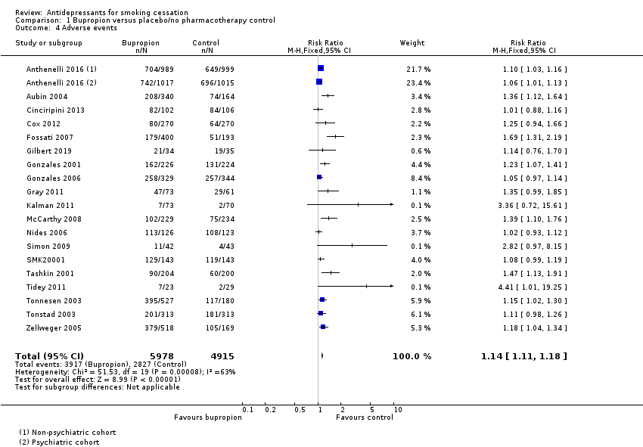
Figure 49: Results of adverse events in Howes et al. (2020), bupropion versus placebo
Source: Howes et al. (2020)

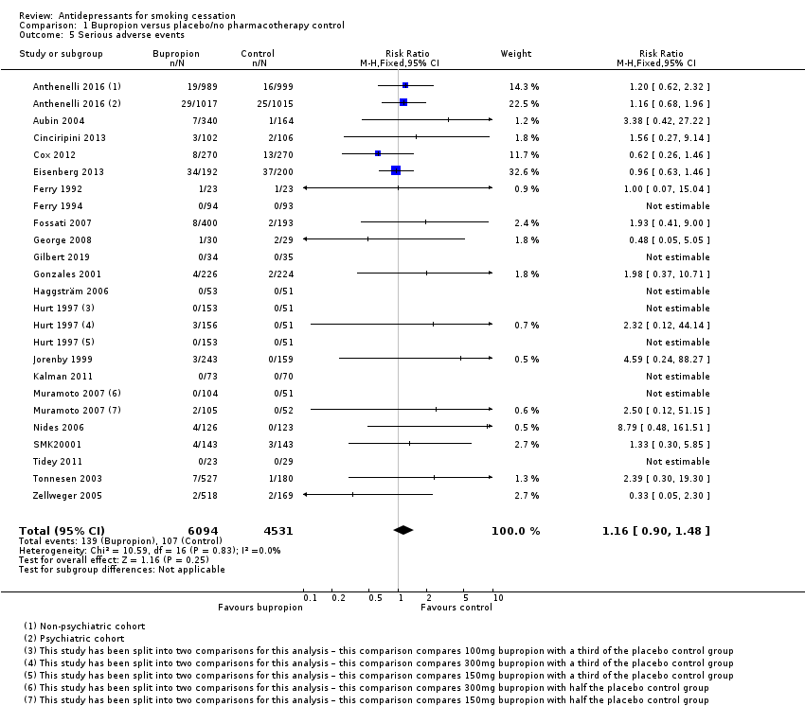
Figure 50: Results of serious adverse events in Howes et al. (2020), bupropion versus placebo
Source: Howes et al. (2020)
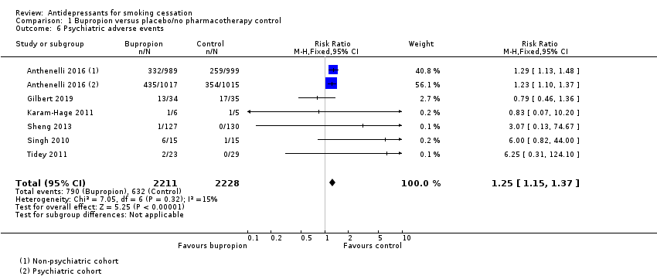
Figure 51: Results of psychiatric adverse events in Howes et al. (2020), bupropion versus placebo
Source: Howes et al. (2020)
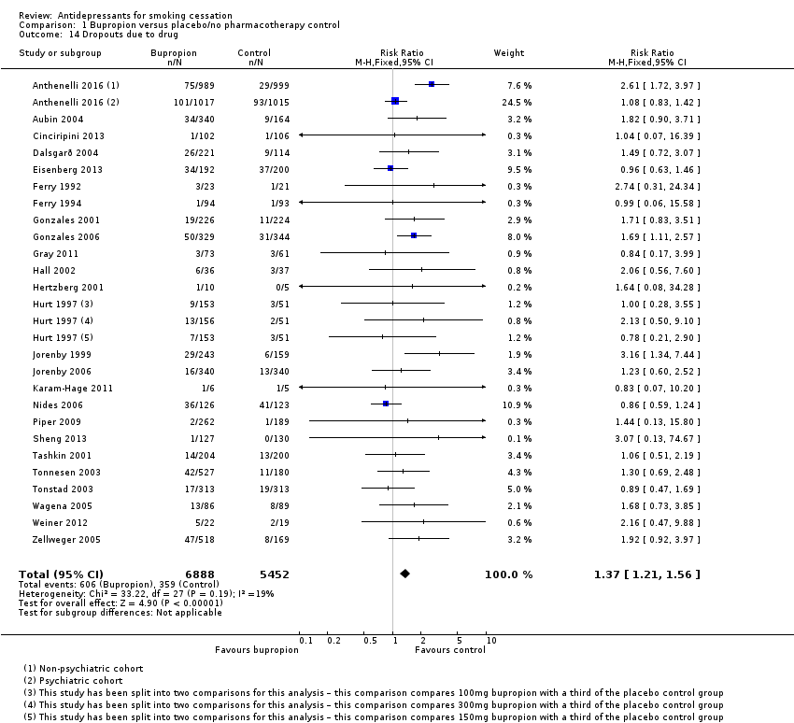
Figure 52: Results of discontinuation due to adverse events in Howes et al. (2020), bupropion versus placebo
Source: Howes et al. (2020)

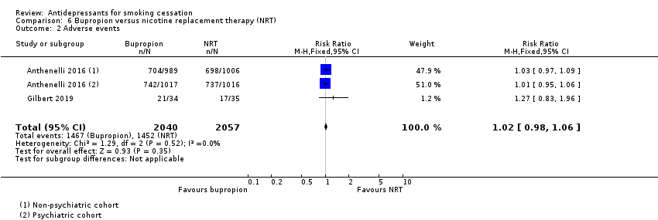
Figure 53: Results of adverse events in Howes et al. (2020), bupropion versus NRT
Source: Howes et al. (2020)
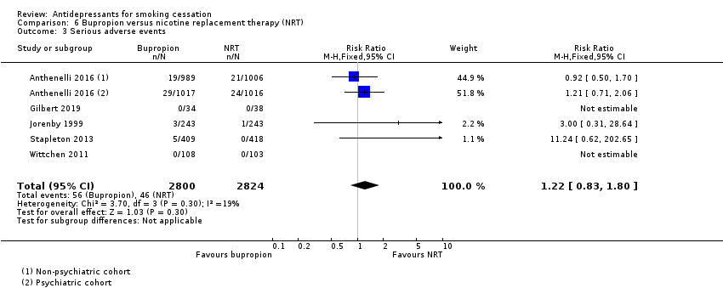
Figure 54: Results of serious adverse events in Howes et al. (2020), bupropion versus NRT
Source: Howes et al. (2020)
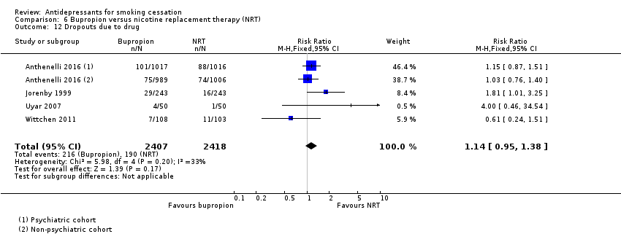
Figure 55: Results of discontinuation due to adverse events in Howes et al. (2020), bupropion versus NRT
Source: Howes et al. (2020)

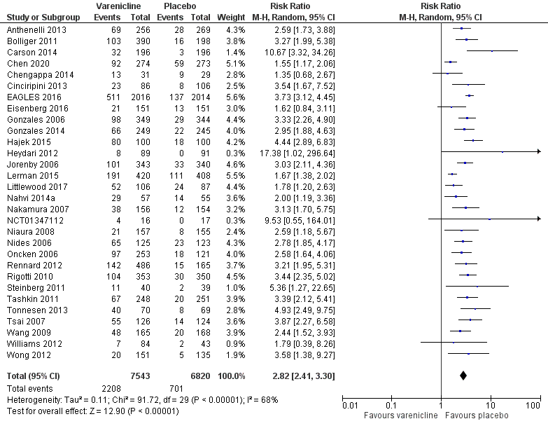
Figure 56: Results of adverse events (nausea) based on updated re-analysis, varenicline versus placebo
Source: Cahill et al. (2016), Lerman et al. (2015), Littlewood et al. (2017), Chen et al. (2020)
Note: Excluded the following studies from updated safety re-analysis due to incorrect treatment duration (NCT00828113, Williams 2007, Stein 2013, Evins 2014, Ebbert 2015; exceeded standard 12 weeks therapy).

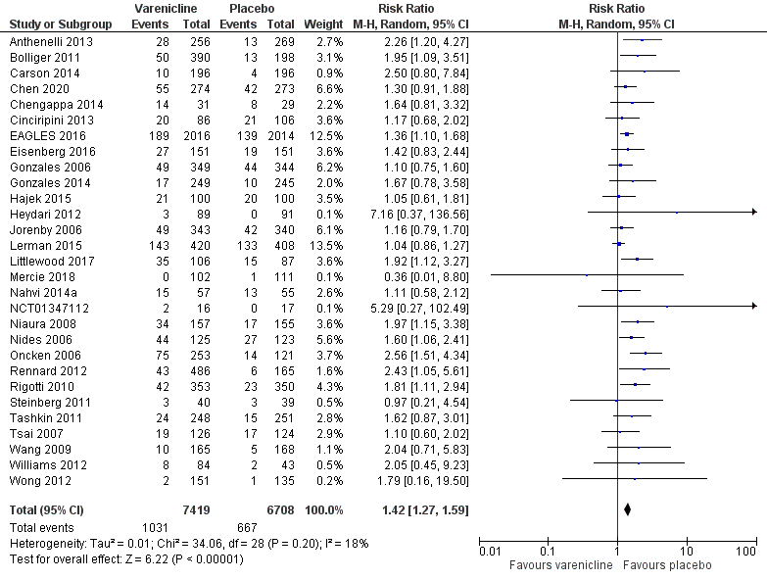
Figure 57: Results of adverse events (insomnia) based on updated re-analysis, varenicline versus placebo
Source: Cahill et al. (2016), Lerman et al. (2015), Littlewood et al. (2017), Mercie et al. (2018), Chen et al. (2020)
Note: Excluded the following studies from updated safety re-analysis due to incorrect treatment duration (Williams 2007, Stein 2013, Evins 2014, Ebbert 2015; exceeded standard 12 weeks therapy).

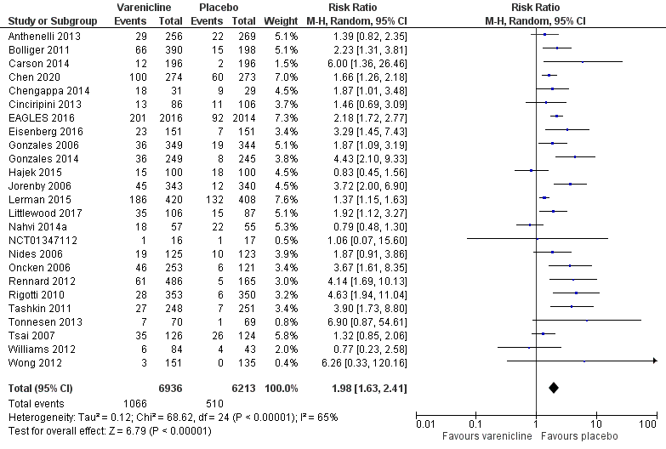
Figure 58: Results of adverse events (abnormal dreams) based on updated re-analysis, varenicline versus placebo
Source: Cahill et al. (2016), Lerman et al. (2015), Littlewood et al. (2017), Chen et al. (2020)
Note: Excluded the following studies from updated safety re-analysis due to incorrect treatment duration (Williams 2007, Stein 2013, Evins 2014, Ebbert 2015; exceeded standard 12 weeks therapy).

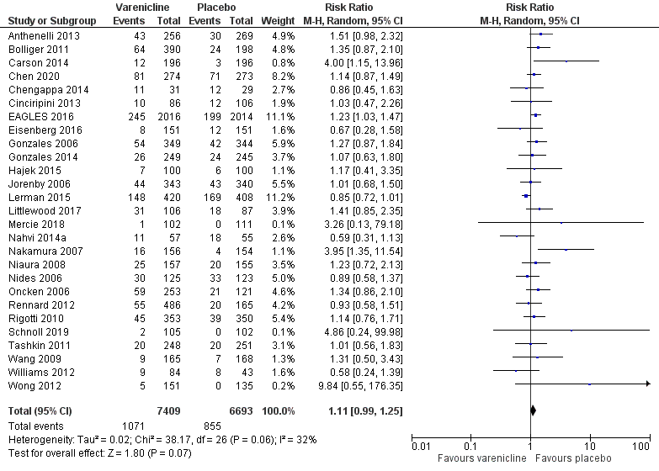
Figure 59: Results of adverse events (headache) based on updated re-analysis, varenicline versus placebo
Source: Cahill et al. (2016), Lerman et al. (2015), Littlewood et al. (2017), Mercie et al. (2018), Chen et al. (2020)
Note: Excluded the following studies from updated safety re-analysis due to incorrect treatment duration (Stein 2013, Evins 2014, Ebbert 2015; exceeded standard 12 weeks therapy).
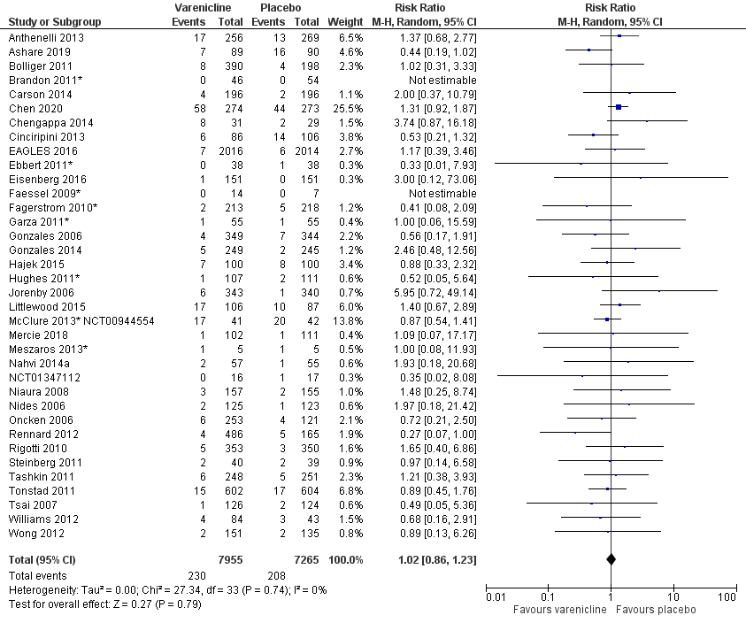
Figure 60: Results of adverse events (depression) based on updated re-analysis, varenicline versus placebo
Source: Cahill et al. (2016), Littlewood et al. (2017), Mercie et al. (2018), Ashare et al. (2019), Chen et al. (2020)
Note: Excluded the following studies from updated safety re-analysis due to incorrect treatment duration (Williams 2007, Stein 2013, Evins 2014, Ebbert 2015; exceeded standard 12 weeks therapy). In Mercie et al. (2018), depression adverse events were recorded as Grade 3 or 4.
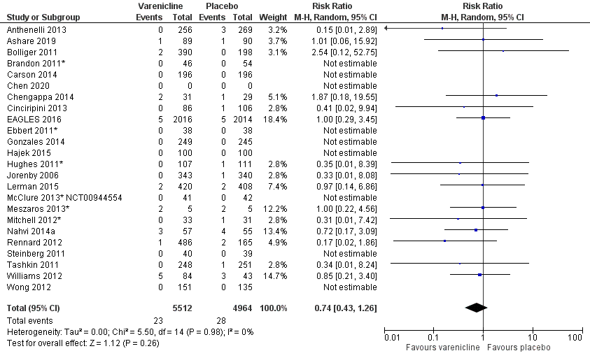
Figure 61: Results of adverse events (suicidal ideation) based on updated re-analysis, varenicline versus placebo
Source: Cahill et al. (2016), Lerman et al. (2015), Ashare et al. (2019), Chen et al. (2020)
Note: Excluded the following studies from updated safety re-analysis due to incorrect treatment duration (Stein 2013, Evins 2014, Ebbert 2015; exceeded standard 12 weeks therapy).

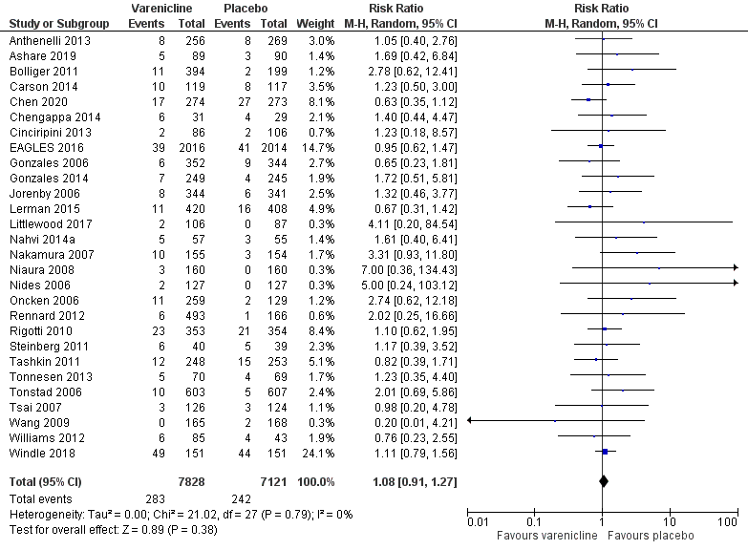
Figure 62: Results of serious adverse events based on updated re-analysis, varenicline versus placebo
Source: Cahill et al. (2016), Lerman et al. (2015), Littlewood et al. (2017), Windle et al. (2018), Ashare et al. (2019), Chen et al. (2020)
Note: Excluded the following studies from updated safety re-analysis due to incorrect treatment duration (NCT00828113, Williams 2007, Stein 2013, Evins 2014, Ebbert 2015; exceeded standard 12 weeks therapy).

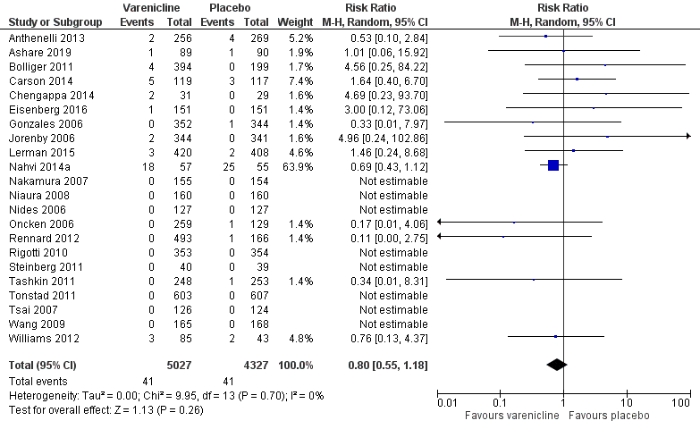
Figure 63: Results of neuropsychiatric serious adverse events based on updated re-analysis, varenicline versus placebo
Source: Cahill et al. (2016), Lerman et al. (2015), Ashare et al. (2019)
Note: Excluded the following studies from updated safety re-analysis due to incorrect treatment duration (Williams 2007, Stein 2013, Evins 2014; exceeded standard 12 weeks therapy).

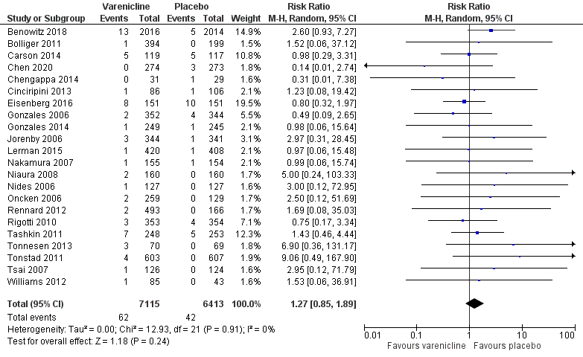
Figure 64: Results of cardiac serious adverse events based on updated re-analysis, varenicline versus placebo
Source: Cahill et al. (2016), Lerman et al. (2015), Benowitz et al. (2018), Chen et al. (2020)
Note: Excluded the following studies from updated safety re-analysis due to incorrect treatment duration (Williams 2007, Evins 2014; exceeded standard 12 weeks therapy).

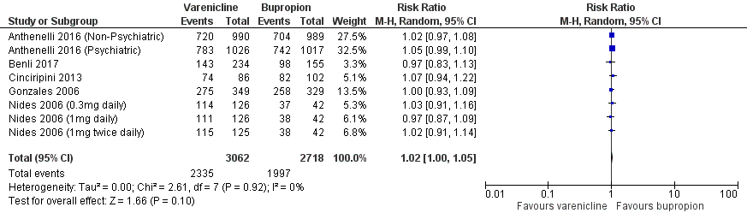
Figure 65: Results of adverse events in Howes et al. (2020), varenicline versus bupropion
Source: Howes et al. (2020)
Note: Howes et al. (2020) presented this comparison as bupropion versus varenicline (inverse) using a fixed-effect model. Re-calculated during the review for varenicline versus bupropion using a random-effect model.

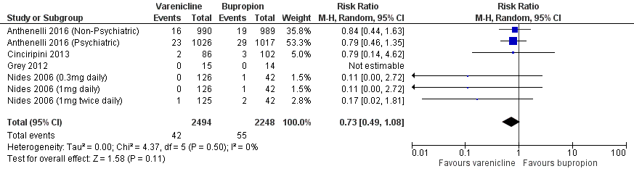
Figure 66: Results of serious adverse events in Howes et al. (2020), varenicline versus bupropion
Source: Howes et al. (2020)
Note: Howes et al. (2020) presented this comparison as bupropion versus varenicline (inverse) using a fixed-effect model. Re-calculated during the review for varenicline versus bupropion using a random-effect model.

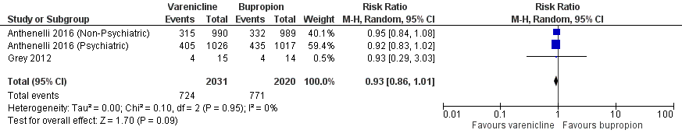
Figure 67: Results of psychiatric adverse events in Howes et al. (2020), varenicline versus bupropion
Source: Howes et al. (2020)
Note: Howes et al. (2020) presented this comparison as bupropion versus varenicline (inverse) using a fixed-effect model. Re-calculated during the review for varenicline versus bupropion using a random-effect model.

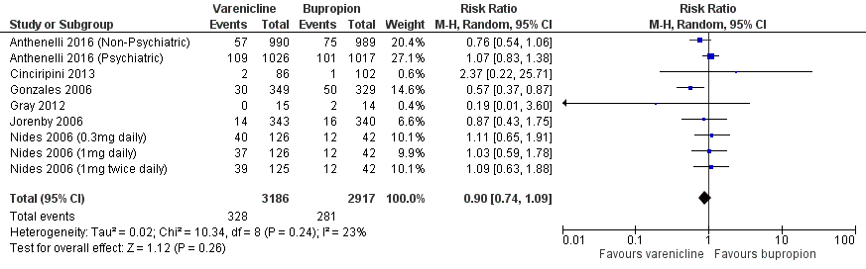
Figure 68: Results of discontinuation due to adverse events in Howes et al. (2020), varenicline versus bupropion
Source: Howes et al. (2020)
Note: Howes et al. (2020) presented this comparison as bupropion versus varenicline (inverse) using a fixed-effect model. Re-calculated during the review for varenicline versus bupropion using a random-effect model.
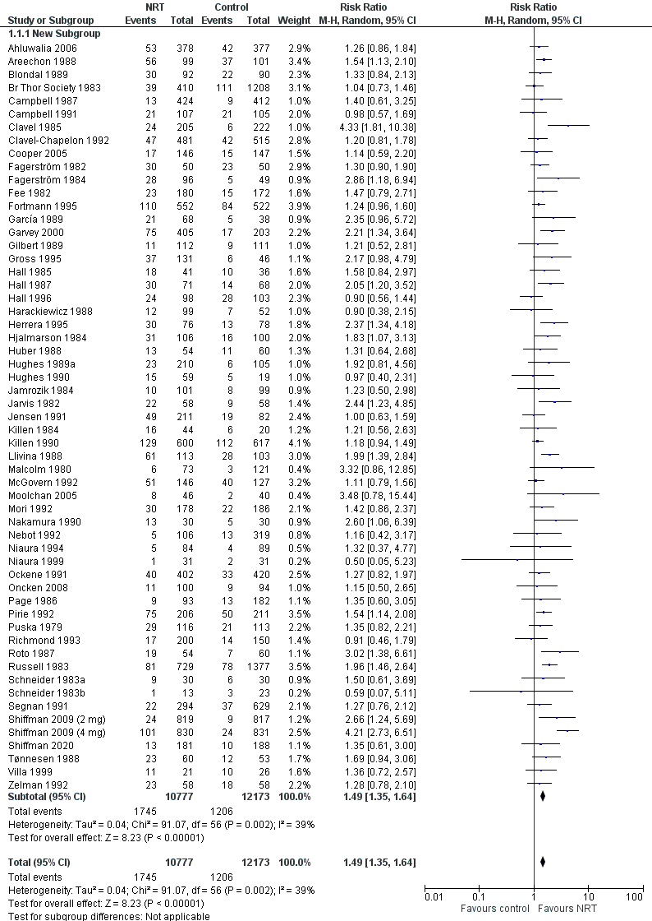
Figure 69: Results of smoking cessation of at least six months follow-up based on updated re-analysis, NRT gum versus placebo
Source: Hartmann-Boyce et al. (2018), Shiffman et al. (2020)
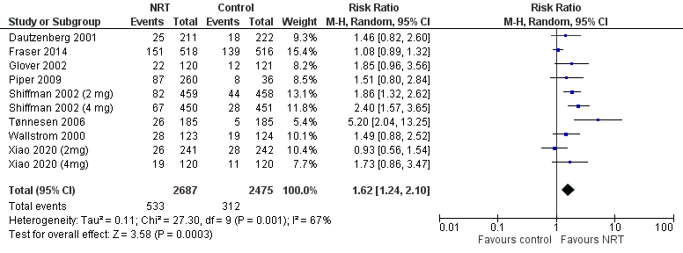
Figure 70: Results of smoking cessation of at least six months follow-up based on updated re-analysis, NRT gum versus placebo
Source: Hartmann-Boyce et al. (2018), Xiao et al. (2020)
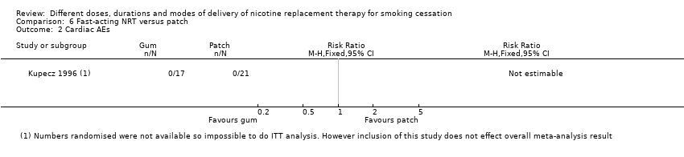
Figure 71: Results of cardiac adverse events in Lindson et al. (2019), NRT gum versus NRT patch
Source: Lindson et al. (2019)
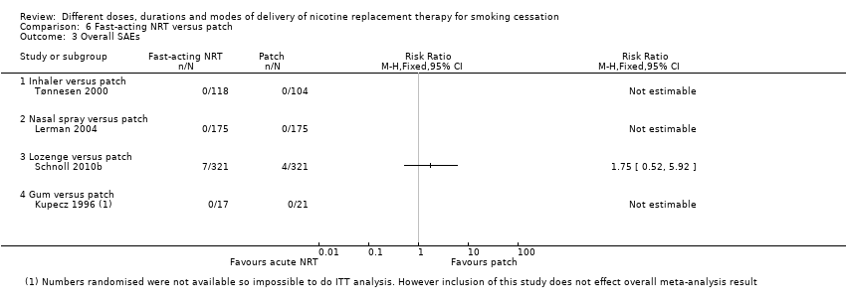
Figure 72: Results of serious adverse events in Lindson et al. (2019), NRT lozenge or gum versus NRT patch
Source: Lindson et al. (2019)
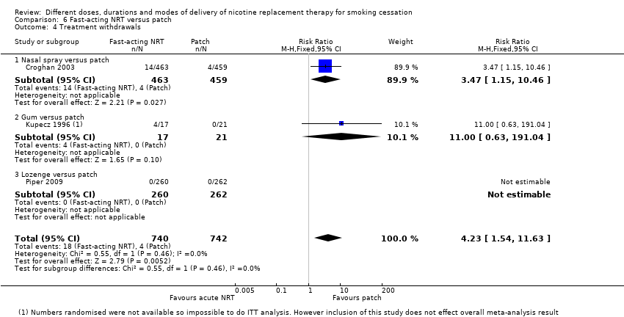
Figure 73: Results of withdrawals due to treatment in Lindson et al. (2019), NRT lozenge or gum versus NRT patch
Source: Lindson et al. (2019)
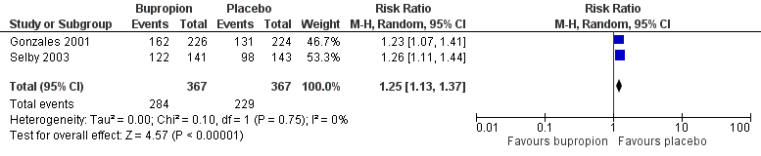
Figure 74: Results of adverse events based on Gonzales (2001) and Selby (2003), bupropion versus placebo
Source: Howes et al. (2020), Gonzales et al. (2001), Selby et al. (2003)
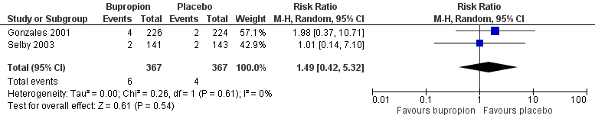
Figure 75: Results of serious adverse events based on Gonzales (2001) and Selby (2003), bupropion versus placebo
Source: Howes et al. (2020), Gonzales et al. (2001), Selby et al. (2003)

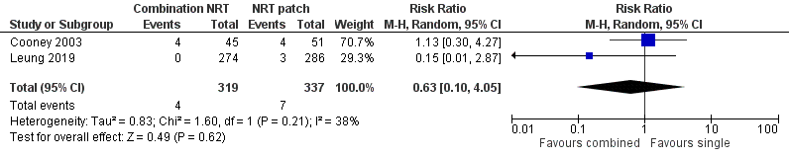
Figure 76: Results of cardiac adverse events in Lindson et al. (2019), combination NRT versus NRT monotherapy
Source: Lindson et al. (2019)

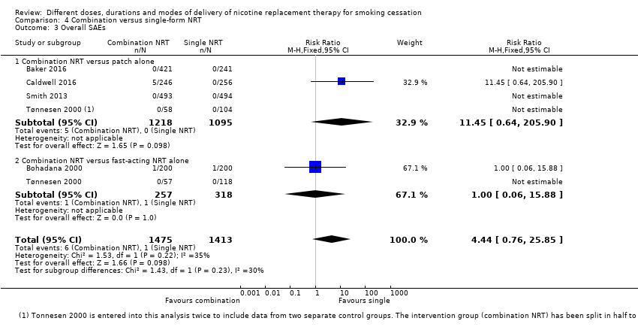
Figure 77: Results of serious adverse events in Lindson et al. (2019), combination NRT versus NRT monotherapy
Source: Lindson et al. (2019)

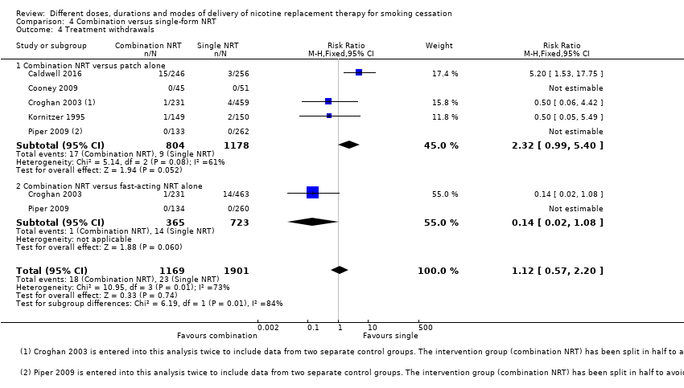
Figure 78: Results of withdrawals due to treatment in Lindson et al. (2019), combination NRT versus NRT monotherapy
Source: Lindson et al. (2019)

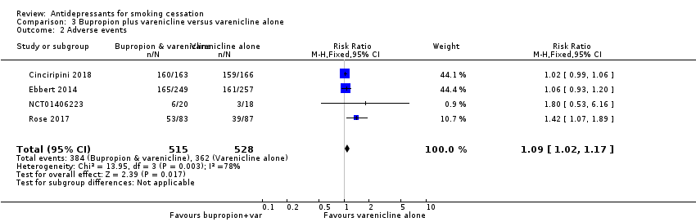
Figure 79: Results of adverse events in Howes et al. (2020), varenicline plus bupropion versus varenicline alone
Source: Howes et al. (2020)

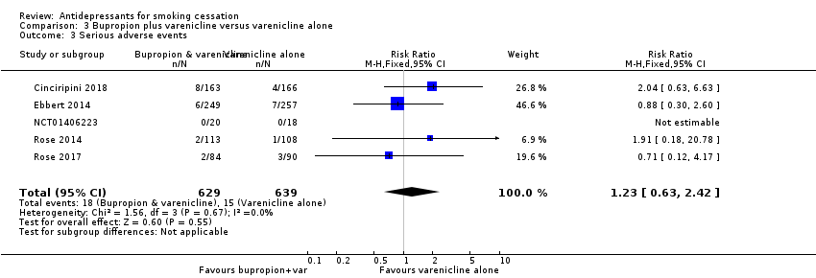
Figure 80: Results of serious adverse events in Howes et al. (2020), varenicline plus bupropion versus varenicline alone
Source: Howes et al. (2020)

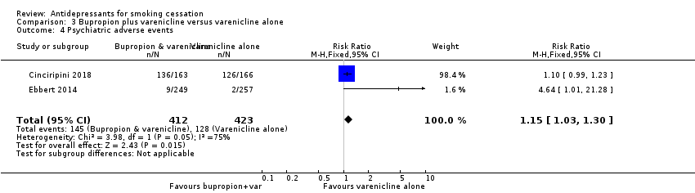
Figure 81: Results of psychiatric adverse events in Howes et al. (2020), varenicline plus bupropion versus varenicline alone
Source: Howes et al. (2020)

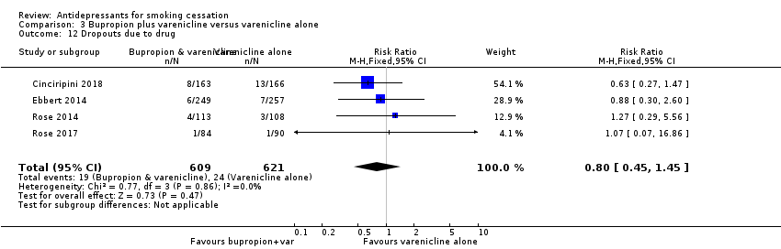
Figure 82: Results of discontinuation due to adverse events in Howes et al. (2020), varenicline plus bupropion versus varenicline alone
Source: Howes et al. (2020)

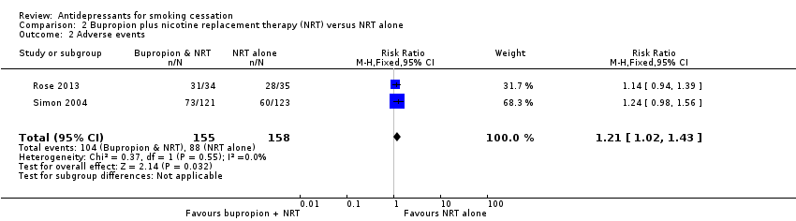
Figure 83: Results of adverse events in Howes et al. (2020), bupropion plus NRT versus NRT alone
Source: Howes et al. (2020)

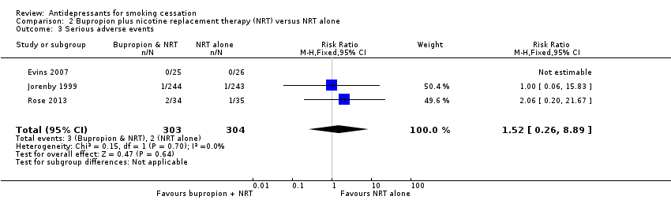
Figure 84: Results of serious adverse events in Howes et al. (2020), bupropion plus NRT versus NRT alone
Source: Howes et al. (2020)

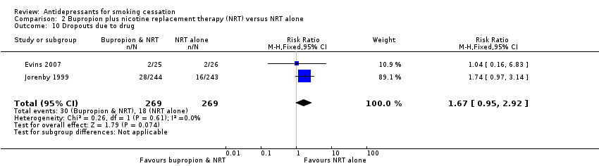
Figure 85: Results of discontinuation due to adverse events in Howes et al. (2020), bupropion plus NRT versus NRT alone
Source: Howes et al. (2020)

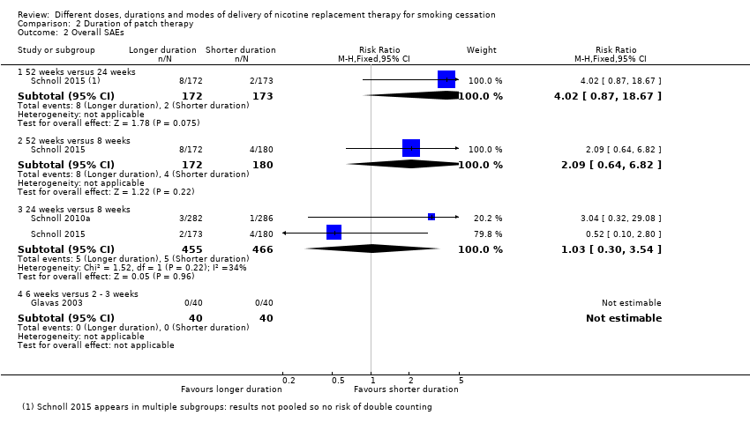
Figure 86: Results of serious adverse events in Lindson et al. (2019), higher dose versus lower dose NRT patch
Source: Lindson et al. (2019)

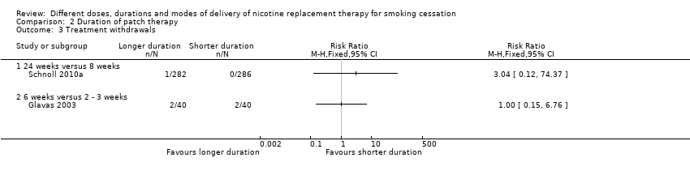
Figure 87: Results of treatment withdrawals in Lindson et al. (2019), higher dose versus lower dose NRT patch
Source: Lindson et al. (2019)

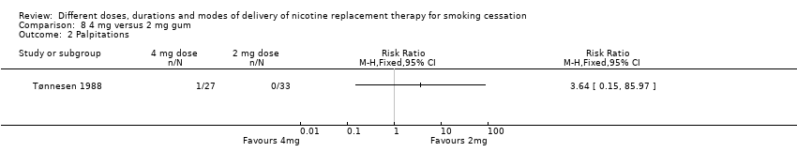
Figure 88: Results of palpitations as adverse events in Lindson et al. (2019), higher dose versus lower dose NRT gum
Source: Lindson et al. (2019)

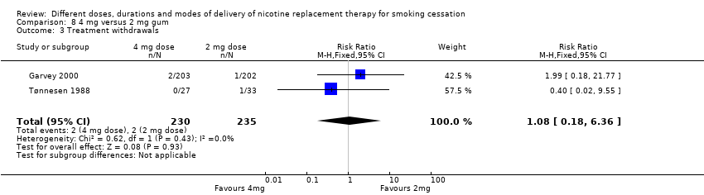
Figure 89: Results of treatment withdrawals in Lindson et al. (2019), higher dose versus lower dose NRT gum
Source: Lindson et al. (2019)

Figure 90: Results of overall serious adverse events in Lindson et al. (2019), longer duration versus shorter duration NRT patch
Source: Lindson et al. (2019)

Figure 91: Results of adverse events (treatment withdrawals) in Lindson et al. (2019), longer duration versus shorter duration NRT patch
Source: Lindson et al. (2019)

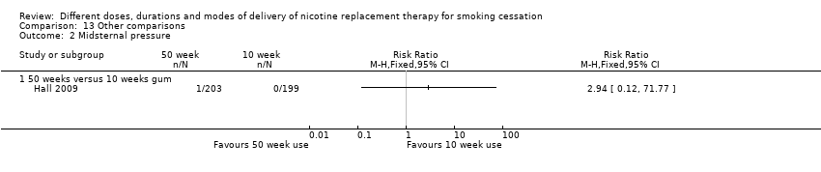
Figure 92: Results of key adverse events (midsternal pressure) in Lindson et al. (2019), 50-week duration versus 10-week duration NRT gum
Source: Lindson et al. (2019)

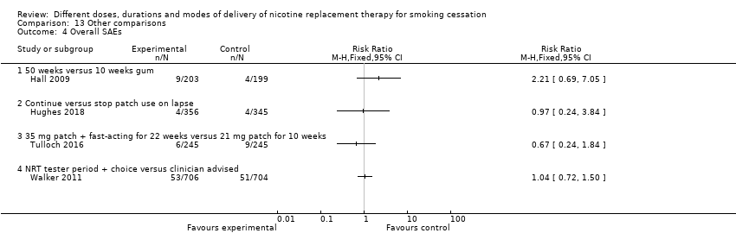
Figure 93: Results of overall serious adverse events in Lindson et al. (2019), 50-week duration versus 10-week duration NRT gum, other variations in NRT use
Source: Lindson et al. (2019)

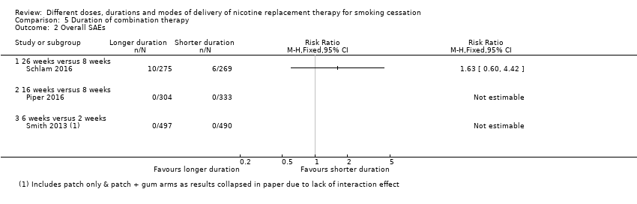
Figure 94: Results of overall serious adverse events in Lindson et al. (2019), longer duration versus shorter duration combination NRT
Source: Lindson et al. (2019)
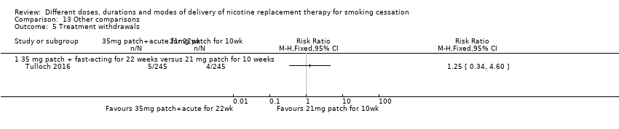
Figure 95: Results of key adverse events (treatment withdrawals) in Lindson et al. (2019), other variations in NRT use
Source: Lindson et al. (2019)

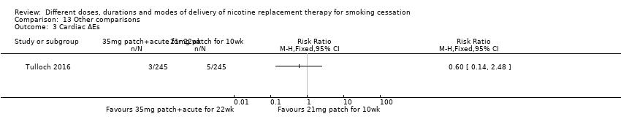
Figure 96: Results of key adverse events (cardiac AEs) in Lindson et al. (2019), other variations in NRT use
Source: Lindson et al. (2019)

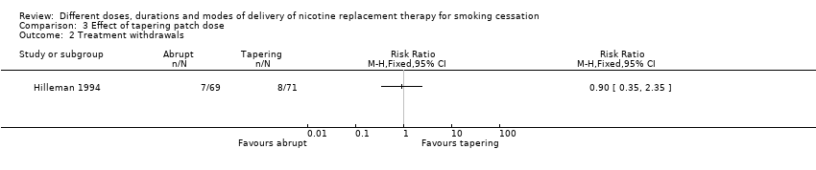
Figure 97: Results of key adverse events (treatment withdrawals) in Lindson et al. (2019), tapering patch dose
Source: Lindson et al. (2019)

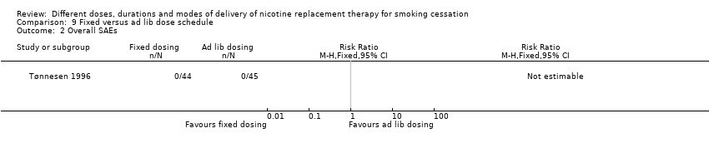
Figure 98: Results of overall serious adverse events in Lindson et al. (2019), fixed versus ad lib dosing
Source: Lindson et al. (2019)

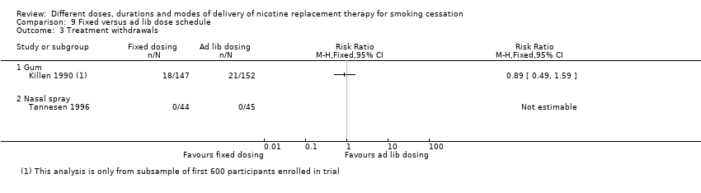
Figure 99: Results of treatment withdrawals in Lindson et al. (2019), fixed versus ad lib dosing
Source: Lindson et al. (2019)

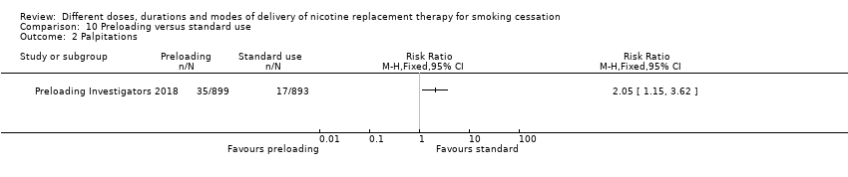
Figure 100: Results key adverse events (palpitations) in Lindson et al. (2019), preloading versus standard use
Source: Lindson et al. (2019)

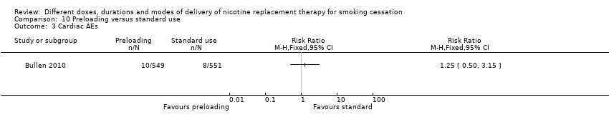
Figure 101: Results key adverse events (cardiac AEs) in Lindson et al. (2019), preloading versus standard use
Source: Lindson et al. (2019)

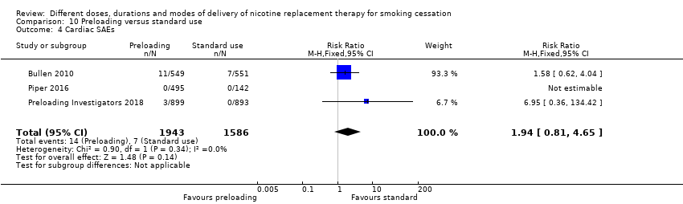
Figure 102: Results key adverse events (cardiac SAEs) in Lindson et al. (2019), preloading versus standard use
Source: Lindson et al. (2019)

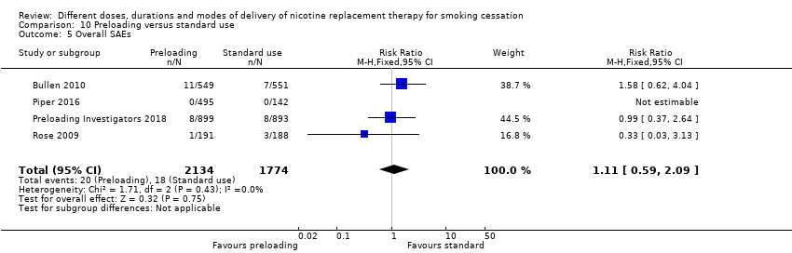
Figure 103: Results key adverse events (overall SAEs) in Lindson et al. (2019), preloading versus standard use
Source: Lindson et al. (2019)

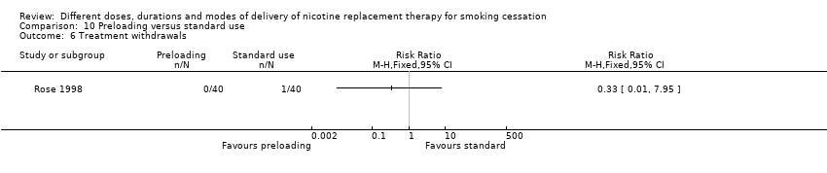
Figure 104: Results of key adverse events (treatment withdrawals) in Lindson et al. (2019), preloading versus standard use
Source: Lindson et al. (2019)

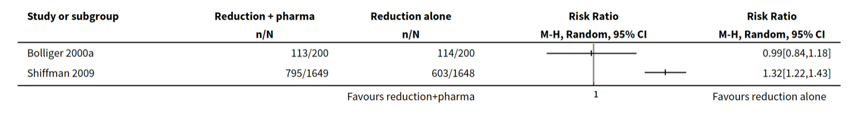
Figure 105: Results of key adverse events (AEs) in Lindson et al. (2019b), reduction with pharmacotherapy versus reduction alone
Source: Lindson et al. (2019b)

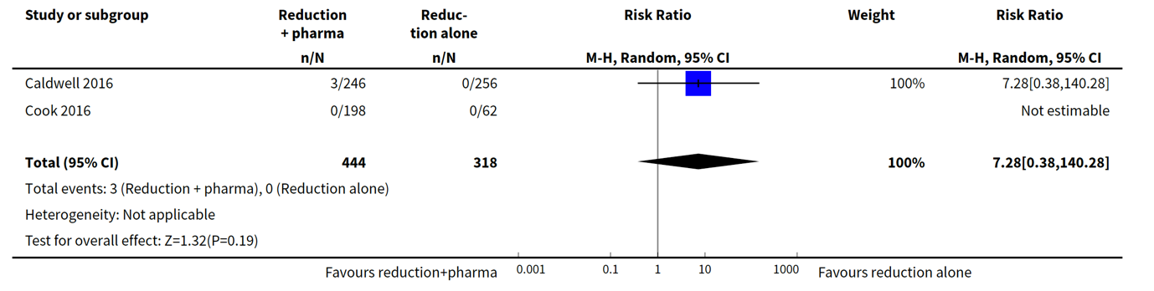
Figure 106: Results of key adverse events (SAEs) in Lindson et al. (2019b), reduction with pharmacotherapy versus reduction alone
Source: Lindson et al. (2019b)

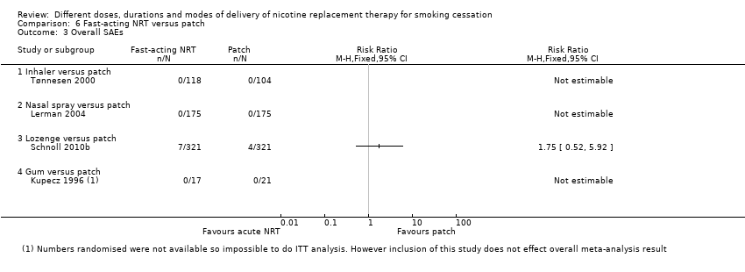
Figure 107: Results of key adverse events (overall SAEs) in Lindson et al. (2019), NRT inhaler versus patch, NRT nasal spray versus patch
Source: Lindson et al. (2019)

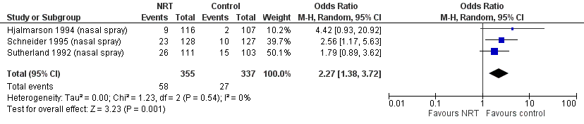
Figure 108: Results of key adverse events (Palpitations/chest pains) in Hartmann-Boyce et al. 2018, NRT intranasal spray versus placebo
Source: Hartmann-Boyce et al. (2018)
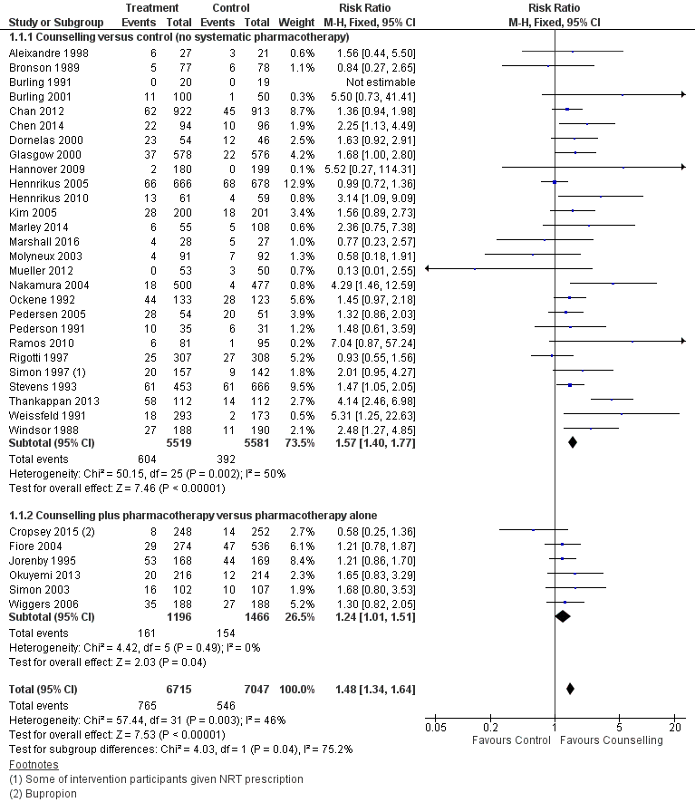
Figure 109: Results of smoking cessation of at least six months follow-up in Lancaster et al. (2017), individual counselling versus minimal contact control
Source: Lancaster et al. (2017)

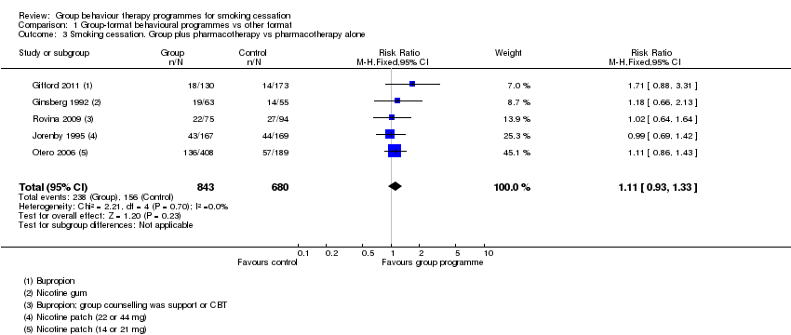
Figure 110: Results of smoking cessation of at least six months follow-up in Stead et al. (2017), group therapy plus pharmacotherapy versus pharmacotherapy alone
Source: Stead et al. (2017)

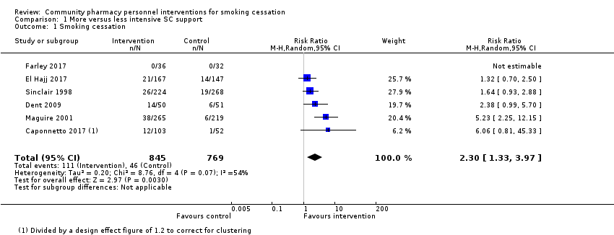
Figure 111: Results of smoking cessation of at least six months follow-up in Carson-Chahhoud et al. (2019), more versus less intensive smoking cessation support
Source: Carson-Chahhoud et al. (2019)

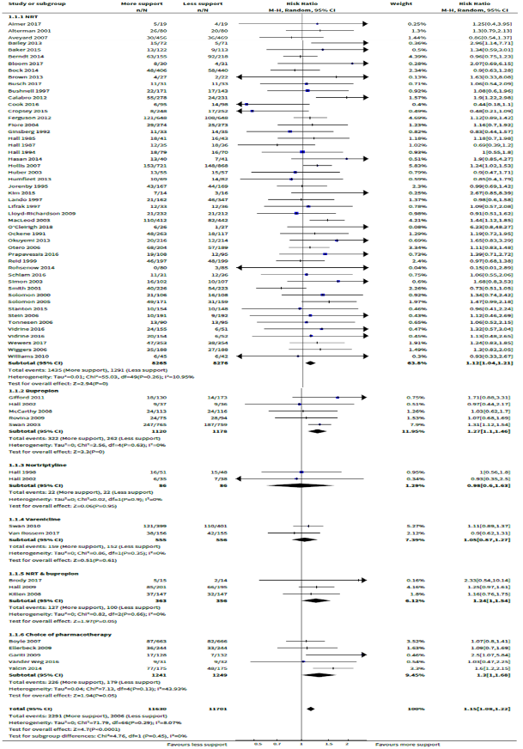
Figure 112: Results of smoking cessation of at least six months follow-up in Hartmann-Boyce et al. (2019), more versus less intensive behavioural support
Source: Hartmann-Boyce et al. (2019)

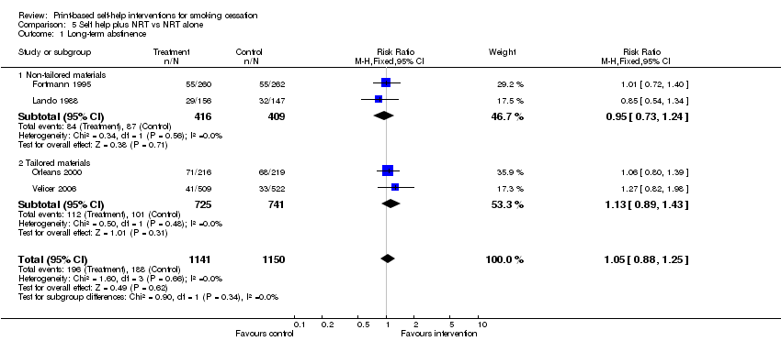
Figure 113: Results of smoking cessation of at least six months follow-up in Livingstone-Banks et al. (2019b), self-help plus NRT versus NRT alone
Source: Livingstone-Banks et al. (2019b)

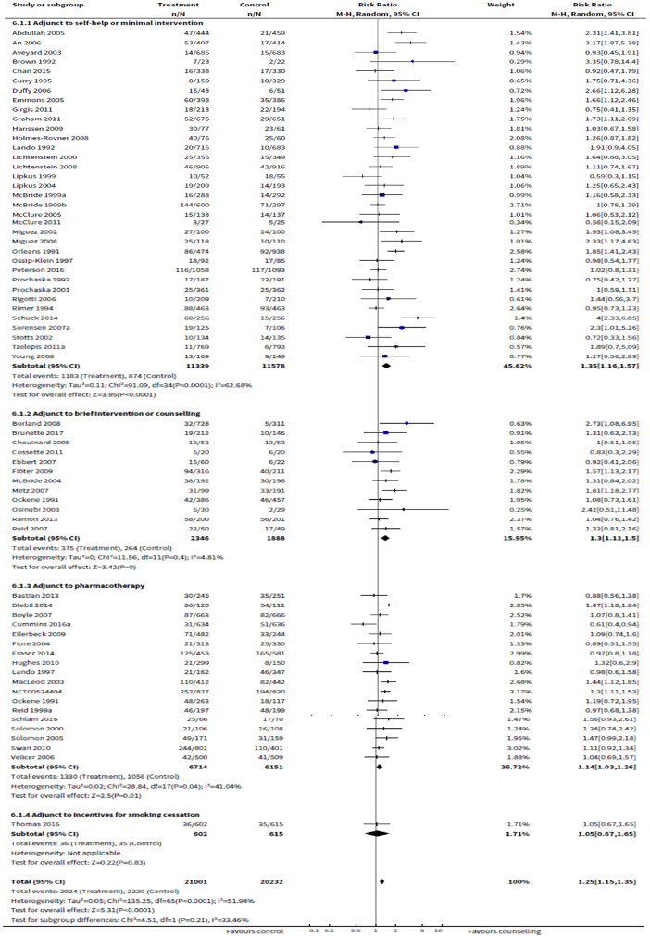
Figure 114: Results of smoking cessation of at least six months follow-up in Matkin et al. (2019), proactive telephone counselling versus no counselling
Source: Matkin et al. (2019)

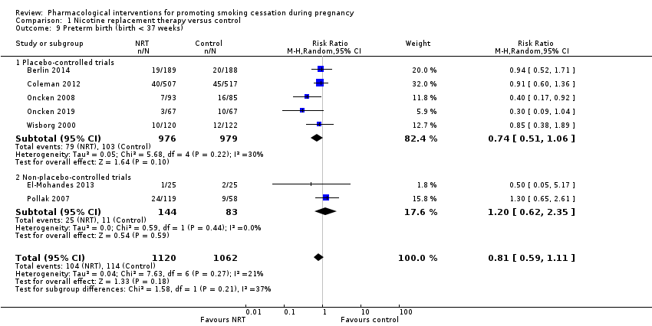
Figure 115: Results of key adverse events (preterm birth) in Claire et al. (2020), NRT versus control
Source: Claire et al. (2020)

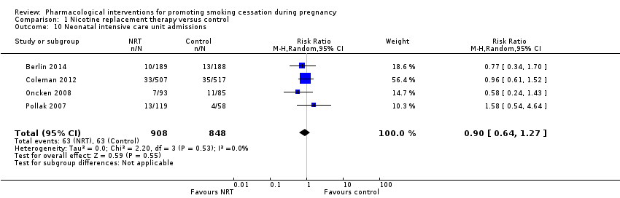
Figure 116: Results of key adverse events (neonatal intensive care unit admissions) in Claire et al. (2020), NRT versus control
Source: Claire et al. (2020)
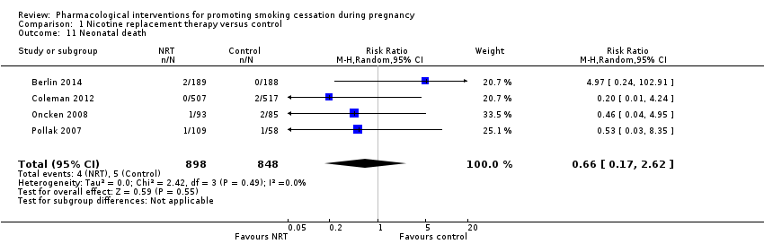
Figure 117: Results of key adverse events (neonatal death) in Claire et al. (2020), NRT versus control
Source: Claire et al. (2020)

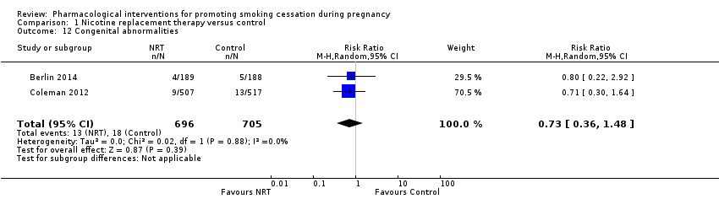
Figure 118: Results of key adverse events (congenital abnormalities) in Claire et al. (2020), NRT versus control
Source: Claire et al. (2020)

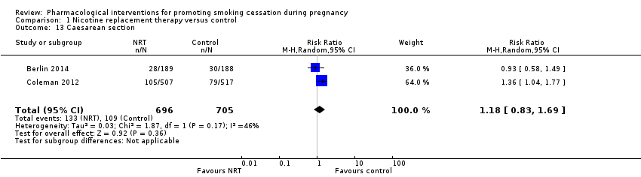
Figure 119: Results of key adverse events (caesarean section) in Claire et al. (2020), NRT versus control
Source: Claire et al. (2020)

Lindson et al. (2019) pooled studies comparing 42 mg/24-hour versus 21 mg/24-hour and 44 mg/24-hour versus 22 mg/24-hour patches

