Price Disclosure Reforms under the New Strategic Agreement – Fact Sheet
Amendments made by the National Health Amendment (Enhancing the Pharmaceutical Benefits Scheme) Act 2021 (Cth) (Amendment Act) and the National Health (Pharmaceutical Benefits) Amendment (2021 Measures No. 1) Regulations 2021 (Cth) (Amendment Regulations) give effect to the commitments in the Strategic Agreements with the medicines industry (2022-2027). The legislative amendments take effect from 1 July 2022 and include the following changes to price disclosure:
- Introduction of floor prices for designated brands – see ‘designated brands’ and ‘floor price protections’ below.
- Changes to the threshold for applying price disclosure price reductions – see ‘price disclosure thresholds’ below.
- Changes to the timing for removal of originator brands from calculations – see ‘early removal of originator brand data’ below.
- Changes to exclusion of supplies to public hospitals within disclosed data – see ‘public hospital data disclosure’ below.
- Changes to adjusted net revenue calculations (effective from the 2023 October price disclosure cycle) – see part 7.2 of the price disclosure guidelines.
Refer to the price disclosure guidelines for further details about these changes.

Designated brands
From 1 July 2022, brands of pharmaceutical items that are ‘designated brands’ will be subject to floor price protections and the 30% threshold or 12.5% average price reduction threshold test under s99ADH of the National Health Act 1953 (the Act). This means the new thresholds for designated brands will apply for price disclosure reductions that occur on 1 October 2022 onwards.
Designated brands meet one of the following criteria under s99ADHC of the Act:
- the drug and manner of administration of the brand’s pharmaceutical item has been on F2 for at least 42 months, and at least 30 months have passed since the first price disclosure price reduction for any brand of pharmaceutical item with the same drug and manner of administration (42 month clock) (s99ADHC(1)(a));
- the approved ex-manufacturer price (AEMP) of the brand is $4 or less (s99ADHC(1)(b));
- the AEMP of the brand has been increased on and after 1 July 2022 through a new price agreement and the Minister has determined that the brand be designated (s99ADHC(1)(c));
- the AEMP of the brand has received a price increase on 1 October 2022 under s104B of the Act (s99ADHC(1)(d)).
From 1 July 2023, designated brands will be subject to the minimum stockholding requirements outlined under Division 3CAA of the Act.

Floor price protections
Designated brands with an AEMP of $4 or less are not subject to price reductions under Part VII of the Act. That is, they will not have their prices reduced as a result of an anniversary, first new brand, combination item flow-on or price disclosure reduction. Floor price protections will apply for price disclosure reductions that occur on 1 October 2022 onwards. The price may reduce below $4 through a price agreement between the responsible person and the Minister.
Designated brands with an AEMP of more than $4 are subject to the 30% threshold or the 12.5% average price reduction threshold test (refer to price reduction thresholds).
If a designated brand with an AEMP of more than $4 exceeds one of the thresholds, the price reduction will not reduce the AEMP any lower than $4. For example, if a designated brand has an AEMP of $4.50, a WADP that exceeds the 12.5% average threshold, and will be subject to a 25% reduction, instead of a new AEMP of $3.38 applying, the new AEMP will be $4.
A brand that is not a designated brand and hence not subject to floor price protections, may have price disclosure reductions (or other price reductions under Part VII of the Act) that reduce the AEMP below $4. Should this price reduction occur, the brand will then become a designated brand.

Price Disclosure reduction thresholds
Changes to the thresholds apply for price disclosure reductions that occur on 1 October 2022 onwards.
A price disclosure reduction may occur when the unadjusted price reduction meets the relevant threshold. The relevant price disclosure thresholds are set out in s99ADH(1)(c) of the Act and are as follows:
- For brands that are not designated brands – 10%;
- For designated brands with an AEMP of more than $4 – 30%; or
- For designated brands with an AEMP of more than $4, if there has been discounting averaging at least 12.5% over the last 3 data collection periods including the one for which calculations are performed and there has not been a price reduction under s99ADH of the Act – 10%.
Refer to Figure 1, Appendix A for more information.

Early removal of originator brand data
The Minister may determine an originator brand for a brand of a pharmaceutical item listed on the F2 formulary. The Minister must have regard to whether, when the brand of the pharmaceutical item was first PBS listed, it was in the F1 formulary or administrative Combination Drugs List. For certain pharmaceutical items, calculations are performed with and without originator brand data, and the calculation resulting in the lowest new price is applied.
If brands of a drug and manner of administration have:
- been listed on the F2 formulary for at least 18 months; and
- there have been no price disclosure reductions in that period; and
- one or more generics are listed during the data collection period of a cycle
the originator brand data is removed for the calculation of a WADP if it results in a lower price.
The early removal of originator brand data (at 18 months) will operate in addition to the existing 30 month clock, whereby the originator brand data is removed after the drug in the brand has been on F2 for at least 30 months. The potential removal of originator brand data at 18 months will apply for price disclosure reductions that occur on 1 April 2023 onwards.
Refer to Figure 2, Appendix A for more information.

Public hospital data disclosure
Changes to the exclusion of supplies to public hospitals within disclosed data are effective from the 2023 October cycle onwards.
For the first 42 months that a drug is listed on F2 public hospital data is excluded from the data which is provided by responsible persons. For a data collection period commencing 1 October 2022 or later, if the drug in the pharmaceutical item has been on F2 for at least 42 months at the end of the previous data collection period for the brand, then supply to a public hospital must be included in the data provided by responsible persons.
Refer to Figure 3, Appendix A for more information.

Appendix A: Price Disclosure Diagrams

Figure 1 Process to determine price disclosure reduction for a brand
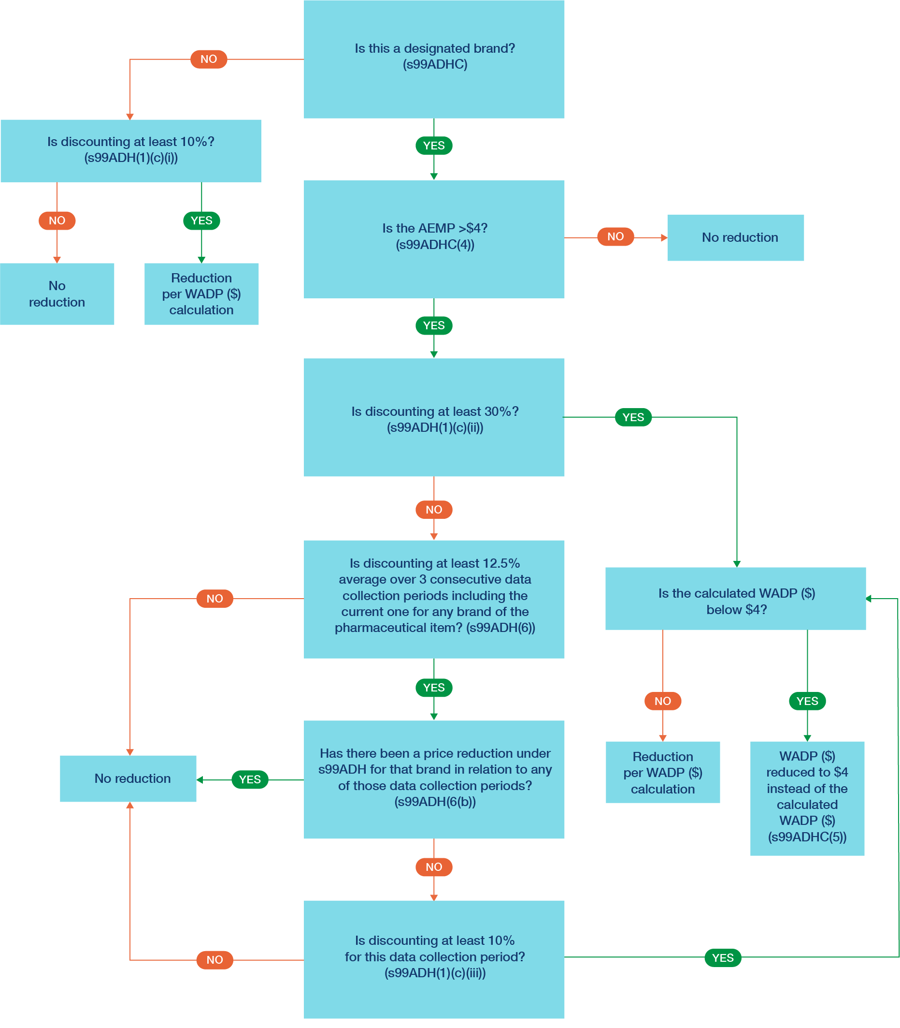

Figure 2 Process to apply calculations with or without originator brand data
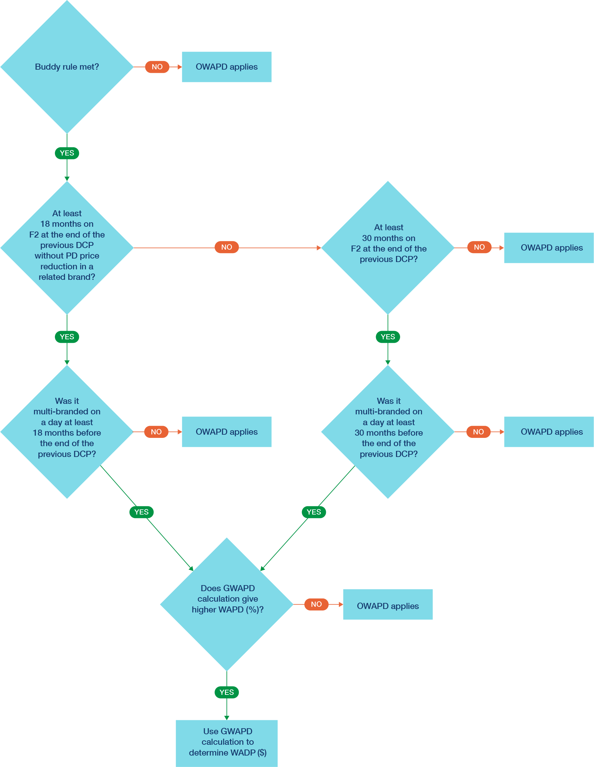

Figure 3 Inclusion of data on public hospital supplies after seven cycles of price disclosure (42 months)
