Pharmaceutical Benefits Scheme
Post-market Review of
Chronic Obstructive Pulmonary Disease Medicines
ToR 4
Final Report
August 2017
Contents
Section 4: ToR 4 Review of safety of prolonged ICS use 4
4.1 Key findings for ToR 4 4
Stakeholder views (Forum and public consultations) 4
4.2 Methodology 5
4.2.1 Identification of relevant studies 5
4.3 ICS safety evidence previously considered by the PBAC 6
4.3.1 ICS safety profile at registration 6
4.3.2 ICS safety evidence previously considered by the PBAC 7
4.4 ICS safety evidence not considered by the PBAC 12
4.4.1 Systematic reviews 12
4.4.2 HTAs 40
4.4.3 Observational studies 43
4.4.4 Regulatory agency reports – ICS safety 52
4.4.5 Additional key studies 55
4.5 Conclusions 59

List of Tables
Table 4.1 Literature search criteria for ToR 4 5
Table 4.2 Adverse event general advice from PIs for FLU/SAL, FLU/VIL and BUD/EFO 7
Table 4.3 Systematic reviews of the safety of ICS/LABA or ICS compared to LABA or placebo 13
Table 4.4 Outline of the identified systematic reviews and selection of key reviews 14
Table 4.5 Fluticasone and budesonide RCTs included in the key systematic reviews 19
Table 4.6 Inclusion and exclusion criteria for Nannini 2012 and 2013 21
Table 4.7 Pooled estimates for FLU/SAL comparisons – Nannini 2012 and 2013 21
Table 4.8 Pooled estimates for BUD/EFO comparisons – Nannini 2012 and 2013 22
Table 4.9 Inclusion and exclusion criteria for Kew (2014) 26
Table 4.10 Fluticasone and budesonide studies, showing comparison types, doses and meta-analyses inclusion – Kew 2014 27
Table 4.11 Statistically significant results for pneumonia risk – Tricco 2015 36
Table 4.12 Pooled analyses investigating the safety of ICS 40
Table 4.13 Study drug dosages for the published trials of fluticasone furoate/vilanterol 41
Table 4.14 Safety results for 52-week Dransfield (2013) RCTs – NICE (2013) Evidence Summary 41
Table 4.15 Observational studies reporting pneumonia outcomes for COPD 43
Table 4.16 Observational studies reporting pneumonia outcomes – summary of findings 46
Table 4.17 Observational studies reporting safety outcomes with ICS use 50
Table 4.18 Pneumonia in the SUMMIT trial of fluticasone furoate/vilanterol – Vestbo 2016 55
Table 4.19 Patient disposition in the TORCH RCT 58
Table 4.20 Selected safety results from the TORCH RCT – Calverley 2007 and SCO30003 CSR 58
List of Figures
Figure 4.1 Pooled analysis of pneumonia SAEs across fluticasone propionate/salmeterol vs placebo trials, presented in the Symbicort® Turbuhaler® major submission 9
Figure 4.2 Risk of pneumonia for FLU/SAL vs SAL and BUD/EFO vs EFO – Nannini 2012 23
Figure 4.3 Pneumonia for FLU/SAL vs SAL and BUD/EFO vs EFO, by dose – Nannini 2012 24
Figure 4.4 Risk of pneumonia for FLU/SAL vs placebo and BUD/EFO vs placebo – Nannini 2013 25
Figure 4.5 Risk of non-fatal pneumonia SAEs for fluticasone versus controls – Kew 2014 29
Figure 4.6 All pneumonia events for fluticasone versus controls – Kew 2014 30
Figure 4.7 Non-fatal pneumonia SAEs for budesonide versus controls – Kew 2014 31
Figure 4.8 Non-fatal pneumonia SAEs for budesonide versus controls by dose – Kew 2014 32
Figure 4.9 Risk of pneumonia for FLU and BUD monotherapy versus placebo – Kew (2014) 33
Figure 4.10 Summary of pooled estimates of ICS vs placebo and combination verus LABA therapy – Kew 2014 34
Figure 4.11 Network meta-analysis plot for pneumonia – Tricco (2015) 35
Figure 4.12 Risk of TB for ICS treatments versus no ICS controls – Dong 2014 37
Figure 4.13 Risk of influenza for ICS treatments versus no ICS controls – Dong 2014 37
Figure 4.14 Pooled RCTs of fracture risk for ICS versus non-ICS, by comparison subgroup – Loke 2011 38
Figure 4.15 Pooled observational studies of fracture risk for ICS versus non-ICS, by exposure subgroup – Loke 2011 39
Figure 4.16 Risk of serious pneumonia after withdrawal from inhaled corticosteroids – Suissa 2015 57
Figure 4.17 Risk factors for pneumonia, adjusted HR – Crim 2009 59

Section 4: ToR 4
Review of safety of prolonged ICS use
Review the published literature on the safety of prolonged ICS use in monotherapy and in combination with LABA and/or LAMA for COPD that PBAC has not previously considered.

Key findings for ToR 4
The key findings from this Review regarding the safety of ICS are:
- Both meta-analyses and observational studies report increases in the risk of pneumonia of 40% to 70%.
- All-cause mortality was found to consistently favour ICS use in observational studies for both the general COPD population and those with pneumonia.
- There is some evidence for an intra-class difference for pneumonia risk between fluticasone and budesonide, favouring budesonide, but it is not conclusive.
- An ICS dose-response for pneumonia is apparent, but not conclusive.
- While the concept of a dose-response for pneumonia risk has biological plausibility and there is some supportive clinical evidence, this has not been demonstrated conclusively across all studies.
- The European Medicines Agency recommended adding pneumonia (in COPD patients) as a common adverse drug reaction in the product information of all ICS-containing products
- Canadian Drug Expert Committee (CDEC) noted that longer-term studies are required to characterise the risk of pneumonia in patients treated with fluticasone furoate/vilanterol and other LABA/ICS products.
- RCTs and observational studies provide some evidence of an increased risk of fracture, but this was not conclusive.
- The SUMMIT trial found that treatment with fluticasone furoate/vilanterol had no significant effect on all-cause mortality or cardiovascular outcomes.

Stakeholder views (Forum and public consultations)
- Predictors of individual patient risk of pneumonia include: age, severity of FEV₁ <50%, season, recent history of exacerbations, lower socio-economic status, current smokers, and those with worse dyspnoea.
- Patient requirement for ICS treatment and whether withdrawal is appropriate should be individually considered. Withdrawel of ICS treatment is not recommended for patients with ACOS and is potentially harmful.
- Diagnostic analysis of eosinophils may help with patient risk stratification. Retrospective evidence indicates that patients with higher eosinophil levels, but within normal levels, achieve greater clinical benefit from ICS treatment. Patients with levels within the low range of normal have a higher risk of pneumonia based on a post hoc analysis.
- Further evidence is required prior to eosinophils being measured routinely in clinical practice and included in clinical guidelines.
- LAMA/LABA agents are likely to provide an effective, convenient and potentially safer alternative for persistently symptomatic COPD patients.
- A recent retrospective analysis of the UPLIFT trial claimed that ICS use was associated with an increase in respiratory adverse event rates and subgroup analysis showed that excess of morbidity in the ICS group appears to be associated with those receiving fluticasone proprionate at randomisation.
- Longer-term studies are required to characterise the risk of pneumonia in patients treated with fluticasone.
- For further information, the Stakeholder Forum Summary is available at Appendix F.
- Additional recent published references were provided (see Appendix U).

Methodology

Identification of relevant studies
A systematic literature review was performed to identify evidence relevant to ToR 4, encompassing both the peer-reviewed literature and any additional evidence (published or unpublished) provided by the sponsors in their public submissions on the final ToR for this Review. Table 4.1 describes the approach to this search. Appendix O includes the search strings used for each database, the results of the screening, and the number of studies excluded.
The peer-reviewed literature was screened for clinical studies that consider the safety of prolonged ICS use in monotherapy and in combination with LAMA and/or LABA. The databases searched include Medline, EMBASE and the Cochrane Library. A date restriction of 2007 onwards was applied to capture any evidence not previously considered by the PBAC for any of the interventions (the first consideration of ICS combination therapies for COPD was at a 2007 meeting).
Table 4.1 Literature search criteria for ToR 4
Limit | Eligibility criteria
Databases of peer-review literature | - EMBASE  - Medline  - Cochrane Library
Other means to identify evidence | - Search of websites of regulatory agencies: TGA, FDA and EMA.  - Search of websites of HTA and reimbursement agencies: AHRQ, CADTH, KCE, NHS HTA/NCCHTA, NHS CRD, NICE, PBAC.  - Scan of public consultation submissions.  - Scan of reference lists of relevant systematic reviews, selected narrative reviews, primary articles and evidence-based clinical practice guidelines.
Publication types | - Full text studies or pharmacovigilance reports of the safety of prolonged ICS use for COPD, either as monotherapy or in combination with LAMA and/or LABA.  - English language only.
Study types | - A hierarchical stepwise method will be used to identify and select studies according to study design, as determined by the NHMRC Evidence Hierarchy for intervention questions (Appendix K).
Search period | - 2010 – 8th of September 2016
Study exclusion criteria | - Not a clinical study: exclude narrative reviews, editorials, letters, conference abstracts, protocols, animal studies, in vitro studies, case reports.  - Wrong patient population: does not include patients with COPD or mixed airways disease (e.g. ACOS).  - Wrong intervention: does not assess prolonged use of ICS.  - Wrong comparator: does not include a relevant pharmacological comparator or placebo.  - Wrong outcomes: does not report relevant safety outcomes.
Source: Final Research Protocol, approved by RG 2nd August 2016
Abbreviations: ACOS, asthma- COPD overlap syndrome; AHRQ, Agency for Healthcare Research and Quality; CADTH, Canadian Agency for Drugs and Technologies in Health; COPD, chronic obstructive pulmonary disease; EMA, European Medicines Agency; FDA, Food and Drug Administration; HTA, health technology assessment; ICS, inhaled corticosteroid; KCE, Belgian Health Care Knowledge Centre; LABA, long-acting beta-2 agonist; LAMA, long-acting muscarinic antagonist; NCCHTA, National Coordinating Centre for Health Technology Assessment; NHS CRD, University of York NHS Centre for Reviews and Dissemination; NHS HTA, National Health Service Health Technology Assessment (UK); NHMRC, National Health and Medical Research Council; NICE, National Institute for Health and Care Excellence; PBAC, Pharmaceutical Benefits Advisory Committee; RCT, randomised controlled trial; TGA, Therapeutic Goods Administration; ToR, Term of Reference.
A total of 1678 unique records were identified from these databases, and a further two records were identified from searches of the websites for regulatory and reimbursement agencies, HTA sites, the public consultation submissions, and the reference lists of relevant systematic reviews.
Studies were assessed for eligibility for inclusion in the systematic review using a staged approach; that is, the highest level of evidence available to answer the individual research questions was included in the systematic review, using the NHMRC Evidence Hierarchy for interventional evidence (Appendix K).
Eligibility criteria were applied to the titles and abstracts of identified citations; full articles were retrieved for further assessment where the citation appeared to meet the eligibility criteria. The same criteria were applied to the full articles. An additional criterion to those in Table 4.1 was applied post hoc for observational studies – those with fewer than 1000 patients were excluded in light of the availability of more informative, larger studies.
Thirty-six systematic reviews and 31 observational studies were eligible for inclusion. Sixty-seven potentially relevant RCTs were also identified, many of which were included in the systematic reviews. This collection of RCTs was used to identify any key additional studies published after the systematic reviews.

ICS safety evidence previously considered by the PBAC

ICS safety profile at registration
The TGA-approved product information (PI) documents on the PBS website for the listed ICS/LABA FDCs (fluticasone propionate/salmeterol, fluticasone furoate/vilanterol and budesonide/eformoterol) list a range of AEs for COPD/asthma. Table 4.2 shows the general advice regarding AEs for the three FDCs. Table: O.1 provides further details from the PIs, including adverse event frequency information (drawn from large trials and post-marketing data for both COPD and asthma). Potential side effects are also discussed in the ‘Precautions’ sections of the PI documents.
The fluticasone/vilanterol PI notes that, with the exception of pneumonia and fractures, the safety profile was similar in patients with asthma and COPD. Due to the potential increased risk of pneumonia and systemic corticosteroid-related AEs with the 200/25 μg dose in patients with COPD, only the lower dose (100/25 μg) is indicated for COPD patients.
Table 4.2 Adverse event general advice from PIs for FLU/SAL, FLU/VIL and BUD/EFO
FLU/SAL  Seretide Accuhaler and Seretide MDI | FLU/VIL  Breo Ellipta | BUD/EFO  Symbicort Turbuhaler/Rapihaler
As Seretide contains fluticasone propionate and salmeterol the type and severity of adverse reactions associated with each of the compounds may be expected. There is no evidence of additional adverse events following concurrent administration of the two compounds. | Breo Ellipta 200/25 micrograms is not indicated for patients with COPD. There is a potential increased risk of pneumonia and systemic corticosteroid-related adverse reactions with the 200/25 micrograms dose.  With the exception of pneumonia and fractures, the safety profile was similar in patients with asthma and COPD. During clinical studies, pneumonia and fractures were more frequently observed in patients with COPD. | Since Symbicort Turbuhaler and Rapihaler contain both budesonide and eformoterol, the same adverse effects as reported for these substances may be expected. No increased incidence of adverse reactions has been seen following concurrent administration of the two compounds.  The most common drug-related adverse reactions are pharmacologically predictable side effects of β2-agonist therapy, such as tremor and palpitations. These tend to be mild and usually disappear within a few days of commencing treatment.  There were no apparent differences in the overall pattern of AE’s between the Symbicort Rapihaler and Symbicort Turbuhaler groups in the clinical program.
Abbreviations: AE, adverse event; BUD, budesonide; COPD, chronic obstructive pulmonary disease; EFO, eformoterol; FLU, fluticasone; MDI, metered dose inhaler; PI, product information; SAL, salmeterol; VIL, vilanterol; FLU/SAL, fluticasone propionate/salmeterol; FLU/VIL, fluticasone furoate/vilanterol.

ICS safety evidence previously considered by the PBAC

Fluticasone propionate/salmeterol (Seretide® Accuhaler® and Seretide® MDI)

March 2007 meeting
In March 2007, the PBAC considered an application by GlaxoSmithKline Australia to extend the restricted benefit listing of fluticasone propionate/salmeterol DPI 500/50 μg (Seretide Accuhaler) and MDI 250/50 μg (Seretide MDI) for the long-term maintenance of COPD in patients with a history of repeated exacerbations. Seretide was recommended by the PBAC as a Restricted Benefit for asthma in March 2000.
The submission made the clinical claim that fluticasone propionate/salmeterol is more effective than tiotropium in COPD patients, with similar toxicity, based on evidence from the INSPIRE trial and two supportive trials, each comparing fluticasone propionate/salmeterol with tiotropium in COPD populations.
In the pivoital trial, 69 subjects (10%) in the Seretide group and 43 subjects (6%) in the tiotropium group experienced AEs during treatment that were considered by the investigator as having a possible relationship to study drug (most commonly, oral candidiasis, oropharyngeal candidiasis, dysphonia and dry mouth). The PES commentary noted '''''''' ''''''' ''''''' '''''''''' ''''''''' ''''''''''' ''''''''''''''''' '''' '''''' '''''''''''''''''''' ''''''''''''''''''''''''''''''''''''''''''' '''''''''''' '''''''' '''' '''''' ''''''''''''''''''''' '''''''''''''
The PBAC did not accept the submission’s clinical claim of superiority over tiotropium, which was based on an unexpectedly lower all-cause mortality rate in the fluticasone propionate/salmeterol arm of the pivotal trial. The sponsor accepted a therapeutic relativity of no difference in effectiveness and safety between fluticasone propionate/salmeterol and tiotropium, and an extended restriction was recommended by the PBAC on a cost-minimisation basis against tiotropium.

November 2010 meeting
The Seretide TORCH RCT was the first to identify a pneumonia safety signal for inhaled corticosteroids. This study was first presented to the PBAC as a comparator in the major submission for budesonide/eformoterol DPI (Symbicort Turbuhaler) in November 2010. Seven placebo-controlled fluticasone propionate/salmeterol trials were pooled, and two trials adding fluticasone propionate/salmeterol to tiotropium were pooled, as part of indirect comparisons with Symbicort. None of these trials were presented in the major submission for Seretide in March 2007, as the comparator was tiotropium, not placebo.
Pooled analyses were presented for the proportion of patients with any AE, non-fatal serious AEs (SAEs), and fatal SAEs (Figure 4.1). The two fluticasone propionate/salmeterol trials with tiotropium in both arms found ''''' '''''''''''''''''' ''''''''''''''' ''''''''''''' '''''' '''''' '''' ''''''' ''''''''''''' ''''''''''''''' '''' '''''''''''' Compared with placebo, ''''' ''''''''''''''''' ''''''''' ''''''''' '''''' '''''' '''''''' ''''''' ''''''''''''''''' '''''''''' ''''''' ''''' '''''''' '''''''''' ''' ''''''''''' '''''''''''''''''' ''''''''''''''''''' ''''''''''''''''''''''''''''''''''''''' '''''''' '''''''''''''''''''
An additional pooled analysis for safety was presented for the placebo comparison: SAEs diagnosed as pneumonia. ''''''' ''''''' ''''' '''''''''''''''''''' '''''''''' '''''''' '''''''''''''''''''''' ''''''''''''' '''''' '''''' '''''''''''''''''''''' ''''''''''''''''''''''''''''''''''''''''''' ''''''''''' ''''''' ''''''''' '''''''''' ''''' '''''''''' '''''''''' '''''' '''''''' '''''''''' '''''' ''''''''' ''''''''''''' '''' ''''''' '''''''''''''' '''''''' ''''''' '''' '''''''''''''''' ''''' '''''' '''''''''''''''''' ''''''''''''''''''''''''''''''''''''''''''''' '''''''''''' '''''''''''' ''''''' '''' '''''' '''''''''''''' ''''''''''' ''''''''''''''''' '''''''''''''''''''' '''' ''''' ''''''' ''''''''''''' '''''''''' '''''''''''''''''''''' '''''' ''''''''''''''''''' ''''''' '''''''''' ''''''''' ''''''' ''''''' '''''''''' ''''''' '''''''''''''' ''''''''' ''''''' '''''''''''''''' ''''''''' '''''' ''''''''''''''''' ''''''''''''''''''' ''''''''''''''''''''' ''''' '''''' '''''''''''''''' ''''''''''''''''''''' ''' '''''''' The PBAC accepted the exclusion of the TORCH trial for the purposes of the indirect comparisons with Symbicort due to the longer duration compared to the other trials.
Figure 4.1 ''''''''''''''' ''''''''''''''''' ''''' '''''''''''''''''''''''' '''''''''''' '''''''''''''' '''''''''''''''''''''''' ''''''''''''''''''''''''''''''''''''''''''''''' ''''' ''''''''''''''''' '''''''''' ''''''''''''''''''''' ''''' ''''''' '''''''''''''''''''''''''' '''''''''''''''''''''''''''' '''''''''''' ''''''''''''''''''''''
'''''''''''''''''''' '''''''''''''' ''''''''''''''' '''''''''''''''''''''''''' '''''' ''''''''''''''''''''''' '''''''''''''''''''''''''' ''''''''' '''''''''''' ''''''''''''''''' ''''''
'''''''''''''''''''''''''''''''''' '''''''' ''''''''''''''''''''''''''' '''''''''''''''''' '''''''''''' '''''''''''''''''''''''''' ''''''''''''' ''''''''''''''''' ''''''''''''''''' '''''''''''''''' ''''''''''''' '''''''''''''''''''''''' '''''''''''''''''''''''' ''''''''''''''''''''''' '''''''''''''''''''''''''''''''''''''''''''''''' '''''''' ''''''''''''''''''
The extended assessment of comparative harms section of the November 2010 Symbicort Turbuhaler submission included findings of a comprehensive UK review by the Medicines and Healthcare products Regulatory Agency (MHRA 2009) into the use of inhaled therapies for COPD. The risk of pneumonia associated with the use of ICS was noted by the review as a key issue, and the final findings with respect to pneumonia were primarily informed by the results of the Seretide TORCH study. Pneumonia risk was 19.6%, 18.3% and 12.3% in the fluticasone propinate/salmeterol, fluticasone and placebo arms respectively; no increase in pneumonia risk was observed with salmeterol alone (13.3%) (see Section 4.4.5 for a brief summary of the TORCH trial).

March 2014 meeting
Seretide was the comparator for Breo Ellipta (fluticasone furoate/vilanterol) in the major submission considered in March 2014. The submission suggested that the long-term pneumonia risk for Breo Ellipta would be similar to that of Seretide, and pneumonia rates from the TORCH trial were tabulated in the extended assessment of comparative harms section.
The TORCH trial, therefore, has been discussed by the PBAC in relation to two submissions, but always in the context of a comparator for other interventions, rather than as a full assessment of the safety of Seretide.

Fluticasone furoate/vilanterol (Breo® Ellipta®)

March 2014 meeting
A major submission for fluticasone furoate/vilanterol DPI 100/25 μg (Breo Ellipta) for COPD was considered by the PBAC at the March 2014 meeting. The submission sought listing on a cost-minimisation basis, claiming non-inferiority in efficacy and safety compared with fluticasone propionate/salmeterol (500/50 μg) FDC. The submission was rejected as the PBAC considered the claim of non-inferiority with regard to safety was not justified by the existing evidence.
The pivotal trial compared fluticasone furoate/vilanterol with fluticasone propionate/salmeterol over a 12-week period. Higher rates of cardiovascular events were reported in the intervention arm compared to the control arm. The PBAC noted the short duration of the trial limited the assessment of the long-term comparative safety risks.
The extended assessment of comparative harms presented a comparison of pneumonia risk in COPD from integrated clinical studies of fluticasone furoate/vilanterol and similarly for fluticasone propionate/salmeterol, and the submission concluded ''''''' ''''''''''''''''''' '''''''''''''''''''''''''''''' ''''''' '' ''''''''''''' '''''''''''''''''' ''''''''''' ''''''''''''' '''' '''''''''''''''''''' ''''''''''''''''''''''''''''''''''''''''''
The PBAC introduced an observational ICS study that was not presented in the submission; an analysis of a population-based cohort of 160,000 COPD patients in the Quebec health insurance database (Suissa, 2013; discussed in Section 4.4.2). The PBAC noted this study found ICS use was associated with a 69% increase in the rate of serious pneumonia (RR 1.69 [95% CI: 1.63, 1.75]), which was sustained with long-term ICS use and declined after ceasing ICS therapy. They also noted this study found a higher pneumonia risk with fluticasone than with budesonide, and that the rate ratio increased proportionally with the daily dose (dose-dependency and differences between ICS drugs are discussed in the following sections).

July 2014 meeting
A minor resubmission for Breo Ellipta was considered at the July 2014 meeting. The PBAC noted that in the pivotal trial, patients in the comparator arm experienced rates of cardiovascular events that were anomalously low and not reproduced in other trials.
In the July 2014 meeting, the PBAC accepted that increased rates of pneumonia in the TORCH study were offset by a 25% reduction in COPD-related exacerbations.
A risk minimisation plan was agreed with the TGA to monitor cardiovascular safety through standard post-marketing surveillance mechanisms, and a recommendation for listing was made.

Budesonide/eformoterol (Symbicort® Turbuhaler®)

November 2010 meeting
Symbicort Turbuhaler was recommended by the PBAC as a Restricted Benefit in March 2002 (200/6 μg) and March 2004 (400/12 μg), on a cost-minimisation basis compared with the individual components, for the treatment of asthma in patients who meet certain criteria. In November 2010, the PBAC considered a submission to extend the restricted benefit listing of Symbicort Turbuhaler 400/12 μg to the treatment of COPD. The submission made the clinical claim that Symbicort Turbuhaler is non-inferior in terms of comparative effectiveness and similar comparative safety compared to Seretide (fluticasone propionate/salmeterol) in the COPD population.
Two indirect comparisons were presented; one using placebo, and the other tiotropium, as a common comparator. All trials included Symbicort dosages that match those available on the PBS for COPD (the metered dose listed on the PBS is 400/12 μg, which is equivalent to a delivered dose of 320/9 μg).
The indirect comparisons found no statistically significant difference in adverse events between Symbicort and Seretide, and the assessment of extended comparative harms did not reveal additional safety concerns. The PBAC considered that the claim of non-inferiority of budesonide/eformoterol compared to fluticasone propionate/salmeterol was reasonable, and recommended listing on a cost-minimisation basis.
The direct comparison of Symbicort with placebo found statistically significantly more patients reported any adverse event in the Symbicort arm, but no significant difference was found for non-fatal SAEs, fatal SAEs, and SAEs diagnosed as pneumonia.
The Seretide trial with tiotropium in both arms did not pool results for pneumonia SAEs. No significant difference between groups was observed for pooled analyses of any AE, any SAE or death.

Budesonide/eformoterol (Symbicort® Rapihaler®)
Minor submissions for budesonide/eformoterol MDI (Symbicort Rapihaler) were considered at the November 2010, November 2011 and November 2012 meetings, and a major submission considered at the July 2013 meeting lead to a recommendation for listing by the PBAC. This resubmission requested a Restricted Benefit listing for both COPD (budesonide/eformoterol MDI 200/6 μg) and asthma, consistent with the existing listing for Symbicort Turbuhaler.
The dosages of Symbicort Rapihaler used in one of the two pivotal trials and two of the three supportive trials are the same as those listed on the PBS for COPD, but all pivotal and supportive trials were conducted in the asthma population. One study conducted in COPD patients was briefly discussed in the submission; Lindberg et al (2007) was a cross-over RCT in which patients received only one dose of each of four treatments administered on four separate visits. Only efficacy outcomes were reported for this study.
The submission claimed equivalence in effectiveness and safety compared to Symbicort Turbuhaler DPI. The PBAC accepted that strong patient preference for device type meant the majority of substitution for Symbicort MDI would be from Seretide MDI, so comparisons of Symbicort MDI with Seretide DPI and MDI were also presented.
No major differences were observed in the number of patients experiencing adverse events with Symbicort MDI versus Symbicort DPI. Discontinuations due to drug-related adverse events were considerably higher in the Symbicort MDI group than in the Seretide DPI group, so it was noted that the possibility of Symbicort MDI being inferior to Seretide DPI in terms of safety cannot be ruled out. However, the PBAC accepted that the clinical claim was adequately supported by the data provided, and Symbicort MDI was deemed to be non-inferior to both Symbicort DPI and Seretide DPI for both safety and effectiveness. Symbicort Rapihaler MDI was listed on a cost-minimisation basis with Symbicort Turbuhaler DPI.

ICS safety evidence not considered by the PBAC
This section of the report will review the pertinent evidence that has not been considered by the PBAC regarding the safety of prolonged ICS use.

Systematic reviews

Identified studies
The literature search identified 36 systematic reviews of the safety of ICS, of which 13 compare ICS/LABA with LABA, placebo or with monotherapy using the same components (Table 4.3). Studies that compared ICS to a LAMA or to placebo with a LAMA background were considered confounded and were excluded from further review, along with reviews that did not include any additional data to those in Table 4.3 (the remaining 23 studies are listed in Appendix P, Table: P.5 with reason for exclusion).
Table 4.3 Systematic reviews of the safety of ICS/LABA or ICS compared to LABA or placebo
Ref ID | Title | Study type
All AEs
Nannini (2013) | Combined corticosteroid and long-acting beta2-agonist in one inhaler versus placebo for chronic obstructive pulmonary disease. | COCHRANE  SR and MA
Nannini (2012) | Combined corticosteroid and long-acting beta(2)-agonist in one inhaler versus long-acting beta(2)-agonists for chronic obstructive pulmonary disease. | COCHRANE  SR and MA
Yang (2012) | Inhaled corticosteroids for stable chronic obstructive pulmonary disease. | COCHRANE  SR and MA
Pneumonia
Festic (2016) | Association of Inhaled Corticosteroids with Incident Pneumonia and Mortality in COPD Patients; Systematic Review and Meta-Analysis. | SR and MA
Tricco (2015) | Comparative safety and effectiveness of long-acting inhaled agents for treating chronic obstructive pulmonary disease: A systematic review and network meta-analysis. | SR and MA
Kew (2014) | Inhaled steroids and risk of pneumonia for chronic obstructive pulmonary disease. | COCHRANE  SR and MA
Loke (2013) | Chronic obstructive pulmonary disease and mortality from pneumonia: Meta-analysis. | SR and MA
Halpin (2011) | Budesonide/formoterol vs. salmeterol/fluticasone propionate in COPD: A systematic review and adjusted indirect comparison of pneumonia in randomised controlled trials. | SR and MA
Other specific AEs
Dong (2014) | Use of inhaled corticosteroids in patients with COPD and the risk of TB and influenza: A systematic review and meta-analysis of randomized controlled trials. | SR and MA
Ni (2014) | Inhaled corticosteroids (ICS) and risk of mycobacterium in patients with chronic respiratory diseases: A meta-analysis. | SR and MA
Dong (2013) | Comparative safety of inhaled medications in patients with chronic obstructive pulmonary disease: Systematic review and mixed treatment comparison meta-analysis of randomised controlled trials [only all-cause mortality and cardiovascular mortality outcomes]. | SR and MA
Loke (2011) | Risk of fractures with inhaled corticosteroids in COPD: Systematic review and meta-analysis of randomised controlled trials and observational studies | SR and MA
Loke (2010) | Risk of myocardial infarction and cardiovascular death associated with inhaled corticosteroids in COPD. | SR and MA
Abbreviations: AE, adverse event; COPD, chronic obstructive pulmonary disease; ICS, inhaled corticosteroids; LABA, long-acting beta-2 agonist; MA, meta-analysis; SR, systematic review; TB, tuberculosis
Table 4.4 summarises the comparisons investigated and the outcomes reported in the systematic reviews. Findings are briefly reported in this table for most studies, but key reviews are presented in more detail in the following section.

Table 4.4 Outline of the identified systematic reviews and selection of key reviews
Ref ID | Relevant comparisons | Safety outcomes | Study design, results | Authors’ conclusion for safety | Key review
Multiple AEs
Nannini (2013) | FLU/​SAL vs PBO  BUD/​EFO vs PBO | Primary:  - mortality  - pneumonia  Secondary: any AE; any SAE; pneumonia AE; candidiasis; hoarseness or dysphonia; cataracts; COPD; tremor; palpitations; increased blood glucose; skin bruising; bronchitis; URTI; nasopharyngitis; cough; headache; bone density (outcomes analysed rather than specified). | Eligible study design: RCTs  Analyses presented by intervention and by degree of reversibility. For BUD/​EFO dose subgroups are shown.  Results reported in following section. | A significant reduction in all-cause mortality was noted, but this outcome was dominated by one trial (TORCH), emphasising the need for further trials of longer duration. Increased risk of pneumonia is a concern; however, this did not translate into increased exacerbations, hospitalisations or deaths. | Yes
Nannini (2012) | FLU/​SAL vs SAL  BUD/​EFO vs EFO | Primary:  - mortality  - pneumonia  Secondary: any AE; any SAE; candidiasis; pneumonia AE; headache; URTI (outcomes analysed rather than specified). | Eligible study design: RCTs  Analyses presented pooled for both interventions and separately by intervention, and by dose for pneumonia.  Results reported in following section. | There was moderate-quality evidence of an increased risk of pneumonia with ICS/LABA (vs LABA). There was moderate-quality evidence that treatments had similar effects on mortality. | Yes
Yang (2012) | ICS vs PBO  Drugs not identified beyond class | Secondary:  - throat irritation  - oropharangeal candidiasis  - hoarseness or dysphonia  - bruising  - vertebral fractures  - any fractures  - cataracts  - serum cortisol  - pneumonia | Eligible study design: RCTs  Analyses pooled all ICS drugs (studies included budesonide, fluticasone propionate, beclomethasone, triamcinolone and mometasone).  Separate analyses performed for studies of different durations, different design (parallel vs cross-over) and for studies of patients with bronchial hyper-responsiveness.  For studies of at least 6 months, parallel design, ICS use was associated with throat irritation, bruising, low serum cortisol (1 study), pneumonia, but not for vertebral fractures (1 study), cataracts or any fractures (no data for other outcomes for studies of this duration). | Patients and clinicians should balance the potential benefits of inhaled steroids in COPD (reduced rate of exacerbations, reduced rate of decline in quality of life and possibly reduced rate of decline in FEV₁) against the potential side effects (oropharyngeal candidiasis and hoarseness, and risk of pneumonia). | No
Pneumonia
Festic (2016) | ICS vs non-ICS  (as monotherapy or with a LABA or LAMA) | All (primary not specified):  - pneumonia  - pneumonia-associated mortality  - pneumonia fatality  - overall mortality | Eligible study design: RCTs and observational studies  Pooled estimates for any ICS vs non-ICS reported separately for RCTs and observational studies. For any pneumonia, pooled estimates from RCTs presented separately for FLU, BUD (and mometasone). | Despite a substantial and significant increase in unadjusted risk of pneumonia associated with inhaled corticosteroid use, pneumonia fatality and overall mortality were found not to be increased in randomised controlled trials and were decreased in observational studies. | No
Tricco (2015) | ICS vs LABA vs LAMA vs placebo plus all comparisons of all combinations of above | Secondary:  - overall mortality  - cardiovascular-related mortality  - pneumonia  - serious arrhythmia | Eligible study design: RCTs  Odds ratios from network meta-analysis and direct meta-analyses, where available, for individual drug comparisons.  Results reported in following section. | Inhaled fluticasone propionate/salmeterol reduces risk of mortality, yet may increase risk of pneumonia. These agents likely do not increase risk of serious arrhythmia. | Yes
Kew (2014) | FLU/SAL vs SAL  FLU/VIL vs VIL  BUD/EFO vs EFO  FLU vs PBO  BUD vs PBO  FLU vs BUD  FLU/SAL vs BUD/​EFO  FLU/VIL vs BUD/​EFO | Primary:  - non-fatal pneumonia SAE  Secondary:  - mortality, all-cause  - fatal pneumonia SAE  - non-fatal SAE  - all pneumonia events | Eligible study design: RCTs  Analyses pooled for all comparisons (for either FLU or BUD), and also stratified by comparison (vs placebo or vs no treatment with LABA in both arms). Subgroup analyses included non-fatal SAE by dose and by duration of study.  Results reported in following section. | Budesonide and fluticasone, delivered alone or in combination with a LABA, are associated with increased risk of serious adverse pneumonia events, but neither significantly affected mortality compared with controls. Comparison of the two drugs revealed no statistically significant difference in serious pneumonias, mortality or serious adverse events.  Fluticasone was associated with higher risk of any pneumonia when compared with budesonide (i.e. less serious cases dealt with in the community), but variation in the definitions used by the respective manufacturers is a potential confounding factor in their comparison. | Yes
Loke (2013) | ICS vs non-ICS  Drugs not identified beyond class. | Primary not specified:  - fatal pneumonia SAE | Eligible study design: study design not specified.  Five large observational studies and one meta-analysis of RCTs were included for this comparison (two other comparisons presented did not involve ICS). The observational studies were pooled.  Neither the RCT nor observational studies pooled estimates showed a significant increased risk of fatal pneumonia SAEs. | ICS use for COPD was not consistently associated with reduced mortality from pneumonia. | No
Halpin (2011) | FLU/SAL vs PBO  BUD/EFO vs PBO  No head-to-head studies available. | All (primary not specified):  - pneumonia AEs  - pneumonia SAEs  - pneumonia-related mortality | Eligible study design: RCTs  Indirect comparison of FLU vs BUD. Use of FLU was associated with a significantly higher risk of pneumonia AEs and SAEs. | The results support the hypothesis that BUD/EFO is associated with fewer pneumonia events than FLU/SAL in COPD.  Limitations: the results from a single study, TORCH, have a large bearing on the overall findings of the analysis, and there is heterogeneity in the length and the dosing of the included studies, although it does not appear that heterogeneity affected the reported results. Another important limitation is the lack of predefined diagnostic standards for pneumonia in these studies. | No
Other AEs
Dong (2014) | ICS vs non-ICS, including combinations with LABA, PBO or TIO  Drugs not identified beyond class, except for TIO | Primary:  - TB  - influenza | Eligible study design: RCTs  Pooled analyses presented for each outcome for all combinations and comparisons, by class.  Results reported in following section. | In view of the balance between benefits and risks of ICS treatment in patients with COPD, the results have substantial implications for clinical practice because use of ICS is shown to carry a significantly (two-fold) increased risk of TB and a borderline risk of influenza. Until more evidence is available, ICS should only be prescribed as an add-on treatment to long-acting bronchodilators for patients with severe airflow limitation and with repeated exacerbations. | Yes
Ni (2014) | ICS vs no ICS  Drugs not identified beyond class | Primary:  - TB/​non-TB mycobacterium | Eligible study design: case-control or cohort design  Statistically significant risk of mycobacterium infection in COPD patients on ICS. | Use of ICS increases the risk of mycobacterium in patients with COPD. | No
Dong (2013) | TIO vs ICS/LABA vs ICS vs PBO  Drugs not identified beyond class, except for TIO (intervention of interest) | Primary:  - overall mortality  Secondary:  - cardiovascular mortality | Eligible study design: RCTs  Direct comparisons and network meta-analyses with subgroup analyses of studies at least 1 year in duration and studies of patients with severe COPD.  For ICS vs non-ICS comparisons, the only statistically significant differences were seen for overall death, favouring ICS (seen for ICS/LABA vs TIO and ICS/LABA vs placebo). | [This] study provided a comparative safety spectrum for each category of inhaled medications.  LABA-ICS was associated with the lowest risk of overall death. | No
Loke (2011) | RCTs  FLU or BUD vs PBO  FLU or BUD /LABA vs LABA  Observational studies  ICS vs no ICS  Drugs not identified beyond class | Primary:  - fracture | Eligible study design: RCTs and controlled observational studies  RCTs pooled according to comparison (ICS/LABA vs LABA, ICS vs placebo). Observational studies pooled according to history of ICS use (e.g. current use vs no current use).  Results reported in following section. | Among patients with COPD, long-term exposure to fluticasone and budesonide is consistently associated with a modest but statistically significant increased likelihood of fractures. | Yes
Loke (2010) | RCTs  ICS vs PBO  ICS/LABA vs LABA  Observational studies  ICS vs no ICS  Drugs not identified beyond class | - myocardial infarction  - cardiovascular death  - overall mortality | Eligible study design: RCTs and controlled observational studies  RCTs pooled according to comparison (ICS/LABA vs LABA, ICS vs placebo). No significant change in risk with ICS use for any of the reported outcomes.  One pooled estimate for any ICS use for all observational studies. Both cardiovascular death and overall mortality were reduced significantly with ICS use. | While observational studies suggest that ICS may potentially confer cardiovascular or mortality benefit, RCTs failed to show any significant effect of ICS therapy on myocardial infarction or cardiovascular death. | No
Abbreviations: AE, adverse event; BUD, budesonide; COPD, chronic obstructive pulmonary disease; EFO, eformoterol; FEV₁, forced expiratory volume at 1 second; FLU, fluticasone; ICS, inhaled corticosteroids; LABA, long-acting beta-2 agonist; URTI, upper respiratory tract infection.

RCTs included in key systematic reviews
Table 4.5 shows the RCTs for fluticasone and budesonide included in the key systematic reviews.
Two Cochrane reviews investigated a wide range of AE outcomes for ICS/LAMA therapy compared to LAMAs alone (Nannini, 2012) or placebo (Nannini, 2013). Fluticasone furoate/vilanterol studies were not eligible for inclusion in either review. The only studies published after the search dates of these reviews that would otherwise have been eligible for inclusion are the budesonide studies by Fukuchi (2013) and Sharafkhaneh (2012) (both eligible for Nannini (2012) only).
Two systematic reviews focused on a more narrow range of outcomes but included pneumonia: the Cochrane review by Kew and Seniukovich (2014), which included pneumonia as a primary outcome; and the mixed treatment comparison (MTC) by Tricco (2015), which included pneumonia as a secondary outcome. The indirect comparisons of the MTC drew on more studies than shown in Table 4.5 (54 studies for pneumonia), but included comparisons of no relevance to the current Review. Therefore, only the studies that also appear in other reviews are shown for Tricco (2015) in Table 4.5.
In general, the disparate publication dates of these reviews has not resulted in substantial differences in the set of fluticasone propionate/salmeterol or budesonide/eformoterol studies that would otherwise have been captured.
Dong (2014) and Loke (2011) were also selected as key reviews as they are the most recent reviews focusing on particular adverse events other than pneumonia.
Neither Nannini (2012) nor Tricco (2015) placed restriction on the length of included studies. Nannini (2013) included studies of at least 4 weeks’ duration. Those reviews with only an adverse event(s) as the primary outcome (Kew et al, 2014; Dong et al, 2014; Loke et al, 2011) had more restrictive minimum study duration criteria (12 weeks, 26 weeks and 24 weeks, respectively). Trial durations were typically 24 to 52 weeks, with a quarter being longer than 52 weeks (Table 4.5), so few trials would have been excluded by these criteria. Therefore, these systematic reviews inform the investigation of prolonged ICS use in the current Review in terms of use for three months or longer. As reported below, Kew (2014) performed subgroup analyses stratified by study length (greater than or less than one year) and found no difference in pneumonia risk with ICS use. However, the length of exposure required to increase risk of AEs is not explored in these reviews.
Table 4.5 Fluticasone and budesonide RCTs included in the key systematic reviews
Primary outcome | Pneumonia  primary | (plus other  outcomes) | Exacerbations  (pneumonia 2ndry outcome) | Pneumonia | TB/​influenza | Fracture
Systematic Review  Study ID/Trial name Duration (weeks) | Nannini (2013)  search date  Jun 2013 | Nannini (2012)  search date  Nov 2011 | Tricco (2015)  search date  Dec 2013 | Kew (2014)  search date  Sep 2013 | Dong (2014)  search date  Jul 2013 | Loke (2011)  search date  Apr 2009
FLU/​SAL (unless otherwise indicated)
Dransfield (2013) 52 |  |  |  | 
Kerwin (2013) 24 |  |  |  | 
Martinez (2013) 24 |  |  |  | 
Calverley (2010) TORCH 156 |  |  |  |  | 
Anzueto (2009) 52 |  |  |  |  |  | 
Crim (2009) TORCH 156 | 
Lapperre (2009) 130 |  |  |  | 
Schermer (2009) 156 |  |  |  | 
Ferguson (2008) 52 |  |  |  |  |  | 
SCO104925 (2008) 13 |  |  |  | 
SCO40041 (2008) 156 |  |  |  |  |  | 
Sin (2008) 4 |  |  | 
Wezdicha (2008) INSPIRE (vs TIO) 104 |  |  |  |  | 
Aaron (2007) (vs TIO) 52 |  |  |  |  | 
Bourbeau (2007) 13 |  |  |  | 
Calverley (2007) TORCH 156 |  |  |  |  |  | 
Choudhury (2007) 52 |  |  |  | 
Kardos (2007) 44 |  |  |  |  |  | 
Zheng (2007) 24 |  |  |  |  | 
Barnes (2006) 13 |  |  | 
SCO100470 (2006) 24 |  |  |  |  |  | 
O’Donnell (2006) 8 |  |  | 
FLTA 3025 (2005) 24 |  |  |  |  |  | 
SCO30002 (2005) 52 |  |  |  |  |  | 
Wouters (2005) 52 |  |  |  |  |  | 
Calverley (2003a) TRISTAN 52 |  |  |  |  |  | 
Dal Negro (2003) 52 |  |  |  | 
Hanania (2003) 24 |  |  |  |  |  | 
van Grunsven (2003) 104 |  |  |  | 
Hattotuwa (2002) 13 |  |  |  | 
Mahler (2002) 26 |  |  |  |  |  | 
Van der valk (2002) 43 |  |  |  |  | 
Verhoeven (2002) 26 |  |  |  | 
Burge (2000) 156 |  |  |  |  |  | 
Paggiaro (1998) 26 |  |  |  |  |  | 
BUD/​EFO
Fukuchi (2013) 12 |  |  |  | 
Sharafkhaneh (2012) 52 |  |  |  |  | 
Rennard (2009) 52 |  |  |  |  | nr
Shaker (2009) 104-208 |  |  |  | 
Tashkin (2008) SHINE 26 |  |  |  |  | nr | 
Ozol (2005) 26 |  |  |  | 
Yildiz (2004) 26 |  |  |  | 
Calverley (2003b) 52 |  |  |  |  | nr
Szafranski (2003) 52 |  |  |  |  | nr
Laptseva (2002) 26 |  |  |  | 
Mirici (2001) 13 |  |  |  | 
Pauwels (1999) 156 |  |  |  |  | 
Senderovitz (1999) 26 |  |  |  | 
Vestbo (1999) 156 |  |  |  |  | 
Bourbeau (1998) 26 |  |  |  |  | 
Renkema (1996) 104 |  |  |  | 
Abbreviations: AE, adverse event; MTC, mixed treatment comparison; nr, study identified but no data for meta-analyses reported; RCT, randomised controlled trial; TB, tuberculosis.

Reviews of multiple adverse events

Nannini (2013) and Nannini (2012)

Design
These two Cochrane Reviews reported a similar array of AEs for different comparators to ICS/LABA:
- the same LABA alone (Nannini, 2012); or
- placebo (Nannini, 2013).
Nannini (2013) also included studies of mometasone/‌eformoterol, which are not reported here.
Study inclusion and exclusion criteria were similar for these reviews (Table 4.6). While no restriction to parallel design is specified in Nannini (2012), all included trials were of parallel design. For both reviews, the doses used in the studies are the same as those listed on the PBS for COPD.
Findings
Across all fluticasone studies, pneumonia, candidiasis and upper respiratory tract infection were significantly more frequent with combination therapy compared to either salmeterol or placebo (Table 4.7). Improved mortality with combination therapy was evident in the placebo comparison, but not when compared with monotherapy.
In a subgroup analysis of three studies using lower dose fluticasone propionate/salmeterol (250/50 μg), significance was not lost for risk of pneumonia, suggesting this effect is not dose-dependent. Forest plots are shown for risk of pneumonia only: for the monotherapy comparison, pooling all studies (Figure 4.2), and for the dose subgroup analysis (Figure 4.3). A forest plot for the placebo comparison is shown in Figure 4.4.
Table 4.6 Inclusion and exclusion criteria for Nannini 2012 and 2013
Ref ID | Nannini (2013) | Nannini (2012)
Inclusion criteria | Study design:  - RCTs of parallel design  - at least 4-weeks duration  Interventions:  - FLU/SAL or BUD/EFO (or MOM/EFO) versus placebo  Patients:  - over 40 years of age  - no exacerbation in prior month | Study design:  - RCTs (no duration restrictions)  Interventions:  - FLU/SAL versus SAL or BUD/EFO vs EFO  Patients:  - over 40 years of age  - no exacerbation in prior month
Exclusion criteria | Any of the following: asthma, cystic fibrosis, bronchiectasis, thoracic surgery, other lung diseases (although partial reversibility on pulmonary function testing allowed). | Any of the following: asthma, cystic fibrosis, bronchiectasis, thoracic surgery, other lung diseases (although partial reversibility on pulmonary function testing allowed).
Abbreviations: BUD, budesonide; EFO, eformoterol; FLU, fluticasone; MOM, mometasone; RCT, randomised controlled trial; SAL, salmeterol; FLU/SAL, fluticasone propionate/salmeterol; FLU/VIL, fluticasone furoate/vilanterol.
Table 4.7 Pooled estimates for FLU/SAL comparisons – Nannini 2012 and 2013
Safety outcome | FLU/SAL vs SAL  OR [95% CI] (n) | FLU/SAL vs placebo  OR [95% CI] (n)
Any AE | 1.05 [0.93, 1.19] 9 studies (8250) | 1.09 [0.95, 1.25] 9 studies (5574)
Any SAE | NR | 1.08 [0.95, 1.23] 9 studies (5531)
Mortality | 0.93 [0.76, 1.13] 6 studies (7408) | 0.79 [0.65, 0.97] 10 studies (5543)
Pneumonia | all doses 1.75 [1.25, 2.45] 9 studies (8242)  500/50 μg 1.55 [0.92, 2.61] 6 studies (6308)  250/50 μg 2.19 [1.35, 3.53] 3 studies (1934) | 1.76 [1.46, 2.14] 9 studies (5447)
Candidiasis | 3.75 [2.33, 6.04] 6 studies (3118) | 5.73 [3.07, 10.67] 7 studies (2039)
Upper respiratory tract infection | 1.32 [1.12, 1.55] 7 studies (6198) | 1.23 [1.04, 1.47] 5 studies (4963)
Headache | 1.06 [0.90, 1.26] 8 studies (7237) | 1.05 [0.84, 1.31] 4 studies (3922)
Bronchitis | NR | 1.36 [1.02, 1.80] 1 study (3090)
Nasopharyngitis | NR | 1.28 [1.05, 1.56] 2 studies (3535)
Hoarseness | NR | 1.61 [0.61, 4.26] 2 studies (585)
Palpitations | NR | 0.05 [0.00, 1.01] 1 study (445)
Blood glucose | NR | 0.16 [0.02, 1.58] 1 study (445)
Skin bruising | NR | not estimable 1 study, no events (445)
Cough | NR | 0.55 [0.23, 1.27] 3 studies (612)
Source: Nannini (2012) Data and analyses, pp48-51; Nannini (2013) Data and analyses, pp74-81.
Abbreviations: AE, adverse event; CI, confidence interval; FLU, fluticasone propionate; NR, not reported; OR, odds ratio; SAE, serious adverse event; SAL, salmeterol.
Bold indicates statistical significance.
For budesonide, pneumonia is pooled across all doses and also stratified by dose for both placebo and monotherapy comparisons, but many analyses for the placebo comparison were stratified by dose due to consistent heterogeneity between these subgroups.
Pooled estimates were statistically significant only for the placebo comparison (Table 4.8). Treatment with budesonide/eformoterol resulted in a higher frequency of any AE, candidiasis and dysphonia, but not pneumonia. Change in lumbar spine bone density was also significantly higher for combination therapy. Mortality was no different between groups.
A dose effect was seen for dysphonia and lumbar spine bone density, although the effect size of the latter was small and from a single, small study.
Table 4.8 Pooled estimates for BUD/EFO comparisons – Nannini 2012 and 2013
Safety outcome | BUD/EFO vs SAL  OR [95% CI] (n) | BUD/EFO vs placebo  OR [95% CI] (n)
Any AE | NR | 320/9 μg 1.42 [1.16, 1.74] 2 studies (1552)  160/9 μg 1.32 [1.08, 1.61] 2 studies (1556)
Any SAE | 0.92 [0.69, 1.25] 4 studies (3243) | 320/9 μg 1.17 [0.95, 1.45] 4 studies (2476)  160/9 μg 1.20 [0.89, 1.63] 2 studies (1556)
Mortality | 1.03 [0.40, 2.67] 4 studies (3273) | all doses 1.05 [0.57, 1.93] 4 studies (3250)
Pneumonia | all doses 1.09 [0.69, 1.73] 3 studies (2834)  320/9 μg 1.08 [0.60, 1.97] 3 studies (1670)  160/9 μg 1.10 [0.53, 2.26] 2 studies (1164) | all doses 0.92 [0.57, 1.47] 3 studies (2837)  320/9 μg 0.89 [0.52, 1.52] 3 studies (2062)  160/9 μg 0.80 [0.45, 1.42] 2 studies (1556)
Candidiasis | Not pooled due to  high and unexplained heterogeneity | 320/9 μg 3.45 [1.88, 6.34] 2 studies (1552)  160/9 μg 2.05 [1.07, 3.92] 2 studies (1556)
Dysphonia | NR | 320/9 μg 4.07 [1.52, 10.90] 2 studies (1552)  160/9 μg 1.17 [0.37, 3.67] 2 studies (1556)
Cataracts | NR | 320/9 μg 0.32 [0.01, 7.97] 1 study (975)  160/9 μg 1.95 [0.18, 21.59] 1 study (975)
COPD | NR | 320/9 μg 0.92 [0.69, 1.22] 2 studies (1552)  160/9 μg 1.16 [0.88, 1.53] 2 studies (1556)
Tremor | NR | 320/9 μg 0.0 [0.0, 0.0] 1 study (577)  160/9 μg 7.55 [0.39, 146.88] 1 study (581)
Palpitations | NR | 320/9 μg 3.26 [0.13, 80.37] 1 study (577)  160/9 μg 0.0 [0.0, 0.0] 1 study (581)
Bone density -change from baseline (lumbar spine) | NR | 320/9 μg MD -0.02 [-0.03, -0.01] 1 study (149)  160/9 μg MD 0.0 [-0.01, 0.01] 1 study (149)
Bone density -change from baseline (hip) | NR | 320/9 μg MD 0.0 [-0.01, 0.01] 1 study (149)  160/9 μg MD 0.01 [0.00, 0.02] 1 study (147)
Source: Nannini (2012) Data and analyses, pp48-51; Nannini (2013) Data and analyses, pp74-81.
Abbreviations: AE, adverse event; BUD, budesonide; CI, confidence interval; COPD, chronic obstructive pulmonary disease; EFO, eformoterol; MD, mean difference; NR, not reported; OR, odds ratio; SAE, serious adverse event.
Bold indicates statistical significance.
Figure 4.2 Risk of pneumonia for FLU/SAL vs SAL and BUD/EFO vs EFO – Nannini 2012
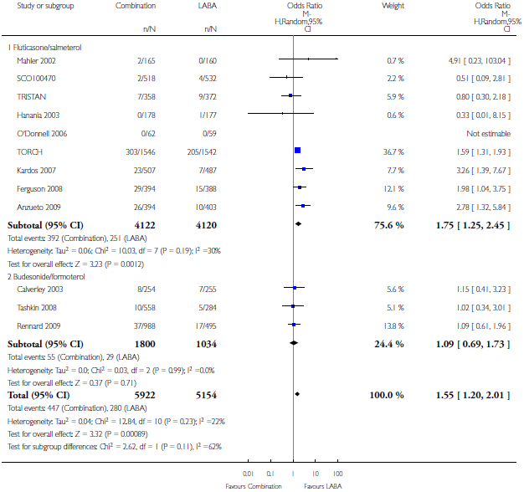
Source: Nannini (2012) Analysis 1.5, p55
Abbreviations: BUD, budesonide; EFO, eformoterol; FLU, fluticasone; LABA, long-acting beta-2 agonist; SAL, salmeterol; vs, versus.
Figure 4.3 Pneumonia for FLU/SAL vs SAL and BUD/EFO vs EFO, by dose – Nannini 2012
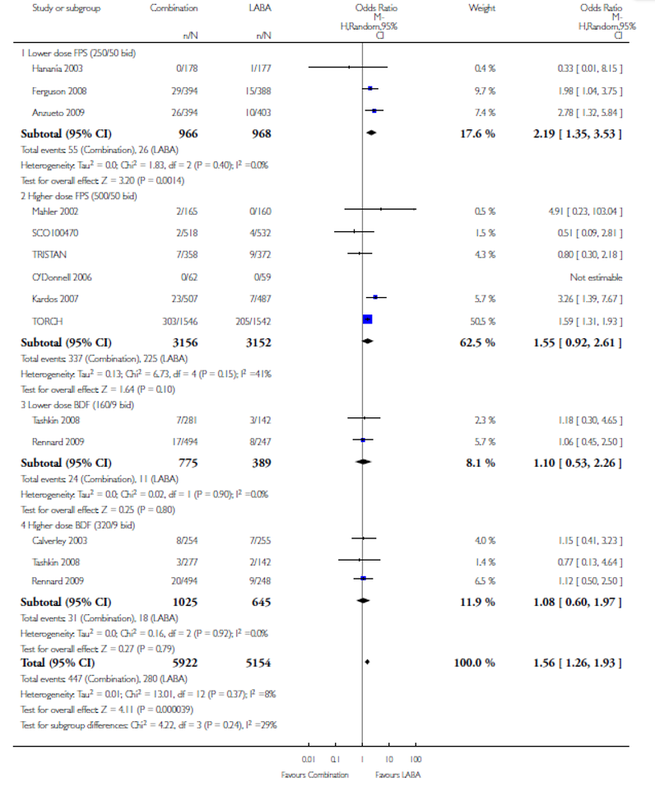
Source: Nannini (2012) Analysis 1.6 pp56-7
Abbreviations: BUD, budesonide; BDF, budesonide/eformoterol; EFO, eformoterol; FLU, fluticasone; FPS, fluticasone propionate/salmeterol; LAMA, long-acting muscarinic antagonist; SAL, salmeterol; vs, versus.
Figure 4.4 Risk of pneumonia for FLU/SAL vs placebo and BUD/EFO vs placebo – Nannini 2013
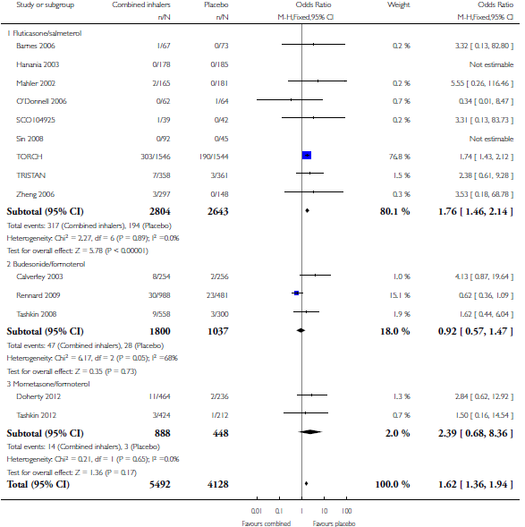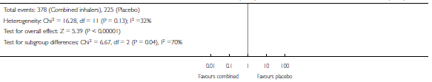
Source: Nannini (2013) Analysis 1.3, p84
Abbreviations: BUD, budesonide; EFO, eformoterol; FLU, fluticasone propionate; SAL, salmeterol; vs, versus.
Note: Mometasone/eformoterol subgroup and pooled estimate for all three ICS/LABA combinations has been removed from this forest plot.

Authors’ conclusions
Nannini et al (2012) found there was moderate-quality evidence of an increased risk of pneumonia with ICS/LABA compared to LABA alone, but that treatments had similar effects on mortality. They conclude that individual patients must balance the increased risk of pneumonia against the possible reduction in exacerbations. Nannini et al (2013) stated the increased risk of pneumonia is a concern, but did not translate into increased exacerbations, hospitalisations or deaths. They considered current evidence does not suggest any major differences between inhalers in terms of effects, but that the evidence is not sufficiently strong to demonstrate that all are equivalent.

Reviews investigating pneumonia

Kew (2014) Cochrane Review

Design
Table 4.9 lists the inclusion and exclusion criteria for the Kew (2014) Cochrane review. Studies of fluticasone furoate/vilanterol combination therapy were included, as were comparisons not covered by the reviews of Nannini and colleagues (ICS monotherapy comparison with each other or with placebo; interclass comparisons of combination therapies). Comparisons of combination therapy with placebo were excluded. An indirect comparison was conducted to compare fluticasone with budesonide, based on monotherapy, placebo-controlled studies.
The safety outcomes reported in Kew (2014) have been shown earlier (Table 4.4) but are reproduced here, along with the additional outcome of withdrawals (Table 4.9). The focus of the current Review is the pneumonia-related outcomes. Many studies lacked a definition for pneumonia, with many designed prior to the first pneumonia safety signal from the TORCH study. Hence the primary outcome was defined as pneumonia requiring hospital admission, where diagnosis is likely to have involved imaging studies and laboratory investigations.
Table 4.9 Inclusion and exclusion criteria for Kew (2014)
Inclusion/exclusion criteria | Outcomes
Study design:  - RCTs of parallel-group design  - at least 12 weeks’ duration  Interventions:  - FLU/SAL vs SAL; BUD/EFO vs EFO; FLU/VIL vs VIL  - FLU or BUD vs placebo  - FLU vs BUD  - FLU/SAL or FLU/VIL vs BUD/EFO  Triple therapy studies were excluded (e.g. BUD/EFO + TIO vs EFO + TIO). | Primary:  - non-fatal pneumonia SAE  Secondary:  - mortality due to pneumonia  - all pneumonia events  - mortality, all-cause  - non-fatal SAE  - withdrawals
Abbreviations: Abbreviations: BUD, budesonide; COPD, chronic obstructive pulmonary disease; EFO, eformoterol; FLU, fluticasone; RCT, randomised controlled trial; SAL, salmeterol; VIL, vilanterol; vs, versus; FLU/SAL, fluticasone propionate/salmeterol; FLU/VIL, fluticasone furoate/vilanterol.

Evidence base
Table 4.10 shows the 43 studies included in Kew (2014): 26 for fluticasone (N = 21,247) and 17 for budesonide (N = 10,067). The types of comparisons performed in each study (e.g. ICS versus placebo) are indicated. As not all studies report all outcomes, the meta-analyses to which these studies contribute are also shown.
The dosages for the main intervention using the highest dose are listed; these are the same as doses used in Australia for COPD with the exception of fluticasone furoate/vilanterol, for which all studies include arms with twice the PBS listed dose for COPD, or more. These studies contribute a combined weight of between 7% and 10% to the fluticasone meta-analyses.
Table 4.10 Fluticasone and budesonide studies, showing comparison types, doses and meta-analyses inclusion – Kew 2014
Comparison type | Ref ID | Main intervention arm | Dose (μg) | Non-fatal pneumonia SAE | All pneumonia | Mortality, pnuemonia | Mortality, all-cause | SAEs – non-fatal | With-drawals
Fluticasone
ICS vs placebo | Bourbeau (2007) | FLU | 500 |  |  |  |  |  | 
ICS vs placebo | Burge (2000) | FLU | 500 |  |  |  |  |  | 
ICS vs placebo | Choudhury (2005) | FLU | 500 |  |  |  |  |  | 
ICS vs placebo | FLTA3025 (2005) | FLU | 500 |  |  |  |  |  | 
ICS vs placebo | SCO30002 (2005) | FLU | 500 |  |  |  |  |  | 
ICS vs placebo | Hattotuwa (2002) | FLU | 500 |  |  |  |  |  | 
ICS vs placebo | Lapperre (2009) | FLU | 500 |  |  |  |  |  | 
ICS vs placebo | Paggiaro (1998) | FLU | 500 |  |  |  |  |  | 
ICS vs placebo | Schermer (2009) | FLU | 500 |  |  |  |  |  | 
ICS vs placebo | van Grunsven (2003) | FLU | 250 |  |  |  |  |  | 
ICS vs placebo | Verhoeven (2002) | FLU | 500 |  |  |  |  |  | 
Both | Calverley (2003) - TRISTAN | FLU/SAL | 500/50 |  |  |  |  |  | 
Both | Calverley (2007) - TORCH | FLU/SAL | 500/50 |  |  |  |  |  | 
Both | SCO104925 (2008) | FLU/SAL | 500/50 |  |  |  |  |  | 
Both | Hanania (2003) | FLU/SAL | 250/50 |  |  |  |  |  | 
Both | Kerwin (2013) | FLU/VIL | 100/25 |  |  |  |  |  | 
Both | Mahler (2002) | FLU/SAL | 500/50 |  |  |  |  |  | 
Both | Martinez (2013) | FLU/VIL | 200/25 |  |  |  |  |  | 
ICS/LABA vs LABA | Anzueto (2009) | FLU/SAL | 250/50 |  |  |  |  | 
ICS/LABA vs LABA | Dal Negro (2003) | FLU/SAL | 250/50 |  |  |  |  |  | 
ICS/LABA vs LABA | Dransfield (2013) | FLU/VIL | 200/25 |  |  |  |  | 
ICS/LABA vs LABA | Ferguson (2008) | FLU/SAL | 250/50 |  |  |  |  | 
ICS/LABA vs LABA | FCO30002 (2005) | FLU/SAL | 500/50 |  |  |  |  | 
ICS/LABA vs LABA | SCO100470 (2006) | FLU/SAL | 250/50 |  |  |  |  | 
ICS/LABA vs LABA | SCO40041 (2008) | FLU/SAL | 250/50 |  |  |  |  | 
ICS/LABA vs LABA | Kardos (2007) | FLU/SAL | 500/50 |  |  |  |  | 
Budesonide
ICS vs placebo | Bourbeau (1998) | BUD | 400 |  |  |  |  |  | 
ICS vs placebo | Laptseva (2002) – no data | BUD | 400
ICS vs placebo | Mirici (2001) | BUD | 400 |  |  |  |  |  | 
ICS vs placebo | Ozol (2005) | BUD | 400 |  |  |  |  |  | 
ICS vs placebo | Pauwels (1999) | BUD | 400 |  |  |  |  |  | 
ICS vs placebo | Renkema (1996) | BUD | 800 |  |  |  |  |  | 
ICS vs placebo | Senderovitz (1999) – no data | BUD | 400
ICS vs placebo | Shaker (2009) | BUD | 400 |  |  |  |  |  | 
ICS vs placebo | Vestbo (1999) | BUD | 400 |  |  |  |  |  | 
ICS vs placebo | Yildiz (2004) | BUD | 800 |  |  |  |  |  | 
Both | Calverley (2003b) | BUD/EFO | 320/9 |  |  |  |  |  | 
Both | Szafranski (2003) | BUD/EFO | 320/9 |  |  |  |  |  | 
ICS/LABA vs LABA | Calverley (2010) | BUD/EFO | 400/12 |  |  |  |  |  | 
ICS/LABA vs LABA | Fukuchi (2013) | BUD/EFO | 320/9 |  |  |  |  |  | 
ICS/LABA vs LABA | Rennard (2009) | BUD/EFO | 320/9 |  |  |  |  |  | 
ICS/LABA vs LABA | Sharafkhaneh (2012) | BUD/EFO | 320/9 |  |  |  |  |  | 
ICS/LABA vs LABA | Tashkin (2008) - SHINE | BUD/EFO | 320/9 |  |  |  |  |  | 
Abbreviations: BUD, budesonide; EFO, eformoterol; FLU, fluticasone; ICS, inhaled corticosteroids; LABA, long-acting beta-2 agonist; SAE, serious adverse event; SAL, salmeterol; VIL, vilanterol; FLU/SAL, fluticasone propionate/salmeterol; FLU/VIL, fluticasone furoate/vilanterol.
The authors noted that the evidence for budesonide was more inconsistent and less precise than for fluticasone, with shorter study duration (average of 9 months versus 16 months, respectively). For budesonide, fewer than half the identified studies contributed to the analyses related to pneumonia due to incomplete outcome data, which the authors comment upon with regard to limitating the conclusions for this intervention. In fact, incomplete outcome data was identified as the main source of potential bias for almost half of the 43 included studies, although it was rated as low risk.
The authors noted there were no systematic differences for inclusion/exclusion criteria or baseline characteristics. Fluticasone studies tended to have larger sample sizes, but neither this nor longer study durations were deemed significant. A similar risk of bias was noted for studies funded by the two main pharmaceutical companies. Control group event rates were similar for fluticasone and budesonide when the three-year TORCH study was excluded, as it skewed rates due to longer duration of event collection.
The use of once-daily dosing with fluticasone furoate was noted as a potential source of heterogeneity, as was the different delivery modes for fluticasone (Diskus or Accuhaler) and budesonide (Turbuhaler), which may have confounded the common placebo comparator in the indirect comparison. In the case of the indirect comparison of combination therapy, the different LABAs used as comparators were deemed sufficiently different between the fluticasone and budesonide studies, and the comparison was not performed.

Findings
Significantly more serious, non-fatal pneumonia events (resulting in hospitalisation – primary outcome) are seen with fluticasone use compared to placebo, and also with combination therapy compared to LABA monotherapy (Figure 4.5). No significant heterogeneity was noted, and the authors noted there was no significant evidence that the odds were affected by the comparison type (monotherapy versus placebo compared with combination versus LABA). These analyses are dominated by the TORCH study. This evidence for this outcome was rated as high quality.
Figure 4.5 Risk of non-fatal pneumonia SAEs for fluticasone versus controls – Kew 2014
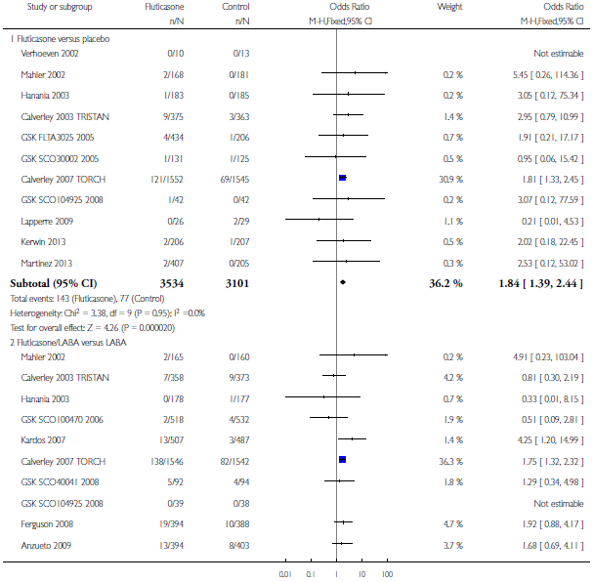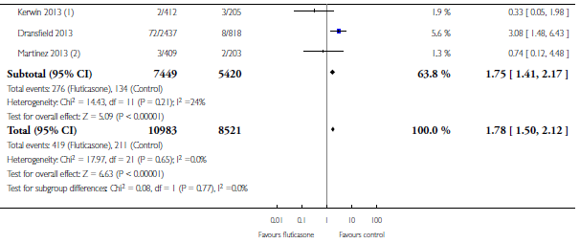
Source: Kew (2014) Analysis 1.1, p114-5. Note: for each analysis, two fluticasone/​vilanterol dose groups were merged. Note: pneumonia SAEs are serious pneumonia events requiring hospital admission.
Abbreviations: CI, confidence interval; LABA, long-acting beta-2 agonist.
Subgroup analyses for the primary outcome of non-fatal pneumonia SAEs found only the high dose fluticasone propionate retained statistical significance (OR 1.78 [95% CI: 1.47, 2.16]). There was no significant difference in event frequency between the dose subgroups (p = 0.90, I² = 0.0%). Duration of study (greater than or less than one year) did not substantially alter the result, which remained significant in both subgroups.
Similar findings were reported for all pneumonia events (Figure 4.6). Being under-reported across the studies, the evidence for this outcome was downgraded to moderate quality.
None of the other safety outcomes were statistically significant for fluticasone. In the case of mortality due to pneumonia, the evidence for this outcome was downgraded to moderate quality due to imprecision as so few events were reported.
Figure 4.6 All pneumonia events for fluticasone versus controls – Kew 2014
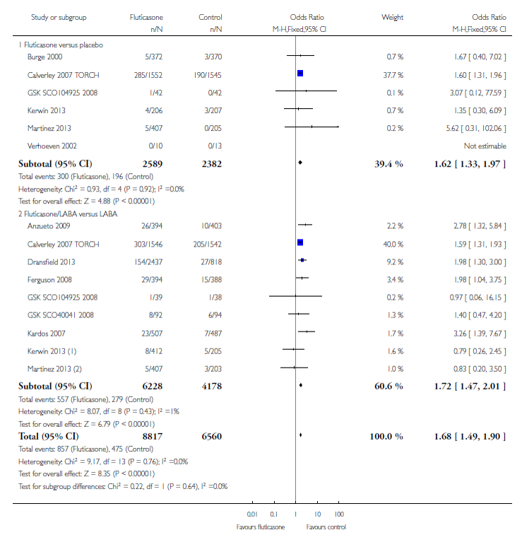
Source: Kew (2014) Analysis 1.5, p122. Note: for each analysis, two fluticasone/​vilanterol dose groups were merged.
Abbreviations: CI, confidence interval; LABA, long-acting beta-2 agonist.
Only eight comparisons from seven studies (n = 6472) contributed to the analysis of non-fatal serious pneumonia events for budesonide. Statistical significance was found for the monotherapy versus placebo comparison, but not for combination therapy compared to LABA (Figure 4.7). Heterogeneity was evident between studies and between the monotherapy and combination studies, but was not significant in either case. The evidence for the primary study outcome was downgraded to moderate quality due to the small proportion of total studies included in the analysis.
Figure 4.7 Non-fatal pneumonia SAEs for budesonide versus controls – Kew 2014
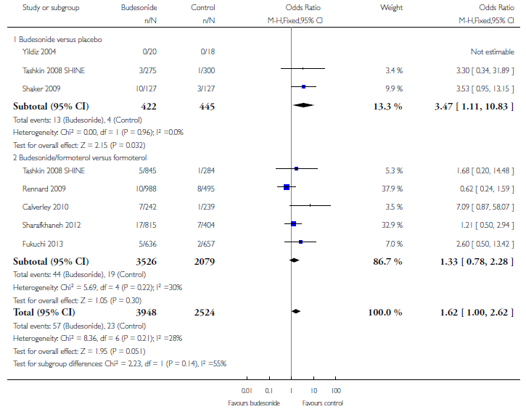
Source: Kew (2014) Analysis 3.1, p130. Note: pneumonia SAEs are serious pneumonia events requiring hospital admission.
Abbreviations: CI, confidence interval.
A subgroup analysis of this outcome by dose found significantly more events with high dose budesonide (320 μg) versus placebo, but not with the lower dose (Figure 4.8), and the difference between the dose subgroups was significant (p = 0.05, I² = 74%).
The authors noted a lack of evidence to draw a conclusion for budesonide for all pneumonia events, for which comparisons of either type were not statistically significant. Only a small proportion of the 17 budesonide studies (six; n = 7011) contributed to the analysis, resulting in a downgrading of the evidence for the outcome to moderate quality. No significant differences were observed for the other safety outcomes for budesonide.
Figure 4.8 Non-fatal pneumonia SAEs for budesonide versus controls by dose – Kew 2014
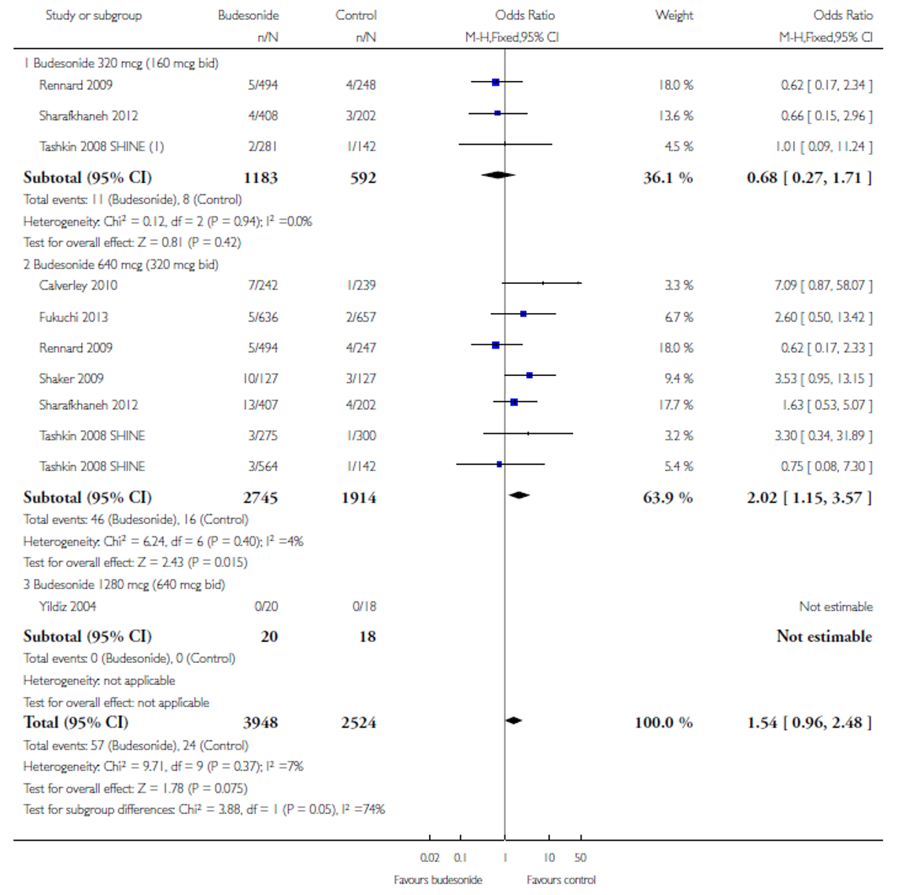
Source: Kew (2014) Analysis 4.1, p136. Note: pneumonia SAEs are serious pneumonia events requiring hospital admission.
Abbreviations: CI, confidence interval

Indirect comparison of fluticasone and budesonide
In the absence of direct, head-to-head studies, an indirect comparison of monotherapy using fluticasone (15 RCTs) and budesonide (five RCTs) was conducted, using placebo as a common comparator (as discussed earlier, sufficient differences prevented an indirect comparison of combination therapy versus LABA).
Of the four outcomes analysed, statistical significance was reached for all pneumonia events only, favouring budesonide (Figure 4.9). This evidence was downgraded to moderate quality on account of the wide confidence interval. When the TORCH study was removed from this analysis, significance was lost.
The indirect comparison by Halpin (2011; Table 4.4; not selected as a key review), also found significantly more serious pneumonia events with fluticasone versus budesonide (OR 0.41 [95% CI: 0.19, 0.86]).
Figure 4.9 Risk of pneumonia for FLU and BUD monotherapy versus placebo – Kew (2014)
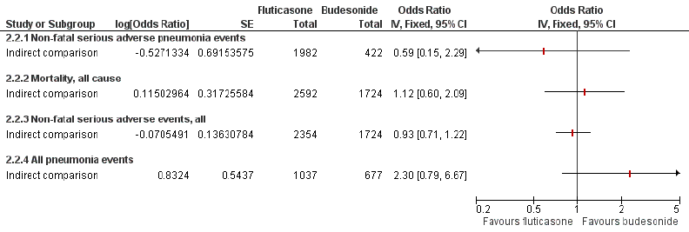
Source: Kew (2014) Figure 5, p20.
Figure 4.10 shows pooled estimates for all studies of fluticasone versus control and all budesonide versus control, for all six outcomes. Estimates were also pooled across both interventions for all outcomes except all pneumonia events, which was prevented by heterogeneity. The pooled estimate for non-fatal serious pneumonia events is OR 1.76 [95% CI: 1.50, 2.07], with the fluticasone studies contributing over 80% of the analysis weight.
The authors note their decision to conduct this indirect analysis was based on statistical consistency and a comprehensive assessment of transitivity across the two set of monotherapy trials, and consider the comparison to be valid. However, the quality of the evidence is limited by the indirect nature of the comparison, and should be interpreted in light of the lack of consistent definition of a diagnosis of pneumonia.
Figure 4.10 Summary of pooled estimates of ICS vs placebo and combination verus LABA therapy – Kew 2014
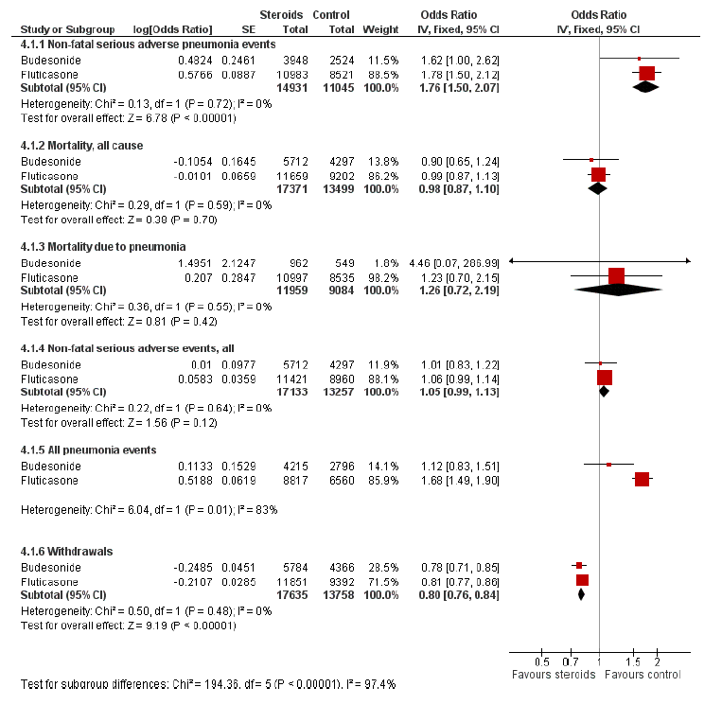
Source: Kew (2014) Figure 4, p17
Abbreviations: CI, confidence interval; ICS, inhaled corticosteroids; LABA, long-acting beta-2 agonist; SE, standard error; vs, versus.

Authors’ conclusions
The authors concluded that whether delivered as monotherapy or in combination with a LABA, budesonide and fluticasone are associated with an increased risk of serious adverse pneumonia events. Neither, however, significantly affected mortality compared with controls, and the increased pneumonia risk should be balanced with recent cohort data and randomised evidence of efficacy regarding exacerbations and quality of life. The indirect comparison of the two drugs found the risk of any pneumonia was higher for fluticasone, but this finding may be confounded by inconsistency in the definitions used by the respective manufacturers.

Tricco (2015) network meta-analysis
Tricco (2015) identified 208 parallel-group RCTs of any long-acting inhaled agents and analysed all available combinations and comparisons in a network meta-analysis. One efficacy outcome (exacerbations in the past year) and four safety outcomes were analysed: pneumonia, mortality, cardiovascular-related mortality, and serious arrhythmia. Pneumonia was not further defined, so presumably refers to any pneumonia. The network meta-analyses plot for pneumonia is shown in Figure 4.11.
Figure 4.11 Network meta-analysis plot for pneumonia – Tricco (2015)
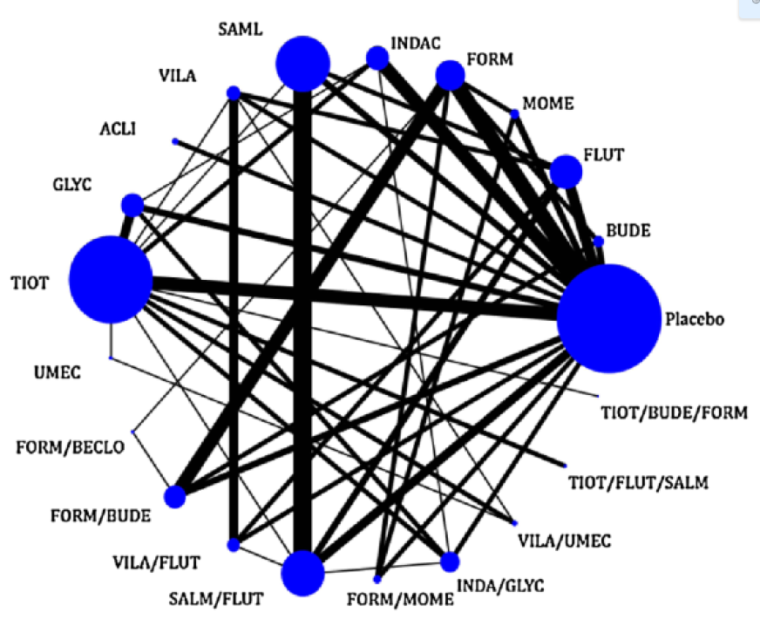
Source: Tricco (2015) Figure 3(D), p6: Note: Nodes are proportional to the number of patients included in the corresponding treatments, and edges [lines] are weighted according to the number of studies included in the respective comparisons.
Abbreviations: ACLI, aclidinium ; BUDE, budesonide; FORM, eformoterol; FLUT, fluticasone; GLYC, glycopyrronium ; INDAC, indacaterol ; MOME, mometasone; SALM, salmeterol; UMEC, umeclidinium ; VILA, vilanterol; BECLO, beclomethasone.
Tiotropium was the focus of this MTC, but only comparisons of relevance to the current Review are presented here. Statistically significant comparisons are shown in Table 4.11. These results are consistent with the findings of the Cochrane reviews reported earlier, and provide an estimate for the additional comparison of fluticasone furoate/vilanterol with vilanterol, separate from the dominating fluticasone propionate/salmeterol data (as discussed earlier, these studies include arms with doses twice that indicated and PBS listed for COPD). Both the network meta-analysis and the direct meta-analysis estimates indicate more pneumonia events with fluticasone furoate/vilanterol than with vilanterol alone.
No relevant comparisons were statistically significant for cardiovascular-related mortality. Only three MTC estimates were significant for overall mortality, which was lower for fluticasone propionate/salmeterol than for placebo, eformoterol or fluticasone monotherapy.

Authors’ conclusions
With regards to inhaled corticosteroids, the authors concluded that fluticasone propionate/salmeterol reduces the risk of mortality, but may increase risk of pneumonia.
Table 4.11 Statistically significant results for pneumonia risk – Tricco 2015
Treatment comparison | NMA estimate  OR [95% CI] | MA estimate  OR [95% CI] | Studies (N), Patients (N) | MA heterogeneity variance
Fluticasone furoate analysis
FLU/VIL vs VIL | 1.87 [1.18, 2.96] | 1.9 [1.20, 3.01] | 4 (2442) | 0
Intra-class comparisons
FLU vs BUD | 2.21 [1.25, 3.92] | – | – | –
FLU/SAL vs BUD | 2.52 [1.44, 4.43] | – | – | –
FLU/VIL vs BUD | 2.83 [1.10, 7.25] | – | – | –
FLU and FLU/​SAL analyses
FLU vs placebo | 1.66 [1.32, 2.08] | 1.6 [1.32, 1.95] | 5 (4258) | 0
FLU/SAL vs SAL | 1.7 [1.38, 2.09] | 1.69 [1.40, 2.04] | 8 (7613) | 0
SAL vs FLU | 0.67 [0.54, 0.84] | 0.68 [0.56, 0.83] | 2 (3174) | 0
EFO vs FLU | 0.55 [0.33, 0.90] | – | – | –
FLU/SAL vs EFO | 2.09 [1.29, 3.37] | – | – | –
FLU/SAL vs placebo | 1.9 [1.53, 2.34] | 1.75 [1.44, 2.13] | 4 (3872) | <0.0001
Source: Tricco (2015) Table 3, p8
Abbreviations: BUD, budesonide; CI, confidence interval; EFO, eformoterol; FLU, fluticasone; MA, meta-analysis; NMA, network meta-analysis; OR, odds ratio; SAL, salmeterol; VIL, vilanterol; FLU/SAL, fluticasone propionate/salmeterol; FLU/VIL, fluticasone furoate/vilanterol.

Reviews investigating other specific adverse events

Dong (2014) review of tuberculosis and influenza
Dong (2014) identified 26 studies lasting at least six months that compared ICS/LABA with no-ICS controls in COPD patients and reported tuberculosis (TB) or influenza outcomes. However, as only comparisons reporting any events were included in the meta-analyses, only five RCTs were included in the analysis for TB (N = 10,203) and eight in the analysis for influenza (N = 13,914). In both analyses, two comparisons used mometasone combination therapy. These analyses were not stratified by specific drugs, and both included comparisons from the TORCH trial.
The risk of TB was significantly higher for ICS treatment compared with no ICS controls (Peto OR 2.29 [95% CI: 1.04, 5.03]). No individual trial comparison was statistically significant in this analysis (Figure 4.12).
A marginal but non-significant increase in the risk of influenza was found across the eight analysed comparisons (Peto OR 1.24 [0.94, 1.63]; Figure 4.13). The comparison of ICS versus no ICS alone from the TORCH study was significant but imprecise (Peto OR 7.37 [1.49, 36.55]).
Analyses were presented for a variety of meta-analytic methods (e.g. Mantel-Haenszel, Bayesian, Peto; random effects, fixed effects), but produced similar results. The authors concluded that ICS results in a two-fold increase in the risk of TB, and a borderline risk of influenza, and these risks need to be balanced against the benefits of ICS treatment.
Figure 4.12 Risk of TB for ICS treatments versus no ICS controls – Dong 2014
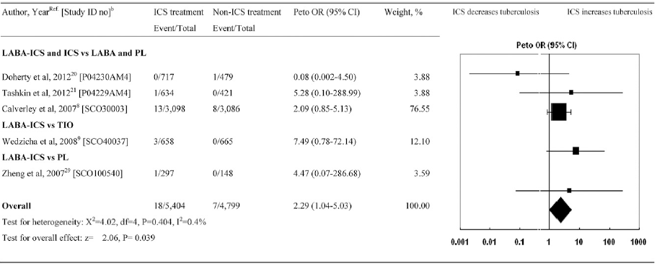
Source: Dong (2014) Figure 2, p1291.
Abbreviations: CI, confidence interval; ICS, inhaled corticosteroids; LABA, long-acting beta-2 agonist; OR, odds ratio; PL, placebo; TB, tuberculosis; TIO, tiotropium.
Figure 4.13 Risk of influenza for ICS treatments versus no ICS controls – Dong 2014
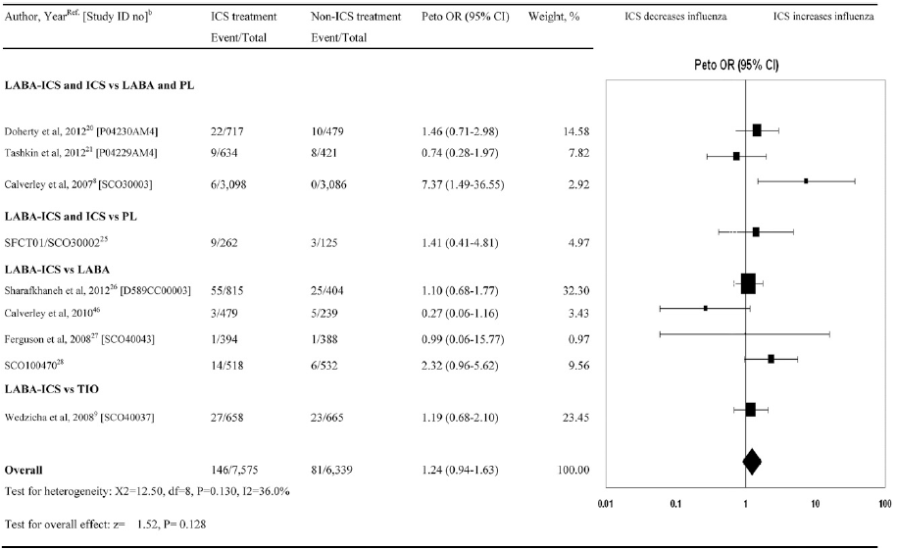
Source: Dong (2014) Figure 3, p1292.
Abbreviations: CI, confidence interval; ICS, inhaled corticosteroids; LABA, long-acting beta-2 agonist; OR, odds ratio; PL, placebo.

Loke (2011) review of fracture
This review included RCTs (of at least 24 weeks’ duration) and observational studies, used data for fluticasone or budesonide use in COPD patients, and did not stratify results by specific drugs.
Of the 16 identified RCTs (N = 17,513 patients), only two used budesonide. Subgroups were analysed according to comparison type: ICS/LABA versus LABA, and ICS versus placebo. Fracture risk was not significant for either of these comparisons, but for ICS versus no ICS controls, there was a significant increase in fracture risk of 1.27 (Peto OR), which came close to, but did not cross, unity (95% CI: 1.01, 1.58; results were similar using a fixed effects, Mantel-Haenszel model: OR 1.27 [95% CI: 1.01, 1.59, p = 0.04]).
The meta-analysis is shown in Figure 4.14. All comparisons had very wide confidence intervals, except for the two derived from the TORCH study, which accounts for over 80% of the weighting in the analysis. The authors pointed out the limitations of long-term RCTs for such analyses, where results can be confounded by oral corticosteroid use and high withdrawal rates in the placebo arms, with some crossing over to ICS use.
Figure 4.14 Pooled RCTs of fracture risk for ICS versus non-ICS, by comparison subgroup – Loke 2011
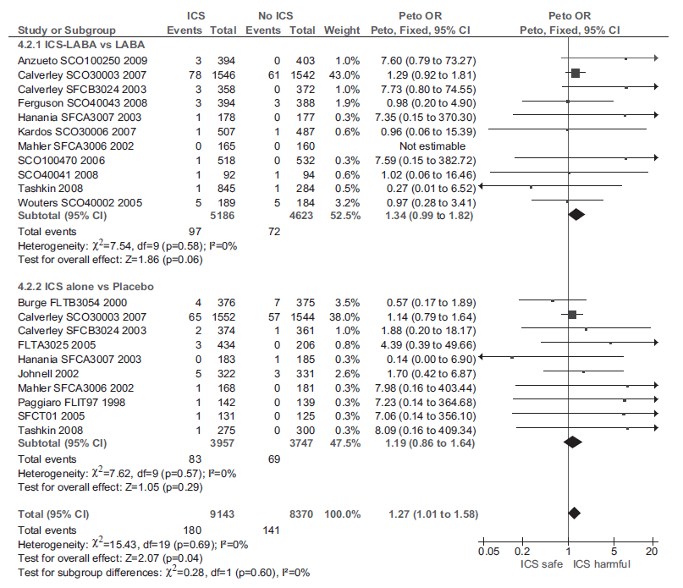
Source: Loki (2011), Figure 2, p 703
Abbreviations: CI, confidence interval; ICS, inhaled corticosteroids; LABA, long-acting beta-2 agonist; OR, odds ratio; RCT, randomised controlled trial.
Seven observational studies (two cross-sectional, five nested case-control; N = 69,000) of ICS versus no ICS controls were identified, and pooled using an inverse variance, fixed effects model (Figure 4.15). For each of three exposure subgroups, the odds of fracture with ICS were statistically significant. The pooled OR across all subgroups was 1.21 (95% CI: 1.12, 1.32; p<0.0001, I² = 37%). Only one study investigated an ICS other than fluticasone or budesonide (beclomethasone and triamcinolone), but sensitivity analyses removing this study did not alter results. A dose meta-regression analysis found each increase in beclomethasone equivalent of 500 μg corresponded to an increase in the likelihood of fractures of 9% (OR 1.09 [1.06, 1.12, p <0.001]).
Figure 4.15 Pooled observational studies of fracture risk for ICS versus non-ICS, by exposure subgroup – Loke 2011
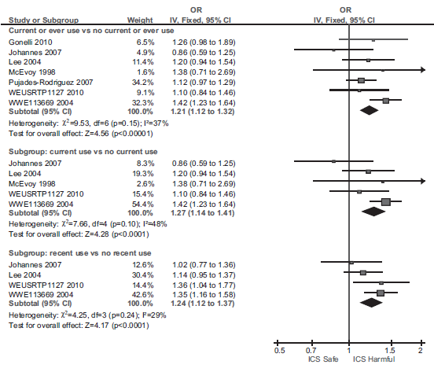
Source: Loki (2011), Figure 2, p 706
Abbreviations: CI, confidence interval; ICS, inhaled corticosteroids; OR, odds ratio.
The authors acknowledged an element of uncertainty in the RCT analysis due to the lower limit of the confidence interval being close to the null effect threshold. However, they noted that taking the evidence as a whole, the similarity of risk point estimates across study designs and the dose-response effect seen in the observational studies strengthen the confidence in the association between ICS use and fracture.

Pooled analyses
The literature search identified the pooled analyses listed in Table 4.12; they investigate interventions, comparisons or analyses not covered by the systematic reviews, so serve to supplement the analyses presented earlier. However, these analyses are subject to studies selection bias and, while the findings are summarised in Table 4.12, will not be discussed further.
Table 4.12 Pooled analyses investigating the safety of ICS
Ref ID | Title | Analyses and findings
FLU/VIL vs VIL
DiSantostefano (2014a) | Risk of pneumonia with inhaled corticosteroid/long-acting beta(2) agonist therapy in chronic obstructive pulmonary disease: A cluster analysis. | Cluster analysis of the two 52-week FLU/VIL vs VIL RCTs reported in Dransfield (2013), to identify patients at greater risk of first pneumonia. Identified clusters included more severe obstruction with body mass index (<19 kg/m²); more severe obstruction with pneumonia history and greater comorbidities; and more severe obstruction with multiple comorbidities and use of psychoanaleptics.
FLU/VIL vs FLU/SAL
Dransfield (2014) | Efficacy and safety of once-daily fluticasone furoate/vilanterol (100/25 μg) versus twice-daily fluticasone propionate/salmeterol (250/50 μg) in COPD patients. | Pooled analysis of three 12-week RCTs of FLU/VIL vs FLU/SAL. No difference in pooled AEs or SAEs . The short study period limits the safety analysis.
BUD, BUD/EFO vs no ICS
O'Byrne (2012) | Risk of new onset diabetes mellitus in patients with asthma or COPD taking inhaled corticosteroids. | Pooled analyses of AstraZeneca datasets for COPD and asthma (BUD or BUD/EFO vs non-ICS). No significant difference seen for diabetes/hyperglycaemia AEs or SAEs in either dataset.
Sin (2009) | Budesonide and the risk of pneumonia: a meta-analysis of individual patient data. | Pooled analysis of BUD or BUD/EFO vs EFO or placebo. All studies are also included in the Kew (2014) SR, which also includes an additional 10 studies, both earlier and later than these and pooled BUD studies separately. However, this analysis used patient-level data to allow adjustment for potential confounders, and found no significant increase in pneumonia AEs or SAEs.
Abbreviations: AE, adverse event; BUD, budesonide; COPD, chronic obstructive pulmonary disease; EFO, eformoterol; FLU, fluticasone; ICS, inhaled corticosteroids; RCT, randomised controlled trial; SAE, serious adverse event; SAL, salmeterol; SR, systematic review; VIL, vilanterol; FLU/SAL, fluticasone propionate/salmeterol; FLU/VIL, fluticasone furoate/vilanterol.

HTAs
A search of HTA websites for assessments of ICS for COPD investigating safety outcomes identified relevant documents from NICE and the Canadian Agency for Drugs and Technologies in Health (CADTH).

NICE
In June 2013, NICE published an Evidence Summary for fluticasone furoate/vilanterol (ESNM21; NICE, 2013), which is marketed as Relvar Ellipta (100/25 μg) in Europe (same product as Breo Ellipta in Australia and US). Three study publications reporting four RCTs were identified (Table 4.13 shows the trial doses, taken once daily). Only three RCTs were used as the basis of the Evidence Summary as the authors of the Martinez (2013) study were precluded, for methodological reasons, from performing a statistical analysis.
Table 4.13 Study drug dosages for the published trials of fluticasone furoate/vilanterol
Study ID | Duration | FLU/VIL  μg | FLU/VIL  μg | FLU/VIL  μg | FLU  μg | FLU  μg | VIL  μg | Placebo
Dransfield (2013) – 2 replicate RCTs | 52 weeks | 200/25 | 100/25 | 50/25 | – | – | 25 | –
Kerwin (2013) | 24 weeks | – | 100/25 | 50/25 | – | 100 | 25
Martinez (2013) | 24 weeks | 200/25 | 100/25 | – | 200 | 100 | 25
Abbreviations: FLU, fluticasone (furoate); RCT, randomised controlled trial; VIL, vilanterol; FLU/VIL, fluticasone furoate/vilanterol.
One further RCT was also identified (Agusti, 2014) but was not discussed in the NICE (2013) Evidence Summary as no study data were available at the time. However, this was the pivotal trial for the Breo Ellipta major submission considered by the PBAC at the March 2014 meeting (discussed earlier in Section 4.3.2). This 12-week trial (n = 528) compared two groups: fluticasone furoate/vilanterol (100/25 μg) and fluticasone propionate/salmeterol (500/50 μg).
The trials in Table 4.13 have not been presented to the PBAC – they were not included in the Breo Ellipta PBAC submission due to the absence of the nominated comparator; fluticasone propionate/salmeterol. The submission did include placebo-controlled trial evidence for safety, but in the form of an integrated analysis of 10 unidentified trials (data from PSUR), so it is probable the data from these trials were incorporated into this synthesis.
Safety outcomes in the two replicate Dransfield (2013) RCTs are reported as combined descriptive statistics across the two studies. Table 4.14 shows the safety outcomes discussed in the Evidence Review (supplemented for some outcomes with data from the original study publication). The pneumonia outcome was any clinically defined pneumonia, either radiographically confirmed (approximately 80-90% of events) or at the investigator’s discretion, while pneumonia requiring hospitalisation was reported as serious pneumonia.
Table 4.14 Safety results for 52-week Dransfield (2013) RCTs – NICE (2013) Evidence Summary
Safety (ITT population) | FLU/VIL, 200/25μg  (n = 811)  n (%) | FLU/VIL, 100/25μg  (n = 806)  n (%) | FLU/VIL, 50/25μg  (n = 820)  n (%) | VIL, 25 μg  (n = 818)  n (%)
AEs leading to discontinuation or withdrawal | 61 (7.5) | 62 (7.7) | 53 (6.5) | 45 (5.5)
Local corticosteroid effects | 140 (17.3) | 121 (15.0) | 142 (17.3) | 96 (11.7)
Pneumonia
Any pneumonia | 55 (6.8) | 51 (6.3) | 48 (5.9) | 27 (3.3)
Serious pneumonia | 23 (3) | 25 (3) | 24 (3) | 8 (1)
Fatal pneumonia-related AE | 7 (1) | 1 (1) | 0 (0) | 0 (0)
Bone disorders (including fractures) | 21 (2.6) | 27 (3.3) | 24 (2.9) | 9 (1.1)
Total fracture events (% of total fracture events) | 13 | 19 | 15 | 8
Non-traumatic | 8 (62) | 6 (32) | 4 (27) | 2 (25)
Traumatic | 5 (38) | 13 (68) | 11 (73) | 6 (75)
Source: NICE (2013) Evidence Summary, Table 2 and p13; supplemented from Dransfield (2013), Table 7.
Abbreviations: AE, adverse events; FLU, fluticasone (furoate); ITT, intention-to-treat; NICE, National Institute of Health and Care Excellence; RCT, randomised controlled trial; VIL, vilanterol; FLU/SAL, fluticasone propionate/salmeterol; FLU/VIL, fluticasone furoate/vilanterol.
Although the trial evidence includes a higher and a lower dose, results for the 100/25 μg product only are discussed in the NICE (2013) Evidence Summary.
The evidence reviewers commented on the limitations on interpretation imposed by the lack of statistical analyses for the safety outcomes. They noted the proportions of patients discontinuing from the study due to adverse events; 7.7% versus 5.5% in the 100/25 μg fluticasone furoate/vilanterol and 25μg vilanterol arms, respectively. They observed that local corticosteroid effects, pneumonia and bone disorders (including fractures) were seen more frequently in the fluticasone furoate/vilanterol 100/25 μg group than in the vilanterol group. They also noted the difference in non-traumatic fractures (0.74% of patients for the 100/25 μg combination therapy and 0.24% for monotherapy).
The reviewers remarked on the two-fold higher rate of any pneumonia in the 100/25 μg combination group compared with vilanterol monotherapy (6.3 versus 3.3%, respectively). This difference is statistically significant. According to the original study publication, this difference was observed in both Dransfield et al (2013) Study 1 and Study 2. For serious pneumonia the difference is even more marked (3.1% versus 0.98%, respectively).
Fatal pneumonia during treatment occurred in no patients in the vilanterol group but in one patient in the 100/25 μg combination group, and the reviewers noted the potential risk of pneumonia with the use of ICS for COPD has been recognised by the Medicines and Healthcare products Regulatory Agency (MHRA).
The authors of the current Review note that a high rate of fatal pneumonia occurred in the highest dose arm of this study (200/25 μg), which accounted for seven of the eight pneumonia deaths. Dransfield et al (2013) report that all seven deaths were in Study 1, and four were in a single centre in the Philippines (Dransfield (2013) and supplementary appendix). They also reported a ninth death, occurring after study treatment in the vilanterol group. Dransfield et al (2013) noted more pneumonia deaths occurred than expected, and raises particular concerns about the 200/25 μg combination.
Discussion of the RCT by Kerwin (2013) was very limited; pneumonia occurred in 2% of patients in the fluticasone furoate/vilanterol group and 1% of patients in the placebo group.

CADTH

CDEC Final Recommendation for Breo Ellipta (FLU/VIL) for COPD – CADTH 2014
CADTH performs evaluations of the clinical, economic, and patient evidence on new drugs, or existing drugs approved for new indications, as part of the Common Drug Review (CDR) process. These reviews inform the development of recommendations by the Canadian Drug Expert Committee (CDEC), for consideration by various publicly funded drug plans. The original CDR report for Breo Ellipta (fluticasone furoate/vilanterol) is not available on the CADTH website, but a redacted version of the Notice of Final Recommendation was released in August 2014, summarising the findings of the CDEC during the July 2014 meeting (CADTH, 2014).
The CDEC recommended listing Breo Ellipta for COPD, restricted to specific clinical criteria. The evaluation report identified 10 double-blind, multicentre RCTs, including the two 12-month vilanterol-controlled trials reported in Dransfield (2013).
The discussion of safety in this Notice of Final Recommendation is limited to the following remarks:
- similar to the product monograph for fluticasone propionate/salmeterol, the product monograph for fluticasone furoate/vilanterol states that an increase in the incidence of pneumonia has been observed in patients with COPD receiving treatment with the LABA/ICS combination;
- the RCTs included in the CDR systematic review were too short in duration and lacked statistical power to draw any conclusions about the comparative risk of pneumonia with fluticasone furoate/vilanterol relative to fluticasone propionate/salmeterol;
- longer-term studies are required to characterise the risk of pneumonia in patients treated with fluticasone furoate/vilanterol and other LABA/ICS products.

Observational studies

Risk of pneumonia
Of 31 identified observational studies investigating safety outcomes for ICS use in COPD patients, the majority report pneumonia. These 15 studies are listed in Table 4.15 by year of publication.
Table 4.15 Observational studies reporting pneumonia outcomes for COPD
Ref ID | Country | Publication title | Overall findings
Kern (2015) | US | Comparative effectiveness of budesonide/formoterol combination and fluticasone/salmeterol combination among chronic obstructive pulmonary disease patients new to controller treatment: A US administrative claims database study. | No intra-class difference
Lee (2015) | Taiwan | Inhaled corticosteroids increase the risk of pneumonia in patients with chronic obstructive pulmonary disease: A nationwide cohort study. | Favours no ICS
Suissa (2015) | Canada | Discontinuation of Inhaled Corticosteroids in COPD and the Risk Reduction of Pneumonia. | Favours discontinuation
DiSantostefano (2014b) | UK | Risk of pneumonia with inhaled corticosteroid versus long-acting bronchodilator regimens in chronic obstructive pulmonary disease: a new-user cohort study. | Favours LABD without ICS
Festic (2014) | US | Prehospital use of inhaled corticosteroids and point prevalence of pneumonia at the time of hospital admission: Secondary analysis of a multicenter cohort study. | No difference
Flynn (2014) | Scotland | Quantifying the real life risk profile of inhaled corticosteroids in COPD by record linkage analysis. [also reports diabetes, cataracts, fracture] | Pneumonia hospitalisations Favours no ICS  Cataract Favours no ICS  Diabetes No difference  Fracture No difference
Eurich (2013) | Canada | Inhaled corticosteroids and risk of recurrent pneumonia: A population-based, nested case-control study. | Favours no ICS
Janson (2013) | Sweden | Pneumonia and pneumonia related mortality in patients with COPD treated with fixed combinations of inhaled corticosteroid and long-acting β₂ agonist: Observational matched cohort study (PATHOS). | FLU/SAL vs BUD/​EFO  Favours BUD/EFO
Lee (2013a) | South Korea | Risk of hospital admission or emergency room visit for pneumonia in patients using respiratory inhalers: A case-crossover study | ICS/LABA vs control Favours no ICS  ICS vs control Favours ICS
Suissa (2013) | Canada | Inhaled corticosteroids in COPD and the risk of serious pneumonia. | Favours no ICS
Yawn (2013) | US | Inhaled corticosteroid use in patients with chronic obstructive pulmonary disease and the risk of pneumonia: A retrospective claims data analysis. | Favours no ICS
Thornton Snider (2012) | US | Inhaled corticosteroids and the risk of pneumonia in Medicare patients with COPD. | Favours no ICS
Joo (2010) | US | Inhaled corticosteroids and risk of pneumonia in newly diagnosed COPD. | Favours no ICS
Mapel (2010) | US | Pneumonia among COPD patients using inhaled corticosteroids and long-acting bronchodilators. | No difference
Ernst (2007) | Canada | Inhaled corticosteroid use in chronic obstructive pulmonary disease and the risk of hospitalization for pneumonia. | Favours no ICS
Abbreviations: AE, adverse event; BUD, budesonide; COPD, chronic obstructive pulmonary disease; EFO, eformoterol; FLU, fluticasone; ICS, inhaled corticosteroids; LABD, long-acting inhaled brochodilators; SAL, salmeterol; vs, versus; FLU/SAL, fluticasone propionate/salmeterol; FLU/VIL, fluticasone furoate/vilanterol.
Note: Adjusted estimates reported.
Table 4.16 summarises the study design and results from all observational studies reporting pneumonia as a main outcome since 2012. These studies do not report the duration of exposure, and so their findings do not necessarily relate exclusively to prolonged ICS use. But the nature of these data sources (registries and databases) means typical use of ICS is captured, and since COPD patients will tend to use ICS combination therapy for extended time periods, it might be assumed these findings relate largely to prolonged ICS use.
With few exceptions, these studies confirm the findings regarding pneumonia risk from the systematic reviews of the RCTs. The 2013 nested case-control study by Suissa and colleagues conducted risk factor analyses in matched cohorts of COPD patients with and without pneumonia from the Quebec health insurance databases. They identified a dose-dependent serious pneumonia risk with all doses of ICS, which was noted by PBAC at the March 2014 meeting for fluticasone furoate/vilanterol (Breo Ellipta). That study found the risk was more evident for fluticasone than budesonide.
The same group later published a study of new users of respiratory medications and ICS using a subset of the original data set. They showed discontinuation of ICS significantly reduces the serious pneumonia risk within four months (Suissa, 2015), for all ICS (RR 0.63 [95% CI: 0.60, 0.66]); fluticasone (0.58 [0.54, 0.61]); budesonide (0.87 [0.78, 0.97]); and all other ICS (0.75 [0.68, 0.82]) (also see Figure 4.16 in Section 4.4.5 for an illustration of the rate of risk decline from this study). Similar studies from the US, Canada and Taiwan also compared risk factors in COPD patients with or without pneumonia (Lee, 2015; Eurick, 2013; Yawn, 2013; Thornton Snider, 2012), each reporting significant associations between ICS use and pneumonia.
Four studies directly compared pneumonia outcomes in COPD patients on ICS with those not on ICS (DiSantostefano, 2014b; Flynn, 2014; Festic, 2014; Lee, 2013a). The first two found increased risk with ICS (DiSantostefano, 2014b; Flynn, 2014), consistent with the studies discussed above. One study reported no difference between groups (Festic, 2014; multi-hospital data). However, the Festic (2014) study did not exclusively include COPD patients, who were a subset of around 10% of the total cohort, making it much smaller than the other studies.
Conflicting results were reported within the fourth of these studies (Lee 2013a; of a South Korean health insurance database). Compared with no ICS or LABA, ICS increased pneumonia risk when used alone (OR 1.89 [1.76, 2.02]), but decreased pneumonia risk when combined with LABA (OR 0.64 [0.61, 0.67]). Like Festic (2014), this study included a broader population, with COPD patients analysed as a subgroup.

Intra-class comparisons
As noted above, the Suissa (2013) study found a more pronounced effect on pneumonia for fluticasone than for budesonide; the effect was evident at all fluticasone doses and all but the lowest budesonide dose. In light of the larger and more numerous studies for fluticasone, it is not clear that this is a reflection of true differences between the drugs. Two studies have directly compared patients taking fluticasone propionate/salmeterol with patients taking budesonide/eformoterol, and reported conflicting findings.
The study by Janson et al (2013) analysed two matched cohorts from a Swedish database of registry-linked primary care medical records (PATHOS study) and found a significantly higher risk for fluticasone propionate/salmeterol compared with budesonide/eformoterol for pneumonia hospitalisation (RR 1.74 [95% CI: 1.56, 1.94]), fatal pneumonia (1.76 [1.22, 2.53]) and any pneumonia (1.73 [1.57, 1.90]).
A US health insurance database was used by Kern et al (2015) who also analysed two matched cohorts of patient taking either fluticasone propionate/salmeterol (250/50 μg) or budesonide/eformoterol (160/4.5 μg), but restricted the population to new users of ICS/LABA. They found no difference between these interventions for any pneumonia, pneumonia hospitalisation, pneumonia emergency department visit or outpatient pneumonia (see Table 4.16).
It remains unclear whether there is an intra-class difference between fluticasone and budesonide for the risk of pneumonia in COPD patients.

Table 4.16 Observational studies reporting pneumonia outcomes – summary of findings
Study ID  Study design | Source/ Period (excl follow up)/ Study cohort size (N) | Population | Comparison (n)  Analysis | Safety findings [95% CI] | Authors’ conclusion
Kern (2015)  Propensity matched cohorts | HealthCore Integrated Research Environment – health insurance, US  Period: Mar 2009 to Mar 2012  N = 10,227 | - primary diagnosis COPD  - > 40y  - new users of ICS/LABA, defined by no use over prior 1 year  - concurrent asthma not excluded | FLU/SAL 250/50 μg (3697 matched)  vs  BUD/EFO 160/4.5 μg (3697 matched)  Groups propensity matched from 3778 and 6439 patients, respectively.  Analysis: logistic regression. | Pneumonia, any  OR 0.92 [0.81,1.04]  Pneumonia hospitalisation  OR 0.87 [0.75, 10.2]  Pneumonia, ED visit  OR 0.80 [0.51, 1.23]  Pneumonia, outpatient  OR 0.97 [0.84, 1.12] | No difference in rates of pneumonia in patients new to FLU/SAL compared with BUD/EFO.
Lee (2015)  Single cohort | Longitudinal Health Insurance Database 2005, Taiwan  Period: 1996 to 2007  N = 6034 | - COPD-compatible diagnosis code  - prescribing history of COPD-specific medications  - no age restriction reported  - eligibility of asthma not reported | Pneumonia (2411)  vs  No pneumonia (3623)  Analysis: multivariate regression analysis, unmatched subgroups. | Risk factor analysis – ICS vs no ICS  Pneumonia  HR 1.06 [1.02, 1.11] Favours no ICS  independent risk factor | This study demonstrates the association between ICS use and pneumonia in COPD patients.
Suissa (2015)  Nested case-control | Quebec health insurance databases, Canada  Period: 1990 to 2005  N = 163,514 | - inferred COPD from respiratory medicines prescribing history and exclusion of asthma  - ≥ 55y  - new users of respiratory medications, defined by no use over prior 2 years (163,514)  - subset of new users of ICS (103,386)  Note: this is subset of Suissa (2013) dataset, selecting new users of ICS and investigating discontinuation. | Pneumonia (new ICS-user cohort) (14,020)  vs  No pneumonia (matched, from new respiratory meds-user cohort) (132,697)  Analysis: conditional logistic regression, matched controls. | Risk factor analysis – ICS vs discontinuation  Pneumonia, serious (hospitalisation or death) RR  All ICS: 0.63 [0.60, 0.66] Favours discontinuation  FLU: 0.58 [0.54, 0.61] Favours discontinuation  BUD: 0.87 [0.78, 0.97] Favours discontinuation  Other ICS: 0.75 [0.68, 0.82] Favours discontinuation  Rate of risk reduction with discontinuation:  1 month, 20%; 4 months, 50% | Discontinuation of ICS use in COPD is associated with a reduction in the elevated risk of serious pneumonia, particularly so with fluticasone.
DiSantostefano (2014b)  Single cohort | CPRD GOLD database, UK  Period: 2002 to 2010  N = 18,047 | - COPD diagnosis  - ≥ 45y  - new users of ICS-containing therapy (ICS not further defined) or LABD  - concurrent asthma not excluded | ICS/LABA (11,555)  vs  LABD monotherapy (6492)  Analysis: logistic regression, unmatched groups. | Pneumonia hospitalisation  HR 1.55 [1.14, 2.10] Favours LABD  Any pneumonia  HR 1.49 [1.22, 1.83] Favours LABD  Dose-response apparent, but CIs overlapping | The results of this new-user cohort study are consistent with published findings; ICS were associated with a 20–50% increased risk of pneumonia in COPD, which reduced with exposure time.
Festic (2014)  Single cohort | Multi-hospital records (prospective and retrospective), US  Period: Mar 2009, Aug 2009  N = 5584  (COPD = 589) | - patients admitted with a risk factor for acute respiratory distress syndrome (N = 5584)  - COPD diagnosis subset (N = 589) | ICS (226)  vs  no ICS (363)  Analysis: multivariate logistic regression, unmatched groups. COPD subgroup analysis. | Pneumonia  OR 1.40 [0.95-2.09] p = 0.093 | ICS use was not independently associated with pneumonia requiring hospitalisation in COPD patients.
Flynn (2014)  Single cohort | Tayside Allergy and Respiratory Disease Information  System (TARDIS)  Period: Jan 2000 to Dec 2012  N = 4305 | - COPD diagnosis, ≥ 40y  - 2-y follow up  - prior cancer diagnosis excluded | ICS (3243)  vs  no ICS (1062)  ICS = FLU (67.7%), BUD (11.8%); BEC (20.5%)  Analysis: multivariate regression (& univariate, not shown here), unmatched subgroups. | New diabetes type 2  HR 0.70 [0.43, 1.12]  Worsening of existing diabetes type 2  HR 0.70 [0.43, 1.12]  Pneumonia hospitalisations  HR 1.38 [1.09, 1.74] Favours no ICS  Fracture hospitalisations  HR 1.08 [0.75, 1.51]  Cataract-related admissions  HR 1.42 [1.07, 1.88] Favours no ICS | ICS exposure in our cohort was not associated with new onset of diabetes, worsening of existing diabetes or fracture hospitalisation. There was however an association with increased cataracts and pneumonia hospitalisations.
Eurich (2013)  Nested case-control | Multi-hospital population-based clinical registry, Canada  Period: 2000 to 2002  N = 6897  (COPD = 2652) | - patients with or without COPD admitted with recurrent pneumonia ≥ 30 days after initial pneumonia episode  - ≥ 65y | Pneumonia (653) COPD subgroup (254)  vs  No pneumonia (6244) COPD subgroup (2398)  Analysis: conditional multivariate logistic regression, matched controls (incl. for COPD history). Covariates analysed for COPD subgroup: current ICS use (within 90 days) vs never used ICS (ICS not further defined). | Risk factor analysis for COPD subgroup  – ICS vs no ICS  Pneumonia  OR 1.72 [1.17, 2.55] Favours no ICS | ICS use was independently associated with a significant 90% increased risk of pneumonia in high risk patients who had previously survived an episode of pneumonia.
Janson (2013)  PATHOS study  Matched cohorts | Primary care medical records data linked to Swedish registries  Period: 1999 to 2009  N = 9893 | - COPD diagnosis  - using FLU/SAL or BUD/EFO | FLU/SAL (2734)  vs  BUD/EFO (2734)  Groups propensity matched from 2738 and 7155 patients, respectively.  Analysis: logistic regression. | Any pneumonia  RR 1.73 [1.57, 1.90] Favours BUD/EFO  Pneumonia hospitalisation  RR 1.74 [1.56, 1.94] Favours BUD/EFO  Fatal pneumonia  HR 1.76 [1.22, 2.53] Favours BUD/EFO  All-cause mortality  HR 1.08 [0.93, 1.14] | There is an intra-class difference between fixed combinations of inhaled corticosteroid/long-acting β₂ agonist with regard to the risk of pneumonia and pneumonia-related events in the treatment of patients with COPD.
Lee (2013a)  Case-crossover study | Health Insurance Review and Assessment Service, South Korea  Period: Jan 2008 - Dec 2010  N = 186, 018  (COPD = 110,333) | - any users of respiratory medications  - method of identification of COPD patients not reported  - no other criteria reported | For COPD subgroup:  NO ICS/LABA (n for case/control periods) (96,261; 97,274)  vs  - ICS/LABA (9,657; 11,184)  - ICS alone (4,242; 1,759)  Analysis: conditional logistic regression. Study uses data from same patient at earlier time period as a control. | Pneumonia (hospitalisation or ED visit)  ICS/LABA vs no ICS/LABA:  OR 0.64 [0.61, 0.67] Favours ICS/LABA  ICS alone vs no ICS/LABA:  OR 1.89 [1.76, 2.02] Favours no ICS/LABA | We suggest that the use of ICS with LABA decreases the risk of hospital admission or ER visit for pneumonia, whereas the use of ICS alone may increase that risk.
Suissa (2013)  Nested case-control | Quebec health insurance databases, Canada  Period: 1990 to 2005  N = 163,514 | - inferred COPD from respiratory medicines prescribing history and exclusion of asthma  - ≥ 55y  - new users of respiratory medications, defined by no use over prior 2 years (163,514) | Pneumonia (20,344)  vs  Matched controls (197,705)  Analysis: conditional logistic regression, matched controls. | Risk factor analysis – ICS use vs no use  Pneumonia, serious (hospitalisation or death)  RR  All ICS: 1.69 [1.63, 1.75] Favours no ICS  Low dose: 1.24 [1.13, 1.36] Favours no ICS  Medium dose: 1.66 [1.59, 1.74] Favours no ICS  High dose: 1.86 [1.77, 1.94] Favours no ICS  Past use: 1.15 [1.10, 1.20] Favours no ICS  Days since stopping:  61-180 1.19 [1.13, 1.26] Favours no ICS  181–270 1.08 [0.99, 1.17]  271–365 1.08 [0.99, 1.18]  FLU: 2.01 [1.93, 2.10] Favours no ICS  Low dose: 1.46 [1.15, 1.87] Favours no ICS  Medium dose: 1.87 [1.77, 1.97] Favours no ICS  High dose: 2.22 [2.10, 2.34] Favours no ICS  BUD: 1.17 [1.09, 1.26] Favours no ICS  Low dose: 1.05 [0.81, 1.36]  Medium dose: 1.23 [1.12, 1.35] Favours no ICS  High dose: 1.13 [1.02, 1.26] Favours no ICS  Results for ‘other ICS’ also reported, not shown. | ICS use by patients with COPD increases the risk of serious pneumonia. The risk is particularly elevated and dose-related with fluticasone. While residual confounding cannot be ruled out, the results are consistent with those from recent randomised trials.
Yawn (2013)  Single cohort | Two MarketScan ® US health insurance databases  Period:  Jan 2006 - Sep 2010  N = 135,445 | - newly diagnosed COPD  - ≥ 45y  - new users of ICS, defined by no use over prior 1 year  - pneumonia in prior year excluded  - asthma, lung cancer | Pneumonia (28,750)  vs  No pneumonia (106,695)  Analysis: multivariate regression analysis, unmatched subgroups. | Risk factor analysis – ICS vs no ICS  Any pneumonia HR  All ICS: 1.51 [1.42, 1.61] Favours no ICS  Low dose: 1.38 [1.27, 1.49] Favours no ICS  Medium dose: 1.69 [1.52, 1.88] Favours no ICS  High dose: 2.57 [1.98, 3.33] Favours no ICS | The use of ICS in newly diagnosed patients with COPD is potentially associated with a dose-related increase in the risk of pneumonia.
Thornton Snider (2012)  Nested case-control | Humana Medicare plan database, US  Period: Jan 2007 - Sep 2011  N = 83,455 | - COPD diagnosis  - ≥ 65y  - asthma excluded | Pneumonia (13,778)  vs  Matched controls (36,767)  Analysis: conditional logistic regression, matched controls. | Risk factor analysis – ICS use vs no use  Any pneumonia OR  Any ICS: 1.11 [1.05, 1.18] Favours no ICS  Current use: 1.26 [1.16, 1.36] Favours no ICS Low dose: 1.11 [1.00, 1.23]  Medium dose: 1.39 [1.25, 1.55] Favours no ICS High dose: 1.55 [1.25, 1.92] Favours no ICS Past use: 1.04 [0.97, 1.11]  Low dose: 1.01 [0.93, 1.10]  Medium dose: 1.05 [0.96, 1.16]  High dose: 1.17 [0.98, 1.39] | This study confirms the results of earlier studies that ICS elevates the risk of pneumonia, and that this risk is greatest among current users. There is also an indication of a dose-response relationship as measured by average daily dose, particularly for current users.
Abbreviations: adj OR, adjusted odds ratio; BEC, beclomethasone; BUD, budesonide; COPD, chronic obstructive pulmonary disease; CPRD GOLD, Clinical Practice Research Datalink GP OnLine Data; ED, emergency department; HR, hazard ratio; ICS, inhaled corticosteroids; LABD, long-acting inhaled bronchodilators; MOM, mometasone; RR, risk ratio; y, years; FLU/SAL, fluticasone propionate/salmeterol; FLU/VIL, fluticasone furoate/vilanterol.
Note: Adjusted estimates reported.

Other outcomes
The remaining observational studies identified in the literature search investigated mortality outcomes (7 studies), fracture (3 studies), lung cancer (2 studies), tuberculosis (1 study), osteoporosis (1 study), stroke (1 study), and cataracts and glaucoma (1 study). These studies are listed in Table 4.17.
Table 4.17 Observational studies reporting safety outcomes with ICS use
Ref ID | Country | Publication title | Overall findings
Mortality |  | In COPD patients with pneumonia
Yamauchi (2016) | Japan | Effect of outpatient therapy with inhaled corticosteroids on decreasing in-hospital mortality from pneumonia in patients with COPD. | All-cause, in-hospital mortality in COPD patients with pneumonia  OR 0.80 [0.68, 0.94] Favours ICS
Chen (2011) | US | Observational study of inhaled corticosteroids on outcomes for COPD patients with pneumonia. | All-cause mortality in COPD patients with pneumonia  30-day OR 0.80 [0.72, 0.89] Favours ICS  90-day OR 0.78 [0.72, 0.85] Favours ICS
Malo De Molina (2010) | US | Inhaled corticosteroid use is associated with lower mortality for subjects with COPD and hospitalised with pneumonia. | All-cause mortality in COPD patients with pneumonia  30-day OR 0.76 [0.70, 0.83] Favours ICS  90-day OR 0.80 [0.75, 0.86] Favours ICS
Mortality |  | All-cause
Di Martino (2016) | Italy | The Effect on Total Mortality of Adding Inhaled Corticosteroids to Long-Acting Bronchodilators for COPD: A Real Practice Analysis in Italy. | All-cause mortality  OR 0.83 [0.72-0.97] Favours ICS
Gershon (2014) | Canada | Combination long-acting beta-agonists and inhaled corticosteroids compared with long-acting beta-agonists alone in older adults with chronic obstructive pulmonary disease. | All-cause mortality  HR 0.92 [0.87, 0.97] Favours ICS  Pneumonia hospitalisation  HR 1.01 [0.93, 1.08] No difference
Cyr (2010) | Canada | Effects of inhaled corticosteroids in monotherapy or combined with long-acting β₂-agonists on mortality among patients with chronic obstructive pulmonary disease. | All-cause mortality  ICS vs LABA:  OR 0.69 [0.53, 0.88] Favours ICS  ICS/LABA vs LABA:  OR 0.73 [0.56, 0.96] Favours ICS
Mapel (2007) | US | Survival among COPD patients using fluticasone/salmeterol in combination versus other inhaled steroids and bronchodilators alone. | All-cause mortality  ICS/LABA vs no ICS/LABA:  HR 0.59 [0.46, 0.77] Favours ICS  ICS vs no ICS:  HR 0.76 [0.61, 0.95] Favours ICS
Fracture
Gonnelli (2010) | Italy | Effect of inhaled glucocorticoids and β₂ agonists on vertebral fracture risk in COPD patients: the EOLO study. | Vertebral fracture  Highest dose:  OR 1.4 [1.04, 1.89] Favours no ICS
Miller (2010) | UK | Long-term use of fluticasone propionate/salmeterol fixed-dose combination and incidence of non-vertebral fractures among patients with COPD in the UK general practice research database. | Non-vertebral fracture  OR 1.12 [0.97, 1.3] No difference
Pujades-Rodriguez (2007) | UK | Inhaled corticosteroids and the risk of fracture in chronic obstructive pulmonary disease. [any fracture] | Any fracture  Highest dose:  OR 1.80 [1.04, 3.11] Favours no ICS  but significance lost with adjustment for oral corticosteroids.
Other
Liu (2016) | Taiwan | Inhaled corticosteroids can reduce osteoporosis in female patients with COPD. | Osteoporosis  HR 0.73 [0.63, 0.84] Favours ICS
Lee (2013b) | Taiwan | Risk factors for pulmonary tuberculosis in patients with chronic obstructive airway disease in Taiwan: A nationwide cohort study. | Tuberculosis  No difference
Miller (2011) | UK | Long-term use of fluticasone propionate/ salmeterol fixed-dose combination and incidence of cataracts and glaucoma among chronic obstructive pulmonary disease patients in the UK general practice research database. | Cataracts  Use vs no use in last year:  OR 1.10 [0.97, 1.24] No difference  Glaucoma  OR 0.94 [0.64, 1.38] No difference
Macie (2008) | Canada | Cardiovascular morbidity and the use of inhaled bronchodilators. | Stroke  No difference
Kiri (2009) | UK | Inhaled corticosteroids and risk of lung cancer among COPD patients who quit smoking. | Lung cancer  HR 0.50 [0.27, 0.90] Favours ICS
Parimon (2007) | US | Inhaled corticosteroids and risk of lung cancer among patients with chronic obstructive pulmonary disease. | Lung cancer  High dose:  HR 0.39 [0.16, 0.96] Favours ICS  Low dose:  HR 1.3 [0.67, 1.90] No difference
Abbreviations: AE, adverse event; BUD, budesonide; CI, confidence interval; COPD, chronic obstructive pulmonary disease; EFO, eformoterol; FLU, fluticasone; HR, hazard ratio; ICS, inhaled corticosteroids; LABD, long-acting inhaled brochodilators; OR, odds ratio; SAL, salmeterol; vs, versus.
Seven studies in North America, Europe, Japan and the US reported all-cause mortality as a main outcome, three in COPD patients admitted to hospital for pneumonia (Yamauchi et al, 2016; Chen et al, 2011; Malo De Molina et al, 2010), and four for all-cause mortality in the COPD population (Di Martino et al, 2016; Gershon et al, 2014; Cyr et al, 2010; Mapel et al, 2007). Each of these studies reported significantly less mortality with ICS use (Table 4.15). Such gains have widely been noted as an important consideration when balancing the risks and benefits of therapy.
Three studies investigated fracture; two in the UK and one in Italy. The Italian study was restricted to vertebral fractures, and found an association with the highest ICS dose (Gonnelli et al, 2010). Similarly, Pujades-Rodriguez (2007) found an increased risk of any fracture with the highest dose of ICS, but the lower bound of the confidence interval reached unity when the results were adjusted for factors including oral corticosteroid use. The third study found no effect of ICS use on non-vertebral fractures. The evidence for fracture is therefore inconsistent.
Two studies reported evidence of protection from lung cancer with ICS use; Kiri (2009) in COPD patients who had quit smoking, and Parimon (2007) in a broader COPD population (after correcting for smoking status). Three further studies found no association between ICS use and tuberculosis (Lee et al, 2013b), stroke (Macie et al, 2008), and glaucoma or cataracts (Miller et al, 2011). However, this latter finding is in contrast to Flynn (2014), which reports ICS use was associated with a significant increase in cataract-related hospital admissions (HR 1.42 [1.07, 1.88]).

Regulatory agency reports – ICS safety
A search of the websites for the regulatory agencies (TGA, FDA and EMA) identified one relevant report from the EMA.

European Medicines Agency Assessment Report – EMA 2016
The ICS products authorised in the European Union for COPD include those registered in Australia for COPD – fluticasone propionate, fluticasone furoate and budesonide – and also beclomethasone and flunisolide. The three-year TORCH trial using fluticasone propionate first revealed the increased risk of pneumonia, later supported by pharmacovigilance data. As a consequence, in April 2015 the European Commission requested the Pharmacovigilance Risk Assessment Committee (PRAC) of the EMA to “assess the impact of the above concerns on the benefit-risk balance of ICS containing medicinal products indicated in the treatment of COPD and to issue a recommendation on whether the relevant marketing authorisations should be maintained, varied, suspended or revoked”. Marketing authorisation holders were asked “to provide all available data on the risk of pneumonia with their ICS-containing products in COPD patients and to comment on the impact thereof on the benefit-risk balance of their products”.
The resulting assessment report, ‘Inhaled corticosteroids (ICS) containing medicinal products indicated in the treatment of chronic obstructive pulmonary disease (COPD)’, was released in March 2016.

Meta-analyses
A selection of meta-analyses were presented in the PRAC review. The PRAC commented that the many meta-analyses performed since the publication of the TORCH study have all found an association between ICS use in COPD patients and an increased risk of pneumonia, and that the TORCH study tends to dominate these analyses. The Cochrane review by Kew and Seniukovich (2012) was identified as the ‘most important’ of the Cochrane meta-analyses for the purpose of the PRAC assessment, and the committee noted this Cochrane review found an overall increased risk of pneumonia of 40% to 70% in ICS-treated COPD patients.

Observational studies
A selection of observational studies was also presented, which the reviewers noted were largely in agreement with the RCT findings. They mentioned three studies that did not find a significant risk increase (Mapel, 2010; Festic 2014; Gershon, 2014), and one with conflicting results within the study (Lee 2013a; the results extracted from this study in the EMA (2016) report are for any patients taking respiratory medications – results for the COPD subgroup are shown in Table 4.16 – also see discussion of this study in Section 4.4.2).
The PRAC considered that as three of these studies investigated pneumonia hospitalisations and not ‘any pneumonia’, an effect may have been evident had cases of less severe pneumonia been captured. Variations in study methodology were also commented upon, including study type, cohort size, patient selection and the degree of adjustment for confounders such as disease severity. The PRAC concluded that the majority of the observational studies estimated an increase in the risk of pneumonia in patients treated with ICS of between 40% to 70%.

Intra-class comparisons
The PRAC commented on the conflicting findings across both the systematic reviews and observational studies regarding the comparative safety of fluticasone and budesonide, with some finding an increased risk with fluticasone and others finding no difference. They discuss the challenge of interpreting studies of such diverse methodologies (especially the observational studies).
The reviewers commented on the indirect comparison of fluticasone and budesonide monotherapy by Kew and Seniukovich (2014), which, as reported earlier, found an increased risk for fluticasone (OR 1.86 [95% CI: 1.04, 3.34]) that was lost when the TORCH trial was removed in sensitivity analyses.
The TORCH trial was considered to have skewed the data as a result of the much higher rates of pneumonia (due to the longer duration of three years) and the larger number of subjects compared to most other studies, especially with the lack of a similar study for budesonide.
The PRAC also discussed a meta-analysis provided by a marketing authorisation holder, which combined 11 budesonide trials showing no increased pneumonia SAE risk compared to control. However, no measure of heterogeneity was presented, and subgroup analysis identified statistically significant pneumonia SAE increase for studies over 12 months duration, studies comparing the 640 μg dose with placebo, and in patients less than 55 years of age.
The PRAC concluded that there is “no conclusive clinical evidence for intra-class differences in the magnitude of the risk among inhaled corticosteroid products”.

Dose-response effect
The PRAC discussed the findings of a number of meta-analyses and observational studies that investigated a possible dose-response effect, noting that while there is some evidence for a dose-response, the evidence is not consistent. General limitations were mentioned that need to be considered when interpreting these studies and generalising to ICS-using COPD patients:
- residual confounding;
- reliance on retrospective data;
- early departure of the subject from the database;
- lack of information about indication of prescription;
- the absence of randomisation;
- difficulties in stratifying by severity of COPD disease from available information on the database;
- reliance on information from dispensed prescriptions with no information on whether the medications were taken or absorbed as prescribed;
- no definitions of pneumonia were used in these studies, and mostly relied on information from clinicians; and
- some studies considered a ‘high’ dose of fluticasone to exceed the daily dose threshold (they noted the extent of usage of a higher than recommended dose of ICS in clinical practice is not known).
They concluded that “while the concept of a dose-response for pneumonia risk has biological plausibility and there is some supportive clinical evidence, this has not been demonstrated conclusively across all studies”.

Concomitant medications
Although the range of ICS-concomitant medications for COPD patients extends across different therapeutic classes (LABAs, LAMAs, aminophyllines and oral corticosteroids), the products assessed in the EMA (2016) report were considered by the PRAC to be commonly administered with LABA, either separately or as a fixed-dose combination. It was noted that not many studies have investigated the potential effects of other classes of medication prescribed for a COPD indication

Overall conclusions
The PRAC made the following observations regarding the body of evidence for the risk of pneumonia from ICS. Despite the range of limitations, including the lack of a consistent pneumonia definition in most studies (especially prior to TORCH) and studies not powered to detect pneumonia, “a consistent association between ICS use and increased risk of pneumonia in COPD patients was seen across the meta-analyses”. The PRAC also considered that the overall evidence from observational studies “was in agreement with the randomised clinical trials (RCT) findings and it was therefore considered that the evidence continues to support the conclusion that treatment with ICS increases the risk of pneumonia in COPD patients”.
It was decided that the evidence provided supports a causal association between the use of ICS-containing products and an increased risk of pneumonia in COPD patients, but that the clinical evidence for intra-class differences in the magnitude of the risk among ICS products is not conclusive.
The following recommendations were made regarding product information:
- pneumonia (in COPD patients) should be added as a common adverse drug reaction in the product information of all ICS-containing products;
- for products with an existing risk management plan (RMP), “increased risk of pneumonia in COPD patients” should be considered an Important Identified Risk;
- a warning should be included in the product information for healthcare professionals and patients to remain vigilant for the possible development of pneumonia in patients with COPD, taking into consideration the overlap of the symptoms of pneumonia with those of exacerbation of COPD and
- a possible dose-response effect should be reflected in the product information.
The report concluded that the benefit-risk balance of ICS-containing products remained favourable, provided the proposed changes to the product information are implemented.

Additional key studies

Mortality study for fluticasone furoate/vilanterol – SUMMIT
The primary purpose of the Study to Understand Mortality and MorbidITy (SUMMIT) was to investigate whether mortality is reduced in COPD patients with heightened cardiovascular risk by fluticasone furoate/vilanterol combination therapy. The rationale for this double-blind RCT came from the fluticasone propionate/salmeterol TORCH study, which found a reduction in all-cause mortality in patients with moderate-to-severe COPD that came close to reaching statistical significance (17.5% relative risk reduction; P=0.052). Many of the deaths were cardiovascular, and a post hoc analysis suggested cardiovascular mortality may be reduced by combination therapy.
In order to power the study to detect a reduction in mortality, 16,590 patients were randomised in 1368 centres across 43 countries (Vestbo et al, 2016). Patient eligibility criteria included % predicted post-bronchodilator FEV₁ between 50% and 70% and a history, or increased risk, of cardiovascular disease (based on age and current medications). Patients were randomised to one of four treatments; fluticasone furoate/vilanterol (100/25 μg) or placebo, or monotherapy with either fluticasone furoate or vilanterol. Follow up continued until at least 1000 deaths had occurred (median study exposure was 1.8 years [interquartile range: 1.2, 2.6], maximum: 4 years).
Contrary to the expectations of the investigators, treatment with fluticasone furoate/vilanterol had no significant effect on all-cause mortality or cardiovascular outcomes. However, the authors acknowledged that “a clinically meaningful difference in mortality has not been entirely excluded because the 95% CI for the HR encompasses a 26% reduction in the risk of dying”.
Pneumonia, defined as new auscultatory findings compatible with parenchymal lung infection and/or radiographic evidence of parenchymal/air space disease, was required to be recorded as an adverse event. Pneumonia rates were not different between the placebo group and the groups receiving fluticasone furoate as monotherapy or in combination with vilanterol (Table 4.18). Rates were lower in the vilanterol monotherapy group, however, than in the other three groups.
Table 4.18 Pneumonia in the SUMMIT trial of fluticasone furoate/vilanterol – Vestbo 2016
Adverse events (safety population) | FLU/VIL, 100/25 μg  (n = 4140) | FLU, 100 μg  (n = 4157) | VIL, 25 μg  (n = 4140) | Placebo  (n = 4131)
Pneumonia, n (%)  [95% CI] | 237 (6)  [3·5, 4·4] | 228 (5)  [3·8, 4·8] | 163 (4)  [2·4, 3·2] | 214 (5)  [3·4, 4·3]
Rate per 100 patient-years | 3.9 | 4.2 | 2.8 | 3.8
Source: Vestbo (2016), Table 2, p1821
Abbreviations: CI, confidence interval; FLU, fluticasone, VIL, vilanterol; FLU/VIL, fluticasone furoate/vilanterol.
Compared to the TORCH trial, which reported the original pneumonia safety signal, the patient population in SUMMIT had milder COPD (mean % predicted post-bronchodilator FEV₁ was around 44% in TORCH versus 60% in SUMMIT). The authors thought this difference in disease severity and the consequent lower rates of pneumonia and bacterial colonisation in the airways of these patients might explain the absence of excess pneumonia risk in the SUMMIT trial.
The apparent lower risk of pneumonia in patients receiving vilanterol monotherapy was not anticipated by the authors, who declared they do not have a ready explanation for this unexpected finding.

Withdrawal studies including WISDOM
A number of RCTs investigating the impact of ICS withdrawal have been conducted, the largest being the WISDOM trial (Magnussen, 2014), in which gradual discontinuation of ICS in severe COPD patients over a three-month period did not result in increased exacerbations. After a 6-week run-in period on triple therapy (fluticasone propionate/salmeterol (500/50 μg) plus tiotropium (18 μg), 2485 patients were randomised to either continued triple therapy or withdrawal of fluticasone. There was no significant reduction in pneumonia rates in the withdrawal arm 12 months from randomisation; the authors speculated whether this might be specific to differences between the patient population in this and other studies, or a residual ICS effect.
The INSTEAD trial (Rossi, 2015) switched patients from fluticasone propionate/salmeterol (500/50 μg) to indacaterol at randomisation (N=581) after a three-month run-in; at 26 weeks there were two pneumonia SAEs in the combination therapy group and none in the indacaterol group (until 5 days after the study, when one patient experienced a pneumonia SAE).
Larger trials powered to detect pneumonia events would be necessary to demonstrate the impact of ICS withdrawal on pneumonia risk. The large nested case-control study by Suissa and colleagues (2015) specifically analysed the impact of ICS withdrawal on pneumonia rates. A fall in risk was evident within a month, and within four months risk had reduced by around 50% (Figure 4.16). As discussed earlier in Section 4.4.2, this effect was seen for both fluticasone and budesonide, with statistically significant falls in risk of 58% and 87%, respectively, compared to patients continuing ICS therapy.
Figure 4.16 Risk of serious pneumonia after withdrawal from inhaled corticosteroids – Suissa 2015
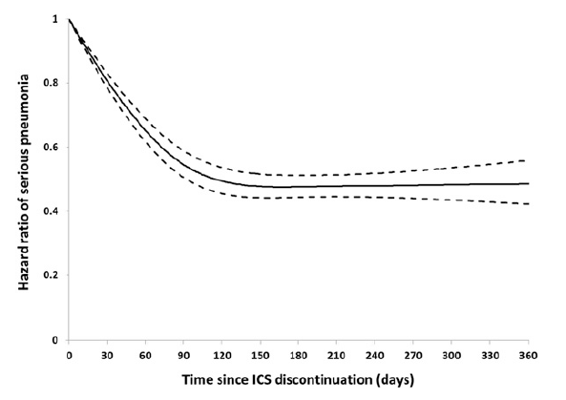
Source: Suissa (2015), Figure 2, p 1181
Abbreviations: ICS, inhaled corticosteroids.

TORCH summary

Study design and selected safety outcomes– Calverley 2007
The three-year TORCH trial randomised 6,184 patients, at 444 centres in 42 countries, to either fluticasonepropionate/salmeterol (500/50 μg) combined therapy, monotherapy with either drug, or to placebo. Patient eligibility criteria included the following: COPD patients 40 to 80 years of age; predicted FEV₁ <60%; an increase of FEV₁ with the use of 400 μg of albuterol of <10% of the predicted value for that patient, and a ratio of pre-bronchodilator FEV₁ to FVC ≤0.7. The primary outcome was all-cause mortality for the comparison of combination therapy with placebo.
The flow of patients in the TORCH trial is shown in Table 4.19. Study withdrawal was very high in all groups, ranging from 34% of patients on combination therapy up to 44% in the placebo group. According to the authors, the high withdrawal rate in the placebo group is likely to have resulted in an underestimation of the effect of the combination therapy on all secondary outcomes.
Table 4.19 Patient disposition in the TORCH RCT
Event (n) | FLU/SAL 500/50 | FLU 500 | SAL 50 | Placabo
Randomised (N = 6184) | 1546 | 1551 | 1542 | 1545
Received study drug | 1533 | 1534 | 1521 | 1524
Withdrawals (proportion of randomised group) | 522  (34.1%) | 587  (38.3%) | 561  (36.9%) | 673  (44.2%)
Withdrew due to AE | 289 | 360 | 303 | 366
Completed study | 1011 | 947 | 960 | 851
Source: Calverley (2007), Figure 1, p778
Abbreviations: FLU, fluticasone; RCT, randomised controlled trial; SAL, salmeterol.
Events resulting in withdrawal or discontinuation of study drug were highest in the placebo group, while more combination therapy patients reported drug-related adverse events (Table 4.20). Pneumonia, fractures and eye disorders were listed as events of special interest. Pneumonia was reported as an adverse event or serious adverse event – it was not prospectively defined in the study protocol as excess risk was not anticipated.
Calverley et al (2007) reported pneumonia rates using event-free survival analyses (Kaplan-Meier). These three-year event-free survival rates for pneumonia have usually been applied to the entire original randomised group sample size to obtain the event frequencies for meta-analyses. Table 4.20 supplements the published results with data from the TORCH Clinical Study Report for pneumonia as an adverse event or serious adverse event.
For the Kapan-Meier pneumonia probability estimate, the differences between the fluticasone group (combination or monotherapy) and the placebo group were statistically significant, as was the difference between the combination therapy and salmeterol groups.
The authors noted that this increase in pneumonia events did not appear to result in an increase in mortality (in fact, a reduction in all-cause mortality in the fluticasone propionate/salmeterol group versus placebo came close to, but did not reach, statistical significance: HR 0.825 [95% CI: 0.681, 1.002], P=0.052).
Table 4.20 Selected safety results from the TORCH RCT – Calverley 2007 and SCO30003 CSR
Adverse Event (% of patients) | FLU/SAL 500/50  (N = 1546) | FLU 500  (N = 1552) | SAL 50  (N = 1542) | Placebo  (N = 1554)
Any adverse event | 89 | 90 | 90 | 90
Serious adverse event | 43 | 42 | 40 | 41
Drug-related adverse event | 18 | 19 | 12 | 13
Event resulting in withdrawal or discontinuation of study drug | 18 | 23 | 20 | 24
Noted as special interest
Pneumonia (% from Kaplan-Meier) | 19.6 | 18.3 | 13.3 | 12.3
Pneumonia AE – n (%) | 207 (13) | 185 (12) | 133 (9) | 112 (7)
Pneumonia SAE – n (%) | 138 (9) | 121 (8) | 82 (5) | 69 (4)
Fractures (% from Kaplan-Meier)
Total | 6.3 | 5.4 | 5.1 | 5.1
Non-traumatic | 1.7 | 1.7 | 2.5 | 1.8
Eye disorders (% from Kaplan-Meier) | 5.2 | 4.1 | 4.3 | 3.6
Source: Calverley (2007) Table 4, p787; GalaxoSmithKline Clinical Study Report SCO30003 – 2006, Table 29, p82
Abbreviations: CSR, clinical study report; FLU, fluticasone; RCT, randomised controlled trial; SAL, salmeterol; FLU/SAL, fluticasone propionate/salmeterol.Pneumonia post hoc analysis of TORCH – Crim 2009
A post hoc analysis of the TORCH trial by Crim and colleagues (2009). To account for the differential drop-out rate, pneumonia was reported as events per 1,000 treatment years. In this analysis, excess pneumonia risk was still evident in the fluticasone and fluticasone propionate/salmeterol groups. Time to first pneumonia was also analysed and found to be shorter in the ICS-containing groups.
An analysis of risk factors for pneumonia was performed for all trial participants, regardless of treatment group. Figure 4.17 shows hazard ratios and associated 95% CIs for the factors from a Cox’s proportional model for time to first pneumonia. Risk of pneumonia was significantly higher in patients with lower % predicted FEV₁, especially less than 30% of predicted (72% higher than patients with ≥50% predicted FEV₁), and those with ≥ 1 exacerbation. This finding suggests the population indicated for ICS/LABA combination therapy is the population most vulnerable to the serious side effects of ICS use. The identification of pneumonia risk in COPD severity subgroups, however, is out of the scope of the current Review, and is not addressed further.
Figure 4.17 Risk factors for pneumonia, adjusted HR – Crim 2009
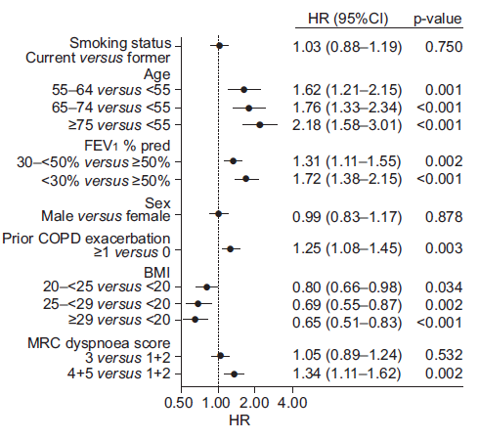
Source: Crim (2009), Figure 2, p 645
Abbreviations: BMI, body mass index; CI, confidence interval; COPD, chronic obstructive pulmonary disease; FEV₁, forced expiratory volume at 1 second; HR, hazard ratio; MRC, Medical Research Council.

Conclusions
The majority of RCTs included in the meta-analyses presented here are of three months duration or longer. The key systematic reviews that used an adverse event(s) as the primary outcome investigated studies treating patients for at least 12 weeks (Kew et al, 2014) or six months (Dong et al, 2014; Loke et al, 2011). The majority of studies in the key systematic review for pneumonia (Kew et al, 2014) were of at least three months’ duration, with half being one year or longer. While the observational studies did not report exposure times, the nature of the long-term real world data used in these studies suggests typical use is captured, which is usually prolonged. Therefore, it is considered appropriate by the current authors to attribute the findings for this ToR to prolonged ICS use.
A number of meta-analyses from systematic reviews have found risk of pneumonia is increased with ICS use. The most relevant key systematic review (Kew et al, 2014) found ICS use increased the risk for non-fatal, pneumonia SAEs by 62% to 78% (budesonide and fluticasone, respectively), and for any pneumonia event by 68% (fluticasone). The large, three-year TORCH study dominated analyses (frequently accounting for over 80% of meta-analysis weightings), but there was little heterogeneity in the results, with most studies reporting a non-significant risk increase. Results were similar for the two comparisons: ICS versus placebo, and ICS/LABA versus LABA.
In subgroup analyses of the TORCH trial, the risk of pneumonia with ICS use was found to be greater in patients with more severe COPD, the population for whom this therapy is indicated. The risk of pneumonia in the more mild COPD population, where the use of ICS/LABA combination therapy is inappropriate, is unclear.
Observational study findings generally agreed with each other and with the meta-analyses regarding pneumonia, with the largest case-control study (Suissa et al, 2013; Quebec health insurance databases) reporting a 69% risk increase across all ICS. Increases were higher for fluticasone (101%) than for budesonide (17%) and a dose-response was evident with both. A subgroup analysis of new ICS users in the same nested case-control found discontinuation of ICS reduced risk within four months to 63% of the risk with ICS (58% with fluticasone, 87% with budesonide; Suissa et al, 2015).
Two observational studies investigated intra-class differences between fluticasone and budesonide (such comparisons were thwarted in the meta-analyses of RCTs by the imbalance in sample sizes and study duration for budesonide, and the more frequently studied fluticasone). Kern (2015) matched 3,697 patients taking fluticasone propionate/salmeterol with the same number taking budesonide/eformoterol (US health insurance database) and found no statistically significant difference between the two for any of the pneumonia outcomes tested. This was in contrast to the PATHOS study (Janson et al, 2013; Swedish primary care medical records linked to registries) that matched 2,734 users of each of these combination therapies and found the risk of all pneumonia outcomes was higher with fluticasone FDC by 73% to 76% compared with budesonide FDC.
All-cause mortality was consistently found to favour ICS use, for both the general COPD population and those with pneumonia, across the observational studies. Findings for fracture were less consistent (with fewer studies).
The European Medicines Agency made the following conclusions in their 2016 Assessment Report on ICS products:
- the Kew and Seniukovich (2014) Cochrane review found an overall increased risk of pneumonia of 40% to 70% in ICS-treated COPD patients;
- the majority of the observational studies estimated an increase in the risk of pneumonia in patients treated with ICS of between 40% to 70%;
- there is no conclusive clinical evidence for intra-class differences in the magnitude of the risk among inhaled corticosteroid products; and
- while the concept of a dose-response for pneumonia risk has biological plausibility and there is some supportive clinical evidence, this has not been demonstrated conclusively across all studies.
The EMA recommended adding pneumonia (in COPD patients) as a common adverse drug reaction in the product information of all ICS-containing products, and concluded that the benefit-risk balance of ICS-containing products remained favourable, provided the proposed changes to the product information are implemented.

The submission did not provide citation details, but this report can be accessed online.
The TORCH study was not included in the integrated analysis for fluticasone/salmeterol due to being of longer duration than any of the fluticasone/vilanterol studies, but pneumonia rates in the TORCH study were presented separately, as discussed in the earlier section for Seretide Accuhaler and MDI).
Australian Product Information for Symbicort Turbuhaler.
Studies of mometasone/eformoterol versus placebo were also included.
Singh, (2009); this meta-analysis was identified by the current Review literature search but excluded from detailed review due to the availability of more recent reviews.
Reasons for ineligibility of recent fluticasone studies: wrong intervention (furoate rather than propionate salt of fluticasone: Dransfield, 2013; Kerwin, 2013; Martinez, 2013) or wrong comparator (no placebo or LAMA arm: Vogelmeier, 2013). Reasons for ineligibility of recent budesonide studies from Nannini (2013): no placebo arm.
Apart from Nanini (2012), the literature searches for these reviews were conducted in a six-month period from June to December 2013. Only the non-key review by Festic (2016) was performed more recently (February 2015) – one unique study was included (Crim, 2015), but this is a post-hoc analysis of the two RCTs reported in Dransfield (2013), and did not provide any additional data for analysis.
Pneumonia was a secondary outcome. The primary outcome in Tricco (2015) was exacerbations. Other secondary outcomes were mortality, cardiovascular-related mortality and serious arrhymthmia.
Non-fatal, serious pneumonia was the primary outcome for Kew (2014). Secondary outcomes were mortality, mortality due to pneumonia, non-fatal serious adverse events and study withdrawals. All pneumonia events were also reported.
Not necessarily an exhaustive list of included fluticasone and budesonide studies for Tricco (2015).
This study identified as Choudhury 2005 in Kew (2014).
This study identified as SFCT01 in Nanini (2013).
This study identified as van Den Boom (2001) in Tricco (2015).
Study publication used was Johnell (2002).
Not shown here, but all studies included in the Nannini et al reviews are also included in the Tricco (2015) MTC: Table 4.10 lists highest doses used, and all align with PBS-listed doses, except the fluticasone/​vilanterol studies, which are not included in Nannini (2012) or Nannini (2013).
Only highest dose for main intervention is shown. All doses taken twice/day, except for fluticasone furoate/vilanterol studies, which were once/day.
This outcome is not reported in the current Review.
For first 6 months, morning dose was 800 μg, evening dose 400 μg, reduced to 400 μg twice per day for following 30 months.
Calculated post hoc by the authors of the current Review using Review Manager 5.3: unadjusted OR 1.98 [95% CI: 1.23, 3.19]

