Pharmaceutical Benefits Scheme
Post-market Review of
Chronic Obstructive Pulmonary Disease Medicines
ToR 5
Final Report
August 2017

Contents
Section 5: ToR5 COPD Medicines Utilisation analysis 4
5.1 Key findings for ToR 5 4
Utilisation analysis of PBS/RPBS claims data 4
MedicineInsight data analysis 4
Stakeholder Views (Forum and Public Consultation) 5
5.2 Introduction 6
5.3 PBS/RPBS claims data sources and limitations 6
5.3.1 Department of Human Services (DHS) PBS claiming system 6
5.3.2 Department of Health (DoH) PBS claims database 6
5.4 PBS/RPBS utilisation analysis methodology 8
5.4.1 Department of Human Services (DHS) PBS claiming system 8
5.4.2 Department of Health (DoH) PBS claims database 9
5.5 Preliminary analysis of COPD PBS/RPBS utilisation 14
5.6 COPD utilisation analysis based on PBS individual unit record data 18
5.6.1 Data inclusions 18
5.6.2 Monthly prescriptions 18
5.6.3 Analysis of COPD prevalent patients 23
5.6.4 Utilisation outside COPD-X Guidelines – Initiations 23
5.6.5 Utilisation outside COPD-X Guidelines – Co-administration analysis 25
5.7 MedicineInsight data source and limitations 28
5.8 MedicineInsight COPD patient profile 30
5.9 MedicineInsight Drug utilisation 30
5.9.1 Number of prescriptions 30
5.9.2 Co-prescribing in 2016 32
5.9.3 Initial therapy for COPD 32
5.9.4 Associated care for COPD patients 33
5.9.5 Adverse events 33

List of Tables
Table 5.1 Standard prescription coverage days calculated from the DoH claims database 10
Table 5.2 COPD dispensed script volumes and year on year movement by quarter from Quarter 4 2012 to Quarter 4 2016 for patients initiating between 1st November 2008 and 31st October 2012 22
Table 5.3 Patients initiating by LABA, LAMA and LAMA/LABA classes by year 24
Table 5.4 Patients initiating to a medicine or combination therapy that is not refilled by LABA, LAMA and LAMA/LABA classes by year 24
Table 5.5 Patients initiating by group and year 25
Table 5.6 Patients initiating by prescriber type, 2015 and 2016 (Jan-Oct) 25
Table 5.7 COPD medicines utilisation by COPD-X guideline indicator, drug class and year 27
Table 5.8 Utilisation of COPD and COPD plus asthma prescriptions (MedicineInsight) 31
Table 5.9 The number of adverse events recorded by drug class (MedicineInsight)…………………………………………………………………………... 33

List of Figures
Figure 5.1 Patient sample showing individual therapy episodes and calculated adjusted treatment regimens 13
Figure 5.2 COPD PBS/RPBS benefits paid total market by COPD and asthma medicine per Appendix B, 2006 to 2016 15
Figure 5.3 COPD PBS/RPBS dispensed script volumes total market by COPD and asthma medicine per Appendix B, 2006 to 2016 16
Figure 5.4 COPD PBS/RPBS dispensed script volumes and year on year movement total market by COPD and asthma medicine class per Appendix B, 2006 to 2016 17
Figure 5.5 COPD dispensed script volumes by year and month from 1st November 2012 to 31st October 2016 for patients initiating between 1st November 2008 and 31st October 2012 20
Figure 5.6 COPD dispensed script volumes excluding Tiotropium 18 μg by year and month from 1st November 2012 to 31st October 2016 for patients initiating between 1st November 2008 and 31st October 2012 21
Figure 5.7 Patients COPD medicines utilisation duration by COPD-X guidelines indicator in 2016 28

Section 5: ToR5
COPD Medicines Utilisation analysis
Analyse the current utilisation of PBS listed COPD medicines to identify the extent of co-prescribing and use that is inconsistent with clinical guidelines and/or PBS restrictions.

5.1 Key findings for ToR 5

Utilisation analysis of PBS/RPBS claims data
- The number of PBS/RPBS prescriptions for COPD/Asthma medicines (LAMA, LABA and ICS) in the 2016 calendar year was approximately 5.2 million scripts based on claims processed. This number has increased by 70.5% compared to 2006 (Figure 5.3).
- The total PBS/RPBS benefits paid for COPD/asthma medicines in the 2016 calendar year was $299 million based on claims processed. This number has grown from $215.2 million in 2006, which represents an increase in benefits paid of $84.1 million or 39.1% (Figure 5.2).
- The number of prescriptions dispensed for tiotropium 18 μg and ICS/LABA has grown year on year to 2014; however, use of these items declined in 2015 and 2016 following the introduction new COPD medicines, mainly LABA/LAMA formulations.
- There has been rapid uptake of tiotropium 2.5 μg since PBS listing in 2015.
- A COPD only cohort was identified from PBS unit record data based on: patients aged 35 years and above who initiated on medicines restricted to COPD only, e.g. tiotropium, indacaterol or LAMA/LABA. Patients initiating ICS/LABA were excluded from the analysis to ensure all patients were treated for COPD and not asthma.
- The final COPD cohort included unique patients that had been dispensed at least one COPD medication and at least one refill of the same medicine in the 8 years between 1 November 2008 and 31 October 2016. 2016 data was extrapolated to 12 months.
- The percentage of patients in the COPD Cohort initiating to combinations outside COPD-X guidelines was 13.2% in 2010 and 25.7% in 2016.
- The percentage of use outside COPD-X guidelines is dominated by initiation to combinations of LABA/LAMA (15.4%) and ICS/LABA plus LAMA (8.3%) in 2016.

MedicineInsight data analysis
The following information on prescribing of COPD medicines is based on GP clinical data collected from volunteer practices recruited to the MedicineInsight program. For this analysis, MedicineInsight data was drawn from 423 clinically relevant practice sites, 3,835 active GPs, and 2,230,658 active patients, to 31 December 2016 inclusive.

- Of the 1.28 million current MedicineInsight patients aged 35 years and over included in the analysis, 3% were ever diagnosed with COPD only (n=38,650), and 1.6% with COPD plus asthma (n=20,546).
- In MedicineInsight data in 2016, 51,903 prescriptions for the medicines of interest were ordered for current patients with COPD only, and 54,197 prescriptions for COPD plus asthma.
- For all COPD and COPD plus asthma patients, 41.6% had no prescriptions written for any SAMA, SABA, LAMA, LABA or ICS (including combinations) inhalers in 2016.
- With regard to medicine combinations of safety concern - for COPD only patients 3.6% were at risk of duplicated therapy, and 1.6% were on combinations of SAMA and LAMA. For patients with COPD plus asthma, 6.1% may be at risk of duplicated therapy, and 3.2% were on combinations of SAMA and LAMA.
- Of the 38,650 COPD only patients, 3,043 people initiated therapy with a COPD medication (excluding SABA) between 1 July 2015 and 31 December 2016:
  - 45.9% were prescribed only one medicine of interest as initial therapy, 49.0% were prescribed dual therapy, and 4.5% triple therapy.
  - The most common choices of initial therapy by class were: dual therapy with ICS + LABA (41.6%), LAMA monotherapy (32.6%) and LAMA + LABA dual therapy (7.0%).
  - A significant amount of combination use of COPD medications was therefore observed to be outside clinical guidelines and PBS restrictions (53.5%).
- Among patients with COPD only and COPD plus asthma, 38.1% (n=22,524) ever had a record of one or more spirometry tests.
- Common adverse events recorded for COPD medicines included: cough, rash, palpitations, muscle spasms, headache, nausea, laryngeal discomfort, and dyspnoea.

Stakeholder Views (Forum and public consultations)
- In the PBS data analysis, the exclusion of patients initiating therapy with ICS/LABA may significantly underestimate the COPD only population.
- The PBS data analysis did not consider samples, hospital initiations, or over-the-counter SABA use, which may lead to an overestimation of use outside guidelines and PBS restrictions.
- Analysis of SAMA, SABA and ICS/LABA patient utilisation, including initiations, is required to better understand the overall use of all COPD medications.
- The MedicineInsight analysis underestimates the utilisation of SABA medications (available over-the-counter) and should be interpreted with caution.
- International evidence was presented regarding the uncertainty in COPD patient identification. Concerns were expressed by a number of stakeholders as to whether healthcare utilisation databases are adequate to inform PBAC decision making.
- For further information, the Stakeholder Forum Summary is available at Appendix F.
- Published references supplied by stakeholders are available in Appendix V.

5.2 Introduction
In October 2013, DUSC reviewed the PBS utilisation of indacaterol for COPD. The review identified co-administration of multiple LABA products in some patients, which is not supported by PBS prescribing restrictions or clinical practice guidelines. This was considered a significant QUM issue. Due to limitations in the information available, DUSC could not determine whether this QUM issue was due to inappropriate prescribing of multiple products by the clinician or inadvertent improper poly-pharmacy due to a lack of understanding on behalf of the clinician or patient.
The following utilisation review was conducted to identify the extent of co-prescribing and medication use that is inconsistent with clinical guidelines and/or PBS restrictions using PBS/RPBS claims data. The MedicineInsight Post-Market Surveillance Report 11 was developed with the purpose of informing the post-market review and medicines policy for COPD. Results from the MedicineInsight Post-Market Surveillance Report 11 are summarised in this section, with the full report at Appendix T.

5.3 PBS/RPBS claims data sources and limitations

5.3.1 Department of Human Services (DHS) PBS claiming system
A preliminary analysis of PBS/RPBS services and benefits was conducted using the DHS PBS claiming system. Claims for reimbursement for the supply of PBS or RPBS subsidised medicines are submitted by pharmacies to the DHS PBS claiming system (PBS Online) for processing. PBS/RPBS services and benefits claims data was extracted from the DHS PBS statistics website on 11 April 2017 for preliminary analysis. The prescription and benefits data is based on the date the prescription was processed, that is, the date on which PBS Online finalises the payment for a prescription. However, some of these scripts could be adjusted later if errors were found by suppling pharmacies or DHS during a final reconciliation. The analysis conducted using the DHS claims data set is therefore subject to monthly variations resulting from bulk processing of prescriptions. The DHS PBS claims data includes the whole market, including all age groups, and asthma and mixed airways disease patients.

5.3.2 Department of Health (DoH) PBS claims database
A data file of individual record claims data was supplied from the Department of Health (DoH) PBS claims database. PBS and RPBS patient records were included in the dataset. The data set contained unique identifiers that enabled patient de-identification. PBS and RPBS data for ATC ‘H02’ and ’R03’ prescriptions were included in the analysis. The data analysis was conducted for prescriptions supplied between the periods of 1 November 2006 to 31 October 2016. Under co-payment prescriptions were included in the analysis from April 2012. As COPD is very uncommon among people aged less than 35 years, the dataset was restricted to patients aged 35 years and older (acknowledging that some patients in the dataset will have asthma or ACOS) as of 31 October 2016. The data was extracted on 31 January 2017. The supplied data file comprised approximately 113 million prescribing records (see data specification in Appendix N).
Caution should be taken when interpreting analyses based on PBS/RPBS prescription claims data as there are important limitations with the data set, including:

Population
- Medications provided during hospitalisation, or given on discharge from hospital, may not be captured in PBS prescriptions data.
- Medications that are obtained through remote Aboriginal Health Service organisations are not captured.

Data availability
- The recent PBS listing dates for some COPD medicines (particularly the FDCs listed in late 2015) means that it may be premature to try to accurately determine the nature and extent of their integration into treatment pathways for COPD patients.

Diagnosis and clinical information
- The data set does not include information relating to patient diagnosis.
- As bronchodilators and ICS are used for the treatment of both COPD and asthma, there is a risk that patients with asthma may be misclassified as COPD and vice versa. For PBS/RPBS items that are not restricted solely to the treatment of COPD (e.g. the ICS/LABAs, which are also listed for asthma), it is not possible to directly determine the underlying condition associated with the prescriptions dispensed. In this case, inferences need to be made, and the approach typically used by DUSC and the Australian Institute for Health and Welfare (AIHW) is to restrict the analyses to specific age groups. For instance, COPD is very uncommon among people aged less than 35 years and therefore it may be reasonable to assume that respiratory medications prescribed in this age group will not be for COPD. On the other hand, medications dispensed to people aged 35 years and over may include those prescribed for either COPD or asthma.
- Patients with ACOS further complicate data interpretation as these patients are treated using a different algorithm and may be eligible for both COPD and asthma treatments. While there is some debate in the scientific community regarding the proportion of patients with ACOS, the estimate typically quoted in Australia is 15% (November 2010 PSD for indacaterol).
- The data set does not contain clinical information about the reason for the prescription or the nature or severity of the condition for which the medication was prescribed. As such, it is not possible to determine whether PBS medicines are being used in the intended population according to the PBS restriction (e.g. the requirement for COPD patients to have a FEV₁ less than 50% of predicted normal prior to therapy in order to access an ICS/LABA on the PBS).

Switching and add on therapy
- Assessing aspects of medication utilisation such as co-administration or switching between medicines is also not straightforward when based on prescription refill data alone.
- The stepwise approach to COPD management, coupled with the selection of therapies available on the PBS, means that patients switch and add on therapies as needed to control symptoms, manage side effects, and simplify treatment regimens. This utilisation analysis has included assumptions relating a standard prescription coverage period to account for switch and add on therapy.

Compliance and adherence
- PBS/RPBS data do not provide information on prescriptions written by a health care professional that are not filled by the patient, thereby making assessment of primary non-adherence and prescriber intent difficult.
- The data does not indicate whether or how often a medication was actually used. Patients may not be completely adherent to their prescribed therapy.
- Poor adherence with COPD treatments is frequently observed, despite it being a highly symptomatic disease. Compliance issues can confound analyses as the prescription coverage period may be appear longer, however it does not represent consistent medicine use.

Stockpiling
- Stockpiling of medication is a phenomenon that can cause data anomalies and must be taken into account when analysing PBS claims data. Stockpiling can occur at any time of the year, but often occurs towards the end of the calendar year when a Safety Net card holder fills prescriptions more frequently than expected, so as to avoid a higher co-payment in the first few months of the next calendar year when they lose Safety Net eligibility.

5.4 PBS/RPBS utilisation analysis methodology

5.4.1 Department of Human Services (DHS) PBS claiming system
A preliminary analysis was conducted to report the total prescriptions and benefits of COPD/asthma medicines subsidised through the DHS PBS claims dataset. Refer to Appendix C for COPD/asthma medicine PBS items included in the analysis. A number of ICS/LABA medications have a Restricted Benefit PBS listing and therefore it is not possible to distinguish between the COPD and asthma populations. All items included in the analysis are above the general co-payment threshold and therefore there was no requirement to add under co-payment source data.

5.4.2 Department of Health (DoH) PBS claims database
A detailed analysis of the DoH PBS claims data set was conducted based on prescriptions dispensed and unique patients. In order to address some of the issues discussed in Section 5.2 and restrict the data analysis to a population with a higher likelihood of COPD, a number of steps were taken to prepare the DoH PBS data set.

Drug treatment inclusion and exclusions
- Patients that were supplied their first prescription with an ICS/LABA medicine in the data set period (1 November 2008 to 31 October 2016) were excluded from the analysis. The rationale for the exclusion is to reduce the likelihood of including patients with asthma and mixed airways disease in the COPD cohort and increase confidence that the study has better captured prescribing patterns relevant to COPD patients.
- A complete analysis of prescribing for COPD would include short-acting reliever medications (SAMAs and SABAs), but analysis of these medications is problematic for several reasons. Firstly, SABAs can be readily purchased over-the-counter in Australia. The extent of utilisation of these medicines is therefore likely to be significantly underestimated on the basis of PBS claims. Secondly, short-acting bronchodilators (and corticosteroids) are inexpensive and priced under the general co-payment. Therefore, these agents were not all captured in the PBS/RPBS dataset prior to April 2012.
- As all LAMA, LABA, LAMA/LAMA and ICS/LABA preparations are dispensed at a price that is higher than the general PBS co-payment, the PBS/RPBS dataset is complete for the long-acting medicines that are the focus of this Review. Refer to Appendix C for the PBS/RPBS items included in this analysis.

COPD patient cohort
A patient cohort was selected based on those patients who had not been supplied with medicines used in the management of COPD prior to 1 November 2008 (i.e. applying a consistent look-back period of two years from the first observed PBS/RPBS COPD claim). This rationale for the COPD selection was to improve the detection and analysis of initiations (event analysis) and analysis of utilisation (prevalent analysis).

Estimation of COPD incident and prevalent patients
Treatment regimens were calculated to account for the number of initiating and prevalent patients co-supplied COPD medications. Standard prescription coverage days (SCDs) were estimated to calculate treatment COPD regimens and assess gaps in the supply of medications including discontinuations. In this analysis SCDs were calculated using the median time-to-refill for PBS items, refer to Table 5.1.
Table 5.1 Standard prescription coverage days calculated from the DoH claims database
PBS item code | Drug name | Standard prescription coverage days
08432T | fluticasone propionate / salmeterol | 32
08519J | fluticasone propionate / salmeterol | 36
08750M | budesonide / eformoterol | 42
10018G | budesonide / eformoterol | 49
10199T | fluticasone furoate / vilanterol | 31
 | ICS/LABA Totalª | 35
05134F | indacaterol | 31
05137J | indacaterol | 31
 | LABA Total | 31
10156M | indacaterol / glycopyrronium | 31
10188F | umeclidinium / vilanterol | 31
10557P | tiotropium / olodaterol | 30
10565C | aclidinium / eformoterol | 33
 | LABA/LAMA Total | 31
08626B | tiotropium | 32
10059K | glycopyrronium | 31
10124W | aclidinium | 35
10187E | umeclidinium | 31
10509D | tiotropium | 31
 | LAMA Total | 32
Source: PBS Dispensing records between 1/11/2006 and 31/10/2016 file R2017068_PBS_COPD_DATA.CSV.
Abbreviations: PBS, Pharmaceutical Benefits Scheme
The SCD is used to work out how many days of supply of a medicine a patient has on hand through accumulation and depletion by filling scripts more or less frequently. Breaks in therapy were assumed when a patient does not refill their prescription within two SCD periods after estimated coverage ends. Stockpile adjustments were accounted for in the analysis by estimating the amount of supply on hand, refer to Appendix R for further details.
In this analysis COPD initiations were defined as a patient, aged 35 years and older, commencing on medications listed on the PBS for COPD only (LABA, LAMA or LABA/LAMA) that refilled a prescription for the same PBS item at least once within two SCDs. The rationale for the requirement to have refilled is reduce the likelihood of including patients that have received a single supply in the study period and potentially discontinued use due to incorrect diagnosis.
A regimen for each one week period was taken to include all medications that were inside their calculated SCDs in that week. Further adjustments were applied to calculate regimens to remove small data artefacts that were not clinically meaningful. Refer to Appendix R for further details regarding the additional rules applied to calculate treatment regimens. The estimated number of COPD patient initiations including regimens are presented in calendar years.
Prevalent patients were calculated based on unique patient counts per year for patient regimens that have coverage of any proportion of that year. Patients that switched drug treatments during a year and had more than one regimen were counted as one unique patient. The estimated number of prevalent patients included initiations to COPD therapies and continuing COPD therapy. Patient death was not recorded in the DoH PBS data set and therefore no adjustments were made to the COPD cohort analysis. Patients were assumed to have discontinued treatment if they had not refilled their prescription within 2 SCDs and they were able to re-enter the prevalent pool in a subsequent year if they refilled their prescription at a later date. Patients re-entering the prevalent population were not recounted as initiations. The estimated numbers of COPD prevalent patient are presented in calendar years.
No censoring adjustments were made in the final months of the study period to allow for the timing effects of initiation and regimen coverage rules, with the exception of extrapolation, where relevant, to improve comparisons between calendar years (which is noted where it has been used). The method of extrapolation of the 2016 patient analysis was conducted by applying 2015 month on month ratios by class to the corresponding 2016 months for September through December. The rationale for this is to improve transparency of patient behaviour in the later periods that cover the introduction of the more recently PBS listed COPD therapies. An analysis was conducted to determine initiating and prevalent patients on COPD medications including regimens within and outside COPD-X guidelines.
A summary of the methodological approach is presented below, for further details refer to Appendix R.

Summary steps completed within the analysis
Step 1 was to remove the PBS-listed items that are not used in the management of COPD.
Step 2 was to exclude patients initiating to ICS/LABA medicine.
Step 3 was to retain only COPD patients starting a COPD medicine for the first time during the study period. This is defined as those patients who had not been supplied with medicines used in the management of COPD prior to 1 November 2008 (i.e. applying a look-back period of two years from the first observed PBS/RPBS COPD claim). This is to improve the detection and analysis of initiations (event analysis) and analysis of utilisation (prevalent analysis).
Step 4 was to perform a time-to-refill analysis to provide values for use as assumptions for calculating ‘standard prescription coverage days’ (SCDs) for each medicine item. The median time for refill was used in the calculation of the SCD of all COPD medications.
Step 5 was to undertake a patient level analysis to determine the estimated medication coverage days for each drug or drug class. This mainly involves detecting breaks in treatment (based upon time-to-refill analysis at Step 4).
Step 6 was to calculate patient incidence and prevalence for the selected COPD patient cohort including drug regimens.
Step 7 involved estimating the proportion of patients supplied COPD medications within and outside COPD-X guidelines.

Data file
Source: PBS Dispensing records between 1/11/2006 and 31/10/2016 file R2017068_PBS_COPD_DATA.CSV refilled at least once (within two SCDs). The SCD values are presented in Table 5.1.

Example of analysis
Figure 5.1 illustrates the method specified above. Step 5 calculates the SCD for each drug – fluticasone propionate/salmeterol 250/25 μg (FLU/SAL 250/25), tiotropium 18 μg (TIO 18), indacaterol 150 μg (IND 150) and indacaterol/glycopyrronium 110/50 μg (IND/GLY) – arriving at the treatment episodes (blue bars). The Step 6 process (including adjustments) determines the treatment regimens (red bars). In Figure 5.1, the first breaks can be observed in the latter half of 2005. Here fluticasone propionate/salmeterol (FLU/SAL 250/25 – Epi 1) is not refilled on at least two expected supply dates, resulting in a clear therapy break, before being re-continued in 2005 (third bar down FLU/SAL 250/25 – Epi 2).
Figure 5.1 also shows (in the second and third blue bars) that tiotropium (TIO 18) and fluticasone propionate/salmeterol (FLU/SAL 250/25) are co-prescribed (and likely co-administered) continuously between late 2005 and late 2013. As a consequence, the treatment regimen is estimated (represented by the red bars) for [FLU_SAL 250/25 with TIO 18] Epi-3. The same logic follows for the remaining individual therapy episodes and the corresponding treatment regimens.
Similar methods have been used for assessing medicine use in Australian populations (Pratt et al, 2011; Vitry et al, 2010). Hallas (2005) describes the method and provides references to early variants. This methodology includes a number of the same refinements as implemented by DUSC when analysing concomitant use of medicines in 12-month post-market reviews. Further explanation of the methods is described in Appendix R.

Figure 5.1 Patient sample showing individual therapy episodes and calculated adjusted treatment regimens
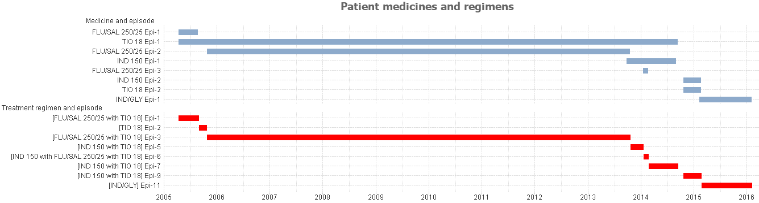
Adjusted treatment regimens
Individual therapy episodes
Sample taken from estimated treatment regimens: PBS Dispensing records between 1/4/2005 and 31/12/2015 file REQ198_COPD.CSV

5.5 Preliminary analysis of COPD PBS/RPBS utilisation
Analysis of PBS/RPBS claims data for the whole market (includes all age groups and asthma and mixed airways disease patients) shows that the total benefits paid in 2016 calendar year for prescriptions for the ‘in-scope’ COPD medicines (LAMAs, LABAs, LAMA/LABAs and ICS/LABAs) was $299 Million (Refer to Figure 5.2). This number has grown from $215.2 million in 2006, which represents an increase in benefits paid of $84.1 million or 39.1%.
Figure 5.3 shows PBS/RPBS prescription volumes in 2016 for all ‘in-scope’ COPD medicines (for the whole market including all age groups, and asthma and mixed airways disease patients) reached approximately 5.2 million. This number has increased from a total of 3.1 million scripts in 2006, which is an increase of 2.1 million scripts or 70.5%.
Figure 5.4 shows PBS/RPBS prescription volumes by class. LAMAs, LABAs and LAMA/LABAs are indicated for use in COPD only patients and total prescription volumes for these COPD only medicines reached 2.5 million scripts in 2016 (noting this includes all patient age groups). This has increased from a total of 1.2 million scripts in 2006, which is an increase of 1.3 million scripts or 106.8%. Figure 5.4 also shows that total PBS/RPBS prescription volumes for COPD only medicines declined by 6.0% year on year between 2015 and 2016.
Tiotropium 18 µg represents the medication with the highest PBS/RPBS utilisation and expenditure for COPD. ICS/LABA medications represent a significant proportion of prescriptions and may include patients with asthma.
There is increasing use of all combination LABA/LAMAs and tiotropium 2.5 µg between 2015 and 2016. This is not unexpected given these medicines are new to market.
Figure 5.2 COPD PBS/RPBS benefits paid, total market by COPD and asthma medicine, 2006 to 2016
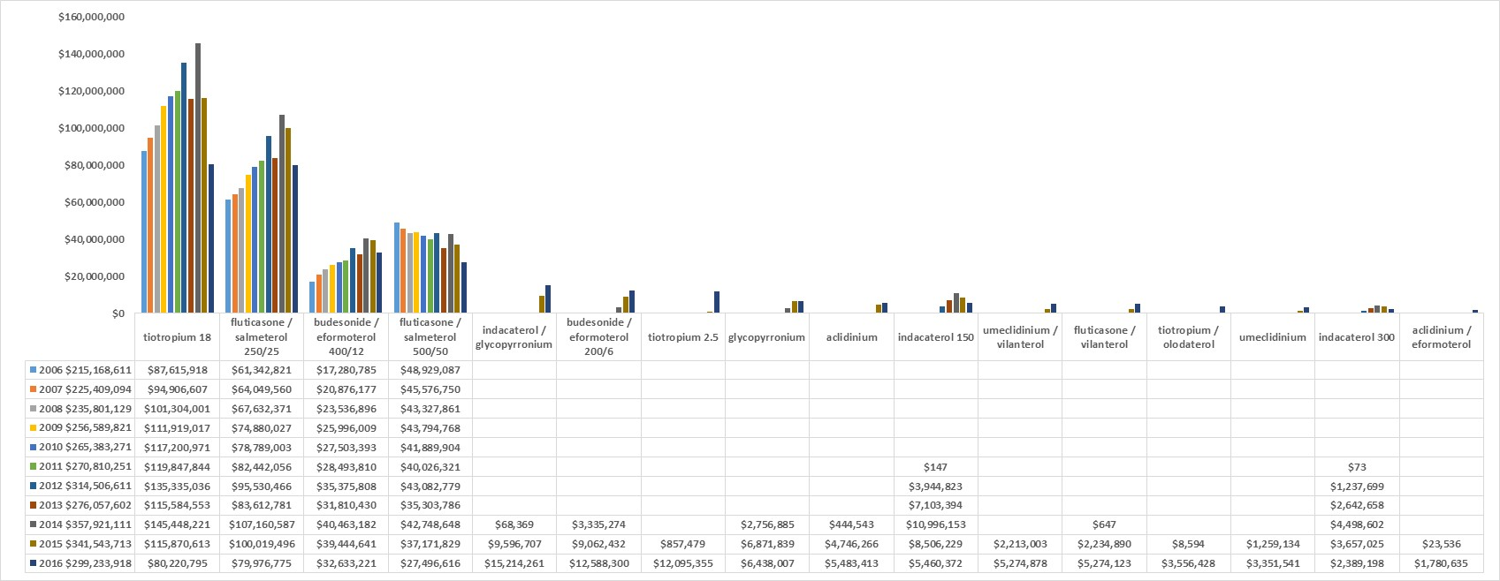 Source: http://medicarestatistics.humanservices.gov.au/statistics/pbs_item.jsp (accessed 15 April 2017)
Includes PBS/RPBS claims data for the whole market including all age groups, and asthma and mixed airways disease patients.
Abbreviations: COPD, chronic obstructive pulmonary disease; PBS, Pharmaceutical Benefits Scheme.

Figure 5.3 COPD PBS/RPBS dispensed script volumes, total market by COPD and asthma medicine, 2006 to 2016
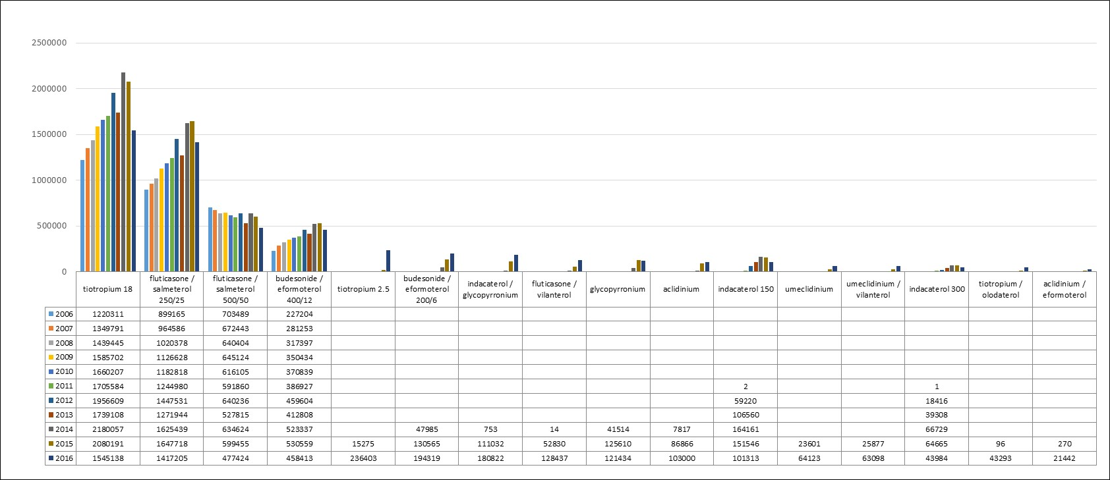
Source: http://medicarestatistics.humanservices.gov.au/statistics/pbs_item.jsp (accessed 15 April 2017)
Includes PBS/RPBS claims data for the whole market including all age groups, and asthma and mixed airways disease patients.
Abbreviations: COPD, chronic obstructive pulmonary disease; PBS, Pharmaceutical Benefits Scheme.
Figure 5.4 COPD PBS/RPBS dispensed script volumes and year on year movement, total market by COPD and asthma medicine class, 2006 to 2016
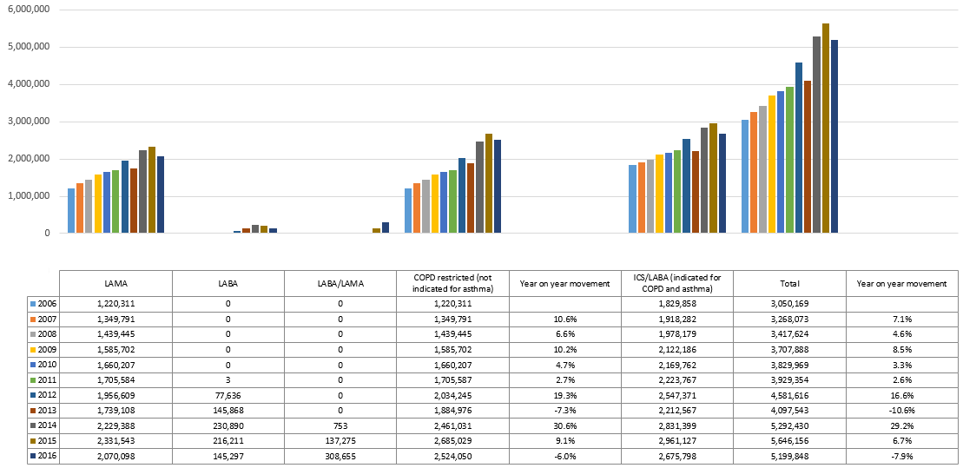
Source: http://medicarestatistics.humanservices.gov.au/statistics/pbs_item.jsp (accessed 15 April 2017)
Includes PBS/RPBS claims data for the whole market including all age groups, and asthma and mixed airways disease patients.
Abbreviations: COPD, chronic obstructive pulmonary disease; PBS, Pharmaceutical Benefits Scheme.

5.6 COPD utilisation analysis based on PBS individual unit record data

5.6.1 Data inclusions
Out of approximately 113 million prescribing records in the supplied file from the DoH claims database, 73.5 million records were excluded immediately as they were not for long-acting bronchodilators used to manage COPD. The remaining 39.5 million records relate to ‘in-scope’ COPD medicines (see Appendix Q for additional data).
For the purposes of identifying the extent of co-prescribing and use that is inconsistent with clinical guidelines, the COPD cohort was further refined. A further 27.2 million records were excluded for patients that did not initiate to therapies within the period from 1 November 2008 to 31 October 2016 (allowing for a minimum two-year look-back). This allows a consistent commencement period of the analysis when trying to develop an understanding of regimen switches and additions, as well as therapy initiations that are typical for this patient population.
Of the remaining 12.3 million records, 5.9 million related to patients that had initiated to ICS/LABA class drugs. As initiating to ICS/LABA is generally not recommended in clinical guidelines or PBS restrictions for COPD, these patients were also excluded leaving 6.4 million records in the final ‘likely COPD’ cohort.
Acknowledging that the refinements discussed above will underestimate the number of COPD patients, the final COPD cohort represents 310,557 unique patients that have been prescribed at least one COPD medicine and at least one subsequent refill in the 8 years between 1 November 2008 and 31 October 2016.

5.6.2 Monthly prescriptions
Figure 5.6 (Figure 5.6 represents the analysis shown in Figure 5.5 with the exclusion of Tiotropium 18 μg to provide better visibility of the other COPD medicines) and Table 5.2 present the dispensed script volumes by month between November 2012 and October 2016 for the cohort of patients initiating to LABA, LAMA and LABA/LAMA between November 2008 and October 2012 based on PBS/RPBS claims data. This analysis was undertaken to better understand the utilisation of COPD medicines in the latter part of the study period that includes the most recent PBS listed medicines for a consistent patient cohort.
The analysis is based on date of supply of prescriptions and excludes ICS/LABA initiations. Seasonal stockpiling towards the end of each calendar year can clearly be seen. Tiotropium 18 μg and fluticasone propionate/salmeterol 250/25 μg are responsible for the largest share of the script volumes throughout the study period. In November 2012, they accounted for 75.4% and 11.9% of scripts, respectively. By October 2016, Tiotropium 18 μg and fluticasone propionate/salmeterol 250/25 μg accounted for 48.7% and 12.4% of scripts, respectively. It is not possible to isolate and measure the factors responsible for the decline in the utilisation of Tiotropium 18 μg. Contributing factors will include patient deaths (which do not feature in the data set), switches to newer and alternative COPD medicines, and potentially discontinued use of Tiotropium 18 μg in cases where the patient is subsequently diagnosed with asthma. The results underline that ICS/LABA use remains a dominant feature of therapy in the management of COPD.
Table 5.2 clearly demonstrates a downward trend in overall utilisation for COPD medicines. Year on year comparisons for each quarter show a reduction in every quarter with the exception of quarter 4, 2016 (noting that this quarter is extrapolated). As before, it is not possible to provide any detail on the proportion of patients that discontinue therapy, including due to patient death.
Figures 5.5 and 5.6, and Table 5.2, also show the introduction of newer medicines. Indacaterol was introduced in December 2011. 2014 and 2015 saw the introduction of four new LAMA medicines (including an alternative dose of tiotropium), the introduction of the four LAMA/LABA FDCs, and two ICS/LABA FDCs with doses suitable for the management of COPD.

Figure 5.5 COPD dispensed script volumes by year and month from 1 November 2012 to 31 October 2016 for patients initiating between 1 November 2008 and 31 October 2012
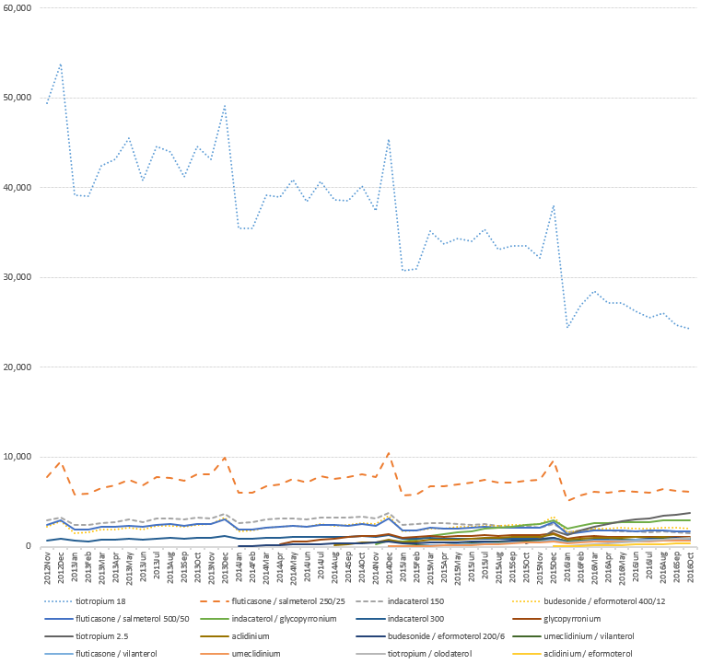
Source: PBS Dispensing records between 1/11/2006 and 31/10/2016 file R2017068_PBS_COPD_DATA.CSV.
Includes only patients who initiated COPD pharmacotherapy with a LABA, LAMA or LABA/LAMA between 1 November 2008 and 31 October 2012.
Abbreviations: COPD, chronic obstructive pulmonary disease.

Figure 5.6 COPD dispensed script volumes excluding Tiotropium 18 μg by year and month from 1 November 2012 to 31 October 2016 for patients initiating between 1 November 2008 and 31 October 2012
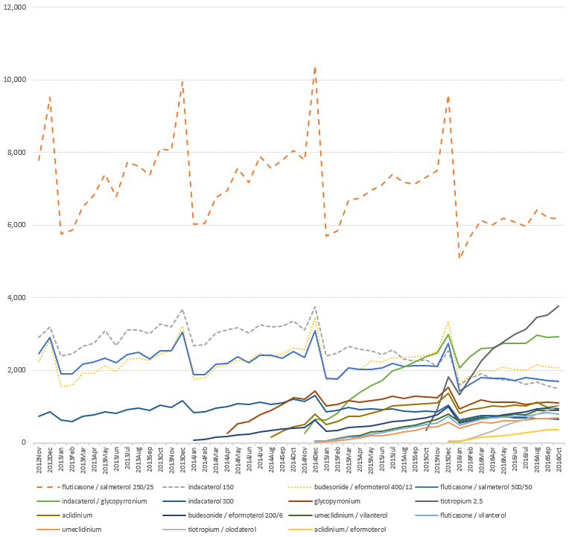
Source: PBS Dispensing records between 1/11/2006 and 31/10/2016 file R2017068_PBS_COPD_DATA.CSV.
Includes only patients who initiated COPD pharmacotherapy with a LABA, LAMA or LABA/LAMA between 1 November 2008 and 31 October 2012.
Excludes Tiotropium 18 μg to prevent obfuscation of other COPD medicines due to the scale of the chart and magnitude of Tiotropium 18 μg dispensed script volumes.
Abbreviations: COPD, chronic obstructive pulmonary disease.
Table 5.2 COPD dispensed script volumes and year on year movement by quarter from Quarter 4 2012 to Quarter 4 2016 for patients initiating between 1 November 2008 and 31 October 2012
Medicine | 2012 Q4 | 2013 Q1 | 2013 Q2 | 2013 Q3 | 2013 Q4 | 2014 Q1 | 2014 Q2 | 2014 Q3 | 2014 Q4 | 2015 Q1 | 2015 Q2 | 2015 Q3 | 2015 Q4 | 2016 Q1 | 2016 Q2 | 2016 Q3 | 2016 Q4
tiotropium 18 | 170,433 | 120,694 | 129,507 | 129,788 | 136,833 | 110,031 | 118,343 | 117,877 | 123,005 | 96,845 | 102,038 | 101,924 | 103,695 | 79,649 | 80,618 | 76,290 | 79,645
Fluticasone propionate / salmeterol 250/25 | 30,610 | 18,133 | 21,022 | 22,717 | 26,123 | 18,853 | 21,704 | 23,245 | 26,255 | 18,245 | 20,809 | 21,702 | 24,402 | 16,872 | 18,278 | 18,586 | 22,508
indacaterol 150 | 10,219 | 7,490 | 8,500 | 9,238 | 10,145 | 8,399 | 9,306 | 9,665 | 10,211 | 7,525 | 7,557 | 7,109 | 6,932 | 5,283 | 5,222 | 4,852 | 4,778
budesonide / eformoterol 400/12 | 9,323 | 5,060 | 6,001 | 6,886 | 8,214 | 5,636 | 6,690 | 7,291 | 8,625 | 5,596 | 6,504 | 7,086 | 8,310 | 5,489 | 6,099 | 6,222 | 7,805
Fluticasone propionate / salmeterol 500/50 | 9,289 | 5,977 | 6,754 | 7,225 | 8,125 | 5,932 | 6,755 | 7,149 | 7,963 | 5,612 | 6,119 | 6,428 | 6,976 | 4,840 | 5,270 | 5,284 | 5,995
indacaterol / glycopyrronium |  |  |  |  |  |  |  |  | 909 | 2,600 | 4,667 | 6,310 | 7,840 | 7,023 | 8,111 | 8,610 | 10,279
indacaterol 300 | 2,672 | 1,956 | 2,433 | 2,753 | 3,182 | 2,641 | 3,115 | 3,272 | 3,657 | 2,733 | 2,764 | 2,669 | 2,751 | 2,063 | 2,169 | 2,022 | 2,163
Glycopyrronium |  |  |  |  |  |  | 1,368 | 2,738 | 3,875 | 3,229 | 3,486 | 3,780 | 4,051 | 3,165 | 3,354 | 3,271 | 3,847
tiotropium 2.5 |  |  |  |  |  |  |  |  |  |  |  |  | 3,071 | 5,360 | 8,350 | 10,103 | 36,328
Aclidinium |  |  |  |  |  |  |  | 473 | 1,743 | 1,815 | 2,442 | 3,114 | 3,535 | 2,699 | 3,071 | 3,111 | 3,594
budesonide / eformoterol 200/6 |  |  |  |  |  | 327 | 623 | 1,011 | 1,452 | 1,096 | 1,448 | 1,818 | 2,444 | 1,811 | 2,293 | 2,733 | 3,767
umeclidinium / vilanterol |  |  |  |  |  |  |  |  | 46 | 354 | 819 | 1,304 | 2,012 | 1,954 | 2,227 | 2,559 | 3,377
Fluticasone furoate / vilanterol |  |  |  |  |  |  |  |  | 47 | 293 | 670 | 1,174 | 1,781 | 1,714 | 2,138 | 2,363 | 3,042
Umeclidinium |  |  |  |  |  |  |  |  | 12 | 183 | 525 | 878 | 1,422 | 1,448 | 1,758 | 1,960 | 2,446
tiotropium / olodaterol |  |  |  |  |  |  |  |  |  |  |  |  | 25 | 378 | 1,370 | 2,325 | 3,434
aclidinium / eformoterol |  |  |  |  |  |  |  |  |  |  |  |  | 52 | 303 | 619 | 948 | 1,237
Total | 232,546 | 159,310 | 174,217 | 178,607 | 192,622 | 151,819 | 167,904 | 172,721 | 187,800 | 146,126 | 159,848 | 165,296 | 179,299 | 140,051 | 150,947 | 151,239 | 194,245
Year on year movement (same quarter) |  |  |  |  | -17.2% | -4.7% | -3.6% | -3.3% | -2.5% | -3.7% | -4.8% | -4.3% | -4.5% | -4.2% | -5.6% | -8.5% | 8.3%
Source: PBS Dispensing records between 1/11/2006 and 31/10/2016 file R2017068_PBS_COPD_DATA.CSV.
IMPORTANT NOTE: Includes only patients who initiated COPD pharmacotherapy with a LABA, LAMA or LABA/LAMA between 1 November 2008 and 31 October 2012.
Quarter 4, 2012 was extrapolated from November and December 2012 using Quarter 4, 2013 ratios.
Quarter 4, 2016 was extrapolated from October 2016 using Quarter 4, 2015 ratios.

5.6.3 Analysis of COPD prevalent patients
Prevalent patient numbers have increased substantially each year with 156,000 patients represented in 2015, and 165,000 patients represented in 2016 (note only 10 months of 2016 represented and therefore has been extrapolated by multiplying to 12 months). Patient deaths do not feature in the analysis, thus it is not possible to paint a complete picture of net COPD patient population.
Dispensed prescriptions for Tiotropium 18 μg and fluticasone propionate/salmeterol 250/25 μg have consistently grown year on year to 2014, and declined from 2015 as patients switch, add and initiate to the newly introduced medicines. It is feasible that this may provide some evidence of adherence to the COPD-X guidelines on stepwise management of stable COPD. ICS/LABA is recommended for exacerbation prevention as the patient’s disease progresses. It is reasonable to expect that the selected cohort of patients may have a steadily growing proportion of patients that are moving from initiation to more advanced disease in the first few years, before settling into a more typical profile for COPD exacerbation prevention.

5.6.4 Utilisation outside COPD-X Guidelines – Initiations
Patient initiations are important in understanding typical patient regimens and how medicines are added and switched over time, and they provide a useful gauge for inappropriate prescribing for combination therapies outside clinical practice guidelines. An initiating patient is defined as a patient who has not received any in-scope COPD medicine prescription supply in the previous two-year period and the patient has initiated to a LABA, LAMA or LABA/LAMA medicine or combination therapy incorporating a LABA, LAMA or LABA/LAMA medicine and their the mono-therapy or combination therapy scripts have been filled again within two subsequent expected refill dates based upon SCD (see Appendix R for additional data). The requirement to have refilled provides increased confidence that the initiating patient has commenced therapy for COPD.
Table 5.3 includes initiating patients by COPD class or combination of COPD class (note that 2016 is a part year and the data has been extrapolated to 12 months by applying 2015 month on month ratios by class to the corresponding 2016 months for September through December). It is immediately apparent from the figures that LAMA is the most common class of drug to initiate to, which as noted earlier, is consistent with, and may be indicative of, adherence to the COPD-X guidelines. It should be noted that patients initiating therapy with ICS/LABA, which would be inconsistent with guidelines, were removed from the dataset.
Overall, initiations to combination therapy (which is inconsistent with the PBS restrictions and COPD-X guidelines) in 2016 was 26.2%, and has increased over the study period. Table 5.3 shows a growing number of patients initiating to LABA/LAMA medicines; 8.2% of initiating patients in 2015, and 15.2% in 2016 (note that 2016 is a part year and the data has been extrapolated to 12 months by applying 2015 month on month ratios by class to the corresponding 2016 months for September through December and may therefore be an underestimate).
PBS restrictions specify the need for a stabilisation period on a LAMA and a LABA product separately, prior to switching to a FDC. Thus initiations to LABA/LAMA are inconsistent with PBS restrictions, and with stepwise management of COPD as recommended in the COPD-X guidelines.
Table 5.3 Patients initiating by LABA, LAMA and LAMA/LABA classes by year
Starting Class | 2010 | 2011 | 2012 | 2013 | 2014 | 2015 | 2016
LABA | 39 | 234 | 3,374 | 3,327 | 2,463 | 1,914 | 1,376
LABA/LAMA | 20 | 27 | 42 | 47 | 398 | 3,518 | 5,682
LAMA | 33,562 | 32,488 | 29,018 | 27,065 | 28,849 | 28,874 | 26,153
Other | 5,088 | 5,244 | 6,062 | 5,900 | 5,956 | 4,920 | 3,791
Total | 38,709 | 37,993 | 38,496 | 36,339 | 37,666 | 39,226 | 37,196
Source: PBS Dispensing records between 1/11/2006 and 31/10/2016 file R2017068_PBS_COPD_DATA.CSV
IMPORTANT NOTE: 2016 is a part year and the data has been extrapolated to 12 months by applying 2015 month on month ratios by class to the corresponding 2016 months for September through December.
Abbreviations: LABA, long-acting beta-2 agonist; LAMA, long-acting muscarinic antagonist.
Table 5.4 shows patients by COPD class or combination of COPD class that do not refill the starting medicine or combination therapy and receive only a single script in the study period. These patients are predominantly those that receive an original supply of LAMA medicines. In 2015, there are 3,765 single script patients of which 2,957 or 78.5% receive a LAMA medicine (2016 is a part year, patients receiving their first COPD medicine in the final months of the study have not had the opportunity to refill and are overstated). This may be indicative of patients that are misdiagnosed and cease use of the COPD medicine.
Table 5.4 Patients initiating to a medicine or combination therapy that is not refilled by LABA, LAMA and LAMA/LABA classes by year
Starting Class | 2010 | 2011 | 2012 | 2013 | 2014 | 2015 | 2016
LABA | - | 19 | 432 | 444 | 361 | 339 | 369
LABA/LAMA | - | - | - | - | 30 | 469 | 1,293
LAMA | 2,262 | 2,275 | 2,101 | 2,111 | 2,576 | 2,957 | 5,612
Other | - | - | - | - | - | - | 707
Total | 2,262 | 2,294 | 2,533 | 2,555 | 2,967 | 3,765 | 7,981
Source: PBS Dispensing records between 1/11/2006 and 31/10/2016 file R2017068_PBS_COPD_DATA.CSV
Abbreviations: LABA, long-acting beta-2 agonist; LAMA, long-acting muscarinic antagonist.
Table 5.5 examines more closely the issue of patients initiating to combinations that are outside COPD-X guidelines. Table 5.5 reveals that the percentage of patients initiating to combinations outside COPD-X guidelines is dominated by LABA/LAMA combinations and ICS/LABA with LAMA combinations, which together represent 23.64% of initiators in 2016. It is interesting to note that ICS/LABA with LAMA initiations have been declining since 2012 where they represented 13.74% of initiations, to 8.29% of initiations in 2016 (again note extrapolation of data for 2016).
Table 5.5 Patients initiating by group and year
Description | Starting Group | 2010 | 2011 | 2012 | 2013 | 2014 | 2015 | 2016
Within COPD-X guidelines | LAMA | 86.70% | 85.51% | 75.38% | 74.48% | 76.59% | 73.61% | 70.62%
 | LABA | 0.10% | 0.62% | 8.76% | 9.16% | 6.54% | 4.88% | 3.71%
 | Total | 86.80% | 86.13% | 84.14% | 83.63% | 83.13% | 78.49% | 74.33%
Outside COPD-X guidelines | ICS/LABA with LAMA | 13.06% | 13.66% | 13.74% | 13.34% | 12.37% | 10.23% | 8.29%
 | LABA/LAMA | 0.05% | 0.07% | 0.11% | 0.13% | 1.06% | 8.97% | 15.35%
 | LABA with LAMA | 0.02% | 0.08% | 1.56% | 2.47% | 2.85% | 1.48% | 0.80%
 | ICS/LABA with LABA | - | - | 0.00% | 0.00% | 0.11% | 0.24% | 0.42%
 | LAMA with LAMA | 0.00% | - | - | - | 0.02% | 0.18% | 0.25%
 | LABA/LAMA with LAMA | 0.01% | 0.01% | 0.34% | 0.25% | 0.21% | 0.09% | 0.05%
 | ICS/LABA with ICS/LABA with LAMA | 0.05% | 0.04% | 0.03% | 0.04% | 0.05% | 0.05% | 0.09%
 | others | 0.01% | 0.01% | 0.08% | 0.13% | 0.20% | 0.27% | 0.42%
 | Total | 13.20% | 13.87% | 15.86% | 16.37% | 16.87% | 21.51% | 25.67%
Base patients |  | 38,709 | 37,993 | 38,496 | 36,339 | 37,666 | 39,226 | 37,196
Source: PBS Dispensing records between 1/11/2006 and 31/10/2016 file R2017068_PBS_COPD_DATA.CSV
IMPORTANT NOTE: 2016 is a part year and the data has been extrapolated to 12 months by applying 2015 month on month ratios by class to the corresponding 2016 months for September through December.
Abbreviations: ICS, inhaled corticosteroid; LABA, long-acting beta-2 agonist; LAMA, long-acting muscarinic antagonist.
Table 5.6 reviews the most common initiation groups by prescriber type for the whole of 2015 and the 2016 part year. The prescriber type is captured at the time of the patient’s original supply to avoid double counting patients in multiple categories (i.e. in cases where the patient has changed prescriber). GPs are responsible for 86.5% of total prescribing for initiating patients in 2015, and 86.7% in 2016. Specialists are largely responsible for the remainder of prescribing for initiating patients, with the exception of 0.5%-0.6% which is attributable to Nurse Practitioners and un-coded supply in the data.
Table 5.6 Patients initiating by prescriber type, 2015 and 2016 (Jan-Oct)
Starting Group | 2015 |  |  |  |  | 2016
 | GP | Specialist | NP | Other | Total | GP | Specialist | NP | Other | Total
LAMA | 87.42% | 12.10% | 0.03% | 0.44% | 100% | 87.32% | 12.02% | 0.11% | 0.55% | 100%
LABA | 87.46% | 12.17% | 0.05% | 0.31% | 100% | 86.67% | 13.24% | - | 0.10% | 100%
LABA/LAMA | 87.55% | 12.25% | 0.03% | 0.17% | 100% | 88.18% | 11.64% | 0.05% | 0.13% | 100%
Others | 79.94% | 19.19% | 0.04% | 0.83% | 100% | 80.47% | 18.52% | 0.00% | 1.01% | 100%
Total | 86.50% | 13.01% | 0.04% | 0.46% | 100% | 86.70% | 12.69% | 0.09% | 0.52% | 100%
Base patients | 33,930 | 14 | 5102 | 180 | 39,226 | 23,740 | 24 | 3476 | 142 | 27,382
Source: PBS Dispensing records between 1/11/2006 and 31/10/2016 file R2017068_PBS_COPD_DATA.CSV
Abbreviations: ICS, inhaled corticosteroid; LABA, long-acting beta-2 agonist; LAMA, long-acting muscarinic antagonist; NP, Nurse Practitioner

5.6.5 Utilisation outside COPD-X Guidelines – Co-administration analysis
Table 5.7 broadens the analysis to co-administration of COPD inhaled medicines across all years from 2008 – 2016 and is not limited to drugs supplied upon initiation. The table shows that the proportion of patients with treatment regimens that are not consistent with the combinations recommended in COPD-X guidelines increased steadily from 3.16% in 2008 up to a peak of 8.61% in 2015, and receding slightly to 8.31% in 2016 (note that the 2016 result is for a part year and is extrapolated to full year).
Figure 5.7 shows patients with treatment regimens in 2016 (note that the 2016 result is for a part year) that were outside recommendations in COPD-X guidelines as they include potentially unsafe combinations. The chart categorises the regimens into bands, depending on how much time the patient was undergoing treatment combinations outside COPD-X guidelines, to develop a sense of clinical significance. The chart shows that 68% of the regimens that were outside COPD-X guidelines were of three months’ duration or less. Only 14% of cases concerned regimens that lasted six months’ or more.

Table 5.7 COPD medicines utilisation by COPD-X guideline indicator, drug class and year
Description | Starting Group | 2008 | 2009 | 2010 | 2011 | 2012 | 2013 | 2014 | 2015 | 2016
 | LAMA wth LAMA | 0.51% | 0.49% | 0.64% | 0.77% | 0.89% | 1.06% | 1.33% | 1.60% | 1.64%
 | ICS/LABA wth ICS/LABA wth LAMA | 0.69% | 0.72% | 0.87% | 0.95% | 0.93% | 0.97% | 0.94% | 0.86% | 0.76%
 | LABA/LAMA wth LAMA | 0.29% | 0.39% | 0.50% | 0.64% | 0.73% | 0.85% | 1.09% | 1.46% | 1.58%
 | ICS/LABA wth LAMA wth LAMA | 0.42% | 0.47% | 0.60% | 0.66% | 0.71% | 0.82% | 0.91% | 0.96% | 0.98%
 | ICS/LABA wth LABA wth LAMA | 0.48% | 0.45% | 0.56% | 0.74% | 0.90% | 1.04% | 0.98% | 0.75% | 0.55%
 | ICS/LABA wth LABA/LAMA wth LAMA | 0.12% | 0.16% | 0.21% | 0.23% | 0.26% | 0.30% | 0.35% | 0.42% | 0.44%
Outside COPD-X guidelines | ICS/LABA wth LABA | 0.02% | 0.03% | 0.05% | 0.13% | 0.40% | 0.50% | 0.48% | 0.36% | 0.26%
 | ICS/LABA wth LABA/LAMA | - | 0.02% | 0.04% | 0.06% | 0.10% | 0.15% | 0.26% | 0.48% | 0.59%
 | LABA/LAMA wth LABA wth LAMA | 0.08% | 0.08% | 0.10% | 0.13% | 0.17% | 0.21% | 0.26% | 0.28% | 0.26%
 | ICS/LABA wth ICS/LABA | 0.08% | 0.08% | 0.14% | 0.18% | 0.20% | 0.22% | 0.22% | 0.22% | 0.18%
 | others | 0.46% | 0.37% | 0.45% | 0.54% | 0.78% | 1.01% | 1.17% | 1.21% | 1.07%
 | Total | 3.16% | 3.28% | 4.15% | 5.03% | 6.08% | 7.13% | 7.99% | 8.61% | 8.31%
 | LAMA | 76.95% | 73.40% | 68.10% | 63.91% | 57.09% | 53.46% | 52.21% | 50.40% | 50.27%
 | ICS/LABA wth LAMA | 16.97% | 18.00% | 19.91% | 21.01% | 20.88% | 20.69% | 20.10% | 18.60% | 17.19%
 | ICS/LABA | 2.08% | 4.32% | 6.41% | 7.76% | 8.53% | 9.03% | 9.28% | 9.18% | 8.71%
Within COPD-X guidelines | LABA wth LAMA | 0.84% | 1.01% | 1.43% | 2.03% | 3.45% | 4.51% | 4.94% | 4.05% | 2.97%
 | LABA | - | - | - | 0.26% | 3.96% | 5.18% | 4.91% | 4.01% | 3.26%
 | LABA/LAMA | - | - | - | - | - | - | 0.57% | 5.15% | 9.29%
 | Total | 96.84% | 96.72% | 95.85% | 94.97% | 93.92% | 92.87% | 92.01% | 91.39% | 91.69%
Source: PBS Dispensing records between 1/11/2006 and 31/10/2016 file R2017068_PBS_COPD_DATA.CSV
Abbreviations: COPD, chronic obstructive pulmonary disease; ICS, inhaled corticosteroid; LABA, long-acting beta-2 agonist; LAMA, long-acting muscarinic antagonist.
Note: Refer to Appendix P for treatment combinations not recommended in COPD-X guidelines
Figure 5.7 Patients COPD medicines utilisation duration by COPD-X guidelines indicator in 2016
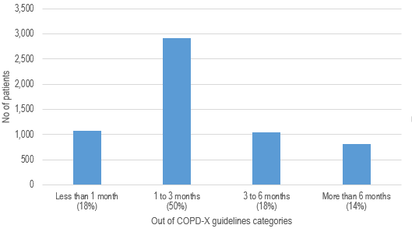
Source: PBS Dispensing records between 1/11/2006 and 31/10/2016 file R2017068_PBS_COPD_DATA.CSV
Abbreviations: COPD, chronic obstructive pulmonary disease;
Note: Refer to Appendix P for treatment combinations not recommended in COPD-X guidelines

5.7 MedicineInsight data source and limitations
This analysis investigates the use of medicines by patients with COPD, with or without asthma, in the MedicineInsight data. The information presented is based on GP clinical data collected from volunteer practices recruited to the MedicineInsight program. Further information on the MedicineInsight program is available at the NPS MedicineWise webpage.
The MedicineInsight Post-Market Surveillance Report 11 was developed with the purpose to inform the post-market review and medicines policy for COPD. Results from Report 11 are summarised below. The full Report is available at Appendix T. For this analysis on COPD medicines prescribing practices, MedicineInsight data was drawn from 423 clinically relevant practice sites, 3,835 active GPs, and 2,230,658 active patients, to 31 December 2016 inclusive.
This analysis uses the following information from the clinical data:
- Patient demographics (including age, sex, Department of Veterans Affairs (DVA) status, rurality of residence, socioeconomic status).
- Medicines prescribed (including medicine generic name, trade name, ATC classification, reason for prescription).
- Encounters (including reason for encounters).
- Diagnosis/Condition.
- Test results, Observations and MBS service items (Spirometry tests).
- Allergy/Adverse event status.
All analyses were cross-sectional. The study time period was 1 January 2016 to 31 December 2016 inclusive, unless otherwise specified. All PBS/RPBS prescriptions for COPD medicines were extracted for the period from 1 January 2012 to 31 December 2016. All PBS/RPBS prescriptions for the smoking cessation therapies were extracted up to 31 December 2016.
The list of COPD medicines of interest used in this analysis included all PBS listed SABA, SAMA, LAMA, LABA, ICS, ICS/LABA, and LAMA/LABA medicines. Medicines used in smoking cessation analysis include: nicotine, bupropion and varenicline. The subset of regular patients ‘active’ in the clinical information system (CIS) 35 years and over who attended a clinically relevant practice 3 or more times in the past 2 years, were included in the main analysis population (n=1,283,107).
The report presents data addressing specific questions on the following topics: patient profile, patterns of drug utilisation, co-prescribing, initial therapy, associated care, and adverse events. The following limitations and issues with using data extracted from GP clinical information systems (CIS) should be noted:
- MedicineInsight data are dependent on the accuracy and completeness of data recorded in and available for extraction from the GP CIS. It is likely that there is under-reporting of clinical information, such as diagnoses, reasons for the encounter or medical history, as information may not be consistently recorded. Information entered in ‘progress notes’ is not currently collected by MedicineInsight.
- The classification of COPD, asthma and other respiratory conditions is based on commonly accepted definitions, and has been reviewed by two GPs. However, there is likely to be variability in GPs’ actual diagnostic labelling practices.
- Practices are recruited to MedicineInsight using non-random sampling, and systematic sampling differences between regions cannot be ruled out.
- Patients in the MedicineInsight database are currently unable to be uniquely identified across the program, although this functionality will be available in the future. Patients are uniquely recorded within a practice, and are recorded as a different patient if they move between practices.
- Medicine use information from MedicineInsight relates to records of GP prescribing, and therefore differs in several important ways from national PBS dispensing data. Not all prescriptions and repeats will be dispensed, i.e. prescription counts are an overestimate of dispensed prescription counts; specialist and hospital prescriptions are not included; and there may be a delay of up to 12 months between prescribing and dispensing.
- There is no visibility of instructions to patients about the use of different regimens for exacerbations versus maintenance therapy, and medicines may have been ceased without a record in the clinical system.
- The proportion of patients with a condition in the dataset does not necessarily reflect the prevalence of that condition. In fact patients with more severe disease/conditions will be more frequently represented in the dataset because they visit the doctor more often.
- A proportion of adverse reactions known to the GP may go unrecorded, e.g. when the reaction is unremarkable or symptoms are managed elsewhere, such as in hospital. Some adverse events may be recorded in the ‘progress notes’ which are not collected by MedicineInsight for confidentiality reasons.
- Coding of adverse reactions may differ slightly between MedicineInsight and TGA terms for some reactions.
The report presents data addressing specific questions on the following topics: patient profile, patterns of drug utilisation, co-prescribing, initial therapy, associated care and adverse events.
Refer to Appendix T for further detail on the methodology used in the MedicineInsight analysis.

5.8 MedicineInsight COPD patient profile
Of the 1.28 million regular MedicineInsight patients aged 35 years and over included in this analysis, 4.6% were ever diagnosed with COPD with or without asthma (COPD (all); n=59,196). 3.0% of MedicineInsight patients had a COPD diagnosis without mention of asthma (COPD only; n=38,650), and 1.6% had both COPD plus asthma diagnoses (n=20,546). Just over one third of patients with a diagnosis of COPD also had an asthma diagnosis.
The age-specific prevalence of patients diagnosed with COPD increased with patient age. The prevalence of COPD among MedicineInsight active patients 45 years and over was 5.9%, compared with 5.1% reported by the 2014–15 ABS National Health Survey. This somewhat higher prevalence estimate in the MedicineInsight data may be partially explained by the restriction in the report to the patient population that regularly visits GP practices (3 visits in the past 2 years). These patients are more likely to have chronic conditions than the general population from the Australian Health Survey who might visit the GP less regularly.
The patient profile was similar to that reported elsewhere, with higher COPD prevalence rates among patients who were older, male, residing in regional and remote areas and in areas of higher socioeconomic disadvantage. As might be expected, MedicineInsight patients who were ex-smokers and current smokers were more likely to have a diagnosis of COPD compared to non-smokers. Patients who were underweight (BMI < 18.5) had a higher prevalence of COPD than those in the healthy or overweight ranges.

5.9 MedicineInsight drug utilisation

5.9.1 Number of prescriptions
In MedicineInsight data in 2016, 51,903 prescriptions for the medicines of interest were ordered for regular patients with COPD only. The most commonly prescribed medicine classes for patients with COPD only were ICS + LABA (31.8%), SABA (27.1%) and LAMA (26.2%). The most commonly prescribed medicines (original prescriptions) for patients with COPD only were salbutamol (26.0%), tiotropium (21.8%) and fluticasone + salmeterol (18.4%).
In 2016, 54,197 prescriptions for the medicines of interest were ordered for patients with COPD plus asthma. The most commonly prescribed medicines (by class) for patients with COPD plus asthma were: ICS/LABA (36.3%), SABA (31.4%) and LAMA (19.2%). The most commonly prescribed medicines (original prescriptions) for patients with COPD plus asthma were: salbutamol (30.1%), fluticasone propionate/salmeterol (20.9%) and tiotropium (15.8%). Refer to Table 5.8 for the proportion of prescriptions by class/medicine for COPD only and COPD plus asthma patients, for the most commonly prescribed classes/medicines.

Table 5.8 Most commonly prescribed medicines of interest for patients with COPD only, and COPD plus asthma, in 2016 (MedicineInsight)
Population | Class/Medicine | Description | Proportion
COPD Only | Class | ICS/LABA FDC | 31.8%
 |  | SABA | 27.1%
 |  | LAMA | 26.2%
 | Medicine | Salbutamol | 26.0%
 |  | Tiotropium | 21.8%
 |  | Fluticasone propionate/salmeterol | 18.4%
 |  | budesonide/formoterol | 10.9%
COPD plus asthma | Class | ICS/LABA | 36.3%
 |  | SABA | 31.4%
 |  | LAMA | 19.2%
 | Medicine | Salbutamol | 30.1%
 |  | Fluticasone propionate/salmeterol | 20.9%
 |  | Tiotropium | 15.8%
From 2012 to 2016, the annual rate of all COPD prescriptions for COPD only patients increased from 9.0 to 11.2 scripts per 100 GP visits. The annual rate of all COPD prescriptions for COPD plus asthma patients was higher than for COPD only patients, and remained relatively stable with a mean average between 2012 and 2016 of 18.6 scripts per 100 GP visits.
A relatively high proportion (41.6%) of patients with COPD (with or without asthma) had no prescriptions for medicines of interest printed in 2016. There are a number of potential explanations for this somewhat surprising result including: a proportion of patients with mild COPD treated with over-the-counter salbutamol, patients being prescribed medicines for COPD elsewhere (e.g. another practice or specialist), patients having enough prescriptions ordered at the end of 2015 to last all of 2016, poor adherence, true management (under-treatment gap), or patients who left the practice in 2016 but were included in the report because they had 3 visits in the last 2 years.

5.9.2 Co-prescribing in 2016
According to patients’ current medications, 52.7% (n=20,352) of the patients with COPD only and 80.8% (n=16,558) of the patients with COPD plus asthma were currently on at least one maintenance therapy (i.e. LAMA, LABA or ICS). With regard to medicine combinations associated with safety concerns, these analyses suggest that around 3.9% of patients with COPD only on maintenance therapy may be at risk of having duplicated therapy and an additional 1.6% had concomitant use of a SAMA and a LAMA. Of patients with COPD plus asthma on maintenance therapy, 6.1% may be at risk of having duplicated therapy and 3.2% had concomitant use of a SAMA and a LAMA. Uses of ICS/LABA with a LABA, LAMA/LABA or a second ICS/LABA were the most common duplicated therapy combinations. This suggests that there may be some confusion among practitioners about the composition of the different formulations and the possibility of adverse events when certain formulations are combined.

5.9.3 Initial therapy for COPD
Of the 30,650 regular patients 35 years and over with COPD only, the MedicineInsight research project identified 3,043 who started therapy with a COPD medication (excluding SABA) between 1 July 2015 and 31 December 2016. Of these, 48.6% were prescribed only one medicine of interest as initial therapy, 46.3% were prescribed dual therapy, and 5.1% triple therapy. The most common choices of initial therapy by class were: dual therapy with ICS + LABA (38.5%), LAMA monotherapy (35.9%), and LAMA + LABA dual therapy (7.4%). A significant amount of combination use of COPD medications was therefore observed to be outside clinical guidelines (51.4%). The most common choices of initial therapy by individual medicine(s) were: tiotropium (23.5%), fluticasone propionate/salmeterol (17.5%) and budesonide/formoterol (16.4%).
When comparing initial therapy for COPD only in the earlier period (July 2013 to June 2015) with the current period (July 2015 to December 2016), initial therapy with:
- LAMA increased from 27.3% to 35.9%
- LAMA + LABA increased from 1.9% to 7.4%
- ICS + LABA decreased from 47.1% to 38.5%
- ICS + LABA + LAMA decreased slightly from 5.5% to 5.1%.
Overall, while prescribing for patients with COPD only appeared to conform to guidelines in many cases, there was good evidence of inappropriate prescribing. It was not possible to provide definitive evidence of inappropriate prescribing without an understanding of the severity and stage of the disease. However, the COPD-X guidelines recommend a stepwise approach to the initiation of COPD therapy, irrespective of treatment severity, until adequate control has been reached. This analysis found that 46.3% of patients with COPD only were prescribed dual therapy at initiation and 5.1% triple therapy.

5.9.4 Associated care for COPD patients
Among patients with COPD (all), 38.1% (n=22,524) ever had a record of one or more spirometry tests. This was lower than results reported in a 2012 survey of GPs which found 64% of COPD patients had undertaken a spirometry test for diagnosis, of which 60% were performed in the general practice.
Overall, among patients with COPD (all), 26.3% (n=15,584) had ever been prescribed smoking cessation therapies. Among the 17,082 current smokers with COPD, 54.5% (n=9,313) had ever been prescribed smoking cessation therapy and of the 29,140 ex-smokers, 20.1% (n=5,865) had ever been prescribed smoking cessation therapy.

5.9.5 Adverse events
The number of AEs were recorded in the MedicineInsight program for COPD regardless of the indication for therapy. Refer to Table 5.9 for the number of AEs by medicine class and a description of common AEs.
Table 5.9 The number of adverse events recorded by drug class (MedicineInsight)
Class | Number of event | Description of adverse event
LAMA | 1,528 adverse events, 318 were not specified | Cough, dry mouth, laryngeal discomfort, rash, nausea, dyspnoea, pruritus, dizziness, vision blurred and headache.
LABA | 598 adverse events, 138 were not specified | Tremor, cough, rash, palpitations, muscle spasms, headache, nausea, laryngeal discomfort, tachycardia and dyspnoea.
LAMA+LABA | 38 adverse events, 7 were not specified | Constipation, cough, dysphonia, headache, nausea, tachycardia, anxiety, diarrhoea, epistaxis and malaise.
ICS+LABA | 2,275 adverse events, 499 were not specified. | Dysphonia, rash, tremor, laryngeal discomfort, nausea, cough, palpitations, oral candidiasis, headache and muscle spasms.

