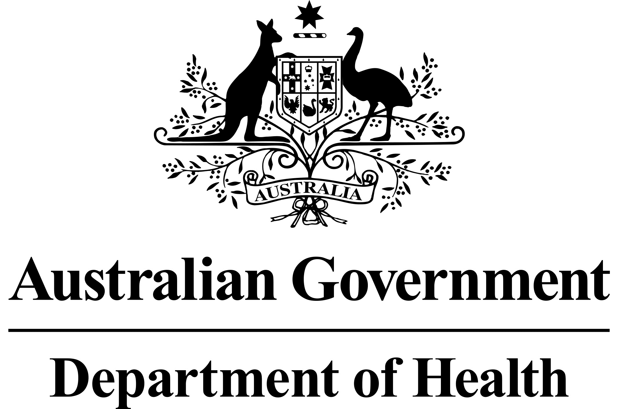

Revised dispensing for nursing home residents

Commencing July 2017, pharmacists should include the RACFId (residential aged care facility identification number) for the nursing home each time a PBS/RPBS item is dispensed for all of the pharmacy’s nursing home patients.

The changes will make dispensing easier for pharmacists, as the RACFId will be used for PBS/RPBS supplies to all nursing homes. At present, the RACFId is only required for most supplies to nursing homes that have started using the National Residential Medication Chart (NRMC), or a commercial equivalent charting product that complies with PBS legislation.

Changes to pharmacy dispensing systems will make it easier for pharmacists to make this change. Pharmacists can obtain the correct RACFId numbers from each of the nursing homes they supply medicines.

These changes will apply to all PBS/RPBS items, whether they are part of a pharmacy’s PBS claim, or being supplied as under co-payment items. The changes are being made to help improve medication safety in the aged care sector, through data-driven quality use of medicines measures.

Background

The RACFId is also known as a nursing home’s RACSId.

Launched for national use in 2014, the National Residential Medication Chart (NRMC) is a medication chart developed for use throughout the residential aged care sector. NRMC implementation trials demonstrated improved medication management for residents, and reduced administrative burden for prescribers, aged care staff, and pharmacists when ordering, administering and supplying medicines.

The NRMC enables the prescribing and supply of most medicines, and PBS/RPBS claiming by pharmacists where applicable, directly from the NRMC without the need for a separate prescription to be written. However, certain medicines (“excluded items”) will still require a traditional prescription, in addition to an order on the NRMC, such as Schedule 8 medicines (Controlled Drugs) and non-streamlined PBS Authority items.

There are a number of commercial medication chart products available that are based on the NRMC and comply with PBS and state and territory legislation.

Contact: [PBSNRMC@health.gov.au](mailto:PBSNRMC@health.gov.au)

## Frequently asked questions

### What do I need to do differently?

You’ll need to ensure that the relevant RACFId number is used when you dispense PBS/RPBS items for all your nursing home patients.

### What’s a valid RACFId?

Each RACFId is a maximum of four digits in length and is applicable to a single nursing home/residential aged care facility. Note that the RACFId is also known as a Residential Aged Care Service (RACS) Id. Your local nursing home will be able to confirm their RACFId for you to use, if you don’t have it already.

### Where do I enter the RACFId when I’m dispensing for my nursing home patients?

Some dispensing software products allow you to link patients with nursing homes, with space for the RACFId when entering new nursing home details. Your software vendor will publish details on the process which you should follow to ensure that the RACFId is entered against all patients who reside in nursing homes.

### Why is this change happening?

The changes will improve our knowledge of medicine use in the residential aged care sector, supporting activities that promote quality use of medicines.

### Who do I contact if I have questions about the changes?

If you have a question about the RACFId for your nursing home patients, you should make contact with the nursing home. If your question relates to PBS aspects of the changes, you can contact the [Health Department](mailto:PBSNRMC@health.gov.au).

picture of medication chart form