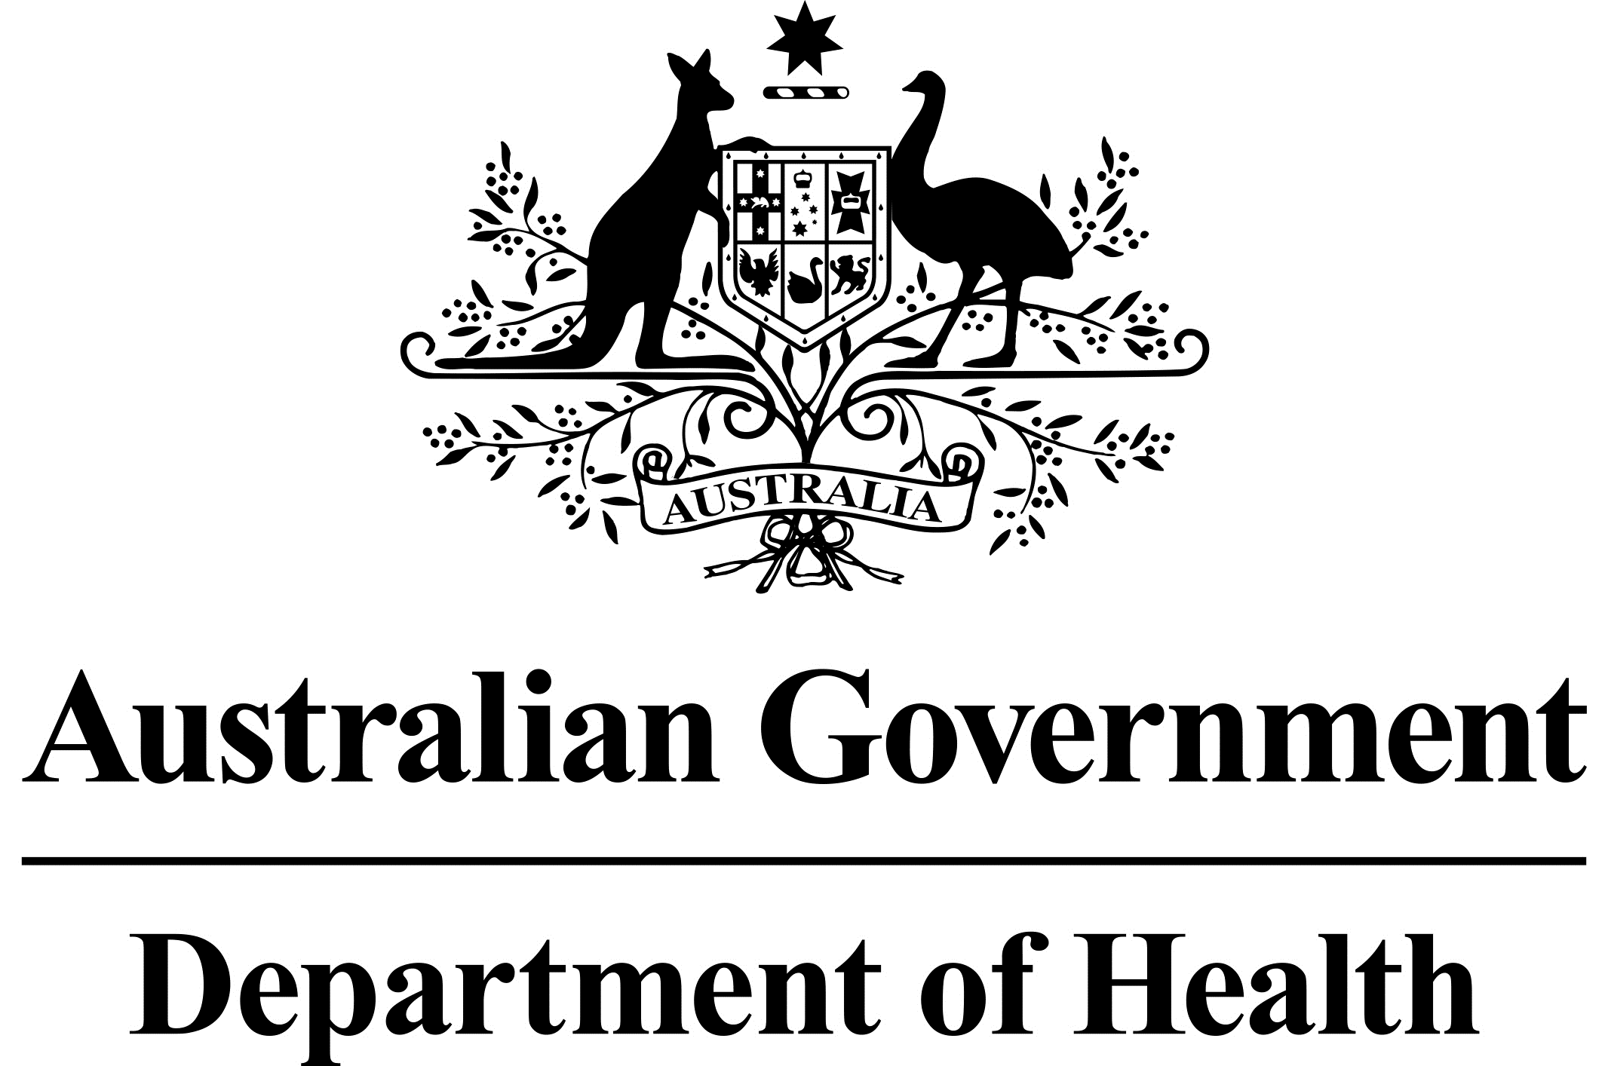

Adalimumab Pharmaceutical Benefits Scheme changes - 1 April 2021
The Pharmaceutical Benefits Scheme (PBS) listings for adalimumab will be amended on 1 April 2021 with the following biosimilars listed alongside the originator brand Humira®.
Brand name | Strength and form
Amgevita® | 40 mg syringe and pen, 20 mg syringe
Hadlima® | 40 mg syringe and pen
Hyrimoz® | 40 mg syringe and pen
Idacio® | 40 mg syringe and pen
These additions to the PBS will result in a number of changes to the circumstances in how adalimumab may be prescribed and dispensed. Importantly, the existing indications and inclusion criteria for adalimumab will not change on 1 April.

Biosimilar strengths and substitutions
The new biosimilar brands will be ‘a-flagged’ allowing substitution between originator and biosimilar brands according to their authority level, form and strength.
- Substitution is permitted between Humira®, Hadlima®, Amgevita®, Hyrimoz® and Idacio®, of the same strength and dosage form, where written/digital authority has been obtained under the Initial 1, Initial 2, Initial 3, First Continuing or Subsequent Continuing treatment phases.
- Substitution is permitted between biosimilar brands Hadlima®, Amgevita®, Hyrimoz® and Idacio®, of the same strength and dosage form, where a streamlined authority prescription has been written under the Subsequent Continuing treatment phase.

Humira® changes
A new reduced volume formulation of Humira® will be PBS listed. This new formulation delivers an equivalent dose to the existing formulations (20 mg & 40 mg) and is ‘a-flagged’ with both of these original formulations. The new formulations are also ‘a-flagged’ to the new biosimilar products.
The original Humira® formulations will remain available for a period of 12 months under ‘Supply Only’ arrangements. As such, the original formulation will no longer be available to prescribe, however all prescriptions written prior to 1 April may still be dispensed. Specific PBS claiming arrangements will apply to these items (see further information below).
A new strength, Humira® 80 mg syringe and pen, will be PBS listed. This product is not equivalent or ‘a-flagged’ to any other products and therefore may not be substituted.

Available pack sizes
Humira® remains available in pack sizes of 2, 4 or 6 units (either 2, 4 or 6 syringes or 2, 4 or 6 pens). Each biosimilar brand of adalimumab is available in pack sizes of 2 units (either 2 syringes or 2 pens). The PBS listings will allow various max quantities of 2, 4 or 6 units to be prescribed. The packs must therefore be dispensed as a single pack or in multiples of 1, 2 or 3 to make up the prescribed maximum quantity.

What do these changes mean for prescribers?
In alignment with the Government’s commitment to the uptake of biosimilars, prescribers are encouraged to prescribe a biosimilar brand to treatment naïve patients where appropriate.
As a prescriber you will need to be aware of the following:
- The PBS item code selected, and the corresponding authority level (written/digital or streamlined) associated with that item, as this will determine which brand may be dispensed in the pharmacy.
- Whether you wish to prescribe the originator or the biosimilar product.
- The quantity you prescribe. Each adalimumab listing contains an Administrative Advice note stating which pack size combinations are considered equivalent for the purpose of supplying the prescribed quantity.
- Available methods of obtaining written/digital authority from Services Australia. Applications may be made by post, or by using the online upload function through Health Professional Online Services (HPOS).

What does this mean for pharmacists?
Pharmacists may substitute brands that are ‘a-flagged’, in consultation with the patient. When dispensing, attention must be paid to the selection of the correct PBS item code to ensure the correct product is claimed. Applying incorrect item codes may result in a rejection warning message from Services Australia.
Prior to 1 April, the PBS listed Humira® pack sizes as ‘1 unit’. With the inclusion of variable pack sizes for the biosimilar brands, these pack sizes have been amended to 2, 4 and 6 units respectively. This means that for prescriptions written prior to, but supplied after 1 April 2021, pharmacies may be incorrectly reimbursed for the supply of 1 pen/syringe (i.e. 1 unit) rather than for the pack quantity actually dispensed.
Services Australia will monitor pharmacies, which claim a quantity of one for the 11 impacted PBS item codes. Services Australia will contact pharmacies that have been reimbursed for one pen/syringe (instead of one pack of pens/syringes) and ask them to amend the quantity supplied, annotate the prescription, and resubmit their PBS Online claim to ensure correct payment. Affected item codes are detailed in the following table.

Impacted PBS Item Codes

Item Code | Previous Listing | New Listing | New Unit Quantity
10404N | Humira® 40 mg syringe 6 x 0.8 mL  Max qty packs:1  Max qty units:1 | Humira® 40 mg syringe 6 x 0.8 mL  Max qty packs:1  Max qty units: 6 | 6
10972L | Humira® 40 mg syringe 6 x 0.8 mL  Max qty packs:1  Max qty units:1 | Humira® 40 mg syringe 6 x 0.8 mL  Max qty packs:1  Max qty units: 6 | 6
8961P | Humira® 40 mg syringe 6 x 0.8 mL  Max qty packs:1  Max qty units:1 | Humira® 40 mg syringe 6 x 0.8 mL  Max qty packs:1  Max qty units: 6 | 6
9186L | Humira® 40 mg syringe 6 x 0.8 mL  Max qty packs:1  Max qty units:1 | Humira® 40 mg syringe 6 x 0.8 mL  Max qty packs:1  Max qty units: 6 | 6
10397F | Humira® 40 mg pen 6 x 0.8 mL  Max qty packs:1  Max qty units:1 | Humira® 40 mg pen 6 x 0.8 mL  Max qty packs:1  Max qty units: 6 | 6
10945C | Humira® 40 mg pen 6 x 0.8 mL  Max qty packs:1  Max qty units:1 | Humira® 40 mg pen 6 x 0.8 mL  Max qty packs:1  Max qty units: 6 | 6
11132X | Humira® 40 mg pen 6 x 0.8 mL  Max qty packs:1  Max qty units:1 | Humira® 40 mg pen 6 x 0.8 mL  Max qty packs:1  Max qty units: 6 | 6
8962Q | Humira® 40 mg pen 6 x 0.8 mL  Max qty packs:1  Max qty units:1 | Humira® 40 mg pen 6 x 0.8 mL  Max qty packs:1  Max qty units: 6 | 6
9187M | Humira® 40 mg pen 6 x 0.8 mL  Max qty packs:1  Max qty units:1 | Humira® 40 mg pen 6 x 0.8 mL  Max qty packs:1  Max qty units: 6 | 6
11133Y | Humira® 40 mg pen 4 x 0.8 mL  Max qty packs:1  Max qty units:1 | Humira® 40 mg pen 4 x 0.8 mL  Max qty packs:1  Max qty units: 4 | 4
11137E | Humira® 40 mg pen 4 x 0.8 mL  Max qty packs:1  Max qty units:1 | Humira® 40 mg pen4 x 0.8 mL  Max qty packs:1  Max qty units: 4 | 4

