RURAL WORKFORCE

Katherine Power

A/g Assistant Secretary

Rural Access Branch, Health Workforce Division

Department of Health

Pharmacy workforce

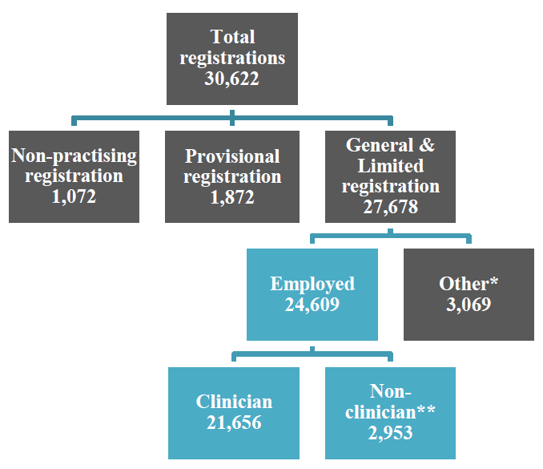
*’Other’ includes: working but on long leave, working outside the profession, looking for work, overseas, and retired.
**‘Non-clinician’ includes roles reported by survey respondents that did not fit predefined survey categories.

Pharmacy workforce

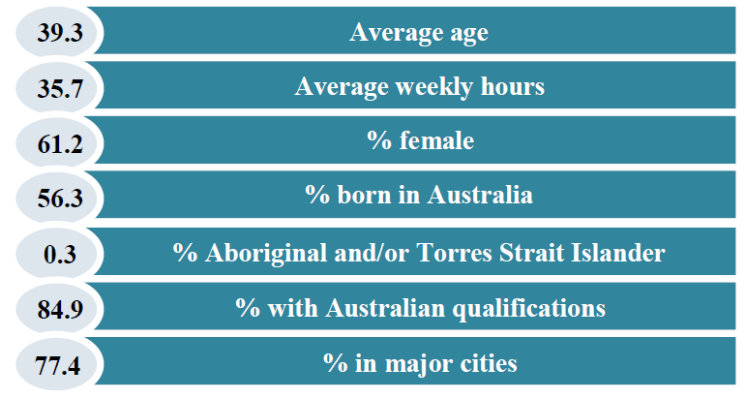

Pharmacy workforce

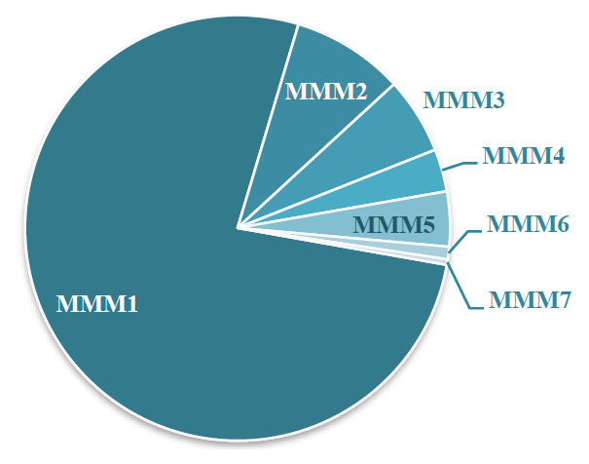
- 76.9% of FTE pharmacists were located in a major city or MM1 location in 2017
For more information on pharmacy workforce please see the Department of Health website.

Commonwealth strategies

- Stronger Rural Health Strategy
  - Commonwealth workforce measures targeting rural and remote communities
- National Medical Workforce Strategy
  - Collaborative long-term plan for structuring the future medical workforce.
- Ten Year Primary Care Plan
  - Reorient the health system towards patient-centred value-based health care

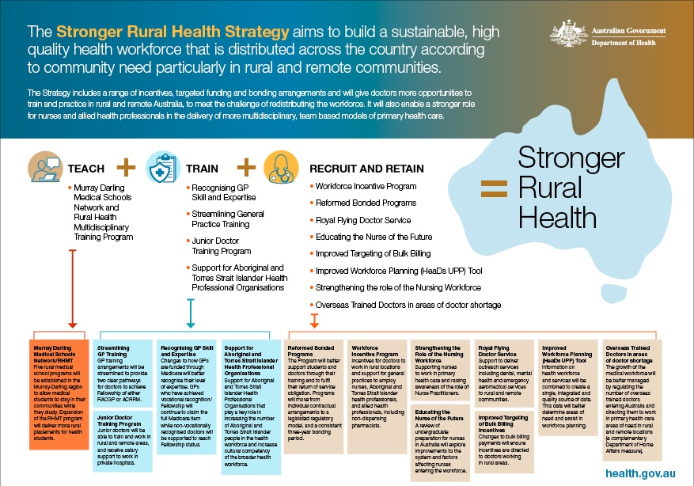

Geographic classification updates

- Distribution Priority Areas (DPA) replaced District of Workforce Shortage (DWS) in July
- Modified Monash Model (MMM) will be updated 1 January 2020

Supporting the rural workforce
Rural Health Outreach Fund
- Supports delivery of medical specialist, GP, nursing, allied and other health services in rural, regional and remote Australia
- Reducing prescription opioid use through better access to pain management services

Rural Health Multidisciplinary Training Program

Background

Rural Health Multidisciplinary Training (RHMT) program

The Government’s main platform in working with the higher education sector to influence health workforce distribution.

This year the RHMT program will support a network of:

18 Rural Clinical Schools;

16 University Departments of Rural Health;

6 dental schools offering extended rural placements; and

26 regional training hubs.

RHMT Universities
University of Adelaide Australian National University
Charles Sturt University Deakin University
Flinders University SA Flinders University NT
Griffith University James Cook University
La Trobe University Monash University
University of Melbourne University of Newcastle
University of New South Wales University of Notre Dame Australia
University of Queensland University of South Australia
University of Sydney University of Tasmania
University of Western Australia Western Sydney University
University of Wollongong

University Departments of Rural Health

Three new UDRHs established in 2017:
  - Wagga Wagga and Orange – CSU
  - Broome – University of Notre Dame Australia
  - Toowoomba – University of Queensland
  - In 2019, La Trobe University joined the RHMT program.

Supporting the rural workforce
Health Workforce Scholarship Program (HWSP)
  - Scholarships and bursaries to existing health professionals committed to rural service

Why develop a National Medical Workforce Strategy?
Address shared medical workforce issues across Australia:
  - Supply of doctors
  - Inequities in workforce distribution
  - Doctor wellbeing
Ensure investment in education and training leads to the services needed by communities

