ASSESSMENT OF PHARMACY PROGRAMS
  - 15 November 2016

Community Pharmacy Program Funding

The total funding allocated for community pharmacy programs is $1.26 billion
over five years, (2015-16 to 2019-20).

- This includes:

$613 million to support community pharmacy programs that are continuing from the Fifth Community Pharmacy Agreement and which are assessed as clinically and cost effective

- This includes:

$50 million to support a new Pharmacy
Trial Program (PTP). This program will fund a number of trials to improve patient outcomes, and seeks to expand the role of pharmacy in delivering a wider range of primary healthcare services; and

- This includes:

$600 million to support a range of new and/or expanded programs, based on the recommendations of an independent health technology assessment body such as the Medical Services Advisory Committee about the outcomes of trials.

Existing Programs
- Dose Administration Aids
- Staged Supply
- Clinical Interventions
- Home Medicines Reviews
- Residential Medication Management Reviews
- MedsCheck and Diabetes MedsCheck
- Rural Pharmacy Workforce Program
- Rural Pharmacy Maintenance Allowance
- Aboriginal and Torres Strait Islander Specific Programs
- Electronic Prescription Fee

- Clause 6.1.3 of the Sixth Community Pharmacy Agreement:

The Community Pharmacy Programmes set out in Appendix B will continue from 1 July 2015 until the Minister determines otherwise and will be subject to a cost effectiveness assessment by an independent health technology assessment body (such as the Medical Services Advisory Committee or the PBAC) as determined by the Minister.

What is HTA

- “HTA involves the medical, social, ethical and economic implications of the development, diffusion and use of a health technology. HTA has been positioned as a ‘bridge between scientific evidence and the needs of policymakers”
- Cost Effectiveness is now common across all major areas of health expenditure including:
PBAC, MSAC, PLAC, SPAP NDSS

Incremental Cost-Effectiveness Ratio

- The tool used for the comparison between two options is the Incremental Cost-Effectiveness Ratio (ICER)

- This is defined as “The extra cost of the additional services divided by the extra outcome of effectiveness”

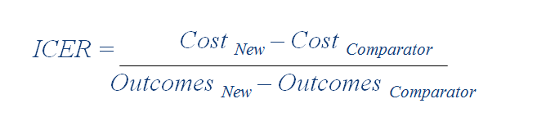

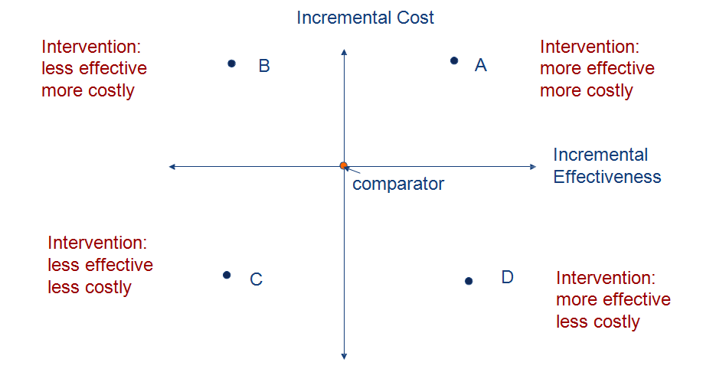
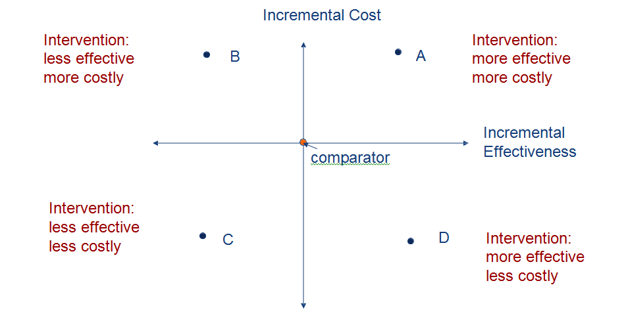

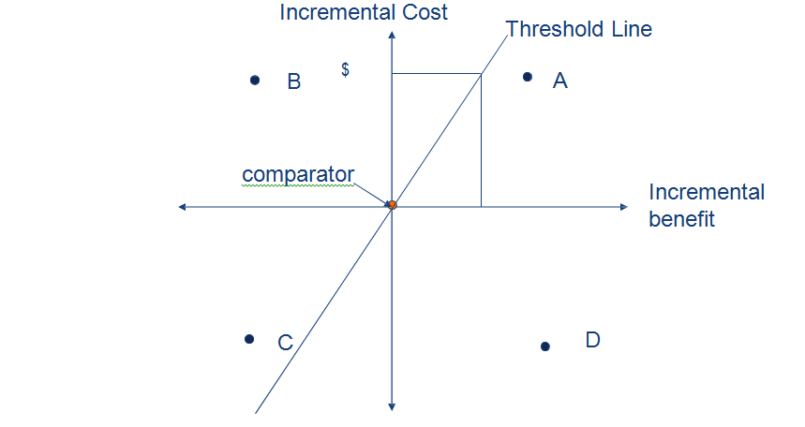
In the Australian system there is NO FIXED threshold. The judgment is based
on the ICER, the level of uncertainty and other factors e.g. value

The Hon Ralph Hunt Minister for Health

“WHATEVER DECISIONS ARE TAKEN WILL REFLECT THE GOVERNMENT’S DETERMINATION TO GET MORE VALUE FOR THE DOLLARS SPENT ON HEALTH CARE”

16 April 1978

The interaction for decision makers-the value proposition
Health Benefit
to patients
Non health
benefits to patients
Benefits to carers
and family
Benefits to
society/health/social care system

PICO for Quantitative Studies

P | Patient, Population or  Problem | What are the characteristics of the patient or population?  What is the condition or disease you are interested in?
I | Intervention or  exposure | What do you want to do with this patient (e.g. treat, diagnose, observe)?
C | Comparison | What is the alternative to the intervention (e.g.standard practice?)
O | Outcome | What are the relevant outcomes (e.g. hospital admission, GP visits)

Process
- Engagement with Medical Services Advisory Committee (MSAC)
  - March 2015
  - November 2015
  - March 2016
  - November 2016
- Development of an evaluation framework and methodology
- Engaging contractors from MSAC and Departmental panels

Medication Management and Medication Adherence Programs
- Full MSAC cost effectiveness assessment in two stages
  - Stage 1: Development of PICO, detailed literature review including any analysis of outcomes from data collected in Australia from the program funded in previous agreements (if any) and analysis of utilisation data
  - Stage 2 (if required): generation and analysis of cost data to establish cost effectiveness
- Contractor sourced from MSAC’s Health Technology Assessment Panel through a select Request for Quotation process
- Various stages of completion for each component
- Stakeholders will be consulted later in the process

Pharmacy Practice Incentives Program

- Dose Administration Aids, Clinical Interventions, Staged Supply Support Allowance
- Health Consult Pty Ltd selected
- Current status
  - Draft Stage 1 Report with MSAC for consideration at November 2016 meeting
- Stakeholders will be consulted once MSAC has provided a recommendation on the Stage 1 Report.
- MSAC may recommend the need for further research in order to address the issue of cost-effectiveness

Medication Management Review Programs
- Home Medicines Review, Residential Medication Management Review, MedsCheck and Diabetes MedsCheck
- HealthConsult Pty Ltd selected
- Current status
  - Commenced in late October 2016 and currently in initial phases
  - Draft Stage 1 Report expected to be presented for consideration at MSAC’s March 2017 meeting
- Stakeholders will be consulted once MSAC has provided a recommendation on the Stage 1 Report.

Pharmacy Workforce Programs
- Hybrid: cost effectiveness/program evaluation
- Contractor sourced from the Department’s Health Economics Services Panel through a competitive Request for Quotation process
- Initial stages have been completed
- Stakeholder consultation will commence in December 2016

Aboriginal and Torres Strait Islander Support Programs
- Simple program evaluation
- Contractor sourced from the Department’s Program Review and Evaluation Services Panel through a competitive Request for Quotation process

Pharmacy Trials Program
- The research proposals for new initiatives are proceeding in two tranches

- Proposals will need to be examined by the Protocol Advisory Sub- Committee (PASC) of MSAC. This is the usual process for considerations of services to be listed on the MBS.

- PASC will advise and provide useful comment to researchers to ensure that the research will provide the inputs and outcomes necessary for MSAC to undertake a cost effectiveness analysis once the research is complete in order to make recommendations to the Minister regarding implementation as an ongoing program.

- Well designed trials will optimise the likelihood of MSAC making a favourable recommendation to the Minister for implementation into pharmacy practice.

Tranche 1
- Diabetes Screening using risk profiling and PoC testing of Blood glucose and HbA1c –protocol approved and being implemented

- *Improved continuity of care from hospital to the community

- *Improved medication management for ATSI through pharmacist advice and culturally appropriate services

- * Protocols been through PASC/TAG and are currently being further developed

Tranche 2

- After a call for expressions of interest, 108 submissions received which the TAG discussed and placed into broad categories
- Minister announced Tranche 2 in the following areas:
- Community pharmacist outreach to RACF
- Medicines management and reconciliation services at point of transitions of care
- Disease management –pharmacy models of shared, collaborative primary health care
- Screening and referral by pharmacists of cardiovascular risk

Process for Tranche 2
- Applications close 15 December 2016
- Referred to PASC meeting in January 2017
- Amendments to proposals by February 2017
- Assessment of applications in March 2017
- Recommendations and completion of processes by April/ May 2017

Clause 6.1.6 of the Sixth Community Pharmacy Agreement:

  - Any funding for a trialled Community Pharmacy Programme after the conclusion of the PTP for that Community Pharmacy Programme will be contingent on:

  - a recommendation to proceed with the programme or service by an independent health technology assessment body (such as the Medical Services Advisory Committee or the PBAC) determined by the Minister; and

  - the programme or service satisfying funding priorities determined by the Minister.

ANY QUESTIONS?

