BIOSIMILARS AWARENESS INITIATIVE

  - 15 November 2016

At a Glance
- Biosimilar medicines are highly similar, but not identical versions of a biological medicine. This is because the manufacturing processes that are used in the production of biological medicines are naturally variable.
- The safety, effectiveness and quality of the biosimilar medicine, once assessed by the regulator, has been shown to not be affected by the minor differences between the originator biological (also known as the reference biological medicine) and the biosimilar medicine.

- The Therapeutic Goods Administration (TGA) regulates and monitors the safety of all medicines, including biosimilar medicines. Manufacturers are required to have a risk management plan in place before the medicine can be registered, and the TGA investigates all reports of problems.
- The introduction of biosimilar medicines improves access to these high-cost treatments by encouraging competition which leads to price reductions. This will have a positive impact within Australian hospitals and the sustainability of the PBS.

Desired Outcomes of the Initiative

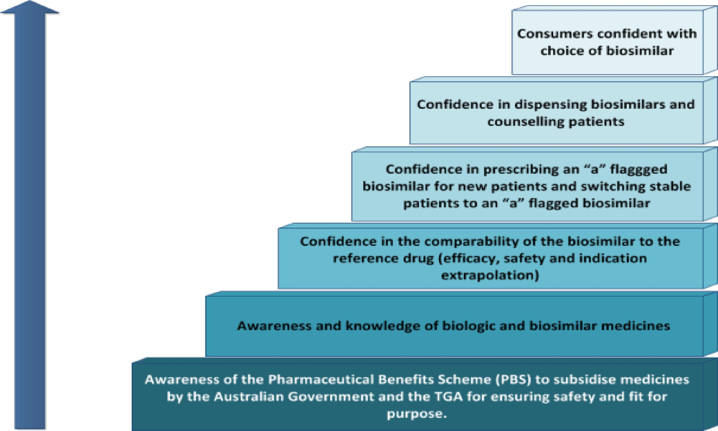

Stakeholder Groups
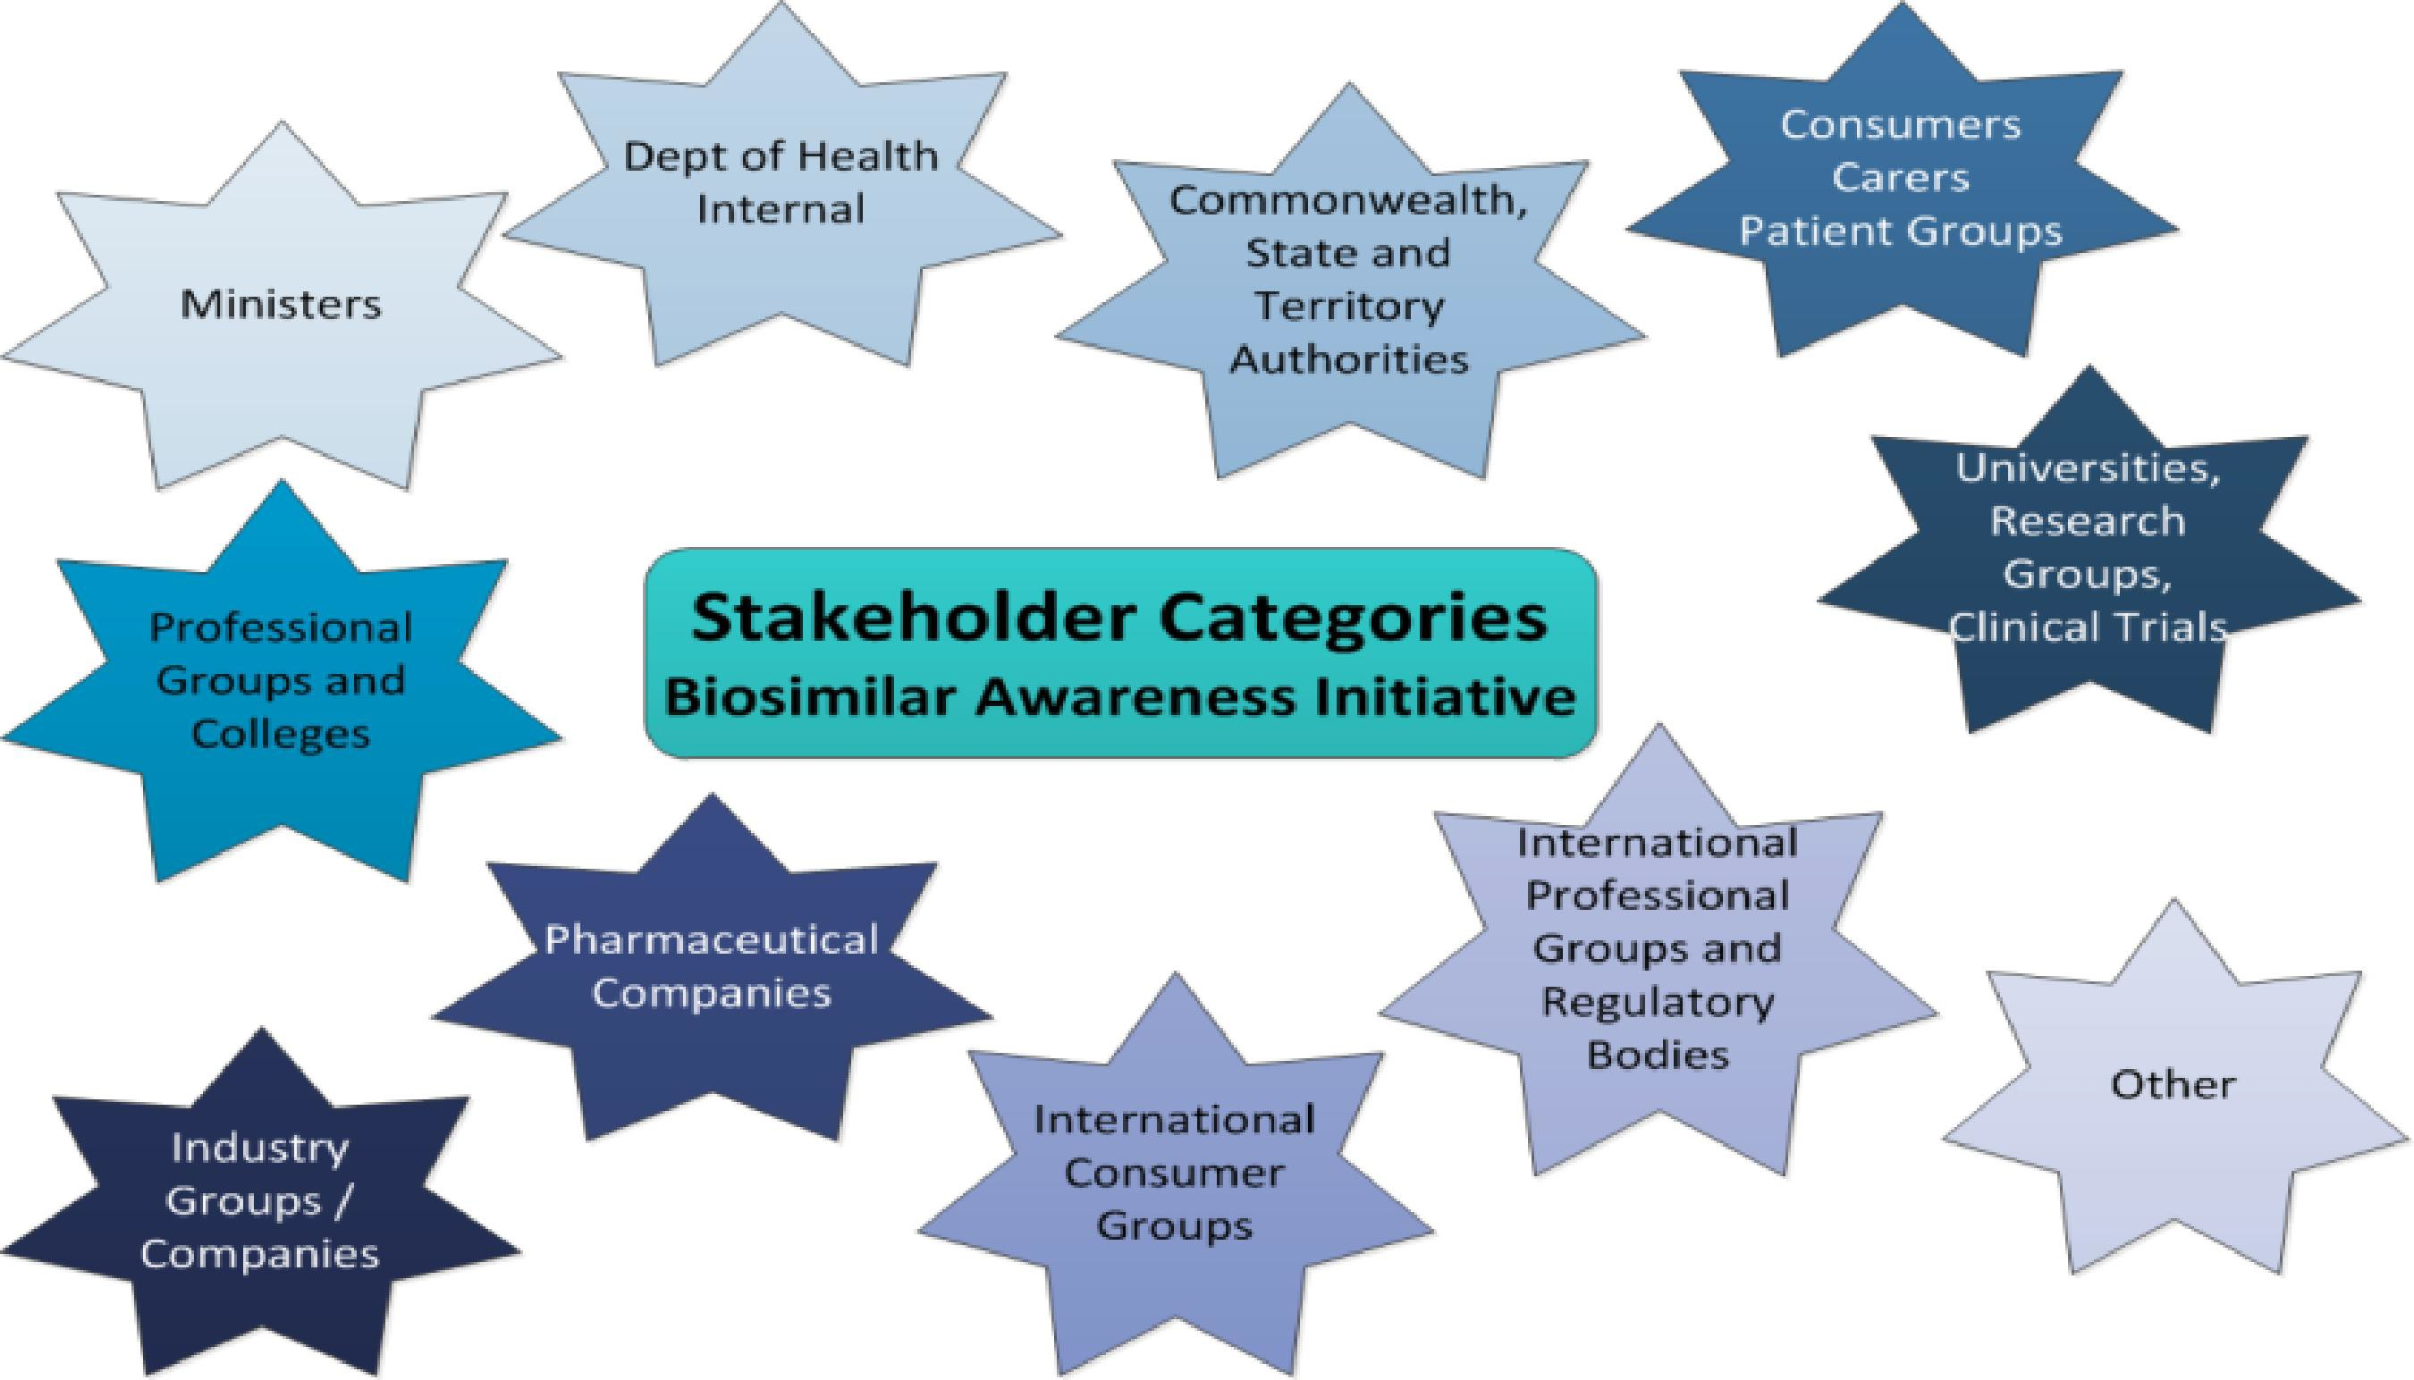

Governance and Research

- Establishment of robust project management processes and governance for the Initiative
- Research activities
  - Market research
  - Literature review
  - Input from other health information providers; the Health Communications Branch, NPS MedicineWise and TGA
- Development of a communications strategy
- Stakeholder identification and analysis
- Development of core themes for the Initiative

RESEARCH RESULTS

Specialists
Perceived barriers and benefits to prescribing/dispensing biosimilar medicines (n=200)

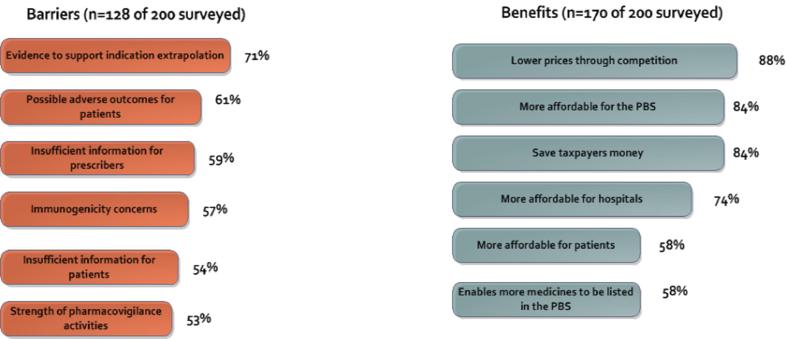

General Practitioners
Perceived barriers and benefits to prescribing/dispensing biosimilar medicines (n=100)
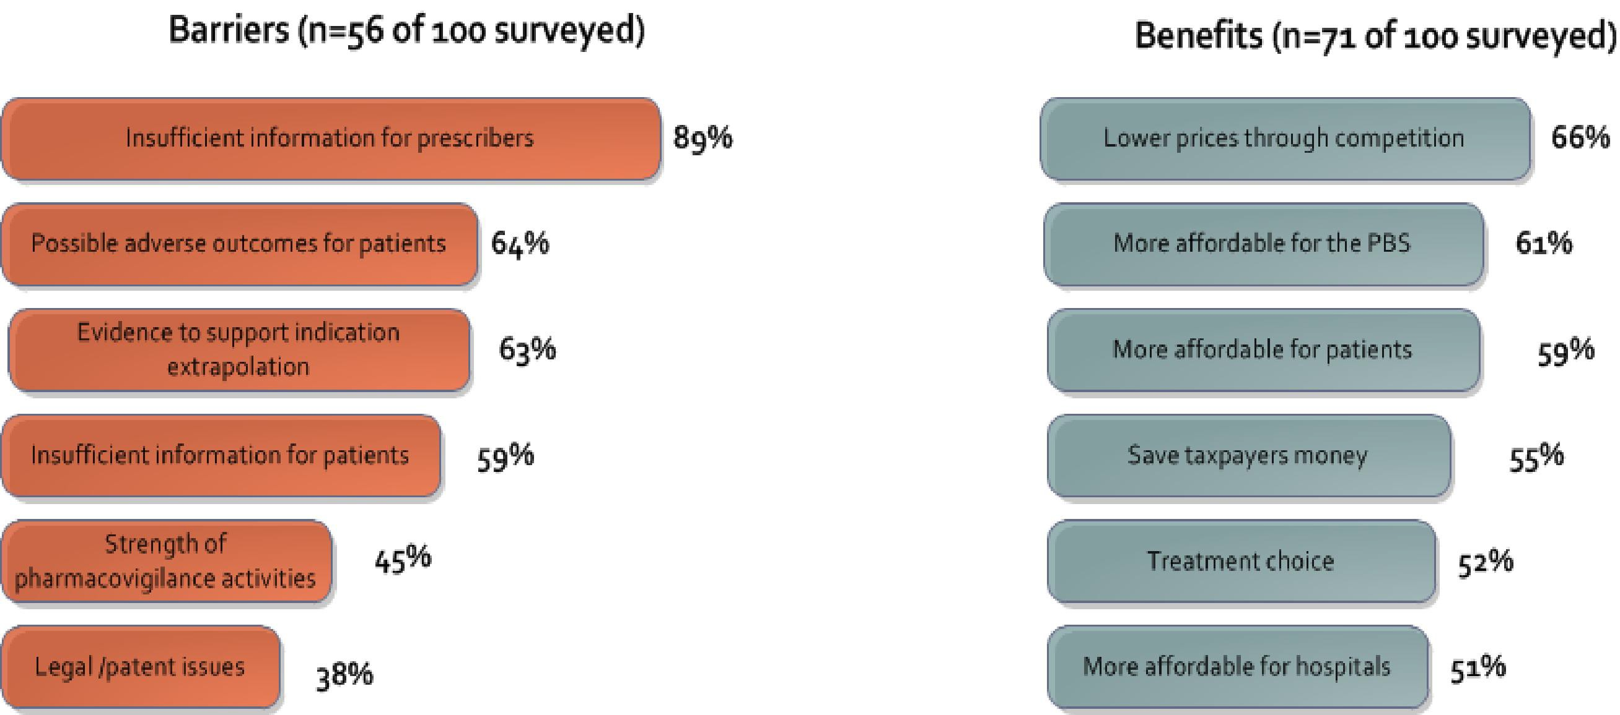

Community Pharmacists
Perceived barriers and benefits to prescribing/dispensing biosimilar medicines (n=100)

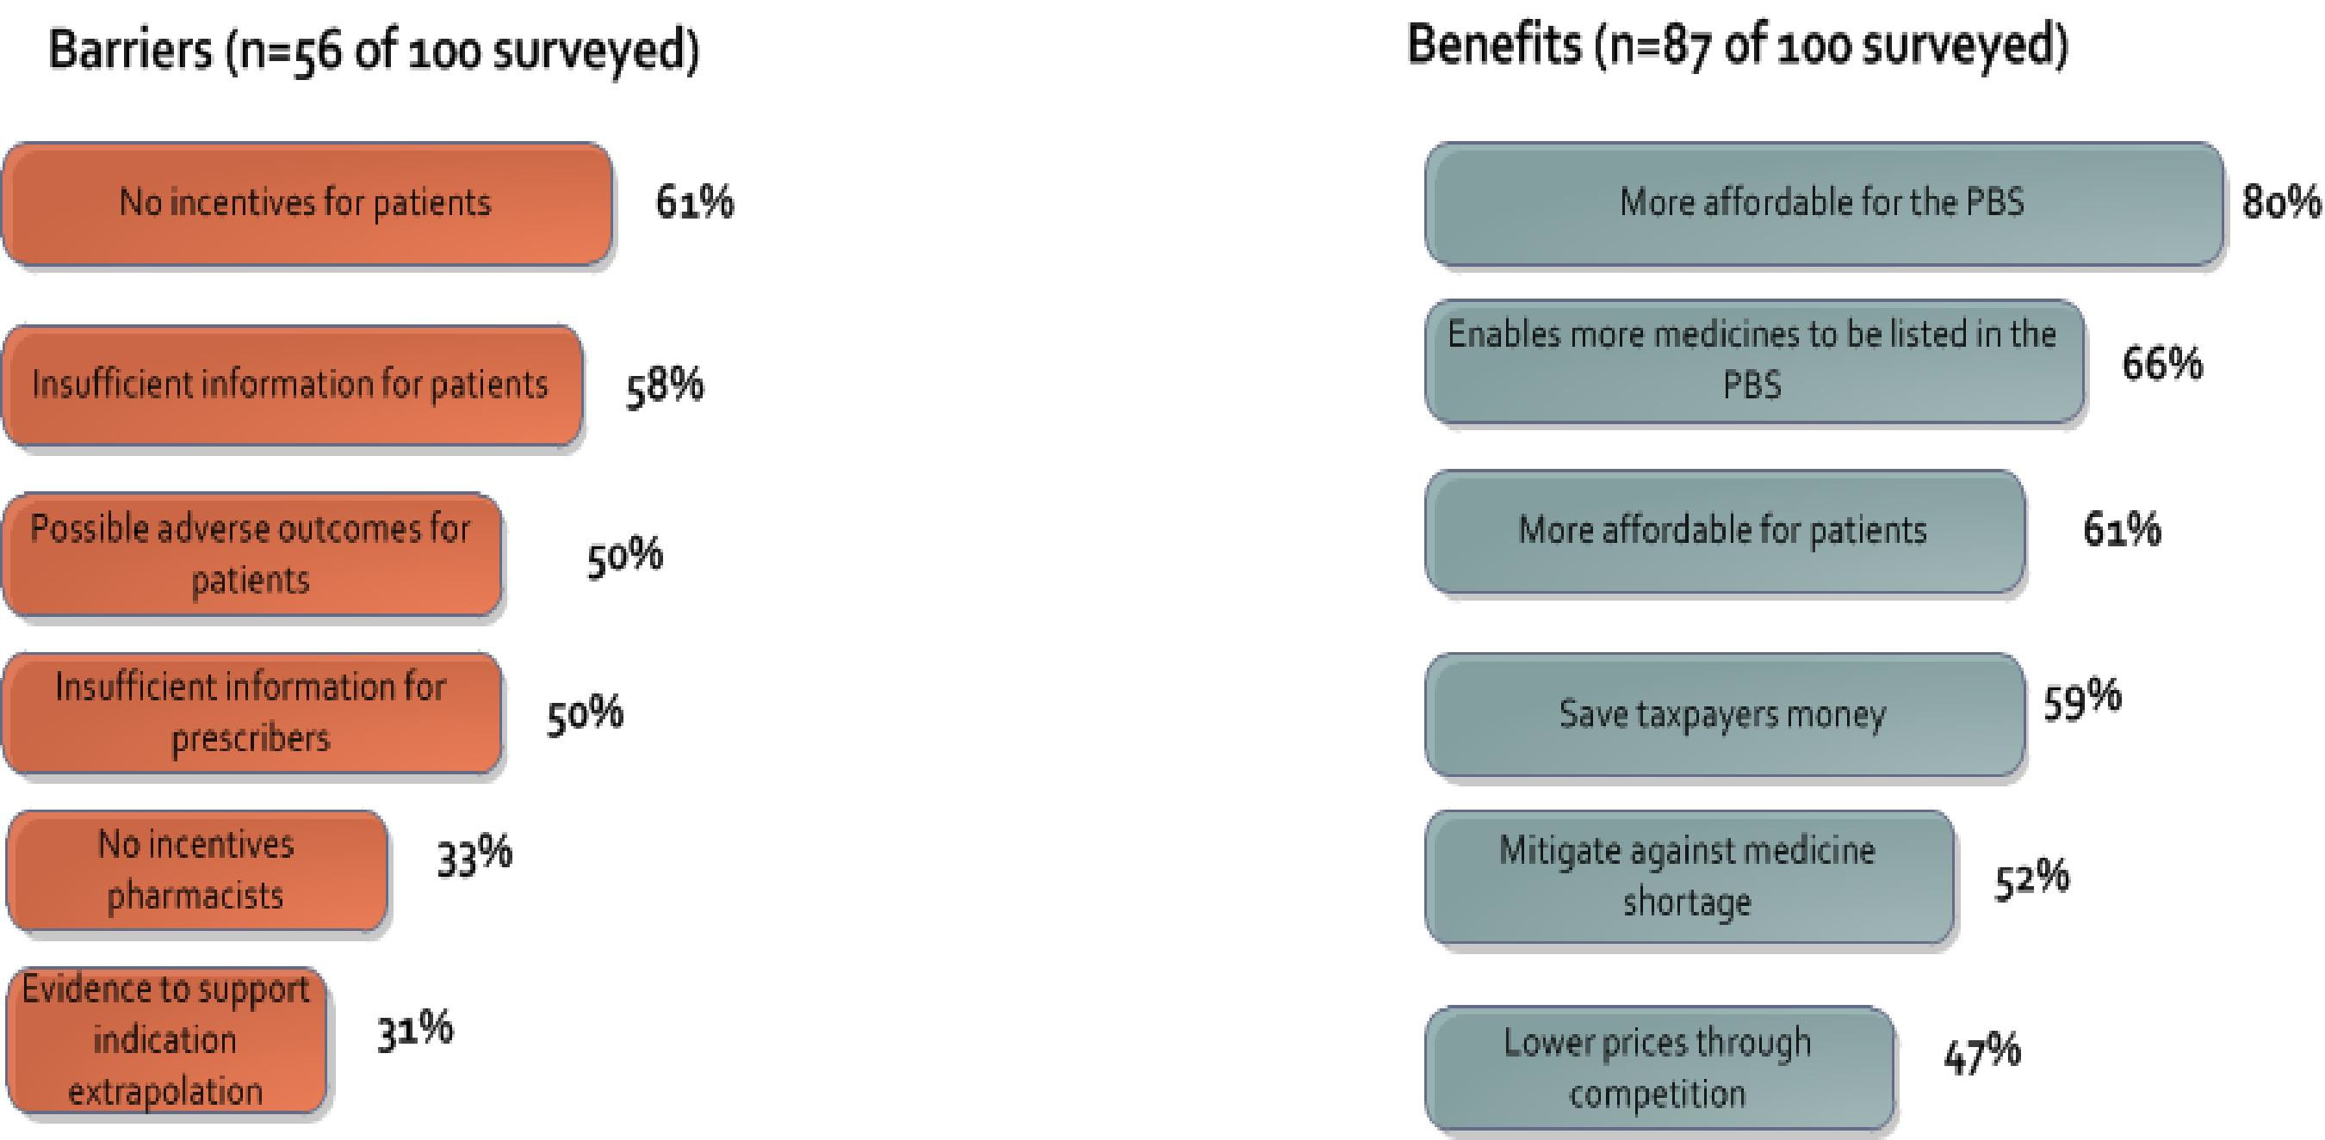

RESULTS FOR PATIENTS AND CARERS

Profile of Patients Included in the Research Sample

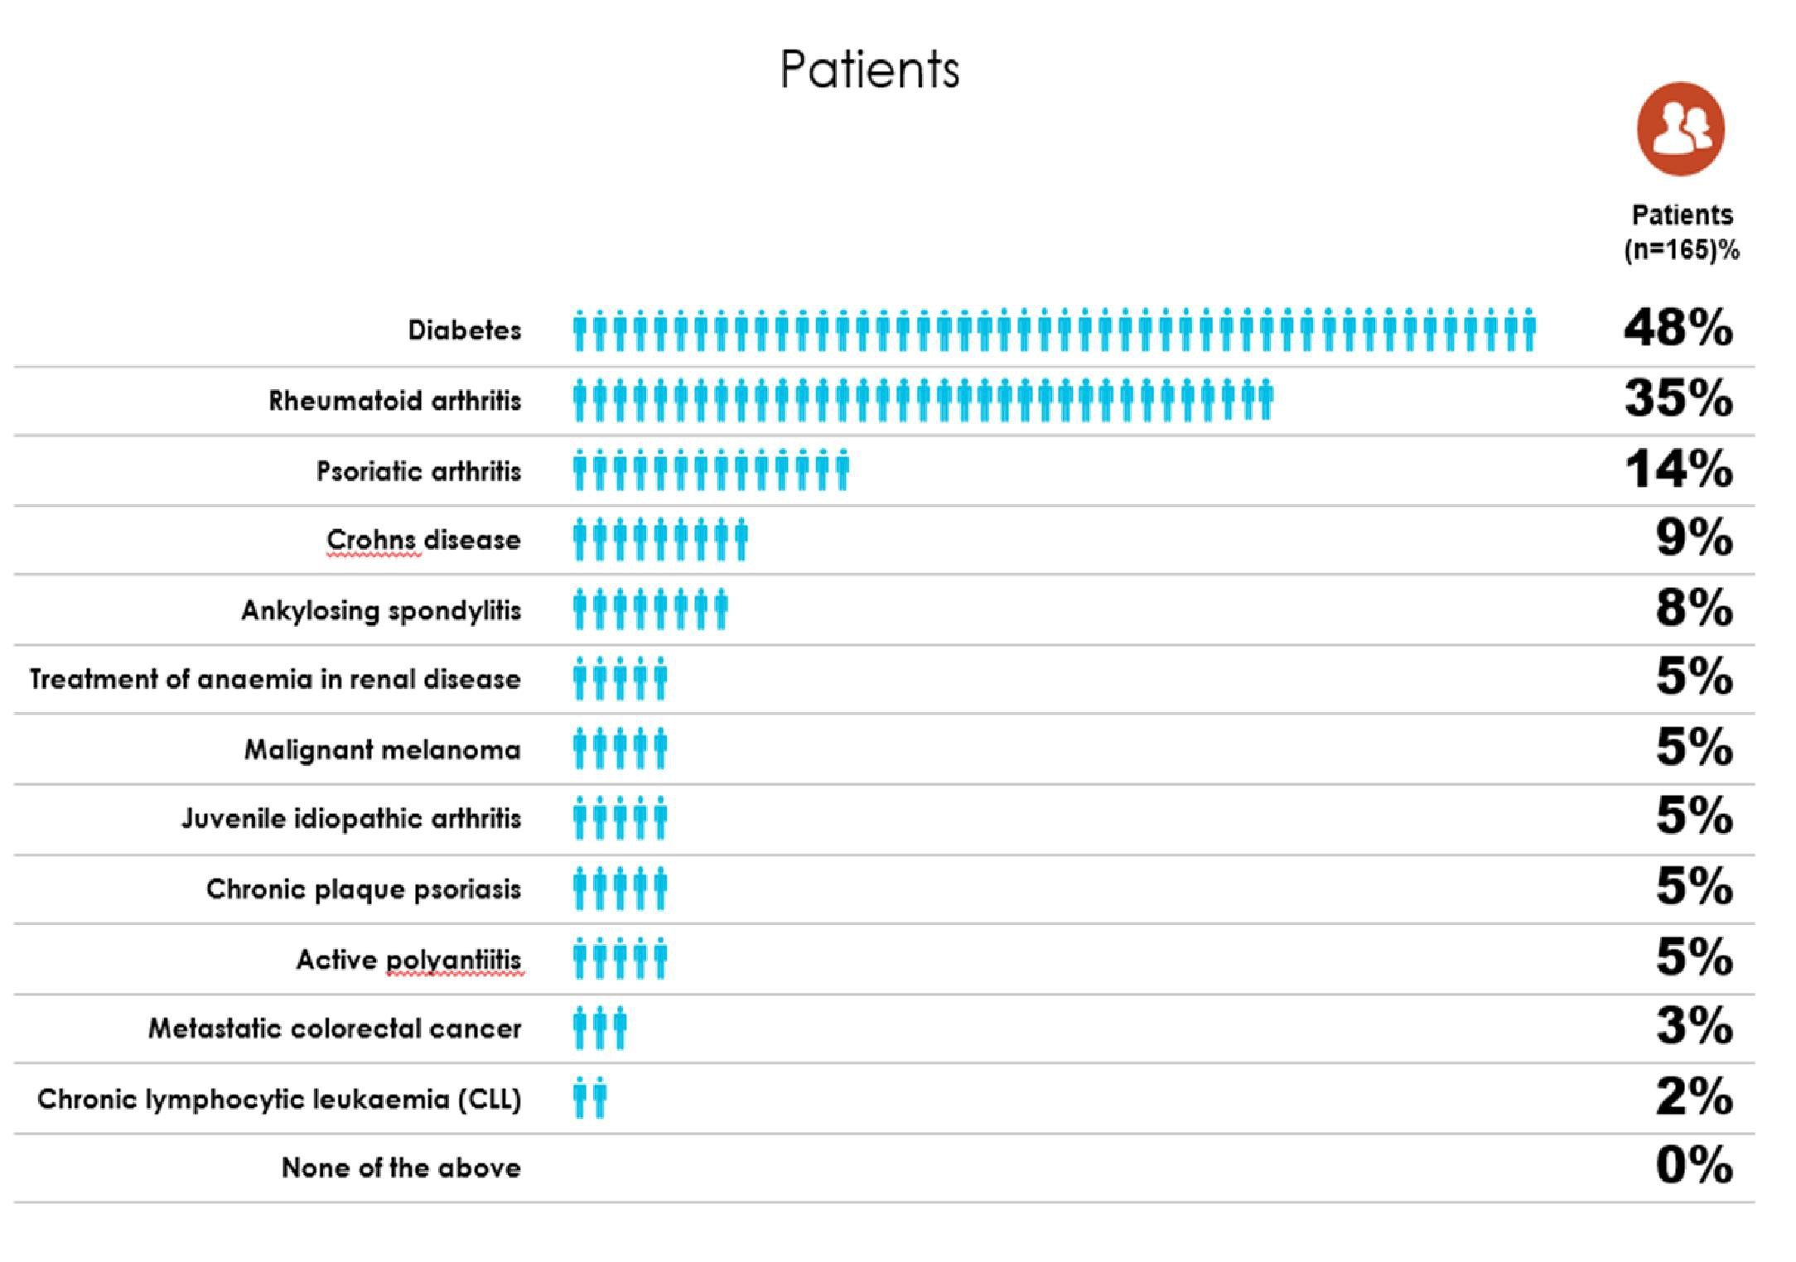

Sources of Information for Consumers
Biologic Medicines | n=198 | Biosimilar Medicines | n=168
GP | 28% | GP | 24%
General information on line | 23% | Pharmacist | 17%
Pharmacist | 18% | Word of mouth | 17%
Word of mouth | 18% | Online information from | 16%
 |  | Department of Health
Specialist | 17% | General information online | 15%
Communication from peak bodies national | 17% | Specialist | 15%

Perceived Barriers and Benefits for Patients and Carers (n=200)
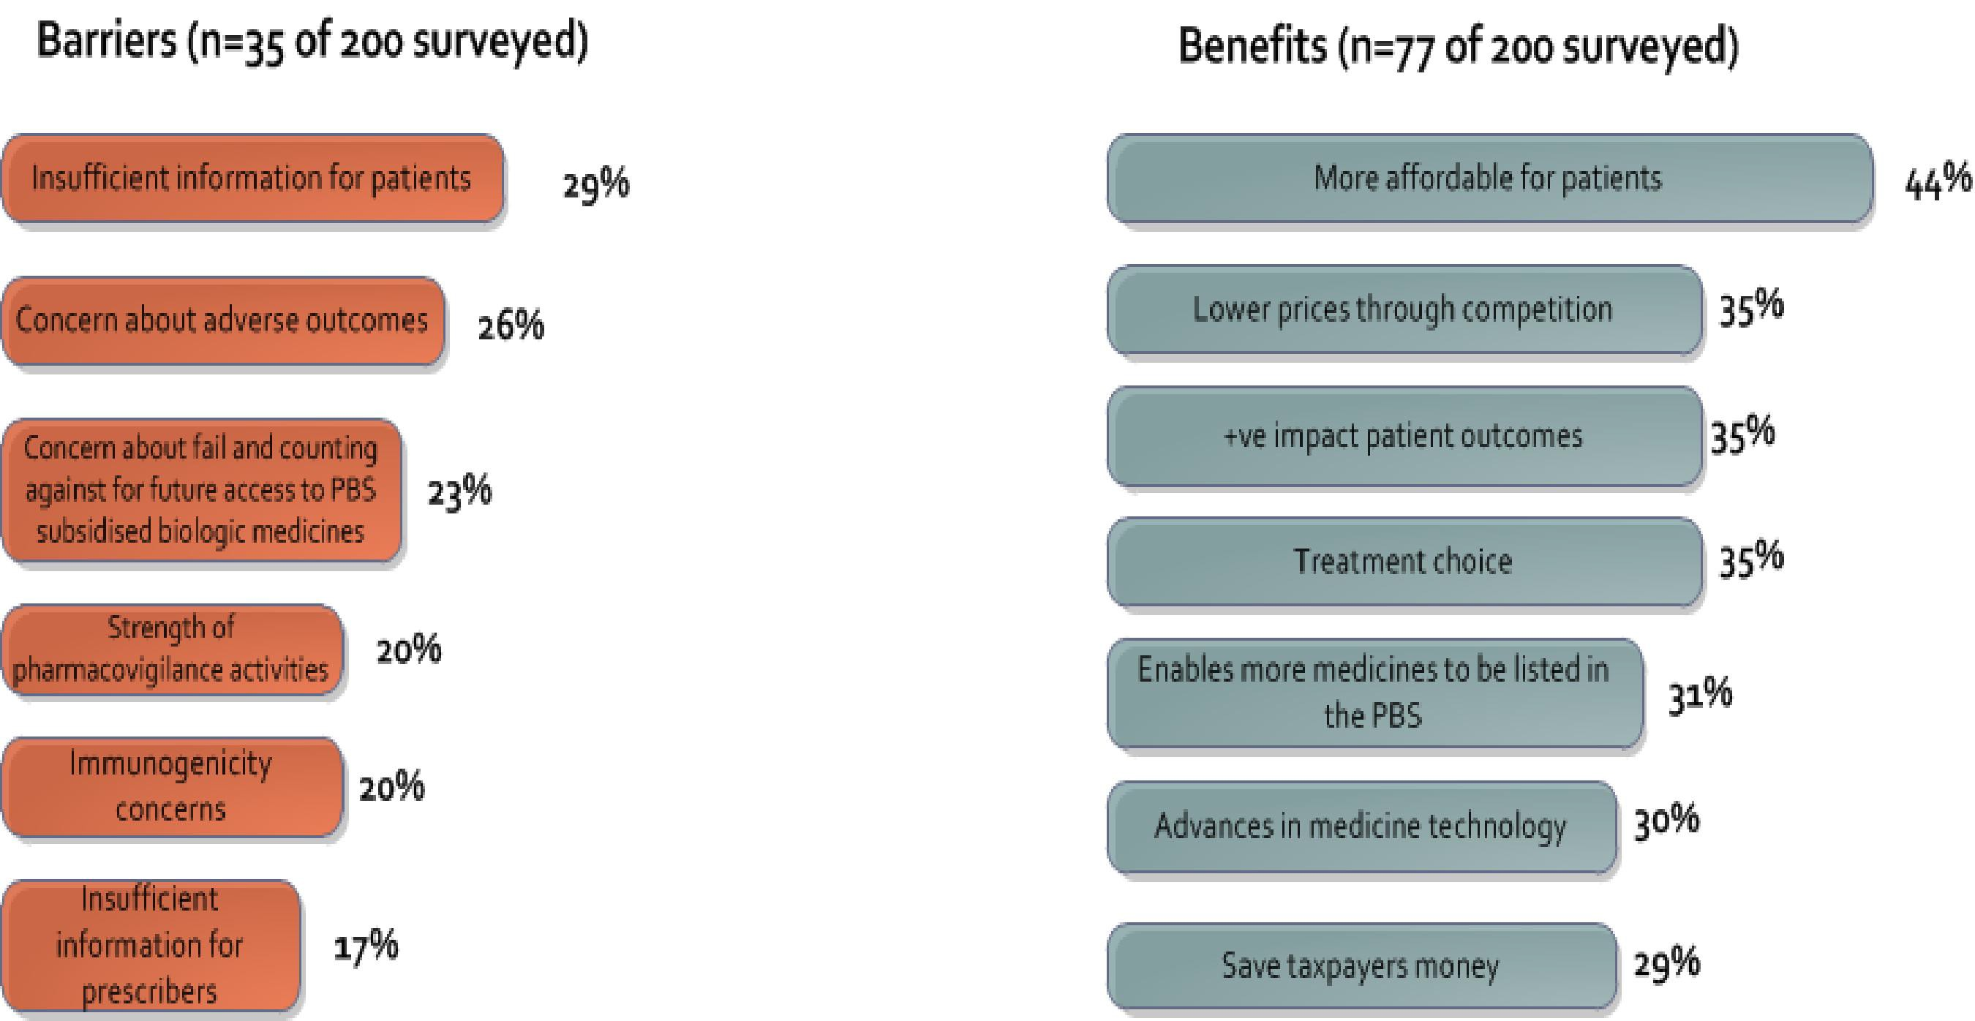

Consumer confidence with pharmacist offering substitution of a biological with a biosimilar medicine
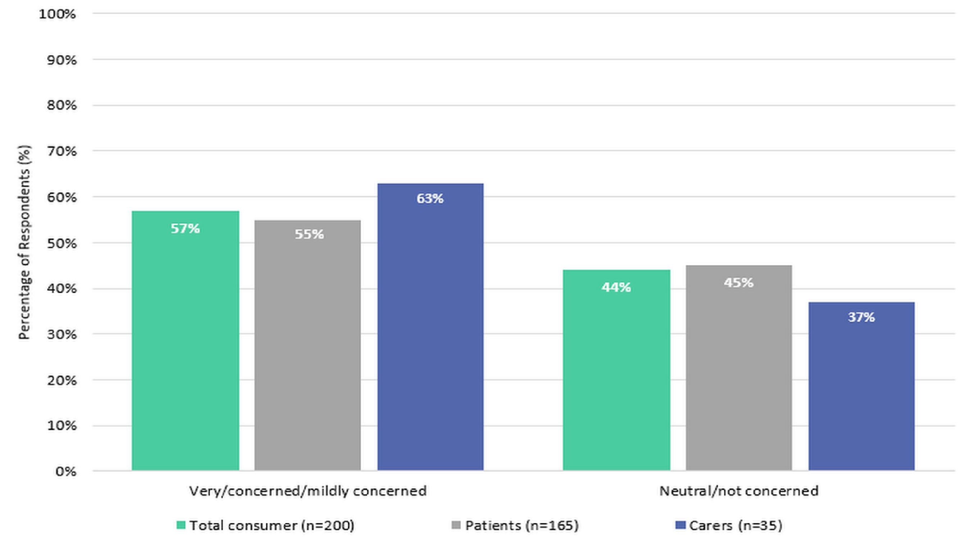

Proposed Activities to Increase Awareness
- Online FAQs
- Brochures
- Biosimilars counselling pad
- Presentations at conferences
- Ongoing updating of the literature review and dissemination of the results
- Articles for journals and newsletters
- Engagement of key professional groups
- Online CPD

Further Information
Biosimilars Awareness Initaitive

Questions
NMP@health.gov.au

