THE INAUGURAL

COMMUNITY PHARMACY STAKEHOLDER FORUM
15 November 2016

  - Pharmacy Diabetes Screening Trial

Project team

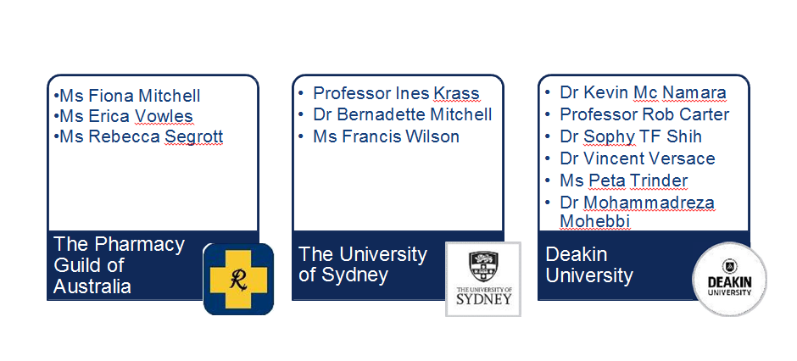

EXPERT PANEL

The Expert Panel provides advice and direction on the implementation of the trial. The project team will work closely with the Expert Panel throughout the trial.
The functions of the Expert Panel include providing guidance on:
- practicalities of the proposed trial design
- communication strategies over the life of the trial
- how best to engage with trial participants
- how to support engagement, recruitment, retention of participants, general practitioners, community pharmacies and other relevant health professionals

Expert panel: chair and representatives

Chair
Professor Stephen Colagiuri,
Professor of Metabolic Health and Co-Director of The Boden Institute at University of Sydney.

Members
Associate Professor Sof Andrikopoulos, Australian Diabetes Society. Kirrily Chambers, Australian Diabetes Educators Association.
Dr Gary Deed, Royal Australian College of General Practitioners. Teresa Di Franco, Pharmaceutical Society of Australia.
Amanda Galbraith, Community Pharmacist.
Adjunct Professor Greg Johnson, Diabetes Australia. Professor Ines Krass, Representative of the Project Partners.
Observers
Katrina Howe, Department of Health (observer). Julianne Quaine, Department of Health (observer).
Emeritus Professor Lloyd Sansom AO, Trials Advisory Group (observer).

Objective

To assess the comparative clinical effectiveness and
cost-effectiveness of three different pharmacy-delivered models of opportunistic assessment for diabetes in an asymptomatic, previously undiagnosed population.

Hypothesis

The addition of either a HbA1c Point of Care (POC) test or scBGT POC test to the AUSDRISK assessment is associated with a statistically significant increase in the proportion of new cases of diagnosed type 2 diabetes mellitus (T2DM) and will be more cost effective than the AUSDRISK assessment alone.

Outcomes

- Primary
  - The difference in proportions of newly diagnosed T2DM cases between the two intervention arms and the comparator arm (to be identified by the subsequent GP assessment and blood test results)
  - Secondary
  - Proportion of newly diagnosed cases of impaired fasting glucose (IFG) or impaired glucose tolerance (IGT)
  - Proportion of people referred to the GP
  - Proportion who take up the referral to the GP

Overview: Trial design is a Clustered RCT
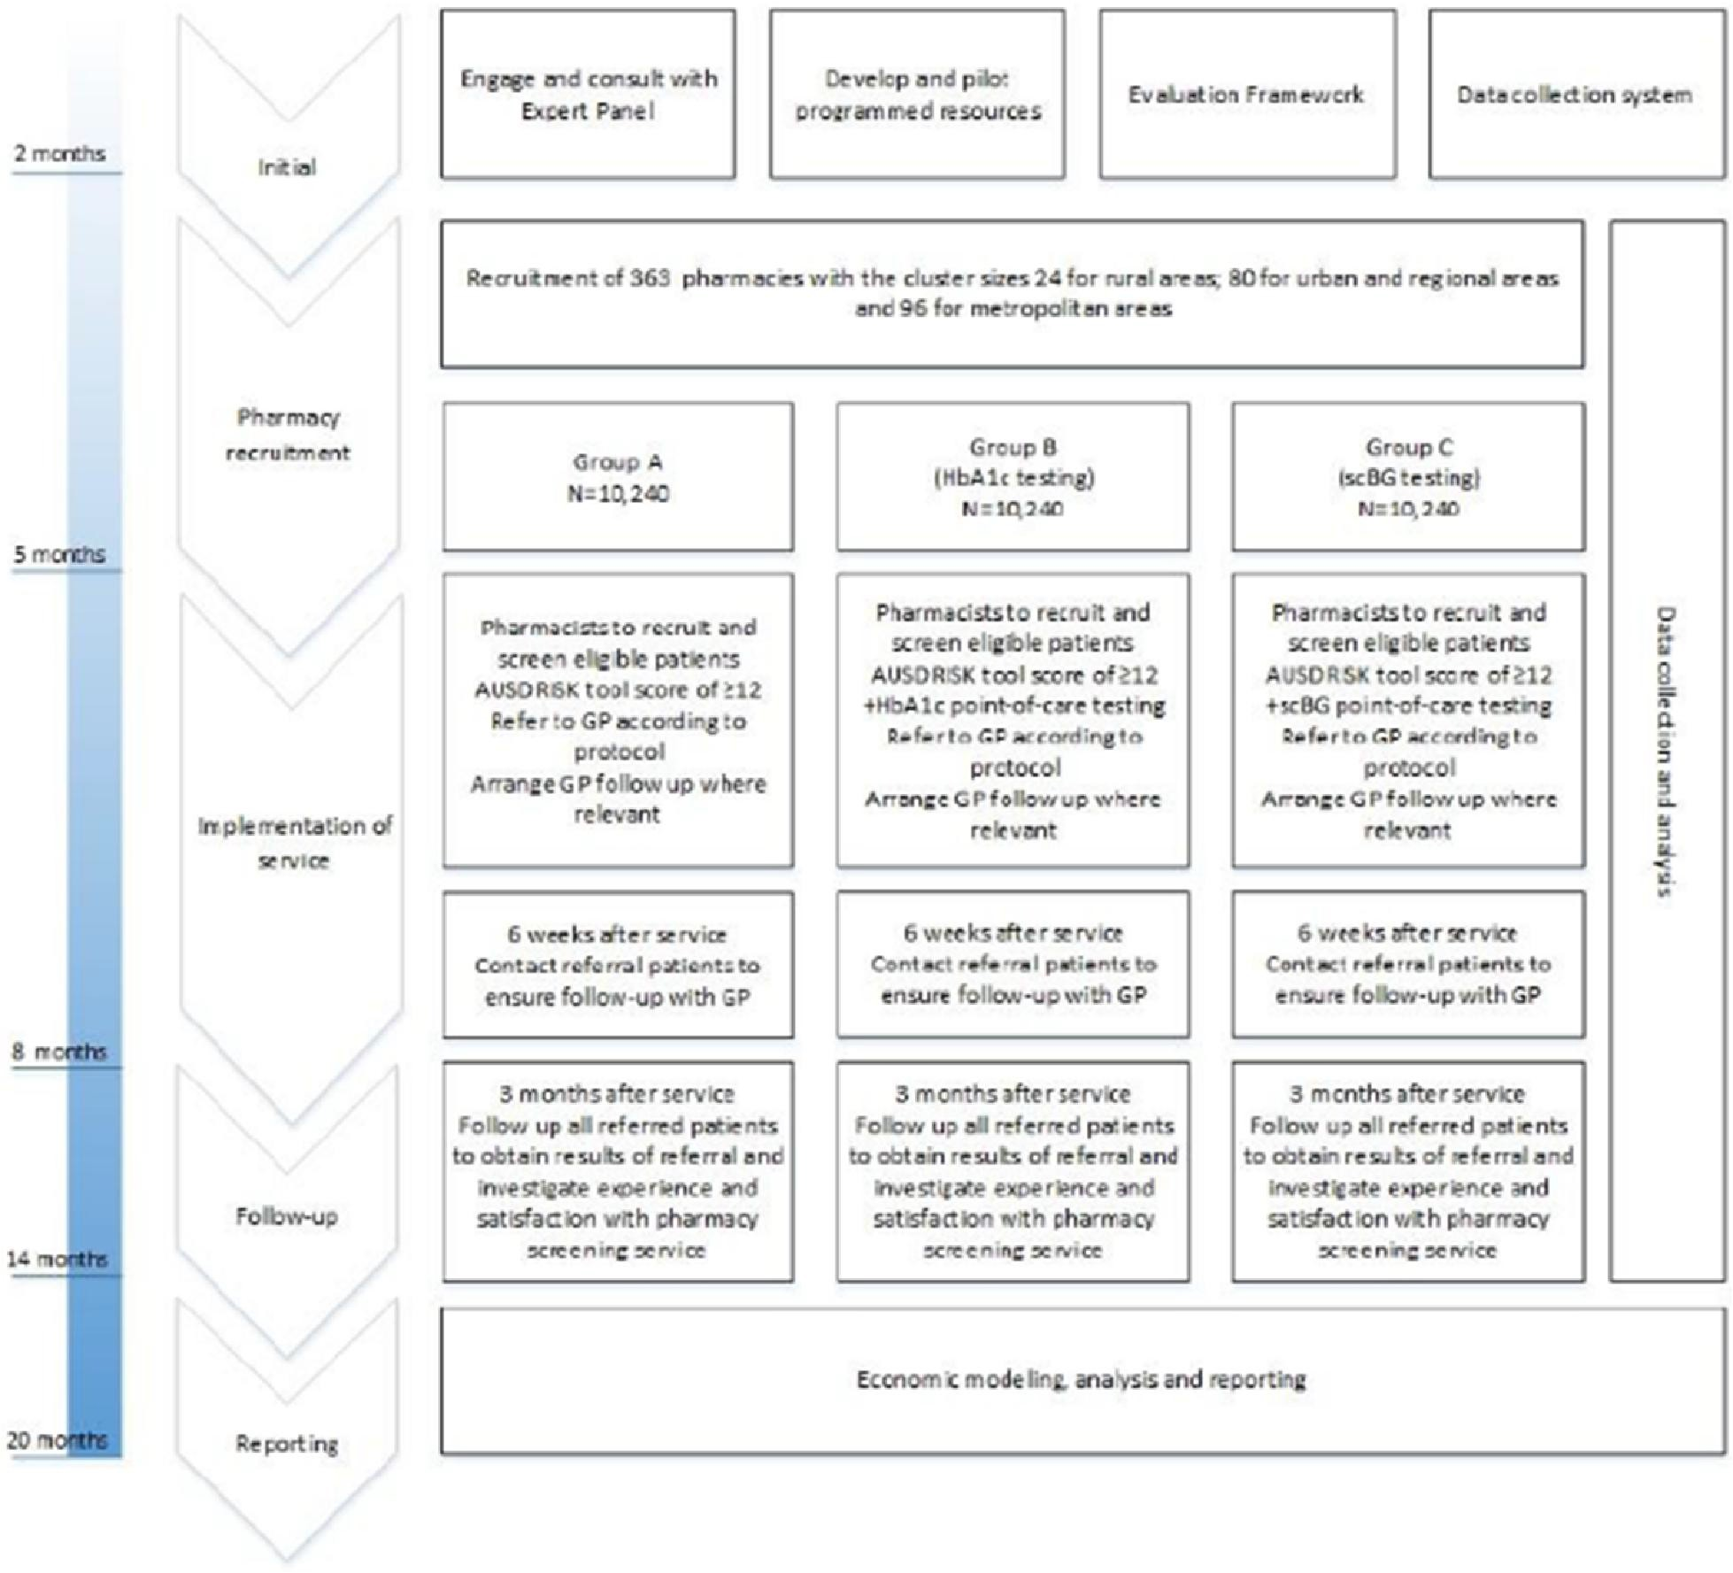

Trial Groups
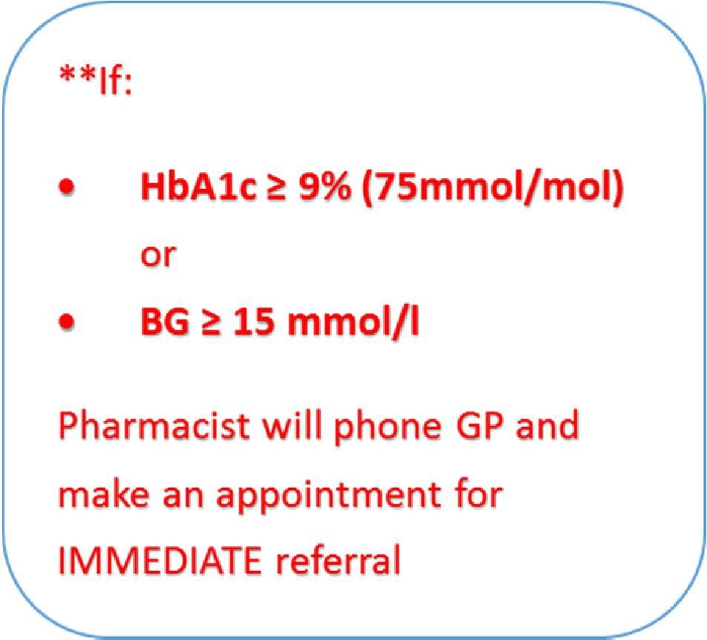

GROUP A:
- AUSDRISK assessment tool alone

- Referral to a GP if AUSDRISK ≥ 12
GROUP B:
- AUSDRISK assessment tool +
- HbA1c point-of-care (POC) test in patients with AUSDRISK ≥ 12
- Referral to a GP if HbA1c ≥ 5.7% (39 mmol/mol) is detected**
GROUP C:
- AUSDRISK assessment tool +
- small capillary blood glucose test (scBGT) in patients with AUSDRISK ≥ 12
- Referral to a GP if
  - fasting blood glucose (FBG) ≥ 5.5mmol/l** or
  - random blood glucose (RBG) ≥ 7.8 mmol/l**

Trial design

Geographical areas are the unit of randomisation
- Randomised to Group A, B or C
- Stratified by metro/regional/remote residential areas
- Pharmacies in the selected areas will be invited to participate

Patients are the unit of analysis and recruited as follows:
- According to the distribution of the Australian population
• By age groups (35-44, 45-54, 55-64, & 65-74)
- By gender

Pharmacy inclusion/exclusion criteria

- Approved Section 90 pharmacy
- Appropriate private area in the pharmacy
- Appropriate storage and disposal of reagents and consumables
- Accredited by an approved Pharmacy Accreditation Program
- Agree to adhere to standards, terms and conditions, guidelines and protocols
- Endeavour to include the Pharmacy Diabetes Screening Trial CPD training in annual training plans as appropriate
- Agree to obtain written patient consent and to provide data required for evaluation of the trial

Pharmacy Recruitment Targets

State/Territory | Major Cities Regional Remote Total | Regional | Remote |  | Total
New South Wales | 80 | 25 |  | 3 |  | 108
Victoria | 59 | 24 |  | 2 |  | 85
Queensland | 38 | 31 |  | 5 |  | 74
South Australia | 14 | 9 |  | 7 |  | 30
Western Australia | 22 | 6 |  | 6 |  | 34
Tasmania | 0 | 10 |  | 3 |  | 13
Northern Territory | 0 | 7 |  | 4 |  | 11
Australian Capital Territory | 8 | 0 |  | 0 |  | 8
Total | 221 | 112 |  | 30 |  | 363

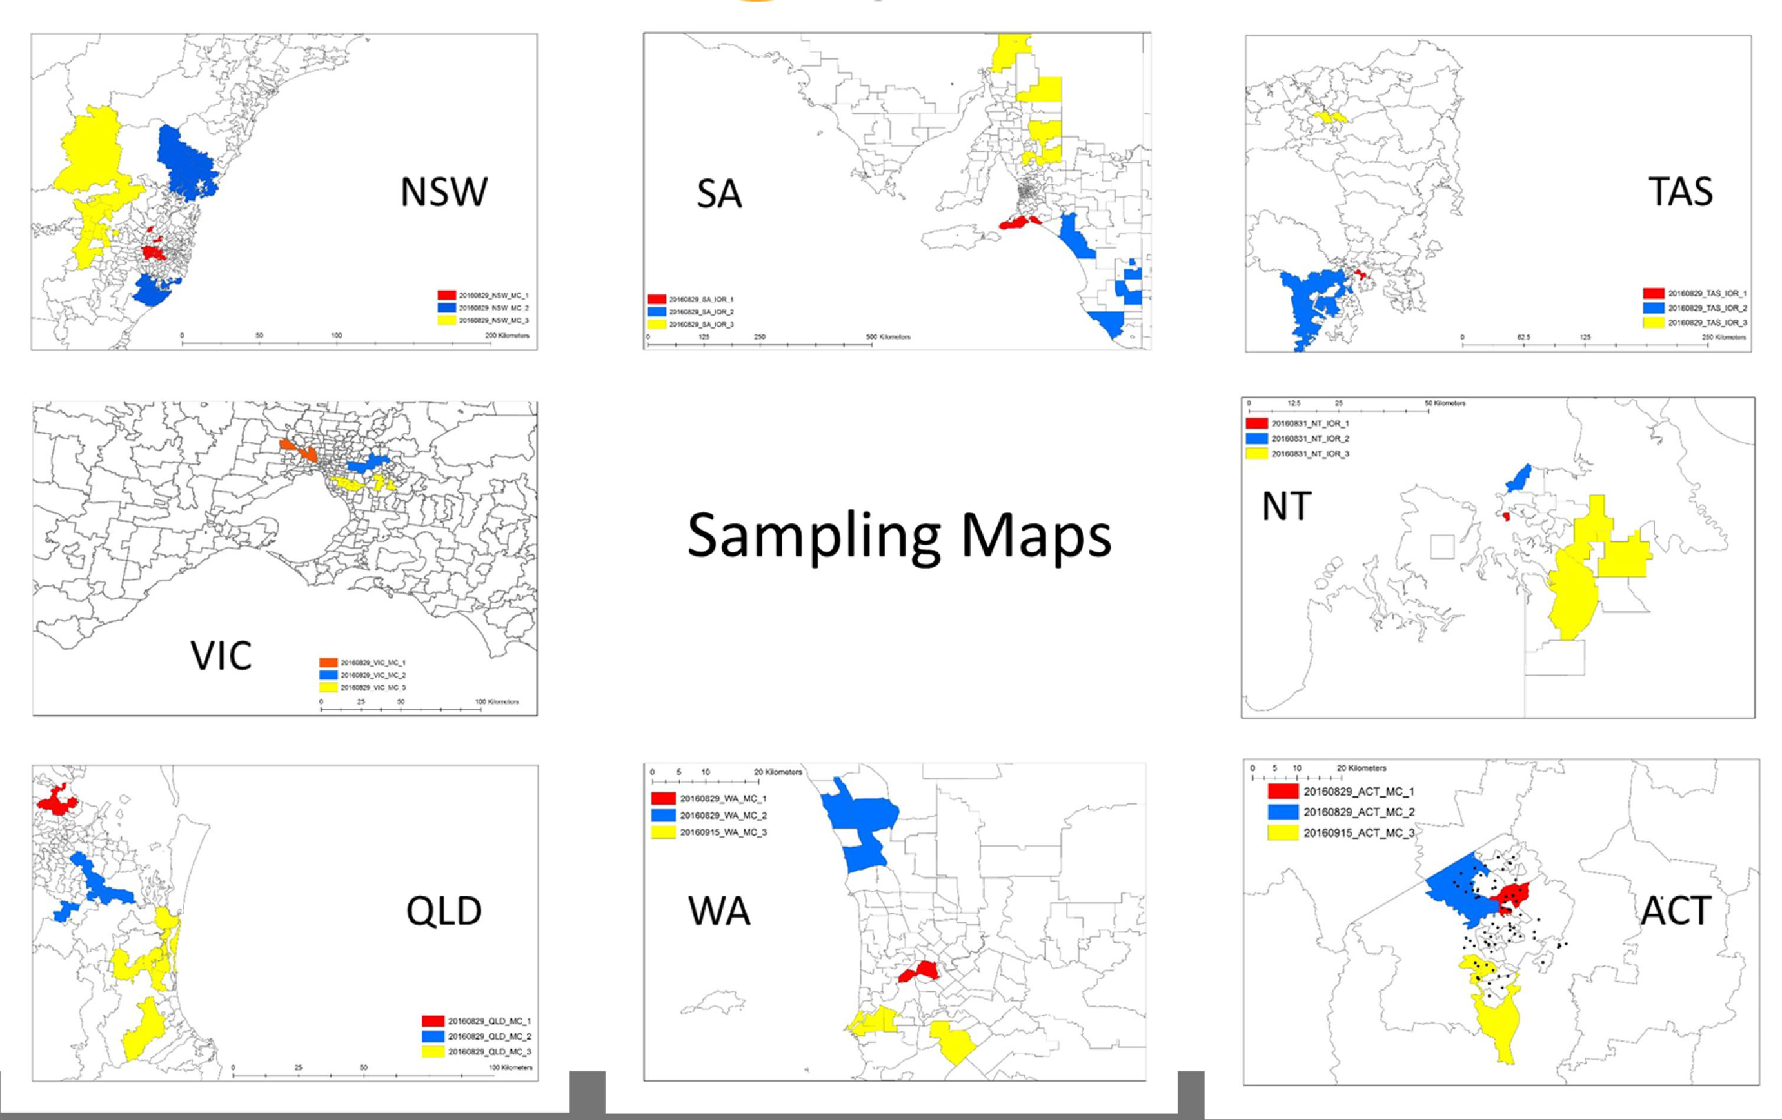

Inclusion/Exclusion Criteria – Screening Participants

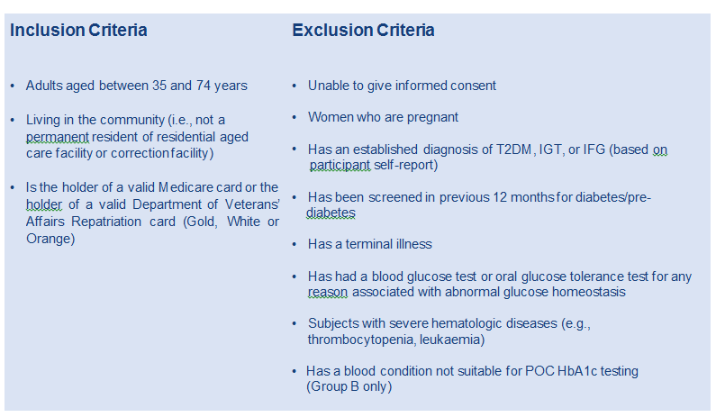

Trial Sample – Screening Participants

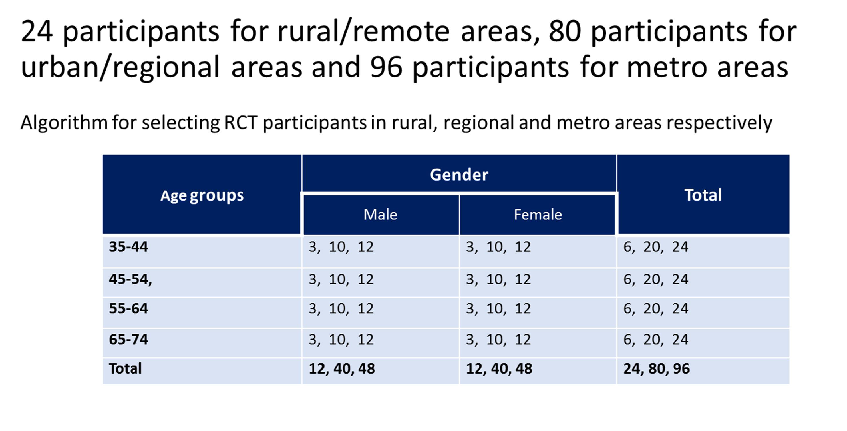

Evaluation – Baseline, Formative and Process

Type of evaluation | Description/measure | Data source
Baseline data | Survey of current screening services provision of  participating pharmacies | Web based self-completion questionnaire
Formative | To identify (a) overall experience, with service implementation, any difficulties with compliance, and options for overcoming these; and (b) perceptions of sustainability of the screening model, and requirements for sustainability | Qualitative interviews with a 10% sample of participating pharmacists/pharmacy staff
Process | Median number of trial screening services/pharmacy/week | Pharmacy records
 | Total number of trial screening services per pharmacy | Pharmacy records
 | % with elevated risk who received appropriate further screening and who were referred to the GP for further  assessment | Pharmacy records
 | % who were screened who were referred to evidence based lifestyle modification programs in pharmacy or  elsewhere | Pharmacy records
 | Patient satisfaction with the pharmacy screening service | Follow up survey of a 10% sample of all screening participants

Evaluation – Clinical Outcomes and Economic Analysis

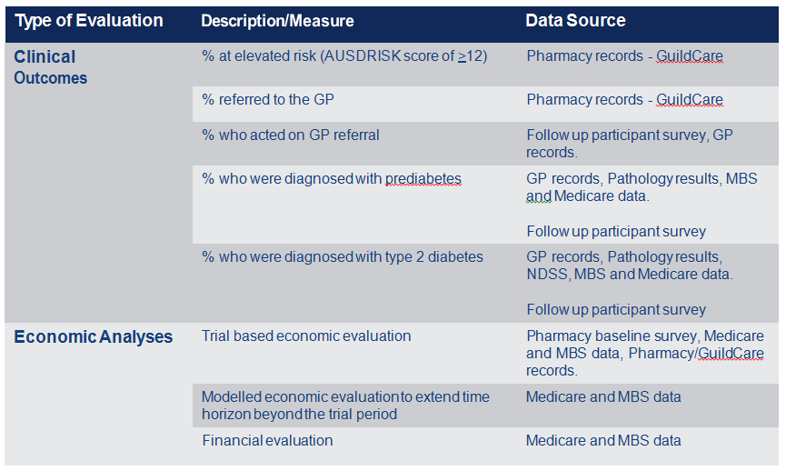

Incentive Payments

Group | No. participants | Component of service | $ | Total $ per service
Group A | 10240 | Initial screen only | 10.00 | 10.00
 |  | Referral | 11.00 | 21.00
Group B | 10240 | Initial screen only | 10.00 | 10.00
 |  | POC testing | 10.50 | 20.50
 |  | Referral | 11.00 | 31.50
Group C | 10240 | Initial screen only | 10.00 | 10.00
 |  | POC testing | 10.50 | 20.50
 |  | Referral | 11.00 | 31.50

A bonus of $750.00 will also be provided to the pharmacies as an incentive to maintain the quality of the collected data e.g., payable upon the completeness of the data collected according to the protocol

Human Ethics Approval

- Application has been approved
  - Participant Information Statement (PIS) for pharmacies/pharmacists
  - Pharmacy/pharmacist consent form
  - PIS for screening participants
  - Screening participant consent form
  - GP information/engagement letter
  - GP Referral
  - Pharmacy baseline survey
  - Patient 3 month follow up survey

Dept of Human Resources Approval

Application to use participant Medicare Data has been approved:
- Medicare Consent Form

Medicare Data will be used to:
- Verify clinical outcomes
- Conduct economic analyses

Training Requirements
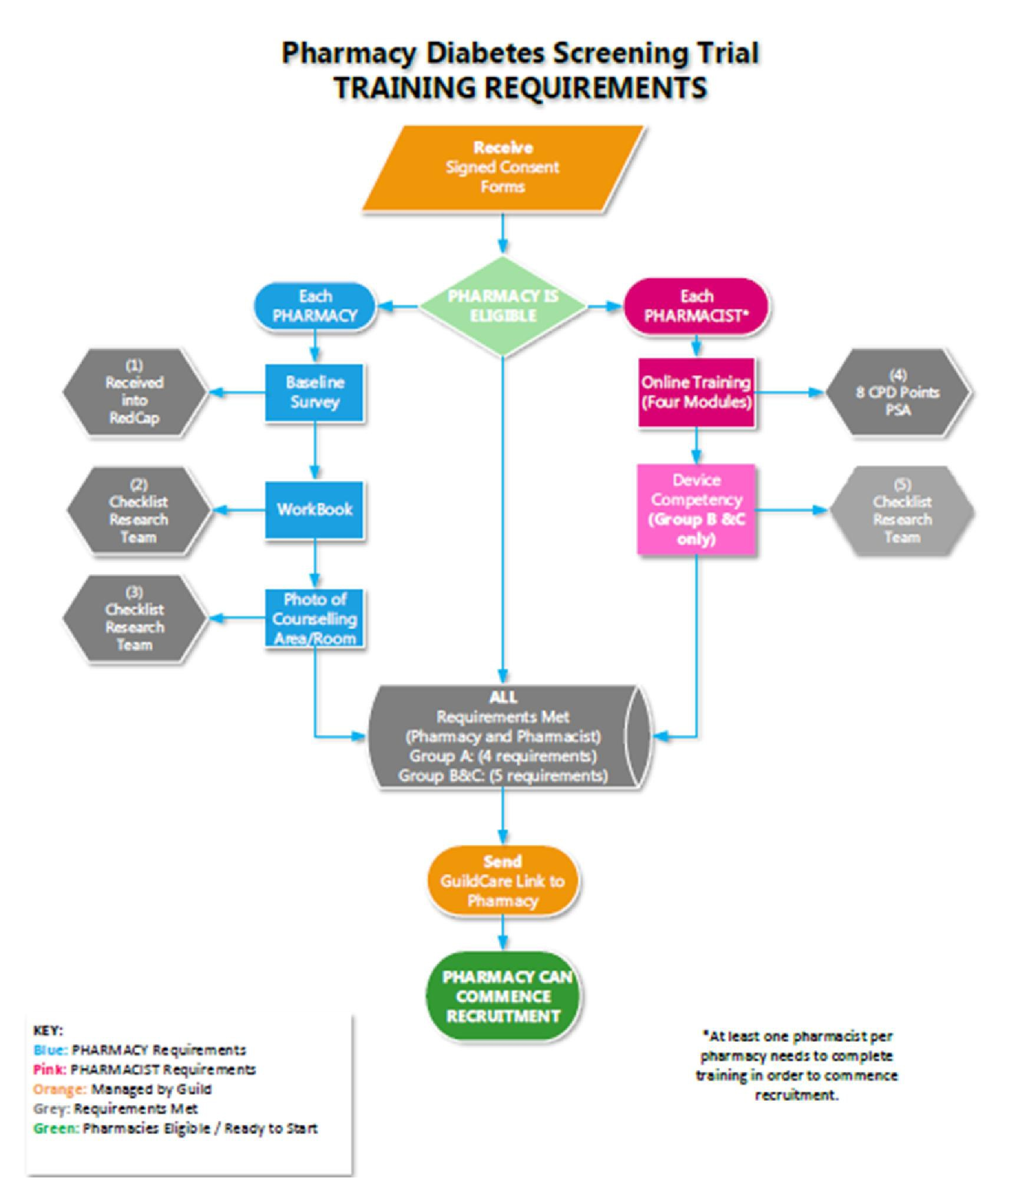

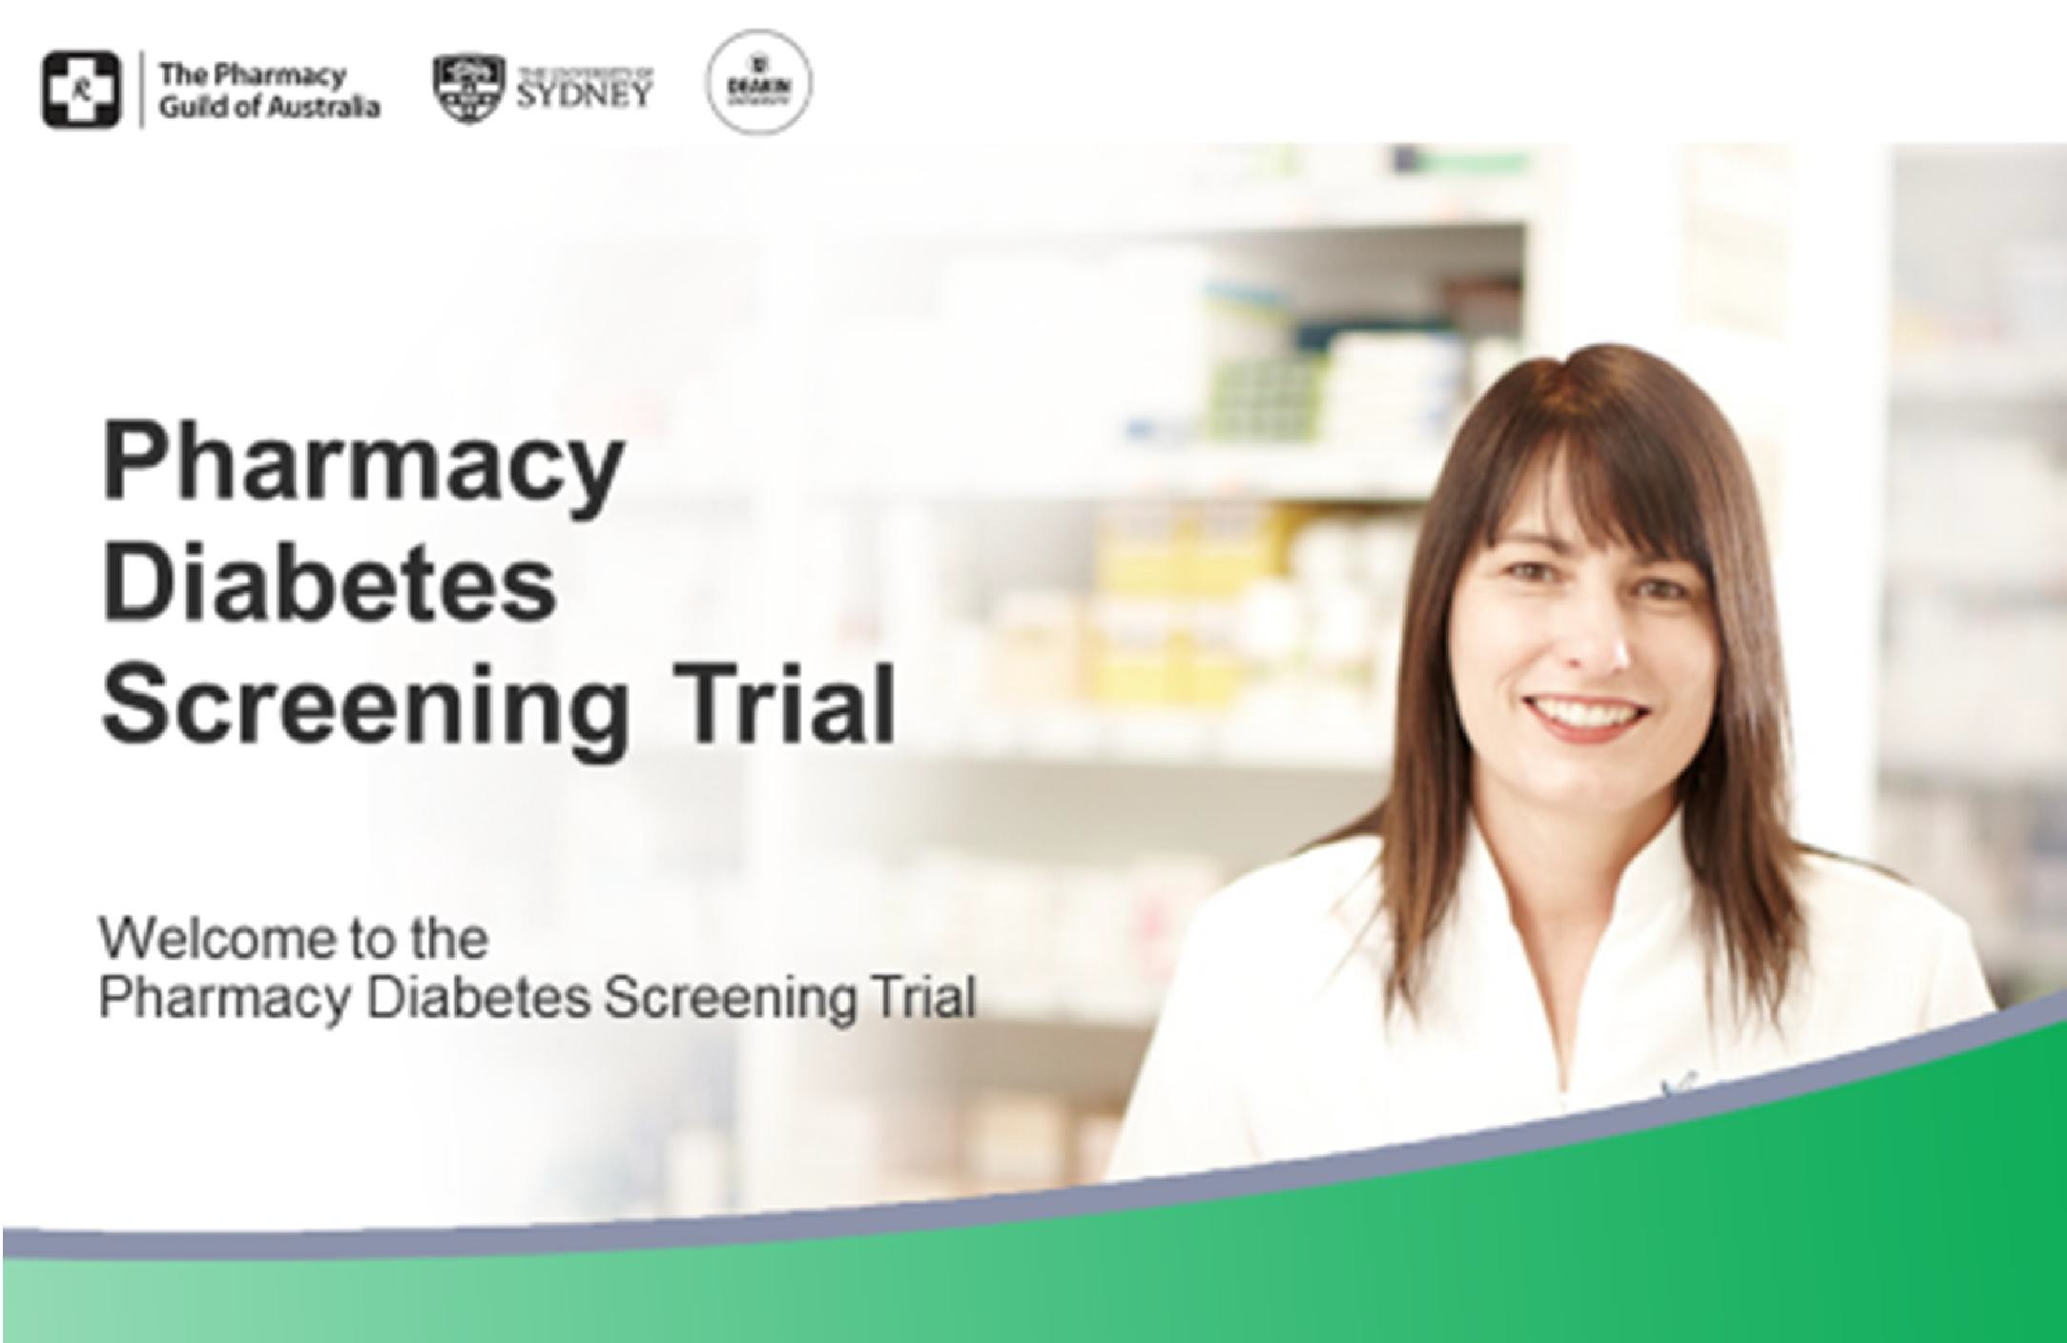

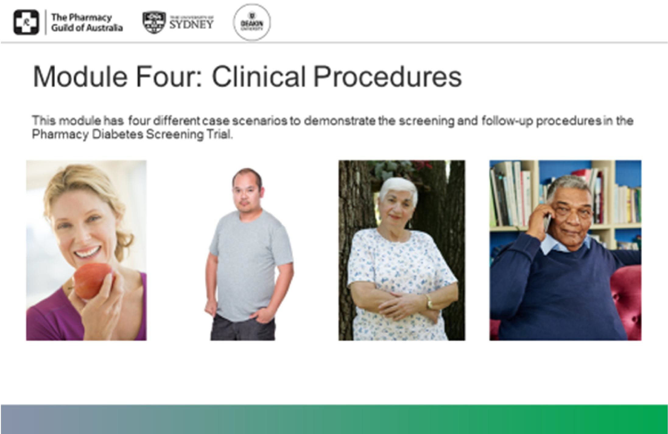

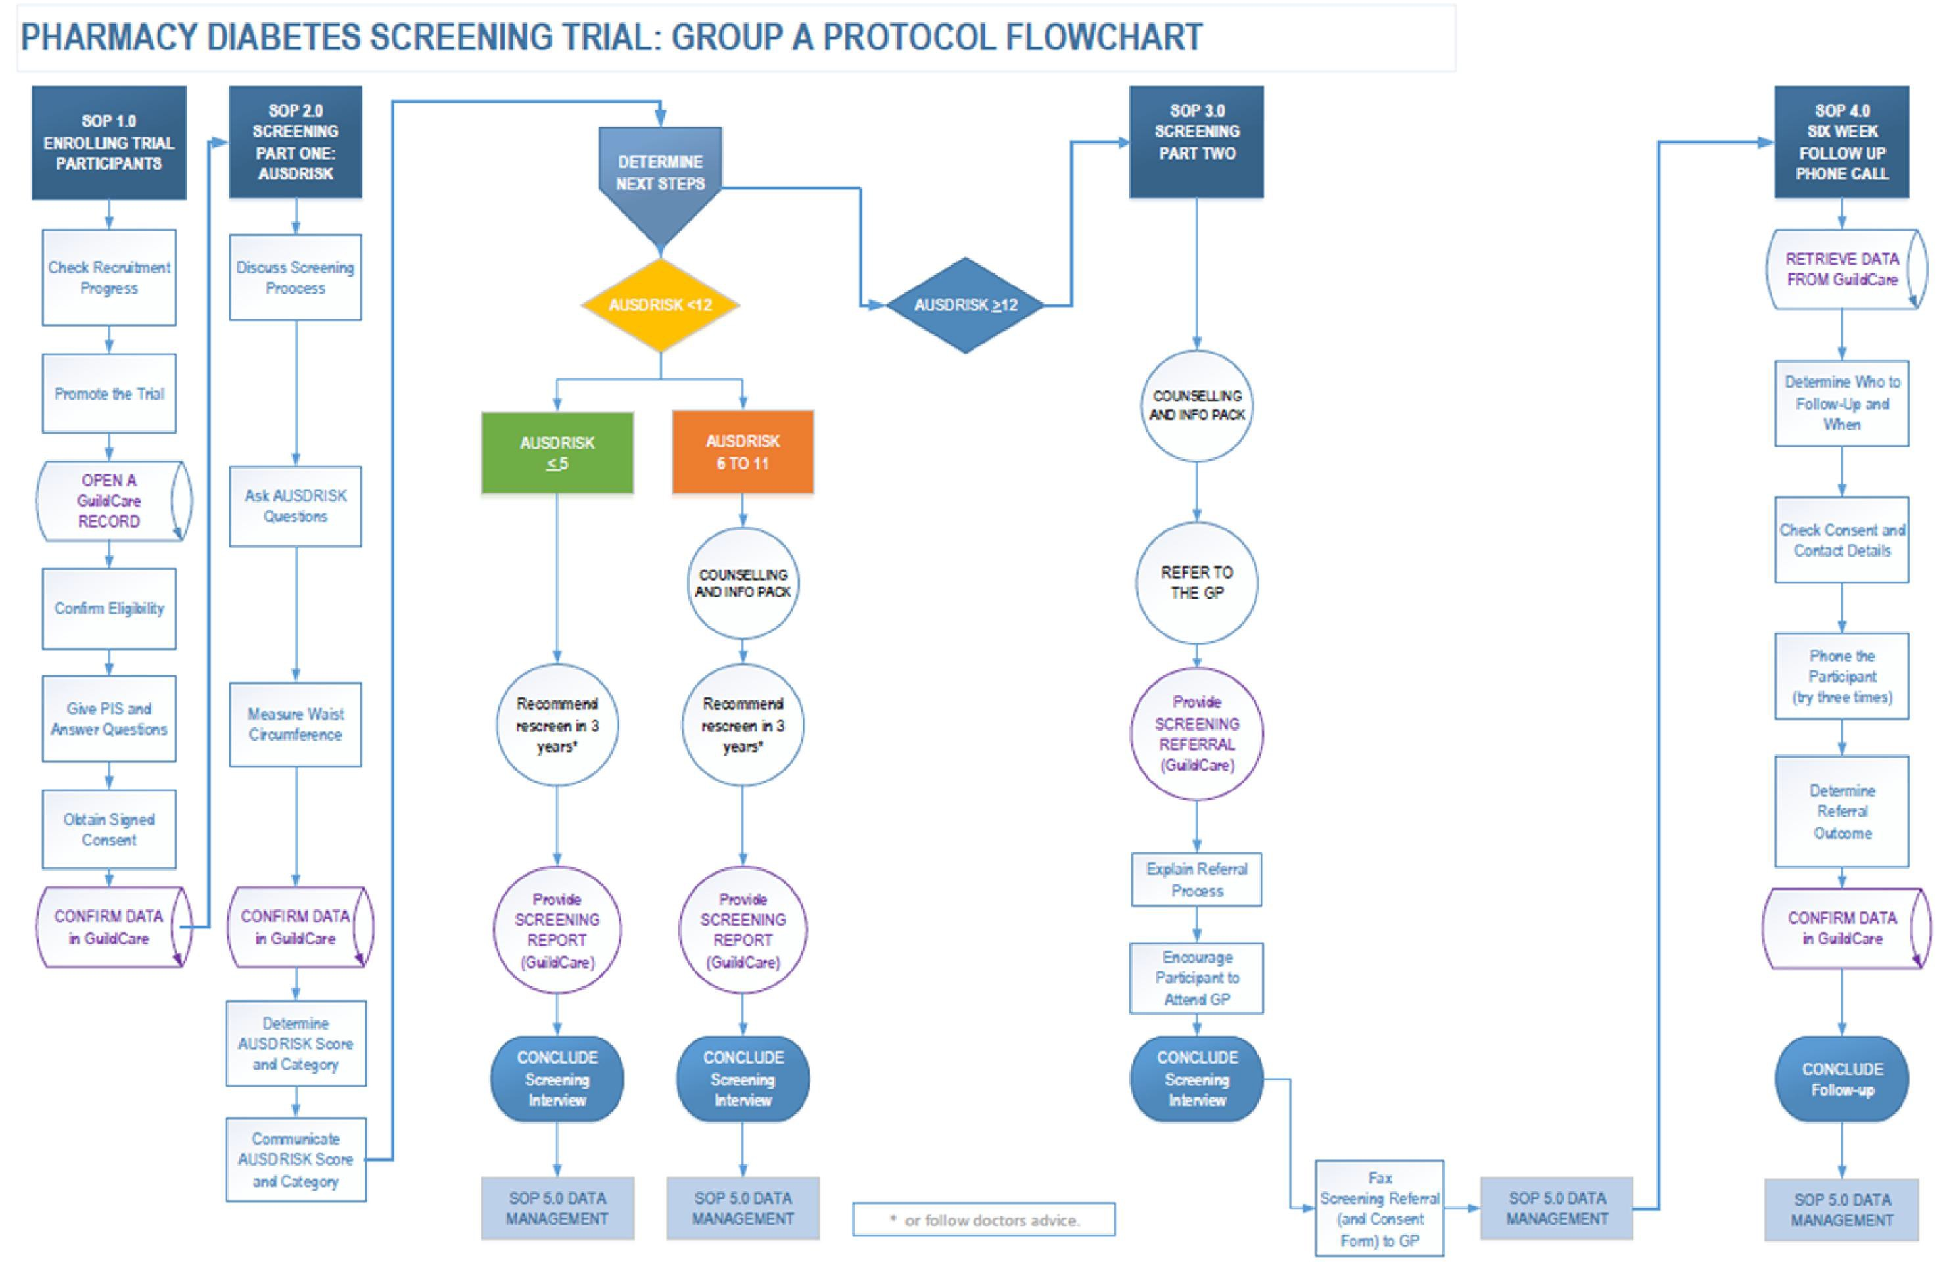

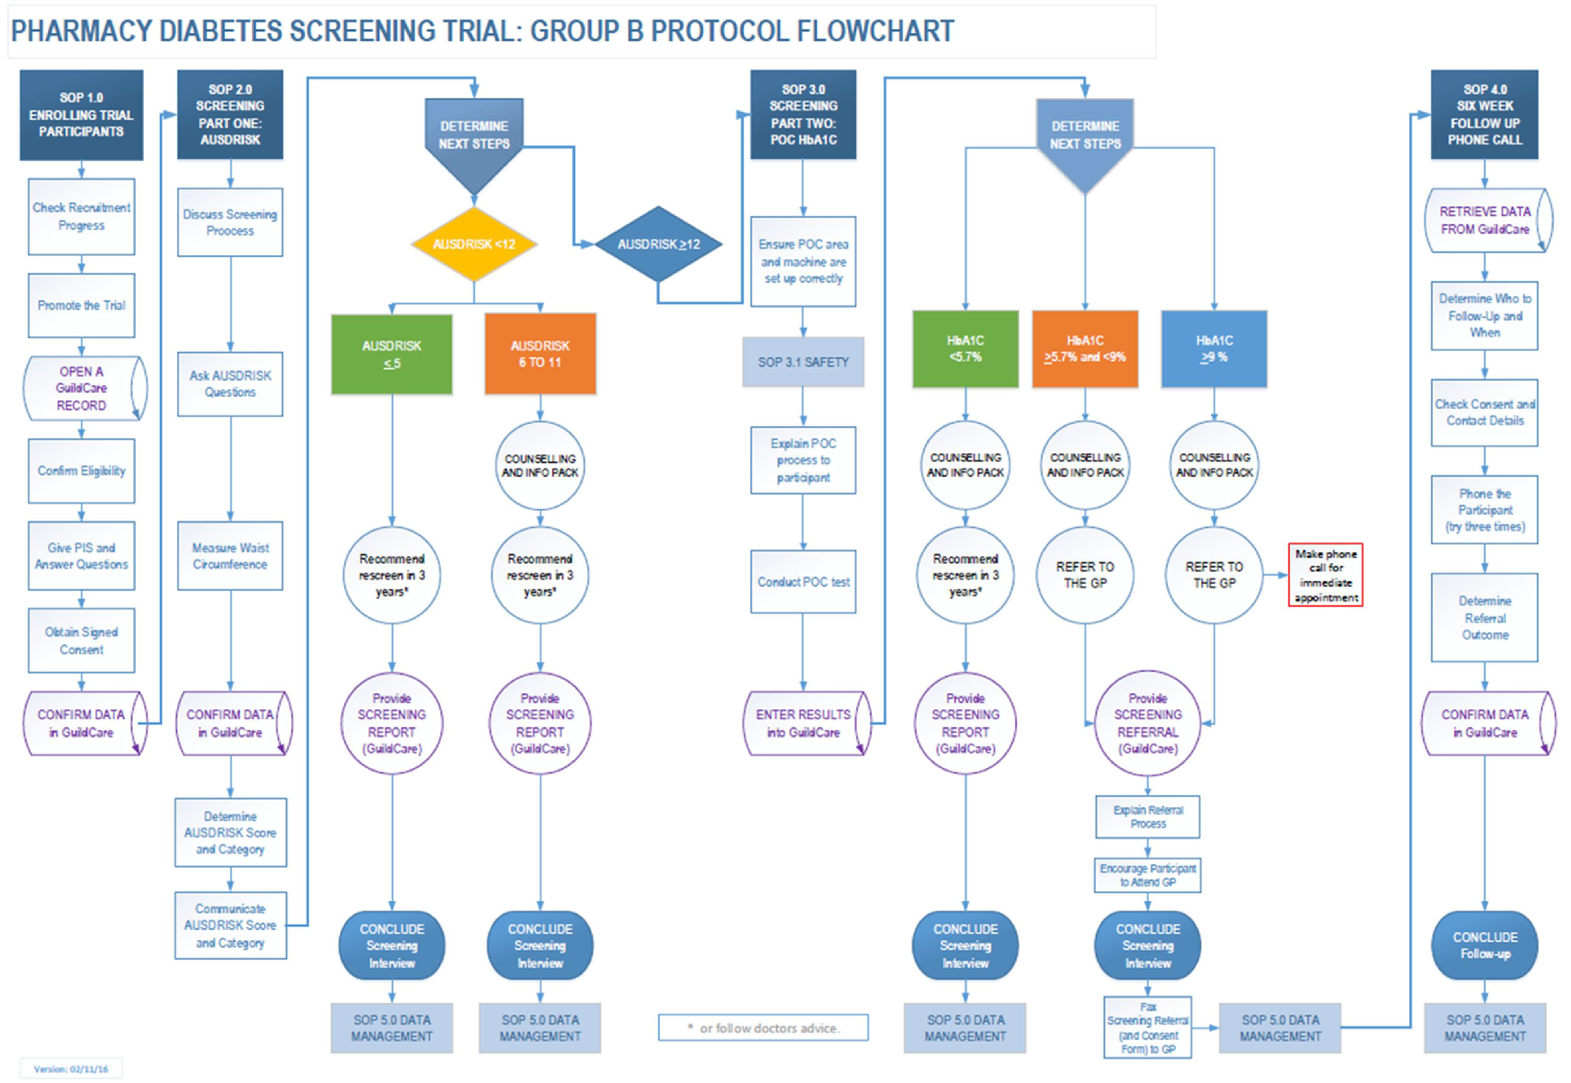

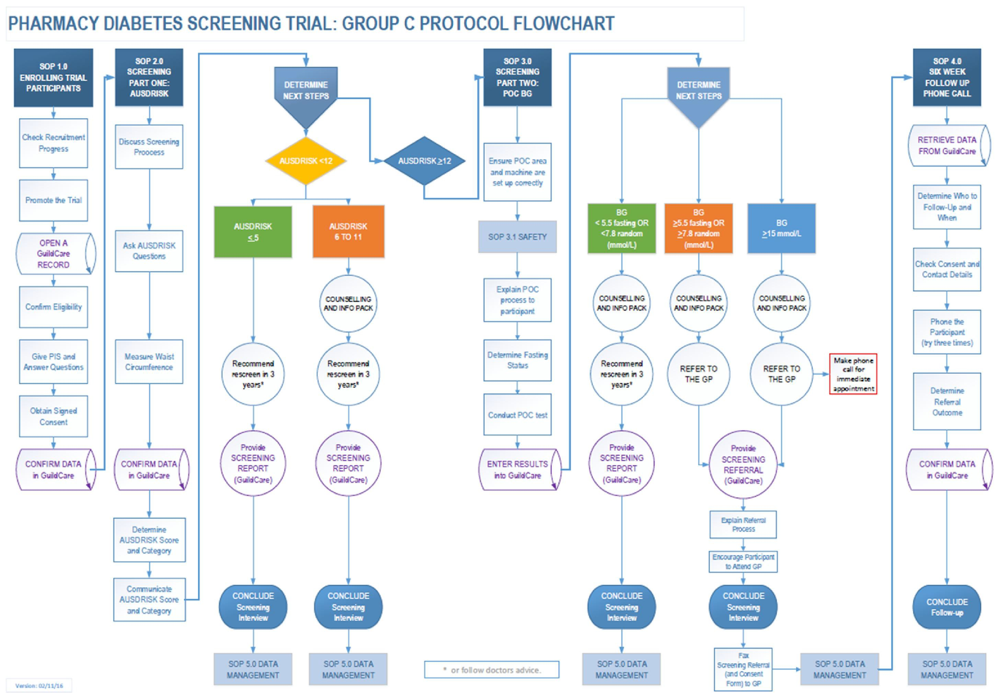

Resources for Participating Pharmacies

Promotional and Printed Material

- Posters
- Flyers
- PIS
- Consent Forms
- GP Letters
- Eligibility Cards
- Brochure Stands
Equipment and Devices

- Point of Care Devices, Waist Measurement Tape, and Consumables
- Tender process based on an open request for proposals.
- Currently being reviewed by Pharmacy Guild, Research Team and Expert Panel

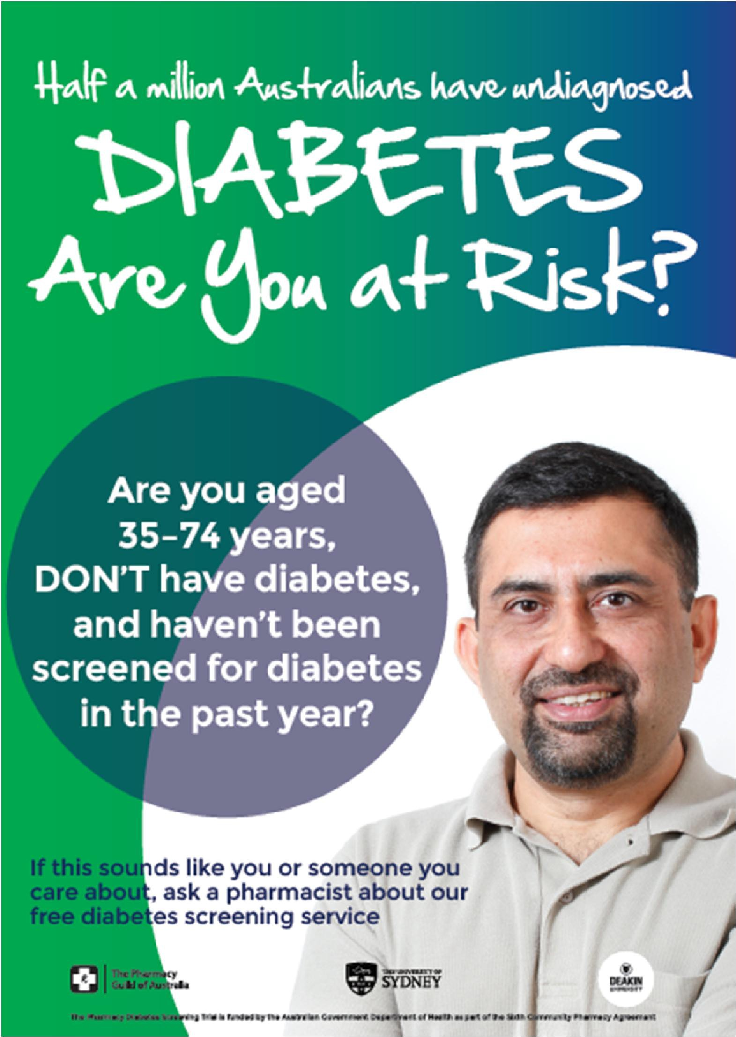
Promotional Material In Pharmacy

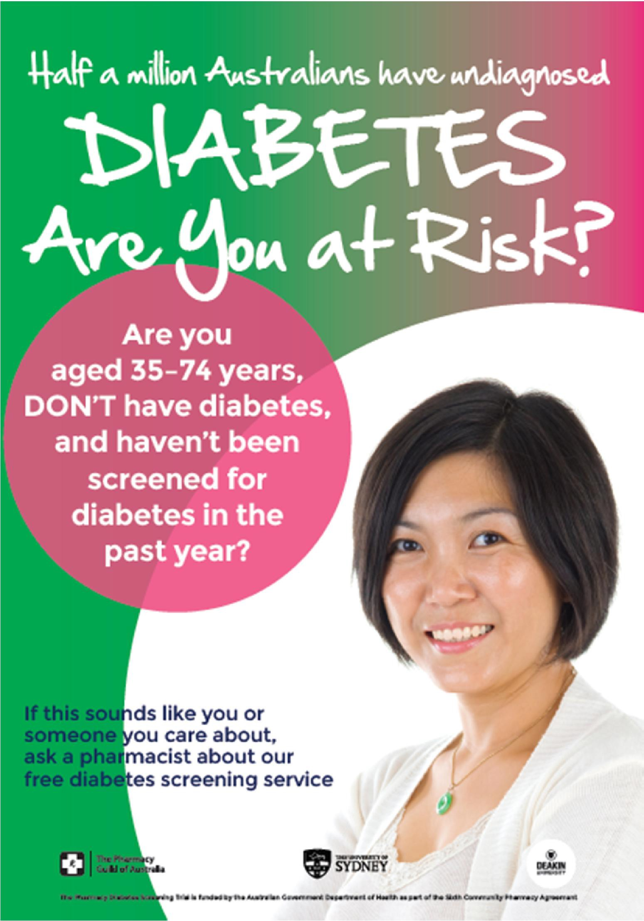
Promotional Material In Pharmacy

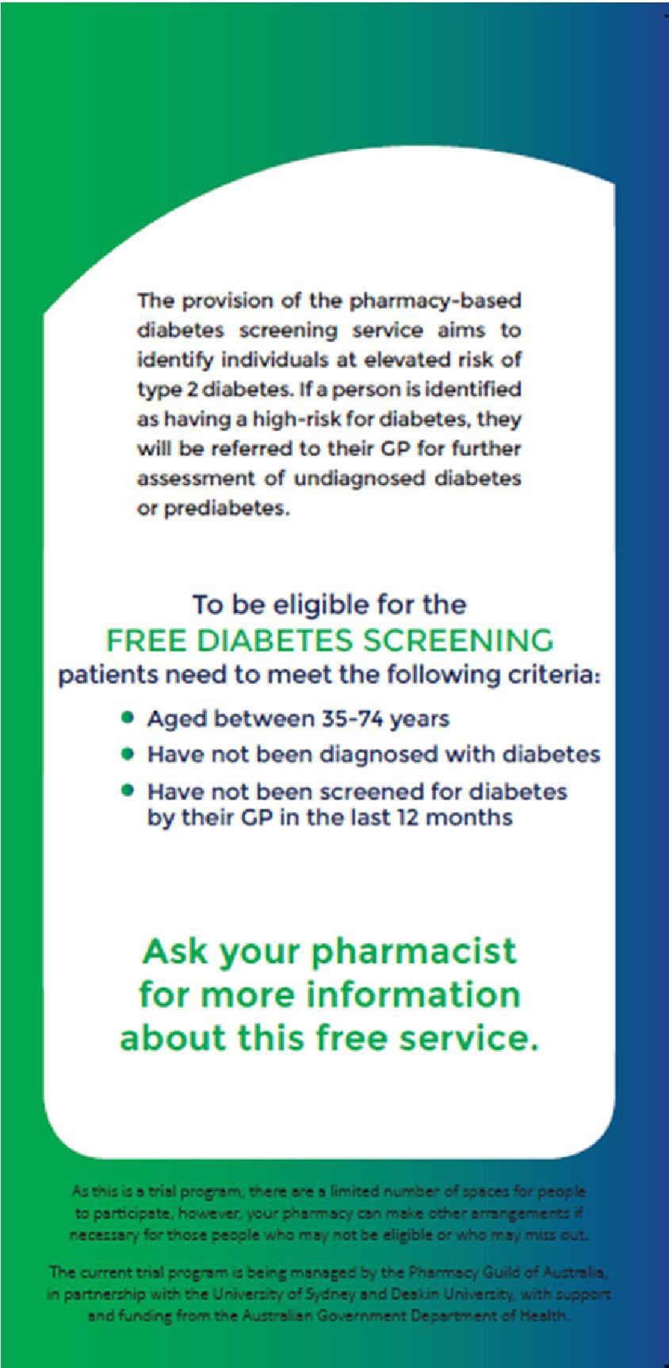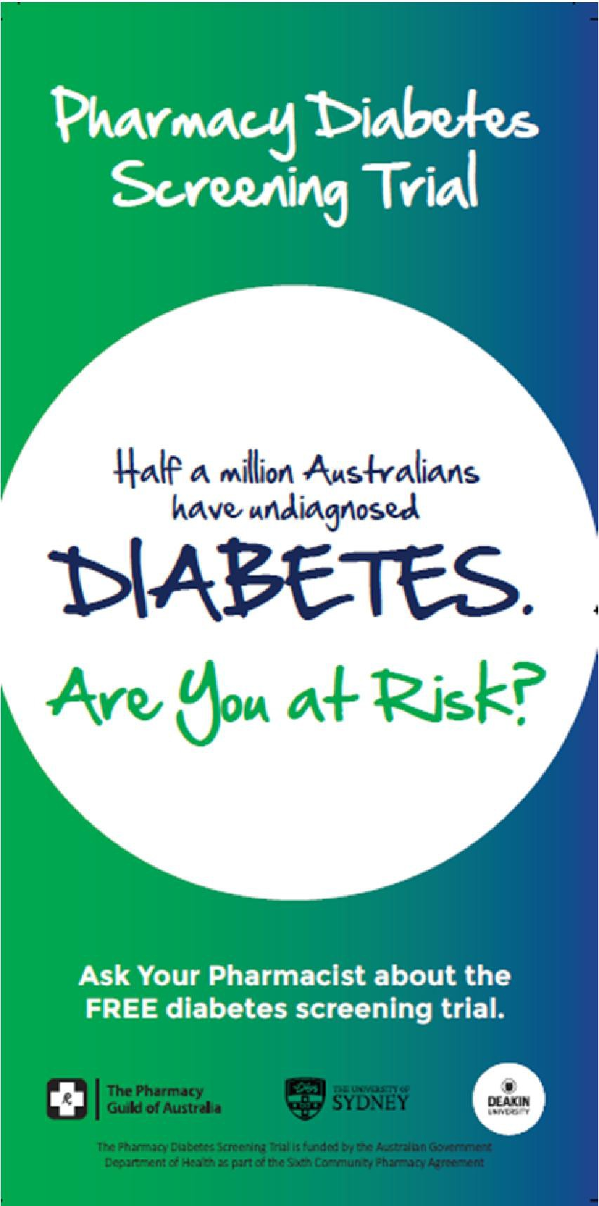
Promotional Material In Pharmacy

Summary of progress

Human Ethics final approval received – University of Sydney
Medicare data final approval received – Department of Human Resources
Online training – Available on Guild Academy
Checklists for device competency – Research Team
Accredited CPD points – Pharmaceutical Society of Australia
Online baseline survey developed – Research Team
Standard Operating Procedures (SOPs) and Flowcharts – Research Team
Pharmacy Operations Manual and Workbook – Research Team
Printed resources for pharmacies (PIS, consent forms, flyers, posters, GP letters, etc) - Guild
Random sample of pharmacies generated – Research Team
Invitation and recruitment of pharmacies from random sample – Guild
GuildCare Pharmacy Diabetes Screening Trial software - Guild
Tender for point of care devices and other resources/consumables for pharmacies - Guild

