Australian Government
Department of Health and Aged Care
HTA Improvement and Cost Recovery Section

COST RECOVERY IMPLEMENTATION STATEMENT

Listing of medicines on the Pharmaceutical Benefits Scheme and designated vaccines on the National Immunisation Program
1 July 2024 to 30 June 2025

Charging for regulatory activity involves government entities charging individuals or organisations in the non-government sector some or all of the minimum efficient costs of a specific government activity. The Cost Recovery Policy along with the Australian Government Charging Framework (the Charging Framework) sets out the policy under which government entities design, implement and review charging for regulatory activities. The CRIS is the public document to ensure the transparency and accountability for the level of the charging and to demonstrate that the purpose for charging, as decided by Government, is being achieved.

CONTENTS
1. INTRODUCTION 4
1.1. Purpose 4
1.2. Description of the regulatory charging activity 4
1.2.1. What is the regulatory activity being cost recovered? 4
ATAGI pre-submission advice 4
PBAC pre-submission meetings and Submission Services 5
PBS Pricing Services (Pricing Pathways) 5
PBS List Management Services 5
Amendments to Ministerial Discretion requests for Statutory Price Reductions (SPRs) 5
Ministerial Determination Requests (Stockholding) 5
1.2.2. What policy outcomes will the activity achieve? 5
Outcome 2: Individual Health Benefits 6
Program 2.3: Pharmaceutical Benefits 6
1.2.3. Why is charging appropriate for the regulatory activity? 6
1.2.4. Who will pay the regulatory charges? 6
2. POLICY AND STATUTORY AUTHORITY TO CHARGE (COST RECOVER) 6
2.1. Government policy approval to charge for this regulatory activity 6
2.1.1. When and what did the government announce? 6
PBS list regulatory activities undertaken but not charged – PBS levy related activity 7
2.2. Statutory Authority to Charge 7
2.2.1. Legislative amendments 7
Cost recovery regulations 7
3. CHARGING (COST RECOVERY) MODEL 7
3.1. Outputs and business processes of the activity 7
3.1.1. ATAGI pre-submission advice (evaluation) 8
3.1.2. PBAC Pre-submission meetings 8
3.1.3. Submission Services including Notice of Intent 8
3.1.4. Pricing Services including Notice of Intent for Pricing 11
3.1.5. PBS List Management Services 12
3.2. Costs of the regulatory activity 13
3.2.1. Outcome of annual review of cost recovery arrangements for 1 July 2024 13
3.2.2. Fees and costs from the activity-based costing model 13
3.3. Design of the regulatory charge 14
4. RISK ASSESSMENT 17
5. STAKEHOLDER ENGAGEMENT 17
6. FINANCIAL PERFORMANCE 18
6.1. Financial Estimates 18
6.2. Financial Outcomes 18
7. NON-FINANCIAL PERFORMANCE 19
8. KEY FORWARD DATES AND EVENTS 19
9. CRIS APPROVAL AND CHANGE REGISTER 20
10. ATTACHMENT A – SUMMARY OF MAIN STAKEHOLDER VIEWS ON REQUIRED CRIS CONSULTATION AND RELATED DEPARTMENT RESPONSES 2023-24 21

INTRODUCTION

Purpose
This Cost Recovery Implementation Statement (CRIS) provides information on how the Department of Health and Aged Care (the Department) implements cost recovery charging for:
- Submissions to the Pharmaceutical Benefits Advisory Committee (PBAC) for medicines seeking to be listed on the Pharmaceutical Benefits Scheme (PBS); or vaccines to be listed on the National Immunisation Program (NIP).
- Applicant-driven PBS listing and list management activities.
It reports actual financial and non-financial performance information for cost recoverable activities related to the listing and management of products included on the PBS and NIP and contains financial and demand forecasts for 2024-2025 and three forward years. The Department will maintain the CRIS while the regulatory activity, or cost recovery for the activity, continues.

Description of the regulatory charging activity

What is the regulatory activity being cost recovered?
The Department provides a range of evaluation, listing and management services for the PBS and NIP that have been cost recovered since January 2010. In 2015, the Australian Government Charging Framework and the Cost Recovery Guidelines (now referred to as the Cost Recovery Policy) were introduced.
In July 2019 a revised cost model, aligned with the Australian Government Charging Framework, was introduced. The revised model included updated activities associated with a range of PBS process improvements (Stage 1) and reflected the efficient costs of providing PBS/NIP evaluation, listing and management services to industry.
In July 2020, an updated cost model was introduced with additional activities for revised submission categories and new resubmission pathways as part of implementing Stage 2 PBS process improvements on 1 January 2021. Fees were also updated to reflect contemporary IT depreciation costs, salary and wage costs, consistent with whole-of-Government requirements.
In July 2023, the cost model was updated with new activities for Ministerial Determination requests (Stockholding), and changes to activities for Ministerial Discretion requests for Statutory Price Reductions (SPRs).
Fees charged only recover the costs of services directly requested by sponsors. Costs are not recovered for fee waivers and regulatory activities not directly attributed to an individual sponsor, such as maintaining the currency of medicine information and ensuring prices are compliant with legislation.
The 2024-25 cost recovered services for PBS/NIP evaluation, listing and management include:
- Australian Technical Advisory Group on Immunisation (ATAGI) pre-submission advice
- PBAC pre-submission meetings
- Submission services (submissions and resubmission pathways) and Notice of Intent services
- Pricing services (pricing pathways) and Notice of Intent for Pricing services
- PBS list management services
- Independent reviews
- Ministerial Determination requests (Stockholding), and
- Ministerial Discretion requests for Statutory Price Reductions (SPRs).

ATAGI pre-submission advice
ATAGI advises the Minister for Health (the Minister) on the NIP and other immunisation issues. The National Health Act 1953 requires a positive recommendation from the PBAC before vaccines may be listed on the NIP. ATAGI has been providing pre-submission advice to vaccine applicants and evaluation advice to the PBAC since 2006.
ATAGI cost recovered activities include providing advice to support PBAC evaluations of vaccines for the NIP, including on clinical, technical and implementation matters. Fees for this service were introduced in 2020.

PBAC pre-submission meetings and Submission Services
PBAC is an independent expert body appointed by the Australian Government. Members include doctors, health professionals, health economists and consumer representatives. Its primary role is to recommend new medicines for listing on the PBS or NIP. No medicine can be listed (or have its listing amended) unless the PBAC makes a positive recommendation. PBAC has two sub-committees: the Drug Utilisation Sub Committee (DUSC) and the Economics Sub Committee (ESC) to assist with analysis and advice.
Cost recovered activities include pre-submission advice provided by the Department to assist sponsors in developing a PBAC submission and evaluation activity to support PBAC consideration of medicines for listing on the PBS. Fees for pre-submission meetings were introduced in 2019. Fees for evaluation activity to support PBAC consideration of medicines for listing on the PBS have been in place since 2010.

PBS Pricing Services (Pricing Pathways)
Pricing services include activities directly requested by applicants seeking to list on the PBS following a ‘recommended’ PBAC outcome. Pricing fees have been in place since 2010. Revised fees to support sponsor identified, individual listing requirements were introduced in mid-2019. There are five pathways for finalising listing terms and conditions:
- Pricing Pathway A (only applies where nominated by the PBAC and accepted by an applicant)
- Pricing Pathway B (new deed)
- Pricing Pathway C (existing deed)
- Pricing Pathway D (no deed), and
- Pricing Secretariat.

PBS List Management Services
PBS list management includes activities that are directly requested by sponsors seeking to manage their medicine’s listing. Fees were introduced in 2019 for price change requests. Deed-related fees were introduced in January 2021. List management services include:
- Price increase requests including brand premium requests
- Ministerial discretion requests
- Deed renewal requests
- Deed variation requests, and
- Ministerial determination requests (stockholding requests).

Amendments to Ministerial Discretion requests for Statutory Price Reductions (SPRs)
Sponsors of PBS-listed medicines subject to an SPR may apply to the Department requesting Ministerial discretion to reduce or not apply a SPR. A fee to recover the cost of assessing and processing of Ministerial discretion requests for SPRs was introduced in July 2023.

Ministerial Determination Requests (Stockholding)
Manufacturers of certain PBS listed medicines are required to hold a minimum quantity of four or six months supply within Australia. Manufacturers may seek a determination from the Minister to alter these stockholding arrangements to remain compliant with their legal obligations of supply. A fee to recover the cost of assessing and processing of Ministerial determination requests was introduced in July 2023.

What policy outcomes will the activity achieve?
The regulatory activity contributes to the achieving Outcome 2 (Program 2.3) in the Health Portfolio Budget Statements.

Outcome 2: Individual Health Benefits
Ensuring improved access for all Australians to cost-effective and affordable medicines, medical, dental and hearing services; improved choice in health care services, through guaranteeing Medicare and the Pharmaceutical Benefits Scheme; supporting targeted assistance strategies and private health insurance.

Program 2.3: Pharmaceutical Benefits
Provide all eligible Australians with reliable, timely, and affordable access to high quality, cost-effective, innovative, clinically effective medicines, and sustainable pharmaceutical services by subsidising the cost of medicines through the Pharmaceutical Benefits Scheme (PBS) and the Life Saving Drugs Program (LSDP).

Why is charging appropriate for the regulatory activity?
Charging for evaluation, listing and management services for products on the PBS and NIP is appropriate because:
- Applicants seeking public reimbursement for medicines/vaccines usually derive a direct financial benefit from the services provided by Government.
- It improves the efficiency and equity with which Government services are provided.
- It sends price signals to individuals or groups about the cost or value of a Government activity.
- an identifiable group of parties produce the regulatory effort required to list their products on the PBS or NIP.
- It supports the quality use of PBS listed medicines and the ongoing sustainability of the PBS.
Cost recovery involves government entities charging individuals or non-government organisations some or all of the efficient costs of a specific government activity. This may include goods, services, regulation, or a combination of these. The Australian Government Cost Recovery Policy, sets out the framework under which government entities design, implement and review cost-recovered activities.
The Australian Government Charging Framework applies to non-corporate and corporate Commonwealth entities as defined in the Public Governance, Performance and Accountability Act 2013 (PGPA Act). The Department is a non-corporate Commonwealth entity.
The Government’s cost recovery policy is that, where appropriate, non-government recipients of specific government activities should be charged some or all of the cost of those activities.

Who will pay the regulatory charges?
The PBAC considers medicine/vaccine submissions from sponsors and contemplates the views of medical bodies, health professionals, individual consumers of medicines and their representatives. Applicants request the regulatory effort of having their medicine listed and maintained on the PBS/NIP as a result of these considerations.
Applicants are charged fees for services provided. In certain circumstances, applicants may be exempt from paying cost recovered fees, or may request that fees are waived where an application is financially unviable, and it is in the public interest. This ensures cost recovery is not a barrier to accessing medicines/vaccines in Australia.

POLICY AND STATUTORY AUTHORITY TO CHARGE (COST RECOVER)

Government policy approval to charge for this regulatory activity

When and what did the government announce?
In the 2008-09 Budget, the Government announced that costs associated with the listing of medicines on the PBS and designated vaccines for the NIP would be recovered from applicants. Cost recovery, via fees for services provided, commenced on 1 January 2010 and was indexed by Consumer Price Index (CPI) up until 2019.
The 2018-19 Mid-Year Economic and Fiscal Outlook (MYEFO) measure: Improving Access to Medicines — streamlined listings provided Government approval for Stage 1 PBS process improvements and related cost recovery including annual indexation of fees in line with the Australian Government Charging Framework. Existing fees were also revised to reflect the efficient costs of services provided to industry during the 2019 PBS listing process. Following stakeholder feedback and to reduce the impact on applicants, Government agreed to the phased increase of existing fees (50 per cent in July 2019 with the remaining 50 per cent in July 2020).
In June 2020, Government agreed to implement ATAGI fees from 1 July 2020, and to further delay implementation of deed management fees until Stage 2 PBS process improvements implementation.
The 2020-21 Budget measure: Improving Access to Medicines — Pharmaceutical Benefits Scheme and Repatriation Pharmaceutical Benefits Scheme — new and amended listings provided Government approval for the Stage 2 PBS process improvements and consequential cost recovery arrangements including new fees for deed management activities. Stage 2 PBS process improvements and related cost recovery changes came into effect on 1 January 2021.
The 2023-24 Budget measure: Portfolio Charging Review Outcomes – Cost Recovery Arrangements for Health Technology Assessment provided Government approval to implement cost recovery arrangements for Ministerial determination requests, also known as Stockholding requests.
The Government has not announced any policy changes affecting PBS/NIP cost recovery for 2024-25.

PBS post listing regulatory activities undertaken but not charged
Consultation with industry in early 2018 included a proposal to charge for PBS post listing activities where the work undertaken cannot be directly attributed to an individual sponsor. Under the Australian Government Charging Framework, these types of costs can be recovered as an annual levy.
For example, activities such as maintaining the currency of information about the medicine and ensuring a medicine’s price is compliant with legislation ensure the ongoing clinical and cost effectiveness of PBS medicines and Australian patients’ ongoing access to medicines. These activities benefit those who cause regulatory effort.
The charges would have applied to each PBS listed medicine with approximately $5 million per annum in cost recovered revenue (2018-19 estimate). Industry raised strong concerns about the additional cost and being charged for these non-requested activities (e.g. price disclosure and statutory price reductions). Consultation also determined there would be an impact on listings on the PBS under this proposed approach.
In 2018-19, the Government did not proceed with a PBS listing levy and therefore the costs for post-listing regulatory activities are not recovered. The appropriateness of this partial cost recovery approach will continue to be reviewed as required under the Australian Government Charging Framework.

Statutory Authority to Charge
Section 99YBA in Division 4C—Cost recovery of the National Health Act 1953 provides for regulations setting out the fees to be charged to recover costs to the Commonwealth of providing certain services. The regulations may make provisions in relation to services outlined in Section 9B (Provision of Vaccines) and Part VII (Pharmaceutical Benefits) of the Act. The National Health (Pharmaceuticals and Vaccines – Cost Recovery) Regulations 2022 (the Regulations) provide authority for cost recovery charges for services provided to list and manage items on the PBS/NIP.

Legislative amendments

Cost recovery regulations
On 1 July 2024 the National Health (Pharmaceutical and Vaccines—Cost Recovery) Regulations 2022 (the Regulations) will be amended to include indexation for 2024-25.
The Regulations can be accessed via the PBS website or on the Federal Register of Legislation.

CHARGING (COST RECOVERY) MODEL

Outputs and business processes of the activity
The cost recovery fee categories are:
- Section 0 – ATAGI pre-submission advice (evaluation)
- Section 3.1.2 – PBAC pre-submission meetings
- Section 3.1.3 – Submission Services, including Notice of Intent
- Section 0 – Pricing Services, including Notice of Intent for Pricing
- Section 3.1.5 – PBS List Management Services.
Activity descriptions are detailed in Tables 1-5, with cost breakdowns in Table 8.

ATAGI pre-submission advice (evaluation)
ATAGI pre-submission advice (evaluations) is an existing service provided as part of the NIP listing process. ATAGI evaluations assess the suitability of a vaccine for the NIP. These evaluations involve the analysis and review of complex clinical, vaccinology and epidemiological data.
A fee waiver or fee exemption may apply for eligible applications – refer to the Cost Recovery Administrative Guidelines and/or Part 7 of the Regulations. Fee Waiver and Fee Exemption requests for ATAGI advice are considered as part of the ATAGI application process.
A Notice of Intent step for ATAGI applications supports increased planning time for applications seeking ATAGI advice. Additional information regarding the Notice of Intent step is provided in section 3.1.3.
There are two types of vaccine submissions - complex and simple as outlined in Table 1.
Table 1 - ATAGI pre-submission evaluation activity description
Fee Category | Description
ATAGI - Complex application | An ATAGI application is in the complex category if the Secretary determines that considering the application will require extensive, or complex, data analysis and review.
ATAGI - Simple application | An ATAGI application is in the simple category if the Secretary determines the application is not in the complex category.
Note: The ATAGI procedures document available on the Department’s website outlines the criteria for complex and simple applications.

PBAC Pre-submission meetings
Pre-submission meetings are an applicant-driven service for the Department to provide formal (non-binding) advice to applicants on the preparation of certain submissions to the PBAC. These services are an optional component of the PBS listing process. Fees only apply where an applicant has requested a meeting.
There are two types of pre-submission meetings, as outlined in Table 2.
Table 2 - PBAC pre-submission meeting activity description
Fee Category | Description
First meeting | The initial pre-submission meeting between an applicant and the Department in relation to a PBAC submission.
Second meeting | A second or subsequent pre-submission meeting applies if a first meeting has been previously convened and invoiced in relation to a PBAC submission.

Submission Services including Notice of Intent
Submission services include cost recovered evaluation activities that are a mandatory part of the PBS listing process. Fees are charged when the Notice of Intent or submission (where a Notice of Intent exception applies) is lodged with the Department.
A Notice of Intent must be lodged for all PBAC submissions. This allows the Department time to plan, prepare and resource all incoming identified assessments, to support efficiency and provide certainty for submissions progressing PBAC.
A fee waiver or fee exemption may apply for eligible applications – refer to the Cost Recovery Administrative Guidelines and/or Part 7 of the Regulations.
PBAC submission services are outlined in Table 3 (Initial Submissions) and Table 4 (Re-Submission).
Table 3 - PBAC submission activity description
Submission  Fee Category | Description
Notice of Intent | A Notice of Intent form must be completed and lodged with the Department at least 20 business days prior to lodgement of a PBAC submission and each ATAGI submission. The Notice of Intent form must include the applicant’s nominated evaluation category based on the type of submission being lodged. The Notice of Intent fee is a non-refundable administrative fee that is invoiced together with the submission services fee (that generally reflects the evaluation category). A Notice of Intent form is not required for generic submissions. Notice of Intent lodgement timeframes vary for resubmission pathways.
Category 1 | Category 1 submissions involve a request for PBS or NIP listing of one or more of the following:  - A first in class medicine or vaccine, and/or a medicine or vaccine for a new population; or  - A first-in-class medicine or vaccine represents a drug or vaccine with a unique mechanism of action that has not been considered by the PBAC; and/or  - A new population could include a disease or medical condition not previously considered by the PBAC. A disease is intended to cover whole diseases when all stages and genetic subtypes are considered.  - A drug with a codependent technology that requires an integrated codependent submission to the PBAC and Medical Services Advisory Committee (MSAC); or  - A drug or designated vaccine with a Therapeutic Goods Administration (TGA) Provisional determination related to the proposed population.  Where multiple submissions are lodged at the same time, the Category 1 fee will apply to each submission that meets the Category 1 criteria.  Activities include evaluation of new clinical or economic information that is supported by an economic evaluation and financial analysis, DUSC and ESC consideration. These submissions may require additional interaction between the PBAC Secretariat and either TGA representatives or MSAC Secretariat and the PBAC to progress these submission types.
Category 2 | Category 2 submissions generally relate to request a PBS or NIP listing of a new medicine or new vaccine, a new indication of a currently listed medicine or vaccine, or to make material changes to a currently listed indication; and do not meet the criteria for a Category 1 submission.  Category 2 may also relate to a request for the PBAC to reconsider an existing recommendation where there is a change to the clinical, economic and/or financial information most recently relied on by the PBAC.  A Category 2 submission may be required for a new form or strength of an already-listed medicine or vaccine that is not bioequivalent to an existing listed form of the medicine or vaccine. This may be necessary to demonstrate that the new form delivers similar clinical outcomes to the existing form. Activities include evaluation as per Category 1 and ESC consideration.
Category 3 | Category 3 submissions generally relate to requests to change existing listings that do not change the population or cost-effectiveness of the medicine or vaccine that do not meet the criteria for a Category 4 submission. This includes requests to enter into a deed or vary an existing deed. Although the PBAC will assess the clinical need for and clinical effectiveness of the requested listing, an economic evaluation is not necessary to support the claims made in the submission. Additionally, the financial estimates do not require the PBAC to assess any substantial financial implications for the supply of a listed medicine or designated vaccine.  Category 3 may also relate to a request for the PBAC to reconsider an existing recommendation where there is no change to the clinical, economic or financial information most recently relied on by the PBAC.  As PBAC advice is required on a case-by-case basis regarding the potential for schedule equivalence for biosimilar listings, Category 3 submissions are also appropriate for a new biosimilar brand of an existing pharmaceutical item with no indication changes.  PBAC advice may also be required through a Category 3 submission process in some other circumstances (e.g. requests for PBS listing of nutritional products (medicinal foods) or some new brands of existing pharmaceutical items with an unusual presentation; or advice on potential equivalence, substitution, or issues related to quality use of medicines).  Activities include departmental assessment of claims made in the submission.
Category 4 | Category 4 submissions involve a request for one or more of the following:  - Listing of a new pharmaceutical item of a listed medicine;  - Consideration as an exempt item;  - Including a listed medicine on the prescriber bag or varying an existing prescriber bag listing;  - A change/new manner of administration of a listed medicine;  - A change to the maximum quantity and/or number of repeats of a listed medicine; or  - A change or addition to the prescriber type(s) of a listed medicine.  Activities include evaluation as per Category 3, consideration by the PBAC Executive and ratification by the PBAC.
Committee secretariat | Committee secretariat submissions relate to applications where the requested listing changes do not require the PBAC to consider comparative effectiveness, cost-effectiveness or clinical need:  - there is no difference in patient safety or population for the new pharmaceutical item in the submission compared to an already-listed pharmaceutical item; and  - there is no financial impact from the proposed change to the PBS.
Generic listing of a new brand or new oral form of existing  pharmaceutical item | These applications do not require PBAC consideration for listing an additional brand (a generic medicine) or new oral form of an existing TGA-approved and PBS-listed pharmaceutical item. Evidence of equivalence from the TGA must also be provided. However, applications that relate to Somatropin (growth hormone), are classified as Category 3.

Table 4 - PBAC submission activity description (Re-Submissions)
Resubmission  Fee Category | Description
Early Resolution Pathway  (optional) | This pathway applies where the PBAC has nominated based on independent assessment of the submission, considers the issues identified can be easily resolved and the medicine or vaccine represents high added therapeutic value (HATV); and the applicant accepts the nomination via the Notice of Intent form.  Activities include departmental assessment of claims made in the submission and out-of-session PBAC reconsideration (where possible).  Where an applicant chooses not to accept the PBAC nominated pathway; addresses issues other than those identified by the PBAC; or is unable to meet the lodgement timeframes, the Standard Re-entry Pathway would apply.
Facilitated Resolution Pathway  (optional) | This pathway applies where the PBAC nominates the pathway based on independent assessment and identification of the issues to be resolved through a workshop; the medicine or vaccine represents HATV; and the applicant accepts the nomination via the Notice of Intent form.  Activities include a post-PBAC meeting with the Chair to determine the workshop agenda, a workshop with PBAC members (relevant to workshop outcomes) and evaluation of new information as per Category 2 submissions.  Where an applicant chooses not to accept the PBAC nominated pathway; or is unable to meet the lodgement timeframes, the Standard Re-entry Pathway would apply.
Early Re-entry Pathway  (optional) | This pathway only applies where the PBAC has nominated the pathway based on their independent assessment of the submission and considers the issues identified can be easily resolved; and the applicant accepts the nomination through the Notice of Intent form.  Activities include departmental assessment of claims made in the submission and early PBAC reconsideration.  Where an applicant chooses not to accept the PBAC nominated pathway; addresses issues other than those identified by the PBAC; or is unable to meet the lodgement timeframes, the Standard Re-entry Pathway would apply.
Standard Re-Entry Pathway | This pathway is the default pathway for resubmissions following a ‘not recommended’ PBAC outcome and also applies where:  - an applicant chooses not to accept the PBAC nominated pathway; or  - an Early Re-entry or Early Resolution Pathway has been nominated by the PBAC and an applicant decides to address issues other than those identified by the PBAC (including a subset of issues); or  - the PBAC does not nominate a resubmission pathway; or  - an Early Re-entry, Early Resolution or Facilitated Resolution resubmission receives a ‘not recommended’ outcome; or  - an applicant decides to lodge their resubmission later than allowable for other pathways.  Activities include evaluation or assessment of the claims made in the submission.
Independent Review  (optional) | Independent reviews are available for applicants where the PBAC has declined to recommend the listing of a new drug on the PBS or in certain circumstances where PBAC has not recommended the listing of an additional indication of an already listed drug.

Pricing Services including Notice of Intent for Pricing
Pricing services include existing cost recovered activities that are a mandatory part of the PBS listing process. A fee waiver or fee exemption may apply for eligible applications – refer to the Cost Recovery Administrative Guidelines and/or Part 7 of the Regulations.
A Notice of Intent for Pricing must be submitted for all pricing applications. The Notice of Intent for Pricing allows time for the Department to plan, prepare and resource all incoming identified pricing applications to support efficiency and provide certainty. It also assists with monitoring and data collection.
Following a positive PBAC recommendation, applicants can elect to proceed to pricing services to reach a listing arrangement for the PBS. For information on NIP listing processes refer to the Department’s website. PBS Pricing Services are outlined in Table 5.
Table 5 - PBS pricing services activity description
Fee Category | Description
Notice of Intent for Pricing | Notice of Intent for Pricing includes whether a sponsor intends to submit a pricing offer and by when; not submit a pricing offer; or return to the PBAC for re-consideration.  Where an applicant intends to submit a pricing application, the Notice of Intent must include the pricing pathway which reflects the listing arrangements sought. The Notice of Intent fee is a non-refundable deposit that is invoiced together with the fee for pricing services.  No fee will be charged where the Notice of Intent Pricing Form reflects a ‘No’ response.
Pricing Pathway A (facilitated) | This pathway only applies where PBAC has nominated the pathway based on the criteria in section 42 of the Regulations and the applicant accepts the nomination via the Notice of Intent for Pricing form.  Activities include allocation of a departmental case manager, negotiation and finalisation of PBS listing arrangements and rebate management services.
Pricing Pathway B (New deed) | This pathway applies for submissions which require negotiation and finalisation of a new deed of agreement where there are no similar arrangements in place. This could include an assessment of proposed risk-sharing, managed entry and/or special pricing arrangements.  Activities include negotiation and finalisation of PBS listing arrangements and rebate management services.
Pricing Pathway C (Existing deed) | This pathway applies to submissions which require third-party responsible person notification of changes to an existing deed of agreement, and/or where an applicant has received a positive PBAC recommendation to list within the scope of existing PBS arrangements, whether these relate to the new listing or to another existing listing.  Activities include negotiation and finalisation of PBS listing arrangements and rebate management services.
Pricing Pathway D (Standard listing) | This pathway applies to submissions that do not involve negotiation of a new or existing deed of agreement.  Activities include finalisation of PBS listing arrangements
Pricing Secretariat | An application is in the Pricing Secretariat category if it is not in the Pricing Pathway A, B, C, or D category. This category is intended for the simplest of applications. The pathway applies to changes to listings of existing medicines which do not require a new price.
Rebate management services | Includes administration of the terms and conditions of the deed of agreement to enable the PBS listing to continue and includes the regular processing of the PBS expenditure rebates payable to the Commonwealth that enable the PBS listing to continue throughout the (five year) term of the deed.  The rebate management fee is charged upfront and is included in the Pricing Pathway A, B and C fees and also when a deed is renewed.

PBS List Management Services
The PBS list management activities include applicant driven services to manage a PBS listing. Price increase requests, brand premium requests and Ministerial discretion requests are invoiced and charged per brand of legal pharmaceutical item, which is made up of the drug, form and manner of administration.
Under the Regulations, a separate fee applies to each list management application, including in instances where multiple applications are made in a single request relating to the same drug and for the same therapy (e.g. for two different strengths). This reflects the work effort associated with these application types as these applications are assessed by the Department per pharmaceutical item.
PBS list management services are outlined in
Table 6.

Table 6 - PBS List Management requested activities description
Fee Category | Description
Price increase request (including brand premiums) | Applicants may seek the Minister (or delegate) to consider a request a price increase for a particular product listed on the PBS.
Ministerial discretion request | Applicants may seek the Minister (or delegate) consider the statutory price reduction or cumulative effects of other price reductions are not to apply.
Deed renewal request | Applicants may seek to renew a deed agreement at the cessation of the existing five year deed term. Activities include re-negotiation and on what terms the existing deed should be renewed under s85E of the National Health Act 1953 and rebate management services.
Deed variation request | Applicants may seek to vary the terms of an existing deed (within the current deed term). Activities include negotiation of the terms the existing deed should be varied under s85E of the National Health Act 1953.
Ministerial determination request (Stockholding request) | Applicants may request a determination of the Minister (or a delegate) to alter stockholding arrangements to remain compliant with their legal obligations to supply a minimum quantity of certain PBS-listed medicines within Australia.

Costs of the regulatory activity

Outcome of annual review of cost recovery arrangements for 1 July 2024
The Department reviews PBS/NIP evaluation, listing and management fees annually. The activity-based costing methodology agreed with the Department of Finance remains the basis for charging. Indexation is applied to all fees to reflect the current minimum efficient costs of delivering the services. This approach is consistent with other cost recovery arrangements across the Department.
The annual review for the 2024-25 financial year has resulted in an increase to fees. On average, fees for PBAC Services have increased by 5.6% (ranging from 3.5% to 7%) compared to fees charged in the 2023-24 financial year. ATAGI fees will also be updated in line with indexation.
There are a number of drivers impacting these fee changes including:
- CPI for supplier costs 3.5%
- increases in salary costs ranging between 3.0-4.4%
- Overhead costs have increased by 6%
- Increase in IT costs, including depreciation costs for the Health Products Portal
The Department is currently undertaking a review of the PBAC activity-based charging model cost base including a ‘time and motion study’ to update the business processes and staff effort involved in the administration of submissions. Outcomes of the review will be reflected in fees for the 2025-26 financial year.

Fees and costs from the activity-based costing model
In line with the CRP, the following costs are included in the activity-based costing model:
Direct costs: allocation of direct costs included in this model are staff salaries (including on-costs for superannuation and leave) for those directly involved in the activity, committee costs and supplier costs (e.g. contractors, consultants and legal).
Indirect costs: cannot be easily linked or where tracking this outweighs the benefits. Indirect costs are allocated as overheads for staff directly involved in performing the activities using the Department of Finance’s approved costing methodology. Indirect costs include staff training and development, workers compensation premium, human resources support, organisational services, desktop ICT services and property operating expenses.
Capital costs: IT system depreciation costs associated with the PBS/NIP listing processes.
Activity based costing methodology has been applied to allocate costs to activities and outputs using volume-based cost drivers. This method enables more informed analysis of the efficiency of outputs and business processes. Costs were estimated on the following basis:
- The regulatory activities to be delivered were identified in consultation with relevant staff
- PBAC costs were estimated based on the number of members and meetings, and include wages/salary of members, travel allowances, accommodation, flights and catering as applicable
- The number of submissions per year is the average number of submissions over a 3-year period;
- Supplier costs were based on signed contracts, and
- Staff costs/overheads include salaries as advised by the Department of Finance.
Table 7 - Unit cost per activity with breakdown for 2024-25
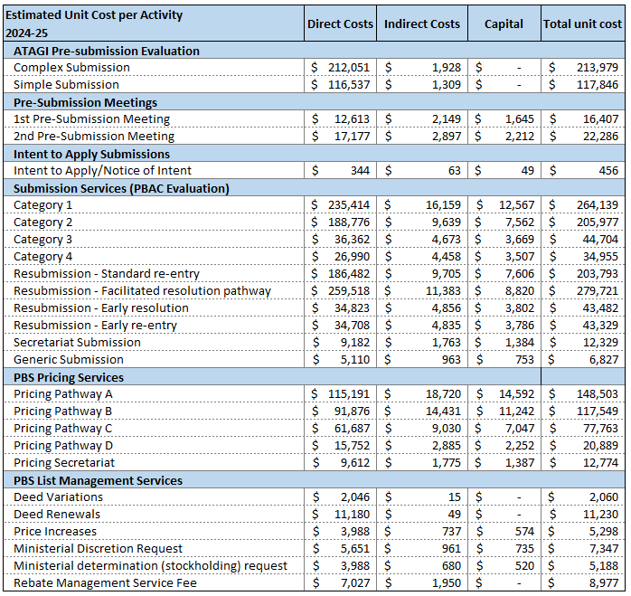

Design of the regulatory charge
For the 2024-25 financial year, the total regulatory effort required by the Department to deliver services related to PBS and NIP listing activities is estimated to be $41.59 million.
The Regulations provide for fee exemptions and waivers in certain circumstances. These are available across all charging categories, except for pre-submission meetings. The estimated cost for waivers and exemptions granted is $2.80 million, which is not recovered.
PBS list regulatory activities (see Section 2.1) are estimated to cost $5.61 million, which is not recovered.
Table 8 details the cost recovery fees and revenue estimates for 2024-25, including waivers and exemptions. With consideration to revenue forgone due to waivers and exemptions, the total revenue is estimated to be $33.62 million.
Table 8 - PBS cost recovery activity and cost summary for 2024-25
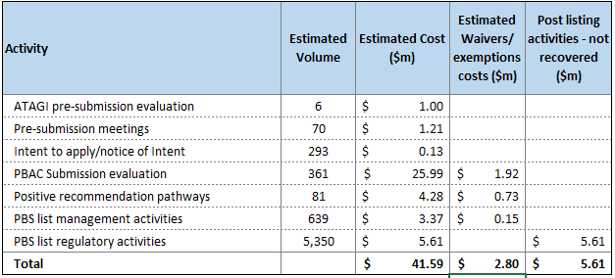
Table 9 details the cost recovery fees, including volume and revenue estimates for 2024-25.
In addition, there is an Independent Review fee, based on the charging approach used for the Category 2 evaluation fee. No independent review applications have been submitted in the past five years, and there is no revenue estimated for this category.
Table 9 - 2024-25 fees, effective from 1 July 2024 with estimated volumes and revenue for 2024-25
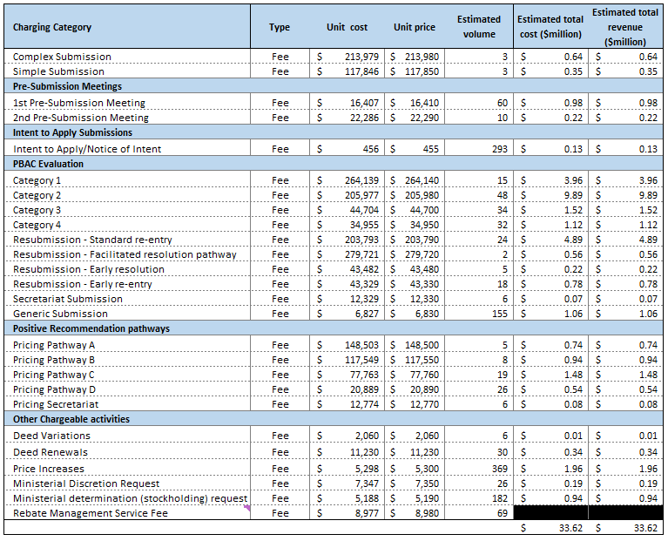
Table 10 below details the fee pay points supporting a consistent approach of upfront payment across all charging categories for PBS listing and management processes. These fees pay points occur prior to activity being undertaken and costs being incurred by the Department.
Table 10 - PBS Listing and Management Process with Cost Recovery Fee Point
Category | ATAGI Pre-submission Evaluation Process
ATAGI Pre-submission evaluation services | Notice of Intent received informing of ATAGI Pre-submission category
 | ATAGI Notice of Intent and Pre-submission application Lodgement Fee Point
 | ATAGI Assessment
 | ATAGI advice
Category | PBS Listing Process
PBAC Pre-submission meetings | Request for pre-submission meeting received
 | Pre-submission Meeting Fee Point
 | Pre-submission meeting with sponsor
 | Review sponsor meeting outcome record
Submission services (PBAC evaluation)  (Submission categories and Resubmission Pathways) | Notice of Intent form received informing of submission evaluation type
 | Notice of Intent and application Lodgement Fee Point
 | PBAC Evaluation
 | Positive PBAC Recommendation
 | (Proceed to positive recommendation pathways)
 | OR
 | Rejected PBAC Recommendation (Proceed to resubmission pathways)
Pricing services | PBAC positive recommendation
 | Notice of Intent form received informing of the positive recommendation pathway
 | Notice of Intent and Positive Recommendation Pathway Fee Point¹
 | Pricing offer made
 | Pricing agreement reached
 | Adjustment to the invoicing based on the pricing agreement reached
 | Listing occurs
Category | PBS Post Listing Process
List Management Services | Request for post listing activity (i.e. price increase, ministerial discretion, ministerial determination (stockholding), deed renewal or deed variation requests) received
 | Post Listing Fee Point
 | Actioning the requested post listing activity
Please refer to Stage 2 – Develop charging model of RMG-302 Implementing the Charging Framework.

RISK ASSESSMENT
A Charging Risk Assessment (CRA) will be undertaken following public consultation, in line with the Cost Recovery Policy. The results will be published in the final CRIS.

STAKEHOLDER ENGAGEMENT
The Department’s stakeholder engagement strategy for PBS/NIP cost recovery arrangements includes regular, transparent, and timely consultation with pharmaceutical industry stakeholders via the Access to Medicines Working Group (AMWG). The AMWG is the primary consultative, policy development and delivery forum for the Government and innovating medicines sector. The AMWG generally meets twice a year, with additional consultation conducted out-of-session. Further information on the AMWG, including meeting communiques, are available on the PBS website – AMWG.
Further public consultation occurs via industry comment on the CRIS. Prior to the current consultation process, the most recent CRIS consultation was undertaken in May 2023 before the publication of the final 2023-24 CRIS. Seven submissions were received from relevant medicine industry stakeholders. These submissions are summarised at Attachment A, alongside Departmental response to feedback raised in those submissions.
The outcomes of the current consultation on the draft 2024-25 CRIS will be summarised and published in the final 2024-25 CRIS.

FINANCIAL PERFORMANCE

Financial Estimates
The forecast expenses and estimated revenue of the partial cost recovery arrangements for the 2024-25 financial year and three forward years are in Table 11.
There is an ongoing net deficit, which is supplemented by Government appropriation to the Department for the shortfall. Forward projections demonstrate the difference between expenses and revenue increases every year.
Should there be any change to the underlying cost recovery model, a new financial estimates table will be provided.
Table 11 - Financial estimates for PBAC cost recovery activities for 2024-25 and three forward years
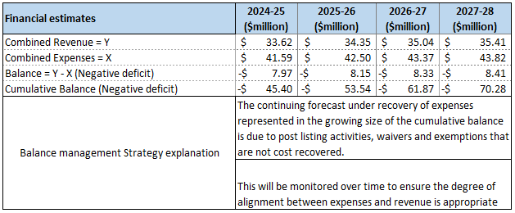

Financial Outcomes
Table 12 is updated after each financial year to report on the actual financial performance.
The forecast financial performance as published in the CRIS will be compared with the actual financial performance for each financial year. Any variance greater than 5 per cent will be identified and explained.
As PBS/NIP listings are only partially cost recovered, the aim of comparing the actual financial results with forecasted financial estimates over a 5-year period is to ensure that the degree of alignment of under-recovery of costs is as agreed by the Government as part of the Department’s financial balance management strategy.
Table 12 - Financial performance for cost recovered activities
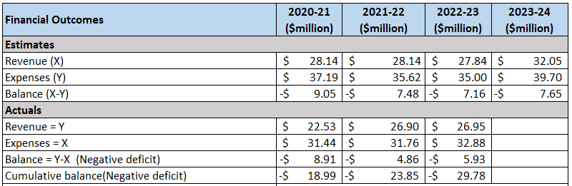
Table 13 details the depreciation of IT assets, including PharmCis and the PBS component of the HPP system build for 2024-25 and three forward years. Depreciation costs are proportionally attributable across a range of NIP/PBS cost recoverable activities.
Table 13 – Depreciation
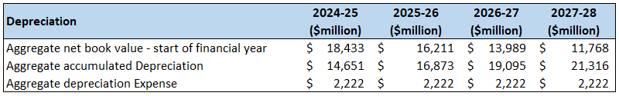

NON-FINANCIAL PERFORMANCE
The Australian Government Charging Framework has been developed to apply across the general government sector. It includes performance requirements based on Section 38 of the Public Governance, Performance and Accountability Act 2013 (the PGPA Act), which is ‘Measuring and assessing performance of Commonwealth entities.’
The non-financial performance of the activities explained in this CRIS is monitored through a set of requirements under subsection 99YBC (5) of the Act included in the Department’s annual report, consistent with the PGPA Act. The performance requirements are:
The Secretary must, as soon as practicable after June 30 in each year, prepare and give to the Minister a report on processes leading up to the Pharmaceutical Benefits Advisory Committee consideration, including:
- the extent and timeliness with which responsible persons are provided copies of documents relevant to their submission to the Pharmaceutical Benefits Advisory Committee
- the extent to which responsible persons exercise their right to comment on these documents, including appearing at hearings before the Pharmaceutical Benefits Advisory Committee, and
- the number of responsible persons seeking a review of the Pharmaceutical Benefits Advisory Committee recommendation.
Table 14 - Ensuring access to cost-effective, innovative, clinically effective medicines through the PBS
Percentage of new medicines recommended by the Pharmaceutical Benefits Advisory Committee (PBAC) that are listed on the Pharmaceutical Benefits Scheme within 6 months of in principle agreement to listing arrangements.
Source: Department of Health and Aged Care Annual Report 2022-23, p. 72.
2023-24 Target | 2023-24 | 2022-23 | 2021-22 | 2020-21 | 2019-20
≥80% | 100% | 100% | 100% | 100% | 100%
 | Result: Met
Metrics to reflect PBS process improvements and target 2017 Strategic Agreement objectives have been developed by the Access to Medicines Working Group. A subset of agreed metrics are published annually on the PBS website.

KEY FORWARD DATES AND EVENTS
Table 15 - KEY FORWARD DATES AND EVENTS
Activity | Date
Report of actual financial results for 2023-24 | November 2024
Update CRIS for 2025-26 | June 2025

CRIS APPROVAL AND CHANGE REGISTER
Table 16 - CRIS APPROVAL AND CHANGE REGISTER
Date of CRIS change | CRIS change | Approver | Basis for change
TBA 2023 | Approval of draft 2024-25 CRIS for consultation | First Assistant Secretary, Technology Assessment and Access Division | Updated for 2022-23 financial results
1 July 2023 | Approval of 2023-24 CRIS | Minister for Health and Aged Care | Further clarification following consultation feedback.
3 May 2023 | Approval of draft 2023-24 CRIS for consultation | First Assistant Secretary, Technology Assessment and Access Division | Revised fees to reflect annual indexation in line with the Australian Government Charging Framework
28 October 2022 | Approval of updates to 2022-23 CRIS | First Assistant Secretary, Technology Assessment and Access Division | Reporting on financial and non-financial performance for 2021-22.
1 August 2022 | Approval of 2022-23 CRIS | First Assistant Secretary, Technology Assessment and Access Division | Further clarification following consultation feedback.
15 June 2022 | Approval of draft 2022-23 CRIS for consultation | Acting First Assistant Secretary, Technology Assessment and Access Division | Revised fees to reflect annual indexation in line with the Australian Government Charging Framework
22 April 2022 | Approval of update to 2021-2022 CRIS | Technology Assessment and Access Division | References to the new National Health (Pharmaceuticals and Vaccines—Cost Recovery) Regulations 2022 updated.
30 November 2021 | Approval of updates to 2021-2022 CRIS | First Assistant Secretary, Technology Assessment and Access Division | Reporting on financial and non-financial performance for 2020-21.
21 June 2021 | Approval of 2021-2022 CRIS | Acting First Assistant Secretary, Technology Assessment and Access Division | Further clarification on fees following consultation feedback.
9 April 2021 | Approval of draft 2021-22 CRIS for consultation | Assistant Secretary, Health Technology Assessment – Policy Branch | Revised fees to reflect annual indexation in line with the Australian Government Charging Framework
1 December 2020 | Approval of 2020-21 CRIS | Minister for Health | New regulatory charging activity and 2019-20 outcome statement
24 September 2020 | Approval of draft 2020-21 CRIS for consultation | Assistant Secretary, Health Technology Assessment – Policy Branch | Changes to the costing model to support stage 2 PBS process improvements (operational change)
19 June 2020 | Approval of 2020-21 CRIS | Acting Secretary for Health | Updated to reflect introduction of ATAGI fees (operational change)
9 December 2019 | Approval of updates to 2019-20 CRIS | First Assistant Secretary, Technology Assessment and Access Division | Reporting on financial performance for 2018-19
11 June 2019 | Approval of 2019-20 CRIS | Minister for Health | Revalidation of the costing model – to reflect delay to ATAGI and deed management fees (policy change)
10 April 2019 | Approval of 2019-20 CRIS | Minister for Finance and the Public Service | New regulatory charging activity
13 March 2019 | Approval of  2019-20 CRIS | Minister for Health | New regulatory charging activity
7 March 2019 | Certification of 2019-20 CRIS | Secretary for Health | To ensure compliance with Australian Government Cost Recovery Guidelines and Government

ATTACHMENT A – SUMMARY OF MAIN STAKEHOLDER VIEWS ON REQUIRED CRIS CONSULTATION AND RELATED DEPARTMENT RESPONSES 2024-25

To be appended to final CRIS following these consultations.

Definition of the direct and indirect costs are from the CRP.
Any submissions requesting a fee waiver or fee exemption will be invoiced within 15 business days after the Department has received an application and a fee waiver or fee exemption has not been granted.
Pathway A, D, Secretariat Pathway – invoice is to be paid in full; if Pathway B or C selected – sponsor is invoiced the Pathway C (existing deed) fee and an adjustment can be made (if needed) once the final pricing agreement is reached. Cost recovery fee points are underlined. Note: Pricing Pathways A, B and C and the Deed Renewal fees include the five-year rebate management fee.
As outlined in the Department of Health’s Annual Report.

