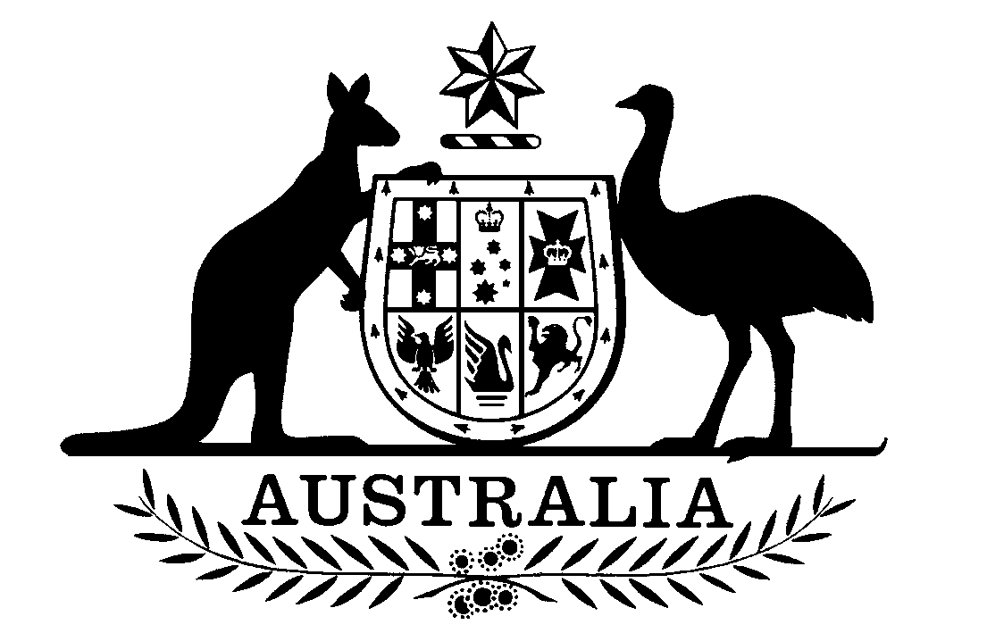
Figure 1 - australian emblem

Pharmaceutical Benefits Advisory Committee

Statement of endorsement:
Improving the Transparency of PBAC Outcomes

The Pharmaceutical Benefits Advisory Committee (PBAC) restates its long-standing view that, as far as possible, information that the Committee takes into consideration when reviewing the submissions it receives are subsequently made publicly available.
For every decision about whether to recommend that a medicine should be subsidised through the Pharmaceutical Benefits Scheme (PBS), the PBAC communicates this through a Public Summary Document (PSD). The PBAC therefore welcomes the reforms to increase the amount of information provided in PSDs. In particular, the Committee strongly believes that all clinical information relevant to its decisions, including information on comparative effectiveness and safety, should be available so clinicians, patients and other stakeholders can see the basis of PBAC decisions.
The PBAC view on the importance of the PSD transparency reforms strongly favours minimal redactions in PSDs. In addition, the PBAC believes that the previous standard ranges used to describe costs associated with a proposed medicine in PSDs were over a decade old, not sufficiently informative and, in some cases, potentially misleading.
The PBAC is encouraged by advice from the Chair of the Consumer Consultative Committee that the transparency reforms are strongly supported by consumers who have a central interest in both the submissions made to the PBAC, as well as the evaluations of those submissions.
The PBAC acknowledges the extensive consultation that has occurred with the pharmaceutical industry in the 12 months leading up to these reforms that included public webinars and ongoing industry consultation. The PBAC recognises industry’s concern to protect commercially sensitive information while meeting the PBAC objectives to make all clinical evidence available. The PBAC also acknowledges that to allow further time to address industry concerns, the implementation plan has included three stages of piloting the Procedure Guidance to ensure it is fit for purpose and will ensure a better long term approach.
The PBAC endorses the approach to standardised redaction criteria and arrangements as outlined in April 2020 through revisions to the PBS’s Procedure Guidance (Section 7.4 Public Summary Documents). The PBAC further commends the agreed transition into these transparency reforms, acknowledging that the Procedure Guidance and a supporting guidance document have been published in sufficient time for them to be used for applicants intending to submit to the November 2020 PBAC meeting.
The PBAC also acknowledges residual industry concerns related to the intended changes, and that the Department of Health has agreed to monitor any unintended consequences of the changes, with an opportunity for these to be reviewed following 12 months of implementation.

