# 5.21 MIFEPRISTONE 200mg tablet [1 tablet] (&) MISOPROSTOL 200 microgram tablet [4 tablets], 1 pack, MS-2 step, MS Health Pty Ltd.

1. **Purpose of Application**
   1. To request an Authority Required listing for a composite pack containing mifepristone and misoprostol for the termination of an intra-uterine pregnancy of up to 63 days gestation.
   2. The listing of the composite pack is intended to replace the current listings of the components, with an amended restriction consistent with revised TGA indications.
2. **Requested listing**

|  |  |  |  |  |
| --- | --- | --- | --- | --- |
| **Name, Restriction,**  **Manner of administration and form** | **Max.**  **Qty** | **№.of**  **Rpts** | **Proprietary Name and Manufacturer** | |
| MIFEPRISTONE (&) MISOPROSTOL  Mifepristone 200 mg tablet [1 tablet] (&) misoprostol 200 microgram tablet [4 tablets], 1 pack | 1 | nil | MS-2 Step | MS Health |

|  |
| --- |
| **Authority required**  Termination of an intra-uterine pregnancy  **Clinical criteria:**  The condition must be an intra-uterine pregnancy of up to 63 days of gestation.  Treatment criteria:  Must be treated by a prescriber who is registered with the MS-2 Step Prescribing Program.  **Note**  No increase in the maximum quantity or number of units may be authorised.  **Note**  No increase in the maximum number of repeats may be authorised. |

* 1. The requested amended restriction is consistent with the recently revised TGA indication of termination of an intra-uterine pregnancy of up to 63 days gestation. Previously the TGA registered indication for the components mifepristone and misoprostol was for termination of an intra-uterine pregnancy of up to 49 days gestation.
  2. The requested Authority Required listing is consistent with the current PBS listings of the components with the exception of the specified length of duration of gestation and the requirement to use the treatments in sequential combination.

*For more detail on PBAC’s view, see section 7 “PBAC outcome”*

1. **Background**
   1. Mifepristone and misoprostol composite pack (MS-2 Step) had not previously been considered by the PBAC.
   2. At its March 2013 meeting the PBAC recommended the PBS listing of the components mifepristone and misoprostol for termination of an intra-uterine pregnancy of up to 49 days gestation on the basis of non-inferior effectiveness and lower cost against surgical termination of pregnancy (STOP). Listing was effective 1 August 2013.
   3. Mifepristone and misoprostol composite pack (MS-2 Step) was TGA registered on 4 June 2014 for the following indication:

“Females of childbearing age for the medical termination of a developing intrauterine pregnancy up to 63 days gestation.

It is recommended that the duration of pregnancy (i.e., up to 63 days gestation) be confirmed by ultrasound. In the event that an ultrasound is not possible, extra caution should be exercised.

Ultrasound is also useful to exclude ectopic pregnancy.”

1. **Clinical place for the proposed therapy**
   1. Mifepristone is a synthetic steroid with an anti-progestational action which antagonises the endometrial and myometrial effects of progesterone, sensitises the myometrium to the contraction inducing action of prostaglandins and allows dilatation of the uterine cervix. Misoprostol is a synthetic analogue of prostaglandin E1 which induces contraction of smooth muscle fibres in the myometrium and relaxation of the uterine cervix. When used in the recommended sequential regimen, mifepristone and misoprostol will cause medical termination of pregnancy (MTOP) and accelerate expulsion of the conceptus of pregnancy from the uterus.

*For more detail on PBAC’s view, see section 7 “PBAC outcome”*

1. **Comparator**
   1. As with the March 2013 major submission, this minor submission nominated first-trimester surgical termination of pregnancy (STOP) as the comparator.

*For more detail on PBAC’s view, see section 7 “PBAC outcome”*

1. **Consideration of the evidence**

***Sponsor hearing***

* 1. As a minor submission, there was no hearing for this item.

***Consumer comments***

* 1. The PBAC noted and welcomed the input from organisations (5) via the Consumer Comments facility on the PBS website. Comments noted the benefits of the composite pack for up to 63 days’ gestation in terms of opportunity for women in rural or remote areas to access MTOP, and noted that PBS listing of the product would remove cost as a barrier to early abortion care and ensure equity across the population.

*For more detail on PBAC’s view, see section 7 “PBAC outcome”*

***Clinical trials***

* 1. No additional clinical evidence comparing MTOP with STOP, beyond that presented in the submission considered by the PBAC at its meeting in March 2013, was presented. A summary of the trials presented in March 2013 is below:

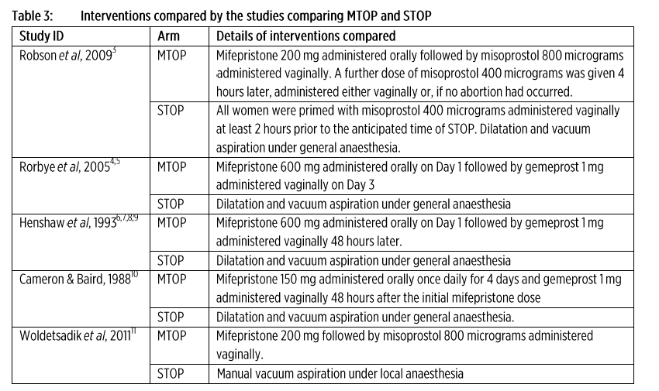

* 1. The submission considered by the PBAC in March 2013 included data for MTOP and STOP up to 63 days gestation but also presented data, where available, for subgroups of up to 49 days of gestation and > 49 days of gestation. The key evidence was re-presented in the resubmission. These data are summarised below:

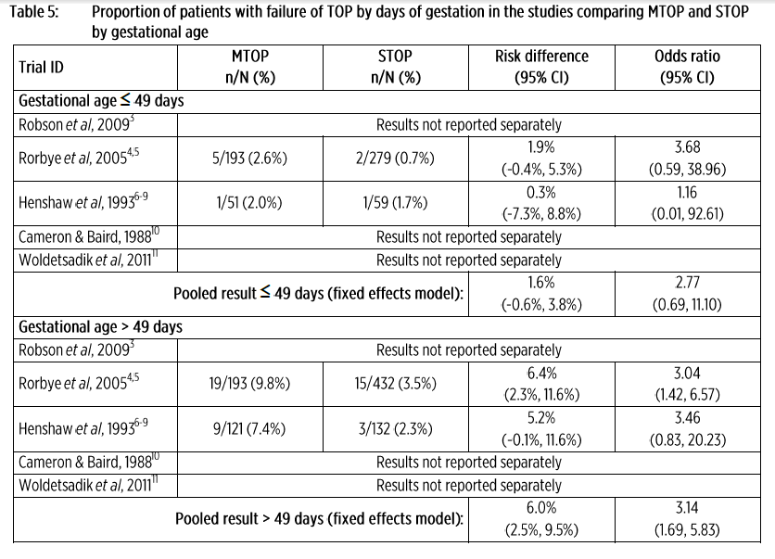

* 1. The additional data presented in the submission were:
* Supplementary, non-comparative evidence of the experience of 15 Marie Stopes International, Australia (MSIA) clinics with the Australian Authorised Prescriber Program for mifepristone in 2012; and
* From the Australian post-registration Phase 4 study, a registry of outcomes associated with the use of mifepristone in MSIA clinics from 1 March 2013 to 31 December 2013.

*For more detail on PBAC’s view, see section 7 “PBAC outcome”*

***Comparative effectiveness***

* 1. The submission presented the following data for outcomes of MTOP up to 63 days’ gestation in 7,166 women treated under the Authorised Prescriber Program at MSIA clinics in 2012:

 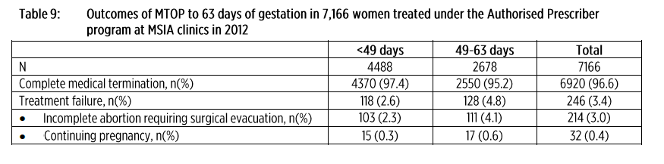

Source: submission, p.14

*For more detail on PBAC’s view, see section 7 “PBAC outcome”*

***Comparative harms***

* 1. In addition to the data on comparative harms presented in March 2013, the submission also presented a summary of serious adverse events by gestational age, as presented below:



Source: submission, p.15

***Benefits/harms***

* 1. No formal benefits/harms analysis was done for this minor submission.

*For more detail on PBAC’s view, see section 7 “PBAC outcome”*

***Clinical claim***

* 1. The submission’s claimed medical termination of pregnancy using mifepristone and misoprostol was equivalent in terms of comparative effectiveness and safety over surgical termination of pregnancy, up to 63 days gestation.
  2. The PBAC considered that the additional data presented in the submission, together with the data already considered in March 2013, adequately supported the clinical claim.

***Economic analysis***

* 1. The March 2013 submission had presented a comparison of the costs associated with MTOP and STOP. This showed that MTOP is less costly than STOP to the whole of health budget (both Commonwealth and State hospital and community costs) where gestation is less than or equal to 49 days. The PBAC recalled that MTOP remained less costly than STOP under all realistic sensitivity analyses.

* 1. The minor submission presented a sensitivity analysis comparing costs where gestational age is between 50 and 63 days, which continued to demonstrate that MTOP remains less costly than STOP.

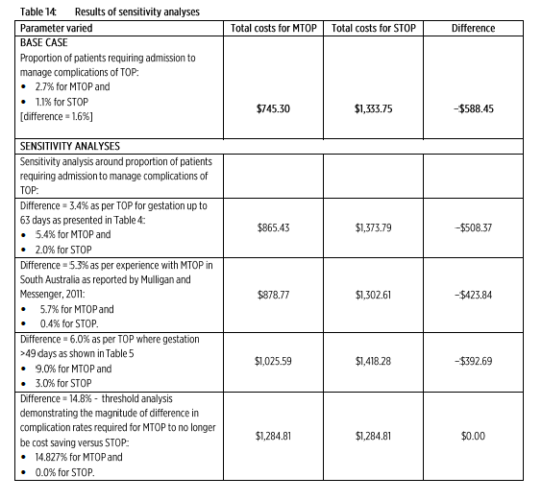

Source: submission, p.18

*For more detail on PBAC’s view, see section 7 “PBAC outcome”*

***Drug cost/patient/course; $745.30.***

* 1. MTOP was estimated to cost $745.30, compared with $1,333.75 for STOP.

***Estimated PBS usage & financial implications***

* 1. The submission re-presented the same estimates as in the March 2013 submission, which estimated less than 10,000 patients treated with MTOP in year 5 of listing, at a total PBS cost of less than $10 million in year 5. The submission estimated a net saving to the Commonwealth of less than $10 million.



*For more detail on PBAC’s view, see section 7 “PBAC outcome”*

1. **PBAC Outcome** 
   1. The PBAC recommended the listing of mifepristone + misoprostol composite pack for termination of an intra-uterine pregnancy of up to 63 days’ gestation on the basis of non-inferior effectiveness against STOP, in line with the revised TGA-approved indication.
   2. The PBAC considered that the restriction proposed in the submission was appropriate.

* 1. The PBAC noted a marginal decline in the clinical effectiveness of MTOP when used between 50 and 63 days compared with 49 days or earlier. The PBAC noted a higher proportion of patients with incomplete abortion requiring surgical evacuation (4.1% vs. 2.3%) and continuing pregnancy (0.6% vs.0.3%). The PBAC recalled its conclusion in March 2013 that the effectiveness of MTOP reduces as gestational age increases. The PBAC therefore concluded that MTOP was non-inferior in terms of clinical effectiveness compared to STOP when used up to 63 days’ gestation.
  2. The rates of the following adverse events were higher for patients using MTOP after 49 days’ gestation compared with before 49 days’ gestation:
* Method failure requiring surgical intervention (6.24% vs. 3.52%);
* Vaginal bleeding, including clots/spotting (5.3% vs. 2.83%);
* Pain (1.65% vs. 0.66%).

Overall, however, the PBAC noted that the absolute numbers of AEs were low and supported a conclusion that in terms of comparative safety MTOP is on balance no worse when used up to 63 days’ gestation compared with up to 49 days’ gestation.

* 1. The PBAC recalled that the March 2013 submission presented an economic analysis comparing the costs associated with MTOP and STOP. This analysis showed that MTOP is less costly than STOP to the whole of health budget (both Commonwealth and State hospital and community costs). The PBAC noted that MTOP remained less costly than STOP under all realistic sensitivity analyses, including when the rates of hospital admission for complications for MTOP and STOP were adjusted to match the observational data (MTOP 5.7% and STOP 0.4%).
  2. The PBAC noted the minor submission’s revised sensitivity analysis for the cost analysis, which presented a comparison of costs for MTOP where gestation age is between 50 and 63 days. The PBAC considered that the sensitivity analysis demonstrated that the costs associated with MTOP would need to increase considerably for MTOP not to be cost saving compared with STOP, and that such an increase was not likely based on the evidence available to date. The PBAC therefore considered that MTOP would likely remain cost saving compared with STOP when used up to 63 days’ gestation.
  3. The PBAC noted that the utilisation of mifepristone and misoprostol has been lower than expected since PBS listing on 1 August 2013. The PBAC noted the sponsor’s claim that the primary barrier to utilisation related to medical indemnity insurance for clinicians wanting to provide MTOP. As matters of professional indemnity are beyond the PBAC’s remit, the Committee did not comment on this claim. Nonetheless, the PBAC considered that in view of utilisation patterns to date, and the fact that the Committee had accepted that MTOP would be cost-saving compared with STOP, it was not likely that utilisation of the composite pack would increase to the point where it would pose a financial risk to the Commonwealth.
  4. The PBAC recommended that mifepristone + misoprostol composite pack should be treated as interchangeable on an individual patient basis with mifepristone and misoprostol (as separate products).
  5. The PBAC advised that mifepristone + misoprostol is not suitable for prescribing by nurse practitioners.
  6. The PBAC recommended that the Safety Net 20 Day Rule should not apply.

**Outcome:**

Recommended

1. **Recommended listing**
   1. Add new item:

|  |  |  |  |  |  |  |
| --- | --- | --- | --- | --- | --- | --- |
| Name, Restriction,  Manner of administration and form | | Max.  Qty | №.of  Rpts |  | Proprietary Name and Manufacturer | |
| MIFEPRISTONE (&) MISOPROSTOL  Mifepristone 200 mg tablet [1 tablet] (&) misoprostol 200 microgram tablet [4 tablets], 1 pack | | 1 | nil |  | MS-2 Step | MS Health |
|  | | | | | | |
| **Condition/Indication:** | Termination of an intra-uterine pregnancy | | | | | |
| **Restriction:** | Authority required | | | | | |
| **Clinical criteria:** | The condition must be an intra-uterine pregnancy of up to 63 days of gestation. | | | | | |
| **Treatment criteria:** | Must be treated by a prescriber who is registered with the MS-2 Step Prescribing Program. | | | | | |
| **Administrative Advice**  *(not included in LI)* | **Note**  No increase in the maximum quantity or number of units may be authorised.  **Note**  No increase in the maximum number of repeats may be authorised. | | | | | |

1. **Context for Decision**

The PBAC helps decide whether and, if so, how medicines should be subsidised in Australia. It considers submissions in this context. A PBAC decision not to recommend listing or not to recommend changing a listing does not represent a final PBAC view about the merits of the medicine. A company can resubmit to the PBAC or seek independent review of the PBAC decision.

1. **Sponsor’s Comment**

The sponsor had no comment.