7.08 PEMBROLIZUMAB,
50 mg injection: powder for, 1 vial,
Keytruda®,
Merck Sharpe & Dohme (Australia) Pty Ltd.

- Purpose of Application

  - Pembrolizumab has a Section 100 (Efficient Funding of Chemotherapy – Public and Private Hospital) Authority Required listing for the treatment of unresectable Stage III or Stage IV metastatic melanoma.

  - The submission was lodged as a “Further submission” under the Deed of Agreement with the Department made on 5 August 2015. The submission seeks PBAC reconsideration of the cost-effectiveness of pembrolizumab and the associated risk sharing arrangement caps contained in the Deed of Agreement.

- Requested listing

  - Pembrolizumab was Therapeutic Goods Administration (TGA)-registered on 16 April 2015 for monotherapy treatment of unresectable or metastatic melanoma in adults. The submission did not seek any changes in the restriction, which is summarised below.

Name, Restriction,  Manner of administration and form |  |  |  | Max.  Amount | №. of  Rpts |  | Dispensed Price for Max. Amount | Proprietary Name and Manufacturer
PEMBROLIZUMAB  Initial treatment  Powder for injection, 50 mg  Continuing treatment  Powder for injection, 50 mg |  |  | 240 mg  240 mg |  | 5  7 | $'''''''''''''''''''''' (public)  $''''''''''''''''''''''' (private) |  | Keytruda® | MK
Treatment phase: Initial
Severity |  | Unresectable Stage III or Stage IV
Condition |  | Malignant melanoma
Clinical criteria |  | BRAF V600 mutation negative  Treatment must be the sole PBS-subsidised therapy for this condition  AND  Patient must be negative for a BRAF V600 mutation  AND  The condition must be previously untreated  AND  The treatment must not exceed a total of 6 doses at a maximum dose of 2 mg/kg every 3 weeks.
Clinical criteria |  | BRAF V600 mutation positive  Treatment must be the sole PBS-subsidised therapy for this condition  AND  The condition must be positive for a BRAF V600 mutation  AND  Patient must have progressed following treatment with a BRAF inhibitor (with or without a MEK inhibitor); OR treatment with a BRAF inhibitor is contraindicated or not tolerated according to the TGA approved Product Information  AND  The condition must be previously untreated with ipilimumab  AND  The treatment must not exceed a total of 6 doses at a maximum dose of 2 mg/kg every 3 weeks.
Administrative advice |  | Note: in the first few months after start of immunotherapy, some patients can have a transient tumour flare with subsequent disease response. When progression is suspected, this should be confirmed through a confirmatory scan, taken at least 4 weeks later.  No increase in the maximum number of repeats may be authorised.
Treatment phase: Continuing
Severity | Unresectable Stage III or Stage IV
Condition | Malignant melanoma
Clinical criteria | Treatment must be the sole PBS-subsidised therapy for this condition  AND  Patient must have previously been issued with an authority prescription for this drug  AND  Patient must have stable or responding disease  AND  The treatment must not exceed a maximum dose of 2 mg/kg every 3 weeks.
Administrative advice | No increase in the maximum number of repeats may be authorised.

  - An additional strength of pembrolizumab, 100 mg/4 mL concentrated injection vial, was TGA registered on 8 March 2016.

  - The Pre-Sub-Committee Response (PSCR, p3) subsequently proposed that ‘due to the fact that all new clinical studies in melanoma (and other tumours) follow a treatment protocol similar to the KN006 protocol, and data is now available to support treatment effect beyond cessation of therapy’, that a maximum 24-month treatment duration, together with an option for an additional 12 months of second course treatment in the case of relapse, should now be reflected in the PBS continuing restriction for pembrolizumab (but presumably not for nivolumab, despite the original submission being a “PD-1 class submission”). In the pre-PBAC response (p2) the sponsor altered this to state that only complete responders were likely to discontinue therapy at 24 months and that patients with a partial response or stable disease would continue to be treated until progressions, therefore not requiring a change to the current PBS restriction.

For more detail on PBAC’s view, see section 7 “PBAC outcome”.

- Background

  - Pembrolizumab was first considered at the March 2015 PBAC meeting in the context of a Managed Entry Scheme (MES). A positive recommendation resulted in the PBS listing of pembrolizumab on 1 September 2015 for monotherapy treatment of unresectable or metastatic melanoma. The March 2015 submission provided a cost-utility analysis compared to ipilimumab based upon subgroup analyses from an uncontrolled, non-comparative phase 1 multi-cohort pembrolizumab trial (KN-001) and a single arm extracted from a randomised, double-blind trial of ipilimumab (Hodi 2010). This was later supplemented for the March 2015 PBAC meeting consideration by early results from a randomised open-label trial comparing pembrolizumab and ipilimumab (KN-006). These early results from KN-006 formed the main basis of the clinical evidence leading to the positive recommendation made by the PBAC. The PBAC concluded that pembrolizumab is no worse than ipilimumab in terms of safety, and possibly less toxic (paragraph 7.14, March 2015 PSD).

  - The PBAC also noted that the extent of incremental effectiveness and duration of benefit could not be estimated with confidence from the current evidence base (paragraph 7.8, March 2015 PSD). The PBAC was further concerned that the economic model submitted was unreliable (paragraph 7.18, March 2015 PSD). The PBAC’s specific concerns are reflected in the subsequent Deed of Agreement dated 15 August 2015 which required the sponsor to submit a “Further submission” (clause 3.4 of the Deed of Agreement), not later than 4 November 2015, and containing an economic evaluation of the full data set from KN-006. Attachment B to the Deed of Agreement lists the economic model obligations of the sponsor.

  - The “Further submission” considered at the March 2016 PBAC meeting presented a cost-utility evaluation based on the second interim analysis of KN-006 (3 March 2015 cut-off date). The PBAC rejected the submission as the model results were considered implausible, and the model also did not comply with key requirements of the Deed of Agreement relating to the estimation of survival (paragraph 7.7, March 2016 PBAC PSD). The PBAC also rejected the submission’s request for an increase in patient numbers contributing to the risk sharing arrangements in the Deed of Agreement (paragraph 7.8, March 2016 PBAC PSD).

  - The current submission was submitted as an “Additional submission” under clause 6.4 of the Deed of Agreement and provided a cost-utility evaluation with two scenarios referred to as a ‘Deed compliant scenario’ and a ‘Realistic scenario’ based on the final analysis of KN-006 (3 December 2015 data cut-off).

  - Table 1 provides a summary of the clauses in Attachment B of the Deed, listing the company’s obligations and the responses in the current submission.

Table 1: Summary of obligations in the Deed of Agreement, August 2015
Summary of obligations in Attachment B of the Deed of Agreement | Comment on submission response
 | ‘Deed compliant scenario’ | ‘Realistic scenario’
B.2.2.a Directly use Kaplan-Meier curves from KN-006 up to median follow-up to estimate each of incremental PFS and incremental OS. | Complied with the Deed of Agreement and was presented in Section C.8 of the submission.
B.2.2.b Apply extrapolation modelling for both arms of the model for PFS and OS with no statistical adjustment to account for use of post-progression therapies. | Complied with the Deed of Agreement and was presented in Section C.8 of the submission.
B.2.2.c Use a time horizon of 5 years as per the original model. | Complied with the Deed of Agreement and was presented in Section C.8 of the submission. | The model time horizon was truncated at 5 years (reduced from 10 years in the March 2015 and March 2016 submissions), however OS curves were extrapolated to converge at 7 years.
B.2.2.d Use the best fit extrapolated curves for both PFS and OS beyond the median duration of follow-up, which are to be structured to converge at 5 years. | Complied with the Deed of Agreement and was presented in Section C.8 of the submission. | Did not comply with the Deed of Agreement. PFS converged at 5 years, but the submission maintained a 10-year time frame is appropriate for OS. The ESC noted that the ‘realistic scenario’ model converged at 7 years with results truncated to 5 years.
B.2.2.e Use the effective price of ipilimumab as monotherapy as comparator. | Complied with the Deed of Agreement. The submission used the effective price for ipilimumab as released for the March 2016 submission and was applied in Section D.4 of the submission.
B.2.2.f Back-calculate the DPMQ and/or effective DPMQ to generate an ICER $45,000/QALY - $75,000/QALY as per the original model. | Complied with the Deed of Agreement. The submission back-calculated an effective vial price of $''''''''''''''''''''. The pre-PBAC response (p3) adjusted the effective vial price to $''''''''''''''''. | Complied with the Deed of Agreement and was presented in Section D.4 of the submission. The submission back-calculated an effective vial price of $'''''''''''''''''''''. The PSCR (p1, 2 and 5) adjusted the effective vial price to $''''''''''''''''''''. The pre-PBAC response (p3) adjusted the effective vial price to $'''''''''''''''''''''.
B.2.2.g Use the drug dose of 2 mg/kg Q3W or reduce the price of the drug accordingly. | Complied with the Deed of Agreement and was presented in Section D.4 of the submission.
B.2.2.h Include the mean duration of therapy in the model which should reflect the mean duration of PFS. | Complied with the Deed of Agreement | Does not comply with the Deed of Agreement. The submission assumed complete responders will terminate therapy at 2 years with an optional 12 months additional therapy.
B.2.2.i Include justified and fully examined utilities for the PFS health state, and the progressed health state of the model. | Complied with the Deed of Agreement and was presented in Section C.6 of the submission.
B.2.2.j Include adverse event profiles to be based upon those reported in the final outcomes of KN-006. | Complied with the Deed of Agreement. Refer to Table D.4.4, p.169 of submission. The AEs included in the model were derived from KN-006, although there was only a statistically significant difference between the two treatments for one AE, colitis. The ESC noted that the model included point estimate differences across adverse events which were not statistically significant.
AE=adverse event; OS=overall survival; PFS=progression-free survival

  - The March 2016 submission also made additional requests concerning the post-MES conditions of the listing for pembrolizumab. These were refined in the current submission to request:
- Agreement on an effective dispensed price per 50 mg vial of $''''''''''''''''''' and effective AEMP price per vial of $'''''''''''''''''''''' (‘Realistic scenario’; Section E of the submission recommends this scenario to the PBAC). The submission also calculated the ‘Deed compliant scenario’ effective dispensed price to be $'''''''''''''''''''''' and the corresponding effective AEMP price to be $''''''''''''''''.
- Acceptance that drug costs in the PSCR’s ‘Realistic scenario’ would reflect patients potentially ceasing pembrolizumab therapy at two years with the added option of a third year of pembrolizumab therapy (e.g. for those who relapse after a complete response) (which would need to be reflected in the continuation restriction), rather than continue until progression.
- An increase in the number of patients initiated on treatment over the next 5 years from less than 10,000 in the current Deed of Agreement to less than 10,000, plus consequential changes to the risk sharing arrangement caps. The submission specified an update of the caps from year 2 onward to reflect payment for prevalent patients remaining on therapy beyond their first year of treatment.
- Maintenance of the existing Deed structure and gross list AEMP of $2,230.

For more detail on PBAC’s view, see section 7 “PBAC outcome”.

- Clinical place for the proposed therapy

  - The PBS restriction for pembrolizumab for the treatment of unresectable or metastatic melanoma places its use as follows:
- first-line for patients who are BRAF mutation negative (BRAF wild type);
- second-line, following progression on a BRAF/MEK inhibitor for patients who are BRAF mutation positive.

  - At the March 2016 PBAC meeting, the PBAC noted that consideration of the possibility of a change to PBS restrictions such that patients with a BRAF mutation, (presently required to use a BRAF/MEK inhibitor as first-line therapy) would be able to use PD-1 inhibitors as first-line therapy would have been informative, particularly in regard to potential uptake of pembrolizumab (paragraph 4.2, March 2016 PBAC PSD). The submission responded to this comment by adjusting the financial estimates. However, the ESC noted that the cost-effectiveness in this group is likely to be less favourable to pembrolizumab than in the group already eligible for PBS-subsidised pembrolizumab.

- Comparator

  - The submission proposed that ipilimumab was the main comparator, as it was in the March 2015 submission.

  - At the March 2016 PBAC meeting, it was noted in relation to nivolumab “…..should nivolumab be listed on the PBS, then consideration of the outcomes of the [March 2016] submission, and the requests within it, would be affected.” (paragraph 3.9, March 2016 PBAC PSD) With the recent PBAC recommendation of nivolumab (which occurred after the submission was lodged), nivolumab would also be a relevant comparator. For more detail on PBAC’s view in March 2016, see section 7 “PBAC outcome”, especially paragraph 7.11.

  - This was relevant to the current submission in respect of both the choice of comparator, and the current submission’s statement that it is a PD-1 class submission for which pembrolizumab is a proxy.

For more detail on PBAC’s view, see section 7 “PBAC outcome”.

- Consideration of the evidence

Sponsor hearing

  - The sponsor requested a hearing for this item. The clinician described their experience of treating patients with pembrolizumab. They noted improved tolerance in patients with pembrolizumab compared with ipilimumab and that the effectiveness experienced in a hospital setting was similar to the efficacy rate in clinical trials. The clinician stated that their experience was that the re-induction rate for ipilimumab was approximately 2% as patients are not reinduced if ipilimumab is not tolerated. The clinician also stated that the effectiveness of pembrolizumab was consistent with nivolumab, however noted the convenience of pembrolizumab associated with a three week dosing interval compared with a two week dosing interval for nivolumab.

Consumer comments

  - The PBAC noted and welcomed the input from one organisation (Melanoma Patients Australia) via the Consumer Comments facility on the PBS website. The comments described a range of benefits for patients with melanoma in Australia who were treated with pembrolizumab, including an improvement in quality of life following treatment with the medicine, without experiencing significant side effects beyond some fatigue.

Clinical trials

  - The submission was based on the final analysis of KN-006 (N=834), the randomised, open-label trial comparing pembrolizumab and ipilimumab (the March 2016 submission was based upon the second interim analysis with data cut-off of 3 March 2015).

  - Publication details of KN-006, and the key features of the trial are provided in the following tables.

Table 2: Trials and associated reports presented in the submission
Trial ID | Protocol title/ Publication title | Publication citation
Direct randomised trial
KN-006 | CSR P006V02: A Multicenter, Randomized, Controlled, Three-Arm, Phase III Study to Evaluate the Safety and Efficacy of Two Dosing Schedules of MK-3475 Compared to Ipilimumab in Patients with Advanced Melanoma. | Merck Sharp & Dohme 9 June 2016
 | Robert C, Schachter J, Long GV et al. Pembrolizumab versus ipilimumab in advanced melanoma.  Schachter J, Ribas A, Long GV, et al. Pembrolizumab versus ipilimumab for advanced melanoma: Final Overall Survival Analysis of KEYNOTE 006. Oral presentation to ASCO Annual meeting. | NEJM 2015; 372: 2521-32  June 2016
Source: Table B.2-3, p43 of the submission

Table 3: Summary of KN-006
Trial ID | N | Treatment arms | Trial design | Primary outcome | Use in the economic evaluation
KN-006 | 834 | Pembrolizumab 10 mg/kg Q2W n=279 | Phase III  R, OL, MC | OS; PFS | PFS+OS; utilities; AEs
 |  | Pembrolizumab 10 mg/kg Q3W n=277
 |  | Ipilimumab 3 mg/kg Q3W n=278
MC=multicentre; OL=open label; OS=overall survival; PFS=progression-free survival; Q2W=every 2 weeks; Q3W=every 3 weeks; R=randomised
Source: Table B.2-4, p46-47 of the submission.

  - It was recommended that KN-006 be stopped early and patients who had been treated with ipilimumab be allowed to access pembrolizumab (no cross-over prior to cut-off). The External Data Monitoring Committee (eDMC) also recommended that patients be followed for OS until the planned final analysis, which is scheduled to be performed after 435 OS events have occurred or after all patients have at last 21 months of follow-up, whichever occurs first (the follow-up criterion was met first, cut-off date was 3 December 2015).

  - KN-006 was a head-to-head comparison of pembrolizumab and ipilimumab. The two pembrolizumab arms of the trial administered different regimens; 10 mg/kg every 2 weeks (Q2W) or every 3 weeks (Q3W). The economic and financial modelling assumed the 2 mg/kg Q3W dose applies as registered for use in Australia. At the March 2016 PBAC meeting, the PBAC noted that “Nothing was provided in the current submission to alleviate the possibility there may be differences in survival and safety for the 10 mg/kg dose compared to the 2 mg/kg dose” (paragraph 6.6, March 2016 PSD). The data presented in the current submission showed support for the equivalence of the two pembrolizumab regimens in KN-006, but the evidence provided in support of the equivalence of the 2 mg/kg Q3W dose and 10 mg/kg regimens is subject to limitations.

  - A new pre-modelling issue was introduced in Section C of the current submission which allowed for increased use of ipilimumab through revision of the rate of re-induction therapy, and reduced use of pembrolizumab by allowing complete responders to cease therapy within 2-3 years from baseline. Updated follow-up data was reported from KN-001 for 61 patients who discontinued pembrolizumab for a median 10 months, and supportive data from a study of nivolumab (Topalian 2014) which the submission used to represent the effect of PD-1 inhibitors. Neither adjustment is considered reasonable. There are a number of issues with stopping pembrolizumab therapy before progression including no allowance for longer-term relapse rates. The increase in the rate of re-induction therapy with ipilimumab was made without any commensurate adjustment for associated survival gains. The ESC noted that the ipilimumab re-induction rate from the INTUITION study was greater than the rate observed in the October 2015 DUSC report and that reducing this rate would increase the ICER.

Comparative effectiveness

  - Survival results from the final analysis of KN-006, based on the 3 December 2015 data cut-off are provided in the table below, followed by the Kaplan-Meier curves for PFS and OS. In the PSCR (p4-7), the sponsor provided updated data from KN-006 with a median follow-up of around 28 months (data cut-off 31 August 2016), see Table 4, below.

Table 4: OS and PFS results in KN-006 (3 December 2015 data cut-off)*
Outcome |  | Pembrolizumab |  |  | Ipilimumab | Absolute difference | HR (95% CI) vs. Ipi
 |  | 10 mg/kg Q2W N=279 | 10 mg/kg Q3W N=277 | Combined N=556 | 3 mg/kg Q3W N=278
Overall survival
Median follow-up | 22.88 months |  |  |  |  | - |  | -
Died | 122  (43.7%) |  | 119  (43.0%) | 241  (43.3%) | 142  (51.1%) | Q2W: -7.4%  Q3W: -8.1%  Comb’d: -7.8% |  | -
Median OS months (95% CI)* | NR (22.1,…) |  | NR (23.5,…) | NR (24.3,…) | 16.0  (13.5, 22.0) | - |  | Q2W: 0.68 (0.53,0.87)  Q3W: 0.68 (0.53,0.86)  Comb’d: 0.67 (0.55,0.83)
OS rate at 24mths % (95% CI) | 55.1%  (48.9, 60.9) |  | 55.3%  (48.9, 61.2) | 55.2%  (50.7, 59.4) | 43.0%  (36.6,49.2) | Q2W: 12.1%  Q3W: 12.3%  Comb’d:12.1% |  | -
Progression-free survival - RECIST 1.1
Median follow-up | 22 months |  |  |  |  | - |  | -
Progressed | 181  (64.9%) |  | 183  (66.1%) | 364  (65.5%) | 202  (72.7%) | Q2W: -7.8%  Q3W: -6.6%  Comb’d: -7.2% |  | -
Median PFS months (95% CI) | 5.6  (3.4, 8.2) |  | 4.1  (2.9, 7.2) | 4.9  (3.7, 6.9) | 2.8  (2.8, 2.9) | Q2W: 2.8  Q3W: 1.3  Comb’d: 2.0 |  | Q2W: 0.61 (0.50,0.75)  Q3W: 0.61 (0.50,0.75)  Comb’d: 0.61 (0.50, 0.73)
Progression-free survival – irRC
Number of events | 177  (63.4%) |  | 180  (65.0%) | 357  (64.2%) | 199  (71.6%) | Q2W: -8.2%  Q3W: -6.6%  Comb’d: -7.4% |  | -
Median PFS, mths (95% CI) | 8.3  (5.6, 12.3) |  | 8.4  (5.8, 11.9) | 8.4  (6.6, 11.1) | 3.3  (2.9, 4.2) | Q2W: 5.0  Q3W: 5.1  Comb’d: 5.1 |  | Q2W: 0.56 (0.45,0.68)  Q3W: 0.57 (0.46,0.69)  Comb’d: 0.56 (0.47,0.67)
* Updated OS results up to the 31 August 2016 data cut-off are presented in Table 5 below.
Comb’d=combined 10 mg/kg Q2W and 10 mg/kg Q3W; HR=hazard ratio; Ipi=ipilimumab; mth=month; NR=not reached; OS=overall survival; PFS=progression-free survival; Q2W=every 2 weeks; Q3W=every 3 weeks
Source: Table B.6-1, p66 of the submission; OS results from Table 2, p.12, Table 3, p.13 of Appendix A of CSRP006 V02; PFS results from Table 4, p.12, Table 3, p.15 and Table 6, p.16 of Appendix A of CSRP006 V02

Figure 1: Kaplan-Meier curve of PFS (ITT analysis, 3 December 2015 data cut-off)
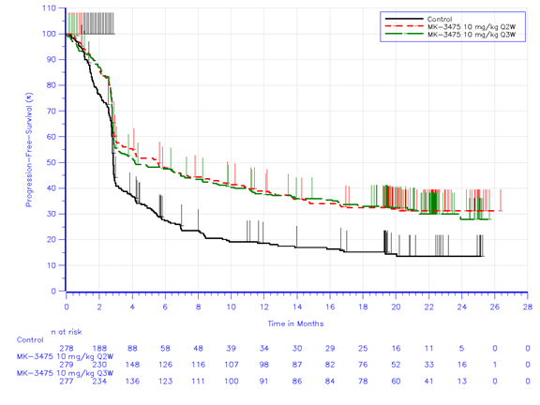
Source: Figure B.6-3, p.73 of the submission

Figure 2: Kaplan-Meier curve of OS (ITT analysis, 3 December 2015 data cut-off)
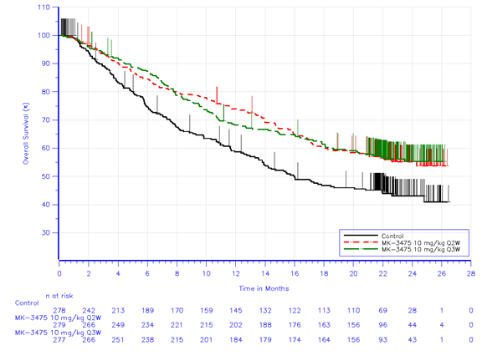
Source: Figure B.6-1, p.68 of the submission

Update of OS results from KN-006 provided in PSCR

  - The PSCR (p4-7) provided an update of the OS results for KN-006 corresponding to a data cut-off of 31 August 2016.

Table 5: OS and PFS results in KN-006 (31 August 2016 data cut-off)
Outcome | Pembrolizumab |  |  |  | Ipilimumab |  | Absolute difference | HR (95% CI) vs. ipilimumab
 | 10 mg/kg Q2W N=279 | 10 mg/kg Q3W N=277 |  | Combined N=556 | 3 mg/kg Q3W N=278
Overall survival
Median follow-up | ‘around 28 months’ |  |  |  |  |  | - | -
Died | 137  (49.1%) | 133  (48.0%) | 270  (48.6%) |  |  | 154  (55.4%) | Q2W: -6.3%  Q3W: -7.4%  Comb’d: -6.8% | -
Median OS months (95% CI) | 30.6 (22.1,NR) | 31.8 (23.5,NR) | Not reported |  |  | 15.9  (13.3, 22.0) | - | Q2W: 0.69 (0.55,0.87)  Q3W: 0.69 (0.55,0.88)
Combined=combined 10 mg/kg Q2W and 10 mg/kg Q3W; HR=hazard ratio; NR=not reached; OS=overall survival; Q2W=every 2 weeks; Q3W=every 3 weeks
Source: Table 3 of the PSCR (converting numbers of patients alive to numbers of patients who have died)

Figure 3: Kaplan-Meier curve of OS (ITT analysis, 31 August 2016 data cut-off)
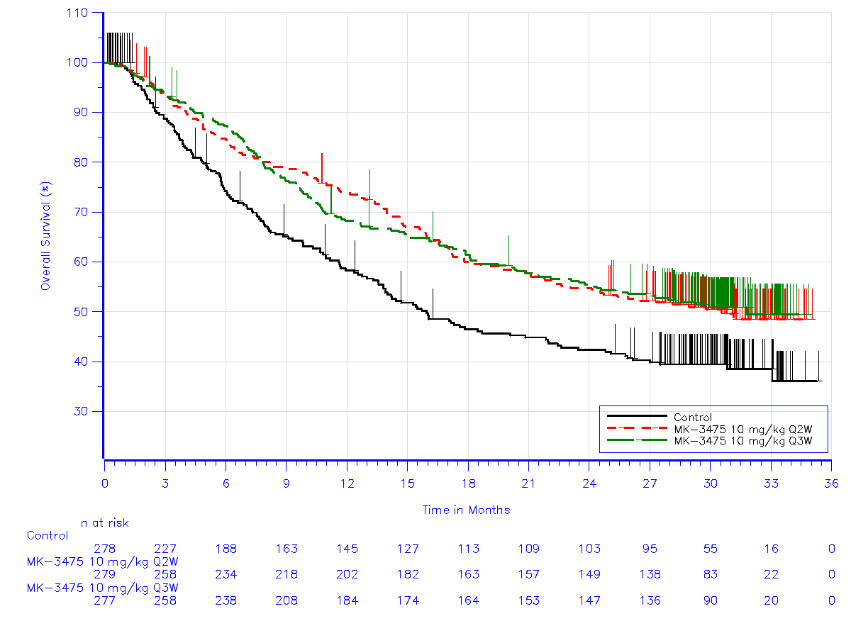
Source: Figure 1, PSCR

  - The results are similar to those presented for PBAC consideration in March 2016. The median PFS was 2.8 months for ipilimumab, 5.6 months for pembrolizumab 10 mg/kg Q2W, and 4.1 months for pembrolizumab 10 mg/kg Q3W. Median OS for ipilimumab was 16 months, and as provided in the PSCR, 30.6 and 31.8 months for pembrolizumab 10 mg/kg Q2W and Q3W, respectively. The point estimates for the hazard ratios remained essentially unchanged, and all comparisons maintained a statistically significant advantage for pembrolizumab.

  - The table below provides summary results for the quality of life scales used in KN-006. These are unchanged from the March 2016 submission.

Table 6: EQ-5D results in KN-006
 | N | Baseline mean (SD) | N | Week 12 mean (SD) | N | Change from baseline LS mean (95% CI)
Ipi 3 mg/kg Q3W | 190 | 0.77 (0.22) | 143 | 0.72 (0.24) | 128 | -0.10 (-0.13, -0.07)
Pembro 10 mg/kg Q2W | 233 | 0.80 (0.19) | 169 | 0.80 (0.20) | 156 | -0.01 (-0.04, 0.01)
Pembro 10 mg/kg Q3W | 219 | 0.78 (0.19) | 183 | 0.78 (0.21) | 165 | -0.02 (-0.04, 0.01)
Pairwise comparison - EQ-5D |  |  |  |  |  | Difference in LS means (95% CI)
Pembro 10 mg/kg Q2W vs. Q3W |  |  |  |  |  | -0.00 (-0.04, 0.04)
Pembro 10 mg/kg Q2W vs. ipi 3 mg/kg Q3W |  |  |  |  |  | 0.08 (0.04, 0.13)
Pembro 10 mg/kg Q3W vs. ipi 3 mg/kg Q3W |  |  |  |  |  | 0.08 (0.04, 0.12)
Ipi=ipilimumab; LS=least squares; pembro=pembrolizumab; Q2W=every 2 weeks; Q3W=every 3 weeks; SD=standard deviation
Source: Table B.6-12, p.89 of the submission.

  - Both scales showed statistically significantly greater change from baseline in quality of life for pembrolizumab compared to ipilimumab. The EQ-5D results were transformed using Australian weights and were applied in the modelled analysis.

Comparative harms

  - A summary of adverse events (AEs) in KN-006 is provided in the table below.
Table 7: Summary of adverse events in KN-006 (APaT population)
Adverse event | Pembrolizumab |  | Ipi  3 mg/kg Q3W N=256 | Differenceª (95%CI)
 | 10 mg/kg Q2W N=278 | 10 mg/kg Q3W N=277 |  | Pembro Q2W vs. ipi | Pembro Q3W vs. ipi
Tier 1 events
Sponsor defined events of interest | 69 (24.8%) | 85 (30.7%) | 49 (19.1%) | -5.7 (NR) | 11.6 (NR)
Grade ≥3 diarrhoea^{b} | 9 (3.2%) | 4 (1.4%) | 8 (3.1%)^{c} | -0.1 (-3.2, 3.4%) | -1.7 (-4.8, 1.0%)
Grade ≥3 colitis^{b} | 4 (1.4%) | 8 (2.9%) | 18 (7.0%) | -5.6 (-9.6, -2.3%) | -4.1 (-8.3, -0.5%)
Grade ≥2 pneumonitis^{b} | 3 (1.1%) | 10 (3.6%) | 1 (0.4%) | 0.7 (-1.1, 2.8%) | 3.3 (0.9, 6.3%)
Grade ≥3 hypo- or hyperthyroidism^{b} | 0 (0.0%) | 0 (0.0%) | 1 (0.4%) | -0.4 (-2.2, 1.0%) | -0.4 (-2.2, 1.0%)
Grade ≥3 skin toxicity^{b} | 5 (1.8%) | 7 (2.5%) | 3 (1.2%%) | 0.6 (-1.8, 3.1%) | 1.4 (-1.2, 4.2%)
Tier 2 events
Serious drug-related events | 34 (12.2%) | 32 (11.6%) | 44 (17.2%) | -5.0 (-11.2,-1.0%) | -5.6 (-11.7,0.4%)
Discontinued - drug-related event | 19 (6.8%) | 30 (10.8%) | 23 (9.0%) | -2.1 (-7.0, 2.5%) | 1.9 (-3.3, 7.1%)
Any drug-related grade 3-5 event | 47 (16.9%) | 46 (16.6%) | 50 (19.5%) | -2.7 (-9.3, 3.9%) | -2.9 (-9.5, 3.7%)
NR = Not reported
ª Based on Miettinen & Nurminen method stratified by line of therapy, PD-L1 status and ECOG
^{b} with potential immunologic aetiology
^{c} Reported as 9 (3.5%) in March 2016 submission (refer Table B.6-17, p.87-88 of March 2016 submission
Source: Table B.6-15, p.94 and Table B.6-17, p.95-96 of the submission

  - These analyses of adverse events also showed similar results to those of the March 2016 submission. Statistically significantly fewer patients treated with pembrolizumab 10 mg/kg experienced grade ≥3 colitis, while significantly fewer patients treated with ipilimumab experienced grade ≥2 pneumonitis compared to those treated with pembrolizumab 10 mg/kg Q3W. Significantly fewer patients treated with pembrolizumab 10 mg/kg Q2W experienced serious drug-related AEs or any drug-related grade 3-5 AEs compared to those treated with ipilimumab.

  - Of the modelled evaluation of grade ≥3 events (endocrine disorders; colitis; diarrhoea; asthenia/fatigue; infections and infestations; and hypertension) the only statistically significant difference was for colitis, favouring pembrolizumab. Thyroid disorders of any grade were much higher amongst pembrolizumab patients but had little impact upon the ICER.

Benefits/harms

  - A summary of the comparative benefits and harms for pembrolizumab versus ipilimumab is presented in the table below.

Table 8: Summary of benefits and harms for pembrolizumab and ipilimumab based on the second interim analysis of KN-006 (ITT analysis, 3 December 2015 data cut-off)
Benefits
 | Pembro10 mg/kg  Q2W + Q3W combined  N=556 | Ipi  3 mg/kg Q3W  N=278 | Absolute difference | HR (95% CI)
Overall survival
Died | 241 (43.3%) | 142 (51.1%) | -7.8% | -
Median mths (95% CI) | NR (24.3, NR) | 16.0 (13.5, 22.0) | - | 0.67 (0.55. 0.83)
OS rate at 24 mths | 55.2% (50.7, 59.4) | 43.0% (36.6, 49.2) | 12.1% | -
Progression-free survival - RECIST 1.1
Progressed | 364(65.5%) | 202 (72.7%) | -7.2% | -
Median mths (95% CI) | 4.9 (3.7, 6.9) | 2.8 (2.8, 2.9) | 2.1 months | 0.61 (0.51, 0.73)
PFS rate at 12 mths (%) | 37.0% (32.7, 41.2) | 17.2% (12.4, 22.5) | 19.8%
PFS rate at 24 mths (%) | 30% | 14% | 16% | -
Progression-free survival – irRC
Progressed | 357 (64.2%) | 199 (71.6%) | -8.4% | -
Median mths (95% CI) | 8.4 (6.6, 11.1) | 3.3 (2.9, 4.2) | 5.1 months | 0.56 (0.47, 0.67)
PFS rate at 12 mths (%) | 43.9% (39.5, 48.1) | 19.5% (14.5, 24.9) | 24.4% | -
Harms
 | Pembro10 mg/kg  Q2W + Q3W combined  N=556 | Ipi  3 mg/kg Q3W  N=278 | Absolute difference  (95% CI) | P-value
Grade ≥3 colitis^{b} | 12 (2.2%) | 18 (7.0%) | -4.8% (-10.5, -1.4) | 0.003
Grade ≥2 pneumonitis^{b} | 13 (2.3%) | 1 (0.4%) | 2.4% (-0.5, 5.0) | 0.073
Sponsor-defined events of clinical interest (drug-related) | 132 (23.8%) | 45 (17.6%) | 6.2% (1.6, 13.4) | 0.0119
ª Based on Miettinen & Nurminen method stratified by line of therapy, PD-L1 status and ECOG
^{b} with potential immunologic aetiology
Comb’d=combined; diff=difference; HR=hazard ratio; ipi=ipilimumab; irRC=immune-related response criteria; mths=months; NR=not reached; OS=overall survival; PFS=progression-free survival; pembro=pembrolizumab; Q2W=every 2 weeks; Q3W=every 3 weeks
Source: p.107 of the submission

  - On the basis of the KN-006 final analysis data with a median follow-up of 22.8 months, for every 100 patients treated with pembrolizumab compared with ipilimumab:
- 8 more patients will be alive at 22.8 months
- 7 more patients will not have progressed at 22.8 months
- 4 fewer patients will have experienced grade ≥3 colitis by 22.8 months
- 2 more patients will have experienced grade ≥2 pneumonitis by 22.8 months.

Clinical claim

  - The submission described pembrolizumab as superior in terms of comparative effectiveness and superior in terms of comparative safety over ipilimumab. In regards to comparative effectiveness, this claim is adequately supported.

  - As in the March 2016 submission, the current submission asserted that, because the frequency of drug-related adverse events of special interest (AEOSIs) was higher with pembrolizumab than ipilimumab, the frequency of high-grade AEOSIs, serious AEOSIs and AEOSIs leading to discontinuation was approximately 2-fold greater for ipilimumab-treated patients compared to those treated with pembrolizumab suggesting that AEOSIs due to pembrolizumab were milder and more easily managed. However, while there were statistically significantly fewer pembrolizumab with grade ≥3 colitis, there were also significantly fewer ipilimumab patients treated for grade ≥2 pneumonitis compared to those treated with pembrolizumab. The current submission has not significantly strengthened the basis for claiming superior safety.

Economic analysis

  - The submission presented a cost-utility analysis based on KN-006. The model is used to present two scenarios; a ‘Deed compliant scenario’ which forms the base case in Section D and complies with the obligations specified in the Deed of Agreement, and; a ‘Realistic scenario’ which is effectively a multivariate sensitivity analysis of the ‘Deed compliant scenario’. The table below provides a summary of the model structure.

Table 9: Summary of model structure and rationale
Component | Summary
Time horizon | ‘Deed compliant scenario’: 5 years in the base case versus 22.8 months median follow-up in KN-006  ‘Realistic scenario’: 5 years versus 22.8 months median follow-up in KN-006 (results were truncated at 5 years, but, unlike the ‘Deed Compliant scenario’, OS was modelled beyond 5 years).
Outcomes | QALYs
Methods used to generate results | ‘Deed compliant scenario’: Partitioned survival analysis using PFS and OS Kaplan-Meier curves to 22.8 months followed by fitted parametric functions (log-normal for PFS and OS for ipilimumab and exponential for PFS and OS for pembrolizumab) to 5 years from baseline.  ‘Realistic scenario’: Partitioned survival analysis using PFS and OS Kaplan-Meier curves to 22.8 months followed by fitted parametric functions (for ipilimumab: log-normal for PFS and OS; for pembrolizumab: exponential for PFS and log-logistic for OS up to 240 weeks (at which point the model was truncated) and exponential for OS after that. OS curves converged at 7 years.
Health states | Progression-free survival (PFS)  Progression (referred to in the submission model as post-PD)  Death
Cycle length | 1 week
Transition probabilities (i.e. distributions; explicit transition probabilities not used) | OS and PFS weekly distributions from Kaplan-Meier curves to 22.8 months and thereafter from extrapolated curves to 5 years for PFS and OS in the ‘Deed compliant scenario’ and from Kaplan-Meier curves to 22.8 months and thereafter from extrapolated curves to 5 years for PFS and 7 years for OS.
Source: Compiled during the evaluation.

  - A key concern at the March 2016 PBAC meeting was that the submission’s model “produced the implausible result that the effect upon PFS diminished by 5 years, but the effect in terms of OS was maintained indefinitely thereafter” (paragraph 6.33, March 2016 PBAC meeting PSD). This contributed to the obligation in the Deed of Agreement to converge both the ipilimumab and pembrolizumab curves for PFS and OS at 5 years. The ‘Deed compliant scenario’ complies with this obligation as seen in the trace diagram is shown in the figure below showing convergence of OS at 5 years and PFS at approximately 5 years.

Figure 4: Trace diagram for OS and PFS in the ‘Deed compliant scenario’
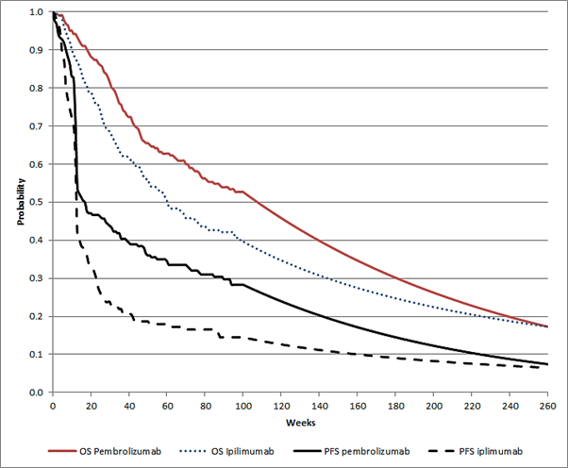
Source: Developed during the evaluation

  - The ESC noted that the PSCR did not present an update of the model commensurate with its provision of the longer follow-up data from KN-006. However, the ESC considered that, given the median OS has now been reached for both pembrolizumab groups (PSCR p6) at around 31 months (133 weeks), the updated Kaplan-Meier curves for overall survival renewed the question of whether these were likely to converge at 5 years.

  - Key drivers of the model are identified in the table below.

Table 10: Key drivers of the model
Description | Method/Value | Impact
Extrapolation | ‘Realistic scenario’: Use of two different curves to constrain OS to converge at 7 years | High, favours pembrolizumab
Assumption that complete responders (CR) cease pembrolizumab therapy at 2 years. | ‘Deed compliant scenario’: Not applied. Therapy continues until progression and which complied with the Deed of Agreement  ‘Realistic scenario’: PSCR ceased pembrolizumab therapy at 2 years, with option of third year - all patients cease therapy by 3 years | High, favours pembrolizumab
Price of pembrolizumab (updated from pre-PBAC response (p3)) | ‘Deed compliant scenario’: effective DPMQ $''''''''''''''''''  ‘Realistic scenario’: effective DPMQ of $''''''''''''''''''''' | High,  higher price favours ipilimumab
Ipilimumab re-induction rate | Both scenarios: increased in the current submission | Moderate, favours pembrolizumab
Source: compiled during the evaluation; note that subsequent updates were not independently verified

  - The results of the modelled evaluation are provided in the two tables below for the ‘Deed compliant scenario’ and the ‘Realistic scenario’ respectively. The below table shows that the ICER for both the ‘Deed compliant scenario’ and ‘Realistic scenario’ was $45,000 - $75,000 per QALY.

Table 11: Updated results of the economic evaluation from pre-PBAC response (p3) for ‘Deed compliant scenario’ (no SAMEP costs, treatment until progression using revised time on treatment, results discounted over time)
Component | Pembrolizumab | Ipilimumab | Increment
Costs | $'''''''''''''''''' | $'''''''''''''''' | $'''''''''''''''
LYS | 2.15 | 1.80 | 0.35
QALY | 1.71 | 1.30 | 0.30
Incremental cost/extra life-year gained |  |  | $'''''''''''''''''
Incremental cost/extra quality-adjusted life-year (QALY) gained |  |  | $'''''''''''''
Note that this subsequent update was not independently verified

Table 12: Updated results of the economic evaluation from pre-PBAC response (p3) for ‘Realistic scenario’ (no SAMEP costs, patients with complete response treated for 2 years with option to extend, patients with partial response or stable disease treated until progression, results discounted over time)
Component | Pembrolizumab | Ipilimumab | Increment
Costs | $'''''''''''''''''''' | $'''''''''''''''' | $''''''''''''''''
LYS | 2.30 | 1.80 | 0.50
QALY | 1.71 | 1.30 | 0.41
Incremental cost/extra life-year gained |  |  | $'''''''''''''''
Incremental cost/extra quality-adjusted life-year (QALY) gained |  |  | $''''''''''''''
Note that this subsequent update was not independently verified

  - The ‘Deed compliant scenario’ complied with the obligations under Attachment B of the Deed of Agreement. This compliance addressed the key concerns of the PBAC with the economic model in the March 2016 submission, including the implausibility of incremental gains in survival accruing more to the post-progression health state than to PFS. The current submission estimates 14.59 life-years in PFS and 11.16 in post-PD for pembrolizumab over the 5 years of the model.

  - The ‘Realistic scenario’ provided in the current submission was effectively a multivariate sensitivity analysis of the ‘Deed compliant scenario’. It assumed CR will stop therapy at 2 years and increased the cost of treating Grade ≥3 colitis citing a letter from the South Australian Medicines Evaluation Panel (SAMEP). Although its results were truncated at a 5-year time horizon, structurally the model extended OS to converge at 7 years. Although the median time to follow-up increased in the current submission from 13.8 months to 22.8 months, giving some increased confidence in the durability of effects, the PBAC has previously rejected extrapolations >5 years in both the March 2015 submission and the March 2016 submission. It similarly rejected the use of SAMEP information for AE rates. Although only cost data is used from SAMEP, the same limitations of small numbers and lack of information to inform the pembrolizumab again limit the value of this information. The assumption introduced for the current submission of patients with complete response stopping pembrolizumab therapy is unjustified and has significant impact upon the ICER. The PSCR (p2) varied this scenario by withdrawing the SAMEP-sourced colitis costs and assuming that patients achieving a complete response would cease pembrolizumab therapy at 2 years, but would have the option of resuming for an extra year. The PSCR (p2) explained its second variation as being to reflect the KN-006 per protocol approach, which allowed for all patients to discontinue therapy at 2 years and then for some of these to receive an additional year of treatment. The ESC noted that changing the duration of pembrolizumab had a significant impact on the ICER and that neither the submission’s approach nor the PSCR’s approach reflected the current PBS restriction for pembrolizumab.

  - A trace diagram for the submission’s ‘Realistic scenario’ is shown in the figure below.

Figure 5: Economic model extrapolation of OS to 7 years (364 weeks) in the ‘Realistic scenario’
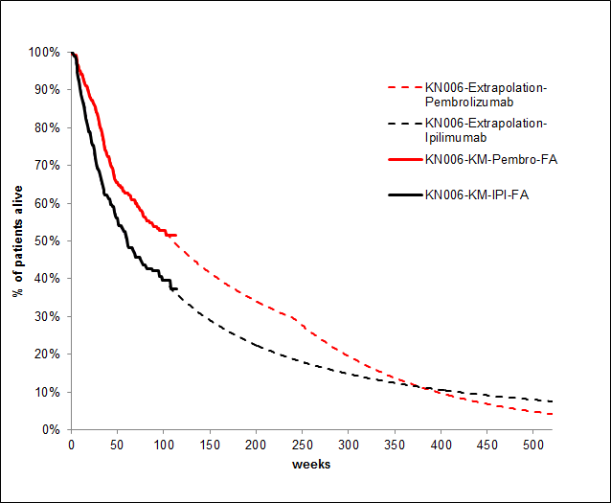Source: adapted from Options worksheet, Excel File Pembrolizumab Section D Workbook November 2015” accompanying the submission

  - The ESC noted that, in this figure, the extrapolated OS curves cross at 7 years (364 weeks). Given that this scenario was truncated at 5 years (260 weeks), the subsequent extrapolations have no direct impact on the ICER. However, the ESC expressed concern about the validity of this subsequent extrapolation, noting that it implausibly generated negative incremental QALYs beyond year 7 in the model.

  - The ESC noted that, although the model in both scenarios was truncated at 5 years, the extrapolations differed across the two scenarios. In the ‘Deed compliant scenario’, both PFS and OS converged at 5 years; whereas in the ‘Realistic scenario’, OS converged at 7 years using a different survival curve from 4.5-7 years. The ESC considered that the arbitrary use of two different curves for the same data was inappropriate, resulting in an implicit and implausible assumption for the ‘Realistic scenario’ that patients remaining alive up to 5 years then have an improbable accelerated rate of death beyond that time point.

  - The PBAC has not accepted any extrapolation beyond 5 years included in either previous submission. Generating a different set of convergence targets (ie at 5 years and at 7 years) from the same data for two different scenarios has also not been previously accepted by the PBAC in the context of either previous submission.

  - The ESC noted that the effective price asked for by the sponsor was modelled from the revised ‘Realistic scenario’, and not from the ‘Deed compliant scenario’ (price requested as per the PSCR (p1, 2 and 5) was $'''''''''''''''''''').

  - The ESC noted that the PSCR therefore used the revised ‘Realistic scenario’ as its base case, and so advised that the PBAC consider how appropriate this is, given that key parameters in this scenario would require acceptance beyond the parameters previously agreed for the MES.

  - In its pre-PBAC response (p1 and 3), the sponsor proposed an effective price according to the ‘Deed compliant scenario’ of $'''''''''''''''''', thereby accepting the ‘Deed compliant scenario’ as the base case.

Drug cost/patient/course: $''''''''''''''' for ‘Deed compliant scenario’; $'''''''''''''''''' for ‘Realistic scenario’ (not updated to reflect the revised price requests in the pre-PBAC response).

  - Although the ‘Realistic scenario’ applies a higher effective dispensed price, the cost per course is lower than for the ‘Deed compliant scenario’ due to the assumption that complete responders stop therapy with pembrolizumab after 2-3 years. This assumption is not reasonable.

Estimated PBS usage & financial implications

  - The DUSC considered the estimates presented in the re-submission to be overestimated. The re-submission assumed that patient numbers from the 18 May 2016 proposal (submission Appendix 12) would be adopted. These numbers had not been accepted by the PBAC or the Department at the time the submission was considered by DUSC. The DUSC noted the following concerns with the methods used to derive, and sources used to verify, the proposed patient numbers:
- An epidemiological approach was taken although the PBAC has previously considered this would overestimate use. The DUSC considered that the epidemiological (top down) approach presented in the current re-submission overestimated use because:
  - growth in the incident patients predicted to be treated (6-7%) exceeded growth in the melanoma incidence (4.3%) and mortality (3-4%). The DUSC considered that application of growth rates from a bottom up (market share approach) may not be applicable to a top down approach. The pre-PBAC response (p2) noted that this growth rate included other factors, namely a reduction in patients enrolling in clinical trials and higher utilisation of pembrolizumab relative to ipilimumab.
  - the proportion of patients on dabrafenib/trametinib who had progressed between 12 and 24 months was applied incorrectly and may result in an overestimate of patients subsequently treated with pembrolizumab.
  - uptake rates were informed on a clinician survey involving a small number of melanoma specialists and may be overestimated. The pre-PBAC response (p2) noted that this survey constituted approximately 80% of advanced melanoma prescribing.
- Additional data presented in the submission and PSCR did not provide strong evidence to support the substantial increase in patient numbers and would overestimate PBS use because:
  - wholesaler vial demand data was not considered to be an appropriate source and there was a lack of methodological detail provided to adequately critique the how PBS vs. non-PBS use could be identified. The pre-PBAC response (p2) noted that wholesaler vial data represented 100% PBS use as Merck Sharp & Dohme manages non-PBS supply of pembrolizumab through compassionate use and private supply programs.
  - use of data from the named patient program (NPP) was not reliable as only four data points were available, and because demand through an NPP may differ from that through the PBS.
- The DUSC considered it reasonable that the estimate of utilisation included use in a proportion of patients’ second and third years of treatment if the PBAC accepts the economic model presented in this re-submission. There was some misalignment in the ways that dose and duration were derived between Section D and Section E and the DUSC considered they should be consistent. The pre-PBAC response (p2) noted that this discrepancy was due to the small number of additional administrations in the ‘Deed compliant scenario’ for an average patient in Year 6 (aligned with the PFS curve extrapolation), whereas Section D reflected the 5-year time horizon.
- Preliminary PBS data over the first ten months of listing showed that the patients being treated with pembrolizumab were generally older than the patients treated with ipilimumab and in the clinical trials. Patterns of use and cost-effectiveness in this broader group are less certain. The pre-PBAC response (p2) noted that forest plots for PFS and OS in the KN006 study demonstrated very similar results for patients > 65 years of age vs. those < 65 years, with no significant difference between the two age groups. The PBAC noted that the use of pembrolizumab in older patients has implication for the extrapolated health gains in the model as the estimated magnitude of these gains may not be realised in older patients.
- Pembrolizumab may be used outside the restriction, for example as adjuvant treatment with resection or for indications other than melanoma.

  - The submission requested an effective price of pembrolizumab of $'''''''''''''''''''' (reduced to $''''''''''''''''''''), associated with a ''''''% increase in the treatment population underpinning the risk sharing arrangement. The associated net costs would be $''''''''''''' under the ‘Deed compliant scenario’, and $'''''''''''''' under the ‘Realistic scenario’ over the next 5 years. By comparison, the risk sharing arrangement caps for the first 5 years of the Deed of Agreement (clause 3.1.3) sum to $'''''''''''''.

  - The pre-PBAC response (p1) proposed that the ‘Deed compliant scenario’ effective price of $'''''''''''''''' would be used in a revised cap, and that patients not currently accommodated in the existing cap would be included at a discount of ''''''% on the average cost per patient. The sponsor proposed that this would result in an increase of approximately $60 - $100 million across the caps over Years 2 to 5 of the Deed.

Financial Management – Risk Sharing Arrangements

  - The request for changes in the current submission addressed the same issues of the size of the treatment population and the effective vial price as raised in Section F of the March 2016 submission. The current submission (p215) requested the following changes to the Deed of Agreement effective from Year 2 onwards:
- an effective pembrolizumab price per vial based on the ‘Realistic scenario’ of $''''''''''''''''''''''', reduced to $''''''''''''''''''''' as per the PSCR (p1, 2 and 5), and reduced further to $'''''''''''''''''' based on the ‘Deed compliant scenario’ in the pre-PBAC response (p1), rather than being based on the effective ipilimumab price;
- payment for prevalent patients remaining on therapy beyond their first year of treatment;
- clause 3.1.3 of the Deed of Agreement be amended to reflect the risk sharing arrangement caps in the table below. The redacted table below shows that at year 5, the net cost to the PBS would be more than $100 million per year.

Table 13: Updated proposed risk sharing arrangement caps from pre-PBAC response (p3)
 | Year
 | Year 2  Sep-16 to Aug-17 | Year 3  Sep-17 to Aug-18 | Year 4  Sep-18 to Aug-19 | Year 5  Sep-19 to Aug-20
Proposed (‘Realistic scenario’) | $''''''''''''''''''''''''''''' | $'''''''''''''''''''''''' | $''''''''''''''''''''''''''''''' | $'''''''''''''''''''''''''''''''''
Note that updates were not independently verified

For more detail on PBAC’s view, see section 7 “PBAC outcome”.

- PBAC Outcome

  - The PBAC decided not to recommend that the circumstances of the PBS listing of pembrolizumab for the treatment of unresectable Stage III or Stage IV metastatic melanoma be changed following the Managed Entry Scheme (MES). The PBAC considered that the requested changes to the cost-effectiveness of pembrolizumab and the associated risk sharing arrangement caps contained in the Deed of Agreement were not justified as the primary basis for previously rejecting the increased cost per patient had not changed since the previous submission, and the numbers of eligible patients each year were likely to be overestimated.

  - To highlight its main reason for rejecting the increased cost per patient, the PBAC reiterated that, since the Deed of Agreement, nivolumab has been listed for the treatment of unresectable Stage III or Stage IV metastatic melanoma, on the basis that nivolumab is non-inferior to pembrolizumab and therefore is an appropriate comparator. “The PBAC recommended that the pricing of nivolumab upon PBS listing be determined only with reference to the initial pricing conditions of the pembrolizumab MES. Any future pricing adjustment that may be sought for pembrolizumab as part of the conditions of the pembrolizumab MES would not apply to nivolumab, thus providing the Commonwealth certainty of the nivolumab pricing. Future applications to prove cost effectiveness of nivolumab over pembrolizumab may be made at any time by the sponsor, if warranted by future clinical trial data” (paragraph 7.6, Nivolumab PSD November 2015 PBAC meeting). The PBAC noted that, as nivolumab is listed on the PBS on the basis of this recommendation, the cost per patient of pembrolizumab is linked to the cost per patient of nivolumab, which would remain consistent with the initial cost per patient conditions of the pembrolizumab MES.

  - The PBAC reiterated that the submission did not contain evidence of greater effectiveness or safety of pembrolizumab compared with nivolumab and as such could not justify a change in the cost per patient of pembrolizumab following the MES.

  - As previously, the PBAC considered the information provided in the submission in relation to the MES, first in the context of the Deed of Agreement, and then in the context of other matters raised in the submission.

  - In this regard, the PBAC noted that the ‘Deed compliant scenario’ proposed in the submission complied with the MES obligations under Attachment B of the Deed of Agreement.

  - However, the PBAC did not accept that the submission’s ‘Realistic scenario’ proposal, of a maximum 24 months treatment duration with pembrolizumab, together with an option for an additional 12 months of subsequent treatment with pembrolizumab in the case of relapse, was reasonable and considered that insufficient data was provided on re-treatment outcomes. The PBAC noted that changing the duration of pembrolizumab had a significant impact on the estimated incremental cost-effectiveness ratio for this scenario.

  - The PBAC also did not accept the submission’s proposed increased ipilimumab re-induction rate without any commensurate adjustment for associated survival gains and noted that the estimated incremental cost-effectiveness ratios thus favoured pembrolizumab.

  - The PBAC separately rejected the submission’s requested increases in annual patient numbers for the risk sharing arrangement caps on the grounds that insufficient evidence had been provided to justify the magnitudes of these proposed increases. In this regard, the PBAC maintained that the use of ex-wholesaler data was inappropriate and that the proportion of patients on dabrafenib/trametinib who had progressed between 12 and 24 months was applied incorrectly. The PBAC also did not accept that the sponsor’s earlier underestimation of the number of patients who would be eligible for grandfathering through the named patient program warranted the requested increase in patient numbers.

  - The PBAC noted that the Department was separately negotiating with the sponsor in relation to increasing the annual risk sharing arrangement caps for pembrolizumab. The Committee considered that, while the increases proposed in the sponsor’s submission were not justified, there remained some uncertainty about the appropriate annual numbers of PBS-eligible patients for PD-L1 inhibitors in melanoma, thus the annual levels of PBS expenditure. The PBAC therefore advised that smaller increases in the annual risk sharing arrangement caps may be reasonable. The Committee further suggested that such changes should only be implemented if it could be ensured that any further financial implications for the Commonwealth could be appropriately controlled.

  - The PBAC advised that, once all matters in relation to the MES had been resolved, the MES information contained in the note of the Pharmaceutical Benefits Schedule for the listing of pembrolizumab could be removed.

  - The PBAC noted that this submission is not eligible for an Independent Review as an Independent Review is not available in response to a request to modify or extend an existing listing.

Outcome:
Rejected

- Context for Decision

The PBAC helps decide whether and, if so, how medicines should be subsidised in Australia. It considers submissions in this context. A PBAC decision not to recommend listing or not to recommend changing a listing does not represent a final PBAC view about the merits of the medicine. A company can resubmit to the PBAC or seek independent review of the PBAC decision.

- Sponsor’s Comment

The sponsor had no comment.

