6.14 TERIFLUNOMIDE
14 mg tablet, 28
Aubagio®,
Sanofi Aventis Australia Pty Ltd.

- Purpose of Application

  - The minor submission sought to amend the current listing of teriflunomide from Authority Required to Authority Required (STREAMLINED).

  - Teriflunomide is one of a range of drugs used in the treatment of relapsing-remitting multiple sclerosis (RRMS).

- Requested listing

  - The submission requested a change to the restriction level of teriflunomide from Authority Required to Authority Required (STREAMLINED). No other changes to existing listings were requested. As no other changes were requested, the restriction has not been reproduced in full.

Name, Restriction,  Manner of administration and form | Max.  Qty | №.of  Rpts | Dispensed Price for Max. Qty | Proprietary Name and Manufacturer
TERIFLUNOMIDE  14 mg tablet, 28 | 1 | 5 | $1836.73 | Aubagio® | Sanofi-Aventis Australia Pty Ltd
Authority Required (STREAMLINED)

- Background

  - Teriflunomide was TGA registered on 14 November 2012 for the treatment of patients with relapsing forms of multiple sclerosis.

  - The PBAC rejected a submission for teriflunomide in November 2012 on the basis of insufficient evidence to support the clinical claims of non-inferior comparative effectiveness and superior safety over interferon β-1a (IFN β-1a) and interferon β-1b (IFN β-1b).

  - The PBAC recommended teriflunomide in July 2013 on a cost minimisation basis with IFN β-1a and IFN β-1b. The PBAC considered that teriflunomide was non-inferior to the beta interferons in terms of comparative effectiveness and had a different, but not worse, safety profile.

  - In making its recommendation, the PBAC considered the estimated extent of use and financial implications were uncertain. A Risk Share Arrangement (RSA) with annual Commonwealth expenditure cap is in place for teriflunomide.

  - Other drugs are PBS listed for the treatment of RRMS. These include subcutaneous and intramuscular forms of IFN β-1a, IFN β-1b, glatiramer acetate, pegylated IFN β-1a (Peg-IFN β-1a), dimethyl fumarate (DMF), fingolimod, natalizumab and alemtuzumab. Older treatments for RRMS, including both forms of IFN β-1a, IFN β-1b and glatiramer acetate are often termed ‘ABCR therapies’, a reference to the trade names of these products (Avonex®, Betaferon®, Copaxone® and Rebif®).

  - All oral treatments for RRMS, including teriflunomide, DMF and fingolimod are currently Authority Required listings. Injectable and infusible drugs for RRMS are generally Authority Required (STREAMLINED).

  - The Drug Utilisation Sub-Committee (DUSC) reviewed the utilisation of RRMS drugs in October 2015. The DUSC considered that the use of teriflunomide had been overestimated, most likely as a consequence of competing for market share with DMF, as both were listed in December 2013.

  - The PBAC previously considered the authority levels of medicines used to treat RRMS as part of the Post-market Review of Authority Required PBS listings, and recommended in December 2014. At that time, the PBAC recommended reducing the restriction levels of the ABCR therapies to Authority Required (STREAMLINED), and considered that, given the oral therapies were only recently listed, that the market for those treatments had not stabilised.

- Comparator

  - The PBAC has previously accepted IFN β-1a and IFN β-1b as appropriate comparators.

  - A range of treatments were listed on cost-minimisation bases to other drugs used in the treatment of RRMS. Teriflunomide and DMF were both listed on cost minimisation bases with one or more of the individual drugs comprising the ABCR therapies.

For more detail on PBAC’s view, see section 6 “PBAC outcome”.

- Consideration of the evidence

Sponsor hearing

  - There was no hearing for this item as it was a minor submission.

Consumer comments

  - The PBAC noted that no consumer comments were received for this item.

Estimated PBS usage & financial implications

  - The submission argued that the utilisation of teriflunomide has been consistent with the estimates provided in the July 2013 submission, as Commonwealth expenditure did not exceed the caps in the existing RSA.

  - Details of the RSA subsidisation cap and Commonwealth expenditure for the first two years and seven months since listing are presented in Table 1.

Table 1: RSA subsidy caps and Commonwealth expenditure over 2 years, 7 months since PBS listing
Time period | Subsidisation cap | Commonwealth expenditure
Dec 13 – Nov 14 | $''''''''''''''''''''''''''' | $''''''''''''''''''''''
Dec 14 – Nov 15 | $'''''''''''''''''''''''''''' | $''''''''''''''''''''''''''''
Dec 15 – Jun 16 | $'''''''''''''''''''''''ª | $'''''''''''''''''''''''''''
Source: Table 3, p 6 of the submission. ª – subsidisation cap adjusted to reflect 7 months’ expenditure

The redacted table above shows that subsidisation caps and Commonwealth expenditure for the above time periods were in the range of $10-$20 million.

  - The submission further stated that the rapid uptake and high utilisation observed following the listing of fingolimod was not observed in teriflunomide, and that utilisation has been more comparable to ABCR therapies. The submission presented monthly prescribing statistics data to support that position.

  - An analysis on the utilisation of RRMS therapy was undertaken by the Drug Utilisation Sub-Committee (DUSC) Secretariat. The use of teriflunomide relative to other RRMS therapies has been low and stable (Figure 1). Between December 2013 and June 2016 there were few identified cases of potential co-administration of teriflunomide with other RRMS agents (1.7%).

Figure 1: Number of prevalent patients by RRMS therapy
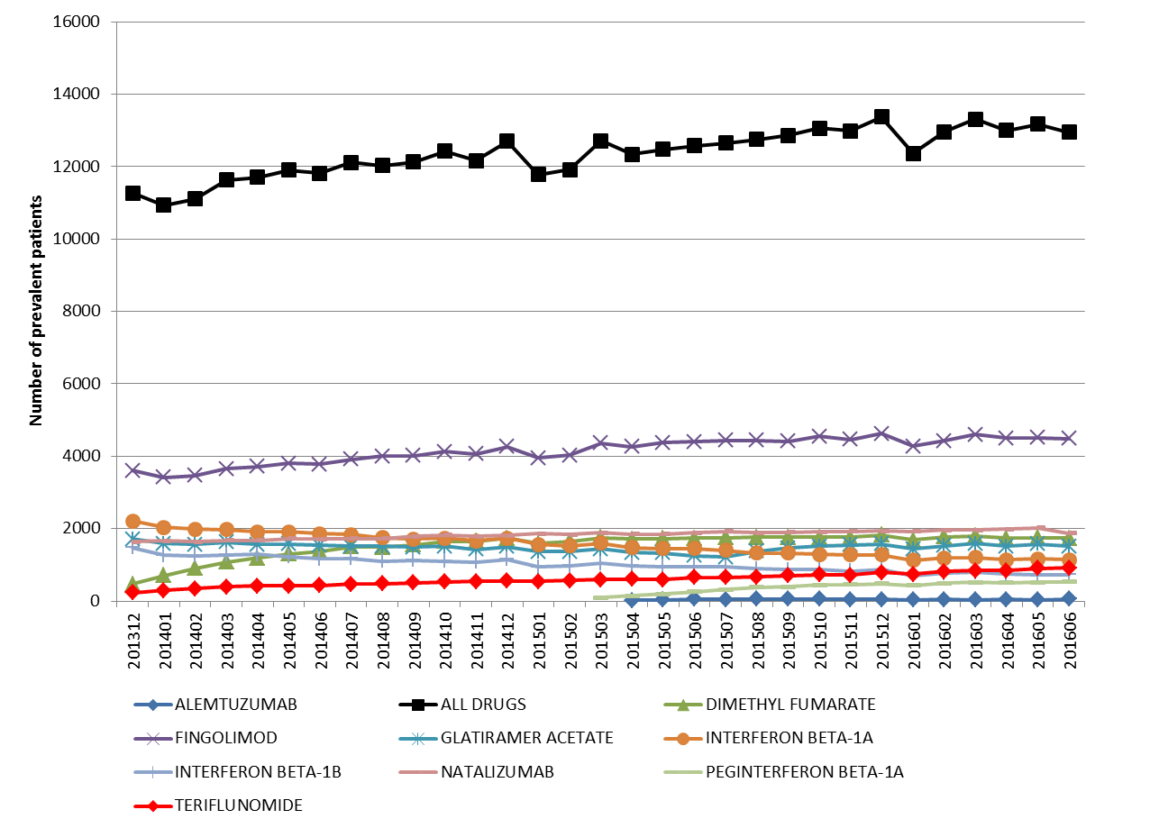
Source: DHS Pharmacy Claims database
*Interferon beta-1a data includes both subcutaneous and intramuscular forms

  - Additional input from DHS provided data on authority approval applications and rejections from September 2015 to August 2016. In that period, DHS approved 2,276 applications for teriflunomide, and rejected 72. Of those rejections, nearly all were rejected because the patient still had 2 or more months’ supply on hand.

  - The submission stated that the requested change to a streamlined authority would not significantly affect the utilisation or financial implications of teriflunomide on the PBS.

For more detail on PBAC’s view, see section 6 “PBAC outcome”.

- PBAC Outcome

  - The PBAC decided not to recommend amending the listing of teriflunomide to Authority Required (STREAMLINED), as it considered that the market for oral therapies for RRMS had not yet stabilised.

  - The PBAC noted the input from the DUSC secretariat with regards to the utilisation of all RRMS therapies, and noted that the utilisation of the other oral therapies, fingolimod and DMF, was higher than teriflunomide and the market for oral treatments was still growing.

  - The Committee also noted that while the utilisation of teriflunomide has been lower than expected, the simultaneous listing of DMF in December 2013 resulted in these two therapies competing for market share and was likely a contributing factor to the lower than expected utilisation of teriflunomide.

  - The PBAC noted that this submission is not eligible for an Independent Review as an Independent Review is not available in response to a request to modify or extend and existing listing.

Outcome:
Rejected

Context for Decision

The PBAC helps decide whether and, if so, how medicines should be subsidised in Australia. It considers submissions in this context. A PBAC decision not to recommend listing or not to recommend changing a listing does not represent a final PBAC view about the merits of the medicine. A company can resubmit to the PBAC or seek independent review of the PBAC decision.

Sponsor’s Comment

The sponsor had no comment.

PBAC Drug Utilisation Sub-Committee (2015). Multiple Sclerosis, predicted versus actual analysis, Public Release Document, p 21. Canberra: Department of Health. Full report available from http://www.pbs.gov.au/info/industry/listing/participants/public-release-docs/dusc-public-release-documents-by-condition. Accessed 9 September 2016.

