6.04 PEMBROLIZUMAB,
Injection concentrate for I.V. infusion 100 mg in 4 mL

Powder for injection 50 mg, 1 vial
KEYTRUDA®,
Merck Sharp & Dohme (AU) Pty Ltd

- Purpose of submission

  - The submission requested a Section 100 (Efficient Funding of Chemotherapy) (S100 EFC) Authority Required listing for the first-line treatment of locally advanced or metastatic non-small cell lung cancer (NSCLC) in patients who do not have an activating epidermal growth factor receptor (EGFR) gene mutation or an anaplastic lymphoma kinase (ALK) gene rearrangement in tumour material and with evidence of high levels of expression of programmed death ligand 1 (PD-L1), defined as a tumour proportion score (TPS) of ≥50%.

- Requested listing

  - The requested PBS listing is shown below. The submission requested a special pricing arrangement.

Name, Restriction,  Manner of administration and form |  | Max.  Qty | №.of  Rpts | Dispensed Price for Max. Amount | Proprietary Name and Manufacturer
PEMBROLIZUMAB  50 mg injection: powder for, 1 vial  100 mg/4 mL injection, 1 vial |  | 200 mg | 5 (initial)ª  7 (continuing) | $''''''''''''''''''' (private)  $''''''''''''''''''''''' (public) | Keytruda® | Merck Sharp & Dohme (AU) Pty Ltd
Treatment phase: Initial treatment
Category / Program | Section 100 – Efficient funding of chemotherapy
Prescriber type: | Dental Medical Practitioners Nurse practitioners Optometrists  Midwives
Severity: | Stage IIIB (locally advanced) or Stage IV (metastatic) NSCLC^{b}
Condition: | Non-small cell lung cancer (NSCLC)
PBS Indication: | Stage IIIB (locally advanced) or Stage IV (metastatic) NSCLC^{b}
Treatment phase: | Initial treatment
Restriction Level / Method: | Restricted benefit  Authority Required - In Writing  Authority Required - Telephone  Authority Required – Emergency  Authority Required - Electronic  Streamlined
Clinical criteria: | Patient must have a performance status of 1 or less^{c},  AND  The condition must be previously untreated,  AND  Treatment must be the sole PBS-subsidised therapy for this condition,  AND  The initial treatment must not exceed a total of 6 doses at a maximum dose of 200 mg every 3 weeks.
Population criteria: | Patient must have evidence of at least 50% programmed death ligand 1 (PD-L1) in tumour material,  AND  Patient must have no evidence of an activating epidermal growth factor receptor (EGFR) gene or of an anaplastic lymphoma kinase (ALK) gene rearrangement in tumour material.
Administrative Advice | In the first few months after start of immunotherapy, some patients can have a transient tumour flare with subsequent disease response. When progression is suspected, this should be confirmed through a confirmatory scan, taken at least 4 weeks later. ^{d}  Special Pricing Arrangements apply.
ª Including Initial treatment and Grandfathering treatment phases
^{b} The requested listing was changed in the Pre-Subcommittee response (PSCR) to only include patients with Stage IV (metastatic) NSCLC.
^{c} The clinical criteria were changed in the PSCR to specify that patients must have a performance status of 1 or less.
^{d} The pre-PBAC response requested removal of the administrative advice in relation to pseudo progression.

Treatment phase: Continuing treatment 1
Category / Program | Section 100 – Efficient funding of chemotherapy
Prescriber type: | Dental Medical Practitioners Nurse practitioners Optometrists  Midwives
Severity: | Stage IIIB (locally advanced) or Stage IV (metastatic) NSCLC^{b}
Condition: | Non-small cell lung cancer (NSCLC)
PBS Indication: | Stage IIIB (locally advanced) or Stage IV (metastatic) NSCLC^{b}
Treatment phase: | Continuing treatment 1 – from initial treatment
Restriction Level / Method: | Restricted benefit  Authority Required - In Writing  Authority Required - Telephone  Authority Required – Emergency  Authority Required - Electronic  Streamlined
Clinical criteria: | Patient must have a performance status of 1 or less^{c},  AND  Treatment must be the sole PBS-subsidised therapy for this condition,  AND  Patient must have previously been issued with an authority prescription for this drug for this condition,  AND  Patient must not have progressive disease,  AND  The treatment must not exceed a dose of 200 mg every 3 weeks,  AND  Treatment must not exceed 24 months.

Treatment phase: Grandfathering
Category / Program | Section 100 – Efficient funding of chemotherapy
Prescriber type: | Dental Medical Practitioners Nurse practitioners Optometrists  Midwives
Severity: | Stage IIIB (locally advanced) or Stage IV (metastatic) NSCLC^{b}
Condition: | Non-small cell lung cancer (NSCLC)
PBS Indication: | Stage IIIB (locally advanced) or Stage IV (metastatic) NSCLC^{b}
Treatment phase: | Initial treatment 1
Restriction Level / Method: | Restricted benefit  Authority Required - In Writing  Authority Required - Telephone  Authority Required – Emergency  Authority Required - Electronic  Streamlined
Clinical criteria: | Patient must have a performance status of 1 or less^{c},  AND  Treatment must be the sole PBS-subsidised therapy for this condition,  AND  Patient must have previously received non-PBS subsidised treatment with this drug for this condition prior to (date of listing),  AND  Patient must have stable or responding disease,  AND  The initial treatment must not exceed a total of 6 doses at a maximum dose of 200 mg every 3 weeks.
Population criteria: | Patient must have evidence of at least 50% programmed death ligand 1 (PD-L1) in tumour material,  AND  Patient must have no evidence of an activating epidermal growth factor gene or of an anaplastic lymphoma kinase (ALK) gene rearrangement in tumour material.
Administrative Advice | In the first few months after start of immunotherapy, some patients can have a transient tumour flare with subsequent disease response. When progression is suspected, this should be confirmed through a confirmatory scan, taken at least 4 weeks later. ^{d}  Special Pricing Arrangements apply.

  - The PSCR amended the requested listing to include patients with a performance status (PS) of 0 or 1, and Stage IV disease only (the submission’s requested listing had been silent on PS criteria and had requested patients with Stage IIIB [locally advanced] or Stage IV [metastatic] NSCLC to be eligible for treatment). The ESC noted that the criteria requested by the PSCR were consistent with the eligibility criteria for trial KN-024 and were therefore appropriate.

  - The submission proposed a pembrolizumab treatment duration of 24 months. However, no subjects in KN-024 had yet reached 24 months in the analysis provided. Therefore data to inform the decision to stop at 24 months was not available. The draft Therapeutic Goods Administration (TGA) Product Information (PI) recommends treatment until disease progression. Advice from the Advisory Committee on Medicines (ACM) concerning maximum duration of therapy was pending at the time of the PBAC meeting. The pre-PBAC response provided an updated version of the PI from the TGA, which stated that “[p]atients with NSCLC without disease progression can be treated for up to 24 months”.

  - The requested listing would allow patients who have stopped pembrolizumab due to complete response, and who subsequently progress, to be retreated. It would also allow patients without disease progression to stop pembrolizumab after the proposed maximum duration of 24 months and then recommence treatment upon subsequent progression. There were no direct data in KN-024 to inform the effectiveness and safety of different retreatment regimens because the trial data are immature (median follow-up approximately 11 months). In addition, the comparative benefit associated with the use of pembrolizumab after progression, relative to starting platinum-based chemotherapy, is lacking. The retreatment criterion would not only allow a patient to receive pembrolizumab as both first- and second-line treatment, but would also allow initiation of retreatment after prior retreatment courses (i.e. third-line, etc.). Furthermore, the proposed pembrolizumab restrictions would allow patients to be retreated with pembrolizumab even if they had received chemotherapy or alternative PD-1 inhibitors since their last course of pembrolizumab. The ESC considered that, although the nominated comparator of platinum based chemotherapy was appropriate for initial treatment, the comparator for retreatment should be docetaxel or pemetrexed in addition to platinum based chemotherapy.

  - The PSCR referred to Section “C.3.4” of the submission citing studies that demonstrate the durable effect of PD-1 inhibition irrespective of tumour type. The submission noted that all pembrolizumab clinical trials from KN-006 onwards incorporated a two-year maximum treatment duration and re-treatment option.

  - The PSCR stated that Herbst et al (2016) showed that most patients who cease treatment after two years of pembrolizumab maintain their tumour response, including patients with stable disease. The PSCR also stated that the emerging data in lung cancer supports several studies in melanoma which demonstrate that a treatment effect is maintained if pembrolizumab is stopped at two years. The ESC noted that data from Herbst et al (2016) were sourced from the pembrolizumab KN-010 trial in later-line NSCLC patients who had failed prior platinum based chemotherapy. The applicability of these data, and the melanoma data, to the requested first-line NSCLC setting is not clear. The ESC commented that there were insufficient data from KN-024 to draw conclusions about anticipated outcomes of the conditional stopping and restarting criteria as described in the requested restriction. The updated version of the PI from the TGA provided with the pre-PBAC response made no mention of retreatment. The pre-PBAC response withdrew the two aspects of the requested PBS restriction pertaining to retreatment.

  - The ESC considered that replacing the requested continuation criterion ‘the patient must not have progressive disease” with the criterion that ‘the patient must have stable or responding disease”, would be consistent with the current listings for PD-1 inhibitors.

  - The administrative advice in the current PBS restriction proposes a confirmatory scan after suspected progression, to avoid ceasing treatment on pseudo-progression. The evidence in the literature suggests that the rate of pseudo-progression is uncommon in NSCLC and that most radiographic progression with immune checkpoint inhibitors in NSCLC is likely to represent true progression. Such an administrative advice would allow patients to stay on an ineffective therapy. With worsening PS, these patients may not be eligible subsequently for platinum-based chemotherapy. The ESC advised that the requirement for a confirmatory scan could be removed from the requested PBS restriction. The pre-PBAC response agreed with ESC and withdrew the request for confirmatory scanning to be in included in the administrative advice.

  - Although pembrolizumab was currently listed in the PBS as part of the S100 (EFC) program for certain patients with melanoma, it is uncertain whether this would remain appropriate for patients with NSCLC, where patients are recommended to receive a flat dose of 200 mg. An “efficient combination” of vials would not apply for the NSCLC indication, given that patients will receive either four of the 50 mg vials or two of the 100 mg vials. As such, it may be more appropriate that pembrolizumab for NSCLC, where the dosage regimen is fixed, be place in the S100 Highly Specialised Drugs (HSD) program if recommended by the PBAC.

Clinical context
  - Approximately 15-20% of advanced NSCLC patients with EGFR gene mutations (10-15%) and ALK gene rearrangements (3-5% of patients) are treated with targeted agents (erlotinib, gefitinib, afatinib and crizotinib). The remaining 80% of NSCLC patients receive platinum-based chemotherapy. Pembrolizumab is proposed for the first-line treatment of advanced NSCLC where the tumour does not harbour an EGFR gene mutation or ALK gene rearrangement but where expression of PD-L1 is high (TPS ≥50%).

Summary of alternative listing options
  - Eligibility for PBS-subsidised pembrolizumab was proposed to be dependent on high PD-L1 expression in tumour samples (TPS ≥50%). Patients with no evidence of PD-L1 expression (TPS <1%) or low PD-L1 expression (TPS 1‒49%) were proposed to be ineligible. The sponsor expressed preparedness to consider a population whose tumours express TPS ≥1% PD-L1 (that is, regardless of the level of PD-L1 expression), if it was deemed to be more appropriate for PBS listing. The key trial in the current submission (KN-024) only enrolled patients whose tumours expressed ≥50% PD-L1 positive cells. In contrast, an ongoing trial (KN-042) of pembrolizumab as first-line treatment for NSCLC enrolled patients with a TPS ≥1%. '''''''''''''''''' '''' ''''''''' '''' '''''''''''''''''''''' '''' ''''''''''''''''''''''' '''''''''''' ''''''''' '''''' ''''''''''''''' '''''''''''''''''' '''' ''''''''' '''' '''''''''''. In the November 2016 consideration of pembrolizumab for later-line NSCLC, the PBAC noted that the issue of the optimum threshold for PD-L1 positivity remained unresolved (Paragraph 7.4, Item 6.05 November 2016 PBAC Meeting).

For more detail on PBAC’s view, see section 7 “PBAC outcome”.

- Background

  - TGA status at time of PBAC advice: Pembrolizumab was approved by the TGA for unresectable or metastatic melanoma in April 2015. The sponsor submitted an application to the TGA under the TGA/PBAC parallel process to extend the indication for pembrolizumab for the treatment of NSCLC in the first- and later-line settings. The pembrolizumab Delegate’s Overview for the Advisory Committee for Medicines (ACM) – February 2017 was available. ACM meeting resolutions were pending. The clinical evaluator’s recommendations to the Delegate, for the first- and later-line NSCLC settings, respectively, were:

  - First-line: This was modified by the clinical evaluator from an initial proposed indication of all NSCLC patients who express PD-L1 to NSCLC patients who only express PD-L1 ≥50% of neoplastic cells:
(Pembrolizumab) is indicated for the treatment of patients with previously untreated metastatic non-small cell lung carcinoma (NSCLC) whose tumours express PD-L1 in ≥ 50% of neoplastic cells as determined by a validated test and do not harbour a sensitizing EGFR mutation or ALK translocation.

  - Relevant advice (p3-4 of Delegate’s Overview) sought from the ACM included: 1) what should the PI recommend regarding the proposed maximum duration of treatment of 35 administrations (or 24 months) for first-line NSCLC given the limited data, 2) whether the ACM consider that NSCLC indications should be limited to metastatic (Stage IV) disease, and 3) whether there was sufficient evidence of causality to support a precaution for myasthenic syndrome and for myocarditis as important identified risks in the risk management plan (RMP).

  - Pembrolizumab was currently PBS-subsidised for the treatment of unresectable Stage III or Stage IV malignant melanoma. A codependent technology submission to list pembrolizumab for the treatment of patients with Stage IIIB/IV NSCLC who demonstrate a high level of PD-L1 expression (TPS ≥50%) in tumour material and have failed platinum-based therapy was considered by the PBAC in November 2016. The PBAC rejected this submission on the basis of unfavourable and uncertain cost-effectiveness. The PBAC also advised that there was uncertainty in selecting a PD-L1 expression threshold to define an optimal patient population mostly likely to respond to treatment (Paragraphs 7.3 and 7.4, Item 6.05, November 2016 PBAC Meeting).

  - This was the first consideration by the PBAC of pembrolizumab for the first-line treatment of NSCLC in patients who express PD-L1 at TPS ≥50%. This submission to PBAC was part of an integrated codependent submission, which also included a request to the Medical Services Advisory Committee (MSAC) for MBS listing of the codependent PD-L1 immunohistochemistry test.

- Clinical place for the proposed therapy

  - The current clinical management algorithm for advanced NSCLC provided in the submission was consistent with the most recent evidence-based Australian Clinical Practice Guidelines. The proposed management algorithm included: 1) testing for PD-L1 expression at initial diagnosis; 2) use of pembrolizumab as first-line therapy for patients who are EGFR wild type/ALK gene rearrangement negative and whose tumours express high levels of PD-L1 (TPS ≥50%).

  - The submission stated that, if a patient progresses on pembrolizumab, the most likely post-progression therapy is a platinum doublet. The proposed treatment algorithm does not reflect the provision for retreatment in the requested listing.

Figure 1: Proposed treatment algorithm in Stage IV NSCLC for pembrolizumab and the PD-L1 test
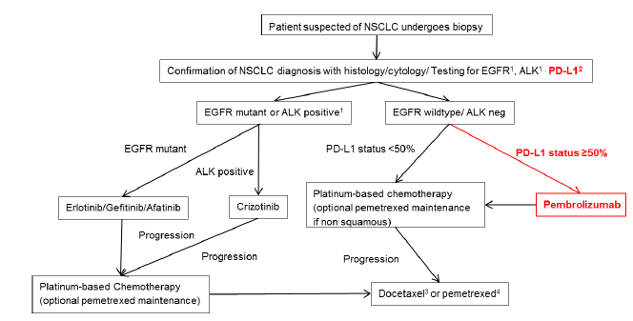
ALK = anaplastic lymphoma kinase; EGFR = epidermal growth factor receptor; NSCLC = non-small cell lung cancer; PD-L1 = programmed death ligand-1
¹ Non-squamous or not otherwise specified histologies only
² All histologies
³ Squamous or prior pemetrexed maintenance
⁴ Non-squamous if no prior maintenance therapy
Source: Figure A.5-2, p64 of the submission

  - The treatment algorithm for NSCLC is evolving rapidly and the potential for future use of PD-1/PD-L1 inhibitors, including in sequence and in combination with other agents, and with different (if any) prior application of PD-L1 testing, remains under investigation. The following are currently ongoing trials of pembrolizumab in the NSCLC first-line setting. The requirement for PD-L1 positivity is not consistent across these trials and the future first-line management of advanced NSCLC could include a combination of PD-1 inhibitors with chemotherapy:
- KN-042: Pembrolizumab versus platinum-based chemotherapy in PD-L1 TPS ≥1% NSCLC patients.
- KN-189: Pembrolizumab plus platinum-pemetrexed chemotherapy versus platinum-pemetrexed chemotherapy in patients with non-squamous NSCLC, regardless of PD-L1 status.
- KN-407: Pembrolizumab plus carboplatin + albumin-bound paclitaxel with carboplatin + albumin-bound paclitaxel in patients with squamous NSCLC, regardless of PD-L1 status.

- Comparator

  - The submission nominated platinum-based doublet chemotherapy as the main comparator. The ESC considered that this comparator is appropriate for initial first-line treatment of patients with Stage IV NSCLC who are EGFR wild type and ALK gene rearrangement negative. However, the ESC considered that the appropriate comparators for any retreatment would be docetaxel or pemetrexed in addition to platinum-based chemotherapy. The ESC also considered that, in clinical practice, the nominated comparator was likely to be displaced, rather than replaced by pembrolizumab.

  - The submission presented one direct randomised trial comparing pembrolizumab with platinum-based chemotherapy in previously untreated patients (KN-024). The submission did not include any evidence in support of the requested listing for retreatment with pembrolizumab in patients with progressive disease (i.e. as later-line therapy), for which the appropriate comparator would be second- or later-line chemotherapy (or best supportive care).

  - The submission did not nominate a specific platinum doublet regimen as a comparator, on the basis that the platinum-doublet chemotherapy regimens used in Australia are considered to produce similar outcomes. The KN-024 trial used platinum-pemetrexed combinations whereas in Australian clinical practice, pemetrexed combinations with platinum are not subsidised by the PBS (noting the current listing for pemetrexed does not exclude its use as maintenance).

For more detail on PBAC’s view, see section 7 “PBAC outcome”.

- Consideration of the evidence

Sponsor hearing
  - The sponsor requested a hearing for this item. A comparison with the key trial for first-line nivolumab in NSCLC was presented briefly in relation to the requested TPS threshold of ≥50%, and more extensively in relation to the practical implementation of the PD-L1 expression test in Australia. The PBAC therefore considered that the hearing was less informative than it might have been because it mostly related to matters for MSAC rather than PBAC consideration.

Consumer comments
  - The PBAC noted and welcomed the input from individuals (11), health care professionals (16) and organisations (4) via the Consumer Comments facility on the PBS website. The comments described a range of benefits of treatment with pembrolizumab including slowing of disease progression, modest side effects, improved quality of life, improved survival rates, reduced hospitalisations, and productivity impacts. The comments also noted the burden of financial hardships incurred by patients and their families in the absence of any subsidy of this class of expensive medicine.

  - The Medical Oncology Group of Australia (MOGA) also expressed its support for the pembrolizumab submission, on the basis of increased survival benefit and decreased toxicity. The PBAC noted that the MOGA presented the European Society for Medical Oncology Magnitude of Clinical Benefit Scale (ESMO-MCBS) in this context as being 5 (out of a maximum of 5, where 5 and 4 represent the grades with substantial improvement), based the KN-024 comparison of pembrolizumab with platinum-based chemotherapy.

Clinical trials
  - The key features of the included evidence are summarised in Table 1.

Table 1: Key features of the included evidence
Trial | N | Design/ duration | Patient population | Outcome(s) | Use in modelled evaluation
Direct comparison between pembrolizumab and platinum-based chemotherapy in PD-L1 positive ≥50% NSCLC
KN-024 | 305 | R (1:1), OL, MC  - Pembrolizumab 200 mg Q3W  - Platinum doublet  Stratification: by ECOG (0 vs 1), region (east Asia vs non East Asia) and histology (squamous vs non-squamous).  Retreatment with pembrolizumab was allowed in the protocolª  Patients were treated with pembrolizumab until disease progression or unacceptable toxicity.  Switching was allowed from chemotherapy to pembrolizumab^{b} | Treatment naïve PD-L1 highly positive (TPS ≥50%) Stage IV NSCLC with no evidence of EGFR gene mutation or ALK gene rearrangement | Primary:  PFS per RECIST 1.1 based on BICR review  Secondary:  OS, ORR, QoL, safety | Used
ª The eligibility criteria for retreatment in KN-024 were experienced disease progression after stopping their initial treatment with pembrolizumab due to attaining a confirmed complete response (CR), was treated for at least six months with pembrolizumab, and received at least two treatments with pembrolizumab beyond the date when the initial CR was declared; AND did not receive any anti-cancer treatment since the last dose of pembrolizumab; OR patients had stable disease (SD), partial response (PR) or CR and stopped pembrolizumab treatment after 24 months of study therapy for reasons other than disease progression or intolerability (Section 7.1.5.5, p90 KN-024 Protocol).
ALK = anaplastic lymphoma kinase; BICR = blinded independent central radiology; NSCLC =non-small cell lung cancer; ORR = objective response rate; ECOG = Eastern Cooperative Oncology Group; EGFR = epidermal growth factor receptor; MC = multi-centre; OL = open label; OS = overall survival; PFS = progression-free survival; QoL = Quality of life; Q3W = every three weeks; R (1:1) = randomised 1 to 1 ratio; TPS = tumour proportion score.
Source: compiled during the evaluation from the submission and the KN-024 clinical study report.

  - The trial protocol titles and citations of corresponding publications are summarised in Table 2.

Table 2: Trial and associated reports comparing pembrolizumab with chemotherapy as first-line treatment of NSCLC presented in the submission
Trial ID | Protocol title/ Publication title | Publication citation
KN-024 | Clinical Study Report KN-024  A randomized open-label Phase III trial of pembrolizumab versus (vs.) platinum based chemotherapy in first-line (1L) subjects with programmed cell death 1 ligand 1 (PD-L1) Strong Metastatic Non-Small Cell Lung Cancer (NSCLC). Data cut-off 9-May-2016. Median (range) follow-up of 11 months (6.3 to 19.7 months). CSR Identification P024V01MK3475  Publication  Reck, M, Rodriguez-Abreu, D, et al. Pembrolizumab versus chemotherapy for PD-L1–positive non–small-cell lung cancer. | Clinical Study Report 11 July 2016  New England Journal of Medicine, 2016. Published online on October 9.  DOI: 10.1056/NEJMoa1606774
Source: Table B.2.3, p76 of the main submission

  - In KN-024, as in another first-line NSCLC ongoing trial of pembrolizumab (KN-042), pembrolizumab was administered at a fixed dose of 200 mg every three weeks (Q3W) regardless of weight. This differs from previous later-line NSCLC pembrolizumab trials (such as the KN-010 and KN-001 studies) which used weight-based dosing regimens of pembrolizumab such as 2 mg/kg or 10 mg/kg Q3W.

  - The overall risk of bias associated with the included evidence is summarised in Table 3.

Table 3: Overall risk of bias/confounding associated with the included evidence KN-024
Direct comparison between pembrolizumab and platinum-based chemotherapy KN-024 (randomisation was stratified by region, histology and ECOG PS). | Low risk of bias for outcome of PFS (Independent assessment)  Unclear risk of confounding for OS depending on the type of statistical analysis. Although the ITT analysis might underestimate the OS benefit associated with pembrolizumab, the adjustment methods may overestimate the OS benefit. The ITT is likely to represent the most conservative estimate of comparative OS.  Safety and patient reported outcomes such as QoL: high risk of bias  Investigators (given the open-label design) would likely to have monitored the grade of immune-related events in the trial such as pneumonitis, diarrhoea and colitis (anticipation by a high risk for such events associated with immunotherapy) and could have implemented rapid measures to minimise or prevent more severe Grade 3/4 events occurring.
ECOG = Eastern Cooperative Oncology Group; ITT = intention-to-treat; OS = overall survival; PFS = progression-free survival; PS = performance status; QoL = quality of life
Source: Constructed during the evaluation

Comparative effectiveness
  - Although PFS was the primary outcome in KN-024, the secondary outcome of OS was more clinically relevant. However, the OS data was immature (median duration of follow-up of 11 months) and 44% of patients switched to pembrolizumab from platinum-based chemotherapy primarily upon progression, which may have confounded the results. Adjustment of OS for treatment switching and the resulting incremental cost-effectiveness ratios (ICERs) are presented in the economic evaluation section below (see Table 16).

  - Tables 4 and 5 summarise the PFS and OS results from the KN-024 trial. Figures 2 and 3 depict the corresponding Kaplan-Meier curves. Figure 4 depicts a forest plot of OS results by subgroup.

Table 4: Analysis of the primary outcome of PFS, based on BICR assessment per RECIST 1.1, ITT population
Treatment | Events  n/N (%) | Person-months | PFS Rate at  Month 12 (%)†  (95% CI) | Median PFSª, months  (95% CI) | HR^{b} (95% CI)  Pembro vs chemo  p-value^{c}
Pembrolizumab | 73/154 (47.4%) | 1000.2 | 47.7% (38.5%, 56.4%) | 10.3 (6.7, -) | 0.50 (0.37, 0.68)  p<0.001^{c}
Chemotherapy | 116/151 (76.8%) | 785.6 | 15.0% (8.6%, 23.0%) | 6.0 (4.2, 6.2)
Database cut-off date: 9 May 2016
− = not reached; BICR = blinded independent central radiologist review; CI = confidence interval; HR = hazard ratio; ITT = intention to treat; PFS = progression-free survival; RECIST = Response Evaluation Criteria in Solid Tumours
ª From product-limit (Kaplan-Meier) method for censored data.
^{b} Based on Cox regression model with treatment as a covariate stratified by geographic region (East Asia vs. non-East Asia), ECOG PS (0 vs. 1) and histology (squamous vs. non-squamous).
^{c} One-sided p-value based on log-rank test.
Source: Table B.6.1, p103 of the main submission Database

Table 5: Analysis of the secondary outcome of OS, ITT population
Treatment | Events  n/N (%) | Person-months | OS Rate at  Month 12 (%)†  (95% CI) | Median OSª, months  (95% CI) | HR^{b} (95% CI)  Pembro vs chemo  p-value^{c}
Pembrolizumab | 44/154 (28.6%) | 1402.0 | 69.9% (61.1%, 77.0%) | − (−, −) | 0.60 (0.41, 0.89)  p<0.001^{c}
Chemotherapy | 64/151 (42.4%) | 1227.5 | 54.2% (44.9%, 62.6%) | − (9.4, −)
Database cut-off date: 9 May 2016
− = not reached; BICR = blinded independent central radiologist review; CI = confidence interval; HR = hazard ratio; ITT = intention to treat; OS = overall survival; RECIST = Response Evaluation Criteria in Solid Tumours
ª From product-limit (Kaplan-Meier) method for censored data.
^{b} Based on Cox regression model with treatment as a covariate stratified by geographic region (East Asia vs. non-East Asia), ECOG PS (0 vs. 1) and histology (squamous vs. non-squamous).
^{c} One-sided p-value based on log-rank test.
Source: Table B.6.1, p103 of the main submission
Figure 2: Kaplan-Meier of PFS based on BICR assessment per RECIST 1.1, ITT Population
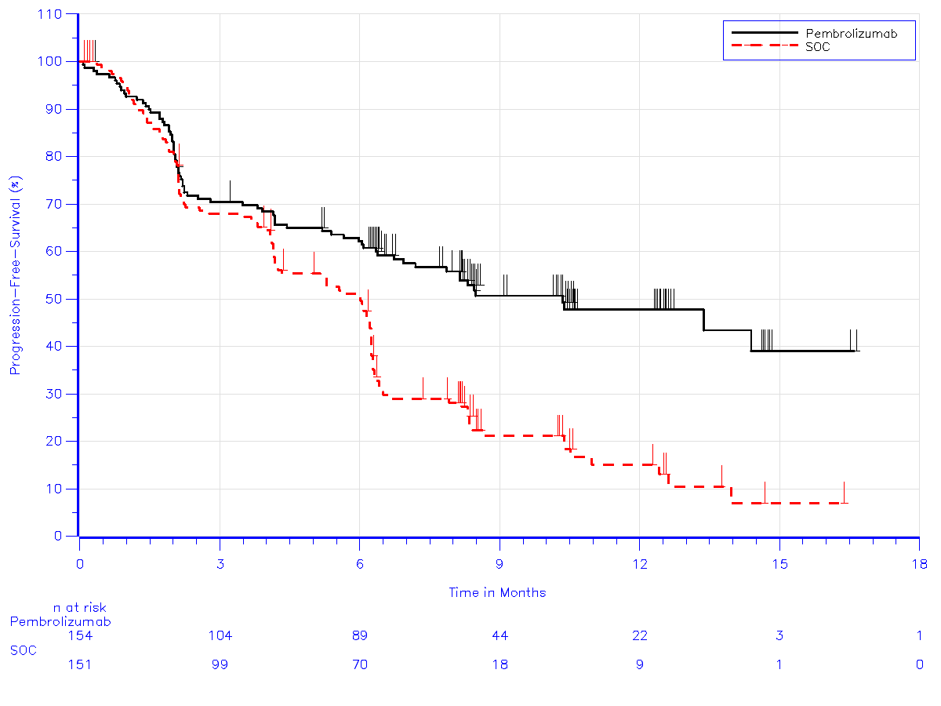
RECIST = Response Evaluation Criteria in Solid Tumours; ITT = intention to treat; PFS = progression-free survival; BICR = Blinded Independent 9 May 2016
Source: Figure B.6.1, p104 of the main submission

Figure 3: Kaplan-Meier of Overall Survival, ITT population
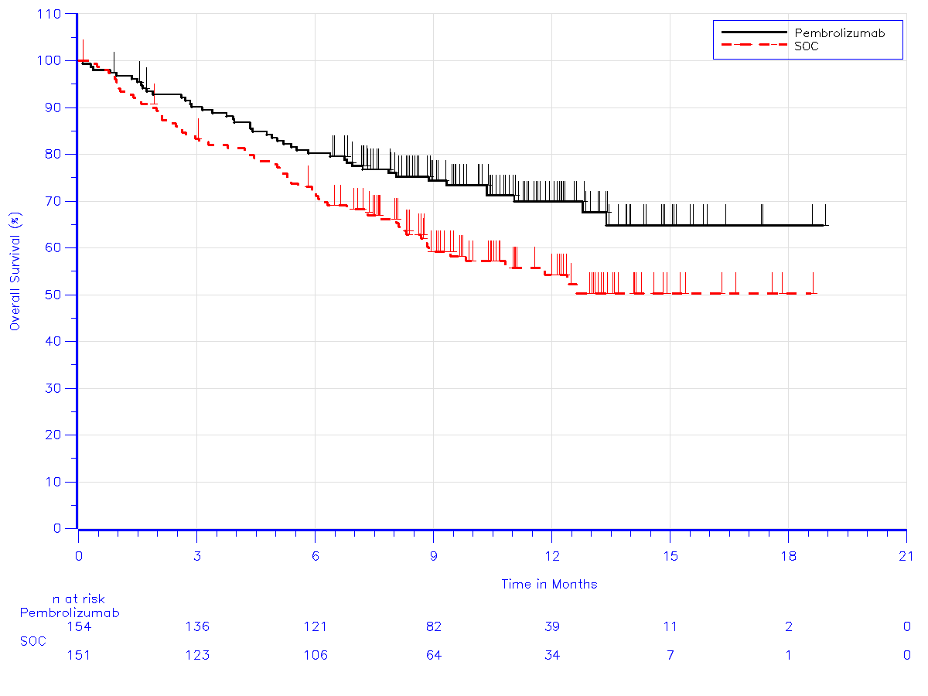
BICR = Blinded Investigators Central Review; SOC = Standard of Care (First-line platinum-based chemotherapy); OS = overall survival
Database cut-off date: 9 May 2016
Source: Figure B.6-2, p107 of the main submission

Figure 4: Forest plot of OS hazard ratio, by subgroup
'''''''''''''' '''''' '''''''''' '''''''''''''''''''''''' '''''''''''''' ''''''''' ''''''''''''''''''''' '''''' ''' '''''''''''''''''''''' '''''''''''''''''' '''''' '''''''''''''''''''''''' ''''''''''''''' '''''''''''' ''''''''''' ''''''' '''''''''''''''''''' ''''''''''''' ''''''''''''''' ''''''' ''''' ''''''' '''''' ''''''''' ''''''''''''''''''''' '''''''''''''''''''''''''' ''''''' '''''''''''''''''''''''''''''''''''''' ''''''''''''''''''''''' ''''''''''''''' ''''''''''' '''''' '''''''''' ''''''''''''
'''''' '''' '''''''''''''''''''''''' '''''''''''''''''' ''''''''' ''' ''''''''''''''''' '''''''''' ''''''''''' '''''''''''''''''''''''' '''''''''''''''''''''''''''''''''''' ''''''' '''''''''''''''''''''''''''''' '''''''''''''''''''''''''''''''
''''''''''''''''''' '''''''''''''' '''''''''''' ''''''''''' ''''' '''''''''''''''' ''''''''''''

  - PFS: A total of 189 progression events were reported at the time of data cut-off (9 May 2016). There was a statistically significant difference in median PFS (4.3 months; hazard ratio (HR) = 0.50; 95% CI 0.37, 0.68) as determined by blinded independent review, favouring pembrolizumab 200 mg Q3W compared to platinum-based chemotherapy. The PFS Kaplan-Meier curves separated early at approximately 4 months, with continuous separation between the two curves over the course of follow-up.

  - OS: A total of 108 deaths were reported at the time of data cut-off (9 May 2016). The median OS times were not reached for both arms. The HR was statistically significant favouring pembrolizumab 200 mg Q3W compared to platinum-based chemotherapy (HR = 0.60; 95% CI 0.41, 0.89). The OS Kaplan-Meier curves separated at approximately 1 month, with continuous separation between the two curves over the course of follow-up. The forest plot indicated the OS benefit favoured pembrolizumab for the majority of subgroups. Approximately 44% (66/151) of patients in the platinum-based chemotherapy arm had switched over to pembrolizumab on progression. The submission conducted multiple statistical analyses (inverse probability of censoring weights (IPCW), rank preserving structural failure time (RPSFT) and two-stage methods) to adjust the OS observed in the ITT analysis. These methods are well established and commonly used in the literature. However, the assumptions associated with these methods are difficult to test. The adjusted HRs should therefore be considered exploratory and the ITT HR remains the most conservative relative treatment effect. Treatment switching is further discussed in the economic evaluation section below.

  - The pre-PBAC response provided updated overall survival results (data cut-off 5 January 2017), extending the median duration of follow-up to 19.2 months (see also Figure 8). '''' ''''''' ''''''''''''''''''''''''''''' ''''''''''' ''''''''''''''''' '''''' '''''''''''''' '''' ''''''''' '''''''''''''''''''''''''''''' '''''''''' ''''''''''''''''''''' ''''' '''' '''''''''''' '''''''''''''''''''' '''''''' '''''''''''''''''''''''''' '''''''''''''''''''''''' '''''''''''''''''' '''''''''''''''''''' ''''''''''''''''''''''''''' '''' ''''''''''''''''' ''''''''''''''''''' '''''''''''''''' '''''''''''''''' ''''''''''' ''''''' '''''''''''' '''' '''''''''''''' ''''''''''''''''''''''' '''''''''''' '''''''''' ''''''' '''''''''''' '''''''''''''''''''''''' ''''''''''''''''''''''''''''''''''''' ''''''''' ''''''''''''''''''''' '''''''''''''''' ''''''' '''''''''' ''''''''''''''''''' '''''' ''''''' '''''''''''''''''''''''''''' ''''''''' ''''''''''' ''''''''''''''''' '''''''''''' ''''''' ''''''''' '''''''''''''' ''''''''' ''''''' ''''''' '''''''' ''''''''''''''''''''''''''''''''' ''''''''''' '''''''''' '''''''''''''''''''' '''''''' '''''' '''''''' '''''''''' ''''''''''''''''''''' ''''' '''''' ''''''''''' ''''''''''''' '''''' ''''''''''''' '''''''''''''.

  - The sponsor also separately provided a more extensive set of subgroup analyses of randomised trials of pembrolizumab in NSCLC (KN-010 and KN-024) to further assess whether varying age (<65 years, 65-74 years, 75-84 years) is associated with a variation in the effectiveness of pembrolizumab.

Comparative harms and extended assessment of comparative harms
  - Table 6 summarises the key AEs in all subjects as treated (ASaT) from the KN-024 trial.

Table 6: Summary of key AEs from KN-024 in all subjects as treated (ASaT)
Subjects | Pembrolizumab  N=154  n (%) | Platinum-chemo  N=150  n (%) | RD % Pembro minus platinum-chemo  (95% CI)^{b} | RR Pembro vs platinum-chemo  (95% CI)^{b}
At least 1 drug-related AE* | 113 (73.4) | 135 (90.0) | -16.6 (-7.9, -25.3) | 0.8 (0.7, 0.9)
Toxicity grade 3-5 drug-related AEs | 41 (26.6) | 80 (53.3) | - 26.7 (-15.7, -37.7) | 0.5 (0.4, 0.7)
Serious drug-related AEs* | 33 (21.4) | 31 (20.7) | 0.8 (-8.4, 9.9) | 1.0 (0.7, 1.6)
Deaths due to drug-related AE* | 1 (0.6) | 3 (2.0) | - | -
Discontinuations due to  - drug-related AE* | 11 (7.1) | 16 (10.7) | -3.5 (-9.9, 2.9) | 0.7 (0.3, 1.4)
- serious drug-related AE* | 10 (6.5) | 7 (4.7) | 1.8 (-7.0, 3.3) | 1.4 (0.5, 3.6)
AEOSIª  - drug-related AE*  - serious drug-related AE* | 39 (25.3)  16 (10.4) | 3 (2.0)  1 (0.7) | 23.3 (16.1, 30.5)  9.7 (4.7, 14.7) | 12.6 (4.0, 40.1)  15.6 (2.1, 116.0)
Grade 3 or 4 Immune mediated pneumonitis∞ | 4 (2.6) | 1 (0.7) | 1.9 (-0.9, 4.8) | 3.9 (0.44, 34.5)
Database cut-off date: May 2016.
* Drug-related AEs were determined by the investigator to be related to the drug.
∞Table 3 of Reck et al (2016) stated that these AEs were not necessarily attributed to study drug. However, these AEs are reflective of the mechanism of pembrolizumab)
AEOSI = adverse event of special interest; ASaT = All patients as treated defined as all patients who received at least one dose of a trial treatment; AE = adverse event; CI = confidence interval; RD = risk difference; RR = relative risk
ª Analyses of AEOSIs were based on a specific list of AE terms pre-identified by Merck as AEOSI. This list was not presented in the current KN-024 CSR, but it represents potentially immune related AEs across several System Organ Classes examined in the pembrolizumab program.
AEs were followed up for 30 days after last dose of study treatment
Serious AE were monitored for at least 90 days after last dose.
^{b} RD and RR calculated during the evaluation
Source: Table B.6-12, p119 and Table B.8-1, p145 of the submission

  - The proportion of patients with any Grade 3, 4, or 5 treatment-related AE in the chemotherapy treatment arm was almost twice that in the pembrolizumab treatment arm (53.3% vs 26.6%). Serious treatment-related adverse events were similar between treatment arms. Adverse events of special interest (AEOSI) that were related to the study drug were significantly higher in the pembrolizumab treatment arm compared to the chemotherapy treatment arm for both serious and non-serious events (25.3 % vs 2.0%; risk difference (RD) = 23.3%; 95% CI: 16.1, 30.5) and for only serious events (10.4% vs 0.7%; RD = 9.7%; 95% CI: 4.7, 14.7). There was a higher proportion of patients in the pembrolizumab treatment arm, compared to the chemotherapy treatment arm, with any immune-mediated AE of any grade (29.2% vs 4.7%) or a Grade 3 or 4 immune-mediated AE (9.7% and 0.7%). Any grade pneumonitis and a Grade 3 or 4 pneumonitis occurred in approximately 6% and 3% of patients, respectively, in the pembrolizumab treatment arm compared to 1% in the chemotherapy arm.

  - Overall, immune-mediated AEs occurred more frequently with pembrolizumab treatment whereas cytopenias, decreased appetite, nausea and fatigue occurred more frequently with chemotherapy treatment. The safety data from KN-024 appear consistent with the mechanism of action for each therapy. The ESC considered that immune-mediated AEs are expected of PD-L1 inhibitors and therefore can mostly be pre-empted and managed accordingly in clinical practice.

Benefits/harms
  - Table 7 summarises the comparative benefits and harms for pembrolizumab 200 mg Q3W versus platinum-based chemotherapy, for a median duration of follow up of approximately 11 months in first-line NSCLC patients who have evidence of a high level of PD-L1 expression (TPS ≥50%).

Table 7: KN-024: Comparative benefits for pembrolizumab 200 mg Q3W vs chemotherapy in the first-line setting (PD-L1 TPS ≥50%)
 | Pembrolizumab | Platinum-based chemotherapy | Absolute difference |  | HR (95% CI)
Benefits
Median PFS,  months (95% CI) | N=154  10.3 (6.7, -.) | N=151  6.0 (4.2, 6.2) | 4.3 |  | 0.50  (0.37, 0.68)
Median OS,  months (95% CI)ª | N=154  − (−, −) | N=151  − (9.4, −) | - |  | 0.60  (0.41, 0.89)
Harms
 | Pembrolizumab | Platinum-based chemotherapy | Event rate/100 patients |  | RD  (95% CI)
 |  |  | Pembrolizumab | Chemotherapy
Treatment related^{b} AEs  - Any Grade  - Grade 3, 4 or 5 | 113/154  41/154 | 135/150  80/150 | 73.4  26.6 | 90.0  53.3 | -16.6 (-25.1, -8.1)  -26.7 (-37.3, -16.1)
Immune mediated AEs  - Any Grade  - Grade 3,4 or 5  - Pneumonitis | 45/154  15/154  4/154 | 7/150  1/150  1/150 | 29.2  9.7  2.6 | 4.7  0.7  0.7 | 24.5 (16.6, 32.5)  9.0 (4.2, 13.9)  1.9 (-0.9, 4.8)
ª (Database cut-off date: May 9, 2016; median duration of follow up of 11.2 months (range 6.3 to 19.7 months). OS data remain immature
^{b} Events were attributed to treatment by the investigator and indicated by the investigator on case-report form
– = median not reached; AE = adverse event; HR = hazard ratio; RD = risk difference; CI = confidence interval; PD-L1 = programmed death ligand-1
Source: Compiled during the evaluation from effectiveness and safety data presented in the submission

  - On the basis of the direct evidence presented in the submission for untreated NSCLC Stage IV patients given treatment with pembrolizumab instead of first-line platinum-based chemotherapy for a median duration of 11 months:
- There was a statistically significant overall survival benefit associated with pembrolizumab over chemotherapy, but the data remain immature as the difference in median overall survival is unknown. The risk of death over 11 months was reduced by almost 40%. There was also a statistically significant increase in progression-free survival (difference in medians of approximately 4 and a half months);
- For every 100 patients, 27 fewer patients would experience a drug-related Grade 3–5 AE, but an additional 9 patients may experience a Grade 3, 4 or 5 immune mediated AE. The risk of these immune-mediated events may be higher in clinical practice than that observed during the trial.
This conclusion applies to patients with tumours which do not have an activating EGFR gene mutation or ALK gene rearrangement, but have high expression levels of PD-L1 (TPS ≥50%).

Clinical claim
  - The submission claimed that pembrolizumab is superior to standard of care (platinum doublet chemotherapy), in terms of both comparative effectiveness and comparative safety, in patients with advanced previously untreated NSCLC whose tumours meet the molecular and immunohistochemical profile described above. This claim is adequately supported based on the available data from Trial KN-024 (data-cut-off May 2016). The data remain immature and extended OS data beyond the latest cut-off (5 January 2017) date would be informative. Compared to its comparator, pembrolizumab was superior in terms of ≥Grade 3 haematologic AEs, but was associated with a higher frequency of immune-mediated AEs. Few of these were ≥Grade 3 events presumably due to close monitoring in an open-label experimental setting. Where these events can be managed promptly in clinical practice (i.e. before worsening to ≥Grade 3 events), pembrolizumab can be considered to be superior in terms of safety. The KN-024 trial currently lacks adequate data to support the effectiveness of retreatment with pembrolizumab after disease progression as proposed by the requested restriction.

  - The PBAC considered that the claim of superior comparative effectiveness was reasonable.

  - The PBAC considered that the claim of superior comparative safety was reasonable.

Claim of co-dependence
  - The submission claimed that treatment guided by PD-L1 status, where PD-L1 strong positives (i.e. TPS ≥50%) are treated with pembrolizumab, and PD-L1 negatives (i.e. TPS <1%) and weakly positives (i.e. TPS 1‒49%) are treated with platinum-based chemotherapy, results in improved outcomes versus the comparator of no testing and platinum-based chemotherapy. This was based on the submission’s conclusions that:
- the test is accurate,
- there is no prognostic impact of PD-L1 status (therefore patients with TPS ≥50% in the trial treated with platinum-based chemotherapy can reasonably approximate an unselected population treated with platinum-based chemotherapy),
- pembrolizumab has improved effectiveness and improved or non-inferior safety, when compared to platinum-based chemotherapy and
- that there is treatment effect variation by PD-L1 status.
The argument presented to support treatment effect modification by PD-L1 status in treatment-naïve patients was not well supported. The evidence presented included single-arm studies (in which the prognostic effect could not be distinguished from the treatment effect) and studies which included both treatment-naïve and treatment-experienced patients. Recently presented data from the nivolumab first-line NSCLC CheckMate 026 trial did not demonstrate treatment effect modification of nivolumab by PD-L1 status.

  - MSAC and PBAC have raised the following important concerns regarding a previous pembrolizumab codependent submission for later-line NSCLC (MSAC Public Summary Document (PSD) Application 1414, November 2016 and Item 6.05 November 2016 PBAC Meeting). These concerns have relevance to the current pembrolizumab codependent submission for first-line NSCLC.
- PD-L1 IHC as a companion diagnostic test has weak evidence of clinical validity (lacks ability to predict response to therapy) and clinical utility (insufficient information to guide treatment).
- The issue of the optimum threshold for PD-L1 positivity remained unresolved. For this current submission, nominating a TPS ≥50% threshold was not justified with a biological basis, and no data were presented to assess clinical utility across patients with first-line NSCLC varying TPS thresholds. In particular, the key trial in the current codependent submission, KN-024, only enrolled patients with a TPS ≥50% and so the treatment effect of pembrolizumab in patients with a TPS <50% could not be established. PD-L1 expression testing was proposed as a means to narrow the population, and therefore, may exclude patients who express lower levels of PD-L1 expression who may benefit from pembrolizumab treatment.
- Unlike many other companion tests, PD-L1 has a wide range of expression and hence the results reported are not dichotomous and are challenging to quantify.
- The Royal College of Pathologists of Australasia (RCPA) does not currently endorse the use of PD-L1 testing as a biomarker to exclude patients from therapy.
- If other programmed death 1 (PD-1)/PD-L1 inhibitors become listed in the PBS for NSCLC in the future that also require PD-L1 testing, the required TPS threshold for eligibility may vary, i.e. with a lower or higher TPS threshold than the 50% requested for pembrolizumab.

Economic analysis
  - A modelled economic evaluation, in terms of incremental cost per life year gained and incremental cost per quality-adjusted life year (QALY) gained, was presented based on the claim of superior effectiveness and safety compared to platinum-doublet chemotherapy in treatment-naïve NSCLC patients who expressed high levels of PD-L1 (TPS ≥50%). The submission presented an ICER of $45,000/QALY - $75,000/QALY based on OS and PFS outcome data from the KN-024 trial, extrapolated to 7 years duration (from median 11 months in the trial) and utility weights from the KN-024 trial. The PSCR changed various economic modelling assumptions as detailed in Table 8.

Table 8: Differences in economic modelling between the submission and PSCR
Model variables | Submission | PSCR
Cost per 50 mg vial | $''''''''''''' | $'''''''''
Time horizon | 7 years | 6 years
Treatment switching | Two-stage treatment cross over adjustment | ITT + second-line immunotherapy ($''''''''''/100 mg vial)
Extrapolation | Log-logistic | Exponential
Cost of pemetrexed | Full price | 85% discount (per April 2017 price reductions)
ICER | $''''''''''''''''/QALY | $'''''''''''''''/QALY (see paragraph 6.25)  Revised: $''''''''''''''''/QALY (see Table 15)
Source: p1, PSCR

  - The PSCR stated that the revised model resulted in an ICER of $45,000/QALY - $75,000/QALY gained, however, the ESC noted that the revised economic modelling workbook accompanying the PSCR presented an ICER of $45,000/QALY - $75,000/QALY gained.

  - The evidence presented in the submission adequately supported the type of economic evaluation presented. However, the data from the KN-024 trial are immature (median OS had not been reached for patients treated with pembrolizumab or platinum-doublet chemotherapy), leading to a proportionately large reliance on extrapolated outcomes. The ESC considered that the submission’s inclusion of retreatment in the economic evaluation was not reasonable as there was no evidence to support the clinical effectiveness of this approach.

Translation issues
  - Translation issues identified by the submission are presented in Table 9.

Table 9: Translation issues identified by the submission
Issue | Results
Applicability premodelling studies
Applicability of trials | The submission identified no differences between patients enrolled in the trial and the proposed PBS population. Study results were directly applied to the modelled evaluation. The initially proposed population eligible for pembrolizumab was broader than the KN-024 trial population, in terms of ECOG PS (no restriction vs 0-1) and stage of disease (Stage IIIB/IV vs Stage IV). The PSCR revised the eligible population to include only patients with Stage IV disease and with a PS of 0 or 1.
Prognostic effect of PD-L1 | The submission did not identify a clear prognostic effect of PD-L1 status in the literature. The submission assumed similar efficacy of platinum-doublet chemotherapy in PD-L1 positive and negative populations. This may be reasonable, however absence of evidence for a prognostic effect is not definitive evidence that no effect exists, and this remains an issue of uncertainty.
Prevalence of PD-L1 positivity | The literature review identified one Australian study that reported prevalence of TPS ≥50% in early (Stage I-III) NSCLC (7.4%) and one Danish study in advanced patients (25%). Prevalence in Australian patients screened for KN-024 was also reported (28.5%), and across all patients screened for KN-024 (28.9%). Prevalence reported in Australian patients screened for KN-024 was used in the economic model. This may be reasonable if the same antibody used in the KN-024 trial is used in clinical practice, and if the test performs in practice as in the trial. However, caution is required when extrapolating the benefit observed in TPS ≥50% patients from the KN-024 to TPS ≥50% patients identified using different PD-1/PD-L1 antibodies that may be used in clinical practice. Furthermore, as the proposed MBS item descriptor did not specify disease stage for PD-L1 testing, should patients with earlier stage disease uptake PD-L1 testing and, if these patients have a lower prevalence of TPS ≥50%, as observed in the study of early stage NSCLC, lower estimates of prevalence may be observed than those modelled in the submission.
Comparison of first-line NSCLC regimens that do and do not include pemetrexed | The systematic review concluded similar efficacy between regimens that do and do not include pemetrexed. The economic model used the overall data from the comparator arm of KN-024. This was consistent with the previous PBAC consideration.
PD-L1 status as treatment effect modifier | The submission claimed that PD-L1 status is a treatment effect modifier based on the plausibility of treatment effect variation and quantitative analysis to demonstrate treatment effect variation. The argument presented to support treatment effect modification by PD-L1 status in chemotherapy-naïve patients was not well supported.
Comparison of the different pembrolizumab doses used in NSCLC trials. | The submission stated that the pembrolizumab 2 mg/kg and 10 mg/kg doses were similar to the pembrolizumab 200 mg fixed dose. Data from KN-001 was used in the model to estimate the relative efficacy of pembrolizumab in the PD-L1 negative population. Less overlap was observed in AUC between the pembrolizumab 10 mg/kg dosing and either the 2 mg/kg dose or 200 mg fixed dose. This may be consistent with the clinical evidence from KN-010 (later-line NSCLC) where patients randomised to pembrolizumab 10 mg/kg experienced longer median OS benefit (17.3 months) compared to those randomised to pembrolizumab 2 mg/kg (14.9 months). Given that the majority of patients in KN-001 received pembrolizumab 10 mg/kg doses (94%), there may be some uncertainty in the applicability of these data to inform outcomes with pembrolizumab treatment in PD-L1 negative (TPS <50%) patients.
Applicability of trial PD-L1 testing to clinical practice | The submission concluded that while there were differences between PD-L1 testing in the trial and as proposed in clinical practice, in terms of timing and type of tissue sample and antibody used, the results from KN-024 would be used in the base case economic evaluation, and would be tested in sensitivity analyses. This was reasonable.
Extrapolation premodelling studies
Extrapolation of PFS and OS | Kaplan-Meier data were used in the model up to selected time points which varied for PFS and OS, and by treatment arm. For OS, these were determined by Chow tests – week 32 for pembrolizumab, and week 25 for platinum-doublet chemotherapy (compared to 48 weeks median follow-up). This was not consistent with the preferred approach to use all reliable empirical data. Further, little information was provided in the submission regarding how the Chow tests were performed. No justification was provided for the time point selected for PFS (week 27 for both treatment arms). Beyond these points, the OS and PFS curves from KN-024 were extrapolated separately by treatment arm, as the proportional hazards assumption did not hold. The OS data from KN-024 were immature (35.4% of patients had died: 28.6% in pembrolizumab arm and 42.4% in the platinum-based chemotherapy arm) – extrapolation of immature data may not be appropriate. Parametric models were fitted to the data remaining after the chosen time point. Long-term extrapolation should primarily be based on data that is regarded as reliable (e.g. with respect to sample size). Therefore, some overlap between the empirical data used in the model and the data informing the extrapolated curve may be reasonable. It may be justified to fit long-term survival to the latter part of the survival curve (i.e. no overlap of the empirical data used in the model and the data used to fit the extrapolation) in circumstances where the alternative approach yields a poor fit, however this should be demonstrated.  Parametric model selection was based on the AIC and BIC for assessing the best fit of the data and clinical plausibility of results. The submission selected the log-logistic model to extrapolate OS with pembrolizumab. This was inadequately justified, as it was not the best fit for the clinical data or by AIC or BIC. This selection projected optimistic survival at seven years (20% of patients in the pembrolizumab arm still alive). The ESC also advised that the time point selected to truncate trial data was not adequately justified nor was it consistent with the preferred approach to use empirical data in the model.  The PSCR argued that the time points nominated in the model were methodologically robust. It stated that the Chow test was used to assess the structural changes to the slope of the cumulative hazard curves. The time point with the most pronounced change to the slope of the cumulative hazard curve was selected as the cut point. Chow tests were performed on a sequence of F-tests for a sequence of cut-off point candidates (starting from week 5 and proceeding at weekly intervals until the end of the trial). The F-tests were based on the null hypothesis (the whole survival curve fit one piece exponential curve) versus the alternative hypothesis (the survival curve is fitted by a two-piece exponential curve with the specific cut-off point). The ESC considered that application of the Chow test would only be appropriate if the “structural changes” of the model slope were known a priori. Therefore, given the submission applied the Chow test as a post-hoc analysis, the ESC considered that this was an inappropriate argument for statistical support, and that the selected cut points were likely chosen to maximize the OS difference.
Time horizon | The submission claimed that patients receiving immunotherapies have been shown to have improved survival patterns compared to those receiving chemotherapies and that a five-year time horizon would be likely to artificially truncate model outcomes. A seven-year time horizon was used in the base case analysis. While survival with pembrolizumab at seven years was projected to be 20%, if the extrapolation is considered to be overly optimistic, then a five-year time horizon may still not sufficiently converge the modelled outcomes. Further, this selection was not consistent with previous submissions to the PBAC in the context of first-line NSCLC (five years).  The PSCR revised the time horizon to 6 years.
Adjustment for treatment switching | The submission claimed that the ITT OS analysis appeared to overestimate survival in the platinum-doublet chemotherapy trial arm. The RPSFT, IPCW and two-stage methods of adjustment for treatment switching were considered, and the two-stage method was used in the base-case economic evaluation. Given the uncertainties associated with the adjustment methods, the ITT analysis is more reasonable in the base case analysis. The need to adjust for OS from KN-024 would also depend on the outcomes of current PBAC considerations of PD-1 inhibitors in the later-line NSCLC setting.  The PSCR revised the economic analysis to use the ITT in the base case, which included an assumption that second-line immunotherapy will be used by 43.7% of patients.
Modelling treatment duration | A maximum treatment duration of 24 months was proposed for pembrolizumab use as the submission claimed that PD-1 inhibitors have a durable response after treatment cessation, based on data in melanoma and later-line NSCLC patients. The applicability of these data is uncertain given the differences in indication and setting. The maximum treatment duration was modelled only in terms of cost as extrapolated PFS and OS data were not adjusted to take treatment cessation into account. At two years, 24% of patients remained in the progression-free health state. It may not be reasonable to assume OS and PFS extrapolated from the trial, where median duration of treatment was seven months and where few patients had stopped pembrolizumab treatment due to complete response or maximum treatment duration, would apply to the context where treatment ceases.  KN-010 (later-line NSCLC) data were used to inform the proportion of patients in the model who would receive retreatment (5.3%). This was modelled in terms of costs only. There is no evidence on the clinical effectiveness of retreatment with pembrolizumab after disease progression nor on the applicability of the estimate used in the model, given the limited follow-up and setting (later-line NSCLC).
Transformation premodelling studies
Utilities | Utility weights from KN-024 mapped to Australian values for pembrolizumab and platinum-doublet chemotherapy were observed to be comparable to utility weights identified for NSCLC patients in the literature. Trial-based utilities mapped to Australian values, by treatment and progression status, were used in the economic model. This was a reasonable approach, however the average utilities may be overestimated given they more strongly reflect patient questionnaires at a relatively early time within each health state, which would favour pembrolizumab.
Resource utilisation for disease management | Ongoing healthcare utilisation costs were drawn directly from the PIVOTAL study. This may be a reasonable approach, however, the PIVOTAL data may have limited applicability to estimating resource utilisation in patients who receive best supportive care (estimated in the model to be 55% of those who progress), as resource utilisation in PIVOTAL was only measured in patients on active treatment.
AIC = Akaike Information Criterion; AUC = area under curve; BIC = Bayesian Information Criterion; ECOG = Eastern Cooperative Oncology Group; ICER = incremental cost-effectiveness ratio; IPCW = inverse probability of censoring weights; ITT = intention-to-treat; NSCLC = non-small cell lung cancer; OS = overall survival; PBAC = Pharmaceutical Benefits Advisory Committee; PBS = Pharmaceutical Benefits Scheme; PD-L1 = programmed death-ligand 1; PFS = progression-free survival; PS = performance status; RPSFT = rank preserving structural failure time method; TPS = tumour proportion score.
Source: Table C.5-1, pp235-238 of the submission.

Modelled evaluation
  - The submission presented a two phase modelled economic evaluation for patients with Stage IIIB/IV NSCLC where PD-L1 status was determined in the ‘Testing phase’; and treatment was guided by PD-L1 status in the ‘Treatment phase’. Each sub-cohort of patients (by PD-L1 status and treatment) entered a Markov model, where three health states were possible: progression-free; progressive disease; and dead.

  - The comparator in the ‘Testing phase’ was no PD-L1 testing, while that in the ‘Treatment phase’ was platinum-doublet chemotherapy.

  - The key structural features of the model are presented in Table 10.

Table 10: Key structural features of the model
 | Summary | Able to be varied? | Appropriate?
Duration | 7 years, revised to 6 years in the PSCR. | Yes | A 5-year time horizon may be more appropriate.
Cycle length | 1 week | No | A 1-week cycle length may be reasonable, however a three-week cycle could be more appropriate, as this is consistent with time between treatment administrations.
When tested | At diagnosis of advanced disease | No | Alternative scenarios for the timing of the test should also have been presented in scenario analyses.
Who tested | Stage IIIB/IV NSCLC | No | This may not be reasonable given that the submission has proposed that testing occur at diagnosis of NSCLC (any stage).
Outcomes | QALYs, LYs | Yes | Yes
Methods used to generate results | Markov model. Cohort expected value analysis | No | Yes
Health states | Progression-free, progressive disease and dead | No | Yes
Transition probabilities | Based on PFS and OS from KN-024 and extrapolated to seven years (revised to six years in the PSCR) using parametric distributions modelled to treatment arms separately, as the proportional hazards assumption did not hold.  In the base case analysis, OS with platinum-doublet chemotherapy was adjusted for treatment switching observed in the KN-024 trial. | Yes | It is not reasonable to adjust for treatment switching in the base case analysis given the uncertainties associated with the adjustment methods.  The selection of log-logistic distribution to extrapolate OS in the pembrolizumab arm may be overly optimistic.  The PSCR revised the economic modelling to use of the ITT analysis, which includes an assumption that second-line immunotherapy will be used by 43.7% of patients, and the OS extrapolation was changed to exponential.
LY = life year; NSCLC = non-small cell lung cancer; OS = overall survival; PD-L1 = programmed death-ligand 1; PFS = progression-free survival; QALY = quality-adjusted life year; TPS = tumour proportion score.
Source: Compiled during the evaluation

  - The model presented in the submission was structurally sound.

  - Variables used in the economic model are presented in Table 11.

Table 11: Variables in the economic model
Variable | Base case value | Source | Tested in sensitivity analyses?
Test cost | $74.50 | Based on MBS item 72848 | No.
Re-biopsy | 0% | Assumption | Yes (10% re-biopsy rate; assuming 22% adverse events)
Prevalence | '''''''''''% | % Australian patients with TPS ≥50% PD-L1 expression screened for KN-024 | Yes (18.5% – 38.5%)
Test performance | Sensitivity: 100%  Specificity: 100% | Evidentiary standard (22C3 antibody) is one of the tests that could be used in practice | Yes, agreement with SP263 antibody
Baseline risk by PD-L1 status | No difference | Systematic review | No
Treatment effect v platinum-doublet chemotherapy  (in trial period) | Per trial | KN-024 | No
Treatment effect v platinum-doublet chemotherapy  (extrapolated) | Per trial, extrapolated treatment arms separately. OS curves do not converge within model time horizon | Section C.3.1 of the submission | Yes – different distributions tested
Utilities: progression-free | Pembrolizumab: 0.78  Chemotherapy: 0.74 | KN-024, mapped to Australian algorithm | Yes (by time-to-death)
Utilities: progressive-disease | Pembrolizumab: 0.67  Chemotherapy: 0.69 | KN-024, mapped to Australian algorithm | Yes (by time-to-death)
OS = overall survival; PD-L1 = programmed death-ligand 1; PFS = progression-free survival; TPS = tumour proportion score.
Source: Compiled during the evaluation

  - The key drivers of the model are presented in Table 12.

Table 12: Key drivers of the model
Description | Method/Value | Impact
Pembrolizumab treatment duration | The submission applied a maximum duration of pembrolizumab treatment of two years (with some retreatment). This was applied in terms of costs only. Extrapolated PFS and OS data were not adjusted to take treatment cessation into account. It may not be reasonable to assume that OS and PFS extrapolated from the trial, where few patients have stopped pembrolizumab treatment due to complete response or maximum treatment duration, would apply to the context where treatment stops. There are no direct data from KN-024 to inform on retreatment. | High, favours PD-L1/pembrolizumab
Extrapolation of pembrolizumab OS | Based on immature data (only 28.6% of patients randomised to pembrolizumab have died) leading to uncertainty in the modelled estimates. The selection of the log-logistic model in the base case analysis may overestimate long-term survival. The PSCR revised the extrapolation to an exponential model. | Moderate, favours PD-L1/pembrolizumab
Time horizon | 7 years, revised to 6 years in the PSCR. | Moderate to high, favours PD-L1/pembrolizumab
OS = overall survival; PD-L1 = programmed death-ligand 1.
Source: Compiled during the evaluation

  - The results of the economic evaluation presented in the submission are presented in Table 13.

Table 13: Results of the economic evaluation
Component | PD-L1/pembrolizumab | Platinum-doublet chemotherapy | Increment
Costs | $'''''''''''''''' | $'''''''''''''''' | $'''''''''''''''
LYs | 1.69 | 1.27 | 0.42
QALYs | 1.21 | 0.91 | 0.30
Incremental cost/extra LY gained |  |  | $''''''''''''''
Incremental cost/extra QALY gained |  |  | $'''''''''''''
LY = life year; PD-L1 = programmed death-ligand 1; QALY = quality-adjusted life year.
Source: Constructed during the evaluation from Table D.5-8, p278 and FINAL_Pembrolizumab Section D Workbook 1L NSCLC Australia.xlsm of the submission.

  - The PSCR presented a revised ICER ($45,000/QALY - $75,000/QALY), which was based on the OS of platinum-doublet chemotherapy which had not been adjusted for treatment switching (i.e. ITT analysis). However the Kaplan-Meier data used was that which was adjusted using the two-stage method. While this was identified during the evaluation of the submission, and where relevant, analyses revised, the PSCR did not correct for this in the respecified analysis presented in the PSCR. As this now affects the base case, all scenario and sensitivity analyses in Tables 16, 17 and 18 have been revised to correct for this.

  - Verification of the PSCR’s revised ICER is presented in Table 14.

Table 14: Stepped economic analysis based on revisions presented in the PSCR
Analysis |  | ICER
1 | Base case ICER from the major submission | $''''''''''''''
2 | 1 + exponential extrapolation of pembrolizumab OS | $''''''''''''''''''
3 | 2 + time horizon 6 years | $'''''''''''''''
4 | 3 + treatment switching changed to ITT analysis | $''''''''''''''''''
5 | 4 + costs for post-progression treatment with immunotherapy amended | $''''''''''''''''
6 | 5 + pemetrexed 85% discount | $''''''''''''''''
 | 5 + pemetrexed 85% discount (corrected for error)ª | $'''''''''''''''
7 | 6 + pembrolizumab cost $''''''''' per 50 mg vial | $''''''''''''''''
 | 6 (corrected) + pembrolizumab cost $'''''''''' per 50 mg vial | $''''''''''''''''
ª In estimating the revised treatment course cost of pemetrexed, the PSCR only multiplied the administration costs by the number of administrations, rather than both the pemetrexed and administration costs.

The redacted table shows ICERs in the range of $45,000/QALY - $75,000/QALY to $75,000/QALY - $105,000/QALY.

  - The PSCR revised the cost per treatment course of later-line immunotherapy from $'''''''''''''''' to $''''''''''''''''''''''. This was based on three changes:
- The number of 50 mg vials per administration (from 3.38 to 4.46), assuming an increase in the average dose of from 169 mg to 223 mg. This was based on the average dose of nivolumab reported in the squamous NSCLC PBAC PSD (March 2016).
- The number of administrations (from '''' to '''''''), based on data from KN-001. It was unclear whether this data was based on all patients in KN-001 (which included treatment-experienced and -naïve patients).
- The cost per vial of pembrolizumab/nivolumab (from $'''''''''''''' per 50 mg vial to $''''''''' per 100 mg vial).

  - Additional scenarios of test accessibility were explored during the evaluation (compared to standard of care). These are presented in Table 15.

Table 15: ICERs and considerations of various testing/treatment funding scenarios
 | ICER
Base case  - MSAC funded test: testing at diagnosis of NSCLC (any stage)  - Highly positive patients (TPS ≥50%) eligible for pembrolizumab  - Maximum treatment duration for initial pembrolizumab course, 24 months  Revised | $'''''''''''''''/QALY  $''''''''''''''/QALY
Scenario 1: Pembrolizumab treatment until progression | $''''''''''''''''''''''/QALY
Scenario 2: Pembrolizumab eligibility not restricted by PD-L1 status (i.e. no testing) ª | $''''''''''''''''''''/QALY
Scenario 3: Testing of archived sample on diagnosis of advanced disease^{b} | $'''''''''''''''/QALY
Scenario 4: Testing of rebiopsied material on diagnosis of advanced disease^{c} | $'''''''''''''''/QALY
Note: Analyses in italics have been revised to correct 1) the Kaplan-Meier data used in the submission’s chemotherapy ITT analysis (which used two-stage adjusted data); and 2) the treatment course cost of pemetrexed (which did not multiply the drug cost per administration by the number of administrations).
ª As KN-024 did not enrol patients with TPS <50%, the submission estimated health outcomes in these patients with pembrolizumab treatment using the OS and PFS HRs of pembrolizumab treatment in patients who expressed high levels PD-L1 (TPS ≥50%) compared to those who weakly expressed or did not express PD-L1 (TPS <50%) from treatment-naïve patients in KN-001.
^{b} Sample retrieval costs were applied in 48.5% of patients who received a diagnosis at earlier stage of disease (based on an analysis of Victorian cancer registry data¹ reported that 51.5% of NSCLC patients were Stage IV at diagnosis). A sample retrieval cost of $150.00 was applied, based on the proposed MBS fee, MSAC Application 1331.
^{c} A 48.5% re-biopsy rate was applied to reflect re-biopsy and subsequent testing in patients who received a diagnosis at earlier stage of disease (based on an analysis of Victorian cancer registry data¹ reported that 51.5% of NSCLC patients were Stage IV at diagnosis).
ICER = incremental cost effectiveness ratio; NSCLC = non-small cell lung cancer; QALY = quality-adjusted life year.
Source: Constructed during the evaluation

The redacted table shows ICERs in the range of $45,000/QALY - $75,000/QALY to $105,000/QALY - $200,000/QALY.

  - A Markov trace depicting the proportion of patients alive per cycle compared to KN-024 Kaplan-Meier OS data is presented in Figure 5.

Figure 5: Markov trace, modelled proportion patients alive, compared to KN-024 Kaplan-Meier OS data
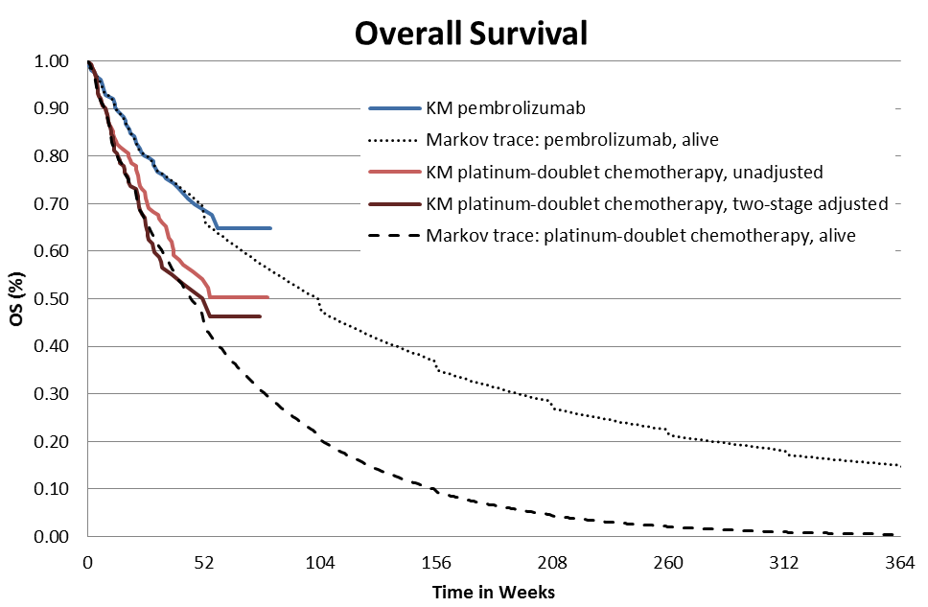
KM = Kaplan-Meier; OS = overall survival.
Source: Constructed during the evaluation from FINAL_Pembrolizumab Section D Workbook 1L NSCLC Australia.xlsm of the submission.

  - The Markov trace from the PSCR’s revised model is presented in Figure 6.

Figure 6: Updated Markov trace from the revised economic model accompanying the PSCR
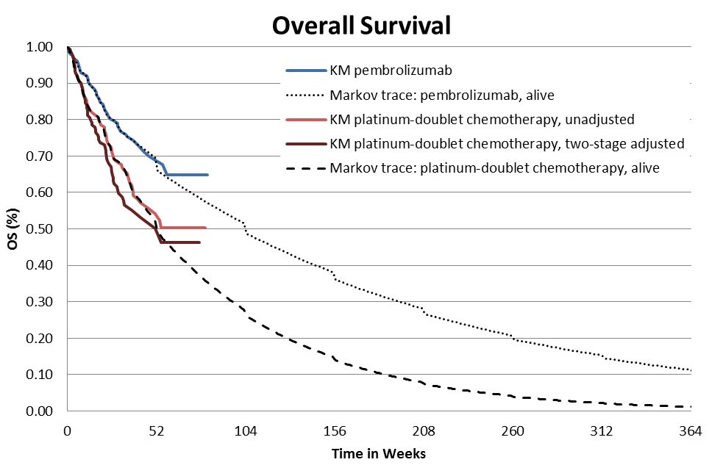
Source: Constructed from workbook accompanying PSCR: AMENDED_Pembrolizumab Section D Workbook 1L NSCLC Australia.xlsm

  - The visual presentation of various extrapolations for OS is presented in Figure 7.

Figure 7: Extrapolation of OS with the revised six year time horizon as per the PSCR
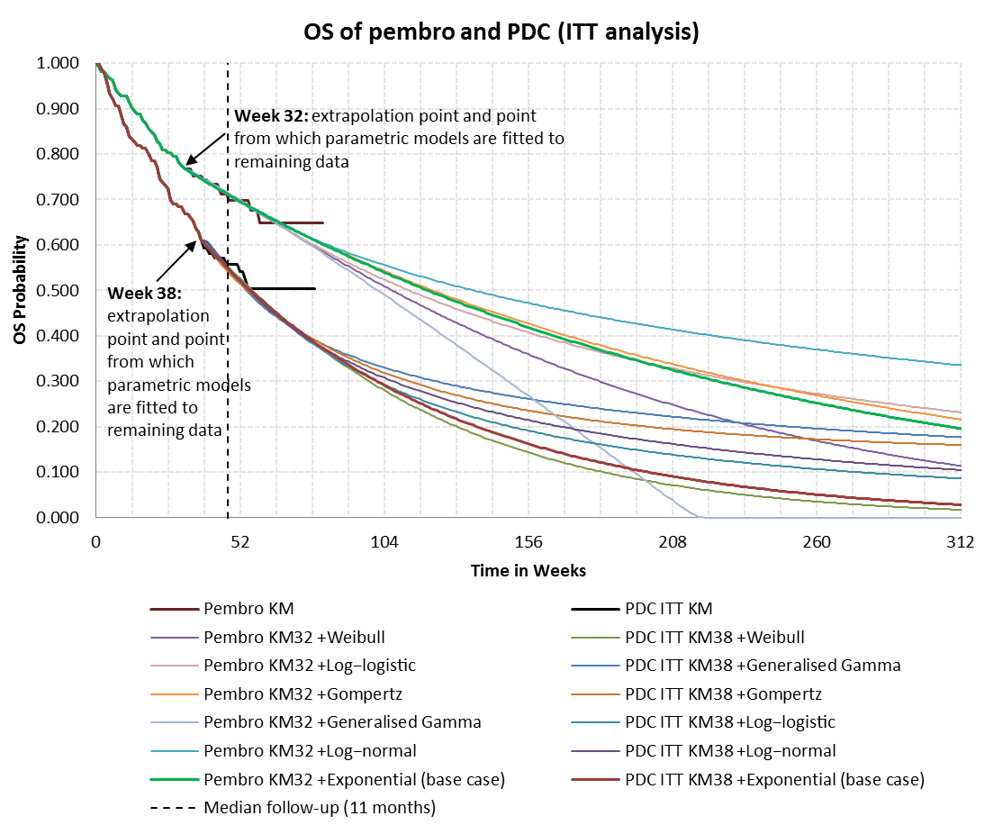
Note: In the base case analysis, an exponential distribution was selected for extrapolation of both pembrolizumab and platinum-doublet chemotherapy.

  - A table summarising the different methods used to adjust for treatment switching and the resulting ICERs is presented in Table 16. Of the three adjustment methods presented, the two-stage approach is associated with the largest effect on the ICER, which is consistent with the most favourable adjusted HR for OS.

Table 16: Results of the economic evaluation, different methods for adjusting for treatment switching
Analysis method | Assumptions | OS HR  (95% CI) | Includes cost of later-line pembrolizumab in the comparator arm | ICER
ITT (base case) | That switching does not confound OS | 0.60  (0.41, 0.89) | Yes | $'''''''''''''''''ª
 |  |  | No | $''''''''''''''''ª
Simplified two-stage | No unmeasured confounders | 0.50  (0.34, 0.76) | No | $'''''''''''''''''
RPSFT | Common treatment effect | 0.57  (0.32, 0.86) | No | $''''''''''''''''
IPCW | No unmeasured confounders | 0.55  (0.34, 0.87) | No | $'''''''''''''''^{b}
ICER results were generated during the evaluation.
CI = confidence interval; HR = hazard ratio; ICER = incremental cost effectiveness ratio; IPCW = inverse probability of censoring weights; ITT = intention-to-treat; OS = overall survival; RPSFT = rank preserving structural failure time method.
ª Analysis was corrected during the evaluation as Kaplan-Meier data used in the PSCR’s ITT analysis used Kaplan-Meier data that had been adjusted using the two-stage approach.
^{b} Relative to the RPSFT method, a less favourable ICER is observed with the IPCW which is not consistent with the relative HRs. This is due to the time point selected from which to extrapolate (week 25). At week 25, the Kaplan-Meier curve adjusted using the IPCW is above that adjusted using the RPSFT method. As the extrapolated curves do not appear to cross, improved survival is observed in the IPCW adjusted analysis, relative to the RPSFT adjusted analysis.
Source: Constructed during the evaluation from FINAL_Pembrolizumab Section D Workbook 1L NSCLC Australia.xlsm of the submission.

The redacted table shows ICERs in the range of $45,000/QALY - $75,000/QALY to $75,000/QALY - $105,000/QALY.

  - The results of the key sensitivity analyses based on changes presented in the PSCR are presented in Table 17.

Table 17: Results of key sensitivity analyses
 |  |  | Incremental costs | Incremental QALYs | ICER | % change from PSCR base case
Base case (PSCR)  Revised |  |  | $'''''''''''''''  $''''''''''''' | 0.249  0.226 | $'''''''''''''  $''''''''''''''' | 10%
1 | Pembrolizumab PFS and OS HRs = 1 after three years (assumes 12-months durable response after treatment cessation) |  | $''''''''''''''' | 0.182 | $''''''''''''''''''''' | 35%
2 | Pembrolizumab treatment cost until disease progression |  | $'''''''''''''''' | 0.226 | $'''''''''''''''''' | 49%
3 | Weibull distribution for OS of pembrolizumab |  | $''''''''''''''' | 0.179 | $'''''''''''''''''' | 37%
4 | Time horizon 5 years |  | $''''''''''''''''' | 0.198 | $'''''''''''''''' | 24%
5 | Extrapolate from median follow-up, fitted to all data ª |  | $'''''''''''''''' | 0.155 | $''''''''''''''''''' | 57%
6 | Discounting 10% |  | $''''''''''''''' | 0.202 | $''''''''''''''''' | 19%
7 | OS extrapolation from week 0 using base case parametric model selection ª |  | $'''''''''''''''' | 0.144 | $'''''''''''''''''''' | 69%
8 | OS extrapolation from week 22 for pembrolizumab, week 14 for platinum-doublet chemotherapy ª |  | $'''''''''''''''' | 0.186 | $''''''''''''''' | 32%
Multivariate analyses
 |  | #3 AND #4 | $''''''''''''''''' | 0.163 | $'''''''''''''''''''''' | 49%
 |  | #1, #3 AND #4 | $'''''''''''''''' | 0.150 | $''''''''''''''''''' | 62%
 |  | #2, #3 AND #4 | $''''''''''''''' | 0.163 | $'''''''''''''''''' | 99%
Note: Revised results and sensitivity analyses have corrected 1) the Kaplan-Meier data used in the PSCR/submission’s chemotherapy ITT analysis (which used two-stage adjusted data); and 2) the treatment course cost of pemetrexed (which did not multiply the drug cost per administration by the number of administrations).
ª Parametric models selected in the base case analysis were used (i.e. exponential for pembrolizumab and exponential for platinum-doublet chemotherapy).
HR = hazard ratio; ICER = incremental cost-effectiveness ratio; ITT = intention to treat; OS = overall survival; PFS = progression-free survival; QALY = quality adjusted life year.
Note: All presented sensitivity analyses in this table were generated during the evaluation.
Source: Table D.6-1, p281 of the submission.

The redacted table shows ICERs in the range of $75,000/QALY - $105,000/QALY to $105,000/QALY to $200,000/QALY.

  - The ICER was sensitive to changes (and combinations of changes) in the model, including the time points selected to fit and extrapolate OS, the duration of the treatment effect, duration of pembrolizumab treatment (until progression), the model selected to extrapolate OS in the pembrolizumab arm and the model time horizon.

  - The pre-PBAC response addressed the issues raised in the following ways:
- a correction to Kaplan Meier curve for the comparator arm of the model
- a reduction of the time horizon to 5 years
- a removal of any pembrolizumab retreatment
- use of 2-weekly second-line immunotherapy with nivolumab (although this assumed vial price equivalence rather than equivalent cost for the same duration of treatment)
- inclusion of wastage for second-line therapies
- a reduction in the proposed effective price of a pembrolizumab 50 mg vial (to $'''''''''''''''''').

  - The pre-PBAC response provided the following figure to illustrate the similarity between its extrapolated overall survival from 32 weeks against the observed overall survival to 19.2 months from the 5 January 2017 cut-off from the KN-024 trial.

Figure 8: Comparison of OS extrapolations with updated KN-024 data (5 January 2017 cut-off)
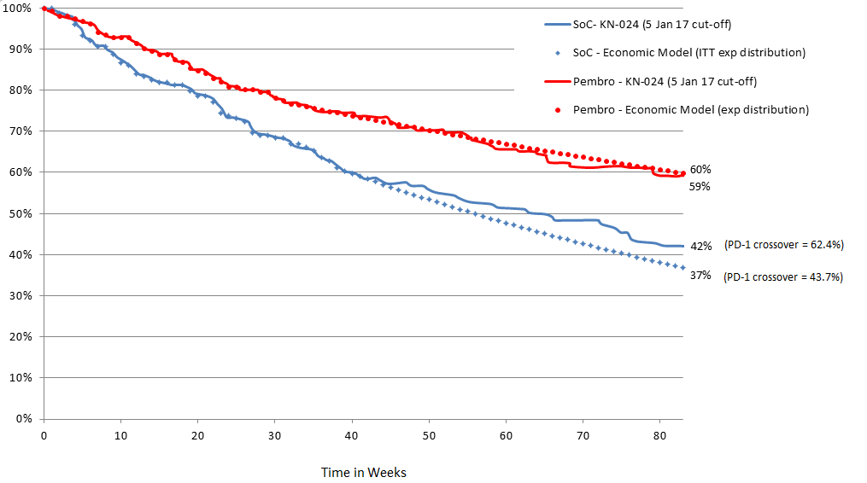

  - Table 18 presents the stepped results of making the changes presented in the pre-PBAC response.

Table 18: Stepped re-analysis from PSCR model to pre-PBAC response model
Analysis |  | ICER/QALY
1 | Base case ICER from the PSCR | $'''''''''''''
2 | 1 + correction to Kaplan Meier curve for the comparator arm of the model | $''''''''''''''''
3 | 2 + time horizon to 5 years | $'''''''''''''''
4 | 3 + removal of pembrolizumab retreatment | $''''''''''''''''''
5 | 4 + 2-weekly costs for post-progression treatment with immunotherapyª | $''''''''''''''''
6 | 5 + inclusion of wastage for second-line therapies | $'''''''''''''''''
7 | 6 + pembrolizumab cost $''''''''''''''' per 50 mg vial | $'''''''''''''''
ª In estimating the revised treatment course cost of immunotherapy, the pre-PBAC response assumed vial price equivalence rather than equivalent cost for the same duration of treatment.

The redacted table shows ICERs in the range of $45,000/QALY - $75,000/QALY to $75,000/QALY - $105,000/QALY.

Drug cost/patient/course: $'''''''''''''' (revised to $''''''''''''''' from changes in PSCR)
  - The submission estimated that the cost per patient per treatment course was $'''''''''''''''''. The average cost per administration was $''''''''''''', which was based on four 50 mg vials per patient per administration. Each patient was assumed to have an average of 17.9 administrations (Q3W) per treatment course, based on estimates from the economic model, applying the maximum treatment duration of two years. Retreatment for an additional 12 months was also included in this estimate. Based on the changes in the PSCR, the cost per patient per treatment course was revised to $''''''''''''''', and the average cost per administration was revised to $'''''''''''''''. Updates to these estimates were not available to reflect the further price reduction offered in the pre-PBAC response.

  - Comparator treatment cost per patient per course of platinum-doublet chemotherapy was $2,604 (revised: $2,462), based on 5 cycles of carboplatin + gemcitabine treatment (as per clinical practice guidelines). Pemetrexed maintenance was additionally assumed in 15% of patients with non-squamous histology. Patients who received pemetrexed maintenance were assumed to receive 6.47 cycles of maintenance, at a cost of $20,267 (revised: $20,138) per course. The cost of pemetrexed was reduced by 85% in the PSCR, as per the April 2017 price cuts. This resulted in a cost of $3,806 (revised: $3,786) per course.

Estimated extent of use and financial implications
  - DUSC considered the estimates presented in the submission to be broadly reasonable. The main issues were identified as being:
- The rate of patients diagnosed with Stage IV NSCLC was likely underestimated.
- It was unclear how the rate of progression to Stage IV disease from earlier stages of disease was determined.
- The estimates should be updated to reflect the amendment to the revised proposed PBS restriction, which only includes treatment of patients with a performance status of 0 or 1.
- There were no data provided to support the proposed PBS restriction for retreatment.

  - The PSCR provided revised estimates of usage and financial implications as a result of removing Stage IIIB patients from the proposed PBS restriction, increasing the uptake in years’ two to five, and decreasing the price. These estimates were able to be replicated, and are shown in the table below.

Table 19: Estimation of the population likely to be treated with pembrolizumab and the cost to the PBS/RPBS
 | Year 1 | Year 2 | Year 3 | Year 4 | Year 5
Patients eligible for first-line pembrolizumab | '''''''''''''' | '''''''''''''' | ''''''''''''' | ''''''''''''' | ''''''''''''
Pembrolizumab uptake | '''''''% | ''''''% | ''''''% | ''''''% | ''''''%
Patients likely to be treated with pembrolizumab | '''''''''''' | '''''''''''' | '''''''''''''' | ''''''''''''''' | ''''''''''''''
Total administrationsª | '''''''''''''''' | '''''''''''''''' | ''''''''''''''' | ''''''''''''''''' | ''''''''''''''''
Cost per administration | $'''''''''''''''''''' | $''''''''''''''''''''' | $'''''''''''''''''''''' | $''''''''''''''''''''''' | $'''''''''''''''''''''
Dispensed cost^{b} | $'''''''''''''''''''''''''' | $''''''''''''''''''''''''''' | $'''''''''''''''''''''''''''''''' | $''''''''''''''''''''''''''''''''' | $''''''''''''''''''''''''''''''
Average patient copayment^{c} | $17 | $17 | $17 | $17 | $17
Patient copayments | $''''''''''''''' | $''''''''''''''' | $''''''''''''''''' | $''''''''''''''''' | $''''''''''''''''
Cost to PBS/RPBS | $''''''''''''''''''''' | $'''''''''''''''''''''' | $''''''''''''''''''''''''' | $'''''''''''''''''''''''' | $'''''''''''''''''''''''''
ª The average number of administrations per patient by treatment year is assumed to be 11.83 in Year 1, 5.89 in Year 2, 0.18 in Year 3, and 0 in Years 4 and 5 of treatment.
^{b} The dispensed cost and the cost to the PBS/RPBS is based on the effective price for pembrolizumab, not accounting for the price reduction offered in the pre-PBAC response, and the other changes accepted in the pre-PBAC response.
^{c} Assumed one per patient

  - The pre-PBAC response further reduced the financial estimates as a results of the following (the revised estimates were not independently verified before the PBAC meeting):
- A revised price of $''''''''''''''' per 50 mg vial.
- The incident population of patients with Stage IIIb/IV changed to 65%.
- The Stage IV patient population reduced to include a performance score of 0 or 1 only.
- The inclusion of patients with Stage I to IIIa patients who progress to Stage IV.
- The treatment rate changed to 83.5% to reflect referral rates of patients with a performance score of 0 or 1.
- The estimate of grandfathered patients aligned to the intended scope of the planned access program.
- The inclusion of the costs of retesting Stage I to IIIa patients when they progress to Stage IV.

Quality Use of Medicines
  - A greater awareness, recognition and management of immune-related AEs was likely to have occurred in the KN-010 trial before AEs progressed to ≥ Grade 3; and until there is adequate familiarity with immunotherapy and its side effects, AE rates in practice may be higher than observed in the trial.

Financial Management – Risk Sharing Arrangements
  - The submission requested a Special Pricing Arrangement (SPA) where the published price is greater than the effective price.

  - The pre-PBAC response confirmed the sponsor’s willingness to enter a Risk Sharing Arrangement in relation to the requested listing, with expenditure caps based on agreed utilisation rates, and a 50% rebate for expenditure beyond these caps.

For more detail on PBAC’s view, see section 7 “PBAC outcome”.

- PBAC Outcome

  - The PBAC decided not to recommend that pembrolizumab be listed in the PBS for the treatment of PD-L1 positive NSCLC on the basis of unfavourable and uncertain cost-effectiveness.

  - The PBAC recognised that there is a clinical need for new treatments for patients with NSCLC, and that there is a clinical place for pembrolizumab in this population. The PBAC noted that the sponsor requested a first-line PBS listing for pembrolizumab as monotherapy for metastatic (Stage IV) NSCLC, in patients who have a performance status of 0 or 1, and whose tumours are EGFR wild type, ALK gene rearrangement negative, and have a TPS ≥50%.

  - As with the previous submission for PBS listing of second- and third-line pembrolizumab treatment for NSCLC, there was uncertainty in selecting a PD-L1 expression threshold to define an optimal patient population most likely to respond to first-line pembrolizumab treatment. For this submission for PBS listing of first-line pembrolizumab treatment, the key trial presented (KN-024) only recruited patients with a TPS ≥50%. The PBAC therefore considered there was no direct basis to evaluate whether this definition of the proposed biomarker was a treatment effect modifier, and any basis for doing so needed to be extrapolated from a small single-arm study in patients receiving later line therapy. The PBAC noted that the ongoing KN-042 trial recruited patients with a TPS ≥1%, and so might provide some relevant evidence to inform this issue, but that this needed to be balanced against the fact that this trial was not expected to be completed until 2018, ''''''''''' ''''''' ''''''''''''''' '''''''''''''''''''' ''''' ''''''''''''. The PBAC noted that different trials of immunotherapies in NSCLC used different PD-L1 thresholds, increasing the appearance of arbitrariness in the exclusion of patients from a potentially beneficial treatment. The PBAC also considered that although variation in PD-L1 expression might vary treatment effectiveness quantitatively, this variation has not been sufficient to identify a patient group whose outcomes would be inferior to those following platinum-based chemotherapy, making it difficult to exclude patients from any subsidy from an equity viewpoint. A number of studies have reviewed the challenges of interpreting and applying molecular testing in lung cancer in general and have also highlighted the limitations of using PD-L1 expression as a discriminatory biomarker to determine treatment eligibility. The studies have also noted that durable responses have been observed in patients without PD-L1 expression. Therefore, as previously, the PBAC considered that the use of the TPS ≥50% threshold was not adequately justified.

  - The PBAC noted the request not to include the administrative advice as is currently linked to the pembrolizumab restriction for melanoma, “In the first few months after start of immunotherapy, some patients can have a transient tumour flare with subsequent disease response. When progression is suspected, this should be confirmed through a confirmatory scan, taken at least 4 weeks later”. The PBAC advised that the administrative advice should be retained on current and future pembrolizumab restrictions, as prescriber experience using this drug may vary. In addition, the PBAC noted that the grandfather restriction for pembrolizumab for unresectable Stage III or Stage IV malignant melanoma has been PBS listed for over a year, and hence should be removed.

  - The PBAC considered that the proposal to limit PBS-subsidised pembrolizumab therapy to up to 24 months’ duration in patients who did not progress was consistent with the TGA’s recommendation in the dosage and administration section of the updated PI. The PBAC also agreed with the sponsor’s withdrawal of its initial request for PBS-subsidised retreatment with pembrolizumab after subsequent disease progression, noting that this withdrawal was consistent with the TGA’s decision not to include any recommendation for retreatment in the updated PI.

  - The submission nominated platinum-based doublet chemotherapy as the main comparator for pembrolizumab in the proposed population. The PBAC considered that this was the appropriate comparator for first-line treatment, but was not sufficient for retreatment comparisons.

  - The PBAC considered that the claim of superior comparative effectiveness (in terms of both progression-free survival and overall survival) and superior comparative safety were both reasonable. However, the PBAC considered that the data on quality of life were equivocal, and provided a weak basis to judge whether pembrolizumab resulted in no detriment to quality of life or possibly improved quality of life. In addition, despite the late presentation of overall survival results up to a median duration of follow-up of 19.2 months, the PBAC considered that future overall survival results from this trial would still be informative.

  - The PBAC considered the basic structure of the economic model was sound, but noted the various iterations of the economic evaluation from the submission, the PSCR and the pre-PBAC response, reflecting different assumptions and inputs which still adopt this basic structure. The pre-PBAC response adopted a 5-year (260-week) time horizon, consistent with the PBAC’s preference, but the two OS curves did not converge before or at this time horizon, and the model was sensitive to the choice of the distribution basis for the extrapolation. In this context, the updated OS results from KN-024 to a median duration of follow-up to 19.2 months (82 weeks) gave some reassurance beyond the original extrapolations from 32-week or 38-week data-cuts. The PBAC also noted the appropriate correction of the comparator arm extrapolation and the removal of pembrolizumab retreatment, although considered that the restriction may not prevent leakage of pembrolizumab beyond either disease progression or two years of therapy in those patients who do not progress. The PBAC did not accept the second-line immunotherapy and wastage cost off-sets as calculated in the submission. Further, the PBAC noted the inclusion of such costs is only valid if second-line immunotherapy is listed on the PBS. The PBAC accepted the second-line immunotherapy and wastage cost off-sets in principle, but not necessarily the all the assumptions behind their calculation. The PBAC also noted that the ICER/QALY for the base case across the three iterations was consistently between $45,000/QALY - $75,000/QALY and$75,000/QALY - $105,000/QALY, well above the $45,000/QALY - $75,000/QALY which it had previously advised was unfavourable in the context of the previous pembrolizumab submission for second-line listing in NSCLC.

  - Overall, the PBAC advised that, with the high medicine cost at the requested price, incremental cost-effectiveness of pembrolizumab, was unfavourable and uncertain. The PBAC considered that MSAC advice would be informative on one aspect of uncertainty, namely whether identifying the eligible population for PBS subsidy on the basis of the expression of the programmed death-ligand 1 (PD-L1) was appropriate. The rationale is that the test helps exclude patients who benefit less from treatment with pembrolizumab. In the context of concerns that testing of patients for PD-L1 expression in regular practice is unlikely to identify similarly eligible patients as were identified in the evidence provided to the PBAC, the clinical benefit of the medicine may be reduced, and thus its cost-effectiveness may become even less favourable.

  - The PBAC considered that the estimated financial implications were also high with some residual uncertainties because the revised estimates provided with the pre-PBAC response had not been independently verified.

  - The PBAC considered that the nature of any resubmission would be influenced by the outcomes of the MSAC consideration of the codependent PD-L1 expression test. However, it would also need to justify the nomination of any TPS threshold for eligibility to use pembrolizumab, provide longer and more extensively documented overall survival data from KN-024, and any interim results from KN-042. In relation to the economic evaluation, any future revised base case would need to (a) address the residual concerns of the most recent iteration already outlined, (b) be presented in the usual way to enable full independent verification, (c) generate a more favourable ICER/QALY than the results presented for NSCLC as either first-line or second-line pembrolizumab therapy, and (d) account for any requested retreatment scenarios. Similarly, the estimates of utilisation and financial implications should address the residual concerns of the most recent iteration already outlined, and be presented in the usual way to enable full independent verification.

  - The PBAC noted that this submission is eligible for an Independent Review.

Outcome:
Rejected

- Context for Decision

The PBAC helps decide whether and, if so, how medicines should be subsidised in Australia. It considers submissions in this context. A PBAC decision not to recommend listing or not to recommend changing a listing does not represent a final PBAC view about the merits of the medicine. A company can resubmit to the PBAC or seek independent review of the PBAC decision.

- Sponsor’s Comment

The sponsor is disappointed with this outcome and will continue to work with government to bring KEYTRUDA to 1st line non-small cell lung cancer patients as soon as possible.

Herbst et al, 2016 Keynote 010: Durable Clinical Benefit in Patients with Previously Treated, PD-L1 expression NSCLC who have completed pembrolizumab presented at WCLC Dec 4-7 2016
Ladwa et al, 2016, Pembrolizumab For Metastatic Melanoma: Results Of The Complete Responders On The Named Patient Access Program, Asia-Pac J Clin Oncol 12(S4):48 2016
Robert C, et al. 3-Year Overall Survival for Patients with Advanced Melanoma Treated with Pembrolizumab in KEYNOTE-001. Presentation at the American Society for Clinical Oncology Conference in Chicago, USA from 3-7 June 2016.
Bagley SJ, Bauml JM, Langer CJ. PD-1/PD-l1 immune checkpoint blockade in non–small cell lung cancer. Clinical Advances in Hematology and Oncology. 2015;13(10):676-83. Ettinger DS, Wood DE, Akerley W, Bazhenova LA, Borghaei H, Camidge DR, et al. NCCN Guidelines Insights: Non-Small Cell Lung Cancer, Version 4. 2016. J Natl Compr Canc Netw. 2016;14(3):255-64.
Cancer Council Australia. Clinical practice guidelines for the treatment of lung cancer. 2015 [updated 26 November 2015]; Available from: http://wiki.cancer.org.au/australia/Guidelines:Lung_cancer
Cherny NI, Sullivan R, Dafni U, et al: A standardised, generic, validated approach to stratify the magnitude of clinical benefit that can be anticipated from anti-cancer therapies: the European Society for Medical Oncology Magnitude of Clinical Benefit Scale (ESMO-MCBS). Ann Oncol 2015; 26:1547-73.
Socinski M. CheckMate 026: A Phase 3 Trial of Nivolumab vs Investigator's Choice (IC) of Platinum-Based Doublet Chemotherapy (PT-DC) as First-Line Therapy for Stage IV/Recurrent Programmed Death Ligand 1 (PD-L1) − Positive NSCLC. Sunday, 9 October 2016. p. Abstract LBA7_PR.
Cooper WA, Tran T, Vilain RE, Madore J, Selinger CI, Kohonen-Corish M, et al. PD-L1 expression is a favorable prognostic factor in early stage non-small cell carcinoma. Lung Cancer. 2015;89(2):181-8.
Sorensen SF, Zhou W, Dolled-Filhart M, Georgsen JB, Wang Z, Emancipator K, et al. PD-L1 Expression and Survival among Patients with Advanced Non-Small Cell Lung Cancer Treated with Chemotherapy. Transl Oncol. 2016;9(1):64-9.
Revised to take into account the efficient combination of vials and the maximum doses allowed on the PBS.
Revised to take into account the maximum dose of pemetrexed allowed on the PBS.
Hiley CT, et al. Challenges in molecular testing in non-small-cell lung cancer patients with advanced disease. Lancet 2016;388:1002-11.

