7.06 TOLVAPTAN,
Pack containing 28 tablets 15 mg and 28 tablets 45 mg,
Pack containing 28 tablets 30 mg and 28 tablets 60 mg,
Pack containing 28 tablets 30 mg and 28 tablets 90 mg,
JINARC®, Otsuka Australia Pharmaceutical P/L

- Purpose of Application
  - The resubmission requested a Section 85 Authority Required (telephone) PBS listing for initiation of tolvaptan and an Authority Required (Streamlined) listing for continuing treatment of autosomal dominant polycystic kidney disease (ADPKD).
  - Tolvaptan was previously considered by the PBAC for a Section 85 Authority Required (written) PBS listing for the treatment of ADPKD at the March 2017 meeting.
Component | Description
Population | Patients with a confirmed diagnosis of ADPKD, in CKD stages 2-3, with evidence of rapidly progressing disease. Patients who had undergone a kidney transplant or with age appropriate kidney function are excluded from treatment.
Intervention | Tolvaptan is administered twice-daily in split-dose regimens of 60 mg (45 mg + 15 mg), 90 mg (60 mg + 30 mg) or 120 mg (90 mg + 30 mg). Unchanged from the previous submission.
Comparator | Best supportive care. Unchanged from the previous submission.
Outcomes | Change in kidney function over time by difference in rate of change in estimated glomerular filtration rate (eGFR), ADPKD composite of complications (e.g. hypertension, kidney pain), adverse events.
Clinical claim | Tolvaptan is superior in efficacy to placebo (both in combination with best supportive care) and inferior with regard to safety in patients with ADPKD. Unchanged from the previous submission.
  - Listing was requested on the basis of a cost-utility analysis, comparing tolvaptan with placebo (both in combination with best supportive care).

Table 1: Key components of the clinical issues addressed by the submission
Abbreviations: ADPKD, autosomal dominant polycystic kidney disease; CKD, chronic kidney disease
Source: Table 1-3, p12 of the submission. See CKD stages Table 1.1.2, Attachment 1.

- Requested listing
Name, Restriction,  Manner of administration and form |  | Max.  Qty | №.of  Rpts | Published (effective) Dispensed Price for Max. Qty | Proprietary Name and Manufacturer
Tolvaptan  15mg + 45mg, oral tablets  30mg + 60mg, oral tablets  30mg + 90mg, oral tablets |  | 56 | 5 | $'''''''''''''''''''  ''''''''''''''''''''''''' |  | Jinarc®  Otsuka Australia Pharmaceutical P/L
Category/Program: | General Schedule
PBS indication: | Autosomal dominant polycystic kidney disease (ADPKD)
Episodicity: | Chronic
Treatment phase: | Initial supply
Restriction: | Authority Required
Treatment criteria: | Must be treated by a specialist who has undergone tolvaptan prescriber training
Clinical criteria: | The condition must be a confirmed diagnosis of ADPKD, CKD stages 2-3 (eGFR 30-89 mL/min/1.73 m²) at the initiation of treatment;  AND  eGFR decline of ≥2.5 mL/min/1.73 m²/year, based on historical eGFR data;  AND  The patient must not have undergone a kidney transplant;  AND  PBS sub-population 1  - Aged 18-50  - eGFR of <90 mL/min/1.73 m² at the initiation of tolvaptan therapy;  OR  PBS sub-population 2  - Aged 51-55  - eGFR <65 mL/min/1.73 m² at the initiation of tolvaptan therapy;  OR  PBS sub-population 3  - Aged 56-65  - eGFR <45 mL/min/1.73 m² at the initiation of tolvaptan therapy.

Category/Program: | General Schedule
PBS indication: | Autosomal dominant polycystic kidney disease (ADPKD)
Treatment phase: | Continuing treatment
Restriction: | Authority Required (Streamlined)
Treatment criteria: | Must be treated by a specialist who has undergone tolvaptan prescriber training
Clinical criteria: | The condition must be a confirmed diagnosis of ADPKD;  AND  Patient must have previously been issued with an authority prescription for this drug for this condition;  AND  - The patient must not have reached end-stage renal disease (eGFR <15 mL/min/1.73 m²) or undergone a kidney transplant.
  - The resubmission proposed a special pricing arrangement, with a published price of $''''''''''''''''' and an effective price of $'''''''''''' (compared to a published price of $''''''''''''''' and an effective price of $'''''''''''''''' in the previous submission). In addition, a risk share arrangement by expenditure cap was proposed.

  - The requested listing is more restrictive than the TGA indication and excludes patients with CKD stage 1, reduced kidney function related to ageing and patients aged >65 years. At the March 2017 meeting the PBAC noted that tolvaptan may be used in patients with slower disease progression or early stage disease in an attempt to preserve maximum kidney function (Tolvaptan PSD, March 2017, para.7.4).
  - The restriction proposed in the resubmission differs from the previous submission in several key criteria:
- The requested restriction includes patients with CKD 2-3; the previous submission included patients with CKD 1-3;
- The requested restriction defines rapidly progressing disease on the basis of historical rate of decline in eGFR; the previous submission defined rapidly progressing disease using the Mayo classification or historical rate of decline in eGFR;
- The requested restriction includes the following eligibility criteria to exclude patients with age related decline in eGFR: PBS sub-population 1: age 18-50 years, eGFR <90 mL/min/1.73 m²; PBS sub-population 2: age 51-55 years, eGFR <65 mL/min/1.73 m²; and PBS sub-population 3: age 56-65 years; eGFR <45 mL/min/1.73 m².
- The requested restriction includes a stopping rule; patients cease treatment with tolvaptan on progression to end-stage kidney disease (ESKD; i.e. eGFR <15 mL/min/1.73 m²) or after kidney transplant.
  - The criteria used to exclude patients with age related decline in eGFR were derived from the inclusion criteria of the clinical trials, and were not consistent with age related decline observed in the general community and were not justified.
  - The evaluation considered it was uncertain whether clinicians would adhere to a restriction excluding patients with CKD 1, age limited eGFR, or patients older the 65 years, given tolvaptan would be the first treatment listed for slowing progression of ADPKD and all patients with rapidly progressing ADPKD may be perceived as likely to benefit from treatment. The ESC agreed that in the absence of other disease-modifying therapy for ADPKD, tolvaptan may be used outside the proposed restriction.
  - The submission requested the PBS restriction include a grandfathering clause to include patients in the patient familiarisation program (PFP). The Pre-PBAC response expects up to 200 PFP patients would meet the proposed PBS eligibility criteria.
For more detail on PBAC’s view, see section 7 PBAC outcome.

- Background

Registration Status
  - Tolvaptan (JINARC®) was registered by the TGA on 24 March 2017 for ADPKD in 15 mg/45 mg, 30 mg/60 mg and 30 mg/90 mg dual dose packs, as well as 15 mg tablet packs and 30 mg tablet packs, to slow the progression of cyst development and renal insufficiency of ADPKD in adults with chronic kidney disease (CKD) stage 1 to 3 at initiation of treatment with evidence of rapidly progressing disease.

Previous PBAC consideration
  - A summary of outstanding matters of concern from the March 2017 submission is presented below.
Table 2: Summary of outstanding matters of concern from March 2017
Component | Matter of concern | How the resubmission addresses it
Clinical issue | [7.5] The PBAC noted that TEMPO 3:4 did not provide adequate data to support the claim that tolvaptan had superior efficacy to placebo in the treatment of autosomal dominant polycystic kidney disease (ADPKD), given the uncertain clinical importance of the very small decreases in the rate of total kidney volume (TKV) growth from baseline reported in the trial.  [7.5] The PBAC noted that change in rate of TKV growth was not a validated surrogate outcome for chronic kidney disease (CKD) progression, and that the outcome of greatest clinical importance was prevention of end-stage kidney disease (ESKD). The PBAC accepted that estimated glomerular filtration rate (eGFR) may be a reasonable surrogate, but was not validated in this setting. | Additional data were presented in the resubmission from the REPRISE trial and TEMPO 4:4 extension study. The primary outcome presented in the resubmission was relative difference in slope of annualised change in eGFR. Validation of eGFR as a surrogate for severity and disease progression in chronic CKD in ADPKD patients treated with tolvaptan was not presented in the resubmission.
Clinical issue | [6.25] The PBAC also noted that the use of relative reductions in slope compared to placebo as measures of treatment effect in the primary and key secondary outcomes of TEMPO 3:4 was not adequately justified, was difficult to interpret, and may not represent patient-relevant outcomes | The relevant primary and secondary outcomes of the REPRISE and TEMPO 3:4: trials were reported as relative reductions in slope and the magnitude of clinical benefit likely to be realised in clinical practice remains uncertain.
Clinical issue | [6.25 and 7.5] The PBAC noted that tolvaptan was associated with an acute hemodynamic effect and that interpretation of affected outcomes in trials designed to avoid confounding due to the effect (TEMPO 3:4) was challenging | The REPRISE and TEMPO 3:4 trials were designed and outcomes adjusted to account for the tolvaptan acute hemodynamic effect, and results unadjusted for the effect were less favourable to tolvaptan. However, it was unclear whether the effect and reversal remain constant over long term treatment, what reversal of the effect means for patients treated with tolvaptan until progression to ESKD and how eGFR will be used to assess CKD progression in tolvaptan treated patients in clinical practice.
Economic issue | [6.49] The PBAC noted that the use of a cohort based economic model, using 270 risk profiles as separate population cohorts to generate weighted aggregate costs and QALYs, was overly complex and increased the uncertainty of the economic model. | The resubmission presented two microsimulations based on individual patient data from TEMPO 3:4 and REPRISE trial populations (selected for PBS eligibility), using TreeAge software with the same underlying structure used in the March 2017 submission; i.e. two module (pre- and post-ESKD) Markov structure with eight health states (CKD 1, CKD 2, CKD 3, CKD 4, CKD 5 pre-dialysis, CKD 5 dialysis, post-transplantation and death; Figure 3.2.1).
Source: Table ES-1, pES-1 of the submission, and Tolvaptan Public Summary Document, March 2017.

For more detail on PBAC’s view, see section 7 PBAC outcome.

- Population and disease
  - ADPKD is a late-onset multisystem disorder characterised by bilateral renal cysts, cysts in other organs (e.g. liver, seminal vesicles, pancreas, arachnoid membrane), vascular abnormalities (e.g. intracranial aneurysms, dilatation of the aortic root, thoracic aortic dissection), mitral valve prolapse and abdominal hernias. Physical manifestations of the disease include hypertension, acute and chronic pain, kidney stones, haematuria, and urinary tract infections. Approximately 50% of patients diagnosed with ADPKD will progress to end-stage kidney disease (ESKD) by 60 years of age.
  - The submission claimed that tolvaptan would provide a treatment option for patients with a confirmed diagnosis of ADPKD, with chronic kidney disease stages 2-3 at the initiation of treatment, and evidence of rapidly progressing disease. There is currently no other disease modifying treatment available for patients with ADPKD. Patients with rapidly progressing disease in CKD stage 1 were excluded from the eligible population in the resubmission on the basis that treatment of this cohort was found to be not cost effective in the previous submission.
For more detail on PBAC’s view, see section 7 PBAC outcome.
- Comparator
  - The resubmission nominated best supportive care (BSC) as the main comparator. Current best supportive care consists of a range of therapies, primarily targeted at symptomatic relief (e.g. antihypertensives and lipid lowering agents, analgesics for controlling pain, antibiotics for urinary tract infections). This was accepted by the PBAC as the appropriate comparator in the previous submission.
For more detail on PBAC’s view, see section 7 PBAC outcome.
- Consideration of the evidence

Sponsor hearing
  - There was no hearing for this item.

Consumer comments
  - The PBAC noted and welcomed the input from individuals (49), health care professionals (1) and organisations (2) via the Consumer Comments facility on the PBS website. The comments described a range of anticipated benefits of treatment with tolvaptan including delayed disease progression, prolonging life, reduced pain, improved quality of life, avoidance of dialysis and transplantation, and employment opportunities. The comments noted the lack of treatment options currently available for this genetic condition, which affects multiple generations of families.

  - The PBAC noted the advice received from Kidney Health Australia supporting the subsidised use of tolvaptan in patients deemed suitable by their nephrologist. The organisation stated that tolvaptan is the first drug to offer the possibility of slowing the rate of decline in kidney function thereby delaying the need for renal replacement therapy and thus reducing utilisation of dialysis and renal transplantation. The PBAC acknowledged the ongoing emotional stress on patients and families affected by ADPKD. However, the PBAC noted the clinical trial data may be consistent with a slight improvement in rate of decline in eGFR but this was dependent on the data points selected; even in the most optimistic case improvement over best supportive care would not be achieved until many years into treatment. No comparative data is expected to become available to confirm this long term potential benefit.

Clinical trials
  - The resubmission was based on the overall trial results and subgroup analyses from two direct randomised trials (TEMPO 3:4 and REPRISE), comparing tolvaptan to placebo in combination with best supportive care, and one open-label, extension study (TEMPO 4:4) comparing patients continuing treatment with tolvaptan to those switching to tolvaptan from placebo. REPRISE and TEMPO 4:4 are recently completed studies and have not been previously considered by PBAC.

  - Details of the trials presented in the submission are provided in the table below.
Table 3: Trials and associated reports presented in the submission
Trial ID | Protocol title/ Publication title | Publication citation
Included trials and studies
REPRISE | An Otsuka sponsored phase 3b, randomised controlled trial in ADPKD patients with chronic kidney disease late stage 2 to early stage 4. Expected completion date May 2017. (156-13-210) (NCT02160145) | Clinical Study Report:  1 September 2017.
 | Rationale and design of a clinical trial investigating tolvaptan safety and efficacy in autosomal dominant polycystic kidney disease. | American Journal of Nephrology 2017; 45(3): 257-266.
TEMPO 3:4 | A phase 3, multi-center, double-blind, placebo-controlled, parallel-arm trial to determine long-term safety and efficacy of oral tolvaptan tablet regimens in adult subjects with autosomal dominant polycystic kidney disease. (156-04-251) (NCT00428948) | Clinical Study Report:  14 February 2013.
 | Torres VE, Chapman AB, Devuyst O, et al. Tolvaptan in patients with autosomal dominant polycystic kidney disease. | New England Journal of Medicine 2012; 367(25):2407-2418.
 | Perrone RD, Coons SJ, Cavanaugh K, Finkelstein F, Meyer KB. Patient-reported outcomes in clinical trials of CKD-related therapies: report of a symposium sponsored by the national kidney foundation and the U.S. Food and Drug Administration. | American Journal of Kidney Diseases Dec 2013; 62(6):1046-1057.
TEMPO 4:4 | Torres VE, et al. Multicenter, open-label, extension trial to evaluate the long-term efficacy and safety of early versus delayed treatment with tolvaptan in autosomal dominant polycystic kidney disease: the TEMPO 4:4 Trial. | Nephrology, Dialysis, Transplant 2017; March 31: 1-13.
Source: Table 2-9, pp48-49 of the resubmission.

  - The key features of the direct randomised trials are summarised in the table below.

Table 4: Key features of the included evidence
Trial | N | Design/ duration | Risk of bias | Patient population | Outcome | Use in modelled evaluation
Tolvaptan versus placebo (addition to best supportive care)
REPRISE | 1,370 | Randomised, double blind, multi-centre, withdrawal study  12 months | Low | 18-55 years, eGFR  25-65 mL/min/1.73 m²/year;  56-65 years, eGFR  25-44 mL/min/1.73 m²/year with a decline in eGFR  >2.0 mL/min/1.73 m²/year | Annualised rate  of change in slope of eGFR decline  (12 months) | REPRISE subgroup excluding CKD 4  (base case)
TEMPO 3:4 | 1,444 | Randomised, double blind, multi-centre, superiority study  36 months | Low | Adults 18-50 yrs  ADPKD + baseline  TKV ≥750mL (MRI)  CrCl ≥60mL/min | Annualised rate change in TKV  Annualised rate  of change in slope of eGFR decline  (36 months) | TEMPO 3:4 subgroup excluding CKD 1  (base case)
TEMPO 4:4 | 1,037 | Open label, multi-center, safety  extension study | High | Patients completing TEMPO 3:4 of 5 other tolvaptan trials | Annualised rate change in eGFR;  Safety outcomes  (24 months) | Treatment discontinuation rates
Abbreviations: ADPKD, autosomal dominant polycystic kidney disease; CKD, chronic kidney disease; CrCl, creatinine clearance; eGFR, estimated glomerular filtration rate; MRI, magnetic resonance scanning; TKV, total kidney volume.

  - The eligibility criteria of REPRISE and TEMPO 3:4 include overlapping populations in terms of ADPKD diagnosis and age, but differ substantially in terms of CKD stage of disease progression and definition of rapidly progressing disease. The REPRISE trial included patients in two age bands (18-55 and 56-65 years) with specific measures of preserved kidney function (eGFR 25-65 mL/min/1.73 m² and 25-44 mL/min/1.73 m²). The criterion for rapidly progressing disease was only applied to the smaller 56-65 year old cohort (decline in eGFR ≥2.0 mL/min/1.73 m²/year). The TEMPO 3:4 trial included patients aged 18-50 years with rapidly progressing disease defined by changes in total kidney volume assessed by MRI scan. CKD stage and preserved kidney function (i.e. eGFR) were not required criteria.

  - The addition of the REPRISE cohorts of older patients with more progressed chronic kidney disease addresses some of the concerns raised by the PBAC at the March 2017 meeting about the applicability of TEMPO 3:4 to the broader ADPKD rapidly progressing population (Tolvaptan Public Summary Document, March 2017, para 6.11). However, given differences between the inclusion criteria of REPRISE and TEMPO 3:4 (baseline eGFR, definition of rapidly progressing disease) and the clinical criteria of the requested restriction, the applicability of both cohorts to the eligible Australian population under the requested restriction is unclear. The PSCR maintained the proposed eligibility criteria were formulated according to the inclusion criteria the REPRISE and TEMPO 3:4 trials whilst capturing elements to restrict subsidised usage to those in CKD stages 2-3 with rapidly progressing disease. The PSCR acknowledged there were some disparities in baseline characteristics between trial patients and the UK THIN database eligibility matches, however, they considered reasonable consistencies between data sets were maintained. The risk of use outside the restriction was proposed to be managed by the prescriber training and a patient registry.

  - The primary outcome of the resubmission was the difference in annualised rate of change in slope of decline in eGFR. In the March 2017 consideration of TEMPO 3:4, the PBAC noted that relative reductions in slope may not represent a patient-relevant outcome given similar differences in slope in each CKD stage reflected substantially different measures of preserved kidney function in terms of eGFR. In particular, it was noted that large relative reductions in slope reflected small differences in preserved kidney function in CKD stages 3 and 4 (Tolvaptan Public Summary Document, March 2017, para 6.25). The clinical relevance of relative changes in slope of decline in eGFR remains uncertain.

  - The resubmission acknowledged that tolvaptan is associated with an acute hemodynamic effect on initiation of tolvaptan (an acute 5-10% decline in eGFR; p36 of the resubmission), reversible on cessation of treatment and not associated with any demonstrable reduction in renal plasma flow or filtration fraction (p16 of the TGA Round 2 Clinical Evaluation Report). This was assumed to be most likely due to an acute effect on serum creatinine, used to calculate eGFR in both the Chronic Kidney Disease Epidemiology Collaboration (CKD-EPI) and the Modification of Diet in Renal Disease (MDRD) Study equations, commonly used in clinical practice to assess kidney function and CKD progression. The resubmission acknowledged that this would make monitoring of CKD progression in tolvaptan treated patients difficult in clinical practice. To avoid confounding due to this effect, baseline values in TEMPO 3:4 were recorded at three weeks post titration while in REPRISE primary outcome baseline and endpoint values were calculated from pre-treatment run-in and off-drug follow-up values, excluding all randomised controlled measures of effect.
  - The PSCR maintained the increase in serum creatinine is not kidney damage and is reversible upon treatment cessation and treatment is stopped once ESKD is reached. The ESC considered the data in the TEMPO 4:4 open-label extension study may support the maintenance of higher renal function post rebound, however, patients were not treated until ESKD in the TEMPO 3:4 trial (baseline eGFR in TEMPO 4:4 was 72.3 mean mL/min/1.73 m² for patients continuing tolvaptan from TEMPO 3:4). The benefit from slowing the decline in eGFR and slowing progression to ESKD will not be realised if patients are on treatment with a reduced renal function and potentially reaching ESKD prematurely. The pre-PBAC response maintained the reduction in eGFR is reversible on treatment cessation and in the context of a long-term condition with lifelong treatment is not a substantial determinant of efficacy or cost-effectiveness. However, PBAC further noted the variability across the TEMPO 3:4 and REPRISE trials made it difficult to establish who would respond to treatment and for how long treatment would need to continue before a benefit would be gained.

Comparative effectiveness
  - The resubmission presented results for REPRISE and TEMPO 3:4 from the overall trial populations and subgroup analyses by age, gender and CKD stage. Table 5 shows the results of the primary outcome of REPRISE, annualised change in eGFR from the pre-trial tolvaptan run-in phase to the off-treatment follow up phase (approximately 12 months).

Table 5: Annualised change in eGFR (CKD-EPI) slope in REPRISE (mL/min/1.73 m²/year; primary endpoint efficacy population; weighted ANCOVA)
REPRISE ª | Tolvaptan  N=668 | Placebo  N=663 | Mean difference  (95% CI) | Relative difference
Mean annualised change in eGFR slope (mL/min/1.73 m²/year) | -2.961 | -4.249 | 1.288 (0.770, 0.510)^{b} | 30.3%
LS mean annualised change in eGFR slope (mL/min/1.73 m²/year) | -2.339 | -3.610 | 1.271 (0.859,1.684) | 35.2%
ª Annualised change from baseline as average of up to three pre-treatment baseline observations to the average of up to three post-treatment follow-up observations. Statistically significant results in bold. Positive comparative outcomes favour tolvaptan.
^{b} 95% confidence intervals calculated post-hoc for the resubmission. The upper confidence interval is in error and could not be corrected.
Abbreviations: CI, confidence interval; CKD-EPI, Chronic Kidney Disease Epidemiology Collaboration equation; eGFR, estimated glomerular filtration rate; LS, least square means.
Source: Table 2-21, p64 of the resubmission.
  - In REPRISE, treatment with tolvaptan was associated with a statistically significantly smaller annualised decline in eGFR, compared to placebo (difference between least square means of 1.271 mL/min/1.73 m²/year). The tolvaptan treatment effect was derived from data before and after the randomised controlled treatment phase, and does not reflect the on-drug trajectory experienced by patients in clinical practice. Differences between tolvaptan and placebo in decline of eGFR appear small, while relative differences in slope appear substantial but are difficult to interpret in terms of patient relevant outcomes.
  - Table 6 shows the results of the REPRISE and TEMPO 3:4 secondary outcome of annualised change in slope of decline in eGFR (linear mixed effect model).

Table 6: Annualised change in eGFR (CKD-EPI) slope in REPRISE and TEMPO 3:4; (mL/min/1.73 m²/year; key secondary endpoint efficacy population; linear mixed effect model)
 | Tolvaptan | Placebo | Mean difference  (95% CI) | Relative difference
REPRISE
N | 680 | 682
Mean annualised change in eGFR slope (mL/min/1.73 m²/year) | -2.552 | -3.238 | 0.728 (NR) | 22.2%
Estimated annualised eGFR change in slopeª | -3.160 | -4.170 | 1.011 (0.618,1.403) | 24.3%
TEMPO 3:4
N | 842 | 464
Mean annualised change in eGFR (mL/min/1.73 m²/year) | -2.680 | -3.568 | 0.888 (NR) | 24.9%
Estimated annualised eGFR change in slope^{b} | -2.723 | -3.700 | 0.977 (0.597,1.357) | 26.4%
ª Derived from all eGFR observations from placebo run-in, tolvaptan run-in, double blind treatment, and post-treatment follow-up periods. Treatment effect derived from the linear mixed model with effects of treatment, time, treatment time interaction, acute hemodynamic effect, pre-treatment baseline, and randomisation stratification factors.
^{b} Derived from testing the time to treatment interaction using linear mixed model in which both intercept and slope are fixed and random effects.
Abbreviations: CI, confidence interval; CKD-EPI, Chronic Kidney Disease Epidemiology Collaboration equation; eGFR, estimated glomerular filtration rate.
Source: Table 2-22, p66 of the resubmission. Statistically significant results in bold. Positive comparative outcomes favour tolvaptan.
  - In the REPRISE and TEMPO 3:4 trials treatment with tolvaptan was associated with smaller annualised reductions in eGFR compared to placebo, and statistically significant differences in slope of decline in eGFR favouring tolvaptan.
  - Results of the primary and key secondary outcomes favoured tolvaptan, but the differences in decline in eGFR were small and may not be clinically important. In addition, results of the key secondary outcome in REPRISE, using a linear mixed-effect model including data points from the randomised controlled treatment phase, were less favourable to tolvaptan than the primary outcome.
  - Tolvaptan is associated with reduction of renal function on commencement and rebound upon cessation, as shown in the TEMPO 3:4 trial, see Figure 1. As presented to the FDA on 5 August 2013, the slope of renal function decline was measured in two ways:
  - using post titration (rather than randomisation) as starting point, and last measurement on drug as end point, where the reduction in renal function at commencement drove the difference in slope (Figure 2)
  - or, using randomisation as starting point, but post trial (off drug follow up) as end point, where the rebound of renal function drives the difference in slope (Figure 3).
  - The sponsor’s pre-PBAC response acknowledged the inclusion of the FDA materials noted above, however maintained the additional evidence provided from the REPRISE trial suggest that even with the haemodynamic effects (and the resulting eGFR drop) the absolute eGFR values would become more favourable among patients on tolvaptan over time with a reversal upon the treatment cessation (providing further prolongation of kidney life). The PBAC considered time on therapy required to prolong kidney life was unknown and speculative.
Figure 1: Acute, Sustained, Reversible Effects of Tolvaptan on Renal Function: TEMPO 3:4
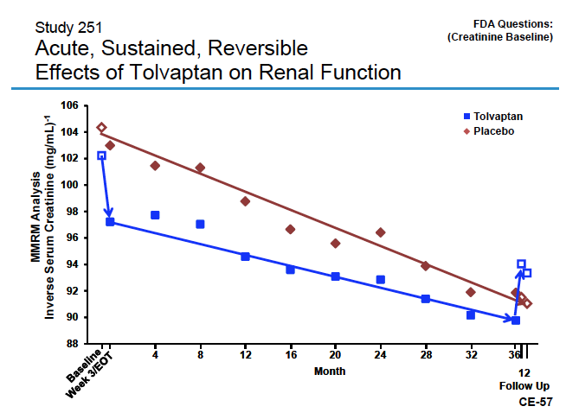
Source: Otsuka presentation to FDA Cardiovascular and Renal Drugs Advisory Committee, 5 August 2013; available via: http://www.fda.gov/AdvisoryCommittees/CommitteesMeetingMaterials/Drugs/CardiovascularandRenalDrugsAdvisoryCommittee/ucm364581.htm
Figure 2: On-Treatment Analysis of Slope (mg/mL) per year: TEMPO 3:4
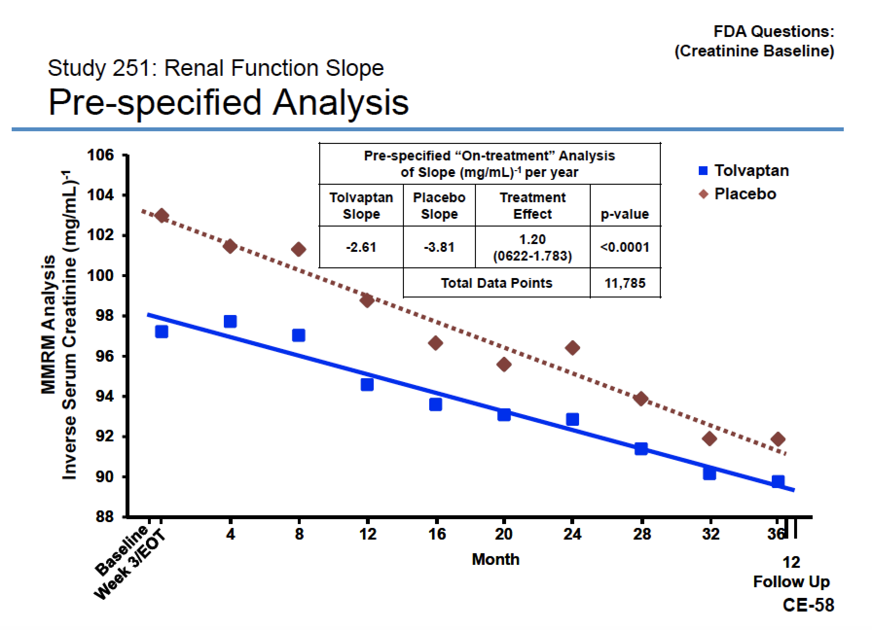
Source: Otsuka presentation to FDA Cardiovascular and Renal Drugs Advisory Committee, 5 August 2013; available via: http://www.fda.gov/AdvisoryCommittees/CommitteesMeetingMaterials/Drugs/CardiovascularandRenalDrugsAdvisoryCommittee/ucm364581.htm
Figure 3: Pre-treatment to Post- treatment Analysis: TEMPO 3:4
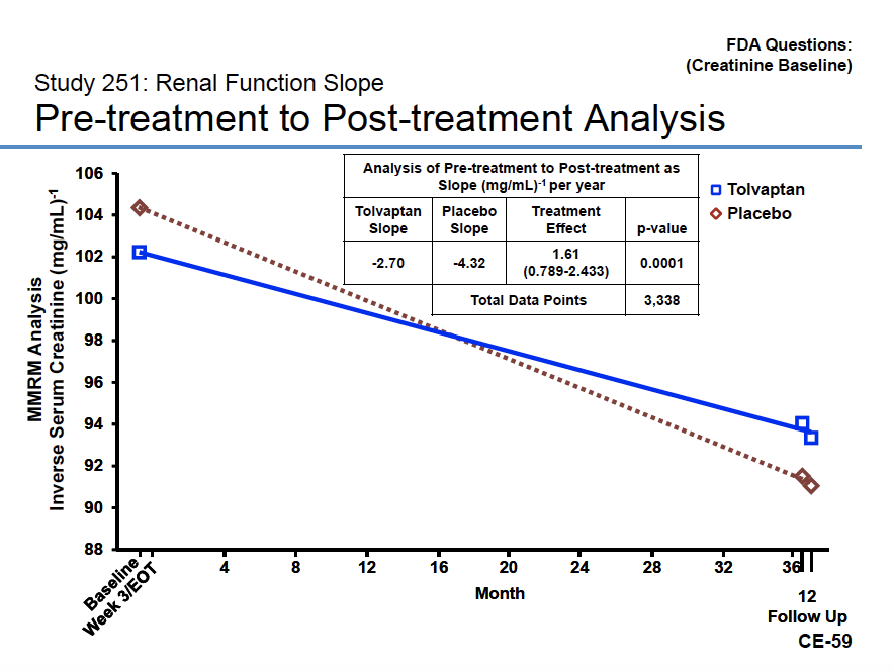
Source: Otsuka presentation to FDA Cardiovascular and Renal Drugs Advisory Committee, 5 August 2013; available via: http://www.fda.gov/AdvisoryCommittees/CommitteesMeetingMaterials/Drugs/CardiovascularandRenalDrugsAdvisoryCommittee/ucm364581.htm

  - In the TEMPO 4:4 follow up and open-label extension study, the early tolvaptan group appeared to maintain higher renal function post rebound, but results are difficult to interpret due to large loss to follow up (25-28%) and differential time off treatment in between (see Figure 4).

Figure 4: Change in eGFR (LS mean) from TEMPO 3:4 baseline to TEMPO 4:4 month 24 visit

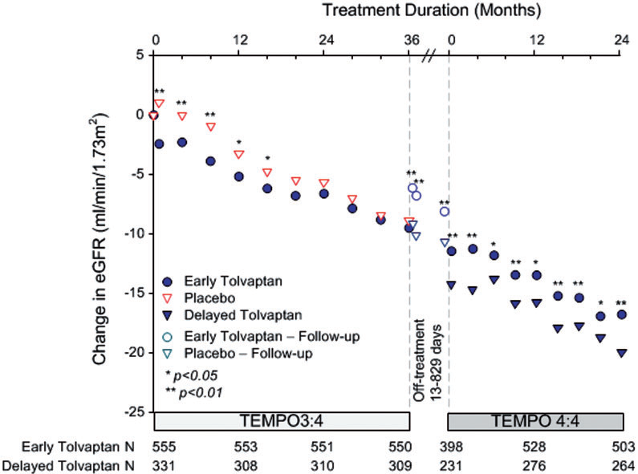

Abbreviations: eGFR, estimated glomerular filtration rate; LS, least square means.
Source: Figure 3-3, p154 of the of the resubmission.
NOTE: The inter-trial period is plotted as a 5-month interval, which approximates the 80th percentile of the off-treatment period (range 13 to 566 days for early treated and 13 to 829 days for late treated patients). Open circles and triangles represent off treatment time points.

  - The REPRISE trial included an enrichment period with tolvaptan to remove patients who can’t tolerate the drug. The primary endpoint was change in eGFR at 1 year starting from screening/placebo run-in period (pre-randomisation data) and ending 2 weeks post treatment (off drug). The change in eGFR over the course of the trial is presented in Figure 5. The trial also examined slopes during treatment period but results were confounded by post tolvaptan withdrawal eGFR rebound at month 1 for the placebo group and are not meaningful.
Figure 5: Change in eGFR over the course of the REPRISE trial
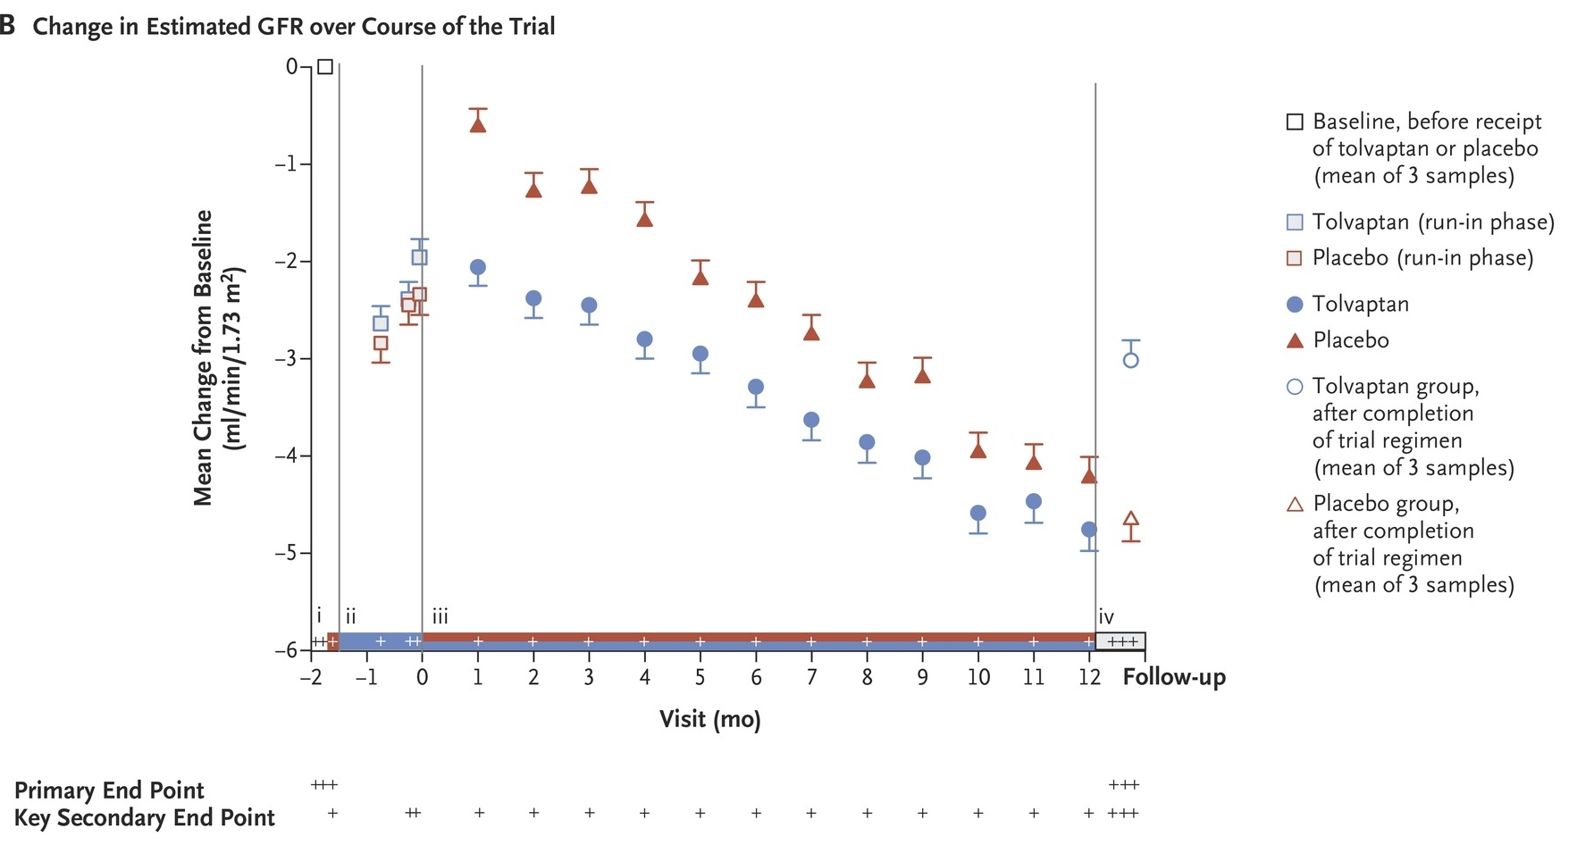
Source: Torres, V. E. Chapman, A. B. Devuyst, O. Gansevoort, R. T. Perrone, R. D. Koch, G. Ouyang, J. McQuade, R. D. Blais, R. D. Czerwiec, F. S. and Sergeyeva, O., ‘Tolvaptan in Later-Stage Autosomal Dominant Polycystic Kidney Disease’, NEJM, November 2017, 377:1930-1942.
  - Table 7 shows the difference between tolvaptan and placebo in rate of decline in eGFR from baseline for the REPRISE pre-specified subgroup analysis and TEMPO 3:4 post-hoc subgroup analysis by baseline CKD stage, used to calculate the weighted mean treatment effect of tolvaptan in the economic analysis.

Table 7: Subgroup analysis of mean annualised rate of change in slope eGFR as slope by CKD stage (mL/min/1.73 m²/year; key secondary endpoint efficacy population; linear mixed effect model; 12 months)
Subgroup | Tolvaptan |  | Placebo |  | Slope reduction |  | p-value
 | N | Mean annualised rate of change in slope | N | Mean annualised rate of change in slope
REPRISE pre-specified subgroup analysis by baseline CKD stages 2-4 (ITT; 12 months)ª
Overall population | 680 | -3.160 | 682 | -4.170 | 24.3% |  | NR
Baseline CKD 2 | 31 | -0.541 | 38 | -4.589 | 88.2% |  | NR
Baseline CKD 3A | 206 | -2.061 | 196 | -4.379 | 52.9% | 30.9% ^{b} | NR
Baseline CKD 3B | 294 | -3.344 | 304 | -3.982 | 16.0% |  | NR
Baseline CKD 4 | 137 | -4.041 | 125 | -4.590 | 12.0% |  | NR
TEMPO 3:4 post-hoc subgroup analysis by baseline CKD stages 1-3 (ITT; end of 3 week titration to 36 months)^{c}
Overall population | 842 | -2.72 | 464 | -3.70 | 26.4% |  | <0.0001
Baseline CKD 1 | 267 | -2.2 | 158 | -2.6 | 15.5% |  | 0.2324
Baseline CKD 2 | 465 | -2.7 | 224 | -3.9 | 29.1% |  | <0.0001
Baseline CKD 3 | 163 | -3.7 | 84 | -5.3 | 31.0% |  | <0.0001
ª Weighted ANCOVA with effects of treatment and randomisation stratification factors and covariate baseline.
^{b} Weighted average of CKD 3A and 3B, to provide a single CKD 3 relative slope reduction of 30.9%. CKD 3A 45-59 mL/min/1.73 m²; CKD 3B 30-44 mL/min/1.73 m²
^{c} Derived testing time treatment interaction using a linear mixed effect model with intercept and slope as fixed and random effects.
Abbreviations: ADPKD, autosomal dominant polycystic kidney disease; eGFR, estimated glomerular filtration rate; ITT, intention-to-treat
Source: Table 11.4.1.1-4, pp112-113 of the REPRISE Clinical Study Report; Table 63, p111 of the March 2017 submission, Appendix A to the resubmission. Figure 3, Torres et al. (2016).

  - In REPRISE tolvaptan showed numerically smaller mean annualised rates of change in slope eGFR in the baseline CKD 3 and CKD 4 subgroups, but the difference in relative slope between tolvaptan and placebo was smallest (<20%) in the CKD 3B and CKD 4 subgroups. No statistical analysis was presented, but analyses conducted on the least square means of the slopes reported for the subgroups showed statistically significantly smaller declines in rate of change in eGFR for patients treated with tolvaptan compared to placebo in all subgroups except CKD 2 and baseline age > 55 years.
  - In TEMPO 3:4 the mean annualised rates of change in slope eGFR for tolvaptan were statistically significantly smaller in baseline CKD stages 2-3 compared to placebo, but in patients with baseline CKD 1 disease progression there was no statistically significant difference.

Comparative harms
  - Table 8 summarises the most frequently reported adverse events in the REPRISE, TEMPO 3:4 and TEMPO 4:4 studies.
Table 8: Summary of the most frequently reported adverse events by ≥5% of patients in REPRISE and TEMPO 3:4, ≥10% of patients in TEMPO 4:4 (safety population)
Patients with events n (%) | REPRISE |  | TEMPO 3:4 |  | TEMPO 4:4
 | Tolvaptan  N=681 | Placebo  N=685 | Tolvaptan  N=961 | Placebo  N=483 | Tolvaptan  (early)  N=557 | Tolvaptan  (delayed)  N=314
Thirst | 27 (4.0%) | 13 (1.9%) | 531 (55.3%) | 99 (20.5%) | 261 (46.9%) | 161 (51.3%)
Polyuria | 36 (5.3%) | 11 (1.6%) | 368 (38.3%) | 83 (17.2%) | 231 (41.5%) | 175 (55.7%)
Nocturia | 32 (4.7%) | 12 (1.8%) | 280 (29.1%) | 63 (13.0%) | 145 (26.0%) | 111 (35.4%)
Kidney Pain | 113 (16.6%) | 130 (19.0%) | 260 (27.1%) | 171 (35.4%) | 147 (26.4%) | 90 (28.7%)
Fatigue | 46 (6.8%) | 24 (3.5%) | 131 (13.6%) | 47 (9.7%) | 53 (9.5%) | 54 (17.2%)
Polydipsia | 12 (1.8%) | 3 (0.4%) | 100 (10.4%) | 17 (3.5%) | 62 (11.1%) | 51 (16.2%)
Haematuria | 37 (5.4%) | 35 (5.1%) | 75 (7.8%) | 68 (14.1%) | 47 (8.4%) | 37 (11.8%)
Decreased appetite | 17 (2.5%) | 5 (0.7%) | 69 (7.2%) | 5 (1.0%) | - | -
Rash | 17 (2.5%) | 10 (1.5%) | 40 (4.2%) | 9 (1.9%) | - | -
Hepatic enzyme increased | 17 (2.5%) | 3 (0.4%) | 17 (1.8%) | 1 (0.2%) | - | -
Dry mouth | - | - | - | - | 45 (8.1%) | 44 (14.0%)
Arthralgia | - | - | - | - | 57 (10.2%) | 16 (5.1%)
Source: Table 2-27, pp71-72 and Table 2-34, pp86 of the resubmission.
  - Adverse events were consistent with those previously reported in the March 2017 submission; i.e. larger proportions of patients taking tolvaptan reported adverse events compared to placebo, most frequently related to tolvaptan’s aquaretic effect (e.g. thirst, polyuria, nocturia and pollakiuria) and fatigue.
  - Three Hy’s Law (high risk of a fatal drug-induced liver injury (DILI)) cases were identified as likely or highly likely to be related to tolvaptan in TEMPO 3:4. No patients met the criteria for Hy’s Law in REPRISE and only one patient in TEMPO 4:4 (recovered after cessation of tolvaptan). The resubmission acknowledged that tolvaptan may cause serious hepatocellular injury in some patients, but suggested the risk of hepatic injury was small and reversible. The ESC advised hepatotoxicity remains a concern given tolvaptan will be a life-long treatment.
  - The tolvaptan Product Information includes a TGA box warning that tolvaptan has been associated with elevated serum liver enzymes and total bilirubin, and to mitigate the risk of liver injury, blood testing for hepatic transaminases is required prior to initiation of tolvaptan, monthly for 18 months, then 3 monthly during treatment.

Benefits/harms
  - A summary of the comparative benefits and harms for tolvaptan versus placebo is presented in the table below.

Table 9: Summary of comparative benefits and harms for tolvaptan and placebo
Benefits | Tolvaptan | Placebo | Treatment difference | Relative difference
Estimated annualised change in slope of decline in eGFR (mL/min/1.73 m²/year; linear mixed effect model)
REPRISE | -2.552 | -3.238 | 0.728 | 22.2%
TEMPO 3:4 | -2.723 | -3.700 | 0.977 | 26.4%
Harms | Tolvaptan | Placebo | Event rate per 100 patients
 |  |  | Tolvaptan | Placebo
REPRISE
Nocturia | 32/681 | 12/685 | 4.7 | 1.8
Renal pain | 113/681 | 130/685 | 16.6 | 19.0
Hepatic enzyme increased | 17/681 | 3/685 | 2.5 | 0.4
Hypernatremia | 3/681 | 0 | 0.4 | 0
Serum sodium increased | 4/681 | 0 | 0.6 | 0
TEMPO 3:4
Nocturia | 280/961 | 63/483 | 29.1 | 13.0
Renal pain | 260/961 | 171/483 | 27.1 | 35.4
Hepatic enzyme increased | 17/961 | 1/483 | 1.8 | 0.2
Hypernatremia | 27/961 | 5/483 | 2.8 | 1.0
Serum sodium increased | 14/961 | 1/483 | 1.5 | 0.2
Abbreviations: eGFR, estimated glomerular filtration rate.
Source: Table 2-22, p66; Table 2-27, pp71-72; and Table 2-34, pp86 of the resubmission.
  - On the basis of the direct evidence presented in the submission in the REPRISE and TEMPO 3:4 trials, treatment with tolvaptan compared with placebo (both in combination with best supportive care) resulted in a smaller decline in eGFR over one year in tolvaptan treated patients, but the difference is small and may not be clinically meaningful. Tolvaptan treatment was also associated with an initial drop in eGFR, only reversible upon stopping treatment.
  - In REPRISE, on the basis of the direct evidence presented in the submission, for every 100 patients treated with tolvaptan compared with placebo (both in combination with best supportive care) over 12 months, approximately:
- 3 additional patients would experience nocturia,
- 2 fewer patients would experience renal pain,
- 2 additional patients would experience an increase in hepatic enzymes,
- 1 additional patient would experience increased blood sodium.
  - In TEMPO 3:4, on the basis of the direct evidence presented in the submission, for every 100 patients treated with tolvaptan compared with placebo (both in combination with best supportive care) over 36 months, approximately:
- 16 additional patients would experience nocturia,
- 8 fewer patients would experience renal pain,
- 2 additional patients would experience an increase in hepatic enzymes,
- 2 additional patients would experience hypernatremia,
- 1 additional patient would experience increased blood sodium.

Clinical claim
  - The submission described tolvaptan as superior in terms of effectiveness and inferior in terms of safety compared to best supportive care alone. The claim of inferior safety was supported however, the claim of superior effectiveness in the submission is uncertain:
- At the March 2017 meeting the PBAC noted that eGFR may be an appropriate surrogate for CKD severity and progression to end-stage kidney disease (ESKD), but was not validated in the setting of ADPKD treated with tolvaptan. The resubmission was based on changes in eGFR, however adequate validation of eGFR as a surrogate in this setting was not presented. The clinical importance of the primary outcome in the resubmission (relative difference in slope of annualised change in eGFR) is unclear given difficulties in translating differences in slope to a patient relevant benefit. The ESC considered it remained unclear how clinicians will assess CKD progression in tolvaptan treated patients given the early decline in eGFR and it raised concerns that tolvaptan may cause premature progression to ESKD.
- At the March 2017 meeting the PBAC noted that tolvaptan was associated with an acute hemodynamic effect and that interpretation of affected outcomes in trials designed to avoid confounding due to the effect (TEMPO 3:4) was challenging (Tolvaptan Public Summary Document, March 2017 para 6.25 and 7.5). Tolvaptan is associated with an acute 5-10% decline in eGFR on initiation of treatment reversible on cessation, not associated with any demonstrable reduction in renal plasma flow or filtration fraction. Treatment results adjusting for acute hemodynamic effects suggest that tolvaptan is superior to placebo, however, unadjusted results suggest similar or worse outcomes for tolvaptan versus placebo. It is unclear whether the acute hemodynamic effect and reversal remain constant over long term treatment, what reversal of the effect means for patients treated with tolvaptan until progression to ESKD and how clinicians will assess CKD progression in tolvaptan treated patients in clinical practice. For the follow up of TEMPO 3:4 patients in TEMPO 4:4, the tolvaptan group appears to maintain higher renal function post rebound, but results are difficult to interpret due to large loss to follow up (25-28%) and differential time off treatment in between.
- Whether results for the broader REPRISE and TEMPO 3:4 trial populations are applicable to the eligible Australian population (in terms of rapidly progressing disease, CKD stage, and age-related eGFR criteria). The Pre-PBAC response maintains the REPRISE and TEMPO 3:4 populations represent subgroups (enriched with rapidly progressing cases) of the overall ADPKD patient population and the proposed listing further restricts to a patient subgroup within which the cost-effectiveness of tolvaptan is proven. The PBAC did not consider the proposed restriction would adequately target treatment to the most high need patients in whom cost-effectiveness remains uncertain.
  - Renal function for tolvaptan is consistently worse whilst on the drug in TEMPO and REPRISE and the beneficial effect on renal function was only seen after coming off drug. The ESC considered possible explanations for this include: the beneficial effect is present throughout on-drug period but not observable by masking; OR the beneficial effect is not present throughout the treatment period but something associated with drug is beneficial and sustained. New data lends support to former possibility.
  - The ESC advised hepatotoxicity with tolvaptan remains a concern.
  - The PBAC considered the claim of superior comparative effectiveness over best supportive care was uncertain and at best very small.
  - The PBAC considered that the claim of inferior comparative safety was reasonable.

Economic analysis
  - The resubmission presented a modelled economic evaluation comparing tolvaptan to placebo (both in combination with best supportive care) in patients with ADPKD meeting the PBS eligibility criteria.
  - At the March 2017 meeting the PBAC noted that the use of a cohort based economic model, using 270 risk profiles as separate population cohorts to generate weighted aggregate costs and QALYs, was overly complex and increased the uncertainty of the economic model (Tolvaptan Public Summary Document, March 2017 para 6.49). In response to PBAC concerns, the resubmission presented a microsimulation approach using TreeAge software, based on individual patient data from the REPRISE and TEMPO 3:4 trials, with the same underlying structure used in the March 2017 submission.

Table 10: Summary of model structure and rationale
Component | Summary
Type of economic analysis | Cost-utility analysis.
Time horizon | Lifetime (maximum 100 years).
Outcomes | Quality-adjusted life years
Methods used to generate results | Two microsimulations with two module (pre- and post-ESKD) Markov structure.
Health states | CKD stage 1, CKD stage 2, CKD stage 3, CKD stage 4, CKD stage 5 (pre-dialysis),  CKD stage 5 (dialysis), post-transplant, death.
Cycle length | 1 year; half-cycle correction
Transition probabilities | Transitions between pre-transplant health states not based on probabilities, but derived from annualised decline in eGFR from individual patient data of selected eligible patients in the TEMPO 3:4 and REPRISE placebo arms.  Transplant; graft rejection; and dialysis and transplantation mortality probabilities based on ANZDATA reports.
Discount rate | 5% for costs and outcomes
Software package | TreeAge 2017
Abbreviations: CKD, chronic kidney disease; ESKD, end stage
Source: Table 3-1, p104 of the resubmission.
  - All individuals start the model in CKD states 2-3 and experience a decline in renal function (eGFR) during each year of the model. Baseline CKD state and annual decline in eGFR are based on individual patient characteristics from the REPRISE and TEMPO 3:4 trials. The updated eGFR value in each year then determines the CKD state up to point of dialysis. Mortality rates for individuals pre-dialysis are based on Australian general population mortality estimates.
  - After reaching the dialysis health state, the transition probabilities are no longer dependent on eGFR levels but were based on Australia and New Zealand Dialysis and Transplant Registry data. Patients on dialysis may continue with dialysis therapy, have kidney transplantation or die in each model cycle. Patients with a kidney transplant may continue in their current state, have a graft rejection (and return to dialysis state) or die in each model cycle.
  - The tolvaptan treatment effect is applied as a relative reduction in eGFR decline for patients receiving tolvaptan therapy. Annual probabilities of treatment discontinuation are applied to patients in the tolvaptan arm, with all patients discontinuing tolvaptan on progression to CKD 5 (end stage kidney disease).
  - The main differences between the economic model presented in the resubmission compared to the March 2017 submission are:
- The reduction in the effective price of tolvaptan (from $''''''''''''''' to $'''''''''''''' per 28-day treatment pack).
- The resubmission used eGFR (CKD-EPI) as the key health outcome and measure of kidney disease progression. The Mayo classification of rate of potential kidney disease progression used in the previous submission was not used.
- The resubmission included additional clinical evidence from the recently completed REPRISE trial, in addition to TEMPO 3:4.
- The resubmission presented two microsimulations populated from TEMPO 3:4 (PBS subpopulation A) and REPRISE (PBS subpopulation B) individual patient data, and weighted ICERs across eligible populations, compared to the 270 patient cohort approach used in the previous submission.
- The resubmission conducted the economic modelling in TreeAge compared to Microsoft EXCEL in March 2017.
  - Costs associated with management of chronic kidney disease, dialysis and kidney transplant were unchanged from the March 2017 submission, updated for inflation using appropriate Australian Bureau of Statistics Health Index inflation factors.
  - Key drivers of the economic model are summarised in Table 11.

Table 11: Key drivers of the model
Description | Method/Value | Impact
Patient population
Natural history | Individual patients are assumed to have a linear decline in renal function over the duration of the model. However, the resubmission acknowledged the inconsistent pattern of eGFR measurements in the TEMPO 3:4 trial, stating that the calculated rate of eGFR change (or annualised eGFR change) could be unreliable if eGFR measurements are taken over a short period of time or too few eGFR measurements are available to inform the calculation. | Uncertain impact
Definition of rapid disease progression | The resubmission applies a strict definition of rapid disease progression in the model (annualised eGFR decline of ≥2.5 mL/min/1.73 m²/year over the maximum period of available data for each patient). This is likely to exclude patients who would qualify for treatment under the requested restriction based on annualised eGFR decline measured over shorter periods. | High,  favours tolvaptan
PBS subpopulations | There is substantial overlap between TEMPO 3:4 and REPRISE modelled populations in terms of PBS subpopulation 1. However, there are limited data to support PBS subpopulations 2 and 3 from the REPRISE trial only. | Uncertain impact
Treatment efficacy
Tolvaptan treatment effect | The PBAC considered that TEMPO 3:4 did not provide data to support a conclusion of superiority for tolvaptan over placebo (Tolvaptan PSD March 2017, para 6.45). It is unclear whether the results from REPRISE are applicable to clinical practice, and results unadjusted for the acute hemodynamic effect of tolvaptan appeared less favourable to tolvaptan, and in some analyses favoured placebo. | High,  favours tolvaptan
Application of tolvaptan treatment effect | Tolvaptan treatment effect is applied as a relative reduction in slope to annualised eGFR change in patients from the placebo arm. This does not account for the acute hemodynamic effects associated with tolvaptan treatment (5-10% reduction in eGFR). | High,  favours tolvaptan
Extrapolation of treatment effect | The model extrapolates tolvaptan treatment effects from 1-3 years in the clinical trials to a maximum of 26 years for some individuals in the REPRISE base case microsimulation and 40 years for some individuals in the TEMPO base case microsimulation. There are limited long term data to support continuing treatment effect over time. | High favours tolvaptan
Adverse event disutility | No utility decrement was included to account for the adverse events associated with tolvaptan treatment. This is inappropriate given the adverse event profile and tolerability issues associated with tolvaptan treatment. | Uncertain,  favours tolvaptan
Costs
Omission of administration oversight costs | No costs for specialist oversight of drug admission. Unreasonable given high side-effect rate, and up-titration. | High, favours tolvaptan
ICER
Efficacy data selection | Base case ICERs from Tempo 3:4 and REPRISE based upon efficacy from a sub-population in the trial, as opposed to the ITT efficacy | High, favours tolvaptan
Source: compiled during the evaluation.
  - The table below summarises the results of the modelled economic evaluation for the analyses based on TEMPO 3:4 and REPRISE ITT populations and efficacy; and the analyses based on TEMPO 3:4 and REPRISE populations selected for PBS eligibility and efficacy based on CKD 2-3 (resubmission’s base case).

Table 12: Results of the modelled economic evaluation
Analysis | Tolvaptan | Placebo | Increment
TEMPO 3:4 ITT population and efficacy
Costs | $'''''''''''''''''' | $''''''''''''''''''''' | $'''''''''''''''''
QALYs | 13.3259 | 12.9842 | 0.3417
Incremental cost/QALY gained |  |  | $'''''''''''''''''''
REPRISE ITT population and efficacy
Costs | $''''''''''''''''''' | $'''''''''''''''''''' | $'''''''''''''''''
QALYs | 10.3675 | 9.9737 | 0.3939
Incremental cost/QALY gained |  |  | $''''''''''''''''
TEMPO 3:4 PBS eligibility population and CKD stage 2-3 efficacy
Costs | $'''''''''''''''''' | $''''''''''''''''' | $'''''''''''''''''
QALYs | 11.5332 | 10.9566 | 0.5766
Incremental cost/QALY gained |  |  | $''''''''''''''''
REPRISE PBS eligibility population and CKD stage 2-3 efficacy
Costs | $'''''''''''''''''' | $''''''''''''''''' | -$''''''''''
QALYs | 9.6281 | 9.0478 | 0.5803
Incremental cost/QALY gained |  |  | ''''''''''''''''''''''' '''''''''''''''''''''''
Abbreviations: CKD, chronic kidney disease; ITT, intention-to-treat; QALY, quality-adjusted life year
Source: constructed during the evaluation using Tolvaptan November 2017 PBAC Section 3 TreeAge model.

The redacted table shows ICERs in the range of less than $15,000/QALY– $200,000/QALY.
  - In the resubmission’s base case, using the TEMPO 3:4 population selected for PBS eligibility, tolvaptan was associated with an incremental cost per QALY gained of $15,000-$45,000 compared to placebo. The incremental cost per QALY gained was $105,000-$200,000 in the broader trial population. The incremental cost per QALY gained was $45,000-$75,000 when using ITT efficacy limited to PBS population 1 (see Table 14).
  - In the resubmission’s base case, using the REPRISE population selected for PBS eligibility, tolvaptan was dominant (i.e. cheaper and more effective) compared to placebo. The incremental cost per QALY gained was $45,000-$75,000 in the broader trial population. With ITT efficacy, the incremental cost per QALY gained was $15,000-$45,000 when limited to PBS population 1, less than$15,000 when limited to PBS population 2, and $15,000-$45,000 when limited to PBS population 3 (see Table 15).
  - The main driver of the differences in cost-effectiveness between the whole trial population and the PBS eligibility population is the application of the definition of rapidly progressing disease. The strict definition of rapid disease progression applied in the model (annualised eGFR decline of ≥2.5 mL/min/1.73 m²/year over the maximum period of available data for each patient) is likely to exclude patients who would qualify for treatment under the requested restriction based on annualised eGFR decline measured over shorter periods and favours tolvaptan. The Pre-PBAC response stated the requested listing selectively targets patients with an established disease who have a more stable rate of eGFR loss. However the response acknowledged that some patients may have to wait till they have sufficient eGFR samples to determine annualised eGFR.
  - The resubmission calculated a weighted incremental cost per QALY gained, based on the extent of overlap between the TEMPO 3:4 and REPRISE PBS eligibility populations observed in the UK THIN database.
Table 13: Results of the economic evaluation based on TEMPO 3:4
PBS population | Incremental cost | Incremental QALYs | Weightingª
TEMPO 3:4 and REPRISE overlap | $'''''''''''''''''  (average -$'''''''''' and $''''''''''''''') | 0.5785  (average 0.5803 and 0.5766) | ''''''''''%
TEMPO 3:4 minus overlap | $''''''''''''''''' | 0.5766 | ''''''''''%
REPRISE minus overlap | -$''''''''' | 0.5803 | ''''''''''''%
Weighted ICER | $''''''''''''''''' | 0.5783 | $''''''''''''''''
Abbreviations: ICER, incremental cost effectiveness ratio; QALYs, quality adjusted life years
Source: Tolvaptan November 2017 PBAC Section 3 Model Outputs Excel spreadsheet.
  - It is unclear whether the weightings from the THIN database reflect the extent of overlap between the REPRISE and TEMPO 3:4 populations given the uncertain applicability of the UK THIN database.
  - Further, it is unclear whether the distribution of patients across PBS restriction subpopulations 1, 2 and 3 in TEMPO 3:4 and REPRISE reflect the distribution of patients in clinical practice. There were limited individual patient data from the trials representative of PBS subpopulations 2 and 3 to inform the economic analysis.
  - Despite substantial overlap in terms of PBS subpopulation 1 in the TEMPO 3:4 and REPRISE modelled populations, the economic analyses based on each of these trials result in substantially different estimates of cost-effectiveness for tolvaptan, due to the more rapid disease progression and larger treatment effect in the REPRISE analysis. The Pre-PBAC response considered these differences due to an artefact of baseline age and less about uncertainty around tolvaptan’s efficacy.
  - Table 14 summarises the key sensitivity analyses for TEMPO 3:4, based on the overall trial population to enable assessment of the impact of different populations and efficacy estimates.
Table 14: Sensitivity analyses using TEMPO 3:4 overall trial population and efficacy as base case
Analysis  [number of patients on which analysis was based] | Incremental cost | Incremental QALYs | ICER
TEMPO 3:4 overall trial population and efficacy [N=474] | $'''''''''''''''''' | 0.3417 | $''''''''''''''''''
Alternative populations
TEMPO 3:4 trial population minus CKD 1 [N=302] | $''''''''''''''''' | 0.3663 | $''''''''''''''''''
PBS population 1 (CKD 2-3; eGFR decline ≥2.5; age 18-50 years; eGFR <90) [N=197] | $''''''''''''''' | 0.5033 | $''''''''''''''''
TEMPO 3:4 CKD stage 1 [N=169] | $'''''''''''''''' | 0.3123 | $''''''''''''''''''''
TEMPO 3:4 CKD stage 2 [N=221] | $'''''''''''''''' | 0.3916 | $'''''''''''''''''''''
TEMPO 3:4 CKD stage 3 [N=81] | $''''''''''''''''' | 0.3284 | $''''''''''''''''''
TEMPO 3:4 CKD stage 1 and eGFR decline ≥2.5 [N=89] | $''''''''''''''' | 0.5339 | $''''''''''''''''
TEMPO 3:4 CKD stage 2 and eGFR decline ≥2.5 [N=144] | $''''''''''''''' | 0.5388 | $''''''''''''''''''
TEMPO 3:4 CKD stage 3 and eGFR decline ≥2.5 [N=53] | $'''''''''''''''' | 0.3657 | $'''''''''''''''
Alternative tolvaptan efficacy estimates (relative reduction; base case 0.264)
TEMPO 3:4 ITT minus CKD stage 1 (0.296) | $''''''''''''''''' | 0.3916 | $'''''''''''''''''''
TEMPO 3:4 by CKD stage  (CKD 1: 0.155; CKD 2: 0.291; CKD 3: 0.310; CKD 4: 0.310) | $'''''''''''''''' | 0.3886 | $'''''''''''''''''
Alternative population and efficacy
Resubmission’s base case (TEMPO 3:4 PBS population 1; efficacy based on TEMPO 3:4 minus CKD stage 1) | $'''''''''''''''' | 0.5766 | $''''''''''''''''
Definition of eGFR rapid progression (base case not limited to rapid progression)
Average eGFR decline ≥2.5 [N=288] | $'''''''''''''''' | 0.4933 | $''''''''''''''''
eGFR decline ≥2.5 in any year (0-12 months or 12-24 months or 24-36 months) [N=426] | $''''''''''''''''' | 0.3711 | $'''''''''''''''''''''
Treatment cost (base case $'''''''''''''''''' including 0.95 compliance)
10% reduction tolvaptan price | $'''''''''''''''''' | 0.3417 | $'''''''''''''''''''
20% reduction tolvaptan price | $''''''''''''''' | 0.3417 | $''''''''''''''''''''''
Dialysis cost (base case: initial $23,307; ongoing $107,667/year)
×1.5 | $''''''''''''''''' | 0.3417 | $''''''''''''''''''
×0.5 | $''''''''''''''' | 0.3417 | $'''''''''''''''''''''
Time horizon (base case: lifetime; maximum 100 years)
5 years | $''''''''''''''' | 0.0127 | $''''''''''''''''''''''
10 years | $'''''''''''''''' | 0.0572 | $''''''''''''''''''
20 years | $'''''''''''''''' | 0.1918 | $'''''''''''''''''''
30 years | $''''''''''''''''' | 0.2884 | $''''''''''''''''''''
Abbreviations: CKD: chronic kidney disease; ICER, incremental cost effectiveness ratio; QALYs: quality adjusted life years
Source: constructed during the evaluation using Tolvaptan November 2017 PBAC Section 3 TreeAge model.
  - The model based on the TEMPO 3:4 trial was most sensitive to inclusion of patients with baseline CKD 1 disease progression, limiting patients to those with rapid eGFR decline (≥2.5 mL/min/1.73 m²/year), alternative definitions of rapid eGFR decline, the efficacy estimate selected, the price of tolvaptan, dialysis costs and model time horizon.
  - The table below summarises the key sensitivity analyses for REPRISE, based on the overall trial population to enable assessment of the impact of different populations and efficacy estimates.
Table 15: Sensitivity analyses REPRISE overall trial population and efficacy as base case
Analysis  [number of patients on which analysis was based] | Incremental cost | Incremental QALYs | ICER
REPRISE overall trial population and efficacy [N=663] | $''''''''''''''''' | 0.3939 | $''''''''''''''''
Alternative populations (base case REPRISE ITT population)
REPRISE trial population minus CKD 4 [N=537] | $'''''''''''''''' | 0.4146 | $'''''''''''''''''
REPRISE trial population minus CKD 4; average eGFR decline ≥2.5 [N=359] | $'''''''''''''' | 0.4829 | $''''''''''''''''
REPRISE PBS population 1 (CKD 2-3; eGFR decline ≥2.5; age 18-50 years; eGFR <90) [N=261] | $'''''''''''' | 0.4714 | $''''''''''''''''
REPRISE PBS population 2 (CKD 2-3; eGFR decline ≥2.5; age 51-55 years; eGFR <65) [N=71] | $''''''''''''' | 0.5528 | $''''''''''''''
REPRISE PBS population 3 (CKD 2-3; eGFR decline ≥2.5; age 56-65 years; eGFR <45) [N=32] | $'''''''''''''''' | 0.6022 | $'''''''''''''''
REPRISE CKD 2 (eGFR 60-89) [N=43] | $''''''''''''''''' | 0.3944 | $'''''''''''''''''''
REPRISE CKD 3 (eGFR 30-59) [N=500] | $'''''''''''''''''' | 0.4095 | $'''''''''''''''''
REPRISE CKD 4 (eGFR 15-29) [N=120] | $'''''''''''''''' | 0.3387 | $''''''''''''''''
REPRISE CKD 2 and eGFR decline ≥2.5 [N=28] | $''''''''''''''''' | 0.5672 | $''''''''''''''''
REPRISE CKD 3 and eGFR decline ≥2.5 [N=337] | $'''''''''''' | 0.4801 | $'''''''''''''''''
REPRISE CKD 4 and eGFR decline ≥2.5 [N=96] | $'''''''''''' | 0.3301 | $''''''''''''
REPRISE Age 18-50 [N=432] | $'''''''''''''''' | 0.3816 | $''''''''''''''''
REPRISE Age 51-55 [N=138] | $'''''''''''''''' | 0.4419 | $''''''''''''''''
REPRISE Age 56-65 [N=93] | $''''''''''''''''' | 0.3831 | $''''''''''''''''''''
Alternative tolvaptan efficacy (relative reduction; base case 0.303 based on change in eGFR, ANCOVA)
REPRISE ITT based on change in slope linear mixed model (0.243) | $'''''''''''''''' | 0.2984 | $'''''''''''''''''''
REPRISE ITT minus CKD stage 4 (0.346) | $''''''''''''''''' | 0.4691 | $''''''''''''''''
REPRISE by CKD stage  (CKD 1: 0.882; CKD 2: 0.882; CKD 3: 0.309; CKD 4: 0.120) | $'''''''''''''''' | 0.2823 | $''''''''''''''''''''
Alternative population and efficacy
Resubmission’s base case (REPRISE PBS populations 1-3; efficacy based on REPRISE minus CKD stage 4) | -$'''''''''' | 0.5803 | ''''''''''''''''''''''''' '''''''''''''''''''''
Treatment cost (base case $''''''''''''''''''''/year including 0.95 compliance)
10% reduction tolvaptan price | $'''''''''''''''' | 0.3939 | $''''''''''''''''''
20% reduction tolvaptan price | $''''''''''''''''' | 0.3939 | $''''''''''''''''
Dialysis cost (base case: initial $23,307; ongoing $107,667/year)
× 1.5 | $'''''''''''''''' | 0.3939 | $'''''''''''''''''
× 0.5 | $'''''''''''''''' | 0.3939 | $'''''''''''''''''''''
Time horizon (base case: lifetime; maximum 100 years)
5 years | $''''''''''''''''' | 0.0352 | $''''''''''''''''''
10 years | $''''''''''''''' | 0.1540 | $''''''''''''''''
20 years | $''''''''''''''' | 0.3239 | $'''''''''''''''
30 years | $''''''''''''''''' | 0.3928 | $''''''''''''''''
Abbreviations: CKD: chronic kidney disease; ICER, incremental cost effectiveness ratio; QALYs: quality adjusted life years; Yr, year.
Source: constructed during the evaluation using Tolvaptan November 2017 PBAC Section 3 TreeAge model.
  - The model based on the REPRISE trial was most sensitive to whether the population was limited to patients with rapid eGFR decline (≥2.5 mL/min/1.73 m²/year), population age, the efficacy estimate selected, the price of tolvaptan, dialysis costs and model time horizon.
  - There was high variability in the ICERs produced from both the TEMPO 3:4 and REPRISE trials based upon the population and the efficacy selected. When the ITT efficacy was applied to the PBS Subpopulations 1, 2 and 3 the ICERs were much higher than those used in the weighted base case.

Drug cost/patient/year: $12,252
  - The estimated annual cost for tolvaptan split dose packs is $'''''''''''' (effective price), based on 13.04 scripts per year (=365 days per year/28 days’ per pack), with an annual cost of $'''''''''''' based on the published price. A flat pricing structure applies over all three split dose combinations.
  - The estimated cost was lower than in the March 2017 submission ($'''''''''''''' based on the effective price; $''''''''''''' based on the published price) due to the price reduction offered in this resubmission.

Estimated PBS usage & financial implications
  - This resubmission was not considered by DUSC. The resubmission used an epidemiological approach to estimate the utilisation/financial implications associated with the PBS listing of tolvaptan, similar the approach used in the March 2017 submission.

Table 16: Estimated use and financial implications
 | Year 1 (2018) | Year 2 (2019) | Year 3 (2020) | Year 4 (2021) | Year 5 (2022) | Year 6  (2023)
Australian population | 25,201,317 | 25,619,895 | 26,037,356 | 26,452,147 | 26,866,209 | 27,279,046
Prevalent ADPKD pop’n  (356 per million) | 8,972 | 9,121 | 9,269 | 9,417 | 9,564 | 9,711
Patients meeting PBS criteria ('''''''''''%) | ''''''''''''' | '''''''''''' | ''''''''''''''' | ''''''''''''''' | '''''''''''''' | '''''''''''''
Tolvaptan estimated initiation rates | '''''''''''''''' | ''''''''''''' | ''''''''''' | '''''''''''''' | '''''''''''' | '''''''''''''
Patients initiating treatment | ''''''''' | '''''''' | ''''''''' | '''''''''' | '''''''''' | '''''''''
Treatment persistence for each year of therapy | ''''''''''''' | '''''''''''''''' | '''''''''''''' | '''''''''''''''' | ''''''''''''''' | ''''''''''''''''
Number of patients remaining on tolvaptan at the beginning of each year among those initiated in:
Year 1 | ''''''''' | '''''''''' | ''''''''' | ''''''''' | '''''''''' | '''''''''
Year 2 | ''' | ''''''''' | '''''''''' | ''''''''' | ''''''''' | ''''''
Year 3 | ''' | '' | ''''''''' | ''''''''' | '''''''''' | ''''''''''
Year 4 | '' | '' | '' | '''''''''' | ''''''''' | ''''''''''
Year 5 | '' | '' | ''' | ''' | '''''''''' | ''''''''''
Year 6 | '' | '' | '' | '' | ''' | ''''''''''
Total patients on therapy | ''''''' | '''''''' | '''''''''' | '''''''''' | ''''''''''' | '''''''''''
Total patient yrs on therapy (half-cycle corrected) | '''''''''' | '''''''''' | '''''''''''' | ''''''''''''''' | ''''''''''''' | ''''''''''''
Total tolvaptan packs dispensed (13.04/patient) | ''''''''''''' | ''''''''''''' | '''''''''''''' | '''''''''''''' | '''''''''''' | '''''''''''''
- 15 mg + 45 mg dose pack | ''''''''''''' | '''''''''''''' | ''''''''''''' | '''''''''''''' | ''''''''''''' | '''''''''''''''
- 30 mg + 60 mg dose pack | '''''''''''''' | '''''''''''' | ''''''''''''''' | '''''''''''''' | ''''''''''''' | ''''''''''''
- 30 mg + 90 mg dose pack | ''''''''''''' | ''''''''''''' | '''''''''''' | ''''''''''''''' | ''''''''''''' | ''''''''''''
Cost with effective DPMQ ($''''''''''''')
Cost of tolvaptan | $''''''''''''''''''''''''' | $'''''''''''''''''''''''' | $'''''''''''''''''''''''''' | $''''''''''''''''''''''''' | $'''''''''''''''''''''''' | $'''''''''''''''''''''''''''
Patient copay (mean $25.06) | $''''''''''''''''''' | $'''''''''''''''''' | $''''''''''''''''''' | $''''''''''''''''''' | $'''''''''''''''''''' | $'''''''''''''''''''
Net cost to the PBS/RPBS | $''''''''''''''''''''' | $'''''''''''''''''''' | $'''''''''''''''''''''' | $''''''''''''''''''''' | $'''''''''''''''''''' | $'''''''''''''''''''''
LFT cost to MBS (12 tests per year, $11.65 per test) | $''''''''''''''''''' | $''''''''''''''''' | $'''''''''''''''' | $'''''''''''''''' | $''''''''''''''''' | $''''''''''''''''
Net cost to government | $''''''''''''''''''''' | $'''''''''''''''''''' | $'''''''''''''''''''''' | $''''''''''''''''''''' | $'''''''''''''''''''''' | $'''''''''''''''''''''
Abbreviations: ADPKD, autosomal dominant polycystic kidney disease; CKD, chronic kidney disease; DPMQ, dispensed price for maximum quantity; ΔeGFR, change in estimated glomerular filtration rate; LFT, liver function test; PBS, Pharmaceutical Benefits Scheme; pop’n, population; RPBS, Repatriation Pharmaceutical Benefits Scheme.
Source: Table 130, p202; Table 131, p203; Table 132, p204; Table 133, p205; Table 134,p206; Table 135, p206; Table 139, p210; Table 142, p212; Table 143, p213 of the resubmission.
  - The net cost of listing tolvaptan on the PBS for the treatment of patients with ADPKD was estimated to be up to $10-$20 million in Year 6 (effective price) or $20-$30 million in Year 6 (published price).
  - The resubmission estimated a total cost to the PBS of $60-$100 million over six years ($60-$100 million over five years) based on the proposed effective price, which was similar to the estimate in the March 2017 submission ($60-$100 million over five years). Key differences between the estimates include the proposed price reduction for tolvaptan, narrower PBS population and higher uptake rates in the resubmission compared with the previous submission.
  - Overall, the estimated utilisation of tolvaptan and cost to the PBS were substantially underestimated in the resubmission. Issues identified with the sources used in the financial estimates were as follows:
- The assumption that prevalence of ADPKD will remain constant due to the approximate equivalence of the incident and discontinuing populations was not adequately justified and the prevalent ADPKD population is most likely underestimated.
- The resubmission acknowledged that the estimated utilisation of tolvaptan based on the UK THIN database was most likely underestimated. Given the lack of applicable epidemiological data, the proportion of Australian ADPKD patients who would be eligible for tolvaptan treatment under the requested listing is highly uncertain.
- The increased uptake of tolvaptan compared with the previous submission may be reasonable, given tolvaptan is the first disease-modifying therapy for ADPKD. However, uptake rates remain uncertain.
- There remains potential for use outside the requested restriction to patients with slower disease progression or early stage disease.
- The use of half-cycle correction in the financial estimates was inappropriate. The trial based estimates of persistence derived from the TEMPO 3:4 and TEMPO 4:4 trials may underestimate discontinuations in clinical practice, particularly given the aquaretic adverse events associated with tolvaptan. The combination of half-cycle correction and annual discontinuation probabilities most likely underestimated the eligible continuing population.
- The assumption of no wastage during the initial titration of tolvaptan is unlikely to be realised in clinical practice and most likely underestimated tolvaptan utilisation.
- As in the March 2017 submission, patient co-payment data were based on the estimated distribution of patients across beneficiary categories for fingolimod (a multiple sclerosis therapy) and may not be representative of the ADPKD population.
- Costs of liver function monitoring were appropriate, but reflect the minimum cost likely to be realised in clinical practice.

Quality Use of Medicines
  - The resubmission described a web-based monitoring and distribution program for tolvaptan, to minimise the risk of hepatic injury and support the long-term monitoring of liver function and safety. The resubmission stated that all prescribers and patients would be required to take part in the program in order to prescribe or receive tolvaptan in Australia. The educational material will provide guidance on patient selection, and will explain the liver function monitoring and recommended guidelines for treatment discontinuation.

Financial Management – Risk Sharing Arrangements
  - The sponsor proposed a risk sharing arrangement whereby PBS expenditure, accounting for the special pricing arrangement, is capped at the amounts presented in Table 17. The proposed risk share arrangement has two tiers, whereby the sponsor makes progressively higher rebates (''''''% and '''''%) after PBS expenditure exceeds the initial cap.
Table 17: Proposed structure of expenditure cap for tolvaptan, net of rebates
Year of PBS listing | Below RSA  (DPMQ=$'''''''''''', proposed effective price) |  | RSA Tier 1  (DPMQ=$'''''''''''', ''''% rebate) |  | RSA Tier 2  (DPMQ=$''''''''''''', '''''% rebate)
 | PBS items | PBS expenditure ª | PBS items (''''% of base case estimates) | PBS expenditure ª | All PBS items thereafter
Year 1 | ''''''''''''''''' | $'''''''''''''''''''''''''' | '''''''''''''' | $'''''''''''''''''''''''''' | '''''''''''''''''
Year 2 | '''''''''''''''' | $'''''''''''''''''''''''''' | '''''''''''' | $''''''''''''''''''''''''' | ''''''''''''''''
Year 3 | '''''''''''''''' | $'''''''''''''''''''''''''''' | ''''''''''''' | $''''''''''''''''''''''' | '''''''''''''''
Year 4 | '''''''''''''''''' | $''''''''''''''''''''''''' | '''''''''''' | $''''''''''''''''''''''''' | ''''''''''''''''
Year 5 | '''''''''''''''' | $'''''''''''''''''''''''''''' | ''''''''''''' | $''''''''''''''''''''''' | '''''''''''''''
a Calculated in the resubmission assuming co-payments of $25.06 per PBS item.
Abbreviations: DPMQ, dispensed price for maximum quantity; RSA, risk sharing arrangement.
Source: Table 4-18, p190 of the resubmission.

For more detail on PBAC’s view, see section 7 PBAC outcome.

- PBAC Outcome
  - The PBAC deferred making a decision regarding the listing of tolvaptan for the treatment of autosomal dominant polycystic kidney disease (ADPKD). The PBAC accepted the high clinical need for effective therapy to treat ADPKD, however it was considered the clinical benefit of tolvaptan treatment was uncertain and at best very small. No new trial data is anticipated that could resolve this issue. Treatment is also expected to be long-term; over 40-50 years. In this context the PBAC considered a further submission for PBS listing would need to consider resolving issues of uncertain clinical benefit and duration of therapy by adjusting the optimistic assumptions in the economic evaluation. The price would also need to be substantially lower to reduce the incremental cost effectiveness ratio (ICER). Further work on the proposed PBS restriction would be required to identify a more severely affected patient group. PBS listing would also require a tight risk share arrangement to limit subsidy to this more severely affected population.
  - The PBAC noted the consumer comments highlight a very high clinical need for an effective treatment in ADPKD and there is a high expectation that tolvaptan would provide a meaningful delay in the rate of decline in kidney function. The PBAC has low confidence in whether tolvaptan reduces ESKD in patients with ADPKD based on the available evidence. The PBAC also noted the risk of liver toxicity and other adverse events related to the haemodynamic effects of treatment may prevent patients from experiencing normal quality of life for longer, as suggested in the consumer comments.
  - The PBAC recalled that at the March 2017 meeting the Committee considered that tolvaptan may be used in patients with slower disease progression or early stage disease in an attempt to preserve maximum kidney function (Tolvaptan PSD, March 2017, para.7.4). The PBAC noted that the requested listing included patients with evidence of rapid disease progression (eGFR decline of ≥2.5 mL/min/1.73 m²/year, based on historical eGFR data). The PBAC considered that the requested restriction would be difficult to implement in practice. Measurement errors in eGFR and other sources of variability in serum creatinine mean that tolvaptan is likely to be used more widely than specified in the proposed PBS criteria; this would lead to increased expenditure and a higher ICER. Similarly, the PBAC considered it remained unclear how clinicians will assess CKD progression in tolvaptan treated patients given the early decline in eGFR associated with the haemodynamic effects of tolvaptan treatment. Overall, the PBAC considered the proposed restriction would not adequately contain use to the most high need patients who may potentially achieve a clinically meaningful benefit. Residual issues with narrowing the eligible patient population would need to be addressed with a price reduction, revised estimates and RSA (see paragraph 7.13 below).
  - The PBAC considered the outcome of greatest clinical importance is prevention of ESKD, but pain, urinary tract infections and hypertension are also important. The PBAC accepted that eGFR is a reasonable surrogate for ESKD (albeit not validated in this setting). The main issue is that, based on the available clinical evidence, PBAC has low confidence in whether tolvaptan decreases ESKD in ADPKD.
  - As noted above in Section 6, tolvaptan is associated with an acute hemodynamic effect (a 5-10% decline in eGFR on initiation of treatment reversible on cessation, not associated with any demonstrable reduction in renal plasma flow or filtration fraction). As was the case in March 2017, the PBAC considered the use of inverse serum creatinine post-titration at week 3 rather than at randomisation, as the starting point for calculating the treatment effect, made interpretation of results challenging.
  - Absolute differences between tolvaptan and placebo in decline of eGFR appear small (approximately 1mL/min change in eGFR per year), only become apparent once treatment with tolvaptan has ceased (eGFR appears worse while on the drug), and do not appear to accrue over time. There is no evidence of halting disease progression.
  - The REPRISE trial provides a 12 months on-drug period in the context of a disease that will progress over 50 years. The balance between (acute) hemodynamic effect and putative disease modifying action which should have become more evident over time (36 months in the TEMPO 3:4 trial) remains unknown; with no clear separation in serum creatinine over time, there is no trial evidence to support the claim that slower decline in eGFR coupled with the initial drop in eGFR would result in a long-term improvement in renal function compared to placebo. The projected differential linear declines in eGFR slopes remain speculative.
  - The PBAC recalled its concern in March 2017 that at the same time as the clinical benefits of tolvaptan were uncertain, it was concerned about the significantly inferior safety compared with placebo. Specifically, it was noted in March 2017 that there was a statistically significantly larger proportion of discontinuations due to adverse events in patients treated with tolvaptan compared with placebo (approximately 3.5 times). In March 2018, the PBAC considered the more frequently reported adverse events related to tolvaptan’s aquaretic effect would be burdensome if little clinical benefit was expected. The PBAC remained concerned about the long-term safety of tolvaptan compared to placebo and noted the TGA had imposed a black box warning in the product information regarding hepatic impairment.
  - In deferring its decision, the PBAC acknowledged there may be some therapeutic benefit for some patients. However, based on the clinical evidence, it considered the change in eGFR was at best very small, and quantifying the subsequent impact on ESKD would be very uncertain. Taking into account the limited clinical effect and the high rates of adverse effects including the potential for substantial liver toxicity, the PBAC considered that the incremental cost-effectiveness was too high. The PBAC therefore deferred the submission in order to establish a cost-effective price.
  - The PBAC noted significant variability between the inclusion criteria of REPRISE and TEMPO 3:4 and considered it remained unclear how the trial populations were applicable to the proposed PBS eligible Australian population in terms of rapidly progressing disease, CKD stage, and age-related eGFR criteria. The PBAC noted that the resubmission base case ICERs from Tempo 3:4 and REPRISE were based upon effectiveness from sub-populations in the trials, as opposed to the ITT populations, with results varying significantly (see paragraphs 6.46 to 6.48 above). In this context the PBAC considered the ICERs highly variable and uncertain.
  - The PBAC considered that the model did not provide a reliable indication of the cost-effectiveness of tolvaptan due to:
  - the reliance on optimistic estimates of long-term treatment effects where delayed renal replacement therapy is the primary source of health benefit
  - no accounting for the acute hemodynamic effects associated with tolvaptan treatment (5-10% reduction in eGFR)
  - the assumption of rapid disease progression
  - no utility decrement for a drug that has appreciable side effects.
The PBAC considered that a substantial price reduction would be required to account for the uncertain clinical benefit, even in a highly selected population.

  - The PBAC considered the estimated eligible population to be highly uncertain and the utilisation and financial implications presented in the submission were most likely underestimated. The PBAC advised the uncertainty around utilisation is unlikely to be mitigated by the proposed RSA in the resubmission. Residual uncertainty about the treatment effect and the most likely population to respond to therapy will require a more targeted population estimate with 100% rebate over an agreed estimated utilisation.
  - The PBAC considered that a resubmission would need to be a major submission to allow for the evaluation of updated economic modelling based on paragraph 7.11. In the absence of stronger clinical evidence of treatment effect, a tighter restriction, significant price reduction and a RSA with a hard cap would be required to identify a more severely affected group for whom PBS subsidy of tolvaptan may be considered reasonably cost-effective.
  - The PBAC noted that this submission is not eligible for an Independent Review as it was deferred.
Outcome:
Deferred

- Context for Decision
The PBAC helps decide whether and, if so, how medicines should be subsidised in Australia. It considers submissions in this context. A PBAC decision not to recommend listing or not to recommend changing a listing does not represent a final PBAC view about the merits of the medicine. A company can resubmit to the PBAC or seek independent review of the PBAC decision.
- Sponsor’s Comment
Tolvaptan is already available as a first in class treatment for ADPKD in Japan, Canada, Europe, US and other countries. There are no other treatments available for this small patient population in Australia. So, whilst disappointed by the deferral, Otsuka is committed to working with the PBAC and the Department of Health to find a way of making tolvaptan accessible to patients as soon as possible.

