6.12 OBINUTUZUMAB
Solution for I.V. infusion 1000 mg/40 mL,
Gazyva®,
Roche Pty Ltd
- Purpose of Application
  - The minor submission requested to amend the current Authority Required (Written) listing to Authority Required (Streamlined) for the treatment of chronic lymphocytic leukaemia (CLL).
- Requested listing
  - The minor submission requested a change in the restriction level of the existing restriction from Authority Required (Written) to Authority Required (Streamlined), but no other changes to the existing listing.
  - Suggestions and additions proposed by the Secretariat to the requested listing are added in italics and suggested deletions are crossed out with strikethrough.

Name, Restriction,  Manner of administration and form |  | Max.  Qty | №.of  Rpts |  | Proprietary Name and Manufacturer
OBINUTUZUMAB  solution for intravenous infusion  1,000 mg in 40 mL |  | 1,000 mg | 7 |  | Gazyva | Roche Products Pty Ltd
Category /  Program | Section 100 (efficient funding of chemotherapy arrangements) public/private hospital
Prescriber type: | Dental Medical Practitioners Nurse practitioners Optometrists  Midwives
Condition: | Chronic lymphocytic leukaemia (CLL)
Indication: | Chronic lymphocytic leukaemia
Restriction Level / Method: | Restricted benefit  Authority Required - In Writing  Authority Required - Telephone  Authority Required – Emergency  Authority Required - Electronic  Streamlined
Treatment criteria: | Patient must require treatment for The condition must be CD20 positive chronic lymphocytic leukaemia (CLL),  AND  The condition must be previously untreated,  AND  Patient must be inappropriate for fludarabine based chemo-immunotherapy,  AND  The treatment must be in combination with chlorambucil,  AND  Patient must have a creatinine clearance 30 mL/min or greater,  AND  Patient must have a total cumulative illness rating scale (CIRS) score of greater than 6 (excluding CLL-induced illness or organ damage);  OR  Patient must have a creatinine clearance less than 70 mL/min.
Prescriber Instructions | Treatment must be discontinued in patients who experience disease progression while on treatment  Applications for authorisation must be in writing and must include:  (a) a completed authority prescription form; AND  (b) a completed CD20 positive Chronic Lymphocytic Leukaemia PBS Authority Application - Supporting Information Form which includes:  i) documentation that the patient has CD20 positive CLL (flow cytometry pathology report from blood or bone marrow, noting that this may be from some time earlier); AND  ii) a statement that the patient is previously untreated, is inappropriate for fludarabine based chemo-immunotherapy, that treatment will be in combination with chlorambucil, AND  iii) documentation that the patient has a creatinine clearance 30 mL/min or greater; AND  iv) One of the following, either:  - A completed cumulative illness rating scale (CIRS) score form demonstrating that the patient has a score of greater than 6 (excluding CLL-induced illness or organ damage)  OR  - Documentation that the patient has a creatinine clearance less than 70 mL/min;
Administrative advice | Note  Any queries concerning the arrangements to prescribe may be directed to the Department of Human Services on 1800 700 270 (hours of operation 8 a.m. to 5 p.m. EST Monday to Friday).  Prescribing information (including Authority Application forms and other relevant documentation as applicable) is available on the Department of Human Services website at www.humanservices.gov.au  Applications for authority to prescribe should be forwarded to:  Department of Human Services  Prior Written Approval of Complex Drugs  Reply Paid 9826  HOBART TAS 7001  Note  Obinutuzumab is not to be used as monotherapy or in combination with anti-cancer drugs other than chlorambucil  Note  A patient may only qualify for PBS-subsidised treatment under this restriction once in a lifetime.  Note  No increase in the maximum quantity or number of units may be authorised  Note  No increase in the maximum number of repeats may be authorised  Note  Special pricing arrangements apply

For more detail on PBAC’s view, see section 5 PBAC outcome.
- Background
  - Obinutuzumab was TGA registered in May 2014 for the treatment of patients with previously untreated CLL.
  - Obinutuzumab in combination with chlorambucil for previously untreated CLL in unfit patients who had comorbidities was first considered by the PBAC in July 2014. The PBAC rejected a submission to list obinutuzumab on the PBS for this indication as the submission failed to demonstrate that obinutuzumab was cost effective (paragraph 7.1, obinutuzumab Public Summary Document (PSD), July 2014).
  - At its July 2014 meeting, the PBAC agreed with DUSC that it was difficult to reliably estimate the number of patients who were likely to use obinutuzumab. In particular, the PBAC considered that there was a risk of use of the drug outside the intended restriction, and agreed with DUSC that there was potential for retreatment with obinutuzumab and potential for use after relapse or progression on other treatments (paragraph 7.19, obinutuzumab PSD, July 2014).
  - The PBAC considered that this risk of use of obinutuzumab outside the requested restriction would be particularly high in the absence of suitable, alternative PBS-listed treatment options for patients with CLL who cannot tolerate a fludarabine-based regimen. Therefore the PBAC considered that, should rituximab remain unlisted for use in combination with chemotherapy, this risk would need to be mitigated though a written Authority Required listing (paragraph 7.20, obinutuzumab PSD, July 2014).
  - Further, in light of the uncertain patient numbers and the risk of use of obinutuzumab outside the requested restriction, the PBAC pre-empted that a risk-sharing arrangement would be required should obinutuzumab be recommended for listing in the future. The PBAC considered that a hard cap would be required, with the price of obinutuzumab to revert to the price of the relevant PBS-listed alternative (i.e. either chlorambucil, or chlorambucil plus rituximab if rituximab is listed in this setting) should the cap be exceeded (paragraph 7.21, obinutuzumab PSD, July 2014).
  - On 1 December 2014, rituximab was listed for the treatment of CLL in combination with chemotherapy. Prior to this, rituximab was only listed for use in CLL in combination with fludarabine and cyclophosphamide (paragraph 3.5, obinutuzumab PSD, March 2015). The PBAC recommended ofatumumab for listing in combination with chlorambucil for CLL on the basis of a cost-minimisation with rituximab (paragraph 7.1, ofatumumab PSD, November 2014).
  - At its March 2015 meeting, the PBAC recommended listing obinutuzumab on the PBS for the treatment of CLL in patients with comorbidities on the basis that it should be available only under special arrangements under Section 100. The PBAC considered that a written authority listing would be appropriate for obinutuzumab to help prevent usage beyond the population in whom the comparative effectiveness and cost-effectiveness of the drug have been demonstrated, particularly given the restriction’s use of the potentially subjective cumulative illness rating scale (CIRS) (paragraph 7.1, obinutuzumab PSD, March 2015).
  - The PBAC considered that there was a high risk of usage of obinutuzumab outside the restriction and that this risk remained high, even with PBS-listed alternative/s for patients with CLL who cannot tolerate fludarabine-based regimens (paragraph 7.5, obinutuzumab PSD, March 2015).
  - In forming this view, the PBAC noted the concerns raised by the ESC and DUSC, that “there is potential for patients who are ‘medically fit’ to be considered eligible for obinutuzumab because: the CIRS involves assessments that may be considered to be subjective; assessment of comorbidity other than CLL may be difficult to determine; and many patients would attain a score greater than six including some patients who may be eligible for fludarabine”. Further, the PBAC had noted that the interpretation of comorbidities in clinical practice may be broader than in the clinical trial, and also that there is potential for retreatment with obinutuzumab, and potential for use after relapse or progression on other treatments (paragraph 2.4, obinutuzumab PSD, March 2015).
  - The PBAC considered that it was difficult to reliably estimate the number of patients who were likely to use obinutuzumab. The PBAC recalled that in July 2014 it had noted the high risk of usage outside the intended restriction, and that the financial estimates relied on clinical opinion and market research. The PBAC considered that the use of a written authority for the first two years of listing would enable a more accurate estimation of the patient population (paragraph 7.12, obinutuzumab PSD, March 2015).
  - The PBAC advised that the restriction level could be reviewed after the initial two years of listing, with a view to changing it to a streamlined authority listing if appropriate (paragraph 7.6, obinutuzumab PSD, March 2015).
  - Obinutuzumab was listed on the PBS on 1 August 2015.
  - The PBAC recommended the listing of idelalisib in combination with rituximab for use in patients with relapsed or refractory CLL or small lymphocytic lymphoma at its July 2016 meeting (paragraph 5.1, idelalisib PSD, July 2016). The PBAC recommended the listing of ibrutinib in relapsed or refractory CLL at its November 2016 meeting (Addendum to November 2016 PBAC minutes, ibrutinib PSD, November 2016).
For more detail on PBAC’s view, see section 5 PBAC outcome.

Consideration of the evidence

Sponsor hearing
  - There was no hearing for this item as it was a minor submission.

Consumer comments
  - The PBAC noted that no consumer comments were received for this submission.

Estimated PBS usage & financial implications
  - In support of its request for an Authority Required (Streamlined) listing, the minor submission presented a comparison of predicted versus actual utilisation for obinutuzumab (Table 1). The minor submission stated that the analysis shows that utilisation of obinutuzumab has been significantly below that estimated in the submission considered at the March 2015 PBAC meeting.
Table 1. Comparison of projected versus actual PBS/RPBS utilisation for obinutuzumab
Obinutuzumab  (PBS items 10407R and 10418H) | Year 1 | Year 2 | Year 3 | Year 4 | Year 5
PBS Services
Projected script volume | '''''''''''''' | ''''''''''''' | '''''''''''''' | '''''''''''''' | ''''''''''''''
Actual script volume | '''''''''' | '''''''''''' | '''''''''' | N/A | N/A

PBS Benefit
Projected expenditure | $''''''''''''''''''''''''' | $'''''''''''''''''''''''' | $'''''''''''''''''''''''''' | $'''''''''''''''''''''''' | $'''''''''''''''''''''''''
Actual expenditure | $'''''''''''''''''''''' | $''''''''''''''''''''''' | $''''''''''''''''''''''' | N/A | N/A
Note: Figures are for calendar years and are based on the date of processing.
The Redacted table shows that at year 5, the projected expenditure was $10-$20 million per year and the actual expenditure at year 3 was less than $10 million.

  - The minor submission proposed that use of obinutuzumab outside of the PBS restriction is less likely following the reimbursement of ibrutinib and idelalisib in relapsed CLL.
  - The minor submission noted that an Authority Required (Streamlined) listing would bring obinutuzumab in line with ofatumumab and rituximab for CLL. The PBAC noted that the PBS listings of ofatumumab and rituximab allow use in patients with CLL who cannot tolerate a fludarabine-based regimen.
  - The minor submission also stated that a Deed of Agreement containing a Risk Sharing Arrangement (in the form of subsidisation cap above agreed use) is in place for the use of obinutuzumab for CLL.
  - The PBAC noted that an additional utilisation analysis of obinutuzumab (and ofatumumab) was undertaken by the DUSC Secretariat. PBS prescription data were extracted from the Department of Human Services prescription claims database for date of supply between 1 April 2015 to 31 January 2018. Claims records for chlorambucil were also extracted from 1 January 2015 to 30 March 2018. The co-administration of obinutuzumab or ofatumumab with chlorambucil was investigated using non-identifying person specific numbers for all patients who received a supply of obinutuzumab or ofatumumab.
  - The PBAC noted that the number of patients first initiating on obinutuzumab or ofatumumab was relatively stable between Quarter 2 to Quarter 4 in 2017 (Figure 1). Based on the number of overall treated patients, the PBAC considered that the market appears to have stabilised since mid-2017 (Figure 2).
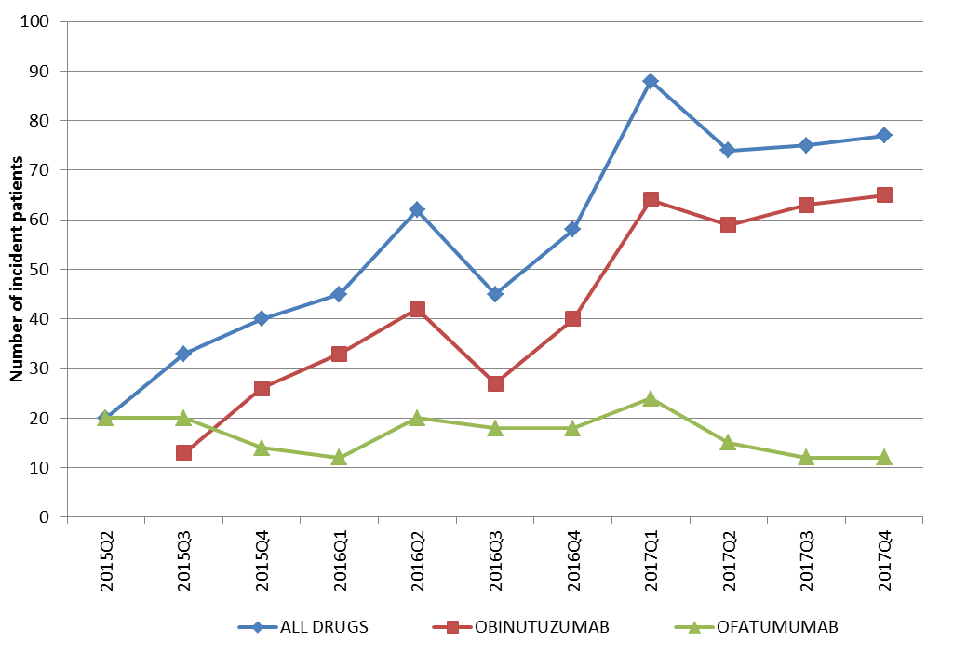
Figure 1: Number of first initiators to obinutuzumab or ofatumumab by quarter
Source: DHS Prescription Claims Database. Data extracted on 30 April 2018 based on the date of supply.

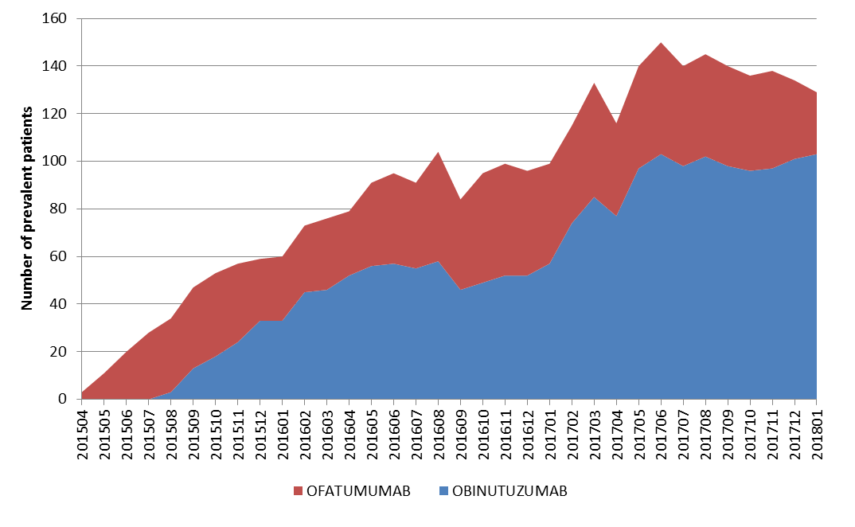
Figure 2: Number of patients treated with obinutuzumab or ofatumumab, April 2015 to January 2018.
Source: DHS Prescription Claims Database. Data extracted on 30 April 2018 based on the date of supply.

  - The PBAC noted that the actual number of prescriptions for year 1 and year 2 in the DUSC Secretariat utilisation analysis (Table 2) was consistent with the data provided in the minor submission. The PBAC considered that the utilisation analysis indicated that the predicted number of eligible patients for obinutuzumab in the March 2015 submission was substantially over-estimated.
  - The PBAC noted that the DUSC Secretariat utilisation analysis reported the actual number of prescriptions per patient and rate of continuation was similar to the predicted assumptions. In addition, very few cases were identified where obinutuzumab was potentially supplied without a co-supply of chlorambucil and no cases were identified where there was switching between obinutuzumab and ofatumumab since the first listing of these agents to 31 December 2017.
Table 2: Predicted versus actual utilisation of obinutuzumab
Parameter | Deed Year 1  (Aug 2015-Jul 2016) | Deed Year 2  (Aug 2016 – Jul 2017)
Number of patients¹
Predicted | '''''''' | ''''''''''
Actual | '''''''''' | ''''''''''
Difference (Actual vs Predicted), % | ''''''''''''''% | '''''''''''''%
Number of prescriptions¹
Predicted | '''''''''''''' | ''''''''''''''
Actual | '''''''''' | '''''''''''''
Difference (Actual vs Predicted), % | '''''''''''''% | ''''''''''''%
Net cost to Government
Subsidisation cap | $'''''''''''''''''''''''''''' | $'''''''''''''''''''''''
Proportion of cap reached | ''''''''''''''% | '''''''''''''''%
Actual expenditure | $''''''''''''''''''''' | $''''''''''''''''''''''''''
Note: Expenditure figures are based on the effective price. Data extraction was based on the date of supply.
¹ Figures are adjusted for the listing commencing on 1 August 2015.
  - The PBAC noted that at its February 2018 meeting, DUSC indicated its intent to undertake a 24 month predicted versus actual analysis of obinutuzumab and ofatumumab for the treatment of chronic lymphocytic leukaemia.
For more detail on PBAC’s view, see section 5 PBAC outcome.

PBAC Outcome
  - The PBAC recommended changing the current S100 Efficient Funding of Chemotherapy (EFC) Program Authority Required (Written) listing for obinutuzumab to a S100 EFC Authority Required (Streamlined) for treatment of CLL.
  - The PBAC recalled that at its March 2015 meeting it had considered a Written Authority listing appropriate for obinutuzumab to help prevent usage outside the population in whom the comparative effectiveness and cost-effectiveness of the medicine have been demonstrated. The committee also recalled that it had advised that the restriction level could be reviewed after the first two years of listing, with a view to changing it to a Streamlined Authority listing if appropriate.
  - The PBAC noted the data provided in the minor submission and by the DUSC Secretariat on obinutuzumab utilisation in the first two years post listing. The PBAC considered that the data provided indicated that the utilisation of obinutuzumab has been significantly lower than that estimated in the March 2015 submission. The PBAC also considered that the utilisation analysis undertaken by the DUSC Secretariat indicated that the obinutuzumab market appears to have stabilised.
  - The PBAC noted that an Authority Required (Streamlined) listing for obinutuzumab would be consistent with the PBS listings for other medicines available for patients with CLL who cannot tolerate a fludarabine-based regimen, including ofatumumab and rituximab.
  - The PBAC noted that a Risk Sharing Arrangement with a subsidisation cap is in place for obinutuzumab, and considered that this provided further protection to the Commonwealth against costs associated with potential use of obinutuzumab outside of the restriction.
  - The PBAC noted that DUSC intended to undertake a 24 month predicted versus actual analysis of obinutuzumab and ofatumumab for the treatment of CLL. The PBAC advised that the predicted versus actual analysis presented by the DUSC Secretariat for this submission was adequate as a 24 month review of these medicines.
  - The PBAC noted that this submission is not eligible for an Independent Review as it received a positive recommendation.
Outcome:
Recommended

Recommended listing
6.1 Amend item:

Name, Restriction,  Manner of administration and form |  | Max.  Qty | №.of  Rpts |  | Proprietary Name and Manufacturer
OBINUTUZUMAB  solution for intravenous infusion  1,000 mg in 40 mL |  | 1,000 mg | 7 |  | Gazyva | Roche Products Pty Ltd
Category / Program | Section 100 (efficient funding of chemotherapy arrangements) public/private hospital
Prescriber type: | Dental Medical Practitioners Nurse practitioners Optometrists Midwives
Condition: | Chronic lymphocytic leukaemia (CLL)
Indication: | Chronic lymphocytic leukaemia
Restriction Level / Method: | Restricted benefit  Authority Required - In Writing  Authority Required - Telephone  Authority Required – Emergency  Authority Required - Electronic  Streamlined
Treatment criteria: | Patient must require treatment for The condition must be CD20 positive chronic lymphocytic leukaemia (CLL),  AND  The condition must be previously untreated,  AND  Patient must be inappropriate for fludarabine based chemo-immunotherapy,  AND  The treatment must be in combination with chlorambucil,  AND  Patient must have a creatinine clearance 30 mL/min or greater,  AND  Patient must have a total cumulative illness rating scale (CIRS) score of greater than 6 (excluding CLL-induced illness or organ damage);  OR  Patient must have a creatinine clearance less than 70 mL/min.
Prescriber Instructions | Treatment must be discontinued in patients who experience disease progression while on treatment.  A patient may only qualify for PBS-subsidised treatment under this restriction once in a lifetime.  Applications for authorisation must be in writing and must include:  (a) a completed authority prescription form; AND  (b) a completed CD20 positive Chronic Lymphocytic Leukaemia PBS Authority Application - Supporting Information Form which includes:  i) documentation that the patient has CD20 positive CLL (flow cytometry pathology report from blood or bone marrow, noting that this may be from some time earlier); AND  ii) a statement that the patient is previously untreated, is inappropriate for fludarabine based chemo-immunotherapy, that treatment will be in combination with chlorambucil, AND  iii) documentation that the patient has a creatinine clearance 30 mL/min or greater; AND  iv) One of the following, either:  - A completed cumulative illness rating scale (CIRS) score form demonstrating that the patient has a score of greater than 6 (excluding CLL-induced illness or organ damage)  OR  - Documentation that the patient has a creatinine clearance less than 70 mL/min;
Administrative advice | Note  Any queries concerning the arrangements to prescribe may be directed to the Department of Human Services on 1800 700 270 (hours of operation 8 a.m. to 5 p.m. EST Monday to Friday).  Prescribing information (including Authority Application forms and other relevant documentation as applicable) is available on the Department of Human Services website at www.humanservices.gov.au  Applications for authority to prescribe should be forwarded to:  Department of Human Services  Prior Written Approval of Complex Drugs  Reply Paid 9826  HOBART TAS 7001  Note  Obinutuzumab is not to be used as monotherapy or in combination with anti-cancer drugs other than chlorambucil  Note  A patient may only qualify for PBS-subsidised treatment under this restriction once in a lifetime.  Note  No increase in the maximum quantity or number of units may be authorised  Note  No increase in the maximum number of repeats may be authorised  Note  Special pricing arrangements apply.

Context for Decision
The PBAC helps decide whether and, if so, how medicines should be subsidised in Australia. It considers submissions in this context. A PBAC decision not to recommend listing or not to recommend changing a listing does not represent a final PBAC view about the merits of the medicine. A company can resubmit to the PBAC or seek independent review of the PBAC decision.

Sponsor’s Comment
The sponsor had no comment.

Outcome Statement from the February 2018 DUSC Meeting. Accessed on 13 June 2018 at: http://www.pbs.gov.au/info/industry/listing/elements/dusc-meetings/dos

