7.18 TOLVAPTAN
Pack containing 28 tablets 15 mg and 28 tablets 45 mg,
Pack containing 28 tablets 30 mg and 28 tablets 60 mg,
Pack containing 28 tablets 30 mg and 28 tablets 90 mg,
JINARC®, Otsuka Australia Pharmaceutical P/L
- Purpose of Application
  - The minor resubmission requested a Section 85 Authority Required (telephone) PBS listing for initiation of tolvaptan and an Authority Required (Streamlined) listing for continuing treatment of autosomal dominant polycystic kidney disease (ADPKD). The resubmission offered a revised price and risk share arrangement (RSA) to offset the uncertain clinical benefit and cost-effectiveness considered by PBAC in the March 2018 major submission. The revised price offer is a 16.7% price reduction (ex-manufacturer) and the proposed RSA offers a hard financial cap.
- Requested listing
  - In March 2018, the PBAC considered the proposed restriction which included patients with evidence of rapid disease progression would be difficult to implement in practice. Overall, the PBAC considered the proposed restriction would not adequately contain use to the most high need patients who may potentially achieve a clinically meaningful benefit. Residual issues with narrowing the eligible patient population would need to be addressed with a price reduction, revised estimates and RSA (Paragraph 7.3, Tolvaptan Public Summary Document (PSD), March 2018). This resubmission requested the simplified restriction below, for patients with stage 2–3 chronic kidney disease (CKD) and rapid disease progression.
Name, Restriction,  Manner of administration and form |  | Max.  Qty | №.of  Rpts | Dispensed Price for Max. Qty | Proprietary Name and Manufacturer
TOLVAPTAN  15mg + 45mg oral tablets  30mg + 60mg oral tablets  30mg + 90mg oral tablets |  | 56 | 5 | $1,815.98 (published)  $''''''''''''''''  (effective) | Jinarc® | Otsuka Australia Pharmaceutical P/L
Category /  Program | GENERAL – General Schedule (Code GE)
Prescriber type: | Dental Medical Practitioners Nurse practitioners Optometrists  Midwives
Episodicity: | Chronic
Severity: | N/A
Condition: | Autosomal dominant polycystic kidney disease (ADPKD)
PBS Indication: | Autosomal dominant polycystic kidney disease (ADPKD)
Treatment phase: | Initial
Restriction Level / Method: | Restricted benefit  Authority Required - In Writing  Authority Required - Telephone  Authority Required – Emergency  Authority Required - Electronic  Streamlined
Treatment criteria: | Prescriber must be a specialist who has undergone tolvaptan prescriber training
Clinical criteria: | The condition must be a confirmed diagnosis of ADPKD  AND  The patient must have an eGFR between 30 and 89 mL/min 1.73 m² at the initiation of treatment.  AND  The patient must have rapidly progressing disease.
Population criteria: | N/A
Foreword | N/A
Definitions | Rapidly progressing disease is defined as either of the following conditions:  A decline in eGFR ≥5 mL/min/1.73 m² within one year OR an average decline in eGFR ≥2.5 mL/min/1.73 m² per year over a five year period
Prescriber Instructions | Details of tolvaptan prescriber training requirements  Otsuka has committed to ensuring that in Australia all the Jinarc prescribers are educated on the use of the drug and that a liver function monitoring program is implemented to minimise the risk of hepatic injury.  The Jinarc Monitoring and Distribution Program (www.jinarc.com.au) has been set up to host the training material and prescriber certification and to support long-term liver monitoring and safety. All prescribers and patients must take part in the Jinarc Monitoring and Distribution Program in order to prescribe/receive Jinarc in Australia.
Administrative Advice | N/A
Cautions | Recommendations for the management of potential hepatic toxicity  To mitigate the risk of significant and/or irreversible liver injury, blood testing for hepatic transaminases and bilirubin is required prior to initiation of Jinarc, continuing monthly for 18 months and at regular 3 monthly intervals thereafter. Concurrent monitoring for symptoms that may indicate liver injury (such as fatigue, anorexia, nausea, right upper abdominal discomfort, vomiting, fever, rash, pruritus, dark urine or jaundice) is recommended.
Category /  Program | GENERAL – General Schedule (Code GE)
Prescriber type: | Dental Medical Practitioners Nurse practitioners Optometrists  Midwives
Episodicity: | Chronic
Severity: | N/A
Condition: | Autosomal dominant polycystic kidney disease (ADPKD)
PBS Indication: | Autosomal dominant polycystic kidney disease (ADPKD)
Treatment phase: | Continuing
Restriction Level / Method: | Restricted benefit  Authority Required - In Writing  Authority Required - Telephone  Authority Required – Emergency  Authority Required - Electronic  Streamlined
Treatment criteria: | Prescriber must be a specialist who has undergone tolvaptan prescriber training
Clinical criteria: | The condition must be a confirmed diagnosis of ADPKD  AND  Patient must have previously been issued with an authority prescription for this drug for this condition  AND  The patient must not have reached end-stage renal disease (eGFR<15 mL/min/1.73m²) or undergone a kidney transplant.
Population criteria: | N/A
Foreword | N/A
Definitions | N/A
Prescriber Instructions | Details of tolvaptan prescriber training requirements  Otsuka has committed to ensuring that in Australia all the Jinarc prescribers are educated on the use of the drug and that a liver function monitoring program is implemented to minimise the risk of hepatic injury.  The Jinarc Monitoring and Distribution Program (www.jinarc.com.au) has been set up to host the training material and prescriber certification and to support long-term liver monitoring and safety. All prescribers and patients must take part in the Jinarc Monitoring and Distribution Program in order to prescribe/receive Jinarc in Australia.
Administrative Advice | N/A
Cautions | Recommendations for the management of potential hepatic toxicity  To mitigate the risk of significant and/or irreversible liver injury, blood testing for hepatic transaminases and bilirubin is required prior to initiation of Jinarc, continuing monthly for 18 months and at regular 3 monthly intervals thereafter. Concurrent monitoring for symptoms that may indicate liver injury (such as fatigue, anorexia, nausea, right upper abdominal discomfort, vomiting, fever, rash, pruritus, dark urine or jaundice) is recommended.

  - The Pre-PBAC response stated that Otsuka postponed the patient familiarisation program following the March 2018 PBAC deferral decision, however, the sponsor suggested a grandfathering clause may still be appropriate for the 50 patients who previously participated in ADPKD clinical trials and continue to receive tolvaptan treatment in Australia.
For more detail on PBAC’s view, see section 5 PBAC outcome.
- Background
  - Tolvaptan was TGA registered on 24 March 2017 to slow the progression of cyst development and renal insufficiency of ADPKD in adults with chronic kidney disease (CKD) stage 1-3 at initiation of treatment with evidence of rapidly progressing disease.
  - Tolvaptan has been considered by the PBAC on two previous occasions.
  - In the March 2017 submission, the PBAC rejected the submission on the basis that it was uncertain about the long-term clinical benefit and it was concerned about the potential for substantial liver toxicity. In this context, the PBAC considered that the incremental cost-effectiveness was very high and unclear and the likelihood of high overall costs to government was unacceptable.
  - In the March 2018 resubmission, the PBAC deferred making a decision regarding the submission as it considered the clinical benefit of tolvaptan treatment was uncertain and at best very small. In this context the PBAC considered no new trial data is anticipated that could resolve this issue. Treatment is also expected to be long-term; over 40-50 years. It was determined a further submission for PBS listing would need to consider resolving issues of uncertain clinical benefit and duration of therapy by adjusting the optimistic assumptions in the economic evaluation. The price would also need to be substantially lower to reduce the incremental cost effectiveness ratio (ICER). Further work on the proposed PBS restriction would be required to identify a more severely affected patient group. PBS listing would also require a tight risk share arrangement to limit subsidy to this more severely affected population.
For more detail on PBAC’s view, see section 5 PBAC outcome.

Consideration of the evidence

Sponsor hearing
  - There was no hearing for this item as it was a minor submission.

Consumer comments
  - The PBAC noted and welcomed the input from individuals (17) and organisations (2) via the Consumer Comments facility on the PBS website that were in keeping with comments received at the March 2018 PBAC meeting, including a range of anticipated benefits of treatment with tolvaptan including delayed disease progression, prolonging life, reduced pain, improved quality of life, avoidance of dialysis and transplantation, and employment opportunities.

  - The PBAC noted the comments from Kidney Health and PKD Foundation Australia and acknowledged the ongoing emotional stress on patients affected by ADPKD.

Economic analysis
  - Table 1 outlines the PBAC’s previous key concerns with the economic evaluation and how these were addressed in the minor resubmission.
Table 1: Summary of outstanding matters of concern with the economic evaluation from March 2018
Previous PBAC concern | How addressed in minor resubmission
Reliance on optimistic estimates of long-term treatment effects where delayed renal replacement therapy is the primary source of health benefit (Para 7.11). | A sensitivity analysis was provided wherein the tolvaptan treatment effect was reduced (halved) after 5 or 10 years of treatment. This sensitivity analysis did not reliably address the long-term treatment effect as the proportion of patients still on treatment at 10 years in the model was 38% in TEMPO 3:4 and 16% in REPRISE (at 5 years, 66% and 53% of patients were still on treatment in TEMPO 3:4 and REPRISE, respectively). Thus, the treatment effect was reduced when a large proportion of patients were off-treatment with tolvaptan (and assumed to be on best supportive care).
Uncertain clinical benefit applied in the economic model (paras 7.1, 7.9); The PBAC considered that a substantial price reduction would be required to account for the uncertain clinical benefit, even in a highly selected population (Para 7.11). | Clinical benefit not adjusted for in the resubmission’s base case model. Sensitivity analyses were conducted during preparation of the minor overview.
No accounting for the acute hemodynamic effects associated with tolvaptan treatment (5-10% reduction in eGFR) (Para 7.11) | The resubmission stated that the price reduction (16.7%) “should account for any residual uncertainty associated with any potential acute hemodynamic effects”. No other adjustments were made in the economic model to account for this.
The assumption of rapid disease progression (Para 7.11)  Significant variability between the inclusion criteria of REPRISE and TEMPO 3:4; unclear how the trial populations were applicable to the proposed PBS eligible Australian population. The PBAC noted that the resubmission base case ICERs from Tempo 3:4 and REPRISE were based upon effectiveness from sub-populations in the trials, as opposed to the ITT populations, (Para 7.10) | Not adjusted for in the resubmission’s model. The resubmission acknowledged the modelled population was not aligned with the proposed PBS restriction, but considered that this issue was addressed through the proposed RSA with a hard financial cap based on the resubmission’s estimate of 15% of the ADPKD population. The resubmission stated that, given that half the ADPKD will experience end stage kidney disease by the age of 60, the population being funded on the PBS does have rapid disease progression”.  The strict definition of rapid disease progression applied in the model (annualised eGFR decline of ≥2.5 mL/min/1.73 m²/year over the maximum period of available data for each patient) is likely to exclude patients who would qualify for treatment under the requested restriction and favours tolvaptan. The definition was applied through using sub-populations of the trials, rather than the ITT populations, which was tested in sensitivity analyses during preparation of the minor overview.
No utility decrement for a drug that has appreciable side effects. (Para 7.11) | A disutility of 0.0123 was applied to 33% of patients for the duration of treatment on tolvaptan. This was based on Sullivan et al 2011 “Catalogue of EQ-5D Scores for the United Kingdom” for the disutility associated with the condition of “other endocrine disorders”. The resubmission stated this was applied to account for thirst and polyuria. The resubmission stated that this was conservative (biased the analysis against tolvaptan) as these adverse events are likely to be transient. However this may not have been conservative as it may not adequately account for long-term safety; in its previous consideration, the PBAC and noted the TGA had imposed a black box warning in the product information regarding hepatic impairment (Para 7.8).
Source: Compiled during preparation of the minor overview based on Section 3 of the minor resubmission.
Abbreviations: CKD, chronic kidney disease; ITT, intention-to-treat; QALY, quality-adjusted life year
  - The minor resubmission made two changes to the economic model:
- the price was reduced by '''''''''% from $'''''''''''''' to $'''''''''''''' (effective DPMQ); and
- a disutility of 0.0123 was applied to account for thirst and polyuria associated with tolvaptan treatment. This was applied to one-third of patients for the entire duration of their tolvaptan treatment.
  - For the TEMPO 3:4 sub-population, the ICER changed from $15,000/QALY - $45,000/QALY (previous submission) to $15,000/QALY - $45,000/QALY with the application of the lower price; then to $15,000/QALY - $45,000/'''''''''' with the application of adverse event disutilities. For the REPRISE subpopulation, the ICER remained dominant when these changes were applied. The resulting weighted ICER is presented in Table 2 below. During preparation of the minor overview, the ICERs were also calculated based on the ITT of the trials (using both the overall trial population characteristics and efficacy) rather than the sub-populations.

Table 2: Results of the modelled economic evaluation
Analysis | Tolvaptan | Placebo | Increment
Current minor resubmission base case (tolvaptan price of $''''''''''''''''/pack and with disutility for adverse events)
TEMPO 3:4 PBS eligibility population and CKD stage 2-3 efficacy ª
Costs | $'''''''''''''''''''' | $''''''''''''''''''' | $''''''''''''''''
Life years gained | 13.75 | 13.20 | 0.55
QALYs | 11.51 | 10.96 | 0.55
Incremental cost/QALY gained |  |  | $''''''''''''''''
REPRISE PBS eligibility population and CKD stage 2-3 efficacy ^{b}
Costs | $''''''''''''''''''' | $'''''''''''''''''' | -$'''''''''''''''
Life years gained | 11.82 | 11.24 | 0.57
QALYs | 9.61 | 9.05 | 0.56
Incremental cost/QALY gained |  |  | Tolvaptan dominant
Weighted ICER (weighting: 54.1% TEMPO 3:4 versus 45.9% REPRISE) ^{c}
Incremental costs |  |  | $'''''''''''''''
Incremental QALYs |  |  | 0.55
Weighted ICER / QALY |  |  | $'''''''''''
Current minor resubmission – ITT population (tolvaptan price of $783.77/pack and with disutility for adverse events)
TEMPO 3:4 ITT population and efficacy
Costs | $'''''''''''''''''' | $''''''''''''''''' | $''''''''''''''''
QALYs | 13.29 | 12.98 | 0.31
Incremental cost/QALY gained |  |  | $''''''''''''''''''
REPRISE ITT population and efficacy ^{d}
Costs | $'''''''''''''''''''' | $''''''''''''''''''''' | $'''''''''''''''
QALYs | 10.35 | 9.97 | 0.37
Incremental cost/QALY gained |  |  | $'''''''''''''''
Weighted ICER for ITT population (weighting: 54.1% TEMPO 3:4 vs 45.9% REPRISE) ^{c}
Incremental costs |  |  | $'''''''''''''''''
Incremental QALYs |  |  | 0.34
Weighted ICER / QALY |  |  | $''''''''''''''
Previous submission summarised results (tolvaptan price of $'''''''''''''''/pack and no disutility for adverse events)
 | Incremental costs | Incremental QALYs | ICER
TEMPO 3:4 subpopulation | $'''''''''''''''' | 0.58 | $'''''''''''''''
REPRISE subpopulation | -$'''''''''' | 0.58 | Dominant
Weighted ICER ^{c} | $''''''''''''''''' | 0.58 | $'''''''''''''''''
Source: Table 3-2, p15 of the minor resubmission and calculated during preparation of the Minor Overview based on ‘Tolvaptan November 2017 PBAC Section 3 Updated for April 2018’
Abbreviations: CKD, chronic kidney disease; ITT, intention-to-treat; QALY, quality-adjusted life year; vs = versus
ª Based on TEMPO 3:4 data filtered for age: 18-50 years; kidney function: eGFR <90 mL/min/1.73 m²; and rapidly progressing disease: eGFR decline ≥2.5 mL/min/1.73 m2/year.
^{b} Based on REPRISE data filtered for (i) age: 18-55 years; kidney function: eGFR 30-65 mL/min/1.73 m²; and rapidly progressing disease: eGFR decline ≥2.5 mL/min/1.73 m2/year; OR (ii) age: 56-65 years; kidney function: eGFR 30-44 mL/min/1.73 m2; and rapidly progressing disease: eGFR decline ≥2.5 mL/min/1.73 m2/year.
^{c} Overall, the weighting between TEMPO 3:4 and REPRISE was 54.1% and 45.9%, respectively. This was based on: 61.2% = A and B overlap (average between the 2 estimates); 23.5% = A only; 15.3% = B only (based on the THIN data, see the March 2018 submission for full details).
^{d} In TreeAge ‘Tolvaptan November 2017 PBAC Section 3 Updated for April 2018’, this was conducted by changing ‘sa_efficacyTOL’ to 4 and ‘sa_PopGroup’ to 5.

The redacted table shows ICERs in the range of less than $15,000/QALY - $105,000/QALY.
  - Unchanged from the previous submission, the tolvaptan treatment effect was applied as a relative reduction in the rate of eGFR decline, based on the weighted mean slope reductions derived by CKD stage in the TEMPO 3:4 and REPRISE trials, using only CKD stages 2 and 3 (Table 3). During preparation of the minor overview, sensitivity analyses were conducted using the estimated tolvaptan treatment effects by CKD stage, rather than the weighted mean across CKD stages 2 and 3.

Table 3: Derivation of the tolvaptan treatment effect used in the base case of the model
Subgroup | Tolvaptan |  | Placebo |  | Slope reduction | Weighted mean slope reduction applied in model
 | N | Mean annualised change in slope | N | Mean annualised change in slope
TEMPO 3:4 (change in slope of eGFR (CKD-EPI) decline; linear mixed-effects Laird–Ware model)
Overall population | 842 | -2.72 | 464 | -3.70 | 26.4% | Not used in base case
Baseline CKD 1 | 267 | -2.2 | 158 | -2.6 | 15.5% | NA
Baseline CKD 2 | 465 | -2.7 | 224 | -3.9 | 29.1% | 29.6% ª
Baseline CKD 3 | 163 | -3.7 | 84 | -5.3 | 31.0%
REPRISE (annualised rate of change in eGFR (CKD-EPI); weighted ANCOVA)
Overall population ^{c} | 668 | -2.961 | 663 | -4.249 | 30.3% ^{c} | Not used in base case
Baseline CKD 2 | 31 | -0.541 | 38 | -4.589 | 88.2% | 34.6% ^{b}
Baseline CKD 3A | 206 | -2.061 | 196 | -4.379 | 52.9%
Baseline CKD 3B | 294 | -3.344 | 304 | -3.982 | 16.0%
Baseline CKD 4 | 137 | -4.041 | 125 | -4.590 | 12.0% | NA
ª ([29.1% × [465 + 224]] + [31.0% × [163+84]]) / (465 + 224 + 163 + 84).
^{b} ([88.2% × [31 + 38]] + [30.9% × [206 + 196 + 294 + 304]]) / (31 + 38 + 206 + 196 + 294 + 304). Note that 30.9% was the weighted average of 52.9% and 16.0%.
^{c} Based on weighted ANCOVA method (refer to Table 5 of the March 2018 PBAC Minutes). The result using the linear mixed effect model was 26.4% (refer to Table 7 of the March 2018 PBAC Minutes).
Abbreviations: CKD, chronic kidney disease; eGFR, estimated glomerular filtration rate; NA, not applicable.
Source: Tables 5 and 7 of the Tolvaptan Minutes March 2018, Table 3.4.1, p 7.06.COM.69, of the March 2018 commentary
  - During preparation of the minor overview it was noted that the revised base case was not conservative because:
- The tolvaptan treatment effect applied in the economic model was unchanged despite the March 2018 PBAC considering that “the change in eGFR was at best very small, and quantifying the subsequent impact on ESKD would be very uncertain” (Paragraph 7.9, Tolvaptan PSD March 2018). As such, the minor resubmission applied a relative reduction in eGFR decline of 29.6% in the TEMPO 3:4 sub-population and 34.6% in the REPRISE sub-population (unchanged from the March 2018 submission). This resulted in tolvaptan treatment delaying progression to ESRD by 2.1 years (the model estimated that progression to ESKD would take 12.4 versus 10.3 years in the tolvaptan and placebo arms respectively for the TEMPO 3:4 sub-population, and 8.2 versus 6.1 years, in the tolvaptan and placebo arms respectively for the REPRISE sub-population).
- Sub-populations from the trials were used, rather than the ITT (unchanged from the March 2018 submission), which was not conservative as the effect size was smaller and the rate of disease progression was slower in the ITT populations. The sub-populations were based on individual patient data from the TEMPO 3:4 and REPRISE placebo arms, filtered post-hoc by the eligibility criteria of the restriction requested in the March 2018 submission:
  - PBS sub-population A: based on TEMPO 3:4 data filtered for age: 18-50 years; kidney function: eGFR <90 mL/min/1.73 m²; and rapidly progressing disease: eGFR decline ≥2.5 mL/min/1.73 m²/year.
  - PBS sub-population B: based on REPRISE data filtered for (i) age: 18-55 years; kidney function: eGFR 30-65 mL/min/1.73 m²; and rapidly progressing disease: eGFR decline ≥2.5 mL/min/1.73 m²/year; OR (ii) age: 56-65 years; kidney function: eGFR 30-44 mL/min/1.73 m²; and rapidly progressing disease: eGFR decline ≥2.5 mL/min/1.73 m²/year.
- As part of using sub-populations (rather than the ITT), only patients with rapid disease progression were included in the model (annualised eGFR decline of ≥2.5 mL/min/1.73 m²/year over the maximum period of available data for each patient). This is likely to have excluded patients who would qualify for treatment under the requested restriction which specifies ‘rapidly progressing disease’ without this specific definition. The resubmission acknowledged that the modelled population was not aligned with the proposed PBS restriction, but considered that this issue was addressed through the proposed RSA with a hard financial cap based on the resubmission’s estimate of 15% of the ADPKD population. The resubmission stated that, “given that half the ADPKD will experience end stage kidney disease by the age of 60, the population being funded on the PBS does have rapid disease progression”.
  - Further, the structure of the economic model may not have been appropriate because:
- The model assumed that the tolvaptan treatment effect would continue unchanged for the entire duration that a patient remains on treatment. That is, the reduction in eGFR decline of 29.6% or 34.6% (which was based on 1-3 years of clinical trial follow-up from TEMPO 3:4 or REPRISE, respectively), was assumed to continue for up to 40 years for some individuals in the TEMPO base case and up to 26 years in the REPRISE base case. There are limited long term data to support the continuing treatment effect over time. To address this, the minor resubmission provided a sensitivity analysis wherein the tolvaptan treatment effect was reduced (halved) after 5 or 10 years of treatment (discussed further below).
- The model did not account for the acute hemodynamic effects associated with tolvaptan treatment (5-10% reduction in eGFR). The resubmission stated that the price reduction (16.7%) “should account for any residual uncertainty associated with any potential acute hemodynamic effects”. No other adjustments were made in the economic analysis to account for this.
- The tolvaptan treatment effect was applied based on the weighted slope reductions across the health states CKD 2 to CKD 4 (based on efficacy in states CKD 2 and CKD 3) rather than applying the actual slope reduction in each of the relevant stages of kidney disease. This was not conservative (e.g. for the TEMPO 3:4 trial, a weighted mean reduction of 29.6% was applied across CKD 2 to 4 rather than applying 29.1% in CKD 2 and 31% in CKD 3 as had been observed in the trial). Further, different methods were used to derive the tolvaptan treatment effect between TEMPO 3:4 and REPRISE (i.e. linear mixed effects model versus weighted ANCOVA, respectively). For REPRISE, this was not conservative (refer to sensitivity analyses below).
Outputs from model
  - The figures below show the Markov traces for the base case economic model presented in the resubmission, comprising the TEMPO 3:4 (Figure 1a) and REPRISE (Figure 2a) sub-populations. For comparison, the ITT populations from the two trials are also presented (Figures 1b and 2b). The trace for ESRD (darker blue line) comprises patients with CKD5, on dialysis or post kidney transplant. Given that dialysis was a key driver of the model — it was associated with significant costs ($100,056 per year on-going cost for dialysis) and disutilities (a dialysis disutility of 0.13 was applied) — this is also shown in separate (lighter blue) traces (as well as being included in the ESRD line).
Figure 1: Markov trace of TEMPO 3:4 - tolvaptan (solid lines) versus placebo (dotted lines): (a) base case presented in model (sub-population with CKD stages 2-3 with rapid disease progression); (b) ITT population from trial
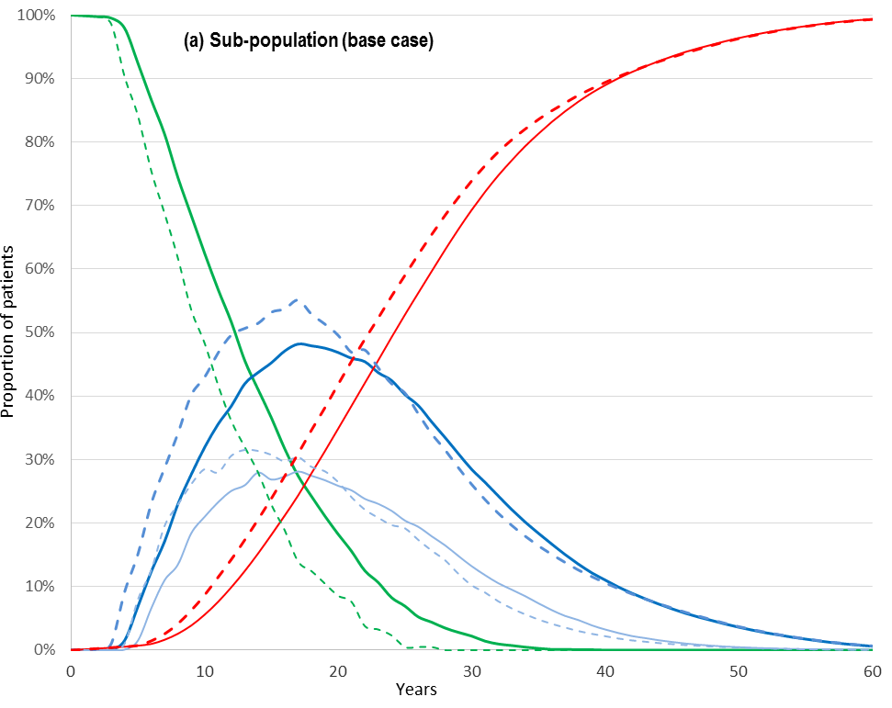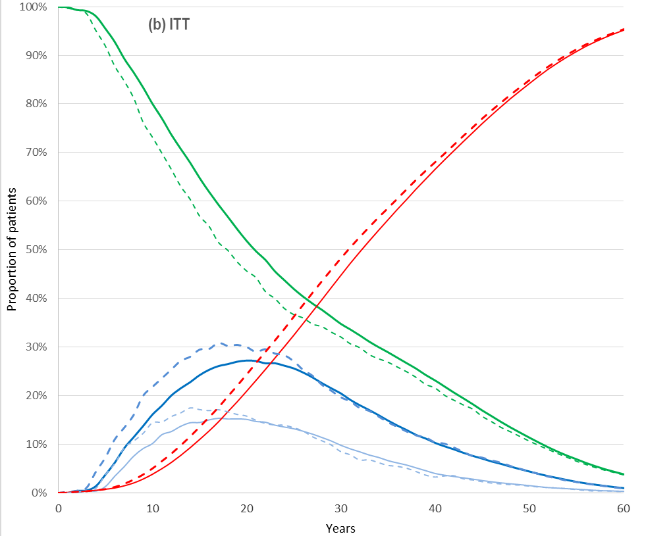
Source: Constructed during preparation of the Minor Overview based on ‘Tolvaptan November 2017 PBAC Section 3 Updated for April 2018’
Abbreviations: CKD, chronic kidney disease; ESRD, end stage renal disease.

Figure 2: Markov trace of REPRISE - tolvaptan (solid lines) versus placebo (dotted lines): (a) base case presented in model (sub-population with CKD stage 2-3 with rapid disease progression); (b) ITT population from trial
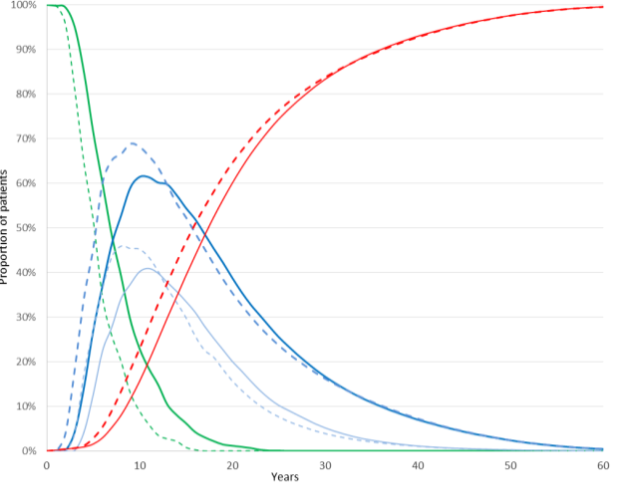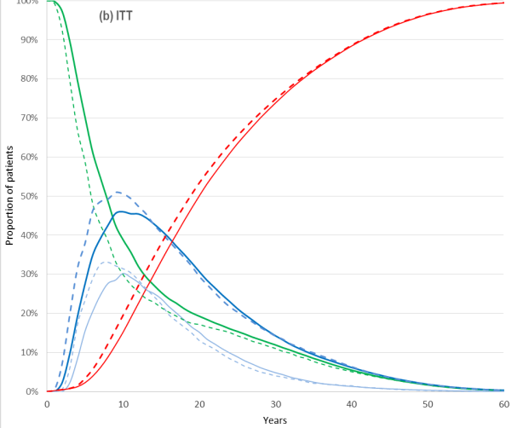
Source: Constructed during preparation of the Minor Overview based on ‘Tolvaptan November 2017 PBAC Section 3 Updated for April 2018
Abbreviations: CKD, chronic kidney disease; ESRD, end stage renal disease.
  - The Markov traces show that patients treated with tolvaptan spend more time in CKD stages 2 to 4 and less time in the ESRD and dead states. In particular, patients on tolvaptan spend less time on dialysis, which is associated with significant costs and utility decrements. The Markov traces also show that patients in the sub-populations have more rapidly progressing disease than the ITT population (earlier and higher rates of CKD5 and dialysis), and that tolvaptan is associated with a greater treatment effect in the subpopulation patients (bigger difference between the tolvaptan and placebo traces for each health state).
  - As outlined in the March 2018 PBAC PSD, the different results between the two trials (TEMPO 3:4 and REPRISE) despite overlapping patient populations, highlight the uncertainty of the treatment effect (Paragraph 6.52, Tolvaptan PSD, March 2018). The different results were likely due to:
- Patients in REPRISE had poorer baseline characteristics (e.g. mean baseline eGFR in the tolvaptan arm was 44 mL/min/1.73m² in REPRISE, versus 68 mL/min/1.73m² in TEMPO 3:4);
- Patients in REPRISE had more rapid disease progression (e.g. mean time to ESKD in the placebo arms were 6.1 years in REPRISE versus 10.3 years in TEMPO 3:4); and
- A larger treatment effect was assumed from REPRISE (relative reduction of 34.6% was assumed in RESPRISE versus 29.6% in TEMPO 3:4).
Sensitivity analyses
  - The resubmission included two sensitivity analyses in which the efficacy of tolvaptan was halved after five or ten years (from a 29.6% reduction in eGFR decline to a 14.8% reduction for TEMPO 3:4; and from 34.6% to 17.3% for REPRISE). These are shown in the table below.
Table 4: Sensitivity analyses conducted by the minor resubmission - tolvaptan’s long term efficacy
Patient populations | Incremental cost | Incremental QALY | ICER
Revised base case
PBS patient sub-population A (TEMPO 3:4 data) | $''''''''''''''' | 0.5500 | $''''''''''''''''''
PBS patient sub-population B (REPRISE data) | -$''''''''''''' | 0.5605 | Dominant
Overall PBS population – weighted average ª | $''''''''''''' | 0.5548 | $''''''''''''''
50% loss in tolvaptan efficacy after 5 years
PBS patient sub-population A (TEMPO 3:4 data) | $''''''''''''''''' | 0.3907 | $''''''''''''''''
PBS patient sub-population B (REPRISE data) | -$''''''''''''''' | 0.4471 | Dominant
Overall PBS population – weighted average ª | $''''''''''''''''' | 0.4166 | $'''''''''''''''
50% loss in tolvaptan efficacy after 10 years
PBS patient sub-population A (TEMPO 3:4 data) | $''''''''''''''' | 0.4823 | $''''''''''''''''''
PBS patient sub-population B (REPRISE data) | -$''''''''''''' | 0.5316 | Dominant
Overall PBS population – weighted average ª | $'''''''''''' | 0.5049 | $'''''''''''''
Source: Table 3-3, p16 of the minor resubmission
ª 61.2% = A and B overlap (average between the 2 estimates); 23.5% = A only; 15.3% = B only (based on the THIN data, see the March 2018 submission for full details).
The redacted table shows ICERs in the range of less than $15,000/QALY - $75,000/QALY.
  - These sensitivity analyses did not reliably address the long-term treatment effect as the model estimated a mean treatment duration of 6.5 to 9.5 years (depending on the population group). The proportion of patients still on treatment at 10 years was 38% in TEMPO 3:4 and 16% in REPRISE (at five years, 66% and 53% of patients were still on treatment in TEMPO 3:4 and REPRISE, respectively). Thus, the treatment effect was reduced when a large proportion of patients were off-treatment with tolvaptan (and assumed to be on best supportive care). Patients would still benefit after ceasing tolvaptan as their eGFR would be higher after having previously been on tolvaptan. An alternative way to address the uncertain long term efficacy would have been to have assumed that the tolvaptan treatment effect converges with best supportive care over time, or to have truncated the model time horizon. While the latter results in a dominant ICER (when weighted between the TEMPO 3:4 and REPRISE sub-populations) at 10 years, it would be markedly higher at shorter time intervals (e.g. the weighted ICER is more than $200,000/QALY at 5 years and more than $200,000/QALY at 7 years).
  - Figure 3 shows the ICER over time for the TEMPO 3:4 sub-population. During preparation of the minor overview it was noted that the ICER is dominant around years 17 and 20 and the reason for the ICER initially decreasing but then increasing with longer time horizons was not clear. With a five year time horizon (not shown on the graph), the ICER was more than $200,000/QALY. This appeared to be due to the disutility applied for adverse events, which although of a small magnitude had a large impact with short time horizons given the small difference in QALYs between the two arms in the earlier stages of the model.
Figure 3: ICER over time for TEMPO 3:4 sub-population used in the base case.
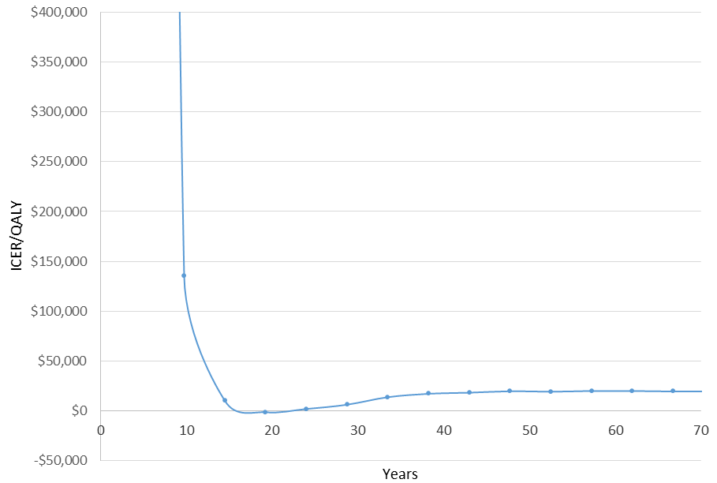
Source: Constructed during preparation of the Minor Overview based on ‘Tolvaptan November 2017 PBAC Section 3 Updated for April 2018, as a one-way sensitivity analysis on the variable ‘dur_years’
  - Tables 5 and 6 provide sensitivity analyses conducted during preparation of the minor overview for TEMPO 3:4 and REPRISE, respectively, based on the sub-populations used in the minor resubmission’s base case.
Table 5: Sensitivity analyses on TEMPO 3:4 sub-population ª
Analysis | ∆ cost | ∆ QALYs | ICER
Resubmission’s base case (PBS eligibility population and CKD stage 2-3 efficacy; efficacy = 0.296) | $''''''''''''''' | 0.5500 | $''''''''''''''' ª
Alternative tolvaptan efficacy and population (relative reduction; base case 0.296; sub-population)
TEMPO 3:4 ITT - overall trial population and efficacy (N=474, efficacy = 0.264) | $''''''''''''''' | 0.3107 | $''''''''''''''''''
Alternative tolvaptan efficacy estimates (relative reduction; base case 0.296) – population per base case
Efficacy = 0.264 (efficacy per ITT, but using sub-population characteristics) ^{b} | $''''''''''''''' | 0.477 | $''''''''''''''''
Efficacy halved at start (0.148) | $''''''''''''''''' | 0.2388 | $'''''''''''''''''''''
Efficacy halved after 2 years | $'''''''''''''''' | 0.3100 | $''''''''''''''''
Efficacy halved after 5 years | $''''''''''''''''' | 0.3907 | $'''''''''''''''
Efficacy halved after 10 years | $'''''''''''''''' | 0.4823 | $'''''''''''''''''
TEMPO 3:4 by CKD stage (CKD 2: 0.291; CKD 3: 0.310; CKD 4: 0.310) ^{c} | $'''''''''''''' | 0.5684 | $''''''''''''''''''
Disutilities (base case = -0.0123 was applied to 33% of patients for duration of treatment)
-0.05 applied to 33% of patients for duration of tolvaptan treatment | $'''''''''''''''''' | 0.4685 | $'''''''''''''''
-0.05 applied to all patients for duration of tolvaptan treatment | $''''''''''''''' | 0.2489 | $''''''''''''''''
Time horizon (base case: lifetime; maximum 100 years) ^{d}
5 years | $'''''''''''''''''' | 0.0072 | $''''''''''''''''''''''
7 years | $'''''''''''''''' | 0.0315 | $''''''''''''''''''
10 years | $''''''''''''''''' | 0.0950 | $'''''''''''''''''
20 years | -$''''''''' | 0.3530 | Dominant
30 years | $'''''''''''' | 0.4994 | $'''''''''''''
50 years | $''''''''''''''' | 0.5486 | $''''''''''''''''
Abbreviations: CKD: chronic kidney disease; ICER, incremental cost effectiveness ratio; QALYs: quality adjusted life years
Source: Table 3-3, p16 of the minor resubmission and calculated during preparation of the Minor Overview based on ‘Tolvaptan November 2017 PBAC Section 3 Updated for April 2018’
ª These sensitivity analyses are based on the minor resubmission’s base case which comprised the trial sub-populations. This differs to the sensitivity analyses presented in Tables 14 and 15 of the March 2018 PBAC Minutes, which used the ITT (overall trial population and efficacy) as the base case.
^{b} Change tbl_TOLefficacy Column 1 to 0.264 for Index 1 to 4.
^{c} Using ‘sa_efficacyTOL’ = 5 and ‘sa_PopGroup’ = 1.
^{d} Change ‘dur_years’ variable definition

The redacted table shows ICERs in the range of less than $15,000/QALY – more than $200,000/QALY.
Table 6: Sensitivity analyses on REPRISE sub-population ª
Analysis | ∆ cost | ∆ QALYs | ICER
Base case presented in minor resubmission (PBS eligibility population and CKD stage 2-3 efficacy; efficacy = 0.346) ª | -$''''''''''''''' | 0.5605 | Dominant
Alternative population and efficacy
REPRISE ITT - overall trial population and efficacy (N=663, efficacy = 0.303) | $''''''''''''''' | 0.37 | $''''''''''''''''
Alternative tolvaptan efficacy (relative reduction; base case 0.346 based on change in eGFR, weighted ANCOVA)
Efficacy halved at start (0.148) | $''''''''''''''''' | 0.2834 | $''''''''''''''''
Efficacy halved after 2 years | $''''''''''''' | 0.3299 | $'''''''''''''''''
Efficacy halved after 5 years | -$'''''''''''''' | 0.4471 | Dominant
Efficacy halved after 10 years | -$'''''''''''''' | 0.5316 | Dominant
Efficacy based on change in slope linear mixed model (0.243) | $''''''''''''''' | 0.3544 | $'''''''''''''''''
REPRISE by CKD stage  (CKD 2: 0.882; CKD 3: 0.309; CKD 4: 0.120) ^{b} | $'''''''''''''' | 0.3636 | $'''''''''''''''
Disutilities (base case = -0.0123 was applied to 33% of patients for duration of treatment)
-0.05 applied to all patients for duration of tolvaptan treatment | -$'''''''''''' | 0.3359 | Dominant
Time horizon (base case: lifetime; maximum 100 years)
5 years | $''''''''''''''' | 0.033 | $'''''''''''''''''
≥6 years (i.e. all analyses with time horizons of ≥6 years are dominant) | - | - | Dominant
7 years | -$'''''''''''''''''' | 0.0952 | Dominant
10 years | -$''''''''''''''''' | 0.2291 | Dominant
Abbreviations: CKD: chronic kidney disease; ICER, incremental cost effectiveness ratio; QALYs: quality adjusted life years; Yr, year.
Source: Table 3-3, p16 of the minor resubmission and calculated during preparation of the Minor Overview based on ‘Tolvaptan November 2017 PBAC Section 3 Updated for April 2018’
ª These sensitivity analyses are based on the minor resubmission’s base case which comprised the trial sub-populations. This differs to the sensitivity analyses presented in Tables 14 and 15 of the March 2018 PBAC Minutes, which used the ITT (overall trial population and efficacy) as the base case.
^{b} Using ‘sa_efficacyTOL’ = 6 and ‘sa_PopGroup’ = 2.
The redacted table shows ICERs in the range of less than $15,000/QALY – more than $200,000/QALY.
  - Overall, the economic model was sensitive to the efficacy estimate, the modelled population and the model time horizon. In particular, the weighted ICER would change from a base case of less than $15,000/QALY to:
- $105,000/QALY - $200,000/QALY for a time horizon of seven years in both models;
- $75,000/QALY - $105,000/QALY if efficacy was halved at the start of the models, rather than after 5 or 10 years as used in the minor resubmission’s sensitivity analyses; and
- $75,000/QALY - $105,000/QALY if the ITT populations were used for both models.
These values were calculated using the weightings applied in the minor resubmission of 54.1% and 45.9% between TEMPO 3:4 and REPRISE, respectively.

Drug cost/patient/year: $'''''''''''.
  - The estimated annual cost for tolvaptan is $ '''''''''''' (effective price) based on 13.04 scripts per year (=365 days per year/28 days per pack).
  - The estimated cost was lower than in the March 2018 submission ($'''''''''''''' based on the effective price).

Estimated PBS usage & financial implications
  - The minor resubmission estimated a net cost to the PBS of up to $10 million in Year 6 of listing, with a total net cost to the PBS of $30 - $60 million over the first 6 years of listing based on the effective price. This compares to $60 - $100 million over 6 years in the March 2018 submission. The tables below summarise the expected patient/prescription numbers and total costs.
Table 7: Revised usage and financial estimates proposed in the current submission
Year | Year 1 | Year 2 | Year 3 | Year 4 | Year 5 | Year 6
Prevalent ADPKD pop’n  (356 per million) | ''''''''''''' | '''''''''''' | '''''''''''''' | ''''''''''''' | ''''''''''''' | '''''''''''''''
ADPKD patients where a ‘hard cap’ is set to ensure cost-effectiveness  (15%) | ''''''''''''' | ''''''''''''' | ''''''''''''' | '''''''''''' | ''''''''''''' | ''''''''''''
Tolvaptan estimated initiation rates | 60.0% | 8.0% | 8.0% | 8.0% | 8.0% | 8.0%
Patients initiating treatment | '''''''' | ''''''''' | ''''''''' | ''''''''' | '''''''' | '''''''''
Treatment persistence for each year of therapy | 100% | 84.7% | 80.8% | 77.1% | 73.5% | 70.2%
Number of patients remaining on tolvaptan at the beginning of each year among those initiated in:
Year 1 | ''''''''' | '''''''' | '''''''''' | '''''''''' | ''''''''' | ''''''''
Year 2 | - | ''''''''' | ''''' | ''''''' | '''''' | '''''
Year 3 | - | - | '''''''''' | ''''' | '''''' | '''''''
Year 4 | - | - | - | ''''''''' | '''''' | ''''''
Year 5 | - | - | - | - | '''''''''' | '''''''
Year 6 | - | - | - | - | - | '''''''''
Total patients on therapy | ''''''''' | '''''''''' | '''''''''' | ''''''''' | '''''''''' | ''''''''''
Total patient yrs on therapy (half-cycle corrected) | '''''''''' | '''''''''' | '''''''''' | '''''''''' | '''''''''' | ''''''''''''''
Total tolvaptan packs dispensed (13.04/patient) | '''''''''''''' | ''''''''''''''''' | '''''''''''''''' | '''''''''''''''' | '''''''''''''''' | ''''''''''''''''
- 15 mg + 45 mg dose pack | ''''''''''''' | '''''''''''''' | '''''''''''''' | ''''''''''''' | ''''''''''''' | ''''''''''''''
- 30 mg + 60 mg dose pack | '''''''''''''' | '''''''''''''' | ''''''''''''''' | ''''''''''''''' | '''''''''''''' | ''''''''''''''
- 30 mg + 90 mg dose pack | '''''''''''''' | ''''''''''''''' | ''''''''''''''' | '''''''''''''' | ''''''''''''' | ''''''''''''''
Cost with effective DPMQ ($''''''''''''''')
Cost of tolvaptan | $''''''''''''''''''''' | $''''''''''''''''''''''''' | $''''''''''''''''''''''''' | $'''''''''''''''''''''' | $''''''''''''''''''''''''' | $'''''''''''''''''''''''''''
Patient copay (mean $25.06) | $'''''''''''''''''''' | $'''''''''''''''''''' | $'''''''''''''''''''''' | $'''''''''''''''''''' | $'''''''''''''''''' | $'''''''''''''''''
Net cost to the PBS/RPBS | $'''''''''''''''''''''''''' | $'''''''''''''''''''''' | $'''''''''''''''''''''' | $''''''''''''''''''''''' | $'''''''''''''''''''''' | $''''''''''''''''''''''''
LFT cost to MBS (12 tests per year, $11.65 per test) | $'''''''''''''''''' | $'''''''''''''''' | $'''''''''''''''' | $''''''''''''''''' | $'''''''''''''''' | $''''''''''''''''
Net cost to government | $''''''''''''''''''''''' | $''''''''''''''''''''''''' | $'''''''''''''''''''''''' | $'''''''''''''''''''''''''' | $''''''''''''''''''''''''' | $''''''''''''''''''''''''
Abbreviations: ADPKD, autosomal dominant polycystic kidney disease; CKD, chronic kidney disease; DPMQ, dispensed price for maximum quantity; ΔeGFR, change in estimated glomerular filtration rate; LFT, liver function test; PBS, Pharmaceutical Benefits Scheme; pop’n, population; RPBS, Repatriation Pharmaceutical Benefits Scheme.
Source: table 4.2, p20 of the minor submission

The redacted table shows that at Year 6, the estimated number of patients was less than 10,000.
Table 8: Stepped-wise presentation of the proposed revisions to the Section 4 estimates – net costs to the PBS / RPBS
Year | Year 1 | Year 2 | Year 3 | Year 4 | Year 5 | Year 6
March 2018 estimates | $'''''''''''''''''''''''''' | $''''''''''''''''''''''''''' | $''''''''''''''''''''''''' | $'''''''''''''''''''''''''' | $''''''''''''''''''''''''''' | $'''''''''''''''''''''''''''''
Price reduction ($''''''''''''''') | $''''''''''''''''''''''' | $'''''''''''''''''''''''' | $'''''''''''''''''''''''''' | $''''''''''''''''''''''''''' | $''''''''''''''''''''''' | $''''''''''''''''''''''''''''
Revised eligible population size – base case estimates for the current minor submission | $'''''''''''''''''''''' | $''''''''''''''''''''''' | $'''''''''''''''''''''' | $''''''''''''''''''''''' | $''''''''''''''''''''' | $'''''''''''''''''''''''
Source: table 4-3, p21 minor submission.

Financial Management – Risk Sharing Arrangements
  - The sponsor proposed a cap-based risk-sharing arrangement (RSA) with any PBS expenditures beyond these caps would result in a 100% rebate (hard cap). The sponsor requested the RSA caps to be based on cumulative estimates, not yearly estimates. However, the submission stated the sponsor is willing to receive PBAC’s direction on the formulation of the RSA. The table below outlines the proposed cap base. The Department advised that the caps in the RSA should not be cumulative.
Table 9: Proposed cap-based RSAs for tolvaptan
Year | Year 1 | Year 2 | Year 3 | Year 4 | Year 5
Yearly estimates to Year 5 | $''''''''''''''''''''''' | $''''''''''''''''''''' | $'''''''''''''''''''''''' | $''''''''''''''''''''''''' | $'''''''''''''''''''''''''
Cumulative estimates to Year 5 | $'''''''''''''''''''''''''' | $''''''''''''''''''''''''' | $'''''''''''''''''''''''''' | $'''''''''''''''''''''''''''' | $'''''''''''''''''''''''''''
Source: table 4-4,p21, minor submission

For more detail on PBAC’s view, see section 5 PBAC outcome.
- PBAC Outcome
  - The PBAC recommended the PBS listing of tolvaptan as Section 85 Authority Required (in writing) for initiation of tolvaptan and an Authority Required (Streamlined) listing for continuing treatment of autosomal dominant polycystic kidney disease (ADPKD). The PBAC was satisfied that for some patients, tolvaptan provides a small benefit although its effect on the prevention of end stage kidney disease (ESKD) is uncertain. The PBAC considered that whilst the modelled cost-effectiveness remained highly variable, the cost effectiveness of tolvaptan at the reduced price offered, in conjunction with proposed financial caps, would be acceptable for patients with stage 2–3 chronic kidney disease (CKD) and rapid disease progression.
  - The PBAC agreed with the modified criteria proposed in this resubmission to include patients with CKD stages 2 and 3 and rapid disease progression to identify patients who will receive the greatest benefit from tolvaptan treatment. The PBAC advised that the PBS listing for tolvaptan should be restricted to prescribing by nephrologists for initiation and in consultation with a nephrologist for continuing treatment. The PBAC also noted the tolvaptan product information provided a special warning and precaution for use regarding tolvaptan-associated liver injury and that continuing monitoring for hepatotoxicity during tolvaptan treatment was required. The PBAC considered the sponsor mandated tolvaptan prescriber training included in the proposed listing was not warranted and advised a cautionary statement regarding hepatotoxicity and monitoring requirements would be sufficient.
  - The PBAC considered a grandfathering clause was not required as patients from the clinical trials should be eligible for PBS treatment under the proposed criteria.
  - The PBAC considered that the tolvaptan economic model was sensitive to the efficacy estimates, the modelled populations and the model time horizon and this resulted in the ICER being highly variable. The ICERs presented, at the reduced price and including the disutility for adverse events, were indicative of cost-effective use in the target population. The PBAC considered the uncertainty with the cost-effectiveness was adequately addressed through the 16.7% reduction in price from the March 2018 submission and in conjunction with a 100% rebate for use beyond the estimates.
  - The PBAC considered the hard cap set at 15% of the prevalent population was acceptable, noting the assumed high persistence with treatment (between 100%–73.5% over the first five years of listing) may be optimistic, but was internally consistent with the modelled assumptions.
  - The PBAC acknowledged the current and previously expressed significant public interest in the listing of tolvaptan in the AKPD population.
  - The PBAC advised that tolvaptan is not suitable for prescribing by nurse practitioners.
  - The PBAC recommended that tolvaptan should not be treated as interchangeable with any other drugs.
  - The PBAC noted that this submission is not eligible for an Independent Review as it is a positive recommendation.
  - The PBAC recommended that the Early Supply Rule should not apply.

Outcome:
Recommended
- Recommended listing
  - Add new item:
Name, Restriction,  Manner of administration and form |  | Max.  Qty | №.of  Rpts | Proprietary Name | Manufacturer
TOLVAPTAN  15mg + 45mg oral tablets  30mg + 60mg oral tablets  30mg + 90mg oral tablets |  | 56 | 5 | Jinarc® | Otsuka Australia Pharmaceutical P/L
Category /  Program | GENERAL – General Schedule (Code GE)
Prescriber type: | Dental Medical Practitioners Nurse practitioners Optometrists  Midwives
Condition: | Autosomal dominant polycystic kidney disease (ADPKD)
PBS Indication: | Autosomal dominant polycystic kidney disease (ADPKD)
Treatment phase: | Initial treatment
Restriction Level / Method: | Authority Required - In Writing
Treatment criteria: | Must be treated by a nephrologist.
Clinical criteria: | Patient must have an estimated glomerular filtration rate (eGFR) between 30 and 89 mL/min 1.73 m² at the initiation of treatment  AND  The patient must have rapidly progressing disease.
Prescriber Instructions | Rapidly progressing disease is defined as either of the following:  A decline in eGFR of greater than or equal to 5 mL/min/1.73 m² within one year;  OR;  an average decline in eGFR of greater than or equal to 2.5 mL/min/1.73 m² per year over a five year period
Caution | Tolvaptan has been associated with idiosyncratic hepatic toxicity. Liver function monitoring is required.
Category /  Program | GENERAL – General Schedule (Code GE)
Prescriber type: | Dental Medical Practitioners Nurse practitioners Optometrists  Midwives
Condition: | Autosomal dominant polycystic kidney disease (ADPKD)
PBS Indication: | Autosomal dominant polycystic kidney disease (ADPKD)
Treatment phase: | Continuing treatment
Restriction Level / Method: | Authority Required (Streamlined)
Treatment criteria: | Must be treated by a nephrologist.  OR  Must be treated in consultation with a nephrologist.
Clinical criteria: | Patient must have previously received PBS-subsidised treatment with for this drug for this condition  AND  Patient must not have end-stage renal disease defined as an estimated glomerular filtration rate (eGFR) of less than 15 mL/min/1.73m²  AND  Patient must not have had a kidney transplant.
Caution | Tolvaptan has been associated with idiosyncratic hepatic toxicity. Liver function monitoring is required.

- Context for Decision
The PBAC helps decide whether and, if so, how medicines should be subsidised in Australia. It considers submissions in this context. A PBAC decision not to recommend listing or not to recommend changing a listing does not represent a final PBAC view about the merits of the medicine. A company can resubmit to the PBAC or seek independent review of the PBAC decision.
- Sponsor’s Comment
Otsuka welcomes the PBAC’s positive recommendation and will keep working with the Department of Health to offer a treatment option to ADPKD patients in Australia as soon as possible.

