6.07 PEMBROLIZUMAB,
Solution concentrate for I.V. infusion 100 mg in 4 mL, Keytruda®,
Merck Sharp & Dohme (Australia) Pty Limited

Purpose of Application
  - The submission requested a Section 100 (Efficient Funding of Chemotherapy – Public and Private Hospital), Authority Required listing for pembrolizumab for the treatment of relapsed or refractory primary mediastinal large B-cell lymphoma (R/R PMBCL). Pembrolizumab is currently PBS listed for use in classical Hodgkin’s lymphoma, metastatic melanoma and non-small cell lung cancer.
  - The submission requested PBS listing on the basis of a cost-utility analysis comparing pembrolizumab with standard of care (SOC). The key components of the submission are summarised in Table 1.
Table 1: Key components of the clinical issue addressed by the submission
Component | Description
Population | Relapsed or refractory primary mediastinal large B-cell lymphoma (R/R PMBCL)
Intervention | Pembrolizumab 200 mg Q3W for up to 35 cycles
Comparator | No single therapy comparator; standard of care (SOC) chemotherapy regimens such as ICE, GDP or DHAP are used if not used in the salvage setting.
Outcomes | PFS, OS, ORR
Clinical claim | The submission claimed that:  - Pembrolizumab is superior to chemotherapy regimens in improving survival compared to chemotherapy and has lower toxicity.  - Patients who achieve a complete response, and maintain it, can be considered cured, and therefore pembrolizumab offers an improved chance of curing this disease.  - Pembrolizumab provides patients with a potential bridge to allogeneic stem cell transplant.
Source: Table 1.1-1, p 3, of the submission.
Abbreviations: DHAP = dexamethasone, high-dose cytarabine, cisplatin; GDP = gemcitabine, doxorubicin, cisplatin; ICE= ifosfamide, carboplatin, etoposide; R/R PMBCL = relapsed or refractory primary mediastinal B-cell lymphoma; PFS = progression free survival, ORR= objective response rate; OS= overall survival; Q3W = every three weeks.

Requested listing
  - The requested restriction is outlined below with the PBAC’s suggested additions in italics and deletions in strikethrough.
Initial restriction
Name, Restriction,  Manner of administration, form |  | Max Amt | №.of  Rpts | Dispensed Price for  Max. Amt | Proprietary Name and Manufacturer
Pembrolizumab  Injection, 100 mg, 1 vial |  | 200 mg | 6 | Published  $9,188.54 (private);  $9,024.44 (public)  Effective  $''''''''''''''''''' (private);  $'''''''''''''''''''''' (public) | Keytruda | MSD
Category / Program | Section 100 – Efficient Funding of Chemotherapy
Prescriber type: | Dental Medical Practitioners Nurse practitioners Optometrists Midwives
Episodicity: | Chronic
PBS Indication: | Relapsed or refractory Primary Mediastinal Large B-cell Lymphoma
Treatment phase: | Initial
Restriction: | Authority Required - In Writing (Section 100 – Efficient Funding of Chemotherapy)
Clinical criteria: | Patient must have refractory primary mediastinal large B-cell lymphoma following rituximab-based chemotherapy for this condition; OR  Patient must have relapsed primary mediastinal large B-cell lymphoma following at least two prior treatments for this condition,  AND  Patient must have undergone an autologous stem cell transplant (ASCT) for this condition; OR  Patient must not be suitable for ASCT for this condition,  AND  Patient must not have received prior treatment with a PD-1 (programmed cell death-1) or PD-L1 (programmed cell death ligand-1) inhibitor for this condition,  AND  The treatment must be the sole PBS-subsidised therapy for this condition
Prescriber Instructions: | Applications for authorisation of initial treatment must be in writing and must include:  (a) a completed authority prescription form;  (b) a completed Primary Mediastinal Large B-cell Lymphoma pembrolizumab PBS Authority Application; and  (c) a signed patient acknowledgement form.
Administrative Advice: | No increase in the maximum number of repeats may be authorised.  No increase in the maximum quantity or number of units may be authorised.  Any queries concerning the arrangements to prescribe may be directed to the Department of Human Services on 1800 700 270 (hours of operation 8 a.m. to 5 p.m. EST Monday to Friday).  Prescribing information (including Authority Application forms and other relevant documentation as applicable) is available on the Department of Human Services website at www.humanservices.gov.au  Applications for authority to prescribe should be forwarded to:  Department of Human Services  Prior Written Approval of Complex Drugs  Reply Paid 9826  GPO Box 9826  HOBART TAS 7001
Notes | Special Pricing arrangements apply.

Continuing restriction
Name, Restriction,  Manner of administration and form |  | Max Amt | №.of  Rpts | Dispensed Price for Max. Amt | Proprietary Name and Manufacturer
Pembrolizumab  Injection, 100 mg, 1 vial |  | 200 mg | 6 |  | Keytruda | MSD
Category / Program | Section 100 – Efficient Funding of Chemotherapy
Prescriber type: | Dental Medical Practitioners Nurse practitioners Optometrists Midwives
Episodicity: | Chronic
PBS Indication: | Relapsed or refractory Primary Mediastinal Large B-cell Lymphoma
Treatment phase: | Continuing
Restriction: | Authority Required – Telephone (Section 100 – Efficient Funding of Chemotherapy)
Clinical criteria: | Patient must have previously received PBS-subsidised treatment with this drug for this condition  AND  Patient must not have progressive disease develop disease progression while receiving PBS-subsidised treatment with this drug for this condition.
Prescriber instructions: | Authority applications for continuing treatment may be made by telephone to the Department of Human Services on 1800 700 270 (hours of operation 8 a.m. to 5 p.m. EST Monday to Friday).  The treatment must not exceed a total of 35 cycles in a lifetime.
Administrative Advice: | No increase in the maximum number of repeats may be authorised.  No increase in the maximum quantity or number of units may be authorised.
Notes | Special pricing arrangements apply.

Grandfathering restriction
Name, Restriction,  Manner of administration and form |  | Max Amt | №.of  Rpts | Dispensed Price for Max. Amt | Proprietary Name and Manufacturer
Pembrolizumab  Injection, 100 mg, 1 vial |  | 200 mg | 6 |  | Keytruda | MSD
Category / Program | Section 100 – Efficient Funding of Chemotherapy
Prescriber type: | Dental Medical Practitioners Nurse practitioners Optometrists Midwives
Episodicity: | Chronic
PBS Indication: | Relapsed or refractory Primary Mediastinal Large B-cell Lymphoma
Treatment phase: | Initial (Grandfathering)
Restriction: | Authority Required - In Writing (Section 100 – Efficient Funding of Chemotherapy)
Clinical criteria: | Patient must have received non-PBS-subsidised treatment with a programmed cell death 1 (PD-1) inhibitor this drug for this condition prior to [date of listing on the PBS],  AND  Patient must have had refractory Primary Mediastinal Large B-cell Lymphoma following rituximab-based chemotherapy prior to receiving treatment with a PD-1 inhibitor this drug for this condition; OR  Patient must have had relapsed Primary Mediastinal Large B-cell Lymphoma following at least two prior treatments prior to receiving treatment with a PD-1 inhibitor this drug for this condition,  AND  Patient must have undergone an autologous stem cell transplant (ASCT) for this condition; OR  Patient must not have been suitable for ASCT prior to receiving treatment with this drug for this condition;  AND  Patient must not have developed disease progression while receiving treatment with a PD-1 inhibitor for this condition,  AND  The treatment must be the sole PBS-subsidised therapy for this condition,  AND  The treatment must not exceed a total of 35 cycles in a lifetime.
Prescriber instructions: | A patient may qualify for PBS-subsidised treatment under this restriction once only. For continuing PBS-subsidised treatment, a Grandfathered patient must qualify under the Continuing treatment criteria.  Applications for authorisation of initial treatment must be in writing and must include:  (a) a completed authority prescription form;  (b) a completed Primary Mediastinal Large B-cell Lymphoma pembrolizumab PBS Authority Application for Grandfathered patients.
Administrative Advice: | Any queries concerning the arrangements to prescribe may be directed to the Department of Human Services on 1800 700 270 (hours of operation 8 a.m. to 5 p.m. EST Monday to Friday).  Prescribing information (including Authority Application forms and other relevant documentation as applicable) is available on the Department of Human Services website at www.humanservices.gov.au.  Applications for authority to prescribe should be forwarded to:  Department of Human Services  Complex Drugs  Reply Paid 9826  HOBART TAS 7001  No increase in the maximum quantity or number of units may be authorised.  No increase in the maximum number of repeats may be authorised.
Notes | Special pricing Arrangements apply.

  - The submission proposed a special pricing arrangement (SPA) with an effective AEMP of $'''''''''' per 100 mg vial.
  - The requested restriction was narrower than the proposed TGA indication as the proposed criteria state that the patient must have either undergone an autologous stem cell transplant (ASCT) or be unsuitable for an ASCT. ASCT eligibility is a potentially subjective criterion, particularly in the context of pembrolizumab having a potential therapeutic role as a bridge to transplant in some patients. The PBAC also noted that eligibility for ASCT can change according to a patient’s clinical status post-treatment.
  - The ESC and the PBAC noted that the criterion around unsuitability for an ASCT was potentially subjective, but considered that clinical judgement was required as many factors are used to determine ASCT eligibility. As such, the PBAC considered that unsuitability for ASCT should not be further defined in the restriction, consistent with the restrictions for brentuximab vedotin and pembrolizumab for relapsed or refractory Hodgkin lymphoma.
  - The proposed restriction included patients who are refractory (i.e. who failed to achieve a complete response or a partial response) to one prior rituximab-based chemotherapy combination; or who have relapsed (i.e. who previously achieved a complete or partial response, but subsequently progressed) following two prior lines of therapy. While the PBAC acknowledged that KN170 did not enrol patients who were refractory to one prior line of therapy (i.e. it only enrolled patients who had received at least two prior lines of therapy, or who had relapsed after an ASCT), the PBAC considered it was reasonable to allow use in such patients consistent with the TGA indication and given the clinical need in this group.
  - The PBAC considered that: a definition of progressive disease was not required in the restriction (as this was well-defined in clinical practice and would be consistent with the restriction for relapsed or refractory Hodgkin lymphoma); PD-L1 testing was not required (as there is no evidence that the degree of PD-L1 relates to outcome); and that the PBS restriction should not specify an age restriction (use in paediatric patients would be appropriate, consistent with the TGA registration).
  - The proposed initial restriction stated that the patient must not have received prior treatment with a PD-1 (programmed cell death-1) inhibitor for this condition. The ESC and PBAC considered that the restriction should also specify that the patient must not have received prior PD-L1 (programmed cell death ligand-1) therapy.
  - The submission proposed that patients who relapse while receiving pembrolizumab can subsequently recommence pembrolizumab as long as the patient previously received less than 35 cycles (i.e. less than the maximum number of cycles allowed overall). The PBAC considered that re-use in patients who had previously relapsed on pembrolizumab was not appropriate as no evidence had been presented to support such use.
  - The proposed restriction also requested the inclusion of grandfathered patients with R/R PMBCL. The submission stated that patients would be able to access pembrolizumab through a “cost-share program” that would be run between the date of TGA registration and PBS reimbursement, with eligibility criteria being identical to the proposed PBS restriction. The submission did not clarify the processes in place to ensure that any patients commencing treatment during that period would meet the proposed PBS criteria, the extent of cost-sharing that would apply to patients accessing treatment post-registration and prior to reimbursement, nor whether that program would be extended in the event that the listing timelines were not as assumed by the submission (PBS listing in May 2019). The submission estimated that 10 patients would be eligible to access pembrolizumab under the grandfathering restriction.
  - The proposed grandfathered restriction states that the patient must have previously received non-PBS-subsidised treatment with a programmed cell death 1 (PD-1) inhibitor for this condition, rather than specifically referring to pembrolizumab. This would allow patients to switch from non-PBS subsidised nivolumab. The PBAC considered that this was not appropriate and the grandfather restriction should require patients to have previously received treatment with pembrolizumab.
For more detail on PBAC’s view, see section 7 PBAC outcome.

Background
Registration status
  - The submission was made under the TGA/PBAC Parallel Process. At the time of PBAC consideration, the TGA approval letter was available which stated that the Delegate had decided to approve the registration of pembrolizumab for: “the treatment of adult and paediatric patients with refractory primary mediastinal B-cell lymphoma (PMBCL), or who have relapsed after 2 or more prior lines of therapy. The approval of this indication is on the basis of objective response rate (ORR) and duration of response from non-randomised studies.”

Population and disease
  - PMBCL is a rare subtype of non-Hodgkin lymphoma (nHL) and a variant of the diffuse large B-cell lymphomas (DLBCL). PMBCL comprises approximately 2-4% of all nHL cases and 6 -10% of all DLBCL. PMBCL occurs in nearly twice as many women as men, with diagnosis typically between the ages of 25 to 40 years.
  - As noted in the TGA CER (p14), 5-year overall survival following first line therapy is over 80%. However, in patients who are refractory to initial therapy with rituximab-based chemotherapy regimens, or who have relapsed after two or more prior therapies, the prognosis is poor, with the submission stating that such patients have two-year survival rates of less than 15%.
  - First-line therapy for PMBCL comprises rituximab-based combination chemotherapy. The submission stated that although the majority of patients will respond with either a complete or partial response, some patients will have no response and are referred to as primary refractory. For those who relapse (i.e. following an initial response), most will do so in the first 12 to 18 months.
  - The PBAC considered that refractory patients would generally receive salvage treatment with a second-line rituximab-containing chemotherapy regimen, while relapsed patients would generally receive second-line rituximab-containing chemotherapy (high dose therapy) aiming for transplant if suitable (which may be autologous or a curative-intent allogeneic transplant). Stem cell transplants are only performed in patients in remission, and the submission stated that autologous stem cell transplantation (ASCT) provides a cure for about 40% of patients who receive it.
  - The submission stated that for patients who do not respond to salvage chemotherapy, are ineligible for ASCT, or who relapse post-ASCT the only option is try another chemotherapy regimen, which is often unsuccessful

Comparator
  - The submission nominated SOC chemotherapies including ICE (comprising: ifosfamide, carboplatin, etoposide), DHAP (dexamethasone, high-dose cytarabine, cisplatin) or GDP (gemcitabine, doxorubicin, cisplatin) as the main comparator.
  - The ESC considered that the nominated comparators do not accurately reflect current clinical practice where most salvage chemotherapy or high dose therapy regimens contain rituximab. The ESC considered that patients who are relapsed/refractory following prior rituximab-containing regimen/s will receive further rituximab, though the chemotherapy backbone may be changed.
  - The ESC noted that the submission did not provide information regarding the relative benefit of adding rituximab to chemotherapy regimens in this specific patient group. However, the ESC noted there is evidence that rituximab has an incremental benefit in PMBCL in the first-line setting (Rieger et al 2011, Dunleavy et al, 2013, Savage et al, 2012) and in relapsed or refractory DLBCL when used post-rituximab containing regimens (Gisselbrech, 2008). The pre-PBAC response re-iterated that these studies were in different settings to the requested PBS-listing, and may not be applicable to a second-line or refractory PMBCL population. However, the PBAC considered that the SOC chemotherapies used as comparators should reflect current practice in Australia, which is likely to include rituximab.
  - The ESC also noted that pembrolizumab would displace, not replace, other lines of therapy in some patients.
  - The submission also presented clinical evidence for brentuximab vedotin (BV) in comparison with pembrolizumab. However, the submission did not nominate BV as a comparator (supplementary or otherwise). Given that BV is not registered or PBS-listed for PMBCL, and that the study presented for BV (Zinzani 2017) was terminated early due to drug inefficacy, the evaluation and the ESC considered that BV was not a relevant comparator.
For more detail on PBAC’s view, see section 7 PBAC outcome.

Consideration of the evidence
Sponsor hearing
  - There was no hearing for this item.

Consumer comments
  - The PBAC noted and welcomed the input from individuals (3), a health care professional and an organisation via the Consumer Comments facility on the PBS website. The comments described a range of benefits of treatment with pembrolizumab including the potential for use as a bridge to HSCT which may be curative.
  - The PBAC noted the advice from Lymphoma Australia which outlined that R/R PMBCL is difficult to treat and affects a small number of patients. Lymphoma Australia stated that pembrolizumab offers potential for longer remission and cure, and has tolerable adverse events compared with traditional chemotherapies.

Clinical trials
  - The submission presented naïve indirect comparisons of pembrolizumab to SOC in patients with R/R PMBCL. The evidence used in the comparison was based on two single-arm studies for pembrolizumab (KN013; N = 21 and KN170; N=53) and a retrospective observational single-arm study for SOC therapies (Kuruvilla 2008; N = 37).
  - A summary of the studies presented in the submission is provided in Table 3.
Table 3: Trials and associated reports presented in the submission
Trial ID | Protocol title/ Publication title | Publication citation
 | A Phase Ib Multi-Cohort Trial of MK-3475 (pembrolizumab) in Patients with Hematologic Malignancies. P013V01. | CSR, 29 September 2017
Keynote-013  (KN013) | Zinzani, P. L., Ribrag, V., Moskowitz, C. H., Michot, J., Kuruvilla, J., Balakumaran, A., Zhang, Y., Chlosta, S., Shipp, M. A., and Armand, P. Safety and tolerability of pembrolizumab in patients with relapsed/refractory primary mediastinal large B-cell lymphoma. | Blood 2017; 130(3): 267-270.
 | Ribrag et al. An open-label, multicohort Phase Ib trial of pembrolizumab (MK-3475) for advanced hematologic malignancies: KEYNOTE-013. | Journal for Immnuo Therapy of Cancer 2015; 3: (Supplement 2).
 | A Phase II Study of Pembrolizumab (MK-3475) in Patients with Relapsed or Refractory Primary Mediastinal Large B-cell Lymphoma (R/R PMBCL) or Relapsed or Refractory Richter Syndrome (rrRS). P170V01 | CSR, 14 December 2017
Keynote – 170  (KN170) | A Phase II Study of Pembrolizumab (MK-3475) in Patients with Relapsed or Refractory Primary Mediastinal Large B-cell Lymphoma (R/R PMBCL) or Relapsed or Refractory Richter Syndrome (rrRS). | KN170 Efficacy Update Report, 19 January 2018.
 | A Phase II Study of Pembrolizumab (MK-3475) in Patients with Relapsed or Refractory Primary Mediastinal Large B-cell Lymphoma (R/R PMBCL) or Relapsed or Refractory Richter Syndrome (rrRS). | KN170 Safety Update Report, 19 January 2018
 | Michot et al. KEYNOTE-170: Phase II Study of Pembrolizumab in Patients with Relapsed/Refractory Primary Mediastinal Large B Cell Lymphoma (R/R PMBCL) or relapsed or refractory Richter syndrome (rrRS). | Journal for ImmunoTherapy of Cancer 2016; 4 (Supplement 1).
 | J-M. Michot, P. Armand, W. Ding, V. Ribrag, B. Christian, A. Balakumaran, P. Marinello, S. Chlosta, Y. Zhang, M. Shipp, P.L. Zinzani; Pembrolizumab in patients with relapsed/refractory primary mediastinal large B-cell lymphoma (R/R PMBCL) or relapsed or refractory Richter syndrome (rrRS): Phase 2 KEYNOTE-170 study. | Annals of Oncology 2016; Volume 27, Issue suppl_6, 944TiP.
 | Zinzani et al. Efficacy and Safety of Pembrolizumab in Relapsed/Refractory Primary Mediastinal Large B-cell Lymphoma (R/R PMBCL): Interim analysis of the KEYNOTE-170 Phase 2 Trial. | Hematological Oncology 2017; 35 (Supplement 2).
Salvage chemotherapy | Kuruvilla, J., Pintilie, M., Tsang, R., Nagy, T., Keating, A. and Crump, M. Salvage chemotherapy and autologous stem cell transplantation are inferior for relapsed or refractory primary mediastinal large B-cell lymphoma compared with diffuse large B-cell lymphoma. | Leukemia and Lymphoma 2008; 49(7): pp.1329-1336.
Source: Table 2.2-1, pp20-22, of the submission.

  - The key features of the studies are summarised in Table 4.
Table 4: Key features of the included evidence
Trial | N | Design/ duration | Risk of bias | Patient population | Outcome(s) | Use in modelled evaluation
Pembrolizumab
KN013 | 21 | Single-arm, OL, Phase I, MC.  Median follow-up 17.1 months | Low | Age 18 years and older; R/R PMBCL;  ineligible for or refused ASCT (100% at baseline);  prior transplant status (38.1%);  prior rituximab therapy (95.2%);  median number of prior therapy lines = 3 [range: 2-9]. | ORR (CR, PR), DoR, PFS, OS | Not used
KN170 | 53 | Single-arm, OL, Phase II, MC,  Median follow-up 9.7 month | Low | Age 18 years and older; R/R PMBCL;  ineligible for or refused ASCT (100% at baseline);  prior transplant status (26.4%);  median number of prior therapy lines = 3 [range: 2-8]. | ORR (CR, PR), DoR, PFS, OS | PFS and OS, AEs and drug exposure are used
SOC therapies
Kuruvilla 2008 | 37 | Retrospective, cohort observational, single-arm, OL  Subgroup of post ASCT (n=8)  Median follow-up post ASCT 1.8 years | Low -Moderate | Age 18 years and older; R/R PMBCL to one prior chemotherapy;  referred for salvage chemotherapy and subsequent ASCT (no prior transplant);  prior rituximab therapy (3%).  Patients referred for salvage chemotherapy and ASCT between 1995-2004 | ORR (CR, CRu, PR), OS.  Subgroup of post ASCT patients: PFS and OS. | OS Used
Source: compiled during evaluation.
Abbreviations: ASCT = autologous stem cell transplant; CR = complete response; CRu = unconfirmed complete response; DoR = duration of response; ECOG PS = Eastern Cooperative Oncology Group Performance Status; MC=multi-centre; OL=open label; ORR = overall rate of response; OS=overall survival; PFS=progression-free survival; PR = partial response.
  - KN013 was a Phase I, dose finding study, the first 10 patients received a 10 mg/kg dose Q2W, and thereafter a trial dose amendment resulted in 11 patients receiving 200 mg Q3W (KN013 CSR, p4). KN170 was a Phase 2 study with a dosing regimen of 200 mg IV Q3W, which is consistent with the proposed doses for registration and reimbursement. Both studies were open label and single-arm. The inclusion of a comparative dose group in KN013 and KN170 allowed comparable outcome types to be combined. The data presented for the Phase 2 study, KN170, were from the January 2018 data cut-off which had a median follow-up of 9.7 months (range 0.1 to 22.8 months) at which time 30% (16/53) of patients remained on pembrolizumab, and 57% (30/53) remained in the study.
  - Kuruvilla 2008 was a retrospective cohort study in which PMBCL patients who were relapsed/refractory to prior chemotherapy received salvage chemotherapy with a view to undergoing ASCT. The results of OS were reported at 2 years for the whole population (N=37), and after median follow-up of 1.8 years for post-ASCT (n=8) patients. Some SOC patients received up to three lines of salvage chemotherapy: one line only (n=5); two lines (n=24); three lines (n=7).
  - The salvage chemotherapy regimens used in Kuruvilla 2008 typically included two to three cycles of platinum-based chemotherapy or other salvage regimens; the regimens used in first salvage were: DHAP (51%), ESHAP (27%), GDP (11%) or mini-BEAM (5%). The publication stated that combination chemotherapy with rituximab was not used in the majority of cases as rituximab was not funded for aggressive NHL in Ontario in patients under the age of 60 years until 2004 (Kuruvilla 2008 included patients who were referred for salvage chemotherapy and ASCT between 1995 and 2004).
  - The ESC and the PBAC considered that Kuruvilla 2008 was not representative of current clinical practice as the salvage regimens did not contain rituximab. The ESC considered that this overestimated the incremental efficacy of pembrolizumab versus the standard of care regimens used in current clinical practice.
  - There were differences across the included studies in terms of:
        - KN013 and KN170 only included patients who were ineligible for or who refused ASCT (ineligibility for ASCT was consistent with the proposed PBS population), while Kuruvilla 2008 recruited patients who were referred for salvage chemotherapy with an intention to undergo ASCT. The ESC considered that, consequentially, patients in Kuruvilla 2008 may have been fitter, with a better baseline prognosis. However, the ESC also noted that the pembrolizumab studies included patients who had “refused ASCT”, and considered this may have included some patients who were otherwise eligible for ASCT (e.g. reasons for refusal of ASCT may potentially include that patients wanted to participate in the study). The PBAC noted that 8/21 (38%) and 14/53 (26%) of patients in KN013 and KN170, respectively had received a prior transplant while there were no patients with prior transplants in Kuruvilla 2008;
        - the studies were conducted over different periods in time (the KN studies of pembrolizumab were conducted in 2014-2017, Kuruvilla 2008 in 1995-2004) and therefore may reflect changes in background therapy for PMBCL. Further, only one patient in Kuruvilla 2008 received a rituximab-containing regimen in the first-line setting;
        - patients in KN170 had received more prior lines of therapy (median of 3) than those in Kuruvilla 2008 (median of 1). This was likely because KN170 only included patients who had received at least two prior therapies (i.e. it did not include patients with primary refractory disease). However, patients in Kuruvilla 2008 may have had more bulky disease, making a comparative assessment of disease status difficult across the studies;
        - KN013 included a dose of pembrolizumab (10 mg/kg) that is not consistent with the proposed registered/reimbursed dose; and
        - within KN170, assessments of outcome were based on the time from study entry (which may have occurred some-time after disease relapse), whereas in Kuruvilla 2008 outcome assessments were based on the time from relapse.
  - The PBAC noted that a more contemporary study of patients with R/R PMBCL who were treated with second-line chemotherapy had recently been published (Vardhana 2018). The study reviewed the outcomes of 60 patients (from 1989 to 2014) with R/R PMBCL who were administered second-line chemotherapy with intent to consolidate with ASCT. The PBAC noted that around 40% of patients in Vardhana 2018 received rituximab in first-line, and 58% were refractory to their initial therapy. Second-line chemotherapy consisted of ICE (33%) and ICE with rituximab (48%) in most cases. The PBAC noted that 85% of patients in Vardhana 2018 received ASCT. Patients were treated with radiotherapy pre-transplant at the discretion of the primary physician (90% of transplanted patients received radiotherapy). The PBAC noted there were key difference between patients in Vardhana 2018 and the pembrolizumab studies (KN013 and KN170), particularly around transplant eligibility (and the proportion of patients who progressed to transplant) and the number of prior therapies. The PBAC considered that some of these limitations also applied to Kuruvilla 2008, while Vardhana 2018 had the advantage of including patients who were treated more recently. As such, the PBAC considered that Vardhana 2018 was also a relevant source for estimating SOC chemotherapy outcomes in current practice.

Comparative effectiveness
  - The summary of effectiveness of pembrolizumab and SOC therapies in patients with R/R PMBCL is presented in Tables 5 to 8. The primary outcome in the three studies was overall response rate (ORR), comprising complete response (CR) and partial response (PR). The submission also presented secondary outcomes of: progression free survival (PFS), overall survival (OS), other response status (stable disease; SD and progressive disease; PD), duration of response (DoR) and safety.
  - The ORR results for KN013 (overall results and results for the 200 mg dose subgroup (n=11)), KN170 and Kuruvilla 2008 are presented in Table 5. Similar rates of ORR (around 45%) were reported in the pembrolizumab studies, while the SOC study reported an ORR of around 25%. This suggests a higher ORR for pembrolizumab, noting the naïve nature of the comparison.
Table 5: Results of ORR across the trials
Outcome/Trial ID | Pembrolizumab  KN013 |  | Pembrolizumab  KN170  N = 53 | SOC  (Kuruvilla 2008)  N = 37
 | Total  N = 21 | 200 mg Q3W  N = 11
Complete response, n (%), [95%CI] | 7 (33.3) [14.6-57.0] | 4 (36.4), [10.9,69.2] | 6 (11.3),  [4.3, 23.0] | 1 (3), [NR]
Partial response, n (%), [95%CI] | 3 (14.3) [3.0, 36.3] | 1 (9.1), [0.2,41.3] | 18 (34),  [21.5, 48.3] | 18 (34), [NR]
ORR (CR +PR), n (%), [95%CI] | 10 (47.6)  [25.7, 70.2] | 5 (45.5),  [16.7, 76.6] | 24 (45.3),  [31.6, 59.6] | 9 (25), [11, 39]
Stable Disease, n (%), [95%CI] | 5 (23.8) [8.2, 47.2] | 1 (9.1),  [0.2, 41.3] | 5 (9.4),  [3.1, 20.7] | 5 (14), [NR]
Progressive disease, n (%), [95%CI] | 4 (19) [5.4, 41.9] | 3 (27.3),  [6.0, 61.0] | 12 (22.6),  [12.3, 36.2] | 22 (61), [NR]
Non-evaluable, n (%), [95%CI] | 1 (4.8) [0.1, 23.8] | 1 (9.1),  [0.2, 41.3] | 12 (22.6),  [12.3, 36.2] | 1 (3), [NR]
No Assessment, n (%), [95%CI] | 1 (4.8) [0.1, 23.8] | 1 (9.1),  [0.2, 41.3] | 0, [0.0, 6.7] | NA
Source: Table 2.6-1, p58, of the submission.
Abbreviations: CI = confidence interval; CR = complete response; n = number of participants with event; N = total participants in group; NA = not applicable; NR = not reported; ORR = overall response rate; PR = partial response; SOC = standard of care.
  - The submission claimed that based on the response rate, pembrolizumab offers patients a chance for cure, serving as a potential bridge to ASCT or allogeneic stem cell transplant (SCT). The ESC considered that a key goal of treatment of relapsed/refractory PMBCL is to get patients to allogeneic SCT which may be curative in some patients. The ESC noted that a total of five (7%) patients proceeded to allogeneic SCT after receiving pembrolizumab, as shown in Table 6.
  - The ESC noted that the number of patients who underwent allogeneic SCT was not reported in the publication of Kuruvilla 2008, but 8 patients (22%) underwent autologous SCT post-treatment. The ESC considered that it would have been informative to compare the number of patients who underwent allogeneic SCT post-treatment, if such data were available. However the ESC noted the potential limitations of such a comparison, including changes in SCT practices between 1995-2004 (when Kuruvilla was conducted) and 2014-2017 (when the KN studies of pembrolizumab were conducted).
Table 6: Number of SCTs post-treatment
Outcome/Trial ID | Pembrolizumab |  | SOC  (Kuruvilla 2008)  N = 37
 | KN013 (both dose groups)  N = 21 | KN170  N = 53
Allogeneic SCT, n (%) | ''' ''''''''''''' | '''' '''''''''' '''' | NR
Autologous SCT, n (%) | ''' '''''''''''' | ''' '''''''''' | 8 (22%)
Total SCT, n (%) | ''' ''''''''''''' | '''' '''''''''''' | NR
Source: Section 2.1.4.4.3, page 26 of KN170 and KN013 safety summary; Table 14.3-18, p 221 of KN013 CSR; Table II, p1333 of Kuruvilla 2008.
Abbreviations: n = number of participants with event; N = total participants in group; NR = not reported; SCT = stem cell therapy; SOC = standard of care.
ª As reported in 2.1.4.4.3, page 26 of KN170 and KN013 safety summary. The safety summary noted that one of the patients was not previously reported in clinical study report.
  - The PFS results for KN013 and KN170 are presented in Table 7 with the Kaplan-Meier data in Figure 1. The median follow-up in KN013 was 17.1 months, with a median PFS of 10.4 months. In KN170 the median follow-up was 9.7 months, with a median PFS of 4.7 months [95% CI: 2.8; 11.00]. The evaluation noted that the PFS results are difficult to interpret due to the small sample sizes. The PBAC further noted that there was a high degree of censoring in the PFS data for both studies, which made the results difficult to interpret.
Table 7: Summary of PFS outcomes in KN013 and KN170
 | Pembrolizumab  KN013 |  | Pembrolizumab  KN170  N = 53
 | Total  N = 21 | 200 mg Q3W  N = 11
Number (%) of PFS Events | 11 (52.4) | 7 (63.6) | 33 (62.3)
Median PFS (Months)† | 10.4 | 9.5 | 4.7
95% CI for Median PFS† | (3.4, Not reached) | (1.0, Not reached) | (2.8, 11.0)
PFS at 6 Months, % † | 64.3 | 54.5 | 44.8
PFS at 12 Months, % † | 45.0 | 32.7 | 34.2
Source: Table 2.5-2, p39, of the submission, Table 11-4, p60 and Table 14.2-28, p151, KN013. The values presented in Table 2.5-2 in the submission were different to the results presented in KN013 CSR.
Abbreviations: CI = confidence interval; n = number of participants with event; N = total participants in group; N/A = not available; Q2W = once every 2 weeks; Q3W = once every 3 weeks. Notes: † From product-limit (Kaplan-Meier) method for censored data.
Figure 1: PFS Kaplan-Meier curves for PFS for pembrolizumab in patients with R/R PMBCL (KN013 and KN170)
KN013 (N=21) | KN170 (N = 53)
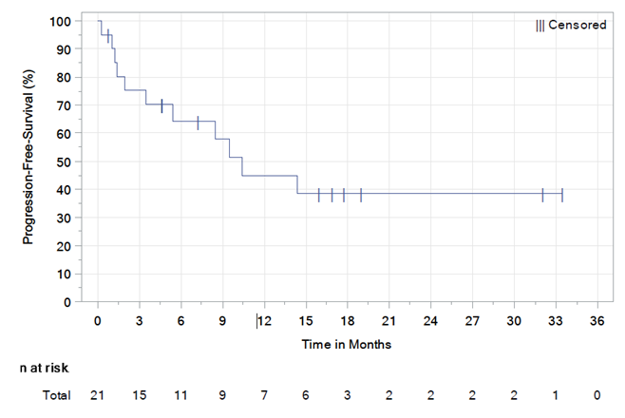 | 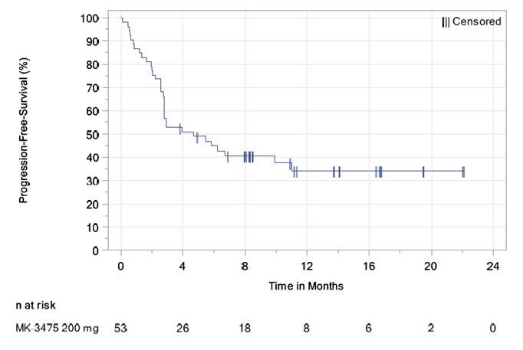
Source: Figure 2.5 – 1, p40 and Figure 2.5 – 2, p41, of the submission. Abbreviations: PFS = progression free survival.

  - The OS results for KN013, KN170 and Kuruvilla 2008 are presented in Table 8 with Kaplan-Meier data representing pembrolizumab studies in Figure 2, and for SOC in Figure 3. The submission stated that in the pembrolizumab studies a ‘plateau’ effect commenced at about 18 months. The ESC and PBAC considered that this claim was not reasonable due to the low number of patients at risk and the high degree of censoring beyond 12 months, which makes the curves difficult to interpret beyond this point. In KN170, there were three patients at risk at Month 21. A large proportion of patients (19/30 at risk (63%)) were censored from Month 9 to Month 18, with only two deaths occurring during that period.
  - Based on the data in Kuruvilla 2008, the submission estimated that 2-year OS for SOC was 15%. The OS data reported by Kuruvilla 2008 included patients who received ASCT (n = 8); the submission stated that this may bias the analysis against pembrolizumab given the relatively high proportion of SOC patients (8/37) who went on to receive a therapy with curative intent (ASCT).
Table 8: Summary of survival outcomes for pembrolizumab studies (KN013 and KN170) and SOC (Kuruvilla 2008)
 | Pembrolizumab  KN013 |  | Pembrolizumab  KN170  N = 53 | SOC  (Kuruvilla 2008)  N = 37
 | Total  N = 21 | 200 mg Q3W  N = 11
Patients with event, Death n (%) | 8 (38.1) | 5 (45.5) | 23 (43.4) | NA
Median months OS (95% CI) | Not reached | Not reached | Not reached | NA
95% CI for Median OS† | (4.9, Not reached) | (1.0, Not reached) | (7.3, Not reached) | NA
OS rate at 6 Months, % † | 71% | 64% | 70% | 65%††
OS rate at 12 Months, % † | 66% | 51% | 58% | 35%††
OS at 2 years post progression, % | NA | NA | NA | 15%
Source: Table 11-5, p62, and Table 14.2-30, p155, KN013 CSR, and Table 2.7.3-pmbcl:13, 20, KN170 efficacy update CSR; Kuruvilla 2008 rates adapted from economic model Inputs_SurvivalCurveData excel sheet, from Att.8 excel workbook, in the submission.
Abbreviations: CI = confidence interval; n = number of participants with event; N = total participants in group; NA = not applicable
Notes: † From product-limit (Kaplan-Meier) method for censored data.
†† OS for SOC at 6 and 12 months were as reported in the digitised KM curves from Kuruvilla 2008 included in the Section 3 (Economic Model) workbook accompanying the submission.
Figure 2: Kaplan-Meier curves for OS for pembrolizumab in patients with R/R PMBCL (KN013 and KN170)
KN013 (N=21) | KN170 (N = 53)
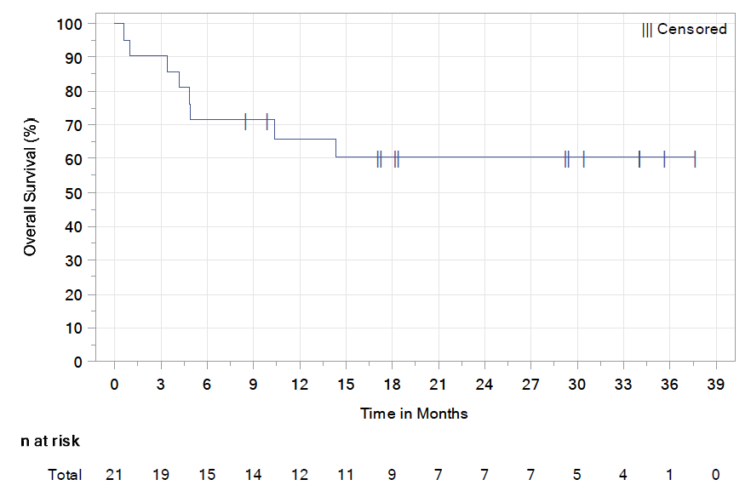 | 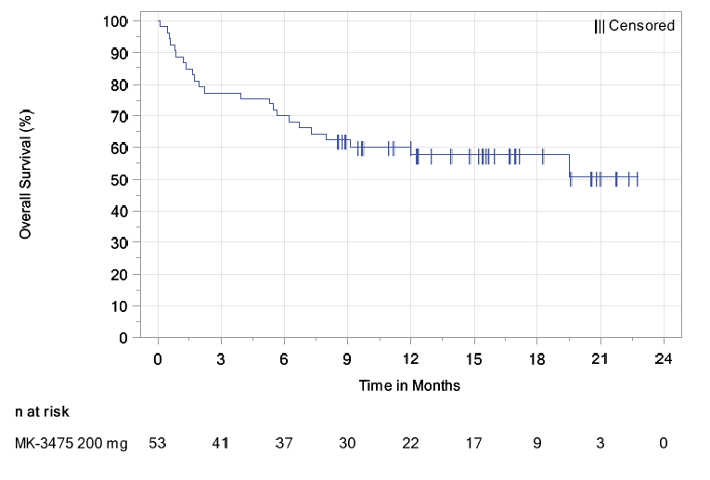
Source: Figure 2.5 – 3, p43 and Figure 2.5 – 4, p44, of the submission. Abbreviations: OS = overall survival.

Figure 3: Kaplan-Meier curves for OS for SOC in patients with R/R PMBCL (Kuruvilla 2008)
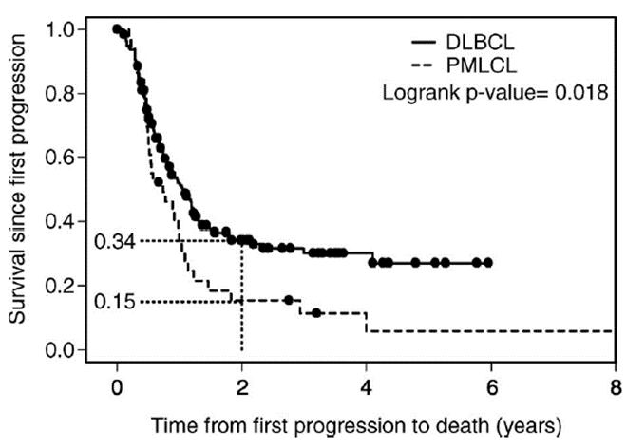
Source: Figure 2.5 – 5, p45, of the submission. Abbreviations: DLBCL = diffuse large B-cell lymphomas; OS = overall survival; PMBCL = primary mediastinal B-cell lymphoma.
  - The PBAC noted that the Kaplan-Meier curve from Vardhana 2018 (Figure 4 below), which included more recently treated patients, showed higher rates of OS with SOC chemotherapies than reported in Kuruvilla 2008, though the Committee acknowledged differences in the proportion of patients who progressed to SCT and reporting of outcomes (Kuruvilla 2008 was based on time since first progression).
Figure 4: OS and event free survival (EFS) in Vardhana 2018; all patients R/R PMBCL (n = 60)
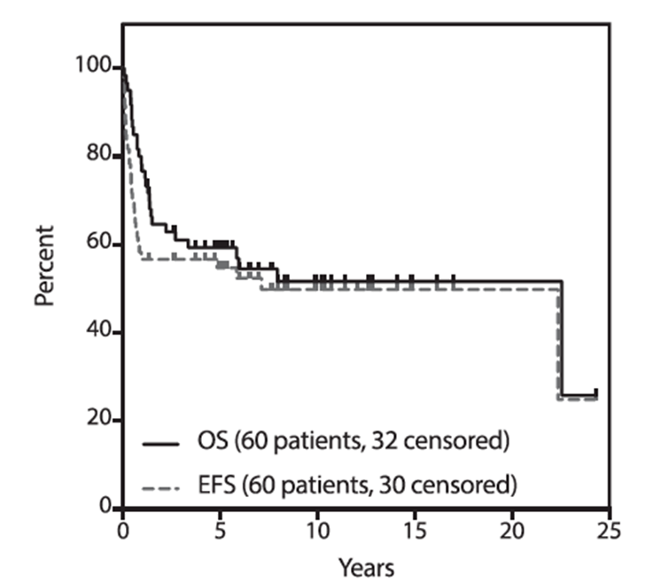
Source: Vardhana 2018

Comparative harms
  - Safety data were presented for pembrolizumab from studies KN013 and KN170. However, the submission did not present safety data for standard of care chemotherapies as Kuruvilla 2008 did not report data on adverse events but noted that there were no treatment-related deaths and that there were cases of febrile neutropenia (without reporting the number of cases; p1330, Kuruvilla 2008).
  - To enable an assessment of comparative harms, the ESC and the PBAC considered that it may have been reasonable for the submission to have based the safety of currently used salvage regimens on trials in other aggressive lymphomas. The ESC considered that such an approach may have been appropriate in the context of the small number of patients with PMBCL.
  - Safety data for KN013 and KN170 were based on all treated patients and are presented in Tables 9 and 10. Approximately two-thirds of patients in KN013 and half of patients in KN170 experienced drug-related AEs. However, more patients in KN170 had Grade 3-5 AEs (58.5% vs 38.1%) compared to KN013. There were five reported AEs that resulted in treatment discontinuation: neutropenia in KN013; and cardiac tamponade, myocardial infarction, aspergillus infection and an increased aspartate aminotransferase in KN170. There were no deaths related to adverse events.
Table 9: Summary of key adverse events in the pembrolizumab studies (KN013 and KN170)
Trial ID | KN013  N = 21 | KN170  N = 53
Any AE, n (%) | '''''' '''''''''''' | '''''' '''''''''''''''
Drug related AEs, n (%) | '''''' '''''''''''' | ''''' '''''''''''''
Any SAE (Grade 3 -5), n (%) | '''' '''''''''''''' | '''''' ''''''''''''''''
Any SAE (Grade 3-5) drug related, n (%) | ''' ''''''''''''' | '''''' '''''''''''''
AE leading to discontinuation of treatment (any grade), n (%) | '''' '''''''''''' | ''' '''''''''''
AE resulting in death, n (%) | ''' | '''
Source: Table 2.5-4, p46 and Table 2.5-8, p51, of the submission, compiled during evaluation.
Abbreviations: AE = adverse events; n = number of participants reporting data; N = total participants in group; NR = not reported; SAE = serious adverse events; SOC = standard of care.
Table 10: Summary of most common adverse events occurring in 10% or more of patients in pembrolizumab studies, KN013 and KN170
Trial ID | KN013  N = 21 | KN170  N = 53
Cough, n (%) | 11 (52.4) | 10 (18.9)
Diarrhoea, n (%) | 7 (33.3) | 6 (11.3)
Pyrexia, n (%) | 7 (33.3) | 15 (28.3)
Nausea, n (%) | 5 (23.8) | 6 (11.3)
Neutropenia, n (%) | 5 (23.8) | 14 (26.4)
Anaemia, n (%) | 4 (19.0) | 6 (11.3)
Dyspnoea, n (%) | 3 (14.3) | 11 (20.8)
Source: Table 2.5-5, p50 and Table 2.5-9, p52, of the submission.
Abbreviations: AE = adverse events; n = number of participants reporting data; N = total participants in group; SAE = serious adverse events; SOC = standard of care.

Benefits/harms
  - The naïve indirect comparison presented in the submission did not allow for a quantitative comparison of the benefits and harms of pembrolizumab with SOC. Accordingly, a benefits/harms table has not been presented.

Clinical claim
  - The submission claimed that pembrolizumab is superior to SOC in terms of effectiveness and safety. The ESC considered that the submission’s claim of superior comparative effectiveness was uncertain given: the study of SOC (Kuruvilla 2008) did not include rituximab-containing regimens and thus likely underestimated the outcomes with current practice; the heterogeneity in study populations and methods; and the absence of an indirect comparison informed by a common reference. The PBAC further considered that the data from the pembrolizumab studies were immature, with the Phase 2 KN170 study having a median duration of follow-up of 9.7 months and a large degree of censoring.
  - Further, the submission’s claim of superior comparative safety was unable to be assessed during evaluation as no safety data were presented for SOC, and no comparison of safety outcomes was provided.
  - The submission also claimed that pembrolizumab may provide patients with a potential bridge to autologous or allogeneic SCT. The evaluation considered that this may be reasonable, given that eight patients (11%) in KN013 and KN170 underwent an autologous or allogeneic SCT after treatment with pembrolizumab. However, the ESC noted that SOC therapies may also act as a bridge to transplant, with eight (22%) patients in Kuruvilla 2008 undergoing an autologous SCT. The ESC noted the limitations of comparing the two pembrolizumab studies to Kuruvilla 2008. However, as SCT (particularly allogeneic SCT) is a key goal of treatment, the ESC considered that a comparison of the number of patients who underwent allogeneic SCT post-treatment would have been informative (i.e. post-treatment with pembrolizumab versus post-treatment with rituximab-containing SOC therapies).

Economic analysis
  - The submission presented a cost-utility analysis. The model structure and rationale are presented in Table 11.
Table 11: Summary of model structure and rationale
Component | Summary
Type of analysis | Cost-utility
Time horizon | 10 years in the model base case versus maximum follow-up of 21 months in KN170 (pembrolizumab) and 2 years in Kuruvilla 2008 (SOC)
Outcomes | QALYs
Methods used to generate results | Cohort analysis using partitioned survival analysis (i.e. area under the curve). Data were extrapolated using all available Kaplan-Meier data, applied from last available observation onwards. Though it was not reasonable to extrapolate from the last available Kaplan-Meier data point, given the large degree of censoring toward the end of the curve, this had little impact on the ICER within the current structure of the model.
Health states | Progression free survival (PFS), progressive disease (PD), death
Health state movement | Health state allocation over time determined by progression free and overall survival curves.
Cycle length | 3 weeks
Source: Table 3.1-2, p71, of the submission.
Abbreviations: KM = Kaplan-Meier; QALYs = quality adjusted life years; SOC = standard of care
  - The submission presented a partitioned-survival (area under the curve) analysis of pembrolizumab compared to SOC (as represented by DHAP, GDP and ICE). The proportion of patients in each of three health states (progression free, progressed, dead) at each cycle was calculated based on predicted survival curves for PFS and OS, by treatment group.
  - The PFS and OS data for pembrolizumab were sourced from KN170. The OS data for SOC were sourced from Kuruvilla 2008. However, as PFS data for SOC were not uniformly reported in Kuruvilla 2008, the submission estimated PFS for SOC by assuming that the ratio of OS to PFS observed for pembrolizumab in KN170 also applied to SOC (i.e. effectively assuming a surrogate relationship between PFS and OS). The submission’s justification for this was that published studies of chemotherapy in nHL showed a positive relationship between PFS and OS (Sehn et al. (1998); Avivi et al. (2018)). The ESC and PBAC considered that this may not have been appropriate.
  - The economic evaluation used a subgroup of the Kuruvilla 2008 population to estimate OS for the SOC arm (the subgroup comprised 24 of the 37 patients included in Kuruvilla 2018). Patients were excluded from the subgroup if they received only one prior line of chemotherapy (n=5) or if they underwent an ASCT following treatment (n=8).
- The submission excluded the five patients who received only one prior line of chemotherapy on the basis that they would be ineligible for pembrolizumab under the proposed restriction, wherein one of the criteria requires patients to have relapsed following at least two prior therapies. However, the evaluation noted that the proposed restriction also enables use in patients who are refractory to one prior rituximab-containing chemotherapy combination, which was not relevant to the Kuruvilla 2008 population as only one patient had received prior rituximab-containing therapy. The ESC considered that these five patients should have been included given it was not possible to determine whether they would have been eligible under the proposed restriction.
- The submission also excluded the eight patients who underwent ASCT post-treatment, on the basis that the proposed PBS restriction requires patients to have failed or be ineligible for ASCT. However, the submission did not establish whether these eight patients were ineligible for ASCT when they commenced SOC. Further, since the submission claimed that pembrolizumab may be a bridge to transplant, the evaluation and the ESC considered that it would be more appropriate to include these eight patients.
  - The ESC and PBAC considered that it was not reasonable to select a subgroup based on these two factors alone, given there were many other differences between the studies. Overall, the ESC considered that it would have been more reasonable to use the full population of Kuruvilla 2008 (rather than a subgroup).
  - The survival curves (OS and PFS) for pembrolizumab and SOC were extrapolated from the last observation on the respective Kaplan-Meier curves. The ESC and the PBAC considered this was not reasonable given the large degree of censoring toward the end of the curve. However, this had only a small impact on the ICER within the current model structure (per the sensitivity analysis in Table 14). The ESC also noted that this resulted in a mismatch between the modelled and the actual survival at the time point of extrapolation.
  - The submission extrapolated the available outcomes data using a log-logistic function. The ESC noted that the submission had only fitted three of the usual six parametric survival curves to the data (i.e. only the Weibull, log-logistic and exponential parametric functions were tested for goodness of fit). The ESC considered that the log normal, gamma and Gompertz models should also have been tested. Further, the ESC noted that the ICER almost doubled when the exponential curve was used. Though the ESC acknowledged the exponential curve was a poor fit, it indicated the potential sensitivity of the model to the choice of parametric function.
  - The pre-PBAC response stated the ICERs using the other three parametric functions (log normal, gamma and Gompertz), however these were not independently verified as they were provided in the pre-PBAC response. The choice of extrapolation function remained poorly justified.
  - Figure 5 shows the extrapolation of the OS and PFS curves applied in the economic model. The Pre-Sub-Committee Response (PSCR) stated that the survival outcomes are starting to converge over time. The ESC noted, that while the OS curves start to converge, they do not converge within the modelled time horizon, and noted that the extrapolation methods resulted in an absolute difference in OS at 10 years of 25% for pembrolizumab versus the ITT of Kuruvilla 2008, or 30% versus the Kuruvilla 2008 sub-group. The ESC noted this absolute difference was in the context of KN170 having a maximum follow-up less than two years and a median follow-up of 9.7 months at which point OS was around 60%. The ESC and the PBAC considered that the estimated ongoing treatment effect was highly uncertain as it was based on immature data that were subject to a high degree of censoring. As such, the ESC considered that the survival curves should have converged within the modelled time horizon.
Figure 5: Extrapolation of the OS (black lines) and PFS (blue lines) curves in the economic model
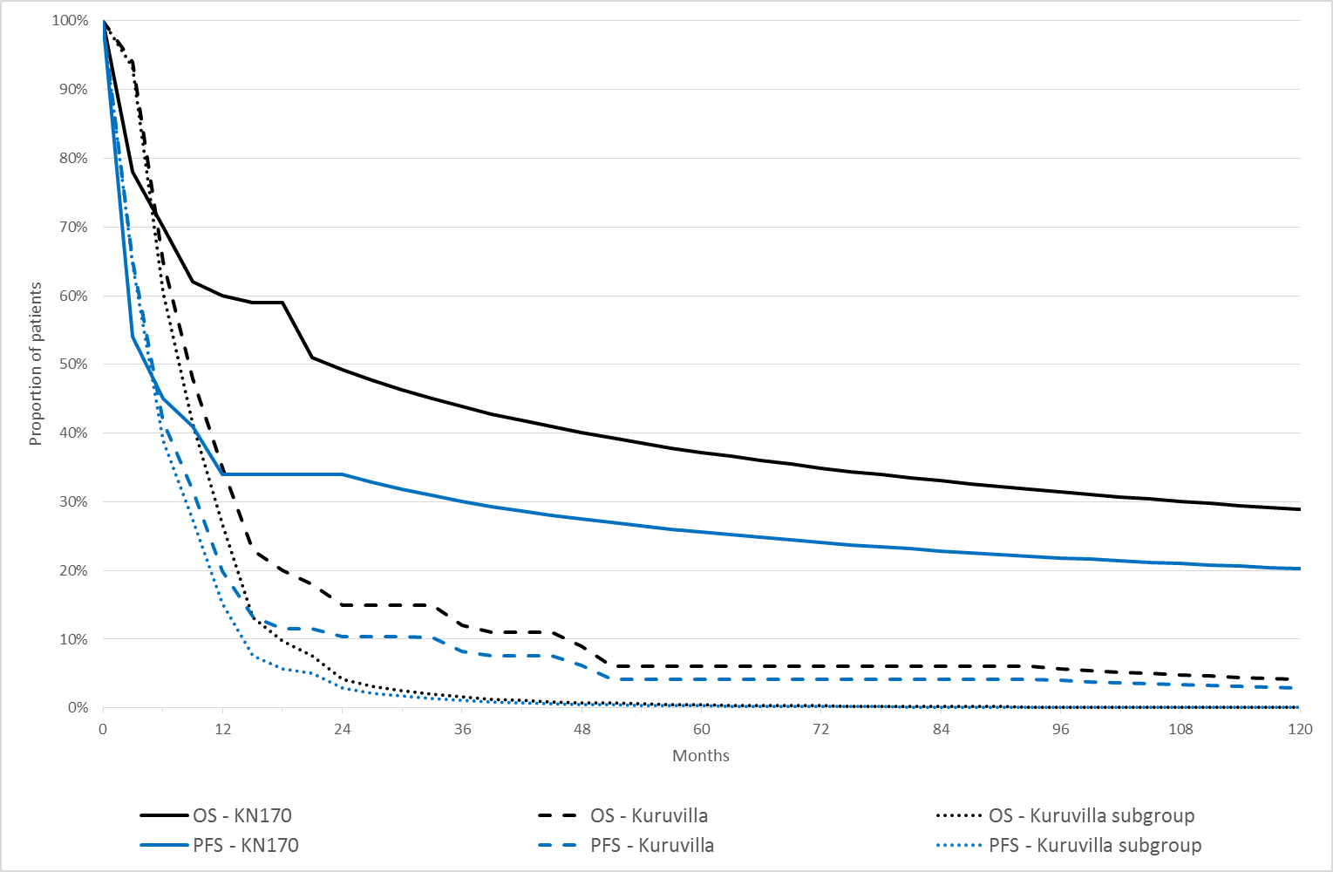
Source: “Chart_SurvivalCurves” worksheet of economic model (Att 8.xlsx); Figure 1 (page 5) of the PSCR
Abbreviations: PEM = pembrolizumab; PD – progressed disease; PF – progression free; SOC = standard of care.

  - A 10 year time horizon was used in the base case of the economic evaluation. The submission justified the 10-year time horizon on the basis of a plateau in the survival data from KN170, however the ESC and PBAC considered this was not reasonable as it was based on immature data that was subject to a high degree of censoring. Further, the evaluation and the ESC considered that a 10-year time horizon may be too long in the context of this condition, particularly when compared with the OS outcomes observed in Kuruvilla 2008 of 15% alive at 2 years. The evaluation and the ESC considered that a 7.5 year time horizon may have been more appropriate given the immature data and uncertain extrapolation.
  - The utility values were estimated from the health-related quality of life results in KN170 based on a subset of patients, data for which was not provided in the submission. Therefore, the validity of using these data to inform the model could not be evaluated. The ESC and PBAC considered that, in the absence of data to evaluate these utilities, more conservative utility values should have been applied. The pre-PBAC response stated that the utility values were consistent with other values reported in the literature for other types of NHL economic models. However, some of the other utility values presented were for follicular lymphoma (e.g. Blommestein et al 2014), which is a more indolent condition.
  - A summary of the key drivers of the economic model is shown in Table 12. The key drivers included the time horizon, the extrapolation method, the approach to estimate the SOC OS and the utility values.
Table 12: Key drivers of the model
Description | Method/Value | Impact  (Base case $''''''''''''''' per QALY)
Data source for SOC OS | The submission applied OS from a subgroup of patients in Kuruvilla 2008 who had not undergone a subsequent ASCT, or who had not received a 2nd line of therapy. The results were sensitive to the use of data from the overall group. | High, favours pembrolizumab  (ICER = $''''''''''''''')
Time horizon | 10 years vs. approx. 21 months maximum follow-up (9.7 months median follow-up) from KN170, and 2 years of Kuruvilla 2008 study. | High, favours pembrolizumab  (ICER = $'''''''''''''''' for a 7.5 year time horizon)
Utilities | Based on an unknown number of patients in KN170 who responded to the HRQoL questionnaire (PFS = 0.80; PD = 0.62). Insufficient information was provided to adequately evaluate the utility values applied. | Moderate, favours comparator
Parametric survival function | The submission selected log-logistic for all curves based on R-squared test statistic and visual inspection of the curves. Other models presented in the submission were Weibull and exponential; the pre-PBAC response reported the results for log-normal, gamma and Gompertz. | High, favours pembrolizumab  (Exponential, ICER = $''''''''''''''')  Convergence of survival curves unable to be tested within current model
Source: Table 3.9-1, p119, of the submission. Abbreviations: HRQoL = health-related quality of life; Log-log = log-logistic; OS = overall survival; PD = progressed disease; PFS = progression-free state.
  - The results of the economic analysis are presented in Table 13. The submission did not present a stepped evaluation.
Table 13: Results of the economic evaluation
Step and component | Pembrolizumab | SOC therapies | Increment
Trial evidence translated to clinical outcomes, the Australian population/setting, extrapolated, with additional modelling and transformed into an economic outcome
Costs | $'''''''''''''''' | $'''''''''''''''' | $'''''''''''''''
LY | 3.5179 | 0.8013 | 2.7166
QALYs | 2.7186 | 0.6854 | 2.0332
Incremental cost/extra QALY gained |  |  | $''''''''''''''' ^{a, b}
Source: Table 3.8-1, p115, of the submission.
Abbreviations: LY = life years; QALY = quality adjusted life years; SOC = standard of care.
ª The re-estimated results based on adjustments of utilisation in of AEs in pembrolizumab arm, updated price mark-up for pembrolizumab and updated DPMQ for SOC.
^{b} This does not correct an error identified during evaluation in the cells used to interpolate the Kaplan-Meier data from the observed months to the cycles in the model. This error resulted in the observed data (post month-13) being applied to the immediately following cycle time-point, effectively extending the survival distribution; see Att.8 Workbook, Inputs_SurvivalCurveData worksheet [cells: I106:P506] and Model worksheet [cells: K16: K362; L16:L362; AC16:AC362; AD16:AD362]. Correcting this would have reduced the base case ICER to $'''''''''''''''.
The redacted table shows an ICER in the range of $15,000/QALY - $45,000/QALY.
  - The submission presented a sensitivity analysis with the OS based on the entire Kuruvilla 2008 cohort, rather than a subgroup. This increased the ICER to $45,000/QALY - $75,000/QALY (21% from the base case). Based on the patient characteristics and treatments compared to KN170, the evaluation and the ESC considered that the entire Kuruvilla 2008 cohort would have formed a more suitable base case.
  - Selected univariate sensitivity analyses are presented in the table below. The model results were most sensitive to use of the entire Kuruvilla 2008 population, choice of extrapolation function, the time horizon and the utility values.
Table 14: Results of sensitivity analyses
 | ∆ costs | ∆ QALYs | ICER per QALY
Base case | $''''''''''''''' | 2.72 | $'''''''''''''
SOC OS (base case: Kuruvilla 2008 sub-group)  Total Kuruvilla 2008 population | $''''''''''''''' | 1.5952 | $'''''''''''''''''
Parametic survival function, PFS and OS (base case: log-log)  Weibull  Exponential | $'''''''''''''''''  $''''''''''''''''' | 1.9608  1.0134 | $'''''''''''''''''  $''''''''''''''''
Point of extrapolation (base case: last available KM data point)  Median follow-up (9 months pembrolizumab, 24 months SOC) | $'''''''''''''''' | 2.0772 | $'''''''''''''''''
Time horizon (base case: 10 years)  5 years  7.5 years | $'''''''''''''''''  $''''''''''''''' | 1.1370  1.6366 | $''''''''''''''''  $'''''''''''''''
Utility values (base case: EQ-5D from KN170; PFS = 0.80, PD = 0.62)  Blommestein (PFS = 0.88, PD = 0.78) | $'''''''''''''''''' | 2.3268 | $''''''''''''''''
Multivariate sensitivity analyses presented in PSCR
Time horizon 7.5 years, Kuruvilla 2008 total population | $'''''''''''''''''' | 1.2684 | $'''''''''''''''
Source: Table 3.9-1, page 118 of the submission with re-estimated results based on adjustments of utilisation in of AEs in pembrolizumab arm, updated price mark-up for pembrolizumab and updated DPMQ for SOC.
Abbreviations: ICER= incremental cost effectiveness ratio, KM= Kaplan-Meier; Log-Log = log Logistic; OS = overall survival; QALY = quality adjusted life years; SOC= standard of care.

  - The PSCR included a multivariate sensitivity analysis in which the time horizon was reduced to 7.5 years and the total population of Kuruvilla 2008 was included. This resulted in an ICER of $45,000/QALY - $75,000/QALY, which the PSCR stated was in a “cost-effective” range. However, the ESC noted that this multivariate sensitivity analysis did not address the issues with the ongoing treatment effect, and that the comparator arm of Kuruvilla 2008 did not reflect current clinical practice. Overall, the ESC and the PBAC considered that the true ICER is likely to be higher than estimated in the submission or the PSCR.

Drug cost/patient/course: $''''''''''''''
  - The drug cost per patient per course of $'''''''''''''' assumed a fixed dose of 200 mg per person, a DPMA of $'''''''''''''''' (2 X 100 mg vials), with an average number of administrations of 15.63 cycles per course of treatment (adapted from the economic evaluation).

Estimated PBS usage & financial implications
  - This submission was not considered by DUSC. The submission presented an epidemiological approach to estimate the expected utilisation and financial impact of listing pembrolizumab for R/R PMBCL.
  - The submission estimated that 12.3% of all PMBCL patients who start first-line rituximab-based chemotherapy would develop relapsed (after two prior lines) or refractory (after one prior line) disease. The evaluation noted this was based on expert opinion. The PBAC considered that this proportion was likely reasonable in the absence of more reliable data.
  - The submission included grandfathered patients as well as a prevalent pool of patients (the relapsed 5-year prevalent population). Including prevalent patients as well as grandfathered patients (who would presumably have been drawn from the prevalent pool), and assuming that prevalent patients would “drip feed” into the treated patient group over the full six years of the analysis, was likely to have overestimated the number of eligible patients as most of these patients are likely to be treated in the first year of listing.
  - The submission stated that with the better toxicity profile and higher efficacy of pembrolizumab versus SOC, there will be a higher treatment uptake. Thus, the submission assumed an uptake rate of 95% with pembrolizumab and 90% with SOC. These assumptions were based on expert opinion and could not be verified.
  - The net cost to the PBS/RPBS, as estimated in the submission, is shown in Table 15.
Table 15: Estimated use and financial implications
 | Year 1 | Year 2 | Year 3 | Year 4 | Year 5 | Year 6
Estimated extent of use
Number of patients treated with pembrolizumab | ''''''' | ''''' | '''''' | '''''' | ''''''' | ''''''
Number of patients treated with SOC | ''''' | ''''''' | ''''''' | ''''' | '''''' | '''''
Number of scripts dispensedª pembrolizumab | ''''''''' | ''''''''' | '''''''''' | ''''''''' | '''''''' | ''''''''''
Number of scripts dispensed for SOC | ''''''''' | ''''''''' | '''''''''' | '''''''''' | '''''''''' | '''''''''
Estimated financial implications of pembrolizumab ($)
Cost to PBS/RPBS | '''''''''''''''''''''''''' | '''''''''''''''''''''''' | '''''''''''''''''''''''' | '''''''''''''''''''''''''' | '''''''''''''''''''''''' | ''''''''''''''''''''''''''
Co-payments | '''''''''''''''' | ''''''''''''''''' | ''''''''''''''' | ''''''''''''''''' | ''''''''''''''' | ''''''''''''''''
Cost to PBS/RPBS less co-payments | ''''''''''''''''''''''''''' | ''''''''''''''''''''''''''''' | ''''''''''''''''''''''''''' | ''''''''''''''''''''''''''''' | '''''''''''''''''''''''''' | '''''''''''''''''''''''''''
Estimated financial implications for SOC ($)
Cost to PBS/RPBS | ''''''''''''''''''''''' | '''''''''''''''''''''' | ''''''''''''''''''''''' | ''''''''''''''''''''''' | ''''''''''''''''''''''' | ''''''''''''''''''''''
Co-payments | '''''''''''''''' | ''''''''''''''' | ''''''''''''''' | '''''''''''''''' | '''''''''''''''' | '''''''''''''''
Cost to PBS/RPBS less co-payments | ''''''''''''''''''''' | '''''''''''''''''' | ''''''''''''''''''''' | '''''''''''''''''''' | '''''''''''''''''''''' | '''''''''''''''''''''
Net financial implications ($)
Net cost to PBS/RPBS | ''''''''''''''''''''''' | ''''''''''''''''''''''''' | '''''''''''''''''''''''''''' | ''''''''''''''''''''''''''' | '''''''''''''''''''''''' | '''''''''''''''''''''''
ª Assuming 15.32 cycles per patient per year as estimated during the evaluation.
Source: Table 4.4-1, p140, Table 4.3-4, p138, Table 4.3-6 and Table 4.3-7, p139, Table 4.4-9, p147, Table 4.4-10, p148, Table 4.4-11, p149, Table 4.5-2, p152, of the submission. Values were corrected for the update DPMA prices (August 2018), updated mark-up costs, corrected errors in the excel workbook and adjusted for re-estimated number of average cycles from 15.63 to 15.32.
The redacted table shows that at Year 6 the estimated number of patients was less than 10,000 per year, and the net cost to the PBS would be less than $10 million per year.
  - The estimated total net cost to the PBS/RPBS over the first six years of listing (allowing for the correction in the number of doses administered), incorporating co-payments and substitution for SOC, was $10 - $20 million.
  - The evaluation and the ESC considered that the cost to the PBS/RPBS was likely overestimated because uptake from prevalent patients was assumed to occur each year for six years.

Quality Use of Medicines
  - The sponsor stated that it would develop materials and inform health professionals and patients about how to identify and manage potential treatment-related adverse events with pembrolizumab.

Financial Management – Risk Sharing Arrangements
  - The submission proposed that pembrolizumab use for R/R PMBCL could be included in the current RSA for pembrolizumab in rrcHL, with the current annual subsidisation cap tiers in the rrcHL RSA increased by an amount equivalent to the additional R/R PMBCL treated patients.
For more detail on PBAC’s view, see section 7 PBAC outcome.
- PBAC Outcome
  - The PBAC did not recommend the listing of pembrolizumab for the treatment of relapsed or refractory primary mediastinal large B-cell lymphoma (R/R PMBCL). The PBAC considered that the incremental effectiveness versus standard of care chemotherapies was uncertain because the pembrolizumab trial data were immature and the control data used in the submission were not contemporary. Thus, the cost-effectiveness was unknown. The PBAC advised that more mature trial data would help inform a resubmission.
  - The PBAC considered there was a high unmet clinical need for effective treatments for R/R PMBCL, particularly given the poor outcomes in patients with this condition.
  - The comparator nominated by the submission was SOC chemotherapies including ICE (comprising: ifosfamide, carboplatin, etoposide), DHAP (dexamethasone, high-dose cytarabine, cisplatin) or GDP (gemcitabine, doxorubicin, cisplatin). The PBAC considered that the nominated comparators do not accurately reflect current clinical practice where most salvage chemotherapy or high dose therapy regimens contain rituximab.
  - The PBAC acknowledged that pembrolizumab appeared to have a higher overall response rate in the naïve indirect comparison and that pembrolizumab may act as a bridge to transplant in some patients. The PBAC also acknowledged the difficulties of conducting comparisons in relatively rare conditions. However, the PBAC considered that the incremental effectiveness versus standard of care chemotherapies was uncertain because the pembrolizumab trial data were immature and the control data were not contemporary.
  - The PBAC noted that the evidence for pembrolizumab comprised two single-arm studies (KN013 n = 21, of which 11 patients receiving the relevant dose; and KN170 n = 53). The median duration of follow-up in KN170 was 9.7 months based on a data-cut from January 2018, at which time 57% of patients remained in the study. The submission claimed that there was a plateau in the Kaplan-Meier OS curves for pembrolizumab commencing at about 18 months. The PBAC considered that this claim was not adequately substantiated by the currently available data due to the low number of patients at risk and the high degree of censoring beyond 12 months, which makes the curves difficult to interpret beyond this point. The PBAC considered that more mature data from KN170 would be required to appropriately assess outcomes with pembrolizumab in this condition.
  - The PBAC noted that the evidence for SOC chemotherapies was a retrospective, observational single-arm study which included patients who were referred for salvage chemotherapy between 1995 and 2004, and did not include rituximab-containing regimens (Kuruvilla 2008). The PBAC considered the treatments received were not applicable to current practice and likely underestimated outcomes with SOC chemotherapies. The PBAC noted that another study had recently been published, Vardhana 2018, which like Kuruvilla 2008 assessed outcomes of patients with R/R PMBCL who were treated with second-line chemotherapy with intent to consolidate with ASCT. The PBAC noted there were key difference between patients in Vardhana 2018 and the pembrolizumab studies (KN013 and KN170), particularly around transplant eligibility (and the proportion of patients progressing to transplant) and the number of prior therapies. The PBAC considered that some of these limitations also applied to Kuruvilla 2008, while Vardhana 2018 had the advantage of including patients who were treated more recently. As such, the PBAC considered that Vardhana 2018 was also a relevant source for estimating SOC chemotherapy outcomes in current practice.
  - The PBAC noted that the submission did not present safety data for SOC chemotherapies because adverse events were not reported in Kuruvilla 2008. The PBAC considered that an assessment of comparative harms would be informative and considered that it may have been reasonable to base the safety of currently used SOC chemotherapies on trials in other aggressive lymphomas given the small number of patients with R/R PMBCL.
  - The PBAC considered that the results of the economic evaluation were not reliable because the control data used to inform the model were not contemporary, and it was not reasonable to assume an ongoing treatment effect because the pembrolizumab data were immature and subject to a high degree of censoring. Further, the PBAC considered that the utility values applied in the model were poorly justified and resulted in a large increment between the progression free (utility of 0.80) and progressed disease health states (0.62).
  - The PBAC considered that the time horizon of ten years was too long in the context of the immature pembrolizumab data and the natural history of the disease as evidenced by the SOC data from Kuruvilla 2008. However, the Committee considered that more mature pembrolizumab data and more contemporary SOC data may potentially support this time horizon. The PBAC also considered that the choice of parametric function was poorly justified and it was not reasonable to extrapolate from the last available Kaplan-Meier data point.
  - The PBAC considered that number of eligible patients may have been overestimated by the inclusion of prevalent PMBCL patients until Year 6.
  - The PBAC considered that any resubmission would need to be a major resubmission and should address the following issues:
- more mature data from the KN170 study should be used to inform the pembrolizumab arm of the indirect comparison and the economic model;
- more recent data should be used to inform the SOC chemotherapy arm of the indirect comparison and the economic model;
- comparative safety data should be provided as outlined in Paragraph 7.7;
- the economic model should be updated as outlined in Paragraphs 7.8 to 7.9; and
- the financial estimates should be updated as outlined in Paragraph 7.11.
  - The PBAC noted that this submission is eligible for an Independent Review.
Outcome:
Rejected

- Context for Decision
The PBAC helps decide whether and, if so, how medicines should be subsidised in Australia. It considers submissions in this context. A PBAC decision not to recommend listing or not to recommend changing a listing does not represent a final PBAC view about the merits of the medicine. A company can resubmit to the PBAC or seek independent review of the PBAC decision.

- Sponsor’s Comment
MSD in disappointed in this decision and maintains that there is a substantial benefit of using pembrolizumab in patients with R/R PMBCL, which is a rare cancer in Australia.

Martelli M et al, Primary mediastinal large B-cell lymphoma. Critical Reviews in Oncology/Hematology. 2017; 113: 318–327.
Rieger M, Osterborg A, Pettengell R, et al. MabThera International Trial (MInT) Group. Primary mediastinal B-cell lymphoma treated with CHOP-like chemotherapy with or without rituximab: results of the Mabthera International Trial Group study. Ann Oncol. 2011; 22(3):664–670.
Dunleavy K, Pittaluga S, Maeda LS, et al. Dose-adjusted EPOCH-rituximab therapy in primary mediastinal B-cell lymphoma. N Engl J Med. 2013; 368(15):1408–1416
Savage KJ, Yenson PR, Shenkier T, et al. The outcome of primary mediastinal large B-cell lymphoma (PMBCL) in the R-CHOP treatment era. Oral presentation at the 54th ASH Annual Meeting and Exposition. December 10, 2012. Atlanta, GA.
Christian Gisselbrecht. Use of rituximab in diffuse large B‐cell lymphoma in the salvage setting First published: 11 November 2008, British Journal of hematology.
Vardhana, S et al. Outcomes of Relapsed and Refractory Primary Mediastinal (Thymic) Large B Cell Lymphoma Treated with Second-Line Therapy and Intent to Transplant. Biology of Blood and Marrow Transplantation, 2018. Volume 24 , Issue 10 , 2133 - 2138

